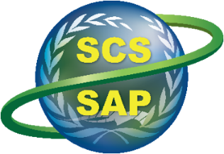
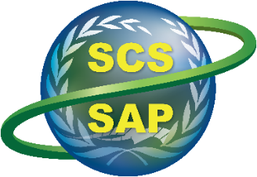
Implementing the Strategic Action Programme for the South China Sea and Gulf of Thailand
(SCS SAP Project)

Meeting of the Regional Task Force on Economic Valuation

Teleconference, 11 December 2025

INTERIM PROVISIONAL AGENDA


PROVISIONAL AGENDA

Thursday, 11 December 2025, 09.00 – 10.35 Indochina Time (ICT)

Objective: Discuss how to develop a template guidance for implementing a Cost-Benefit Analysis (CBA) of core actions that address transboundary environmental problems in the SCS-GOT LMEs. The template will be used for evaluating recommended actions using a CBA approach for regional and national actions. Actions at regional and national scales with NET BENEFITS (social, ecological, economical and climate-resilient) will be ranked for actual implementation by recipient bodies such as the COBSEA.

Time | Agenda/Topic | Responsible Person
09:00-09:05 | - Introduction and Background | Anders Poulsen  Liana McManus
09:05-09:10 | - Recommended actions for Ecosystems - LME scale and national scales  - Note: National actions across all environmental themes will be evaluated by national economics experts | Vo Si Tuan
09:10-09:15 | - Recommended actions for Pollution - LME scale and national scales | Gil Jacinto
09:15-09:20 | - Recommended actions for Fisheries - LME scale and national scales | Somboon Sriraksophon
09:20-09:25 | - Recommended actions for Climate Mitigation — LME scale and national scales | Liana McManus
09:25-09:30 | - Recommended actions for Governance - LME scale and national scales | Megan Knight
09:30-09:35 | - Approaching the social aspects  - It is important that gender equality and vulnerable sectors of the impacted populations are taken into account across all themes. The intent is that the transition from unsustainable to resilient paths be JUST especially for vulnerable sectors, and that metrics in the COSTS and BENEFITS analysis take these issues into account. | Liana McManus
10:35-10:20 | - RTF-EV Response and discussion on the technical aspects of COST BENEFIT analysis (20 minutes response followed by 30 minutes of discussion) | Luky Adrianto (to lead as Chair of RTF-EV)
10:20-10:30 | 9. Charting next steps  9.1 DEVELOPING A GUIDANCE DOCUMENT TO SHARE TO NATIONAL TEAMS  9.2 DEVELOPING THE CBA FOR THE REGIONAL SAP | TDA SAP and RTF-EV Teams
10:30-10:35 | - Closing | Anders Poulsen

