Socio-Economic Conditions and Climate Risks in the South China Sea– A Multi Regional Analysis of Eastern-Southern Sumatera and Western Kalimantan Coastal Area to Strengthen Indonesia’s Coastal and Marine Resilience

Luky Adrianto^{1,2}, Akhmad Nurhijayat¹, Ainnur Widiastuti Khoirunnisa^{1,}
1) Center for Coastal and Marine Resources Studies, IPB University
2) Faculty of Fisheries and Marine Sciences, IPB University

Abstract
Indonesia’s coastal regions face intensifying social-ecological pressures driven by climate change, habitat degradation, and strong economic reliance on natural resources. This study assesses socio-economic vulnerability and climate risks across five key sites—Bangka, Belitung, Mapur Island, Batu Ampar of Eastern Sumatera and Sembilang National Park of Western Kalimantan—representing diverse coastal systems dependent on small-scale fisheries, mangrove and coral reef ecosystems, and, in Bangka, tin mining. Results show that sea-level rise, tidal flooding, shoreline erosion, and seawater intrusion are increasingly disrupting ecosystem functions and threatening local fisheries-based livelihoods. Each site exhibits distinct characteristics: Bangka experiences severe human-induced stress from intensive mining, while Mapur, Belitung, and Sembilang contain high-value ecosystems that remain essential for food security and fisheries productivity. Overall, the findings highlight that coastal vulnerability varies across locations and is shaped by the interaction of ecological conditions, livelihood dependence, and localized climate impacts. Strengthening resilience requires integrated, site-specific strategies that combine ecosystem-based management with targeted socio-economic adaptation measures.
Keywords: coastal systems, climate change, social-ecological systems, climate resilience, coastal management, Eastern and Southern Sumatera, Western Kalimantan, Indonesia

Introduction
The study sites—Bangka Regency, Belitung Regency, Mapur Island of Eastern Sumatera, Sembilang National Park of Southern Sumatera and Batu Ampar of Western Kalimantan—represent frontline zones of human–environment interaction in Indonesia’s coastal regions. Local economies in these areas rely heavily on small-scale fisheries, the integrity of coastal ecosystems such as mangroves and coral reefs, and, in some locations, extractive industries such as tin mining in Bangka. This dependence reflects regional economic characteristics documented in previous studies (FAO 2025; Bidayani et al., 2023; BPS 2024).
Climate- and coastal-related threats emerge as cross-cutting issues across all sites. Sea-level rise, tidal flooding, coastal erosion, and seawater intrusion have reduced productive land, disrupted fisheries supply chains, and weakened the carrying capacity of coastal ecosystems (IPCC 2025; KKP 2024). These patterns are consistent with global evidence on the impacts of climate change on vulnerable coastal and island regions.
Despite sharing similar reliance on natural resources, each location exhibits distinct socio-economic dynamics. Bangka faces severe anthropogenic pressure from intensive tin mining, which drives habitat degradation and spatial competition. In contrast, Mapur Island and parts of Sembilang maintain high-value ecosystems, where mangroves and coral reefs support sustainable fisheries, local food security, and emerging ecotourism opportunities (Ibrahim 2023; Silvus 2018).
These findings highlight the need for coastal management strategies that are location-specific yet integrated. Such strategies must combine ecosystem-based conservation with socio-economic interventions to strengthen the climate resilience of coastal communities. Ecosystem protection, sustainable resource use, and proactive climate-risk anticipation are essential to achieving a balance between human well-being and environmental sustainability. Geographically, the five study areas exhibit diverse biophysical and administrative characteristics. The Bangka Belitung Islands Province—79.90% of which is marine area—includes Bangka and Belitung Regencies, both characterized by tropical climates, hilly landscapes, and abundant natural resources such as fisheries, agriculture, and marine tourism (BPS 2019; Adibrata et al., 2023). In West Kalimantan, Kubu Raya Regency consists largely of lowlands and swamps, with Batu Ampar serving as a key coastal zone facing the Natuna Sea. In Riau Province, Mapur Island within Bintan Regency features low-lying coastal terrain with coral reef and seagrass ecosystems that support traditional fisheries. Meanwhile, Sembilang National Park in South Sumatra is a major coastal biodiversity hotspot, encompassing extensive mangrove forests, freshwater swamps, and estuarine waters that play vital roles in coastal protection and traditional fisheries livelihoods (Febriansyah et al., 2019). Overall, the profile of these sites illustrates that the interplay between biophysical conditions, anthropogenic pressures, and climate challenges demands an adaptive, integrated, and evidence-based approach to coastal management.
Methodology
Data Types
This study applies a mixed-methods approach, combining secondary data, literature review, and primary data collected through field surveys and Focus Group Discussions (FGDs). This approach provides a comprehensive understanding of socio-economic conditions, coastal activities, and climate-related vulnerabilities in the study sites.
Data Analysis
Data were analyzed using a descriptive–visual approach that integrates descriptive statistics with spatial mapping to uncover key patterns and contrasts across coastal sites. This method is effective for capturing the diverse socio-economic dynamics and climate vulnerabilities present along Indonesia’s maritime zone bordering the South China Sea. Five study sites—Bangka, Belitung, Mapur Island, Batu Ampar, and Sembilang National Park—were selected based on:
- their representation of major coastal social–ecological systems situated within or influenced by the South China Sea region;
- their high exposure to climate hazards, including sea-level rise, tidal flooding, shoreline erosion, and saltwater intrusion; and
- their contrasting anthropogenic pressures, ranging from intensive tin mining in Bangka, traditional fisheries and emerging tourism in Belitung and Mapur Island, low-lying geomorphological vulnerability in Batu Ampar, to the ecologically rich and conservation-critical wetlands of Sembilang.
These differences provide a strong basis for cross-site comparison and offer insight into how socio-ecological vulnerability manifests across coastal zones connected—directly or indirectly—to the broader South China Sea system (Figure 1).
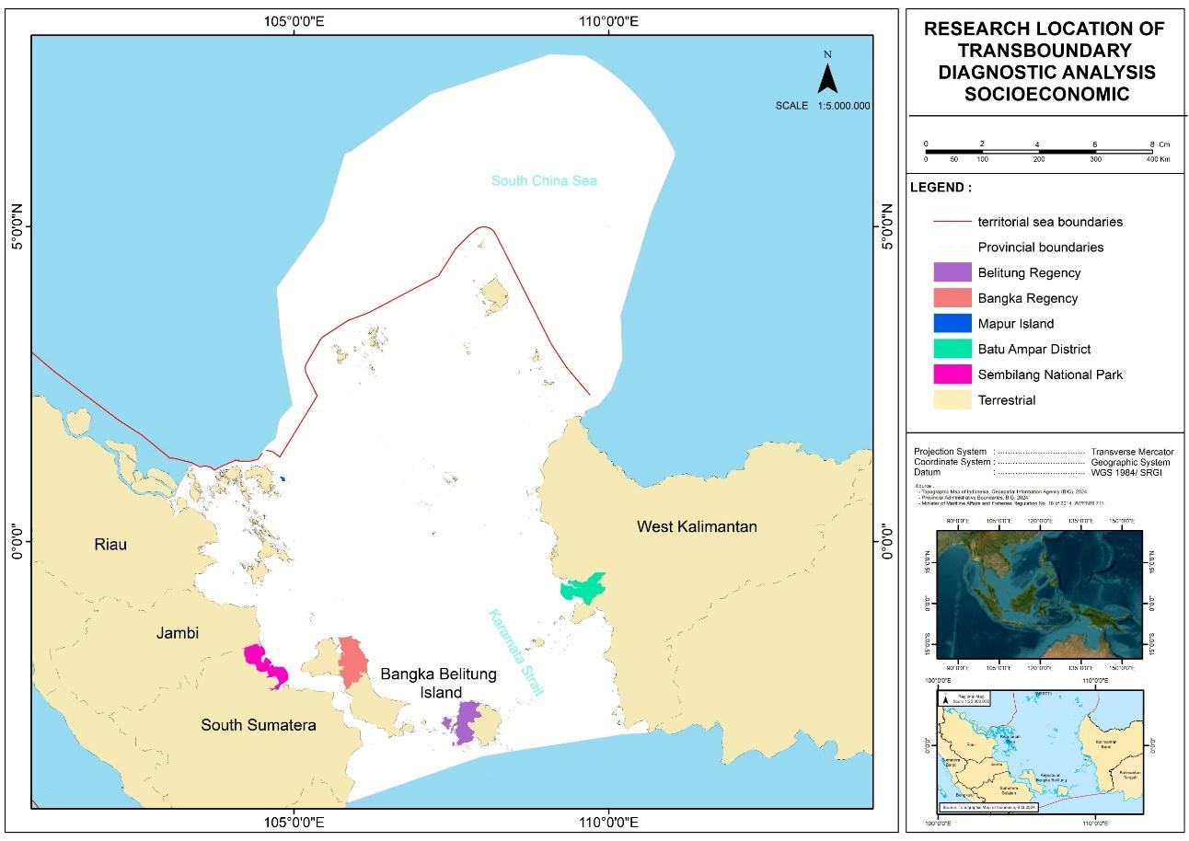
Figure 1 Research Location

Results and Discussion
2.2. Current Socioeconomics Status based on Indicator Group
2.2.1 Demographic Conditions
SE1-1. Subnational coastal populations
The coastal population in the study areas has continued to increase over time. South Sumatra has the largest coastal population, while the Bangka Belitung Islands have the smallest. These differences are influenced by the size of coastal areas and coastline length, which determine settlement capacity (Cisneros et al., 2016). Regions with long coastlines, such as South Sumatra and West Kalimantan, tend to have larger populations (Djunarsjah et al., 2023). Geographic conditions, accessibility, as well as economic factors and urbanization also contribute to this trend, particularly because major coastal cities like Palembang and Pontianak serve as population hubs (BPS, 2024). The demographic information is illustrated in Figure 2.2.1.
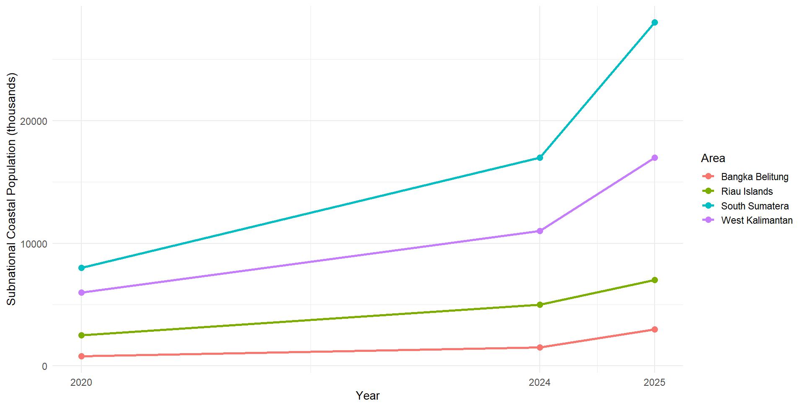
Figure 2.2.1 Subnational Coastal Population (Persons – thousands)
(Data source: Statistics of Indonesia)

The study locations show a declining sex ratio from 2020 to 2025, indicating a reduced dominance of the male population. This trend is linked to migration patterns, especially the movement of male workers into industrial and mining sectors. Weeks (2015) notes that demographic changes, including sex ratio shifts, are strongly shaped by mobility and urbanization. The Riau Islands and Bangka Belitung have higher sex ratios than the other regions because their major economic sectors—fisheries, mining, and logistics—employ more men. However, the recent decline may reflect changes in local economic structures and growing participation of women in both informal and formal sectors. This is consistent with gender-responsive coastal development approaches that promote equal access to economic opportunities and decision-making (FAO, 2020). The sex ratio distribution for the study areas is shown in Figure 2.2.2.
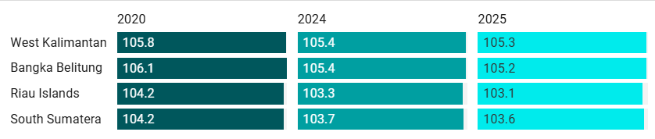
Figure 2.2.2 Population Sex Ratio in the Study Locations
(Data Source: Statistics of Indonesia)

SE1-2. Areas of subnational first level administrative region
The land area distribution across the four provinces shows geographic differences that directly influence coastal socio-economic development. West Kalimantan and South Sumatra have large land areas and long coastlines, giving them substantial potential for coastal and marine resources. However, this often creates spatial inequality, especially in access to infrastructure, markets, and public services between coastal and urban zones (Setiawan et al., 2021). From a Resilience Theory perspective (Folke et al., 2016), large territories require diverse strategies, including integrated maritime transportation, stronger local market networks, and protection of key ecosystems. In contrast, the Riau Islands Province is smaller but strategically located along international trade routes, allowing it to adopt faster-growing economic models based on maritime services and cross-border trade. Nurhidayah et al. (2023) highlight that small but strategically positioned provinces can maximize marine logistics, coastal tourism, and high–value fisheries. The distribution of subnational first-level administrative areas is illustrated in Figure 2.2.3.
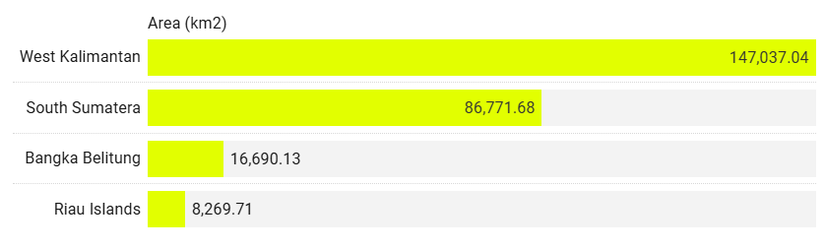
Figure 2.2.3 Areas of Subnational First-Level Administrative Regions
(Data Source: Statistics of Indonesia)

SE1-3. Subnational coastal populations as % of national
Population Distribution
During 2020–2025, South Sumatra contributed the largest proportion of coastal population to the national total (around 3.13–3.14%), followed by West Kalimantan at about 2%, while Bangka Belitung and the Riau Islands each accounted for less than 1%. These differences reflect varying demographic capacities that may shape coastal economic activity. Adrianto et al. (2019) note that provinces with larger coastal populations tend to have a wider labor base for fisheries, maritime, and trade sectors. However, high population concentration also increases pressure on coastal resources if not supported by sustainable management. The population distribution is shown in Figure 2.2.4.
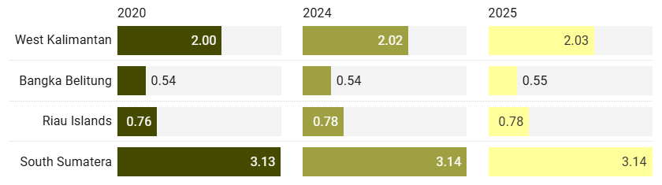
Figure 2.2.4 Population Distribution (%) in the Study Locations
(Data Source: Statistics Indonesia)

SE1-4. Subnational Coastal region areas as % of national area
The four provinces contribute differently to Indonesia’s total land area of 1,919,440 km². West Kalimantan has the largest coastal area at 147,037.04 km² (7.66%), reflecting its long coastline and broad landmass, which support fisheries, aquaculture, and port development. South Sumatra follows with 86,771.68 km² (4.52%), characterized by major river estuaries such as the Musi, Banyuasin, and Ogan that function as transport corridors and centers of coastal economic activity. The Bangka Belitung Islands cover 16,690.13 km² (0.87%), a small land proportion for an archipelagic province but rich in marine and mineral resources, particularly tin. These areas, however, face environmental pressures from mining and land-use change. The Riau Islands have the smallest coastal area at 8,269.71 km² (0.43%), yet their strategic position along the Malacca Strait and North Natuna Sea makes them economically and geopolitically important, with strengths in fisheries, trade, tourism, and port services. Overall, the variation in coastal area proportions reflects differing physical characteristics, resource potentials, and management challenges. Provinces with large coastal areas have greater marine economic opportunities but also require robust governance to maintain ecosystem sustainability. The proportional distribution of coastal areas is shown in Figure 2.2.5.
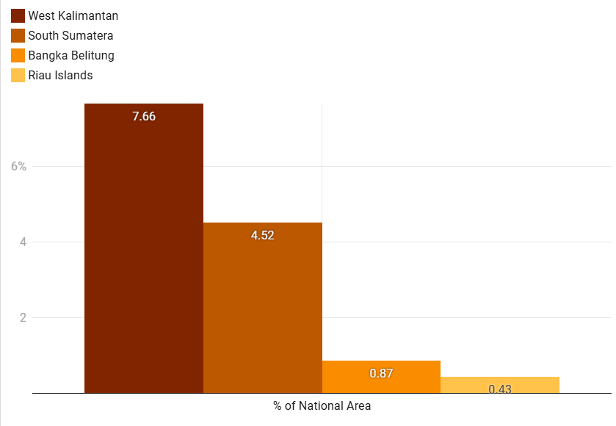
Figure 2.2.5 Subnational Coastal Region Areas as a Percentage of the National Area in the Study Locations (Data Source: Statistics of Indonesia)
SE1-5. Annual population changes
Annual population change in South Sumatra, West Kalimantan, Bangka Belitung, and the Riau Islands was assessed for 2010–2020, 2020–2024, and 2020–2025. All provinces show positive growth but with different trajectories. From 2010–2020, the Riau Islands grew fastest (2.02%) due to in-migration and BBK industrial expansion, followed by Bangka Belitung (1.70%). South Sumatra and West Kalimantan grew steadily at 1.25%. During 2020–2024, growth slowed in most provinces—linked to reduced mobility during COVID-19. South Sumatra dropped to 1.15%, Bangka Belitung to 1.36%, and the Riau Islands to 1.50%. In contrast, West Kalimantan rose to 1.62% due to new infrastructure and industrial development. For 2020–2025, the slowdown continued modestly: South Sumatra (1.12%), Bangka Belitung (1.34%), Riau Islands (1.48%). West Kalimantan remained relatively high at 1.60%. These variations reflect differing economic structures and migration drivers, where industrial hubs and resource-rich regions attract more population growth. Understanding these trends is essential for regional planning, labor policies, and preparing for challenges such as climate change and rapid urbanization (see Figure 2.2.6).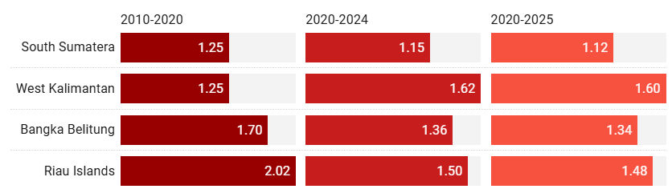
Figure 2.2.6 Percentage Change per Year (Growth or Attrition) in the Study Locations (Data Source: Statistics of Indonesia)
SE1-6. Coastal population densities

Coastal population density in the study areas varies significantly. The Riau Islands show the highest density, rising from 252 people/km² in 2020 to 268 people/km² in 2025. Neumann et al. (2015) note that high coastal density is typically linked to strategic locations that serve as hubs for trade, international ports, and maritime industries, which stimulate urbanization and economic growth. However, high density can also create ecological pressures, including habitat degradation, coastal pollution, and spatial conflict between industry and fisheries. West Kalimantan has the lowest density due to its large land area and dispersed settlements. This provides opportunities for resource-based coastal development with lower environmental stress, but also results in higher infrastructure and market access costs (Baiquni et al., 2021). Bangka Belitung and South Sumatra fall in the medium-density range, reaching 93 and 103 people/km² in 2025. According to the carrying capacity and sustainable livelihoods framework (Cinner & Barnes, 2019), moderate density can be advantageous if supported by adaptive coastal governance and strong economic productivity. These density patterns are presented in Figure 2.2.7.

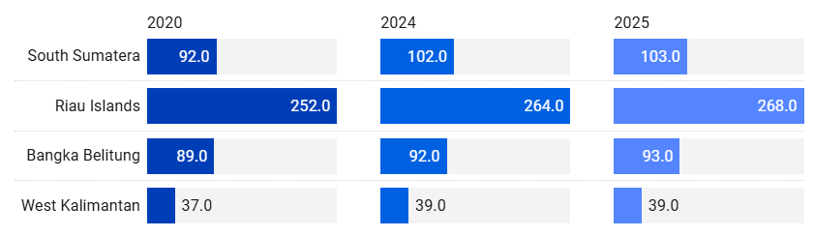
Figure 2.2.7 Population Density (per sq. km) in the Study Locations
(Data Source: Statistics of Indonesia)

SE1-7. National Coastal populations by elevation (1,3,5,7,9,10,12,20 meters above SL)
Number of Villages/Subdistricts by Province and Topographical
Spatial patterns of coastal settlements across the four provinces reveal clear topographical contrasts (Figure 2.2.8). West Kalimantan consistently has the flattest coastal villages, reflecting how flat terrain supports denser settlements through easier access, transport, and maritime connectivity. Slope-area villages increased sharply from 111 (2018) to 798 (2021) before dropping to 588 (2024), likely due to migration or administrative changes. These areas face higher risks of erosion and landslides. Bangka Belitung shows stable flat-settlement numbers, while the Riau Islands saw a decline in slope settlements—from 250 (2021) to 145 (2024)—suggesting movement toward lower-lying zones linked to maritime economic opportunities. South Sumatra remains dominated by flat coastal villages but experienced a major rise in slope areas (83 to 481), indicating possible adaptation to sea-level rise and tidal flooding. Such shifts, however, may increase transport costs and reduce access to marine resources.
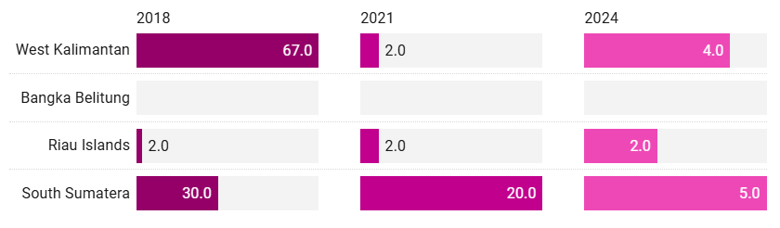
Figure 2.2.8a Number of Villages/Subdistricts by Province and Topographical Areas (Valley)
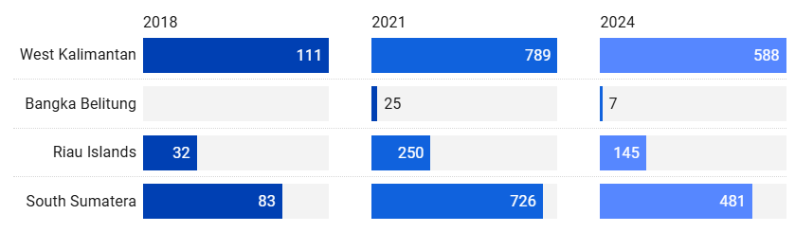
Figure 2.2.8 b Number of Villages/Subdistricts by Province and Topographical Areas (Slop)
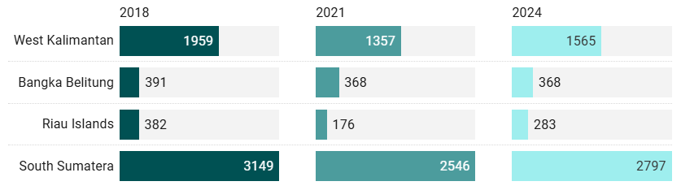
Figure 2.2.8 c Number of Villages/Subdistricts by Province and Topographical Areas (Flat)
(Data Source: Statistics of Indonesia)

2.2.2. Human Wellbeing Conditions

SE2-1 Coastal Poverty Status
Figure 2.2.9 presents 2024 urban and rural poverty rates across the four provinces. South Sumatra has the highest poverty (9.02% urban; 11.43% rural), while Bangka Belitung has the lowest (4.09% urban; 6.49% rural). The Riau Islands (4.36% urban; 8.55% rural) and West Kalimantan (4.62% urban; 7.26% rural) show moderate levels. In all provinces, rural poverty exceeds urban poverty, highlighting persistent challenges in infrastructure, market access, and employment for rural communities.
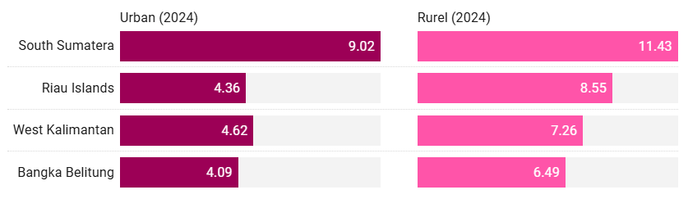
Figure 2.2.9 Percentage of Poor Population in the Study Locations
SE2-2 Human Development Index
The Average Years of Schooling increased across all provinces from 2022 to 2024, with the Riau Islands recording the highest levels, rising from 10.37 years to 10.50 years. Based on human capital theory (Becker, 1993; Psacharopoulos & Patrinos, 2018), higher schooling years in coastal regions indicate improved access to education and contribute to greater labor productivity. However, disparities remain. West Kalimantan reached only 7.78 years in 2024, suggesting geographic constraints or limited educational facilities in remote coastal areas (Suharto et al., 2022). These gaps have implications for the adaptive capacity of coastal communities, especially as global and maritime-related economic changes increasingly require higher skills.
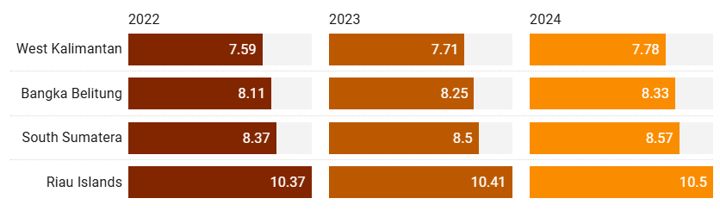
Figure 2.2.10. Average Years of Schooling in the Study Area
In terms of Adjusted Real Expenditure per Capita, the Riau Islands recorded the highest value in 2024 at IDR 15,573 thousand, reflecting its position as a major trade and logistics hub. According to spatial inequality theory (Kanbur & Venables, 2005), regions with access to international ports generally have higher purchasing power due to stronger integration with global markets. In contrast, West Kalimantan had the lowest expenditure at IDR 10,321 thousand, largely because its economy depends more on low–value primary sectors. In coastal areas, these differences in purchasing power influence community capacity to invest in education, health services, and modern fishing or aquaculture technologies.
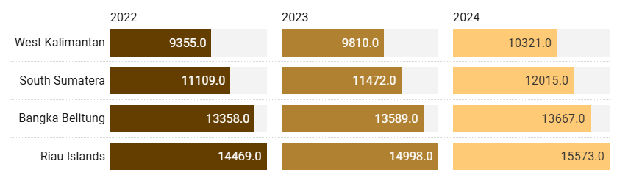
Figure 2.2.11. Adjusted Real Expenditure per Capita per Year in the Study Area

The Human Development Index (HDI) shows a similar pattern to the previous indicators (Figure 2.2.12). The Riau Islands recorded the highest HDI in 2024 at 79.89, while West Kalimantan had the lowest at 71.19. Gupta and Vegelin (2016) emphasize that human development in coastal areas must integrate economic, social, and environmental dimensions to reduce vulnerabilities from climate change and marine ecosystem degradation. The high HDI in the Riau Islands is likely supported by better education, higher expenditure, and stronger infrastructure. Meanwhile, provinces with lower HDI face the risk of a persistent structural poverty cycle unless supported by comprehensive policy reforms.

Figure 2.2.12 Human Development Index in the Study Locations

2.2.3. Economic Activities

SE3-1 Subnational Gross Domestic Product (GDP)

Gross regional Domestic Product at current market - The three graphs display the Gross Regional Domestic Product (GRDP) of South Sumatra, the Riau Islands, Bangka Belitung, and West Kalimantan from 2021 to 2023, shown in both Indonesian Rupiah (IDR) and U.S. Dollars (USD). GRDP increased steadily in all provinces over this period, indicating consistent nominal economic growth driven by post-pandemic recovery, inflation, and sectoral expansion. South Sumatra recorded the highest GRDP, rising from IDR 49.36 trillion (USD 34,491.2) in 2021 to IDR 62.91 trillion (USD 41,292.8) in 2023, reflecting its diversified economy in mining, manufacturing, and services. The Riau Islands remained the second-largest economy, increasing from IDR 27.56 trillion (USD 19,267.2) to IDR 33.19 trillion (USD 21,780.2), supported by maritime trade, free-trade zones, and shipyard industries. West Kalimantan’s GRDP grew from IDR 23.13 trillion (USD 16,158.6) in 2021 to IDR 27.44 trillion (USD 18,014.0) in 2023, driven mainly by agriculture, forestry, and mining. Bangka Belitung recorded the smallest GRDP, rising from IDR 8.59 trillion (USD 6,006.6) to IDR 10.26 trillion (USD 6,735.3), consistent with its reliance on tin mining and small-scale tourism, which limits rapid growth. Exchange rates—IDR 14,307.8 (2021), 14,845.7 (2022), and 15,237.0 (2023)—influenced the USD conversion but did not change the overall upward trend. GRDP values in USD still increased despite IDR depreciation. The GRDP at current market prices is presented in Figure 2.2.13.

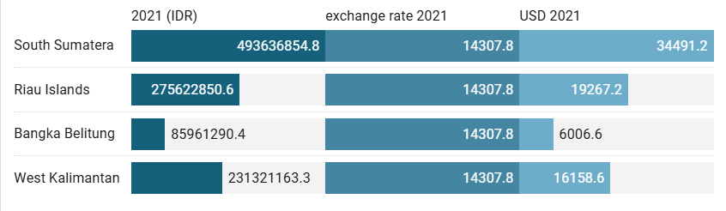
Figure 2.2.13a presents the Gross Regional Domestic Product (GRDP) at current market prices for the study locations in 2021.
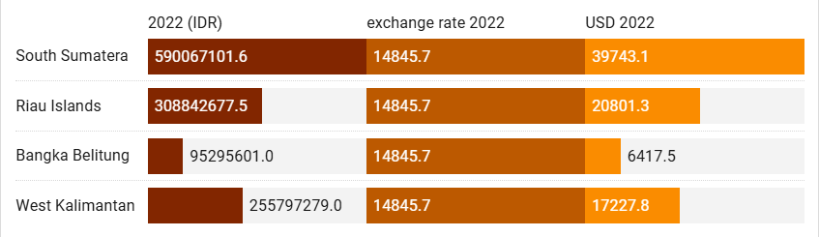
Figure 2.2.13b shows the Gross Regional Domestic Product (GRDP) at current market prices for the study locations in 2022.
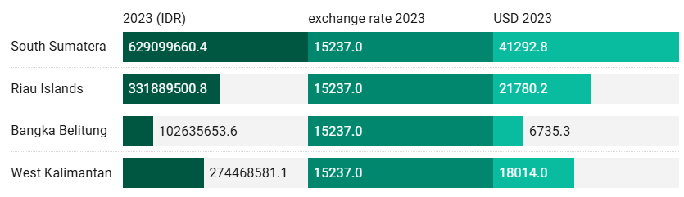
Figure 2.2.13c presents the Gross Regional Domestic Product (GRDP) at current market prices for the study locations in 2023.

SE3-2 Sustainable fisheries contribution to GDP

Figure 2.2.14 shows the fishery value (USD) of four coastal provinces in 2021, revealing clear economic disparities shaped by resource availability, infrastructure, and market access. The Riau Islands lead with USD 571.36 million, driven by strategic maritime location, strong export access, and diverse high-value species. Bangka Belitung follows at USD 507.37 million, supported by rich marine resources and established fishing communities, though its export capacity remains developing. West Kalimantan recorded USD 438.62 million, reflecting substantial potential but constrained by traditional fishing practices and limited cold-chain and processing facilities. South Sumatra registered the lowest value (USD 338.03 million), as fisheries play a smaller economic role amid dominant agriculture, plantations, and mining, alongside a shorter coastline. Overall, the figures highlight uneven fishery development across provinces, influenced by geography, infrastructure, technology, and integration into global value chains—informing the need for targeted policy interventions to boost efficiency, market access, and sustainable resource management in lagging areas.
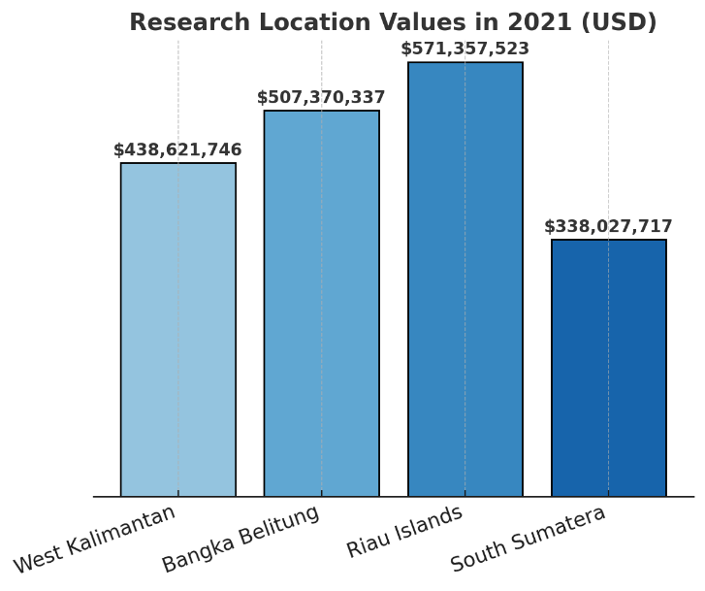
Figure 2.2.14 – Fishery Value (Rp million) in the Research Locations in 2021 (Average exchange rate 2021: 1 USD ≈ Rp 14,308)
Provinces with coastal-oriented economies and strong international trade linkages—such as the Riau Islands—tend to have a larger share of their labor force employed in services and manufacturing. In contrast, provinces with vast land areas and abundant natural resources, including West Kalimantan and South Sumatra, are more likely to exhibit labor dominance in agriculture, forestry, and fisheries. Bangka Belitung shows a distinct pattern shaped by its tin mining industry and growing marine tourism, resulting in a mixed distribution between primary and tertiary sectors. Understanding these employment structures is important not only for interpreting regional economic characteristics but also for informing labor policies, sectoral development priorities, and strategies to enhance productivity across provinces.
Table 1. Distribution of Employed Persons Aged 15 Years and Over by Province and Major Industry, 2024
Sectors | West Kalimantan | Bangka Belitung | Riau Islands | South Sumatera
Agriculture, Forestry, and Fishing | 1.318.123 | 299.496 | 74.225 | 2.209.165
Mining and Quarrying | 77.48 | 42.392 | 11.82 | 99.611
Manufacturing | 145.012 | 62.567 | 28.825 | 452.299
Electricity, Gas, Steam, and Air Conditioning Supply | 5.874 | 2.897 | 425 | 24.625
Water Supply; Sewerage, Waste Management, and Remediation Activities | 4.817 | 2.105 | 186 | 21.23
Construction | 176.08 | 25.594 | 6.202 | 216.895
Wholesale and Retail Trade; Repair of Motor Vehicles and Motorcycles | 408.815 | 135.4 | 174.014 | 755.936
Transportation and Storage | 80.823 | 13.35 | 67.739 | 174.791
Accommodation and Food Service Activities | 180.56 | 52.649 | 113.512 | 227.472
Information and Communication | 12.507 | 1.318 | 7.335 | 9.299
Financial and Insurance Activities | 31.556 | 7.866 | 13.78 | 28.471
Real Estate | 4.153 | 1.935 | 6.968 | 8.054
Professional Activities and Administrative & Support Activities | 19.212 | 9.66 | 60.432 | 155.402
Public Administration and Defence; Compulsory Social Security | 115.842 | 47.458 | 69.453 | 212.522
Education | 198.122 | 75.664 | 20.212 | 96.172
Human Health and Social Work Activities | 48.176 | 12.362 | 18.126 | 26.955
Other Services Activities | 105.457 | 32.65 | 55.232 | 148.65

The economic sector distribution in Indonesia’s coastal regions varies across provinces. West Kalimantan and South Sumatra are dominated by agriculture, forestry, and fisheries, indicating strong dependence on primary natural resources. Bangka Belitung relies heavily on tin mining, while the Riau Islands specialize in maritime transport and logistics due to their strategic location along international trade routes. This pattern reflects the resource-based economy perspective, where natural resource availability shapes regional economic and employment structures (Barbier, 2015). However, heavy reliance on primary or extractive industries increases vulnerability to commodity price fluctuations, environmental degradation, and climate change impacts (Béné et al., 2016). The next section outlines the average monthly net wages across provinces in 2024 by major occupation, highlighting regional and sectoral differences (see Table 2).
Table 2. Average of Net Wage/Salary per Month of Employee by Province and Main Occupation (rupiahs), 2024
Sectors | West Kalimantan | Bangka Belitung | Riau Islands | South Sumatera
Agriculture, Forestry, and Fishing | 1.957.214 | 3.147.608 | 3.272.496 | 2.356.642
Mining and Quarrying | 3.439.580 | 4.708.699 | 5.935.531 | 2.893.483
Manufacturing | 2.493.007 | 3.573.360 | 5.477.068 | 2.605.767
Electricity, Gas, Steam, and Air Conditioning Supply | 4.206.048 | 4.830.250 | 6.430.327 | 4.017.421
Water Supply; Sewerage, Waste Management, and Remediation Activities | 2.796.133 | 3.613.183 | 3.644.784 | 2.603.442
Construction | 2.588.497 | 3.769.569 | 3.769.285 | 2.426.630
Wholesale and Retail Trade; Repair of Motor Vehicles and Motorcycles | 2.334.744 | 3.291.000 | 3.531.046 | 2.329.841
Transportation and Storage | 3.352.640 | 4.369.605 | 5.795.661 | 2.517.105
Accommodation and Food Service Activities | 1.983.770 | 2.226.187 | 3.296.030 | 1.759.692
Information and Communication | 3.774.222 | 3.809.097 | 5.521.474 | 2.672.693
Financial and Insurance Activities | 4.264.882 | 4.861.632 | 5.760.058 | 3.487.176
Real Estate | 2.624.935 | 4.220.193 | 4.712.266 | NA
Professional Activities and Administrative & Support Activities | 2.739.407 | 4.183.699 | 4.668.533 | 2.712.496
Public Administration and Defence; Compulsory Social Security | 3.289.044 | 4.446.600 | 5.444.600 | 3.844.026
Education | 2.464.207 | 3.520.012 | 4.059.276 | 2.796.289
Human Health and Social Work Activities | 2.992.518 | 4.492.495 | 4.946.053 | 2.879.469
Other Services Activities | 1.565.814 | 2.319.012 | 3.033.272 | 1.459.027

The average net monthly wages across major sectors in West Kalimantan, Bangka Belitung, the Riau Islands, and South Sumatra in 2024 show clear differences between provinces and types of occupations. Mining and quarrying offer the highest wages—reaching IDR 5.93 million in the Riau Islands—reflecting the sector’s capital-intensive and skill-demanding nature (ILO 2022). Meanwhile, the lowest wages are found in service-related sectors, such as in South Sumatra at IDR 1.45 million, indicating lower productivity and value added (Pratomo & Rahmawati 2020). These wage gaps align with labor market segmentation theory, where workers in low-wage sectors like agriculture, forestry, and fisheries often face skill and mobility barriers that limit access to better-paying jobs (Fields 2019). Such disparities can heighten the economic vulnerability of coastal households. The next section presents the provincial minimum monthly wages in Indonesia (see Table 2), highlighting regional policy differences shaped by economic structure, cost of living, and labor market conditions.
The Provincial Minimum Wages (UMP) in the four coastal provinces increased at different rates between 2022 and 2024, reflecting variations in economic structure and local policy conditions. In 2024, Bangka Belitung recorded the highest UMP at IDR 3.64 million, followed by South Sumatra (IDR 3.46 million), the Riau Islands (IDR 3.40 million), and West Kalimantan with the lowest at IDR 2.77 million. Overall increases reached about +11.5% in Bangka Belitung, +9.9% in South Sumatra, and +13.6% in West Kalimantan, while the Riau Islands experienced a decline of –10.3%. Since 2023, UMP calculations use a new formula that incorporates inflation, economic growth, and productivity, making the results sensitive to regional economic differences (Kemnaker 2023). In coastal regions, living costs, logistics, sectoral composition, and labor demand also shape the fiscal and political capacity to set minimum wages (World Bank 2021) (see Table 3).
Table 3. Provincial Minimum Wages per month (Rupiahs)
Area | 2022 | 2023 | 2024
West Kalimantan | 2.434.328 | 2.608.601 | 2.765.234
Bangka Belitung | 3.264.884 | 3.498.479 | 3.640.000
Riau Islands | 3.501.172 | 3.791.194 | 3.402.492
South Sumatera | 3.144.446 | 3.404.177 | 3.456.874

The production volume and value of capture fisheries in 2023 vary widely across the four provinces. Bangka Belitung recorded the highest output, with 228,616 tons and a production value of IDR 9.15 trillion, dominated by marine fisheries. West Kalimantan ranked second with 197,488 tons and IDR 5.62 trillion. The Riau Islands produced a smaller volume (135,773 tons) but still generated IDR 4.05 trillion, indicating higher value-added per unit of catch. South Sumatra is distinct, as inland fisheries contribute significantly (74,649 tons; IDR 3.99 trillion). Although its marine catch is lower (87,456 tons), its total production value reached IDR 7.82 trillion, showing the importance of freshwater ecosystems. Overall, economic contributions depend not only on catch volume but also on ecosystem type, commodity prices, and supply-chain dynamics. Regions with high-value coastal resources can generate substantial income even with smaller catch volumes (Barney 1991; FAO 2022) (see Table 4).
Table 4. Production Volume and Production Value of Fish Capture by Province and Type of Captures, 2023
Area | Marine Capture Fisheries |  | Inland Water Capture Fisheries |  | Total
Area | Volume (ton) | Value (000 Rp) | Volume (ton) | Value (000 Rp) | Volume (ton) | Value (000 Rp)
West Kalimantan | 162.638 | 4.829.548.806 | 34.85 | 791.754.127 | 197.488 | 5.621.302.933
Bangka Belitung | 228.583 | 9.146.522.781 | 33 | 2.491.686 | 228.616 | 9.149.014.467
Riau Islands | 112.078 | 3.085.056.513 | 23.695 | 967.408.220 | 135.773 | 4.052.464.733
South Sumatera | 87.456 | 3.826.053.518 | 74.649 | 3.997.816.587 | 162.105 | 7.823.870.105

The production volume and value of aquaculture in 2023 also vary widely across the four provinces. South Sumatra recorded the highest output, producing 323,352 tons valued at IDR 8.80 trillion, supported by large cultivation areas and abundant freshwater resources. The Riau Islands ranked second with 124,734 tons and IDR 2.80 trillion, driven by high-value export commodities such as grouper, pomfret, and vannamei shrimp. West Kalimantan followed with 84,659 tons and IDR 2.73 trillion, reflecting strong potential for freshwater and brackish aquaculture. Bangka Belitung produced the least (10,914 tons; IDR 660.93 billion), mainly due to limited cultivation areas and the stronger role of capture fisheries. From a blue economy perspective, South Sumatra’s strong performance highlights effective use of inland waters for large-scale production, consistent with FAO (2022), which emphasizes the importance of freshwater access and supporting infrastructure. The Riau Islands’ focus on high-value, export-oriented species also aligns with findings by Hishamunda and Ridler (2014), showing that smaller volumes can still generate high economic value (see Table 5).

Table 5. Production Volume and Production Value of Aquaculture by Province and Type of Culture, 2023

Area | Total
Area | Volume (ton) | Value (000 Rp)
West Kalimantan | 84.659 | 2.726.651.810
Bangka Belitung | 10.914 | 660.927.122
Riau Islands | 124.734 | 2.799.409.704
South Sumatera | 323.352 | 8.801.794.872

2.3. Climate-related Threats
The South China Sea and Surrounding Areas (SCSSA) are a dynamic climate hub where ocean, land, and atmosphere interact intensely. High sea surface temperatures make the region highly sensitive to global climate change (Figure 2.2.15a). Convection variations over the SCSSA influence the El Niño–Southern Oscillation (ENSO) by modifying Pacific trade winds, while ENSO events, in turn, affect SCSSA convection. La Niña strengthens the Walker circulation, enhancing regional convection and triggering atmospheric teleconnections that impact climates in North Africa, South Asia, and East Asia (Li et al., 2020; He et al., 2017).
Warming over the Maritime Continent and Tibetan Plateau further shapes ENSO characteristics and global weather anomalies, influencing areas from Southern Europe to the North Atlantic. Air–sea interactions generate Rossby waves, linking tropical processes to both hemispheres (Yang et al., 2019; Basconcillo, 2021) (Figure 2.2.15b). The SCSSA also drives South and East Asian monsoons via Tibetan Plateau forcing, with modulation from the Madden–Julian Oscillation, cross-equatorial flows, Pacific Meridional Mode, and intraseasonal oscillations. Overall, the SCSSA acts as a major climate driver: small regional changes can propagate globally, affecting extreme weather, rainfall patterns, and climate stability from the tropics to the poles.
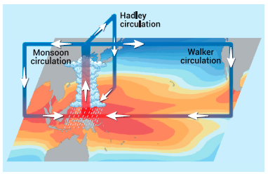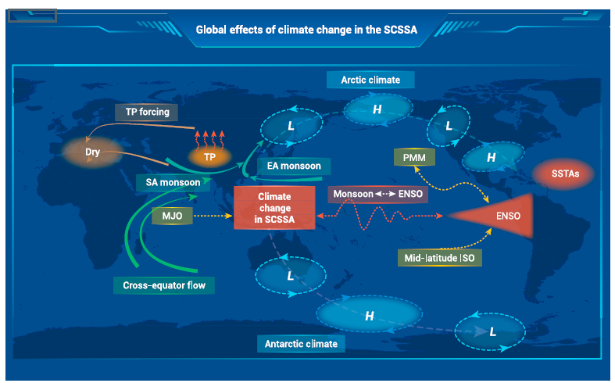
Figure 2.2.15 (a) Schematic diagram of sea surface temperature and atmospheric overturning circulations in the SCSSA (Yang et al. 2024) (b) Known global impacts of climate change in the SCSSA (Yang et al. 2024)
Climate change in the South China Sea and Surrounding Areas (SCSSA) drives ocean–atmosphere interactions that influence climate from the tropics to the poles. The region is closely tied to the South Asian and East Asian monsoons, which are affected by warming over the Tibetan Plateau. Atmospheric systems such as the Madden–Julian Oscillation (MJO) and cross-equatorial flow regulate air mass movement and shape monsoon intensity. The SCSSA also has a two-way relationship with ENSO, where Pacific sea surface temperature anomalies influence monsoons, while monsoon changes can feedback into the ENSO cycle. These processes, mediated by the Pacific Meridional Mode (PMM) and intraseasonal oscillations (ISO), link tropical dynamics with mid-latitude climate patterns. Their impacts extend globally, affecting high- and low-pressure systems and influencing climate conditions in the Arctic and Antarctic. Overall, the SCSSA acts as a major climate driver, with changes in this region capable of triggering atmospheric teleconnections that affect extreme weather and climate stability worldwide.
2.4. Discussion
2.4.1. Risk Assessment from Socio-Economic Trends
The socio-economic risk analysis was conducted by considering coastal population density, economic dependence on marine and fisheries sectors, and the vulnerability of economic infrastructure to external disruptions (Table 6).
Table 6. Risk Assessment of Socio-economic
Province | Coastal Region Area (km²) | % of National Area | Est. Coastal Population (2023) | GDP Dependency on Fisheries & Marine Sector (%) | Socio-Economic Risk Index*
West Kalimantan | 147,037.04 | 7.66% | 1.52 million | 28–32% | High (0.71)
South Sumatera | 86,771.68 | 4.52% | 0.98 million | 22–26% | Moderate (0.58)
Bangka Belitung | 16,690.13 | 0.87% | 0.35 million | 36–40% | High (0.74)
Riau Islands | 8,084.00 | 0.42% | 0.29 million | 30–34% | High (0.69)
*The Socio-Economic Risk Index is calculated based on a combination of the dependency ratio, coastal poverty rate, and vulnerability to economic shocks.
2.4.2. Climate and Environmental Threat Risk Profile
The assessment of climate and environmental risks in the coastal areas of the South China Sea highlights two key indicators: the rate of sea-level rise (SLR) and the frequency of extreme weather events. These indicators represent the most critical climate pressures affecting ecosystem stability, community livelihoods, and coastal infrastructure. Scientifically derived estimates for both indicators are presented in the following table.
Table 7. Climate-Environmental Threats
Province | Coastal Region Area (km²) | % of National Area | Sea-Level Rise Rate (mm/year) | Extreme Event Frequency (events/year) | Risk Level*
West Kalimantan | 147.037,04 | 7,66 | 4,8 | 6 | High
South Sumatera | 86.771,68 | 4,52 | 4,5 | 5 | Medium-High
Bangka Belitung | 16.690,13 | 0,87 | 4,2 | 4 | Medium
Riau Islands | 8.200,00 | 0,43 | 4,0 | 3 | Medium
*Note: The Risk Level is determined based on a combination of sea-level rise rate and the frequency of extreme events

2.4.3 Mitigating Socio-Economic Vulnerability in Climate-Affected Coastal Regions
Addressing socio-economic vulnerability in Indonesia’s coastal regions bordering the South China Sea requires an integrated approach that combines infrastructure development, community empowerment, and technological innovation. Key strategies include:
• Strengthening Adaptive Infrastructure:
Mangrove restoration, coastal land rehabilitation, and the construction of seawalls or natural buffers are essential to reduce erosion, storm surges, and seawater intrusion. These measures protect livelihoods and enhance ecosystem services that support long-term resilience.
• Economic Empowerment of Coastal Communities:
Livelihood diversification—through aquaculture training, ecotourism development, and value-added marine product processing—reduces dependence on capture fisheries and strengthens households’ ability to withstand environmental shocks.
• Early Warning Systems (EWS):
Deploying buoys, weather radars, and real-time monitoring systems enables early detection of storms and high waves, allowing communities to take preventive action and improve adaptive capacity.
Together, these strategies help coastal regions build resilience against climate-driven risks while supporting sustainable livelihoods and ecosystem health. However, several key gaps still hinder the long-term effectiveness of adaptation efforts. Addressing these gaps is crucial to strengthening socio-economic and ecological resilience (Table 8).
Table 8. Critical Gaps Limiting Coastal Adaptation Effectiveness
Gap / Challenge | Description | Implications for Adaptation
Limited Integration of Climate Data into Regional Planning | Key climate indicators (sea-level rise, extreme waves, storm projections) are not fully incorporated into spatial and coastal zone planning. | Reduces the effectiveness of adaptation strategies and evidence-based decision-making.
Sustainable Financing Constraints | Many adaptation projects rely on short-term donor funding without long-term financial sustainability. | Limits continuity, scalability, and long-term impact of adaptation programs.
Suboptimal Community Participation | Some coastal communities perceive climate change as distant or abstract. | Low engagement reduces effectiveness of local mitigation and adaptation measures.
Insufficient Inter-Regional Cooperation | Coordination across provincial or administrative boundaries is limited. | Hinders large-scale adaptation efforts, knowledge sharing, and transboundary climate response.

2.5. Recommended Priority Actions
Strengthening socio-economic and ecological resilience in climate-impacted coastal regions requires practical, evidence-based actions coordinated across provinces. Five priority measures are proposed:
- Climate-Informed Coastal Planning
Integrate sea-level rise and extreme weather data into development and spatial plans to reduce exposure and risk.
- Sustainable Financing
Secure long-term funding through public–private partnerships, climate finance, and investments in ecosystem-based adaptation.
- Community-Centered Engagement
Enhance awareness, capacity, and participation of coastal communities by incorporating traditional knowledge and inclusive decision-making.
- Cross-Provincial Cooperation
Establish formal collaboration among South China Sea coastal provinces for data sharing, joint adaptation efforts, and coordinated disaster responses.
- Monitoring, Evaluation, and Learning (MEL)
Build strong systems to track adaptation progress, inform policy adjustments, and capture best practices for broader replication.
Together, these actions strengthen coastal regions’ ability to anticipate, withstand, and recover from climate-related socio-economic shocks while ensuring long-term livelihoods and ecological sustainability.

Table 9. Strategic Coastal Adaptation Actions with Regional Cooperation Potential
Priority Action | Description | Potential for Regional Cooperation
1. Integration of Climate Data into Regional Planning | Incorporate projections of sea-level rise (SLR), storms, and high waves into regional spatial plans (RTRW) and local development plans (RPJMD) to ensure climate-informed decision-making. | Establish a shared cross-provincial climate data repository for the South China Sea rim to support coordinated planning.
2. Landscape-Scale Mangrove Restoration Program | Rehabilitate mangroves in areas prone to coastal erosion and seawater intrusion, enhancing coastal protection and ecosystem services. | Facilitate technical collaboration and sharing of seedlings across provinces, and exchange best practices for large-scale restoration.
3. Coastal Economic Diversification | Develop integrated fisheries enterprises, ecotourism, and agro-marine businesses to reduce community dependence on single livelihoods. | Create joint markets and collective branding for South China Sea coastal products across provinces, promoting regional economic integration.
4. Enhancement of Early Warning Systems | Modernize technology for detecting extreme weather events and high waves, improving disaster preparedness. | Deploy shared sensor networks and enable real-time data exchange among provinces to enhance regional early warning capabilities.
5. Sustainable Adaptation Financing Schemes | Implement revolving funds and micro-financing mechanisms to support community-based adaptation initiatives. | Establish a cross-provincial “Coastal Climate Fund” to ensure long-term financing and sustainability of adaptation projects.

A collaborative approach that integrates scientific evidence with active community participation is essential for reducing vulnerability in this region. Because the four provinces—West Kalimantan, South Sumatra, Bangka Belitung, and the Riau Islands—face similar climate threats and share interconnected coastal ecosystems, strong regional coordination is required. Embedding adaptation programs within a cross-provincial cooperation framework will not only reinforce the resilience of coastal communities but also strengthen Indonesia’s strategic position in international forums concerning the South China Sea.

References
Adrianto L, Matsuda Y, Sakurai Y. 2019. Marine policy and coastal governance in Indonesia. Marine Policy. 109:103671. https://doi.org/10.1016/j.marpol.2019.103671
Baiquni M, Widianingsih NN, Nurlaili. 2021. Pengelolaan wilayah pesisir terpadu: Tantangan dan strategi pembangunan berkelanjutan di Indonesia. Jurnal Pembangunan Wilayah & Kota, 17(3):201–214. https://doi.org/10.14710/pwk.v17i3.31516
Basconcillo B, Moon IJ, Wang B, Mistry M. 2021. Possible influence of the warm pool ITCZ on compound climate extremes during the boreal summer. Environ Res Lett.;16(11):Article 114039
Béné C. 2016. Contribution of Fisheries and Aquaculture to Food Security and Poverty Reduction: Assessing the Current Evidence. World Development. 79:177–196.
BPS. 2021. Statistik Indonesia 2021. Jakarta: BPS. Retrieved from https://www.bps.go.id
Cinner JE, Barnes ML. 2019. Social dimensions of resilience in social-ecological systems. One Earth. 1(1):51–56. https://doi.org/10.1016/j.oneear.2019.08.003
Cisneros MAH, Sarmiento NVR, Delrieux CA, Piccolo MC, Perillo GM, 2016. Beach carrying capacity assessment through image processing tools for coastal management. Ocean & Coastal Management. 130: 138-147.
Diemer A, Iammarino S, Rodríguez-Pose PA, Storper M. 2022. The Regional Development Trap in Europe. Economic Geography.8(5):487–509.
FAO. 2020. Gender and Fisheries: Do women count?. Rome: Food and Agriculture Organization of the United Nations.
FAO. 2022. The State of World Fisheries and Aquaculture 2022. Rome: FAO
Fields GS. 2019. Employment and Development: How Work Can Lead to Better Living Standards. Oxford: Oxford University Press.
Folke, C, Biggs R, Norström AV, Reyers B, Rockström J. 2016. Social-ecological resilience and biosphere-based sustainability science. Ecology and Society. 21(3):41. https://doi.org/10.5751/ES-08748-210341
Gupta J, Vegelin C. 2016. Sustainable development goals and inclusive development. International Environmental Agreements: Politics, Law and Economics, 16:433–448. https://doi.org/10.1007/s10784-016-9323-z
Hishamunda N, Ridler N. 2014. Policy frameworks for sustainable aquaculture development. Fisheries and Aquaculture Technical Paper. Rome: FAO.
Ibrahim I, Sulista S, Pratama S. 2022. Struggling for power over the Bangka coast: Tin amongst the vortex of companies, the state, and residents. Society. https://doi.org/10.1016/j.exis.2022.101055.
ILO. 2022. Global Wage Report 2022–2023: The Impact of Inflation and COVID-19 on Wages and Purchasing Power. Geneva: International Labour Organization.
Kanbur R, Venables AJ. 2005. Spatial inequality and development. Oxford University Press.
Neumann B, Vafeidis AT, Zimmermann J. Nicholls RJ. 2015. Future coastal population growth and exposure to sea-level rise and coastal flooding—a global assessment. PLOS ONE:10(3), e0118571. https://doi.org/10.1371/journal.pone.0118571
Nurhidayah L, McIlgorm A, Amaral P. 2023. Implementation of the blue economy in coastal regions: Lessons for Indonesia. Ocean & Coastal Management.234:106453.
Psacharopoulos G, Patrinos HA. 2018. Returns to investment in education: A decennial review of the global literature. Education Economics, 26(5):445–458. https://doi.org/10.1080/09645292.2018.1484426
Rahman MM, Hassan M, Islam MA. 2020. Coastal vulnerability, migration, and adaptation: A case study from Bangladesh. Sustainability. 12(12): 5086. https://doi.org/10.3390/su12125086
Setiawan A, Wicaksono R, Kusumastanto T. 2021. Spatial inequality in Indonesian coastal development: Challenges and opportunities. Indonesian Journal of Geography, 53(2):210–223. https://doi.org/10.22146/ijg.65432
Silvius MJ, Noor YR, Lubis IR, Giesen W, Rais D. 2018. Sembilang National Park: Mangrove Reserves of Indonesia. Springer. 10.1007/978-94-007-4001-3_213.
Smith N. 2016. Urbanization in the coastal zone: Impacts and implications. Ocean & Coastal Management. 125:1–8. https://doi.org/10.1016/j.ocecoaman.2016.02.003
Suharto R, Pribadi A, Kusuma H. 2022. Pendidikan dan pembangunan wilayah pesisir: Tantangan pemerataan akses di Indonesia Timur. Jurnal Pembangunan Daerah. 10(2):115–128. https://doi.org/10.56083/jpd.v10i2.534
Todaro MP, Smit SC. 2020. Economic Development (13th ed.). Harlow: Pearson Education Limited. https://www.indonesia-tourism.com/index.php.
United Nations. 2019. World Population Prospects 2019. New York: United Nations Department of Economic and Social Affairs, Population Division.
Weeks JR. 2015. Population: An Introduction to Concepts and Issues (12th ed.):Cengage Learning.
World Bank. 2021. Blue Economy Development Framework. Washington, DC: World Bank Group.
World Bank. 2021. Indonesia Economic Prospects: Boosting the Recovery. Washington, DC: World Bank Group.
Yang Y, Zhu Z, Li T, Yao M. 2019. Effects of western Pacificintraseasonal convection on surface air temperature anomalies over North America. Int J Climatol.40(6):2913–2923.
Yang S, Chen D, Deng K. 2024. Global Effects of Climate Change in the South China Sea and Its Surrounding Areas. Ocean-Land- Atmos.https://doi.org/10.34133/olar.0038

