Coastal Frontiers: Indonesia’s Coastal Ecosystem Insights in South China Sea and Gulf Thailand

Yonvitner, Boimin, M Hafizd, Sayid Muhadhar, Aditya Yuniarti, Heru Waluyo, Isdahartati, Ferry Kurniawan, Tri Edy Kuriandewa, Nyoto Santoso, Ragil Satrio, Lucita Meilana.

Abstract
During the period 2008–2021, the condition of mangrove, coral, seagrass, and wetland ecosystems in the Indonesian portion of the South China Sea experienced improvements in both ecological quality and governance. These improvements can be seen in the strengthening of policies as well as actions taken to restore and build the resilience of these ecosystems. During this period, there were 3 laws, 1 government regulation, and 3 ministerial regulations issued to govern ecosystems in the South China Sea region, including those related to rehabilitation activities.
Mangrove restoration efforts Riau Archipelago were carried out as part of rehabilitation and ecological recovery initiatives. A total of 16,319 hectares was set as the mangrove restoration target for the Bangka Belitung Islands; of this, 3,069 hectares were located within conservation areas, and 13,250 hectares outside conservation areas. West Kalimantan is among the priority provinces for mangrove restoration under BRGM. Nationally, from 2016 to 2024, BRGM rehabilitated around 84,396 hectares of mangroves across priority provinces.
Artificial reef rehabilitation activities in the Bangka Belitung Islands included the installation of around 7,680 units from 2016–2024, including 240 reef modules installed in Rambak in 2022. During 2022–2024, average seagrass cover in South Bangka—used here as an example—was only 26.8%, classified as “poor.” In Kayong Utara District, seagrass beds at one surveyed location also showed low density and cover, at 27.77%. These ecosystem conditions indicate ongoing efforts to restore mangrove, seagrass, coral, and wetland ecosystems, along with improvements in related policies. Furthermore, strengthening national and regional cooperation is needed to accelerate ecosystem recovery in the future.
Keyword: Ecosystem degradation, Resilience, TDA, SAP, Future Action

Introduction
The Indonesian chapter of the South China Sea hosts a rich mosaic of coastal and marine ecosystems that play a vital role in supporting biodiversity, fisheries productivity, and the livelihoods of coastal communities. Among the most important of these ecosystems are mangrove forests, coral reefs, seagrass beds, and wetlands, each providing essential ecological functions and contributing to the overall resilience of the region’s marine environment.
Mangrove ecosystems along the Indonesian coastline form critical buffers between land and sea, protecting shorelines from erosion, storm surges, and sedimentation. They serve as nurseries for numerous commercially and ecologically important fish and invertebrate species while also acting as significant carbon sinks, contributing to climate change mitigation.
Coral reefs within the Indonesian waters of the South China Sea are part of the globally significant Coral Triangle region, known for its unparalleled marine species richness. These reefs support complex ecological interactions, sustain artisanal and commercial fisheries, and attract tourism activities that contribute to local economies. However, they remain vulnerable to overfishing, habitat degradation, and climate-induced stressors such as coral bleaching.
Seagrass meadows, often found adjacent to coral reef and mangrove systems, function as productive feeding grounds for species such as sea turtles, dugongs, and various fish communities. Their ability to stabilize sediments, enhance water clarity, and sequester carbon makes them essential components of coastal ecosystem health.
Wetlands across the coastal landscapes of the South China Sea region further enrich ecological diversity by providing habitat for migratory birds, supporting nutrient cycling, and regulating hydrological processes. They play a key role in maintaining water quality and sustaining ecological connectivity between terrestrial and marine environments.
Together, these interconnected ecosystems form the ecological backbone of the Indonesian South China Sea, supporting biodiversity, enhancing climate resilience, and underpinning the socio-economic well-being of surrounding communities. Understanding their status, ecological roles, and the pressures they face is critical for advancing sustainable management and conservation efforts in this strategically and ecologically important marine region. Coastal and marine ecosystems in the Indonesian chapter of the South China Sea highlights the ecological richness and vulnerability of mangroves, coral reefs, seagrass beds, and coastal wetlands.
Studies on mangrove ecosystems in the region emphasize their critical role in shoreline protection, fisheries productivity, and carbon sequestration, while also documenting pressures from land-use change and coastal development (e.g., regional mangrove assessments and restoration reviews by Gerona-Daga et al., 2022). Coral reef research, including assessments through the International and National Society for Reef Studies, reveals that reefs in the South China Sea are part of the highly diverse Coral Triangle and remain threatened by overfishing, sedimentation, and climate-driven bleaching events. Additional analyses (such as Heery et al., 2019) show how reefs near urbanized or heavily used waters—conditions relevant to Indonesian waters near Natuna—face degradation but also exhibit varying degrees of resilience.
Seagrass ecosystems have been widely documented across Southeast Asia, with Fortes et al. (2018) providing one of the most comprehensive regional reviews. Their work highlights Indonesia as a major seagrass hotspot, supporting critical species such as dugongs and sea turtles, while facing pressures from trawling, coastal reclamation, and declining water quality. Meanwhile, research on coastal wetlands, including Indonesian-focused studies such as Hapsari (2019) and reports from Wetlands International, illustrates their importance for hydrological regulation, nutrient cycling, and migratory bird habitats. These wetlands are increasingly affected by land conversion, aquaculture expansion, and altered sediment dynamics. This paper aims to examine the status of mangrove, seagrass, and coral reef ecosystems, as well as coastal wetlands, in the South China Sea region as part evaluation on transboundary achievement of Indonesia nation on South China Sea Large Marine Ecosystem (SCS-LME).

2. Key Ecosystem Concern

The key findings of the TDA–SAP study on mangrove, seagrass, coral reef, and wetland ecosystems indicate that information on the extent and condition of these habitats has become increasingly well documented from 2008 to 2024 in the Natuna Sea region, although the data has not yet been fully consolidated. Overall, ecosystem status remains relatively similar, but several areas show a decline in extent and coverage due to various coastal pressures. Global commitments have also encouraged efforts to strengthen local rehabilitation and restoration initiatives. Programs aimed at improving coral reef conditions include the establishment of conservation areas and ongoing monitoring; for example, the Anambas National Marine Park contains an estimated 6,740.66 ha of coral reef habitat, with live coral cover exceeding 36% in its core zone. Despite this, fish biomass has declined sharply—from 355 kg/ha in 2018 to 176.16 kg/ha in 2024, representing a reduction of approximately 50.3% over six years. From 2021 to 2024, mangrove rehabilitation activities covered 574 ha, including 61 ha restored in 2024, while in West Kalimantan national programs achieved 6,010 ha of rehabilitation. Seagrass protection measures generally focus on establishing conservation areas, monitoring, preventing destructive activities, and supporting other preservation efforts. Overall, the Natuna Sea and South China Sea are considered sensitive and vulnerable, subject to pressures from fishing, pollution, and a wide range of human activities, placing many ecosystem functions at ongoing risk. Major issues identified include both local and transboundary threats, such as oil spills, plastic pollution, habitat damage caused by foreign and illegal activities, and other destructive events.

3. Current Ecosystem Status

3.2.1 Coral Reef and Seagrass
The essential ecosystems in the South China Sea and Gulf of Thailand (Indonesia sites) are mangroves, seagrass, coral reefs, and wetlands. The data show notable changes in ecosystem coverage across several Indonesian regions bordering the South China Sea between 2008 and 2024. The Indonesia region of mangrove, coral, seagrass and wetland distribution as below and Tabel 1 in Apendix.
Figure 1. Mangrove, Coral, Seagrass and Wetland Distribution

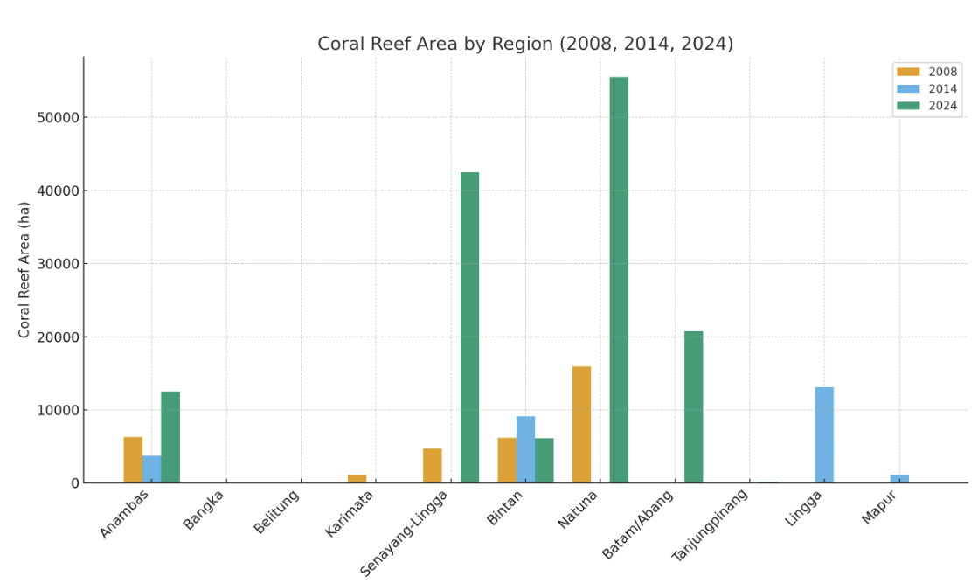
Figure 2. Regional Variability in Coral Habitat Extent Within Indonesian Marine Protected Areas

The bar chart illustrates substantial variability in coral reef area changes across Indonesian coastal regions between 2008, 2014, and 2024. Significant increases are evident in Anambas, Senayang-Lingga, Natuna, and Batam/Abang, with Natuna showing the most dramatic rise from 15,905 ha in 2008 to 55,527 ha in 2024. In contrast, regions such as Karimata, Bangka, and Belitung recorded no coral reef data in 2014 and 2024, suggesting possible degradation or gaps in monitoring. Bintan exhibits notable fluctuations, while Lingga and Mapur only appear in the 2014 dataset. Tanjungpinang reports a small coverage in 2024. Overall, the graphic highlights uneven progress among sites, where some regions show strong recovery or improved assessments, while others reflect data limitations or ecosystem decline, underscoring the need for consistent monitoring and strengthened coastal ecosystem management.
Seagrass species composition varies across locations, reflecting ecosystem complexity. The highest species diversity is found in the Riau Islands, with species including Halodule uninervis, Halophila ovalis, Thalassia hemprichii, Cymodocea rotundata, Enhalus acoroides, and Syringodium isoetifolium. The data show varying trends in ecosystem extent across several Indonesian regions between 2008 and 2024, all of which fall under either National or Regional Marine Protected Areas.
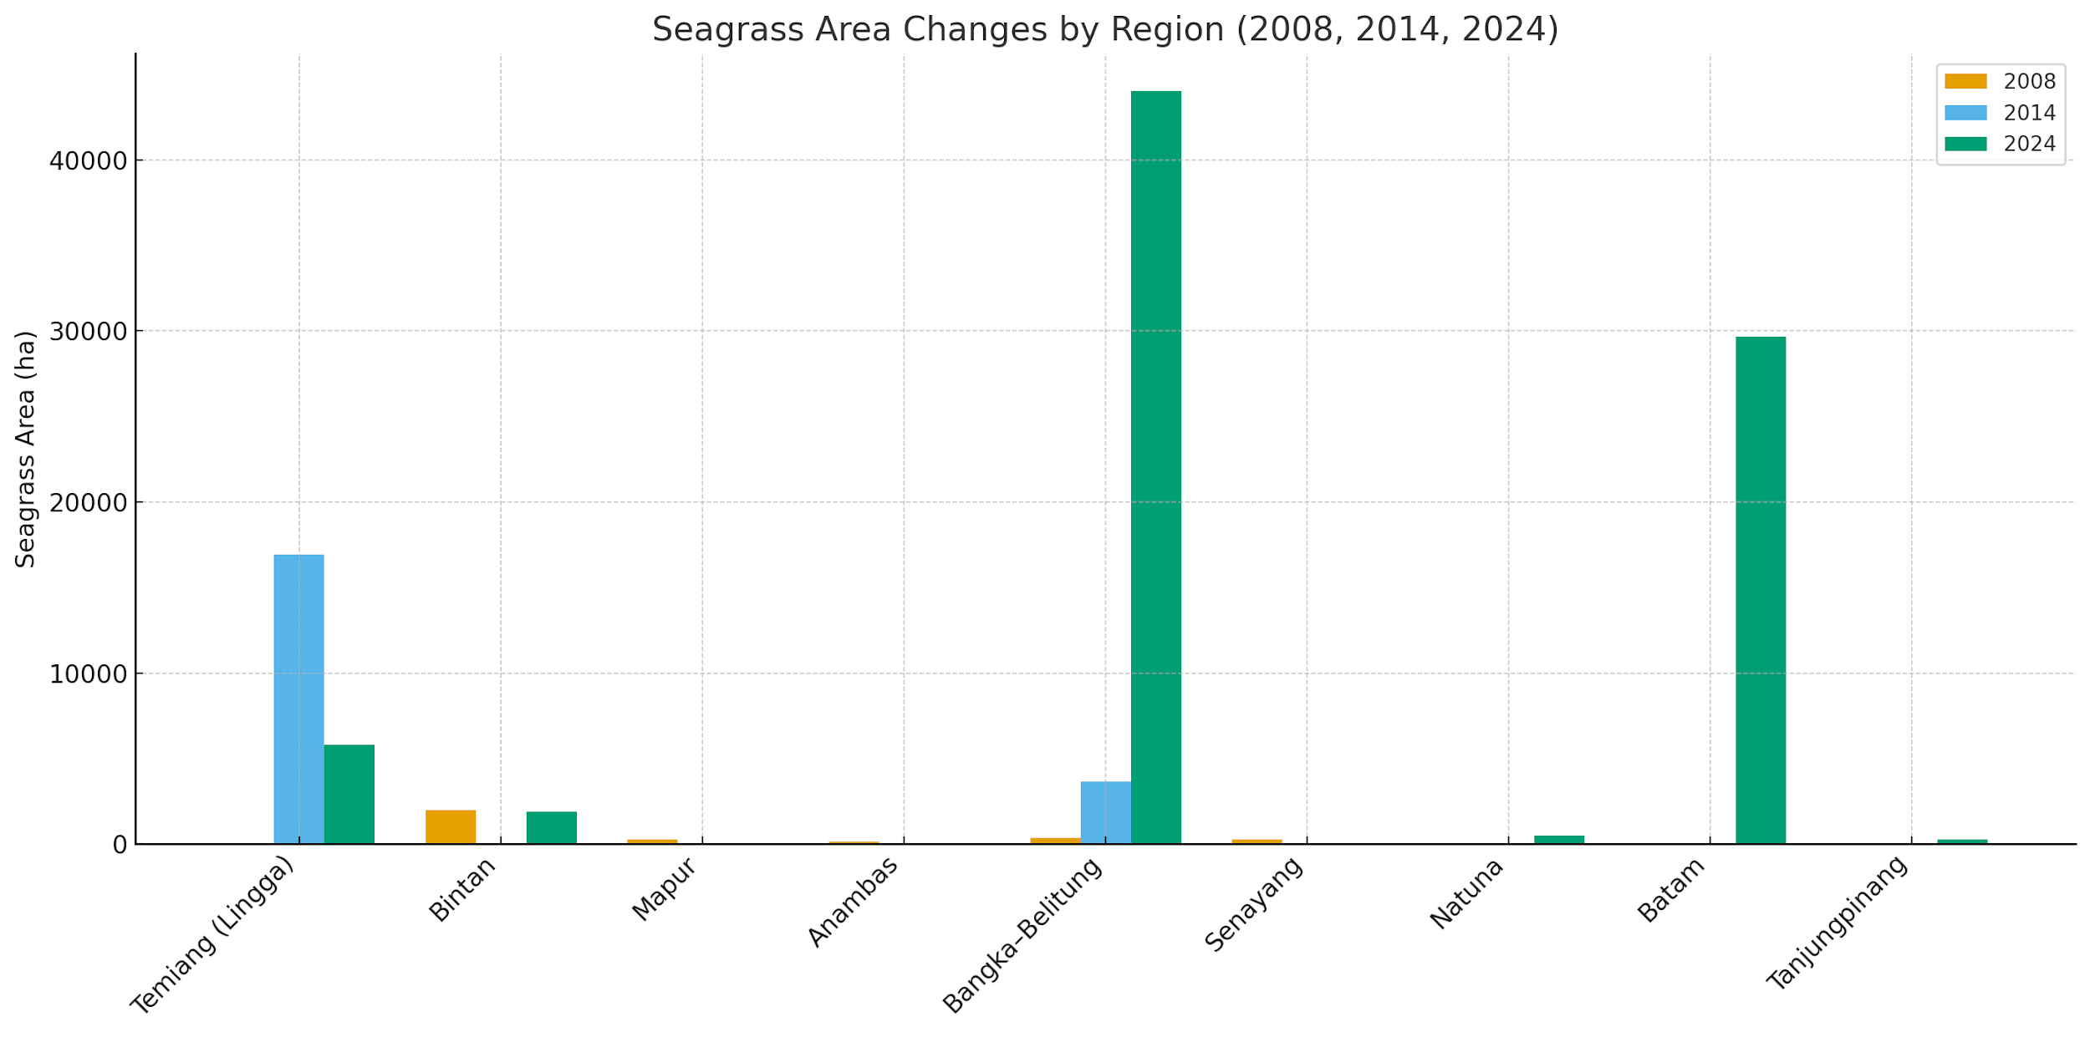
Figure 2. Regional Variability in Seagrass Habitat Extent Within Indonesian Marine Protected Areas
The data reveal substantial variability in seagrass ecosystem extent across regions from 2008 to 2024. Temiang (Lingga) shows the most dramatic fluctuations, rising from only 5 ha in 2008 to 16,942 ha in 2014 before declining to 5,816 ha in 2024. Bangka–Belitung also demonstrates major growth, expanding from 350 ha to 3,641 ha and then to 44,050 ha in 2024. Several areas—such as Bintan, Natuna, Batam, and Tanjungpinang—display significant increases only in 2024, indicating recent improvements in monitoring or conservation efforts. In contrast, Mapur, Senayang, and Anambas experienced declines or loss of recorded seagrass extent over time. Overall, the patterns suggest diverse regional trajectories influenced by ecological conditions, management effectiveness, and varying levels of data availability.

3.2.2 Mangrove dan Wetland
Between 2003 and 2025, Indonesia has experienced both mangrove loss and efforts towards restoration (Jong 2022; Ismi, 2024; World Bank, 2021). In 2020, the government set an ambitious target to rehabilitate 600,000 hectares of mangroves by 2024, concentrated in nine provinces (Ismi, 2024). While progress has been made, the initial target was not fully met, with only 130,000 hectares restored by February 2024. Despite this, the restoration efforts are crucial for mitigating climate change and protecting coastal communities (Ismi, 2024). The total of mangrove coverage in Indonesia from 2003-2025 can be seen on Tabel 2 and 3 in Appendix.
The mangrove coverage in West Kalimantan (Kubu Raya) shows a significant decrease. The mangrove coverage in 1993 was 1,011,37 km² and in 2023 was 964.37 km². The average loss of mangrove forest cover was 3.25 km² per year, including mangroves, open areas, ponds, water bodies, agricultural areas, and settlements (Wiarta et al., 2025). Mangrove in Riau Island based on Saputra et al (2021), there was degradation of 34.19% mangrove area, or about 46.61 ha, from 2007 to 2018. Koesdariyanto et al (2024) reported that the mangrove cover analysis on the east coast of South Sumatra found that the area of mangroves in 2003, 2013, and 2023 reached 115,072, 118,674, and 97,332 ha. The mangrove area increased by 3,601.47 ha (+3.13%) in 2003-2013 and decreased by 21,342 ha (-17.98%) in 2013-2023.

Wetlands in eastern Sumatra and West Kalimantan (2008-now) have undergone significant ecological change driven by land conversion, drainage, and recurring fires. Between 2008 and 2014, rapid expansion of plantations—especially on peat—accelerated degradation across both regions, culminating in the catastrophic 2015 fires that burned more than two million hectares nationally and severely damaged peat swamp ecosystems in Sumatra and Kalimantan. In response, Indonesia established the Peatland Restoration Agency (BRG) in 2016, targeting the rehabilitation of 2.6 million hectares of degraded peatlands. From 2016 to 2023, restoration activities in West Kalimantan alone reached over 200,000 hectares through canal blocking and rewetting initiatives, although large areas remain at risk. Recent regional assessments estimate that West Kalimantan still retains around 3.14 million hectares of wetlands, including 1.79 million hectares of peatland, while eastern Sumatra continues to experience fragmentation, subsidence, and hydrological degradation despite ongoing restoration programs. Overall, both regions show progress in restoration efforts but still face substantial challenges in halting wetland loss and meeting long-term ecological recovery targets.
Based on Field survey results (2018) and Landsat images (1992; 2017)— by Armanto et al. (2018)—reclamation was one of the main causes of wetland ecosystem losses in South Sumatera. Reclamation alone contributed 78% of total wetland losses. During 1990-2017, the wetland loss had been occured approximately (-) 20.09%. That number came from the wetland expantion ((+) 32.24%) minus the wetland lost ((-) 52.33%). Data related the coverage of Wetland (Sites characterized by the SCS Project) in Indonesia (Sumatra and Kalimantan) can be seen in Table 4 in Apendix.

3.2.3 Biodiversity Hotspot and Sensitive Area
Annual monitoring data from 2015 to 2018 in the Bangka Belitung Islands identified 342 coral species from 63 genera. Of these, 231 species (>65%) were rare or uncommon, occurring in <40% of all sites. The species richness of hard corals was categorized as moderate compared to other studies in Indonesia, averaging 53 species across sites and years, and there was an increasing number of sites with high species richness (Hadi et al, 2023).
Coral fish biodiversity found in Natuna about 100 species of target-reef fish belonging to 18 families and 23 species of indicator-reef fish of the Chaetodontidae family. Species with the highest individual number in Natuna coral reefs was Scarus ghobban (18.64 %) of family Scaridae, followed by Caesio cuning (14,28 %) of family Caesionidae. Furthermore, the top biomass rank of reef fish species were Caesio cuning (15.2 %), followed by Caesio caerulaurea (12 %) and Scarus ghobban (10.5 %) (Edrus and Pratiwi, 2020).
An assessment covering 19 sites—including Natuna Besar, Tiga, and Sedanau Islands— The number of species was recorded 42 species: 6 corallivores; 30 herbivores and 6 carnivores. At Sedanau Island only 12 species were recorded across all groups (Febarianto, 2021). In 2010, a trawl-based survey around Tambelan Island revealed: 105 species across 44 families from 1,224 individuals. Dominant families: Mullidae (~35.7%), Nemipteridae (16.3%), Apogonidae (11.4%), and Lutjanidae (7.7%). Diversity and evenness values varied by site, with richness indexes ~1862–3121 and evenness (equitability) ~0.33–0.58 (Fahmi and Yonvitner, 2017).
Seagrass biodiversity based on a multi-site survey (published 2023) across Batam, Bintan, Lingga, Anambas, and Natuna recorded 11 species: Enhalus acoroides, Thalassia hemprichii, Cymodocea rotundata, C. serrulata, Halophila ovalis, H. minor, H. spinulosa, Thalassodendron ciliatum, Halodule uninervis, H. pinifolia, and Syringodium isoetifolium (Nugraha et al, 2023). Riau archipelagic province, wide seagrass cover ranges from 20.7–54.5%, with an overall classification around “mederate” (fair/moderate) in that 2021 survey (Hadi et al, 2023).
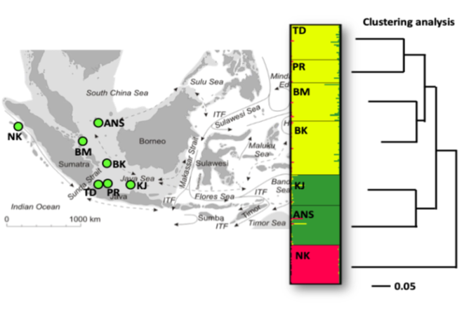
Figure 3 Seagrass connectivity of Enhalus acroides biodiversity (Hadi, et al, 2023)

The biodiversity seagrass, based on observed locations, shows that the connectivity of seagrass (Enhalus) between Tunda Island (TD), Pramuka Island (PR), Batam Island (BM), and Bangka Belitung is relatively close shown at figure above. According to Maduppa (2021), the similarity of genetic biological characteristics is related to the dispersal processes of genetic sources, which can extend widely due to the dynamics of marine waters.
Mangrove flora (biodiversity) found in Bintan are Avicennia officinalis, Bruguiera gymnorhiza, Rhizophora apiculata, R. mucronata, R. stylosa, Sonneratia alba, S. caseolaris, Xylocarpus granatum; with common associates like Acrostichum speciosum, Derris trifoliata, Pandanus odoratissimus, Scaevola taccada, Thespesia populnea (Hakim et al, 2023). Other biota associate with mangroves: long-tailed macaque (Macaca fascicularis), Natuna leaf monkey (Presbytis natunae), dugong (Dugong dugon); and at least 32 bird species recorded around Ekang Mangrove Park (8 orders, 20 families), including hornbills and kingfishers (Hakim et al, 2023).

3.2.4. Sensitivity Area
A sensitivity area can be defined as an area that is easily affected and potentially vulnerable and at risk. These areas include ecosystems, species and regions that support community livelihoods, and areas that play an important role for society. Several sensitive areas around the South China Sea include sea transportation, national boundaries, conservation areas, submarine cables, EETS migration species routes, and local transportation as table below.

Tabel 1. Sensitivity issue in Indonesia region
Name | Sensitive issue | Descrition
Sea Line (ALKI) Indonesia | Balast discharge and oil spill from ship and oil and gas minning | A Study for the northern South China Sea (2015–2019) identified 632 oil slicks, of which 490 came from ships and 57 from platforms; the average slick size was about 4.8 km², though half of all slicks were under 1.7 km². (Hong et al, 2022).
National Boundaries | The overlapping maritime claims in the South China Sea (China versus ASEAN member states) | China’s expansive claims in the South China Sea have created several sensitive issues for the region, including legal disputes stemming from the invalidated nine-dash line, overlapping maritime boundaries with ASEAN states, and the militarization of artificial islands.
Conservation area | Impact from antropigenic and non antropogenic to coral, mangrove and seagrass | Muawanah et al. (2020), record, only 53% of coral reef ecosystems are managed within conservation areas. In addition to the sensitivity of designated conservation areas, coral reef ecosystems themselves are highly sensitive and vulnerable to degradation, both from anthropogenic influences and non-anthropogenic factors.
Submarine Cable | Sensitivity and risks related to cable cuts: Frequent disruptions may occur due to ship anchors, fishing trawlers, and natural hazards. | Cybersecurity risks: There are growing concerns about interception or tapping of submarine cables by state actors, making risk management in cybersecurity an urgent priority.
EETS Route and Migration | These are migratory or resident marine species that move along the South China Sea corridor, passing through Natuna waters | Dugong (Dugong dugon) with habitat in seagrass beds in Natuna & Bintan. Sea Turtles that dominantly found green turtle (Chelonia mydas) and Hawksbill Turtle (Eretmochelys imbricata) migration route across SCS feeding grounds (Natuna–Spratlys–Philippines–Malaysia). Napoleon Wrasse (Cheilinus undulatus) have migration route at Coral reef belts from Natuna to Spratly Islands and in the Philippines. Whale Shark (Rhincodon typus) as one of Vulnerable species have migration route Vietnam coast to Natuna and Java Sea while alga blooms. The Irrawaddy Dolphin (Orcaella brevirostris) as endangered found in estuaries and shallow coastal waters. The migration route from and to Mekong estuary (Vietnam/Cambodia) to Natuna Sea and along side of West Kalimantan coastal. The Scalloped Hammerhead Shark (Sphyrna lewini) that record as Critically Endangered (CE) have route from Spratlys to Natuna and Banda Sea. Leatherback Turtle (Dermochelys coriacea) record as Critically Endangered have route from Pacific (Papua nesting sites) to South China Sea (feeding grounds) and the end in Indian Ocean.
Fish Spawning Habitat | Disruption of essential habitat for spawning and nursery | The potential spawning grounds for skipjack, yellowfin tuna, mackerel mainly on offshore pelagic zones north and northeast of Bunguran Island. Coral reef-associated areas around Sedanau, Pulau Senoa, Midai as spawning ground for groupers (Epinephelus), snappers (Lutjanus). Seagrass meadows as spawning habitat of rabbitfish (Siganus), mullets.

3.2.4 Endemic, Endanger, and Threatened Species (EETS)
Endemic, endangered, and threatened species (EETS) found in the waters of the Natuna and North Natuna Seas include groups of dolphins, whales, dugongs, and several Napoleon wrasses (Cheilinus undulatus). Species such as dugongs and the Napoleon wrasse (Cheilinus undulatus), as well as spinner dolphins (Stenella longirostris) and bottlenose dolphins (Tursiops truncatus), are listed as protected fauna. Based on their IUCN Red List status, spinner dolphins are categorized as Least Concern (LC), while bottlenose dolphins are classified as Near Threatened (NT). According to CITES, these species are included in Appendix II (not necessarily threatened with extinction but may become so unless trade is strictly regulated).
All EETS groups are widely distributed across Indonesian waters. Some of the EETS species found in the Natuna waters of Indonesia are as follows:
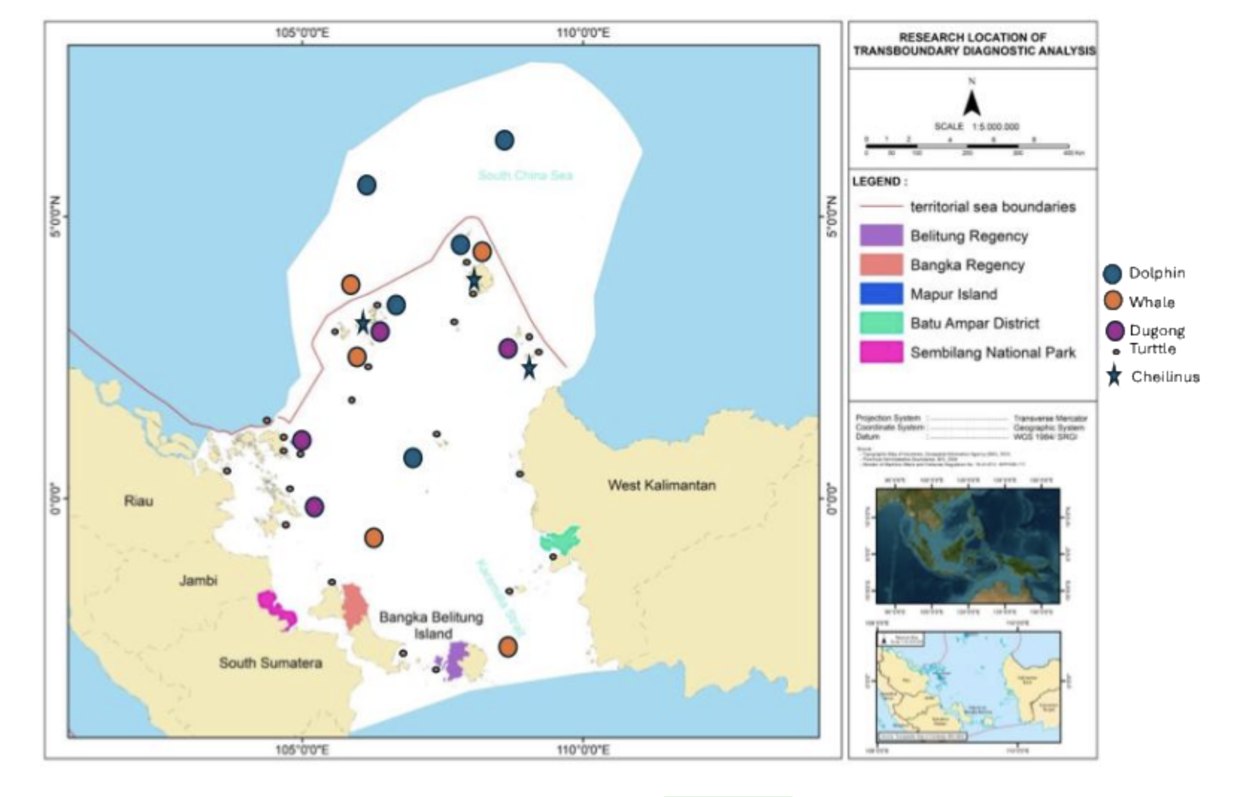
Figure 4. The distribution of EETS species in Indonesia
The dolphin species likely to be found in the waters around the North Natuna Sea are the South China Sea dolphin (Lagenodelphis hosei) or the Malacca dolphin (Delphininae sp.) (Sudjoko, 1988). Based on the literature, the distribution range of Lagenodelphis hosei is very wide, covering tropical to temperate regions, within approximately 30° north and 30° south latitude. Meanwhile, the distribution of Delphininae sp. includes the waters of the Riau Archipelago, along the coast of the Malacca Peninsula, and the Malacca Strait (Sudjoko, 1988). The following presents the conservation status information of EETS (Endemic, Endangered, and Threatened Species) found in the waters of Natuna, Indonesia.

4. Discussion

4.1 Priority Transboundary Issue
Based on surveys and data collection conducted at local and provincial levels in Bintan, West Borneo, the crucial issues and programs related to the marine ecosystems of Bintan, Natuna, and other waters in Western Kalimantan have been identified. This physical destruction is further exacerbated by reclamation and coastal construction, which increase water turbidity and directly destroy coral and mangrove areas. The conversion of land cover for brackish water aquaculture is another major driver of mangrove degradation. Additional pressures stem from destructive fishing practices, unregulated sand mining, and pollution from local tourism. Compounding these issues, large-scale national strategic projects pose a threat of irreversible landscape changes. The main identified trandboundary issues and their descriptions are summarized in the table below.

Table 2. The main identified issues and their descriptions
No | Transboundary Issue | Description
1 | Climate Impact | Increasing sea surface temperature causes coral bleaching and is exacerbated by coastal ecosystem changes from waves and currents.
2 | Marine Pollution | Degradation of mangrove, coral, and seagrass ecosystems due to debris and plastic pollution.
3 | Oil Spill | Oil spills impact coasts, mangroves, coral reefs, and coastal biodiversity.
4 | Ecosystem Degradation from Illegal Fishing | Illegal fishing causes coral destruction in various coral ecosystems in the Natuna and Anambas Seas.
5 | Invasive Species in Ecosystems | The main issue regarding marine invasives is the predation by the Crown-of-Thorns Starfish (Acanthaster planci) and the invasion of other fish populations from different ecosystems in the region.

4.2. Risk Assessment and Valuation of economic losses
Mangrove forests and coastal wetlands in the Indonesian part of the South China Sea covering the Natuna Islands, Anambas Islands, and the western coast of Kalimantan are facing increasing ecological risks due to the combined pressures of climate change and anthropogenic activities. Global studies estimate that about 40–56% of the world’s mangrove area is at high to very high risk due to a combination of sea-level rise and tropical storms, including the Southeast Asian region such as Indonesia (Hülsen et al., 2025). Overall, the combination of climate hazards (sea-level rise, cyclones), biophysical exposure (fragmented cover), and social vulnerability (economic dependence and limited livelihood diversification) places the coastal areas of Natuna, Anambas, and West Kalimantan within the medium-to-high risk category.
The site-level risk data for the western South China Sea demonstrates a compelling narrative of interconnected threats. High-risk sites like Bangka and Belitung are characterized by a synergy of intense stressors, primarily sedimentation from tin mining and growing tourism. In contrast, sites like Batam, Bintan, and the Barelang islands face a different risk profile, dominated by high-impact tourism and coastal development. The "High" scores for uncontrolled tourism and medium-to-high scores for eutrophication point to pressures from resort wastewater, sewage, and physical damage from reef trampling and anchors.
Conversely, sites within the western South China Sea such as Karimata and Natuna presently reside in lower risk categories. Karimata's seagrass and coral ecosystems benefit from limited access and lower direct anthropogenic input, while Natuna's offshore ecosystems remain relatively intact due to lower population density. However, Natuna faces a unique transboundary threat: a "High" risk from Illegal, Unreported, and Unregulated (IUU) fishing by foreign vessels. This highlights that risk to these marine ecosystems is not only from resident population growth but also from external resource demand, which can undermine local fisheries and cause collateral habitat destruction for reefs and seagrasses. The assessment of risk and its level from each issue in list at Tabel 4 in Apendix.

4.3 Current Management and Institutions
The management of coastal ecosystems—coral reefs, mangroves, seagrass beds, and wetlands—in the Indonesian sector of the South China Sea is carried out through a multi-layered system involving national ministries, regional governments, research institutions, and community-based initiatives. At the national level, the Ministry of Marine Affairs and Fisheries (KKP) leads marine conservation policy, MPA establishment, habitat mapping, and fisheries regulation, while the Ministry of Environment and Forestry (KLHK) oversees mangrove and wetland protection within the coastal–terrestrial regulatory framework. Scientific support is provided by the National Research and Innovation Agency (BRIN) and universities, which conduct ecosystem monitoring and generate updated habitat data to guide planning.
At the provincial and district levels—particularly in the Riau Islands Province covering Natuna, Anambas, and Bintan—local marine and fisheries agencies are responsible for implementing zoning, enforcing regulations, and managing regionally administered MPAs. Large programs such as COREMAP, the GFCR/Koralestari blue-finance initiative, and various restoration projects led by NGOs (e.g., WWF, YKAN, TNC), private partners, and coastal communities strengthen on-the-ground conservation through co-management, restoration, and livelihood integration. Together, these institutions form an integrated governance system that combines national policy, local capacity, scientific evidence, and community participation to safeguard Indonesia’s coastal ecosystems in the South China Sea region.

4.3. Gaps and Priority Challenges

Several critical gaps and challenges persist in Indonesia’s mangrove governance, which have direct implications for the TDA process. First, there is a scale mismatch between ambition and achievement. The national target of 600,000 ha restoration by 2024 (BRGM, 2021) remains far from completion, with less than one-fourth realized by 2024 (Ismi, 2024). Land-use constraints and competing economic priorities exacerbate the issue (Jong, 2022). Second, fragmented governance and overlapping mandates among KLHK, KKP, BRGM, and provincial authorities have hindered coordination and enforcement, leading to inconsistent zoning and weak law enforcement (MoEF, 2020; Rahman et al., 2024). Third, data gaps and limited interoperability remain major bottlenecks. Although the National Mangrove Map (PMN 2021) provides a strong baseline, data sharing and updating are uneven across regions (BRIN & MoEF, 2021). Fourth, economic pressures continue to drive conversion for aquaculture, agriculture, and coastal infrastructure (Koesdaryanto et al., 2024; Wiarta et al., 2025). These pressures are locally driven yet have transboundary ecological effects across the SCS region. Fifth, sustainable financing mechanisms remain limited. Many restoration projects depend on donor grants, and blue carbon markets are still nascent (Alongi, 2020; Arifanti et al., 2021). Finally, regional coordination under the SCS TDA/SAP remains weak. Despite regional frameworks, operationalizing joint mangrove monitoring, pollution control, and ecological corridor planning among ASEAN countries has yet to materialize effectively (Sievers et al., 2023).

4.4 Recommended priority actions including regional cooperation
Recommendations and action planning for each ecosystem must be carried out based on the criteria of the key issues identified. Differences in challenges require different actions and approaches. Therefore, each action should be planned according to the characteristics of each ecosystem—mangroves, wetlands, coral reefs, and seagrass.
Tabel 3. Key issu and recommendation action and regional cooperation
Key Issue | Mangrove | Wetland | Seagrass and coral reef
Governance and Policy | - Clarify mandates and establish joint coordinating bodies. This includes forming a National Mangrove Coordination Taskforce to align restoration targets, spatial planning, and enforcement, and establishing an SCS Mangrove Working Group under the SCS TDA–SAP to coordinate cross-border priorities (Rahman et al., 2024).  - Harmonize legal and land-use instruments. Clarifying land tenure for rehabilitation sites, tightening permits for aquaculture conversion, and adopting standardized restoration protocols will prevent further degradation (MoEF, 2022). | Operationalize the One Map Policy to clarify land-use boundaries across ministries and provinces, aligning PHUs under a unified national platform (MoEF, 2022). | Policy priorities should emphasize strengthening co-management arrangements with coastal communities, securing sustainable funding for long-term monitoring using indicators such as the Coral Health Index and Seagrass Ecological Quality Index, and promoting low-impact marine tourism in high-conservation-value areas. In the Bangka–Belitung region, post-mining rehabilitation should combine substrate stabilization, coral transplantation, and pioneer seagrass restoration, financed through transparent industry partnerships and corporate social responsibility schemes (Adi & Hartoko, 2024). In the estuarine–coastal zone of eastern Sumatra, closer integration between the Ministry of Environment and Forestry (KLHK) and the Ministry of Marine Affairs and Fisheries (KKP) is crucial to incorporate coastal water quality monitoring and seagrass surveys into national park management, ensuring that wetland conservation benefits extend to shallow marine habitats (UNESCO, 2018).
Science, Data, and Monitoring | - A regional interoperable monitoring system is needed for consistent tracking of mangrove extent, carbon stock, and biodiversity. Integration with blue carbon accounting linked to national NDCs can enhance financing access and ensure transparency (Alongi, 2020; Arifanti et al., 2021).  - Restoration Quality and Site Selection. Site selection should prioritize hydrologically suitable zones identified in the PMN, avoiding areas unsuitable for natural regeneration. Local incentives and capacity building for communities must precede restoration to ensure long-term success (Setyawan & Winarno, 2006; Spalding et al., 2014). | Invest in provincial and local capacity building, embed community-based knowledge in wetland management, and integrate wetlands into Indonesia’s NDC and ASEAN reporting systems (MoEF, 2022; Murdiyarso et al., 2015). | At the national level, the National Coral Reef and Seagrass Map, jointly developed by KKP and the Nature Conservancy Indonesia (YKAN), serves as the “single source of truth” for marine spatial planning and policy evaluation (YKAN & KKP, 2025). This map also underpins blue carbon accounting frameworks that can unlock conservation financing.
Mobilizing of Finance and Market Mechanisms | Blending national funds, World Bank grants, and private sector finance (blue carbon) is essential. Introducing performance-based disbursement—linked to verified restoration outcomes such as carbon sequestration and survival rates—can enhance accountability (World Bank, 2021). Simplifying carbon project legal pathways will allow community cooperatives to participate and share equitable benefits (Arifanti et al., 2021). | Develop results-based payment schemes for rewetting and emission reduction, leverage carbon and blue carbon markets, and incentivize private sector compliance with no-deforestation and no-peat-drainage commitments (BRGM, 2021; MoEF, 2022).
Regional Cooperation Actions | Creating an SCS Mangrove Corridor connecting Indonesian hotspots (Riau, Natuna, North Kalimantan) with neighboring countries (Malaysia, Vietnam, Philippines) can protect nursery connectivity and migratory species (Sievers et al., 2023). A joint pollution mitigation program—addressing plastic, agricultural runoff, and mining sediment—should be coordinated via SCS TDA/SAP and ASEAN mechanisms (Murdiyarso et al., 2015). Establishing an SCS-level R&D Fund for blue carbon, larval connectivity, and climate resilience studies is also recommended. | Establish a National Wetland Monitoring Dashboard integrating satellite, hydrological, and social data—aligned with ASEAN’s APMS indicators (ASEAN Secretariat, 2023). Annual State of the Wetlands Reports would strengthen transparency and attract climate finance (MoEF, 2022).  Align national restoration efforts with ASEAN Peatland Management Strategy (APMS 2023–2030) and South China Sea SAP, establish an ASEAN Peat Knowledge Hub, and strengthen cross-border haze prevention with Malaysia, Brunei, and Viet Nam (ASEAN Secretariat, 2023; UNEP/GEF SCS, 2007). | Regionally, implementation of the CTI-CFF Regional Plan of Action 2.0 (RPOA 2.0) and cooperative mechanisms within WPPNRI 711 (North Natuna Sea) can enhance cross-border surveillance, ecological data sharing, and rapid response to bleaching events and extreme weather phenomena (CTI-CFF, 2020; World Bank, 2024). With an integrated, science-based, and multi-level governance approach, the sustainability of seagrass and coral reef ecosystems can serve as a cornerstone of the blue economy across the South China Sea.
Social Safeguards and Inclusion | Embedding community co-management and gender equity ensures sustainability. Formalized tenure rights for community forests and empowerment of women’s groups can make mangrove restoration socially inclusive (Setyawan & Winarno, 2006; Spalding et al., 2014).
Advancing Hydrology-First Restoration |  | Focus on rewetting and canal blocking in degraded PHUs of South Sumatra, Jambi, and West Kalimantan, complemented by native revegetation that supports local livelihoods (Evans et al.,
Empowering Community-Based Fire Prevention |  | Expand village fire brigades (MPA), integrate early-warning systems, and promote alternative livelihoods such as wetland rice and fishponds (Mongabay Indonesia, 2023; Rizki & Suryadi, 2023).

Reference

Adrim M, Iis Chen, ZP Chen, KKP Lim, HH Tan, Y Yusuf. 2004. Marine fishes recorded from the Anambas and Natuna islands, South China Sea. The Rafless Bulleting of Zoology.
Hadi TA, Utama RS, Arfianti T. Species richness and the dynamics of coral cover in Bangka Belitung Islands, Indonesia. PeerJ. 2023 Feb 24;11:e14625. doi: 10.7717/peerj.14625. PMID: 36860768; PMCID: PMC9969856.
A. H. Nugraha et al., "Sebaran Jenis dan Kondisi Tutupan Lamun di Perairan Kepulauan Riau," Journal of Marine Research, vol. 12, no. 3, pp. 431-438, Jul. 2023. https://doi.org/10.14710/jmr.v12i3.36274
PPID Loka Konservasi Pekanbaru. 2025. Ekosistem Terumbu Karang di Kawasan Konservasi Anambas.
Wiarta R, Firdaus Silamon R, Ishag Arbab M, Badshah MT and Hayat U and Meng J (2025) Assessing of driving factors and change detection of mangrove forest in Kubu Raya District, Indonesia. Front. For. Glob. Change 8:1511361. doi: 10.3389/ffgc.2025.1511361.
Fahmi, and Yonvitner; 2017. Biodiversity and Abundance of Demersal Fish Stock in Tambelan Water, Natuna Sea. (2017). Jurnal Ilmu Dan Teknologi Kelautan Tropis, 8(2), 503-516.
Adi, W., & Hartoko, A. (2024). Ecological condition of seagrass meadows around sea-based tin mining activities in the waters of Bangka Belitung Islands, Indonesia. Marine Pollution Bulletin, 198, 120685.
CTI-CFF. (2020). Regional Plan of Action 2.0 (RPOA 2.0): Securing the Coral Triangle for future generations. Coral Triangle Initiative on Coral Reefs, Fisheries, and Food Security.
Hughes, T. P., et al. (2017). Global warming and recurrent mass bleaching of corals. Nature, 543, 373–377.
Hong, X., Chen, L., Sun, S., Sun, Z., Chen, Y., Mei, Q., & Chen, Z. (2022). Detection of Oil Spills in the Northern South China Sea Using Landsat-8 OLI. Remote Sensing, 14(16), 3966. https://doi.org/10.3390/rs14163966
IPCC. (2022). Climate Change 2022: Impacts, Adaptation and Vulnerability. Contribution of Working Group II to the Sixth Assessment Report. Cambridge University Press.
Kementerian Kelautan dan Perikanan. (2022). Keputusan Menteri Kelautan dan Perikanan Nomor 18 Tahun 2022 tentang Kawasan Konservasi di Perairan Timur Pulau Bintan. Jakarta: KKP.
NOAA Coral Reef Watch. (2024). Annual bleaching outlook and DHW metrics for the Indo-Pacific. National Oceanic and Atmospheric Administration.
Ramsar Secretariat. (2011). Sembilang National Park (RIS No. 1945). Gland: Ramsar Convention Bureau.
Rifai, H., et al. (2024). Understanding stakeholders’ perception on developing seagrass-associated tourism: Evidence from MPAs of Bintan Island, Indonesia. Marine Pollution Bulletin, 203, 115244.
Turissa, P., et al. (2024). Sentinel‑2A multispectral image analysis for seagrass mapping in Bintan’s shallow-water ecosystem. Kuwait Journal of Science, 51(4), 1–16.
UNESCO. (2018). Berbak–Sembilang Biosphere Reserve (Indonesia). Paris: UNESCO.
World Bank. (2024). Indonesia – Coral Reef Rehabilitation and Management Program (COREMAP‑CTI): Project Performance Assessment Report No. 187437. Washington DC: World Bank.
YKAN & KKP. (2025). Indonesia develops national map of coral reefs and seagrass beds. Jakarta: Yayasan Konservasi Alam Nusantara
Bappenas. (2023). National Strategy for Wetland Management. Jakarta: Ministry of National Development Planning (Bappenas).
CIFOR-ICRAF. (2022). Coastal Rehabilitation for Climate Change Mitigation (Working Paper 11). Bogor: CIFOR-ICRAF.
Fan, B., Ren, H., Liu, H., Chen, Q., & Wang, Y. (2024). Exploring cumulative vulnerability of mangrove forests to intensive coastal anthropogenic threats. Environmental Health & Sustainability, 1(1), 0153.
Gerona-Daga, M. E. B., et al. (2022). A systematic review of mangrove restoration studies in Southeast Asia. Frontiers in Marine Science, 9, 987737.
Hülsen, S., Dee, L. E., Kropf, C. M., Meiler, S., & Bresch, D. N. (2025). Mangroves and their services are at risk from tropical climate change. Communications Earth & Environment, 6, 262.
KLHK (Ministry of Environment and Forestry). (2021). National Mangrove Map 2021. Jakarta: KLHK.
Republic of Indonesia. (2020). Presidential Regulation No. 120 of 2020 on the Peatland and Mangrove Restoration Agency (BRGM). Jakarta.
Sasmito, S. D., Basyuni, M., Kridalaksana, A., Saragi-Sasmito, M. F., Lovelock, C. E., Murdiyarso, D., & Friess, D. A. (2023). Challenges and opportunities for achieving sustainable mangrove rehabilitation in Indonesia. Nature Ecology & Evolution, 7, 62–70.
Wiarta, R., Yamada, Y., Matsushita, B., & Nurdiana, A. (2025). Assessing driving factors and change detection of mangrove forest over 30 years in Kubu Raya District, West Kalimantan, Indonesia. Frontiers in Forests and Global Change, 8, 1511361.
Zhou, P., Jiang, Z., Zhao, L., Hu, H., & Li, D. (2025). Mapping and potential risk assessment of marine debris in mangrove wetlands in the northern South China Sea. Sustainability, 17(14), 6311.
Alongi, D. M. (2018). The role of mangroves in coastal protection and climate change adaptation. Estuarine, Coastal and Shelf Science, 210, 1–8.
Alongi, D. M. (2020). The impact of climate change on mangrove forests. Current Climate Change Reports, 6, 1–7.
Arifanti, V. B. et al. (2021). Carbon dynamics and deforestation in Indonesian mangroves. Nature Communications, 12, 4164.
Badan Restorasi Gambut dan Mangrove (BRGM). (2021). National Peatland and Mangrove Restoration Targets. Government of Indonesia, Jakarta.
Donato, D. C., Kauffman, J. B., Murdiyarso, D. et al. (2011). Mangroves among the most carbon-rich forests in the tropics. Nature Geoscience, 4, 293–297.
Duke, N. C. et al. (2007). A world without mangroves? Science, 317, 41–42.
Giri, C., Ochieng, E., Tieszen, L. L. et al. (2011). Status and distribution of mangrove forests of the world using Earth observation satellite data. Global Ecology and Biogeography, 20, 154–159.
Ismi, N. (2024). Progress and Challenges of Indonesia’s Mangrove Rehabilitation Program. MoEF Policy Brief No. 8/2024.
Jong, H. (2022). Indonesia’s Mangrove Restoration Progress and Deforestation Trends. Mongabay News, Jakarta.
Koesdaryanto, E., et al. (2024). Mangrove cover dynamics and community drivers in South Sumatra. Journal of Coastal Research, 40(2), 150–162.
Ministry of Environment and Forestry (MoEF). (2020). State of Indonesia’s Forests 2020. Government of Indonesia, Jakarta.
Ministry of Environment and Forestry (MoEF). (2022). Indonesia’s Enhanced Nationally Determined Contribution. Republic of Indonesia, Jakarta.
Murdiyarso, D. et al. (2015). The potential of Indonesian mangrove forests for global climate change mitigation. Nature Climate Change, 5, 1089–1092.
Rahman, R. et al. (2024). A review on the biodiversity and conservation of mangrove ecosystems in Indonesia. Biodiversity and Conservation, 33, 875–903.
Richards, D. R. & Friess, D. A. (2016). Rates and drivers of mangrove deforestation in Southeast Asia, 2000–2012. Proceedings of the National Academy of Sciences, 113, 344–349.
Setyawan, A. D. & Winarno, K. (2006). Rehabilitation of mangroves in Java: Case study of community-based management. Biodiversitas, 7, 45–50.
Sievers, M. et al. (2023). The role of mangroves in supporting fisheries and coastal resilience. Nature Ecology & Evolution, 7, 635–646.
Spalding, M. et al. (2014). Coastal ecosystems: Nature-based solutions for climate change mitigation and adaptation. Frontiers in Ecology and the Environment, 12, 123–130.
Wiarta, D. et al. (2025). Socio-environmental drivers of mangrove cover change in Kubu Raya, West Kalimantan. Environmental Monitoring and Assessment, 197(4), 112–125.
World Bank. (2021). Blue Economy Development Framework: Mangrove and Coastal Resilience in Indonesia. Washington, DC.
ASEAN Secretariat. ASEAN Peatland Management Strategy 2023–2030. Jakarta: ASEAN Secretariat, 2023.
Badan Restorasi Gambut dan Mangrove (BRGM). National Peatland and Mangrove Restoration Targets. Jakarta: Government of Indonesia, 2021.
Evans, C. D., et al. “Overriding Importance of Water Table Depth in Controlling Greenhouse Gas Emissions from Peatlands.” Nature Geoscience 14 (2021): 868–874.
Jong, H. N. “Saling Bantah Antara Greenpeace dan APP tentang Pelanggaran Janji Tanpa Deforestasi.” Mongabay Indonesia, 2023.
Ministry of Environment and Forestry (MoEF). Indonesia’s Enhanced Nationally Determined Contribution. Jakarta: Republic of Indonesia, 2022.
Mongabay Indonesia. Ground Perspectives on Peatland Fires and Restoration (2023–2024). https://www.mongabay.co.id
Murdiyarso, D., et al. “Policy Options for Sustainable Peatland Management in Indonesia.” Nature Climate Change 5 (2015): 1089–1092.
Page, S. E., Rieley, J. O., and Banks, C. J. “Global and Regional Importance of the Tropical Peatland Carbon Pool.” Global Change Biology 17 (2011): 798–818.
Ritzema, H., et al. “Hydrology of Peatlands: Impact of Drainage, Land Use Change, and Climate.” Hydrology and Earth System Sciences 18 (2014): 3651–3670.
Rizki, R. D., and Suryadi. “Asap Karhutla Mulai Ganggu Kesehatan Warga.” Mongabay Indonesia, 2023.
UNEP/GEF South China Sea Project. Transboundary Diagnostic Analysis for the South China Sea. Bangkok: UNEP, 2007.
Ward, R. D., et al. “Peatland Restoration: A Global Challenge.” Nature Reviews Earth & Environment 3 (2022): 417–433.
Wijaya, T., and Rahmad

