The governance of Indonesia water as part of the South China Sea

Taryono Kodiran^{1,2}, Retia Revany¹, Isdahartati¹

¹Center for Coastal and Marine Resources Studies, IPB University
²Department of Aquatic Resources Management, Faculty of Fisheries and Marine Sciences, IPB University

Abstract

The enhancement of governance in Indonesia's South China Sea (SCS) waters is critical for advancing both national and regional interests. Therefore, a comprehensive assessment is critical to be conducted. This analysis reveals low-to-medium governance effectiveness, which reflects the disparity between regulatory frameworks and their implementation. Risk governance analysis was conducted by assessing completeness policy cycle, stakeholder engagement and integration. Risk governance analysis uncovers the regulatory completeness scores low risk, stakeholder engagement and policy integration face medium risk, indicating that coordination challenges present a greater obstacle than regulatory gaps.

To address these shortcomings, this study emphasizes a dual pathway. Domestically, it is imperative to strengthen the multi-level governance platform that connects central, provincial, and regency/city administrations. Internationally, the existing regional SCS cooperation requires fortification, particularly marine pollution and expansion to encompass other transboundary issues such as ecosystem degradation, plastic waste, and Abandoned, Lost, or Discarded Fishing Gear (ALDFG). Ultimately, the establishment of an integrated land-sea collaboration platform across Indonesian jurisdictions is essential. This would directly tackle the land-based drivers of marine degradation while simultaneously strengthening Indonesia's strategic position within regional cooperation frameworks.

Keywords: governance, land-sea collaboration, regional SCS cooperation, risk analysis.

1. Introduction

The South China Sea plays an important role in the development of the coastal states, the region and even the world by virtue of its rich biological and oil and gas resources and convenient shipping lanes. But in recent years, the ecological environment of the South China Sea has been facing increasingly severe impacts and challenges due to complex reasons (Wei and Zihao, 2024).
In 2023, the South China Sea (SCS) facilitated the transit of 10 billion barrels of petroleum and 6.7 trillion cubic feet of LNG, underscoring its rich resources and strategic significance (US Energy Information, 2024). Oceanographically, the SCS throughflow acts as a crucial heat and freshwater conveyor, regulating regional sea surface temperatures (Qu et al., 2009).

The South China Sea (SCS) holds immense importance, not only due to its geopolitical significance but also because of its rich biodiversity and vital role in supporting livelihoods and ensuring food security through fishing activities (Sembiring, 2024). Then safeguarding the marine and coastal ecosystems of the South China Sea (SCS) is imperative, given escalating threats from pollution, biodiversity erosion, and climate change impacts. While transboundary environmental mechanisms exist at a regional level, advancing country-based collaboration among SCS nations is essential. Such cooperation is particularly critical for mitigating marine plastic debris, an issue intrinsically linked to human behavior, societal norms, and policy frameworks. This paper aims to analysis the status of governance of the Indonesia water as part of the South China Sea (SCS) region (Figure 1).

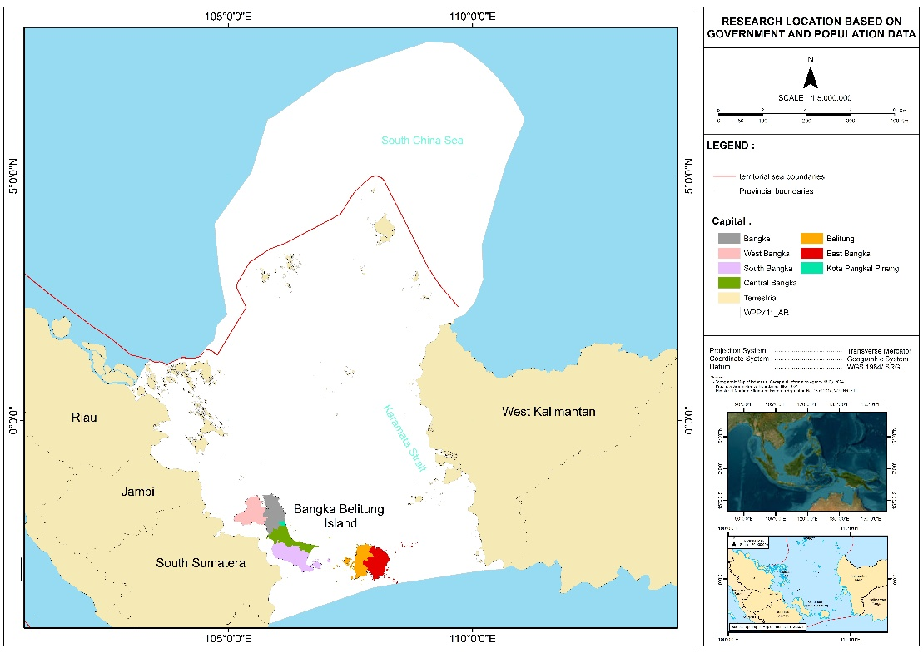
Figure 1 Study Area

2. Key Governance Concern

The current situation is that the existing environmental governance mechanism in the South China Sea is currently characterized by predominantly bilateral governance, supplemented by 75 multilateral cooperation (Sichun, 2021). With poor of governance, it is possibly becoming a tragedy of common, so it is mandated to enhance transboundary partnership (Astuti, 2017). Indonesia has established a national policy for marine resource management, which is implemented at the sub-national level. This includes the South China Sea region, which encompasses several provinces and regencies with diverse socio-economic conditions. While a cooperation platform exists, its effectiveness remains limited. An explicit policy foundation has been laid for fisheries management purpose, with this direction being reinforced in subsequent development plans including pollution control, ecosystem protection, and economic and climate development. Regarding regional disputes, Shaleh et al. (2021) recommend utilizing ASEAN-led platforms for dialogue and leveraging international partnerships. Although a working group for SCS and Gulf of Thailand management exists, it is ineffective in resolving transboundary issues.

3. Current Status

3.1. Economic and policy driver
GDP and economic growth
GDP at current prices demonstrated stable quarterly and annual growth from 2020 to 2023. However, it remained relatively stagnant when measured at constant 2010 prices (see Annex 1).
During the period 2016–2023, Indonesia’s economy generally recorded growth. However, in 2019–2020, the economy contracted that was largely attributable to the outbreak of the COVID-19 pandemic, which led to economic stagnation and, in some sectors, a significant downturn. But, since 2021 the economy constantly growth up to 5.05% in 2023 (Figure 2)

Source: BPS-Statistics Indonesia, 2020 and BPS-Statistics Indonesia, 2024
Figure 2 The Economic Growth of Indonesia 2016-2023

Indonesia’s poverty rate as of March 2023 was 9.36%, slightly decreasing to 9.03% in March 2024, with around 7.3% in urban and 12.2% in rural areas. Extreme poverty (those living on less than USD 2.15 per day) is much lower, at approximately 2% of the population. Poverty rate of each mainland Indonesia is in Figure 3.

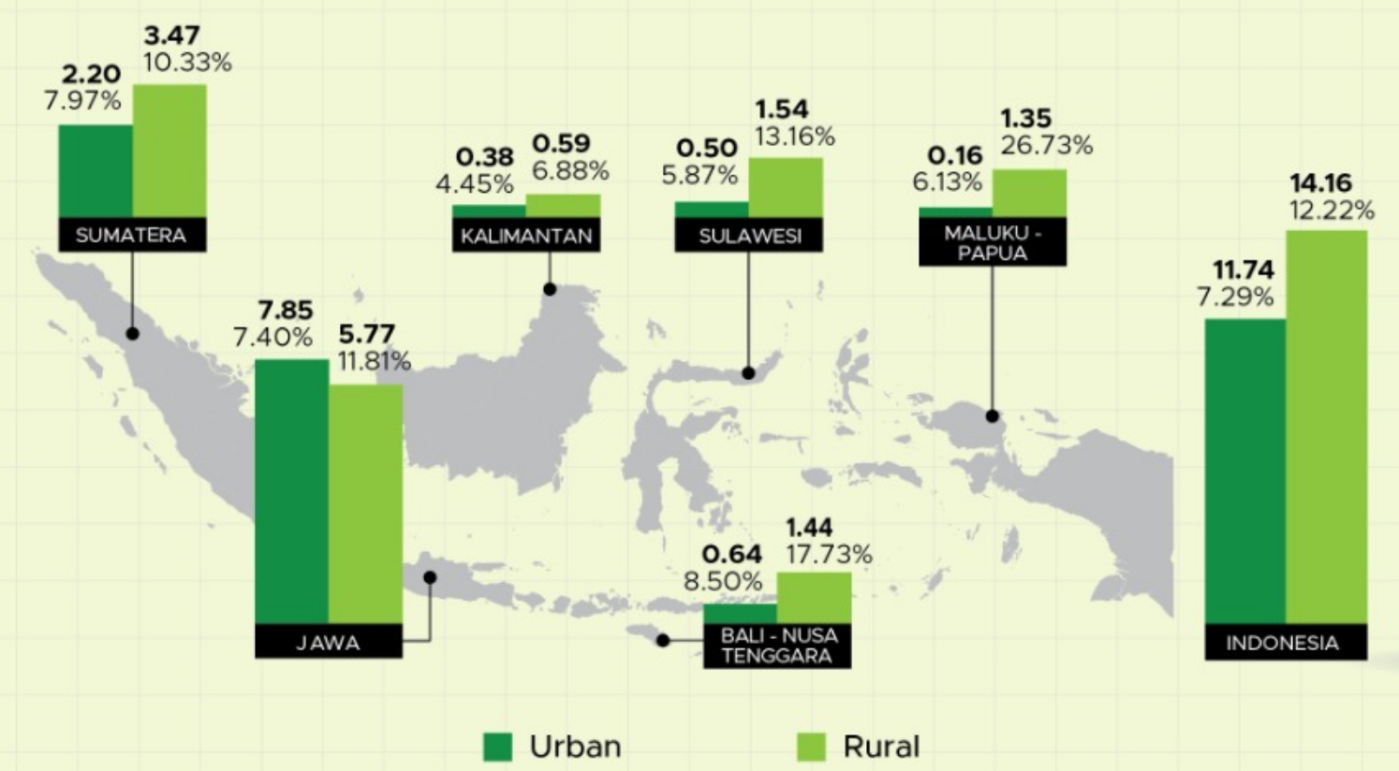

Source: official statistics news, No.47/07/th xxvi, 17 Juli 2023
Figure 3 Number (Million people) and Percentage of Poor Population by Island, March 2023

Inflation during the 2020–2024 period fluctuated, with vary monthly inflation movements. The highest inflation occurred between the second quarter of 2022 and the second quarter of 2023, peaking in September 2022. Thereafter, inflation began to decline, reaching its lowest point in February 2025 at 0.09% (see Annex 2)

Maritime GDP
The contribution of the maritime sector’s GDP to Indonesia’s total GDP averaged 7.93% during the 2020–2024 period. Prior to the COVID-19 pandemic, the maritime sector’s contribution reached 8.14%. However, to date, in the post-COVID-19 period, the maritime sector’s GDP contribution has not yet returned to the 8% level (Annex 3).

In line with national GDP, the current price maritime GDP contracted more sharply than the national GDP in 2020 before returning to growth in the following years (Figure 4). Of the 11 sectors within Maritime GDP, the five main contributors are Aquaculture and Marine Capture, Ocean Energy Resources, Other Maritime-related Industries, Maritime Transportation and Related Services, and Seaborne Trade.

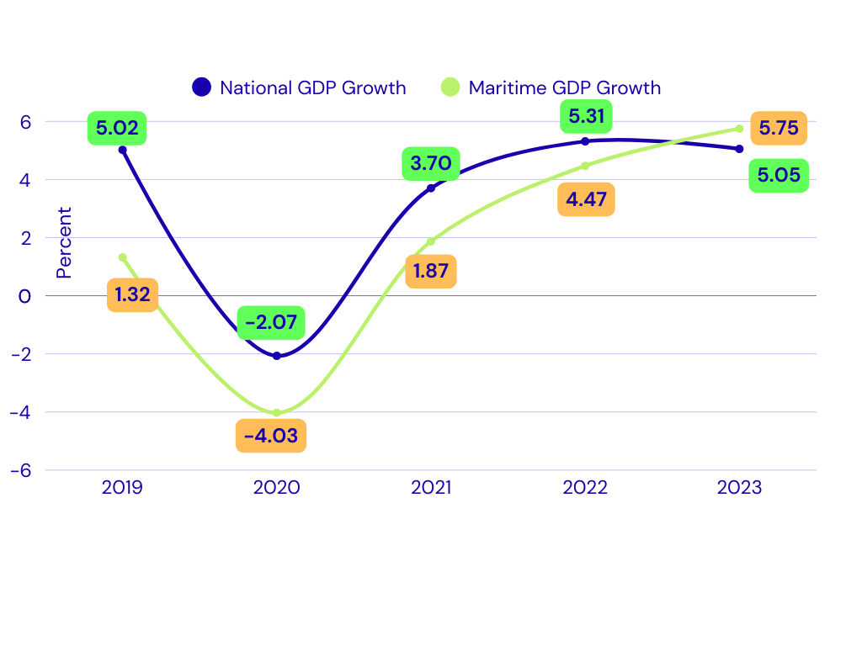

Source: Statistic Indonesia (BPS) and Coordinating Ministry of Marine Affair and Investment, 2024
Figure 4 Growth of National GDP and Maritime GDP Growth at Current Price

National Debt
Between 2000 and 2024, Indonesia's total debt grew from USD 141.2 billion to USD 426.1 billion. Public sector debt (government and central bank) constituted 51.35% of the total, while private sector debt accounted for 48.65%. Government debt represented the largest share (48.76%), substantially exceeding the central bank's contribution (2.59%). Within private debt, non-financial corporations held 37.83%, compared to 10.81% held by financial corporations. The annual debt trajectory is shown in Annex 4.

Unemployment
Indonesia’s open unemployment rate during the 2014–2024 period was dynamic, ranging from 4.9% to 7.1%. The lowest unemployment rate occurred in the third quarter of 2019, while the highest was recorded in the second quarter of 2021 (see Annex 5).

Foreign Investment
Foreign investment during the 2010–2023 period ranged from US$16.21 billion to US$50.27 billion, growing at an average annual rate of 9.96%. The highest growth was recorded in 2023 at 46.67%, while the lowest occurred in 2018 at 9.98%. The lowest investment value was in 2014 at US$16.21 billion, and the highest was in 2023 at US$50.27 billion (see Annex 6).

3.2. Institutional Setting
At least 13 ministries and two ministerial-level institutions are involved in maritime governance in Indonesia, with their engagement varying across significant issues as shown in the Table 1.

Table 1 Legal and institutional mapping, and stakeholders related to coastal and marine management in the South China Sea and Gulf of Thailand
Institution | Pollution | Ecosystem Based Assessment | Climate Change | Fisheries & Livelihoods | Endangered Species | Marine Economy/  Blue Economy
- Coordinating Ministry of Food Affairs |  |  |  | V |  | V
- Ministry of Environment | V | V | V |  | V
- Ministry of Forestry |  | V | V |  | V
- Ministry of Marine Affair and Fisheries |  | V | V | V | V | V
- Ministry of Home Affair |  | V |  |  |  | V
- Ministry of Foreign Affair | V |  | V | V | V | V
- Ministry of Ministry of National Development Planning | V | V | V | V | V | V
- Ministry of Transportation | V |  |  |  |  | V
- Ministry of Defense | V | V
- Ministry of Tourism
- Ministry of agriculture | V
- Ministry of Energy and Mineral Resources | V
- Ministry of Investment and Downstream Industry/Indonesia Coordinating Investment Board |  |  |  | V |  | V
- Peatland and Mangrove Restoration Agency of the Republic of Indonesia (BRGM) |  | V
- Indonesian Maritime Security Agency (BAKAMLA) | V | V |  |  |  | V

Three provinces (Kepulauan Riau Province, Bengka Belitung Province, West Kalimantan Province) and twenty regencies/cities in Indonesia share borders with the South China Sea (SCS) waters (see Annex 7).

3.3. Legal Policy Setting
The governance of Indonesia's coastal and marine waters in the South China Sea (SCS) is framed by a combination of international agreements and domestic legal hierarchy comprising laws, government regulations, presidential regulations, and ministerial regulations. These instruments collectively address various management concerns in the region, as detailed in the Table 2.

Table 2 Legal Basis of International and Indonesia Regulation concerning to South China Sea waters
No. | Level | Concern Issue | Contents Related to SCS
1 | International Agreement | Socio economic and climate threat | UNCLOS 1982 (ZEE Indonesia)
1 | International Agreement | Socio economic and climate threat | The Kyoto Protocol (Climate Change)
1 | International Agreement | Socio economic and climate threat | Paris Agreement (Climate change)
1 | International Agreement | Socio economic and climate threat | UN Framework Convention on Climate Change (Climate change)
1 | International Agreement | Pollution | IMO Regulation (Transportation)
1 | International Agreement | Pollution | The Basel Convention No.22/1989 (Pollution)
1 | International Agreement | Pollution | Rotterdam Convention (Pollution)
1 | International Agreement | Pollution | Stockholm Convention (Pollution)
1 | International Agreement | Pollution | UN Convention to Combat Desertification (Land based pollution)
1 | International Agreement | Ecosystem | CBD-Global Biodiversity Framework (Marine Conservation)
1 | International Agreement | Ecosystem | The Ramsar Convention on Wetlands of International Importance (Ramsar Convention) (Mangrove)
1 | International Agreement | Fisheries and Aquaculture | The Convention on International Trade in Endangered Species of Wild Fauna and Flora (CITES) (Fisheries)
1 | International Agreement | Fisheries and Aquaculture | The Convention on the Conservation of Migratory Species of Wild Animals (CMS), also known as the Bonn Convention (Fisheries)
2 | Laws (Undang-Undang/UU) | Socio economic and climate threat | Law 22/2019 on Sustainable Agriculture (Feed, fertilizer)
2 | Laws (Undang-Undang/UU) | Socio economic and climate threat | Law 32/2014 on Maritime (Maritime zones, underwater cable, maritime safety and sovereignty)
2 | Laws (Undang-Undang/UU) | Socio economic and climate threat | Law 59/2024 on National Long Term Development Plan 2025-2045 (Blue Economy)
2 | Laws (Undang-Undang/UU) | Pollution | Law No. 32/2024 on Natural Resource Conservation (Pollution)
2 | Laws (Undang-Undang/UU) | Pollution | Law 66/2024 Third Amendment to Law Number 17 of 2008 concerning Shipping (Sea Transportation)
2 | Laws (Undang-Undang/UU) | Pollution | Law No. 32/2024 on Natural Resource Conservation
2 | Laws (Undang-Undang/UU) | Ecosystem | Law No. 32/2024 on Natural Resource Conservation (Mangrove)
2 | Laws (Undang-Undang/UU) | Ecosystem | Law 41/1999 on Forestry
2 | Laws (Undang-Undang/UU) | Fisheries and Aquaculture | Law 11/2020 on Job Creation (fisheries)
2 | Laws (Undang-Undang/UU) | Fisheries and Aquaculture | Law 45/2014 on Fisheries (Fisheries (capture and aquaculture))
2 | Laws (Undang-Undang/UU) | Fisheries and Aquaculture | Law 23/2014 on Local Government Autonomy (12 nm water authority)
2 | Laws (Undang-Undang/UU) | Fisheries and Aquaculture | Law 5/1983 on Indonesia Economic Exclusive Zone (Fisheries)
3 | Government Regulation/GR (Peraturan Pemerintah/PP) | Socio economic and climate threat | GR 13/2022 on Implementation of the Implementation of Safety, Security, and Law Enforcement in the Indonesian Waters and Jurisdictional Waters of Indonesia (Sea safety and security)
3 | Government Regulation/GR (Peraturan Pemerintah/PP) | Pollution | GR 22/2021 on the Implementation of Environmental Protection and Management
3 | Government Regulation/GR (Peraturan Pemerintah/PP) | Ecosystem | GR 27/2025 on Management and Conservation of Mangrove Ecosystem (Mangrove)
3 | Government Regulation/GR (Peraturan Pemerintah/PP) | Fisheries and Aquaculture | GR 27/2021 on the Implementation of Marine Affair and Fisheries
3 | Government Regulation/GR (Peraturan Pemerintah/PP) | Fisheries and Aquaculture | GR 11/2023 on Quota Based Fisheries Management
3 | Government Regulation/GR (Peraturan Pemerintah/PP) | Fisheries and Aquaculture | GR 50/2015 on Fisheries Management Area
4 | Presidential Regulation/PR (Peraturan Presiden/Perpres) | Socio economic and climate threat | PR 12/2025 on National Medium-Term Development Plan 2025-2029 (Blue economy)
4 | Presidential Regulation/PR (Peraturan Presiden/Perpres) | Ecosystem | PR 98/2021 on the Implementation of Carbon Economic Value for NDC Achievement and GHG Emission Control in National Development (Mangrove, seagrass)
5 | Ministerial Regulation/MR | Ecosystem | MR Marine Affair and Fisheries 1/2025 on Procedures for the Implementation of Carbon Economic Value in the Marine Sector (Mangrove, seagrass)
5 | Ministerial Regulation/MR | Fisheries and Aquaculture | MR Marine Affair and Fisheries 1/2009 on Fisheries Management Area (FMA 711)
5 | Ministerial Regulation/MR | Fisheries and Aquaculture | MR Marine Affair and Fisheries 36/2023 on the Placement of Fishing Gear and Fishing Aid in Measured Fishing Zones and Fisheries Management Areas of Indonesia (Capture Fisheries)
5 | Ministerial Regulation/MR | Fisheries and Aquaculture | MR Marine Affair and Fisheries 51/2017 on the Fisheries Management Plan in Fisheries Management Area (Capture Fisheries)
5 | Ministerial Regulation/MR | Fisheries and Aquaculture | MR Marine Affair and Fisheries 55/2020 on Procedures, Requirements, and Determination of Aquaculture Areas (Aquaculture)

Regarding the management of specific ecosystems, multiple regulations and policies may coexist in a manner that complement and reinforces each other. For instance, Razak et al. (2022) identified 17 regulations that explicitly stipulate provisions related to the management of coral reef restoration in Indonesia.

3.4. Civil Society, Stakeholders and Participation

Key NGOs and special interest group
Numerous NGOs and local interest groups engage in South China Sea (SCS) governance, focusing on socio-economic, pollution, ecosystem, and fisheries issues. Their scope ranges from nationwide organizations with local branches to purely local groups, and their interests vary from multi-issue to specialized. While most prioritize coastal/marine pollution, ecosystems, and socio-economic matters, fewer focus on aquaculture and marine capture fisheries. Their specific interests are detailed in Annex 8.

Trade Associations and Business Group
Trade associations and business groups exhibit diverse, province-specific interests. While most engage with socio-economic and coastal ecosystem issues, few focus on marine capture fisheries and aquaculture. Their interests range from single-issue to multi-sectoral engagement, as detailed in Annex 9.

Co-Management, Traditional Systems and Customary Rights
Numerous community-based organizations in South China Sea border provinces employ co-management, traditional systems, and customary rights. While primarily focused on socio-economic, coastal ecosystem, and fisheries issues, they largely neglect coastal pollution. This gap is attributed to the issue's sensitivity and the groups' limited technical capacity. Predominantly culturally based, these groups are listed in Annex 10.

Decentralized Governance and Coastal Governance
Under Indonesia's decentralization policy, the management of marine resources is delegated solely to the provincial level. Consequently, the relevant marine management institutions are decentralized provincial bodies. These institutions have distinct focus areas, as defined by their core mandates and functions established by the provincial governor. A complete list of these institutions is provided in Annex 11.

  - Governance Performance and Effectiveness
Governance performance and effectiveness will be assessed against key issues, categorized as: Socio-economic and climate-related threats; Pollution; Ecosystems; and Fish, Fisheries, and Aquaculture. The assessment will utilize a three-tier ordinal scale : high, medium and low. The analysis for each issue follows in the subsequent sections.

Socio-economic and Climate Related Threat
a. Decline in Food Production, Fisheries, and Tourism due to Mangrove and Coral Reef Degradation Caused by Tin Mining
The institutions involved in this governance are Ministry of Environment (KLH), Ministry of Forestry (Kemenhut), Ministry of Marine Affairs and Fisheries (KKP), Ministry of Agriculture (Kementan), Ministry of Tourism and Creative Economy (Kemenparekraf), Coordinating Ministry for Economic Affairs (Kemenko Perekonomian), and Local Governments.

Tin mining in Bangka Belitung has a long historical legacy, with operations conducted by both corporate entities and illegal artisanal miners across terrestrial and marine areas. While governance measures exist covering permits, pollution control, mangrove protection, and coastal zoning—regulatory enforcement remains inadequate. Consequently, non-compliant mining practices persist, resulting in low governance effectiveness.

b. Decline in Land Productivity and Fisheries Supply Chain Management due to sea level rise (SLR), Tidal Flooding, Coastal Erosion, and Environmental Degradation.
The institutions involved in this governance include KLH, Kemenhut, KKP, Kementan and Local Governments. Implemented governance measures encompass national and sub-national regulations, such as those for coastal ecosystem protection and integrated spatial planning. Other efforts include public awareness campaigns, environmental degradation prohibitions, SLR impact mitigation, and monitoring by central and provincial authorities. However, coastal erosion, environmental degradation, and flooding persist with no significant improvement. It can therefore be concluded that the governance performance and effectiveness in addressing declining land productivity and disruptions to the fish supply chain remain low.

Marine Pollution
- Plastic Pollution
Plastic pollution, comprising items like bottles, sachets and food containers is pervasive in the waters of Bintan, a key tourism area. This has raised local community concerns and poses a potential transboundary risk. Multiple institutions are involved in governance, led by the Ministry of Environment (KLH) following the National Action Plan on Marine Debris (PR No. 83/2018). Sectoral ministries, including KKP, Ministry of Transportation (Kemenhub), Ministry of Industry (Kemenperin), and Ministry of Energy and Mineral Resources (Kemen ESDM), along with Local Governments, have specific mandates for waste reduction, regulation, and technological development. Governance measures include the national action plan, local initiatives like plastic bag bans, and specific regulations such as KKP's PERMEN-KP No. 26/2021, which prohibits the disposal of fishing gear at sea and Abandoned, Lost, or Discarded Fishing Gear (ALDFG). Despite these efforts, plastic waste continues to accumulate, particularly in populated coastal zones. Consequently, governance performance and effectiveness are assessed as low.

b. Oil Spills
Oil spills, particularly stranded oil spills, occur on the islands of Batam and Bintan, washing ashore on their northern coastlines. These spills consist of oil discharges from ship tank cleaning operations for all vessel types, conducted in the international waters of the South China Sea (SCS). This oil spill pollution is most acutely observed during the west monsoon season (November to March) each year.
To address oil spills, the involved institutions include the ASEAN Working Group on Oil Spill, the ASEAN Secretariat, KLH, Kemenhub, Ministry of Foreign Affairs (Kemlu), Indonesian Coast Guard (Bakamla), ESDM, Special Task Force for Upstream Oil and Gas Business Activities (SKK Migas), and local Governments, particularly those in the Riau Islands Province (Batam and Bintan). The Indonesian government has established policies for regional and national coordination on oil spills, with Ministry of Transportation as the lead coordinator. Local governments (Bintan Regency and Batam City) coordinate clean-up efforts for stranded oil sludge management.

Factually, oil spills occur annually and remain a persistent public complaint. The government's capacity to control these incidents is limited, as the pollution originates from international waters. This indicates that the governance performance and effectiveness is low.

Ecosystems

- Habitat Destruction
Habitat destruction involves the permanent loss of a habitat, driven by land conversion, reclamation, illegal mangrove logging, and mining-induced sedimentation. Mangrove ecosystems are frequently converted for aquaculture and settlements, while illegal logging for livelihoods like charcoal (in West Kalimantan) production persists. Coastal mining (e.g., tin, bauxite, coal) in coastal of Bangka Belitung, Bintan-Riau Kepulauan and Kalimantan often artisanal yet cumulatively significant, causes further habitat loss and sedimentation.
Multiple institutions govern this issue, including KLH, Kemenhut, KKP, Kemen ESDM, and Local Governments. Key measures include policy development (e.g., integrated spatial planning), regulatory enforcement, inter-governmental cooperation, and public education. Regulations concerning illegal mangrove logging have been issued by the government. Inter sub-national governmental collaboration has been developed for consolidating some issues related to habitat destruction. However, enforcement is challenging, and despite these efforts, governance performance and effectiveness remain low.

- Habitat Quality Degradation
Habitat quality degradation, the deterioration of environmental conditions that reduces a habitat's capacity to support life, is primarily driven by pollution and climate change. Coastal mining causes sedimentation, polluting water and impairing habitat function. Concurrently, climate change raises sea temperatures and levels, leading to coral bleaching.

Governance involves multiple institutions, including KLH, Kemenhut, KKP, Kemen ESDM and Local Governments. Implemented measures include policy development, regulatory enforcement, inter-governmental cooperation, and public education. Key regulations govern waste management of Hazardous and Toxic Waste (B3). A critical challenge in B3 management is the lack of treatment facilities in all regions, requiring costly inter-provincial transport for disposal. Despite initiatives like cooperation on land-based waste and public outreach, governance effectiveness remains low.

Fish, Fisheries and Aquaculture
a. Illegal Fishing
Illegal fishing encompasses several issues, including incursion of foreign fishing vessels, improper placement of FADs, the use of destructive fishing gear, and transshipment activities. The improper deployment of FADs occurs frequently in the waters of Natuna. Destructive fishing includes the use of cyanide, unregulated fishing gear, and prohibited fishing gear.

Institutions involved in managing illegal fishing are KKP, Bakamla, the Ministry of Foreign Affairs (Kemlu), and Provincial Marine and Fisheries Services (DKP). Management actions include outreach on permitted and prohibited fishing gear, enforcement actions by KKP as part of its mandate to combat illegal fishing, and patrols conducted by KKP and Bakamla.

Illegal fishing is perpetrated by both foreign vessels entering Indonesian waters and local fishers. Factually, violations and incidents of illegal fishing remain frequent. Consequently, overall governance effectiveness is assessed are low.

- Overfishing in Fisheries Management Area (WPP) 711
Fishery resources in the South China Sea (Fishing Management Area 711) are officially classified as overexploited (Ministry Decree KP No.19/2022), with an exploitation rate exceeding 1 for key species like small pelagic, squid, cuttlefish and octopus. This overfishing is driven by excessive effort from local, inter-regional, and foreign fishers, compounded by complex multi-level governance.

The Ministry of Marine Affairs and Fisheries (KKP) and related institutions (Bakamla, and Provincial fisheries office) govern this through measures such as national catch quotas, vessel licensing, and Monitoring, Control, and Surveillance (MCS). Government established National Commission for Fish Stock Assessment (PERMEN-KP No. 20/2021). According to PERMEN-KP No. 19/2022, three of nine species groups are overexploited. While quota management has faced challenges, active MCS and a stock status where six species groups remain under-exploited lead to an overall governance assessment of medium effectiveness.

- Conflicts over Fishing Grounds
Indonesia has established regulated fishing lanes (Lanes I-IV and High Seas) under PERMEN-KP No. 36/2023 to segregate vessel sizes and gear types, aiming to reduce conflicts. However, disputes persist due to lane incursions by larger vessels and overlapping use of active and passive gears, particularly around Fish Aggregating Devices (FADs).
Governance involves the Ministry of Marine Affairs and Fisheries (KKP) and provincial agencies through regulations. Governance measures include establishment Fisheries Management Area Institutions (LPP) (as per PERMEN-KP No. 22/2021), and community surveillance groups (Pokmaswas). Despite these measures, governance effectiveness remains low

d. Abandoned, Lost, or Otherwise Discarded Fishing Gear (ALDFG)
The ALDFG issue in Indonesia arises. Available studies are sporadic, with more comprehensive research in eastern waters (e.g., Arafura Sea) compared to the western regions (South China Sea and Gulf of Thailand). Including the work of Buttler et al. (2013), Richardson et al. (2018), Riyanto et al. (2025), Maya et al., (2024), and Tumulyadi et al., (2024).

Main instiutions involved in managing ALDFG include KKP, KLH, the Ministry of Industry (Kemenperin), Ministry of Trade (Kemendag) and DKP. Key policy measures include the National Action Plan on Marine Debris (PR No. 83/2018) and sectoral regulations such as PERMEN-KP No. 26/2021 prohibiting gear disposal at sea. The other technical regulations include KEPMEN-KP No. 130/2023, PERMEN-KP No. 36/2023, PERMEN-KP No. 33/2021, PERMEN-KP No. 3/2013 which covers some prevention efforts focus on gear management standards, vessel inspections, and awareness campaigns.
However, implementation faces significant challenges, including weak coordination, inadequate port reception facilities, and limited cleanup operations and governance effectiveness remains low due to the gap between policy and practice.
- Incidental Capture of Endangered, Threatened, and Protected (ETP) Species
Sea turtle is Endangered, Threatened, and Protected (ETP) species, in Indonesian waters of the SCS face ongoing pressure from both intentional and unintentional capture. Key institutions, including KKP)and KLH, govern ETP species through a regulatory framework (e.g., PERMEN-KP No. 20/2022 on CITES-listed species and PERMEN-KP No. 49/2016, on Procedures for Determining the Protected Status of Fish Species) and widespread awareness campaigns in collaboration with NGOs. Current governance performance is assessed as medium, reflecting a decreasing trend in ETP issues.
The of performance and effectiveness of governance for the transboundary threats are summarized in Table 3.

Table 3 Governance Performance and Effectiveness of Indonesia for South China Sea Waters
No. | Threat | Performance and effectiveness
1. | Socio-economic and climate threat
1. | Decline in Food Production, Fisheries, and Tourism | Low
1. | Decline in Land Productivity and Fisheries Supply Chain Management | Low
2 | Marine Pollution
2 | Plastic Pollution | Low
2 | Oil Spill | Low
3 | Ecosystem Stress
3 | Habitat Destruction | Low
3 | Habitat Quality Degradation | Low
4 | Marine capture fisheries and aquaculture
4 | Illegal Fishing | Low
4 | Overfishing in Fisheries Management Area (WPP) 711 | Medium
4 | Conflicts over Fishing Grounds | Low
4 | Abandoned, Lost, or Otherwise Discarded Fishing Gear (ALDFG) | Low
4 | Incidental Capture of Endangered, Threatened, and Protected (ETP) Species | Medium

This analysis results a lower level than general Indonesia governance effectiveness of the World Bank reports (medium to high), primarily due to weak enforcement despite established regulatory frameworks. The enforcement deficit stems from inconsistent implementation and is influenced by insufficient commitment, integrity issues, and socioeconomic constraints. These findings correlate with the World Bank's reported low corruption control percentile ranks of Indonesia over recent decades.

4. Discussion and Conclusion
4.1. Risk assessment: Current governance capacity to engage stakeholders, reduce ecosystem stresses, improve or protect ecosystems, achieve socially just outcomes, and improve human well-being.

Following Fanning et al. (2017), governance capacity in the Indonesian SCS region is assessed through three elements: completeness, integration, and engagement. The method of governance risk assessment is provided in Annex 12.

Completeness
Completeness evaluates how thoroughly formal policy arrangements address key governance objectives, including stakeholder engagement, ecosystem protection, and social equity. It reflected in the policy cycle step include policy analysis and advice, policy decision-making, planning analysis and advice, planning decision-making, implementation, review and evaluation and data and information

These arrangements are categorized into four types: (1) national development for inclusive governance, (2) marine pollution control, (3) coastal ecosystem protection, and (4) community economic improvement through fisheries and aquaculture. Each category is scored (0-100) based on its coverage of the policy cycle stages from analysis and decision-making to implementation and evaluation. The completeness score for each formal arrangement is in Annex 13. The summary of completeness scores for these arrangements for each type of arrangement is in Table 4.

Table 4 Average Score level of Formal Arrangement Completeness for Governance of SCS
No. | Formal Arrangement | Score (%)
1 | Inclusive governance | 95.20
2 | Marine Pollution Control | 80.95
3 | Coastal ecosystem protection | 80.95
4 | Capture Fisheries and Aquaculture Development | 80.95
 | Average | 84.51

Integration
The level of integration among stakeholders indicates the extent to which stakeholders within each of 4 formal arrangements can integrate the policies generated across each policy cycle to address cross-stakeholder issues. Integration among stakeholders for each formal arrangement is scored on a scale of 0-1. A score of 0 indicates no integration, while a score of 1 indicates full integration. The complete score of integration among stakeholders for each formal arrangement is provided in Annex 14. The score of integration among the stakeholders is in the following table Table 5.

Table 5 Integration between key stakeholders on transboundary issues formal arrangement
No. | Policy cycle stage | Integration score (%)
1 | policy analysis and advice | 50.00
2 | policy decision-making | 33.33
3 | Planning analysis and advice | 50.00
4 | Planning decision-making | 83.33
5 | Implementation | 83.33
6 | review and evaluation | 83.33
7 | Data and information | 67.67
 | Average | 56.80

Engagement
Engagement illustrates the level of involvement of key stakeholders in addressing several transboundary issues that require resolution. This engagement is fundamental to the governance capacity required to effectively involve stakeholders, reduce ecosystem stresses, improve or protect ecosystems, achieve socially just outcomes, and enhance human well-being. The analysis was conducted based on engagement of 12 stakeholders consisting of multistakeholder group including national government bodies, universities, national research center and NGO. The engagement score for stakeholders to each formal arrangement is provided in Annex 15. The average score of stakeholder engagement is 58.2 % as in the Table 6.

Table 6 Stakeholder Engagement on Formal Arrangement
No. | Arrangement | Score (%)
1 | Inclusive governance | 50.00
2 | pollution | 67.00
3 | ecosystem | 58.00
4 | fisheries and aquaculture | 58.00
 | Average | 58.20

The governance risk rankings for Indonesia was developed following the classification by Fanning et al. (2017) as in the Table 7.

Table 7 Governance Risk Classification
Risk Range | Completeness Range (%) | Integration Range (%) | Engagement Range (%)
Very low | 80-100 | 80-100 | 80-100
Low | 60-80 | 60-80 | 60-80
Medium | 40-60 | 40-60 | 40-60
High | 20-40 | 20-40 | 20-40
Very High | 0-20 | 0-20 | 0-20

Based on the table above, the governance risks in the South China Sea (SCS) from Indonesia's national perspective are shown in the Table 8.

Table 8 Aggregate Score of Governance Risk of Indonesia for SCS water
 | Completeness | Integration | Engagement
Score (%) | 84.51 | 56.8 | 58.2
Risk Rank
Classification | Very Low | Medium | Medium

4.2. Current governance capacity to respond to climate and major environmental changes, as well as population growth and demand

The current governance capacity to respond to climate change is demonstrated through the establishment of several formal arrangements, as detailed in the following explanation.

- Development of Low-Carbon and Climate-Resilient Development Plans
Indonesia's National Medium-Term Development Plan (RPJMN) 2025-2029 mandates low-carbon development, targeting a 45.17% reduction in emission intensity. This involves a cumulative emission reduction of 30.1% by 2029, with annual targets rising from 18.4% (2025) to 21.1% (2029). Aligned with its Enhanced NDC and 2060 Net Zero Emission goal, this effort is structured around five pillars of energy, land use/forestry, transport, industry/circular economy, and environmental planning which are supported by National Action Plans. The national strategy is further guided by the Climate Resilience Development Policy (CRDP) 2020-2045.

2. Formulating the National Climate Change Mitigation and Adaptation Action Plan (RAN MAPI)
Indonesia has enacted Law No. 6/1994 on the Ratification of the UN Framework Convention on Climate Change. In line with this, several ministries have responded by issuing policies within their authority. The Ministry of Public Works (Kemen PU) issued Regulation PU No. 11/2012 on the Climate Change Mitigation and Adaptation Action Plan for 2012-2020. The Ministry of Environment and Forestry (KLHK) has developed a Roadmap for NDC Climate Change Adaptation (KLHK, 2024), which covers 8 strategies and focusses on food, water, energy, health, ecosystems, and disaster management with Indonesian waters of the SCS, are among the regions vulnerable to these climate impacts.

3. Developing Funding to Encourage Climate Change Adaptation and Mitigation Actions
Indonesia employs Ecological Fiscal Transfers (EFT) to incentivize regional governments in natural resource conservation and greenhouse gas reduction. Domestic public funding includes various EFT instruments such as TAPE, TANE, TAKE, and ALAKE alongside other schemes like the Regional Incentive Fund (DID), Village Fund (DD) and Special Allocation Fund (DAK). Additional policy mechanisms include Green Sukuk and the Indonesia Climate Change Trust Fund (ICCTF) and international cooperation opportunities.

4. Formulating Incentive-Based Financial Service Policies for Emission Reduction and Carbon Sequestration
Indonesia has established a regulatory framework to incentivize private sector engagement in greenhouse gas reduction and carbon sequestration. Key policies include Presidential Regulations on Carbon Economic Value and Carbon Capture and Storage, alongside Financial Services Authority (OJK) regulations governing carbon trading. To guide investment, OJK introduced the Indonesian Sustainable Finance Taxonomy (TKBI), replacing the prior Green Taxonomy.

4.3. Strategies to enhance government responses to climate change and achieve sustainability of the coastal and marine environments

1. Strengthening the Domestic Governance Architecture
The domestic governance architecture can be enhanced by:
- Maintaining formal arrangements for coastal and marine resource management, ensuring alignment with the current national development plan (RPJMN 2025-2029).
- Refining these arrangements by integrating emerging global and regional agreements.
- Strengthening implementation and enforcement mechanisms.

2. Developing Institutional Arrangements and Collaborative Instruments Across and Within Provinces
Under Indonesian law, maritime management is divided between provincial (0-12 nm) and central governments (beyond 12 nm). The South China Sea (SCS) borders five provinces, comprising 20 regencies and cities. While each province manages resources within its jurisdiction, effective governance requires inter-provincial and inter-regency collaboration to address transboundary SCS pressures. Although some bilateral cooperation exists, the current management paradigm for Fisheries Management Area 711 should be expanded beyond fisheries to encompass economic development, climate change, and marine pollution. A comprehensive collaborative framework involving both provincial and regency/city levels is therefore essential.

3.Promoting Fairer and More Effective Regional Collaboration
Several issues in the South China Sea (SCS), including marine pollution, ecosystem degradation, plastic waste, and Abandoned Lost Discarded Fishing Gear (ALDFG), are or can become transboundary. Addressing these requirements is equitable regional agreements supported by collaborative mapping, impact assessment, and joint mitigation.

Revitalizing an SCS working group is critical to manage existing transboundary issues like oil sludge and illegal fishing, and to address emerging threats. This platform should be complemented by reactivated regional forums focused on climate change. Effective, science-based diplomacy is essential to establishing mutually acceptable agreements.

4.4. Recommended priority actions including regional cooperation

- Establish a multi-level governance framework (central-provincial-regency) for integrated blue economy development, pollution control, and coastal ecosystem conservation.
- Strengthening illegal fishing eradication through enhanced monitoring, enforcement, and regional cooperation.
- Revitalize ASEAN working groups via diplomatic channels to address transboundary sludge pollution affecting Batam and Bintan.
- Create a dedicated regional platform for managing marine plastic debris and ALDFG.
- Enhance the effectiveness of SCS working groups focused on coastal ecosystem conservation (mangroves, seagrass, coral reefs).

5. Conclusion

This study finds Indonesia has mainstreamed marine water (including SCS water) governance into its national development plans for both medium term (2025-2045) and long term (2025-2029) through promoting a blue and green economy. This commitment is decentralized to provinces using the Indonesian Blue Economy Index (IBEI) as one of indexes to track 45 national development targets.

However, governance performance and effectiveness remain low-to-medium across socio-economic, climate, pollution, ecosystem, and fisheries issues. Risk analysis reveals adequate regulations (completeness and engagement) but lack of stakeholder coordination (integration), undermining enforcement.

Regional cooperation of SCS exists, it requires strengthening on marine pollution (e.g., oil sludge) and expansion to include transboundary issues like ecosystem degradation, plastic waste, and ALDFG. Moreover, effective SCS water of Indonesia management necessitates a land-sea collaboration platform among central government, five provinces, and twenty regencies/cities. This would address land-based drivers of marine issues while strengthening Indonesia’s position in regional cooperation frameworks.

Glossary

Acknowledgements: The authors are grateful to the Ministry of Environment of Indonesia, UNOPS and the Center for Coastal and Marine Resources Studies, IPB University (PKSPL IPB), Indonesia, that provided the research facilities and funding, especially during data collection processes including Focus Group Discussion in Bintan and Pontianak.

Author Contributions: conceptualization, T.K.; data curation, T.K., R.R.; formal analysis, T.K., R.R; funding acquisition, investigation, T.K, R.R.; methodology, T.K.; project administration, I.H.; resources, I.H.; supervision, T.K., M.K. ; visualization, T.K. , R.R. ; writing-original draft, T.K. R.R.; writing-review and editing, T.K. R.R.

Funding: This research was funded by UNOPS TDA SAP Project 2023-2026.
References
Arifin Z. Falahudin D, Saito H, Mintarsih TH, Hafizt M, Suteja Y. 2023. Indonesian Policy and Research toward 70% reduction of marine plastic pollution by 2025. Marine Policy. 155.
Astuti R. 2017. Marine Environmental Governance in the South China Sea. RSIS Commentary. 112.
Bappenas. 2021. Ringkasan Eksekutif Kebijakan Pembangunan Berketahanan Iklim (Climate Resilience Development Policy) 2020-2045. Jakarta (ID): Badan Perencanaan Pembangunan Nasional.
Bappenas. 2024. Peta Jalan dan Rencana Aksi Nasional Ekonomi Sirkuler Indonesia 2025–2045. Jakarta (ID): Badan Perencanaan Pembangunan Nasional.
Bappenas. 2025. Ringkasan Rencana Pembangunan Jangka Menengah 2025–2029. Jakarta (ID): Badan Perencanaan Pembangunan Nasional
BPS and Coordinating Ministry of Maritim Affair and Investment. 2024. GDP Maritim 2019-2023 (in Bahasa Indonesia). BPS and Coordinating Ministry of Maritim Affair and Investment, Jakarta.
BPS-Statistic Indonesia. 2024. National Income of Indonesia 2019–2023. BPS-Statistic Indonesia, Jakarta.
Fanning F, Mahon R, Baldwin K, S Douglas.2017. Transboundary Waters Assessment Programme (TWAP) Assessment of Governance Arrangements for the Ocean: Annex to Volume 1 – Individual Governance Architecture Assessment for Fifty Transboundary Large Marine Ecosystems. Centre for Resource Management and Environmental Studies, University of the West Indies, CERMES Technical Report No 85: 834 p.
ICLEI Indonesia. 2020. Akses Pendanaan Iklim Bagi Daerah. Jakarta (ID): ICLEI Indonesia.
Indonesia Financial Services Authority (OJK). 2024. Indonesia taxonomy for Sustainable Finance. Jakarta. Indonesia Financial Services Authority
KLHK. 2020. Roadmap Nationally Determined Contribution (NDC) Adaptasi Perubahan Iklim. Jakarta (ID): Kementerian Lingkungan Hidup dan Kehutanan Republik Indonesia.
KLHK. 2024. Peta Jalan ENDC Mitigasi Perubahan Iklim. Jakarta (ID): Kementerian Lingkungan Hidup dan Kehutanan Republik Indonesia.
Ministry of Finance and Bank Indonesia. 2025. External Debt Statistic of Indonesia. Ministry of Finance and Bank Indonesia, Jakarta.
Ministry of Investment and Downstream Industry/Indonesia Coordinating Investment Board. 2025. Realization of Foreign Direct Investment in Indonesia 2024. https://bkpm.go.id/id/info/realisasi-investasi Accessed 2025.
Maya ES, Fauni AM, Sa’diyah Y, Sajiwo PB, Hapsari TD, Prihantoko KE, Pebruwanti N, and Kodiran T. 2024. Identification of used components of purse seine in Pekalongan City, Central Java, Indonesia. BIO Web of Conferences 112, 03002. https://doi.org/10.1051/bioconf/202411203002
Ministry of Home Affair. 2024. Agregat Jumlah Penduduk Per Kabupaten Kota. Satu Data Pemerintahan Dalam. https://pelita.kemendagri.go.id/kemendagri/dataset/1490/tabel-data acessed 08-13-2025.
Qua T, Song YT, Yamagata T. 2009. An introduction to the South China Sea throughflow: Its dynamics, variability, and application for climate. Dynamics of Atmospheres and Oceans 47: 3–14.
Richardson K, Gunn R, Wilcox C, Hardesty BD. 2018. Understanding causes of gear loss provides a sound basis for fisheries management. Marine Policy. 96: 278-284.
Saleh A, Permal S, Vergara PL, Son NH, Laksamana EA. 2001. The South China Sea : Realities and Responses in South Asia. The Asia Society Policy Institute. New York.
Sembiring, M. 2024. Marine Environmental Protection in the South China Sea : Advancing Stronger People-to-People Cooperation on Plastic Waste Management. S Rajaratnam School of International Studies, Nanyang Technological University-Singapore.
Shicun W.2021.Advancing Cooperation in the South China Sea through Regional Multilateralism. https://opinion.huanqiu.com/article/433kwXL0j9L
US EIA. 2024. Regional Analysis Brief: South China Sea. U.S. Department of Energy. Washington DC.
Wei W, Zihao W. 2024. Study on Environmental Governance Mechanisms in the South China Sea. Science of Law Journal.3 (6). DOI: 10.23977/law.2024.030611

Appendix
Annex 1. Quarterly GDP Trends of Indonesia, 2020–2023, at Current Prices and 2010 Constant Prices
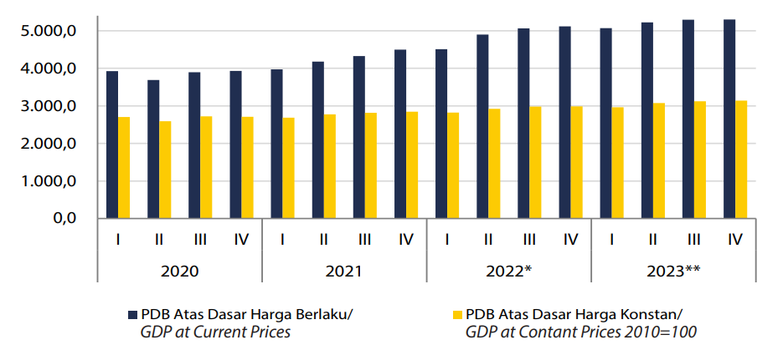
Source: Statistic Indonesia (BPS), 2024
Annex 2. Economic Inflation of Indonesia 2020-202
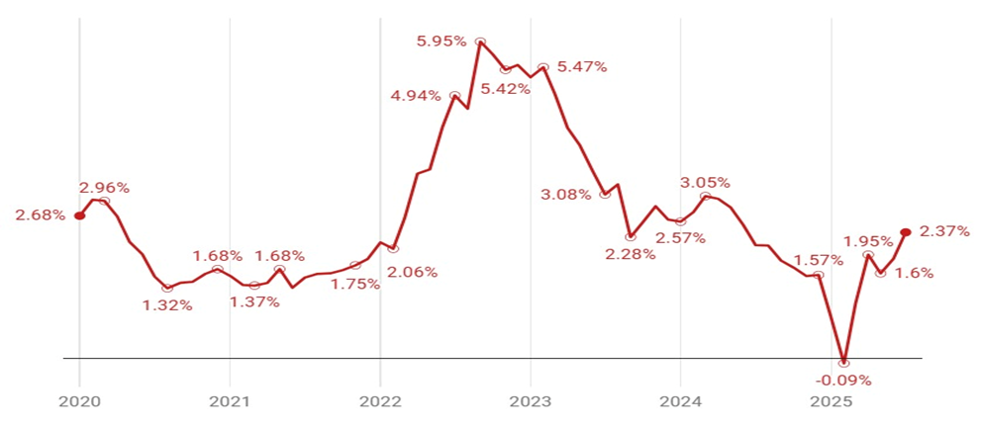
Source: Data processed from Bank Indonesia, accessed in 2025.

Annex 3. GDP Maritim 2019-2023: Value and Contribution to National GDP
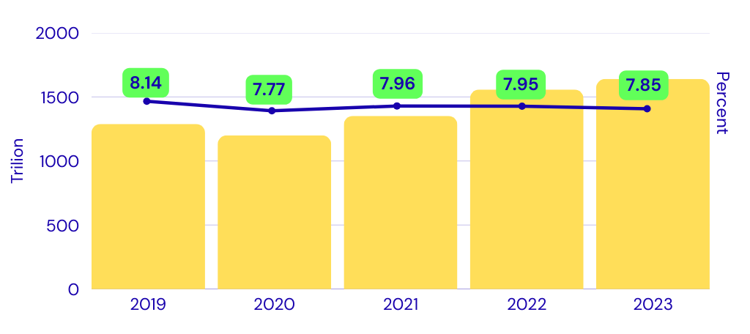

Source: Statistic Indonesia (BPS) and Coordinating Ministry of Marine Affair and Investment, 2024

Annex 4. Indonesia Debt 2000-2024

Source: statistica.com (2025)
statista.com/statistics/531621/national-debt-of-indonesia/

Annex 5. Unemployment Rate of Indonesia 2014-2024

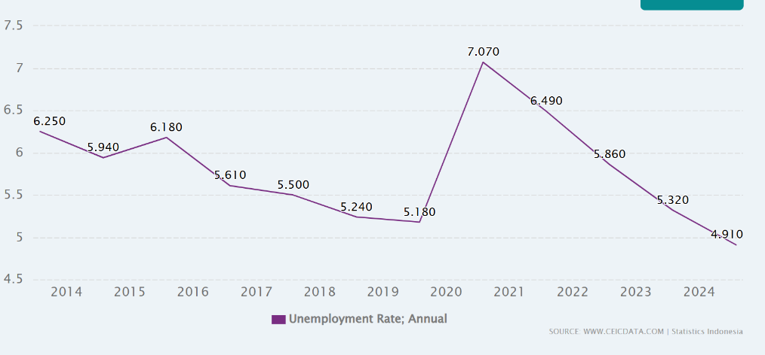

Appendix Source: https://www.ceicdata.com/en/indicator/indonesia/unemployment-rate

Annex 6. Foreign Direct Investment Realization in Indonesia, 2010–2023

Source: Indonesia Investment Coordinating Board (BKPM), 2025

Annex 7. The Provinces and Regencies/Cities adjacent to the South China Sea (SCS).
Province | District/City | Capital | Population (people)
Kepulauan Riau | Natuna | Ranai | 84.017
Kepulauan Riau | Kepulauan Anambas | Tarempa | 50.703
Kepulauan Riau | Bintan | Bandar Seri Bentan | 178,826
Kepulauan Riau | Karimun | Tanjung Balai Karimun | 272.391
Kepulauan Riau | Batam | Batam | 1.294.548
Kepulauan Riau | Lingga | Daik | 101.978
Kepulauan Riau | Tanjungpinang | Tanjungpinang | 237.580
Bangka Belitung | Bangka | Sungailiat | 335,292
Bangka Belitung | Bangak Tengah | Koba | 209,117
Bangka Belitung | Bangka Selatan | Toboali | 213,871
Bangka Belitung | Bangka Barat | Muntok | 216,238
Bangka Belitung | Pangkalpinang | Pangkalpinang | 239,730
Bangka Belitung | Belitung | Tanjungpandan | 191,252
Bangka Belitung | Belitung Timur | Manggar | 132,121
West Kalimantan | Pontianak | Pontianak | 682.896
West Kalimantan | Singkawang | Singkawang | 247.924
West Kalimantan | Sambas | Sambas | 648.307
West Kalimantan | Kayong Utara | Sukadana | 127.346
West Kalimantan | Ketapang | Delta Pawan | 581.859
South Sumatera | Palbang | Palembang | 1.781.672
Source: Agregat Jumlah Penduduk Per Kabupaten Kota. Satu Data Pemerintahan Dalam Negeri accessed 2025. https://pelita.kemendagri.go.id/kemendagri/dataset/1490/tabel-data

Annex 8. List of NGOs and local special interest group in each provinces bordering the South China Sea (SCS)
Province and  NGO and Special Interest Group | Interest
Province and  NGO and Special Interest Group | Socio-Economic | Coastal & Marine Pollution | Fisheries & Aquaculture | Coastal & Marine Ecosystems
- Kepulauan Riau Province
WALHI | ✔ | ✔ | ✔ | ✔
JATAM | ✔ | ✔ | ✔ | ✔
KIARA | ✔ | ✔ | ✔ | ✔
Dompet Dhuafa | ✔
LSM Alim |  | ✔ |  | ✔
LSM PLH-K |  | ✔ | ✔ | ✔
Akar Bhumi Indonesia |  | ✔ |  | ✔
Yayasan Embun Pelangi | ✔
- Bangka Belitung Province
WALHI Bangka Belitung | ✔ | ✔ | ✔ | ✔
HNSI Bangka Belitung (Fishermen's Association of All Indonesia) | ✔ | ✔ | ✔ | ✔
Yayasan ALOBI |  | ✔ |  | ✔
SNV (Netherlands Development Organisation) | ✔
LSM Laskar Hijau |  | ✔ |  | ✔
- West Kalimantan Province
WALHI Kalimantan Barat | ✔ | ✔ |  | ✔
Lembaga Gemawan | ✔
Swandiri Institute |  | ✔ |  | ✔
Yayasan Sampan Kalbar | ✔ |  |  | ✔
AMAN Kalbar (Alliance of Indigenous Peoples of the Archipelago) | ✔ |  |  | ✔
RiAk Kalbar (JARI Borneo Barat) |  | ✔ |  | ✔
KIARA (Koalisi Rakyat untuk Keadilan Perikanan) | ✔ | ✔ | ✔ | ✔

Annex 9. List of Trade Association and Business Group and special interest group in each provinces bordering the South China Sea (SCS)

Province-  Trade Association and Business Group | Interest
Province-  Trade Association and Business Group | Socio-Economic | Coastal & Marine Pollution | Fisheries & Aquaculture | Coastal & Marine Ecosystems
- Kepulauan Riau Province
KADIN Kepri (Kamar Dagang & Industri) | ✔ | ✔ | ✔ | ✔
INSA Kepri (Indonesian National Shipowners' Assoc.) | ✔ | ✔
PHRI Kepri (Perhimpunan Hotel & Restoran) | ✔ |  |  | ✔
APINDO Kepri (Indonesian Employers Association) | ✔
HKI Kepri (Himpunan Kawasan Industri) | ✔ | ✔
- Bangka Belitung Province
PT Timah Tbk | ✔ | ✔ | ✔ | ✔
AETI (Indonesian Tin Exporters Association) | ✔ | ✔
KADIN Babel (Kamar Dagang & Industri) | ✔ | ✔ |  | ✔
PHRI Babel (Perhimpunan Hotel & Restoran) | ✔ |  |  | ✔
- West Kalimantang Province
GAPKI Kalbar (Gabungan Pengusaha Kelapa Sawit) | ✔ | ✔ |  | ✔
Asosiasi Penambang (Bauksit, Zirkon) | ✔ | ✔ |  | ✔
KADIN Kalbar (Kamar Dagang & Industri) | ✔ | ✔ | ✔ | ✔
PHRI Kalbar (Perhimpunan Hotel & Restoran) | ✔ |  |  | ✔

Annex 10. List of Co-Management, Traditional System and Customary Right in each provinces bordering the South China Sea (SCS)

Province-  Organization/System | Interest
Province-  Organization/System | Socio-Economic | Coastal & Marine Pollution | Fisheries & Aquaculture | Coastal & Marine Ecosystems
- Kepulauan Riau Province
Orang Suku Laut (Orang Laut) | ✔ |  | ✔ | ✔
Lembaga Adat Melayu (LAM) Kepri | ✔ |  |  | ✔
Pokmaswas (Kelompok Masyarakat Pengawas) |  |  | ✔ | ✔
Hutan Adat (Masyarakat Adat) | ✔ |  |  | ✔
- Bangka Belitung Province
Pokmaswas (Kelompok Masyarakat Pengawas) |  |  | ✔ | ✔
Lembaga Adat Mapur (Orang Lom) | ✔ |  | ✔ | ✔
Moang Jong (Tradisi Suku Sawang) | ✔ |  | ✔ | ✔
- West Kalimantan Province
Perhutanan Sosial (Hutan Desa/Hutan Adat) | ✔ |  | ✔ | ✔
Pokmaswas (Kelompok Masyarakat Pengawas) |  |  | ✔ | ✔
Masyarakat Adat (via AMAN) | ✔ | ✔ |  | ✔
Kearifan Lokal Nelayan Pesisir (Melayu Sambas/Kubu) | ✔ |  | ✔ | ✔

Annex 11. List of Decentralized Agency in each provinces bordering the South China Sea (SCS)

Province-  Decentralized Agency | Issue
Province-  Decentralized Agency | Socio-Economic | Coastal & Marine Pollution | Fisheries & Aquaculture | Coastal & Marine Ecosystems
- Kepulauan Riau Province
DPRD Provinsi Kepri | ✔ | ✔ | ✔ | ✔
Fisheries and Marine Affair Office (Dinas Kelautan & Perikanan/DKP) Kepri Province | ✔ |  | ✔ | ✔
Dinas Lingkungan Hidup & Kehutanan (DLHK) Kepri |  | ✔ |  | ✔
BAPPEDA Kepri | ✔ | ✔ | ✔ | ✔
Musrenbang (Village/Regency/Province) | ✔ | ✔ | ✔ | ✔
- Bangka Belitung Province
DPRD Provinsi Babel | ✔ | ✔ | ✔ | ✔
DKP Babel (Dinas Kelautan & Perikanan) | ✔ |  | ✔ | ✔
DLH Babel (Dinas Lingkungan Hidup) |  | ✔ |  | ✔
BAPPEDA Babel (Badan Perencanaan Pembangunan Daerah) | ✔ | ✔ | ✔ | ✔
Musrenbang (Musyawarah Perencanaan Pembangunan) | ✔ | ✔ | ✔ | ✔
- West Kalimantang Province
DPRD Provinsi Kalbar | ✔ | ✔ | ✔ | ✔
BAPPEDA Kalbar | ✔ | ✔ | ✔ | ✔
DKP Kalbar (Dinas Kelautan & Perikanan) | ✔ |  | ✔ | ✔
DLHK Kalbar (Dinas Lingkungan Hidup & Kehutanan) |  | ✔ |  | ✔
Musrenbang (Musyawarah Perencanaan Pembangunan) | ✔ | ✔ | ✔ | ✔

Annex 12. Method for Risk Governance Analysis

Governance Risk Analysis is approached through three components: Completeness, Engagement, and Integration. The calculation of the governance risk components is as follows.

A. Completeness
Completeness is assessed based on 7 components of the policy cycle, which include:
- Policy analysis and advice,
- Policy decision-making,
- Planning analysis and advice,
- Planning decision-making,
- Implementation,
- Review and evaluation,
- And data and information.
Each component of the policy cycle within a formal arrangement is given a score of 0-3, following Fanning et al. (2017). The step to calculate of completeness score for each formal arrangement follows the subsequent explainatoin.

Completeness score for each formal arrangement is calculated based on following formula.

$Ci=\frac{\sum_{j=1}^{n}{c_{ji}}}{C_{maxi}} x 100\%$
C_{i} = Completeness score for the i-th formal arrangement (%)
j = The j-th policy cycle component, from 1 to n
c_{i}= Completeness score for the j-th policy cycle component of the i-th formal arrangement
C_{max i} = Maximum possible completeness score for the i-th formal arrangement, derived from the total number of policy cycle components (n) multiplied by the maximum score of 3.

The total Completeness score (C) is the mean of the completeness scores for all formal arrangements, calculated using the following formula.

$$C=\frac{\sum_{i=1}^{m}{C_{i}}}{m}$$
Where:
C = Total completeness score (%)
i = Formal arrangement, from 1 to m
C_{i} = Completeness score of the i-th formal arrangement (%)
m= Total number of formal arrangements

The scoring for the completeness stage follows Fanning et al. (2017), as detailed below:
Advisory mechanism (policy and management)
0 = No transboundary science policy mechanism
1 = Science-policy interface mechanism unclear - irregular, unsupported by formal
documentation
2 = Science-policy interface not specified in the agreement, but identifiable as a regular process
3 = Science-policy interface clearly specified in the agreement

Decision-making (policy and management):
0 = No decision-making mechanism
1 = Decisions are recommendations to specific agency
2 = Decisions are binding with the possibility for agency to opt out of complying
3 = Decisions are binding

Implementation:
0 = Agency alone
1 = Agency supported by secretariat
2 = Agency and sub-national support
3 = Implemented through a coordinated national and regional mechanism

Review:
0 = No review mechanism
1 = Countries review and self-report
2 = Agreed review of implementation at regime level
3 = Agreed compliance mechanism with repercussions

Data and information:
0 = No DI mechanism
1 = Countries provide DI which is used as is
2 = DI centrally coordinated, reviewed and shared
3 = DI centrally managed and share

B. Integration

Integration among stakeholders for each formal arrangement is scored on a scale of 0-1. A score of 0 indicates no integration, while a score of 1 indicates full integration. The integration score for the i-th formal arrangement is derived according to the following formula.
$$I_{i}=\frac{\sum_{i}^{m}{I_{ki}}}{I_{maxi}}x 100\%$$
Where:
I_{i}= Integration score of stakeholders for the i-th formal arrangement.
k = The k-th stakeholder integration combination.
I_{k}= Stakeholder integration score for the k-th combination.
I_{ki}= Stakeholder integration score for the k-th combination within the i-th formal arrangement.
I_{maxi}= Maximum possible stakeholder integration score for the i-th formal arrangement, which occurs if all I_{ki} values are 1.
The total integration score is calculated using the following formula:

$$I=\frac{\sum_{i=1}^{m}{I_{i}}}{m}$$
Where:
I = Total integration score (%)
i = Formal arrangement, from 1 to m
I_{i}= Integration score for the i-th formal arrangement (%)
m = Total number of formal arrangements

- Engagement
Engagement illustrates the level of involvement of key stakeholders in addressing several transboundary issues that require resolution or formal arrangement. Stakeholders’ engagement to each formal arrangement is scored on a scale of 0-1. A score of 0 indicates no engagement, while a score of 1 indicates full engagement. Stakeholder engagement within a single formal arrangement is calculated using the following formula.

$$E_{i}=\frac{\sum_{i=1}^{m}{E_{si}}}{E_{maxi}}x100\%$$

Where:
Ei= Stakeholder engagement score for the i-th formal arrangement.
Es = Engagement score for the s-th stakeholder.
Esi = Engagement score of the s-th stakeholder within the i-th formal arrangement.
Emaxi = Maximum possible stakeholder engagement score for the i-th formal arrangement, which is achieved when all E<sub>si</sub> values are 1.
The total engagement score is calculated according to the following formula.

$$E=\frac{\sum_{i=1}^{m}{E_{i}}}{m}$$
Where:
E = Total engagement score (%)
i = Formal arrangement, from 1 to m
Ei = Engagement score for the i-th formal arrangement (%)
m = Total number of formal arrangements

- Governance Risk Classification

Governance risk classification refer to Fanning et al. (2017) classification.
Risk Range | Completeness Range (%) | Integration Range (%) | Engagement Range (%)
Very low | 80-100 | 80-100 | 80-100
Low | 60-80 | 60-80 | 60-80
Medium | 40-60 | 40-60 | 40-60
High | 20-40 | 20-40 | 20-40
Very High | 0-20 | 0-20 | 0-20

Annex 13. The completeness score for each formal arrangement
- Completeness Arrangement Score for inclusive development governance

Policy cycle stage | Responsible body or agency | Score | Observation
policy analysis and advice | BAPPENAS, Coordinating Ministry of Economy | 3 | Arrangements for addressing socio-economic and inclusive governance of development issues are formally articulated in the National Medium-Term Development Plan (RPJMN). These arrangements are mandated for implementation by local governments and are actively responded by Non-Governmental Organizations (NGOs).
policy decision-making | BAPPENAS, Coordinating Ministry of Economy, Ministry of Environment, Ministry of Fisheries and Marine Affair, Ministry of Forestry | 3
Planning analysis and advice | BAPPENAS, Coordinating Ministry of Economy | 3
Planning decision-making | BAPPENAS, Ministry of Environment, Ministry of Fisheries and Marine Affair, Ministry of Forestry | 3
Implementation | Ministry of Environment, Ministry of Fisheries and Marine Affair, Ministry of Forestry, Local Gov’ts, NGO | 3
review and evaluation | Ministry of Environment, Ministry of Fisheries and Marine Affair, Ministry of Forestry, Local Gov’ts, | 3
Data and information | Ministry of Environment, Ministry of Fisheries and Marine Affair, Ministry of Forestry, Local Gov’ts | 2
 |  | 20/21 =95.2%

- Completeness Arrangement Score for marine pollution control

Policy cycle stage | Responsible body or agency | Score | Observation
policy analysis and advice | Ministry of Environment, University, National Research and Innovation Agency | 2 | Transboundary marine pollution primarily consists of oil spills/sludge, notably originating from ship tank cleaning operations. Currently, issues concerning plastic debris and Abandoned, Lost, or otherwise Discarded Fishing Gear (ALDFG) are also emerging. The management of oil spills from ship tank cleaning falls under the primary authority of the Ministry of Environment (KLH) and the Ministry of Transportation, in relation to International Maritime Organization (IMO) prerequisites
policy decision-making | Ministry of Environment | 3
Planning analysis and advice | Ministry of Environment, University, National Research and Innovation Agency | 2
Planning decision-making | Ministry of Environment, University, Ministry of Transportation, Ministry of Energy and Mineral Resource | 3
Implementation | Ministry of Environment, Ministry of Transportation, Ministry of Fisheries and Marine Affair, Ministry of Energy and Mineral Resource, Local Government | 3
review and evaluation | Ministry of Environment, Ministry of Transportation, Ministry of Fisheries and Marine Affair, University | 2
Data and information | Ministry of Environment, Ministry of Fisheries and Marine Affair, Ministry of Forestry | 2
 |  | 17/21 =80.95.%

- Completeness Arrangement score for the protection of coastal ecosystem

Policy cycle stage | Responsible body or agency | Score | Observation
policy analysis and advice | Ministry of Environment, Ministry of Fisheries and Marine Affair, University | 2 | Ecosystem management for natural resource protection is led by the Ministry of Environment (KLH) but involves the Ministry of Forestry (Kemenhut) (for mangroves), the Ministry of Marine Affairs and Fisheries (KKP) (for mangroves, coral reefs, and seagrasses), and Provincial Governments.
policy decision-making | Ministry of Environment, Ministry of Fisheries and Marine Affair, Ministry of Forestry | 3
Planning analysis and advice | Ministry of Environment, Ministry of Fisheries and Marine Affair, Ministry of Forestry, University, National Research and Innovation Agency | 2
Planning decision-making | Ministry of Environment, Ministry of Fisheries and Marine Affair, Ministry of Forestry | 3
Implementation | Ministry of Environment, Ministry of Fisheries and Marine Affair, Ministry of Forestry, Local Gov’t, NGO | 3
review and evaluation | Ministry of Environment, Ministry of Fisheries and Marine Affair, Ministry of Forestry, Local Gov’t | 2
Data and information | Ministry of Environment, Ministry of Fisheries and Marine Affair, Ministry of Forestry, Local Gov’t | 2
 |  | 17/21 =80.95%

- Completeness Arrangement score level for improving coastal community wellbeing through development of Capture Fisheries and Aquaculture

Policy cycle stage | Responsible body or agency | Score | Observation
policy analysis and advice | Ministry of Fisheries and Marine Affair, BAPPENAS, University, National Research and Innovation Agency | 2 | The policy for developing capture fisheries and aquaculture falls under the authority of the Ministry of Marine Affairs and Fisheries (KKP). However, as it pertains to production targets within national development planning, the Ministry of National Development Planning (Bappenas) is also involved. At the policy analysis level, the process significantly involves universities and the National Research and Innovation Agency (BRIN).
policy decision-making | Ministry of Fisheries and Marine Affair, BAPPENAS | 3
Planning analysis and advice | Ministry of Fisheries and Marine Affair, BAPPENAS, University, National Research and Innovation Agency | 2
Planning decision-making | Ministry of Environment, Ministry of Fisheries and Marine Affair, Ministry of Forestry | 3
Implementation | Ministry of Fisheries and Marine Affair, Local Gov’t | 3
review and evaluation | Ministry of Fisheries and Marine Affair, Bappenas, Local Gov’t | 2
Data and information | Ministry of Fisheries and Marine Affair, Gov’t | 2
 |  | 17/21 =80.95%

- Average Score level of Formal Arrangement Completeness for Governance of SCS
No. | Formal Arrangement | Score (%)
1 | Inclusive governance | 95.20
2 | Marine Pollution Control | 80.95
3 | Coastal ecosystem protection | 80.95
4 | Capture Fisheries and Aquaculture Development | 80.95
 | Average | 84.51

Annex 14. The score of integration of each formal arrangement
The score of stakeholder integration to formal arrangement based on policy cycle components.
Common agency between formal arrangement | policy analysis and advice | policy decision-making | Planning analysis and advice | Planning decision-making | implementation | review and evaluation | data and information
1 and 2 | 0 | 0 | 0 | 0 | 1 | 1 | 1
1 and 3 | 1 | 1 | 1 | 1 | 1 | 0 | 1
1 and 4 | 1 | 1 | 1 | 1 | 1 | 1 | 1
2 and 3 | 0 | 0 | 0 | 0 | 0 | 1 | 0
2 and 4 | 0 | 0 | 0 | 0 | 1 | 1 | 0
3 and 4 | 1 | 0 | 1 | 1 | 1 | 1 | 1
 | 3/6=50% | 2/6=33.33% | 3/6=50% | 3/6=30% | 5/6=83.33% | 5/6=83.33% | 4/6 =67.67%

Annex 15. Stakeholder’s engagement to formal arrangement
Stakeholder | Arrangement
Stakeholder | Inclusive governance | Marine pollution control | Coastal Ecosystem protection | Development of capture fisheries and aquaculture
Ministry of National Development Planning (BAPPENAS) | V |  |  | V
Ministry of Environment (KLH) | V | V | V | V
Ministry of Forestry (Kemenhut) | V |  | V
Ministry of Marine Affairs and Fisheries (KKP) | V | V | V | V
Ministry of Industry (Kemenperin) |  | V
Ministry of Transportation (Kemenhub) |  | V
Ministry of Energy and Mineral Resources (Kemen ESDM) |  | V
National Research and Innovation Agency (BRIN) |  | V | V | V
Indonesian Coast Guard (Bakamla)
Universities |  | V | V | V
Local Governments (Pemda) | V | V | V | V
Non-Governmental Organizations (NGOs) | V |  | V | V
% engagement | 50.00 | 67.00 | 58.3 | 58.30

