- CONCLUSION of the National TDA Report

Meeting the TDA objectives
The Transboundary Diagnostic Analysis (TDA) update aims to advance the management of transboundary ecosystems by shifting the focus from simply assessing environmental conditions to evaluating associated risks to ecosystems, populations, and livelihoods. It also sharpens an integrated view of governance at national and regional scales that enables formulating multi-focal strategic actions.
National TDA reports will supply detailed inputs at watershed and country levels to support this integrated assessment. Quantitative directional indicators allow for comparison of changes across subnational and national scales and can be translated into risk levels at both national and LME scales. This risk-informed framework facilitates proactive decision-making and provides a foundation for prioritizing strategic interventions.
Serving as a foundational scientific assessment, the TDA systematically identifies and evaluates transboundary environmental issues in the South China Sea. Its strength lies in the integrated analysis of pollution, ecosystem status, fisheries, socio-economic drivers, and governance factors. Understanding interactions among these components such as how pollution affects fisheries or how socio-economic activities influence ecosystem pressures is critical for designing effective adaptation and mitigation strategies.
Mapping these interactions fosters a shared governance vision, encouraging collaborative decision-making and harmonized policies for sustainable coastal and marine resource management. Analysis across the five domains highlights complex cross-domain interactions that must be considered in planning and management

7.2. Key conclusions and crosscutting interactions
In this report, Transboundary Diagnostic Analysis (TDA) is a foundational scientific assessment that systematically identifies and evaluates environmental problems that extend across sub-national boundaries within this national marine ecosystem within the boundaries of the South China Sea (SCS). Central strength of the TDA lies in its integrated analysis of multiple interacting components — in this report encompassing 5 domains i.e. pollution status, ecosystems conditions, fisheries dynamics, socio-economic drivers, and governance factors — to capture the full dimension of coastal and marine environmental pressures.
Recognizing how these components interact is crucial because environmental stressors in the SCS’s Indonesia boundary occur as part of multi-interactions between the components, for example how is pollution dynamics may affect fisheries and how socioeconomics drivers may effluence the pollution or other ecosystems disturbance in case of SCS’s Indonesia boundary. Understanding these multi-interactions can help to identify the adaptation and mitigation strategies required to enhance the quality of coastal and marine governance for the region. Moreover, mapping the relationships between these components increases shared vision and mission among the governance level for sustainable coastal and marine resources management in the region. By doing so, the shared governability platform may underpin collaborative decision-making and harmonized policy design.
We make conclusions for the context of interactions between domains by using interactions/network analysis using indicators per domain as shown in Table 26 below.
Table 26 Domain and Indicators Used in the Interactions/Network Analysis
Domain | Indicators
Pollution | P-Agriculture
 | P-Domestic Waste
 | P-Solid Waste
 | P-Hazardous (Industry)
 | P-Oil Pollution
 | P-Atmospheric
 | P-Hotspot of Pollution
Fisheries | F- Fisheries Production
 | F- Catch Structures/Composition
 | F- Fishing Efforts
 | F-Ratio of Capacity-enhancing subsidies to value of landed catch
 | F-Primary production required (ecological footprint of fisheries)
 | F-Marine Trophic Index (MTI)
 | F-Fishing in Balance Index (FIB)
 | F-Catch from Bottom-Impacting Gear Types
 | F-Change in Catch Potential Under Global Climate Change
 | F-Aquaculture Productions
Ecosystems | E-Occurrence and Existence of Ecosystem
 | E-Ecosystem Health
 | E-Sensitivity and Vulnerability
 | E-Rehabilitation and Restoration
 | E-Restoration and Conservation
Socio-Economics | S-Demographic
 | S-Human Wellbeing
 | S-Economic Activity
 | S-Climate Indicators
Governance | G-Legal Setting
 | G-Policy Setting
 | G-Governance Performance Effectiveness
 | G-Completeness
 | G-Integration
 | G-Engagement

Using a simple networks analysis, we put a value of interactions by 4 types i.e. 0-no interactions, 1 – small interactions, 3 – medium interactions, and 5 - high interactions. With all of interactions may occur among the cross indicators (38x38), we can have value of interactions and total value of interactions per indicator as presented in Appendix 7.1 and Appendix 7.2. Valuation of interactions is conducted using professional judgement method conducted among the TDA team members.

Using the interactions and total value of interactions between all indicators of five domains i.e. pollution, ecosystem, fisheries, socioeconomics, and governance we can reveals that their interactions are very complex in terms of their affection on one to another. Figure 56 shows the complexity of all networks between indicators (i.e. total 38 indicators) of five domains.
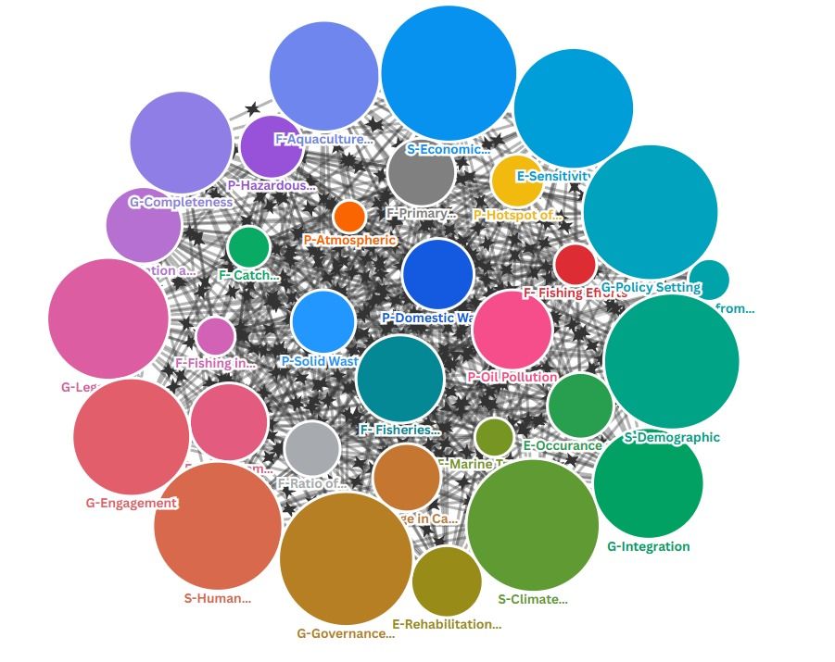

Figure 56 Overall networks/interactions of all indicators of pollution, ecosystem, fisheries, socioeconomics and governance

Further analysis of interactions shows that for the domain of pollution; indicator oil pollution is the most interacted indicator among others in the context of its relation to all other indicators of TDA’s domains. While, in the domain of fisheries, indicator of aquaculture productions is the most sensitive interconnected indicator, indicator ecosystem sensitivity and vulnerability is the most interconnected from the perspective of ecosystems domain. In th context of socio-economics domain, indicator of economic activity and human well-being has the most sensitive interconnectivity among others and in the domain governance, indicator government effectiveness is the most important indicators in terms of its connectivity. Figure 57 shows the interactions of the most indicator for each domain relative to all other indicators.

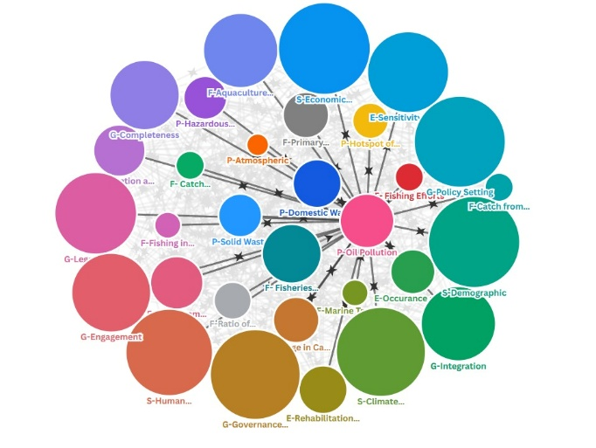 | 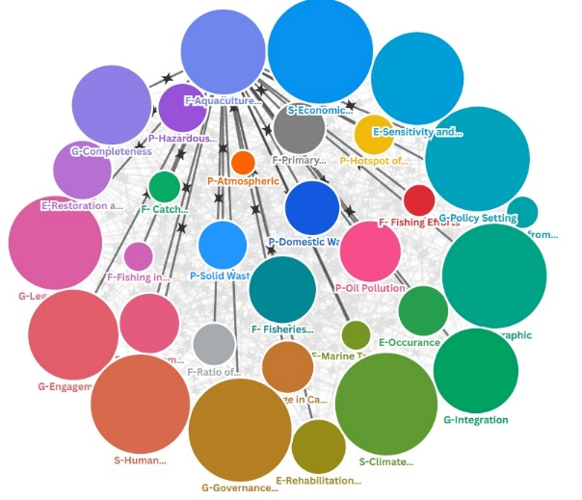
A. P-Oil pollution | B. F-Aquaculture
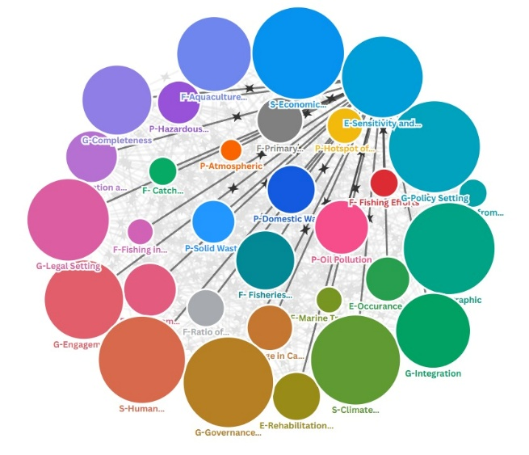 | 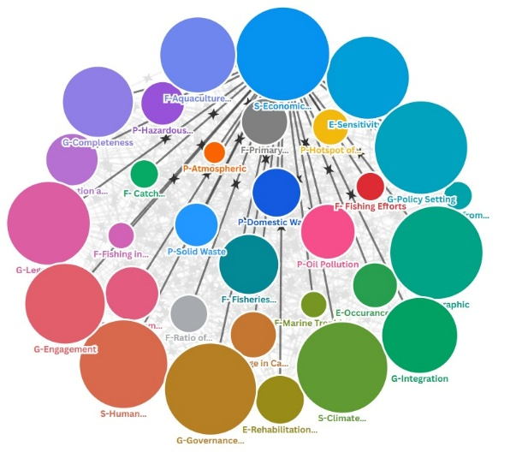
C. E-Sensitivity and Vulnerability | D. S-Economic Activities
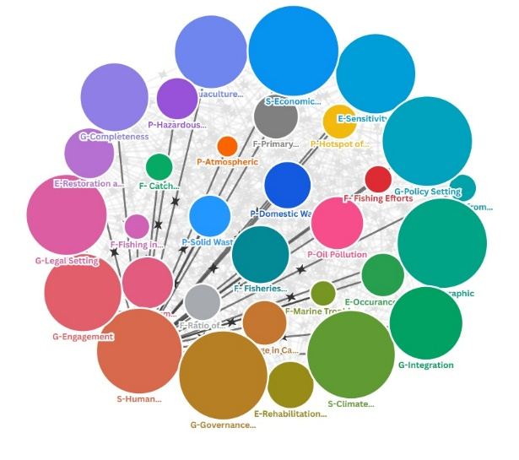 | 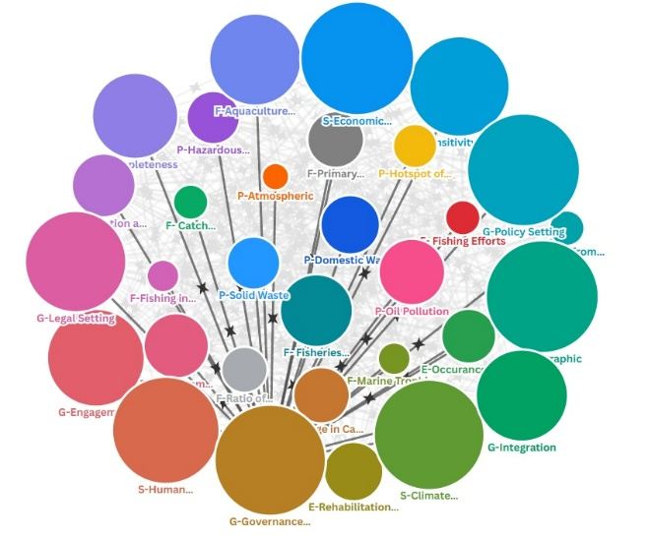
E. S-Human Wellbeing | F. G-Government Effectiveness

Figure 57 Interactions of the Most Connected Indicators in Relations to Other Indicators for Each Domain

From the analysis we can conclude that shared governability platform should be designed using such collaborative decision-making and harmonized policy within sub national and national level of the Indonesia’s TDA boundary especially for the interaction between oil pollution, aquaculture productions, ecosystem sensitivity and vulnerability, economic activity and human well-being and governance effectiveness.

7.3. Patterns of risk among spatial units of analyses and at country scale
A composite analysis of all key indicators across each unit of analysis are pollution, ecosystem, fisheries, governance, and socio-economic dimensions reveals distinct risk class patterns, as presented in Matrix. Green flag indicates low-risk relationships, yellow flag represents moderate risk, and red flag denotes high-risk conditions. In addition, the risk representation pattern derived from the analysing units of analysis is illustrated in Figure 58. The socio-economic component functions as the dominant risk driver, governance acts as a systemic risk amplifier, the ecosystem serves as the primary risk receiver, while fisheries and pollution operate as secondary drivers and mediators. The mapping of these analytical units within the TDA framework for the Indonesian region is shown in the following figure.

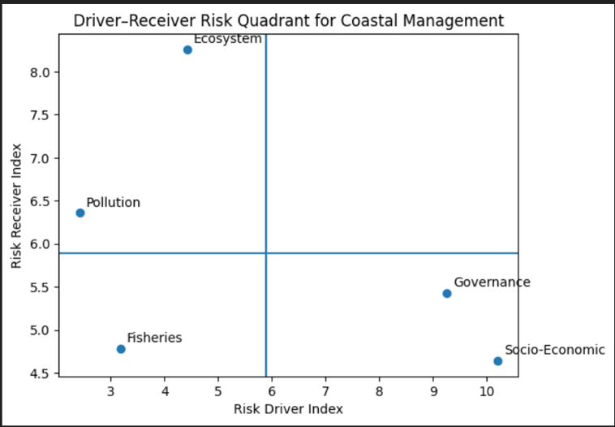

Figure 58 Risk classes and spatial distribution of risk based on driver and receiver characteristics of the analytical units.

Based on the risk class analysis, the distribution of analytical units is identified according to their roles as risk drivers or risk receivers. Socio-Economic; This dimension acts as the primary driver of risk within the coastal management system. Socio-economic pressures—such as livelihood dependency, poverty, competition over coastal space, and population growth—generate substantial risk for other sectors while being relatively less affected by them. The risk reduction strategies should prioritize structural socio-economic interventions, including livelihood diversification, social protection, and economic resilience, rather than focusing solely on environmental remediation.
The governance functions as a systemic risk amplifier. Weak regulatory frameworks, fragmented institutional mandates, and limited enforcement capacity both generate and absorb risks across all sectors. Strengthening governance represents the most strategic entry point for risk mitigation, as improvements in institutional coordination and enforcement capacity simultaneously reduce multiple risk pathways.
Primary risk receivers is ecosystem unit on Indonesia region. The ecosystem dimension emerges as the main recipient of risk, rather than a significant source. Ecosystem degradation is largely the cumulative outcome of pressures originating from socio-economic activities, governance failures, and sectoral exploitation. Ecosystem restoration should be framed as a response to systemic risk, not as the primary risk prevention mechanism.

Secondary drivers and mediators with low driver low receiver of risk area fisheries and pollution unit. Fisheries operate as a context-dependent mediator. Poorly managed fisheries can escalate risks, while adaptive and sustainable fisheries management can mitigate socio-economic and ecological pressures. Pollution primarily functions as an impact indicator, reflecting the combined effects of upstream socio-economic and governance drivers. Sector-specific management remains important but should be aligned with broader socio-economic and governance reforms

7.4. Target audience
Legal and institutional mapping has identified at least fifteen key stakeholders that must be engaged in the management of Indonesia’s jurisdictional waters in the South China Sea (SCS). These stakeholders demonstrate varying degrees of interest and intensity across critical issues, including marine pollution, ecosystem-based assessment, climate change, fisheries and livelihoods, endangered species conservation, and the marine/blue economy. For analytical clarity, these issues can be grouped into four primary focal areas: (1) socio-economic dimensions, (2) coastal and marine pollution, (3) fisheries and aquaculture and (4) coastal and marine ecosystems.
Addressing the complex challenges of SCS management requires the establishment of formal governance arrangements, which encompass: (1) Inclusive governance to ensure broad stakeholder participation and representation, (2) marine pollution control to mitigate environmental degradation, (3) coastal ecosystem protection to safeguard biodiversity and ecological resilience and (4) capture fisheries and aquaculture development to promote sustainable resource use and livelihoods. The effective implementation of these arrangements is contingent upon robust stakeholder support at both national and sub-national levels. Such engagement is essential to foster legitimacy, enhance coordination, and ensure that management strategies are both sustainable and responsive to diverse stakeholder interests.
Empirical evidence indicates that stakeholder support for the established formal arrangements remains suboptimal, with significant variation in the intensity of integration across different stages of the policy cycle. Integration, understood as the process of combining, involving, and aligning stakeholder interests within strategies, policies, or management activities for the South China Sea (SCS), is currently assessed at a medium risk level and requires substantial improvement.
While integration is relatively stronger during the implementation and evaluation stages, it is notably weaker in the policy formulation and decision-making phases. The lowest scores are observed in policy decision-making and early implementation, where decisions tend to be dominated by a small number of influential stakeholders rather than being taken collectively and participatively. This imbalance undermines inclusivity and reduces the legitimacy of governance processes, making it difficult to secure broad-based support. Stakeholders excluded from early stages are unable to fully comprehend or commit to the design of formal arrangements, thereby weakening overall alignment.
The limited integration during policy formulation has a direct impact on stakeholder engagement, which also remains below optimal levels. Engagement, defined as the active involvement of stakeholders in formal arrangements, varies across governance mechanisms but generally falls within the medium to low range. Although engagement is highest in the domain of marine pollution control, even this area requires further strengthening to ensure effective outcomes.
The combined weakness of integration and engagement constrains the performance of governance systems, resulting in effectiveness levels that range from low to medium, with a predominance at the lower end. This suggests that while the completeness of policy design is relatively adequate, the quality of participatory processes remains insufficient. The lack of inclusivity and collective decision-making increases governance risks, particularly in terms of legitimacy, stakeholder buy-in, and long-term sustainability.

To enhance performance, it is necessary to strengthen the role of stakeholders who function as nodes or integrators in decision-making, both at the planning and implementation stages. From a national perspective, the roles of the Ministry of Environment, the Ministry of Marine Affairs and Fisheries, and the Ministry of National Development Planning/Bappenas are vital in promoting stakeholder integration and engagement. These roles extend beyond mobilizing ministries and agencies at the central level to also encompass sub-national institutions, particularly provincial governments. This is crucial given that the institutional authority for managing the South China Sea (SCS) lies not only with national bodies but also with provincial governments, notably West Kalimantan, Bangka Belitung, and the Riau Islands. Strengthened integration and engagement are expected to establish a domestic cooperation platform among stakeholders that is robust, stable, and well-directed for effective SCS management.

At the regional level, the Ministry of Foreign Affairs must coordinate effective diplomacy while inclusively incorporating input from a broad range of stakeholders, including central and local governments, researchers, NGOs, and civil society groups. The Ministry of Foreign Affairs plays a critical role as the spokesperson for Indonesia’s interests in regional cooperation forums on SCS governance. Outcomes from these forums should then be operationalized by relevant technical ministries and institutions, ensuring that regional commitments are translated into concrete national and sub-national actions.

Future indicator-based environmental assessments
Based on the assessment of environmental conditions, which reflects the outcomes of interactions between ecosystem components and the drivers of disturbance and degradation, it is evident that the current set of indicators is not yet sufficient to comprehensively describe environmental dynamics. The environment is a complex system in which biophysical, chemical, and biological components interact continuously with both natural and anthropogenic stressors. Therefore, to better capture these interactions and their implications, several additional indicators need to be incorporated in future assessments.
These proposed indicators are presented according to each ecosystem component, allowing for a more structured and component-specific evaluation. The inclusion of such indicators is expected to improve the sensitivity of monitoring efforts in detecting early signs of environmental change, disturbance, or degradation. Furthermore, these indicators will provide more robust information for understanding causal relationships between ecosystem processes and external pressures.
The addition of these indicators is intended to support more effective and adaptive environmental management in the future. By enhancing the analytical framework, decision-makers will be better equipped to design targeted management strategies, prioritize intervention measures, and evaluate management performance over time. Ultimately, the expanded indicator set will contribute to more sustainable ecosystem management and improved environmental resilience.
Table 27 Additional indicators for each component of future environmental management are proposed based on an assessment of existing interactions among components in the management of the Indonesian sector of the South China Sea (SCS).
Component | Additional Indicators | Typical unit | Data required
Pollution | Eutrophication Index | Index | Dissolved oxygen; DIN; DIP; Chl-a
 | Riverine load | ton/day of Total N | River discharge; total N
 |  | ton/day of Total P | River discharge; total P
 |  | Number/day | River discharge; Total Coliform
 | Volume of oil sludge stranded | Ton/m2 | Volume of oil sludge
 | Volume of marine debris stranded | Ton/m2 | Volume of marine debris based on types
Fisheries | Sustainable Fisheries | Sustainable Index | Production; DIN; DIP
 |  | Number of illegal fishing | Number of cases
 |  | Number and volume of the abandoned fishing gears | Volume of abandoned fishing gears
 | Aquaculture Productions | Feed Conversion Ratio - FCR | Measures the amount of feed required to produce 1 kg of fish biomass
 |  | Water Use Efficiency | The volume of water used per unit of production (m³/kg)
 |  | Biodiversity Impact Index | The percentage of native species affected by fish escapes or habitat alteration. Target: <5% loss of local species, measured through ecosystem monitoring
Ecosystems | Policy Development for Ecosystem Protection and Mitigation | Mitigation action  Destruction reducing  Literation | The future important indicator is strengthening the policy action and plan to mitigate and protect the potential source of ecosystem production
Governance | Regional cooperation and coordination | Regional cooperation and coordination in addressing transboundary pollution issues | Frequency and volume of oil sludge stranded, frequency and volume of marine debris stranded
 |  | Regional cooperation and coordination in addressing transboundary fisheries issues | Frequency and volume of illegal fishing

The table above presents a comprehensive list of additional indicators required to strengthen the assessment framework for pollution, fisheries, and ecosystem management, with a particular focus on the Indonesian waters of the South China Sea (SCS). These indicators were identified to address existing gaps in the current assessment system and to better capture the complexity of environmental interactions within the study area. The Indonesian sector of the SCS is characterized by diverse ecological processes, intensive human activities, and transboundary environmental pressures, which necessitate the use of context-specific indicators.
The additional indicators proposed in this table are not intended to be universally applied across all regions of Indonesia. Instead, they represent indicators that are particularly relevant to the environmental conditions, management challenges, and ecological characteristics of the Indonesian SCS waters. The selection of these indicators was informed by an inter-component assessment analysis that examined interactions among pollution sources, fisheries activities, and ecosystem components under existing conditions at the time this study was conducted.
By incorporating these additional indicators, the assessment framework is expected to provide a more integrated and holistic understanding of environmental status and management effectiveness. This enhanced framework will support evidence-based decision-making, facilitate adaptive management strategies, and improve the capacity to respond to emerging environmental pressures in the Indonesian sector of the SCS.

Apendix Chapter 7

