
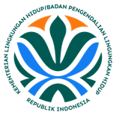
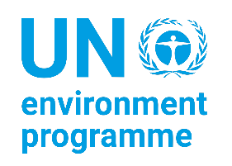



Transboundary Diagnostic Analysis/ TDA Report

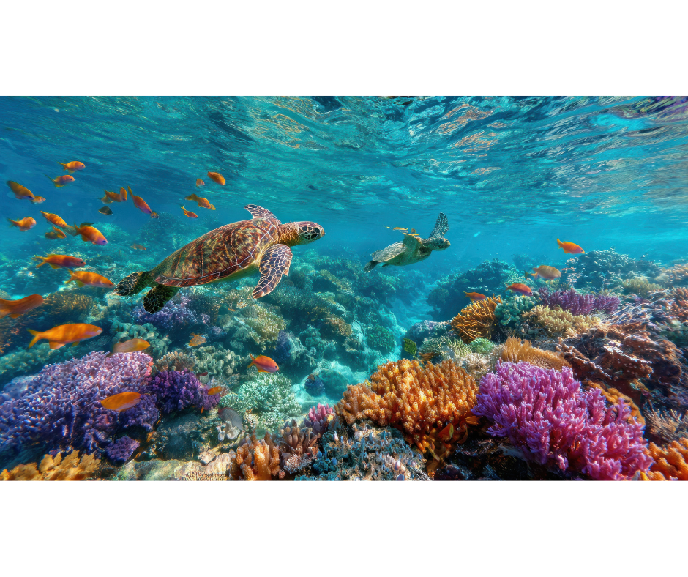
Implementation of National Activities of the UNEP/GEF Implementing the Strategic Action Transboundary Diagnostic Analysis/ TDA Report
Implementation of National Activities of the UNEP/GEF Implementing the Strategic Action Programme for the South China Sea and Gulf of Thailand

DECEMBER 2025

This report was prepared by the Center for Coastal and Marine Resources Studies (CCMRS) of IPB University, Indonesia

Acknowledgements

Lead Authors
Luky Adriato, Yonvitner, Ario Damar, Taryono Kodiran, Mochammad Riyanto

Contributing Authors
Sayid Muhadhar, Aditya Yuniarti, Heru Waluyo, Nyoto Santoso, Fery Kurniawan, Tri Edi Kuriandewa, Ragil Satriyo Gumilang, Isdahartati, Bambang Yudho Rudianto, Retno Purwaning Hastuti, Lusita Meilana, Dony Suhartono Kesowo, Boimin, Akhmad Nurhijayat, Retia Revany, Qonita Sinatria, Aisyah Qurota A’yun, Hafizh Raihan Jayanegara, Ainnur Widiastuti Khoirunnisa

Reviewers

Name | Primary affiliation | Primary review responsibility
Peer Review
Liana Talaue McManus | Independent Marine Science & Policy Consultant  SCS SAP Project TDA-SAP Lead
Vo Si Tuan | UNEP/GEF Implementing the Strategic Action Programme for the South China Sea | Regional Science Coordinator
Megan Patricia KNIGHT | UNEP/GEF Implementing the Strategic Action Programme for the South China Sea | International Environmental and Natural Resources Specialist
Gil Suico JACINTO | The Marine Science Institute, University of the Philippines Diliman | Marine Science (LbP)
Anders Faaborg POULSEN | UNEP/GEF Implementing the Strategic Action Programme for the South China Sea | Senior Project Manager
Somboon SIRIRAKSOPHON | SEAFDEC/UNEP/GEF Fisheries. Refugia | Project Director of the SEAFDEC/UNEP/GEF Fisheries. Refugia
Reynaldo F Molina | UNEP/GEF Implementing the Strategic Action Programme for the South China Sea | Project Management Support Specialist

Feedback

Key Dates | Milestone Output | Porpose
October 30, 2025 | Upload of 1st version of Complete TDA Report | Substantive eveluation by TDA-SAP Team for integration to and comparation with the LME-scale Regional TDA Report
November 30, 2025 | Upload of 2^{sd} version of Complete TDA Report | For circulation to Jan 2026 Meeting Participants
December 5, 2025 | Distribution od TDA Report to January 2026 Meeting Participant | - Initial review by Project RSTC if TDA Report are project-compliant. RSTC to define technical review process of TDA report as GEF sponsored publication  - Initial scoping of recommendation action by the RWG Economic Valuation
January 19-23, 2026 | Project Meeting | - Presentation of National and Regional TDA report  - RSTC Meeting to evaluate TDA report for project compliance and to define technical review process  - RWG economic Valuation to recommended valuation template to identify NET BENEFITS of ACTION and NET COSTS on INACTION as bases to prioritizing recommended action that will comprise the SAP at national and LME scales
Preface

This Transboundary Diagnostic Analysis (TDA) Report has been prepared as an official national submission under the United Nations Environment Programme/Global Environment Facility (UNEP/GEF) Project: Implementing the Strategic Action Programme for the South China Sea and Gulf of Thailand (SCS SAP). The Report constitutes a fundamental component of the regional undertaking to systematically identify, assess, and prioritize environmental issues of transboundary concern, with particular focus on socio-economic dimensions, critical coastal and marine ecosystems, land-based pollution, fisheries, and governance.

In accordance with established international methodologies, the TDA presents a comprehensive and scientifically substantiated assessment of the condition and trends of key ecosystems—mangroves, coral reefs, seagrass beds, and wetlands and evaluates the immediate and underlying drivers contributing to their degradation. The analysis further addresses the socio-economic implications associated with the use and management of coastal and marine resources, including impacts on livelihoods, economic activities, and community resilience.

The Report additionally examines the scope and severity of pollution, with emphasis on land-based sources, including solid and liquid waste, nutrient enrichment, and industrial and agricultural discharges that affect coastal water quality and ecosystem health. The status of fisheries resources is analysed in relation to overexploitation, habitat loss, and transboundary stock dynamics, highlighting the need for strengthened management measures and collaborative approaches. Furthermore, the TDA evaluates existing governance frameworks, regulatory instruments, institutional capacities, and cross-sectoral coordination mechanisms that influence the effectiveness of national and regional marine environmental management efforts.

The preparation of this Report has been made possible through the sustained cooperation and technical contributions of national institutions, government authorities, academic and scientific bodies, and relevant stakeholders. Their inputs have been essential to ensuring the accuracy, completeness, and policy relevance of the analyses and findings presented.
It is anticipated that the outcomes of this TDA will provide a robust basis for evidence-based decision-making, promote enhanced regional coordination, and support the coherent and effective implementation of national and regional commitments under the SCS SAP. The continued commitment of all participating countries remains vital to safeguarding the ecological integrity and ensuring the long-term sustainability of the shared marine and coastal resources of the South China Sea and the Gulf of Thailand.

This Report reflects the analysis conducted by the author team as part of an assignment commissioned by the Ministry of Environment and coordinated by the Center for Coastal and Marine Ocean Resources Studies (PKSPL), IPB University.

Acronyms

ALDFG | : | Abandoned, Lost, or Discarded Fishing Gear. Fishing gear that is abandoned, lost, or discarded, is a transboundary issue and is prohibited from being dumped into the sea under KKP regulations.
B3 | : | Hazardous and Toxic Waste Materials (Bahan Berbahaya dan Beracun). Waste whose management is regulated by key legislation but faces critical challenges due to a lack of processing facilities across all regions.
BAKAMLA | : | Indonesian Maritime Security Agency (Badan Keamanan Laut Republik Indonesia). An agency involved in Indonesia's maritime governance, including handling Pollution and Illegal Fishing.
BPS | : | Central Statistics Agency (Badan Pusat Statistik). The institution that is the source of Indonesia's economic statistical data, such as economic growth and GDP.
COFA/Kemenko Pangan | : | Coordinating Ministry of Food Affair (Kementerian Koordinator Urusan Pangan)
CRDP | : | Climate Resilience Development Policy. The 2020-2045 Climate Resilience Development Policy guiding Indonesia's national strategy.
DKP | : | Marine and Fisheries Agency (Dinas Kelautan dan Perikanan). A provincial-level body involved in marine resource management, including handling illegal fishing.
ETP Species | : | Endangered, Threatened, and Protected Species. Species such as sea turtles, which are regulated through the KKP and KLH regulatory frameworks.
FADs | : | Fish Aggregating Devices. Devices used to aggregate fish, whose improper placement often occurs in Natuna waters.
GDP | : | Gross Domestic Product. An indicator of economic growth. The maritime sector's contribution to Indonesia's total GDP averaged 7.93% during the 2020–2024 period.
MHA/Kemendagri | : | Ministry of Home Affair/Kementerian Dalam Negeri (Kemendagri)
MOMAF/KKP | : | Ministry of Marine Affairs and Fisheries/Kementerian Kelautan dan Perikanan (KKP). The main Ministry involved in maritime governance, covering issues of Ecosystems, Climate Change, Fisheries, and the Blue Economy.
IMSA/BAKAMLA | : | Indonesia Maritime Security Agency/Badan Keamanan Laut Nasional (Bakamla)
MOE/KLH | : | Ministry of Environment/Kementerian Lingkungan Hidup (KLH). The Ministry involved in maritime governance, covering issues of Pollution, Ecosystem-Based Assessment, Climate Change, and Endangered Species.
MOEMR/ESDM | : | Ministry of Energy and Mineral Resource/Kementerian Energi dan Sumberdaya Mineral (ESDM)
MOFA/Kemlu | : | Ministry of Foreign Affair/Kementerian Luar Negeri (Kemenlu)
MOIDI | : | Ministry of Investment and Downstreaming Industry (Kementerian Investasi dan Hilirisasi Industri)
MONDP/Bappenas | : | Ministry of Developing Planning/Badan Perencana Pembangunan Nasional (Bappenas)
MOT/Kemenhub | : | Ministry of Transportation (Kementerian Perhubungan). The Ministry is involved in maritime governance, particularly in Pollution/Transportation issues, and is the main coordinator for oil spill response.
MOTCE/Kemenparekraf | : | Ministry of Tourism and Creative Economy/Kementerian Pariwisata dan Ekonomi Kreatif (Kemenparekraf)
MCS | : | Monitoring, Control, and Surveillance. Monitoring, control, and surveillance actions taken to manage fishery resources, such as addressing overfishing in WPP 711.
NDC | : | Nationally Determined Contribution. Emission reduction target aligned with Indonesia's RPJMN, targeting a cumulative emission reduction of 30.1% by 2029.
PMRA/BRGM | : | Peatland and Mangrove Rehabilitation Agency/Badan Restorasi Gambut dan Mangrove (BRGM)
RPJMN | : | National Medium-Term Development Plan (Rencana Pembangunan Jangka Menengah Nasional). The development plan mandating low-carbon development for the 2025-2029 period.
SCS | : | South China Sea. Waters of strategic, geopolitical, and resource-rich importance where Indonesia's governance is focused in this document.
SLR | : | Sea Level Rise. A climate-related threat causing a decrease in land productivity, coastal flooding (banjir rob), and coastal erosion.
UNCLOS 1982 | : | United Nations Convention on the Law of the Sea. An international treaty governing socio-economic and climate threat issues, including Indonesia's Exclusive Economic Zone (EEZ).
FMA/WPP 711 | : | Fishery Management Area 711 (Wilayah Pengelolaan Perikanan 711/WPP 711). A fishing area in the South China Sea water as part of Indonesia FMA.
ZEE | : | Exclusive Economic Zone (Zona Ekonomi Eksklusif). Indonesia's maritime zone regulated under UNCLOS 1982.

Contents

Acronyms 5
Technical Summary 12
1. INTRODUCTION 12
1.1 The Project Objective 12
1.2 Assessment Methodology 13
2. SOCIO-ECONOMIC: Socio-Economic Conditions and Climate Risks in the South China Sea– A Multi Regional Analysis of Eastern-Southern Sumatera and Western Kalimantan Coastal Area to Strengthen Indonesia’s Coastal and Marine Resilience 14
2.1. Introduction 14
2.2. Key Finding Concern 15
2.3. Methodology 15
2.4. Results and Discussion 16
2.5. Discussion 29
2.6. Recommended Priority Actions 30
References 32
3. ECOSYSTEM: Coastal Frontiers - Indonesia’s Coastal Ecosystem Insights in South China Sea and Gulf Thailand 34
3.1. Introduction 34
3.2. Key Finding 35
3.3. Current Ecosystem Status 35
3.4. Discussion 41
References 47
4. POLLUTION: The status and recent management of the marine pollution in the waters of the Indonesian part of the South China Sea 50
4.1. Introduction 50
4.2. Key Finding 51
4.3. Current Status by indicator group 51
4.4. Pollution Hotspots and Sensitive Areas 55
4.5. Discussion 57
4.6. Gaps and Priority Challenges 61
4.7. Recommended Priority Actions, Emphasizing Regional Cooperation 62
4.8. Conclusion 64
References 64
5. FISHERIES: The Status and Recent Management of the Fisheries and Aquaculture Sector in the Fisheries Management Area of 711, part of the South China Sea 68
5.1. Introduction 68
5.2. Key Finding Concern 69
5.3. Overexploitation of Living Aquatic Resources 69
5.4. Status of Coastal Aquaculture 79
5.5. Problems and Issues 82
5.6. Conclusion 83
References 83
6. GOVERNANCE: The governance of Indonesia water as part of the South China Sea 86
6.1. Introduction 86
6.2. Key Governance Concern 87
6.3. Current Status 87
6.4. Discussion and Conclusion 96
6.5. Recommended priority actions including regional cooperation 99
6.6. Conclusion 99
References 100
7. CONCLUSION of the National TDA Report 102
7.1. Meeting the TDA objectives 102
7.2. Key conclusions and crosscutting interactions 102
7.3. Patterns of risk among spatial units of analyses and at country scale 105
7.4. Target audience 107
7.5. Future indicator-based environmental assessments 108
APPENDIXES 110
Appendix Chapter 3 (Ecosystems) 111
Appendix Chapter 4 (Pollution) 119
Appendix Chapter 6 (Governance) 135
Appendix Chapter 7 (Conclusion) 158

Figure Contents

Figure 1 The research locations for the Transboundary Diagnostic Analysis (TDA) 12
Figure 2 Assessment methodology 13
Figure 3 Research Location Socio-economic 16
Figure 4 Subnational Coastal Population (Persons – thousands) (Data source: Statistics of Indonesia) 16
Figure 5 Population Sex Ratio in the Study Locations (Data Source: Statistics of Indonesia) 17
Figure 6 Areas of Subnational First-Level Administrative Regions (Data Source: Statistics of Indonesia) 17
Figure 7 Population Distribution (%) in the Study Locations (Data Source: Statistics Indonesia) 18
Figure 8 Subnational Coastal Region Areas as a Percentage of the National Area in the Study Locations (Data Source: Statistics of Indonesia) 19
Figure 9 Percentage Change per Year (Growth or Attrition) in the Study Locations 19
Figure 10 Population Density (per sq. km) in the Study Locations (Data Source: Statistics of Indonesia) 20
Figure 11 Number of Villages/Subdistricts by Province and Topographical Areas (Valley) 20
Figure 12 Number of Villages/Subdistricts by Province and Topographical Areas (Slop) 20
Figure 13 Number of Villages/Subdistricts by Province and Topographical Areas (Flat) 21
Figure 14 Percentage of Poor Population in Study Locations 21
Figure 15 Average Years of Schooling in the Study Area 22
Figure 16 Adjusted Real Expenditure per Capita per Year in the Study Area 22
Figure 17 Human Development Index in the Study Locations 22
Figure 18 presents the Gross Regional Domestic Product (GRDP) at current market prices for the study locations in 2021. 23
Figure 19 shows the Gross Regional Domestic Product (GRDP) at current market prices for the study locations in 2022. 23
Figure 20 presents the Gross Regional Domestic Product (GRDP) at current market prices for the study locations in 2023. 24
Figure 21 Fishery Value (Rp million) in the Research Locations in 2021 (Average exchange rate 2021: 1 USD ≈ Rp 14,308) 24
Figure 22 (a) Schematic diagram of sea surface temperature and atmospheric overturning circulations in the SCSSA (Yang et al. 2024) (b) Known global impacts of climate change in the SCSSA (Yang et al. 2024) 28
Figure 23 Mangrove, Coral, Seagrass and Wetland Distribution 36
Figure 24 Regional Variability in Coral Habitat Extent Within Indonesian Marine Protected Areas 36
Figure 25 Regional Variability in Seagrass Habitat Extent Within Indonesian Marine Protected Areas 37
Figure 26 Seagrass connectivity of Enhalus acroides biodiversity (Hadi, et al, 2023) 39
Figure 27 The distribution of EETS species in Indonesia 41
Figure 28 South China Sea Indonesia’s part (red box) 51
Figure 29 Estimates of total volume (tonnes) of uneaten feed (become waste) Aquaculture (tonnes) in several provinces in the area around the SCS from 2019 to 2024 (source: Indonesia Fisheries Statistics 2020, 2021, 2022, 2023, 2024). 52
Figure 30 Distribution of subsidized urea fertilizer in the agricultural sector (tonnes) in the provinces adjacent to SCS area (source: Environment Statistics of Indonesia 2020, 2021, 2022, 2023, 2024) 52
Figure 31 Distribution of subsidized urea fertilizer in the agricultural sector (tonnes) in the provinces adjacent to SCS area (source: Environment Statistics of Indonesia 2020, 2021, 2022, 2023, 2024) 53
Figure 32 Volume of hazardous waste (B3) Tonnes from each of the provinces in the SCS region (source: Environment Statistics of Indonesia, 2020, 2021, 2022, 2023, 2024). 53
Figure 33 Annual riverine pollutant loads of NH₃-N (upper chart), TSS (middle chart) and Total Coliform (lower chart) of each river into South China Sea waters (source: data analysis 2025) 54
Figure 34 Annual solid waste generation based on municipality, regencies and provinces 2022-2023 (source: Environment Statistics of Indonesia, 2020, 2021, 2022, 2023, 2024). 55
Figure 35 RWQI calculated at each province for the period between 2019-2023 (source: Environment Statistics of Indonesia, 2020, 2021, 2022, 2023, 2024) 56
Figure 36 Distribution of marine water quality index (IKAL) values across the provinces associated with Indonesia’s South China Sea (SCS) region (source: Environment Statistics of Indonesia, 2020, 2021, 2022, 2023, 2024). 57
Figure 37 Hydrodynamics process in the South China Sea (above) and around Bintan Island where oil frequently stranded (source: Wang et al., 2019; Kok et al., 2021; Nie et al., 2023) 58
Figure 38 The South China Sea’s shipping lanes connecting the Mallaca Strait and the South China Sea passing through the Indonesia’s province of Riau Kepulauan (source: ERIA, 2016) 59
Figure 39 Marine pollution caused by oil sludge on the Bintan Coastal, Indonesia, in 2023 (Purnaweni et al., 2022; Thahira et al., 2023) 60
Figure 40 Coverage of the SCS sub-area that is part of WPPNRI 711 69
Figure 41 Capture fisheries production in the South China Sea from 1950 to 2019 (FAO, 2022) 70
Figure 42 Capture fisheries by species group production in the South China Sea from 1950-2019 (FAO, 2022) 71
Figure 43 Freshwater production potential from 1960 to 2020 (FAO, 2022) 72
Figure 44 Production potential (FAO, 2022) 72
Figure 45 Fish production (tonnes) by fisheries sector in the South China Sea from 1950 to 2019 73
Figure 46 Fish production (tonnes) in the South China Sea from 1950-2019 (FAO, 2022) 74
Figure 47 Fish production value in the South China Sea from 1950-2019 (FAO, 2022) 75
Figure 48 Number of fleets in the South China Sea from 1950 to 2019 77
Figure 49 Projected change in fisheries catch potential in the South China Sea (WPPNRI 711) from 1990 to 2025, adapted from Cheung et al. (2016), Palomares & Pauly (2020), and IPCC (2022). 78
Figure 50 Aquaculture production by province from 1998 to 2024 80
Figure 51 Spatial distribution of multiyear warm season (1982-2020) in the SCS (Li et al., 2022) 81
Figure 52 Study Area Governance 87
Figure 53 The Economic Growth of Indonesia 2016-2023 88
Figure 54 Number (Million people) and Percentage of Poor Population by Island, March 2023 88
Figure 55 Growth of National GDP and Maritime GDP Growth at Current Price 89
Figure 56 Overall networks/interactions of all indicators of pollution, ecosystem, fisheries, socioeconomics and governance 104
Figure 57 Interactions of the Most Connected Indicators in Relations to Other Indicators for Each Domain 105
Figure 58 Risk classes and spatial distribution of risk based on driver and receiver characteristics of the analytical units. 106

Table Contents

Table 1 Distribution of Employed Persons Aged 15 Years and Over by Province and Major Industry, 2024 25
Table 2 Average of Net Wage/Salary per Month of Employee by Province and Main Occupation (rupiahs), 2024 25
Table 3 Provincial Minimum Wages per month (Rupiahs) 26
Table 4 Production Volume and Production Value of Fish Capture by Province and Type of Captures, 2023 27
Table 5 Production Volume and Production Value of Aquaculture by Province and Type of Culture, 2023 28
Table 6 Risk Assessment of Socio-economic 29
Table 7 Climate-Environmental Threats 29
Table 8 Critical Gaps Limiting Coastal Adaptation Effectiveness 30
Table 9 Strategic Coastal Adaptation Actions with Regional Cooperation Potential 31
Table 10 Sensitivity issue in Indonesia region 39
Table 11 The main identified issues and their descriptions 42
Table 12 Key issu and recommendation action and regional cooperation 43
Table 13 Recommendations for reducing pollution in the Indonesian South China Sea (SCS) Region 63
Table 14 Number of fleets by fishing boats and gears 73
Table 15 Exploitation level in the South China Sea from 1950 to 2019 75
Table 16 Environmental data of the South China Sea 77
Table 17: Aquaculture production of the seven provinces in the South China Sea 80
Table 18 Legal and institutional mapping, and stakeholders related to coastal and marine management in the South China Sea and Gulf of Thailand 90
Table 19 Legal Basis of International and Indonesia Regulation concerning to South China Sea waters 91
Table 20 Governance Performance and Effectiveness of Indonesia for South China Sea Waters 96
Table 21 Average Score level of Formal Arrangement Completeness for Governance of SCS 97
Table 22 Integration between key stakeholders on transboundary issues formal arrangement 97
Table 23 Stakeholder Engagement on Formal Arrangement 97
Table 24 Governance Risk Classification 97
Table 25 Aggregate Score of Governance Risk of Indonesia for SCS water 98
Table 26 Domain and Indicators Used in the Interactions/Network Analysis 102
Table 27 Additional indicators for each component of future environmental management are proposed based on an assessment of existing interactions among components in the management of the Indonesian sector of the South China Sea (SCS). 108

Technical Summary

INTRODUCTION
The SCS SAP Project is complemented by the UNEP/GEF initiative entitled “Establishment and Operation of a Regional System of Fisheries Refugia in the South China Sea and Gulf of Thailand,” implemented by SEAFDEC in Cambodia, Indonesia, Malaysia, the Philippines, Thailand, and Viet Nam. The project aims to operationalize and expand a regional network of fisheries refugia in order to strengthen the management of fisheries resources and the ecological linkages with critical marine habitats. This effort contributes directly to achieving the medium- and long-term objectives of the fisheries component of the Strategic Action Programme for the South China Sea. Further information is available at: https://fisheries-refugia.org/.
The research locations for the Transboundary Diagnostic Analysis (TDA) of Indonesia comprise five key sites: Bangka and Belitung Regency in Bangka Belitung Province; Bintan and Mapur Island in Kepulauan Riau Province; Batu Ampar in West Kalimantan Province; and Berbak Sembilang National Park in South Sumatra and Jambi Provinces, as presented in Figure 1.1
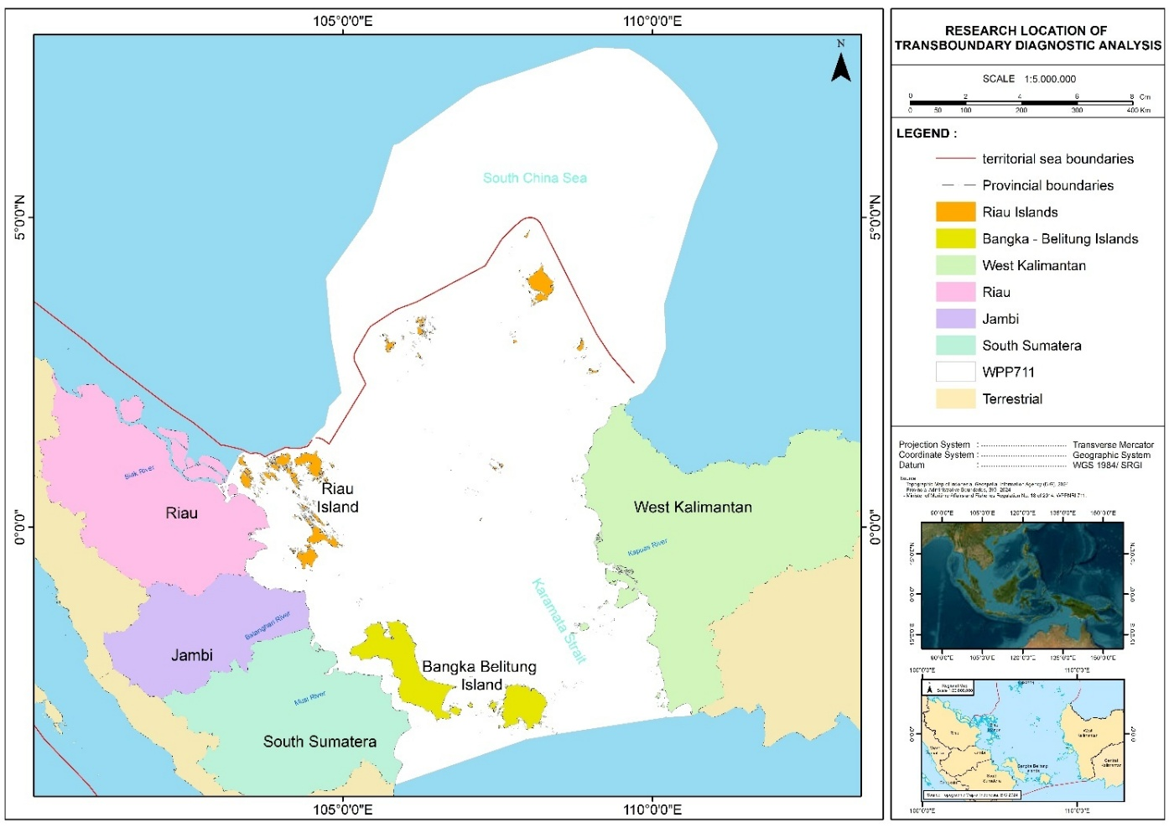
Figure 1 The research locations for the Transboundary Diagnostic Analysis (TDA)

1.1 The Project Objective
- The objective of the project is to support participating countries in achieving the targets of the approved Strategic Action Programme (SAP) for the marine and coastal environment of the South China Sea and Gulf of Thailand, through the implementation of National Action Plans in alignment with the SAP, and by strengthening regional coordination mechanisms for effective SAP implementation.
- The project will also contribute to global commitments, including the Sustainable Development Goals (SDGs), Agenda 2030, and the Convention on Biological Diversity (CBD) Post-2020 Global Biodiversity Framework.
- Activities will be implemented across local, national, and regional levels through three main components, with the aim of achieving the outcomes associated with Components 1, 2, and 3

1.2 Assessment Methodology
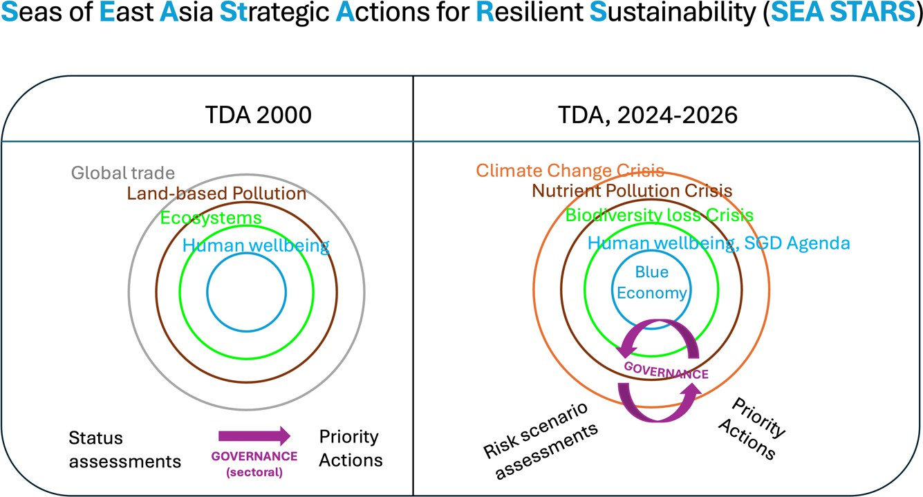
The current TDA update aims to underpin a shift from assessing environmental states to evaluating concomitant risks to ecosystems, people, and livelihoods. It also sharpens an integrated view of governance at national and regional scales that enables formulating multi-focal strategic actions. The national TDA reports will provide fine-scale inputs at the level of watersheds and countries in this integrated assessment. Quantitative directional indicators can be used to compare magnitudes of change across subnational scales and across countries and convert levels of risk at national and LME scales, see Figure 1. 2.
Figure 2 Assessment methodology

2. SOCIO-ECONOMIC: Socio-Economic Conditions and Climate Risks in the South China Sea– A Multi Regional Analysis of Eastern-Southern Sumatera and Western Kalimantan Coastal Area to Strengthen Indonesia’s Coastal and Marine Resilience
Luky Adrianto^{1,2}, Akhmad Nurhijayat¹, Ainnur Widiastuti Khoirunnisa¹, Isdahartati ¹
1) Center for Coastal and Marine Resources Studies, IPB University
2) Faculty of Fisheries and Marine Sciences, IPB University
Abstract
Indonesia’s coastal regions face intensifying social-ecological pressures driven by climate change, habitat degradation, and strong economic reliance on natural resources. This study assesses socio-economic vulnerability and climate risks across five key sites Bangka, Belitung, Mapur Island, Batu Ampar of Eastern Sumatera and Berbak Sembilang National Park of Western Kalimantan representing diverse coastal systems dependent on small-scale fisheries, mangrove and coral reef ecosystems, and, in Bangka, tin mining. Results show that sea-level rise, tidal flooding, shoreline erosion, and seawater intrusion are increasingly disrupting ecosystem functions and threatening local fisheries-based livelihoods. Each site exhibits distinct characteristics: Bangka experiences severe human-induced stress from intensive mining, while Mapur, Belitung, and Berbak Sembilang contain high-value ecosystems that remain essential for food security and fisheries productivity. Overall, the findings highlight that coastal vulnerability varies across locations and is shaped by the interaction of ecological conditions, livelihood dependence, and localized climate impacts. Strengthening resilience requires integrated, site-specific strategies that combine ecosystem-based management with targeted socio-economic adaptation measures
  - Introduction
The study sites Bangka Regency, Belitung Regency, Mapur Island of Eastern Sumatera, Sembilang National Park of Southern Sumatera and Batu Ampar of Western Kalimantan represent frontline zones of human–environment interaction in Indonesia’s coastal regions. Local economies in these areas rely heavily on small-scale fisheries, the integrity of coastal ecosystems such as mangroves and coral reefs, and, in some locations, extractive industries such as tin mining in Bangka. This dependence reflects regional economic characteristics documented in previous studies (FAO 2025; Bidayani et al., 2023; BPS 2024).
Climate- and coastal-related threats emerge as cross-cutting issues across all sites. Sea-level rise, tidal flooding, coastal erosion, and seawater intrusion have reduced productive land, disrupted fisheries supply chains and weakened the carrying capacity of coastal ecosystems (IPCC 2025; KKP 2024). These patterns are consistent with global evidence on the impacts of climate change on vulnerable coastal and island regions.
Despite sharing similar reliance on natural resources, each location exhibits distinct socio-economic dynamics. Bangka faces severe anthropogenic pressure from intensive tin mining, which drives habitat degradation and spatial competition. In contrast, Mapur Island and parts of Berbak Sembilang maintain high-value ecosystems, where mangroves and coral reefs support sustainable fisheries, local food security, and emerging ecotourism opportunities (Ibrahim 2023; Silvus 2018).
These findings highlight the need for coastal management strategies that are location-specific yet integrated. Such strategies must combine ecosystem-based conservation with socio-economic interventions to strengthen the climate resilience of coastal communities. Ecosystem protection, sustainable resource use, and proactive climate-risk anticipation are essential to achieving a balance between human well-being and environmental sustainability. Geographically, the five study areas exhibit diverse biophysical and administrative characteristics. The Bangka Belitung Islands Province 79.90% of which is marine area includes Bangka and Belitung Regencies, both characterized by tropical climates, hilly landscapes, and abundant natural resources such as fisheries, agriculture, and marine tourism (BPS 2019; Adibrata et al., 2023). In West Kalimantan, Kubu Raya Regency consists largely of lowlands and swamps, with Batu Ampar serving as a key coastal zone facing the Natuna Sea. In Riau Province, Mapur Island within Bintan Regency features low-lying coastal terrain with coral reef and seagrass ecosystems that support traditional fisheries. Meanwhile, Berbak Sembilang National Park in South Sumatra is a major coastal biodiversity hotspot, encompassing extensive mangrove forests, freshwater swamps, and estuarine waters that play vital roles in coastal protection and traditional fisheries livelihoods (Febriansyah et al., 2019). Overall, the profile of these sites illustrates that the interplay between biophysical conditions, anthropogenic pressures, and climate challenges demands an adaptive, integrated, and evidence-based approach to coastal management.
  - Key Finding Concern
The study sites Bangka, Belitung, Bintan, Mapur Island, Batu Ampar, and Berbak Sembilang National Park reflect strong human environment interactions in Indonesia’s coastal zones. Local economies depend on small-scale fisheries, healthy mangroves and coral reefs, and, in Bangka, tin mining.
All locations face climate-related risks such as sea-level rise, erosion, tidal flooding, and seawater intrusion, which threaten land, fisheries, and ecosystem stability.
While all rely on natural resources, each site has distinct conditions: Bangka is heavily impacted by tin mining, whereas Bintan, Mapur Island and Berbak Sembilang maintain high ecosystem value that supports fisheries, food security, and eco-tourism.
These findings highlight the need for location-specific yet integrated coastal management that protects ecosystems, manages resources sustainably, and strengthens community climate resilience.
  - Methodology
Data Types
This study applies a mixed-methods approach, combining secondary data, literature review, and primary data collected through field surveys and Focus Group Discussions (FGDs). This approach provides a comprehensive understanding of socio-economic conditions, coastal activities, and climate-related vulnerabilities in the study sites.

Data Analysis
Data were analyzed using a descriptive–visual approach that integrates descriptive statistics with spatial mapping to uncover key patterns and contrasts across coastal sites. This method is effective for capturing the diverse socio-economic dynamics and climate vulnerabilities present along Indonesia’s maritime zone bordering the South China Sea. Five study sites Bangka, Belitung, Mapur Island, Batu Ampar, and Berbak Sembilang National Park—were selected based on:
- their representation of major coastal social–ecological systems situated within or influenced by the South China Sea region;
- their high exposure to climate hazards, including sea-level rise, tidal flooding, shoreline erosion, and saltwater intrusion; and
- their contrasting anthropogenic pressures, ranging from intensive tin mining in Bangka, traditional fisheries and emerging tourism in Belitung and Mapur Island, low-lying geomorphological vulnerability in Batu Ampar, to the ecologically rich and conservation-critical wetlands of Sembilang.
These differences provide a strong basis for cross-site comparison and offer insight into how socio-ecological vulnerability manifests across coastal zones connected directly or indirectly to the broader South China Sea system (Figure 3).
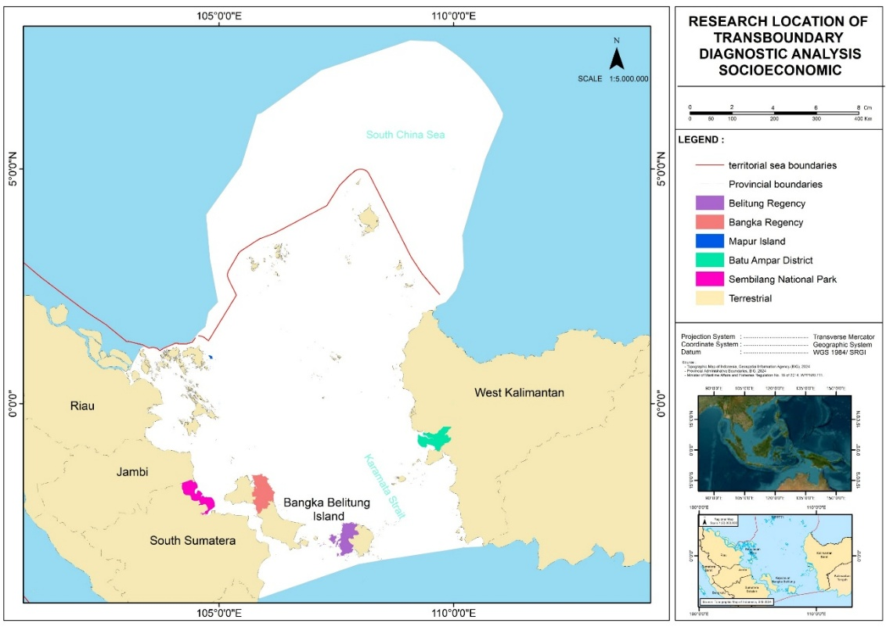

Figure 3 Research Location Socio-economic

  - Results and Discussion
    - Current Socioeconomics Status based on Indicator Group
      - Demographic Conditions
SE1-1. Subnational coastal populations
The coastal population in the study areas has continued to increase over time. South Sumatra has the largest coastal population, while the Bangka Belitung Islands have the smallest. These differences are influenced by the size of coastal areas and coastline length, which determine settlement capacity (Cisneros et al., 2016). Regions with long coastlines, such as South Sumatra and West Kalimantan, tend to have larger populations (Djunarsjah et al., 2023). Geographic conditions, accessibility, as well as economic factors and urbanization also contribute to this trend, particularly because major coastal cities like Palembang and Pontianak serve as population hubs (BPS, 2024). The demographic information is illustrated in Figure 4.

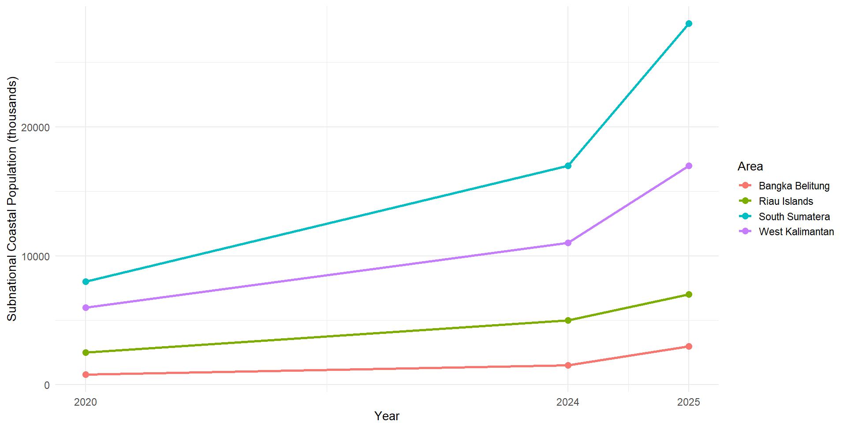
Figure 4 Subnational Coastal Population (Persons – thousands)
(Data source: Statistics of Indonesia)

The study locations show a declining sex ratio from 2020 to 2025, indicating a reduced dominance of the male population. This trend is linked to migration patterns, especially the movement of male workers into industrial and mining sectors. Weeks (2015) notes that demographic changes, including sex ratio shifts, are strongly shaped by mobility and urbanization. The Riau Islands and Bangka Belitung have higher sex ratios than the other regions because their major economic sectors fisheries, mining, and logistics employ more men. However, the recent decline may reflect changes in local economic structures and growing participation of women in both informal and formal sectors. This is consistent with gender-responsive coastal development approaches that promote equal access to economic opportunities and decision-making (FAO, 2020). The sex ratio distribution for the study areas is shown in Figure 5.

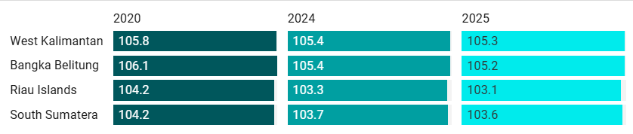
Figure 5 Population Sex Ratio in the Study Locations
(Data Source: Statistics of Indonesia)

SE1-2. Areas of subnational first level administrative region
The land area distribution across the four provinces shows geographic differences that directly influence coastal socio-economic development. West Kalimantan and South Sumatra have large land areas and long coastlines, giving them substantial potential for coastal and marine resources. However, this often creates spatial inequality, especially in access to infrastructure, markets, and public services between coastal and urban zones (Setiawan et al., 2021). From a Resilience Theory perspective (Folke et al., 2016), large territories require diverse strategies, including integrated maritime transportation, stronger local market networks, and protection of key ecosystems. In contrast, the Riau Islands Province is smaller but strategically located along international trade routes, allowing it to adopt faster-growing economic models based on maritime services and cross-border trade. Nurhidayah et al. (2023) highlight that small but strategically positioned provinces can maximize marine logistics, coastal tourism, and high–value fisheries. The distribution of subnational first-level administrative areas is illustrated in Figure 6.
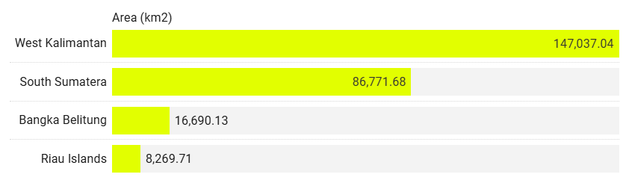
Figure 6 Areas of Subnational First-Level Administrative Regions
(Data Source: Statistics of Indonesia)

SE1-3. Subnational coastal populations as % of national
Population Distribution
During 2020–2025, South Sumatra contributed the largest proportion of coastal population to the national total (around 3.13–3.14%), followed by West Kalimantan at about 2%, while Bangka Belitung and the Riau Islands each accounted for less than 1%. These differences reflect varying demographic capacities that may shape coastal economic activity. Adrianto et al. (2019) note that provinces with larger coastal populations tend to have a wider labor base for fisheries, maritime, and trade sectors. However, high population concentration also increases pressure on coastal resources if not supported by sustainable management. The population distribution is shown in Figure 7.

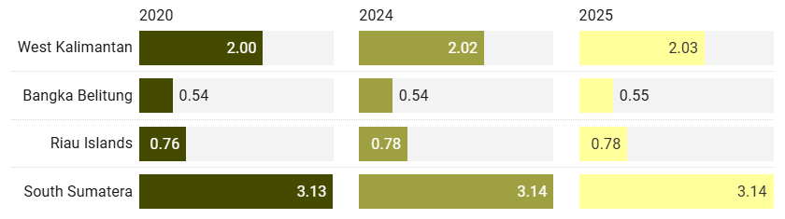
Figure 7 Population Distribution (%) in the Study Locations
(Data Source: Statistics Indonesia)

SE1-4. Subnational Coastal region areas as % of national area
The four provinces contribute differently to Indonesia’s total land area of 1,919,440 km². West Kalimantan has the largest coastal area at 147,037.04 km² (7.66%), reflecting its long coastline and broad landmass, which support fisheries, aquaculture, and port development. South Sumatra follows with 86,771.68 km² (4.52%), characterized by major river estuaries such as the Musi, Banyuasin, and Ogan that function as transport corridors and centers of coastal economic activity. The Bangka Belitung Islands cover 16,690.13 km² (0.87%), a small land proportion for an archipelagic province but rich in marine and mineral resources, particularly tin. These areas, however, face environmental pressures from mining and land-use change. The Riau Islands have the smallest coastal area at 8,269.71 km² (0.43%), yet their strategic position along the Malacca Strait and North Natuna Sea makes them economically and geopolitically important, with strengths in fisheries, trade, tourism, and port services. Overall, the variation in coastal area proportions reflects differing physical characteristics, resource potentials, and management challenges. Provinces with large coastal areas have greater marine economic opportunities but also require robust governance to maintain ecosystem sustainability. The proportional distribution of coastal areas is shown in Figure 8.

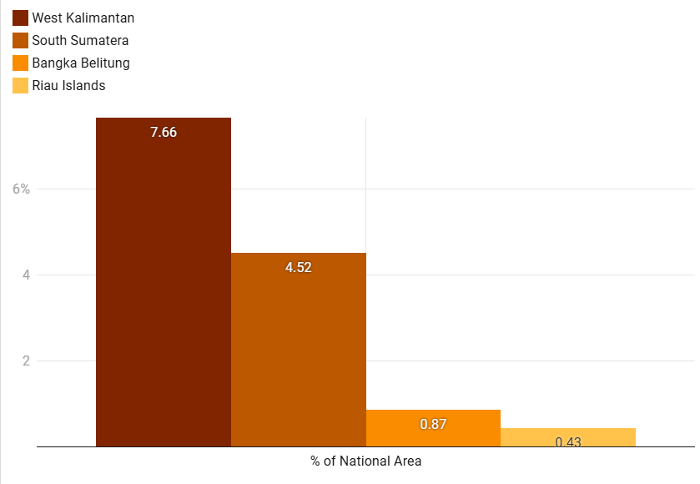
Figure 8 Subnational Coastal Region Areas as a Percentage of the National Area in the Study Locations (Data Source: Statistics of Indonesia)

SE1-5. Annual population changes
Annual population change in South Sumatra, West Kalimantan, Bangka Belitung, and the Riau Islands was assessed for 2010–2020, 2020–2024, and 2020–2025. All provinces show positive growth but with different trajectories. From 2010–2020, the Riau Islands grew fastest (2.02%) due to in-migration and BBK industrial expansion, followed by Bangka Belitung (1.70%). South Sumatra and West Kalimantan grew steadily at 1.25%. During 2020–2024, growth slowed in most provinces—linked to reduced mobility during COVID-19. South Sumatra dropped to 1.15%, Bangka Belitung to 1.36%, and the Riau Islands to 1.50%. In contrast, West Kalimantan rose to 1.62% due to new infrastructure and industrial development. For 2020–2025, the slowdown continued modestly: South Sumatra (1.12%), Bangka Belitung (1.34%), Riau Islands (1.48%). West Kalimantan remained relatively high at 1.60%. These variations reflect differing economic structures and migration drivers, where industrial hubs and resource-rich regions attract more population growth. Understanding these trends is essential for regional planning, labor policies, and preparing for challenges such as climate change and rapid urbanization (see Figure 9).

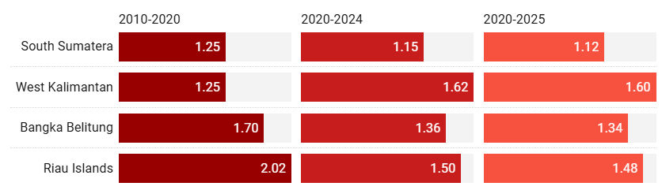
Figure 9 Percentage Change per Year (Growth or Attrition) in the Study Locations
(Data Source: Statistics of Indonesia)
SE1-6. Coastal population densities
Coastal population density in the study areas varies significantly. The Riau Islands show the highest density, rising from 252 people/km² in 2020 to 268 people/km² in 2025. Neumann et al. (2015) note that high coastal density is typically linked to strategic locations that serve as hubs for trade, international ports, and maritime industries, which stimulate urbanization and economic growth. However, high density can also create ecological pressures, including habitat degradation, coastal pollution, and spatial conflict between industry and fisheries. West Kalimantan has the lowest density due to its large land area and dispersed settlements. This provides opportunities for resource-based coastal development with lower environmental stress but also results in higher infrastructure and market access costs (Baiquni et al., 2021). Bangka Belitung and South Sumatra fall in the medium-density range, reaching 93 and 103 people/km² in 2025. According to the carrying capacity and sustainable livelihoods framework (Cinner & Barnes, 2019), moderate density can be advantageous if supported by adaptive coastal governance and strong economic productivity. These density patterns are presented in Figure 10.

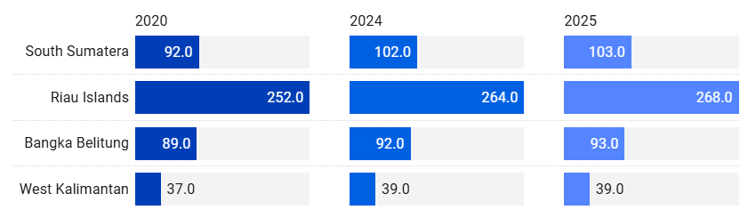
Figure 10 Population Density (per sq. km) in the Study Locations
(Data Source: Statistics of Indonesia)

SE1-7. National Coastal populations by elevation (1,3,5,7,9,10,12,20 meters above SL)
Number of Villages/Subdistricts by Province and Topographical
Spatial patterns of coastal settlements across the four provinces reveal clear topographical contrasts (Figure 2.4.8). West Kalimantan consistently has the flattest coastal villages, reflecting how flat terrain supports denser settlements through easier access, transport, and maritime connectivity. Slope-area villages increased sharply from 111 (2018) to 798 (2021) before dropping to 588 (2024), likely due to migration or administrative changes. These areas face higher risks of erosion and landslides. Bangka Belitung shows stable flat-settlement numbers, while the Riau Islands saw a decline in slope settlements—from 250 (2021) to 145 (2024)—suggesting movement toward lower-lying zones linked to maritime economic opportunities. South Sumatra remains dominated by flat coastal villages but experienced a major rise in slope areas (83 to 481), indicating possible adaptation to sea-level rise and tidal flooding. Such shifts, however, may increase transport costs and reduce access to marine resources.
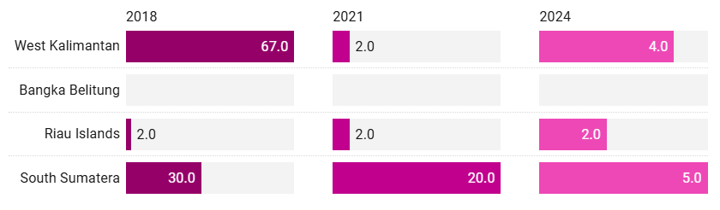
Figure 11 Number of Villages/Subdistricts by Province and Topographical Areas (Valley)
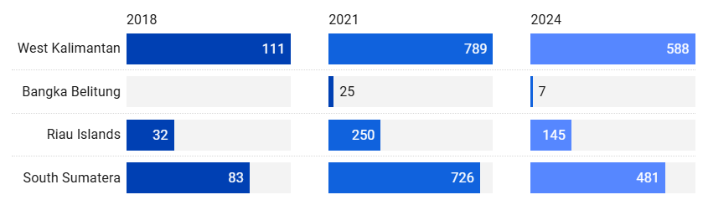
Figure 12 Number of Villages/Subdistricts by Province and Topographical Areas (Slop)
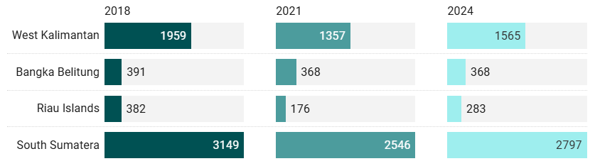
Figure 13 Number of Villages/Subdistricts by Province and Topographical Areas (Flat)
(Data Source: Statistics of Indonesia)

      - Human Wellbeing Conditions
SE2-1 Coastal Poverty Status
Figure 14 presents 2024 urban and rural poverty rates across the four provinces. South Sumatra has the highest poverty (9.02% urban; 11.43% rural), while Bangka Belitung has the lowest (4.09% urban; 6.49% rural). The Riau Islands (4.36% urban; 8.55% rural) and West Kalimantan (4.62% urban; 7.26% rural) show moderate levels. In all provinces, rural poverty exceeds urban poverty, highlighting persistent challenges in infrastructure, market access, and employment for rural communities.
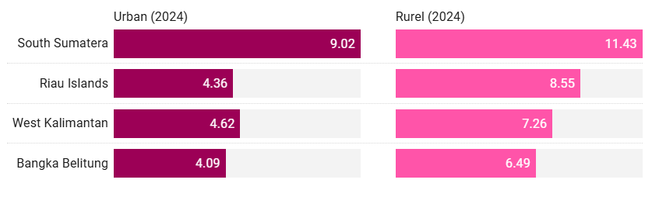
Figure 14 Percentage of Poor Population in Study Locations

SE2-2 Human Development Index
The Average Years of Schooling increased across all provinces from 2022 to 2024, with the Riau Islands recording the highest levels, rising from 10.37 years to 10.50 years. Based on human capital theory (Becker, 1993; Psacharopoulos & Patrinos, 2018), higher schooling years in coastal regions indicate improved access to education and contribute to greater labor productivity. However, disparities remain. West Kalimantan reached only 7.78 years in 2024, suggesting geographic constraints or limited educational facilities in remote coastal areas (Suharto et al., 2022). These gaps have implications for the adaptive capacity of coastal communities, especially as global and maritime-related economic changes increasingly require higher skills.
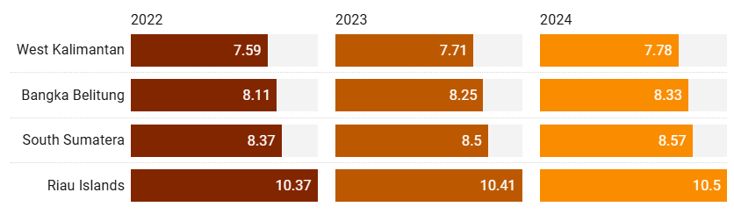
Figure 15 Average Years of Schooling in the Study Area
In terms of Adjusted Real Expenditure per Capita, the Riau Islands recorded the highest value in 2024 at IDR 15,573 thousand, reflecting its position as a major trade and logistics hub. According to spatial inequality theory (Kanbur & Venables, 2005), regions with access to international ports generally have higher purchasing power due to stronger integration with global markets. In contrast, West Kalimantan had the lowest expenditure at IDR 10,321 thousand, largely because its economy depends more on low–value primary sectors. In coastal areas, these differences in purchasing power influence community capacity to invest in education, health services, and modern fishing or aquaculture technologies.
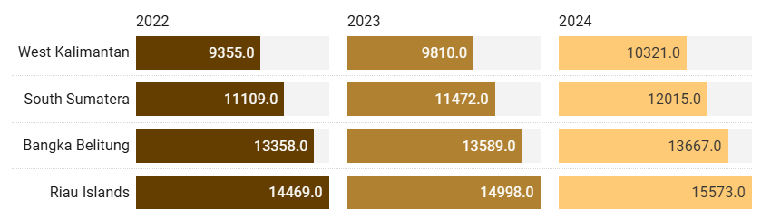
Figure 16 Adjusted Real Expenditure per Capita per Year in the Study Area

The Human Development Index (HDI) shows a similar pattern to the previous indicators (Figure 17). The Riau Islands recorded the highest HDI in 2024 at 79.89, while West Kalimantan had the lowest at 71.19. Gupta and Vegelin (2016) emphasize that human development in coastal areas must integrate economic, social, and environmental dimensions to reduce vulnerabilities from climate change and marine ecosystem degradation. The high HDI in the Riau Islands is likely supported by better education, higher expenditure, and stronger infrastructure. Meanwhile, provinces with lower HDI face the risk of a persistent structural poverty cycle unless supported by comprehensive policy reforms.

Figure 17 Human Development Index in the Study Locations

      - Economic Activities
SE3-1 Subnational Gross Domestic Product (GDP)
Gross regional Domestic Product at current market - The three graphs display the Gross Regional Domestic Product (GRDP) of South Sumatra, the Riau Islands, Bangka Belitung, and West Kalimantan from 2021 to 2023, shown in both Indonesian Rupiah (IDR) and U.S. Dollars (USD). GRDP increased steadily in all provinces over this period, indicating consistent nominal economic growth driven by post-pandemic recovery, inflation, and sectoral expansion. South Sumatra recorded the highest GRDP, rising from IDR 49.36 trillion (USD 34,491.2) in 2021 to IDR 62.91 trillion (USD 41,292.8) in 2023, reflecting its diversified economy in mining, manufacturing, and services. The Riau Islands remained the second-largest economy, increasing from IDR 27.56 trillion (USD 19,267.2) to IDR 33.19 trillion (USD 21,780.2), supported by maritime trade, free-trade zones, and shipyard industries. West Kalimantan’s GRDP grew from IDR 23.13 trillion (USD 16,158.6) in 2021 to IDR 27.44 trillion (USD 18,014.0) in 2023, driven mainly by agriculture, forestry, and mining. Bangka Belitung recorded the smallest GRDP, rising from IDR 8.59 trillion (USD 6,006.6) to IDR 10.26 trillion (USD 6,735.3), consistent with its reliance on tin mining and small-scale tourism, which limits rapid growth. Exchange rates—IDR 14,307.8 (2021), 14,845.7 (2022), and 15,237.0 (2023)—influenced the USD conversion but did not change the overall upward trend. GRDP values in USD still increased despite IDR depreciation. The GRDP at current market prices is presented in Figure 18.
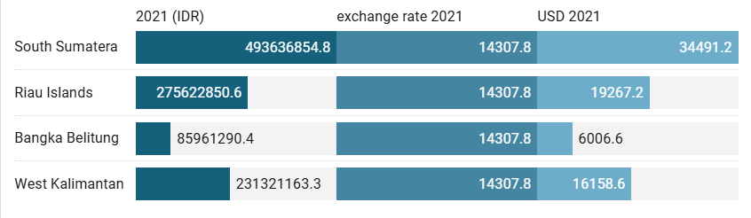
Figure 18 presents the Gross Regional Domestic Product (GRDP) at current market prices for the study locations in 2021.
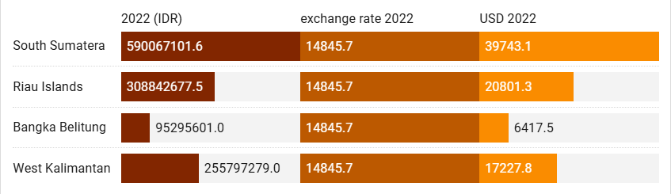
Figure 19 shows the Gross Regional Domestic Product (GRDP) at current market prices for the study locations in 2022.
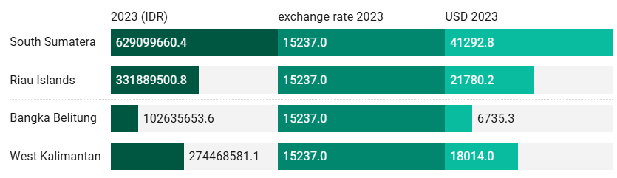
Figure 20 presents the Gross Regional Domestic Product (GRDP) at current market prices for the study locations in 2023.

SE3-2 Sustainable fisheries contribution to GDP
Figure 21 shows the fishery value (USD) of four coastal provinces in 2021, revealing clear economic disparities shaped by resource availability, infrastructure, and market access. The Riau Islands lead with USD 571.36 million, driven by strategic maritime location, strong export access, and diverse high-value species. Bangka Belitung follows at USD 507.37 million, supported by rich marine resources and established fishing communities, though its export capacity remains developing. West Kalimantan recorded USD 438.62 million, reflecting substantial potential but constrained by traditional fishing practices and limited cold-chain and processing facilities. South Sumatra registered the lowest value (USD 338.03 million), as fisheries play a smaller economic role amid dominant agriculture, plantations, and mining, alongside a shorter coastline. Overall, the figures highlight uneven fishery development across provinces, influenced by geography, infrastructure, technology, and integration into global value chains—informing the need for targeted policy interventions to boost efficiency, market access, and sustainable resource management in lagging areas.
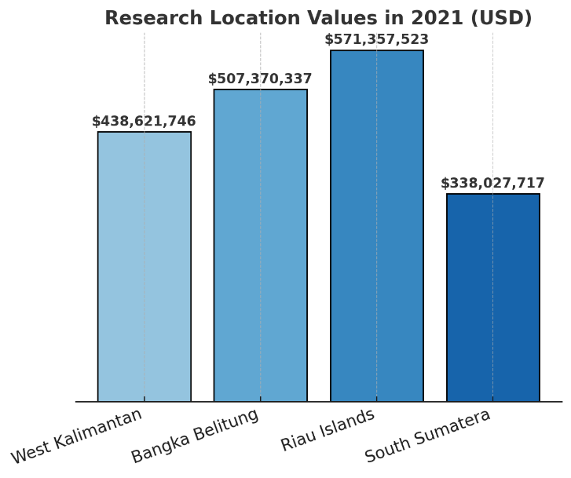
Figure 21 Fishery Value (Rp million) in the Research Locations in 2021 (Average exchange rate 2021: 1 USD ≈ Rp 14,308)
Provinces with coastal-oriented economies and strong international trade linkages such as the Riau Islands tend to have a larger share of their labor force employed in services and manufacturing. In contrast, provinces with vast land areas and abundant natural resources, including West Kalimantan and South Sumatra, are more likely to exhibit labor dominance in agriculture, forestry, and fisheries. Bangka Belitung shows a distinct pattern shaped by its tin mining industry and growing marine tourism, resulting in a mixed distribution between primary and tertiary sectors. Understanding these employment structures is important not only for interpreting regional economic characteristics but also for informing labor policies, sectoral development priorities, and strategies to enhance productivity across provinces.

Table 1 Distribution of Employed Persons Aged 15 Years and Over by Province and Major Industry, 2024
Sectors | West Kalimantan | Bangka Belitung | Riau Islands | South Sumatera
Agriculture, Forestry, and Fishing | 1.318.123 | 299.496 | 74.225 | 2.209.165
Mining and Quarrying | 77.48 | 42.392 | 11.82 | 99.611
Manufacturing | 145.012 | 62.567 | 28.825 | 452.299
Electricity, Gas, Steam, and Air Conditioning Supply | 5.874 | 2.897 | 425 | 24.625
Water Supply; Sewerage, Waste Management, and Remediation Activities | 4.817 | 2.105 | 186 | 21.23
Construction | 176.08 | 25.594 | 6.202 | 216.895
Wholesale and Retail Trade; Repair of Motor Vehicles and Motorcycles | 408.815 | 135.4 | 174.014 | 755.936
Transportation and Storage | 80.823 | 13.35 | 67.739 | 174.791
Accommodation and Food Service Activities | 180.56 | 52.649 | 113.512 | 227.472
Information and Communication | 12.507 | 1.318 | 7.335 | 9.299
Financial and Insurance Activities | 31.556 | 7.866 | 13.78 | 28.471
Real Estate | 4.153 | 1.935 | 6.968 | 8.054
Professional Activities and Administrative & Support Activities | 19.212 | 9.66 | 60.432 | 155.402
Public Administration and Defence; Compulsory Social Security | 115.842 | 47.458 | 69.453 | 212.522
Education | 198.122 | 75.664 | 20.212 | 96.172
Human Health and Social Work Activities | 48.176 | 12.362 | 18.126 | 26.955
Other Services Activities | 105.457 | 32.65 | 55.232 | 148.65

The economic sector distribution in Indonesia’s coastal regions varies across provinces. West Kalimantan and South Sumatra are dominated by agriculture, forestry, and fisheries, indicating strong dependence on primary natural resources. Bangka Belitung relies heavily on tin mining, while the Riau Islands specialize in maritime transport and logistics due to their strategic location along international trade routes. This pattern reflects the resource-based economy perspective, where natural resource availability shapes regional economic and employment structures (Barbier, 2015). However, heavy reliance on primary or extractive industries increases vulnerability to commodity price fluctuations, environmental degradation, and climate change impacts (Béné et al., 2016). The next section outlines the average monthly net wages across provinces in 2024 by major occupation, highlighting regional and sectoral differences (see Table 2).

Table 2 Average of Net Wage/Salary per Month of Employee by Province and Main Occupation (rupiahs), 2024
Sectors | West Kalimantan | Bangka Belitung | Riau Islands | South Sumatera
Agriculture, Forestry, and Fishing | 1.957.214 | 3.147.608 | 3.272.496 | 2.356.642
Mining and Quarrying | 3.439.580 | 4.708.699 | 5.935.531 | 2.893.483
Manufacturing | 2.493.007 | 3.573.360 | 5.477.068 | 2.605.767
Electricity, Gas, Steam, and Air Conditioning Supply | 4.206.048 | 4.830.250 | 6.430.327 | 4.017.421
Water Supply; Sewerage, Waste Management, and Remediation Activities | 2.796.133 | 3.613.183 | 3.644.784 | 2.603.442
Construction | 2.588.497 | 3.769.569 | 3.769.285 | 2.426.630
Wholesale and Retail Trade; Repair of Motor Vehicles and Motorcycles | 2.334.744 | 3.291.000 | 3.531.046 | 2.329.841
Transportation and Storage | 3.352.640 | 4.369.605 | 5.795.661 | 2.517.105
Accommodation and Food Service Activities | 1.983.770 | 2.226.187 | 3.296.030 | 1.759.692
Information and Communication | 3.774.222 | 3.809.097 | 5.521.474 | 2.672.693
Financial and Insurance Activities | 4.264.882 | 4.861.632 | 5.760.058 | 3.487.176
Real Estate | 2.624.935 | 4.220.193 | 4.712.266 | NA
Professional Activities and Administrative & Support Activities | 2.739.407 | 4.183.699 | 4.668.533 | 2.712.496
Public Administration and Defence; Compulsory Social Security | 3.289.044 | 4.446.600 | 5.444.600 | 3.844.026
Education | 2.464.207 | 3.520.012 | 4.059.276 | 2.796.289
Human Health and Social Work Activities | 2.992.518 | 4.492.495 | 4.946.053 | 2.879.469
Other Services Activities | 1.565.814 | 2.319.012 | 3.033.272 | 1.459.027

The average net monthly wages across major sectors in West Kalimantan, Bangka Belitung, the Riau Islands, and South Sumatra in 2024 show clear differences between provinces and types of occupations. Mining and quarrying offer the highest wages—reaching IDR 5.93 million in the Riau Islands—reflecting the sector’s capital-intensive and skill-demanding nature (ILO 2022). Meanwhile, the lowest wages are found in service-related sectors, such as in South Sumatra at IDR 1.45 million, indicating lower productivity and value added (Pratomo & Rahmawati 2020). These wage gaps align with labor market segmentation theory, where workers in low-wage sectors like agriculture, forestry, and fisheries often face skill and mobility barriers that limit access to better-paying jobs (Fields 2019). Such disparities can heighten the economic vulnerability of coastal households. The next section presents the provincial minimum monthly wages in Indonesia (see Table 2), highlighting regional policy differences shaped by economic structure, cost of living, and labor market conditions.
The Provincial Minimum Wages (UMP) in the four coastal provinces increased at different rates between 2022 and 2024, reflecting variations in economic structure and local policy conditions. In 2024, Bangka Belitung recorded the highest UMP at IDR 3.64 million, followed by South Sumatra (IDR 3.46 million), the Riau Islands (IDR 3.40 million), and West Kalimantan with the lowest at IDR 2.77 million. Overall increases reached about +11.5% in Bangka Belitung, +9.9% in South Sumatra, and +13.6% in West Kalimantan, while the Riau Islands experienced a decline of –10.3%. Since 2023, UMP calculations use a new formula that incorporates inflation, economic growth, and productivity, making the results sensitive to regional economic differences (Kemnaker 2023). In coastal regions, living costs, logistics, sectoral composition, and labor demand also shape the fiscal and political capacity to set minimum wages (World Bank 2021) (see Table 3).

Table 3 Provincial Minimum Wages per month (Rupiahs)
Area | 2022 | 2023 | 2024
West Kalimantan | 2.434.328 | 2.608.601 | 2.765.234
Bangka Belitung | 3.264.884 | 3.498.479 | 3.640.000
Riau Islands | 3.501.172 | 3.791.194 | 3.402.492
South Sumatera | 3.144.446 | 3.404.177 | 3.456.874

The production volume and value of capture fisheries in 2023 vary widely across the four provinces. Bangka Belitung recorded the highest output, with 228,616 tons and a production value of IDR 9.15 trillion, dominated by marine fisheries. West Kalimantan ranked second with 197,488 tons and IDR 5.62 trillion. The Riau Islands produced a smaller volume (135,773 tons) but still generated IDR 4.05 trillion, indicating higher value-added per unit of catch. South Sumatra is distinct, as inland fisheries contribute significantly (74,649 tons; IDR 3.99 trillion). Although its marine catch is lower (87,456 tons), its total production value reached IDR 7.82 trillion, showing the importance of freshwater ecosystems. Overall, economic contributions depend not only on catch volume but also on ecosystem type, commodity prices, and supply-chain dynamics. Regions with high-value coastal resources can generate substantial income even with smaller catch volumes (Barney 1991; FAO 2022) (see Table 4)

Table 4 Production Volume and Production Value of Fish Capture by Province and Type of Captures, 2023
Area | Marine Capture Fisheries |  | Inland Water Capture Fisheries |  | Total
Area | Volume (ton) | Value (000 Rp) | Volume (ton) | Value (000 Rp) | Volume (ton) | Value (000 Rp)
West Kalimantan | 162.638 | 4.829.548.806 | 34.85 | 791.754.127 | 197.488 | 5.621.302.933
Bangka Belitung | 228.583 | 9.146.522.781 | 33 | 2.491.686 | 228.616 | 9.149.014.467
Riau Islands | 112.078 | 3.085.056.513 | 23.695 | 967.408.220 | 135.773 | 4.052.464.733
South Sumatera | 87.456 | 3.826.053.518 | 74.649 | 3.997.816.587 | 162.105 | 7.823.870.105

The production volume and value of aquaculture in 2023 also vary widely across the four provinces. South Sumatra recorded the highest output, producing 323,352 tons valued at IDR 8.80 trillion, supported by large cultivation areas and abundant freshwater resources. The Riau Islands ranked second with 124,734 tons and IDR 2.80 trillion, driven by high-value export commodities such as grouper, pomfret, and vannamei shrimp. West Kalimantan followed with 84,659 tons and IDR 2.73 trillion, reflecting strong potential for freshwater and brackish aquaculture. Bangka Belitung produced the least (10,914 tons; IDR 660.93 billion), mainly due to limited cultivation areas and the stronger role of capture fisheries. From a blue economy perspective, South Sumatra’s strong performance highlights effective use of inland waters for large-scale production, consistent with FAO (2022), which emphasizes the importance of freshwater access and supporting infrastructure. The Riau Islands’ focus on high-value, export-oriented species also aligns with findings by Hishamunda and Ridler (2014), showing that smaller volumes can still generate high economic value (see Table 5).

Table 5 Production Volume and Production Value of Aquaculture by Province and Type of Culture, 2023
Area | Total
Area | Volume (ton) | Value (000 Rp)
West Kalimantan | 84.659 | 2.726.651.810
Bangka Belitung | 10.914 | 660.927.122
Riau Islands | 124.734 | 2.799.409.704
South Sumatera | 323.352 | 8.801.794.872
    - Climate-related Threats
The South China Sea and Surrounding Areas (SCSSA) are a dynamic climate hub where ocean, land, and atmosphere interact intensely. High sea surface temperatures make the region highly sensitive to global climate change (Figure 22a). Convection variations over the SCSSA influence the El Niño–Southern Oscillation (ENSO) by modifying Pacific trade winds, while ENSO events, in turn, affect SCSSA convection. La Niña strengthens the Walker circulation, enhancing regional convection and triggering atmospheric teleconnections that impact climates in North Africa, South Asia, and East Asia (Li et al., 2020; He et al., 2017).
Warming over the Maritime Continent and Tibetan Plateau further shapes ENSO characteristics and global weather anomalies, influencing areas from Southern Europe to the North Atlantic. Air–sea interactions generate Rossby waves, linking tropical processes to both hemispheres (Yang et al., 2019; Basconcillo, 2021) (Figure 22b). The SCSSA also drives South and East Asian monsoons via Tibetan Plateau forcing, with modulation from the Madden–Julian Oscillation, cross-equatorial flows, Pacific Meridional Mode, and intraseasonal oscillations. Overall, the SCSSA acts as a major climate driver: small regional changes can propagate globally, affecting extreme weather, rainfall patterns, and climate stability from the tropics to the poles.
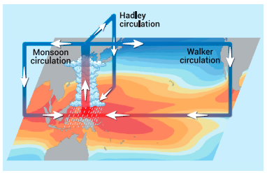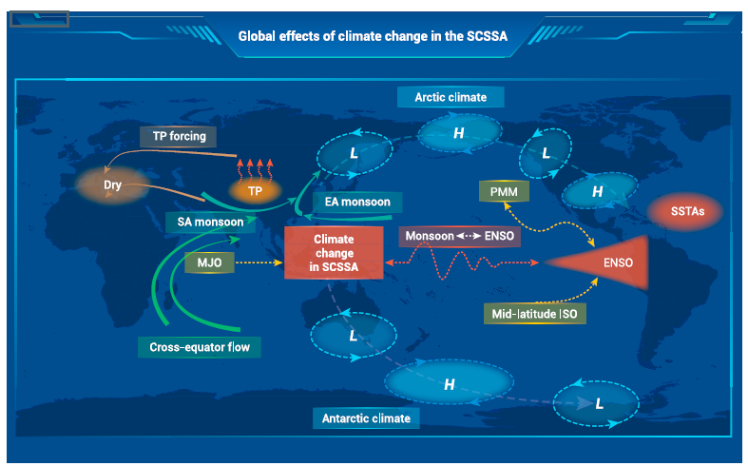
Figure 22 (a) Schematic diagram of sea surface temperature and atmospheric overturning circulations in the SCSSA (Yang et al. 2024) (b) Known global impacts of climate change in the SCSSA (Yang et al. 2024)
Climate change in the South China Sea and Surrounding Areas (SCSSA) drives ocean–atmosphere interactions that influence climate from the tropics to the poles. The region is closely tied to the South Asian and East Asian monsoons, which are affected by warming over the Tibetan Plateau. Atmospheric systems such as the Madden–Julian Oscillation (MJO) and cross-equatorial flow regulate air mass movement and shape monsoon intensity. The SCSSA also has a two-way relationship with ENSO, where Pacific sea surface temperature anomalies influence monsoons, while monsoon changes can feedback into the ENSO cycle. These processes, mediated by the Pacific Meridional Mode (PMM) and intraseasonal oscillations (ISO), link tropical dynamics with mid-latitude climate patterns. Their impacts extend globally, affecting high- and low-pressure systems and influencing climate conditions in the Arctic and Antarctic. Overall, the SCSSA acts as a major climate driver, with changes in this region capable of triggering atmospheric teleconnections that affect extreme weather and climate stability worldwide.

  - Discussion
    - Risk Assessment from Socio-Economic Trends
The socio-economic risk analysis was conducted by considering coastal population density, economic dependence on marine and fisheries sectors, and the vulnerability of economic infrastructure to external disruptions (Table 6).

Table 6 Risk Assessment of Socio-economic
Province | Coastal Region Area (km²) | % of National Area | Est. Coastal Population (2023) | GDP Dependency on Fisheries & Marine Sector (%) | Socio-Economic Risk Index*
West Kalimantan | 147,037.04 | 7.66% | 1.52 million | 28–32% | High (0.71)
South Sumatera | 86,771.68 | 4.52% | 0.98 million | 22–26% | Moderate (0.58)
Bangka Belitung | 16,690.13 | 0.87% | 0.35 million | 36–40% | High (0.74)
Riau Islands | 8,084.00 | 0.42% | 0.29 million | 30–34% | High (0.69)
*The Socio-Economic Risk Index is calculated based on a combination of the dependency ratio, coastal poverty rate, and vulnerability to economic shocks.
    - Climate and Environmental Threat Risk Profile
The assessment of climate and environmental risks in the coastal areas of the South China Sea highlights two key indicators: the rate of sea-level rise (SLR) and the frequency of extreme weather events. These indicators represent the most critical climate pressures affecting ecosystem stability, community livelihoods, and coastal infrastructure. Scientifically derived estimates for both indicators are presented in the following table.

Table 7 Climate-Environmental Threats
Province | Coastal Region Area (km²) | % of National Area | Sea-Level Rise Rate (mm/year) | Extreme Event Frequency (events/year) | Risk Level*
West Kalimantan | 147.037,04 | 7,66 | 4,8 | 6 | High
South Sumatera | 86.771,68 | 4,52 | 4,5 | 5 | Medium-High
Bangka Belitung | 16.690,13 | 0,87 | 4,2 | 4 | Medium
Riau Islands | 8.200,00 | 0,43 | 4,0 | 3 | Medium
*Note: The Risk Level is determined based on a combination of sea-level rise rate and the frequency of extreme events
    - Mitigating Socio-Economic Vulnerability in Climate-Affected Coastal Regions
Addressing socio-economic vulnerability in Indonesia’s coastal regions bordering the South China Sea requires an integrated approach that combines infrastructure development, community empowerment, and technological innovation. Key strategies include:
• Strengthening Adaptive Infrastructure:
Mangrove restoration, coastal land rehabilitation, and the construction of seawalls or natural buffers are essential to reduce erosion, storm surges, and seawater intrusion. These measures protect livelihoods and enhance ecosystem services that support long-term resilience.
• Economic Empowerment of Coastal Communities:
Livelihood diversification through aquaculture training, ecotourism development, and value-added marine product processing reduces dependence on capture fisheries and strengthens households’ ability to withstand environmental shocks.
• Early Warning Systems (EWS):
Deploying buoys, weather radars, and real-time monitoring systems enables early detection of storms and high waves, allowing communities to take preventive action and improve adaptive capacity.
Together, these strategies help coastal regions build resilience against climate-driven risks while supporting sustainable livelihoods and ecosystem health. However, several key gaps still hinder the long-term effectiveness of adaptation efforts. Addressing these gaps is crucial to strengthening socio-economic and ecological resilience (Table 8).

Table 8 Critical Gaps Limiting Coastal Adaptation Effectiveness

Gap / Challenge | Description | Implications for Adaptation
Limited Integration of Climate Data into Regional Planning | Key climate indicators (sea-level rise, extreme waves, storm projections) are not fully incorporated into spatial and coastal zone planning. | Reduces the effectiveness of adaptation strategies and evidence-based decision-making.
Sustainable Financing Constraints | Many adaptation projects rely on short-term donor funding without long-term financial sustainability. | Limits continuity, scalability, and long-term impact of adaptation programs.
Suboptimal Community Participation | Some coastal communities perceive climate change as distant or abstract. | Low engagement reduces effectiveness of local mitigation and adaptation measures.
Insufficient Inter-Regional Cooperation | Coordination across provincial or administrative boundaries is limited. | Hinders large-scale adaptation efforts, knowledge sharing, and transboundary climate response.

  - Recommended Priority Actions
Strengthening socio-economic and ecological resilience in climate-impacted coastal regions requires practical, evidence-based actions coordinated across provinces. Five priority measures are proposed:
- Climate-Informed Coastal Planning
Integrate sea-level rise and extreme weather data into development and spatial plans to reduce exposure and risk.
- Sustainable Financing
Secure long-term funding through public–private partnerships, climate finance, and investments in ecosystem-based adaptation.
- Community-Centered Engagement
Enhance awareness, capacity, and participation of coastal communities by incorporating traditional knowledge and inclusive decision-making.
- Cross-Provincial Cooperation
Establish formal collaboration among South China Sea coastal provinces for data sharing, joint adaptation efforts, and coordinated disaster responses.
- Monitoring, Evaluation, and Learning (MEL)
Build strong systems to track adaptation progress, inform policy adjustments, and capture best practices for broader replication.
Together, these actions strengthen coastal regions’ ability to anticipate, withstand, and recover from climate-related socio-economic shocks while ensuring long-term livelihoods and ecological sustainability.

Table 9 Strategic Coastal Adaptation Actions with Regional Cooperation Potential

Priority Action | Description | Potential for Regional Cooperation
1. Integration of Climate Data into Regional Planning | Incorporate projections of sea-level rise (SLR), storms, and high waves into regional spatial plans (RTRW) and local development plans (RPJMD) to ensure climate-informed decision-making. | Establish a shared cross-provincial climate data repository for the South China Sea rim to support coordinated planning.
2. Landscape-Scale Mangrove Restoration Program | Rehabilitate mangroves in areas prone to coastal erosion and seawater intrusion, enhancing coastal protection and ecosystem services. | Facilitate technical collaboration and sharing of seedlings across provinces, and exchange best practices for large-scale restoration.
3. Coastal Economic Diversification | Develop integrated fisheries enterprises, ecotourism, and agro-marine businesses to reduce community dependence on single livelihoods. | Create joint markets and collective branding for South China Sea coastal products across provinces, promoting regional economic integration.
4. Enhancement of Early Warning Systems | Modernize technology for detecting extreme weather events and high waves, improving disaster preparedness. | Deploy shared sensor networks and enable real-time data exchange among provinces to enhance regional early warning capabilities.
5. Sustainable Adaptation Financing Schemes | Implement revolving funds and micro-financing mechanisms to support community-based adaptation initiatives. | Establish a cross-provincial “Coastal Climate Fund” to ensure long-term financing and sustainability of adaptation projects.
A collaborative approach that integrates scientific evidence with active community participation is essential for reducing vulnerability in this region. Because the four provinces—West Kalimantan, South Sumatra, Bangka Belitung, and the Riau Islands—face similar climate threats and share interconnected coastal ecosystems, strong regional coordination is required. Embedding adaptation programs within a cross-provincial cooperation framework will not only reinforce the resilience of coastal communities but also strengthen Indonesia’s strategic position in international forums concerning the South China Sea.
Acknowledgements : The authors are grateful to the Misitry of Environment of Indonesia, UNOPS and the Center for Coastal and Marine Resources Studies, IPB University (PKSPL IPB), Indonesia, that provided the research facilities and funding, especially during data collection processes including Focus Group Discussion in Bintan and Pontianak.

References
Adrianto L, Matsuda Y, Sakurai Y. 2019. Marine policy and coastal governance in Indonesia. Marine Policy. 109:103671. https://doi.org/10.1016/j.marpol.2019.103671
Baiquni M, Widianingsih NN, Nurlaili. 2021. Pengelolaan wilayah pesisir terpadu: Tantangan dan strategi pembangunan berkelanjutan di Indonesia. Jurnal Pembangunan Wilayah & Kota, 17(3):201–214. https://doi.org/10.14710/pwk.v17i3.31516
Basconcillo B, Moon IJ, Wang B, Mistry M. 2021. Possible influence of the warm pool ITCZ on compound climate extremes during the boreal summer. Environ Res Lett.;16(11):Article 114039
Béné C. 2016. Contribution of Fisheries and Aquaculture to Food Security and Poverty Reduction: Assessing the Current Evidence. World Development. 79:177–196.
BPS. 2021. Statistik Indonesia 2021. Jakarta: BPS. Retrieved from https://www.bps.go.id
Cinner JE, Barnes ML. 2019. Social dimensions of resilience in social-ecological systems. One Earth. 1(1):51–56. https://doi.org/10.1016/j.oneear.2019.08.003
Cisneros MAH, Sarmiento NVR, Delrieux CA, Piccolo MC, Perillo GM, 2016. Beach carrying capacity assessment through image processing tools for coastal management. Ocean & Coastal Management. 130: 138-147.
Diemer A, Iammarino S, Rodríguez-Pose PA, Storper M. 2022. The Regional Development Trap in Europe. Economic Geography.8(5):487–509.
FAO. 2020. Gender and Fisheries: Do women count?. Rome: Food and Agriculture Organization of the United Nations.
FAO. 2022. The State of World Fisheries and Aquaculture 2022. Rome: FAO
Fields GS. 2019. Employment and Development: How Work Can Lead to Better Living Standards. Oxford: Oxford University Press.
Folke, C, Biggs R, Norström AV, Reyers B, Rockström J. 2016. Social-ecological resilience and biosphere-based sustainability science. Ecology and Society. 21(3):41. https://doi.org/10.5751/ES-08748-210341
Gupta J, Vegelin C. 2016. Sustainable development goals and inclusive development. International Environmental Agreements: Politics, Law and Economics, 16:433–448. https://doi.org/10.1007/s10784-016-9323-z
Hishamunda N, Ridler N. 2014. Policy frameworks for sustainable aquaculture development. Fisheries and Aquaculture Technical Paper. Rome: FAO.
Ibrahim I, Sulista S, Pratama S. 2022. Struggling for power over the Bangka coast: Tin amongst the vortex of companies, the state, and residents. Society. https://doi.org/10.1016/j.exis.2022.101055.
ILO. 2022. Global Wage Report 2022–2023: The Impact of Inflation and COVID-19 on Wages and Purchasing Power. Geneva: International Labour Organization.
Kanbur R, Venables AJ. 2005. Spatial inequality and development. Oxford University Press.
Neumann B, Vafeidis AT, Zimmermann J. Nicholls RJ. 2015. Future coastal population growth and exposure to sea-level rise and coastal flooding—a global assessment. PLOS ONE:10(3), e0118571. https://doi.org/10.1371/journal.pone.0118571
Nurhidayah L, McIlgorm A, Amaral P. 2023. Implementation of the blue economy in coastal regions: Lessons for Indonesia. Ocean & Coastal Management.234:106453.
Psacharopoulos G, Patrinos HA. 2018. Returns to investment in education: A decennial review of the global literature. Education Economics, 26(5):445–458. https://doi.org/10.1080/09645292.2018.1484426
Rahman MM, Hassan M, Islam MA. 2020. Coastal vulnerability, migration, and adaptation: A case study from Bangladesh. Sustainability. 12(12): 5086. https://doi.org/10.3390/su12125086
Setiawan A, Wicaksono R, Kusumastanto T. 2021. Spatial inequality in Indonesian coastal development: Challenges and opportunities. Indonesian Journal of Geography, 53(2):210–223. https://doi.org/10.22146/ijg.65432
Silvius MJ, Noor YR, Lubis IR, Giesen W, Rais D. 2018. Sembilang National Park: Mangrove Reserves of Indonesia. Springer. 10.1007/978-94-007-4001-3_213.
Smith N. 2016. Urbanization in the coastal zone: Impacts and implications. Ocean & Coastal Management. 125:1–8. https://doi.org/10.1016/j.ocecoaman.2016.02.003
Suharto R, Pribadi A, Kusuma H. 2022. Pendidikan dan pembangunan wilayah pesisir: Tantangan pemerataan akses di Indonesia Timur. Jurnal Pembangunan Daerah. 10(2):115–128. https://doi.org/10.56083/jpd.v10i2.534
Todaro MP, Smit SC. 2020. Economic Development (13th ed.). Harlow: Pearson Education Limited. https://www.indonesia-tourism.com/index.php.
United Nations. 2019. World Population Prospects 2019. New York: United Nations Department of Economic and Social Affairs, Population Division.
Weeks JR. 2015. Population: An Introduction to Concepts and Issues (12th ed.):Cengage Learning.
World Bank. 2021. Blue Economy Development Framework. Washington, DC: World Bank Group.
World Bank. 2021. Indonesia Economic Prospects: Boosting the Recovery. Washington, DC: World Bank Group.
Yang Y, Zhu Z, Li T, Yao M. 2019. Effects of western Pacificintraseasonal convection on surface air temperature anomalies over North America. Int J Climatol.40(6):2913–2923.
Yang S, Chen D, Deng K. 2024. Global Effects of Climate Change in the South China Sea and Its Surrounding Areas. Ocean-Land- Atmos.https://doi.org/10.34133/olar.0038
- ECOSYSTEM: Coastal Frontiers - Indonesia’s Coastal Ecosystem Insights in South China Sea and Gulf Thailand
Yonvitner, Boimin, Hafizh Raihan Jayanegara, Sayid Muhadhar, Aditya Yuniarti, Heru Waluyo, Isdahartati, Ferry Kurniawan, Tri Edy Kuriandewa, Nyoto Santoso, Ragil Satrio, Lusita Meilana.

Abstract
During the period 2008–2021, the condition of mangrove, coral, seagrass, and wetland ecosystems in the Indonesian portion of the South China Sea experienced improvements in both ecological quality and governance. These improvements can be seen in the strengthening of policies as well as actions taken to restore and build the resilience of these ecosystems. During this period, there were 3 laws, 1 government regulation, and 3 ministerial regulations issued to govern ecosystems in the South China Sea region, including those related to rehabilitation activities.

Mangrove restoration efforts Riau Archipelago were carried out as part of rehabilitation and ecological recovery initiatives. A total of 16,319 hectares was set as the mangrove restoration target for the Bangka Belitung Islands; of this, 3,069 hectares were located within conservation areas, and 13,250 hectares outside conservation areas. West Kalimantan is among the priority provinces for mangrove restoration under BRGM. Nationally, from 2016 to 2024, BRGM rehabilitated around 84,396 hectares of mangroves across priority provinces.
Artificial reef rehabilitation activities in the Bangka Belitung Islands included the installation of around 7,680 units from 2016–2024, including 240 reef modules installed in Rambak in 2022. During 2022–2024, average seagrass cover in South Bangka—used here as an example—was only 26.8%, classified as “poor.” In Kayong Utara District, seagrass beds at one surveyed location also showed low density and cover, at 27.77%. These ecosystem conditions indicate ongoing efforts to restore mangrove, seagrass, coral, and wetland ecosystems, along with improvements in related policies. Furthermore, strengthening national and regional cooperation is needed to accelerate ecosystem recovery in the future.
Keyword: Ecosystem degradation, Resilience, TDA, SAP, Future Action
  - Introduction
The Indonesian chapter of the South China Sea hosts a rich mosaic of coastal and marine ecosystems that play a vital role in supporting biodiversity, fisheries productivity, and the livelihoods of coastal communities. Among the most important of these ecosystems are mangrove forests, coral reefs, seagrass beds, and wetlands, each providing essential ecological functions and contributing to the overall resilience of the region’s marine environment.
Mangrove ecosystems along the Indonesian coastline form critical buffers between land and sea, protecting shorelines from erosion, storm surges, and sedimentation. They serve as nurseries for numerous commercially and ecologically important fish and invertebrate species while also acting as significant carbon sinks, contributing to climate change mitigation.
Coral reefs within the Indonesian waters of the South China Sea are part of the globally significant Coral Triangle region, known for its unparalleled marine species richness. These reefs support complex ecological interactions, sustain artisanal and commercial fisheries, and attract tourism activities that contribute to local economies. However, they remain vulnerable to overfishing, habitat degradation, and climate-induced stressors such as coral bleaching.
Seagrass meadows, often found adjacent to coral reef and mangrove systems, function as productive feeding grounds for species such as sea turtles, dugongs, and various fish communities. Their ability to stabilize sediments, enhance water clarity, and sequester carbon makes them essential components of coastal ecosystem health.
Wetlands across the coastal landscapes of the South China Sea region further enrich ecological diversity by providing habitat for migratory birds, supporting nutrient cycling, and regulating hydrological processes. They play a key role in maintaining water quality and sustaining ecological connectivity between terrestrial and marine environments.
Together, these interconnected ecosystems form the ecological backbone of the Indonesian South China Sea, supporting biodiversity, enhancing climate resilience, and underpinning the socio-economic well-being of surrounding communities. Understanding their status, ecological roles, and the pressures they face is critical for advancing sustainable management and conservation efforts in this strategically and ecologically important marine region. Coastal and marine ecosystems in the Indonesian chapter of the South China Sea highlights the ecological richness and vulnerability of mangroves, coral reefs, seagrass beds, and coastal wetlands.
Studies on mangrove ecosystems in the region emphasize their critical role in shoreline protection, fisheries productivity, and carbon sequestration, while also documenting pressures from land-use change and coastal development (e.g., regional mangrove assessments and restoration reviews by Gerona-Daga et al., 2022). Coral reef research, including assessments through the International and National Society for Reef Studies, reveals that reefs in the South China Sea are part of the highly diverse Coral Triangle and remain threatened by overfishing, sedimentation, and climate-driven bleaching events. Additional analyses (such as Heery et al., 2019) show how reefs near urbanized or heavily used waters conditions relevant to Indonesian waters near Natuna face degradation but also exhibit varying degrees of resilience.
Seagrass ecosystems have been widely documented across Southeast Asia, with Fortes et al. (2018) providing one of the most comprehensive regional reviews. Their work highlights Indonesia as a major seagrass hotspot, supporting critical species such as dugongs and sea turtles, while facing pressures from trawling, coastal reclamation, and declining water quality. Meanwhile, research on coastal wetlands, including Indonesian-focused studies such as Hapsari (2019) and reports from Wetlands International, illustrates their importance for hydrological regulation, nutrient cycling, and migratory bird habitats. These wetlands are increasingly affected by land conversion, aquaculture expansion, and altered sediment dynamics. This paper aims to examine the status of mangrove, seagrass, and coral reef ecosystems, as well as coastal wetlands, in the South China Sea region as part evaluation on transboundary achievement of Indonesia nation on South China Sea Large Marine Ecosystem (SCS-LME).
  - Key Finding
The key findings of the TDA–SAP study on mangrove, seagrass, coral reef, and wetland ecosystems indicate that information on the extent and condition of these habitats has become increasingly well documented from 2008 to 2024 in the Natuna Sea region, although the data has not yet been fully consolidated. Overall, ecosystem status remains relatively similar, but several areas show a decline in extent and coverage due to various coastal pressures. Global commitments have also encouraged efforts to strengthen local rehabilitation and restoration initiatives. Programs aimed at improving coral reef conditions include the establishment of conservation areas and ongoing monitoring; for example, the Anambas National Marine Park contains an estimated 6,740.66 ha of coral reef habitat, with live coral cover exceeding 36% in its core zone. Despite this, fish biomass has declined sharply—from 355 kg/ha in 2018 to 176.16 kg/ha in 2024, representing a reduction of approximately 50.3% over six years. From 2021 to 2024, mangrove rehabilitation activities covered 574 ha, including 61 ha restored in 2024, while in West Kalimantan national programs achieved 6,010 ha of rehabilitation. Seagrass protection measures generally focus on establishing conservation areas, monitoring, preventing destructive activities, and supporting other preservation efforts. Overall, the Natuna Sea and South China Sea are considered sensitive and vulnerable, subject to pressures from fishing, pollution, and a wide range of human activities, placing many ecosystem functions at ongoing risk. Major issues identified include both local and transboundary threats, such as oil spills, plastic pollution, habitat damage caused by foreign and illegal activities, and other destructive events.

  - Current Ecosystem Status
    - Coral Reef and Seagrass
The essential ecosystems in the South China Sea and Gulf of Thailand (Indonesia sites) are mangroves, seagrass, coral reefs, and wetlands. The data show notable changes in ecosystem coverage across several Indonesian regions bordering the South China Sea between 2008 and 2024. The Indonesia region of mangrove, coral, seagrass and wetland distribution as below and Tabel 1 in Apendix.
Figure 23 Mangrove, Coral, Seagrass and Wetland Distribution

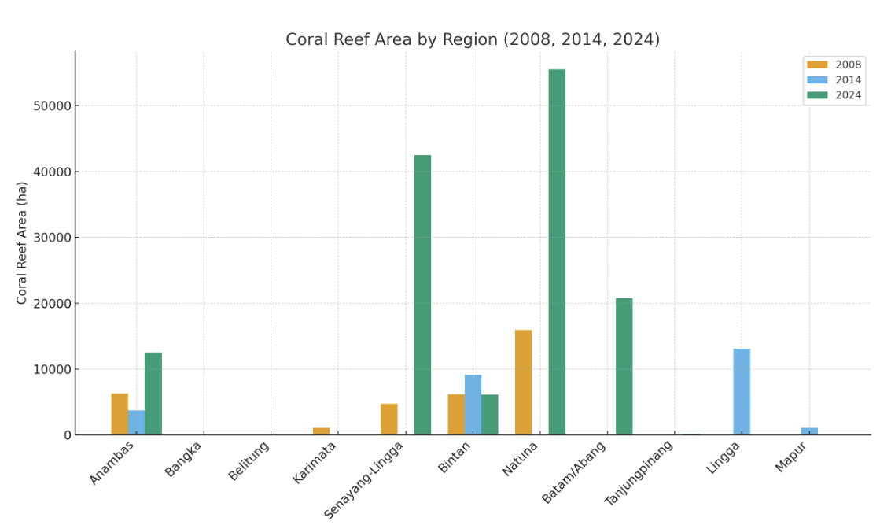
Figure 24 Regional Variability in Coral Habitat Extent Within Indonesian Marine Protected Areas
The bar chart illustrates substantial variability in coral reef area changes across Indonesian coastal regions between 2008, 2014, and 2024. Significant increases are evident in Anambas, Senayang-Lingga, Natuna, and Batam, with Natuna showing the most dramatic rise from 15,905 ha in 2008 to 55,527 ha in 2024. In contrast, regions such as Karimata, Bangka, and Belitung recorded no coral reef data in 2014 and 2024, suggesting possible degradation or gaps in monitoring. Bintan exhibits notable fluctuations, while Lingga and Mapur only appear in the 2014 dataset. Tanjungpinang reports a small coverage in 2024. Overall, the graphic highlights uneven progress among sites, where some regions show strong recovery or improved assessments, while others reflect data limitations or ecosystem decline, underscoring the need for consistent monitoring and strengthened coastal ecosystem management.

Seagrass species composition varies across locations, reflecting ecosystem complexity. The highest species diversity is found in the Riau Islands, with species including Halodule uninervis, Halophila ovalis, Thalassia hemprichii, Cymodocea rotundata, Enhalus acoroides, and Syringodium isoetifolium. The data show varying trends in ecosystem extent across several Indonesian regions between 2008 and 2024, all of which fall under either National or Regional Marine Protected Areas.

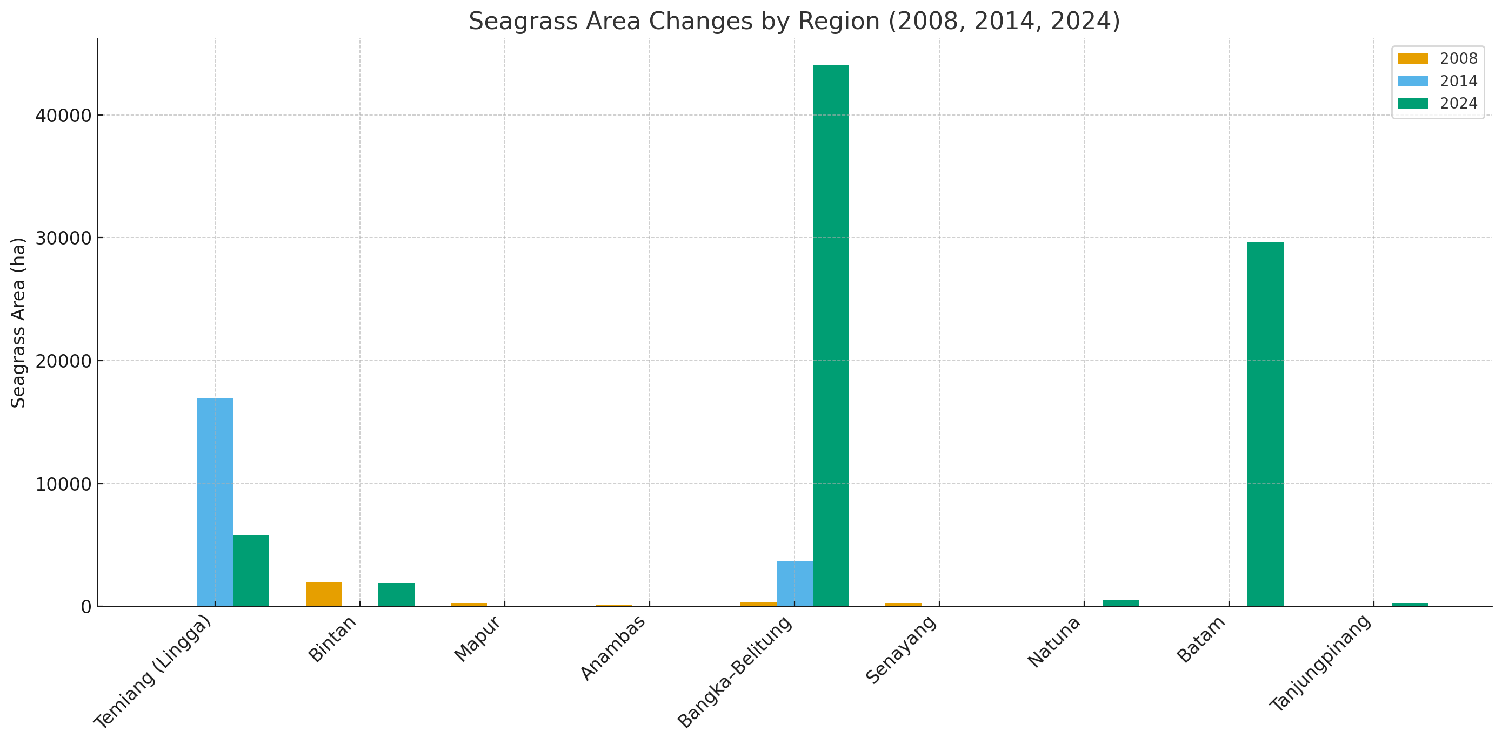
Figure 25 Regional Variability in Seagrass Habitat Extent Within Indonesian Marine Protected Areas
The data reveal substantial variability in seagrass ecosystem extent across regions from 2008 to 2024. Temiang (Lingga) shows the most dramatic fluctuations, rising from only 5 ha in 2008 to 16,942 ha in 2014 before declining to 5,816 ha in 2024. Bangka–Belitung also demonstrates major growth, expanding from 350 ha to 3,641 ha and then to 44,050 ha in 2024. Several areas—such as Bintan, Natuna, Batam, and Tanjungpinang—display significant increases only in 2024, indicating recent improvements in monitoring or conservation efforts. In contrast, Mapur, Senayang, and Anambas experienced declines or loss of recorded seagrass extent over time. Overall, the patterns suggest diverse regional trajectories influenced by ecological conditions, management effectiveness, and varying levels of data availability.
    - Mangrove dan Wetland
Between 2003 and 2025, Indonesia has experienced both mangrove loss and efforts towards restoration (Jong 2022; Ismi, 2024; World Bank, 2021). In 2020, the government set an ambitious target to rehabilitate 600,000 hectares of mangroves by 2024, concentrated in nine provinces (Ismi, 2024). While progress has been made, the initial target was not fully met, with only 130,000 hectares restored by February 2024. Despite this, the restoration efforts are crucial for mitigating climate change and protecting coastal communities (Ismi, 2024). The total of mangrove coverage in Indonesia from 2003-2025 can be seen on Tabel 2 and 3 in Appendix 3.2 and Appendix 3.3.
The mangrove coverage in West Kalimantan (Kubu Raya) shows a significant decrease. The mangrove coverage in 1993 was 1,011,37 km2 and in 2023 was 964.37 km2. The average loss of mangrove forest cover was 3.25 km2 per year, including mangroves, open areas, ponds, water bodies, agricultural areas, and settlements (Wiarta et al., 2025). Mangrove in Riau Island based on Saputra et al (2021), there was degradation of 34.19% mangrove area, or about 46.61 ha, from 2007 to 2018. Koesdariyanto et al (2024) reported that the mangrove cover analysis on the east coast of South Sumatra found that the area of mangroves in 2003, 2013, and 2023 reached 115,072, 118,674, and 97,332 ha. The mangrove area increased by 3,601.47 ha (+3.13%) in 2003-2013 and decreased by 21,342 ha (-17.98%) in 2013-2023.
Wetlands in eastern Sumatra and West Kalimantan (2008-now) have undergone significant ecological change driven by land conversion, drainage, and recurring fires. Between 2008 and 2014, rapid expansion of plantations—especially on peat—accelerated degradation across both regions, culminating in the catastrophic 2015 fires that burned more than two million hectares nationally and severely damaged peat swamp ecosystems in Sumatra and Kalimantan. In response, Indonesia established the Peatland Restoration Agency (BRG) in 2016, targeting the rehabilitation of 2.6 million hectares of degraded peatlands. From 2016 to 2023, restoration activities in West Kalimantan alone reached over 200,000 hectares through canal blocking and rewetting initiatives, although large areas remain at risk. Recent regional assessments estimate that West Kalimantan still retains around 3.14 million hectares of wetlands, including 1.79 million hectares of peatland, while eastern Sumatra continues to experience fragmentation, subsidence, and hydrological degradation despite ongoing restoration programs. Overall, both regions show progress in restoration efforts but still face substantial challenges in halting wetland loss and meeting long-term ecological recovery targets.
Based on Field survey results (2018) and Landsat images (1992; 2017)— by Armanto et al. (2018)—reclamation was one of the main causes of wetland ecosystem losses in South Sumatera. Reclamation alone contributed 78% of total wetland losses. During 1990-2017, the wetland loss had been occured approximately (-) 20.09%. That number came from the wetland expantion ((+) 32.24%) minus the wetland lost ((-) 52.33%). Data related the coverage of Wetland (Sites characterized by the SCS Project) in Indonesia (Sumatra and Kalimantan) can be seen in Table 4 in Apendix.
    - Biodiversity Hotspot and Sensitive Area
Annual monitoring data from 2015 to 2018 in the Bangka Belitung Islands identified 342 coral species from 63 genera. Of these, 231 species (>65%) were rare or uncommon, occurring in <40% of all sites. The species richness of hard corals was categorized as moderate compared to other studies in Indonesia, averaging 53 species across sites and years, and there was an increasing number of sites with high species richness (Hadi et al, 2023).
Coral fish biodiversity found in Natuna about 100 species of target-reef fish belonging to 18 families and 23 species of indicator-reef fish of the Chaetodontidae family. Species with the highest individual number in Natuna coral reefs was Scarus ghobban (18.64 %) of family Scaridae, followed by Caesio cuning (14,28 %) of family Caesionidae. Furthermore, the top biomass rank of reef fish species were Caesio cuning (15.2 %), followed by Caesio caerulaurea (12 %) and Scarus ghobban (10.5 %) (Edrus and Pratiwi, 2020).
An assessment covering 19 sites—including Natuna Besar, Tiga, and Sedanau Islands— The number of species was recorded 42 species: 6 corallivores; 30 herbivores and 6 carnivores. At Sedanau Island only 12 species were recorded across all groups (Febarianto, 2021). In 2010, a trawl-based survey around Tambelan Island revealed: 105 species across 44 families from 1,224 individuals. Dominant families: Mullidae (~35.7%), Nemipteridae (16.3%), Apogonidae (11.4%), and Lutjanidae (7.7%). Diversity and evenness values varied by site, with richness indexes ~1862–3121 and evenness (equitability) ~0.33–0.58 (Fahmi and Yonvitner, 2017).
Seagrass biodiversity based on a multi-site survey (published 2023) across Batam, Bintan, Lingga, Anambas, and Natuna recorded 11 species: Enhalus acoroides, Thalassia hemprichii, Cymodocea rotundata, C. serrulata, Halophila ovalis, H. minor, H. spinulosa, Thalassodendron ciliatum, Halodule uninervis, H. pinifolia, and Syringodium isoetifolium (Nugraha et al, 2023). Riau archipelagic province, wide seagrass cover ranges from 20.7–54.5%, with an overall classification around “mederate” (fair/moderate) in that 2021 survey (Hadi et al, 2023).
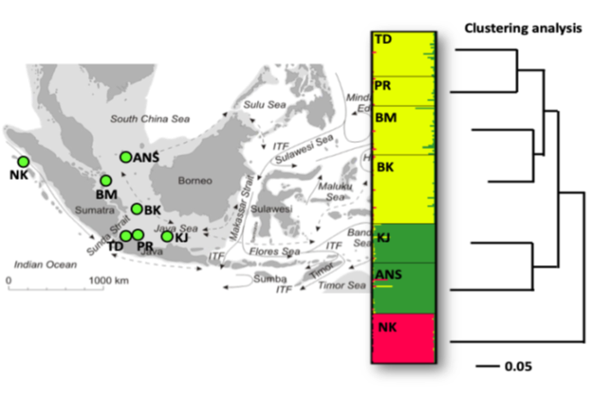
Figure 26 Seagrass connectivity of Enhalus acroides biodiversity (Hadi, et al, 2023)
The biodiversity seagrass, based on observed locations, shows that the connectivity of seagrass (Enhalus) between Tunda Island (TD), Pramuka Island (PR), Batam Island (BM), and Bangka Belitung is relatively close shown at figure above. According to Maduppa (2021), the similarity of genetic biological characteristics is related to the dispersal processes of genetic sources, which can extend widely due to the dynamics of marine waters.
Mangrove flora (biodiversity) found in Bintan are Avicennia officinalis, Bruguiera gymnorhiza, Rhizophora apiculata, R. mucronata, R. stylosa, Sonneratia alba, S. caseolaris, Xylocarpus granatum; with common associates like Acrostichum speciosum, Derris trifoliata, Pandanus odoratissimus, Scaevola taccada, Thespesia populnea (Hakim et al, 2023). Other biota associate with mangroves: long-tailed macaque (Macaca fascicularis), Natuna leaf monkey (Presbytis natunae), dugong (Dugong dugon); and at least 32 bird species recorded around Ekang Mangrove Park (8 orders, 20 families), including hornbills and kingfishers (Hakim et al, 2023).
    - Sensitivity Area
A sensitivity area can be defined as an area that is easily affected and potentially vulnerable and at risk. These areas include ecosystems, species and regions that support community livelihoods, and areas that play an important role for society. Several sensitive areas around the South China Sea include sea transportation, national boundaries, conservation areas, submarine cables, EETS migration species routes, and local transportation as table 10 below.
Table 10 Sensitivity issue in Indonesia region
Name | Sensitive issue | Description
Sea Line (ALKI) Indonesia | Balast discharge and oil spill from ship and oil and gas minning | A Study for the northern South China Sea (2015–2019) identified 632 oil slicks, of which 490 came from ships and 57 from platforms; the average slick size was about 4.8 km², though half of all slicks were under 1.7 km². (Hong et al, 2022).
National Boundaries | The overlapping maritime claims in the South China Sea (China versus ASEAN member states) | China’s expansive claims in the South China Sea have created several sensitive issues for the region, including legal disputes stemming from the invalidated nine-dash line, overlapping maritime boundaries with ASEAN states, and the militarization of artificial islands.
Conservation area | Impact from antropigenic and non antropogenic to coral, mangrove and seagrass | Muawanah et al. (2020), record, only 53% of coral reef ecosystems are managed within conservation areas. In addition to the sensitivity of designated conservation areas, coral reef ecosystems themselves are highly sensitive and vulnerable to degradation, both from anthropogenic influences and non-anthropogenic factors.
Submarine Cable | Sensitivity and risks related to cable cuts: Frequent disruptions may occur due to ship anchors, fishing trawlers, and natural hazards. | Cybersecurity risks: There are growing concerns about interception or tapping of submarine cables by state actors, making risk management in cybersecurity an urgent priority.
EETS Route and Migration | These are migratory or resident marine species that move along the South China Sea corridor, passing through Natuna waters | Dugong (Dugong dugon) with habitat in seagrass beds in Natuna & Bintan. Sea Turtles that dominantly found green turtle (Chelonia mydas) and Hawksbill Turtle (Eretmochelys imbricata) migration route across SCS feeding grounds (Natuna–Spratlys–Philippines–Malaysia). Napoleon Wrasse (Cheilinus undulatus) have migration route at Coral reef belts from Natuna to Spratly Islands and in the Philippines. Whale Shark (Rhincodon typus) as one of Vulnerable species have migration route Vietnam coast to Natuna and Java Sea while alga blooms. The Irrawaddy Dolphin (Orcaella brevirostris) as endangered found in estuaries and shallow coastal waters. The migration route from and to Mekong estuary (Vietnam/Cambodia) to Natuna Sea and along side of West Kalimantan coastal. The Scalloped Hammerhead Shark (Sphyrna lewini) that record as Critically Endangered (CE) have route from Spratlys to Natuna and Banda Sea. Leatherback Turtle (Dermochelys coriacea) record as Critically Endangered have route from Pacific (Papua nesting sites) to South China Sea (feeding grounds) and the end in Indian Ocean.
Fish Spawning Habitat | Disruption of essential habitat for spawning and nursery | The potential spawning grounds for skipjack, yellowfin tuna, mackerel mainly on offshore pelagic zones north and northeast of Bunguran Island. Coral reef-associated areas around Sedanau, Pulau Senoa, Midai as spawning ground for groupers (Epinephelus), snappers (Lutjanus). Seagrass meadows as spawning habitat of rabbitfish (Siganus), mullets.
    - Endemic, Endanger, and Threatened Species (EETS)
Endemic, endangered, and threatened species (EETS) found in the waters of the Natuna and North Natuna Seas include groups of dolphins, whales, dugongs, and several Napoleon wrasses (Cheilinus undulatus). Species such as dugongs and the Napoleon wrasse (Cheilinus undulatus), as well as spinner dolphins (Stenella longirostris) and bottlenose dolphins (Tursiops truncatus), are listed as protected fauna. Based on their IUCN Red List status, spinner dolphins are categorized as Least Concern (LC), while bottlenose dolphins are classified as Near Threatened (NT). According to CITES, these species are included in Appendix II (not necessarily threatened with extinction but may become so unless trade is strictly regulated).

All EETS groups are widely distributed across Indonesian waters. Some of the EETS species found in the Natuna waters of Indonesia are as follows:
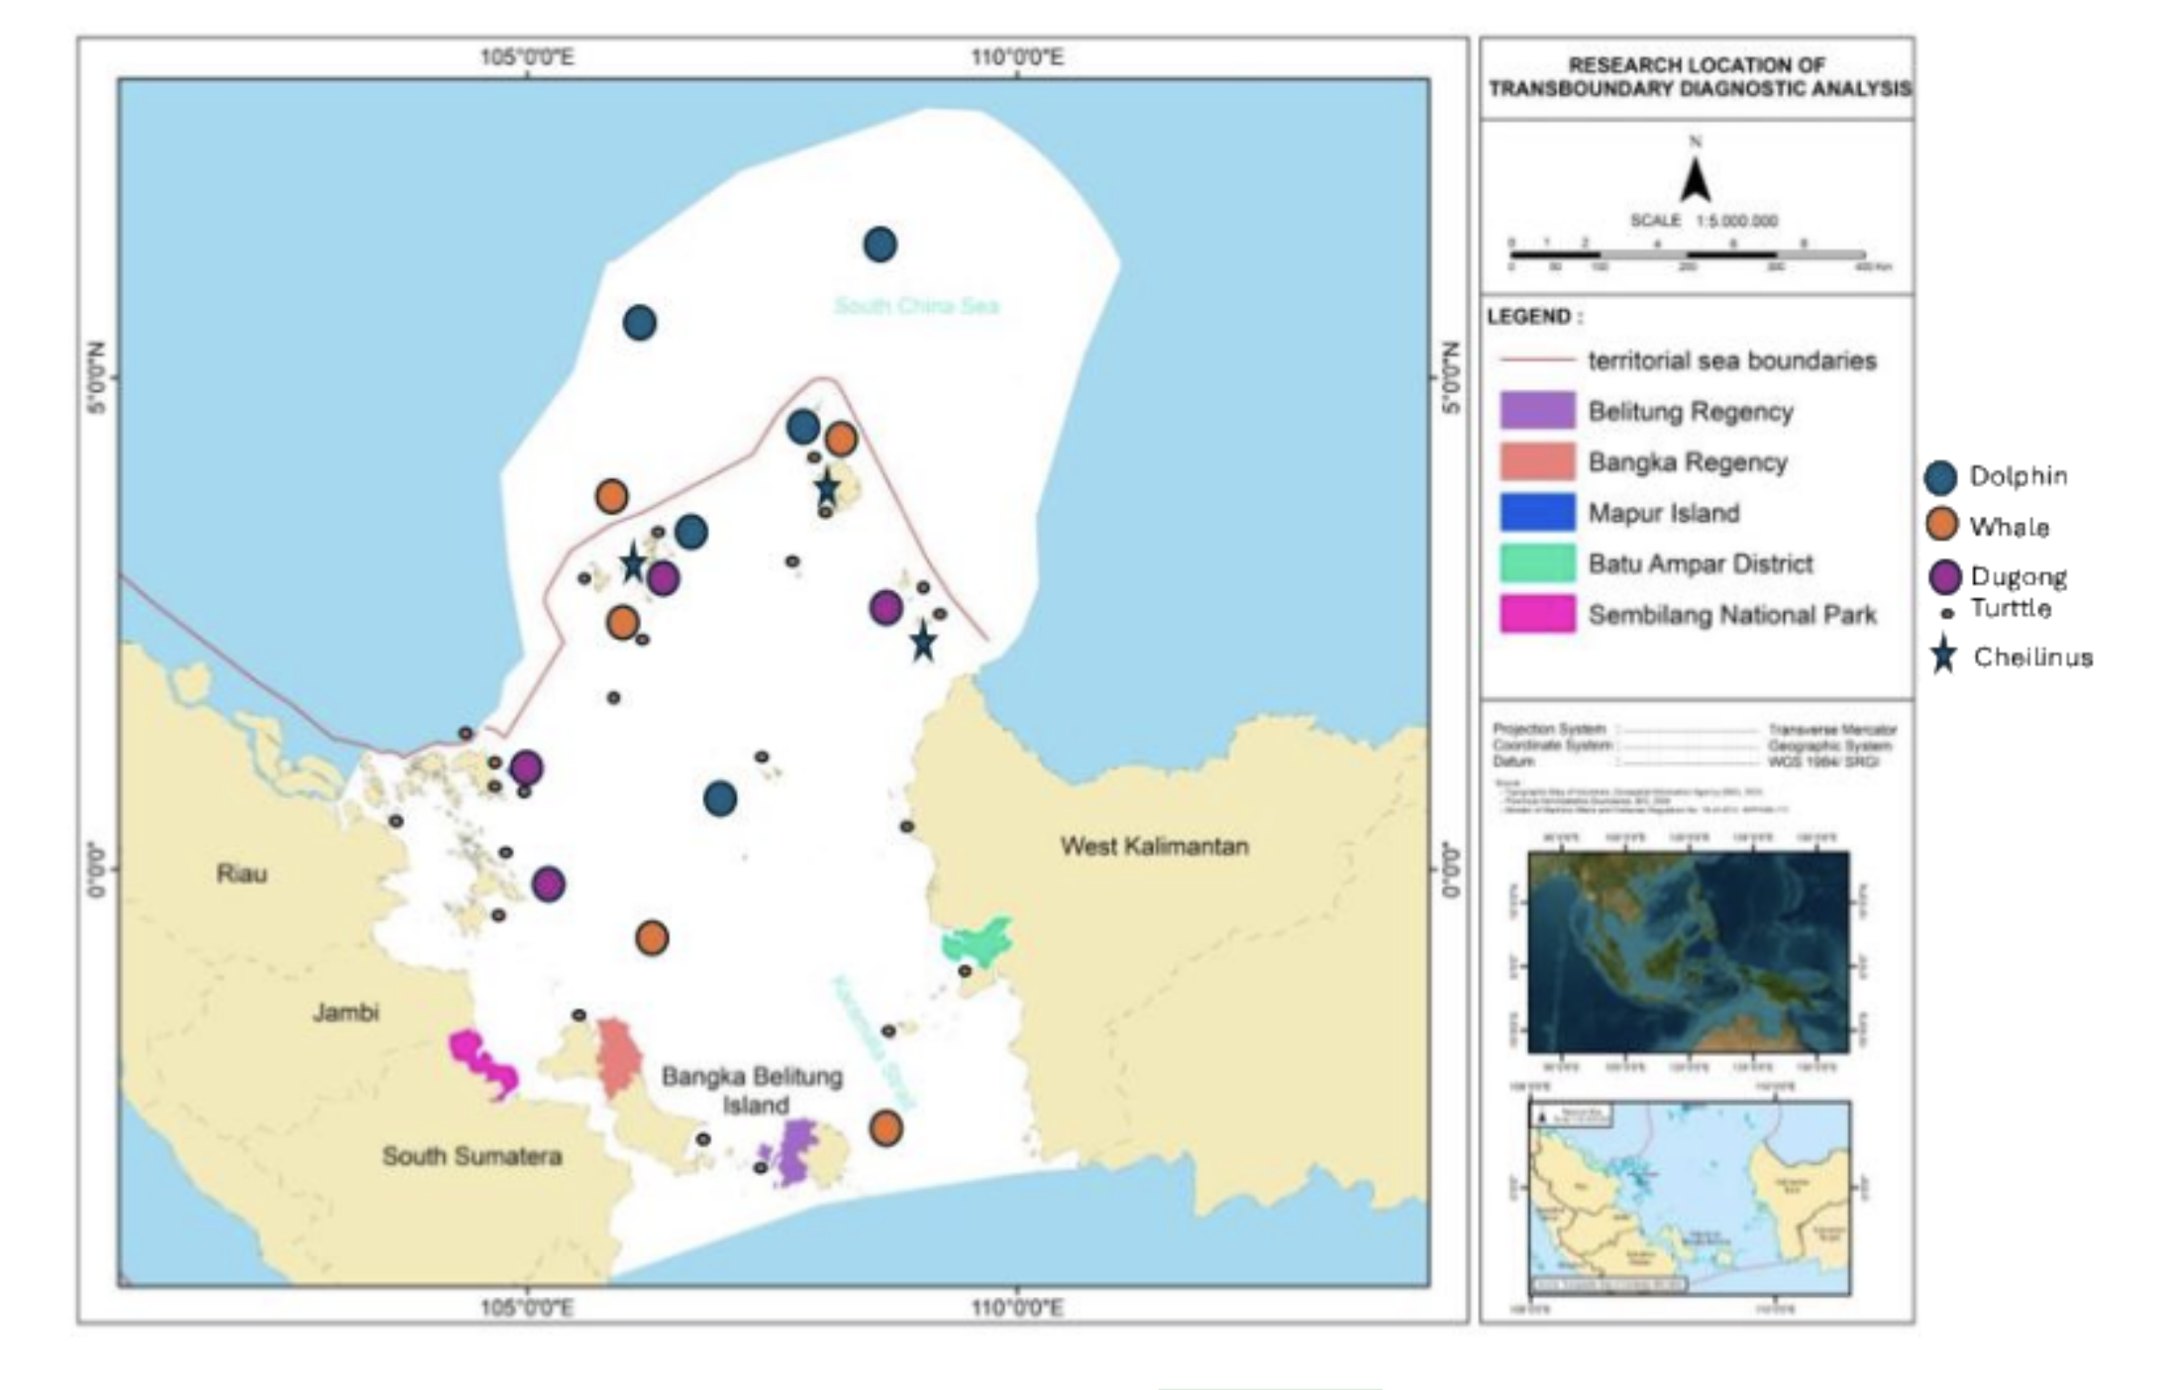
Figure 27 The distribution of EETS species in Indonesia
The dolphin species likely to be found in the waters around the North Natuna Sea are the South China Sea dolphin (Lagenodelphis hosei) or the Malacca dolphin (Delphininae sp.) (Sudjoko, 1988). Based on the literature, the distribution range of Lagenodelphis hosei is very wide, covering tropical to temperate regions, within approximately 30° north and 30° south latitude. Meanwhile, the distribution of Delphininae sp. includes the waters of the Riau Archipelago, along the coast of the Malacca Peninsula, and the Malacca Strait (Sudjoko, 1988). The following presents the conservation status information of EETS (Endemic, Endangered, and Threatened Species) found in the waters of Natuna, Indonesia.

  - Discussion
    - Priority Transboundary Issue
Based on surveys and data collection conducted at local and provincial levels in Bintan, West Borneo, the crucial issues and programs related to the marine ecosystems of Bintan, Natuna, and other waters in Western Kalimantan have been identified. This physical destruction is further exacerbated by reclamation and coastal construction, which increase water turbidity and directly destroy coral and mangrove areas. The conversion of land cover for brackish water aquaculture is another major driver of mangrove degradation. Additional pressures stem from destructive fishing practices, unregulated sand mining, and pollution from local tourism. Compounding these issues, large-scale national strategic projects pose a threat of irreversible landscape changes. The main identified transboundary issues and their descriptions are summarized in the table 11 below.

Table 11 The main identified issues and their descriptions
No | Transboundary Issue | Description
1 | Climate Impact | Increasing sea surface temperature causes coral bleaching and is exacerbated by coastal ecosystem changes from waves and currents.
2 | Marine Pollution | Degradation of mangrove, coral, and seagrass ecosystems due to debris and plastic pollution.
3 | Oil Spill | Oil spills impact coasts, mangroves, coral reefs, and coastal biodiversity.
4 | Ecosystem Degradation from Illegal Fishing | Illegal fishing causes coral destruction in various coral ecosystems in the Natuna and Anambas Seas.
5 | Invasive Species in Ecosystems | The main issue regarding marine invasives is the predation by the Crown-of-Thorns Starfish (Acanthaster planci) and the invasion of other fish populations from different ecosystems in the region.

    - Risk Assessment and Valuation of economic losses
Mangrove forests and coastal wetlands in the Indonesian part of the South China Sea covering the Natuna Islands, Anambas Islands, and the western coast of Kalimantan are facing increasing ecological risks due to the combined pressures of climate change and anthropogenic activities. Global studies estimate that about 40–56% of the world’s mangrove area is at high to very high risk due to a combination of sea-level rise and tropical storms, including the Southeast Asian region such as Indonesia (Hülsen et al., 2025). Overall, the combination of climate hazards (sea-level rise, cyclones), biophysical exposure (fragmented cover), and social vulnerability (economic dependence and limited livelihood diversification) places the coastal areas of Natuna, Anambas, and West Kalimantan within the medium-to-high risk category.
The site-level risk data for the western South China Sea demonstrates a compelling narrative of interconnected threats. High-risk sites like Bangka and Belitung are characterized by a synergy of intense stressors, primarily sedimentation from tin mining and growing tourism. In contrast, sites like Batam, Bintan, and the Barelang islands face a different risk profile, dominated by high-impact tourism and coastal development. The "High" scores for uncontrolled tourism and medium-to-high scores for eutrophication point to pressures from resort wastewater, sewage, and physical damage from reef trampling and anchors.
Conversely, sites within the western South China Sea such as Karimata and Natuna presently reside in lower risk categories. Karimata's seagrass and coral ecosystems benefit from limited access and lower direct anthropogenic input, while Natuna's offshore ecosystems remain relatively intact due to lower population density. However, Natuna faces a unique transboundary threat: a "High" risk from Illegal, Unreported, and Unregulated (IUU) fishing by foreign vessels. This highlights that risk to these marine ecosystems is not only from resident population growth but also from external resource demand, which can undermine local fisheries and cause collateral habitat destruction for reefs and seagrasses. The assessment of risk and its level from each issue in list at Tabel 4 in Appendix 3.5.
    - Current Management and Institutions
The management of coastal ecosystems—coral reefs, mangroves, seagrass beds, and wetlands—in the Indonesian sector of the South China Sea is carried out through a multi-layered system involving national ministries, regional governments, research institutions, and community-based initiatives. At the national level, the Ministry of Marine Affairs and Fisheries (KKP) leads marine conservation policy, MPA establishment, habitat mapping, and fisheries regulation, while the Ministry of Environment and Forestry (KLHK) oversees mangrove and wetland protection within the coastal–terrestrial regulatory framework. Scientific support is provided by the National Research and Innovation Agency (BRIN) and universities, which conduct ecosystem monitoring and generate updated habitat data to guide planning.
At the provincial and district levels particularly in the Riau Islands Province covering Natuna, Anambas, and Bintan local marine and fisheries agencies are responsible for implementing zoning, enforcing regulations, and managing regionally administered MPAs. Large programs such as COREMAP, the GFCR/Koralestari blue-finance initiative, and various restoration projects led by NGOs (e.g., WWF, YKAN, TNC), private partners, and coastal communities strengthen on-the-ground conservation through co-management, restoration, and livelihood integration. Together, these institutions form an integrated governance system that combines national policy, local capacity, scientific evidence, and community participation to safeguard Indonesia’s coastal ecosystems in the South China Sea region.

    - Gaps and Priority Challenges
Several critical gaps and challenges persist in Indonesia’s mangrove governance, which have direct implications for the TDA process. First, there is a scale mismatch between ambition and achievement. The national target of 600,000 ha restoration by 2024 (BRGM, 2021) remains far from completion, with less than one-fourth realized by 2024 (Ismi, 2024). Land-use constraints and competing economic priorities exacerbate the issue (Jong, 2022). Second, fragmented governance and overlapping mandates among KLHK, KKP, BRGM, and provincial authorities have hindered coordination and enforcement, leading to inconsistent zoning and weak law enforcement (MoEF, 2020; Rahman et al., 2024). Third, data gaps and limited interoperability remain major bottlenecks. Although the National Mangrove Map (PMN 2021) provides a strong baseline, data sharing and updating are uneven across regions (BRIN & MoEF, 2021). Fourth, economic pressures continue to drive conversion for aquaculture, agriculture, and coastal infrastructure (Koesdaryanto et al., 2024; Wiarta et al., 2025). These pressures are locally driven yet have transboundary ecological effects across the SCS region. Fifth, sustainable financing mechanisms remain limited. Many restoration projects depend on donor grants, and blue carbon markets are still nascent (Alongi, 2020; Arifanti et al., 2021). Finally, regional coordination under the SCS TDA/SAP remains weak. Despite regional frameworks, operationalizing joint mangrove monitoring, pollution control, and ecological corridor planning among ASEAN countries has yet to materialize effectively (Sievers et al., 2023).

    - Recommended priority actions including regional cooperation
Recommendations and action planning for each ecosystem must be carried out based on the criteria of the key issues identified. Differences in challenges require different actions and approaches. Therefore, each action should be planned according to the characteristics of each ecosystem mangroves, wetlands, coral reefs, and seagrass.

Table 12 Key issu and recommendation action and regional cooperation
Key Issue | Mangrove | Wetland | Seagrass and coral reef
Governance and Policy | - Clarify mandates and establish joint coordinating bodies. This includes forming a National Mangrove Coordination Taskforce to align restoration targets, spatial planning, and enforcement, and establishing an SCS Mangrove Working Group under the SCS TDA–SAP to coordinate cross-border priorities (Rahman et al., 2024).  - Harmonize legal and land-use instruments. Clarifying land tenure for rehabilitation sites, tightening permits for aquaculture conversion, and adopting standardized restoration protocols will prevent further degradation (MoEF, 2022). | Operationalize the One Map Policy to clarify land-use boundaries across ministries and provinces, aligning PHUs under a unified national platform (MoEF, 2022). | Policy priorities should emphasize strengthening co-management arrangements with coastal communities, securing sustainable funding for long-term monitoring using indicators such as the Coral Health Index and Seagrass Ecological Quality Index, and promoting low-impact marine tourism in high-conservation-value areas. In the Bangka–Belitung region, post-mining rehabilitation should combine substrate stabilization, coral transplantation, and pioneer seagrass restoration, financed through transparent industry partnerships and corporate social responsibility schemes (Adi & Hartoko, 2024). In the estuarine–coastal zone of eastern Sumatra, closer integration between the Ministry of Environment and Forestry (KLHK) and the Ministry of Marine Affairs and Fisheries (KKP) is crucial to incorporate coastal water quality monitoring and seagrass surveys into national park management, ensuring that wetland conservation benefits extend to shallow marine habitats (UNESCO, 2018).
Science, Data, and Monitoring | - A regional interoperable monitoring system is needed for consistent tracking of mangrove extent, carbon stock, and biodiversity. Integration with blue carbon accounting linked to national NDCs can enhance financing access and ensure transparency (Alongi, 2020; Arifanti et al., 2021).  - Restoration Quality and Site Selection. Site selection should prioritize hydrologically suitable zones identified in the PMN, avoiding areas unsuitable for natural regeneration. Local incentives and capacity building for communities must precede restoration to ensure long-term success (Setyawan & Winarno, 2006; Spalding et al., 2014). | Invest in provincial and local capacity building, embed community-based knowledge in wetland management, and integrate wetlands into Indonesia’s NDC and ASEAN reporting systems (MoEF, 2022; Murdiyarso et al., 2015). | At the national level, the National Coral Reef and Seagrass Map, jointly developed by KKP and the Nature Conservancy Indonesia (YKAN), serves as the “single source of truth” for marine spatial planning and policy evaluation (YKAN & KKP, 2025). This map also underpins blue carbon accounting frameworks that can unlock conservation financing.
Mobilizing of Finance and Market Mechanisms | Blending national funds, World Bank grants, and private sector finance (blue carbon) is essential. Introducing performance-based disbursement—linked to verified restoration outcomes such as carbon sequestration and survival rates—can enhance accountability (World Bank, 2021). Simplifying carbon project legal pathways will allow community cooperatives to participate and share equitable benefits (Arifanti et al., 2021). | Develop results-based payment schemes for rewetting and emission reduction, leverage carbon and blue carbon markets, and incentivize private sector compliance with no-deforestation and no-peat-drainage commitments (BRGM, 2021; MoEF, 2022).
Regional Cooperation Actions | Creating an SCS Mangrove Corridor connecting Indonesian hotspots (Riau, Natuna, North Kalimantan) with neighboring countries (Malaysia, Vietnam, Philippines) can protect nursery connectivity and migratory species (Sievers et al., 2023). A joint pollution mitigation program—addressing plastic, agricultural runoff, and mining sediment—should be coordinated via SCS TDA/SAP and ASEAN mechanisms (Murdiyarso et al., 2015). Establishing an SCS-level R&D Fund for blue carbon, larval connectivity, and climate resilience studies is also recommended. | Establish a National Wetland Monitoring Dashboard integrating satellite, hydrological, and social data—aligned with ASEAN’s APMS indicators (ASEAN Secretariat, 2023). Annual State of the Wetlands Reports would strengthen transparency and attract climate finance (MoEF, 2022).  Align national restoration efforts with ASEAN Peatland Management Strategy (APMS 2023–2030) and South China Sea SAP, establish an ASEAN Peat Knowledge Hub, and strengthen cross-border haze prevention with Malaysia, Brunei, and Viet Nam (ASEAN Secretariat, 2023; UNEP/GEF SCS, 2007). | Regionally, implementation of the CTI-CFF Regional Plan of Action 2.0 (RPOA 2.0) and cooperative mechanisms within WPPNRI 711 (North Natuna Sea) can enhance cross-border surveillance, ecological data sharing, and rapid response to bleaching events and extreme weather phenomena (CTI-CFF, 2020; World Bank, 2024). With an integrated, science-based, and multi-level governance approach, the sustainability of seagrass and coral reef ecosystems can serve as a cornerstone of the blue economy across the South China Sea.
Social Safeguards and Inclusion | Embedding community co-management and gender equity ensures sustainability. Formalized tenure rights for community forests and empowerment of women’s groups can make mangrove restoration socially inclusive (Setyawan & Winarno, 2006; Spalding et al., 2014).
Advancing Hydrology-First Restoration |  | Focus on rewetting and canal blocking in degraded PHUs of South Sumatra, Jambi, and West Kalimantan, complemented by native revegetation that supports local livelihoods (Evans et al.,
Empowering Community-Based Fire Prevention |  | Expand village fire brigades (MPA), integrate early-warning systems, and promote alternative livelihoods such as wetland rice and fishponds (Mongabay Indonesia, 2023; Rizki & Suryadi, 2023).

Acknowledgements : The authors are grateful to the Misitry of Environment of Indonesia, UNOPS and the Center for Coastal and Marine Resources Studies, IPB University (PKSPL IPB), Indonesia, that provided the research facilities and funding, especially during data collection processes including Focus Group Discussion in Bintan and Pontianak.

References

Adrim M, Iis Chen, ZP Chen, KKP Lim, HH Tan, Y Yusuf. 2004. Marine fishes recorded from the Anambas and Natuna islands, South China Sea. The Rafless Bulleting of Zoology.
Hadi TA, Utama RS, Arfianti T. Species richness and the dynamics of coral cover in Bangka Belitung Islands, Indonesia. PeerJ. 2023 Feb 24;11:e14625. doi: 10.7717/peerj.14625. PMID: 36860768; PMCID: PMC9969856.
A. H. Nugraha et al., "Sebaran Jenis dan Kondisi Tutupan Lamun di Perairan Kepulauan Riau," Journal of Marine Research, vol. 12, no. 3, pp. 431-438, Jul. 2023. https://doi.org/10.14710/jmr.v12i3.36274
PPID Loka Konservasi Pekanbaru. 2025. Ekosistem Terumbu Karang di Kawasan Konservasi Anambas.
Wiarta R, Firdaus Silamon R, Ishag Arbab M, Badshah MT and Hayat U and Meng J (2025) Assessing of driving factors and change detection of mangrove forest in Kubu Raya District, Indonesia. Front. For. Glob. Change 8:1511361. doi: 10.3389/ffgc.2025.1511361.
Fahmi, and Yonvitner; 2017. Biodiversity and Abundance of Demersal Fish Stock in Tambelan Water, Natuna Sea. (2017). Jurnal Ilmu Dan Teknologi Kelautan Tropis, 8(2), 503-516.
Adi, W., & Hartoko, A. (2024). Ecological condition of seagrass meadows around sea-based tin mining activities in the waters of Bangka Belitung Islands, Indonesia. Marine Pollution Bulletin, 198, 120685.
CTI-CFF. (2020). Regional Plan of Action 2.0 (RPOA 2.0): Securing the Coral Triangle for future generations. Coral Triangle Initiative on Coral Reefs, Fisheries, and Food Security.
Hughes, T. P., et al. (2017). Global warming and recurrent mass bleaching of corals. Nature, 543, 373–377.
Hong, X., Chen, L., Sun, S., Sun, Z., Chen, Y., Mei, Q., & Chen, Z. (2022). Detection of Oil Spills in the Northern South China Sea Using Landsat-8 OLI. Remote Sensing, 14(16), 3966. https://doi.org/10.3390/rs14163966
IPCC. (2022). Climate Change 2022: Impacts, Adaptation and Vulnerability. Contribution of Working Group II to the Sixth Assessment Report. Cambridge University Press.
Kementerian Kelautan dan Perikanan. (2022). Keputusan Menteri Kelautan dan Perikanan Nomor 18 Tahun 2022 tentang Kawasan Konservasi di Perairan Timur Pulau Bintan. Jakarta: KKP.
NOAA Coral Reef Watch. (2024). Annual bleaching outlook and DHW metrics for the Indo-Pacific. National Oceanic and Atmospheric Administration.
Ramsar Secretariat. (2011). Sembilang National Park (RIS No. 1945). Gland: Ramsar Convention Bureau.
Rifai, H., et al. (2024). Understanding stakeholders’ perception on developing seagrass-associated tourism: Evidence from MPAs of Bintan Island, Indonesia. Marine Pollution Bulletin, 203, 115244.
Turissa, P., et al. (2024). Sentinel‑2A multispectral image analysis for seagrass mapping in Bintan’s shallow-water ecosystem. Kuwait Journal of Science, 51(4), 1–16.
UNESCO. (2018). Berbak–Sembilang Biosphere Reserve (Indonesia). Paris: UNESCO.
World Bank. (2024). Indonesia – Coral Reef Rehabilitation and Management Program (COREMAP‑CTI): Project Performance Assessment Report No. 187437. Washington DC: World Bank.
YKAN & KKP. (2025). Indonesia develops national map of coral reefs and seagrass beds. Jakarta: Yayasan Konservasi Alam Nusantara
Bappenas. (2023). National Strategy for Wetland Management. Jakarta: Ministry of National Development Planning (Bappenas).
CIFOR-ICRAF. (2022). Coastal Rehabilitation for Climate Change Mitigation (Working Paper 11). Bogor: CIFOR-ICRAF.
Fan, B., Ren, H., Liu, H., Chen, Q., & Wang, Y. (2024). Exploring cumulative vulnerability of mangrove forests to intensive coastal anthropogenic threats. Environmental Health & Sustainability, 1(1), 0153.
Gerona-Daga, M. E. B., et al. (2022). A systematic review of mangrove restoration studies in Southeast Asia. Frontiers in Marine Science, 9, 987737.
Hülsen, S., Dee, L. E., Kropf, C. M., Meiler, S., & Bresch, D. N. (2025). Mangroves and their services are at risk from tropical climate change. Communications Earth & Environment, 6, 262.
KLHK (Ministry of Environment and Forestry). (2021). National Mangrove Map 2021. Jakarta: KLHK.
Republic of Indonesia. (2020). Presidential Regulation No. 120 of 2020 on the Peatland and Mangrove Restoration Agency (BRGM). Jakarta.
Sasmito, S. D., Basyuni, M., Kridalaksana, A., Saragi-Sasmito, M. F., Lovelock, C. E., Murdiyarso, D., & Friess, D. A. (2023). Challenges and opportunities for achieving sustainable mangrove rehabilitation in Indonesia. Nature Ecology & Evolution, 7, 62–70.
Wiarta, R., Yamada, Y., Matsushita, B., & Nurdiana, A. (2025). Assessing driving factors and change detection of mangrove forest over 30 years in Kubu Raya District, West Kalimantan, Indonesia. Frontiers in Forests and Global Change, 8, 1511361.
Zhou, P., Jiang, Z., Zhao, L., Hu, H., & Li, D. (2025). Mapping and potential risk assessment of marine debris in mangrove wetlands in the northern South China Sea. Sustainability, 17(14), 6311.
Alongi, D. M. (2018). The role of mangroves in coastal protection and climate change adaptation. Estuarine, Coastal and Shelf Science, 210, 1–8.
Alongi, D. M. (2020). The impact of climate change on mangrove forests. Current Climate Change Reports, 6, 1–7.
Arifanti, V. B. et al. (2021). Carbon dynamics and deforestation in Indonesian mangroves. Nature Communications, 12, 4164.
Badan Restorasi Gambut dan Mangrove (BRGM). (2021). National Peatland and Mangrove Restoration Targets. Government of Indonesia, Jakarta.
Donato, D. C., Kauffman, J. B., Murdiyarso, D. et al. (2011). Mangroves among the most carbon-rich forests in the tropics. Nature Geoscience, 4, 293–297.
Duke, N. C. et al. (2007). A world without mangroves? Science, 317, 41–42.
Giri, C., Ochieng, E., Tieszen, L. L. et al. (2011). Status and distribution of mangrove forests of the world using Earth observation satellite data. Global Ecology and Biogeography, 20, 154–159.
Ismi, N. (2024). Progress and Challenges of Indonesia’s Mangrove Rehabilitation Program. MoEF Policy Brief No. 8/2024.
Jong, H. (2022). Indonesia’s Mangrove Restoration Progress and Deforestation Trends. Mongabay News, Jakarta.
Koesdaryanto, E., et al. (2024). Mangrove cover dynamics and community drivers in South Sumatra. Journal of Coastal Research, 40(2), 150–162.
Ministry of Environment and Forestry (MoEF). (2020). State of Indonesia’s Forests 2020. Government of Indonesia, Jakarta.
Ministry of Environment and Forestry (MoEF). (2022). Indonesia’s Enhanced Nationally Determined Contribution. Republic of Indonesia, Jakarta.
Murdiyarso, D. et al. (2015). The potential of Indonesian mangrove forests for global climate change mitigation. Nature Climate Change, 5, 1089–1092.
Rahman, R. et al. (2024). A review on the biodiversity and conservation of mangrove ecosystems in Indonesia. Biodiversity and Conservation, 33, 875–903.
Richards, D. R. & Friess, D. A. (2016). Rates and drivers of mangrove deforestation in Southeast Asia, 2000–2012. Proceedings of the National Academy of Sciences, 113, 344–349.
Setyawan, A. D. & Winarno, K. (2006). Rehabilitation of mangroves in Java: Case study of community-based management. Biodiversitas, 7, 45–50.
Sievers, M. et al. (2023). The role of mangroves in supporting fisheries and coastal resilience. Nature Ecology & Evolution, 7, 635–646.
Spalding, M. et al. (2014). Coastal ecosystems: Nature-based solutions for climate change mitigation and adaptation. Frontiers in Ecology and the Environment, 12, 123–130.
Wiarta, D. et al. (2025). Socio-environmental drivers of mangrove cover change in Kubu Raya, West Kalimantan. Environmental Monitoring and Assessment, 197(4), 112–125.
World Bank. (2021). Blue Economy Development Framework: Mangrove and Coastal Resilience in Indonesia. Washington, DC.
ASEAN Secretariat. ASEAN Peatland Management Strategy 2023–2030. Jakarta: ASEAN Secretariat, 2023.
Badan Restorasi Gambut dan Mangrove (BRGM). National Peatland and Mangrove Restoration Targets. Jakarta: Government of Indonesia, 2021.
Evans, C. D., et al. “Overriding Importance of Water Table Depth in Controlling Greenhouse Gas Emissions from Peatlands.” Nature Geoscience 14 (2021): 868–874.
Jong, H. N. “Saling Bantah Antara Greenpeace dan APP tentang Pelanggaran Janji Tanpa Deforestasi.” Mongabay Indonesia, 2023.
Ministry of Environment and Forestry (MoEF). Indonesia’s Enhanced Nationally Determined Contribution. Jakarta: Republic of Indonesia, 2022.
Mongabay Indonesia. Ground Perspectives on Peatland Fires and Restoration (2023–2024). https://www.mongabay.co.id
Murdiyarso, D., et al. “Policy Options for Sustainable Peatland Management in Indonesia.” Nature Climate Change 5 (2015): 1089–1092.
Page, S. E., Rieley, J. O., and Banks, C. J. “Global and Regional Importance of the Tropical Peatland Carbon Pool.” Global Change Biology 17 (2011): 798–818.
Ritzema, H., et al. “Hydrology of Peatlands: Impact of Drainage, Land Use Change, and Climate.” Hydrology and Earth System Sciences 18 (2014): 3651–3670.
Rizki, R. D., and Suryadi. “Asap Karhutla Mulai Ganggu Kesehatan Warga.” Mongabay Indonesia, 2023.
UNEP/GEF South China Sea Project. Transboundary Diagnostic Analysis for the South China Sea. Bangkok: UNEP, 2007.
Ward, R. D., et al. “Peatland Restoration: A Global Challenge.” Nature Reviews Earth & Environment 3 (2022): 417–433.
Wijaya, T., and Rahmad
- POLLUTION: The status and recent management of the marine pollution in the waters of the Indonesian part of the South China Sea
Ario Damar^{1,2}, Irene Aditya³, Qonita Sinathrya¹, Isdahartati¹
¹Center for Coastal and Marine Resources Studies, IPB University
²Department of Aquatic Resources Management, Faculty of Fisheries and Marine Sciences, IPB University
³Ministry of Environment of the Republic of Indonesia

Abstract
The South China Sea (SCS) represents a critical ecological and economic region for Indonesia, supporting fisheries, energy, and trade. However, it faces escalating environmental degradation driven by land-based and marine pollution. This paper examines pollution dynamics across Indonesia’s SCS provinces—Riau, Riau Islands, Bangka Belitung, South Sumatra, and West Kalimantan—covering the period 2019–2024. Using national environment statistics and risk assessment analysis, five major pollution sources were evaluated: aquaculture waste, agricultural runoff, hazardous waste, domestic solid and liquid discharges, and oil pollution. Results indicate that land-based pollution dominates, with rivers such as the Kapuas and Batanghari transporting large nutrient and organic loads into coastal waters. The River Water Quality Index (RWQI) remains in poor to moderate categories, while Marine Water Quality Index (IKAL) scores range from moderate to good, with recent declines. Oil sludge strandings along Batam and Bintan beaches pose the highest transboundary risk, disrupting tourism and damaging mangroves and coral reefs. Plastic debris and microplastics also persist across coastal habitats, while domestic wastewater contributes localized E. coli contamination. Risk mapping identifies oil pollution as high-priority issues, followed by moderate risks from marine debris and nutrients. Institutional coordination involves multiple ministries and provincial governments but remains fragmented. The study recommends enhanced regional cooperation, particularly through ASEAN, strengthened waste management infrastructure, stricter maritime enforcement, and public awareness programs. Integrated transboundary governance is essential to safeguard Indonesia’s SCS ecosystems and sustain coastal livelihoods.
Keywords : pollution; the South China Sea; oil sludge; plastic debris; marine debris; domestic waste
  - Introduction
The South China Sea (SCS) is one of the world’s most strategic and ecologically important seas, rich in biodiversity, fisheries, and energy resources that support millions of livelihoods and global maritime trade (Teh et al., 2017; Meierding, 2017). For Indonesia, the northern waters around the Natuna Islands, within its Exclusive Economic Zone (EEZ), serve as a vital resource base and ecological frontier (Pramono, 2023; Aziz et al., 2020). However, the region faces increasing environmental stress, primarily from land-based and marine pollution, which threatens marine ecosystems, food security, and coastal welfare. Pollution in the SCS has intensified due to rapid coastal development, urbanization, overfishing, and weak environmental governance (Xiao et al., 2022; McManus (2017).
In Indonesia, land-based pollution dominates, contributing 70–80% of total marine pollutants (Dsikowitzky et al., 2018; Sianipar et al., 2022; Damar et al., 2020). Major sources include untreated sewage, industrial discharges, agricultural runoff, and plastic waste entering the sea from Sumatra, Kalimantan, and Java through rivers and estuaries. These pollutants degrade water quality, coral reefs, mangroves, and seagrass beds, which are critical habitats for fisheries and tourism.
Plastic waste represents the most visible and persistent pollutant. As the world’s second-largest contributor of ocean plastics (Jambeck et al., 2015), Indonesia releases large volumes of debris into semi-enclosed seas like the SCS. This waste breaks down into microplastics, which harm marine life, contaminate seafood, and threaten the livelihoods of small-scale fishers in Natuna. Meanwhile, agricultural and aquaculture runoff triggers eutrophication, resulting in algal blooms and oxygen-depleted zones that damage coral reefs and marine biodiversity (Zheng et al., 2023).
Marine-based pollution also remains significant. Heavy shipping traffic in the SCS leads to frequent oil spills and oil sludge, particularly near Bintan and Batam, where recurring oil contamination, often linked to ship tank-cleaning activities in the Strait of Malacca, has persisted for years (Sahputra, 2024).
This paper aims to comprehensively examine the status of the land-based pollution in the Indonesian part of the South China Sea (SCS) region (Figure 28), including the major forms of pollution, their impacts on ecosystems and economy. The paper concludes with a set of recommendations in the form of a strategic action plan, which is expected to serve as a reference for pollution management in Indonesia, particularly within the SCS region

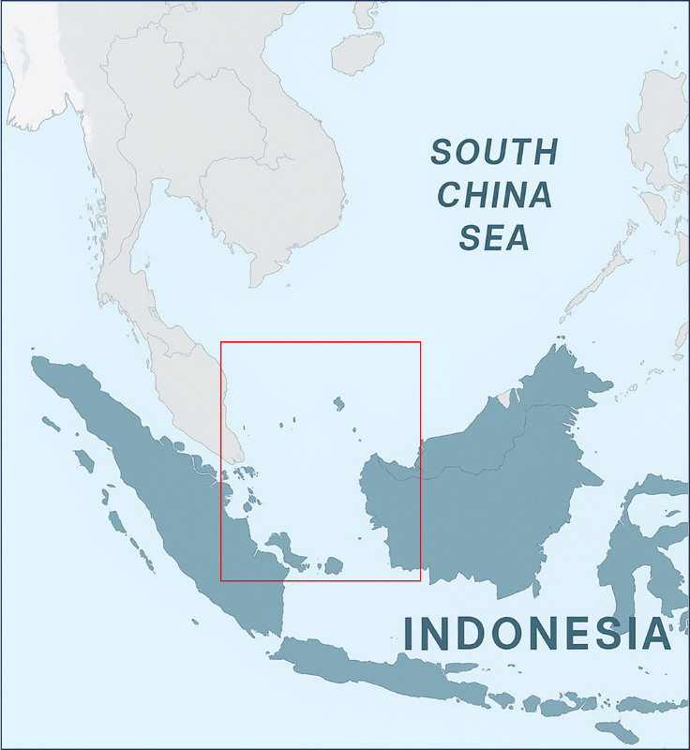
Figure 28 South China Sea Indonesia’s part (red box)
  - Key Finding
The Indonesian part of the South China Sea (SCS) is located in the country’s western maritime region (Figure 1), bordered by eastern Sumatra (Riau and Riau Islands Provinces), the Bangka Belitung Islands to the south, and West Kalimantan to the east. This semi-enclosed sea comprises numerous small islands, straits, and shallow shelves forming part of the Sunda Shelf, including key ecological areas such as the Natuna Sea, Anambas Islands, and Karimata Strait. These waters, relatively less urbanized than other Indonesian coasts, sustain diverse marine ecosystems and play crucial roles in fisheries, hydrodynamics, and maritime transport (Yulianto et al., 2019).
Coastal provinces show distinct economic patterns influencing marine conditions. Riau Province (6.86 million people) depends on oil, gas, forestry, and plantations, particularly palm oil and rubber, generating both economic benefits and environmental stress. The Riau Islands (2.18 million) center around Batam, a major manufacturing and logistics hub linked to Singapore, while smaller islands rely on fisheries and tourism. Further south, the Bangka Belitung Islands (1.51 million) are shifting from tin mining to tourism and agriculture, while West Kalimantan (5.62 million) is dominated by forestry, mining, and plantations (Indonesian Statistics, 2024).
  - Current Status by indicator group
    - Pollution Sources and Magnitude
      - Aquaculture-generated Pollution
The estimation of the pollution load generated by aquaculture activities is approached trough the total aquaculture production volume multiplied by its Feed Conversion Ratio (FCR). It is generally assumed that approximately 25% of the total feed input is released as organic waste, contributing to nutrient enrichment and potential degradation of the surrounding aquatic environment (detail method is presented at App.1). South Kalimantan consistently records the highest aquaculture-derived waste (>30,000 tonnes yr⁻¹ since 2020), reflecting intensive pond and cage culture with limited feed conversion efficiency. West Kalimantan follows with 20,000–22,000 tonnes yr⁻¹, indicating sustained production and feed loss. The Riau Islands exhibit greater variability (6,000–8,000 tonnes yr⁻¹) with a sharp increase in 2023, whereas Bangka Belitung remains below 5,000 tonnes yr⁻¹. These spatial disparities suggest that highly intensive systems disproportionately contribute to nutrient loading, emphasizing the need for improved feed management and ecosystem-based aquaculture governance (Figure 29).

Figure 29 Estimates of total volume (tonnes) of uneaten feed (become waste) Aquaculture (tonnes) in several provinces in the area around the SCS from 2019 to 2024 (source: Indonesia Fisheries Statistics 2020, 2021, 2022, 2023, 2024).
The primary pollutants derived from agricultural activities are associated with fertilization use. Fertilizer application introduces organic matter and nutrient loads into receiving water bodies, which can drive eutrophication processes.
The data (Figure 30) indicate that South Sumatra consistently contributes the highest volume of urea fertilizer used from 2019 to 2023, peaking in 2020 and gradually declining thereafter. West Kalimantan shows moderate but stable levels, while Riau Islands and Jambi exhibit lower yet increasing trends until 2021–2022 before declining in 2023. Bangka Belitung remains comparatively low and decreases sharply in 2023. Overall, the chart reflects spatial variability among provinces and a general downward trend after 2020, suggesting changes in pollutant inputs, management effectiveness, or reporting accuracy.

Figure 30 Distribution of subsidized urea fertilizer in the agricultural sector (tonnes) in the provinces adjacent to SCS area (source: Environment Statistics of Indonesia 2020, 2021, 2022, 2023, 2024)
      - Agricultural-generated Pollution
The primary pollutants derived from agricultural activities are associated with fertilization use. Fertilizer application introduces organic matter and nutrient loads into receiving water bodies, which can drive eutrophication processes.
The data (Figure 30) indicate that South Sumatra consistently contributes the highest volume of urea fertilizer used from 2019 to 2023, peaking in 2020 and gradually declining thereafter. West Kalimantan shows moderate but stable levels, while Riau Islands and Jambi exhibit lower yet increasing trends until 2021–2022 before declining in 2023. Bangka Belitung remains comparatively low and decreases sharply in 2023. Overall, the chart reflects spatial variability among provinces and a general downward trend after 2020, suggesting changes in pollutant inputs, management effectiveness, or reporting accuracy.

Figure 31 Distribution of subsidized urea fertilizer in the agricultural sector (tonnes) in the provinces adjacent to SCS area (source: Environment Statistics of Indonesia 2020, 2021, 2022, 2023, 2024)

Hazardous Waste and Heavy Metals Pollution
The chart (Figure 32) illustrates the annual generation of hazardous (B3) waste across five provinces, Riau Islands, West Kalimantan, Bangka Belitung, South Sumatra, and Jambi, from 2019 to 2023. Overall, the data show moderate fluctuations but a generally increasing trend in hazardous waste production across most provinces.
In the Riau Islands, B3 waste rose from about 82 tonnes in 2019 to a peak of approximately 84 tonnes in 2022, before decreasing slightly in 2023. West Kalimantan exhibited a steady increase from roughly 68 tonnes in 2019 to more than 82 tonnes in 2023, indicating a consistent upward trajectory. Bangka Belitung followed a similar pattern, increasing from around 67 tonnes in 2019 to over 84 tonnes by 2022, although values stabilized in 2023.
South Sumatra showed relatively stable levels, ranging between 63 and 81 tonnes, with a gradual rise through 2022 before a slight decline in 2023. Jambi demonstrated moderate variability, increasing steadily from 71 tonnes in 2019 to approximately 81 tonnes in 2022, followed by a reduction in 2023.
Overall, the provinces exhibit converging waste volumes over time, with West Kalimantan and Bangka Belitung showing the most pronounced growth.

Figure 32 Volume of hazardous waste (B3) Tonnes from each of the provinces in the SCS region (source: Environment Statistics of Indonesia, 2020, 2021, 2022, 2023, 2024).

Domestic Liquid Waste and Solid Waste
The estimation of liquid waste was derived from calculations of the organic pollution load transported by major rivers discharging into the South China Sea (see App. 2 for methodological details). The South China Sea (SCS), particularly the Indonesian sector, also receives discharges originating from land-based activities, specifically from Sumatra, Bangka Belitung, and West Kalimantan. The terrestrial pollution load enters the SCS through several rivers, including the Musi River (South Sumatra), the Siak River (Riau), the Batanghari River (Jambi), rivers in Bintan, and the Kapuas River (West Kalimantan). Figure 4.6 presents the discharge volumes of each of these rivers.

Figure 33 Annual riverine pollutant loads of NH₃-N (upper chart), TSS (middle chart) and Total Coliform (lower chart) of each river into South China Sea waters (source: data analysis 2025)
Riverine organic pollution load analysis in the South China Sea (SCS) indicates that the Kapuas River (West Kalimantan) contributes the highest NH₃-N load (~700,000 tonnes yr⁻¹), followed by the Batanghari River (Jambi, ~300,000 tonnes yr⁻¹) and South Sumatra (<200,000 tonnes yr⁻¹). The Siak and Bangka Belitung rivers show lower loads (<50,000 tonnes yr⁻¹), while Bintan records negligible levels. Similar patterns occur for TSS and coliforms, reflecting spatial variation driven by watershed scale, land-use intensity, and anthropogenic inputs across SCS river systems.
Solid waste generation across South China Sea–bordering provinces in 2022–2023 showed pronounced spatial variation. Kota Batam (Riau Islands Province) recorded the highest waste load (>400,000 tonnes yr⁻¹), followed by Kota Pontianak (West Kalimantan Province) and Musi Banyuasin (South Sumatera Province), while smaller municipalities such as Lingga, Karimun (Riau Islands Province), and Bangka Tengah produced <50,000 tonnes yr⁻¹. Provincial totals were greatest in Riau Islands and West Kalimantan (Figure 34). Between 2022 and 2023, Batam, Pontianak, and Bangka Selatan experienced waste increases linked to urban and industrial growth, whereas Musi Banyuasin and Ogan Komering Ulu Timur showed slight declines, indicating improved collection efficiency or waste reduction efforts.

Figure 34 Annual solid waste generation based on municipality, regencies and provinces 2022-2023 (source: Environment Statistics of Indonesia, 2020, 2021, 2022, 2023, 2024).

Oil Pollution
A recurrent major oil pollution event identified in the study area is the stranding of oil sludge along the northern coast of Bintan Island, likely originating from ship tank-cleaning operations in adjacent international waters. These incidents consistently occur during the northeast monsoon, when prevailing currents transport pollutants southward, resulting in the accumulation of residues along Bintan’s shoreline. The seasonal regularity of these events suggests strong hydrodynamic influence and highlights the need for enhanced regional monitoring and stricter enforcement of maritime waste discharge regulations. The stranding of oil sludge along the northern coast of Bintan Island has caused significant losses, particularly to marine tourism activities in the area. The recurring contamination has disrupted beach operations, reduced visitor numbers, and negatively affected the overall attractiveness and economic value of the coastal tourism sector (Purnaweni et al., 2022).

Atmospheric Pollution
Atmospheric and deposition studies across the South China Sea (SCS) region reveal distinct pollution dynamics modulated by climatic variability. Observations at Taiping Island and SCS cruises reported GEM concentrations of ~1.3–1.5 ng m⁻³, with RGM and particulate Hg in the pg m⁻³ range (Yeh et al., 2021; Wang et al., 2019). Acid deposition and particulate matter levels increase notably during ENSO and biomass-burning periods, especially in Sumatra and West Kalimantan (Budiwati et al., 2016; Kusumaningtyas, 2013). Elevated Pb, Cd, and As levels in Natuna’s coastal sediments (Rahayu et al., 2016) and persistent high PM₂.₅ concentrations over the Indonesian Maritime Continent (Napitupulu et al., 2024) highlight the combined influence of regional emissions, monsoon-driven transport, and interannual climate variability on atmospheric and coastal pollution.
  - Pollution Hotspots and Sensitive Areas
4.4.1 River Pollution Level
From the compilation of secondary data derived from monitoring activities conducted by the environmental agencies of each province, the following detailed data have been obtained (Environmental statistics of Indonesia, 2020-2024). The methods of the River Water Quality Index analysis is described in the App. 3 involving water quality parameters such as pH, BOD, COD, TSS, DO, NO₃-N, total phosphate, and fecal coliform.
Figure 4.8. shows that the River Water Quality Index (RWQI) for six South China Sea–bordering provinces (2019–2023) ranged from poor to moderate, reflecting persistent pollution pressures. Bangka Belitung recorded the highest scores (65–70, moderate), while South Sumatra showed moderate but slightly declining quality. Jambi exhibited the poorest conditions (<50), likely due to domestic and agricultural discharges, as reflected by the high values of the total fecal coliform microbial parameter. Riau, Riau Islands, and West Kalimantan remained borderline poor–moderate (50–60), indicating continued urban and wastewater stress. A slight overall decline from 2022–2023 suggests worsening river conditions. No province achieved good status, underscoring the need for strengthened wastewater management and pollution control measures.
.
Figure 35 RWQI calculated at each province for the period between 2019-2023 (source: Environment Statistics of Indonesia, 2020, 2021, 2022, 2023, 2024)
From the assessment of other parameters, it was observed that E. coli concentrations were relatively high in several rivers within the study area, such as the Batanghari River (Jambi Province) and the Kapuas River (West Kalimantan Province) (App. 3). This finding indicates that the rivers in the study area have been influenced by domestic sewage discharges from local communities
    - Coastal and Sea Waters
Marine Water Quality Index (IKAL) assessments (the methods of the River Water Quality Index analysis is described in the App. 4.) across South China Sea (SCS)–bordering provinces indicate overall Moderate to Good conditions during 2019–2023 (Figure 36), with limited fluctuation. Monitoring currently emphasizes organic pollution, excluding heavy metals or hazardous substances. Kepulauan Riau consistently achieved Good status, while Jambi and South Sumatra remained Moderate. Water quality peaked in 2022, when five provinces recorded IKAL >80, before declining in 2023, particularly in Jambi and Riau. West Kalimantan the Very Good threshold (>90). The 2023 decline suggests renewed environmental stress or reduced management effectiveness, underscoring the need for enhanced wastewater control, inclusion of toxic parameters, and sustained monitoring to support long-term SCS water quality protection. In general, the seawater quality index in the provinces within the study area does not yet indicate marine pollution. This condition is presumably due to the high flushing effect in the area, which prevents the accumulation of dissolved contaminant parameters. At least, several key water quality parameters—such as Total Suspended Solids (TSS), Dissolved Oxygen (DO), Oil and Grease, Total Ammonia (NH₃-N), and Ortho-Phosphate (PO₄-P)—remain below the Indonesian marine water quality standard thresholds.
Figure 36 Distribution of marine water quality index (IKAL) values across the provinces associated with Indonesia’s South China Sea (SCS) region (source: Environment Statistics of Indonesia, 2020, 2021, 2022, 2023, 2024).
  - Discussion
    - Priority Transboundary Pollution Issues
Transboundary pollution issue in the Indonesian part of the South China Sea primarily involves oil-related pollution, marine litter and plastic waste, and organic pollution. The distribution pattern of pollutants in the study area is related to water mass transport, strongly influenced by the hydrodynamic patterns of the region, which are governed by the monsoonal system. Water mass transport in the South China Sea (SCS) and adjacent Indonesian waters is primarily governed by monsoon variability. Figure 9 shows that during the southeast monsoon (May–September), winds drive currents from the Java Sea northward through the Karimata and Gaspar Straits, forming part of the South China Sea Throughflow (SCSTF) and transporting water, nutrients, and pollutants toward the SCS. Conversely, the northwest monsoon (November–March) reverses the flow, contributing to the Indonesian Throughflow (ITF) and enhancing freshwater input, stratification, and vertical mixing. These seasonal reversals strongly influence the spatial transport of pollutants and nutrient fluxes, southward during the southeast monsoon and northward during the northwest monsoon (Zeng et al., 2021). Interactions between riverine plumes, particularly from the Mekong, and monsoon-driven currents further modulate pollutant dispersion, nutrient cycling, and marine ecosystem productivity across the SCS–Indonesian region.
Figure 37 Hydrodynamics process in the South China Sea (above) and around Bintan Island where oil frequently stranded (source: Wang et al., 2019; Kok et al., 2021; Nie et al., 2023)
As shown in Figure 37, during the northeast monsoon season, which occurs between December and March, water masses flow from the Strait of Malacca and the South China Sea (SCS), reaching the northern coasts of Batam and Bintan. During this period, oil sludge stranding events occur along the northern shores of Batam and Bintan.
      - Oil-related pollution from marine transportation
Foreign vessels, frequently operate in the SCS both in the international and in the Indonesian waters around Natuna and the Riau Islands, often discharging oil, fuel, and waste. A persistent issue in the Riau Islands, particularly on the northern coasts of Bintan, is stranded oil sludge that appears during the northeast monsoon when currents move pollutants from the northern South China Sea southward. Investigations by the Ministry of Environment strongly suggest that the oil sludge originates from international vessels cleaning their tanks in the areas.
Incidents of oil spills associated with shipping activities continue to occur. For example, oil layers have been found washed ashore along the northern coasts of Batam and Bintan Islands. On Bintan Island, reported locations include Sungai Kecil Beach, Bintang Sayang Beach, Sakera Beach, and the coastal area of Lobam Island. Additional reports from local communities have identified oil pollution in Sebong Lagoi, Sebong Pereh, North Bintan, Malang Rapat, Berakit, Sri Bintan and Pengudang (Purnaweni et al., 2022).
Figure 38 The South China Sea’s shipping lanes connecting the Mallaca Strait and the South China Sea passing through the Indonesia’s province of Riau Kepulauan (source: ERIA, 2016)
The western maritime transport route of Indonesia is a busy corridor connecting the Indian Ocean and the Pacific Ocean. International shipping routes pass through the Strait of Malacca, then through the narrow Singapore Strait between Batam Island and Singapore, before entering the waters of the South China Sea (SCS) (Figure 38). In relation to this study, the Indonesian islands closest to areas affected by oil spill impacts are Batam and Bintan. These two islands are located directly along the maritime transport entrance route from the Strait of Malacca into the SCS waters.
      - Marine Litter and Plastic Pollution from Neighboring Countries and from Indonesia
Plastic waste entering the ocean varies greatly worldwide, from 1.15 to 12.7 million tonnes annually, with Indonesia contributing an estimated 0.20–1.29 million tonnes (Jambeck et al., 2015). Marine debris and plastic pollution are serious environmental issues in Indonesian waters, including the South China Sea (SCS), primarily originating from domestic solid waste dominated by plastics. Studies in Bintan Island show average microplastic concentrations of about 0.45 particles/m³ (≈122 particles per station), indicating low to moderate pollution levels. Polymer analyses revealed that polypropylene (PP) (54%), polyethylene (PE/LDPE), and polystyrene (PS) are the most common types, appearing as fragments, fibers, granules, and films. Surveys of Bintan’s coastal areas found varying amounts of stranded plastic debris, particularly LDPE, PP, and PS, reflecting ongoing land-based and marine waste inputs that continue to impact local mangrove and coastal ecosystems (Hidayati et al., 2023; Syakti et al., 2018).
      - Organic Pollution from Domestic Activities
Organic pollution mainly results from domestic wastewater discharges due to the lack of adequate communal wastewater treatment systems (IPAL). Many residential areas release untreated wastewater into rivers and coastal zones, which eventually reaches the sea. Although this pollution is currently localized and not yet transboundary in scale, it highlights weaknesses in urban wastewater management.

    - Interactions : Impacts on Environment and Society
      - Impact of oil pollution on mangroves, coral reef and tourism
Oil strandings harm coastal tourism and damage mangrove, coral reef, and seagrass ecosystems by coating mangrove roots and smothering marine organisms. Oil sludge regularly washes ashore on the sandy beaches of northern Bintan, an area recognized as a premium tourist destination attracting both domestic and international visitors.
Reports from local communities have identified oil pollution in Sebong Lagoi, Sebong Pereh, North Bintan, Malang Rapat, Berakit, Sri Bintan and Pengudang (Purnaweni et al., 2022) (Figure 39).

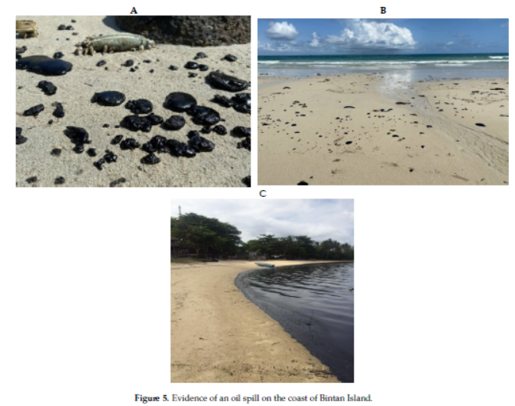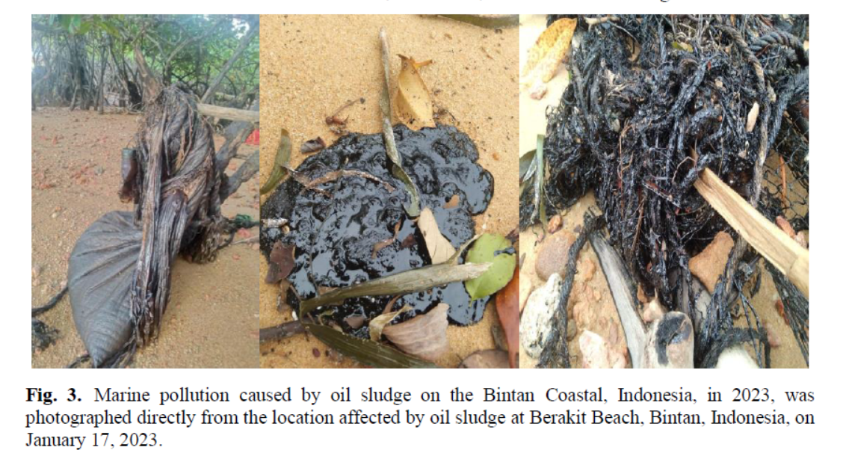
Figure 39 Marine pollution caused by oil sludge on the Bintan Coastal, Indonesia, in 2023 (Purnaweni et al., 2022; Thahira et al., 2023)
      - Impact of marine debris stranded on mangroves
Hidayati et al. (2022) reported significant macro-debris and microplastic accumulation in Bintan’s mangroves, affecting associated organisms such as gastropods. Microplastics (<5 mm) occur as pellets, fibers, fragments, and films, threatening fragile habitats that support biodiversity and coastal protection. Syakti et al. (2018) and Ma et al. (2020) found that microplastics enter food webs through ingestion, while Covernton et al. (2021) detected high concentrations in clupeid fish. Utami et al. (2021) noted that corals ingest microplastics, causing tissue damage and bleaching. Mendrik et al. (2025) observed that fibrous microplastics reduce photosynthetic activity in Acropora corals, highlighting serious ecological risks.
    - Risk Assessment of Marine Pollution
Risk assessment applies a risk analysis approach using three main variables probability, impacts, and adaptive capacity within specific pollution scenarios (Cornelly et al., 2018; Ortega et al., 2014). Probability reflects the likelihood of pollution events based on pollution source intensity and is rated from 1 to 5. Impacts include water quality conditions, deviations from standards, and socio-ecological effects, also scored from 1 to 5; both are positively correlated with risk. Adaptive capacity, rated similarly, measures the ability of management units to address pollution and is negatively correlated with risk. A higher adaptive capacity reduces overall risk.
Detailed methods are provided in the App. 5 while detail risk analysis results are shown at App. 6. Risk analysis results indicate high-risk levels for oil pollution (oil sludge) in Bintan while other pollution types showed low to moderate risks. Maximum risk for oil sludge pollution in Bintan coastal area is due to mostly its high probability and impacts and low in adaptive capacity. The high probability is evident from the relatively intense frequency of maritime transportation activities in the international waters of the region, occurring almost daily, which represents a major potential source of oily waste discharges from ship tank-cleaning operations (Thahira et al., 2023). In addition, the mechanism of this impact is transboundary in nature, involving cross-border pollution pathways. From an impact perspective, the recurrent stranding of oil sludge along the Bintan coastline has produced tangible environmental consequences, affecting beach cleanliness, disrupting coastal tourism, and degrading mangrove ecosystems (Hairo et al., 2024; Purwaneni et al., 2022).
Compared with Jakarta Bay, pollution levels in Batam, Bintan, and the wider South China Sea are relatively lower due to less intense pollution sources and impacts. In Jakarta Bay, severe contamination has led to heavy metal pollution (Hg, Pb, Cd) and toxic compounds (Dsikowitzky et al., 2018), eutrophication (Damar et al., 2020), and hypoxia (Ladwig et al., 2016; Hayami et al., 2020). Contaminants have also entered the food chain (Baum et al., 2016; Kunzmann et al., 2018; Oetama et al., 2016). Priority actions should target oil and TSS pollution, while moderate risks include marine debris, plastic waste, and E. coli contamination
    - Interactions: Current Management and Institutions
Pollution management in the South China Sea (SCS) region involves coordination among multiple Indonesian institutions. At the national level, key agencies include the Ministry of Environment, Ministry of Transportation, Ministry of Home Affairs, Ministry of Foreign Affairs, and Ministry of Marine Affairs and Fisheries. At the regional level, the main authorities are the provincial governments of Riau Islands, Bangka Belitung, and West Kalimantan, supported by their respective Environmental Agencies, Marine and Fisheries Agencies, Tourism Agencies, and Regional Development Planning Agencies (Bappeda). These institutions collaborate to monitor, manage, and mitigate marine pollution across Indonesia’s SCS territories. Specifically for the management of oil-sludge spills stranded along the northern coast of Bintan, coordination has been carried out under the coordination of the Ministry of Environment. Several institutions have been involved, including the Ministry of Transportation (as the national coordinator for oil-spill response), the Ministry of Foreign Affairs (due to the diplomatic engagement required with neighboring countries and ASEAN), the Provincial Government of the Riau Islands, and the Bintan Regency Government.
  - Gaps and Priority Challenges
The main types of pollution in the Indonesian South China Sea (SCS) region include oil sludge, plastic and marine debris, and organic and microbial contamination (e.g., E. coli, Total coliforms).
    - Oil Sludge Pollution
This transboundary issue mainly affects the northern and eastern coasts of Batam and Bintan Islands, where oil sacks and tar balls regularly wash ashore during the Northeast Monsoon (October–February). Satellite and hydrodynamic analyses trace the source to international waters between Indonesia and Singapore, likely from vessel tank-cleaning operations. The pollution damages coral reefs and coastal ecosystems, including Bintan’s marine protected areas and tourist beaches (Purnaweni et al., 2022; Thahira et al., 2023). To address it, stronger inter-ministerial coordination (Foreign Affairs, Environment and Transportation) and regional cooperation through ASEAN are needed, supported by a special task force and tourism stakeholder association for monitoring and response. Until today, oil sludge strandings along the northern coasts of Batam and Bintan continue to occur, causing major disruptions to coastal tourism. An essential effort to address this issue is cross-border coordination involving regional and international maritime transport committees. To date, efforts have been undertaken by the Indonesian government, particularly through the Ministry of Environment, including initiatives within the regional framework of the ASEAN Working Group on Biodiversity. Direct field actions include routine clean-up operations of oil sludge stranded along the northern coasts of Batam and Bintan.
Despite these efforts, oil sludge strandings on the Batam and Bintan coasts continue to occur, indicating that effective mitigation measures have yet to be achieved. Addressing this issue requires sustained efforts to prevent similar incidents from occurring in the future.
    - Plastic and Marine Debris Pollution
This type of pollution affects nearly all provinces in the SCS region, including Riau Islands, Bangka Belitung, West Kalimantan, South Sumatera and Riau. Driven by monsoonal currents, debris moves from the South China Sea toward Indonesia during the Northeast Monsoon, and in reverse during the Southeast Monsoon (Hidayati et al., 2022; Syakti et al, 2018). The main strategy should target waste reduction at the source, particularly from densely populated areas such as Batam, Bintan, and surrounding provinces. A notable gap remains in the efforts of the government, particularly local governments, to reduce plastic waste generation in their respective regions. Although relevant regulations are already in place, including a National Action Plan (NAP) for reducing plastic waste generation and marine plastic pollution, the main challenge lies in the effective implementation of this NAP. The NAP is outlined in the Presidential Regulation of the Republic of Indonesia Number 97 of 2017 concerning the National Policy and Strategy on Household Waste and Household-like Waste Management, and Presidential Regulation Number 83 of 2018 concerning the Handling of Marine Debris.
Although it has been mandated in national regulations, plastic pollution and marine debris continue to persist. Efforts to reduce plastic waste generation need to involve multiple relevant stakeholders, including producers of plastic packaging for food, beverages, detergents, shampoos, and other products, as well as waste management authorities responsible for handling and preventing waste from entering public waters.
    - Domestic Pollution
This type of organic and microbial pollution occurs not only in the Riau Islands but also across most provinces within the Indonesian South China Sea (SCS) region. Although currently domestic in nature and not transboundary, inadequate mitigation could increase its scale and pose public health risks. The main sources are household sanitation activities (bathing, washing, toilet use), which release wastewater containing coliform bacteria, including E. coli, known to cause digestive disorders such as diarrhea. Priority actions include reducing domestic wastewater contamination in rivers and coastal areas, especially in Batam, Bintan, Riau, Jambi, and Bangka Belitung. While regulations exist, stronger implementation and coordination between national and local governments are urgently needed to control pollution at its source. The main challenges include not only the provision of communal domestic wastewater treatment facilities in densely populated residential areas but also raising public awareness to encourage responsible behavior in managing household waste.
The main improvements required include not only raising public awareness to promote clean behavior but also providing infrastructure such as integrated wastewater treatment facilities in every city and settlement, establishing domestic waste collection facilities, and developing a coordinated system for managing domestic solid waste and wastewater at the community level.
  - Recommended Priority Actions, Emphasizing Regional Cooperation
To date, the Government of Indonesia, both at the national and sub-national levels (provincial and district/municipal), has implemented a range of actions to reduce the level of marine pollution. In principle, these efforts encompass: (1) mitigation measures aimed at reducing pollutant loads entering aquatic systems; (2) comprehensive and routine pollution monitoring; and (3) rehabilitation of contaminated ecosystems.
Mitigation efforts to reduce pollution loads have been undertaken through various approaches, including the enactment of environmental regulations concerning pollution prevention, routine budget allocations for pollution control infrastructure at both central and regional levels, and community awareness programs promoting pollution-minimizing behaviors.
Pollution monitoring activities are conducted both as an early-warning mechanism and as a means to support law enforcement in cases of suspected water pollution by specific parties. Routine monitoring of water pollution status is carried out in all provinces using evaluation instruments such as the River Water Quality Index (IKA) and the Marine Water Quality Index (IKAL). These efforts have been consistently implemented over at least the past eight years as part of an evaluation mechanism to assess the effectiveness of ongoing pollution prevention measures.
Rehabilitation efforts are directed particularly toward areas affected by acute pollution events, such as oil spills. In relation to the present study, regular cleanup operations have been conducted along the northern coast of Bintan Island and its surrounding areas to remove oil sludge. Coastal cleanup campaigns are also routinely organized by both local and central government agencies as part of broader marine environmental management initiatives. In detail, the efforts undertaken by the Government of Indonesia to address various pollution issues, both mitigation and rehabilitation measures, are presented in App. 7.
However, with regard specifically to transboundary pollution issues in the South China Sea (SCS) region, further efforts are required that extend beyond the actions of the Indonesian government alone. Regional coordination within the ASEAN framework needs to be continuously strengthened, given the inherently transnational nature of the pollution occurring in this area. With regard to recommended actions for addressing the major types of pollution, several of recommend actions are presented in Table 13. In principle, transboundary pollution in the Indonesian part of the South China Sea can be managed through coordination at the regional level, namely within ASEAN, as well as at the national and local levels. The primary and urgent issue requiring immediate attention is the problem of oil sludge stranded along the Bintan coastline, which necessitates intensive coordination at the ASEAN level.

Table 13 Recommendations for reducing pollution in the Indonesian South China Sea (SCS) Region
Type of pollution | Priority Actions | Level of coordination
Oil pollution | Regional coordination on oil pollution combats due to vessel activities in international waters | ASEAN
Oil pollution | National coordination on the combat of oil sludge pollution | National Indonesian Government:  - Ministry of Transportation  - Ministry of Environment  - Local Government
Oil pollution | Local coordination on stranded oil sludge management | - Local Government of Kepulauan Riau Province  - Local Government of Bintan Regency and Batam Municipality
Oil pollution | Bintan Batam Tourism Association coordination on mitigating stranded oil sludge oil | - Local Government of Bintan Regency and Batam Municipality  - Local tourism companies
Marine Debris and Plastic pollution | Regional cooperation and coordination on marine debris and plastic pollution combat | ASEAN
Marine Debris and Plastic pollution | National coordination on marine debris and plastic pollution combat | National Indonesian Government:  - Ministry of Environment  - Local Government
Marine Debris and Plastic pollution | Solid waste infrastructures | Local Government
Marine Debris and Plastic pollution | Community awareness on solid waste reduction programs | Local Government
Marine Debris and Plastic pollution | Fishers’ awareness on abandoned fishing gears waste reduction programs | Local Government
Domestic pollution | Sanitary infrastructures | Local Government
Domestic pollution | Community awareness on hygienic living | Local Government

  - Conclusion
This study shows that pollution in the Indonesian part of the South China Sea (SCS) is combination of land and marine-based sources, with major rivers such as the Kapuas and Batanghari transporting substantial nutrient and organic loads into coastal waters. Across the provinces of Riau, Riau Islands, Bangka Belitung, South Sumatra, and West Kalimantan, five key pollution categories, agricultural runoff, aquaculture waste, hazardous waste, domestic discharges, and oil contamination, continue to influence ecosystem health. The RWQI (IKA) remains categorized as poor to moderate, in contrast to IKAL scores, which lie between moderate and good, although recent measurements indicate a decline. Oil sludge strandings along Batam and Bintan beaches pose the highest transboundary risk, disrupting tourism and damaging mangroves and coral reefs.
Oil pollution represents the most critical threat, as recurrent oil sludge strandings in Batam and Bintan create significant transboundary risks, damaging mangroves, coral reefs, and seagrass meadows while disrupting tourism and coastal livelihoods. Marine debris, including plastics and microplastics, persists across beaches and shallow habitats, highlighting chronic waste management deficiencies. Localized E. coli contamination also reflects inadequate domestic wastewater treatment in some rivers in the study area.
Risk assessment identifies oil pollution (oil sludge) as the top priority for transboundary pollution issue, followed by moderate risks from nutrient enrichment and marine debris. Fragmented institutional coordination remains a major challenge. Strengthening regional cooperation, especially through ASEAN, along with improved waste and wastewater infrastructure, stricter maritime enforcement, and enhanced public awareness is essential. An integrated transboundary governance approach is crucial to protect ecological resilience and sustain the socio-economic benefits of Indonesia’s SCS waters.

Acknowledgements : The authors are grateful to the Mistry of Environment of Indonesia, UNOPS and the Center for Coastal and Marine Resources Studies, IPB University (PKSPL IPB), Indonesia, that provided the research facilities and funding, especially during data collection processes including Focus Group Discussion in Bintan and Pontianak.
Author Contributions: conceptualization, A.D. ; data curation, A.D., Q.S.; formal analysis, A.D., Q.S; funding acquisition, I.A., I., A.D.; investigation, A.D., Q.S.; methodology, A.D., Q.S.; project administration, I.H.; resources, I.H.; supervision, A.D., I.A.; visualisation, A.D., Q.S.; writing-original draft, A.D., Q.S.; writing-review and editing, A.D.,Q.S.

References

Aziz, M.F., K. Istakhori, A. A. A. Agung, Y. Prastia. 2020. Possibility To Utilize Joint Arrangement On Fisheries Between Indonesia And Vietnam On Disputed Exclusive Economic Zone (Eez) In The North Natuna Sea. Indonesian Law Journal Volume 13 No. 1, 2020, Vol. 13 No. 1 (2020). DOI: https://doi.org/10.33331/ilj.v13i1.15
Baum, G.; Kegler, P.; Scholz-Böttcher, B.M.; Alfiansah, Y.R.; Abrar, M.; Kunzmann, A. 2016. Metabolic performance of the coral reef fish Siganus guttatus exposed to combinations of water borne diesel, an anionic surfactant and elevated temperature in Indonesia. Mar. Pollut. Bull. 2016, 110, 735–746.
BPS-Statistics Indonesia. 2020. Environment Statistics Indonesia. Directorate of Social Resilience Statistics, editor. BPS-Statistics Indonesia.
BPS-Statistics Indonesia. 2021. Environment Statistics Indonesia. Directorate of Social Resilience Statistics, editor. BPS-Statistics Indonesia.
BPS-Statistics Indonesia. 2021. Kepulauan Bangka Belitung Province in Figures. BPS-Statistics of Kepulauan Bangka Belitung Province, editor. BPS-Statistics Indonesia.
BPS-Statistics Indonesia. 2022. Environment Statistics Indonesia. Directorate of Social Resilience Statistics, editor. BPS-Statistics Indonesia.
BPS-Statistics Indonesia. 2023. Environment Statistics Indonesia. Vol. 42. Directorate of Social Resilience Statistics, editor. BPS-Statistics Indonesia.
BPS-Statistics Indonesia. 2023. Kepulauan Bangka Belitung Province in Figures. BPS-Statistics of Kepulauan Bangka Belitung Province, editor. BPS-Statistics Indonesia.
BPS-Statistics Indonesia. 2024. Environment Statistics Indonesia. Vol. 43. Directorate of Social Resilience Statistics, editor. BPS-Statistics Indonesia.
BPS-Statistics Indonesia. 2024. Kepulauan Bangka Belitung Province in Figures. Vol. 23. BPS-Statistics of Kepulauan Bangka Belitung Province, editor. BPS-Statistics Indonesia.
BPS-Statistics Indonesia. 2025. Kepulauan Bangka Belitung Province in Figures. Vol. 24. BPS-Statistics of Kepulauan Bangka Belitung Province, editor. BPS-Statistics Indonesia.
Budiwati, T., Setyawati, W. & Tanti, D.A. 2016. Chemical characteristics of rainwater in Sumatera, Indonesia, during 2001–2010. International Journal of Atmospheric Sciences. https://doi.org/10.1155/2016/1876046
Connelly, A., J. Carter, J. Handley, S. Hincks. 2018. Enhancing the Practical Utility of Risk Assessments in Climate Change Adaptation. Sustainability 2018, 10, 1399; doi: https://10.3390/su10051399
Covernton, G. A., Davies, H. L., Cox, K. D., et al. 2021. A Bayesian analysis of the factors determining microplastics ingestion in fishes. J Hazard Mater. https:// doi. org/ 10. 1016/j. jhazm at. 2021. 125405
Damar A., F. Colijn, K-J. Hesse, L. Adrianto, Yonvitner, A. Fahrudin, F. Kurniawan, A. D. Prismayanti, S. M. Rahayu, B. Y. Rudianto, A. Ramli. 2020. Phytoplankton Biomass Dynamics in Tropical Coastal Waters of Jakarta Bay, Indonesia in the Period between 2001 and 2019. J. Mar. Sci. Eng. 2020, 8, 674; doi:10.3390/jmse8090674
Dsikowitzky, L., S.A. Van der Wulp, Dwiyitno, F. Ariyani, K-J. Hesse, A. Damar, J. Schwarzbauer. 2018. Transport of pollution from the megacity Jakarta into the ocean: Insights from organic pollutant mass fluxes along the Ciliwung River. Estuarine, Coastal and Shelf Science 215 (2018), 219–228.
Environment Statistics of Indonesia 2025. Indonesian Statistics Bureau 2020-2024.
ERIA (2016), ‘Sea lane security in the selected EAS countries’, in Kimura, S., T. Morikawa and S. Singh (eds.), Sea Lane Security of Oil and Liquefied Natural Gas in the EAS Region. ERIA Research Project Report 2015-14, Jakarta: ERIA, pp.41-55.
Gompi, W. H. Sambali, O. J. Kalesaran, E. L.A. Ngangi, J. D. Mudeng, W. M. Mingkid. 2023. Case study of feed convertion ratio (FCR) in intensive ponds of vanname shrimp (Litopenaeus vannamei) CV. Sinar Limunga. e-Journal Budidaya Perairan 2023, Vol. 11No. 2: 309-320
Hairo, A.F., Mubarak, D. Yoswaty, B. Amin, I. Ilahi. 2024. Analysis of Oil Spill Distribution in Bintan Utara Waters Using Sentinel-1A Satellite Imagery. Jurnal Natur Indonesia, 22(1): 48–56.
Hayami, Y., A. Morimoto, A. Sudaryanto, S. I. Sachoemar, E. Soeyanto, A. Rusdiansyah, M. Saleh. 2020. A quasi-persistent hypoxic water mass in an equatorial coastal sea, Jakarta Bay, Indonesia. Estuarine, Coastal and Shelf Science, Volume 246, 5 November 2020, 107030.
Hidayati, J. R., Apdillah D, Idris, B. F., Anugrah, S., Hamza, S., Sihite, D., Syafitri, M., Febrianto, T., and Syakti, A. D. Size and Types Distribution of Marine Debris in the Mangrove Ecosystem of Bintan Island – Indonesia. In book: Proceedings of the 2022 Brawijaya International Conference (BIC 2022) (pp.144-155). DOI:10.2991/978-94-6463-140-1_15.
Indonesian Fisheries Statistics. 2025. Indonesian Statistics Bureau 2020-2024.
Jambeck, J.R., R. Geyer, C. Wilcox, T. R. Siegler, M. Perryman, A. Andrady, R. Narayan, K. L. Law. 2015. Plastic waste inputs from land into the ocean.Science 347(6223):768–771 (2015); doi:10.1126/science.1260352
Kok, P. H., Wang, D. W., Wang, Y., & Dwi, S. P. (2021). Interconnection between the Southern South China Sea and Java Sea through the Karimata Strait. Journal of Marine Science and Engineering, 9(10), 1040.
Kunzmann, A.; Arifin, Z.; Baum, G. 2018. Pollution of Coastal Areas of Jakarta Bay: Water Quality And Biological Responses. Mar. Res. Indones. 2018, 43, 37–51.
Kusumaningtyas, S.D.A., 2013. Chemical characteristics on rain water during forest fire in West Kalimantan and South Sumatera. Jurnal Meteorologi dan Geofisika Vo. 14, 2013: 1-8.
Ladwig, N.; Hesse, K.-J.; van derWulp, S.A.; Damar, A.; Koch, D. 2016. Pressure on oxygen levels of Jakarta Bay. Mar. Pollut. Bull. 2016, 110, 665–674.
Ma, H., Pu, S., Liu, S. et al. 2020. Microplastics in aquatic environments: toxicity to trigger ecological consequences. Environ Pollut. https:// doi. org/ 10. 1016/j. envpol. 2020. 114089
McManus, J. W. (2017). Offshore Coral Reef Damage, Overfishing, and Paths to Peace in the South China Sea. The International Journal of Marine and Coastal Law, 32(2), 199-237. https://doi.org/10.1163/15718085-12341433
Meierding, E. 2017. Joint development in the South China Sea: Exploring the prospects of oil and gas cooperation between rivals. Energy Research & Social Science, Vol. 24, February 2017: 65-70. Energy Research & Social Science.
Mendrik F., C. R. Hackney, V. M. Cumming, C. Waller, D. Hak, R. Dorrell, N. N. Hung, D. R. Parsons. 2025. The transport and vertical distribution of microplastics in the Mekong River, SE Asia. Journal of Hazardous Materials, Volume 484, 2025, 136762,ISSN 0304-3894, https://doi.org/10.1016/j.jhazmat.2024.136762.
Napitupulu, G., Rafid, Yulianti, K.K., Sinuraya, D.E., Waryatno, N.F.P. & Fekranie, N.A. 2024. Spatiotemporal variation of particulate matter (PM₂.₅) concentration in the Indonesian Maritime Continent. Malaysian Journal of Tropical Geography. 50(1): pp. 1–17.
Nie, Y., Xu, T., Wang, Y., & Chu, P. C. (2023). Amplitude modulations of seasonal variability in the Karimata Strait throughflow. Frontiers in Marine Science, 10, 1085032.
Oetama, V.S.P.; Hennersdorf, P.; Abdul-Aziz, M.A.; Mrotzek, G.; Haryanti, H.; Saluz, H.P. 2016. Microbiome analysis and detection of pathogenic bacteria of Penaeus monodon from Jakarta Bay and Bali. Mar. Pollut. Bull. 2016, 110, 718–725.
Ortega, S.T, N. Hanley and P. D. Simal. 2014. A Proposed Methodology for Prioritizing Project Effects to Include in Cost-Benefit Analysis Using Resilience, Vulnerability and Risk Perception. Sustainability 2014, 6, 7945-7966; doi: https://10.3390/su6117945
Pramono, B. 2023. The Indonesia's Strategies For Exclusive Economic Zone (EEZ) Sovereignty With 1982 UNCLOS Provisions: North Natuna Sea. Jurnal Defendonesia,Vol. 7 No. 1 (2023): April. DOI: https://doi.org/10.54755/defendonesia.v7i1.128
Purnaweni, H.; Saputra, J.; Roziqin, A.; Kismartini, K.; Djumiarti, T.; Seitz, T. 2022. Oil Spill Governance: Evidence from Bintan Island, Indonesia. Sustainability 2022, 14, 3, 1603. DOI: https://doi.org/10.3390/su14031603
Rahayu, Y.P., Adi, R.A., Priyambodo, D.G., Puspita, C.D. & Triwibowo, H. 2016. Kualitas air permukaan dan sebaran sedimen dasar perairan Sedanau, Natuna, Kepulauan Riau. Jurnal Segara. 12(1).
Republic of Indonesia. (2021). Regulation of the Minister of Environment and Forestry of the Republic of Indonesia Number 27 of 2021 concerning the Marine Water Quality Index
Sahputra, Y. E. 2024 Mar 27. Mongabay. Minyak Hitam Kembali Cemari Laut Bintan, Bagaimana Solusinya?. [diakses 2025 Agt 15]. https://mongabay.co.id/2024/03/27/minyak-hitam-kembali-cemari-laut-bintan-bagaimana-solusinya/
Sianipar, I.M.J., I. W. Koko Suryawan, S. R. Tarigan. 2022. The Challenges and Future of Marine Debris Policy in Indonesia and Taiwan Case Studies. Journal of Sutainable Infrastructure Volume 1 No. 2: 56-62
Syakti, A. D., Hidayati, V. N., Jaya, Y. V., Siregar, S. H., Yude, R., Suhendy, Asia, L., Wong-Wah-Chung, P., Doumenq, P. 2018. Simultaneous grading of microplastic size sampling in the Small Islands of Bintan water, Indonesia. Marine Pollution Bulletin, Volume 137, p. 593-600. DOI: https://doi.org/10.1016/j.marpolbul.2018.11.005
Teh LS, Witter A, Cheung WW, Sumaila UR, Yin X. 2017. What is at stake? Status and threats to South China Sea marine fisheries. Ambio. 2017 Feb;46(1):57-72. doi: 10.1007/s13280-016-0819-0. Epub 2016 Sep 23. PMID: 27663231; PMCID: PMC5226903.
Thahira, A., S. Syofyan S, Z. Daulay, and Ferdi. 2023. The Outside of Port Limit (OPL) as a new maritime zone to overcome marine pollution due to oil sludge impacting the coast of Bintan, Indonesia to actualise sustainable development. 2023. BIO Web of Conferences 70, 02001. DOI: https://doi.org/10.1051/bioconf/20237002001
Utami, D.A., Reuning, L., Konechnaya, O., Schwarzbauer, J. 2021. Microplastics as a sedimentary component in reef systems: a case study from the Java Sea. Sedimentology. https:// doi. org/ 10. 1111/ sed. 12879
Wang, Y., Wang, D. W., Sprintall, J., & Susanto, R. D. (2019). Seasonal variation of water transport through the Karimata Strait. Journal of Oceanology and Limnology, 37(3), 956–968.
Xiao, J., W. Wang, X. Wang, P. Tian, W. Niu. 2022. Recent deterioration of coral reefs in the South China Sea due to multiple disturbances. PeerJ. 2022 Jul 25;10:e13634. doi: https://10.7717/peerj.13634
Yeh, M.J., Yuan, C.S., Hung, K.N., Ie, I.R., Lee, C.E., Chiang, K.C. & Soong, K.Y. 2021. Temporal variation and potential origins of atmospheric speciated mercury at a remote island in South China Sea based on two-year field measurement data. Scientific Reports. 11(1). p. 5678. https://doi.org/10.1038/s41598-021-84434-z
Yulianto, E., Sukapti, W.S., Dewi, K.T., 2019. Late Holocene Pollen Record of Environmental Changes in Karimata Strait, Sunda Shelf Region. Indonesian Journal on Geoscience, 6 (1), p.41-55. DOI: 10.17014/ijog.6.1.41-55
Zeng, X., et al. (2021). Monsoonal Effects on Nutrient and Pollutant Transport in the South China Sea. Arxiv. https://arxiv.org/abs/2112.11252
Zheng, X., S. Ruikun, D. Zhenqing, H. Lei, L.Chengyong. (2023). Distribution and risk assessment of microplastics in typical ecosystems in the South China Sea. Science of The Total Environment. 883. 163678. https://10.1016/j.scitotenv.2023.163678 .

- FISHERIES: The Status and Recent Management of the Fisheries and Aquaculture Sector in the Fisheries Management Area of 711, part of the South China Sea
Mochammad Riyanto², Irene Aditya³, Aisyah Qurota A’yun¹, Isdahartati¹

¹Center for Coastal and Marine Resources Studies, IPB University
²Department of Fisheries Resource Utilization, Faculty of Fisheries and Marine Sciences, IPB University
³Ministry of Environment of the Republic of Indonesia

Abstract
The South China Sea sub-region of Indonesia (FMA 711) represents a major contributor to national fisheries production, supporting both industrial and small-scale sectors and sustaining significant marine biodiversity. This report provides a comprehensive assessment of capture fisheries, aquaculture, stock status, fishing effort, and emerging environmental pressures across the region. Findings reveal long-term increases in reported capture production since the 1950s, driven by fleet modernization and expanded fishing capacity. At the same time, unreported catches remain comparatively low but still pose uncertainties for stock assessment. Several key species groups, including large pelagic, demersal, cephalopods, shrimp, and crab, show signs of overexploitation, exacerbated by destructive gear use, habitat degradation, and IUU fishing. Environmental variability and climate change further influence species distribution, productivity, and catch potential, with models indicating an approximate 12% decline in maximum catch potential from 1990 to 2025. Aquaculture production displays substantial regional disparity, dominated by East Java, Jakarta, and West Java, while smaller provinces exhibit limited growth due to regulatory and infrastructural constraints. Collectively, these findings highlight the urgent need for science-based fisheries management, strengthened monitoring and enforcement, and adaptive strategies to enhance the resilience of both capture fisheries and aquaculture under increasing anthropogenic and climatic pressures.
Keywords: aquaculture, fisheries, South China Sea
  - Introduction
The fisheries sector in Indonesia plays a vital role both economically and socially, serving as one of the main pillars of national food security and a source of livelihood for millions of coastal communities. The contribution of the capture fisheries sub-sector to the national Gross Domestic Product (GDP) reached around 2.7% in 2023, with an average growth of 5–6% per year (MMAF, 2024). The high national consumption of fish, which has increased to around 57 kg per capita per year, reflects the importance of this sector in supporting the nutrition of the Indonesian people. One of the strategic fisheries areas that supports this contribution is the South China Sea (SCS) sub-region, also known as the Indonesian Fisheries Management Area (FMA) 711, which covers the northern waters of the Natuna Islands, Anambas, and surrounding areas in the Riau Islands Province.

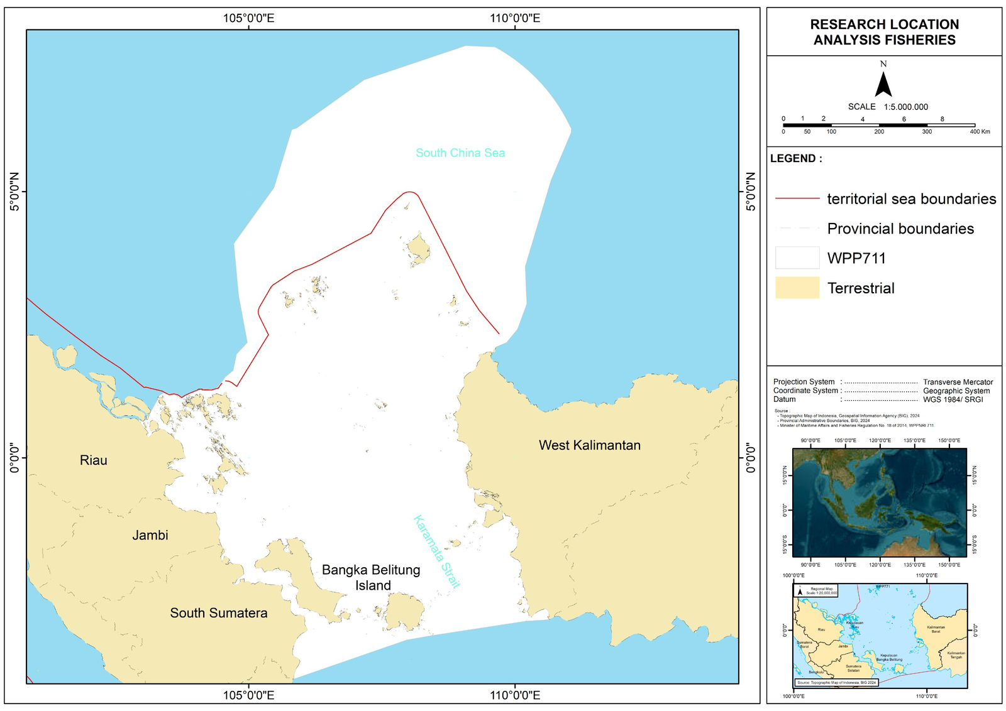
Figure 40 Coverage of the SCS sub-area that is part of WPPNRI 711

The Indonesian sub-region of the South China Sea (WPPNRI 711) is a biodiverse tropical ecosystem and key migration route for large pelagic fish, contributing 11–13% of national capture fisheries production with high MSY potential for pelagic and demersal resources. Despite this significance, the area faces significant challenges, including overexploitation, IUU fishing, habitat degradation, and climate-driven shifts in temperature and currents that affect species distribution and productivity. These pressures highlight the need for adaptive, science-based, and collaborative management approaches, as NTDA findings indicate notable overexploitation of high-value pelagic and demersal stocks. This paper, therefore, assesses the fisheries and aquaculture status of WPPNRI 711 and provides strategic recommendations intended to guide sustainable resource and pollution management in the region.
This paper aims to comprehensively examine the status of fisheries and aquaculture in the WPPNRI 711 of the South China Sea (SCS) region (Figure 40). The paper concludes with a set of recommendations in the form of a strategic action plan, which is expected to serve as a reference for pollution management in Indonesia, particularly within the SCS region
  - Key Finding Concern
- WPPNRI 711 is a major fisheries producer with high marine biodiversity.
- Capture production has increased, but key species show overexploitation from high fishing pressure and IUU fishing.
- Climate change reduces productivity, with an estimated 12% decline in catch potential.
- Aquaculture growth is uneven and concentrated in a few provinces.
- Stronger science-based management and enforcement are urgently needed.

5.3. Overexploitation of Living Aquatic Resources
5.3.1. Production Required by Reporting Status
Fisheries in the South China Sea under WPPNRI 711 form a key component of regional marine productivity, requiring an indicator-based framework to assess resource potential amid rising anthropogenic and climatic pressures. Five core indicators, biomass, reproductive dynamics, mortality, habitat condition, and environmental parameters, collectively support comprehensive stock evaluation. Biomass estimation, derived from trawl surveys, CPUE, and stock assessment models, provides the primary metric for determining MSY and assessing exploitation levels, a critical function in this transboundary and migratory species–dominated region. Studies show that declines in biomass can amplify the effects of climate variability and fishing intensity on population trajectories.
Habitat quality, particularly within coral reefs, mangroves, and seagrass systems, underpins recruitment and trophic stability. Degradation from sedimentation, pollution, and destructive fishing has reduced habitat complexity and carrying capacity, diminishing biodiversity and coastal fishery productivity. Environmental conditions, including SST, salinity, dissolved oxygen, and nutrient dynamics, further shape species physiology, distribution, and recruitment. Climate-driven anomalies and changing monsoon patterns in WPPNRI 711 have been linked to shifts in species composition and poleward migration, underscoring the need for continuous monitoring to inform ecosystem-based fisheries management.
Analysis of capture fisheries production from 1950 to 2019 shows a persistent dominance of reported over unreported catches. Reported production increased steadily, peaking near 900,000 tonnes in the late 2010s, reflecting fleet modernization, improved reporting systems, and stronger governance. Unreported catches remained comparatively low and stable, though this may indicate both effective monitoring and ongoing challenges in detecting IUU fishing, particularly in remote or disputed areas (Figure 41).

Figure 41 Capture fisheries production in the South China Sea from 1950 to 2019 (FAO, 2022)
From a scientific and management perspective, the significant disparity between reported and unreported catches carries important implications for sustainable fisheries governance in the South China Sea. The predominance of reported data provides a strong foundation for conducting stock assessments, setting quotas, and formulating science-based policy decisions. However, even a small proportion of unreported catch can introduce significant uncertainty into biomass estimates, especially when it involves high-value or ecologically important species. Unreported fishing may occur due to small-scale artisanal operations outside the formal monitoring system, cross-border fishing in disputed territories, or deliberate underreporting to evade regulations and taxes. This underestimation of total catch can lead to overly optimistic assessments of stock health, inadvertently increasing the risk of overexploitation and long-term stock depletion. To address this, it is essential to strengthen catch documentation schemes, expand the use of electronic monitoring and vessel tracking systems, and promote regional cooperation among South China Sea nations.

Figure 42 Capture fisheries by species group production in the South China Sea from 1950-2019 (FAO, 2022)

The artisanal fisheries sector in the South China Sea is essential for coastal livelihoods and food security, with catches dominated by anchovies, herring-like species, and other small pelagics that have grown steadily, especially since the late 1990s. Molluscs, crustaceans, and perch-like species also contribute significantly, reflecting the region’s ecological richness and the reliance of small-scale fishers on nearshore resources. Although some high-value species such as sharks, rays, and tuna are caught in smaller volumes, they provide important economic benefits. However, the expanding fishing range of artisanal fleets driven by market demand and technological improvements, combined with pressure from industrial fisheries, raises growing concerns about overfishing and long-term resource sustainability.

5.3.2. Fisheries Production Potential
The capture fisheries production potential in freshwater areas of the South China Sea region demonstrates distinct trends when viewed over the period from 1960 to 2020 (Figure 4). Freshwater fishes (nei) have consistently dominated production, showing peaks in the mid-1960s and early 1970s before experiencing fluctuations and a gradual decline after 2005. Despite these variations, they remain the most significant contributor to freshwater capture production, indicating that fish species still hold significant economic and nutritional value in the region's inland fisheries.

Figure 43 Freshwater production potential from 1960 to 2020 (FAO, 2022)
Aquatic plants in the region have shown intermittent but notable production spikes, particularly in the late 1960s and early 2000s, likely driven by seasonal harvests and shifting market demand, while freshwater crustaceans and molluscs have become more prominent since 2010, though their volumes remain modest. These groups hold niche market potential and could be strengthened through targeted management, improved harvesting methods, and integration with aquaculture. Freshwater gastropods remain minimal, reflecting low availability or demand, yet they indicate untapped biodiversity. Overall, freshwater capture fisheries in the South China Sea region offer opportunities for diversification and economic enhancement, provided that sustainable management and habitat conservation measures are implemented.

Figure 44 Production potential (FAO, 2022)
Capture fisheries in the South China Sea are dominated by miscellaneous demersal fishes, which surged dramatically in the early 2000s and peaked in 2014–2015 at over 11 million tonnes, reflecting intensified fishing pressure and technological improvements. Although production has slightly declined since then, demersal catches remain far higher than those of other groups. Pelagic fishes, tunas, billfishes, sharks, and rays contribute much smaller volumes, with pelagics and tunas maintaining steady commercial importance, while low shark and ray catches likely reflect conservation limits or declining stocks. Cephalopods and crustaceans, though modest in volume, are economically valuable and show stable trends that could support targeted fishery expansion. In contrast, seaweed and sea cucumbers appear only minimally in capture data. The strong dependence on demersal resources raises sustainability concerns due to their slower life histories, highlighting the need for diversified fishing targets, spatial management, selective gear use, and better utilization of underexploited species to strengthen long-term fisheries resilience.

5.3.3. Fishing Effort
Table 14 Number of fleets by fishing boats and gears
Country/ Sub Regions | Number of fleets by type of fishing boats |  |  |  | Number of fleets by type of fishing gear
Country/ Sub Regions | Inboard | Outboard | Non-motorized | Total | Trawlers | Purse Seiners | Hook & Lines | Gillnet | Total
Indonesia
Riau-Batam | 19,783 | 6,794 | 11,612 | 38,189 | - | - | - | - | -
Bangka-Belitung and South Sumatra | 2,350 | 757 | 418 | 3,525 | - | - | - | - | -
Jakarta and West Java | 6,766 | 11,425 | 20 | 18,211 | - | - | - | - | -
East Java | 27,224 | 26,365 | 3,654 | 57,243 | - | - | - | - | -
South Kalimantan | 5,901 | 68 | 68 | 6,037 | - | - | - | - | -
West Kalimantan | 7,777 | 3,536 | 4,591 | 15,904 | - | - | - | - | -
Subtotal | 69,801 | 48,945 | 20,363 | 139,109 | - | - | - | - | -

Figure 45 Fish production (tonnes) by fisheries sector in the South China Sea from 1950 to 2019
The fishing effort in the Indonesian regions bordering the South China Sea is characterized by a significant number of fleets, with a mix of inboard, outboard, and non-motorized vessels. According to the table, East Java has the largest total fleet with 57,243 boats, followed by Riau-Batam with 38,189 vessels. The prevalence of non-motorized boats in areas like Riau-Batam (11,612 units) highlights the importance of small-scale artisanal fisheries, which rely heavily on traditional fishing methods and nearshore resources. However, the large numbers of inboard and outboard motorized vessels in key provinces suggest a growing fishing capacity that can exert considerable pressure on fish stocks.
Figure 45 illustrates the long-term production trend of two main fisheries sectors, artisanal (traditional) and industrial fisheries, which together represent the dominant fishing activities within Indonesia's South China Sea sub-region. From the 1950s to 2019, industrial fisheries production increased exponentially, reaching nearly 600,000 tonnes, while artisanal fisheries showed a steadier but consistent growth, rising from less than 50,000 tonnes in the 1950s to over 300,000 tonnes by 2019. The continuous upward trend in both sectors reflects the expansion of fishing capacity, technological advancement, and market-driven demand for export-oriented species such as tuna, mackerel, and anchovy.
Figure 45 and Table 14 reveal a structural dualism in Indonesia's fishing economy, a coexistence between the rapidly modernizing industrial sector, supported by motorized fleets and advanced gear such as purse seiners and hook-and-line systems, and the traditional artisanal sector, which remains vital for coastal livelihoods and local food security. The expansion of industrial fleets correlates with the sharp rise in production after the 1980s, whereas artisanal fisheries growth is constrained by limited vessel capacity and spatial competition in nearshore waters. This dual-sector dynamic underscores the need for differentiated management strategies ensuring industrial efficiency while safeguarding artisanal sustainability, particularly in the WPPNRI 711 region, where both sectors play complementary but increasingly competitive roles.
5.3.4. Stock Numbers and Catch Biomass
Capture fisheries production in the South China Sea has risen steadily from 1950 to the late 2010s, driven by fleet mechanization, technological advancements, expanded fishing grounds, and improved reporting. Production reached its highest levels in the late 2010s, nearly one million tonnes, before dropping sharply in the most recent year, a decline that may reflect stricter management, reporting changes, or reduced resource availability. While the long-term growth trend highlights the sector’s expansion, the recent downturn signals ecological limits and increasing pressure on stocks, emphasizing the need for science-based management, stronger monitoring, and ecosystem-based approaches to maintain sustainability and safeguard coastal livelihoods.

Figure 46 Fish production (tonnes) in the South China Sea from 1950-2019 (FAO, 2022)

Figure 47 Fish production value in the South China Sea from 1950-2019 (FAO, 2022)
The economic value of capture fisheries in the South China Sea has grown substantially from 1950 to the late 2010s, rising gradually in the early decades and then sharply from the 1970s onward due to improved technology, offshore expansion, and stronger market integration. After fluctuating through the 1980s and early 2000s, the sector experienced its steepest growth in the mid-2000s, peaking above one trillion rupiah in the early–mid 2010s as demand and prices for high-value species increased. The abrupt decline in the most recent year parallels drops in production, indicating possible reductions in catch, market disruptions, or reporting changes. This trend demonstrates the economic vulnerability of fisheries-dependent regions and reinforces the need for sustainable management to stabilize both biomass and long-term economic returns.

Table 15 Exploitation level in the South China Sea from 1950 to 2019
Country/Sub-Regions or coastal provinces | Resource Categories (Fish Species Groups)
Country/Sub-Regions or coastal provinces |  | Miscellaneous demersal fishes | Miscellaneous pelagic fishes |  | Squids, cuttlefish, and Octopus | Crustaceans nei
Country/Sub-Regions or coastal provinces |  | Miscellaneous demersal fishes | Small Pelagic | Big Pelagic | Squids, cuttlefish, and Octopus | Shrimp | Lobster | Crab | Blue Crab
Indonesia
Riau-Batam | Potency | 131,070 | 330,284 | 185,855 | 23,499 | 62,342 | 1,421 | 2,318 | 9,711
Riau-Batam | TAC | 104,856 | 264,227 | 148,684 | 18,799 | 49,874 | 1,137 | 1,854 | 7,769
Riau-Batam | Level of Utilization | 0.61 | 1.41 | 0.93 | 1.84 | 0.53 | 0.54 | 1.09 | 1.18
Bangka-Belitung and South Sumatra | Potency | 131,070 | 330,284 | 185,855 | 23,499 | 62,342 | 1,421 | 2,318 | 9,711
Bangka-Belitung and South Sumatra | TAC | 104,856 | 264,227 | 148,684 | 18,799 | 49,874 | 1,137 | 1,854 | 7,769
Bangka-Belitung and South Sumatra | Level of Utilization | 0.61 | 1.41 | 0.93 | 1.84 | 0.53 | 0.54 | 1.09 | 1.18
Jakarta and West Java | Potency | 657,525 | 364,663 | 72,812 | 126,554 | 57,965 | 989 | 7,664 | 23,508
Jakarta and West Java | TAC | 526,020 | 291,730 | 58,250 | 101,243 | 46,372 | 791 | 6,131 | 18,806
Jakarta and West Java | Level of Utilization | 0.83 | 0.38 | 0.63 | 2.02 | 1.11 | 1.36 | 0.7 | 0.65
East Java | Potency | 657,525 | 364,663 | 72,812 | 126,554 | 57,965 | 989 | 7,664 | 23,508
East Java | TAC | 526,020 | 291,730 | 58,250 | 101,243 | 46,372 | 791 | 6,131 | 18,806
East Java | Level of Utilization | 0.83 | 0.38 | 0.63 | 2.02 | 1.11 | 1.36 | 0.7 | 0.65
South Kalimantan | Potency | 252,869 | 208,414 | 645,058 | 10,519 | 30,404 | 927 | 4,347 | 5,463
South Kalimantan | TAC | 202,295 | 166,731 | 516,046 | 8,415 | 24,323 | 742 | 3,478 | 4,370
South Kalimantan | Level of Utilization | 0.96 | 1.23 | 1.13 | 1.19 | 0.52 | 1.4 | 0.83 | 0.73
West Kalimantan | Potency | 131,070 | 330,284 | 185,855 | 23,499 | 62,342 | 1,421 | 2,318 | 9,711
West Kalimantan | TAC | 104,856 | 264,227 | 148,684 | 18,799 | 49,874 | 1,137 | 1,854 | 7,769
West Kalimantan | Level of Utilization | 0.61 | 1.41 | 0.93 | 1.84 | 0.53 | 0.54 | 1.09 | 1.18
Average Score |  | 1 |  | 2 | 3
 |  | Under Exploitation |  | Exploitation | Over exploitation
The fisheries status of Indonesian waters bordering the South China Sea shows differing levels of resource use across species groups, as summarized in Table 15 Indonesia’s marine resources in WPPNRI 711 are categorized into demersal fishes, pelagic fishes (small and large), cephalopods, and crustaceans. Key species include small pelagics such as Decapterus spp., Sardinella spp., and Rastrelliger spp. Large pelagics such as Thunnus tonggol, Thunnus albacares, and Scomberomorus commerson. Demersal species such as Lutjanus spp., Epinephelus spp., and Nemipterus spp., and crustaceans including Penaeus merguiensis, Panulirus spp., Portunus pelagicus, and Scylla serrata.
The term "potential" refers to Maximum Sustainable Yield (MSY) or Total Allowable Catch (TAC) estimates derived from biomass assessments by the Ministry of Marine Affairs and Fisheries. These values represent the biological capacity for sustainable harvest rather than recorded catches, emphasizing the need for science-based management in WPPNRI 711 through catch limits, gear controls, and habitat protection. Overexploitation in several sub-regions, particularly Jakarta and West Java, East Java, South Kalimantan, and West Kalimantan, indicate fishing pressure exceeding TAC. High utilization of cephalopods, shrimp, and crab is driven by the expansion of industrial and artisanal vessels, especially purse seines and trawls. East Java alone operates over 57,000 vessels, intensifying spatial and operational pressure on shared resources.
Key drivers of overexploitation include technological advancements that boost fishing efficiency, weak enforcement of quotas and spatial regulations, and strong market demand for export-oriented species such as Penaeus merguiensis, Portunus pelagicus, and various cephalopods. Habitat degradation, particularly coral reef and mangrove loss, further reduces ecosystem resilience, while climate-driven shifts in temperature and productivity alter distribution and recruitment.
5.3.5. Catch from Bottom Impacting Gear Types
The types of gear used in Indonesia are diverse, ranging from simple fishing gear to modern fishing gear that uses certain types of machinery. The type of fishing gear used can have an impact on the number of fish caught. The following graph shows the types of fishing gear used and the number of fish caught.

Figure 48 Number of fleets in the South China Sea from 1950 to 2019
Purse seine is the dominant gear in the South China Sea, expanding rapidly since the 1970s and peaking at over 400,000 units in 2010–2016, driving pelagic fisheries but raising concerns over juvenile bycatch and stock decline. Bottom trawls, the second primary gear type, have increased since the 1980s and remain highly productive for demersal species, though they cause severe habitat damage and high bycatch. Longlines, while fewer, contribute significantly to high-value tuna and billfish markets, reflecting a gradual shift toward selective, premium fisheries. Traditional small-scale gears show modest, stable contributions mainly supporting local food security. Overall, data from 1950–2019 indicate substantial industrial intensification, with purse seines and trawls dominating production but amplifying sustainability risks; in WPP 711 and 718, bottom seine nets add further pressure due to high bycatch, habitat disruption, and conflicts with artisanal fishers.
5.3.6. Change in Catch Potential Under Global Climate Change
The region of WPPNRI 711, located in the southern part of the South China Sea, exhibits significant variability in sea surface temperature (SST) and ocean circulation driven by monsoon systems and regional currents. For example, studies report that SST in the area fell to as low as 27.1 °C in February and rose to around 30.9 °C in May between 2017 and 2021, with a long‐term mean near 29.0 °C. The lowest values typically occur during the West Monsoon season, when colder water masses and stronger winds reduce surface temperatures. In terms of sea surface salinity (SSS), measurements show an average of about 33.3 psu during the West Monsoon (Dec–Feb), with observed ranges between approximately 30.4 psu and 33.6 psu for that seasonal period. At depth in the upper ~54 m layer of the sea, salinity ranges from about 33.3 psu to 34.2 psu, indicating variability due to dynamic processes and mixing.

Table 16 Environmental data of the South China Sea
Variable | Observed Values | Sources
Sea Surface Temperature (SST) | - Lowest record for 2017-2021 in North Natuna: 27,1 °C (February)  - Highest recorded for 2017-2021 in North Natuna: 30.9 °C (May)  - Long-term (2011-2020) mean 29.0 °C | Debiyanti et al. 2025
Sea Surface Salinity (SSS) | - Average salinity ~ 33,3 psu during West Monsoon (Dec-Feb)  - 30,4 psu to 33,6 psu for Dec-Feb period  - In the upper ~54 m depth of SCS: salinity range ~ 33,3 psu to 34,2 psu (for the SCS upper layer) | Debiyanti et al. 2025, Xie et al. 2023
SST Anomaly/Variation | Seasonal maximum SST in SCS > 29,8ºC (summer) and minimum in winter < ~ 27ºC | Tan et al. 2016, Belkin&Shen 2025
Salinity vertical variability | Maximum horizontal difference at depth ~54 m in SCS 2,1 psu, and at depth >500 m, difference ~ 0,3 psu | Xie et al. 2022
Three-dimensional salinity patterns in WPPNRI 711 reveal substantial variability in the upper water column, with horizontal differences reaching 2.1 psu at ~54 m but narrowing to about 0.3 psu below 500 m, indicating that surface and subsurface layers are far more dynamic than deeper waters. These conditions, shaped by monsoons, circulation, mixing, and river inputs, underscore the region’s highly variable oceanographic environment—an important factor for understanding ecosystem behavior and informing resource management.
Climate change is projected to further reshape this system by reducing catch potential through warming, acidification, and declining primary productivity, which drive species to cooler or deeper habitats and disrupt food webs. Long-term assessments show an estimated 12% decline in maximum catch potential from 1990 to 2025, with many pelagic and demersal species shifting poleward or into less suitable environments. These changes pose significant challenges for fisheries governance, highlighting the need for ecosystem-based management, regional cooperation, habitat protection, and adaptive strategies to maintain resource sustainability and support vulnerable coastal communities.
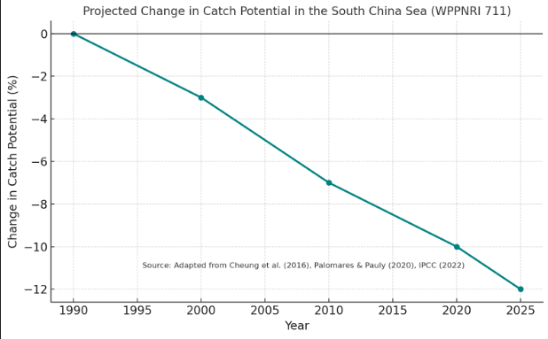
Figure 49 Projected change in fisheries catch potential in the South China Sea (WPPNRI 711) from 1990 to 2025, adapted from Cheung et al. (2016), Palomares & Pauly (2020), and IPCC (2022).
Risk Assessment
The projected decline in catch potential presents multiple risks to fish stocks, fisheries, and coastal livelihoods. Under moderate to severe warming scenarios, key pelagic species such as mackerel (Rastrelliger spp.), tuna (Thunnus spp.), and anchovy (Stolephorus spp.) are expected to lose 10–20% of their biomass due to altered thermal regimes and disrupted spawning patterns. These biological impacts cascade into socioeconomic vulnerabilities, particularly in nations bordering the South China Sea, Indonesia, Vietnam, and the Philippines, where a high proportion of protein intake and employment depend on marine resources. Studies by Sumaila et al. (2019) suggest that without adaptive measures, climate-induced changes in fish stocks could exacerbate income inequality, reduce food security, and drive overexploitation in nearshore ecosystems as communities seek to compensate for declining yields.
Reporting and Communication
To manage and mitigate these impacts, systematic monitoring and transparent communication are essential. Regional initiatives such as the Southeast Asian Fisheries Development Center (SEAFDEC) and the ASEAN-SEAFDEC Strategic Partnership play a crucial role in coordinating research and sharing data. Regular reports integrating satellite-based environmental observations, catch statistics, and species distribution models should be disseminated to policymakers, fishery managers, and local communities. These reports serve to inform evidence-based decision-making and promote the implementation of adaptive strategies such as climate-resilient fisheries management, spatial zoning, and ecosystem-based approaches to enhance sustainability in the region's fisheries sector.

5.4. Status of Coastal Aquaculture
5,4.1. Aquaculture Production
Aquaculture production in the South China Sea region varies significantly across different provinces over the observed period from 1998 to 2024 (Figure 11). In the early years, production levels were generally low, with sporadic increases in Riau-Batam and East Java. Before 2012, most regions maintained relatively modest outputs, reflecting either limited aquaculture development or data availability. However, East Java began showing a steady increase in production from 2010 onward, becoming a notable contributor to the overall output.
From 2013 to 2016, production trends shifted dramatically. Jakarta and West Java experienced a sharp spike, peaking at around 1.5 million units in 2015 before rapidly declining. In the same period, East Java also saw a substantial surge, reaching its highest levels around 2016, before stabilizing at a high output range through the following years. West Kalimantan, while less dominant, showed a gradual upward trend starting in the mid-2010s, contributing steadily to total production.
In contrast, South Kalimantan and Bangka-Belitung, with South Sumatra, maintained consistently low production throughout the period, indicating smaller-scale aquaculture activities. By 2018 onward, production from East Java and Jakarta–West Java dominated the regional aquaculture output, despite fluctuations. This pattern suggests a regional concentration of aquaculture capacity in these provinces, likely due to better infrastructure, market access, and technological investment compared to other areas in the South China Sea region (Table 17)

Figure 50 Aquaculture production by province from 1998 to 2024
Table 17: Aquaculture production of the seven provinces in the South China Sea
Years | Riau-Batam | Bangka-Belitung and South Sumatra | Jakarta and West Java | East Java | South Kalimantan | West Kalimantan
1998 | - | - | - | - | - | 3,006.70
1999 | 265,843.10 | - | - | - | - | 2,684.90
2000 | 288,473.30 | - | - | - | - | 2,347.80
2001 | - | - | - | - | - | 2,856.70
2002 | - | 313.99 | 3,760 | - | 502.1 | 2,921.80
2003 | 313,656.40 | 626.84 | 13,760 | - | 511.3 | 3,321.70
2004 | - | 788.74 | 11,092.60 | - | 496.2 | 3,671.70
2005 | 97,781.80 | 724.64 | 14,662.57 | - | 504.9 | 6,903.60
2006 | 99,188.20 | 935.48 | 11,774.50 | - | 316.0 | 7,757.20
2007 | 102,090.20 | 903.12 | 12,381.69 | - | - | 9,269.30
2008 | 87,919.20 | 1,502.56 | 12,624.41 | 73,737.60 | 5,622 | 14,888.90
2009 | 75,517.50 | 2,076.68 | 2,676.17 | 339,487.50 | 1,833 | 15,204.80
2010 | 77,113.50 | 2,622.27 | 9,577.84 | 1,680.30 | 1,866.90 | 27,039.10
2011 | 90,505.30 | 1,683.05 | 8,799.88 | 10,690 | 3,063.40 | 33,878.30
2012 | 96,611 | 8.107.50 | 4,505.12 | 79,610 | 2,725.90 | 40,309
2013 | 93,279.20 | 3,209.37 | 211,272.25 | 395,396 | 2,426.20 | 79,154
2014 | 107,306 | 4,199 | 1,048,114 | 601,413 | 2,705.60 | 57,936
2015 | 105,296.30 | 4,307 | 1,430,700 | 845,862 | 486 | 65,267
2016 | - | 4,623 | 57,079 | 640,818.91 | 675 | 62,301
2017 | 68,606 | 3,845 | 1,160,748 | 1,189,443 | 164,715 | 77,970
2018 | 19,686 | 9,334 | 1,174,435 | 1,226,560 | 177,852 | 78,349
2019 | 33,195 | 7,151 | 1,327,271 | 1,243,767 | 129,442 | 74,245
2020 | 27,237 | 8,164 | 1,186,738 | 1,264,159 | 139,079 | 81,474
2021 | 20,235 | 9,144 | 1,235,930 | 1,279,959 | 118,059 | 83,149
2022 | 27,942 | 11,165 | 1,240,853 | 1,284,129 | 126,468 | 84,076
2023 | 126,344.73 | 10,913.68 | 1,148,456 | 1,054,927 | - | 84,717.32
2024 | 27,421 | 11,165 | - | 1,369,571 | - | -

5.4.2. Climate Change Impacts
Climate change poses significant challenges to the marine aquaculture sector through its influence on ocean temperature, chemistry, and circulation patterns. Rising sea surface temperatures can alter the growth rates, metabolism, and reproductive cycles of cultured species, often leading to reduced productivity or increased mortality. Warm-water stress may also create conditions that favor harmful algal blooms (HABs), which release toxins that can contaminate shellfish and disrupt fish farming operations. Additionally, changes in ocean currents and stratification can affect nutrient availability and water exchange in aquaculture sites, further impacting the health and yield of farmed stocks.
Extreme weather events, including storms, floods, and prolonged heatwaves, are expected to increase in frequency and intensity under climate change, posing direct physical threats to aquaculture infrastructure. Storm surges and strong waves can damage cages, nets, and mooring systems, leading to stock losses and economic setbacks. Salinity fluctuations from heavy rainfall or drought can stress farmed species, especially those with narrow tolerance ranges. These combined impacts not only threaten production stability but also increase operational costs due to the need for adaptive measures, such as selective breeding for climate-resilient species, improved farm design, and strategic relocation of aquaculture facilities to less vulnerable areas.
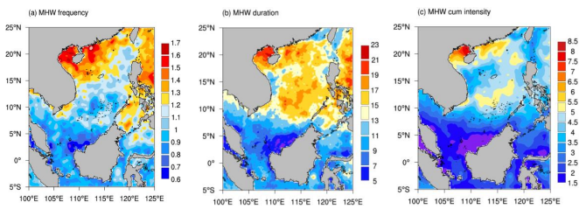
Figure 51 Spatial distribution of multiyear warm season (1982-2020) in the SCS (Li et al., 2022)
In the South China Sea, climate change has already shown tangible impacts on marine aquaculture, particularly in coastal provinces such as Guangdong, Hainan, and the Gulf of Thailand region. Rising sea surface temperatures have led to more frequent outbreaks of fish diseases, including viral nervous necrosis (VNN) in groupers and streptococcosis in tilapia, which thrive in warmer and more stagnant waters. Farmers have reported reduced growth rates and increased mortality in high-value species like shrimp, as higher temperatures and lower dissolved oxygen levels stress the animals. In shellfish farming areas, such as oyster and mussel beds, shifts in seasonal temperature cycles have disrupted spawning periods, affecting seed availability and production timing. These biological changes, compounded by unpredictable monsoon patterns, have made it more difficult for farmers to plan stocking and harvesting schedules.
Ocean acidification in the South China Sea has further exacerbated challenges, particularly for calcifying organisms such as pearl oysters in Hainan and scallops in northern Vietnam. Lower pH levels have been linked to weaker shell formation and higher larval mortality, reducing yields and threatening the economic viability of hatcheries. Additionally, stronger typhoons, which have increased in intensity over the past two decades, have caused significant physical damage to fish cages, seaweed lines, and other infrastructure, resulting in both stock loss and environmental degradation from escaped non-native species. These climate-driven impacts highlight the urgent need for adaptive strategies in the region, including selective breeding for heat- and acidification-resistant strains, the use of deeper or more sheltered farming sites, and the integration of climate forecasting into aquaculture management.
Climate change has measurably affected fisheries in Indonesia’s South China Sea sub-region (WPPNRI 711), encompassing the Natuna and Anambas waters. Satellite observations show that sea surface temperatures have increased by 0.2–0.4 °C per decade since the early 2000s, while marine heatwaves occur up to four times annually, lasting 8–18 days with temperature anomalies reaching +1.6 °C (Zandika et al., 2024). These thermal shifts disrupt plankton productivity—chlorophyll-a concentrations fluctuate between 0.1–5 mg/m³—and drive habitat shifts in pelagic fish such as mackerel (Scomberomorus commerson), yellowfin tuna (Thunnus albacares), and skipjack tuna (Katsuwonus pelamis). The area of potential fishing grounds has declined by about 30% during transitional monsoon seasons, causing reduced catch efficiency and up to 20–25% higher fuel costs for local fleets (Untan, 2023). Socioeconomic surveys in Natuna indicate that over 60% of small-scale fishers have experienced declining income due to changing fishing patterns. These findings highlight that without adaptive, data-driven management and improved resilience of coastal communities, climate-related stressors could significantly reduce fishery productivity in Indonesia's portion of the South China Sea

  - Problems and Issues
    - Fisheries Issue
The waters around Bintan within WPPNRI 711 (Natuna and the South China Sea) are highly strategic but face significant ecological and governance pressures. IUU fishing remains a major issue, with violations by Vietnamese vessels increasing despite reductions in Thai incursions, placing heavy pressure on demersal and pelagic stocks and creating economic disadvantages for local fishers. Bottom seine vessels from Java—along with continued use of bouke ami, seine nets, and other bottom-contact gears—frequently violate spatial regulations and damage benthic habitats, particularly in areas such as Tambelan and Anambas where destructive practices like blast fishing, cyanide use, and compressor-assisted capture persist.
Harmful traditional gears, including Muroami and coral-placed fish traps, further degrade reef structures, reduce habitat complexity, and weaken fish recruitment. Spatial conflicts between fishing and marine tourism have intensified in Bintan and Anambas due to overlapping use zones, underscoring the need for clearer zoning and stronger enforcement under RZWP3K. Additional concerns include abandoned and lost fishing gear (ALDFG), which accumulates in coral and dive sites, posing entanglement risks and contributing to marine debris. Cross-border trade challenges persist for high-value or protected species such as Napoleon wrasse, sharks, and sea cucumbers, with recent export restrictions from China affecting local livelihoods. Illegal harvest of protected fauna, including dugongs and sea turtles, continues in remote areas, despite the region’s role as a migratory corridor for many ETP species. Overall, these issues highlight the need for enhanced monitoring, stricter compliance mechanisms, and the development of sustainable livelihood alternatives for coastal communities.
    - Aquaculture Issues
In addition to captured fisheries, aquaculture activities in Bintan and Pontianak face several regulatory and environmental challenges that hinder their sustainable development. One major issue is the absence of clear regulations for limited aquaculture activities within the designated aquaculture utilization zones in Pontianak. This regulatory gap often leads to overlapping spatial use, unmonitored farm expansion, and potential conflicts with other coastal activities such as capture fisheries and tourism. The lack of formal governance mechanisms also weakens law enforcement, making it difficult to control environmental impacts and ensure that aquaculture practices comply with sustainability principles.
Environmental concerns are also evident in both regions. Uncontrolled feed input, poor waste management, and weak water quality monitoring contribute to nutrient accumulation and eutrophication in coastal waters, particularly around floating net cages and pond systems. Inadequate biosecurity and disease surveillance further exacerbate production risks, leading to periodic losses that affect small-scale farmers. Moreover, limited access to high-quality seed stock, feed, and technology remains a constraint for many aquaculture operators. Dependence on wild-caught juveniles, especially for species like grouper and lobster, not only reduces natural stock populations but also threatens ecosystem balance. Without sufficient hatchery development and local government support, reliance on natural seed sources is likely to persist.
From a socioeconomic perspective, small-scale aquaculture producers also struggle to meet market demands and international export standards. The lack of certification schemes, product traceability, and stable market access, especially for live reef fish such as Napoleon wrasse and groupers, makes the sector vulnerable to fluctuating trade policies and demand, such as China's recent import restrictions. To ensure long-term sustainability, the aquaculture sector in Bintan and Pontianak require stronger spatial planning, clear regulatory frameworks, and enhanced capacity-building programs that promote environmentally responsible and economically viable aquaculture development
  - Conclusion
The fisheries and aquaculture systems of Indonesia's South China Sea sub-region are at a critical juncture, balancing high productivity with mounting ecological and governance challenges. Analysis of historical production trends demonstrates substantial growth supported by technological advancement and expanded fishing capacity; however, several major species groups now face overexploitation and habitat pressures. IUU fishing, destructive and bottom-impacting gears, and weak enforcement continue to undermine resource sustainability, particularly in ecologically sensitive areas such as Bintan, Natuna, and Anambas. Climate-driven changes, including rising sea surface temperatures, altered salinity structure, and shifting species distributions further reduce catch potential and increase socioeconomic vulnerability among coastal communities.

Aquaculture presents a growing but unevenly distributed sector, with substantial development concentrated in East Java and Jakarta, West Java. At the same time, other provinces face regulatory gaps, environmental constraints, and limited access to technology and quality seed. Strengthening spatial planning, improving biosecurity, and promoting environmentally responsible practices are essential to support sustainable aquaculture growth.
Overall, ensuring the long-term viability of fisheries in WPPNRI 711 requires integrated, ecosystem-based management that incorporates accurate stock assessments, improved catch documentation, habitat protection, and climate adaptation measures. Enhanced regional cooperation, transparent reporting, and community-focused livelihood diversification will be critical to maintaining food security, economic stability, and ecological resilience in Indonesia’s portion of the South China Sea.

Acknowledgements: The authors are grateful to the Ministry of Environment of Indonesia, UNOPS, and the Center for Coastal and Marine Resources Studies, IPB University (PKSPL IPB), Indonesia, which provided the research facilities and funding, especially during data collection processes, including Focus Group Discussion in Bintan and Pontianak.

Author Contributions: conceptualization, A.D.; data curation, A.D., Q.S.; formal analysis, A.D., Q.S.; funding acquisition, I.A., A.D.; investigation, A.D., Q.S.; methodology, A.D., Q.S.; project administration, I.H.; resources, I.H.; supervision, A.D., I.A.; visualisation, A.D., Q.S.; writing-original draft, A.D., Q.S.; writing-review and editing, A.D., Q.S.

References
Allen, M.S. (2014). Fish Population Dynamics: Mortality, Growth, Reproduction. American Fisheries Society. https://fisheries.org/docs/books/55060C/2.pdf
Belkin IM, Shen C. (2025). Long-term variability of surface temperature in the South China Sea. NOAA AOML Technical Report. Retrieved from https://www.aoml.noaa.gov/phod/docs/jcli-d-15-0338.1.pdf
Cheung WWL, Reygondeau G, Frölicher TL. (2016). Large benefits to marine fisheries of meeting the 1.5°C global warming target. Science. 345(6319): 1591–1594. https://doi.org/10.1126/science.aag2331
Debiyanti N, Alfiansyah S, Hidayat M. 2025. Cycle of potential fishing area of WPP-NRI 711 (2011–2020). Journal of Regional Science and Sustainable Fisheries Development. 12(3): 115–124.
Degnbol P, Jarre A. (2004). Review of indicators in fisheries management. African Journal of Marine Science, 26(1), 303–313. https://doi.org/10.2989/18142320409504063
Durant JM, Holt RE, Langangen. (2024). Large biomass reduction effects on the relative role of climate, fishing, and recruitment on fish population dynamics. Scientific Reports. 14: 15469. https://doi.org/10.1038/s41598-024-59569-4
FAO. 2018. The State of World Fisheries and Aquaculture 2018: Meeting the Sustainable Development Goals. Rome: Food and Agriculture Organization of the United Nations.
FAO. 2020. Fishery and Aquaculture Country Profiles – Southeast Asian Region. Rome: Food and Agriculture Organization.
FAO. 2021. Global Capture Production Database (1950–2019). Rome: Food and Agriculture Organization.
Friedland KD, Tanaka KR, Smolinski S, Wang Y, Hodgdon C, Mazur M, Wiedenmann J, Goetscg C, Pendleton DE. 2023. Trends in the area of occurrence and biomass of fish and macroinvertebrates. Marine and Coastal Fisheries, 15(2), e210235. https://doi.org/10.1002/mcf2.210235
IPCC. (2022). Sixth Assessment Report: Impacts, Adaptation and Vulnerability – Chapter 18: Climate Change Impacts on Fisheries and Aquaculture. Intergovernmental Panel on Climate Change.
Li Y, Ren G, Wang Q, Mu L, Niu Q. 2022. Marine heatwaves in the South China Sea: temporal-spatial pattern and its association with large-scale circulation. Remote Sens. 14: 1-19
Nash, K. L., et al. (2016). Habitat structure and the resilience of reef fish communities. Ecosphere, 7(8), e01362. https://doi.org/10.1002/ecs2.1362
Nilsson JA, Johnson CR, Fulton EA, Haward M. (2019). Fisheries sustainability relies on biological understanding. ICES Journal of Marine Science, 76(6), 1436–1447. https://doi.org/10.1093/icesjms/fsz058
Palomares MLD, Pauly D. 2020. On the creeping increase of marine fisheries catches in the South China Sea: A basin-wide analysis, 1950–2016. Frontiers in Marine Science. 7: 309. https://doi.org/10.3389/fmars.2020.00309
SEAFDEC. (2019). Regional Catch and Effort Data Compilation for the South China Sea Area. Southeast Asian Fisheries Development Center.
SEAFDEC. (2021). Status and Trends of Fisheries and Aquaculture in the ASEAN Region. Bangkok: SEAFDEC.
SEAFDEC. (2022). Fishing Capacity and Resource Utilization in the South China Sea Sub-region. Southeast Asian Fisheries Development Center.
Su C, Shan X, Jin X, Han Q, Chen W, Gorfine H. 2024. Simulated reproductive allocation to fisheries-induced evolution. Ecological Indicators, 160, 112257. https://doi.org/10.1016/j.ecolind.2024.112257
Sumaila UR, Tai TC, Lam VWY. 2019. Benefits of the Paris Agreement to ocean life, economies, and people. Science Advances, 5(2): 38-55. https://doi.org/10.1126/sciadv.aau3855
Tan W, Wang C, Zhang L. (2016). Sea surface temperature variability and monsoon influence in the South China Sea. Journal of Climate. 29(4), 1423–1438. https://doi.org/10.1175/JCLI-D-15-0338.1
Xie Q, Wang G, Qiu Y. (2023). Seasonal variability and salinity structure in the South China Sea based on long-term observation. Frontiers in Marine Science. 10: 1168486. https://doi.org/10.3389/fmars.2023.1168486
Zandika R, Ismunarti DH, Kunarso, Hatmaja RB, Ayubi MAA. 2024. Variabilitas thermal front dan keterkaitan dengan klorofil-a di wilayah pengelolaan perikanan Negara Republik Indonesia 711. Buletin Oseanografi Marina. 13(2): 250-260

- GOVERNANCE: The governance of Indonesia water as part of the South China Sea

Taryono Kodiran^{1,2}, Retia Revany¹, Isdahartati¹

¹Center for Coastal and Marine Resources Studies, IPB University
²Department of Aquatic Resources Management, Faculty of Fisheries and Marine Sciences, IPB University

Abstract

The enhancement of governance in Indonesia's South China Sea (SCS) waters is critical for advancing both national and regional interests. Therefore, a comprehensive assessment is critical to be conducted. This analysis reveals low-to-medium governance effectiveness, which reflects the disparity between regulatory frameworks and their implementation. Risk governance analysis was conducted by assessing completeness policy cycle, stakeholder engagement and integration. Risk governance analysis uncovers the regulatory completeness scores low risk, stakeholder engagement and policy integration face medium risk, indicating that coordination challenges present a greater obstacle than regulatory gaps.
To address these shortcomings, this study emphasizes a dual pathway. Domestically, it is imperative to strengthen the multi-level governance platform that connects central, provincial, and regency/city administrations. Internationally, the existing regional SCS cooperation requires fortification, particularly marine pollution and expansion to encompass other transboundary issues such as ecosystem degradation, plastic waste, and Abandoned, Lost, or Discarded Fishing Gear (ALDFG). Ultimately, the establishment of an integrated land-sea collaboration platform across Indonesian jurisdictions is essential. This would directly tackle the land-based drivers of marine degradation while simultaneously strengthening Indonesia's strategic position within regional cooperation frameworks.

Keywords: governance, land-sea collaboration, regional SCS cooperation, risk analysis

6.1. Introduction
The South China Sea plays an important role in the development of the coastal states, the region and even the world by virtue of its rich biological and oil and gas resources and convenient shipping lanes. But in recent years, the ecological environment of the South China Sea has been facing increasingly severe impacts and challenges due to complex reasons (Wei and Zihao, 2024).
In 2023, the South China Sea (SCS) facilitated the transit of 10 billion barrels of petroleum and 6.7 trillion cubic feet of LNG, underscoring its rich resources and strategic significance (US Energy Information, 2024). Oceanographically, the SCS throughflow acts as a crucial heat and freshwater conveyor, regulating regional sea surface temperatures (Qu et al., 2009).
The South China Sea (SCS) holds immense importance, not only due to its geopolitical significance but also because of its rich biodiversity and vital role in supporting livelihoods and ensuring food security through fishing activities (Sembiring, 2024). Then safeguarding the marine and coastal ecosystems of the South China Sea (SCS) is imperative, given escalating threats from pollution, biodiversity erosion, and climate change impacts. While transboundary environmental mechanisms exist at a regional level, advancing country-based collaboration among SCS nations is essential. Such cooperation is particularly critical for mitigating marine plastic debris, an issue intrinsically linked to human behavior, societal norms, and policy frameworks. This paper aims to analysis the status of governance of the Indonesia water as part of the South China Sea (SCS) region (Figure 52).

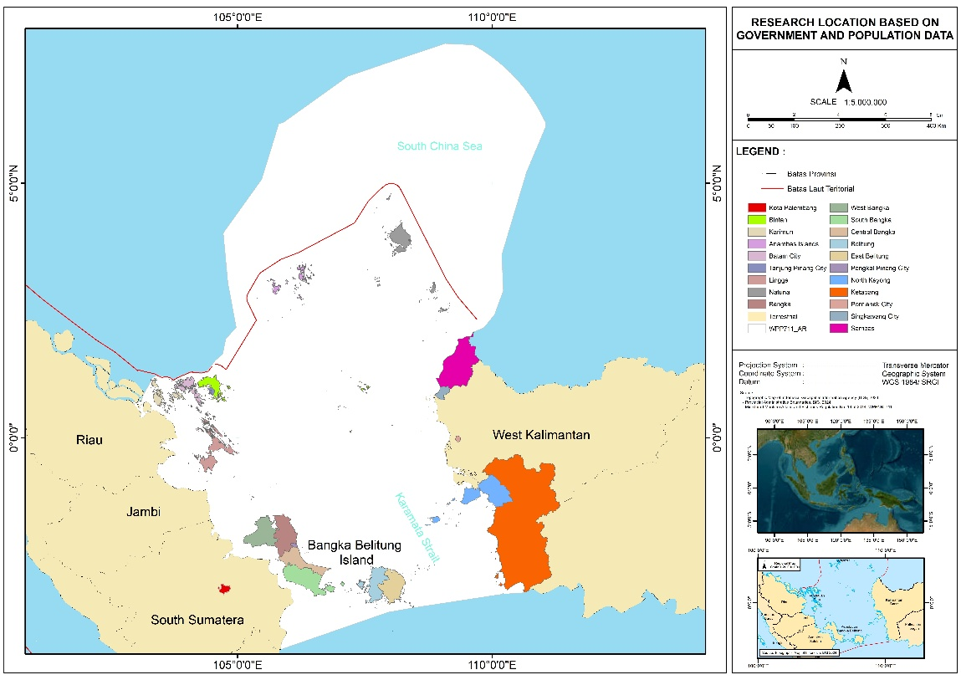
Figure 52 Study Area Governance

6.2. Key Governance Concern
The current situation is that the existing environmental governance mechanism in the South China Sea is currently characterized by predominantly bilateral governance, supplemented by 75 multilateral cooperation (Sichun, 2021). With poor of governance, it is possibly becoming a tragedy of common, so it is mandated to enhance transboundary partnership (Astuti, 2017). Indonesia has established a national policy for marine resource management, which is implemented at the sub-national level. This includes the South China Sea region, which encompasses several provinces and regencies with diverse socio-economic conditions. While a cooperation platform exists, its effectiveness remains limited. An explicit policy foundation has been laid for fisheries management purpose, with this direction being reinforced in subsequent development plans including pollution control, ecosystem protection, and economic and climate development. Regarding regional disputes, Shaleh et al. (2021) recommend utilizing ASEAN-led platforms for dialogue and leveraging international partnerships. Although a working group for SCS and Gulf of Thailand management exists, it is ineffective in resolving transboundary issues

  - Current Status
    - Economic and policy driver
GDP and economic growth
GDP at current prices demonstrated stable quarterly and annual growth from 2020 to 2023. However, it remained relatively stagnant when measured at constant 2010 prices (see Appendix 6.1).
During the period 2016–2023, Indonesia’s economy generally recorded growth. However, in 2019–2020, the economy contracted that was largely attributable to the outbreak of the COVID-19 pandemic, which led to economic stagnation and, in some sectors, a significant downturn. But, since 2021 the economy constantly growth up to 5.05% in 2023 (Figure 53)

Source: BPS-Statistics Indonesia, 2020 and BPS-Statistics Indonesia, 2024

Figure 53 The Economic Growth of Indonesia 2016-2023

Indonesia’s poverty rate as of March 2023 was 9.36%, slightly decreasing to 9.03% in March 2024, with around 7.3% in urban and 12.2% in rural areas. Extreme poverty (those living on less than USD 2.15 per day) is much lower, at approximately 2% of the population. Poverty rate of each mainland Indonesia is in Figure 54.

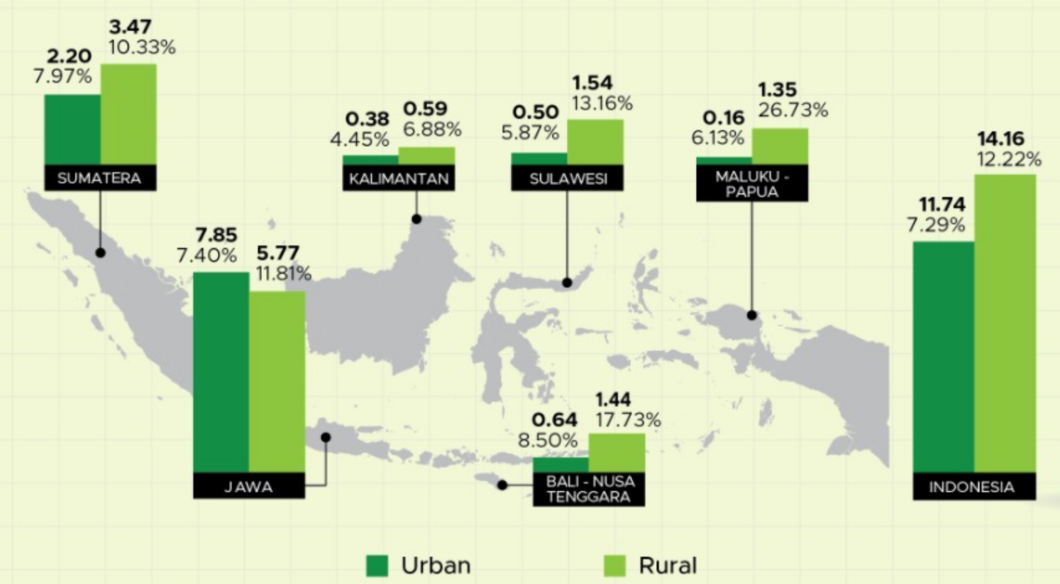

Source: official statistics news, No.47/07/th xxvi, 17 Juli 2023
Figure 54 Number (Million people) and Percentage of Poor Population by Island, March 2023

Inflation during the 2020–2024 period fluctuated, with vary monthly inflation movements. The highest inflation occurred between the second quarter of 2022 and the second quarter of 2023, peaking in September 2022. Thereafter, inflation began to decline, reaching its lowest point in February 2025 at 0.09% (see Appendix 6.2)

Maritime GDP
The contribution of the maritime sector’s GDP to Indonesia’s total GDP averaged 7.93% during the 2020–2024 period. Prior to the COVID-19 pandemic, the maritime sector’s contribution reached 8.14%. However, to date, in the post-COVID-19 period, the maritime sector’s GDP contribution has not yet returned to the 8% level (Appendix 6.3).
In line with national GDP, the current price maritime GDP contracted more sharply than the national GDP in 2020 before returning to growth in the following years (Figure 55). Of the 11 sectors within Maritime GDP, the five main contributors are Aquaculture and Marine Capture, Ocean Energy Resources, Other Maritime-related Industries, Maritime Transportation and Related Services, and Seaborne Trade.
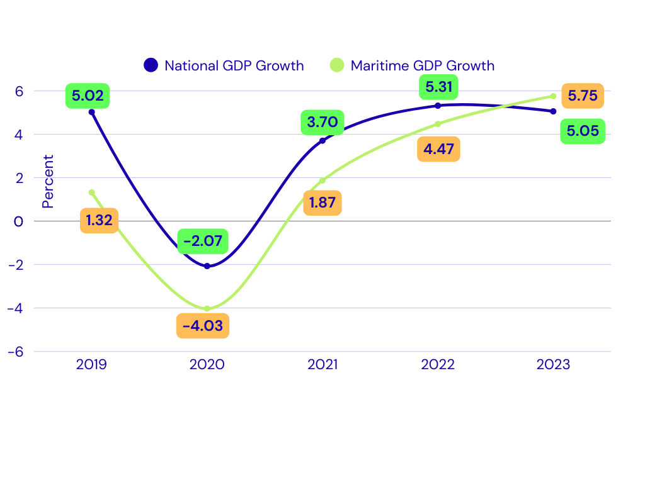

Source: Statistic Indonesia (BPS) and Coordinating Ministry of Marine Affair and Investment, 2024
Figure 55 Growth of National GDP and Maritime GDP Growth at Current Price

National Debt
Between 2000 and 2024, Indonesia's total debt grew from USD 141.2 billion to USD 426.1 billion. Public sector debt (government and central bank) constituted 51.35% of the total, while private sector debt accounted for 48.65%. Government debt represented the largest share (48.76%), substantially exceeding the central bank's contribution (2.59%). Within private debt, non-financial corporations held 37.83%, compared to 10.81% held by financial corporations. The annual debt trajectory is shown in Appendix 6.4.

Unemployment
Indonesia’s open unemployment rate during the 2014–2024 period was dynamic, ranging from 4.9% to 7.1%. The lowest unemployment rate occurred in the third quarter of 2019, while the highest was recorded in the second quarter of 2021 (see Appendix 6.5).

Foreign Investment
Foreign investment during the 2010–2023 period ranged from US$16.21 billion to US$50.27 billion, growing at an average annual rate of 9.96%. The highest growth was recorded in 2023 at 46.67%, while the lowest occurred in 2018 at 9.98%. The lowest investment value was in 2014 at US$16.21 billion, and the highest was in 2023 at US$50.27 billion (see Appendix 6.6).
    - Institutional Setting
At least 13 ministries and two ministerial-level institutions are involved in maritime governance in Indonesia, with their engagement varying across significant issues as shown in the Table 18.

Table 18 Legal and institutional mapping, and stakeholders related to coastal and marine management in the South China Sea and Gulf of Thailand
Institution | Pollution | Ecosystem Based Assessment | Climate Change | Fisheries & Livelihoods | Endangered Species | Marine Economy/  Blue Economy
- Coordinating Ministry of Food Affairs (COMFA) |  |  |  | V |  | V
- Ministry of Environment (MOE) | V | V | V |  | V
- Ministry of Forestry (MOF) |  | V | V |  | V
- Ministry of Marine Affair and Fisheries (MOMAF) |  | V | V | V | V | V
- Ministry of Home Affair (MHA) |  | V |  |  |  | V
- Ministry of Foreign Affair (MOFA) | V |  | V | V | V | V
- Ministry of National Development Planning (MONDP) | V | V | V | V | V | V
- Ministry of Transportation (MOT) | V |  |  |  |  | V
- Ministry of Defense (MOD) | V | V
- Ministry of Tourism and Creative Economy (MOTCE))
- Ministry of Agriculture (MOA) | V
- Ministry of Energy and Mineral Resources (MOEMR) | V
- Ministry of Investment and Downstream Industry/Indonesia Coordinating Investment Board (MOIDI) |  |  |  | V |  | V
- Peatland and Mangrove Restoration Agency of the Republic of Indonesia (BRGM) |  | V
- Indonesian Maritime Security Agency (BAKAMLA) | V | V |  |  |  | V
Three provinces (Kepulauan Riau Province, Bengka Belitung Province, West Kalimantan Province) and twenty regencies/cities in Indonesia share borders with the South China Sea (SCS) waters (see Appendix 6.7).
    - Legal Policy Setting
The governance of Indonesia's coastal and marine waters in the South China Sea (SCS) is framed by a combination of international agreements and domestic legal hierarchy comprising laws, government regulations, presidential regulations, and ministerial regulations. These instruments collectively address various management concerns in the region, as detailed in Table 19.

Table 19 Legal Basis of International and Indonesia Regulation concerning to South China Sea waters
No. | Level | Concern Issue | Contents Related to SCS
1 | International Agreement | Socio economic and climate threat | UNCLOS 1982 (ZEE Indonesia)
1 | International Agreement | Socio economic and climate threat | The Kyoto Protocol (Climate Change)
1 | International Agreement | Socio economic and climate threat | Paris Agreement (Climate change)
1 | International Agreement | Socio economic and climate threat | UN Framework Convention on Climate Change (Climate change)
1 | International Agreement | Pollution | IMO Regulation (Transportation)
1 | International Agreement | Pollution | The Basel Convention No.22/1989 (Pollution)
1 | International Agreement | Pollution | Rotterdam Convention (Pollution)
1 | International Agreement | Pollution | Stockholm Convention (Pollution)
1 | International Agreement | Pollution | UN Convention to Combat Desertification (Land based pollution)
1 | International Agreement | Ecosystem | CBD-Global Biodiversity Framework (Marine Conservation)
1 | International Agreement | Ecosystem | The Ramsar Convention on Wetlands of International Importance (Ramsar Convention) (Mangrove)
1 | International Agreement | Fisheries and Aquaculture | The Convention on International Trade in Endangered Species of Wild Fauna and Flora (CITES) (Fisheries)
1 | International Agreement | Fisheries and Aquaculture | The Convention on the Conservation of Migratory Species of Wild Animals (CMS), also known as the Bonn Convention (Fisheries)
2 | Laws (Undang-Undang/UU) | Socio economic and climate threat | Law 22/2019 on Sustainable Agriculture (Feed, fertilizer)
2 | Laws (Undang-Undang/UU) | Socio economic and climate threat | Law 32/2014 on Maritime (Maritime zones, underwater cable, maritime safety and sovereignty)
2 | Laws (Undang-Undang/UU) | Socio economic and climate threat | Law 59/2024 on National Long Term Development Plan 2025-2045 (Blue Economy)
2 | Laws (Undang-Undang/UU) | Pollution | Law No. 32/2024 on Natural Resource Conservation (Pollution)
2 | Laws (Undang-Undang/UU) | Pollution | Law 66/2024 Third Amendment to Law Number 17 of 2008 concerning Shipping (Sea Transportation)
2 | Laws (Undang-Undang/UU) | Pollution | Law No. 32/2024 on Natural Resource Conservation
2 | Laws (Undang-Undang/UU) | Ecosystem | Law No. 32/2024 on Natural Resource Conservation (Mangrove)
2 | Laws (Undang-Undang/UU) | Ecosystem | Law 41/1999 on Forestry
2 | Laws (Undang-Undang/UU) | Fisheries and Aquaculture | Law 11/2020 on Job Creation (fisheries)
2 | Laws (Undang-Undang/UU) | Fisheries and Aquaculture | Law 45/2014 on Fisheries (Fisheries (capture and aquaculture))
2 | Laws (Undang-Undang/UU) | Fisheries and Aquaculture | Law 23/2014 on Local Government Autonomy (12 nm water authority)
2 | Laws (Undang-Undang/UU) | Fisheries and Aquaculture | Law 5/1983 on Indonesia Economic Exclusive Zone (Fisheries)
3 | Government Regulation/GR (Peraturan Pemerintah/PP) | Socio economic and climate threat | GR 13/2022 on Implementation of the Implementation of Safety, Security, and Law Enforcement in the Indonesian Waters and Jurisdictional Waters of Indonesia (Sea safety and security)
3 | Government Regulation/GR (Peraturan Pemerintah/PP) | Pollution | GR 22/2021 on the Implementation of Environmental Protection and Management
3 | Government Regulation/GR (Peraturan Pemerintah/PP) | Ecosystem | GR 27/2025 on Management and Conservation of Mangrove Ecosystem (Mangrove)
3 | Government Regulation/GR (Peraturan Pemerintah/PP) | Fisheries and Aquaculture | GR 27/2021 on the Implementation of Marine Affair and Fisheries
3 | Government Regulation/GR (Peraturan Pemerintah/PP) | Fisheries and Aquaculture | GR 11/2023 on Quota Based Fisheries Management
3 | Government Regulation/GR (Peraturan Pemerintah/PP) | Fisheries and Aquaculture | GR 50/2015 on Fisheries Management Area
4 | Presidential Regulation/PR (Peraturan Presiden/Perpres) | Socio economic and climate threat | PR 12/2025 on National Medium-Term Development Plan 2025-2029 (Blue economy)
4 | Presidential Regulation/PR (Peraturan Presiden/Perpres) | Ecosystem | PR 98/2021 on the Implementation of Carbon Economic Value for NDC Achievement and GHG Emission Control in National Development (Mangrove, seagrass)
5 | Ministerial Regulation/MR | Ecosystem | MR Marine Affair and Fisheries 1/2025 on Procedures for the Implementation of Carbon Economic Value in the Marine Sector (Mangrove, seagrass)
5 | Ministerial Regulation/MR | Fisheries and Aquaculture | MR Marine Affair and Fisheries 1/2009 on Fisheries Management Area (FMA 711)
5 | Ministerial Regulation/MR | Fisheries and Aquaculture | MR Marine Affair and Fisheries 36/2023 on the Placement of Fishing Gear and Fishing Aid in Measured Fishing Zones and Fisheries Management Areas of Indonesia (Capture Fisheries)
5 | Ministerial Regulation/MR | Fisheries and Aquaculture | MR Marine Affair and Fisheries 51/2017 on the Fisheries Management Plan in Fisheries Management Area (Capture Fisheries)
5 | Ministerial Regulation/MR | Fisheries and Aquaculture | MR Marine Affair and Fisheries 55/2020 on Procedures, Requirements, and Determination of Aquaculture Areas (Aquaculture)
Regarding the management of specific ecosystems, multiple regulations and policies may coexist in a manner that complement and reinforces each other. For instance, Razak et al. (2022) identified 17 regulations that explicitly stipulate provisions related to the management of coral reef restoration in Indonesia
    - Civil Society, Stakeholders and Participation
Key NGOs and special interest group
Numerous NGOs and local interest groups engage in South China Sea (SCS) governance, focusing on socio-economic, pollution, ecosystem, and fisheries issues. Their scope ranges from nationwide organizations with local branches to purely local groups, and their interests vary from multi-issue to specialized. While most prioritize coastal/marine pollution, ecosystems, and socio-economic matters, fewer focus on aquaculture and marine capture fisheries. Their specific interests are detailed in Appendix 6.8.

Trade Associations and Business Group
Trade associations and business groups exhibit diverse, province-specific interests. While most engage with socio-economic and coastal ecosystem issues, few focus on marine capture fisheries and aquaculture. Their interests range from single-issue to multi-sectoral engagement, as detailed in Appendix 6.9.

Co-Management, Traditional Systems and Customary Rights
Numerous community-based organizations in South China Sea border provinces employ co-management, traditional systems, and customary rights. While primarily focused on socio-economic, coastal ecosystem, and fisheries issues, they largely neglect coastal pollution. This gap is attributed to the issue's sensitivity and the groups' limited technical capacity. Predominantly culturally based, these groups are listed in Appendix 6.10.

Decentralized Governance and Coastal Governance
Under Indonesia's decentralization policy, the management of marine resources is delegated solely to the provincial level. Consequently, the relevant marine management institutions are decentralized provincial bodies. These institutions have distinct focus areas, as defined by their core mandates and functions established by the provincial governor. A complete list of these institutions is provided in Appendix 6.11.

    - Governance Performance and Effectiveness
Governance performance and effectiveness will be assessed against key issues, categorized as: Socio-economic and climate-related threats; Pollution; Ecosystems; and Fish, Fisheries, and Aquaculture. The assessment will utilize a three-tier ordinal scale : high, medium and low. The analysis for each issue follows in the subsequent sections.
Socio-economic and Climate Related Threat
a. Decline in Food Production, Fisheries, and Tourism due to Mangrove and Coral Reef Degradation Caused by Tin Mining
The institutions involved in this governance are MOE, MOF, MOMAF, MOA, MOTCE, Coordinating Ministry for Economic Affairs (CMFEA), and Local Governments.
Tin mining in Bangka Belitung has a long historical legacy, with operations conducted by both corporate entities and illegal artisanal miners across terrestrial and marine areas. While governance measures exist covering permits, pollution control, mangrove protection, and coastal zoning—regulatory enforcement remains inadequate. Consequently, non-compliant mining practices persist, resulting in low governance effectiveness.

b. Decline in Land Productivity and Fisheries Supply Chain Management due to sea level rise (SLR), Tidal Flooding, Coastal Erosion, and Environmental Degradation.
The institutions involved in this governance include MOE, MOF, MOMAF, MOA, and sub-national governments. Implemented governance measures encompass national and sub-national regulations, such as those for coastal ecosystem protection and integrated spatial planning. Other efforts include public awareness campaigns, environmental degradation prohibitions, sea level rise (SLR) impact mitigation, and monitoring by central and provincial authorities. However, coastal erosion, environmental degradation, and flooding persist with no significant improvement. It can therefore be concluded that the governance performance and effectiveness in addressing declining land productivity and disruptions to the fish supply chain remain low.

Marine Pollution
- Plastic Pollution
Plastic pollution, comprising items like bottles, sachets and food containers is pervasive in the waters of Bintan, a key tourism area. This has raised local community concerns and poses a potential transboundary risk. Multiple institutions are involved in governance, led by the MOE, following the National Action Plan on Marine Debris (PR No. 83/2018). Sectoral ministries, including MOMAF, MOT, MOI, and MOEMR along with sub-national/local governments, have specific mandates for waste reduction, regulation, and technological development. Governance measures include the national action plan, local initiatives like plastic bag bans, and specific regulations such as MOMAF's PERMEN-KP No. 26/2021, which prohibits the disposal of fishing gear at sea and Abandoned, Lost, or Discarded Fishing Gear (ALDFG). Despite these efforts, plastic waste continues to accumulate, particularly in populated coastal zones. Consequently, governance performance and effectiveness are assessed as low.

b. Oil Spills
Oil spills, particularly stranded oil spills, occur on the islands of Batam and Bintan, washing ashore on their northern coastlines. These spills consist of oil discharges from ship tank cleaning operations for all vessel types, conducted in the international waters of the South China Sea (SCS). This oil spill pollution is most acutely observed during the west monsoon season (November to March) each year.
To address oil spills, the involved institutions include the ASEAN Working Group on Oil Spill, the ASEAN Secretariat, MOE, MOT, Ministry of Foreign Affairs (MOFA), Indonesian Coast Guard (ICG/Bakamla), MOEMR, Special Task Force for Upstream Oil and Gas Business Activities (SKK Migas), and local Governments, particularly those in the Riau Islands Province (Batam and Bintan). The Indonesian government has established policies for regional and national coordination on oil spills, with Ministry of Transportation (MOT) as the lead coordinator. Local governments (Bintan Regency and Batam City) coordinate clean-up efforts for stranded oil sludge management.
Factually, oil spills occur annually and remain a persistent public complaint. The government's capacity to control these incidents is limited, as the pollution originates from international waters. This indicates that the governance performance and effectiveness is low.

Ecosystems
- Habitat Destruction
Habitat destruction involves the permanent loss of a habitat, driven by land conversion, reclamation, illegal mangrove logging, and mining-induced sedimentation. Mangrove ecosystems are frequently converted for aquaculture and settlements, while illegal logging for livelihoods like charcoal (in West Kalimantan) production persists. Coastal mining (e.g., tin, bauxite, coal) in coastal of Bangka Belitung, Bintan-Riau Kepulauan and Kalimantan often artisanal yet cumulatively significant, causes further habitat loss and sedimentation.
Multiple institutions govern this issue, including MOE, MOF, MOMAF, MOEMR, and Local Governments. Key measures include policy development (e.g., integrated spatial planning), regulatory enforcement, inter-governmental cooperation, and public education. Regulations concerning illegal mangrove logging have been issued by the government. Inter sub-national governmental collaboration has been developed for consolidating some issues related to habitat destruction. However, enforcement is challenging, and despite these efforts, governance performance and effectiveness remain low.

- Habitat Quality Degradation
Habitat quality degradation, the deterioration of environmental conditions that reduces a habitat's capacity to support life, is primarily driven by pollution and climate change. Coastal mining causes sedimentation, polluting water and impairing habitat function. Concurrently, climate change raises sea temperatures and levels, leading to coral bleaching.

Governance involves multiple institutions, including MOE, MOMAF, MOEMR and Local Governments. Implemented measures include policy development, regulatory enforcement, inter-governmental cooperation, and public education. Key regulations govern waste management of Hazardous and Toxic Waste (HTW/B3). A critical challenge in B3 management is the lack of treatment facilities in all regions, requiring costly inter-provincial transport for disposal. Despite initiatives like cooperation on land-based waste and public outreach, governance effectiveness remains low.

Fish, Fisheries and Aquaculture
a. Illegal Fishing
Illegal fishing encompasses several issues, including incursion of foreign fishing vessels, improper placement of FADs, the use of destructive fishing gear, and transshipment activities. The improper deployment of FADs occurs frequently in the waters of Natuna. Destructive fishing includes the use of cyanide, unregulated fishing gear, and prohibited fishing gear.

Institutions involved in managing illegal fishing are MOMAF, ICG, MOFA, and Provincial Marine and Fisheries Services (DKP). Management actions include outreach on permitted and prohibited fishing gear, enforcement actions by MOMAF as part of its mandate to combat illegal fishing, and patrols conducted by MOMAF and ICG/Bakamla.

Illegal fishing is perpetrated by both foreign vessels entering Indonesian waters and local fishers. Factually, violations and incidents of illegal fishing remain frequent. Consequently, overall governance effectiveness is assessed are low.

- Overfishing in Fisheries Management Area (WPP) 711
Fishery resources in the South China Sea (Fishing Management Area 711) are officially classified as overexploited (Ministry Decree KP No.19/2022), with an exploitation rate exceeding 1 for key species like small pelagic, squid, cuttlefish and octopus. This overfishing is driven by excessive effort from local, inter-regional, and foreign fishers, compounded by complex multi-level governance.
The Ministry of Marine Affairs and Fisheries (MOMAF) and related institutions (ICG/Bakamla, and Provincial fisheries office) govern this through measures such as national catch quotas, vessel licensing, and Monitoring, Control, and Surveillance (MCS). Government established National Commission for Fish Stock Assessment (PERMEN-KP No. 20/2021). According to PERMEN-KP No. 19/2022, three of nine species groups are overexploited. While quota management has faced challenges, active MCS and a stock status where six species groups remain under-exploited lead to an overall governance assessment of medium effectiveness.

- Conflicts over Fishing Grounds
Indonesia has established regulated fishing lanes (Lanes I-IV and High Seas) under PERMEN-KP No. 36/2023 to segregate vessel sizes and gear types, aiming to reduce conflicts. However, disputes persist due to lane incursions by larger vessels and overlapping use of active and passive gears, particularly around Fish Aggregating Devices (FADs).
Governance involves MOMAF and provincial agencies through regulations. Governance measures include establishment Fisheries Management Area Institutions (FMAI/LPP) (as per PERMEN-KP No. 22/2021), and community surveillance groups (Pokmaswas). Despite these measures, governance effectiveness remains low.

d. Abandoned, Lost, or Otherwise Discarded Fishing Gear (ALDFG)
The ALDFG issue in Indonesia arises. Available studies are sporadic, with more comprehensive research in eastern waters (e.g., Arafura Sea) compared to the western regions (South China Sea and Gulf of Thailand). Including the work of Buttler et al. (2013), Richardson et al. (2018), Riyanto et al. (2025), Maya et al., (2024), and Tumulyadi et al., (2024).
Main instiutions involved in managing ALDFG include MOMAF, MOE, MOI, Ministry of Trade (MOT) and DKP. Key policy measures include the National Action Plan on Marine Debris (PR No. 83/2018) and sectoral regulations such as PERMEN-KP No. 26/2021 prohibiting gear disposal at sea. The other technical regulations include KEPMEN-KP No. 130/2023, PERMEN-KP No. 36/2023, PERMEN-KP No. 33/2021, PERMEN-KP No. 3/2013 which covers some prevention efforts focus on gear management standards, vessel inspections, and awareness campaigns.
However, implementation faces significant challenges, including weak coordination, inadequate port reception facilities, and limited cleanup operations and governance effectiveness remains low due to the gap between policy and practice.
- Incidental Capture of Endangered, Threatened, and Protected (ETP) Species
Sea turtle is Endangered, Threatened, and Protected (ETP) species, in Indonesian waters of the SCS face ongoing pressure from both intentional and unintentional capture. Key institutions, including KKP) and KLH, govern ETP species through a regulatory framework (e.g., PERMEN-KP No. 20/2022 on CITES-listed species and PERMEN-KP No. 49/2016, on Procedures for Determining the Protected Status of Fish Species) and widespread awareness campaigns in collaboration with NGOs. Current governance performance is assessed as medium, reflecting a decreasing trend in ETP issues.
The of performance and effectiveness of governance for the transboundary threats are summarized in Table 20

Table 20 Governance Performance and Effectiveness of Indonesia for South China Sea Waters
No. | Threat | Performance and effectiveness
1. | Socio-economic and climate threat
1. | Decline in Food Production, Fisheries, and Tourism | Low
1. | Decline in Land Productivity and Fisheries Supply Chain Management | Low
2 | Marine Pollution
2 | Plastic Pollution | Low
2 | Oil Spill | Low
3 | Ecosystem Stress
3 | Habitat Destruction | Low
3 | Habitat Quality Degradation | Low
4 | Marine capture fisheries and aquaculture
4 | Illegal Fishing | Low
4 | Overfishing in Fisheries Management Area (WPP) 711 | Medium
4 | Conflicts over Fishing Grounds | Low
4 | Abandoned, Lost, or Otherwise Discarded Fishing Gear (ALDFG) | Low
4 | Incidental Capture of Endangered, Threatened, and Protected (ETP) Species | Medium
This analysis results a lower level than general Indonesia governance effectiveness of the World Bank reports (medium to high), primarily due to weak enforcement despite established regulatory frameworks. The enforcement deficit stems from inconsistent implementation and is influenced by insufficient commitment, integrity issues, and socioeconomic constraints. These findings correlate with the World Bank's reported low corruption control percentile ranks of Indonesia over recent decades.
  - Discussion and Conclusion
    - Risk assessment: Current governance capacity to engage stakeholders, reduce ecosystem stresses, improve or protect ecosystems, achieve socially just outcomes, and improve human well-being
Following Fanning et al. (2017), governance capacity in the Indonesian SCS region is assessed through three elements: completeness, integration, and engagement. The method of governance risk assessment is provided in Appendix 6.12.
Completeness
Completeness evaluates how thoroughly formal policy arrangements address key governance objectives, including stakeholder engagement, ecosystem protection, and social equity. It reflected in the policy cycle step include policy analysis and advice, policy decision-making, planning analysis and advice, planning decision-making, implementation, review and evaluation and data and information
These arrangements are categorized into four types: (1) national development for inclusive governance, (2) marine pollution control, (3) coastal ecosystem protection, and (4) community economic improvement through fisheries and aquaculture. Each category is scored (0-100) based on its coverage of the policy cycle stages from analysis and decision-making to implementation and evaluation. The completeness score for each formal arrangement is in Appendix 6.13. The summary of completeness scores for these arrangements for each type of arrangement is in Table 21.

Table 21 Average Score level of Formal Arrangement Completeness for Governance of SCS
No. | Formal Arrangement | Score (%)
1 | Inclusive governance | 95.20
2 | Marine Pollution Control | 80.95
3 | Coastal ecosystem protection | 80.95
4 | Capture Fisheries and Aquaculture Development | 80.95
 | Average | 84.51

Integration
The level of integration among stakeholders indicates the extent to which stakeholders within each of 4 formal arrangements can integrate the policies generated across each policy cycle to address cross-stakeholder issues. Integration among stakeholders for each formal arrangement is scored on a scale of 0-1. A score of 0 indicates no integration, while a score of 1 indicates full integration. The complete score of integration among stakeholders for each formal arrangement is provided in Appendix 6.14. The score of integration among the stakeholders is in the following table 22.

Table 22 Integration between key stakeholders on transboundary issues formal arrangement
No. | Policy cycle stage | Integration score (%)
1 | Policy analysis and advice | 50.00
2 | Policy decision-making | 33.33
3 | Planning analysis and advice | 50.00
4 | Planning decision-making | 33.33
5 | Implementation | 83.33
6 | Review and evaluation | 83.33
7 | Data and information | 67.67
 | Average | 57.22

Engagement
Engagement illustrates the level of involvement of key stakeholders in addressing several transboundary issues that require resolution. This engagement is fundamental to the governance capacity required to effectively involve stakeholders, reduce ecosystem stresses, improve or protect ecosystems, achieve socially just outcomes, and enhance human well-being. The analysis was conducted based on engagement of 12 stakeholders consisting of multistakeholder group including national government bodies, universities, national research center and NGO. The engagement score for stakeholders to each formal arrangement is provided in Appendix 6.15. The average score of stakeholder engagement is 58.2 % as in the Table 23
Table 23 Stakeholder Engagement on Formal Arrangement
No. | Arrangement | Score (%)
1 | Inclusive governance | 50.00
2 | Marine Pollution Control | 67.00
3 | Coastal ecosystem protection | 58.00
4 | Capture Fisheries and Aquaculture Development | 58.00
 | Average | 58.20
The governance risk rankings for Indonesia were developed following the classification by Fanning et al. (2017) as in the Table 24
Table 24 Governance Risk Classification
Risk Range | Completeness Range (%) | Integration Range (%) | Engagement Range (%)
Very low | 80-100 | 80-100 | 80-100
Low | 60-80 | 60-80 | 60-80
Medium | 40-60 | 40-60 | 40-60
High | 20-40 | 20-40 | 20-40
Very High | 0-20 | 0-20 | 0-20

Based on the table above, the governance risks in the South China Sea (SCS) from Indonesia's national perspective are shown in the Table 25
Table 25 Aggregate Score of Governance Risk of Indonesia for SCS water
 | Completeness | Integration | Engagement
Score (%) | 84.51 | 57.22 | 58.2
Risk Rank
Classification | Very Low | Medium | Medium
    - Current governance capacity to respond to climate and major environmental changes, as well as population growth and demand
The current governance capacity to respond to climate change is demonstrated through the establishment of several formal arrangements, as detailed in the following explanation.
- Development of Low-Carbon and Climate-Resilient Development Plans
Indonesia's National Medium-Term Development Plan (RPJMN) 2025-2029 mandates low-carbon development, targeting a 45.17% reduction in emission intensity. This involves a cumulative emission reduction of 30.1% by 2029, with annual targets rising from 18.4% (2025) to 21.1% (2029). Aligned with its Enhanced Nationally Determined Contribution (NDC) and 2060 Net Zero Emission goal, this effort is structured around five pillars i.e. energy, land use/forestry, transport, industry/circular economy, and environmental planning which are supported by National Action Plans (NAP). The national strategy is further guided by the Climate Resilience Development Policy (CRDP) 2020-2045.
2. Formulating the National Action Plan for Climate Change Mitigation and Adaptation (NAP-CCMA)
Indonesia has enacted Law No. 6/1994 on the Ratification of the UN Framework Convention on Climate Change. In line with this, several ministries have responded by issuing policies within their authority. The Ministry of Public Works (Kemen PU) issued Regulation PU No. 11/2012 on the Climate Change Mitigation and Adaptation Action Plan for 2012-2020. The Ministry of Environment and Forestry (MOEF/KLHK) has developed a Roadmap for NDC Climate Change Adaptation (MOEF/KLHK, 2024), which covers 8 strategies and focusses on food, water, energy, health, ecosystems, and disaster management with Indonesian waters of the SCS, are among the regions vulnerable to these climate impacts.
3. Developing Funding to Encourage Climate Change Adaptation and Mitigation Actions
Indonesia employs Ecological Fiscal Transfers (EFT) to incentivize regional governments in natural resource conservation and greenhouse gas reduction. Domestic public funding includes various EFT instruments such as TAPE, TANE, TAKE, and ALAKE alongside other schemes like the Regional Incentive Fund (DID), Village Fund (DD) and Special Allocation Fund (DAK). Additional policy mechanisms include Green Sukuk and the Indonesia Climate Change Trust Fund (ICCTF) and international cooperation opportunities.
4. Formulating Incentive-Based Financial Service Policies for Emission Reduction and Carbon Sequestration
Indonesia has established a regulatory framework to incentivize private sector engagement in greenhouse gas reduction and carbon sequestration. Key policies include Presidential Regulations on Carbon Economic Value and Carbon Capture and Storage, alongside Financial Services Authority (FSA/OJK) regulations governing carbon trading. To guide investment, FSA introduced the Indonesian Sustainable Finance Taxonomy (ISFT/TKBI), replacing the prior Green Taxonomy
    - Strategies to enhance government responses to climate change and achieve sustainability of the coastal and marine environments
1. Strengthening the Domestic Governance Architecture
The domestic governance architecture can be enhanced by:
- Maintaining formal arrangements for coastal and marine resource management, ensuring alignment with the current national development plan (RPJMN 2025-2029).
- Refining these arrangements by integrating emerging global and regional agreements.
- Strengthening implementation and enforcement mechanisms.
2. Developing Institutional Arrangements and Collaborative Instruments Across and Within Provinces
Under Indonesian law, maritime management is divided between provincial (0-12 nm) and central governments (beyond 12 nm). The South China Sea (SCS) borders five provinces, comprising 20 regencies and cities. While each province manages resources within its jurisdiction, effective governance requires inter-provincial and inter-regency collaboration to address transboundary SCS pressures. Although some bilateral cooperation exists, the current management paradigm for FMA 711 should be expanded beyond fisheries to encompass economic development, climate change, and marine pollution. A comprehensive collaborative framework involving both provincial and regency/city levels is therefore essential.
3.Promoting Fairer and More Effective Regional Collaboration
Several issues in the South China Sea (SCS), including marine pollution, ecosystem degradation, plastic waste, and Abandoned Lost Discarded Fishing Gear (ALDFG), are or can become transboundary. Addressing these issues based on equitable regional agreements need supported by collaborative mapping, impact assessment, and joint mitigation.
Revitalizing an SCS working group is critical to manage existing transboundary issues like oil sludge and illegal fishing, and to address emerging threats. This platform should be complemented by reactivated regional forums focused on climate change. Effective, science-based diplomacy is essential to establishing mutually acceptable agreements.
  - Recommended priority actions including regional cooperation
- Establish a multi-level governance framework (central-provincial-regency) for integrated blue economy development, pollution control, and coastal ecosystem conservation.
- Strengthening illegal fishing eradication through enhanced monitoring, enforcement, and regional cooperation.
- Revitalize ASEAN working groups via diplomatic channels to address transboundary sludge pollution affecting Batam and Bintan.
- Create a dedicated regional platform for managing marine plastic debris and ALDFG.
- Enhance the effectiveness of SCS working groups focused on coastal ecosystem conservation (mangroves, seagrass, coral reefs).

  - Conclusion
This study finds Indonesia has mainstreamed marine water (including SCS water) governance into its national development plans for both medium term (2025-2045) and long term (2025-2029) through promoting a blue and green economy. This commitment is decentralized to provinces using the Indonesian Blue Economy Index (IBEI) as one of indexes to track 45 national development targets.
However, governance performance and effectiveness remain low-to-medium across socio-economic, climate, pollution, ecosystem, and fisheries issues. Risk analysis reveals adequate regulations (completeness and engagement) but lack of stakeholder coordination (integration), undermining enforcement.
Regional cooperation of SCS exists, it requires strengthening on marine pollution (e.g., oil sludge) and expansion to include transboundary issues like ecosystem degradation, plastic waste, and ALDFG. Moreover, effective SCS water of Indonesia management necessitates a land-sea collaboration platform among central government, five provinces, and twenty regencies/cities. This would address land-based drivers of marine issues while strengthening Indonesia’s position in regional cooperation frameworks.

Acknowledgements: The authors are grateful to the Ministry of Environment of Indonesia, UNOPS, and the Center for Coastal and Marine Resources Studies, IPB University (PKSPL IPB), Indonesia, which provided the research facilities and funding, especially during data collection processes, including Focus Group Discussion in Bintan and Pontianak.

Author Contributions: conceptualization, T.K.; data curation, T.K., R.R.; formal analysis, T.K., R.R; funding acquisition, investigation, T.K, R.R.; methodology, T.K.; project administration, I.H.; resources, I.H.; supervision, T.K., M.K. ; visualization, T.K. , R.R. ; writing-original draft, T.K. R.R.; writing-review and editing, T.K. R.R

References
Arifin Z. Falahudin D, Saito H, Mintarsih TH, Hafizt M, Suteja Y. 2023. Indonesian Policy and Research toward 70% reduction of marine plastic pollution by 2025. Marine Policy. 155.
Astuti R. 2017. Marine Environmental Governance in the South China Sea. RSIS Commentary. 112.
Bappenas. 2021. Ringkasan Eksekutif Kebijakan Pembangunan Berketahanan Iklim (Climate Resilience Development Policy) 2020-2045. Jakarta (ID): Badan Perencanaan Pembangunan Nasional.
Bappenas. 2024. Peta Jalan dan Rencana Aksi Nasional Ekonomi Sirkuler Indonesia 2025–2045. Jakarta (ID): Badan Perencanaan Pembangunan Nasional.
Bappenas. 2025. Ringkasan Rencana Pembangunan Jangka Menengah 2025–2029. Jakarta (ID): Badan Perencanaan Pembangunan Nasional
BPS and Coordinating Ministry of Maritim Affair and Investment. 2024. GDP Maritim 2019-2023 (in Bahasa Indonesia). BPS and Coordinating Ministry of Maritim Affair and Investment, Jakarta.
BPS-Statistic Indonesia. 2024. National Income of Indonesia 2019–2023. BPS-Statistic Indonesia, Jakarta.
Fanning F, Mahon R, Baldwin K, S Douglas.2017. Transboundary Waters Assessment Programme (TWAP) Assessment of Governance Arrangements for the Ocean: Appendix to Volume 1 – Individual Governance Architecture Assessment for Fifty Transboundary Large Marine Ecosystems. Centre for Resource Management and Environmental Studies, University of the West Indies, CERMES Technical Report No 85: 834 p.
ICLEI Indonesia. 2020. Akses Pendanaan Iklim Bagi Daerah. Jakarta (ID): ICLEI Indonesia.
Indonesia Financial Services Authority (OJK). 2024. Indonesia taxonomy for Sustainable Finance. Jakarta. Indonesia Financial Services Authority
KLHK. 2020. Roadmap Nationally Determined Contribution (NDC) Adaptasi Perubahan Iklim. Jakarta (ID): Kementerian Lingkungan Hidup dan Kehutanan Republik Indonesia.
KLHK. 2024. Peta Jalan ENDC Mitigasi Perubahan Iklim. Jakarta (ID): Kementerian Lingkungan Hidup dan Kehutanan Republik Indonesia.
Ministry of Finance and Bank Indonesia. 2025. External Debt Statistic of Indonesia. Ministry of Finance and Bank Indonesia, Jakarta.
Ministry of Investment and Downstream Industry/Indonesia Coordinating Investment Board. 2025. Realization of Foreign Direct Investment in Indonesia 2024. https://bkpm.go.id/id/info/realisasi-investasi Accessed 2025.
Maya ES, Fauni AM, Sa’diyah Y, Sajiwo PB, Hapsari TD, Prihantoko KE, Pebruwanti N, and Kodiran T. 2024. Identification of used components of purse seine in Pekalongan City, Central Java, Indonesia. BIO Web of Conferences 112, 03002. https://doi.org/10.1051/bioconf/202411203002
Ministry of Home Affair. 2024. Agregat Jumlah Penduduk Per Kabupaten Kota. Satu Data Pemerintahan Dalam. https://pelita.kemendagri.go.id/kemendagri/dataset/1490/tabel-data acessed 08-13-2025.
Qua T, Song YT, Yamagata T. 2009. An introduction to the South China Sea throughflow: Its dynamics, variability, and application for climate. Dynamics of Atmospheres and Oceans 47: 3–14.
Richardson K, Gunn R, Wilcox C, Hardesty BD. 2018. Understanding causes of gear loss provides a sound basis for fisheries management. Marine Policy. 96: 278-284.
Saleh A, Permal S, Vergara PL, Son NH, Laksamana EA. 2001. The South China Sea : Realities and Responses in South Asia. The Asia Society Policy Institute. New York.
Sembiring, M. 2024. Marine Environmental Protection in the South China Sea : Advancing Stronger People-to-People Cooperation on Plastic Waste Management. S Rajaratnam School of International Studies, Nanyang Technological University-Singapore.
Shicun W.2021.Advancing Cooperation in the South China Sea through Regional Multilateralism. https://opinion.huanqiu.com/article/433kwXL0j9L
US EIA. 2024. Regional Analysis Brief: South China Sea. U.S. Department of Energy. Washington DC.
Wei W, Zihao W. 2024. Study on Environmental Governance Mechanisms in the South China Sea. Science of Law Journal.3 (6). DOI: 10.23977/law.2024.030611

- CONCLUSION of the National TDA Report

7.1. Meeting the TDA objectives
The Transboundary Diagnostic Analysis (TDA) update aims to advance the management of transboundary ecosystems by shifting the focus from simply assessing environmental conditions to evaluating associated risks to ecosystems, populations, and livelihoods. It also sharpens an integrated view of governance at national and regional scales that enables formulating multi-focal strategic actions.
National TDA reports will supply detailed inputs at watershed and country levels to support this integrated assessment. Quantitative directional indicators allow for comparison of changes across subnational and national scales and can be translated into risk levels at both national and LME scales. This risk-informed framework facilitates proactive decision-making and provides a foundation for prioritizing strategic interventions.
Serving as a foundational scientific assessment, the TDA systematically identifies and evaluates transboundary environmental issues in the South China Sea. Its strength lies in the integrated analysis of pollution, ecosystem status, fisheries, socio-economic drivers, and governance factors. Understanding interactions among these components such as how pollution affects fisheries or how socio-economic activities influence ecosystem pressures is critical for designing effective adaptation and mitigation strategies.
Mapping these interactions fosters a shared governance vision, encouraging collaborative decision-making and harmonized policies for sustainable coastal and marine resource management. Analysis across the five domains highlights complex cross-domain interactions that must be considered in planning and management

7.2. Key conclusions and crosscutting interactions
In this report, Transboundary Diagnostic Analysis (TDA) is a foundational scientific assessment that systematically identifies and evaluates environmental problems that extend across sub-national boundaries within this national marine ecosystem within the boundaries of the South China Sea (SCS). Central strength of the TDA lies in its integrated analysis of multiple interacting components — in this report encompassing 5 domains i.e. pollution status, ecosystems conditions, fisheries dynamics, socio-economic drivers, and governance factors — to capture the full dimension of coastal and marine environmental pressures.
Recognizing how these components interact is crucial because environmental stressors in the SCS’s Indonesia boundary occur as part of multi-interactions between the components, for example how is pollution dynamics may affect fisheries and how socioeconomics drivers may effluence the pollution or other ecosystems disturbance in case of SCS’s Indonesia boundary. Understanding these multi-interactions can help to identify the adaptation and mitigation strategies required to enhance the quality of coastal and marine governance for the region. Moreover, mapping the relationships between these components increases shared vision and mission among the governance level for sustainable coastal and marine resources management in the region. By doing so, the shared governability platform may underpin collaborative decision-making and harmonized policy design.
We make conclusions for the context of interactions between domains by using interactions/network analysis using indicators per domain as shown in Table 26 below.
Table 26 Domain and Indicators Used in the Interactions/Network Analysis
Domain | Indicators
Pollution | P-Agriculture
 | P-Domestic Waste
 | P-Solid Waste
 | P-Hazardous (Industry)
 | P-Oil Pollution
 | P-Atmospheric
 | P-Hotspot of Pollution
Fisheries | F- Fisheries Production
 | F- Catch Structures/Composition
 | F- Fishing Efforts
 | F-Ratio of Capacity-enhancing subsidies to value of landed catch
 | F-Primary production required (ecological footprint of fisheries)
 | F-Marine Trophic Index (MTI)
 | F-Fishing in Balance Index (FIB)
 | F-Catch from Bottom-Impacting Gear Types
 | F-Change in Catch Potential Under Global Climate Change
 | F-Aquaculture Productions
Ecosystems | E-Occurrence and Existence of Ecosystem
 | E-Ecosystem Health
 | E-Sensitivity and Vulnerability
 | E-Rehabilitation and Restoration
 | E-Restoration and Conservation
Socio-Economics | S-Demographic
 | S-Human Wellbeing
 | S-Economic Activity
 | S-Climate Indicators
Governance | G-Legal Setting
 | G-Policy Setting
 | G-Governance Performance Effectiveness
 | G-Completeness
 | G-Integration
 | G-Engagement

Using a simple networks analysis, we put a value of interactions by 4 types i.e. 0-no interactions, 1 – small interactions, 3 – medium interactions, and 5 - high interactions. With all of interactions may occur among the cross indicators (38x38), we can have value of interactions and total value of interactions per indicator as presented in Appendix 7.1 and Appendix 7.2. Valuation of interactions is conducted using professional judgement method conducted among the TDA team members.

Using the interactions and total value of interactions between all indicators of five domains i.e. pollution, ecosystem, fisheries, socioeconomics, and governance we can reveals that their interactions are very complex in terms of their affection on one to another. Figure 56 shows the complexity of all networks between indicators (i.e. total 38 indicators) of five domains.
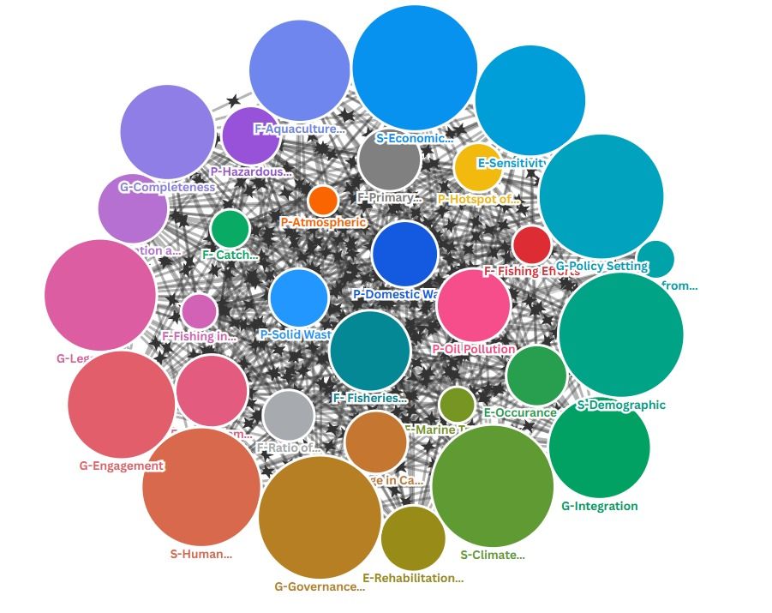

Figure 56 Overall networks/interactions of all indicators of pollution, ecosystem, fisheries, socioeconomics and governance

Further analysis of interactions shows that for the domain of pollution; indicator oil pollution is the most interacted indicator among others in the context of its relation to all other indicators of TDA’s domains. While, in the domain of fisheries, indicator of aquaculture productions is the most sensitive interconnected indicator, indicator ecosystem sensitivity and vulnerability is the most interconnected from the perspective of ecosystems domain. In th context of socio-economics domain, indicator of economic activity and human well-being has the most sensitive interconnectivity among others and in the domain governance, indicator government effectiveness is the most important indicators in terms of its connectivity. Figure 57 shows the interactions of the most indicator for each domain relative to all other indicators.

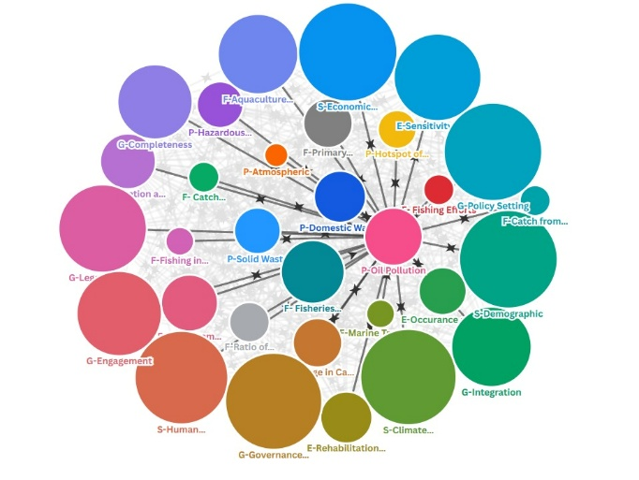 | 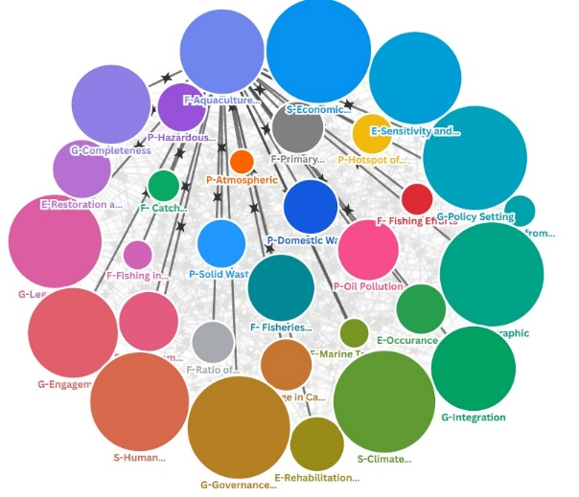
A. P-Oil pollution | B. F-Aquaculture
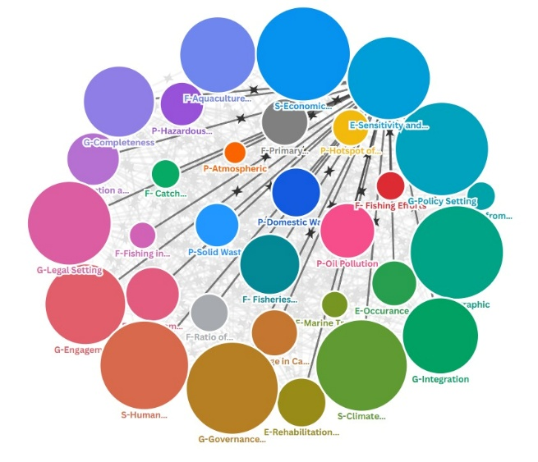 | 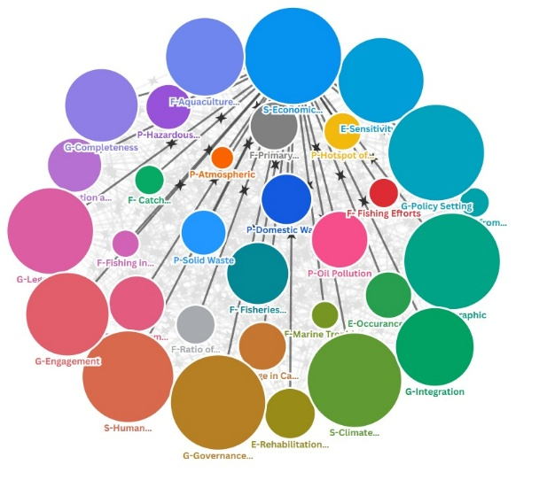
C. E-Sensitivity and Vulnerability | D. S-Economic Activities
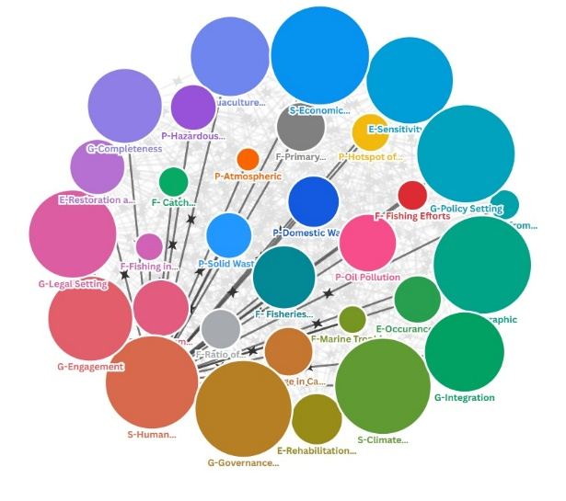 | 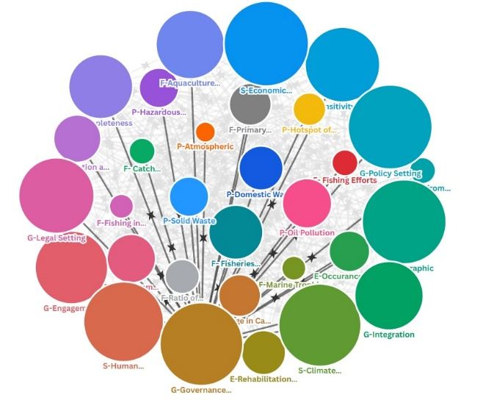
E. S-Human Wellbeing | F. G-Government Effectiveness

Figure 57 Interactions of the Most Connected Indicators in Relations to Other Indicators for Each Domain

From the analysis we can conclude that shared governability platform should be designed using such collaborative decision-making and harmonized policy within sub national and national level of the Indonesia’s TDA boundary especially for the interaction between oil pollution, aquaculture productions, ecosystem sensitivity and vulnerability, economic activity and human well-being and governance effectiveness.

7.3. Patterns of risk among spatial units of analyses and at country scale
A composite analysis of all key indicators across each unit of analysis are pollution, ecosystem, fisheries, governance, and socio-economic dimensions reveals distinct risk class patterns, as presented in Matrix. Green flag indicates low-risk relationships, yellow flag represents moderate risk, and red flag denotes high-risk conditions. In addition, the risk representation pattern derived from the analysing units of analysis is illustrated in Figure 58. The socio-economic component functions as the dominant risk driver, governance acts as a systemic risk amplifier, the ecosystem serves as the primary risk receiver, while fisheries and pollution operate as secondary drivers and mediators. The mapping of these analytical units within the TDA framework for the Indonesian region is shown in the following figure.

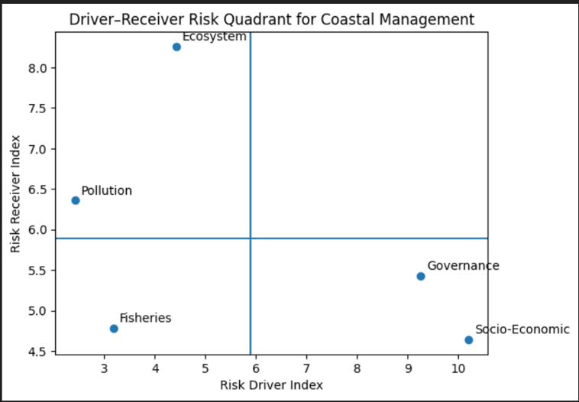

Figure 58 Risk classes and spatial distribution of risk based on driver and receiver characteristics of the analytical units.

Based on the risk class analysis, the distribution of analytical units is identified according to their roles as risk drivers or risk receivers. Socio-Economic; This dimension acts as the primary driver of risk within the coastal management system. Socio-economic pressures—such as livelihood dependency, poverty, competition over coastal space, and population growth—generate substantial risk for other sectors while being relatively less affected by them. The risk reduction strategies should prioritize structural socio-economic interventions, including livelihood diversification, social protection, and economic resilience, rather than focusing solely on environmental remediation.
The governance functions as a systemic risk amplifier. Weak regulatory frameworks, fragmented institutional mandates, and limited enforcement capacity both generate and absorb risks across all sectors. Strengthening governance represents the most strategic entry point for risk mitigation, as improvements in institutional coordination and enforcement capacity simultaneously reduce multiple risk pathways.
Primary risk receivers is ecosystem unit on Indonesia region. The ecosystem dimension emerges as the main recipient of risk, rather than a significant source. Ecosystem degradation is largely the cumulative outcome of pressures originating from socio-economic activities, governance failures, and sectoral exploitation. Ecosystem restoration should be framed as a response to systemic risk, not as the primary risk prevention mechanism.

Secondary drivers and mediators with low driver low receiver of risk area fisheries and pollution unit. Fisheries operate as a context-dependent mediator. Poorly managed fisheries can escalate risks, while adaptive and sustainable fisheries management can mitigate socio-economic and ecological pressures. Pollution primarily functions as an impact indicator, reflecting the combined effects of upstream socio-economic and governance drivers. Sector-specific management remains important but should be aligned with broader socio-economic and governance reforms

7.4. Target audience
Legal and institutional mapping has identified at least fifteen key stakeholders that must be engaged in the management of Indonesia’s jurisdictional waters in the South China Sea (SCS). These stakeholders demonstrate varying degrees of interest and intensity across critical issues, including marine pollution, ecosystem-based assessment, climate change, fisheries and livelihoods, endangered species conservation, and the marine/blue economy. For analytical clarity, these issues can be grouped into four primary focal areas: (1) socio-economic dimensions, (2) coastal and marine pollution, (3) fisheries and aquaculture and (4) coastal and marine ecosystems.
Addressing the complex challenges of SCS management requires the establishment of formal governance arrangements, which encompass: (1) Inclusive governance to ensure broad stakeholder participation and representation, (2) marine pollution control to mitigate environmental degradation, (3) coastal ecosystem protection to safeguard biodiversity and ecological resilience and (4) capture fisheries and aquaculture development to promote sustainable resource use and livelihoods. The effective implementation of these arrangements is contingent upon robust stakeholder support at both national and sub-national levels. Such engagement is essential to foster legitimacy, enhance coordination, and ensure that management strategies are both sustainable and responsive to diverse stakeholder interests.
Empirical evidence indicates that stakeholder support for the established formal arrangements remains suboptimal, with significant variation in the intensity of integration across different stages of the policy cycle. Integration, understood as the process of combining, involving, and aligning stakeholder interests within strategies, policies, or management activities for the South China Sea (SCS), is currently assessed at a medium risk level and requires substantial improvement.
While integration is relatively stronger during the implementation and evaluation stages, it is notably weaker in the policy formulation and decision-making phases. The lowest scores are observed in policy decision-making and early implementation, where decisions tend to be dominated by a small number of influential stakeholders rather than being taken collectively and participatively. This imbalance undermines inclusivity and reduces the legitimacy of governance processes, making it difficult to secure broad-based support. Stakeholders excluded from early stages are unable to fully comprehend or commit to the design of formal arrangements, thereby weakening overall alignment.
The limited integration during policy formulation has a direct impact on stakeholder engagement, which also remains below optimal levels. Engagement, defined as the active involvement of stakeholders in formal arrangements, varies across governance mechanisms but generally falls within the medium to low range. Although engagement is highest in the domain of marine pollution control, even this area requires further strengthening to ensure effective outcomes.
The combined weakness of integration and engagement constrains the performance of governance systems, resulting in effectiveness levels that range from low to medium, with a predominance at the lower end. This suggests that while the completeness of policy design is relatively adequate, the quality of participatory processes remains insufficient. The lack of inclusivity and collective decision-making increases governance risks, particularly in terms of legitimacy, stakeholder buy-in, and long-term sustainability.

To enhance performance, it is necessary to strengthen the role of stakeholders who function as nodes or integrators in decision-making, both at the planning and implementation stages. From a national perspective, the roles of the Ministry of Environment, the Ministry of Marine Affairs and Fisheries, and the Ministry of National Development Planning/Bappenas are vital in promoting stakeholder integration and engagement. These roles extend beyond mobilizing ministries and agencies at the central level to also encompass sub-national institutions, particularly provincial governments. This is crucial given that the institutional authority for managing the South China Sea (SCS) lies not only with national bodies but also with provincial governments, notably West Kalimantan, Bangka Belitung, and the Riau Islands. Strengthened integration and engagement are expected to establish a domestic cooperation platform among stakeholders that is robust, stable, and well-directed for effective SCS management.

At the regional level, the Ministry of Foreign Affairs must coordinate effective diplomacy while inclusively incorporating input from a broad range of stakeholders, including central and local governments, researchers, NGOs, and civil society groups. The Ministry of Foreign Affairs plays a critical role as the spokesperson for Indonesia’s interests in regional cooperation forums on SCS governance. Outcomes from these forums should then be operationalized by relevant technical ministries and institutions, ensuring that regional commitments are translated into concrete national and sub-national actions.

Future indicator-based environmental assessments
Based on the assessment of environmental conditions, which reflects the outcomes of interactions between ecosystem components and the drivers of disturbance and degradation, it is evident that the current set of indicators is not yet sufficient to comprehensively describe environmental dynamics. The environment is a complex system in which biophysical, chemical, and biological components interact continuously with both natural and anthropogenic stressors. Therefore, to better capture these interactions and their implications, several additional indicators need to be incorporated in future assessments.
These proposed indicators are presented according to each ecosystem component, allowing for a more structured and component-specific evaluation. The inclusion of such indicators is expected to improve the sensitivity of monitoring efforts in detecting early signs of environmental change, disturbance, or degradation. Furthermore, these indicators will provide more robust information for understanding causal relationships between ecosystem processes and external pressures.
The addition of these indicators is intended to support more effective and adaptive environmental management in the future. By enhancing the analytical framework, decision-makers will be better equipped to design targeted management strategies, prioritize intervention measures, and evaluate management performance over time. Ultimately, the expanded indicator set will contribute to more sustainable ecosystem management and improved environmental resilience.
Table 27 Additional indicators for each component of future environmental management are proposed based on an assessment of existing interactions among components in the management of the Indonesian sector of the South China Sea (SCS).
Component | Additional Indicators | Typical unit | Data required
Pollution | Eutrophication Index | Index | Dissolved oxygen; DIN; DIP; Chl-a
 | Riverine load | ton/day of Total N | River discharge; total N
 |  | ton/day of Total P | River discharge; total P
 |  | Number/day | River discharge; Total Coliform
 | Volume of oil sludge stranded | Ton/m2 | Volume of oil sludge
 | Volume of marine debris stranded | Ton/m2 | Volume of marine debris based on types
Fisheries | Sustainable Fisheries | Sustainable Index | Production; DIN; DIP
 |  | Number of illegal fishing | Number of cases
 |  | Number and volume of the abandoned fishing gears | Volume of abandoned fishing gears
 | Aquaculture Productions | Feed Conversion Ratio - FCR | Measures the amount of feed required to produce 1 kg of fish biomass
 |  | Water Use Efficiency | The volume of water used per unit of production (m³/kg)
 |  | Biodiversity Impact Index | The percentage of native species affected by fish escapes or habitat alteration. Target: <5% loss of local species, measured through ecosystem monitoring
Ecosystems | Policy Development for Ecosystem Protection and Mitigation | Mitigation action  Destruction reducing  Literation | The future important indicator is strengthening the policy action and plan to mitigate and protect the potential source of ecosystem production
Governance | Regional cooperation and coordination | Regional cooperation and coordination in addressing transboundary pollution issues | Frequency and volume of oil sludge stranded, frequency and volume of marine debris stranded
 |  | Regional cooperation and coordination in addressing transboundary fisheries issues | Frequency and volume of illegal fishing

The table above presents a comprehensive list of additional indicators required to strengthen the assessment framework for pollution, fisheries, and ecosystem management, with a particular focus on the Indonesian waters of the South China Sea (SCS). These indicators were identified to address existing gaps in the current assessment system and to better capture the complexity of environmental interactions within the study area. The Indonesian sector of the SCS is characterized by diverse ecological processes, intensive human activities, and transboundary environmental pressures, which necessitate the use of context-specific indicators.
The additional indicators proposed in this table are not intended to be universally applied across all regions of Indonesia. Instead, they represent indicators that are particularly relevant to the environmental conditions, management challenges, and ecological characteristics of the Indonesian SCS waters. The selection of these indicators was informed by an inter-component assessment analysis that examined interactions among pollution sources, fisheries activities, and ecosystem components under existing conditions at the time this study was conducted.
By incorporating these additional indicators, the assessment framework is expected to provide a more integrated and holistic understanding of environmental status and management effectiveness. This enhanced framework will support evidence-based decision-making, facilitate adaptive management strategies, and improve the capacity to respond to emerging environmental pressures in the Indonesian sector of the SCS.

APPENDIXES

Appendix Chapter 3 (Ecosystems)
- Marina national park data related ecosystem and management status
Name | Estbled | Updated | Total area (ha) | MG area (ha) | WL area (ha) | CR area (ha) | SG  area  (ha) | Mngmnt  Effectiveness
Anambas  National MPA | 2011 | 2025 | 1.262.686,2 | 766,2 | 850-860  (estimation) | 3,706.0 | 89.63* | Collaborationwork with LKKPN Pekanbaru
Bangka  Regional MPAs | 2013 | 2020 | 7.372,5 | 12.120 | 10.470 | 2,348.0 | 350 | Low efektive 44,64% (evika)
Belitung  Regional MPA (P Memporang) | 2011 | 2017 | 124.320,7 | 19.395 |  | 1842,9 | 10.131 | 39,42% low  effective  (evika)
Karimata  Regional MPA | 2004 | 2014 | 77.000  (2004)  210.000  (2014) | 1034 |  | 1,041.0 | 326 | No effectiveness measurements have been conducted at the Ministry of Forestry.
Senayang  Lingga Regional MPA | 2002 |  | 419.134,75 | 58 |  | 4,735.0 | 260 | Not yet measured with EVIKA
Barelang & Bintan Regional MPA | 2007 | 2022 | 66.867 | 1.880 |  | 6,145.0 | 2.094 | Not yet measured with EVIKA
Natuna Regional MPA | 2007 | 2007 | 142.977 | 5.017 |  | 4,774.0 | 1060 | Not yet measured
Batam/Abang  Island Regional MPA | 2007 | 2007 | 64,735 | 60 |  | 44,539 | - | Not yet evaluated
Lingga seagrass sanctuaries | 2019 | 2025 | 17.500 | - | - | - | 462.0 | Not yet evaluated
Sembilang  National Park | 2003 |  | 202.896,31 | 88.586 | 267,592.0 | - | - | Not yet measured with EVIKA

Bintan 1 Conservation  Area | 2024 |  | 138.561,42 |  |  |  | 1,500 | Not yet evaluated
Bintan 3 Conservation  Area | 2024 |  |  |  |  |  | 257 | Not yet evaluated
Batu Ampar Protected Forest | 2014 |  | 65,585 | 33,235 | 33.140 |  |  | Not yet evaluated
Source: PPID LKKPN Pekanbaru, 2025.
- Total Mangrove Coverage in Indonesia based on data from various resources
Country/Area (Sites characterized by the SCS Project)
Indonesia | 2003  (ha) | 2008  (ha) | 2013  (ha) | 2017  (ha) | 2018  (ha) | 2021  (ha) | 2002  (ha) | 2023  (ha) | 2024  (ha) | 2025  (ha)
Total of Mangrove  Coverage | 216209.29 | 130,501 | 118,674 | 195,000 | 79,229 | 913,443.7 | 341,109.8 | 467,464.83 | 529,066.54 | 67,417
Bangka  Belitung | 0 | 22,457 | 0 | 0 | 0 | 275,299.7 | 273,692.8  1 | 273,692.80 | 61,832.44 | 0
Kep Riau | 0 | 0 | 0 | 0 | 79,229 | 67,417 | 67,417 | 0 | 67,417 | 67,417
Sumatera  Selatan | 115,072.29 | 0 | 118,674 | 195,000 | 0 | 171,629 | 0 | 97,332.03 | 167,050.13 | 0
Jambi | 0 | 0 | 0 | 0 | 0 | 12,236 | 0 | 0 | 11,515.55 | 0
Riau | 0 | 42,459 | 0 | 0 | 0 | 224,895 | 0 | 0 | 230,000 | 0
West  Kalimantan | 101,137 | 65,585 | 0 | 0 | 0 | 161,967 | 0 | 96,440 | 158,302 | 0

- Total Mangrove Coverage in Indonesia based on data from various resources
Country/Area (Sites characterized by the SCS Project)
Indonesia | 2003  (ha) | 2008  (ha) | 2013  (ha) | 2017  (ha) | 2018  (ha) | 2021  (ha) | 2022  (ha) | 2023  (ha) | 2024  (ha) | 2025  (ha)
Province
Bangka  Belitung | 0 | 22,457 | 0 | 0 | 0 | 275,299.75 | 0.00 | 273,692.80 | 61832.439 | 0
1. Bangka | 0 | 0 | 0 | 0 | 0 | 38,957.14 | 0 | 0 | 0 | 0
2. Bangka  Barat | 0 | 0 | 0 | 0 | 0 | 48,529.43 | 0 | 0 | 0 | 0
3.Bangka  Selatan | 0 | 0 | 0 | 0 | 0 | 58,165.04 | 0 | 0 | 0 | 0
4.Bangka  Tengah | 0 | 0 | 0 | 0 | 0 | 19,151 | 0 | 0 | 0 | 0
5. Belitung | 0 | 22,457 | 0 | 0 | 0 | 67,265.00 | 0 | 273,692.80 | 61,832.44 | 0
6.Belitung  Timur | 0 | 0 | 0 | 0 | 0 | 43,232 | 0 | 0 | 0 | 0
Kep Riau | 0 | 0 | 0 | 0 | 79,229 | 67,417 | 67,417 | 0 | 67,417 | 67,417
1.Tanjung  Pinang | 0 | 0 | 0 | 0 | 2,009 | 0 | 0 | 0 | 0 | 0
2. Batam | 0 | 0 | 0 | 0 | 20,698 | 0 | 0 | 0 | 0 | 0
3. Bintan | 0 | 0 | 0 | 0 | 8,327 | 0 | 0 | 0 | 0 | 0
4. Lingga | 0 | 0 | 0 | 0 | 16,480 | 0 | 0 | 0 | 0 | 0
5. Karimun | 0 | 0 | 0 | 0 | 14,875 | 0 | 0 | 0 | 0 | 0
6. Natuna | 0 | 0 | 0 | 0 | 16,480 | 0 | 0 | 0 | 0 | 0
7. Anambas | 0 | 0 | 0 | 0 | 359 | 0 | 0 | 0 | 0 | 0
Sumatera  Selatan | 115,072.29 | 0 | 118,674 | 195,000 | 0 | 171,629 | 0 | 97,332.03 | 167.050.134 | 0
Jambi | 0 | 0 | 0 | 0 | 0 | 12,236 | 0 | 0 | 11,515.55 | 0
Riau | 0 | 42,459 | 0 | 0 | 0 | 224,895 | 0 | 0 | 230,000 | 0
1. Bengkalis | 0 | 42,459 | 0 | 0 | 0 | 0 | 0 | 0 | 0 | 0
West  Kalimantan | 101,137 | 65,585 | 0 | 0 | 0 | 161,967 | 0 | 96,440 | 158,302 | 0
1. Kubu Raya | 101,137 | 0 | 0 | 0 | 0 | 0 | 0 | 96,440 | 0 | 0
2. Batu Ampar | 0 | 65,585 | 0 | 0 | 0 | 161,967 | 0 | 0 |  | 0

- The Coverage of Wetland (Sites characterized by the SCS Project) in Indonesia (Sumatra and Kalimantan) based on various resources (by provinces)
Country/Area (Sites characterized by the SCS Project)
Indonesia | 2023 (ha) | 2024 (ha)
Banka Belitung | 150,000 | 45,145.90
Riau Island | 57,000 | 8,277,846
South Sumatera | 855,000.00 | 1,234,966.45
Jambi | 682,000 | 608,910
Riau | 768,000 | 222,538.10
West Kalimantan |  | 1,430,813

- Site level Risk Assessment of Seagrass and Coral Reef Ecosystems in the Western South China Sea. Qualitative categories retained as provided (High, Medium, Low–Medium, Low). Quantitative equivalence for reviewers: High = 3; Medium = 2; Low = 1. Scores represent relative pressure or vulnerability across stressor categories and sites.
No | Location | Overfishing | Illegal fishing | Sedimentation | Eutrophic ation | Uncontrol  tourism | Landfills | Habitat loss | Community  change | LC/SG cover decline
1 | Anambas | Medium | Present  (domestic/dest ructive fishing historically) | Local  (port/settlement) – Low/Med | Localized  near  villages | Rising risk (island  hopping  growth) | Spot trash issues | Turtle nesting & reef pressure sites | Tourism & gear shift in fishing | LC: variable; reef monitoring & elasmobranch  survey sites
2 | Bangka | Medium | Present  (blast/cyanide historically) | High (tin mining on/offshore -> turbidity) | Estuaries  near towns | Growing  coastal  tourism | Local dumps & marine debris | Mangrove/reef  damage from mining | Livelihood shift mining↔fishing | SG impacted near sea-based tin mining
3 | Belitung | Medium | Present  (historical) | High  (river/nearshore  from mining/land use) | Ports & settlement  s | Medium  (island  hopping  sites) | Local waste issues | Reef/shoreline  alteration | Tourism expansion | Reef condition East Belitung sites
4 | Karimata | Low–Medium | Present  (small-scale) | Local (near villages/boat traffic) | Low | Low  (access  limited) | Low | Sensitive reefs & turtle sites; boat traffic | Small island out-migration | LC Pelapis: site specific (2023– 2024 study)
5 | Senayang  Lingga | Medium | Present  (small-scale  destructive  gear) | Medium (near river mouths) | Localized  nutrients | Rising  (Benan, etc.) | Local waste leakage | Seagrass/reef  pressure | Tourism-based  livelihood shift | —
6 | Barelang dan Bintan | Medium | Present  (small-scale) | Medium (coastal development) | Medium–  High  (urban  wastewate  r & oil incidents) | High  (resorts/mas s tourism) | Urban waste issues | Coastal habitat conversion & oiling | Rapid coastal development | Bintan: oil spill governance;  tourism sewage risk (regional refs)
7 | Natuna | Medium | High (foreign IUU focus) | Low–Medium  (localized) | Low | Low | Low | Fishing ground pressure;  seagrass/reef intact offshore | Fisheries  dominated  economy | —
8 | Batam/Aban  g Island | Medium | Present | Medium (urban + boat traffic) | Medium  (sewage to rivers/bays ) | High  (snorkeling/ diving) | Urban landfill & leakage | Reef  trampling/anchor damage | Tourism-driven  change | LC Abang: 38.8–84.9% (station range)
9 | Bintan | Medium | Present | Medium (coastal dev.) | Medium  (resort  wastewate  r); oil sludge  cases | High (Lagoi etc.) | Tourism/urban  waste | Mangrove/reef  conversion in pockets | Service economy growth | —
10 | Medang-  Mesanak  (Lingga) | Medium | Present  (small-scale) | Medium  (nearshore) | Low | Low–  Medium | Local dumping | Reef pressure | Demographic  change small isles
11 | Temiang  (Lingga) | Medium | Present | Medium | Low | Low–  Medium | Local dumping | Reef pressure | Tourism village shift | —
12 | Mapor | Medium | Present | Low–Medium | Low | Emerging | Local dumping | Reef pressure | Potential tourism shift | —
13 | Senayang | Medium | Present | Medium | Low–  Medium | Medium | Local dumping | Reef/Seagrass stress | Tourism gateway shift | —

Appendix Chapter 4 (Pollution)
- Analysis of Aquaculture Waste Load Estimates
Analysis of estimates of pollutant load from aquaculture activities was conducted using formulae from Gompi et al. (2023):
- Food conversion rate = 1.8
- Left uneaten food = 15% of the food
Food waste = 15%*(P/FCR)
Where,
FCR = food conversion rate, 1.8
P = aquaculture production, tonnes/year
- Analysis of Riverine Pollution Load Estimates
The analysis of river pollution load estimates use the formulae of (Environmental Ministry Decree Number 28/2009 about Carrying Capacity and Assimilative Capacity):
Pollution load_{i} = C_{i} x Q
Where:
- C_{i} = Concentration of the i-pollutant (e.g., in mg/L)
- Q= Mean river flow rate or mean discharge (e.g., in L/s or m³/s)
- Pollution Load_{i} (e.g., in mg/s, kg/day, depending on the unit conversion)
Data on annual mean concentration of the I- water quality parameter and mean river discharge were collected from environmental statistics of Indonesia.

- Methods for calculating River Water Quality (WRQI-IKA) (Environment and Forestry Ministerial Regulation No. 27 of 2021)
The IKA is a composite index summarizing key water quality parameters—including pH, BOD, COD, TSS, DO, NO₃-N, total phosphate, and fecal coliform counts—and is calculated using weighted sub-indices on a 0–100 scale. The classification thresholds used above are based on the standard national interpretation:
- Very Good: 90-100
- Good: 70-89
- Moderate: 50-69
- Poor: 25-49
- Very Poor: 10-24
For each water-use category j (e.g. domestic use, aquatic life), a Pollution Index (IPₙ) is calculated using multiple water quality parameters:
IP_{j} = CiLij M2 + CiLijR22
- Ci is the measured concentration of parameter i (e.g. DO, BOD, COD, pH, TSS, total phosphate, nitrate, fecal coliform).
- Lij​ is the regulatory standard (limit) for that parameter relative to water use j (e.g. Class II river standard per PP 22/2021).
Commonly measured parameters for Indonesian river WQI include:
- pH
- Dissolved Oxygen (DO)
- Biochemical Oxygen Demand (BOD₅)
- Chemical Oxygen Demand (COD)
- Total Suspended Solids (TSS)
- Nitrate (NO₃-N)
- Total Phosphate (T-Phosphate)
- Fecal Coliform (or Total Coliform)

- Methods for calculating Sea Water Quality Index (SWQI-IKAL)
Under Indonesia’s Ministerial Regulation No. 27 of 2021, the IKAL is calculated using five key parameters, based on the NSF-WQI model adapted for marine waters:
- Total Suspended Solids (TSS)
- Dissolved Oxygen (DO)
- Oil and Grease
- Total Ammonia (NH₃-N)
- Ortho-Phosphate (PO₄-P)
These parameters were selected for their relevance to marine pollution sources and ecological impact, including turbidity, hypoxia, toxicity, and eutrophication potential.
The Marine Water Quality Index (IKAL) is calculated as the sum of the sub-indices of each seawater parameter, multiplied by the weight of each parameter
IKAL=i=1n(WiQi)
where:
- Qi= sub-index of i-parameter ke-i
- Wi= weighted score of i-parameter
- n= number of parameter

- Analysis of Risk Assessment
Risk assessment is conducted using a risk analysis approach based on a simple formula that incorporates three key variables: probability, impacts, and adaptive capacity, within the context of a specific pollution scenario (Cornelly et al., 2018; Ortega et al., 2014).
The variables probability and impacts are positively correlated with the level of risk—meaning that as their values increase, the overall risk also increases. Conversely, adaptive capacity is negatively correlated to risk value.
Probability refers to the likelihood or potential for a specific pollution event to occur, which in this context is represented by the magnitude of pollution sources within a given area. Higher probability values indicate a greater risk. The probability is measured on a scale from 1 to 5. The data for this variable represents the likelihood of a specific type of pollution occurring, based on its pollution source. The data was collected through discussions during focus group discussions (FGDs) as well as from available secondary data, such as environmental statistics from a given region. FGD participants were asked to assign a probability score ranging from 1 to 5, where a score of 1 indicates low probability, and a score of 5 indicates high probability.
The next variable, impacts, comprises several sub-variables, including the existing water quality in the relevant coastal or marine waters, the deviation of parameter values from quality standards, social impacts, and ecological impacts. This variable is also positively correlated with the risk value—greater impacts are associated with higher levels of risk. Impacts are also scored on a scale from 1 to 5. Impact data represents the severity of the consequences resulting from a specific pollution contamination event in a given area. The impact data consists of the following variables: (1) sea water quality index (IPAL), (2) water quality status relative to standards, (3) social impacts, and (4) ecological impacts. Each variable is assigned a score ranging from 1 to 5. FGD participants were asked to determine the score, where a score of 1 indicates low impact and a score of 5 indicates high impact.
The final variable, adaptive capacity, represents the ability of a management unit to effectively manage a specific type of pollution within its administrative area. A higher adaptive capacity indicates stronger management capability, and therefore, is negatively correlated with risk. Adaptive capacity is also rated on a scale from 1 to 5. Based on this assessment, adaptive capacity consists of the following variables: (1) the level of existing pollution management, (2) availability of financial allocation, and (3) availability of regulations. The higher the aggregate capacity of a unit to manage pollution, the lower the resulting pollution risk. The formula for risk calculation is as follows:
Risk = (P * I)/AC, where:
- P = probability
- I = Impacts
- AC = Adaptive Capacity
The risk value, ranges from 0.2 to 25, with the following risk classification levels:
- Very low = 0.2 - 1.0
- Low = 1.0 - 3.0
- Moderate = 3.0 - 8.0
- High = 8.0 - 12.5
- Very High = 12.5 - 25

- Results of the risk assessment analysis for each type of pollution and administrative region (source: data analysis 2025)
Administrative Area | Type of pollution | Source of pollution | Probability |  | Impact |  |  |  |  | Adaptive Capacity |  |  |  | Risk | Class
Administrative Area | Type of pollution | Source of pollution | Source of pollutant (1-5) | Average Probability (1-5) | Sea Water Quality Index (1-5) | Status towards Standard (1-5) | Social impact (1-5) | Ecological Impact (1-5) | Average Impact (1-5) | Existing pollution management level (1-5) | Financial allocation availability (1-5) | Regulation availability (1-5) | Average AC | (0.2-25)
Riau Archipelago Province
Batam City and Bintan | Oil | seaport, oil facility, shipping activity | 5 | 5 | 5 | 5 | 5 | 5 | 5.0 | 2 | 3 | 4 | 3.0 | 8.3 | H
Batam City and Bintan | Hazardous waste and heavy metals | industry | 5 | 5 | 4 | 4 | 3 | 4 | 3.8 | 3 | 3 | 4 | 3.3 | 5.6 | M
Batam City and Bintan | Plastic-marine debris | Domestics | 4 | 4 | 3 | 3 | 4 | 4 | 3.5 | 3 | 3 | 4 | 3.3 | 4.2 | M
Batam City and Bintan | Organics/nutrients | Domestic, agriculture, aquaculture | 5 | 5 | 5 | 5 | 4 | 4 | 4.5 | 3 | 3 | 4 | 3.3 | 6.8 | M
Batam City and Bintan | E-Coli and bacteria | Domestics | 5 | 5 | 5 | 5 | 4 | 3 | 4.3 | 3 | 3 | 4 | 3.3 | 6.4 | M
Batam City and Bintan | Pesticides | Agriculture | 3 | 3 | 2 | 2 | 2 | 2 | 2.0 | 3 | 3 | 3 | 3.0 | 2.0 | L
Batam City and Bintan | TSS | Mineral Mining and sand mining | 5 | 5 | 4 | 5 | 4 | 5 | 4.5 | 2 | 3 | 4 | 3.0 | 7.5 | M
Bangka Belitung Province
 | Oil | seaport, oil facility, shipping activity | 4 | 4 | 3 | 3 | 3 | 3 | 3.0 | 2 | 3 | 4 | 3.0 | 4.0 | M
 | Hazardous waste and heavy metals | industry, mineral mining | 3 | 3 | 3 | 3 | 3 | 3 | 3.0 | 3 | 3 | 4 | 3.3 | 2.7 | L
 | Plastic-marine debris | Domestics | 5 | 5 | 4 | 4 | 4 | 3 | 3.8 | 3 | 3 | 4 | 3.3 | 5.6 | M
 | Organics/nutrients | Domestic, agriculture, aquaculture | 5 | 5 | 4 | 4 | 3 | 3 | 3.5 | 3 | 3 | 4 | 3.3 | 5.3 | M
 | E-Coli and bacteria | Domestics | 5 | 5 | 5 | 5 | 4 | 3 | 4.3 | 3 | 3 | 4 | 3.3 | 6.4 | M
 | Pesticides | Agriculture | 3 | 3 | 2 | 3 | 2 | 2 | 2.3 | 3 | 3 | 4 | 3.3 | 2.0 | L
 | TSS | Mineral Mining and sand mining | 5 | 5 | 5 | 5 | 4 | 5 | 4.8 | 3 | 3 | 4 | 3.3 | 7.1 | H
West Kalimantan
 | Oil | seaport, oil facility, shipping activity | 3 | 3 | 3 | 3 | 3 | 3 | 3.0 | 3 | 3 | 4 | 3.3 | 2.7 | L
 | Hazardous waste and heavy metals | industry, mineral mining | 4 | 4 | 4 | 3 | 3 | 4 | 3.5 | 3 | 3 | 4 | 3.3 | 4.2 | M
 | Plastic-marine debris | Domestics | 4 | 4 | 4 | 4 | 4 | 4 | 4.0 | 3 | 3 | 4 | 3.3 | 4.8 | M
 | Organics/nutrients | Domestic, agriculture, aquaculture | 5 | 5 | 5 | 5 | 3 | 3 | 4.0 | 3 | 3 | 4 | 3.3 | 6.0 | M
 | E-Coli and bacteria | Domestics | 5 | 5 | 5 | 5 | 3 | 3 | 4.0 | 3 | 3 | 4 | 3.3 | 6.0 | M
 | Pesticides | Agriculture | 4 | 4 | 3 | 3 | 3 | 3 | 3.0 | 3 | 3 | 4 | 3.3 | 3.6 | M
 | TSS | Mineral Mining and sand mining | 4 | 4 | 4 | 4 | 3 | 4 | 3.8 | 3 | 3 | 4 | 3.3 | 4.5 | M

- Types of pollution and government actions against marine pollution
No | Type of Pollution | Location | Pollution Status | Mitigation and Prevention Measures/ Efforts
1 | Oil Pollution | Riau Islands Province | Moderate (2020) and Good (2021) (source: 2020-2021 Performance Report DLHK/ Environmental and Forestry Agency of Riau Islands Province)  Good (source: Q1 2025 Performance Report DLHK/ Environmental and Forestry Agency of Riau Islands Province) | - Environmental Pollution and/or Damage Control Program: Coordination, Synchronization, and Implementation of Greenhouse Gas Emission Control, Climate Change Mitigation and Adaptation  - Environmental Complaint Handling Program  - Hazardous and Toxic Materials (B3) and Hazardous Waste (B3 Waste) Control Program  (source: 2024 Work Agreement, 2024 Government Agency Performance Report, 2025 Annual Work Plan, 2021-2026 Strategic Plan DLHK/ Environmental and Forestry Agency of Riau Islands Province)
1 | Oil Pollution | Batam City | Moderate (source: Executive Summary of 2024 Environmental Management Performance Information DLH/ Environmental Agency of Batam City) | - Environmental Planning Program  - Environmental Pollution and/or Damage Control Program  - Environmental Education, Training, and Community Outreach Program  (source: Executive Summary of 2024 Environmental Management Performance Information DLH/ Environmental Agency of Batam City)
1 | Oil Pollution | Bintan Regency | Black oil waste found along the coast of Bintan Regency. This is not the first occurrence; oil spills happen every year.  (source: Agusthin et al. 2024) | - Sent letter to the Ministry of Environment regarding water pollution on Bintan Island by Bintan Environmental Agency  Held Oil Spill Coordination  - Meeting attended by various agencies such as the Coordinating Ministry for Maritime Affairs, BAKAMLA/ Indonesian Maritime Security Agency, and others  - Collaboration between DLHK/ Environmental and Forestry Agency of Riau Islands Province, Bintan Environmental Agency, and coastal communities for cleaning black oil waste; collected into drums for transport to B3 Waste Management Facility in Batam  - Issued Decree on Formation of Oil Spill Response Team in Riau Islands Province (Governor Decree No. 742/2018 dated 14 May 2018)  (source: Agusthin et al. 2024)  (source: Agusthin et al. 2024)
1 | Oil Pollution | Nationwide | - | Oil spill pollution mitigation (10 locations): 1. Pulau Bintan 2. Provinsi Aceh 3. Provinsi Banten 4. Provinsi Jawa Barat 5. Provinsi Jawa Tengah 6. Provinsi Nusa Tenggara Barat 7. Provinsi Nusa Tenggara Timur 8. Provinsi Sulawesi Selatan 9. Provinsi Maluku 10. Provinsi Maluku Utara  (source: 2024 Action Plan and 2024 Performance Report Directorate of Coastal and Marine Pollution and Damage Control, KLHK/ The Ministry of Environment and Forestry)
2 | Marine Debris | Riau Islands Province | Moderate (2020) and Good (2021) (source: 2020-2021 Performance Report DLHK/ Environmental and Forestry Agency of Riau Islands Province)  Good (source: Q1 2025 Performance Report DLHK/ Environmental and Forestry Agency of Riau Islands Province) | - Environmental Pollution and/or Damage Control Program: Coordination, Synchronization, and Implementation of Greenhouse Gas Emission Control, Climate Change Mitigation and Adaptation  - Environmental Planning Program: Preparation and Implementation of SEA for Development Plans with Potential Environmental Impact/Risk  - Environmental Complaint Handling Program  - Waste Management Program: Provision of Waste Handling Facilities at Regional Final Disposal Site (TPA)/ Integrated Waste Processing Facility (Integrated Waste Processing Facility)  - Watershed Management Program: Implementation of Inter-District/City and Intra-Province Watershed Management  (source: 2024 Work Agreement, 2024 Government Agency Performance Report, 2025 Annual Work Plan, 2021-2026 Strategic Plan DLHK/ Environmental and Forestry Agency of Riau Islands Province; 2024 Work Agreement and 2024 Government Agency Performance Report DLHK/ Environmental and Forestry Agency of Riau Islands Province)
2 | Marine Debris | Batam City | Moderate (source: Executive Summary of 2024 Environmental Management Performance Information DLH/ Environmental Agency of Batam City) | - Environmental Planning Program  - Environmental Pollution and/or Damage Control Program  - Environmental Education, Training, and Community Outreach Program  - Domestic Waste Management Facility  - Muka Kuning WTP Construction  - Development of Sewage System in Batam  - Wastewater Management and Development  - Waste Management Program  (source: Executive Summary of 2024 Environmental Management Performance Information DLH/ Environmental Agency of Batam City)
2 | Marine Debris | Nationwide | - | - Marine debris and microplastic monitoring (24 provinces): 1. Aceh 2. Sumatera Utara 3. Kepulauan Riau 4. Sumatera Barat 5. Sumatera Selatan 6. Bangka Belitung 7. Lampung 8. Banten 9. Jawa Barat 10. DKI Jakarta 11. Jawa Tengah 12. Jawa Timur 13. D.I. Yogyakarta 14. Bali 15. Nusa Tenggara Barat 16. Nusa Tenggara Timur 17. Kalimantan Barat 18. Kalimantan Timur 19. Sulawesi Utara 20. Gorontalo 21. Sulawesi Selatan 22. Sulawesi Tengah 23. Maluku 24. Papua Barat  - Technical approval for wastewater discharge into the sea (50 proposals)  (source: 2024 Action Plan and 2024 Performance Report Directorate of Coastal and Marine Pollution and Damage Control, KLHK/ The Ministry of Environment)
3 | Hazardous Pollution | Riau Islands Province | Moderate (2020) and Good (2021) (source: 2020-2021 Performance Report DLHK/ Environmental and Forestry Agency of Riau Islands Province)  Good (source: Q1 2025 Performance Report DLHK/ Environmental and Forestry Agency of Riau Islands Province) | - Environmental Pollution and/or Damage Control Program: Coordination, Synchronization, and Implementation of Greenhouse Gas Emission Control, Climate Change Mitigation and Adaptation  - Environmental Complaint Handling Program  - Hazardous and Toxic Materials (B3) and Hazardous Waste (B3 Waste) Control Program  - Hazardous and Toxic Materials (B3) and Hazardous Waste (B3 Waste) Control Program  (source: 2024 Work Agreement, 2024 Government Agency Performance Report, 2025 Annual Work Plan, 2021-2026 Strategic Plan DLHK/ Environmental and Forestry Agency of Riau Islands Province)
3 | Hazardous Pollution | Batam City | Moderate (source: Executive Summary of 2024 Environmental Management Performance Information DLH/ Environmental Agency of Batam City) | - Environmental Planning Program  - Environmental Pollution and/or Damage Control Program  - Environmental Education, Training, and Community Outreach Program  - Hazardous Waste Management Facility  (source: Executive Summary of 2024 Environmental Management Performance Information DLH/ Environmental Agency of Batam City)
4 | Habitat Degradation | Batam City | Moderate: Illegal Sand Mining (source: Executive Summary of 2024 Environmental Management Performance Information DLH/ Environmental Agency of Batam City) | - Environmental Planning Program  - Environmental Pollution and/or Damage Control Program  - Environmental Education, Training, and Community Outreach Program  (source: Executive Summary of 2024 Environmental Management Performance Information DLH/ Environmental Agency of Batam City)
4 | Habitat Degradation | Nationwide | - | - Marine Water Quality Monitoring (37 provinces)  - Marine Water Quality Index Formulation (37 provinces)  - Port performance evaluation (36 ports): 1. PT Pelabuhan Indonesia (Persero) Cabang Lhokseumawe 2. PT Pelabuhan Indonesia (Persero) Cabang Malahayati 3. PT Pelabuhan Indonesia (Persero) Cabang Belawan 4. PT Pelabuhan Indonesia (Persero) Cabang Kuala Tanjung 5. PT Pelabuhan Indonesia (Persero) Cabang Tanjung Balai Karimun 6. Badan Pengelola Pelabuhan Batam- Operasional Pelabuhan Batu Ampar 7. PT Pelabuhan Indonesia (Persero) Cabang Teluk Bayur 8. PT Pelabuhan Indonesia (Persero) Cabang Dumai 9. PT Pelabuhan Indonesia (Persero) Cabang Palembang 10. PT Pelabuhan Indonesia (Persero) Cabang Bengkulu 11. PT Pelabuhan Indonesia (Persero) Cabang Panjang 12. PT Pelabuhan Indonesia (Persero) Cabang Tanjung Pandan 13. PT Pelabuhan Indonesia (Persero) Cabang Pangkal Balam 14. PT Pelabuhan Indonesia (Persero) Cabang Tanjung Priok 15. PT Pelabuhan Indonesia (Persero) Cabang Banten 16. PT Pelabuhan Patimban Internasional 17. PT Pelabuhan Indonesia (Persero) Cabang Cirebon 18. PT Pelabuhan Indonesia (Persero) Cabang Tanjung Emas 19. PT Pelabuhan Indonesia (Persero) Cabang Tanjung Intan 20. PT Pelabuhan Indonesia (Persero) Cabang Tanjung Perak 21. PT Pelabuhan Indonesia (Persero) Cabang Teluk Lamong 22. PT Pelabuhan Indonesia (Persero) Cabang Lembar 23. PT Pelabuhan Indonesia (Persero) Cabang Tenau Kupang 24. PT Pelabuhan Indonesia (Persero) Cabang Labuan Bajo 25. PT Pelabuhan Indonesia (Persero) Cabang Pontianak 26. PT Pelabuhan Indonesia (Persero) Cabang Banjarmasin 27. PT Pelabuhan Indonesia (Persero) Cabang Balikpapan 28. PT Kaltim Kariangau Terminal 29. PT Pelabuhan Indonesia (Persero) Cabang Bitung 30. PT Pelabuhan Indonesia (Persero) Cabang Manado 31. PT Pelabuhan Indonesia (Persero) Cabang Gorontalo 32. PT Pelabuhan Indonesia (Persero) Cabang Makassar 33. PT Pelabuhan Indonesia (Persero) Cabang Ambon 34. PT Pelabuhan Indonesia (Persero) Cabang Manokwari 35. PT Pelabuhan Indonesia (Persero) Cabang Sorong 36. PT Pelabuhan Indonesia (Persero) Cabang Jayapura  - Seagrass/coral reef ecosystem restoration (11 locations): 1. Gorontalo 2. Maluku 3. Kalimantan Timur 4. DKI Jakarta 5. Sulawesi Selatan 6. Sulawesi Tenggara 7. Sulawesi Tengah 8. Bengkulu 9. Nusa Tenggara Timur 10. Bali 11. Jawa Timur  (source: 2024 Action Plan and 2024 Performance Report Directorate of Coastal and Marine Pollution and Damage Control, KLHK/ The Ministry of Environment)

Appendix Chapter 6 (Governance)
- Quarterly GDP Trends of Indonesia, 2020–2023, at Current Prices and 2010 Constant Prices
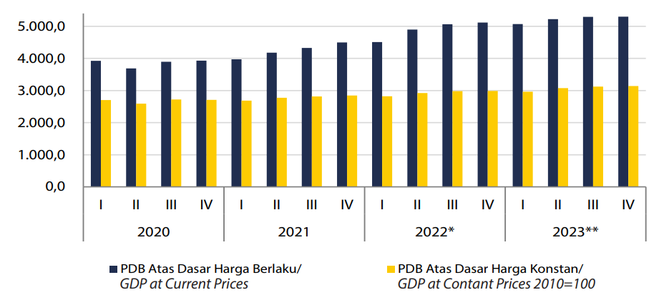
Source: Statistic Indonesia (BPS), 2024
- Economic Inflation of Indonesia 2020-2025
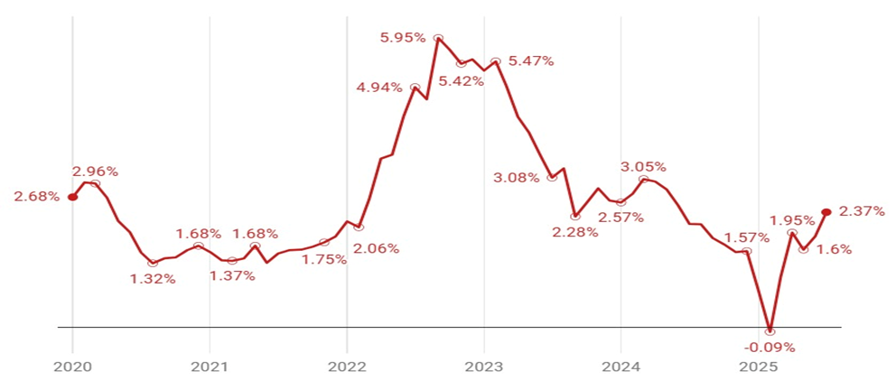
Source: Data processed from Bank Indonesia, accessed in 2025.

- GDP Maritim 2019-2023: Value and Contribution to National GDP
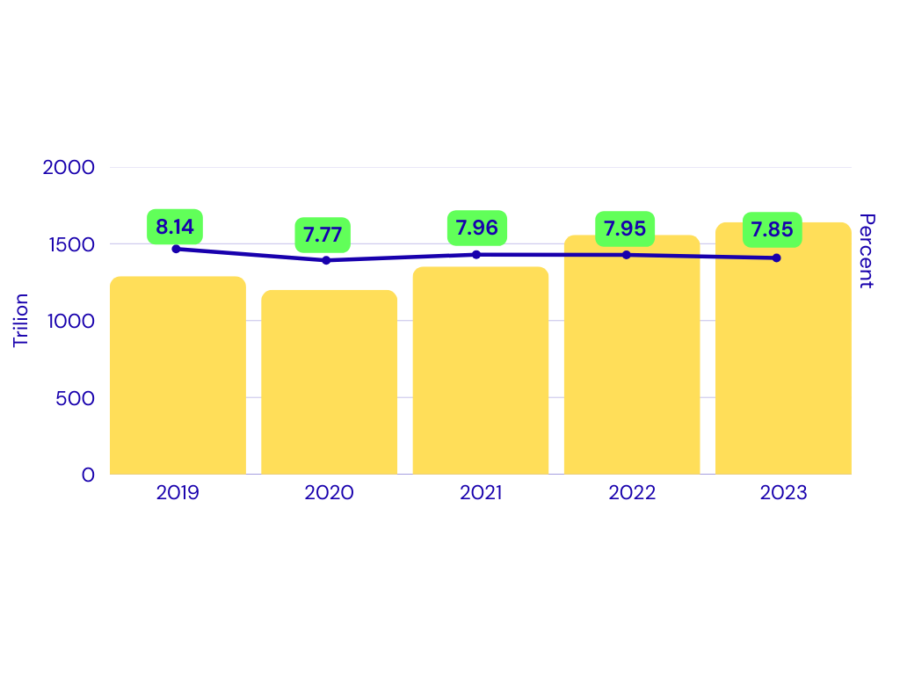Source: Statistic Indonesia (BPS) and Coordinating Ministry of Marine Affair and Investment, 2024

- Indonesia Debt 2000-2024
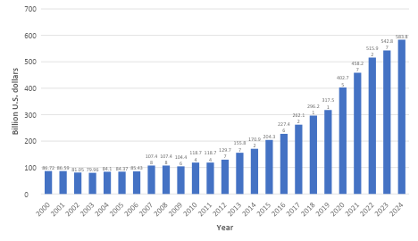
Source: statistica.com (2025)
statista.com/statistics/531621/national-debt-of-indonesia/

- Unemployment Rate of Indonesia 2014-2024
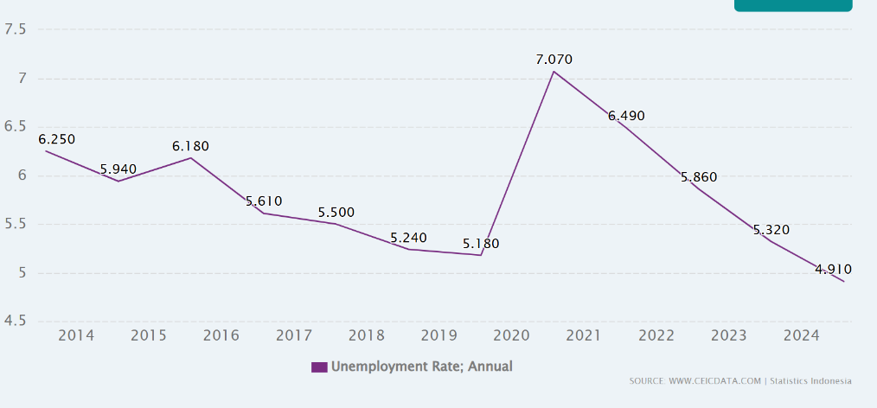
Appendix Source: https://www.ceicdata.com/en/indicator/indonesia/unemployment-rate

- Foreign Direct Investment Realization in Indonesia, 2010–2023
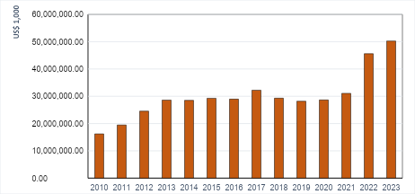
Source: Indonesia Investment Coordinating Board (BKPM), 2025

- The Provinces and Regencies/Cities adjacent to the South China Sea (SCS).
Province | District/City | Capital | Population (people)
Riau Island | Natuna | Ranai | 84.017
Riau Island | Anambas Island | Tarempa | 50.703
Riau Island | Bintan | Bandar Seri Bentan | 178,826
Riau Island | Karimun | Tanjung Balai Karimun | 272.391
Riau Island | Batam | Batam | 1.294.548
Riau Island | Lingga | Daik | 101.978
Riau Island | Tanjungpinang | Tanjungpinang | 237.580
Bangka Belitung | Bangka | Sungailiat | 335,292
Bangka Belitung | Middle Bangak | Koba | 209,117
Bangka Belitung | South Bangka | Toboali | 213,871
Bangka Belitung | West Bangka | Muntok | 216,238
Bangka Belitung | Pangkalpinang | Pangkalpinang | 239,730
Bangka Belitung | Belitung | Tanjungpandan | 191,252
Bangka Belitung | East Belitung | Manggar | 132,121
West Kalimantan | Pontianak | Pontianak | 682.896
West Kalimantan | Singkawang | Singkawang | 247.924
West Kalimantan | Sambas | Sambas | 648.307
West Kalimantan | North Kayong | Sukadana | 127.346
West Kalimantan | Ketapang | Delta Pawan | 581.859
South Sumatera | Palbang | Palembang | 1.781.672
Source: Agregat Jumlah Penduduk Per Kabupaten Kota. Satu Data Pemerintahan Dalam Negeri accessed 2025. https://pelita.kemendagri.go.id/kemendagri/dataset/1490/tabel-data

- List of NGOs and local special interest group in each provinces bordering the South China Sea (SCS)
Province and  NGO and Special Interest Group | Interest
Province and  NGO and Special Interest Group | Socio-Economic | Coastal & Marine Pollution | Fisheries & Aquaculture | Coastal & Marine Ecosystems
- Riau Island Province
WALHI | ✔ | ✔ | ✔ | ✔
JATAM | ✔ | ✔ | ✔ | ✔
KIARA | ✔ | ✔ | ✔ | ✔
Dompet Dhuafa | ✔
LSM Alim |  | ✔ |  | ✔
LSM PLH-K |  | ✔ | ✔ | ✔
Akar Bhumi Indonesia |  | ✔ |  | ✔
Yayasan Embun Pelangi | ✔
- Bangka Belitung Province
WALHI Bangka Belitung | ✔ | ✔ | ✔ | ✔
HNSI Bangka Belitung (Fishermen's Association of All Indonesia) | ✔ | ✔ | ✔ | ✔
Yayasan ALOBI |  | ✔ |  | ✔
SNV (Netherlands Development Organisation) | ✔
LSM Laskar Hijau |  | ✔ |  | ✔
- West Kalimantan Province
WALHI Kalimantan Barat | ✔ | ✔ |  | ✔
Lembaga Gemawan | ✔
Swandiri Institute |  | ✔ |  | ✔
Yayasan Sampan Kalbar | ✔ |  |  | ✔
AMAN Kalbar (Alliance of Indigenous Peoples of the Archipelago) | ✔ |  |  | ✔
RiAk Kalbar (JARI Borneo Barat) |  | ✔ |  | ✔
KIARA (Koalisi Rakyat untuk Keadilan Perikanan) | ✔ | ✔ | ✔ | ✔

- List of Trade Association and Business Group and special interest group in each provinces bordering the South China Sea (SCS)
Province-  Trade Association and Business Group | Interest
Province-  Trade Association and Business Group | Socio-Economic | Coastal & Marine Pollution | Fisheries & Aquaculture | Coastal & Marine Ecosystems
- Riau Island Province
KADIN Kepri (Kamar Dagang & Industri) | ✔ | ✔ | ✔ | ✔
INSA Kepri (Indonesian National Shipowners' Assoc.) | ✔ | ✔
PHRI Kepri (Perhimpunan Hotel & Restoran) | ✔ |  |  | ✔
APINDO Kepri (Indonesian Employers Association) | ✔
HKI Kepri (Himpunan Kawasan Industri) | ✔ | ✔
- Bangka Belitung Province
PT Timah Tbk | ✔ | ✔ | ✔ | ✔
AETI (Indonesian Tin Exporters Association) | ✔ | ✔
KADIN Babel (Kamar Dagang & Industri) | ✔ | ✔ |  | ✔
PHRI Babel (Perhimpunan Hotel & Restoran) | ✔ |  |  | ✔
- West Kalimantang Province
GAPKI Kalbar (Gabungan Pengusaha Kelapa Sawit) | ✔ | ✔ |  | ✔
Asosiasi Penambang (Bauksit, Zirkon) | ✔ | ✔ |  | ✔
KADIN Kalbar (Kamar Dagang & Industri) | ✔ | ✔ | ✔ | ✔
PHRI Kalbar (Perhimpunan Hotel & Restoran) | ✔ |  |  | ✔

- List of Co-Management, Traditional System and Customary Right in each provinces bordering the South China Sea (SCS)
Province-  Organization/System | Interest
Province-  Organization/System | Socio-Economic | Coastal & Marine Pollution | Fisheries & Aquaculture | Coastal & Marine Ecosystems
- Kepulauan Riau Province
Orang Suku Laut (Orang Laut) | ✔ |  | ✔ | ✔
Lembaga Adat Melayu (LAM) Kepri | ✔ |  |  | ✔
Pokmaswas (Kelompok Masyarakat Pengawas) |  |  | ✔ | ✔
Hutan Adat (Masyarakat Adat) | ✔ |  |  | ✔
- Bangka Belitung Province
Pokmaswas (Kelompok Masyarakat Pengawas) |  |  | ✔ | ✔
Lembaga Adat Mapur (Orang Lom) | ✔ |  | ✔ | ✔
Moang Jong (Tradisi Suku Sawang) | ✔ |  | ✔ | ✔
- West Kalimantan Province
Perhutanan Sosial (Hutan Desa/Hutan Adat) | ✔ |  | ✔ | ✔
Pokmaswas (Kelompok Masyarakat Pengawas) |  |  | ✔ | ✔
Masyarakat Adat (via AMAN) | ✔ | ✔ |  | ✔
Kearifan Lokal Nelayan Pesisir (Melayu Sambas/Kubu) | ✔ |  | ✔ | ✔
- List of Decentralized Agency in each provinces bordering the South China Sea (SCS)
Province-  Decentralized Agency | Issue
Province-  Decentralized Agency | Socio-Economic | Coastal & Marine Pollution | Fisheries & Aquaculture | Coastal & Marine Ecosystems
- Kepulauan Riau Province
DPRD Provinsi Kepri | ✔ | ✔ | ✔ | ✔
Fisheries and Marine Affair Office (Dinas Kelautan & Perikanan/DKP) Kepri Province | ✔ |  | ✔ | ✔
Dinas Lingkungan Hidup & Kehutanan (DLHK) Kepri |  | ✔ |  | ✔
BAPPEDA Kepri | ✔ | ✔ | ✔ | ✔
Musrenbang (Village/Regency/Province) | ✔ | ✔ | ✔ | ✔
- Bangka Belitung Province
DPRD Provinsi Babel | ✔ | ✔ | ✔ | ✔
DKP Babel (Dinas Kelautan & Perikanan) | ✔ |  | ✔ | ✔
DLH Babel (Dinas Lingkungan Hidup) |  | ✔ |  | ✔
BAPPEDA Babel (Badan Perencanaan Pembangunan Daerah) | ✔ | ✔ | ✔ | ✔
Musrenbang (Musyawarah Perencanaan Pembangunan) | ✔ | ✔ | ✔ | ✔
- West Kalimantang Province
DPRD Provinsi Kalbar | ✔ | ✔ | ✔ | ✔
BAPPEDA Kalbar | ✔ | ✔ | ✔ | ✔
DKP Kalbar (Dinas Kelautan & Perikanan) | ✔ |  | ✔ | ✔
DLHK Kalbar (Dinas Lingkungan Hidup & Kehutanan) |  | ✔ |  | ✔
Musrenbang (Musyawarah Perencanaan Pembangunan) | ✔ | ✔ | ✔ | ✔
- Method for Risk Governance Analysis
Governance Risk Analysis is approached through three components: Completeness, Engagement, and Integration. The calculation of the governance risk components is as follows.
A. Completeness
Completeness is assessed based on 7 components of the policy cycle, which include:
- Policy analysis and advice,
- Policy decision-making,
- Planning analysis and advice,
- Planning decision-making,
- Implementation,
- Review and evaluation,
- And data and information.
Each component of the policy cycle within a formal arrangement is given a score of 0-3, following Fanning et al. (2017). The step to calculate of completeness score for each formal arrangement follows the subsequent explainatoin.
Completeness score for each formal arrangement is calculated based on following formula.
Ci=j=1ncjiCmaxi x 100%
C_{i} = Completeness score for the i-th formal arrangement (%)
j = The j-th policy cycle component, from 1 to n
c_{i}= Completeness score for the j-th policy cycle component of the i-th formal arrangement
C_{max i} = Maximum possible completeness score for the i-th formal arrangement, derived from the total number of policy cycle components (n) multiplied by the maximum score of 3.

The total Completeness score (C) is the mean of the completeness scores for all formal arrangements, calculated using the following formula.
C=i=1mCim
Where:
C = Total completeness score (%)
i = Formal arrangement, from 1 to m
C_{i} = Completeness score of the i-th formal arrangement (%)
m= Total number of formal arrangements

The scoring for the completeness stage follows Fanning et al. (2017), as detailed below:
Advisory mechanism (policy and management)
0 = No transboundary science policy mechanism
1 = Science-policy interface mechanism unclear - irregular, unsupported by formal
documentation
2 = Science-policy interface not specified in the agreement, but identifiable as a regular process
3 = Science-policy interface clearly specified in the agreement

Decision-making (policy and management):
0 = No decision-making mechanism
1 = Decisions are recommendations to specific agency
2 = Decisions are binding with the possibility for agency to opt out of complying
3 = Decisions are binding

Implementation:
0 = Agency alone
1 = Agency supported by secretariat
2 = Agency and sub-national support
3 = Implemented through a coordinated national and regional mechanism

Review:
0 = No review mechanism
1 = Countries review and self-report
2 = Agreed review of implementation at regime level
3 = Agreed compliance mechanism with repercussions

Data and information:
0 = No DI mechanism
1 = Countries provide DI which is used as is
2 = DI centrally coordinated, reviewed and shared
3 = DI centrally managed and share

B. Integration
Integration among stakeholders for each formal arrangement is scored on a scale of 0-1. A score of 0 indicates no integration, while a score of 1 indicates full integration. The integration score for the i-th formal arrangement is derived according to the following formula.
Ii=imIkiImaxix 100%
Where:
I_{i}= Integration score of stakeholders for the i-th formal arrangement.
k = The k-th stakeholder integration combination.
I_{k}= Stakeholder integration score for the k-th combination.
I_{ki}= Stakeholder integration score for the k-th combination within the i-th formal arrangement.
I_{maxi}= Maximum possible stakeholder integration score for the i-th formal arrangement, which occurs if all I_{ki} values are 1.

The total integration score is calculated using the following formula:
I=i=1mIim
Where:
I = Total integration score (%)
i = Formal arrangement, from 1 to m
I_{i}= Integration score for the i-th formal arrangement (%)
m = Total number of formal arrangements
- Engagement
Engagement illustrates the level of involvement of key stakeholders in addressing several transboundary issues that require resolution or formal arrangement. Stakeholders’ engagement to each formal arrangement is scored on a scale of 0-1. A score of 0 indicates no engagement, while a score of 1 indicates full engagement. Stakeholder engagement within a single formal arrangement is calculated using the following formula.
Ei=i=1mEsiEmaxix100%
Where:
Ei= Stakeholder engagement score for the i-th formal arrangement.
Es = Engagement score for the s-th stakeholder.
Esi = Engagement score of the s-th stakeholder within the i-th formal arrangement.
Emaxi = Maximum possible stakeholder engagement score for the i-th formal arrangement, which is achieved when all E<sub>si</sub> values are 1.

The total engagement score is calculated according to the following formula.
E=i=1mEim
Where:
E = Total engagement score (%)
i = Formal arrangement, from 1 to m
Ei = Engagement score for the i-th formal arrangement (%)
m = Total number of formal arrangements

- Governance Risk Classification
Governance risk classification refer to Fanning et al. (2017) classification.
Risk Range | Completeness Range (%) | Integration Range (%) | Engagement Range (%)
Very low | 80-100 | 80-100 | 80-100
Low | 60-80 | 60-80 | 60-80
Medium | 40-60 | 40-60 | 40-60
High | 20-40 | 20-40 | 20-40
Very High | 0-20 | 0-20 | 0-20

- The completeness score for each formal arrangement
- Completeness Arrangement Score for inclusive development governance

Policy cycle stage | Responsible body or agency | Score | Observation
policy analysis and advice | BAPPENAS, Coordinating Ministry of Economy | 3 | Arrangements for addressing socio-economic and inclusive governance of development issues are formally articulated in the National Medium-Term Development Plan (RPJMN). These arrangements are mandated for implementation by local governments and are actively responded by Non-Governmental Organizations (NGOs).
policy decision-making | BAPPENAS, Coordinating Ministry of Economy, Ministry of Environment, Ministry of Fisheries and Marine Affair, Ministry of Forestry | 3
Planning analysis and advice | BAPPENAS, Coordinating Ministry of Economy | 3
Planning decision-making | BAPPENAS, Ministry of Environment, Ministry of Fisheries and Marine Affair, Ministry of Forestry | 3
Implementation | Ministry of Environment, Ministry of Fisheries and Marine Affair, Ministry of Forestry, Local Gov’ts, NGO | 3
review and evaluation | Ministry of Environment, Ministry of Fisheries and Marine Affair, Ministry of Forestry, Local Gov’ts, | 3
Data and information | Ministry of Environment, Ministry of Fisheries and Marine Affair, Ministry of Forestry, Local Gov’ts | 2
 |  | 20/21 =95.2%

- Completeness Arrangement Score for marine pollution control
Policy cycle stage | Responsible body or agency | Score | Observation
policy analysis and advice | Ministry of Environment, University, National Research and Innovation Agency | 2 | Transboundary marine pollution primarily consists of oil spills/sludge, notably originating from ship tank cleaning operations. Currently, issues concerning plastic debris and Abandoned, Lost, or otherwise Discarded Fishing Gear (ALDFG) are also emerging. The management of oil spills from ship tank cleaning falls under the primary authority of the Ministry of Environment (KLH) and the Ministry of Transportation, in relation to International Maritime Organization (IMO) prerequisites
policy decision-making | Ministry of Environment | 3
Planning analysis and advice | Ministry of Environment, University, National Research and Innovation Agency | 2
Planning decision-making | Ministry of Environment, University, Ministry of Transportation, Ministry of Energy and Mineral Resource | 3
Implementation | Ministry of Environment, Ministry of Transportation, Ministry of Fisheries and Marine Affair, Ministry of Energy and Mineral Resource, Local Government | 3
review and evaluation | Ministry of Environment, Ministry of Transportation, Ministry of Fisheries and Marine Affair, University | 2
Data and information | Ministry of Environment, Ministry of Fisheries and Marine Affair, Ministry of Forestry | 2
 |  | 17/21 =80.95.%

- Completeness Arrangement score for the protection of coastal ecosystem
Policy cycle stage | Responsible body or agency | Score | Observation
policy analysis and advice | Ministry of Environment, Ministry of Fisheries and Marine Affair, University | 2 | Ecosystem management for natural resource protection is led by the Ministry of Environment (KLH) but involves the Ministry of Forestry (Kemenhut) (for mangroves), the Ministry of Marine Affairs and Fisheries (KKP) (for mangroves, coral reefs, and seagrasses), and Provincial Governments.
policy decision-making | Ministry of Environment, Ministry of Fisheries and Marine Affair, Ministry of Forestry | 3
Planning analysis and advice | Ministry of Environment, Ministry of Fisheries and Marine Affair, Ministry of Forestry, University, National Research and Innovation Agency | 2
Planning decision-making | Ministry of Environment, Ministry of Fisheries and Marine Affair, Ministry of Forestry | 3
Implementation | Ministry of Environment, Ministry of Fisheries and Marine Affair, Ministry of Forestry, Local Gov’t, NGO | 3
review and evaluation | Ministry of Environment, Ministry of Fisheries and Marine Affair, Ministry of Forestry, Local Gov’t | 2
Data and information | Ministry of Environment, Ministry of Fisheries and Marine Affair, Ministry of Forestry, Local Gov’t | 2
 |  | 17/21 =80.95%

- Completeness Arrangement score level for improving coastal community wellbeing through development of Capture Fisheries and Aquaculture

Policy cycle stage | Responsible body or agency | Score | Observation
policy analysis and advice | Ministry of Fisheries and Marine Affair, BAPPENAS, University, National Research and Innovation Agency | 2 | The policy for developing capture fisheries and aquaculture falls under the authority of the Ministry of Marine Affairs and Fisheries (KKP). However, as it pertains to production targets within national development planning, the Ministry of National Development Planning (Bappenas) is also involved. At the policy analysis level, the process significantly involves universities and the National Research and Innovation Agency (BRIN).
policy decision-making | Ministry of Fisheries and Marine Affair, BAPPENAS | 3
Planning analysis and advice | Ministry of Fisheries and Marine Affair, BAPPENAS, University, National Research and Innovation Agency | 2
Planning decision-making | Ministry of Environment, Ministry of Fisheries and Marine Affair, Ministry of Forestry | 3
Implementation | Ministry of Fisheries and Marine Affair, Local Gov’t | 3
review and evaluation | Ministry of Fisheries and Marine Affair, Bappenas, Local Gov’t | 2
Data and information | Ministry of Fisheries and Marine Affair, Gov’t | 2
 |  | 17/21 =80.95%

- Average Score level of Formal Arrangement Completeness for Governance of SCS
No. | Formal Arrangement | Score (%)
1 | Inclusive governance | 95.20
2 | Marine Pollution Control | 80.95
3 | Coastal ecosystem protection | 80.95
4 | Capture Fisheries and Aquaculture Development | 80.95
 | Average | 84.51

- The score of integration of each formal arrangement
The score of stakeholder integration to formal arrangement based on policy cycle components.
Common agency between formal arrangement | policy analysis and advice | policy decision-making | Planning analysis and advice | Planning decision-making | implementation | review and evaluation | data and information
1 and 2 | 0 | 0 | 0 | 0 | 1 | 1 | 1
1 and 3 | 1 | 1 | 1 | 1 | 1 | 0 | 1
1 and 4 | 1 | 1 | 1 | 1 | 1 | 1 | 1
2 and 3 | 0 | 0 | 0 | 0 | 0 | 1 | 0
2 and 4 | 0 | 0 | 0 | 0 | 1 | 1 | 0
3 and 4 | 1 | 0 | 1 | 1 | 1 | 1 | 1
 | 3/6=50% | 2/6=33.33% | 3/6=50% | 3/6=30% | 5/6=83.33% | 5/6=83.33% | 4/6 =67.67%

- Stakeholder’s engagement to formal arrangement
Stakeholder | Arrangement
Stakeholder | Inclusive governance | Marine pollution control | Coastal Ecosystem protection | Development of capture fisheries and aquaculture
Ministry of National Development Planning (BAPPENAS) | V |  |  | V
Ministry of Environment (KLH) | V | V | V | V
Ministry of Forestry (Kemenhut) | V |  | V
Ministry of Marine Affairs and Fisheries (KKP) | V | V | V | V
Ministry of Industry (Kemenperin) |  | V
Ministry of Transportation (Kemenhub) |  | V
Ministry of Energy and Mineral Resources (Kemen ESDM) |  | V
National Research and Innovation Agency (BRIN) |  | V | V | V
Indonesian Coast Guard (Bakamla)
Universities |  | V | V | V
Local Governments (Pemda) | V | V | V | V
Non-Governmental Organizations (NGOs) | V |  | V | V
% engagement | 50.00 | 67.00 | 58.3 | 58.30

Appendix Chapter 7 (Conclusion)
- Matrix Connectivity
Domain | Indicators | Value
P-Agriculture | P-Agriculture | 0
P-Agriculture | P-Domestic Waste | 0
P-Agriculture | P-Solid Waste | 0
P-Agriculture | P-Hazardous (Industry) | 0
P-Agriculture | P-Oil Pollution | 0
P-Agriculture | P-Atmospheric | 0
P-Agriculture | P-Hotspot of Pollution | 0
P-Agriculture | F-Fisheries Production | 0
P-Agriculture | F- Catch Structures/Composition | 0
P-Agriculture | F- Fishing Efforts | 0
P-Agriculture | F-Ratio of Capacity-enhancing subsidies to value of landed catch | 0
P-Agriculture | F-Primary production required (ecological footprint of fisheries) | 0
P-Agriculture | F-Marine Trophic Index (MTI) | 0
P-Agriculture | F-Fishing in Balance Index (FIB) | 0
P-Agriculture | F-Catch from Bottom-Impacting Gear Types | 0
P-Agriculture | F-Change in Catch Potential Under Global Climate Change | 0
P-Agriculture | F-Aquaculture Productions | 0
P-Agriculture | E-Occurance and Existence of Ecosystem | 1
P-Agriculture | E-Ecosystem Health | 0
P-Agriculture | E-Sensitivity and Vulnerability | 1
P-Agriculture | E-Rehabilitation and Restoration | 0
P-Agriculture | E-Restoration and Conservation | 0
P-Agriculture | S-Demographic | 0
P-Agriculture | S-Human Wellbeing | 0
P-Agriculture | S-Economic Activity | 0
P-Agriculture | S-Climate Indicators | 0
P-Agriculture | G-Legal Setting | 1
P-Agriculture | G-Policy Setting | 1
P-Agriculture | G-Governance Performance Effectiveness | 1
P-Agriculture | G-Completeness | 1
P-Agriculture | G-Integration | 1
P-Agriculture | G-Engagement | 1
P-Domestic Waste | P-Agriculture | 0
P-Domestic Waste | P-Domestic Waste | 0
P-Domestic Waste | P-Solid Waste | 0
P-Domestic Waste | P-Hazardous (Industry) | 0
P-Domestic Waste | P-Oil Pollution | 0
P-Domestic Waste | P-Atmospheric | 0
P-Domestic Waste | P-Hotspot of Pollution | 0
P-Domestic Waste | F-Fisheries Production | 1
P-Domestic Waste | F- Catch Structures/Composition | 0
P-Domestic Waste | F- Fishing Efforts | 0
P-Domestic Waste | F-Ratio of Capacity-enhancing subsidies to value of landed catch | 0
P-Domestic Waste | F-Primary production required (ecological footprint of fisheries) | 3
P-Domestic Waste | F-Marine Trophic Index (MTI) | 3
P-Domestic Waste | F-Fishing in Balance Index (FIB) | 0
P-Domestic Waste | F-Catch from Bottom-Impacting Gear Types | 0
P-Domestic Waste | F-Change in Catch Potential Under Global Climate Change | 0
P-Domestic Waste | F-Aquaculture Productions | 1
P-Domestic Waste | E-Occurance and Existence of Ecosystem | 1
P-Domestic Waste | E-Ecosystem Health | 1
P-Domestic Waste | E-Sensitivity and Vulnerability | 1
P-Domestic Waste | E-Rehabilitation and Restoration | 1
P-Domestic Waste | E-Restoration and Conservation | 1
P-Domestic Waste | S-Demographic | 0
P-Domestic Waste | S-Human Wellbeing | 0
P-Domestic Waste | S-Economic Activity | 1
P-Domestic Waste | S-Climate Indicators | 0
P-Domestic Waste | G-Legal Setting | 1
P-Domestic Waste | G-Policy Setting | 1
P-Domestic Waste | G-Governance Performance Effectiveness | 1
P-Domestic Waste | G-Completeness | 1
P-Domestic Waste | G-Integration | 1
P-Domestic Waste | G-Engagement | 1
P-Solid Waste | P-Agriculture | 0
P-Solid Waste | P-Domestic Waste | 0
P-Solid Waste | P-Solid Waste | 0
P-Solid Waste | P-Hazardous (Industry) | 0
P-Solid Waste | P-Oil Pollution | 0
P-Solid Waste | P-Atmospheric | 0
P-Solid Waste | P-Hotspot of Pollution | 0
P-Solid Waste | F-Fisheries Production | 0
P-Solid Waste | F- Catch Structures/Composition | 0
P-Solid Waste | F- Fishing Efforts | 0
P-Solid Waste | F-Ratio of Capacity-enhancing subsidies to value of landed catch | 0
P-Solid Waste | F-Primary production required (ecological footprint of fisheries) | 0
P-Solid Waste | F-Marine Trophic Index (MTI) | 0
P-Solid Waste | F-Fishing in Balance Index (FIB) | 0
P-Solid Waste | F-Catch from Bottom-Impacting Gear Types | 0
P-Solid Waste | F-Change in Catch Potential Under Global Climate Change | 0
P-Solid Waste | F-Aquaculture Productions | 0
P-Solid Waste | E-Occurance and Existence of Ecosystem | 3
P-Solid Waste | E-Ecosystem Health | 1
P-Solid Waste | E-Sensitivity and Vulnerability | 1
P-Solid Waste | E-Rehabilitation and Restoration | 1
P-Solid Waste | E-Restoration and Conservation | 1
P-Solid Waste | S-Demographic | 1
P-Solid Waste | S-Human Wellbeing | 1
P-Solid Waste | S-Economic Activity | 1
P-Solid Waste | S-Climate Indicators | 0
P-Solid Waste | G-Legal Setting | 1
P-Solid Waste | G-Policy Setting | 1
P-Solid Waste | G-Governance Performance Effectiveness | 1
P-Solid Waste | G-Completeness | 1
P-Solid Waste | G-Integration | 1
P-Solid Waste | G-Engagement | 1
P-Hazardous (Industry) | P-Agriculture | 0
P-Hazardous (Industry) | P-Domestic Waste | 0
P-Hazardous (Industry) | P-Solid Waste | 0
P-Hazardous (Industry) | P-Hazardous (Industry) | 0
P-Hazardous (Industry) | P-Oil Pollution | 0
P-Hazardous (Industry) | P-Atmospheric | 0
P-Hazardous (Industry) | P-Hotspot of Pollution | 0
P-Hazardous (Industry) | F-Fisheries Production | 1
P-Hazardous (Industry) | F- Catch Structures/Composition | 1
P-Hazardous (Industry) | F- Fishing Efforts | 0
P-Hazardous (Industry) | F-Ratio of Capacity-enhancing subsidies to value of landed catch | 0
P-Hazardous (Industry) | F-Primary production required (ecological footprint of fisheries) | 0
P-Hazardous (Industry) | F-Marine Trophic Index (MTI) | 0
P-Hazardous (Industry) | F-Fishing in Balance Index (FIB) | 0
P-Hazardous (Industry) | F-Catch from Bottom-Impacting Gear Types | 0
P-Hazardous (Industry) | F-Change in Catch Potential Under Global Climate Change | 0
P-Hazardous (Industry) | F-Aquaculture Productions | 3
P-Hazardous (Industry) | E-Occurance and Existence of Ecosystem | 0
P-Hazardous (Industry) | E-Ecosystem Health | 1
P-Hazardous (Industry) | E-Sensitivity and Vulnerability | 1
P-Hazardous (Industry) | E-Rehabilitation and Restoration | 1
P-Hazardous (Industry) | E-Restoration and Conservation | 1
P-Hazardous (Industry) | S-Demographic | 0
P-Hazardous (Industry) | S-Human Wellbeing | 0
P-Hazardous (Industry) | S-Economic Activity | 1
P-Hazardous (Industry) | S-Climate Indicators | 0
P-Hazardous (Industry) | G-Legal Setting | 1
P-Hazardous (Industry) | G-Policy Setting | 1
P-Hazardous (Industry) | G-Governance Performance Effectiveness | 1
P-Hazardous (Industry) | G-Completeness | 1
P-Hazardous (Industry) | G-Integration | 1
P-Hazardous (Industry) | G-Engagement | 1
P-Oil Pollution | P-Agriculture | 0
P-Oil Pollution | P-Domestic Waste | 0
P-Oil Pollution | P-Solid Waste | 0
P-Oil Pollution | P-Hazardous (Industry) | 0
P-Oil Pollution | P-Oil Pollution | 0
P-Oil Pollution | P-Atmospheric | 0
P-Oil Pollution | P-Hotspot of Pollution | 0
P-Oil Pollution | F-Fisheries Production | 0
P-Oil Pollution | F- Catch Structures/Composition | 0
P-Oil Pollution | F- Fishing Efforts | 0
P-Oil Pollution | F-Ratio of Capacity-enhancing subsidies to value of landed catch | 0
P-Oil Pollution | F-Primary production required (ecological footprint of fisheries) | 0
P-Oil Pollution | F-Marine Trophic Index (MTI) | 0
P-Oil Pollution | F-Fishing in Balance Index (FIB) | 0
P-Oil Pollution | F-Catch from Bottom-Impacting Gear Types | 0
P-Oil Pollution | F-Change in Catch Potential Under Global Climate Change | 0
P-Oil Pollution | F-Aquaculture Productions | 1
P-Oil Pollution | E-Occurance and Existence of Ecosystem | 3
P-Oil Pollution | E-Ecosystem Health | 3
P-Oil Pollution | E-Sensitivity and Vulnerability | 3
P-Oil Pollution | E-Rehabilitation and Restoration | 3
P-Oil Pollution | E-Restoration and Conservation | 3
P-Oil Pollution | S-Demographic | 0
P-Oil Pollution | S-Human Wellbeing | 0
P-Oil Pollution | S-Economic Activity | 3
P-Oil Pollution | S-Climate Indicators | 0
P-Oil Pollution | G-Legal Setting | 1
P-Oil Pollution | G-Policy Setting | 1
P-Oil Pollution | G-Governance Performance Effectiveness | 1
P-Oil Pollution | G-Completeness | 1
P-Oil Pollution | G-Integration | 1
P-Oil Pollution | G-Engagement | 1
P-Atmospheric | P-Agriculture | 0
P-Atmospheric | P-Domestic Waste | 0
P-Atmospheric | P-Solid Waste | 0
P-Atmospheric | P-Hazardous (Industry) | 0
P-Atmospheric | P-Oil Pollution | 0
P-Atmospheric | P-Atmospheric | 0
P-Atmospheric | P-Hotspot of Pollution | 0
P-Atmospheric | F-Fisheries Production | 0
P-Atmospheric | F- Catch Structures/Composition | 0
P-Atmospheric | F- Fishing Efforts | 0
P-Atmospheric | F-Ratio of Capacity-enhancing subsidies to value of landed catch | 0
P-Atmospheric | F-Primary production required (ecological footprint of fisheries) | 0
P-Atmospheric | F-Marine Trophic Index (MTI) | 0
P-Atmospheric | F-Fishing in Balance Index (FIB) | 0
P-Atmospheric | F-Catch from Bottom-Impacting Gear Types | 0
P-Atmospheric | F-Change in Catch Potential Under Global Climate Change | 0
P-Atmospheric | F-Aquaculture Productions | 0
P-Atmospheric | E-Occurance and Existence of Ecosystem | 0
P-Atmospheric | E-Ecosystem Health | 0
P-Atmospheric | E-Sensitivity and Vulnerability | 0
P-Atmospheric | E-Rehabilitation and Restoration | 0
P-Atmospheric | E-Restoration and Conservation | 0
P-Atmospheric | S-Demographic | 0
P-Atmospheric | S-Human Wellbeing | 0
P-Atmospheric | S-Economic Activity | 0
P-Atmospheric | S-Climate Indicators | 0
P-Atmospheric | G-Legal Setting | 0
P-Atmospheric | G-Policy Setting | 0
P-Atmospheric | G-Governance Performance Effectiveness | 0
P-Atmospheric | G-Completeness | 0
P-Atmospheric | G-Integration | 0
P-Atmospheric | G-Engagement | 0
P-Hotspot of Pollution | P-Agriculture | 0
P-Hotspot of Pollution | P-Domestic Waste | 0
P-Hotspot of Pollution | P-Solid Waste | 0
P-Hotspot of Pollution | P-Hazardous (Industry) | 0
P-Hotspot of Pollution | P-Oil Pollution | 0
P-Hotspot of Pollution | P-Atmospheric | 0
P-Hotspot of Pollution | P-Hotspot of Pollution | 0
P-Hotspot of Pollution | F-Fisheries Production | 0
P-Hotspot of Pollution | F- Catch Structures/Composition | 0
P-Hotspot of Pollution | F- Fishing Efforts | 0
P-Hotspot of Pollution | F-Ratio of Capacity-enhancing subsidies to value of landed catch | 0
P-Hotspot of Pollution | F-Primary production required (ecological footprint of fisheries) | 0
P-Hotspot of Pollution | F-Marine Trophic Index (MTI) | 0
P-Hotspot of Pollution | F-Fishing in Balance Index (FIB) | 0
P-Hotspot of Pollution | F-Catch from Bottom-Impacting Gear Types | 0
P-Hotspot of Pollution | F-Change in Catch Potential Under Global Climate Change | 0
P-Hotspot of Pollution | F-Aquaculture Productions | 0
P-Hotspot of Pollution | E-Occurance and Existence of Ecosystem | 1
P-Hotspot of Pollution | E-Ecosystem Health | 1
P-Hotspot of Pollution | E-Sensitivity and Vulnerability | 1
P-Hotspot of Pollution | E-Rehabilitation and Restoration | 1
P-Hotspot of Pollution | E-Restoration and Conservation | 1
P-Hotspot of Pollution | S-Demographic | 0
P-Hotspot of Pollution | S-Human Wellbeing | 0
P-Hotspot of Pollution | S-Economic Activity | 0
P-Hotspot of Pollution | S-Climate Indicators | 0
P-Hotspot of Pollution | G-Legal Setting | 1
P-Hotspot of Pollution | G-Policy Setting | 1
P-Hotspot of Pollution | G-Governance Performance Effectiveness | 1
P-Hotspot of Pollution | G-Completeness | 1
P-Hotspot of Pollution | G-Integration | 1
P-Hotspot of Pollution | G-Engagement | 1
F- Fisheries Production | P-Agriculture | 0
F- Fisheries Production | P-Domestic Waste | 0
F- Fisheries Production | P-Solid Waste | 1
F- Fisheries Production | P-Hazardous (Industry) | 0
F- Fisheries Production | P-Oil Pollution | 1
F- Fisheries Production | P-Atmospheric | 0
F- Fisheries Production | P-Hotspot of Pollution | 1
F- Fisheries Production | F-Fisheries Production | 0
F- Fisheries Production | F- Catch Structures/Composition | 0
F- Fisheries Production | F- Fishing Efforts | 0
F- Fisheries Production | F-Ratio of Capacity-enhancing subsidies to value of landed catch | 0
F- Fisheries Production | F-Primary production required (ecological footprint of fisheries) | 0
F- Fisheries Production | F-Marine Trophic Index (MTI) | 0
F- Fisheries Production | F-Fishing in Balance Index (FIB) | 0
F- Fisheries Production | F-Catch from Bottom-Impacting Gear Types | 0
F- Fisheries Production | F-Change in Catch Potential Under Global Climate Change | 0
F- Fisheries Production | F-Aquaculture Productions | 0
F- Fisheries Production | E-Occurance and Existence of Ecosystem | 3
F- Fisheries Production | E-Ecosystem Health | 3
F- Fisheries Production | E-Sensitivity and Vulnerability | 3
F- Fisheries Production | E-Rehabilitation and Restoration | 3
F- Fisheries Production | E-Restoration and Conservation | 3
F- Fisheries Production | S-Demographic | 0
F- Fisheries Production | S-Human Wellbeing | 3
F- Fisheries Production | S-Economic Activity | 3
F- Fisheries Production | S-Climate Indicators | 0
F- Fisheries Production | G-Legal Setting | 1
F- Fisheries Production | G-Policy Setting | 1
F- Fisheries Production | G-Governance Performance Effectiveness | 1
F- Fisheries Production | G-Completeness | 1
F- Fisheries Production | G-Integration | 1
F- Fisheries Production | G-Engagement | 1
F- Catch Structures/Composition | P-Agriculture | 0
F- Catch Structures/Composition | P-Domestic Waste | 0
F- Catch Structures/Composition | P-Solid Waste | 0
F- Catch Structures/Composition | P-Hazardous (Industry) | 0
F- Catch Structures/Composition | P-Oil Pollution | 0
F- Catch Structures/Composition | P-Atmospheric | 0
F- Catch Structures/Composition | P-Hotspot of Pollution | 0
F- Catch Structures/Composition | F-Fisheries Production | 0
F- Catch Structures/Composition | F- Catch Structures/Composition | 0
F- Catch Structures/Composition | F- Fishing Efforts | 0
F- Catch Structures/Composition | F-Ratio of Capacity-enhancing subsidies to value of landed catch | 0
F- Catch Structures/Composition | F-Primary production required (ecological footprint of fisheries) | 0
F- Catch Structures/Composition | F-Marine Trophic Index (MTI) | 0
F- Catch Structures/Composition | F-Fishing in Balance Index (FIB) | 0
F- Catch Structures/Composition | F-Catch from Bottom-Impacting Gear Types | 0
F- Catch Structures/Composition | F-Change in Catch Potential Under Global Climate Change | 0
F- Catch Structures/Composition | F-Aquaculture Productions | 0
F- Catch Structures/Composition | E-Occurance and Existence of Ecosystem | 1
F- Catch Structures/Composition | E-Ecosystem Health | 1
F- Catch Structures/Composition | E-Sensitivity and Vulnerability | 1
F- Catch Structures/Composition | E-Rehabilitation and Restoration | 0
F- Catch Structures/Composition | E-Restoration and Conservation | 1
F- Catch Structures/Composition | S-Demographic | 0
F- Catch Structures/Composition | S-Human Wellbeing | 0
F- Catch Structures/Composition | S-Economic Activity | 3
F- Catch Structures/Composition | S-Climate Indicators | 0
F- Catch Structures/Composition | G-Legal Setting | 0
F- Catch Structures/Composition | G-Policy Setting | 0
F- Catch Structures/Composition | G-Governance Performance Effectiveness | 0
F- Catch Structures/Composition | G-Completeness | 0
F- Catch Structures/Composition | G-Integration | 0
F- Catch Structures/Composition | G-Engagement | 0
F- Fishing Efforts | P-Agriculture | 0
F- Fishing Efforts | P-Domestic Waste | 0
F- Fishing Efforts | P-Solid Waste | 0
F- Fishing Efforts | P-Hazardous (Industry) | 0
F- Fishing Efforts | P-Oil Pollution | 0
F- Fishing Efforts | P-Atmospheric | 0
F- Fishing Efforts | P-Hotspot of Pollution | 0
F- Fishing Efforts | F-Fisheries Production | 0
F- Fishing Efforts | F- Catch Structures/Composition | 0
F- Fishing Efforts | F- Fishing Efforts | 0
F- Fishing Efforts | F-Ratio of Capacity-enhancing subsidies to value of landed catch | 0
F- Fishing Efforts | F-Primary production required (ecological footprint of fisheries) | 0
F- Fishing Efforts | F-Marine Trophic Index (MTI) | 0
F- Fishing Efforts | F-Fishing in Balance Index (FIB) | 0
F- Fishing Efforts | F-Catch from Bottom-Impacting Gear Types | 0
F- Fishing Efforts | F-Change in Catch Potential Under Global Climate Change | 0
F- Fishing Efforts | F-Aquaculture Productions | 0
F- Fishing Efforts | E-Occurance and Existence of Ecosystem | 1
F- Fishing Efforts | E-Ecosystem Health | 1
F- Fishing Efforts | E-Sensitivity and Vulnerability | 1
F- Fishing Efforts | E-Rehabilitation and Restoration | 0
F- Fishing Efforts | E-Restoration and Conservation | 1
F- Fishing Efforts | S-Demographic | 0
F- Fishing Efforts | S-Human Wellbeing | 0
F- Fishing Efforts | S-Economic Activity | 3
F- Fishing Efforts | S-Climate Indicators | 0
F- Fishing Efforts | G-Legal Setting | 0
F- Fishing Efforts | G-Policy Setting | 0
F- Fishing Efforts | G-Governance Performance Effectiveness | 0
F- Fishing Efforts | G-Completeness | 0
F- Fishing Efforts | G-Integration | 0
F- Fishing Efforts | G-Engagement | 0
F-Ratio of Capacity-enhancing subsidies to value of landed catch | P-Agriculture | 0
F-Ratio of Capacity-enhancing subsidies to value of landed catch | P-Domestic Waste | 0
F-Ratio of Capacity-enhancing subsidies to value of landed catch | P-Solid Waste | 0
F-Ratio of Capacity-enhancing subsidies to value of landed catch | P-Hazardous (Industry) | 0
F-Ratio of Capacity-enhancing subsidies to value of landed catch | P-Oil Pollution | 0
F-Ratio of Capacity-enhancing subsidies to value of landed catch | P-Atmospheric | 0
F-Ratio of Capacity-enhancing subsidies to value of landed catch | P-Hotspot of Pollution | 0
F-Ratio of Capacity-enhancing subsidies to value of landed catch | F-Fisheries Production | 0
F-Ratio of Capacity-enhancing subsidies to value of landed catch | F- Catch Structures/Composition | 0
F-Ratio of Capacity-enhancing subsidies to value of landed catch | F- Fishing Efforts | 0
F-Ratio of Capacity-enhancing subsidies to value of landed catch | F-Ratio of Capacity-enhancing subsidies to value of landed catch | 0
F-Ratio of Capacity-enhancing subsidies to value of landed catch | F-Primary production required (ecological footprint of fisheries) | 0
F-Ratio of Capacity-enhancing subsidies to value of landed catch | F-Marine Trophic Index (MTI) | 0
F-Ratio of Capacity-enhancing subsidies to value of landed catch | F-Fishing in Balance Index (FIB) | 0
F-Ratio of Capacity-enhancing subsidies to value of landed catch | F-Catch from Bottom-Impacting Gear Types | 0
F-Ratio of Capacity-enhancing subsidies to value of landed catch | F-Change in Catch Potential Under Global Climate Change | 0
F-Ratio of Capacity-enhancing subsidies to value of landed catch | F-Aquaculture Productions | 0
F-Ratio of Capacity-enhancing subsidies to value of landed catch | E-Occurance and Existence of Ecosystem | 0
F-Ratio of Capacity-enhancing subsidies to value of landed catch | E-Ecosystem Health | 0
F-Ratio of Capacity-enhancing subsidies to value of landed catch | E-Sensitivity and Vulnerability | 1
F-Ratio of Capacity-enhancing subsidies to value of landed catch | E-Rehabilitation and Restoration | 0
F-Ratio of Capacity-enhancing subsidies to value of landed catch | E-Restoration and Conservation | 1
F-Ratio of Capacity-enhancing subsidies to value of landed catch | S-Demographic | 0
F-Ratio of Capacity-enhancing subsidies to value of landed catch | S-Human Wellbeing | 1
F-Ratio of Capacity-enhancing subsidies to value of landed catch | S-Economic Activity | 3
F-Ratio of Capacity-enhancing subsidies to value of landed catch | S-Climate Indicators | 0
F-Ratio of Capacity-enhancing subsidies to value of landed catch | G-Legal Setting | 1
F-Ratio of Capacity-enhancing subsidies to value of landed catch | G-Policy Setting | 1
F-Ratio of Capacity-enhancing subsidies to value of landed catch | G-Governance Performance Effectiveness | 1
F-Ratio of Capacity-enhancing subsidies to value of landed catch | G-Completeness | 1
F-Ratio of Capacity-enhancing subsidies to value of landed catch | G-Integration | 1
F-Ratio of Capacity-enhancing subsidies to value of landed catch | G-Engagement | 1
F-Primary production required (ecological footprint of fisheries) | P-Agriculture | 0
F-Primary production required (ecological footprint of fisheries) | P-Domestic Waste | 0
F-Primary production required (ecological footprint of fisheries) | P-Solid Waste | 0
F-Primary production required (ecological footprint of fisheries) | P-Hazardous (Industry) | 0
F-Primary production required (ecological footprint of fisheries) | P-Oil Pollution | 0
F-Primary production required (ecological footprint of fisheries) | P-Atmospheric | 0
F-Primary production required (ecological footprint of fisheries) | P-Hotspot of Pollution | 0
F-Primary production required (ecological footprint of fisheries) | F-Fisheries Production | 0
F-Primary production required (ecological footprint of fisheries) | F- Catch Structures/Composition | 0
F-Primary production required (ecological footprint of fisheries) | F- Fishing Efforts | 0
F-Primary production required (ecological footprint of fisheries) | F-Ratio of Capacity-enhancing subsidies to value of landed catch | 0
F-Primary production required (ecological footprint of fisheries) | F-Primary production required (ecological footprint of fisheries) | 0
F-Primary production required (ecological footprint of fisheries) | F-Marine Trophic Index (MTI) | 0
F-Primary production required (ecological footprint of fisheries) | F-Fishing in Balance Index (FIB) | 0
F-Primary production required (ecological footprint of fisheries) | F-Catch from Bottom-Impacting Gear Types | 0
F-Primary production required (ecological footprint of fisheries) | F-Change in Catch Potential Under Global Climate Change | 0
F-Primary production required (ecological footprint of fisheries) | F-Aquaculture Productions | 0
F-Primary production required (ecological footprint of fisheries) | E-Occurance and Existence of Ecosystem | 3
F-Primary production required (ecological footprint of fisheries) | E-Ecosystem Health | 3
F-Primary production required (ecological footprint of fisheries) | E-Sensitivity and Vulnerability | 3
F-Primary production required (ecological footprint of fisheries) | E-Rehabilitation and Restoration | 3
F-Primary production required (ecological footprint of fisheries) | E-Restoration and Conservation | 3
F-Primary production required (ecological footprint of fisheries) | S-Demographic | 0
F-Primary production required (ecological footprint of fisheries) | S-Human Wellbeing | 0
F-Primary production required (ecological footprint of fisheries) | S-Economic Activity | 3
F-Primary production required (ecological footprint of fisheries) | S-Climate Indicators | 0
F-Primary production required (ecological footprint of fisheries) | G-Legal Setting | 0
F-Primary production required (ecological footprint of fisheries) | G-Policy Setting | 0
F-Primary production required (ecological footprint of fisheries) | G-Governance Performance Effectiveness | 0
F-Primary production required (ecological footprint of fisheries) | G-Completeness | 0
F-Primary production required (ecological footprint of fisheries) | G-Integration | 0
F-Primary production required (ecological footprint of fisheries) | G-Engagement | 0
F-Marine Trophic Index (MTI) | P-Agriculture | 0
F-Marine Trophic Index (MTI) | P-Domestic Waste | 0
F-Marine Trophic Index (MTI) | P-Solid Waste | 0
F-Marine Trophic Index (MTI) | P-Hazardous (Industry) | 0
F-Marine Trophic Index (MTI) | P-Oil Pollution | 0
F-Marine Trophic Index (MTI) | P-Atmospheric | 0
F-Marine Trophic Index (MTI) | P-Hotspot of Pollution | 0
F-Marine Trophic Index (MTI) | F-Fisheries Production | 0
F-Marine Trophic Index (MTI) | F- Catch Structures/Composition | 0
F-Marine Trophic Index (MTI) | F- Fishing Efforts | 0
F-Marine Trophic Index (MTI) | F-Ratio of Capacity-enhancing subsidies to value of landed catch | 0
F-Marine Trophic Index (MTI) | F-Primary production required (ecological footprint of fisheries) | 0
F-Marine Trophic Index (MTI) | F-Marine Trophic Index (MTI) | 0
F-Marine Trophic Index (MTI) | F-Fishing in Balance Index (FIB) | 0
F-Marine Trophic Index (MTI) | F-Catch from Bottom-Impacting Gear Types | 0
F-Marine Trophic Index (MTI) | F-Change in Catch Potential Under Global Climate Change | 0
F-Marine Trophic Index (MTI) | F-Aquaculture Productions | 0
F-Marine Trophic Index (MTI) | E-Occurance and Existence of Ecosystem | 0
F-Marine Trophic Index (MTI) | E-Ecosystem Health | 1
F-Marine Trophic Index (MTI) | E-Sensitivity and Vulnerability | 1
F-Marine Trophic Index (MTI) | E-Rehabilitation and Restoration | 0
F-Marine Trophic Index (MTI) | E-Restoration and Conservation | 1
F-Marine Trophic Index (MTI) | S-Demographic | 0
F-Marine Trophic Index (MTI) | S-Human Wellbeing | 0
F-Marine Trophic Index (MTI) | S-Economic Activity | 3
F-Marine Trophic Index (MTI) | S-Climate Indicators | 0
F-Marine Trophic Index (MTI) | G-Legal Setting | 0
F-Marine Trophic Index (MTI) | G-Policy Setting | 0
F-Marine Trophic Index (MTI) | G-Governance Performance Effectiveness | 0
F-Marine Trophic Index (MTI) | G-Completeness | 0
F-Marine Trophic Index (MTI) | G-Integration | 0
F-Marine Trophic Index (MTI) | G-Engagement | 0
F-Fishing in Balance Index (FIB) | P-Agriculture | 0
F-Fishing in Balance Index (FIB) | P-Domestic Waste | 0
F-Fishing in Balance Index (FIB) | P-Solid Waste | 0
F-Fishing in Balance Index (FIB) | P-Hazardous (Industry) | 0
F-Fishing in Balance Index (FIB) | P-Oil Pollution | 0
F-Fishing in Balance Index (FIB) | P-Atmospheric | 0
F-Fishing in Balance Index (FIB) | P-Hotspot of Pollution | 0
F-Fishing in Balance Index (FIB) | F-Fisheries Production | 0
F-Fishing in Balance Index (FIB) | F- Catch Structures/Composition | 0
F-Fishing in Balance Index (FIB) | F- Fishing Efforts | 0
F-Fishing in Balance Index (FIB) | F-Ratio of Capacity-enhancing subsidies to value of landed catch | 0
F-Fishing in Balance Index (FIB) | F-Primary production required (ecological footprint of fisheries) | 0
F-Fishing in Balance Index (FIB) | F-Marine Trophic Index (MTI) | 0
F-Fishing in Balance Index (FIB) | F-Fishing in Balance Index (FIB) | 0
F-Fishing in Balance Index (FIB) | F-Catch from Bottom-Impacting Gear Types | 0
F-Fishing in Balance Index (FIB) | F-Change in Catch Potential Under Global Climate Change | 0
F-Fishing in Balance Index (FIB) | F-Aquaculture Productions | 0
F-Fishing in Balance Index (FIB) | E-Occurance and Existence of Ecosystem | 1
F-Fishing in Balance Index (FIB) | E-Ecosystem Health | 0
F-Fishing in Balance Index (FIB) | E-Sensitivity and Vulnerability | 1
F-Fishing in Balance Index (FIB) | E-Rehabilitation and Restoration | 0
F-Fishing in Balance Index (FIB) | E-Restoration and Conservation | 1
F-Fishing in Balance Index (FIB) | S-Demographic | 0
F-Fishing in Balance Index (FIB) | S-Human Wellbeing | 0
F-Fishing in Balance Index (FIB) | S-Economic Activity | 3
F-Fishing in Balance Index (FIB) | S-Climate Indicators | 0
F-Fishing in Balance Index (FIB) | G-Legal Setting | 0
F-Fishing in Balance Index (FIB) | G-Policy Setting | 0
F-Fishing in Balance Index (FIB) | G-Governance Performance Effectiveness | 0
F-Fishing in Balance Index (FIB) | G-Completeness | 0
F-Fishing in Balance Index (FIB) | G-Integration | 0
F-Fishing in Balance Index (FIB) | G-Engagement | 0
F-Catch from Bottom-Impacting Gear Types | P-Agriculture | 0
F-Catch from Bottom-Impacting Gear Types | P-Domestic Waste | 0
F-Catch from Bottom-Impacting Gear Types | P-Solid Waste | 0
F-Catch from Bottom-Impacting Gear Types | P-Hazardous (Industry) | 0
F-Catch from Bottom-Impacting Gear Types | P-Oil Pollution | 0
F-Catch from Bottom-Impacting Gear Types | P-Atmospheric | 0
F-Catch from Bottom-Impacting Gear Types | P-Hotspot of Pollution | 0
F-Catch from Bottom-Impacting Gear Types | F-Fisheries Production | 0
F-Catch from Bottom-Impacting Gear Types | F- Catch Structures/Composition | 0
F-Catch from Bottom-Impacting Gear Types | F- Fishing Efforts | 0
F-Catch from Bottom-Impacting Gear Types | F-Ratio of Capacity-enhancing subsidies to value of landed catch | 0
F-Catch from Bottom-Impacting Gear Types | F-Primary production required (ecological footprint of fisheries) | 0
F-Catch from Bottom-Impacting Gear Types | F-Marine Trophic Index (MTI) | 0
F-Catch from Bottom-Impacting Gear Types | F-Fishing in Balance Index (FIB) | 0
F-Catch from Bottom-Impacting Gear Types | F-Catch from Bottom-Impacting Gear Types | 0
F-Catch from Bottom-Impacting Gear Types | F-Change in Catch Potential Under Global Climate Change | 0
F-Catch from Bottom-Impacting Gear Types | F-Aquaculture Productions | 0
F-Catch from Bottom-Impacting Gear Types | E-Occurance and Existence of Ecosystem | 0
F-Catch from Bottom-Impacting Gear Types | E-Ecosystem Health | 1
F-Catch from Bottom-Impacting Gear Types | E-Sensitivity and Vulnerability | 1
F-Catch from Bottom-Impacting Gear Types | E-Rehabilitation and Restoration | 1
F-Catch from Bottom-Impacting Gear Types | E-Restoration and Conservation | 1
F-Catch from Bottom-Impacting Gear Types | S-Demographic | 0
F-Catch from Bottom-Impacting Gear Types | S-Human Wellbeing | 0
F-Catch from Bottom-Impacting Gear Types | S-Economic Activity | 3
F-Catch from Bottom-Impacting Gear Types | S-Climate Indicators | 0
F-Catch from Bottom-Impacting Gear Types | G-Legal Setting | 0
F-Catch from Bottom-Impacting Gear Types | G-Policy Setting | 0
F-Catch from Bottom-Impacting Gear Types | G-Governance Performance Effectiveness | 0
F-Catch from Bottom-Impacting Gear Types | G-Completeness | 0
F-Catch from Bottom-Impacting Gear Types | G-Integration | 0
F-Catch from Bottom-Impacting Gear Types | G-Engagement | 0
F-Change in Catch Potential Under Global Climate Change | P-Agriculture | 0
F-Change in Catch Potential Under Global Climate Change | P-Domestic Waste | 0
F-Change in Catch Potential Under Global Climate Change | P-Solid Waste | 0
F-Change in Catch Potential Under Global Climate Change | P-Hazardous (Industry) | 0
F-Change in Catch Potential Under Global Climate Change | P-Oil Pollution | 0
F-Change in Catch Potential Under Global Climate Change | P-Atmospheric | 0
F-Change in Catch Potential Under Global Climate Change | P-Hotspot of Pollution | 0
F-Change in Catch Potential Under Global Climate Change | F-Fisheries Production | 0
F-Change in Catch Potential Under Global Climate Change | F- Catch Structures/Composition | 0
F-Change in Catch Potential Under Global Climate Change | F- Fishing Efforts | 0
F-Change in Catch Potential Under Global Climate Change | F-Ratio of Capacity-enhancing subsidies to value of landed catch | 0
F-Change in Catch Potential Under Global Climate Change | F-Primary production required (ecological footprint of fisheries) | 0
F-Change in Catch Potential Under Global Climate Change | F-Marine Trophic Index (MTI) | 0
F-Change in Catch Potential Under Global Climate Change | F-Fishing in Balance Index (FIB) | 0
F-Change in Catch Potential Under Global Climate Change | F-Catch from Bottom-Impacting Gear Types | 0
F-Change in Catch Potential Under Global Climate Change | F-Change in Catch Potential Under Global Climate Change | 0
F-Change in Catch Potential Under Global Climate Change | F-Aquaculture Productions | 0
F-Change in Catch Potential Under Global Climate Change | E-Occurance and Existence of Ecosystem | 0
F-Change in Catch Potential Under Global Climate Change | E-Ecosystem Health | 3
F-Change in Catch Potential Under Global Climate Change | E-Sensitivity and Vulnerability | 3
F-Change in Catch Potential Under Global Climate Change | E-Rehabilitation and Restoration | 3
F-Change in Catch Potential Under Global Climate Change | E-Restoration and Conservation | 3
F-Change in Catch Potential Under Global Climate Change | S-Demographic | 0
F-Change in Catch Potential Under Global Climate Change | S-Human Wellbeing | 0
F-Change in Catch Potential Under Global Climate Change | S-Economic Activity | 3
F-Change in Catch Potential Under Global Climate Change | S-Climate Indicators | 3
F-Change in Catch Potential Under Global Climate Change | G-Legal Setting | 0
F-Change in Catch Potential Under Global Climate Change | G-Policy Setting | 0
F-Change in Catch Potential Under Global Climate Change | G-Governance Performance Effectiveness | 0
F-Change in Catch Potential Under Global Climate Change | G-Completeness | 0
F-Change in Catch Potential Under Global Climate Change | G-Integration | 0
F-Change in Catch Potential Under Global Climate Change | G-Engagement | 0
F-Aquaculture Productions | P-Agriculture | 3
F-Aquaculture Productions | P-Domestic Waste | 3
F-Aquaculture Productions | P-Solid Waste | 3
F-Aquaculture Productions | P-Hazardous (Industry) | 3
F-Aquaculture Productions | P-Oil Pollution | 3
F-Aquaculture Productions | P-Atmospheric | 3
F-Aquaculture Productions | P-Hotspot of Pollution | 3
F-Aquaculture Productions | F-Fisheries Production | 0
F-Aquaculture Productions | F- Catch Structures/Composition | 0
F-Aquaculture Productions | F- Fishing Efforts | 0
F-Aquaculture Productions | F-Ratio of Capacity-enhancing subsidies to value of landed catch | 0
F-Aquaculture Productions | F-Primary production required (ecological footprint of fisheries) | 0
F-Aquaculture Productions | F-Marine Trophic Index (MTI) | 0
F-Aquaculture Productions | F-Fishing in Balance Index (FIB) | 0
F-Aquaculture Productions | F-Catch from Bottom-Impacting Gear Types | 0
F-Aquaculture Productions | F-Change in Catch Potential Under Global Climate Change | 0
F-Aquaculture Productions | F-Aquaculture Productions | 0
F-Aquaculture Productions | E-Occurance and Existence of Ecosystem | 3
F-Aquaculture Productions | E-Ecosystem Health | 3
F-Aquaculture Productions | E-Sensitivity and Vulnerability | 3
F-Aquaculture Productions | E-Rehabilitation and Restoration | 3
F-Aquaculture Productions | E-Restoration and Conservation | 3
F-Aquaculture Productions | S-Demographic | 0
F-Aquaculture Productions | S-Human Wellbeing | 3
F-Aquaculture Productions | S-Economic Activity | 3
F-Aquaculture Productions | S-Climate Indicators | 0
F-Aquaculture Productions | G-Legal Setting | 1
F-Aquaculture Productions | G-Policy Setting | 1
F-Aquaculture Productions | G-Governance Performance Effectiveness | 1
F-Aquaculture Productions | G-Completeness | 1
F-Aquaculture Productions | G-Integration | 1
F-Aquaculture Productions | G-Engagement | 1
E-Occurance and Existence of Ecosystem | P-Agriculture | 0
E-Occurance and Existence of Ecosystem | P-Domestic Waste | 1
E-Occurance and Existence of Ecosystem | P-Solid Waste | 0
E-Occurance and Existence of Ecosystem | P-Hazardous (Industry) | 3
E-Occurance and Existence of Ecosystem | P-Oil Pollution | 5
E-Occurance and Existence of Ecosystem | P-Atmospheric | 1
E-Occurance and Existence of Ecosystem | P-Hotspot of Pollution | 1
E-Occurance and Existence of Ecosystem | F- Fisheries Production | 0
E-Occurance and Existence of Ecosystem | F- Catch Structures/Composition | 0
E-Occurance and Existence of Ecosystem | F- Fishing Efforts | 0
E-Occurance and Existence of Ecosystem | F-Ratio of Capacity-enhancing subsidies to value of landed catch | 0
E-Occurance and Existence of Ecosystem | F-Primary production required (ecological footprint of fisheries) | 0
E-Occurance and Existence of Ecosystem | F-Marine Trophic Index (MTI) | 0
E-Occurance and Existence of Ecosystem | F-Fishing in Balance Index (FIB) | 0
E-Occurance and Existence of Ecosystem | F-Catch from Bottom-Impacting Gear Types | 0
E-Occurance and Existence of Ecosystem | F-Change in Catch Potential Under Global Climate Change | 0
E-Occurance and Existence of Ecosystem | F-Aquaculture Productions | 0
E-Occurance and Existence of Ecosystem | E-Occurance and Existence of Ecosystem | 0
E-Occurance and Existence of Ecosystem | E-Ecosystem Health | 0
E-Occurance and Existence of Ecosystem | E-Sensitivity and Vulnerability | 0
E-Occurance and Existence of Ecosystem | E-Rehabilitation and Restoration | 0
E-Occurance and Existence of Ecosystem | E-Restoration and Conservation | 0
E-Occurance and Existence of Ecosystem | S-Demographic | 0
E-Occurance and Existence of Ecosystem | S-Human Wellbeing | 3
E-Occurance and Existence of Ecosystem | S-Economic Activity | 1
E-Occurance and Existence of Ecosystem | S-Climate Indicators | 1
E-Occurance and Existence of Ecosystem | G-Legal Setting | 0
E-Occurance and Existence of Ecosystem | G-Policy Setting | 0
E-Occurance and Existence of Ecosystem | G-Governance Performance Effectiveness | 1
E-Occurance and Existence of Ecosystem | G-Completeness | 0
E-Occurance and Existence of Ecosystem | G-Integration | 0
E-Occurance and Existence of Ecosystem | G-Engagement | 0
E-Ecosystem Health | P-Agriculture | 0
E-Ecosystem Health | P-Domestic Waste | 1
E-Ecosystem Health | P-Solid Waste | 3
E-Ecosystem Health | P-Hazardous (Industry) | 3
E-Ecosystem Health | P-Oil Pollution | 5
E-Ecosystem Health | P-Atmospheric | 1
E-Ecosystem Health | P-Hotspot of Pollution | 1
E-Ecosystem Health | F- Fisheries Production | 1
E-Ecosystem Health | F- Catch Structures/Composition | 1
E-Ecosystem Health | F- Fishing Efforts | 0
E-Ecosystem Health | F-Ratio of Capacity-enhancing subsidies to value of landed catch | 0
E-Ecosystem Health | F-Primary production required (ecological footprint of fisheries) | 1
E-Ecosystem Health | F-Marine Trophic Index (MTI) | 0
E-Ecosystem Health | F-Fishing in Balance Index (FIB) | 0
E-Ecosystem Health | F-Catch from Bottom-Impacting Gear Types | 0
E-Ecosystem Health | F-Change in Catch Potential Under Global Climate Change | 0
E-Ecosystem Health | F-Aquaculture Productions | 0
E-Ecosystem Health | E-Occurance and Existence of Ecosystem | 0
E-Ecosystem Health | E-Ecosystem Health | 0
E-Ecosystem Health | E-Sensitivity and Vulnerability | 0
E-Ecosystem Health | E-Rehabilitation and Restoration | 0
E-Ecosystem Health | E-Restoration and Conservation | 0
E-Ecosystem Health | S-Demographic | 1
E-Ecosystem Health | S-Human Wellbeing | 1
E-Ecosystem Health | S-Economic Activity | 1
E-Ecosystem Health | S-Climate Indicators | 0
E-Ecosystem Health | G-Legal Setting | 1
E-Ecosystem Health | G-Policy Setting | 1
E-Ecosystem Health | G-Governance Performance Effectiveness | 1
E-Ecosystem Health | G-Completeness | 0
E-Ecosystem Health | G-Integration | 1
E-Ecosystem Health | G-Engagement | 0
E-Sensitivity and Vulnerability | P-Agriculture | 1
E-Sensitivity and Vulnerability | P-Domestic Waste | 3
E-Sensitivity and Vulnerability | P-Solid Waste | 3
E-Sensitivity and Vulnerability | P-Hazardous (Industry) | 5
E-Sensitivity and Vulnerability | P-Oil Pollution | 5
E-Sensitivity and Vulnerability | P-Atmospheric | 3
E-Sensitivity and Vulnerability | P-Hotspot of Pollution | 1
E-Sensitivity and Vulnerability | F- Fisheries Production | 1
E-Sensitivity and Vulnerability | F- Catch Structures/Composition | 1
E-Sensitivity and Vulnerability | F- Fishing Efforts | 3
E-Sensitivity and Vulnerability | F-Ratio of Capacity-enhancing subsidies to value of landed catch | 0
E-Sensitivity and Vulnerability | F-Primary production required (ecological footprint of fisheries) | 0
E-Sensitivity and Vulnerability | F-Marine Trophic Index (MTI) | 0
E-Sensitivity and Vulnerability | F-Fishing in Balance Index (FIB) | 0
E-Sensitivity and Vulnerability | F-Catch from Bottom-Impacting Gear Types | 5
E-Sensitivity and Vulnerability | F-Change in Catch Potential Under Global Climate Change | 3
E-Sensitivity and Vulnerability | F-Aquaculture Productions | 3
E-Sensitivity and Vulnerability | E-Occurance and Existence of Ecosystem | 0
E-Sensitivity and Vulnerability | E-Ecosystem Health | 0
E-Sensitivity and Vulnerability | E-Sensitivity and Vulnerability | 0
E-Sensitivity and Vulnerability | E-Rehabilitation and Restoration | 0
E-Sensitivity and Vulnerability | E-Restoration and Conservation | 0
E-Sensitivity and Vulnerability | S-Demographic | 3
E-Sensitivity and Vulnerability | S-Human Wellbeing | 1
E-Sensitivity and Vulnerability | S-Economic Activity | 3
E-Sensitivity and Vulnerability | S-Climate Indicators | 1
E-Sensitivity and Vulnerability | G-Legal Setting | 3
E-Sensitivity and Vulnerability | G-Policy Setting | 3
E-Sensitivity and Vulnerability | G-Governance Performance Effectiveness | 3
E-Sensitivity and Vulnerability | G-Completeness | 1
E-Sensitivity and Vulnerability | G-Integration | 1
E-Sensitivity and Vulnerability | G-Engagement | 1
E-Rehabilitation and Restoration | P-Agriculture | 0
E-Rehabilitation and Restoration | P-Domestic Waste | 0
E-Rehabilitation and Restoration | P-Solid Waste | 1
E-Rehabilitation and Restoration | P-Hazardous (Industry) | 3
E-Rehabilitation and Restoration | P-Oil Pollution | 3
E-Rehabilitation and Restoration | P-Atmospheric | 0
E-Rehabilitation and Restoration | P-Hotspot of Pollution | 0
E-Rehabilitation and Restoration | F- Fisheries Production | 0
E-Rehabilitation and Restoration | F- Catch Structures/Composition | 0
E-Rehabilitation and Restoration | F- Fishing Efforts | 0
E-Rehabilitation and Restoration | F-Ratio of Capacity-enhancing subsidies to value of landed catch | 0
E-Rehabilitation and Restoration | F-Primary production required (ecological footprint of fisheries) | 0
E-Rehabilitation and Restoration | F-Marine Trophic Index (MTI) | 0
E-Rehabilitation and Restoration | F-Fishing in Balance Index (FIB) | 0
E-Rehabilitation and Restoration | F-Catch from Bottom-Impacting Gear Types | 0
E-Rehabilitation and Restoration | F-Change in Catch Potential Under Global Climate Change | 0
E-Rehabilitation and Restoration | F-Aquaculture Productions | 0
E-Rehabilitation and Restoration | E-Occurance and Existence of Ecosystem | 0
E-Rehabilitation and Restoration | E-Ecosystem Health | 0
E-Rehabilitation and Restoration | E-Sensitivity and Vulnerability | 0
E-Rehabilitation and Restoration | E-Rehabilitation and Restoration | 0
E-Rehabilitation and Restoration | E-Restoration and Conservation | 0
E-Rehabilitation and Restoration | S-Demographic | 0
E-Rehabilitation and Restoration | S-Human Wellbeing | 0
E-Rehabilitation and Restoration | S-Economic Activity | 1
E-Rehabilitation and Restoration | S-Climate Indicators | 0
E-Rehabilitation and Restoration | G-Legal Setting | 3
E-Rehabilitation and Restoration | G-Policy Setting | 5
E-Rehabilitation and Restoration | G-Governance Performance Effectiveness | 3
E-Rehabilitation and Restoration | G-Completeness | 1
E-Rehabilitation and Restoration | G-Integration | 0
E-Rehabilitation and Restoration | G-Engagement | 0
E-Restoration and Conservation | P-Agriculture | 0
E-Restoration and Conservation | P-Domestic Waste | 1
E-Restoration and Conservation | P-Solid Waste | 1
E-Restoration and Conservation | P-Hazardous (Industry) | 3
E-Restoration and Conservation | P-Oil Pollution | 3
E-Restoration and Conservation | P-Atmospheric | 1
E-Restoration and Conservation | P-Hotspot of Pollution | 1
E-Restoration and Conservation | F- Fisheries Production | 0
E-Restoration and Conservation | F- Catch Structures/Composition | 0
E-Restoration and Conservation | F- Fishing Efforts | 1
E-Restoration and Conservation | F-Ratio of Capacity-enhancing subsidies to value of landed catch | 0
E-Restoration and Conservation | F-Primary production required (ecological footprint of fisheries) | 0
E-Restoration and Conservation | F-Marine Trophic Index (MTI) | 0
E-Restoration and Conservation | F-Fishing in Balance Index (FIB) | 0
E-Restoration and Conservation | F-Catch from Bottom-Impacting Gear Types | 0
E-Restoration and Conservation | F-Change in Catch Potential Under Global Climate Change | 0
E-Restoration and Conservation | F-Aquaculture Productions | 0
E-Restoration and Conservation | E-Occurance and Existence of Ecosystem | 0
E-Restoration and Conservation | E-Ecosystem Health | 0
E-Restoration and Conservation | E-Sensitivity and Vulnerability | 0
E-Restoration and Conservation | E-Rehabilitation and Restoration | 0
E-Restoration and Conservation | E-Restoration and Conservation | 0
E-Restoration and Conservation | S-Demographic | 0
E-Restoration and Conservation | S-Human Wellbeing | 0
E-Restoration and Conservation | S-Economic Activity | 0
E-Restoration and Conservation | S-Climate Indicators | 0
E-Restoration and Conservation | G-Legal Setting | 1
E-Restoration and Conservation | G-Policy Setting | 3
E-Restoration and Conservation | G-Governance Performance Effectiveness | 3
E-Restoration and Conservation | G-Completeness | 1
E-Restoration and Conservation | G-Integration | 1
E-Restoration and Conservation | G-Engagement | 3
S-Demographic | P-Agriculture | 3
S-Demographic | P-Domestic Waste | 3
S-Demographic | P-Solid Waste | 5
S-Demographic | P-Hazardous (Industry) | 3
S-Demographic | P-Oil Pollution | 3
S-Demographic | P-Atmospheric | 0
S-Demographic | P-Hotspot of Pollution | 0
S-Demographic | F- Fisheries Production | 3
S-Demographic | F- Catch Structures/Composition | 3
S-Demographic | F- Fishing Efforts | 3
S-Demographic | F-Ratio of Capacity-enhancing subsidies to value of landed catch | 3
S-Demographic | F-Primary production required (ecological footprint of fisheries) | 1
S-Demographic | F-Marine Trophic Index (MTI) | 3
S-Demographic | F-Fishing in Balance Index (FIB) | 1
S-Demographic | F-Catch from Bottom-Impacting Gear Types | 1
S-Demographic | F-Change in Catch Potential Under Global Climate Change | 1
S-Demographic | F-Aquaculture Productions | 3
S-Demographic | E-Occurance and Existence of Ecosystem | 3
S-Demographic | E-Ecosystem Health | 3
S-Demographic | E-Sensitivity and Vulnerability | 3
S-Demographic | E-Rehabilitation and Restoration | 3
S-Demographic | E-Restoration and Conservation | 3
S-Demographic | S-Demographic | 0
S-Demographic | S-Human Wellbeing | 0
S-Demographic | S-Economic Activity | 0
S-Demographic | S-Climate Indicators | 0
S-Demographic | G-Legal Setting | 3
S-Demographic | G-Policy Setting | 3
S-Demographic | G-Governance Performance Effectiveness | 3
S-Demographic | G-Completeness | 3
S-Demographic | G-Integration | 3
S-Demographic | G-Engagement | 3
S-Human Wellbeing | P-Agriculture | 0
S-Human Wellbeing | P-Domestic Waste | 1
S-Human Wellbeing | P-Solid Waste | 3
S-Human Wellbeing | P-Hazardous (Industry) | 3
S-Human Wellbeing | P-Oil Pollution | 3
S-Human Wellbeing | P-Atmospheric | 0
S-Human Wellbeing | P-Hotspot of Pollution | 0
S-Human Wellbeing | F- Fisheries Production | 3
S-Human Wellbeing | F- Catch Structures/Composition | 3
S-Human Wellbeing | F- Fishing Efforts | 3
S-Human Wellbeing | F-Ratio of Capacity-enhancing subsidies to value of landed catch | 3
S-Human Wellbeing | F-Primary production required (ecological footprint of fisheries) | 1
S-Human Wellbeing | F-Marine Trophic Index (MTI) | 3
S-Human Wellbeing | F-Fishing in Balance Index (FIB) | 1
S-Human Wellbeing | F-Catch from Bottom-Impacting Gear Types | 1
S-Human Wellbeing | F-Change in Catch Potential Under Global Climate Change | 1
S-Human Wellbeing | F-Aquaculture Productions | 3
S-Human Wellbeing | E-Occurance and Existence of Ecosystem | 3
S-Human Wellbeing | E-Ecosystem Health | 3
S-Human Wellbeing | E-Sensitivity and Vulnerability | 3
S-Human Wellbeing | E-Rehabilitation and Restoration | 3
S-Human Wellbeing | E-Restoration and Conservation | 3
S-Human Wellbeing | S-Demographic | 0
S-Human Wellbeing | S-Human Wellbeing | 0
S-Human Wellbeing | S-Economic Activity | 0
S-Human Wellbeing | S-Climate Indicators | 0
S-Human Wellbeing | G-Legal Setting | 3
S-Human Wellbeing | G-Policy Setting | 3
S-Human Wellbeing | G-Governance Performance Effectiveness | 3
S-Human Wellbeing | G-Completeness | 3
S-Human Wellbeing | G-Integration | 3
S-Human Wellbeing | G-Engagement | 3
S-Economic Activity | P-Agriculture | 0
S-Economic Activity | P-Domestic Waste | 5
S-Economic Activity | P-Solid Waste | 5
S-Economic Activity | P-Hazardous (Industry) | 5
S-Economic Activity | P-Oil Pollution | 3
S-Economic Activity | P-Atmospheric | 0
S-Economic Activity | P-Hotspot of Pollution | 0
S-Economic Activity | F- Fisheries Production | 5
S-Economic Activity | F- Catch Structures/Composition | 3
S-Economic Activity | F- Fishing Efforts | 3
S-Economic Activity | F-Ratio of Capacity-enhancing subsidies to value of landed catch | 3
S-Economic Activity | F-Primary production required (ecological footprint of fisheries) | 1
S-Economic Activity | F-Marine Trophic Index (MTI) | 3
S-Economic Activity | F-Fishing in Balance Index (FIB) | 1
S-Economic Activity | F-Catch from Bottom-Impacting Gear Types | 1
S-Economic Activity | F-Change in Catch Potential Under Global Climate Change | 1
S-Economic Activity | F-Aquaculture Productions | 3
S-Economic Activity | E-Occurance and Existence of Ecosystem | 3
S-Economic Activity | E-Ecosystem Health | 3
S-Economic Activity | E-Sensitivity and Vulnerability | 3
S-Economic Activity | E-Rehabilitation and Restoration | 3
S-Economic Activity | E-Restoration and Conservation | 3
S-Economic Activity | S-Demographic | 0
S-Economic Activity | S-Human Wellbeing | 0
S-Economic Activity | S-Economic Activity | 0
S-Economic Activity | S-Climate Indicators | 0
S-Economic Activity | G-Legal Setting | 3
S-Economic Activity | G-Policy Setting | 1
S-Economic Activity | G-Governance Performance Effectiveness | 3
S-Economic Activity | G-Completeness | 3
S-Economic Activity | G-Integration | 3
S-Economic Activity | G-Engagement | 3
S-Climate Indicators | P-Agriculture | 0
S-Climate Indicators | P-Domestic Waste | 3
S-Climate Indicators | P-Solid Waste | 3
S-Climate Indicators | P-Hazardous (Industry) | 3
S-Climate Indicators | P-Oil Pollution | 3
S-Climate Indicators | P-Atmospheric | 0
S-Climate Indicators | P-Hotspot of Pollution | 0
S-Climate Indicators | F- Fisheries Production | 3
S-Climate Indicators | F- Catch Structures/Composition | 3
S-Climate Indicators | F- Fishing Efforts | 3
S-Climate Indicators | F-Ratio of Capacity-enhancing subsidies to value of landed catch | 3
S-Climate Indicators | F-Primary production required (ecological footprint of fisheries) | 1
S-Climate Indicators | F-Marine Trophic Index (MTI) | 3
S-Climate Indicators | F-Fishing in Balance Index (FIB) | 1
S-Climate Indicators | F-Catch from Bottom-Impacting Gear Types | 1
S-Climate Indicators | F-Change in Catch Potential Under Global Climate Change | 5
S-Climate Indicators | F-Aquaculture Productions | 3
S-Climate Indicators | E-Occurance and Existence of Ecosystem | 1
S-Climate Indicators | E-Ecosystem Health | 3
S-Climate Indicators | E-Sensitivity and Vulnerability | 3
S-Climate Indicators | E-Rehabilitation and Restoration | 3
S-Climate Indicators | E-Restoration and Conservation | 3
S-Climate Indicators | S-Demographic | 0
S-Climate Indicators | S-Human Wellbeing | 0
S-Climate Indicators | S-Economic Activity | 0
S-Climate Indicators | S-Climate Indicators | 0
S-Climate Indicators | G-Legal Setting | 5
S-Climate Indicators | G-Policy Setting | 1
S-Climate Indicators | G-Governance Performance Effectiveness | 3
S-Climate Indicators | G-Completeness | 3
S-Climate Indicators | G-Integration | 3
S-Climate Indicators | G-Engagement | 3
G-Legal Setting | P-Agriculture | 1
G-Legal Setting | P-Domestic Waste | 3
G-Legal Setting | P-Solid Waste | 3
G-Legal Setting | P-Hazardous (Industry) | 3
G-Legal Setting | P-Oil Pollution | 5
G-Legal Setting | P-Atmospheric | 0
G-Legal Setting | P-Hotspot of Pollution | 0
G-Legal Setting | F- Fisheries Production | 3
G-Legal Setting | F- Catch Structures/Composition | 3
G-Legal Setting | F- Fishing Efforts | 3
G-Legal Setting | F-Ratio of Capacity-enhancing subsidies to value of landed catch | 3
G-Legal Setting | F-Primary production required (ecological footprint of fisheries) | 1
G-Legal Setting | F-Marine Trophic Index (MTI) | 1
G-Legal Setting | F-Fishing in Balance Index (FIB) | 1
G-Legal Setting | F-Catch from Bottom-Impacting Gear Types | 1
G-Legal Setting | F-Change in Catch Potential Under Global Climate Change | 1
G-Legal Setting | F-Aquaculture Productions | 3
G-Legal Setting | E-Occurance and Existence of Ecosystem | 3
G-Legal Setting | E-Ecosystem Health | 3
G-Legal Setting | E-Sensitivity and Vulnerability | 3
G-Legal Setting | E-Rehabilitation and Restoration | 3
G-Legal Setting | E-Restoration and Conservation | 3
G-Legal Setting | S-Demographic | 3
G-Legal Setting | S-Human Wellbeing | 1
G-Legal Setting | S-Economic Activity | 1
G-Legal Setting | S-Climate Indicators | 3
G-Legal Setting | G-Legal Setting | 0
G-Legal Setting | G-Policy Setting | 0
G-Legal Setting | G-Governance Performance Effectiveness | 0
G-Legal Setting | G-Completeness | 0
G-Legal Setting | G-Integration | 0
G-Legal Setting | G-Engagement | 0
G-Policy Setting | P-Agriculture | 3
G-Policy Setting | P-Domestic Waste | 3
G-Policy Setting | P-Solid Waste | 3
G-Policy Setting | P-Hazardous (Industry) | 3
G-Policy Setting | P-Oil Pollution | 5
G-Policy Setting | P-Atmospheric | 0
G-Policy Setting | P-Hotspot of Pollution | 0
G-Policy Setting | F- Fisheries Production | 5
G-Policy Setting | F- Catch Structures/Composition | 1
G-Policy Setting | F- Fishing Efforts | 5
G-Policy Setting | F-Ratio of Capacity-enhancing subsidies to value of landed catch | 3
G-Policy Setting | F-Primary production required (ecological footprint of fisheries) | 1
G-Policy Setting | F-Marine Trophic Index (MTI) | 3
G-Policy Setting | F-Fishing in Balance Index (FIB) | 1
G-Policy Setting | F-Catch from Bottom-Impacting Gear Types | 3
G-Policy Setting | F-Change in Catch Potential Under Global Climate Change | 3
G-Policy Setting | F-Aquaculture Productions | 3
G-Policy Setting | E-Occurance and Existence of Ecosystem | 3
G-Policy Setting | E-Ecosystem Health | 3
G-Policy Setting | E-Sensitivity and Vulnerability | 3
G-Policy Setting | E-Rehabilitation and Restoration | 3
G-Policy Setting | E-Restoration and Conservation | 3
G-Policy Setting | S-Demographic | 3
G-Policy Setting | S-Human Wellbeing | 3
G-Policy Setting | S-Economic Activity | 3
G-Policy Setting | S-Climate Indicators | 3
G-Policy Setting | G-Legal Setting | 0
G-Policy Setting | G-Policy Setting | 0
G-Policy Setting | G-Governance Performance Effectiveness | 0
G-Policy Setting | G-Completeness | 0
G-Policy Setting | G-Integration | 0
G-Policy Setting | G-Engagement | 0
G-Governance Performance Effectiveness | P-Agriculture | 3
G-Governance Performance Effectiveness | P-Domestic Waste | 3
G-Governance Performance Effectiveness | P-Solid Waste | 3
G-Governance Performance Effectiveness | P-Hazardous (Industry) | 3
G-Governance Performance Effectiveness | P-Oil Pollution | 5
G-Governance Performance Effectiveness | P-Atmospheric | 0
G-Governance Performance Effectiveness | P-Hotspot of Pollution | 0
G-Governance Performance Effectiveness | F- Fisheries Production | 3
G-Governance Performance Effectiveness | F- Catch Structures/Composition | 3
G-Governance Performance Effectiveness | F- Fishing Efforts | 3
G-Governance Performance Effectiveness | F-Ratio of Capacity-enhancing subsidies to value of landed catch | 3
G-Governance Performance Effectiveness | F-Primary production required (ecological footprint of fisheries) | 1
G-Governance Performance Effectiveness | F-Marine Trophic Index (MTI) | 1
G-Governance Performance Effectiveness | F-Fishing in Balance Index (FIB) | 1
G-Governance Performance Effectiveness | F-Catch from Bottom-Impacting Gear Types | 3
G-Governance Performance Effectiveness | F-Change in Catch Potential Under Global Climate Change | 3
G-Governance Performance Effectiveness | F-Aquaculture Productions | 3
G-Governance Performance Effectiveness | E-Occurance and Existence of Ecosystem | 3
G-Governance Performance Effectiveness | E-Ecosystem Health | 5
G-Governance Performance Effectiveness | E-Sensitivity and Vulnerability | 3
G-Governance Performance Effectiveness | E-Rehabilitation and Restoration | 3
G-Governance Performance Effectiveness | E-Restoration and Conservation | 3
G-Governance Performance Effectiveness | S-Demographic | 3
G-Governance Performance Effectiveness | S-Human Wellbeing | 3
G-Governance Performance Effectiveness | S-Economic Activity | 3
G-Governance Performance Effectiveness | S-Climate Indicators | 3
G-Governance Performance Effectiveness | G-Legal Setting | 0
G-Governance Performance Effectiveness | G-Policy Setting | 0
G-Governance Performance Effectiveness | G-Governance Performance Effectiveness | 0
G-Governance Performance Effectiveness | G-Completeness | 0
G-Governance Performance Effectiveness | G-Integration | 0
G-Governance Performance Effectiveness | G-Engagement | 0
G-Completeness | P-Agriculture | 1
G-Completeness | P-Domestic Waste | 1
G-Completeness | P-Solid Waste | 1
G-Completeness | P-Hazardous (Industry) | 1
G-Completeness | P-Oil Pollution | 1
G-Completeness | P-Atmospheric | 0
G-Completeness | P-Hotspot of Pollution | 0
G-Completeness | F- Fisheries Production | 1
G-Completeness | F- Catch Structures/Composition | 1
G-Completeness | F- Fishing Efforts | 1
G-Completeness | F-Ratio of Capacity-enhancing subsidies to value of landed catch | 1
G-Completeness | F-Primary production required (ecological footprint of fisheries) | 1
G-Completeness | F-Marine Trophic Index (MTI) | 1
G-Completeness | F-Fishing in Balance Index (FIB) | 1
G-Completeness | F-Catch from Bottom-Impacting Gear Types | 1
G-Completeness | F-Change in Catch Potential Under Global Climate Change | 1
G-Completeness | F-Aquaculture Productions | 1
G-Completeness | E-Occurance and Existence of Ecosystem | 3
G-Completeness | E-Ecosystem Health | 3
G-Completeness | E-Sensitivity and Vulnerability | 3
G-Completeness | E-Rehabilitation and Restoration | 3
G-Completeness | E-Restoration and Conservation | 3
G-Completeness | S-Demographic | 3
G-Completeness | S-Human Wellbeing | 3
G-Completeness | S-Economic Activity | 3
G-Completeness | S-Climate Indicators | 3
G-Completeness | G-Legal Setting | 0
G-Completeness | G-Policy Setting | 0
G-Completeness | G-Governance Performance Effectiveness | 0
G-Completeness | G-Completeness | 0
G-Completeness | G-Integration | 0
G-Completeness | G-Engagement | 0
G-Integration | P-Agriculture | 3
G-Integration | P-Domestic Waste | 5
G-Integration | P-Solid Waste | 5
G-Integration | P-Hazardous (Industry) | 5
G-Integration | P-Oil Pollution | 5
G-Integration | P-Atmospheric | 0
G-Integration | P-Hotspot of Pollution | 0
G-Integration | F- Fisheries Production | 5
G-Integration | F- Catch Structures/Composition | 1
G-Integration | F- Fishing Efforts | 1
G-Integration | F-Ratio of Capacity-enhancing subsidies to value of landed catch | 1
G-Integration | F-Primary production required (ecological footprint of fisheries) | 1
G-Integration | F-Marine Trophic Index (MTI) | 1
G-Integration | F-Fishing in Balance Index (FIB) | 1
G-Integration | F-Catch from Bottom-Impacting Gear Types | 1
G-Integration | F-Change in Catch Potential Under Global Climate Change | 1
G-Integration | F-Aquaculture Productions | 3
G-Integration | E-Occurance and Existence of Ecosystem | 1
G-Integration | E-Ecosystem Health | 1
G-Integration | E-Sensitivity and Vulnerability | 1
G-Integration | E-Rehabilitation and Restoration | 1
G-Integration | E-Restoration and Conservation | 1
G-Integration | S-Demographic | 1
G-Integration | S-Human Wellbeing | 1
G-Integration | S-Economic Activity | 1
G-Integration | S-Climate Indicators | 1
G-Integration | G-Legal Setting | 0
G-Integration | G-Policy Setting | 0
G-Integration | G-Governance Performance Effectiveness | 0
G-Integration | G-Completeness | 0
G-Integration | G-Integration | 0
G-Integration | G-Engagement | 0
G-Engagement | P-Agriculture | 3
G-Engagement | P-Domestic Waste | 3
G-Engagement | P-Solid Waste | 3
G-Engagement | P-Hazardous (Industry) | 3
G-Engagement | P-Oil Pollution | 3
G-Engagement | P-Atmospheric | 0
G-Engagement | P-Hotspot of Pollution | 0
G-Engagement | F- Fisheries Production | 1
G-Engagement | F- Catch Structures/Composition | 1
G-Engagement | F- Fishing Efforts | 1
G-Engagement | F-Ratio of Capacity-enhancing subsidies to value of landed catch | 1
G-Engagement | F-Primary production required (ecological footprint of fisheries) | 1
G-Engagement | F-Marine Trophic Index (MTI) | 1
G-Engagement | F-Fishing in Balance Index (FIB) | 1
G-Engagement | F-Catch from Bottom-Impacting Gear Types | 1
G-Engagement | F-Change in Catch Potential Under Global Climate Change | 1
G-Engagement | F-Aquaculture Productions | 3
G-Engagement | E-Occurance and Existence of Ecosystem | 3
G-Engagement | E-Ecosystem Health | 3
G-Engagement | E-Sensitivity and Vulnerability | 3
G-Engagement | E-Rehabilitation and Restoration | 3
G-Engagement | E-Restoration and Conservation | 3
G-Engagement | S-Demographic | 3
G-Engagement | S-Human Wellbeing | 3
G-Engagement | S-Economic Activity | 3
G-Engagement | S-Climate Indicators | 3
G-Engagement | G-Legal Setting | 0
G-Engagement | G-Policy Setting | 0
G-Engagement | G-Governance Performance Effectiveness | 0
G-Engagement | G-Completeness | 0
G-Engagement | G-Integration | 0
G-Engagement | G-Engagement | 0

- TDA Network Total Value Points

Domain | Indicators | Total Value
Pollution | P-Agriculture | 8
 | P-Domestic Waste | 20
 | P-Solid Waste | 16
 | P-Hazardous (Industry) | 16
 | P-Oil Pollution | 25
 | P-Atmospheric | 0
 | P-Hotspot of Pollution | 11
Fisheries | F- Fisheries Production | 30
 | F- Catch Structures/Composition | 7
 | F- Fishing Efforts | 7
 | F-Ratio of Capacity-enhancing subsidies to value of landed catch | 12
 | F-Primary production required (ecological footprint of fisheries) | 18
 | F-Marine Trophic Index (MTI) | 6
 | F-Fishing in Balance Index (FIB) | 6
 | F-Catch from Bottom-Impacting Gear Types | 7
 | F-Change in Catch Potential Under Global Climate Change | 18
 | F-Aquaculture Productions | 48
Ecosystems | E-Occurance and Existence of Ecosystem | 17
 | E-Ecosystem Health | 24
 | E-Sensitivity and Vulnerability | 57
 | E-Rehabilitation and Restoration | 20
 | E-Restoration and Conservation | 23
Socio-Economics | S-Demographic | 72
 | S-Human Wellbeing | 65
 | S-Economic Activity | 73
 | S-Climate Indicators | 69
Governance | G-Legal Setting | 58
 | G-Policy Setting | 72
 | G-Governance Performance Effectiveness | 70
 | G-Completeness | 42
 | G-Integration | 48
 | G-Engagement | 54

