1. Introduction

1.1 Aims of National Report

1.1.1 Inputs to the SCS-GOT TDA
The South China Sea (SCS) is a global center of shallow water tropical marine biodiversity and is one of the 64 Large Marine Ecosystems (LME) that supports unique habitats and ecosystems that are amongst the most biologically diverse shallow-water marine ecosystems globally. Large marine ecosystems are regions of ocean space of 200,00 km² or greater that encompasses the coastal areas from river basins and estuaries to the outer margins of a continental shelf or the seaward extent of a predominant coastal current. It is defined by ecological criteria including bathymetry, hydrography, productivity and trophically-linked populations (Duda and Sherman, 2002). The LME concept is for an ecosystem-based management approach focused on productivity, fish and fisheries, pollution and ecosystem health, socioeconomics, climate and governance.
As an LME, the SCS is central to defining environmental sustainability and food security in the region. However, the richness and productivity of the SCS and associated environments like coastal communities are seriously threatened by pollution, overharvest, climate change, and habitat modification, resulting in high habitat loss rates and impairment of living resources' regenerative capacities. According to studies, the decadal rates of loss of coastal habitats from the SCS are high and increasing. In fact, each decade, around 30 percent of seagrass, 16 percent of mangrove, and 16 percent of live coral cover (Felix et al., 2025) is lost from this basin due to pressures associated with unsustainable patterns of use by the 270 million people that reside on the SCS’s coast. Therefore, it is inarguable that the socio-economic impacts of environmental deterioration are significant for the economies of this region.
Recognizing that strategic actions are urgently needed to arrest the degradation of the environment of this marine basin, the countries of the region sought the assistance of United Nations Environment Programme (UNEP) and the Global Environment Facility (GEF) in preparing a Transboundary Diagnostic Analysis (TDA) in 2000 of the issues and problems and their societal root causes as the basis for the development of a Strategic Action Programme (SAP), which was adopted at the inter-governmental level in 2008, representing the agreed common vision among the participating countries on targets and actions for reversing environmental degradation trends in the SCS. The SAP established a series of objectives and priority-costed actions for coastal habitats, land-based pollution management, and the over-exploitation of fish stocks in the SCS.
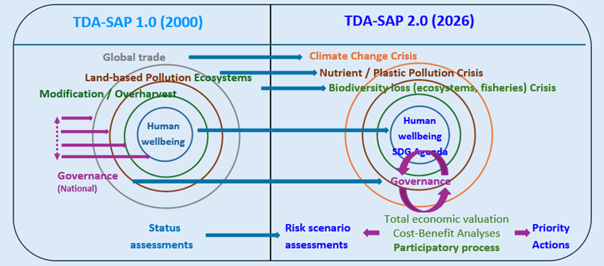
The TDA is a key component of the SAP for the marine and coastal environment of the South China Sea and Gulf of Thailand LMEs, serving as the scientific and technical foundation for identifying and understanding the root causes of environmental issues that transcend national borders. In contrast to the TDA-SAP Version 1.0 in 2000, which primarily focuses on status assessments, the TDA-SAP Version 2 for 2026 introduces a strategic shift toward forward-looking risk scenario assessments (Figure 1.1). This new version places greater emphasis on addressing the three (3) interlinked planetary crises namely climate change, nutrient and plastic pollution, and biodiversity loss. The revised framework aims to enhance the region’s resilience by integrating these global environmental challenges into transboundary diagnostic and strategic action planning. For the Philippines, ensuring the accuracy and completeness of its TDA inputs is essential to reflect local conditions, national priorities, and emerging environmental challenges within the broader regional context.
Figure 1.1. Composition of TDA-SAP 1.0 vs the updated 2026 TDA-SAP 2.0)

The participating countries of the region made a commitment and prepared the SAP. This commitment was further reinforced in 2016, when the six (6) countries in the region namely Cambodia, China, Indonesia, Philippines, Thailand and Vietnam signed a special Memorandum of Understanding (MoU), committing to cooperate with one another to implement the SAP. For the Philippines, the MoU was signed in 2016 by Atty. Jonas R. Leones, Undersecretary for Environment and International Environmental Affairs, for and on behalf of the then Secretary of the Department of Environment and Natural Resources, H.E. Ramon J.P. Paje.
This commitment provided a clear signal to the international community to support the financing of the SAP through various projects, including the project titled “Implementing the Strategic Action Programme for the South China Sea and Gulf of Thailand (SCS SAP Project).” Later on, the project was financed and adopted by the GEF on November 03, 2016 and was implemented by the UNEP. The United Nations Office for Project Services (UNOPS), on the other hand, executed the project in partnership with the Ministries responsible for the environment in Cambodia, China, Indonesia, Thailand, and Vietnam. Meanwhile, for the Philippines, the one currently undertaking the SCS-SAP project is the Society for the Conservation of Philippine Wetlands, Inc (SCPW). The SCPW signed the Grant Service Agreement with UNOPS in November 2024 and since then has embarked on mobilization and full implementation of the project. The project has recently secured security clearance from the National Task Force for the West Philippine Sea (NTF-WPS). In response, the Department of Environment and Natural Resources (DENR) has issued a memorandum directing its concerned offices to extend support to the project’s overall objective. That is, to assist the governments of the participating countries in meeting the targets of the approved SAP 2008 through the provision of technical assistance as required in implementing national activities in support of the SAP; and the provision of strong regional co-ordination of the process of the SAP implementation for the marine and coastal environments of the SCS and Gulf of Thailand (GOT).
The Project Team was formed composed of consultants and technical staff with extensive and strong backgrounds on ecosystem management. The team frequently met online and in-person and gathered, reviewed and discussed various environmental reports focusing on the above-cited fields. They agreed to incorporate additional information on pollution hotspots, sensitive habitats, and some national frameworks and international initiatives that address governance.
Each consultant is tasked to lead the assessment and drafting of specific components of the Philippine TDA Report. These components include (i) Socio-economics and Climate, covering demographic trends, economic drivers and activities, and climate- and environment-related threats; (ii) Pollution, focusing on pollution sources and magnitude, nutrient loading, plastic waste, and other land-based transboundary pollution issues affecting the South China Sea; (iii) Ecosystems, which is subdivided into Coastal Wetlands, Coral Reefs, Seagrasses, and Mangroves, addressing biodiversity hotspots and sensitive areas, endemic, endangered, and threatened species, conservation priorities, as well as the valuation of economic losses; (iv) Fish, fisheries and aquaculture, concentrating on fisheries and ecosystem health indicators, including its management and conservation efforts; and (v) Governance, that explores economic and policy drivers, institutional setting and frameworks, legal and policy setting, and governance performance and effectiveness. Accordingly, each consultant is responsible for their assigned component, integrating scientific considerations, which were harmonized into the consolidated National TDA for submission to the regional process.
Through this coordinated approach, the Project Team ensures that all thematic areas are comprehensively addressed given available data, establishing a cohesive and evidence-based Philippine TDA Report that reflects both national priorities and the shared vision for the sustainable management of the LMEs in the SCS and GOT LMEs.

1.1.2 Analysis to Help National Reporting to SDG and other National Commitments
While the emphasis of this project is on supporting the participating countries to meet the targets of the SCS SAP, which must be considered globally significant, the project has also envisioned to contribute to the attainment of the global targets such as the Sustainable Development Goals (SDG), Agenda 2030 and the targets established by the Convention on Biological Diversity (CBD) under the Kunming-Montreal Global Biodiversity Framework (KMGBF). It is noted that alignment of SAP actions with CBD targets was a key consideration in SAP formulation. After all, the design of the results framework for the SAP project focuses as well in aligning outcomes with the KMGBF.
Importantly, the project seeks to contribute towards the achievement of the Sustainable Development Goals: 1, 6, 12, 13, 14, and 15.
Recognizing the urgency of achieving these goals given the identified threats, the countries bordering the SCS requested the assistance of the United Nations Environment Program (UNEP) and the Global Environment Facility (GEF) to prepare a Transboundary Diagnostic Analysis (TDA) as the scientific basis for a Strategic Action Program (SAP). The first regional TDA-SAP cycle culminated in the intergovernmental adoption of the SAP in 2008, setting objectives and priority actions to:
- Conserve and restore critical coastal habitats
- Manage land-based sources of pollution, and
- Reduce the over-exploitation of fish stocks.
In contrast to the TDA-SAP Version 1.0 finalized in 2000, which largely concentrated on status assessments of coastal and marine resources, the forthcoming TDA-SAP Version 2 (2026) represents a strategic evolution. It introduces forward-looking risk scenario assessments (Figure 1) that allow countries to anticipate and prepare for emerging threats rather than only responding to current conditions. This second version highlights the need to confront the three interlinked planetary crises—climate change, nutrient and plastic pollution, and biodiversity loss—by embedding these global challenges directly into transboundary diagnostic and strategic action planning. For the Philippines, this means ensuring that its national TDA inputs are both accurate and comprehensive, so that local realities, national priorities, and evolving environmental issues are effectively reflected within the broader regional framework.
Overall, efforts will be made to align the agreed reporting systems with national reporting requirements to various international conventions and processes.

1.2 Major Water Related Environmental Problems
The Philippine coastal waters in the SCS-LME face multiple pressures that threaten the integrity of marine and coastal ecosystems. Land-based pollution, including nutrient loading, plastic waste, and other transboundary contaminants, degrades water quality and leads to eutrophication, which negatively affects seagrass beds and wetlands through smothering and reduced light penetration (Orth et al., 2006; Short et al., 2011). Coral reefs also suffer from sedimentation and nutrient enrichment, which encourage algal overgrowth and weaken reef resilience (Fabricius, 2005; Hughes et al., 2017).
Climate change and rising sea surface temperatures intensify these impacts. Warmer waters trigger coral bleaching and harmful algal blooms (HAB) when combined with nutrient loading (Hoegh-Guldberg et al., 2007; Peñaflor et al., 2009), while also reducing seagrass productivity and causing large-scale die-offs (Waycott et al., 2009). Mangroves are increasingly vulnerable to sea-level rise, saltwater intrusion, and coastal erosion (Alongi, 2015; Primavera et al., 2019), while wetlands face shifts in salinity that threaten their ecological functions (Finlayson et al., 2017). Ocean acidification further weakens coral skeletons and limits the growth of calcifying organisms, thereby diminishing reef structures that provide habitat for fish (Kleypas et al., 2006; Kroeker et al., 2013). Seagrasses are also affected, as changes in carbonate chemistry alter their productivity and associated biodiversity (Campbell & Fourqurean, 2014).
Extreme weather events such as stronger typhoons cause direct physical damage across ecosystems—breaking coral branches, uprooting seagrass meadows, eroding mangrove shorelines, and flooding wetlands (Villanoy & Yñiguez, 2024; Licuanan et al., 2019). Meanwhile, other natural hazards such as earthquakes and tsunamis destabilize seabeds, trigger submarine landslides, and generate powerful waves that can bury reefs and seagrass beds, displace marine life, and alter coastal landscapes (Satake, 2015; Imamura, 2018).

1.3 Biogeophysical Setting

1.3.1 Geomorphology and Geological History
The geomorphology of the Philippine Seas in SCS-LME is shaped by its tectonic and oceanographic setting within the Philippine archipelago, which comprises about 40% of the country’s Exclusive Economic Zone (EEZ) (VLIZ 2022, 2023; PD 1596, 1978; NGA 2004 as cited in Villanoy & Yñiguez, 2024). It features continental shelves, deep basins, reefs, and atolls—particularly around the Kalayaan Island Group (KIG) and western Palawan—formed through tectonic processes, reef accretion, and sedimentation. The Philippine Seas in SCS-LME evolved through seafloor spreading that began around 55–50 Ma and ceased by ~30 Ma, leaving behind extinct spreading centers such as the Central Basin Spreading Center and crustal features like the Benham and Gagua Rises (Taylor & Hayes 1980; Deschamps & Lallemand 2002; Li et al. 2021). Its semi-enclosed setting drives counterclockwise circulation that redistributes sediments and nutrients, while subduction and tectonic reorientations continue to shape its margins (Villanoy & Yñiguez, 2024). Seasonal monsoons and increasing typhoon frequency further influence erosion, sediment transport, and productivity, illustrating the dynamic geological and geomorphological history of the Philippine Seas in SCS-LME (Villanoy & Yñiguez, 2024).

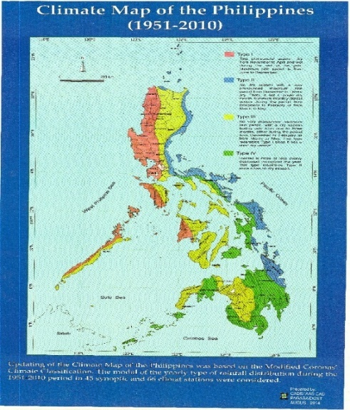
1.3.2 Climatology, Present and Projected
According to the Modified Coronas Classification System (MCCS) of PAGASA, Philippine climate can be classified into four (4) types (Figure 1.2). The Philippine western seaboard predominantly exhibits a Type 1 climate, characterized by distinct wet and dry seasons—dry period from November to April and wet season for the rest of the year, with peak rainfall from June to September.
The Department of Science and Technology – Philippine Council for Agriculture and Aquatic Resource and Research Development (PCAARRD) also provided a complimentary classification system of the Philippine climate (Figure 1.3) through the Remote Sensing Information for Living Environments and Nationwide Tools for Sentinel Ecosystems in our Archipelagic Seas Program for Climate Change (RESILIENT SEAS Program, 2009-2012). It divides the seas surrounding the Philippine archipelago into 11 distinct clusters (David, 2012), each characterized by climatic and oceanographic conditions resulting from complex land-sea interactions in the coasts (e.g., precipitation, sea surface temperature, sea surface height, etc.) (PEMSEA, 2019).
Figure 1.2. Modified Coronas Classification System (PAGASA)

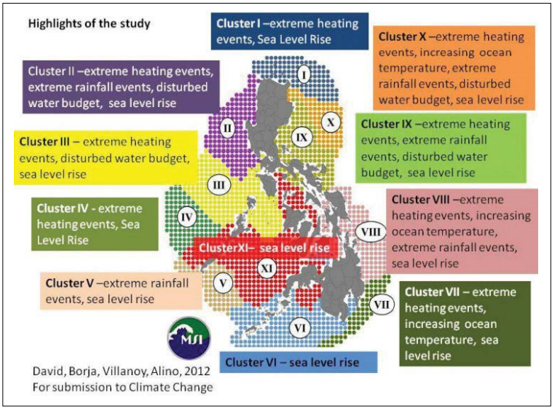
Figure 1.3. Climate Typologies in the Philippines (David, 2012 as cited by PEMSEA in the National State of the Coasts, 2019)
The country also experiences two (2) main monsoons: the stronger and more consistent northeast monsoon (amihan) which occurs from November to March, and the comparatively weaker and less predictable southwest monsoon (habagat) which prevails from June to September (Villanoy & Yñiguez, 2024). While the Type 1 climate is heavily influenced by the habagat (Villarin et. al., 2016) the strong winds and cooler temperature associated with the amihan plays a significant role in enhancing primary productivity in the Philippine waters facing the SCS-LME. This is driven by wind jets funneled through the straits within the archipelago, generating localized upwelling zones—particularly along the west coast of Palawan—which may further enhance water column productivity (Villanoy & Yñiguez, 2024).
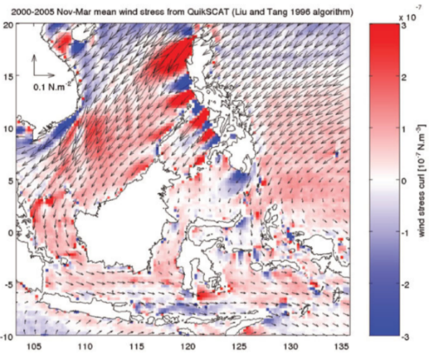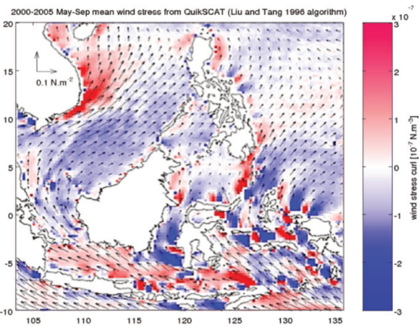
Figure 1.4. Wind Stress and Wind Stress Curl during Amihan (left) and Habagat (right) seasons

Positive wind stress curl areas (winds turning to the left) are associated with upwelling, and negative wind stress curl (winds turning to the right) areas with downwelling (Villanoy & Yñiguez, 2024).
To support climate adaptation and mitigation planning, PAGASA developed baseline (1981-2020) and projected (2021-2050) climate data for temperature and rainfall. Climate projections under various scenarios were generated using models from Coupled Model Intercomparison Project (CMIP) of the World Research Programme (IPCC, 2013b as cited in Villarin et al., 2016).
Temperature
The last 30 years (1981-2020) show that increasing temperatures have been observed in most parts of the country while some areas particularly in western Ilocos Region, eastern portion of Rizal province, and southern islands of Luzon experienced a slight decrease in temperature. Using these baseline data, projections for surface area temperature show that the country will experience significantly warmer climate towards the end of 21st century (2021-2050), ranging from 2.6ºC up to 4.4ºC increase from the average temperature and was seen highest for the month of May (DOST-PAGASA, 2024).
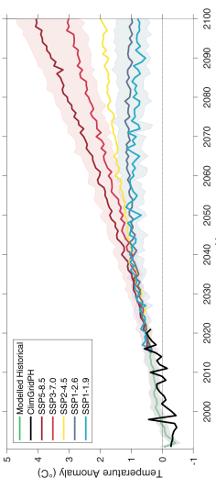
Figure 1.5. Time series of the annual mean temperature anomalies in the Philippines (DOST-PAGASA CMIP 6-BASED Climate Change Projections in the Philippines Report, 2024).
Rainfall
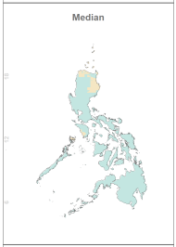
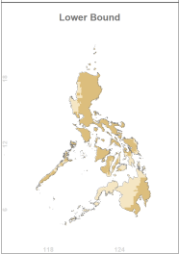
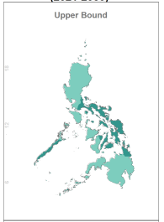
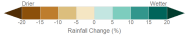
From the baseline period of 1981-2010, observed trend in rainfall revealed an increasing level in majority of the country particularly Luzon and Visayas. In December, increasing rainfall was observed in Luzon and Visayas and moves to Mindanao in January, coinciding with the northeast monsoon or amihan season. However, from July to October, western areas facing the SCS-LME experience heavy rainfalls due to the southwest monsoon or habagat season. Rainfall projections for 2021-2050 show a decrease in rainfall level in most parts of Luzon particularly from January to May but may experience about 5-10% increase in rainfall from June to December (except for the southern portions of Luzon and most parts of Visayas in August, and most parts of Visayas and Mindanao in September, where a potential decrease in rainfall is projected (DOST-PAGASA, 2024).
Figure 1.6. Range of projected changes in annual rainfall over the Philippines for 2021-2050 using baseline period 1981-2020 (DOST PAGASA CMIP 6-BASED Climate Change Projections in the Philippines Report, 2024).

The varying climatic conditions exert considerable impacts on the marine ecosystems. During wet seasons in June to September, increased precipitation contributes to greater surface runoff, leading to elevated nutrient loading, sedimentation, and coastal pollution (Gomez et al., 2016). Seagrass beds, which support nurseries for fish species and other invertebrates may be affected by sediment loading (Fortes, 2018). Surface run-off increases organic matter in the marine ecosystems leading to hypoxic conditions in coastal waters (Zhang, 2022). Meanwhile, the dry and hot seasons usually from March to May is associated with rising sea surface temperature (SST) which can trigger coral bleaching events (Licuanan et al., 2019). Elevated SST and ocean acidification also reduces calcification rates of corals, further threatening reef resilience (Fabricius et al., 2011). Moreover, climate-driven changes in temperature, salinity, and nutrient availability influence fish spawning cycles and migration patterns, ultimately affecting fisheries productivity (Barut et al., 2004).
Due to its geographical location, the Philippines is also highly susceptible to tropical cyclones (PAGASA, n.d.). Approximately 19 to 20 tropical cyclones enter the Philippine Area of Responsibility (PAR) per year (Cayanan et al., 2011 as cited in Villarin et al., 2016). Intense typhoons can damage mangroves forests which are natural buffers against storm surges thereby compromising their ability to support vulnerable marine life (Primavera & Esteban, 2008).

1.3.3 Biogeography Endemic and Unique Marine Species
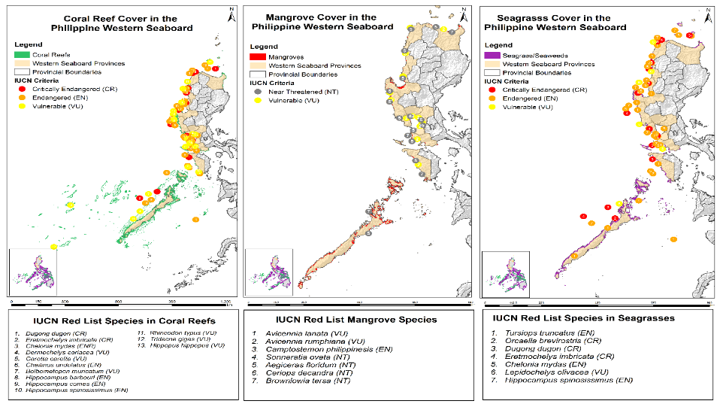
Figure 1.7. IUCN Red List Species of Endemic and Unique Marine Species in the Philippine Western Seaboard
The mangroves, seagrass and wetlands at Philippine waters at SCS-LME are home to a number of threatened mammals and reptiles species.

1.4 Assessment Methodology

1.4.1 Conceptual Framework
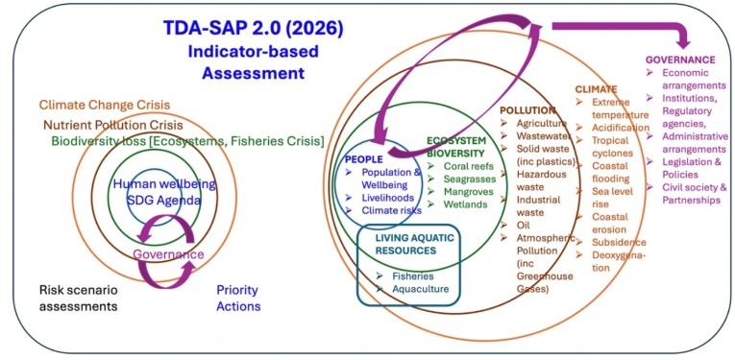
Figure 1.8. TDA-SAP 2.0 (2026) Indicator-based Assessment
The TDA SAP 2.0 (2026) is an indicator-based assessment. It is something that is metric and it indicates whether the status is good or bad. It also indicates whether the risk is high of low. In this TDA SAP 2.0, not everything is of metric indicator. In the case of governance, it also has qualitative descriptor of the state of governance relative to the major environmental issue. As shown in Figure 1.8, there are six components, namely:
- People
- Ecosystem Diversity: coral reefs, seagrasses, mangroves, and wetlands
- Pollution
- Fisheries or living aquatic resources
- Impact of climate which affects all of the components – the people and ecosystems
- Governance
The TDA SAP 2.0 intends to help governance informed not just on climate but the impact of climate on people and ecosystems and help governance be more attuned to the environmental crises that climate is imposing on people and ecosystems.

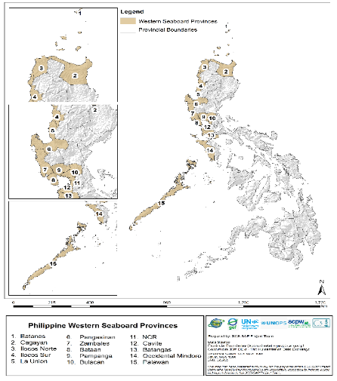
1.4.2 Subnational Geographic Divisions Used in the Analysis
This analysis uses provinces as the subnational geographic units, allowing localized variations to be captured and providing clearer insights for accurate interpretation and targeted recommendations.
Figure 1.9. depicts the political boundaries of the provinces along the Philippine western seaboard which face the SCS-LME, namely: Ilocos Norte, Ilocos Sur, La Union, and Pangasinan of Region I (Ilocos Region), Batanes and Cagayan of Region II (Cagayan Valley), Zambales, Bataan, Pampanga, and Bulacan of Region III (Central Luzon), the National Capital Region (NCR) which include 16 cities, Cavite and Batangas of Region IV-A (CALABARZON), and Occidental Mindoro and Palawan of Region IV-B (MIMAROPA). Understanding of the spatial dynamics and geopolitical considerations within the country facilitates a more comprehensive analysis of the socio-economic drivers, coastal and marine resource use, livelihoods, and governance frameworks relevant to the SCS-LME.
Figure 1.9. Political Boundaries of the Philippine Western Seaboard Provinces

1.4.3 List of Indicators by Components
Tables 1.1-1.5 below present only the indicators up to the second level. For the complete list of indicators per component, please refer to Annex 1.A.
- Socioeconomics and Climate-related Threats – Assesses the vulnerability of coastal communities and livelihoods to socioeconomic pressures and climate change impacts
Table 1.1. List of Indicators for Socio-Economic and Climate
Socio-Economics and Climate Indicators | Components
Demographics
SE1-1. Subnational Population | Number of Female Households
SE1-1. Subnational Population | Number of Male Households
SE1-1. Subnational Population | Total Households
SE1-1. Subnational Population | Total Population
SE1-1. Subnational Population | Growth Rate
SE1-2. Areas of Subnational First Level Administrative Region | Total Land Area (sq km)
SE1-3. Subnational Populations as % of National Population | % to Philippine Population
SE1-4. Subnational Region Areas as % of National Area | % to Philippines' Total Land Area (sq km)
SE1-5. Annual Population Changes | % Annual Change in the Population
SE1-6. Population Densities | Population Density (people/ sq km)
SE1-10 Urbanization Rate
SE1-11 Built Up Surface | Total Floor Area of Construction (sq km)
Human Well-Being
SE2.1 Poverty | Poverty Incidence Among Families (%)
SE2.2 Contemporary Human Development Index (HDI) | Level of Literacy (Illiterate, Low Literate, Basic Literate)
 | HDI Value and Classification

- Pollution – Evaluates the sources, levels, and effects of land- and sea-based pollution on coastal and marine environments
Table 1.2. List of indicators for Pollution
Pollution Category | Parameter | Indicator
P-1. Marine and coastal water quality | PO1-1. Nutrient Pollution  PO1-2. Organic Pollution  PO1-3. Coliform  PO1-4. Heavy Metals  PO1-5. Water Quality  PO1-6. Contaminants of Emerging PO1-7. Concerns (CEC) | Nitrate, Phosphate, Ammonia  BOD, DO  Fecal, Total Coliform  Cadmium, Chromium, Lead, Mercury  TSS  Microplastics
P-2. Aquaculture / mariculture pollution | PO2-1. Fish Kill Events  PO2-2. Shellfish Advisories | Harmful Algal Blooms (HABs)

- Ecosystems – Examines the status, trends, and resilience of critical marine and coastal ecosystems and their services.
Table 1.3. List of Indicators for Ecosystems
Properties and Variables | Data & Information needed
Mangroves And Wetlands
MW-1.1 Geographic information
MW-1.1. Name of area | Name of locality (coastal areas, estuaries, lagoon, …)
MW-1.2. Co-ordinates | Latitude & Longitude central position of areas <50 Ha; GPS Boundary or number (min 4) of paired co-ordinates for larger areas; end points for linear strips.
MW-1.3. Total area | (Units Km² or Ha)
MW-1.4. Areas of mangrove forest | (Units Km² or Ha)
MW-1.5. Area of tidal flats | (Units Km² or Ha)
MW-1.6. Area of seagrass beds | (Units Km² or Ha)
MW-2. Social & use information
MW-2.1. Ownership | Description: Federal, State, Community, private
MW-2.2. Management regime | Description: Land-use planning, Institutional framework, stakeholder co-ordination, forestry practices, restoration replanting, stakeholder investment, fishery practices.
MW-2.3. Current use | Description: Commercial, subsistence
MW-2.4. Potential use | Alternative livelihoods
MW-2.5. Significance/ national importance | Use designation in national/state master plans
MW-2.6. Protection status | Protection category (MPA, National Park…), total area, mangrove area, tidal flats area, seagrass area in hectare,
Coral Reefs And Seagrasses
CS-1. Geographic Information
CS-1.1. Name of area | Name of locality (islands, bay…)
CS-1.2. Co-ordinates | Latitude & Longitude central position of areas, GPS Boundary or number (min 4) of paired co-ordinates for larger areas; end points for linear strips.
CS-1.3. Area of coral reefs | Units Km2 or Ha
CS-1.4. Area of seagrass beds | Units Km2 or Ha
CS-1.5. Reef type | Fringing (mainland & island), barrier, atoll, patch, other
CS-2. Environmental state information
CS-2.1. Present status | Live coral cover, dead coral cover, algae, abiotic (%)
CS-2.1. Present status | Seagrass cover (%)
CS-2.2. Present threats | - Sedimentation
CS-2.2. Present threats | - Destructive fishing (no. of cases, both bombing & poisoning, reported per year
CS-2.2. Present threats | - Pollution (no. population & distance to the sources of pollutants)
CS-2.2. Present threats | - Crown of Thorns (COT), years, infestation (density of COT, no. of cases, and infested areas)
CS-2.2. Present threats | - Bleaching (2010, 2014-2017, 2019, 2024, others (% bleaching of live coral, % of mortality)
CS-2.2. Present threats | - Others
CS-2.3. Trends of change | Increase or decrease of live coral cover and/or seagrass cover & density
CS-2.4. Future threats | Development plan & distance to the coral reef and/or seagrass area

- Fish, Fisheries, and Aquaculture – Monitors the sustainability, productivity, and impacts of wild fisheries and aquaculture practices.
Table 1.4. List of Indicators for Fisheries
Indicator/Parameter | Units
FS-1. Annual Catch | Metric Tons
FS-2. Catch Value | USD

- Governance – Reviews the effectiveness of policies, institutions, and cooperative mechanisms in managing marine and coastal resources.
Table 1.5. List of Indicators for Governance
Indicators | Components
GO-1. Economic Arrangements | GO-1.1. Political and Economic Drivers
GO-1. Economic Arrangements | GO-1.2. National Budgetary Allocations
GO-1. Economic Arrangements | GO-1.3. Investments (National, International)
GO-1. Economic Arrangements | GO-1.4. Provincial Investment Profile
GO-1. Economic Arrangements | GO-1.5. Sustainable Financing Initiatives
GO-2. Institutional Setting | GO-2.1. Institutions, Regulatory Agencies, and Administrative Arrangements

1.4.4 Assessing Risks to Ecosystems, People and Livelihoods, including those that are Related to Climate Warming, as Bases for Integrated Governance
The Philippine waters within the SCS-LME are subject to an increasing convergence of environment and socio-economic risks, both localized and transboundary in nature. Key drivers such as pollution, habitat degradation, and overfishing (cited in Chapter 7.3 of this report) collectively undermine the ecological integrity and sustainability of marine and coastal resources in the country. These stressors are further magnified by climate change impacts of rising sea surface temperatures (SST), ocean acidification (Fabricius et al., 2011), and sea level rise. Collectively, this worsens existing vulnerabilities and introduces new systemic risks to ecosystems, communities, and marine-dependent livelihoods (UNEP, 2019; PEMSEA, 2018). A comprehensive assessment of such interconnected risks is crucial for integrated and evidence-based governance frameworks for the country’s marine and coastal ecosystems.
Ecosystems
Critical coastal ecosystems such as mangroves, seagrass beds, coral reefs, and wetlands provide essential ecosystem services including shoreline protection, fish nursery functions, water filtration, and carbon sequestration (McLeod et al., 2010; Barbier et al., 2011). These services play a crucial role in enhancing climate resiliency and adaptive capacity especially of coastal communities. However, the continued degradation of these ecosystems, driven primarily by anthropogenic pressures including land and water use change, reclamation, destructive practices, and pollution (cited in Chapter 7.3 of this report), poses significant threat to their functionality.
Furthermore, climate-induced stressors such as ocean warming, coral bleaching, and sea-level rise add to these existing pressures leading to substantial decline in habitat suitability and driving shifts in species distribution (Hughes et al., 2017). In this assessment, key areas such as Manila Bay, Lingayen Gulf, Batangas Bay and the Verde Island Passage, and Palawan have been identified as critical ecosystem hotspots where high biodiversity overlaps with commercial, industrial and tourism-driven pressures (Licuanan et al, 2019; cited in Chapters 3 and 4 of this report) raising both their risk and biodiversity significance and further highlighting the need for integrated management strategies.
Socio-Economic and Climate Vulnerabilities
Densely populated urban areas particularly Metro Manila in the National Capital Region (NCR) and adjacent provinces exhibit the highest exposure to climate-induced hazards such as flooding, storm surge, and sea level rise (ADB, 2021; cited in Chapter 2 of this report). These areas are also burdened by significant socio-economic and infrastructural vulnerabilities i.e., lack of disaster-resilient and climate-adaptive structures, pollution overload, and encroachment of informal settlement families (ISF) in hazard-prone areas which cumulatively increase their vulnerability to adverse climate-related events (World Bank, 2022).
On the other hand, while remote provinces such as Batanes are less exposed to hazards, their limited adaptive capacities—measured by lower incomes, high poverty indices, limited technology and infrastructure, and insufficient policy and institutional mechanisms—directly contribute to their increased vulnerabilities and overall risk (Yusuf & Francisco, 2009). Both scenarios, although contrasting, underpin the role of climate warming as a “risk amplifier”—intensifying the frequency and magnitude of extreme weather events and disproportionately affecting the marginalized and vulnerable sectors (IPCC, 2023).
Livelihood Risk
Fisheries in the Philippines remain to be a primary livelihood particularly in small-scale coastal communities. However, the sector continues to suffer from overfishing, habitat loss, and illegal, unreported, and unregulated (IUU) fishing (cited in Chapter 5 of this report) particularly in Fisheries Management Areas 5 (Palawan and Occidental Mindoro) and 6 (Ilocos Norte, Ilocos Sur, La Union, Pangasinan, Bataan, Bulacan, Pampanga, Zambales, Batangas, Cavite, Occidental Mindoro) in this assessment. Degradation of mangroves, coral reefs, and fish spawning grounds directly affects fish productivity in addition to ocean warming which alters migration patterns and composition of fish species (DA-BFAR, 2020; Barange et al., 2018).
Without effective adaptive management, climate change will seriously threaten food security and livelihood stability of marine-dependent households. Therefore, climate change adaptation must be mainstreamed into policy measures, ensuring that these efforts complement and reinforce existing governance systems for sustainable fisheries and coastal resource use (Barange et al., 2018).
Risk-Based Integrated Governance
Globally pressing environmental challenges stem from complex socio-economic systems that transcend political, institutional, and governance areas. The fragmented structure of our existing governance frameworks is poorly equipped to manage cross-cutting issues, resulting in overlapping risks both at local and regional scales (PEMSEA, 2019; UNEP, 2019).
Hence, addressing the complex and interconnected nature of our country’s social, economic, and environmental problems require systemic reform of institutional mechanisms. Governance frameworks must be data-driven, multi-level—linking local and national actions—and cross-sectoral, incorporating socio-economic dimensions with the three (3) interlinked planetary crises of climate change, nutrient and plastic pollution, and biodiversity loss (United Nations Framework Convention on Climate Change, n.d.). Furthermore, our governance frameworks should also adopt risk-based approaches that recognize the interaction between these drivers and the intensifying impacts of climate change. Such transformation is critical for minimizing socio-economic vulnerabilities and reducing ecological stress in our marine ecosystems (Raworth 2012; O’Neill et al. 2018 as cited in GEO-6 by UNEP, 2019; PEMSEA, 2019).

Chapter 1 References
Barut, N.C. & Santos, Mudjekeewis & Garces, L.R.. (1997). Overview of Philippine marine fisheries. https://www.researchgate.net/publication/285675177
Deschamps, A., & Lallemand, S. (2002). The West Philippine Basin: An Eocene to early Oligocene back arc basin opened between two opposed subduction zones. Journal of Geophysical Research: Solid Earth, 107(B12), 2322. https://doi.org/10.1029/2001JB001706
DOST-PAGASA, 2024. CMIP6-Based Climate Change Projections in the Philippines. Department of Science and Technology-Philippine Atmospheric, Geophysical and Astronomical Services Administration, Quezon City, Philippines.
Fabricius, K., Langdon, C., Uthicke, S. et al. Losers and winners in coral reefs acclimatized to elevated carbon dioxide concentrations. Nature Clim Change 1, 165–169 (2011). https://doi.org/10.1038/nclimate1122
Fortes, Miguel. (2018). Seagrass ecosystem conservation in Southeast Asia needs to link science to policy and practice. Ocean & Coastal Management. 159. 51-56. https://doi.org/10.1016/j.ocecoaman.2018.01.028
Hall, R. (1995). Plate tectonic reconstructions of the Indonesian region. Tectonophysics, 251(1–4), 1–4. https://doi.org/10.1016/0040-1951(95)00038-0
IODP Expedition 349 Scientists. (2014). South China Sea tectonics: Opening of the South China Sea and its implications for Southeast Asian tectonics, climates, and deep mantle processes. Proceedings of the Integrated Ocean Drilling Program, 349. International Ocean Discovery Program. https://doi.org/10.2204/iodp.proc.349.101.2014
Licuanan WY, Robles R, Reyes M. Status and recent trends in coral reefs of the Philippines. Mar Pollut Bull. 2019 May;142:544-550. DOI: 10.1016/j.marpolbul.2019.04.013. Epub 2019 Apr 10. PMID: 31232337.
Liu, K.-K., Chao, S.-Y., Shaw, P.-T., Gong, G.-C., Chen, C.-C., & Tang, T. Y. (2008). Monsoon-forced chlorophyll distribution and primary production in the South China Sea: Observations and a numerical study. Deep Sea Research Part I: Oceanographic Research Papers, 49(, 1387–1412. https://doi.org/10.1016/S0967-0637(02)00035-3
Marine Regions / VLIZ. (2023). Philippine Exclusive Economic Zone (EEZ). Flanders Marine Institute. https://www.marineregions.org/gazetteer.php?id=8322&p=details
PEMSEA and Department of Environment and Natural Resources (Philippines). (2019). National State of Oceans and Coasts 2018: Blue Economy Growth of the Philippines. Partnerships in Environmental Management for the Seas of East Asia (PEMSEA), Quezon City, Philippines. 376 p. https://www.pemsea.org/resources/publications/reports/nsoc-philippines
Primavera, Jurgenne & Esteban, J.. (2008). A review of mangrove rehabilitation in the Philippines: Successes, failures and future prospects. Wetlands Ecology and Management. 16. 345-358. DOI:10.1007/s11273-008-9101-y
Seno, T. (1984). Paleogeographic reconstruction and origin of the Philippine Sea. Tectonophysics, 102(1–4), 53–84. https://doi.org/10.1016/0040-1951(84)90008-8
Taylor, B., & Hayes, D. E. (1983). Origin and history of the South China Sea Basin. In D. E. Hayes (Ed.), The tectonic and geologic evolution of Southeast Asian seas and islands: Part 2 (Vol. 27, pp. 23–56). American Geophysical Union. https://doi.org/10.1029/GM027p0023
Villarin, J. T., Algo, J. L., Cinco, T. A., Cruz, F. T., de Guzman, R. G., Hilario, F. D., Narisma, G. T., Ortiz, A. M., Siringan, F. P., Tibig, L. V. (2016). 2016 Philippine Climate Change Assessment (PhilCCA): The Physical Science Basis. The Oscar M. Lopez Center for Climate Change Adaptation and Disaster Risk Management Foundation Inc. and Climate Change Commission. https://climate.gov.ph/files/PhilCCA-WG1.pdf
Villanoy, C. L., & Yñiguez, A. T. (2024). Oceanography and connectivity. In H. O. Arceo, M. J. P. Velos, M. A. C. Nuñez, & P. M. Aliño (Eds.), The West Philippine Sea: State of the Coasts (pp. 26–34). University of the Philippines Marine Science Institute.
Zhang, W., 2022. Unexpected high indirect impacts of riverine organic matter to coastal deoxygenation. Water Res. 225, 119180 https://doi.org/10.1016/j. watres.2022.119180

Chapter 1 Annexes

Annex 1.A. List of Indicators by Component
Annex 1A.1. List of Indicators for Socio-Economic and Climate (Continuation)
Socio-Economics and Climate Indicators | Components
Blue Economy
SE3.1. Subnational Regional GDP by Economic Sector (Agriculture, Manufacturing, Services) | Agriculture, Forestry, and Fisheries Value Added at Current Price
Manufacturing Value Added at Current Price:
- Manufacturing
- Mining and Quarrying
- Electricity, Steam, Water, and Waste Management
- Construction
Services Value Added at Current Price
- Wholesale and Retail Trade, Repair of Motor Vehicles and Motorcycles
- Transportation and Storage
- Accommodation and Food Service Activities
- Information and Communication
- Financial and Insurance Activities
- Real Estate and Ownership of Dwellings
- Professional and Business Services
- Public Administration & Defense and Compulsory Social Activities
- Education
- Human Health and Social Work Activities
- Other Services
Climate-Related Threats
SE4-1. Number of Tropical Cyclones and Typhoons
SE4-2. Number of Deaths Because of Tropical Cyclones and Typhoons
SE4-3 Possible Total Damage Due to Hazards and Disasters (Exposed Population, Exposed Capital in USD) | Storm Surge
 | - Typhoon Winds
 | - Tsunami
 | - Flooding
 | - Landslide
 | - Earthquake
 | - Liquefaction
 | - Volcanic Eruption
 | - Wildfire
 | - Drought
 | - Other risks (epidemics, conflicts, etc)
Table 1.A.2. List of indicators for Pollution (Continuation)
Pollution Category | Parameter | Indicator
P-3. Wastewater and industrial | PO3-1. Wastewater  PO3-2. Treatment Facility  PO3-3. Pollution Load | Generated, Collected and Treated  Nitrate, Phosphate, BOD, COD, TSS, Fecal Coliform
P-4. Agricultural runoff | PO4-1. Fertilizer Use  PO4-2. Pesticide Use  PO4-3. Nutrient Load | N, P, K Fertilizer  Nitrate, Phosphorus
P-5. Solid waste | PO5-1. Projected Generation  PO5-2. Disposal Facilities  PO5-3. Top Plastic-Emitting Rivers in the Philippines | Illegal Dumps, Sanitary Landfill, MRFs
P-6. Hazardous waste | PO6-1. Hazardous Waste  PO6-2. Types of Hazardous Waste  PO6-3. Treatment Facility | Generated, Collected and Treated  Waste with Cyanide, Acid Wastes, Alkali Wastes, Waste with Inorganic Chemicals, Reactive Chemical Wastes, Inks/Dyes/Pigments/  Paint/Latex/Adhesives/  Organic Sludge, Waste Organic Solvent, Organic Wastes, Oil, Containers, Immobilized/Stabilized Wastes, Organic Chemicals, Miscellaneous Wastes
P-7. Oil pollution | PO7-1. Oil Spill | Major Incidents, Volume
P-8. Atmospheric pollution | PO8-1. Wet Deposition  PO8-2. Dry Deposition | Sulfate, Nitrate  Sulfate (Particulate-bound), Nitrate (Particulate-bound)
Table 1.A.3. List of indicators for Ecosystems (Continuation)
Properties and Variables | Data & Information needed
Mangroves And Wetlands
MW-3. Biological data
MW-3.1. Present status | Vegetation Canopy Cover, Seagrass cover (% area)
MW-3.2. Natural/Managed | Proportions of total area natural and replanted
MW-3.3. Mangrove diversity | (True) Mangrove tree species Density (no ha⁻¹)
MW-3.4. Seagrass diversity | Number of Seagrass species
MW-3.5. Migrating species | Species of mammals, birds
MW-3.6. SCS Endemic species | List species and abundance
MW-3.7. Endangered or threatened species (IUCN criteria) | List species and abundance if data available
MW-3.8. Source & sink of larvae | Location & types (breeding/nursery grounds of fishery species), density of larvae
MW-4. Stress-pressure information
MW-4.1. Intrinsic/internal sources of change | - Resident human population
MW-4.1. Intrinsic/internal sources of change | - Natural e.g. frequency of typhoon throws, change in allochthonous sediment inputs, marine based flooding, erosion
MW-4.2. Extrinsic/external sources of change | Changes in catchment basin e.g. dam construction, water diversion etc.
MW-4.3. Rates of change, historical review | Rates of loss of cover and/or species over the period 2010-2024
MW-4.4. Social and economic drivers of change in environmental state | Description, quantitatively, if possible, e.g. population growth, immigration, income/livelihood, demand/ consumption, management regime)
MW-5. Economic valuation (based on Barbier, E.B. 1997)
MW-5.1. Values of direct use | Timber, charcoal, living marine resource extraction
MW-5.2. Values of indirect use | Carbon sequestration, ecotourism, nursery areas for shrimps
MW-5.3. Values from environmental services | Coastal protection, sediment stabilization, water quality enhancement, contaminant sink, reduction of wave energy & erosion
MW-5.4. Value of investment | Restoration, replanting
MW-5.5. Values of potential (commercial) sustainable use
MW-5.6. Total Economic Value | Local currency total (year?)
Coral Reefs And Seagrasses
CS-3. Social & use information
CS-3.1. Ownership | Description: Federal, State, Community, private, common property
CS-3.2. Management regime | Description: Land-use planning and coastal zoning, Institutional framework, stakeholder co-ordination, restoration, stakeholder investment, fishery practices
CS-3.3. Current use | Description: Commercial, subsistence, fishing ground, tourism and/or MPA
CS-3.4. Traditional use | Description of
CS-3.5. Potential use | Tourism and MPA (sustainable use)
CS-3.6. Significance/national importance | Use designation in national/state master plans
CS-3.7. Protection status | Protection category (MPA, National Park…), total area, coral reef area, seagrass area in hectare
CS-4. Biological data
CS-4.1. Species diversity | - No. of species and coverage of hard corals
CS-4.1. Species diversity | - No. of species and coverage of soft corals
CS-4.1. Species diversity | - No. of species and coverage of seagrasses
CS-4.2. SCS Endemic species | List species and abundance
CS-4.3. Endangered or threatened species (IUCN criteria) | List species and abundance
CS-4.4. Source & sink of larvae | Location & types (breeding/nursery grounds of fishery species), density of larvae
CS-4.5. Migratory species | List species and abundance
CS-5. Economic valuation (based on Barbier, E.B. 1997)
CS-5.1. Extractive | Reef related fish landing (mt/$$)
CS-5.1. Extractive | Subsistence fishery (no. of fishers dependent on reef – mt/$)
CS-5.1. Extractive | Commercially (live fish and fish landing – mt/$)
CS-5.2. Non extractive (tourism) | No. of visitors. ($ generated)
CS-5.2. Non extractive (tourism) | No. of people involved in industry (income generated) – no. of chalets/hotels operators - no. ferry/boats operator - no. guide/agents
CS-5.2. Non extractive (tourism) | Environment services
CS-5.2. Non extractive (tourism) | Education
CS-5.2. Non extractive (tourism) | Others
CS-5.3. Total Economic Value | Local currency total (year)
Table 1.A.4. List of indicators for Fisheries (Continuation)
Indicator/Parameter | Units
FS-3. Species Population Size | Number of Individuals
FS-4. Biomass | Kg/km² (Tons/area)
FS-5. Stock Status Plots | %
FS-6. Fishing Effort | Number of Vessels or Hours Fished
FS-7. Catch per unit effort (CPUEs) | Kg per hour of trawling
FS-7. Catch per unit effort (CPUEs) | Kg/ 1000 hooks of Long Line
FS-8. Subsidies | USD or local currency
FS-9. Primary Production Required (PPR) | mgC·day⁻¹·m⁻²
FS-10. Marine Trophic Index | Level 1 - 5
FS-11. Fishing-in-Balance Index (FIB) | = 0; = More than 0; = Less than 0
FS-12. Catch from Bottom Impacting Gear | Percentage (%)
FS-13. Change in Catch Potential under environmental temperature change | Percentage (%)
FS-14. Aquaculture Products | Metric Tons
FS-15. Aquaculture values | USD
Table 1.A.5. List of indicators for Governance (Continuation)
Indicators | Components
GO-3. Legislation and Policies | GO-3.1. International Legal/Policy Frameworks & Forums  - United Nations Convention on the Law of The Sea (UNCLOS)  - Fisheries Related Instruments  - Biodiversity Related Instruments  - Pollution Related Instruments  - Climate Change Related Instruments
GO-3. Legislation and Policies | GO-3.2. Regional Legal/Policy Frameworks & Forums
GO-3. Legislation and Policies | GO-3.3. National and Subnational Legislation and Policies
GO-3. Legislation and Policies | GO-3.4. Current Development Plans, Policies
GO-4. Civil Society, Stakeholders and Partnerships | GO-4.1. Key NGOs and Special Interest Groups
GO-4. Civil Society, Stakeholders and Partnerships | GO-4.2. Trade Associations and Business Groups
GO-4. Civil Society, Stakeholders and Partnerships | GO-4.3. Co-Management, Traditional Systems and Customary Rights
GO-4. Civil Society, Stakeholders and Partnerships | GO-4.4. Decentralized Governance, Coastal Governance (Formal, Informal)

