Socioeconomics and Climate-Related Threats in the Philippine Seas in the South China Sea Large Marine Ecosystem
Casper Boongaling Agaton^{1,*}, Mary Joy J. Ancheta²
¹Department of Community and Environmental Resource Planning, College of Human Ecology, University of the Philippines Los Baños, Los Baños 4031, Laguna, Philippines
²Society for the Conservation of Philippine Wetlands, Inc. (SCPW), Unit 208 Grand Emerald Tower, F. Ortigas, Jr. cor. Garnet St., Ortigas Center, Pasig, 1605 Metro Manila
*corresponding author: cbagaton@up.edu.ph
Abstract
The South China Sea Large Marine Ecosystem (SCS-LME) is a biologically diverse tropical marine area that is vital to the surrounding coastal countries due to its high biodiversity and significant role in global fisheries, providing essential food security and economic benefits. However, these benefits are greatly affected by sociodemographic and environment-related threats contributing to the Triple Planetary Crisis: climate change, pollution, and biodiversity loss. This chapter presents the current status of the demographics, human well-being, blue economy, and climate-related risks in the Philippine Seas in the SCS-LME. Using provincial data as a sub-national unit, this chapter analyzes these indicators focusing on the coastal provinces along the SCS-LME. Results found that the National Capital Region (NCR) has the highest population density at 21.7 thousand/sqm, followed by surrounding provinces, which provide better access to basic goods and services and more social and economic opportunities, reflecting a high human development index (HDI). While HDI trends are increasing from 2006-2019 across different localities, high poverty incident rates are observed in island provinces, such as Occidental Mindoro and Palawan, along with areas far from NCR like Pangasinan and Zambales. In terms of the blue economy, most of the industries and services are centered in these areas while food production particularly, agriculture, forestry, and fisheries are situated in rural and island provinces. Moreover, all provinces are vulnerable to various hazards and disasters, increasing the risks to the exposed population and capital across various localities. These are exacerbated by uncontrolled and excessive urbanization, particularly in NCR and neighboring provinces, which can lead to higher vulnerability to the impacts of climate change. The risk assessments from sociodemographic trends and climate- and environment-related threats provide bases for recommended mitigation measures and priority actions to build resilience and ensure sustainable and inclusive development in the localities along the SCS-LME.
Keywords: blue economy; climate change; human development; large marine ecosystem; socioeconomic
Graphical Abstract
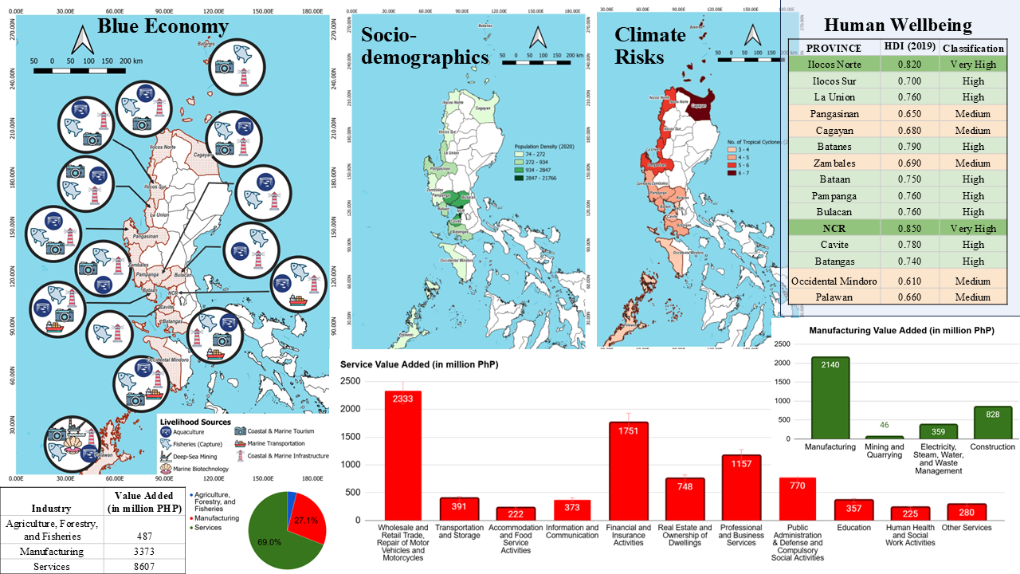

2. Socioeconomics and Climate-Related Threats
The South China Sea Large Marine Ecosystem (SCS-LME) is a vital source of food, livelihood, and economy for several countries surrounding it, which are home to about 270 million people. The SCS-LME is heavily fished and the main source of animal protein for East and Southeast Asian regions. There are large reserves of oil and natural gas being utilized and still explored under its seafloor. It also serves as a hub for the blue economy containing some of the world’s most important shipping routes, ocean transport and shipping ports, fishing industry, renewable (offshore wind) energy, coastal tourism, and community fishing ports.
However, these economic activities are facing challenges related to sociodemographic and climate and disaster risks. For instance, the rising sea levels, driven by climate change, can lead to coastal erosion and inundation, threatening infrastructure, water security, and food security, which is particularly problematic for communities that rely on marine resources for their livelihoods (Mishra, Gupta & Verma, 2025). Coastal areas are increasingly vulnerable to extreme weather events such as hurricanes, tsunamis, and storm surges as well as oil spillage, which can cause significant physical damage to marine and coastal ecosystems and disrupt local economies (Agaton et al., 2025; Laino & Iglesias, 2023). Meanwhile, the growing population and economic activities increase the number of people at risk from climate impacts with low-income coastal communities being particularly vulnerable due to limited adaptive capacity and reliance on natural resources for livelihoods (Yuan, Beard & Johnson, 2021). These are exacerbated by unregulated urban growth and development in coastal areas, particularly in developing and island countries, resulting in an increased pressure on ecosystems and reducing resilience to natural hazards (Tsilimigkas, Deligianni & Zerbopoulos, 2016). Moreover, challenges such as geopolitical tensions, overfishing, and habitat degradation hinder efforts to achieve sustainable economic growth in the region.
This component summarizes the sociodemographics, human well-being, blue economy, and climate-related threats, which are essential for formulating strategic actions, both at national and regional levels. The sub-national unit of analysis used in the study covers the data from provinces along Philippine Seas in the SCS-LME. The risk assessments from sociodemographic trends and climate- and environment-related threats provide bases for recommended mitigation measures and priority actions to build resilience and ensure sustainable and inclusive development.

2.1 Key Findings
- Demographics - The majority of the growing populations are situated in the National Capital Region (NCR) and its nearby provinces, which provide better access to basic goods and services, along with more social and economic opportunities. On the other hand, island provinces and those situated in farther regions from NCR, remain with fewer populations despite having vast land areas and natural resources.
- Human Well-Being - Ilocos Norte and NCR have very high human development index (HDI), while the rest of the localities have high and medium HDIs. Improving literacy rates and declining poverty incidences are expected to increase the HDI in the next years.
- Blue Economy - Most of the industries and services are centered in NCR and its nearby provinces, because of urban growth expansion from the metropolitan area. Food production is situated in rural areas, prioritizing agriculture, forestry, and fisheries for economic development.
- Climate-Related Threats - All localities are exposed to various hazards and disasters. Aside from the geographic location of the Philippines, continuous land conversions, illegal agricultural and fishing practices, mining and quarrying, improper waste management, congestion, and pollution, among others, result in environmental degradation. As such, there is little to no natural protection against hazards and disasters. Population and capital are increasingly exposed across various localities.

2.2 Current Status by Indicator Group
This section details the current status of the demographics, human well-being, blue economy, and climate-related threats for the provinces in the Philippine Seas in the SCS-LME.

2.2.1 Demographics
The Philippines has a total population of 109,035,343 in 2020. This makes the country ranked the 13th most populous nation across the globe and the second most populous country in the Association of Southeast Asian Nations (ASEAN) (Philippine Statistics Authority (PSA), 2021). Among the localities covering the Philippine Seas in the SCS-LME, NCR ranked the highest while Batanes ranked last in terms of population. Although all localities showed an increase in the population from 2015 to 2020, NCR and its nearby provinces like Cavite and Bulacan showed the most rapid population growth (PSA, 2020). Moreso, these most populous localities have smaller land areas; thus, higher population density that lead to congestion (Figure 2.1).
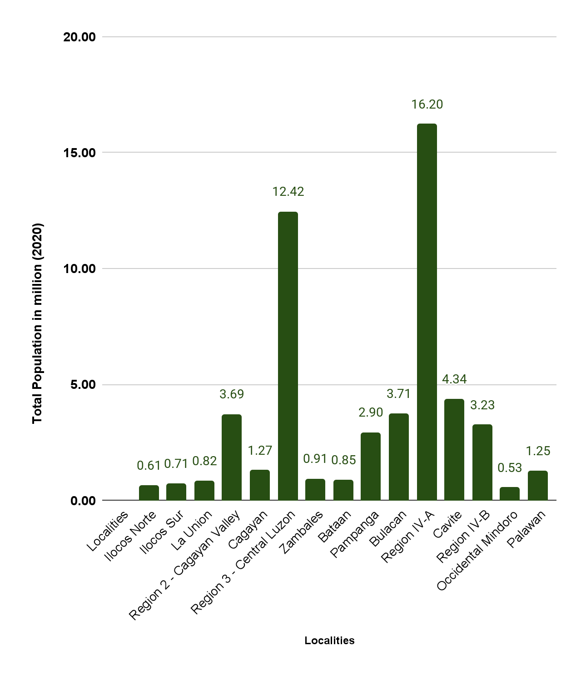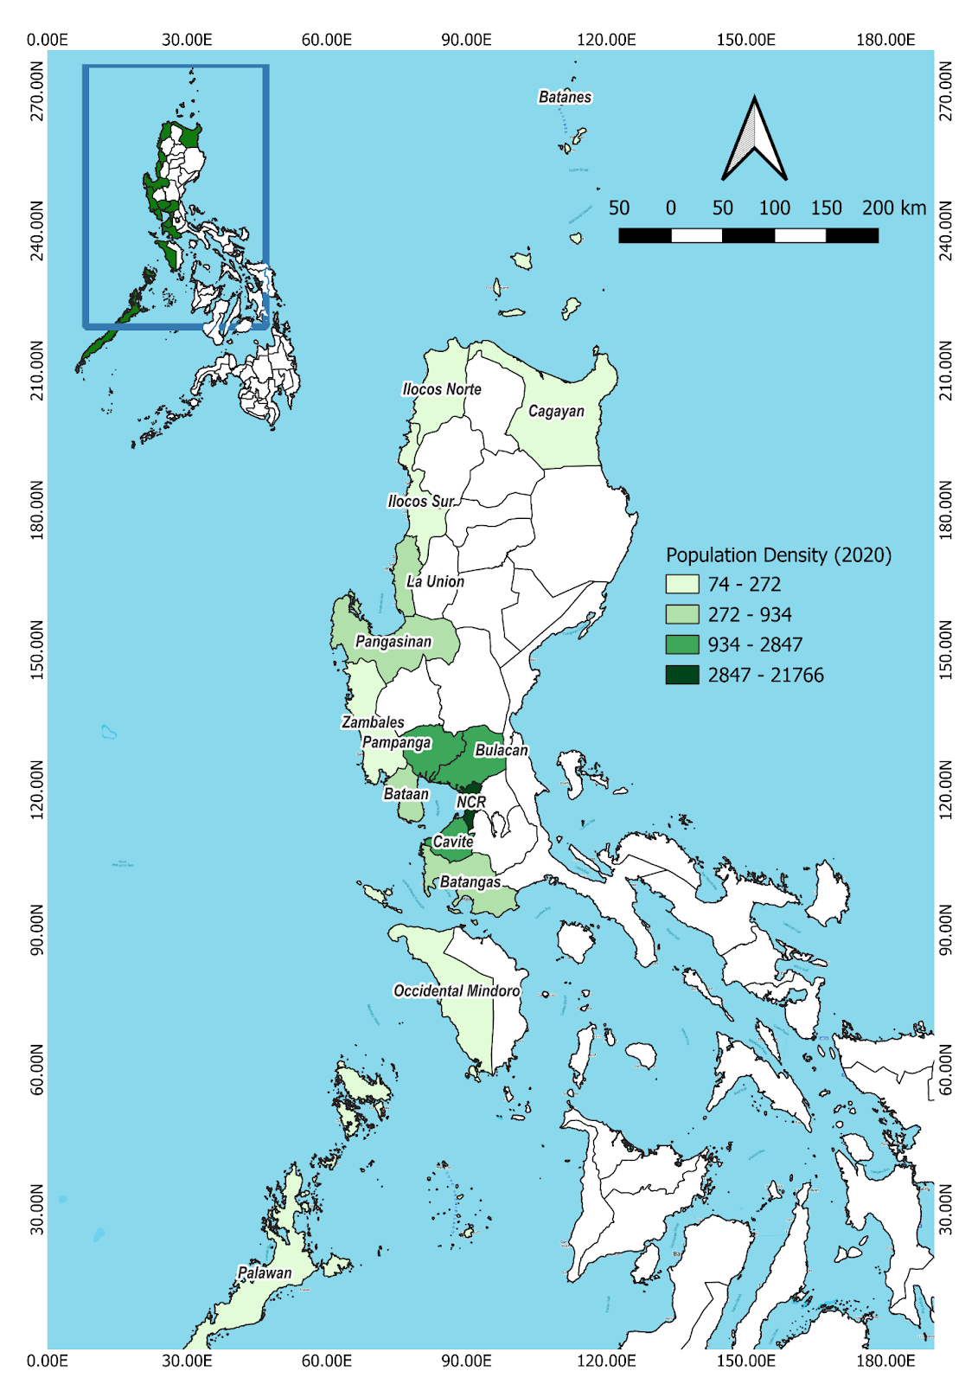
Figure 2.1. Population Data of Localities in 2020 (PSA, 2020)
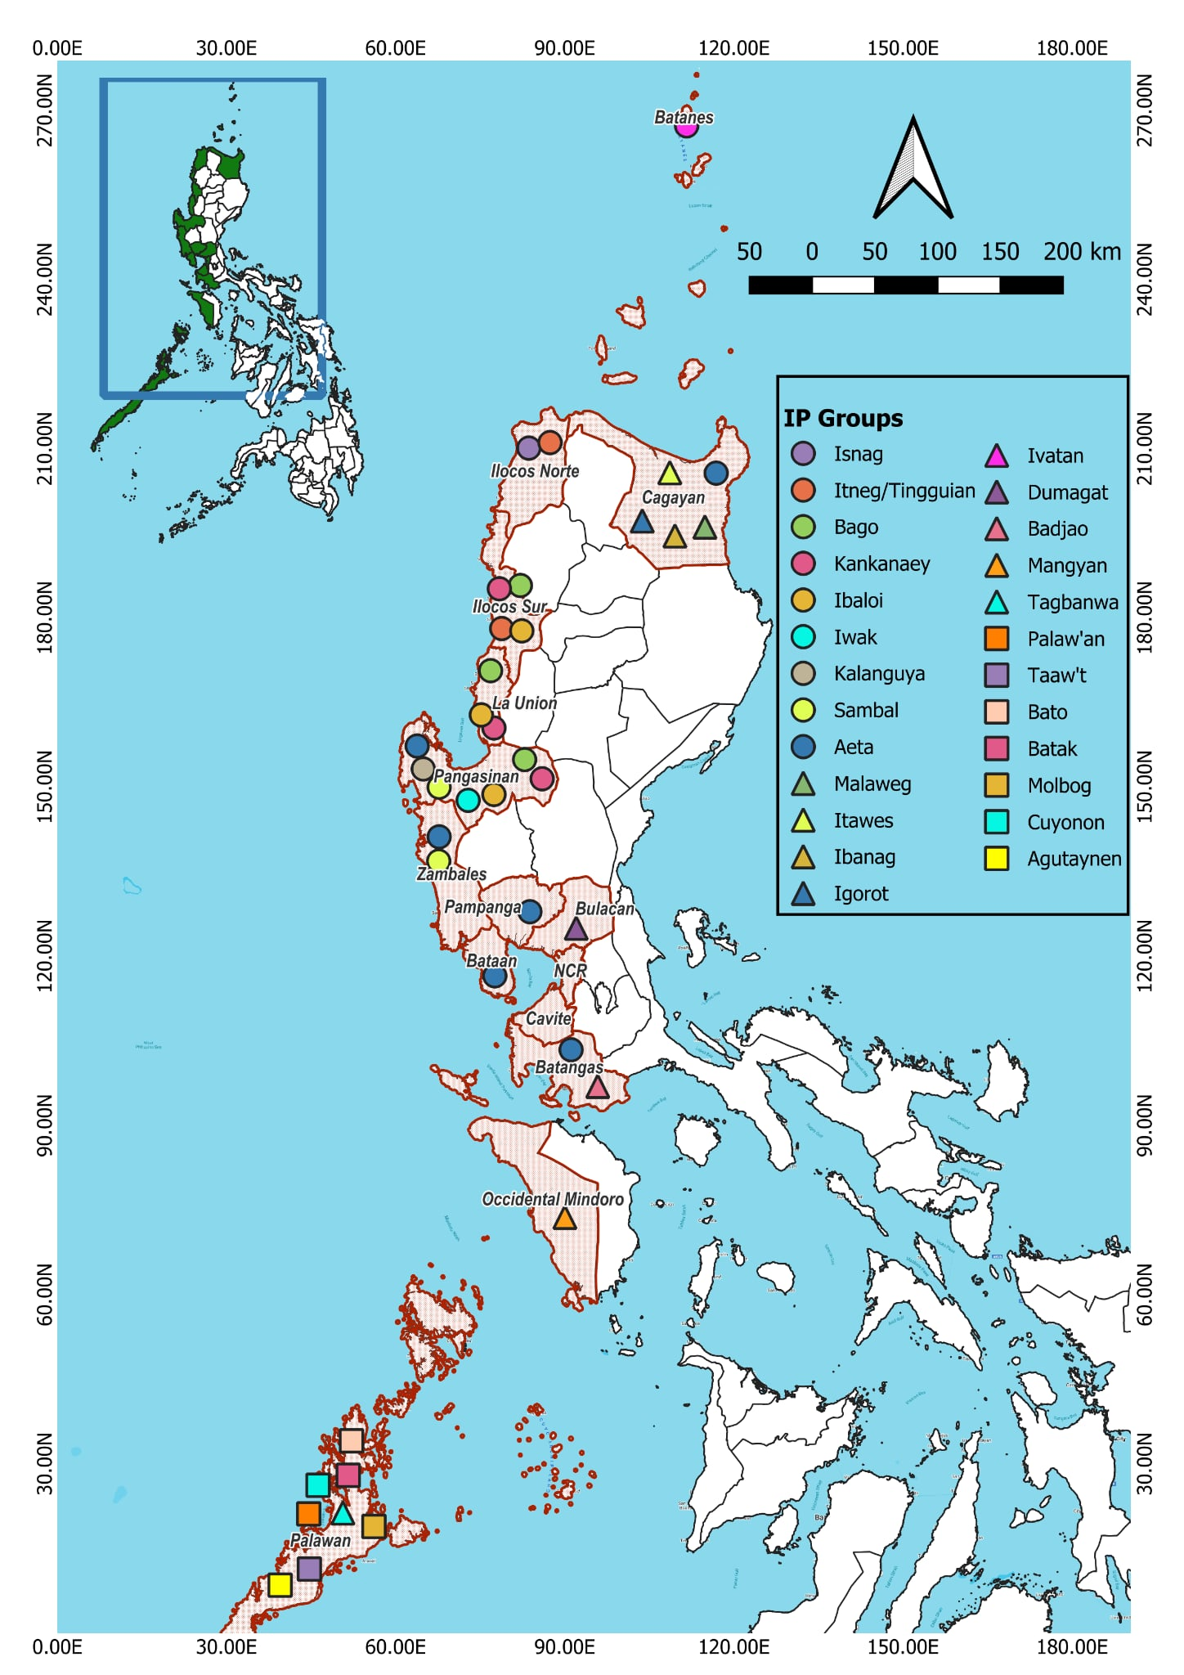
Figure 2.2. Indigenous Peoples (IP) Groups in Different Localities (PSA, 2020)
Studies also revealed that majority of the world’s population/ households opt to live in urban areas (Dodman et al., 2023). Reasons include more access to services and opportunities, including technologies, telecommunication (D’Acci, 2021), transportation, and employment (Moro et al., 2021). However, due to limited land area for the growing population, common practices include the conversion of forests and agricultural lands to residential, commercial, and industrial needs. If uncontrolled, this may lead to degradation of natural resources; hence, poor ecosystem services. Current manifestations include global warming, more intense and frequent disasters, poor sanitation, less access to safe water, and increased demand, yet lower supply of food (Dodman et al., 2023).
On the contrary, rural provinces like Batanes have lower population. People are not attracted to live here since these will require more energy and resources to access different goods and services (Talubo & Saroj, 2019). Given the insufficient human capital and local budget, access to water supply (Aquino, Sanchez, & Roa, 2023), electricity, sanitation, and other essentials have been major issues in these localities. Although there are vast natural resources capable of providing more provision services for a smaller human population, due to geographic location, Batanes and similar island provinces are prone to many hazards and disasters, including earthquakes and typhoons (Hadlos et al., 2023); thus, often resulting in socio-economic losses. Similar experiences can be observed by IPs situated in far-flung areas of provinces within SCS-LME (Macusi et al., 2023) (Figure 2.2).

2.2.2 Human Wellbeing
Assessing the status of human wellbeing is also important consideration in developing strategic plans for SCS-LME as this recognizes the equitable access to diverse ecosystem services it provides and the socioeconomic impacts of conservation initiatives. Using different dimensions of human wellbeing, planners and policymakers can proactively understand future impacts of marine management decisions and co-create solutions with various stakeholders to ensure that marine conservation initiatives improve the welfare of the communities while attaining sustainable development goals (SDGs).
As per Republic Act No. 8425 of 1997, also known as Social Reform & Poverty Alleviation Act of the Philippines, the Department of Economy, Planning, and Development (DEPDev) defines poor families as households whose per capita income or expenses are lower than the per capita national family poverty threshold of Php 13,873 or USD 250 per month for a family of five (PSA, 2023, 2024). Among the localities covered by Philippine Seas in the SCS-LME, Ilocos Norte, Pampanga, and NCR have the least recorded poverty incidences, while Occidental Mindoro and Palawan have the highest (Figure 2.2). Priority programs, projects, and activities (PPAs) in Ilocos Norte included poverty reduction, improved agricultural productivity, and employment opportunities. This contributed to why the province had the least poverty incidence recorded (Adriano, 2024). On the other hand, economic development, especially in NCR and its nearby provinces, including Pampanga, aided in more access to basic goods and necessities to alleviate poverty (Ayoo, 2022). As for island provinces such as Occidental Mindoro and Palawan, studies showed that geographic isolation is a huge factor for less accessibility to basic goods and services (Deziel et al., 2023; Zhou & Huang, 2023).
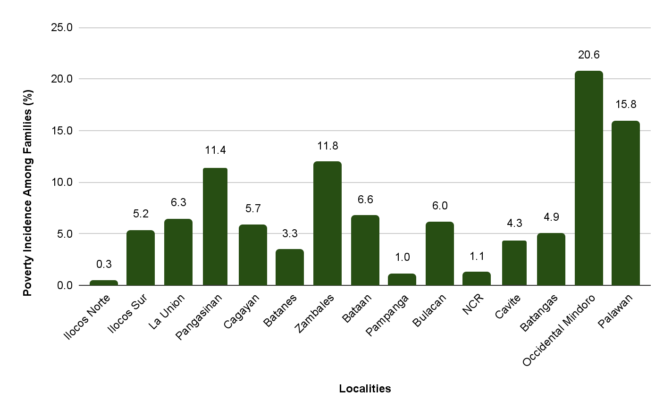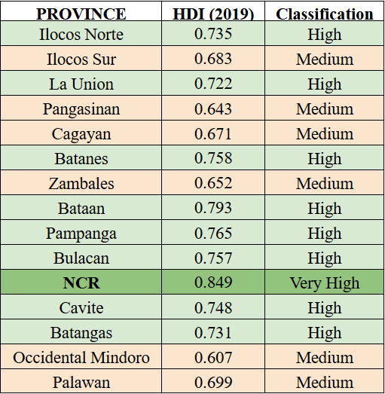
Figure 2.3. Localities’ Poverty Incidence Among Families in 2023 (PSA, 2020; 2023)
Human Development Index or HDI, as a key metric of the United Nations (UN) for measuring human well-being and quality of life, uses indicators/ elements including per capita income, education, and life expectancy (Qori'atunnadyah, 2023). Following the United Nations Development Programme (UNDP) HDI classifications (very high: ≥ 0.800; high: 0.700-0.799; medium: 0.550-0.699; low: < 0.550), report by Human Development Network Foundation Incorporated (HDNFI) showed that NCR has very high HDI. Ilocos Norte, La Union, Batanes, Bataan, Pampanga, Bulacan, Cavite, and Batangas have high HDI results, while Ilocos Sur, Pangasinan, Cagayan, Zambales, Occidental Mindoro, and Palawan have medium HDIs (Figure 2.3).
Considering that the majority of the localities mentioned focused on economic development, as supported by the demographic results and analysis, this may have contributed to an increase in per capita income. Increase in income level also aided to longer life expectancy caused by improved access to health care services and nutrition. However, this may have been feasible through improved quality education, as the majority of higher-income jobs may apply to those with better educational backgrounds/ completed primary, secondary, tertiary, and/or postgraduate studies (Sart et al., 2024).

2.2.3 Blue Economy
Blue economy refers to the sustainable use of ocean resources for economic growth, jobs, ocean health, and to improve livelihoods (Narwal et al., 2024). It is composed of eight key sectors which all aim at using marine resources sustainably for economic growth and human well-being. These include (i) fisheries, (ii) aquaculture, (iii) marine transportation, (iv) coastal and marine tourism, (v) deep-sea mining, (vi) coastal and marine infrastructure, (vii) renewable energy, and (viii) marine biotechnology.
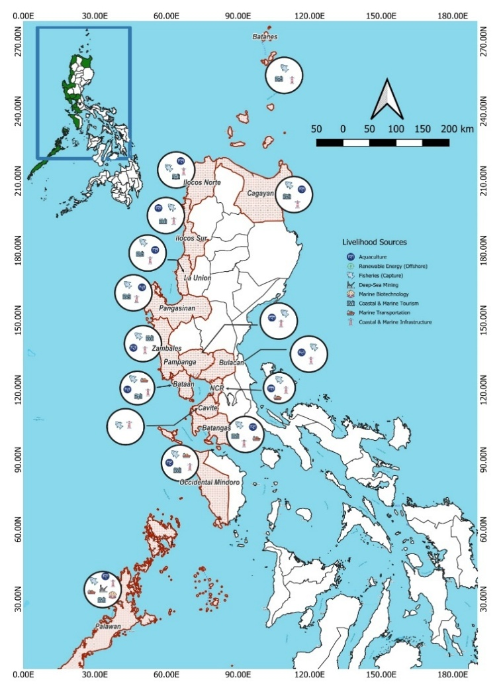
Figure 2.4. Blue Economy in Different Localities
As shown in Figure 2.4, all localities covered by Philippine Seas in the SCS-LME have coastal and marine infrastructure, which also aid in transportation and other economic activities. Among the major seaports are the Ports of Manila, Batangas, Subic (Zambales), San Fernando (La Union), and Irene (Cagayan), which serve as maritime transport hubs for local and international shipping industry.
Blue economy sectors common to the majority of the localities include coastal & marine tourism, aquaculture, and fisheries. On the other hand, deep-sea mining and marine biotechnology were evident in Palawan.
In terms of renewable energy, the World Bank estimated a 178 GW potential of offshore wind, which can significantly contribute to the country's climate goal and renewable energy target of 50% share by 2040. The Department of Energy (DoE) identified the potential offshore wind development zones in SCS-LME area such as Northwest Luzon (2-5 GW), NCR (up to 3 GW), Northern Mindoro (3-10 GW), and Southern Mindoro (20-36 GW).
Many Pacific countries recognize that in analyzing the total impacts of blue economy, ridge-to-reef approach has to be used due to interconnectedness of various sectors and their ecosystem services, including activities in the uplands which then affect the quantity and quality of services provided in the coastal areas and vice versa (Fache & Pauwels, 2022). Hence, all economic sectors comprising a locality were divided into (1) agriculture, forestry, and fisheries; (2) manufacturing, and (3) services. All of these were analyzed below.
Provinces such as Pampanga, Pangasinan, and Batangas have the highest value added at current price (2023) in terms of agriculture, forestry, and fisheries. This is evident considering that these provinces rely on the said economic ventures as primary sources of income/ livelihood (Provincial Government of Pampanga, 2013; Province of Batangas, 2021). On the other hand, Batanes, although a known rural area, had low values due to extreme weather conditions, which are not suitable for these economic activities (Hadlos et al., 2023).
For manufacturing and services, NCR and its nearby provinces have the highest value added at current prices since these economic activities, requiring much energy, labor, and other resources, are attributed to metropolitan and urban areas. On the other hand, mining and quarrying, often in mountainous areas, are known only in selected rural areas such as Palawan and Zambales since these activities are not actively being promoted (Pascual et al., 2022) because of numerous negative impacts. Moreover, Palawan LGU approved the ordinance on a 50-year mining moratorium due to increasing environmental concerns brought about by illegal mining and quarrying in this biodiversity hotspot (Ticke & Lagare, 2025).
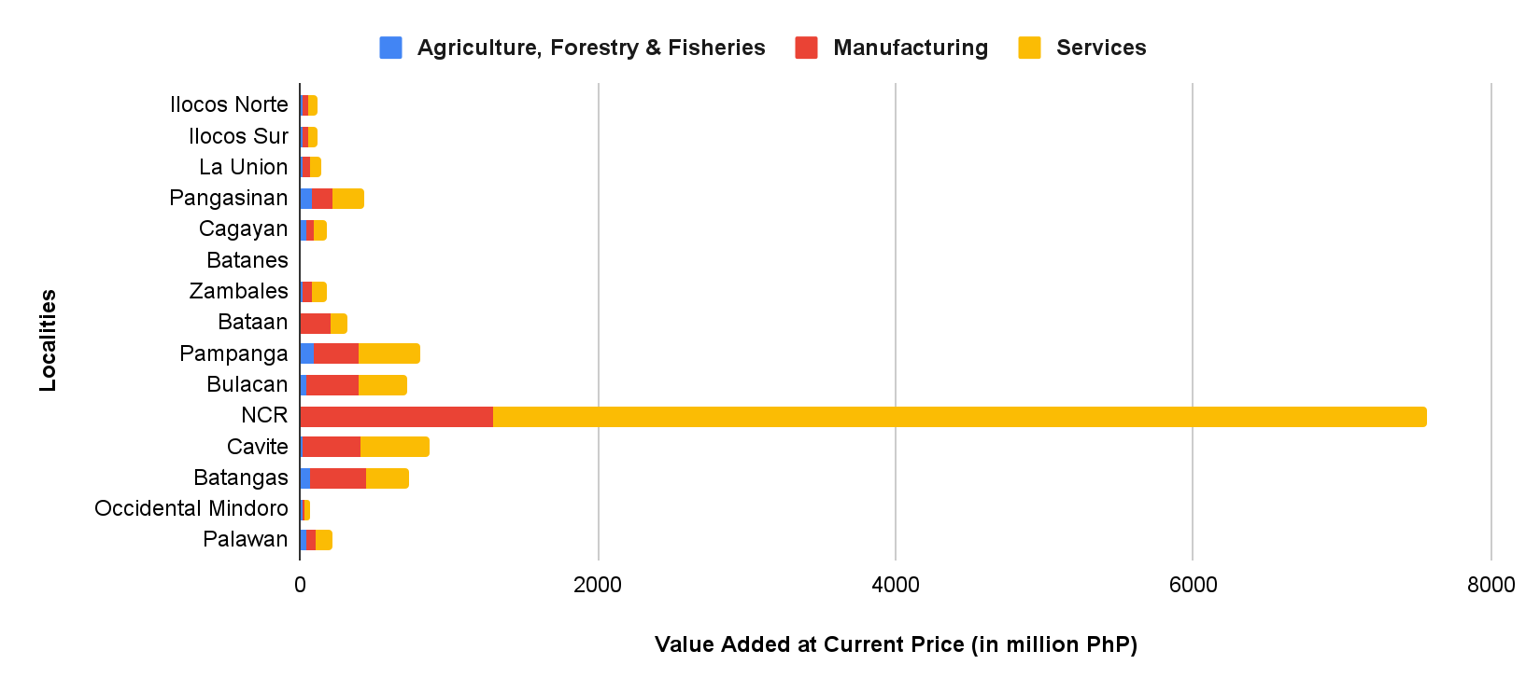
Figure 2.5. Value Added at Current Prices in 2023 of Economic Sectors in Different Localities (PSA, 2025)

2.2.4 Climate-Related Threats
According to the Department of Science and Technology-Philippine Atmospheric, Geophysical and Astronomical Services Administration (DOST-PAGASA) (2025), the Philippines has the largest number of tropical cyclones (TCs) entering the country per year than any other nation across the globe. This is shown in the map below, with localities surrounded by bodies of water experiencing frequent tropical cyclones and typhoons. The majority are in the northern part of Luzon, namely, Cagayan and Batanes, followed by Ilocos Norte, Ilocos Sur, La Union, and Pangasinan. Among these localities with Philippine Seas in the SCS-LME, NCR had the lowest number of TCs in 2024, yet still with the recorded 7 deaths. Batangas had the highest with 64 declared dead people. The majority of this was caused by Tropical Cyclone Trami (Kristine). The high population density and concentration of service infrastructure in the NCR and its nearby provinces can result in huge economic negative impacts if not properly mitigated.
In terms of the COVID-19 pandemic record of the Department of Health or DOH (2024), NCR had the highest recorded deaths, while Palawan, Occidental Mindoro, and Batanes had the lowest (Figure 2.7). This is evident considering that NCR suffers from congestion (Lagundimao et al., 2024); hence, higher exposure and contact with different people. On the other hand, island provinces are isolated and do not attract many migrants (Deziel et al., 2023; Zhou & Huang, 2023). Hence, there is less entry and spread of the virus.
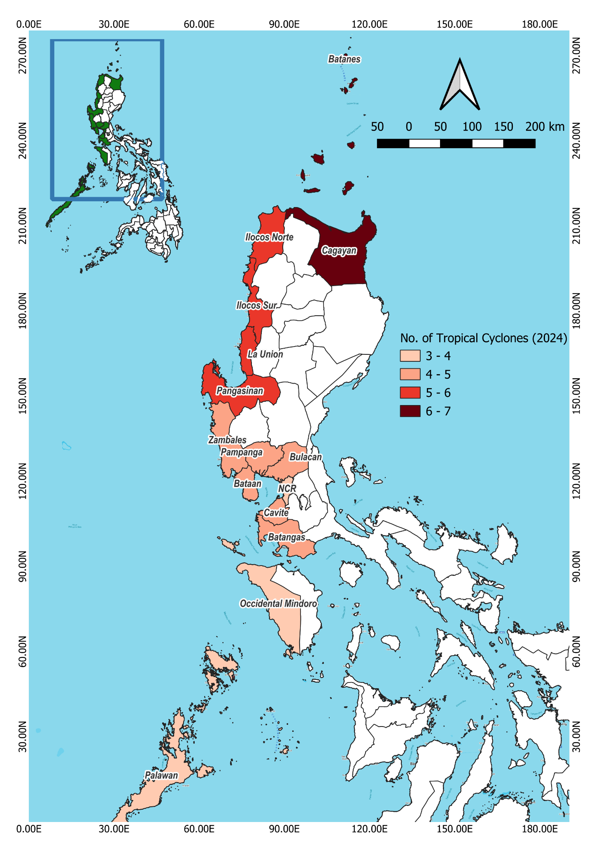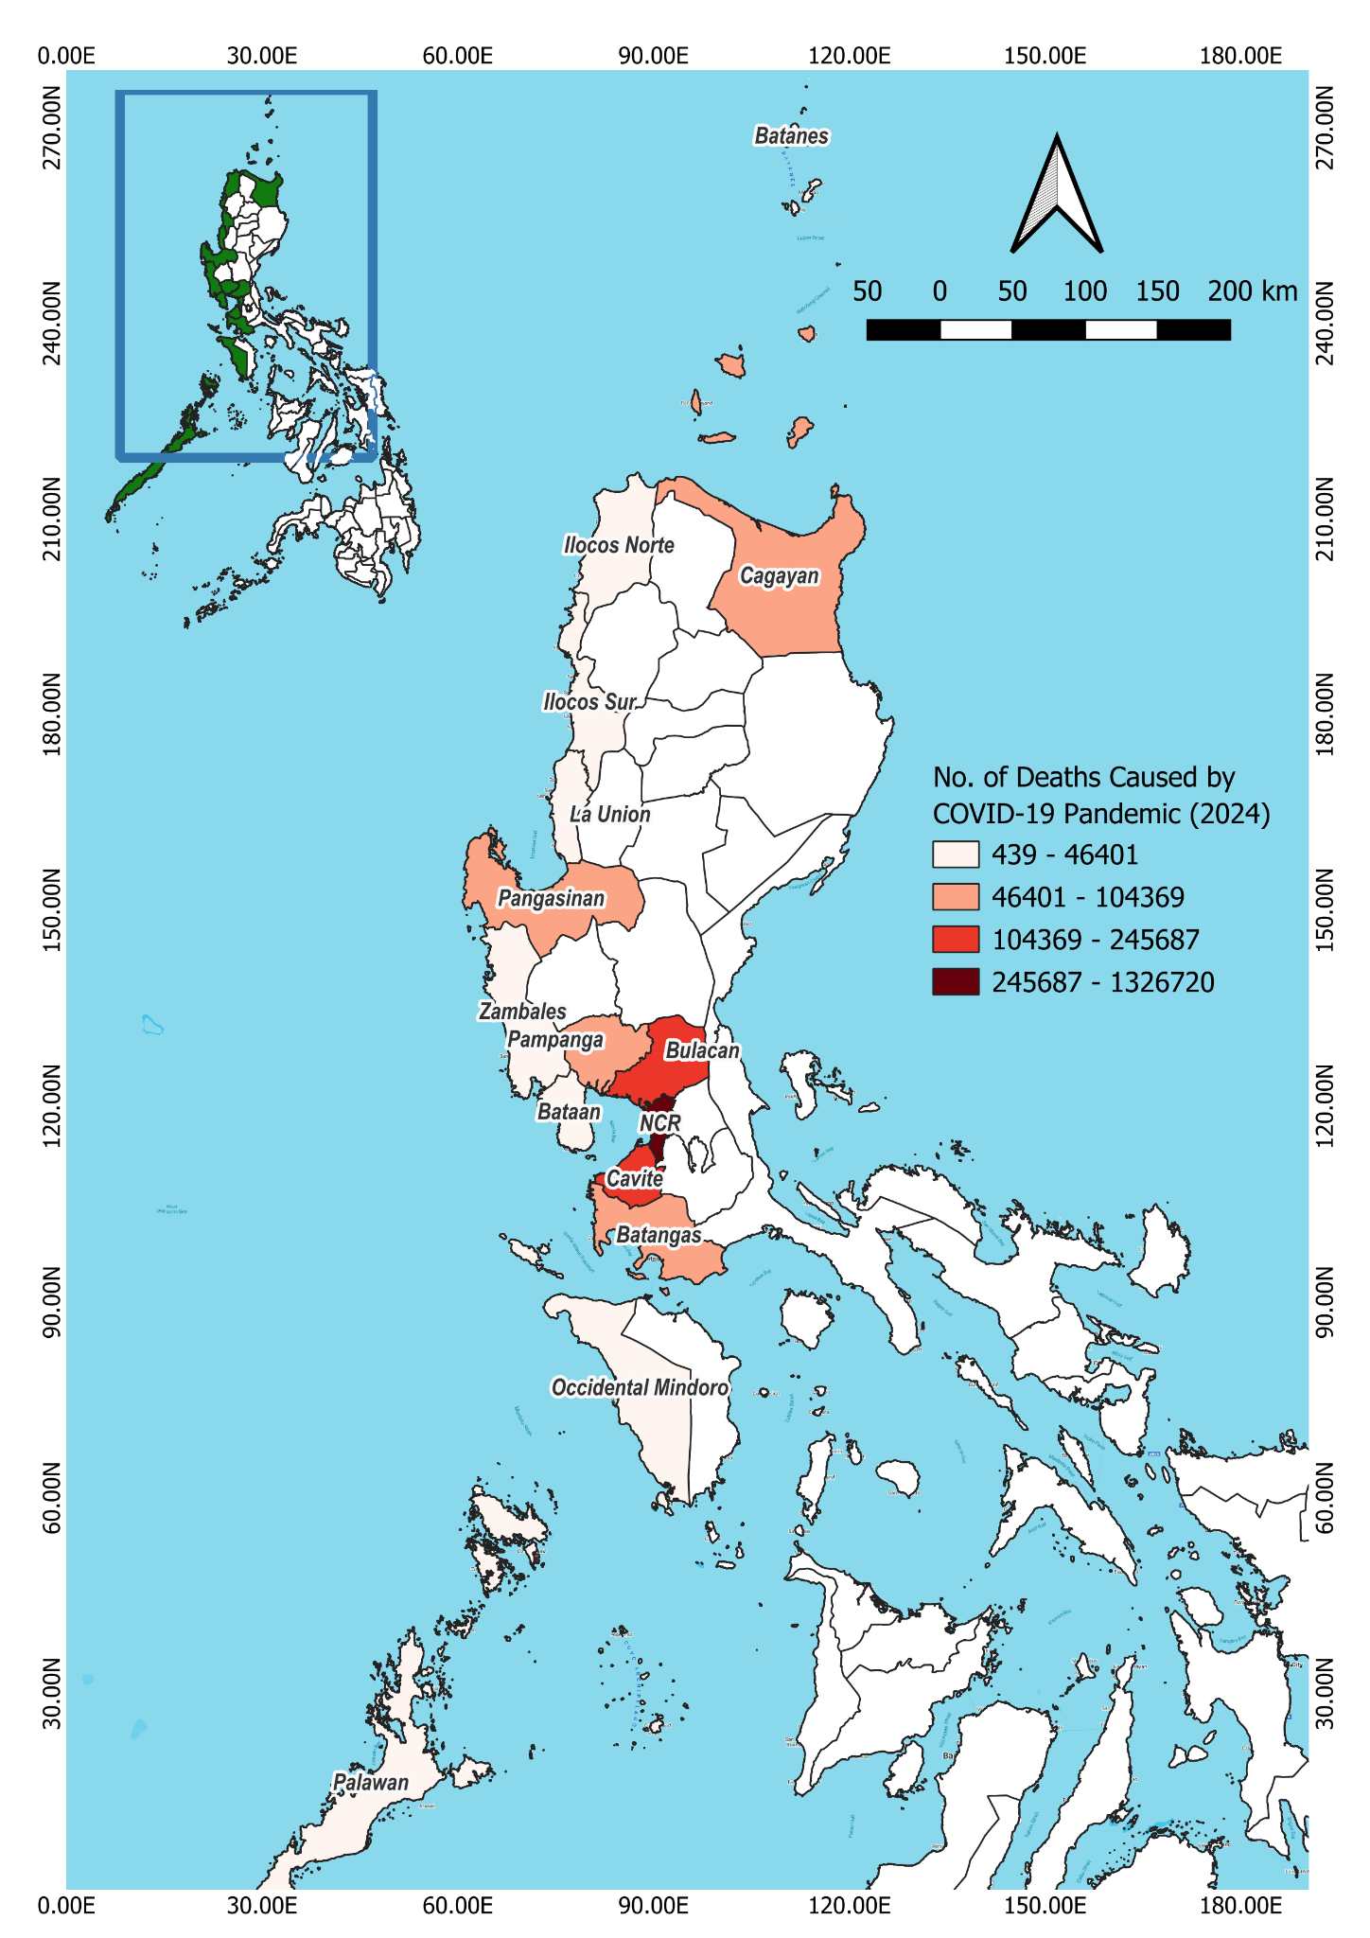
Figure 2.7. Number of Deaths Caused by COVID-19 Pandemic in Different Localities (DOH, 2024)

Figure 2.6. Number of Tropical Cyclones Affecting Localities in 2024 (CRED/UC Louvain, 2025)

2.3 Discussion and Conclusions

2.3.1 Risk Assessment from Socioeconomic Trends
All of the local government units (LGUs) show increasing populations and it is still expected to grow in the coming years as shown in the figure below. However, NCR has a significantly higher population compared to other localities. This is given considering that it is composed of 16 cities and a municipality (PSA, 2025), and the majority of the population wanted to live in urban areas (Czaika & Reinprecht, 2022). Despite this, population increases in a slower pace over the past years. According to Gu et al (2021), this is attributed to declining fertility rates. Among the factors include education, exposure of women to mass media, access to anti-fertility drugs, and employment/career priorities (Borzoiepour et al., 2024).
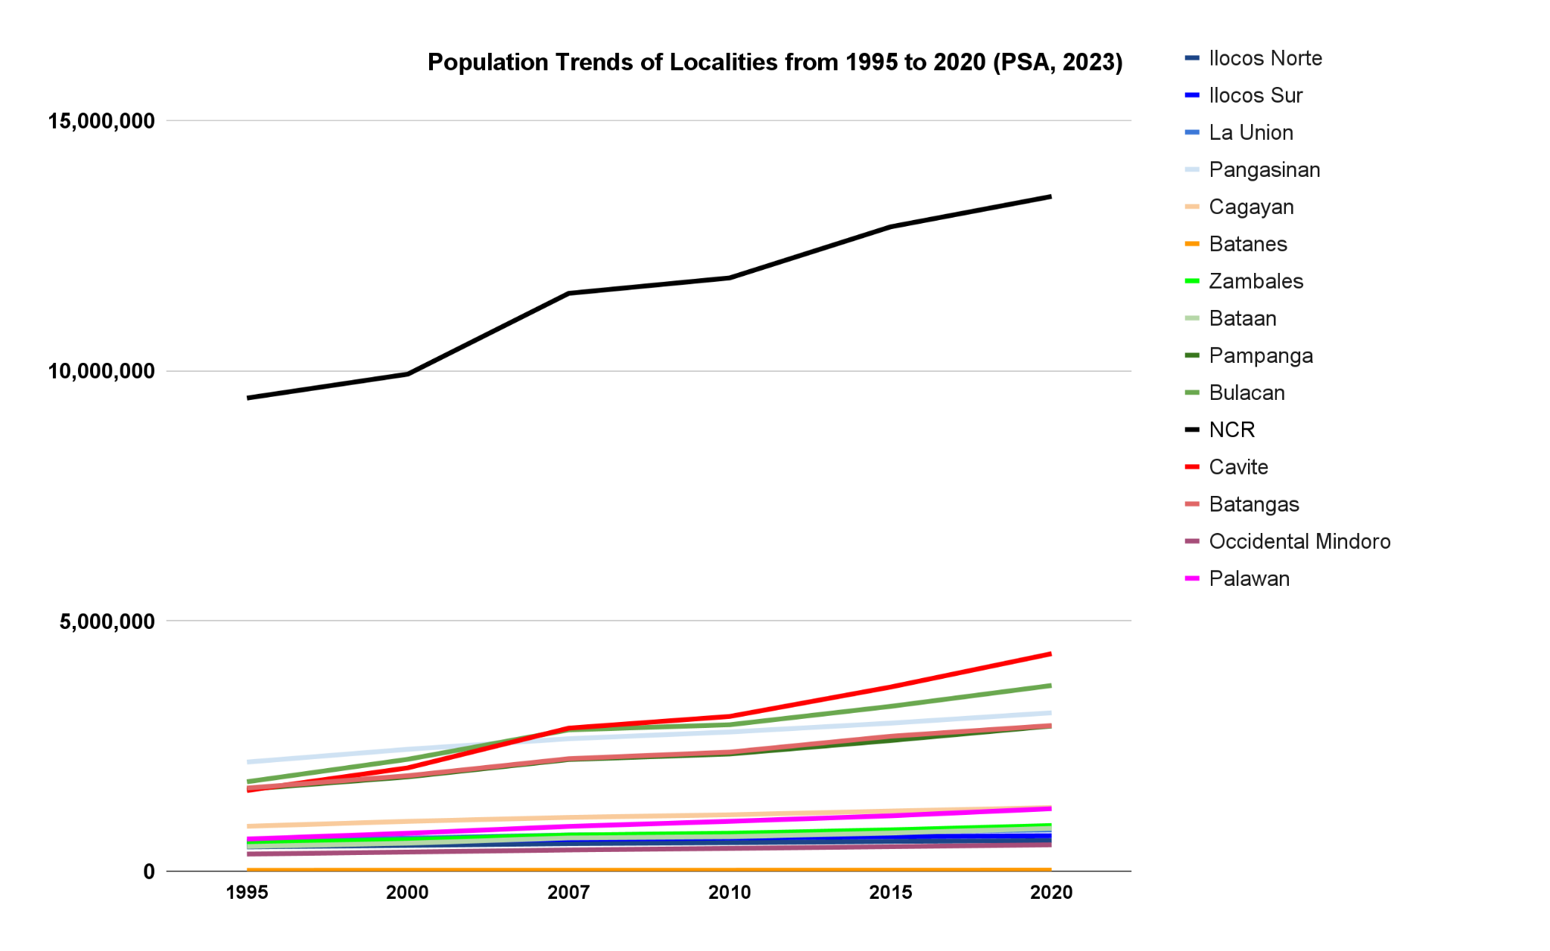
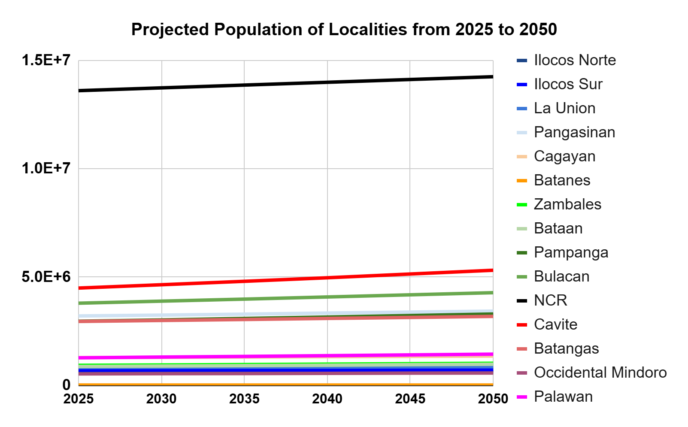
Figure 2.8. Population Trends and Projections of Localities from 1995 to 2050 (PSA, 2023)
Such access to information, education, and technology may also be a factor for decreasing overall poverty incidences in different localities. However, in the figure below, it can be observed that a sudden increase in poverty incidences occurred in 2021. This may be attributed to the COVID-19 pandemic, wherein many households suffered from less access to income/employment (Lavado et al., 2021). Many establishments and businesses shut down; hence, little to no money for food (Angeles-Agdeppa et al., 2022) and other necessities.
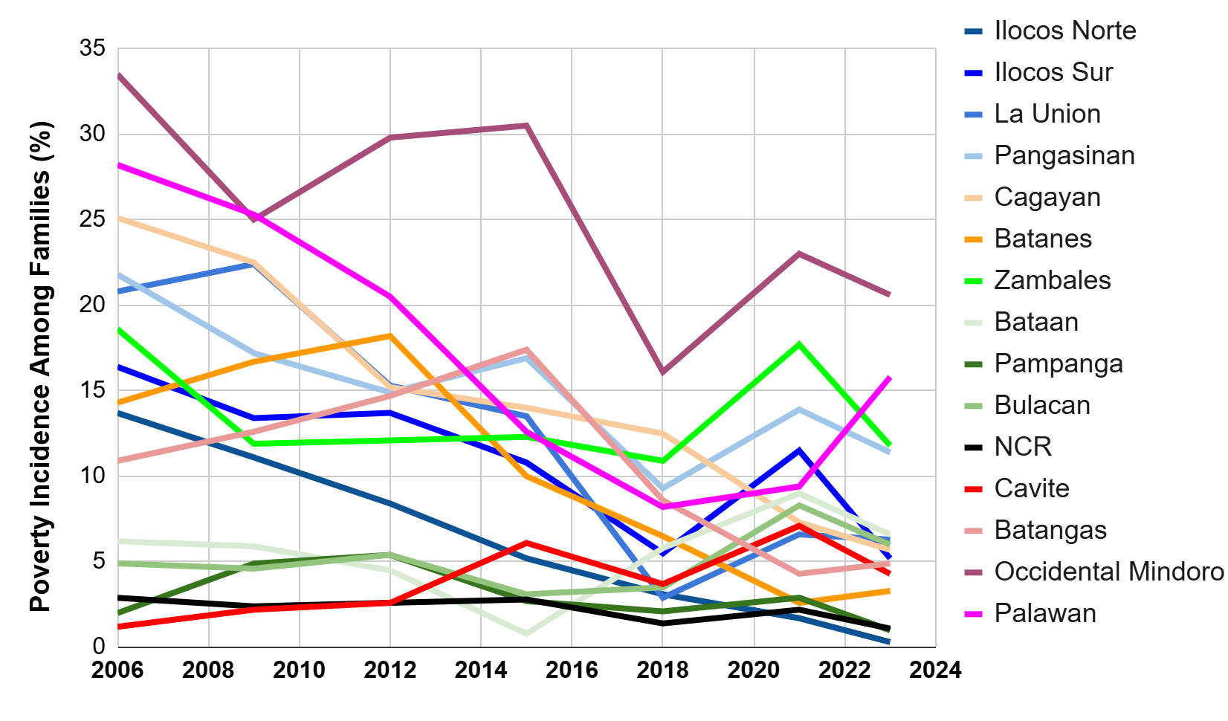
Figure 2.9. Trends of Localities’ Poverty Incidence Among Families from 2006-2023 (National Statistical Coordination Board, 2013; PSA, 2018, 2021, 2023; Siosion, 2022)
Overall, increasing HDI trends can be observed from 2006-2019 across different localities (Figure 2.10). The NCR and nearby provinces had higher HDI results compared to those farther from the metro. However, a significant increase in the HDIs of these provinces far from the NCR can be observed from 2012 to 2019. This can be attributed to a shift in priority, such as Ilocos Norte’s administration focus on health, education, and employment (Adriano, 2024).
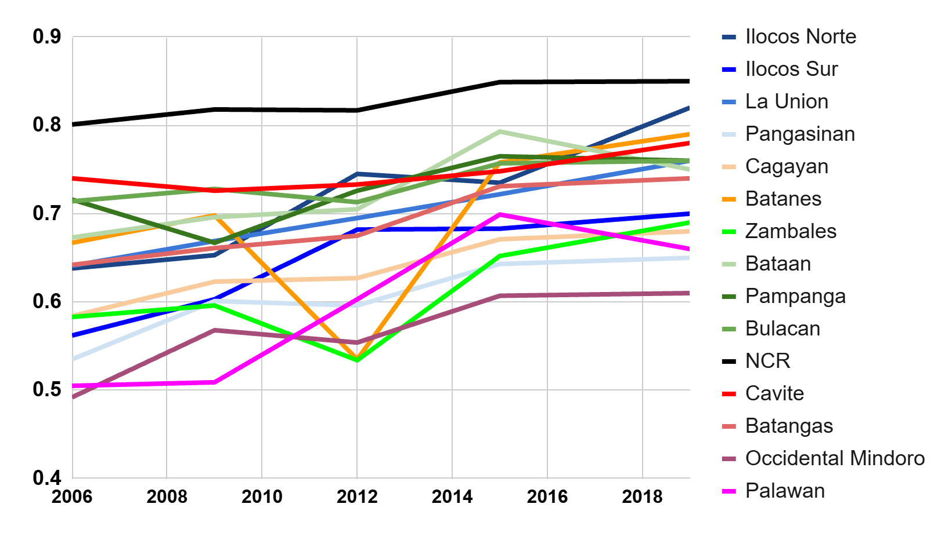
Figure 2.10. Human Development Index (HDI) Trends of Localities from 2006-2019 (PSA, 2020, 2023)
Given that education is one of the indicators, it is expected that there can be an HDI increase considering that the majority of the population was basically literate (able to read, write with understanding, and compute) in the 2024 PSA result of Functional Literacy, Education, and Mass Media Survey (FLEMMS) as presented in the figure below. However, considering that there are still illiterate (cannot read and write) and low literate (can only read and write) populations across different localities, there should be efforts to improve education access such as additional public schools, libraries, and teachers along with offering more scholarships and incentives (e.g., free uniforms, school supplies, tablets, and internet connectivity in schools).
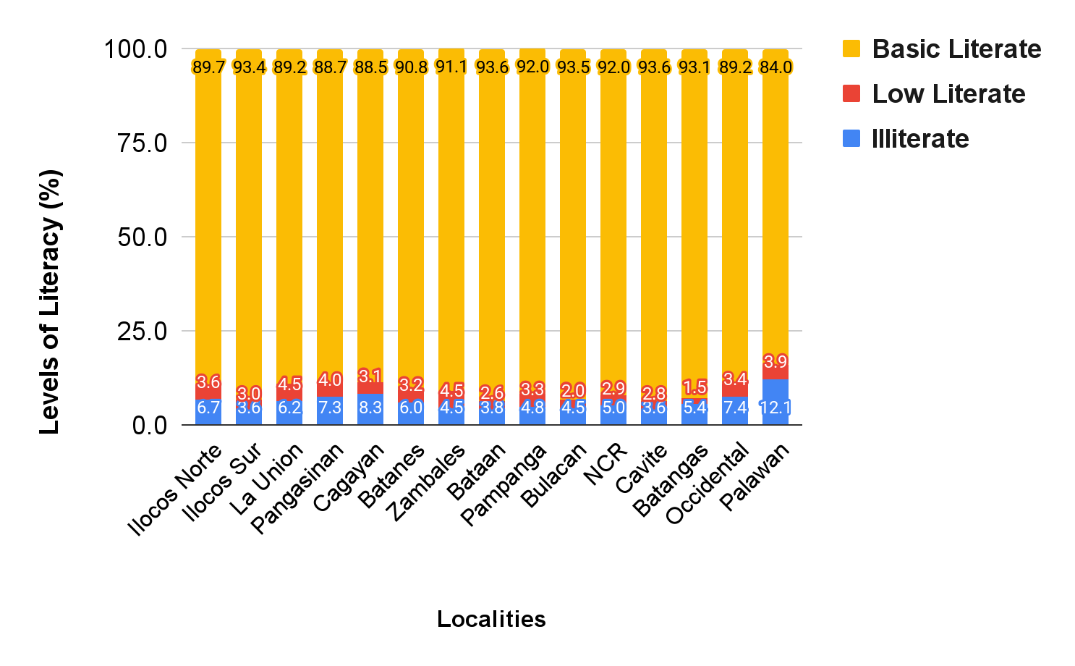
Figure 2.11. Localities’ Levels of Literacy (PSA, 2024)
In terms of employment and livelihood components, rural areas contribute the highest economic outputs for agriculture, forestry, and fisheries. However, according to the National Economic and Development Authority or NEDA (2021), it is evident that primary production had the least economic contribution as compared to manufacturing and services which are centered in cities and urban areas. Hence, a contributing factor as to why rural areas have higher poverty incidence compared to NCR and its nearby provinces.
Overall, increase in value added at current prices from 2018 to 2023 is evident for all economic sectors. However, all experienced sudden decrease during the period of COVID-19 pandemic. Urban areas were recovering their manufacturing and services while some rural areas also ventured on increasing economic efforts centered on these aspects during the post-pandemic. If this continues, increase land conversion for commercial and industries may occur. Hence fewer agricultural lands in the future which may threaten supply and demand of primary production for the increasing population.
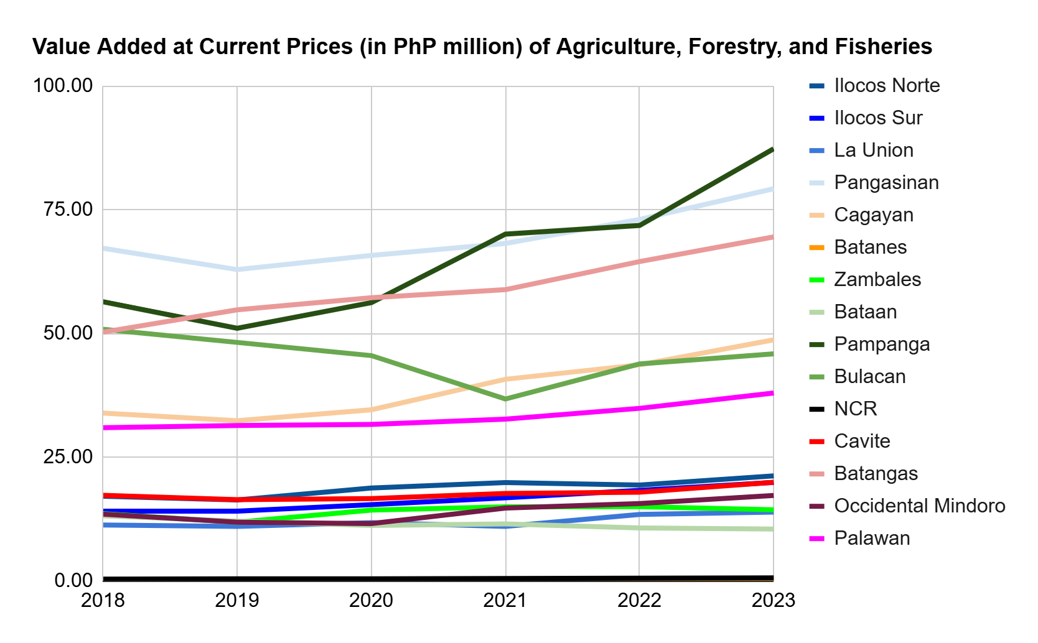
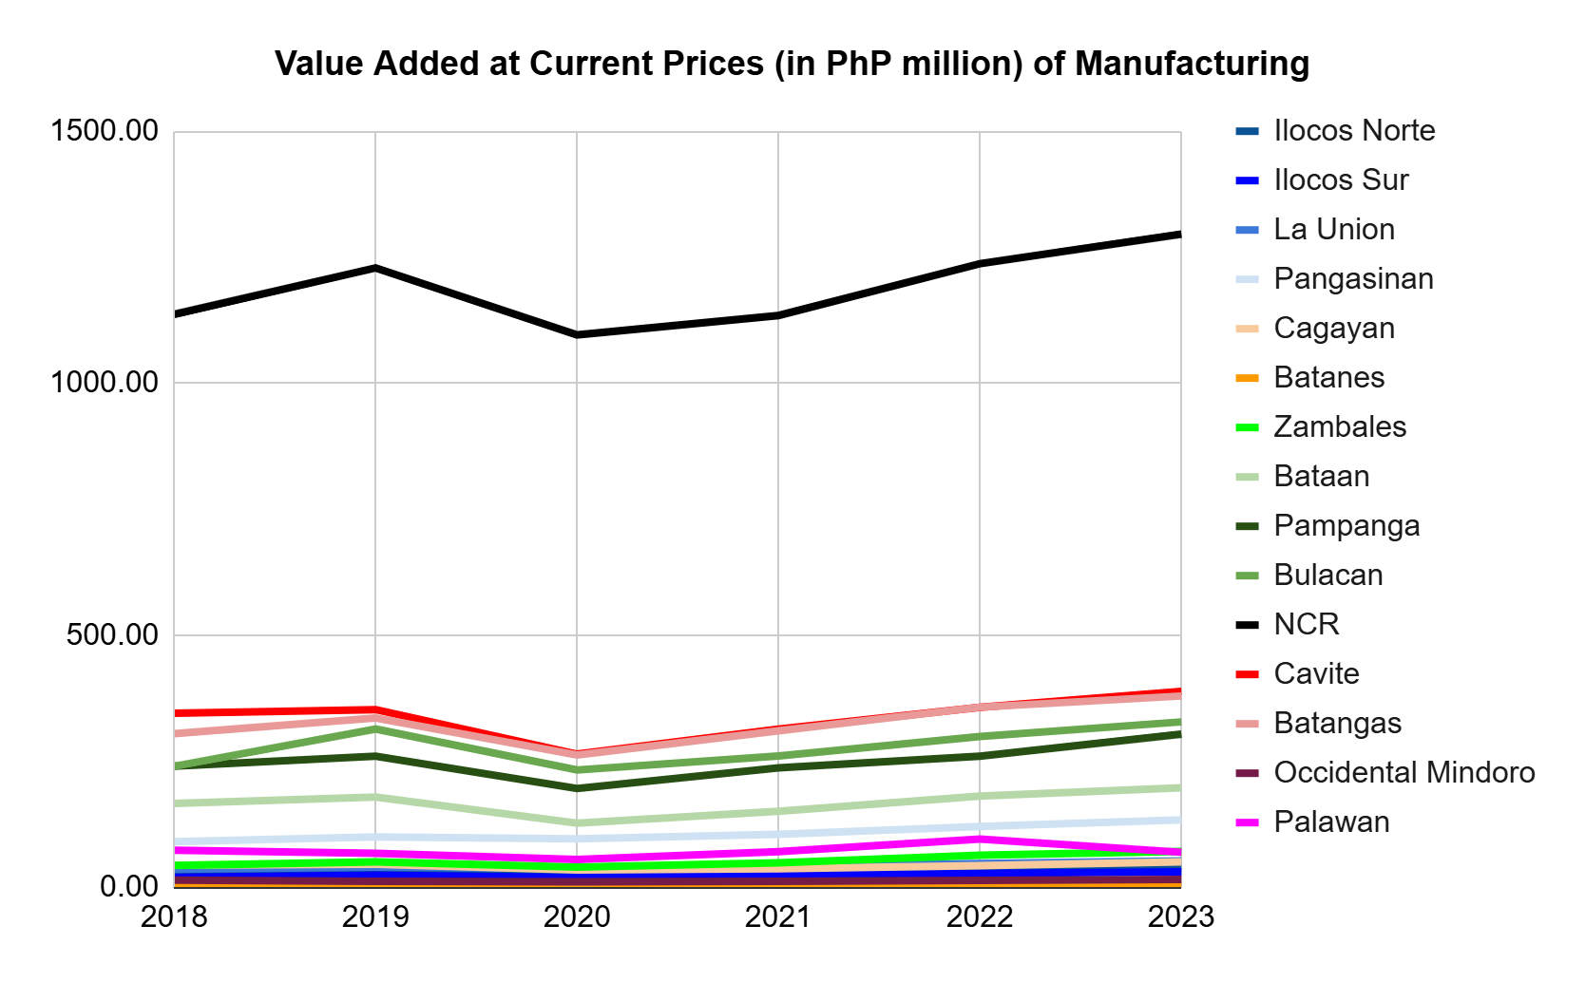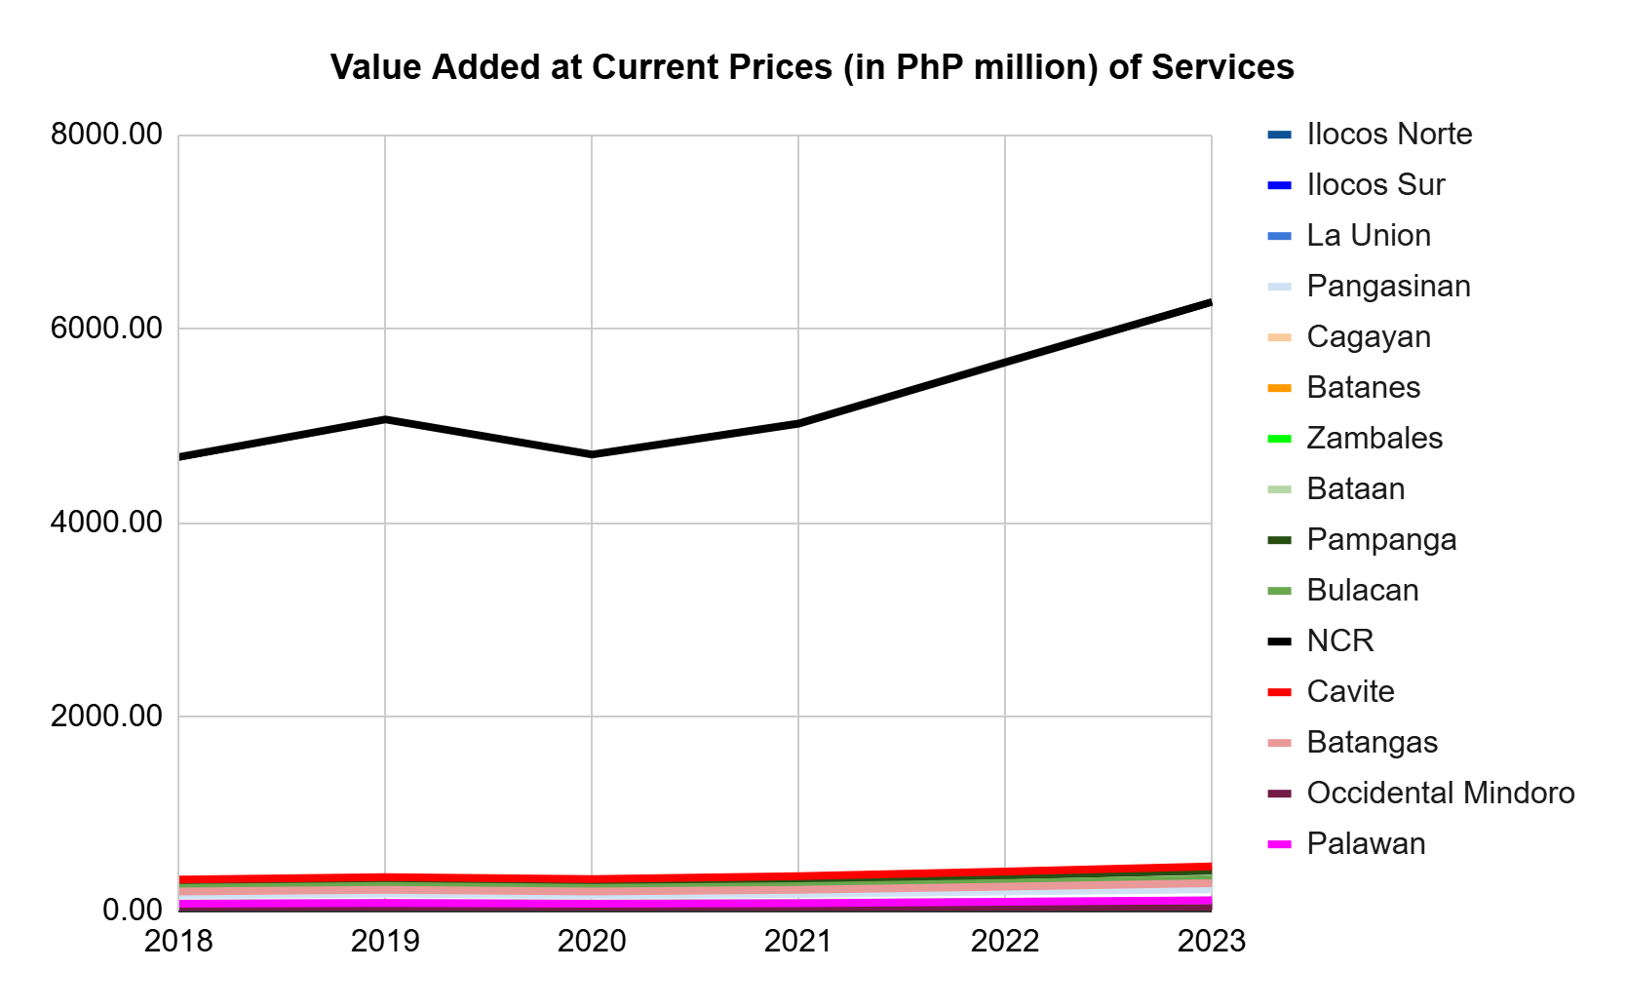
Figure 2.12. Economic Sector Trends of Value Added at Current Prices from 2018-2023 (PSA, 2025)

2.3.2 Risk Assessment from Climate- and Environment-Related Threats
The Philippines is an archipelago situated in the Pacific Ring of Fire. Thus, it is exposed and vulnerable to many hazards and disasters, especially hydrometeorological and geological in nature (Morante-Carballo, 2024). This is shown in the maps below, where all localities were exposed to many types of hazards. The NCR had the highest exposed population, followed by its nearby provinces. On the other hand, Batanes had the lowest, considering that it also had the least population among the provinces in the Philippines.
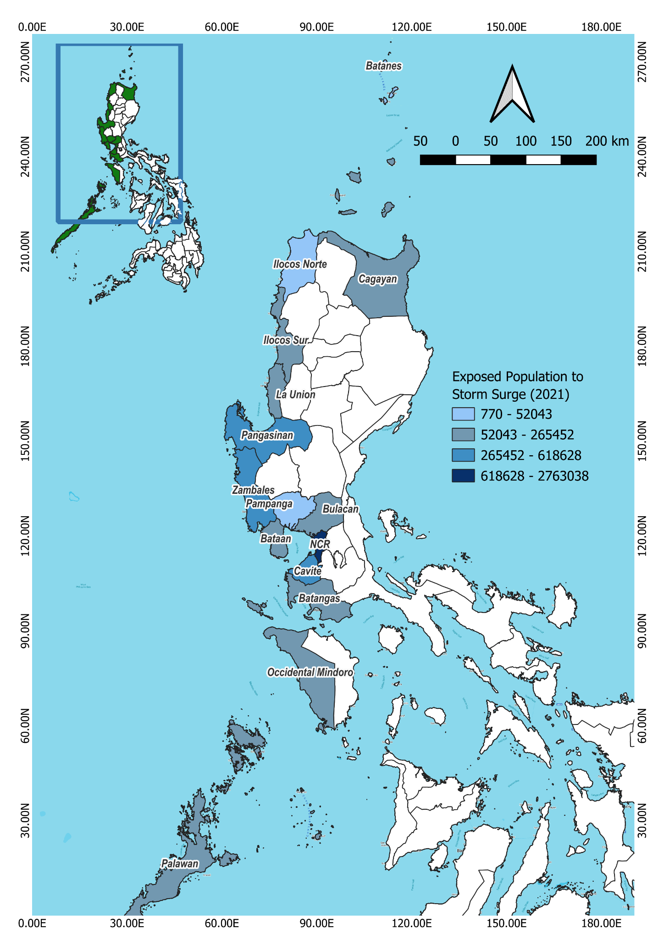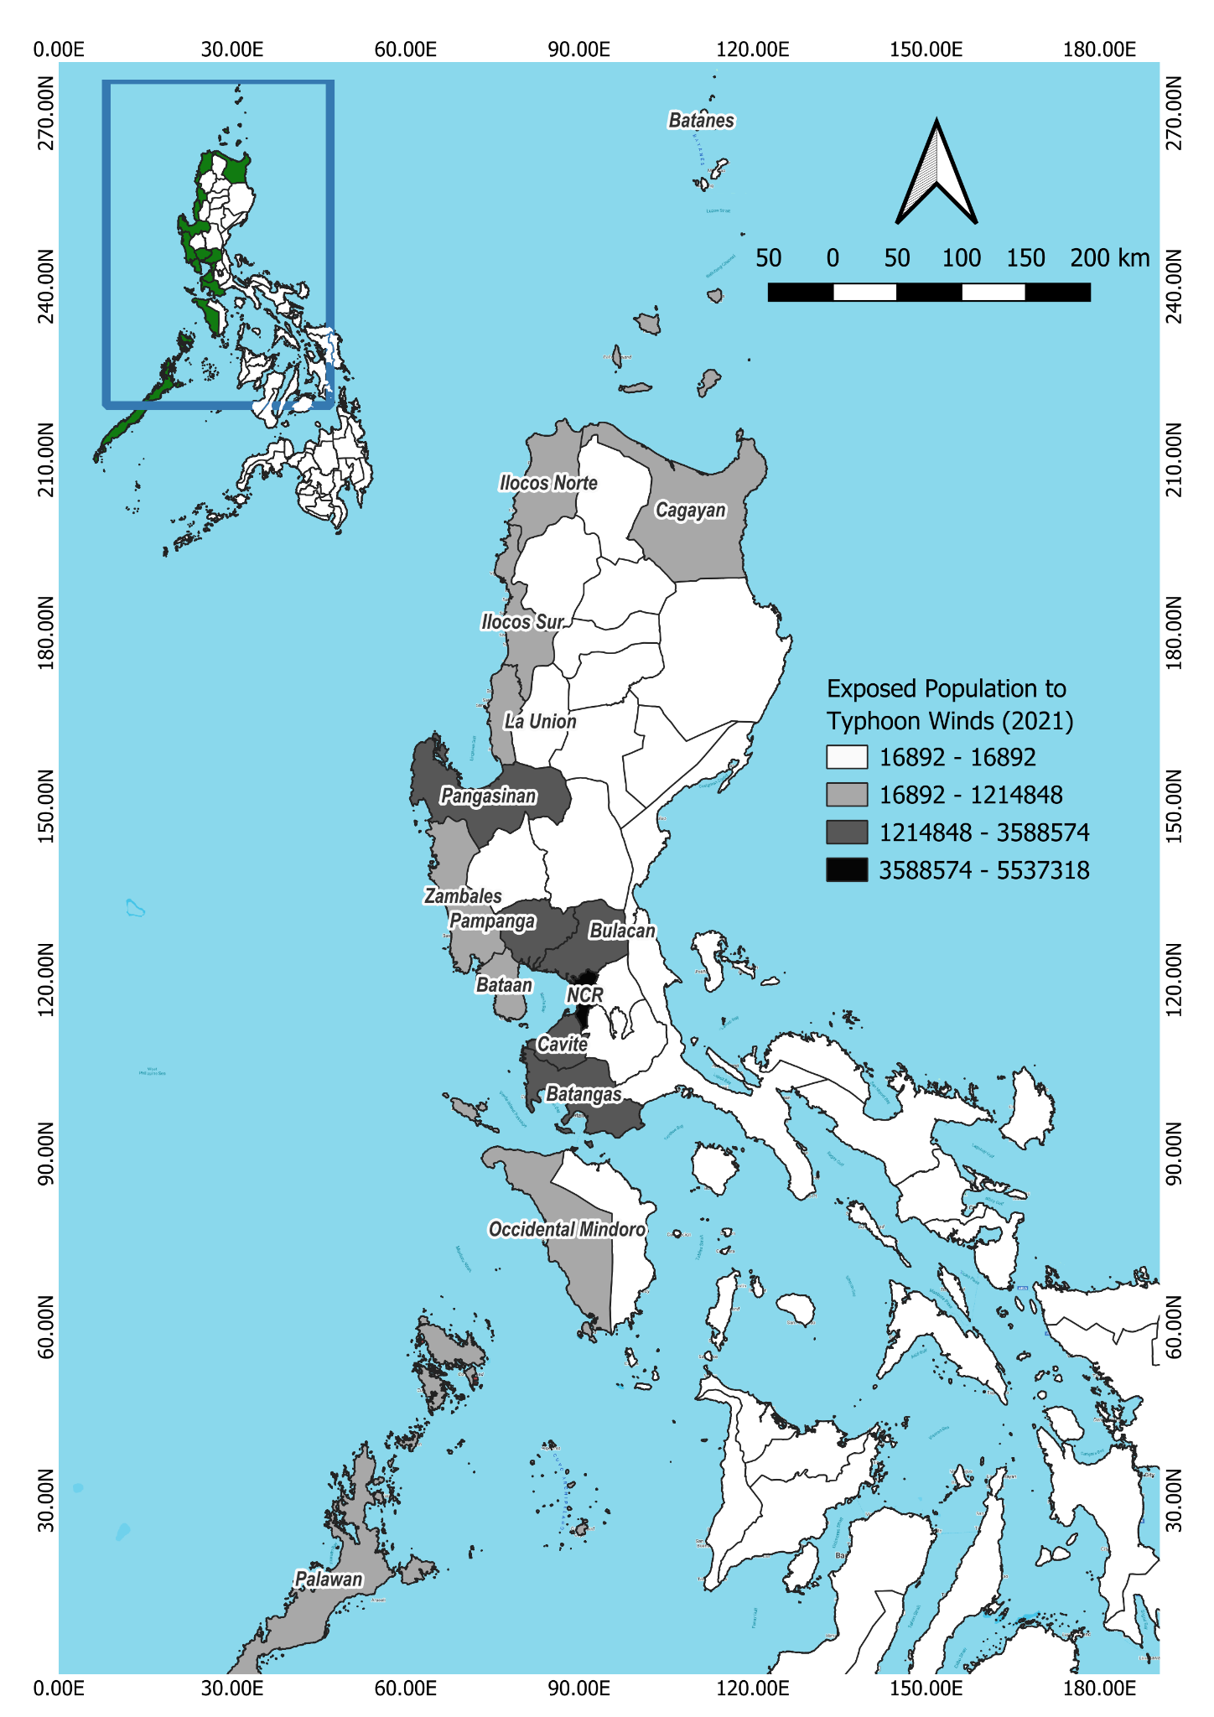
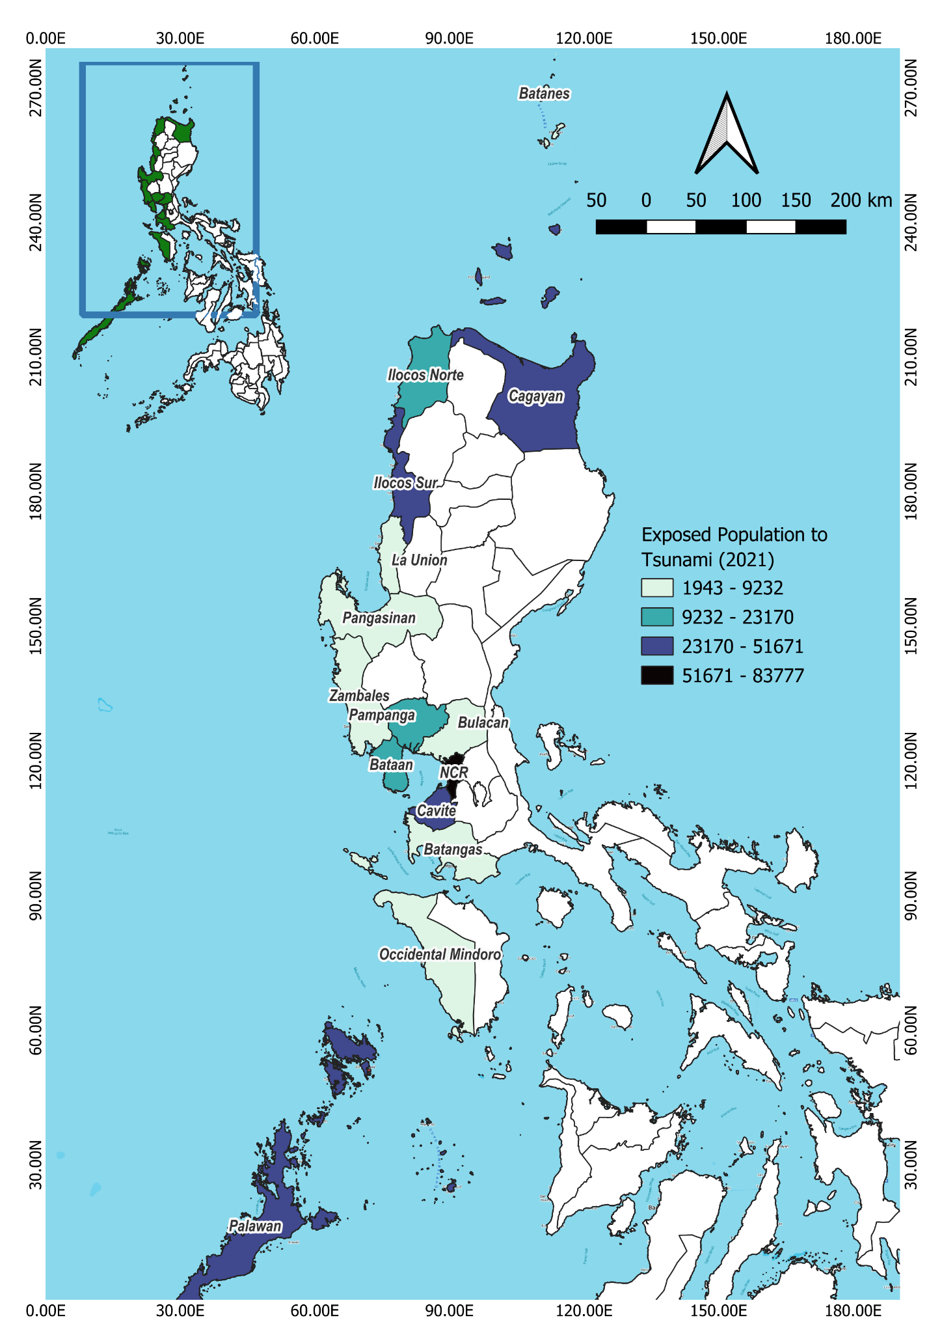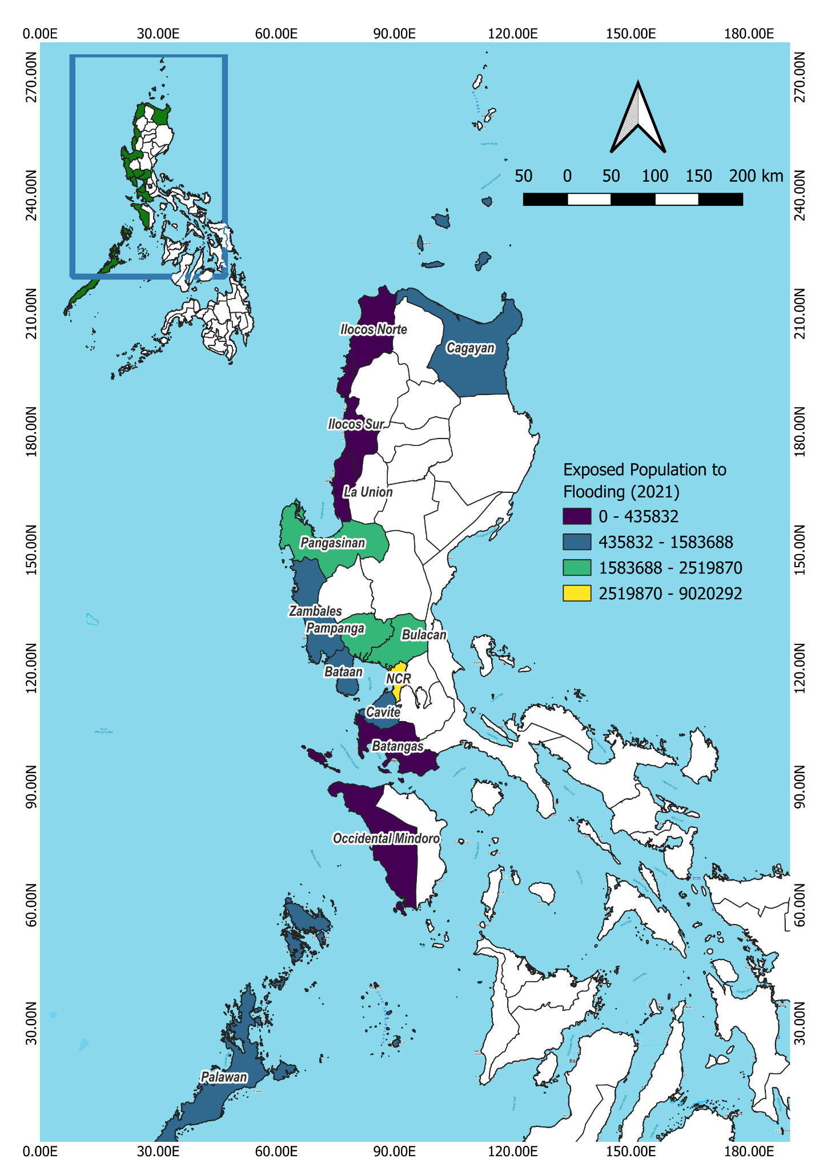

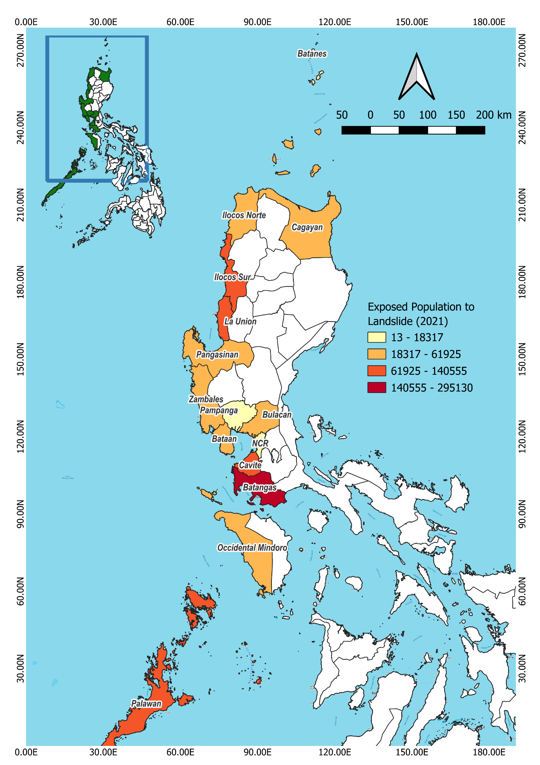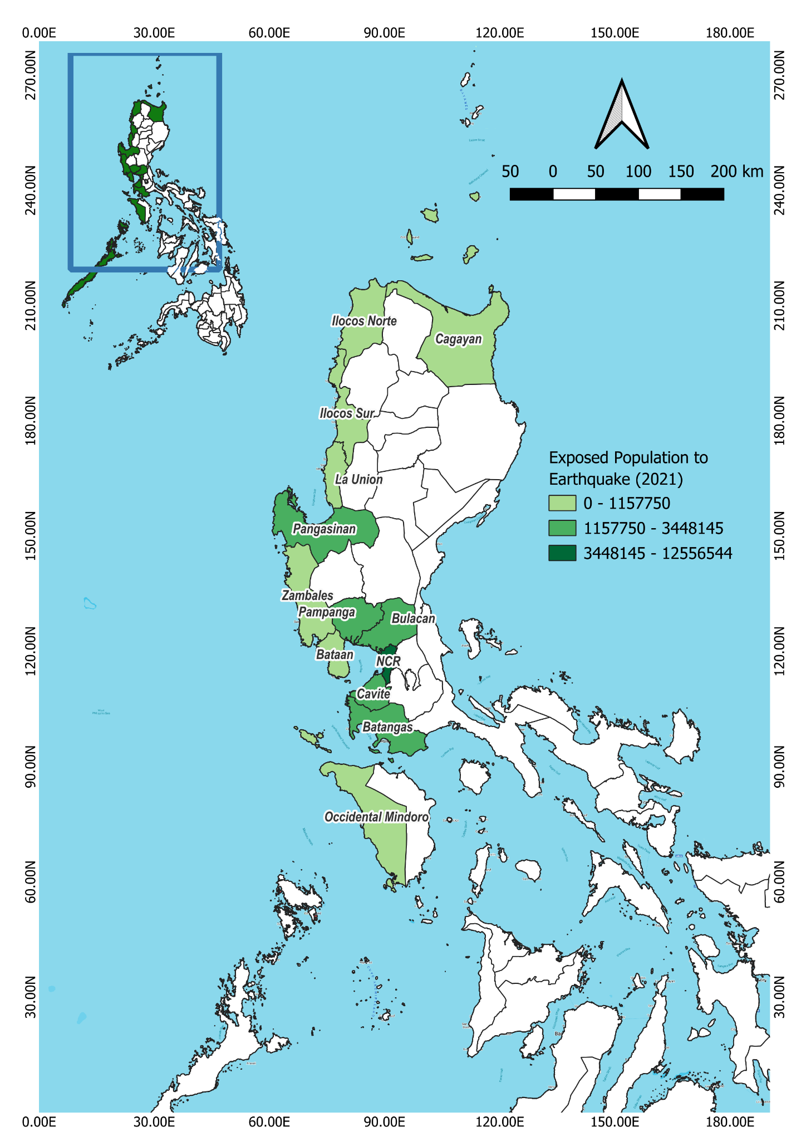
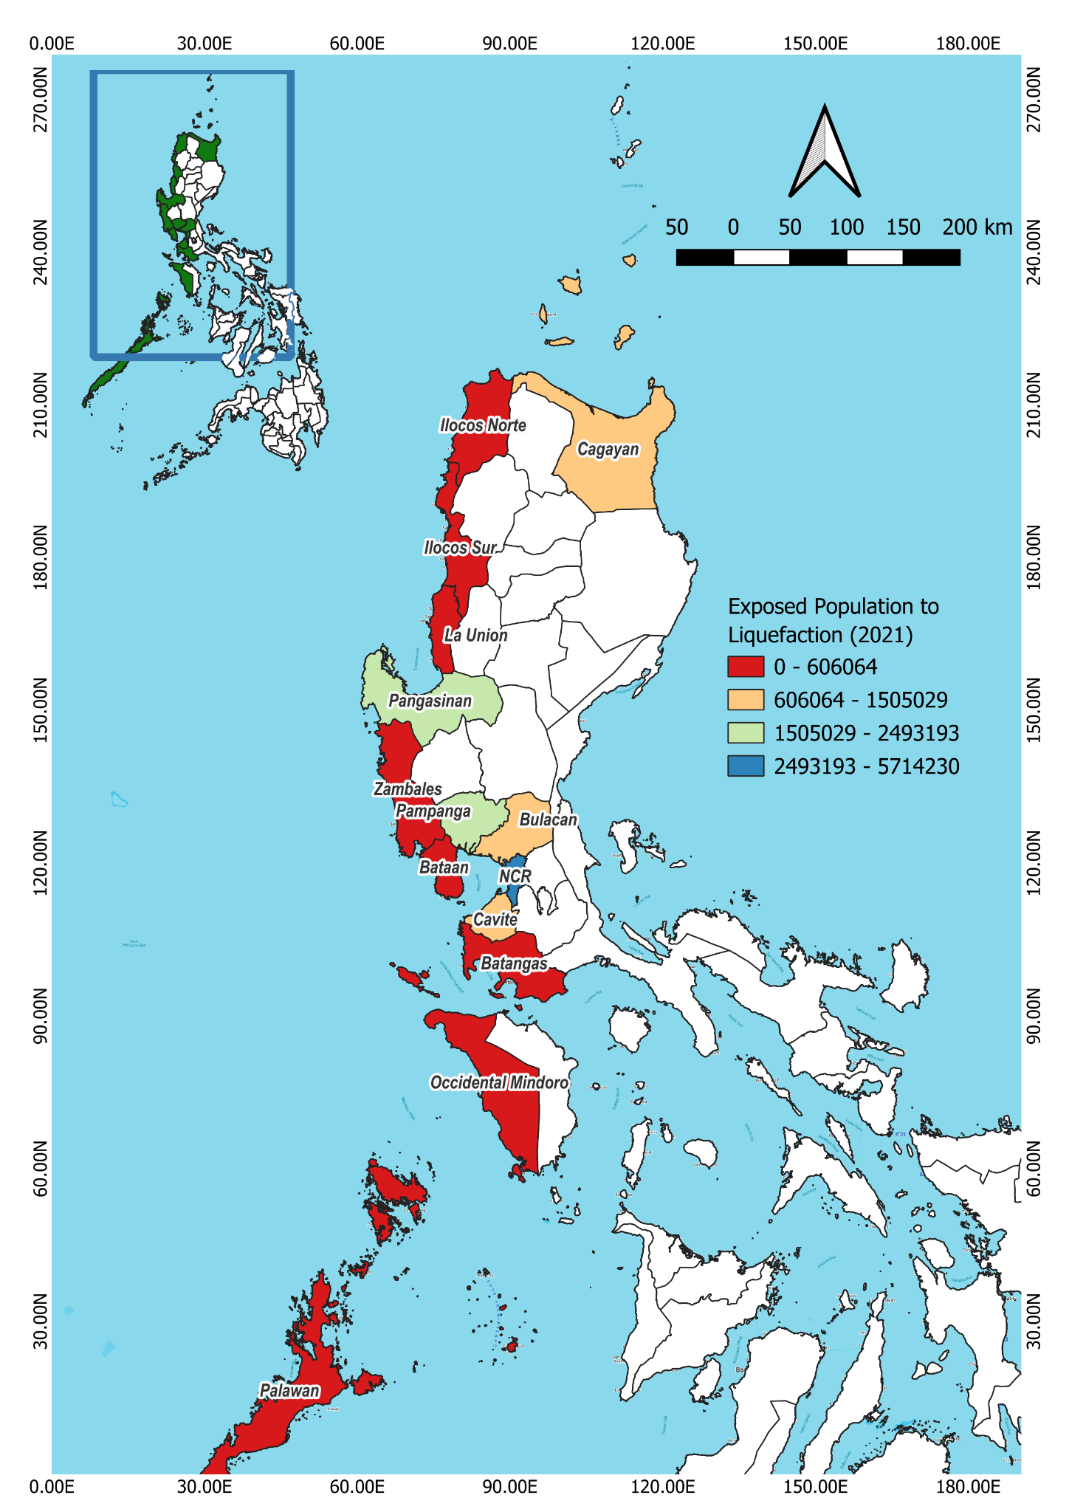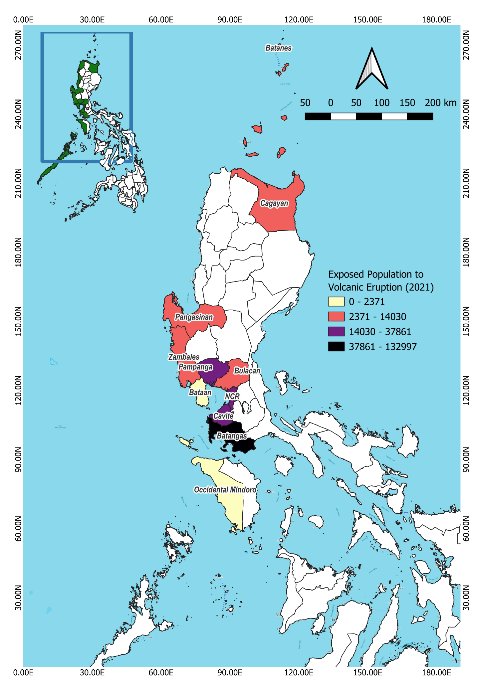

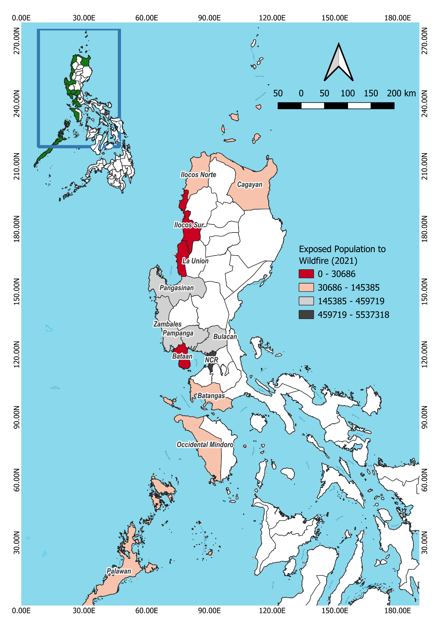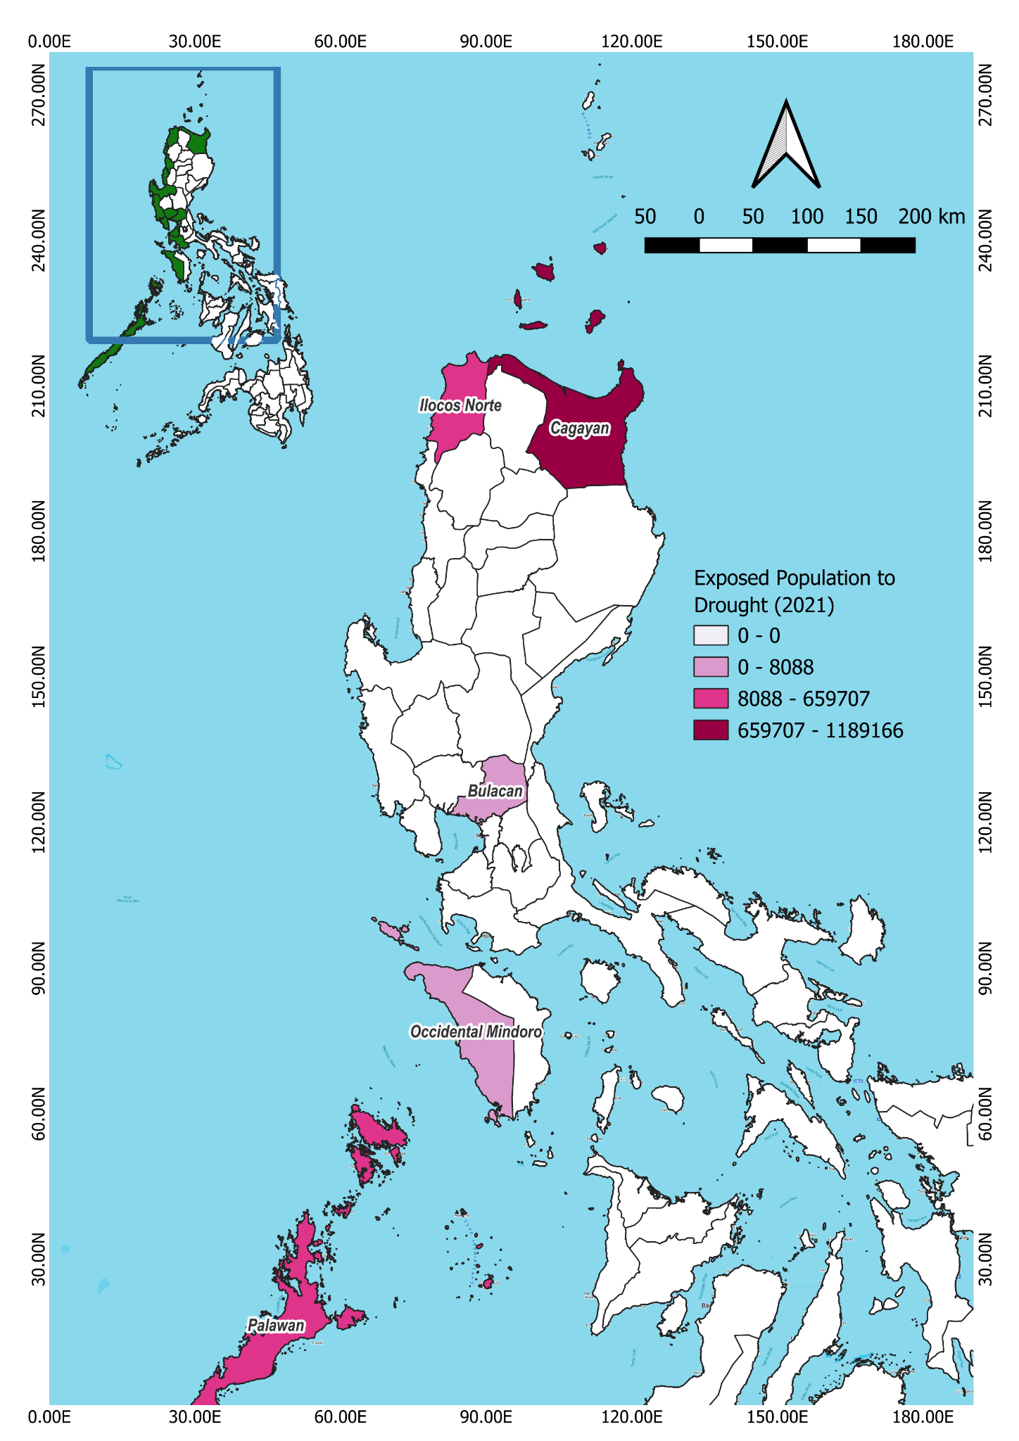
Figure 2.13. Exposed Population to Different Hazards of Localities in 2021 (Pacific Disaster Center, 2021)
Aside from natural hazards, human-induced maritime disasters such as oil spill is also evident. Localities experiencing shipping traffic and those with seaports are more prone to oil spill incidents. Hence, as seen in the figure below, NCR had the highest overall frequency of recorded oil spill.
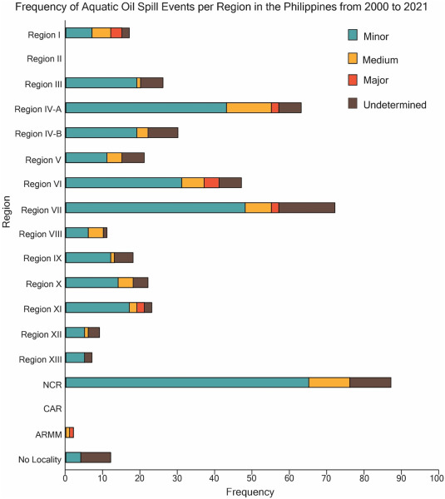
Figure 2.14. Frequency of Oil Spill Incidences Across Regions from 2000 to 2021 (Alea et al., 2022)

Climate change is also a major concern that may intensify disasters. In fact, it is expected that there will be higher average temperatures in the coming years. In Figure 2.13, the thick black line represented the baseline data from 1990 to 2020. SSP are possible future scenarios of the Philippines. SSP1-1.9 and SSP1-2.6 showed that if the country continues with its sustainability pathways, temperature increases from 0.5 °C to 1.5 °C will still be experienced at the end of the 21st century. On the other hand, if SSP3-7.0 and SSP5-8.5 happen due to continuous vast emission of greenhouse gases (GHG), temperature may increase from 2.6 °C to 4.4 °C (DOST-PAGASA, 2024). Such impacts of global warming can lead to more frequent and intense hazards and disasters.
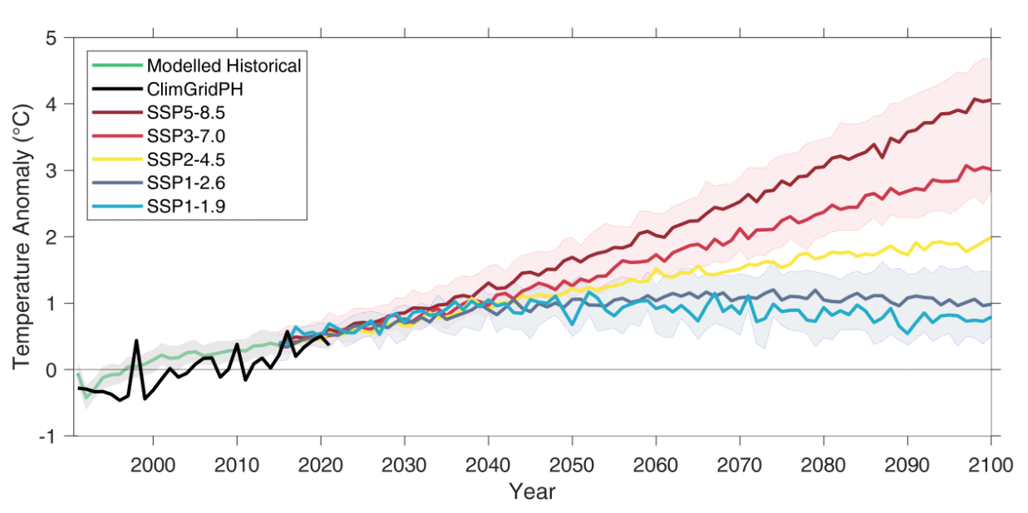
Figure 2.15. Time Series Showing the Annual Mean Temperature Anomalies in the Philippines (DOST-PAGASA, 2024)
In terms of rainfall projections, there are numerous scenarios for the Philippines. Rainfall in upper bound indicates that annual rainfall may increase to around 15% during the mid-21st century (2021-2050). Most areas in Luzon may have wetter conditions. On the other hand, for the median (50th percentile), this shows that rainfall in the country may become wetter by about 5% in comparison to 1981 to 2010. Lastly, for the lower bound (25th percentile), a projected decrease instead of about 10%-15% may be experienced across various localities. Excluding Zambales to Ilocos Sur, along with central part of Palawan, majority of Luzon cities and provinces will experience great reduction in rainfall (DOST-PAGASA, 2024). All these scenarios still pointed out a worse future due to more intense and heavy rainfall or a warmer country. Hence, disaster mitigation and preparedness efforts should be done to avoid or lessen the worse future scenarios.
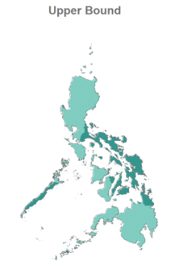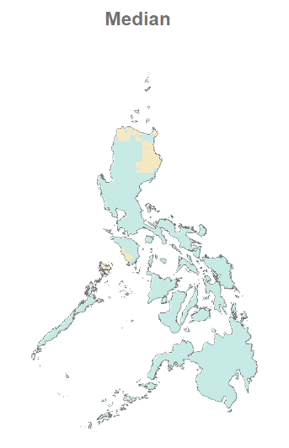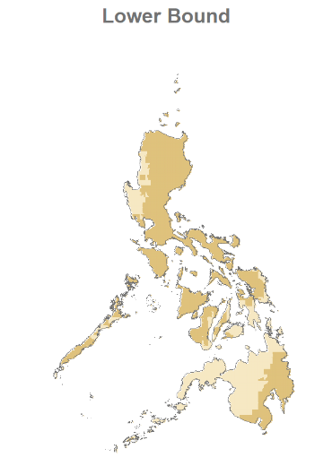
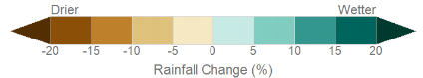
Figure 2.16. Projected Changes in Annual Rainfall from 2021 to 2050 (DOST-PAGASA, 2024)
According to Maskrey & Lavell (2023), uncontrolled and excessive urbanization, such as the NCR and its neighboring provinces, contribute to the aforementioned climate-related threats. As more people opt to live in these areas, land conversion to cater to social, economic, and infrastructure needs is being prioritized; thus, leading to environmental depletion. Furthermore, improper waste management and pollution add to the degradation of the physical environment. This can also lead to higher exposed capital as majority of economic activities are centered in the cities and urban areas (Table 2.1).
Table 2.1. Exposed Capital (in USD) Against Hazards of Localities in 2021 (Pacific Disaster Center, 2021).
Localities | Exposed Capital in million USD (2021)
Localities | Storm Surge | Typhoon Winds | Tsunami | Flooding | Landslide | Earthquake | Liquefaction | Volcanic Eruption | Wildfire | Drought
Ilocos Norte | 170.2 | 3,100 | 51.9 | 1,600 | 108.2 | 3,000 | 2,400 | NA | 353.3 | 2,900
Ilocos Sur | 1,300 | 3,600 | 59.3 | 2,300 | 217.3 | 3,500 | 3,200 | NA | 92.9 | NA
La Union | 1,200 | 4,400 | 2.4 | 2,700 | 332 | 3,800 | 3,000 | NA | 184.2 | NA
Pangasinan | 1900 | 14,900 | 7.9 | 12,600 | 166.8 | 14,700 | 12,500 | 26.3 | 1700 | NA
Cagayan | 617.7 | 8,200 | 163.1 | 6,400 | 156 | 8,000 | 7,200 | 49.4 | 499.1 | 8,200
Batanes | NA | 55.5 | 1.6 | NA | 27 | NA | NA | 19.7 | NA | NA
Zambales | 782.3 | 1,500 | 4.3 | 912.6 | 73.4 | 1,400 | 1,200 | 15.6 | 711.2 | NA
Bataan | 870.6 | 1,900 | 8.9 | 1,700 | 72.6 | 1,800 | 1,200 | 6 | 20 | NA
Pampanga | 16 | 5,500 | 5.8 | 5,500 | 25.4 | 5,500 | 4,900 | 74.8 | 682.8 | NA
Bulacan | 2,000 | 13,100 | 5.2 | 10,500 | 27.2 | 13,100 | 7,400 | 39.2 | 2,900 | 0.97
NCR | 33,700 | 5.54 | 434.5 | 119,600 | NA | 156,100 | 74,200 | 472 | NA | NA
Cavite | 1,700 | 3.59 | 32.2 | 6,300 | 101.1 | 10,300 | 4,700 | 57.8 | 6,800 | NA
Batangas | 744.7 | 6,900 | 6.6 | 0.3 | 0.3 | 6,800 | 1,200 | 290.5 | 416.5 | NA
Occidental Mindoro | 343.8 | 1,200 | 7.6 | 1,100 | 129.2 | 1,100 | 728.5 | 0.64 | 444.9 | 3.5
Palawan | 321 | 1,100 | 10.2 | 1,100 | 310.1 | NA | 679 | NA | 154 | 1,500
Legend: | High | Medium | Low | NA/No Data

2.3.3. Mitigating Socioeconomic Vulnerability from Climate-Mediated Environmental Change- Current Actions and Gaps
There were various social, economic, and environmental interconnected challenges discussed above. It showed how climate-related threats can bring huge negative social and economic impacts to various affected localities; thus, a need for mitigation measures.
The NCR and nearby provinces were the center of economic development. The majority of the industries and services were located in these areas. Increasing income and taxes paved the way for investments in information, communication, and technology (D’Acci, 2021) for better predictions on and communication of hazards and disasters. However, insufficient digital literacy (Andaya et al., 2025) hinders the effective delivery of information. Moreover, uncontrolled urbanization led to further environmental degradation. Thus, more frequent and intense disasters result in greater losses since there is little to no vegetation as natural protection against calamities (Maskrey & Lavell, 2023).
Neighboring provinces of the NCR prioritized urban green spaces (Province of Cavite, 2021). However, increasing demand for economic and residential needs due to urbanization led to land conversions. Aside from this, improper waste management may result in pollution and degradation of water resources across the country.
Eco-tourism played a vital role in increasing economic growth yet conserving the natural environment of island provinces and those situated far from the NCR. Ironically, illegal and unsustainable economic practices threaten the biodiversity and natural beauty of these places. Although ordinances such as a mining moratorium (Ticke & Lagare, 2025) are being implemented, these will not be effectively enforced without proper monitoring and evaluation.

2.3.4 Recommended Priority Actions
To strengthen current actions and resolve the challenges, the figure below was provided to better visualize recommended laws and PPAs that can be done within 20 years. This highlights the use of research to come up with baseline data and smart efforts for local communities. For instance, it can include nature-based solutions (NbS) and grassroot initiatives anchored to science, technology, and innovation (STI). Hence, modernization efforts, including infrastructure projects, were aligned with sustainability and local ecological knowledge. Moreover, regular capacitation was proposed across all sectors to ensure that people are knowledgeable and skilled on future development efforts so they can actively participate and have a sense of ownership of the proposed efforts to their communities. These would be feasible through partnerships, network-building, and strong executive-legislative support of the government.
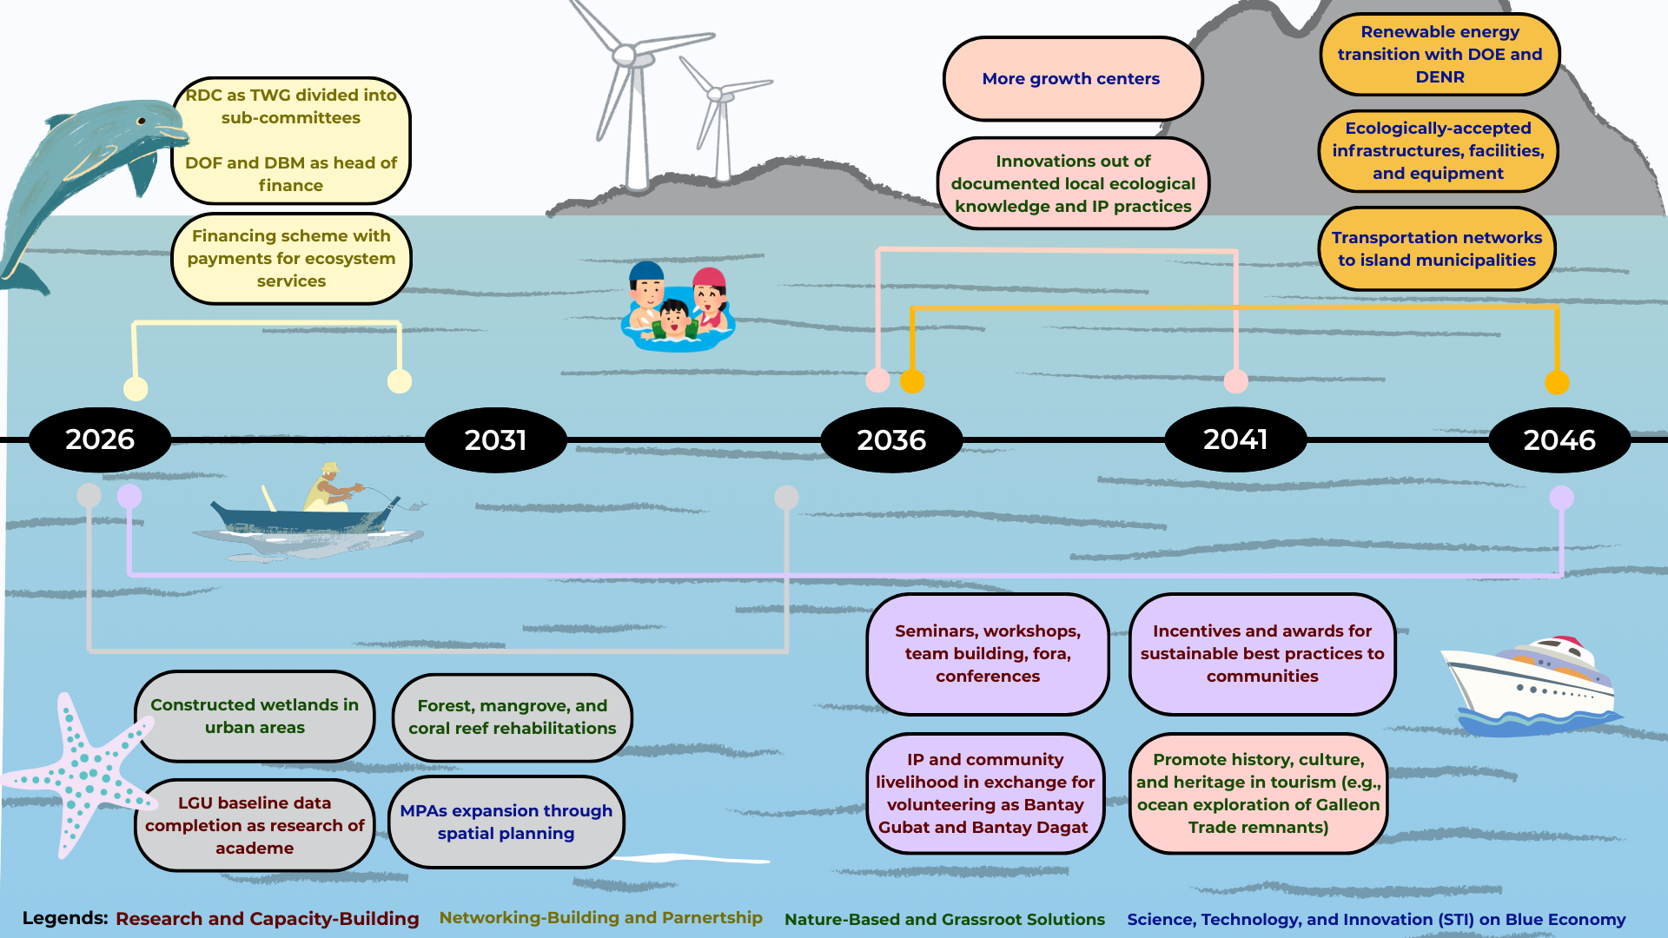
Figure 2.17. Roadmap of Recommended Priority Actions for 2026-2046

2.4 Methodology and Analysis
This chapter covered the coastal provinces along the Philippine Seas in the SCS-LME from Regions I to IV-B of the Philippines (Region I: Ilocos Norte, Ilocos Sur, La Union, Pangasinan; Region II: Cagayan, Batanes; Region III: Zambales, Bataan, Pampanga, Bulacan; NCR; Region IV-A: Cavite, Batangas; Region IV-B: Occidental Mindoro, Palawan). The sub-national unit used in the analyses is at the provincial level considering the ridge-to-reef approach, where economic activities in the upland communities affect the blue economy and vice versa.
There were given socio-economic indicators (Annex I) that should be filled out through provincial data available online. Hence, PSA, PAGASA, provincial websites, and various data searches were conducted from June to August 2025 to fill in the data requirements of the indicators. Tables (Annex II and III) and graphs were created in Google Sheets while digitized maps (Annex IV) were created through the QGIS application. These were used for better visualization of the data. Brief explanations of the figures were provided along with analysis, as supported by several studies.
Glossary
- Biodiversity Hotspot - biogeographic region with high number of classified endemic species, yet significant habitat loss
- Blue Economy - sustainable utilization of ocean resources for livelihood/ job enhancement and economic growth, yet preserving healthy ocean ecosystems, divided into the following sectors:
- Aquaculture - farming aquatic organisms within open ocean or coastal waters
- Coastal and Marine Infrastructure - institutional and physical systems that facilitate sustainable utilization of resources for economic purposes while protecting the ecosystem
- Coastal and Marine Tourism - recreational activities done in marine and coastal zones
- Deep Sea Mining - industries requiring retrieval of non-living resources below the seafloor
- Fisheries - capturing wild aquatic biological resources such as plants, shellfish, and fish
- Marine Biotechnology - developing new and important products out of marine biodiversity
- Marine Transportation - moving/ transporting people, goods, and services across seas
- Renewable Marine Energy - clean energy generation from the ocean
- Congestion - state of being crowded, clogged, or full
- Ecosystem Services - benefits that human obtain from the ecosystem, categorized into:
- Cultural Services - non-material benefits from the environment (e.g., tourism and recreation, education, research, spiritual enhancement)
- Provisioning Services - tangible products from the environment (e.g., food, water, medicine, fuel)
- Regulating Services - acquired out of the ability of the environment to regulate ecosystem processes (e.g., water purification, pest and disease control, climate and flood control)
- Supporting Services - essential support for producing the other services (e.g., soil formation, photosynthesis, nutrient cycling)
- Far-Flung Areas - very distant, remote, or difficult to reach places
- Fertility Rates - a measure of the woman’s average number of children over a lifetime
- Geographic Isolation - state where population is physically separated by barriers (e.g., mountains, rivers, oceans) that may limit flow of goods and services
- Global Warming - long-term, yet rapid increase in the average surface temperature of the Earth, mainly caused by unsustainable human activities (e.g., deforestation, burning fossil fuel)
- Grassroot Solutions - community-driven efforts to resolve development problems by using local knowledge, resources, and networks
- Greenhouse Gases - gases in the atmosphere of the Earth with the ability to trap heat coming from the sun
- Human Capital - economic value of people based on education, knowledge, skills, potential, experience, health, and other attributes that may strengthen productivity
- Human Development Index - a key metric to measure human well-being and quality of life using indicators/ elements which include per capita income, education, and life expectancy
- Indigenous Peoples - communities with deep historical and cultural ties with their ancestral lands, possessing unique history, tradition, language, knowledge, and social structures
- Local Ecological Knowledge - deeply-rooted and practical knwoledge/ understanding of the local ecosystems, the species, and the environment that communities develop through experience and cultural practices, usually passed down to generations and offer important insights for resource management efforts, conservation, and climate shift adaptation
- Nature-Based Solutions - smart and cost-effective ways of using natural processes/ nature to resolve societal concerns
- Per Capita - Latin term for “per person/ head”
- Poor Families - in the Philippines, as per Republic Act No. 8425, this refers to households with per capita income/ expenses lower than declared per capita national family poverty threshold of Php 13,873 (USD 250) per month for a family composed of 5 members
- Population Density - use to measure the number of people situated per unit of land area to assess their distribution/ crowdedness of a place
- Poverty Incidence - proportion of individuals/ families with income below poverty threshold
- Ridge-to-Reef Approach - holistic way of managing land, water, and marine resources by recognizing their interconnectedness; hence, integrated issues and efforts that should be done from mountain uplands (ridges) to coastal areas/ coral reefs
- Rural Areas - outside cities known for low population density, yet large land area for agriculture and forestry
- Tropical Cyclone - a powerful rotating storm system that forms over warm ocean waters
- Urban Areas - settlement with high population density wherein in the Philippines, as per Republic Act No. 7279, this can refer to localities with population density of at least 500 persons per square kilometer of land
Acronyms
- ASEAN - Association of Southeast Asian Nations
- CALABARZON - Cavite, Laguna, Batangas, Rizal
- CDRA - Climate and Disaster Risk Assessment
- CDP - Comprehensive Development Plan
- CLUP - Comprehensive Land Use Plan
- COVID - Coronavirus Disease
- CSOs - Civil Society Organizations
- DMB - Department of Budget and Management
- DEPDev - Department of Economy, Planning, and Development
- DOF - Department of Finance
- DOH - Department of Health
- DOST - Department of Science and Technology
- FLEMMS - Functional Literacy, Education, and Mass Media Survey
- GHG - Greenhouse Gases
- HDI - Human Development Index
- HDNFI - Human Development Network Foundation Incorporated
- ICM - Integrated Coastal Management
- IEC - Information, Communication, and Education
- LDIP - Local Development Investment Program
- NCR - National Capital Region
- NEDA - National Economic and Development Authority
- NLUA - National Land Use Act
- PAGASA - Philippine Atmospheric, Geophysical and Astronomical Services Administration
- PPAs - Programs, projects, and activities
- PSA - Philippine Statistics Authority
- QGIS - Quantum Geographic Information System
- RDC - Regional Development Council
- SCS-LME - South China Sea Large Marine Ecosystem
- SDGs - Sustainable Development Goals
- STI - Science, Technology, and Innovation
- TC - Tropical Cyclone
- UNDP - United Nations Development Programme
Declaration of competing interest
The authors declare no conflicts of interest influencing the design, conduct, or interpretation of this work.
Acknowledgments
The authors acknowledge the support from the Society for the Conservation of Philippine Wetlands (SCPW), Inc. and the Department of Community and Environmental Resource Planning (DCERP) Geomatics Lab of the University of the Philippines Los Banos. The authors would like to thank the national government agencies, particularly PAG-ASA and PSA, for providing us our requested data.
Author Contributions
- C.B.A.: conceptualization, formal analysis, methodology, supervision, validation, writing – original draft, writing – review and editing
- M.J.J.A.: data curation, formal analysis, investigation, methodology, project administration, validation, visualization, writing – original draft, writing – review and editing

Chapter 2 References
Adriano, L. (2024). Ilocos Norte sustains tag as among ‘least poor province’ in PH. Philippine News Agency. https://www.pna.gov.ph/articles/1230652
Adriano, L. (2024). 364 families evacuate in Ilocos Norte due to ‘Kristine’. Philippine News Agency. https://www.pna.gov.ph/articles/1236279#:~:text=By%20Leilanie%20Adriano,(international%20name%3A%20Trami).
Agaton, C. B., Ancheta, M. J. J., Paraiso, K. A. H., Palomares, Z. F., & Sabo-o, A. J. M. (2025). Phenomenological Analysis of The Economic Impacts of a Coastal Disaster on The Tourism Sector of Pola, Oriental Mindoro. In BIO Web of Conferences (Vol. 176, p. 01005). EDP Sciences. https://doi.org/10.1051/bioconf/202517601005
Alea, C., Ruiz, C. I., Yap, J. B., Molina, E. F., Saballa, A. J., Ñuneza, J. S., & Bacharo, K. B. B. (2022). An investigation of aquatic oil spills in the Philippines from 2000 to 2021. Marine Pollution Bulletin, 185, 114241. https://doi.org/10.1016/j.marpolbul.2022.114241
Andaya, E., Orlina, R. J., & Ilustre, R. (2025). Digital governance in the Philippines: a scoping review of current challenges and opportunities. Global Sustainability Research, 4(1), 10-56556. https://doi.org/10.56556/gssr.v4i1.1204
Angeles-Agdeppa, I., Javier, C. A., Duante, C. A., & Maniego, M. L. V. (2022). Impacts of COVID-19 pandemic on household food security and access to social protection programs in the Philippines: findings from a telephone rapid nutrition assessment survey. Food and Nutrition Bulletin, 43(2), 213-231. https://doi.org/10.1177/03795721221078363
Aquino, J. O., Sanchez, P. A. J., & Roa, U. F. A. (2023). Experiences, Challenges, and Initiatives on Water Resource Management of a Small Island Community: The Case of Basco, Batanes, Philippines. https://doi.org/10.54645/202316SupESZ-63
Argosino, F. (2024). 21 dead after Typhoon Gaemi pounds the Philippines. Philippine Daily Inquirer. https://asianews.network/21-dead-after-typhoon-gaemi-pounds-the-philippines/#:~:text=READ%3A%20More%20Luzon%20areas%20under,died%20from%20drowning%20and%20electrocution.
Ayoo, C. (2022). Poverty reduction strategies in developing countries. Rural development-education, sustainability, multifunctionality, 19.
Baccay, O. T. (2024). ‘Enteng’ leaves Cagayan Valley with zero casualty. Philippine Information Agency. https://pia.gov.ph/enteng-leaves-cagayan-valley-with-zero-casualty/#:~:text=TUGUEGARAO%20CITY%2C%20Cagayan%20(PIA),reported%20casualties%20or%20major%20damage.
Borzoiepour, S., Alizadeh, G., Jafary, H., & Zarnaq, R. K. (2024). Identify Affecting Factors on Total Fertility Rate: A Systematic Review. Health Scope, 13(3).
Chavez, P. (2024). Death toll in hard-hit Batangas province reaches 59. Philippine News Agency. https://www.pna.gov.ph/articles/1236509#:~:text=BATANGAS%20CITY%20%E2%80%93%20The%20death%20toll,missing%20and%2018%20were%20injured.
Choi, S. (2021). Urban/rural disparities in the wage effect of additional vocational education after formal education: the case of the Philippines. International Journal of Training Research, 19(3), 229–241. https://doi.org/10.1080/14480220.2021.1935296
CRED/UC Louvain. (2025). Public EM-DAT. https://public.emdat.be/
Citizens Disaster Response Center. (2024). Typhoon Marce (I.N. Yinxing) Situation Report. https://www.cdrc-phil.com/typhoon-marce-i-n-yinxing-situation-report/
Corrales, N. (2024). Kristine death toll hits over 40 as damage widens. Philippine Daily Inquirer. https://newsinfo.inquirer.net/1997598/kristine-death-toll-hits-over-40-as-damage-widens
Czaika, M., & Reinprecht, C. (2022). Migration drivers: Why do people migrate. Introduction to migration studies: An interactive guide to the literatures on migration and diversity, 49-82.
D’Acci, L. S. (2021). Preferring or Needing Cities? (Evolutionary) psychology, utility and life satisfaction of urban living. City, Culture and Society, 24. https://doi.org/10.1016/j.ccs.2021.10037 5
Delizo, M. (2024). 2 dead in Cavite as ‘Kristine’ causes widespread flooding. ABS-CBN News. https://www.abs-cbn.com/regions/2024/10/25/2-dead-in-cavite-as-kristine-causes-widespread-flooding-2314
Department of Health. (2024). COVID-19 Case Tracker. https://doh.gov.ph/diseases/covid-19/covid-19-case-tracker/
Department of Science and Technology-Philippine Atmospheric, Geophysical, and Astronomical Services Administration. (2024). CMIP6-Based Climate Change Projections in the Philippines. https://www.pagasa.dost.gov.ph/climate/climate-change/dynamic-downscaling
Department of Science and Technology-Philippine Atmospheric, Geophysical, and Astronomical Services Administration. (2025). Tropical Cyclone Information. https://www.pagasa.dost.gov.ph/climate/tropical-cyclone-information
Deziel, N. C., Warren, J. L., Bravo, M. A., Macalintal, F., Kimbro, R. T., & Bell, M. L. (2023). Assessing community-level exposure to social vulnerability and isolation: spatial patterning and urban-rural differences. Journal of exposure science & environmental epidemiology, 33(2), 198-206. https://doi.org/10.1038/s41370-022-00435-8
Dodman, D., B. Hayward, M. Pelling, V. Castan Broto, W. Chow, E. Chu, R. Dawson, L. Khirfan, T. McPhearson, A. Prakash, Y. Zheng, and G. Ziervogel. (2023). Cities, Settlements and Key Infrastructure. Climate Change, 907–1040. https://doi:10.1017/9781009325844.008.
Fache, E., Pauwels, S. (2022). The ridge-to-reef approach on Cicia Island, Fiji. Ambio 51, 2376–2388. https://doi.org/10.1007/s13280-021-01669-w
Grundy, J., Wang, X., Hirabayashi, K.C. Duncan, R., Bersonda, D., Eltayeb, A. O., Mindra, G., & Nandy, R. (2019). Health and immunisation services for the urban poor in selected countries of Asia. Infect Dis Poverty 8, 26. https://doi.org/10.1186/s40249-019-0538-4
Gu, D., Andreev, K., & Dupre, M. E. (2021). Major trends in population growth around the world. China CDC weekly, 3(28), 604. https://doi.org/10.46234/ccdcw2021.160
Hadlos, A., Opdyke, A., & Hadigheh, S. A. (2023). Deriving expert-driven seismic and wind fragility functions for non-engineered residential typologies in Batanes, Philippines. Scientific Reports, 13(1). https://doi.org/10.1038/s41598-023-49398-2
Human Development Network Foundation Incorporated. (2021). Philippine Human Development Report 2020/21. chrome-extension://efaidnbmnnnibpcajpcglclefindmkaj/https://hdr.undp.org/system/files/documents/national-report-document/philippinesnhdr2020-21en.pdf
Kennedy, C. M., Fariss, B., Oakleaf, J. R., Garnett, S. T., Fernandez-Llamazares, A., Fa, J. E., Baruch-Mordo, S., & Kiesecker, J. (2023). Indigenous Peoples’ lands are threatened by industrial development; conversion risk assessment reveals need to support Indigenous stewardship. One Earth, 6(8), 1032-1049. https://doi.org/10.1016/j.oneear.2023.07.006
Lagundimao, R. M.B., Bosto, J.P., Yu, S.W.J., Navarro, M.M., Tenerife, J.T., Panganiban, R.M.M., Serrano, A.S. (2024). Productivity Loss Factors in NCR Commuters Amidst Traffic Congestion: Exploring through Factor Analysis and Structural Equation Modeling. In M. Shelley & O. T. Ozturk (Eds.), Proceedings of ICRES 2024-- International Conference on Research in Education and Science (pp. 1477-1504), Antalya, Turkiye. ISTES. (PDF) Productivity Loss Factors in NCR Commuters Amidst Traffic Congestion: Exploring through Factor Analysis and Structural Equation Modeling. https://www.researchgate.net/publication/389166074_Productivity_Loss_Factors_in_NCR_Commuters_Amidst_Traffic_Congestion_Exploring_through_Factor_Analysis_and_Structural_Equation_Modeling#fullTextFileContent.
Laino, E., & Iglesias, G. (2023). Scientometric review of climate-change extreme impacts on coastal cities. Ocean & Coastal Management, 242, 106709. https://doi.org/10.1016/j.ocecoaman.2023.106709
Lavado, R. F., Nowacka, K., Raitzer, D. A., Rodgers, Y. V. D. M., & Zveglich Jr, J. E. (2022). COVID‐19 disparities by gender and income: Evidence from the Philippines. International labour review, 161(1), 107-123. https://doi.org/10.1111/ilr.12226
Limbo-Dizon, J. E., & Dagamac, N. H. A. (2023, April). Assessment of coastal change detection on an urban coastline: A case study in metropolitan Manila, Philippines. In IOP Conference Series: Earth and Environmental Science (Vol. 1165, No. 1, p. 012015). IOP Publishing. https://doi.org/10.1088/1755-1315/1165/1/012015
Macusi, E. S., Sales, A. C., Macusi, E. D., Bongas, H. P., Cayacay, M. A., Omandam, J. L., Schüler, M., & Vidal, C. (2023). Indigenous knowledge systems and practices (IKSPs), livelihood resources and aspirations of the Matigsalog and Ata tribes. Sustainability, 15(14), 11182. https://doi.org/10.3390/su151411182
Mallari, D. T., Jr., Gascon, M., & Loreto, R. P. (2024). Aghon death toll at 7; Marcos says 6 regions hardest hit. Philippine Daily Inquirer. https://newsinfo.inquirer.net/1945954/aghon-death-toll-at-7-marcos-says-6-regions-hardest-hit
Manegdeg, R. F. G., Regunay, J. M., & Magnaye, D. C. (2024). An Examination of the Decision of Microentrepreneurs to Remain in Urban Flood-prone Areas in Marikina City, Metro Manila (NCR), Philippines. Environment and Urbanization ASIA, 15(2), 298-314. https://doi.org/10.1177/09754253241278773
Maskrey, A., & Lavell, A. (2023). The urbanisation of risk. In Urbicide: The death of the city (pp. 235-261). Cham: Springer International Publishing. https://doi.org/10.1007/978-3-031-25304-1
Mishra, R., Gupta, J., & Verma, A. (2025). Anthropogenic climate change and the escalating vulnerability of coastal communities. In Geometrical Enhancements Based on Data-Driven Design Decisions (pp. 171-184). CRC Press. https://doi.org/10.1201/9781003621102-11
Morante-Carballo, F., Pinto-Ponce, B., Santos-Baquerizo, E., Briones-Bitar, J., Berrezueta, E., & Carrión-Mero, P. (2024). Systematic Review on Seismic Hazards in the Coastal Regions of the Pacific Ring of Fire. International Journal of Safety & Security Engineering, 14(5), 1591-1605. https://doi.org/10.18280/ijsse.140526
Moro, E., Calacci, D., Dong, X., & Pentland, A. (2021). Mobility patterns are associated with experienced income segregation in large US cities. Nature communications, 12(1), 4633. https://doi.org/10.1038/s41467-021-24899-8
Narwal, S., Kaur, M., Yadav, D. S., & Bast, F. (2024). Sustainable blue economy: Opportunities and challenges. Journal of Biosciences, 49(1), 18. https://doi.org/10.1007/s12038-023-00375-x
National Economic and Development Authority. (2021). Chapter 3: Overlay of Economic Growth, Demographic Trends, and Physical Characteristics. chrome-extension://efaidnbmnnnibpcajpcglclefindmkaj/https://pdp.depdev.gov.ph/wp-content/uploads/2021/12/Chapter-03.pdf
National Statistical Coordination Board. (2013). 2012 Full Year Official Poverty Statistics. chrome-extension://efaidnbmnnnibpcajpcglclefindmkaj/https://psa.gov.ph/system/files/main-publication/Report%2520on%2520the%25202012%2520Full%2520Year%2520Poverty%2520Statistics_0_0.pdf
NewsWatch Plus Philippines. (2024). 12-year-old girl reported dead amid Typhoon Marce.
Ombay, G. (2024). 1 reported dead due to Marce - NDRRMC. GMA Integrated News. https://www.gmanetwork.com/news/topstories/nation/926544/1-reported-dead-due-to-marce-ndrrmc/story/#:~:text=By%20GISELLE%20OMBAY%2C%20GMA%20Integrated,Marce%20causes%20devastation%20in%20Cagayan
Pacific Disaster Center. (2021). NDPBA Philippines Province Risk Profiles: Subnational Assessment Results. chrome-extension://efaidnbmnnnibpcajpcglclefindmkaj/https://www.pdc.org/wp-content/uploads/NDPBA-PHL-Province-Profile-New-Merged-compressed.pdf
Pascual, L. J. H., Domingo, S. N., & Manejar, A. J. A. (2022). Implications of Lifting the Open-Pit Mining Ban in the Philippines (No. 2022-60). PIDS Discussion Paper Series. chrome-extension://efaidnbmnnnibpcajpcglclefindmkaj/https://pidswebs.pids.gov.ph/CDN/document/pidsdps2260.pdf
Peralta-Malonzo, T. A. (2024). 5 dead due to ‘Julian’ onslaught. SunStar. https://www.sunstar.com.ph/manila/5-dead-due-to-julian-onslaught#:~:text=In%20a%20situational%20report%20on,Ana%2C%20Cagayan%20due%20to%20electrocution.
Philippine Daily Inquirer. (2024). Ilocos Norte under calamity state due to Julian. https://newsinfo.inquirer.net/1988803/ilocos-norte-under-calamity-state-due-to-julian
Philippine Statistics Authority. (2018). Updated 2015 and 2018 Full Year Poverty Statistics. https://psa.gov.ph/statistics/poverty/stat-tables/released/Updated%202015%20and%202018%20Full%20Year%20Poverty%20Statistics
Philippine Statistics Authority. (2020). Gender and Special Population Groups; Provincial Human Development Index. https://openstat.psa.gov.ph/PXWeb/pxweb/en/DB/DB__3E__CH__IP/0023E3D2080.px/?rxid=5bf7d5c2-1a5c-4991-a66d-5a3e07689377
Philippine Statistics Authority. (2021). Highlights of the Philippine Population 2020 Census of Population and Housing (2020 CPH). https://psa.gov.ph/content/highlights-philippine-population-2020-census-population-and-housing-2020-cph
Philippine Statistics Authority. (2021). Official Poverty Statistics of the Philippines: Preliminary 2021 Full Year. chrome-extension://efaidnbmnnnibpcajpcglclefindmkaj/https://psa.gov.ph/system/files/phdsd/2023-01/Preliminary%25202021%2520Full%2520Year%2520Poverty%2520Statistics%2520Publication_25Aug2022.pdf
Philippine Statistics Authority. (2022). Age and Sex Distribution in the Philippine Population (2020 Census of Population and Housing. https://psa.gov.ph/content/age-and-sex-distribution-philippine-population-2020-census-population-and-housing
Philippine Statistics Authority. (2023). 2023 Philippine Statistical Yearbook. https://psa.gov.ph/philippine-statistical-yearbook
Philippine Statistics Authority. (2023). Preliminary 2023 First Semester: Poverty Statistics. chrome-extension://efaidnbmnnnibpcajpcglclefindmkaj/https://psa.gov.ph/sites/default/files/infographics/Preliminary%202023%20First%20Semester%20Poverty%20Statistics.pdf
Philippine Statistics Authority. (2023). Official Poverty Statistics of the Philippines: 2023 Full Year. chrome-extension://efaidnbmnnnibpcajpcglclefindmkaj/https://psa.gov.ph/sites/default/files/phdsd/2023%20FY%20Official%20Poverty%20Statistics%20Publication_15August2024.pdf
Philippine Statistics Authority. (2024). 11 out of 18 Regions Recorded Significant Decreases in Poverty Incidence in 2023. https://psa.gov.ph/statistics/poverty/node/1684064929#:~:text=Poverty%20Threshold,poverty%20threshold%20at%20PhP%2012%2C241.
Philippine Statistics Authority. (2024). 2024 FLEMMS Statistical Tables Press Release 2. https://psa.gov.ph/system/files/sdsd/2024%20FLEMMS%20Statistical%20Tables%20Press%20Release%202.xlsx
Philippine Statistics Authority. (2025). National Capital Region (NCR). https://psa.gov.ph/classification/psgc/citimuni/1300000000
Qori'atunnadyah, M. (2023). Fuzzy C-Means for Regional Clustering in East Java Province Based on Human Development Index Indicators. J Statistika: Jurnal Ilmiah Teori dan Aplikasi Statistika, 16(2), 524-534. https://doi.org/10.36456/jstat.vol16.no2.a8240
Reyes, D., & Corrales, N. (2024). Storm Yagi leaves 15 dead, 21 missing, over 500,000 people affected in the Philippines. Philippine Daily Inquirer. https://asianews.network/storm-yagi-leaves-15-dead-21-missing-over-500000-people-affected-in-philippines/#:~:text=Cesar%20Idio%2C%20OCD%20operations%20service,in%20Negros%20Occidental%2C%20Idio%20said.
Rita, J. (2024). NDRRMC: 5 reported dead due to Julian. GMA Integrated News. https://www.gmanetwork.com/news/topstories/nation/922573/ndrrmc-5-reported-dead-due-to-julian/story/#:~:text=In%20its%20report%2C%20the%20NDRRMC,year%2Dold%20male%20in%20Sta.
Sart, G., Bayar, Y., & Danilina, M. (2024). Impact of education and income inequalities on life expectancy: insights from the new EU members. Frontiers in Public Health, 12, 1397585. https://doi.org/10.3389/fpubh.2024.1397585
Serquiña, M. C. (2024). 1 reported dead in Camarines Norte due to Super Typhoon Pepito. GMA Integrated News. https://www.gmanetwork.com/news/topstories/regions/927344/1-reported-dead-in-camarines-norte-due-to-super-typhoon-pepito/story/#:~:text=1%20reported%20dead%20in%20Camarines,Pictures
Sioson, C. D. (2022). Highlights of the 2021 Full Year Official Poverty Statistics. Philippine Statistics Authority. chrome-extension://efaidnbmnnnibpcajpcglclefindmkaj/https://psa.gov.ph/system/files/phdsd2023-01/3-Highlights%2520of%2520the%25202021%2520Full%2520Year%2520Official%2520Poverty%2520Statistics%252C%252012Aug2022_0.pdf
Sowińska-Świerkosz, B., & García, J. (2022). What are Nature-based solutions (NBS)? Setting core ideas for concept clarification. Nature-Based Solutions, 2, 100009. https://doi.org/10.1016/j.nbsj.2022.100009
Supsup, C. E., Asis, A. A., Eslava, M. R. R., Domingo, J. P. S., Amarga, A. K. S., Carestia Jr, U. V., Cantil, J.A., delos Angeles, M.D., & Acosta-Lagrada, L. S. (2023). Revisiting environmental management zones toward conserving globally important species in western Philippines. Journal for Nature Conservation, 73, 126415. https://doi.org/10.1016/j.jnc.2023.126415
Talubo, J. P. P., & Saroj, D. (2019). Looking at Disaster Resilience through an Interdisciplinary Lens: The Case of Batanes, Philippines. In Proceedings of the International Conference on Natural Hazards and Infrastructure. National Technical University of Athens. https://www.researchgate.net/publication/359734662_Looking_at_Disaster_Resilience_through_an_Interdisciplinary_Lens_The_Case_of_Batanes_Philippines_-_Presented_at_the_2nd_International_Conference_on_Natural_Hazards_Infrastructure_23-26_June_2019_Chani#fullTextFileContent
Ticke, G., & Lagare, J. B. (2025). Palawan imposes 50-year mining moratorium. Philippine Daily Inquirer. https://newsinfo.inquirer.net/2041339/palawan-imposes-50-year-mining-moratorium
Tsilimigkas, G., Deligianni, M., & Zerbopoulos, T. (2016). Spatial typologies of Greek coastal zones and unregulated Urban growth. Journal of Coastal Conservation, 20(5), 397-408. https://doi.org/10.1007/s11852-016-0453-9
Tumbaga, J. R. A., Hipolito, M. C., & Gabriel, A. G. (2021). Community participation toward biodiversity conservation among protected areas in Pangasinan, Philippines. Environment, Development and Sustainability, 23(3), 4698-4714. https://doi.org/10.1007/s10668-020-00705-1
Tupas, E. (2024). PNP: Carina death toll climbs to 21. The Philippine Star. https://www.philstar.com/headlines/2024/07/26/2373100/pnp-carina-death-toll-climbs-21
Wulandari, R. D., Laksono, A. D., & Rohmah, N. (2021). Urban-rural disparities of antenatal care in South East Asia: a case study in the Philippines and Indonesia. BMC Public Health, 21(1). https://doi.org/10.1186/s12889-021-11318-2
Zhou, Y., & Huang, H. (2023). Geo-environmental and socioeconomic determinants of poverty in China: an empirical analysis based on stratified poverty theory. Environmental Science and Pollution Research, 30(9), 23836-23850. https://doi.org/10.1007/s11356-022-23839-3

Chapter 2 Annexes

Annex 2.A. List of Indicators
Table 2.A.1. List of Demographic Indicators
SC1 Demographics | Components
SE1-1.  Subnational Population | Number of Female Households
SE1-1.  Subnational Population | Number of Male Households
SE1-1.  Subnational Population | Total Households
SE1-1.  Subnational Population | Total Population
SE1-1.  Subnational Population | Growth Rate
SE1-2. Areas of Subnational First Level Administrative Region | Total Land Area (sq km)
SE1-3. Subnational Populations as % of National Population | % to Philippine Population
SE1-4. Subnational Region Areas as % of National Area | % to Philippines' Total Land Area (sq km)
SE1-5. Annual Population Changes | % Annual Change in the Population
SE1-6. Population Densities | Population Density (people/ sq km)
SE1-10 Urbanization Rate
SE1-11 Built Up Surface | Total Floor Area of Contruction (sq km)
Table 2.A.2. List of Human Well-Being Indicators
SC2 Human Well-being | Components
SE2.1 Poverty | Poverty Incidence Among Families (%)
SE2.2 Contemporary Human Development Index | HDI | Level of Literacy (Illiterate, Low Literate, Basic Literate)
SE2.2 Contemporary Human Development Index | HDI | HDI Value and Classification
Table 2.A.3. List of Blue Economy Indicators
SC3 Blue Economy | Components
SE3.1. Subnational Regional GDP by Economic Sector (Agriculture, Manufacturing, Services) | Agriculture, Forestry, and Fisheries Value Added at Current Price
 | Manufacturing Value Added at Current Price | Manufacturing
 | Manufacturing Value Added at Current Price | Mining and Quarrying
 | Manufacturing Value Added at Current Price | Electricity, Steam, Water, and Waste Management
 | Manufacturing Value Added at Current Price | Construction
 | Services Value Added at Current Price | Wholesale and Retail Trade, Repair of Motor Vehicles and Motorcycles
 | Services Value Added at Current Price | Transportation and Storage
 | Services Value Added at Current Price | Accommodation and Food Service Activities
 | Services Value Added at Current Price | Information and Communication
 | Services Value Added at Current Price | Financial and Insurance Activities
 | Services Value Added at Current Price | Real Estate and Ownership of Dwellings
 | Services Value Added at Current Price | Professional and Business Services
 | Services Value Added at Current Price | Public Administration & Defense and Compulsory Social Activities
 | Services Value Added at Current Price | Education
 | Services Value Added at Current Price | Human Health and Social Work Activities
 | Services Value Added at Current Price | Other Services
Table 2.A.4. List of Climate-Related Threats Indicators
SE4 Climate-Related Threats | Components
SE4-1. Number of Tropical Cyclones and Typhoons
SE4-2. Number of Deaths Because of Tropical Cyclones and Typhoons
SE4-3 Possible Total Damage Due to Hazards and Disasters | Storm Surge
SE4-3 Possible Total Damage Due to Hazards and Disasters | Typhoon Winds
SE4-3 Possible Total Damage Due to Hazards and Disasters | Tsunami
SE4-3 Possible Total Damage Due to Hazards and Disasters | Flooding
SE4-3 Possible Total Damage Due to Hazards and Disasters | Landslide
SE4-3 Possible Total Damage Due to Hazards and Disasters | Earthquake
SE4-3 Possible Total Damage Due to Hazards and Disasters | Liquefaction
SE4-3 Possible Total Damage Due to Hazards and Disasters | Volcanic Eruption
SE4-3 Possible Total Damage Due to Hazards and Disasters | Wildfire
SE4-3 Possible Total Damage Due to Hazards and Disasters | Drought
SE4-3 Possible Total Damage Due to Hazards and Disasters | Other risks (epidemics, conflicts, etc)

Annex 2.B. Socioeconomics Threats Database
Table 2.B.1. Population of Localities from 1995 to 2020 (Philippine Statistics Authority, 2023).
Localities | Historical Data of Population
Localities | 1995 | 2000 | 2007 | 2010 | 2015 | 2020
Ilocos Norte | 482,651 | 514,241 | 547,284 | 568,017 | 593,081 | 609,588
Ilocos Sur | 545,385 | 594,206 | 633,138 | 658,587 | 689,668 | 706,009
La Union | 597,442 | 657,945 | 720,972 | 741,906 | 786,653 | 822,352
Pangasinan | 2,178,412 | 2,434,086 | 2,645,395 | 2,779,862 | 2,956,726 | 3,163,190
Cagayan | 895,050 | 993,580 | 1,072,571 | 1,124,773 | 1,199,320 | 1,268,603
Batanes | 14,180 | 16,467 | 15,974 | 16,604 | 17,246 | 18,831
Zambales | 569,266 | 627,802 | 720,355 | 755,621 | 823,888 | 909,932
Bataan | 491,459 | 557,659 | 662,153 | 687,482 | 760,650 | 853,373
Pampanga | 1,635,767 | 1,882,730 | 2,229,349 | 2,340,355 | 2,609,744 | 2,900,637
Bulacan | 1,784,441 | 2,234,088 | 2,822,216 | 2,924,433 | 3,292,071 | 3,708,890
NCR | 9,454,040 | 9,932,560 | 11,547,959 | 11,855,975 | 12,877,253 | 13,484,462
Cavite | 1,610,324 | 2,063,161 | 2,856,765 | 3,090,691 | 3,678,301 | 4,344,829
Batangas | 1,658,567 | 1,905,348 | 2,245,869 | 2,377,395 | 2,694,335 | 2,908,494
Occidental Mindoro | 339,605 | 380,250 | 421,952 | 452,971 | 487,414 | 525,354
Palawan | 640,486 | 755,412 | 892,660 | 994,340 | 1,104,585 | 1,246,673
Table 2.B.2. Projected Population of Localities from 2025 to 2050
Localities | Projected Populations
Localities | 2025 | 2030 | 2035 | 2040 | 2045 | 2050
Ilocos Norte | 612,952 | 616,334 | 619,735 | 623,154 | 626,593 | 630,050
Ilocos Sur | 709,330 | 712,666 | 716,018 | 719,386 | 722,769 | 726,169
La Union | 829,711 | 837,135 | 844,625 | 852,182 | 859,807 | 867,500
Pangasinan | 3,206,416 | 3,250,233 | 3,294,649 | 3,339,671 | 3,385,309 | 3,431,570
Cagayan | 1,282,998 | 1,297,556 | 1,312,279 | 1,327,169 | 1,342,228 | 1,357,458
Batanes | 19,168 | 19,510 | 19.859 | 20,214 | 20,575 | 20,943
Zambales | 928,338 | 947,116 | 966.274 | 985,819 | 1,005,759 | 1,026,103
Bataan | 873,418 | 893,934 | 914,932 | 936,422 | 958,418 | 980,930
Pampanga | 2,963,128 | 3,026,966 | 3,092,178 | 3,158,796 | 3,226,849 | 3,296,367
Bulacan | 3799253 | 3,891,817 | 3,986,636 | 4,083,765 | 4,183,261 | 4,285,180
NCR | 13,609,761 | 13,736,224 | 13,863,862 | 13,992,685 | 14,122,706 | 14,253,935
Cavite | 4,493,987 | 4,648,265 | 4,807,840 | 4,972,893 | 5,143,611 | 5,320,191
Batangas | 2,953,604 | 2,999,414 | 3,045,934 | 3,093,176 | 3,141,150 | 3,189,868
Occidental Mindoro | 533,338 | 541,443 | 549,670 | 558,023 | 566,503 | 575,112
Palawan | 1,277,514 | 1,309,117 | 1,341,503 | 1,374,689 | 1,408,696 | 1,443,545

Table 2.B.3. Growth Rate of Localities from 1995 to 2020
Localities | Historical Data of Growth Rate |  |  |  |  | Annual Growth Rate
Localities | 1995-2000 | 2000-2007 | 2007-2010 | 2010-2015 | 2015-2020 | Annual Growth Rate
Ilocos Norte | 1.276 | 0.894 | 1.247 | 0.867 | 0.551 | 0.110
Ilocos Sur | 1.729 | 0.911 | 1.322 | 0.927 | 0.469 | 0.094
La Union | 1.948 | 1.315 | 0.959 | 1.178 | 0.892 | 0.178
Pangasinan | 2.244 | 1.196 | 1.666 | 1.241 | 1.359 | 0.272
Cagayan | 2.111 | 1.099 | 1.597 | 1.292 | 1.130 | 0.226
Batanes | 3.036 | -0.433 | 1.298 | 0.762 | 1.774 | 0.355
Zambales | 1.977 | 1.984 | 1.606 | 1.745 | 2.007 | 0.401
Bataan | 2.560 | 2.484 | 1.259 | 2.043 | 2.327 | 0.465
Pampanga | 2.852 | 2.443 | 1.633 | 2.203 | 2.136 | 0.427
Bulacan | 4.597 | 3.395 | 1.193 | 2.397 | 2.413 | 0.483
NCR | 0.992 | 2.176 | 0.881 | 1.666 | 0.926 | 0.185
Cavite | 5.081 | 4.759 | 2.658 | 3.542 | 3.387 | 0.677
Batangas | 2.813 | 2.377 | 1.915 | 2.535 | 1.541 | 0.308
Occidental Mindoro | 2.287 | 1.498 | 2.393 | 1.477 | 1.510 | 0.302
Palawan | 3.356 | 2.414 | 3.661 | 2.125 | 2.450 | 0.490
Table 2.B.4. Population Density of Localities from 1995 to 2020
Localities | Total Land Area (sq km) | Population Density (people/ sq km)
Localities | Total Land Area (sq km) | 1995 | 2000 | 2007 | 2010 | 2015 | 2020
Ilocos Norte | 3,418.75 | 142 | 151 | 161 | 167 | 174 | 179
Ilocos Sur | 2,596.00 | 211 | 229 | 244 | 254 | 266 | 272
La Union | 1,499.28 | 399 | 439 | 481 | 495 | 525 | 549
Pangasinan | 5,450.59 | 400 | 447 | 486 | 511 | 543 | 581
Cagayan | 9,398.07 | 96 | 106 | 115 | 120 | 128 | 135
Batanes | 203.22 | 70 | 82 | 79 | 82 | 85 | 93
Zambales | 3,815.35 | 150 | 165 | 189 | 199 | 216 | 239
Bataan | 1,372.98 | 358 | 407 | 483 | 501 | 555 | 622
Pampanga | 2,064.59 | 793 | 912 | 1,080 | 1,134 | 1,265 | 1,405
Bulacan | 2,783.69 | 642 | 803 | 1,014 | 1,051 | 1,183 | 1,333
NCR | 619.54 | 15,260 | 16,033 | 18,640 | 19,137 | 20,786 | 21,766
Cavite | 1,526.28 | 1,056 | 1,352 | 1,872 | 2,025 | 2,410 | 2,847
Batangas | 3,115.05 | 533 | 612 | 721 | 764 | 865 | 934
Occidental Mindoro | 5,851.09 | 59 | 65 | 73 | 78 | 84 | 90
Palawan | 17,030.75 | 38 | 45 | 53 | 59 | 65 | 74

Table 2.B.5. Projected Population Density of Localities from 2025 to 2050
Localities | Projected Population Density (people/sq km)
Localities | 2025 | 2030 | 2035 | 2040 | 2045 | 2050
Ilocos Norte | 180 | 181 | 182 | 183 | 184 | 185
Ilocos Sur | 274 | 275 | 276 | 278 | 279 | 280
La Union | 554 | 559 | 564 | 569 | 574 | 579
Pangasinan | 589 | 597 | 605 | 613 | 622 | 630
Cagayan | 137 | 139 | 140 | 142 | 143 | 145
Batanes | 95 | 97 | 98 | 100 | 102 | 104
Zambales | 244 | 249 | 254 | 259 | 264 | 269
Bataan | 637 | 652 | 667 | 683 | 699 | 715
Pampanga | 1436 | 1467 | 1498 | 1530 | 1563 | 1597
Bulacan | 1365 | 1399 | 1433 | 1468 | 1503 | 1540
NCR | 21968 | 22172 | 22378 | 22586 | 22796 | 23008
Cavite | 2945 | 3046 | 3151 | 3259 | 3371 | 3486
Batangas | 949 | 963 | 978 | 993 | 1009 | 1025
Occidental Mindoro | 92 | 93 | 94 | 96 | 97 | 99
Palawan | 76 | 77 | 79 | 81 | 83 | 85
Table 2.B.6. Localities’ Poverty Incidence Among Families from 2006 to 2023 (Sources: National Statistical Coordination Board, 2013; Philippine Statistics Authority, 2018, 2021, 2023; Siosion, 2022).
Localities | Poverty Incidence Among Families (%)
Localities | 2006 | 2009 | 2012 | 2015 | 2018 | 2021 | 2023
Ilocos Norte | 13.7 | 11.1 | 8.4 | 5.2 | 3.1 | 1.7 | 0.3
Ilocos Sur | 16.4 | 13.4 | 13.7 | 10.8 | 5.5 | 11.5 | 5.2
La Union | 20.8 | 22.4 | 15.3 | 13.5 | 2.9 | 6.6 | 6.3
Pangasinan | 21.8 | 17.2 | 14.9 | 16.9 | 9.3 | 13.9 | 11.4
Cagayan | 25.1 | 22.5 | 15.2 | 14.0 | 12.5 | 7.3 | 5.7
Batanes | 14.3 | 16.7 | 18.2 | 10.0 | 6.5 | 2.6 | 3.3
Zambales | 18.6 | 11.9 | 12.1 | 12.3 | 10.9 | 17.7 | 11.8
Bataan | 6.2 | 5.9 | 4.5 | 0.8 | 5.8 | 9.0 | 6.6
Pampanga | 2.0 | 4.9 | 5.4 | 2.7 | 2.1 | 2.9 | 1.0
Bulacan | 4.9 | 4.6 | 5.4 | 3.1 | 3.5 | 8.3 | 6.0
NCR | 2.9 | 2.4 | 2.6 | 2.8 | 1.4 | 2.2 | 1.1
Cavite | 1.2 | 2.2 | 2.6 | 6.1 | 3.7 | 7.1 | 4.3
Batangas | 10.9 | 12.6 | 14.7 | 17.4 | 8.6 | 4.3 | 4.9
Occidental Mindoro | 33.5 | 25.0 | 29.8 | 30.5 | 16.1 | 23.0 | 20.6
Palawan | 28.2 | 25.3 | 20.5 | 12.6 | 8.2 | 9.4 | 15.8

Table 2.B.7. HDI of Localities from 2006 to 2019 (Philippine Statistics Authority, 2020; 2023)
Localities | HDI
Localities | 2006 | 2009 | 2012 | 2015 | 2019
Ilocos Norte | 0.638 | 0.653 | 0.745 | 0.735 | 0.820
Ilocos Sur | 0.562 | 0.603 | 0.682 | 0.683 | 0.700
La Union | 0.641 | 0.669 | 0.695 | 0.722 | 0.760
Pangasinan | 0.535 | 0.601 | 0.596 | 0.643 | 0.650
Cagayan | 0.584 | 0.623 | 0.627 | 0.671 | 0.680
Batanes | 0.667 | 0.698 | 0.535 | 0.758 | 0.790
Zambales | 0.583 | 0.596 | 0.534 | 0.652 | 0.690
Bataan | 0.673 | 0.696 | 0.705 | 0.793 | 0.750
Pampanga | 0.716 | 0.667 | 0.726 | 0.765 | 0.760
Bulacan | 0.714 | 0.728 | 0.713 | 0.757 | 0.760
NCR | 0.801 | 0.818 | 0.817 | 0.849 | 0.850
Cavite | 0.74 | 0.726 | 0.733 | 0.748 | 0.780
Batangas | 0.642 | 0.661 | 0.675 | 0.731 | 0.740
Occidental Mindoro | 0.492 | 0.568 | 0.554 | 0.607 | 0.610
Palawan | 0.505 | 0.509 | 0.603 | 0.699 | 0.660

Table 2.B.8. HDI Indicators of Localities in 2015 (Human Development Network Foundation Inc., 2021).
Localities | HDI Indicators (2015)
Localities | Life Expectancy at Birth (Years) | Mean Years of Schooling | Expected Years of Schooling | Per Capita Income  (US 2011 PPP $)
Ilocos Norte | 70.0 | 9.9 | 12.8 | 2,956
Ilocos Sur | 71.2 | 9.4 | 13.6 | 2,729
La Union | 68.5 | 9.9 | 13.0 | 2,663
Pangasinan | 69.1 | 9.8 | 12.2 | 2,307
Cagayan | 70.6 | 8.9 | 12.9 | 2,570
Batanes | 71.2 | 11.2 | 7.0 | 5,226
Zambales | 70.2 | 9.6 | 13.1 | 3,007
Bataan | 69.9 | 10.0 | 12.3 | 4,276
Pampanga | 70.8 | 9.9 | 12.6 | 3,520
Bulacan | 70.6 | 9.7 | 12.6 | 3,397
NCR | 73.3 | 11.1 | 13.1 | 4,590
Cavite | 70.7 | 10.4 | 12.3 | 3,702
Batangas | 70.2 | 9.7 | 12.6 | 3,167
Occidental Mindoro | 68.4 | 8.4 | 12.5 | 2,151
Palawan | 70.1 | 8.6 | 12.7 | 2,648

Table 2.B.9. Value Added at Current Prices (2023) of Economic Sectors in Different Localities (Philippine Statistics Authority, 2025).
Localities | Agriculture, Forestry, and Fisheries Value Added at Current Price (2023) | Manufacturing Value Added at Current Price (2023) |  |  | Services Value Added at Current Price (2023)
Localities |  | Manufacturing | Electricity, Steam, Water, and Waste Management | Construction | Wholesale and Retail Trade, Repair of Motor Vehicles and Motorcycles | Transportation and Storage | Accomm. and Food Service Activities | Info and Comm | Financial and Insurance Activities
Ilocos Norte | 21,230,803.15 | 6,705,006.06 | 13,815,692.20 | 17,594,635.69 | 19,494,889.67 | 5,092,558.54 | 3,888,511.57 | 3,937,442.40 | 5,059,036.50
Ilocos Sur | 19,908,982.14 | 2,589,322.65 | 6,670,539.31 | 21,437,368.67 | 22,581,851.19 | 2,749,742.00 | 4,090,437.27 | 3,523,167.48 | 6,122,531.06
La Union | 13,923,341.21 | 10,497,288.41 | 12,695,632.53 | 28,873,379.98 | 27,708,155.48 | 4,348,522.55 | 3,558,868.29 | 5,488,280.13 | 4,978,502.23
Pangasinan | 79,233,747.09 | 52,994,305.59 | 29,868,480.97 | 50,059,143.56 | 72,778,393.88 | 11,761,859.36 | 13,499,490.42 | 15,234,596.85 | 18,528,561.84
Cagayan | 48,713,791.21 | 13,734,292.34 | 4,456,319.35 | 31,418,103.56 | 24,203,139.63 | 10,163,254.01 | 4,058,420.78 | 6,879,939.20 | 5,757,956.67
Batanes | 388,306.85 | 362,878.45 | 187,707.92 | 1,363,816.27 | 433,947.60 | 918,354.90 | 530,055.12 | 231,273.83 | 163,628.79
Zambales | 14,403,770.41 | 18,505,379.74 | 11,139,062.39 | 35,180,023.88 | 24,043,529.74 | 12,277,856.03 | 4,713,759.57 | 8,703,805.51 | 7,079,141.67
Bataan | 10,482,070.37 | 139,343,421.81 | 22,338,083.00 | 35,709,660.37 | 27,497,285.75 | 10,393,384.46 | 6,199,633.81 | 8,898,228.28 | 8,520,159.81
Pampanga | 87,300,435.82 | 208,366,809.20 | 21,328,513.57 | 69,747,068.35 | 82,859,202.92 | 35,269,619.41 | 25,292,173.86 | 32,707,480.17 | 34,531,757.55
Bulacan | 45,872,149.37 | 187,864,140.40 | 20,974,550.68 | 130,434,408.01 | 85,536,073.02 | 28,630,983.44 | 16,757,016.83 | 35,557,278.92 | 24,002,277.22
NCR | 622,442.86 | 859,803,102.69 | 113,054,723.58 | 322,595,779.31 | 1,713,958,489.10 | 187,277,601.61 | 97,612,255.57 | 171,873,049.58 | 1,532,893,897.77
Cavite | 19,938,327.86 | 341,712,048.97 | 12,031,534.76 | 34,855,654.52 | 136,021,585.01 | 38,668,678.61 | 19,713,309.56 | 43,771,790.94 | 52,594,585.24
Batangas | 69,499,766.61 | 270,832,950.71 | 76,987,567.70 | 30,934,510.15 | 63,512,695.17 | 21,725,547.65 | 11,476,194.74 | 26,063,854.86 | 37,325,921.65
Occidental Mindoro | 17,279,740.28 | 3,062,139.79 | 4,985,167.97 | 7,236,669.00 | 8,556,689.45 | 2,916,868.78 | 535,876.12 | 1,757,574.61 | 4,321,428.18
Palawan | 37,960,025.22 | 23,847,718.32 | 8,782,228.08 | 10,663,562.19 | 23,960,120.56 | 18,774,591.29 | 9,636,136.53 | 8,636,996.02 | 9,233,045.87
Table 2.B.9. (Continuation…)
Localities | Agriculture, Forestry, and Fisheries Value Added at Current Price (2023) | Manufacturing Value Added at Current Price (2023) |  |  | Services Value Added at Current Price (2023)
Localities |  | Manufacturing | Electricity, Steam, Water, and Waste Management | Construction | Real Estate and Ownership of Dwellings | Professional and Business Services | Public Administration and Defense, Compulsory Social Activities | Education | Human Health and Social Work Activities | Other Services
Ilocos Norte | 21,230,803.15 | 6,705,006.06 | 13,815,692.20 | 17,594,635.69 | 6,268,275.43 | 1,600,532.54 | 3,652,679.19 | 5,966,938.22 | 2,343,230.21 | 1,791,597.10
Ilocos Sur | 19,908,982.14 | 2,589,322.65 | 6,670,539.31 | 21,437,368.67 | 7,170,640.80 | 1,331,905.04 | 4,820,104.78 | 6,745,135.13 | 4,037,544.82 | 1,867,755.23
La Union | 13,923,341.21 | 10,497,288.41 | 12,695,632.53 | 28,873,379.98 | 8,154,768.96 | 2,271,367.10 | 7,567,375.30 | 7,115,248.34 | 3,252,021.55 | 3,828,044.74
Pangasinan | 79,233,747.09 | 52,994,305.59 | 29,868,480.97 | 50,059,143.56 | 25,410,388.56 | 7,287,291.03 | 11,212,538.83 | 26,486,419.20 | 10,416,624.19 | 9,166,889.95
Cagayan | 48,713,791.21 | 13,734,292.34 | 4,456,319.35 | 31,418,103.56 | 8,373,054.61 | 1,638,153.31 | 6,035,458.75 | 11,223,377.67 | 4,766,774.47 | 1,114,762.83
Batanes | 388,306.85 | 362,878.45 | 187,707.92 | 1,363,816.27 | 166,445.81 | 139,574.90 | 504,240.02 | 454,308.62 | 217,044.43 | 79,417.11
Zambales | 14,403,770.41 | 18,505,379.74 | 11,139,062.39 | 35,180,023.88 | 10,008,137.47 | 3,449,930.60 | 5,267,065.23 | 7,497,519.80 | 2,038,756.23 | 7,343,086.38
Bataan | 10,482,070.37 | 139,343,421.81 | 22,338,083.00 | 35,709,660.37 | 10,943,214.77 | 11,716,342.63 | 4,218,125.23 | 7,066,099.87 | 2,881,916.52 | 8,465,314.64
Pampanga | 87,300,435.82 | 208,366,809.20 | 21,328,513.57 | 69,747,068.35 | 51,610,669.55 | 75,208,071.91 | 16,452,313.19 | 22,235,871.68 | 13,481,115.48 | 21,970,104.09
Bulacan | 45,872,149.37 | 187,864,140.40 | 20,974,550.68 | 130,434,408.01 | 37,406,319.91 | 33,534,540.89 | 9,201,839.34 | 26,209,327.78 | 10,074,032.40 | 20,003,525.91
NCR | 622,442.86 | 859,803,102.69 | 113,054,723.58 | 322,595,779.31 | 471,552,062.16 | 978,264,419.87 | 652,711,226.25 | 159,239,357.20 | 146,838,075.65 | 163,596,339.82
Cavite | 19,938,327.86 | 341,712,048.97 | 12,031,534.76 | 34,855,654.52 | 57,270,963.89 | 25,234,834.93 | 18,850,742.84 | 36,453,103.98 | 12,012,736.11 | 17,770,292.93
Batangas | 69,499,766.61 | 270,832,950.71 | 76,987,567.70 | 30,934,510.15 | 45,338,693.03 | 12,325,537.50 | 19,653,942.14 | 26,756,167.00 | 8,484,973.61 | 11,386,609.86
Occidental Mindoro | 17,279,740.28 | 3,062,139.79 | 4,985,167.97 | 7,236,669.00 | 1,473,555.68 | 906,637.83 | 2,549,677.02 | 4,123,143.74 | 803,297.13 | 2,242,168.92
Palawan | 37,960,025.22 | 23,847,718.32 | 8,782,228.08 | 10,663,562.19 | 6,838,719.98 | 2,338,897.77 | 7,292,329.34 | 9,628,384.96 | 3,272,547.36 | 9,172,044.35

Table 2.B.10. Value Added at Current Prices of Agriculture, Forestry, and Fisheries in Different Localities from 2018 to 2023 (Philippine Statistics Authority, 2025)
Localities | Agriculture, Forestry, and Fisheries Value Added at Current Price (2023)
Localities | 2018 | 2019 | 2020 | 2021 | 2022 | 2023
Ilocos Norte | 17,107,229.24 | 16,360,223.43 | 18,772,234.93 | 19,887,559.33 | 19,372,172.25 | 21,230,803.15
Ilocos Sur | 14,118,038.90 | 14,117,404.29 | 15,423,318.90 | 16,797,339.75 | 18,314,873.71 | 19,908,982.14
La Union | 11,301,327.27 | 11,026,759.74 | 11,796,742.01 | 11,031,735.10 | 13,453,174.60 | 13,923,341.21
Pangasinan | 67,200,148.80 | 62,910,244.03 | 65,760,438.42 | 68,181,053.57 | 73,032,458.73 | 79,233,747.09
Cagayan | 33,914,777.20 | 32,384,298.86 | 34,583,516.41 | 40,753,256.75 | 43,669,858.74 | 48,713,791.21
Batanes | 232,490.48 | 255,762.70 | 237,735.30 | 255,139.87 | 282,496.88 | 388,306.85
Zambales | 13,594,894.73 | 11,872,112.95 | 14,326,538.17 | 14,996,747.26 | 15,026,079.42 | 14,403,770.41
Bataan | 13,157,228.09 | 12,107,583.87 | 11,230,130.12 | 11,516,476.77 | 10,700,379.93 | 10,482,070.37
Pampanga | 56,404,652.18 | 51,029,311.32 | 56,218,697.28 | 70,073,070.21 | 71,807,998.57 | 87,300,435.82
Bulacan | 50,857,107.64 | 48,194,297.66 | 45,530,244.57 | 36,756,659.70 | 43,843,776.43 | 45,872,149.37
NCR | 397,869.79 | 442,597.10 | 450,941.54 | 503,378.47 | 560,698.27 | 622,442.86
Cavite | 17,307,658.08 | 16,420,834.50 | 16,657,912.24 | 17,697,988.80 | 17,925,715.31 | 19,938,327.86
Batangas | 50,262,883.88 | 54,782,090.46 | 57,224,160.88 | 58,842,851.81 | 64,522,404.68 | 69,499,766.61
Occidental Mindoro | 13,514,546.12 | 11,864,155.86 | 11,600,903.83 | 14,719,199.66 | 15,644,945.65 | 17,279,740.28
Palawan | 30,963,790.46 | 31,401,751.07 | 31,618,704.24 | 32,691,904.36 | 34,878,803.01 | 37,960,025.22

Table 2.B.11. Value Added at Current Prices of Manufacturing in Different Localities from 2018 to 2023 (Philippine Statistics Authority, 2025)
Localities | Manufacturing at Current Prices
Localities | 2018 | 2019 | 2020 | 2021 | 2022 | 2023
Ilocos Norte | 4,905,840.39 | 5,665,943.19 | 5,426,458.07 | 5,849,697.56 | 6,461,760.47 | 6,705,006.06
Ilocos Sur | 1,916,225.91 | 2,171,712.95 | 2,047,827.66 | 2,168,092.78 | 2,384,008.50 | 2,589,322.65
La Union | 8,077,289.32 | 9,175,936.67 | 8,672,818.97 | 9,536,874.40 | 10,308,489.77 | 10,497,288.41
Pangasinan | 38,156,770.71 | 42,664,638.89 | 40,814,767.88 | 45,213,454.29 | 49,285,363.70 | 52,994,305.59
Cagayan | 11,912,932.41 | 12,594,404.18 | 10,762,603.28 | 11,541,152.56 | 12,447,176.71 | 13,734,292.34
Batanes | 297,232.98 | 315,909.62 | 274,874.10 | 295,359.96 | 317,055.84 | 362,878.45
Zambales | 18,098,939.40 | 19,475,969.71 | 13,142,626.96 | 15,267,037.83 | 17,421,269.49 | 18,505,379.74
Bataan | 119,630,166.47 | 127,341,553.70 | 89,728,153.40 | 109,132,521.82 | 130,000,078.91 | 139,343,421.81
Pampanga | 180,020,128.65 | 194,218,190.02 | 143,252,417.37 | 172,481,046.69 | 195,710,075.68 | 208,366,809.20
Bulacan | 177,718,684.63 | 189,217,677.30 | 137,156,293.90 | 163,725,998.03 | 178,257,192.64 | 187,864,140.40
NCR | 789,421,475.80 | 822,544,373.27 | 759,278,157.77 | 770,700,168.34 | 835,168,015.28 | 859,803,102.69
Cavite | 308,127,756.35 | 311,778,338.25 | 235,988,928.06 | 277,843,154.22 | 316,475,229.10 | 341,712,048.97
Batangas | 233,435,892.91 | 258,636,718.07 | 190,677,061.07 | 229,413,205.78 | 263,922,067.41 | 270,832,950.71
Occidental Mindoro | 3,295,136.43 | 3,019,780.99 | 2,837,865.68 | 2,930,793.10 | 3,143,810.99 | 3,062,139.79
Palawan | 21,565,186.42 | 21,445,968.14 | 19,987,716.73 | 21,480,411.61 | 23,975,368.40 | 23,847,718.32

Table 2.B.12. Value Added at Current Prices of Mining and Quarrying in Different Localities from 2018 to 2023 (Philippine Statistics Authority, 2025).
Localities | Mining and Quarrying at Current Prices
Localities | 2018 | 2019 | 2020 | 2021 | 2022 | 2023
Ilocos Norte | 148,658.76 | 174,642.72 | 203,359.35 | 214,177.25 | 265,870.54 | 280,128.59
Ilocos Sur | 58,928.09 | 77,361.05 | 72,387.97 | 90,328.01 | 100,534.61 | 110,301.55
La Union | 350,446.84 | 413,636.65 | 422,803.92 | 483,434.11 | 520,404.85 | 528,360.24
Pangasinan | 677,335.67 | 781,033.85 | 816,238.45 | 866,584.31 | 1,011,915.56 | 1,080,968.07
Cagayan | 704,232.05 | 774,450.29 | 822,546.23 | 984,464.74 | 1,036,143.03 | 1,072,590.13
Batanes | 1,819.77 | 2,098.10 | 2,470.89 | 2,912.13 | 3,141.97 | 3,334.83
Zambales | 968,543.99 | 504,572.97 | 596,086.70 | 2,367,069.16 | 5,225,750.39 | 6,217,029.07
Bataan | 17,929.75 | 17,745.77 | 11,516.81 | 13,977.02 | 16,965.44 | 22,177.93
Pampanga | 2,885,185.63 | 2,634,725.09 | 1,867,008.58 | 2,366,311.27 | 3,386,703.28 | 4,447,310.03
Bulacan | 2,745,570.71 | 2,750,644.18 | 1,975,736.03 | 2,193,759.07 | 3,201,337.79 | 4,194,324.36
NCR | 473,494.13 | 435,845.60 | 375,384.05 | 396,643.82 | 430,591.79 | 454,249.62
Cavite | 77,847.32 | 83,912.66 | 68,798.52 | 88,822.62 | 106,177.77 | 110,811.40
Batangas | 458,579.73 | 564,579.97 | 524,204.30 | 594,724.47 | 710,529.84 | 758,052.66
Occidental Mindoro | 86,806.76 | 99,400.82 | 98,935.22 | 128,805.06 | 165,006.60 | 166,043.33
Palawan | 38,806,465.68 | 32,812,741.47 | 22,483,489.45 | 35,552,679.49 | 55,453,156.09 | 26,286,054.35
Table 2.B.13. Value Added at Current Prices of Electricity, Steam, Water, and Waste Management in Different Localities from 2018 to 2023 (Philippine Statistics Authority, 2025).
Localities | Electricity, Steam, Water, and Waste Management at Current Prices
Localities | 2018 | 2019 | 2020 | 2021 | 2022 | 2023
Ilocos Norte | 8,517,391.18 | 9,352,974.78 | 9,208,364.23 | 9,340,725.76 | 12,165,575.63 | 13,815,692.20
Ilocos Sur | 4,276,370.89 | 4,758,834.39 | 4,585,211.99 | 4,673,453.00 | 6,048,600.49 | 6,670,539.31
La Union | 8,162,996.74 | 9,031,312.79 | 8,582,659.06 | 8,762,373.28 | 11,328,840.53 | 12,695,632.53
Pangasinan | 19,172,510.91 | 21,510,395.67 | 21,090,454.13 | 21,522,411.82 | 26,946,724.90 | 29,868,480.97
Cagayan | 2,646,829.69 | 3,077,975.64 | 3,187,686.52 | 3,433,220.60 | 4,215,826.32 | 4,456,319.35
Batanes | 118,524.13 | 141,757.42 | 141,653.70 | 149,485.15 | 175,624.76 | 187,707.92
Zambales | 5,706,190.68 | 6,541,164.75 | 6,622,745.67 | 7,115,885.24 | 9,346,684.89 | 11,139,062.39
Bataan | 11,583,206.87 | 13,374,793.34 | 13,415,285.17 | 15,002,158.76 | 19,410,325.37 | 22,338,083.00
Pampanga | 11,550,330.19 | 13,005,488.92 | 13,012,009.64 | 14,303,476.13 | 17,924,043.29 | 21,328,513.57
Bulacan | 11,402,845.89 | 12,997,494.82 | 13,226,241.20 | 13,969,130.11 | 17,545,104.62 | 20,974,550.68
NCR | 89,675,048.03 | 99,362,853.48 | 90,302,412.72 | 92,298,621.28 | 97,268,593.15 | 113,054,723.58
Cavite | 8,143,152.98 | 8,805,092.84 | 9,208,441.60 | 9,826,089.56 | 10,251,213.92 | 12,031,534.76
Batangas | 49,769,816.84 | 53,357,519.73 | 52,578,164.08 | 58,577,104.09 | 67,159,198.21 | 76,987,567.70
Occidental Mindoro | 3,143,033.15 | 3,423,458.65 | 3,346,202.80 | 3,653,716.59 | 4,157,754.63 | 4,985,167.97
Palawan | 5,275,124.83 | 5,608,408.84 | 5,970,171.69 | 6,245,428.48 | 7,372,612.56 | 8,782,228.08
Table 2.B.14. Value Added at Current Prices of Construction in Different Localities from 2018 to 2023 (Philippine Statistics Authority, 2025)
Localities | Construction at Current Prices
Localities | 2018 | 2019 | 2020 | 2021 | 2022 | 2023
Ilocos Norte | 12,051,226.46 | 14,484,216.58 | 11,793,308.34 | 12,883,535.80 | 15,701,428.09 | 17,594,635.69
Ilocos Sur | 13,781,143.07 | 16,919,959.70 | 12,863,374.57 | 16,983,294.60 | 18,873,343.03 | 21,437,368.67
La Union | 19,315,241.12 | 21,597,641.08 | 19,732,347.43 | 23,872,617.62 | 25,246,571.03 | 28,873,379.98
Pangasinan | 32,569,239.61 | 35,083,580.13 | 33,532,826.71 | 37,686,576.07 | 43,232,386.84 | 50,059,143.56
Cagayan | 28,606,013.08 | 29,279,376.69 | 19,936,214.46 | 20,701,270.89 | 25,369,791.40 | 31,418,103.56
Batanes | 679,353.47 | 857,732.03 | 756,530.79 | 967,713.50 | 1,138,998.81 | 1,363,816.27
Zambales | 18,541,204.01 | 23,754,378.65 | 19,704,800.26 | 23,910,504.29 | 31,508,709.25 | 35,180,023.88
Bataan | 34,975,011.78 | 38,182,005.49 | 24,269,867.88 | 26,717,031.45 | 31,381,696.09 | 35,709,660.37
Pampanga | 45,736,631.57 | 50,150,075.14 | 38,061,676.22 | 47,771,903.46 | 60,923,503.50 | 69,747,068.35
Bulacan | 93,150,759.44 | 109,347,229.81 | 80,448,630.85 | 80,626,989.16 | 100,299,980.09 | 115,137,448.94
NCR | 257,110,627.68 | 306,290,371.07 | 246,094,017.67 | 271,074,220.55 | 304,430,580.02 | 322,595,779.31
Cavite | 28,785,798.71 | 31,892,439.62 | 18,941,879.32 | 25,872,612.68 | 30,404,868.82 | 34,855,654.52
Batangas | 21,103,834.53 | 23,191,791.74 | 18,671,475.35 | 21,834,242.12 | 25,566,294.47 | 30,934,510.15
Occidental Mindoro | 6,012,873.41 | 5,095,388.37 | 4,592,891.77 | 5,378,573.32 | 6,365,830.72 | 7,236,669.00
Palawan | 7,797,908.13 | 7,408,751.45 | 6,548,496.83 | 7,372,322.19 | 9,090,542.84 | 10,663,562.19

Table 2.B.15. Value Added at Current Prices of Wholesale and Retail Trade, Repair of Motor Vehicles and Motorcycles in Different Localities from 2018 to 2023 (Philippine Statistics Authority, 2025).
Localities | Wholesale and Retail Trade, Repair of Motor Vehicles and Motorcycles at Current Prices
Localities | 2018 | 2019 | 2020 | 2021 | 2022 | 2023
Ilocos Norte | 12,177,826.07 | 13,669,805.23 | 13,549,233.88 | 14,462,271.11 | 16,789,914.86 | 19,494,889.67
Ilocos Sur | 15,010,575.47 | 16,613,468.39 | 16,233,772.40 | 17,298,050.74 | 20,201,782.33 | 22,581,851.19
La Union | 18,642,523.35 | 21,233,722.15 | 21,026,929.39 | 22,093,609.03 | 24,446,882.28 | 27,708,155.48
Pangasinan | 50,068,420.03 | 55,948,887.00 | 54,578,310.61 | 56,668,485.35 | 65,114,635.87 | 72,778,393.88
Cagayan | 16,664,559.90 | 17,806,453.10 | 17,434,626.04 | 18,555,121.52 | 21,651,343.35 | 24,203,139.63
Batanes | 237,461.14 | 266,068.07 | 289,295.52 | 307,720.77 | 394,498.13 | 433,947.60
Zambales | 18,885,112.31 | 20,365,866.68 | 18,653,597.82 | 18,645,310.39 | 21,811,253.26 | 24,043,529.74
Bataan | 19,720,608.37 | 21,805,129.55 | 21,347,879.81 | 22,451,252.46 | 24,827,330.59 | 27,497,285.75
Pampanga | 60,011,819.73 | 66,990,670.24 | 63,448,656.05 | 65,956,608.06 | 75,032,984.62 | 82,859,202.92
Bulacan | 64,316,699.12 | 68,815,190.65 | 67,275,597.69 | 69,072,669.29 | 76,931,034.70 | 85,536,073.02
NCR | 1,309,125,634.32 | 1,422,206,846.53 | 1,301,144,789.75 | 1,382,042,733.04 | 1,552,955,566.27 | 1,713,958,489.10
Cavite | 102,432,986.42 | 110,042,044.95 | 102,480,338.68 | 106,288,687.02 | 119,918,456.76 | 136,021,585.01
Batangas | 44,560,128.25 | 47,555,954.57 | 44,020,781.16 | 46,241,589.04 | 55,981,664.43 | 63,512,695.17
Occidental Mindoro | 5,558,088.20 | 6,258,928.60 | 6,474,802.99 | 6,631,886.64 | 7,547,208.95 | 8,556,689.45
Palawan | 14,907,550.31 | 17,547,464.14 | 17,705,119.15 | 18,060,829.50 | 21,335,229.82 | 23,960,120.56

Table 2.B.16. Value Added at Current Prices of Transportation and Storage in Different Localities from 2018 to 2023 (Philippine Statistics Authority, 2025)
Localities | Transportation and Storage at Current Prices
Localities | 2018 | 2019 | 2020 | 2021 | 2022 | 2023
Ilocos Norte | 4,531,737.73 | 4,401,783.36 | 2,186,255.79 | 2,045,679.36 | 4,254,381.18 | 5,092,558.54
Ilocos Sur | 1,896,192.04 | 1,878,400.58 | 1,366,459.12 | 1,334,385.51 | 1,695,504.64 | 2,749,742.00
La Union | 3,381,256.78 | 3,368,697.84 | 2,429,877.49 | 2,529,985.20 | 3,351,347.86 | 4,348,522.55
Pangasinan | 10,654,543.86 | 11,260,687.97 | 8,258,539.27 | 8,567,903.80 | 10,671,811.21 | 11,761,859.36
Cagayan | 9,870,461.20 | 9,728,699.98 | 5,964,575.74 | 6,270,166.37 | 8,885,072.21 | 10,163,254.01
Batanes | 949,685.96 | 915,723.98 | 457,508.42 | 373,794.33 | 570,515.53 | 918,354.90
Zambales | 8,497,005.65 | 8,750,725.25 | 7,470,914.06 | 7,998,758.43 | 9,605,143.14 | 12,277,856.03
Bataan | 7,158,689.51 | 7,433,842.22 | 6,514,759.30 | 7,211,344.64 | 8,549,758.12 | 10,393,384.46
Pampanga | 25,864,336.69 | 27,857,456.98 | 21,098,517.33 | 23,326,842.25 | 29,207,811.98 | 35,269,619.41
Bulacan | 19,580,039.38 | 20,375,321.85 | 18,267,623.60 | 20,440,662.26 | 23,884,630.61 | 28,630,983.44
NCR | 149,376,555.87 | 151,711,031.24 | 104,217,761.01 | 112,514,501.25 | 160,215,981.57 | 187,277,601.61
Cavite | 25,668,470.70 | 27,361,689.92 | 25,156,343.13 | 28,728,180.38 | 34,280,870.99 | 38,668,678.61
Batangas | 14,699,354.31 | 16,372,360.79 | 14,137,133.48 | 15,932,168.75 | 19,035,790.78 | 21,725,547.65
Occidental Mindoro | 2,474,850.27 | 2,807,760.01 | 2,278,616.78 | 2,210,098.74 | 2,624,442.66 | 2,916,868.78
Palawan | 12,931,003.00 | 14,033,315.38 | 9,750,546.66 | 9,406,742.75 | 16,429,237.81 | 18,774,591.29
Table 2.B.17. Value Added at Current Prices of Accommodation and Food Service Activities in Different Localities from 2018 to 2023 (Philippine Statistics Authority, 2025).
Localities | Accommodation and Food Service Activities at Current Prices
Localities | 2018 | 2019 | 2020 | 2021 | 2022 | 2023
Ilocos Norte | 2,807,865.08 | 3,036,163.37 | 1,879,424.08 | 2,275,801.60 | 3,026,529.68 | 3,888,511.57
Ilocos Sur | 2,684,375.26 | 2,932,049.26 | 1,805,394.83 | 2,131,555.95 | 3,255,630.37 | 4,090,437.27
La Union | 3,061,295.28 | 3,282,503.87 | 1,617,532.19 | 1,910,777.00 | 2,961,377.87 | 3,558,868.29
Pangasinan | 10,834,361.44 | 11,521,048.75 | 6,498,915.18 | 7,583,989.88 | 10,951,506.73 | 13,499,490.42
Cagayan | 2,864,828.35 | 3,171,678.24 | 1,677,314.13 | 2,120,675.50 | 3,328,766.02 | 4,058,420.78
Batanes | 339,194.70 | 405,402.38 | 252,591.71 | 301,174.08 | 407,012.98 | 530,055.12
Zambales | 3,617,413.96 | 3,762,931.06 | 2,205,631.14 | 2,489,051.42 | 3,534,185.69 | 4,713,759.57
Bataan | 4,545,102.39 | 4,926,209.24 | 3,023,493.85 | 3,517,838.43 | 4,849,182.88 | 6,199,633.81
Pampanga | 19,314,063.85 | 20,059,329.81 | 11,338,120.97 | 13,394,467.58 | 18,972,731.90 | 25,292,173.86
Bulacan | 12,649,973.54 | 13,622,541.63 | 7,386,427.79 | 9,023,867.13 | 12,114,208.45 | 16,757,016.83
NCR | 110,538,628.59 | 113,000,796.23 | 58,412,776.32 | 58,278,078.05 | 77,076,648.09 | 97,612,255.57
Cavite | 11,710,465.19 | 12,087,944.70 | 8,576,183.09 | 11,781,147.56 | 15,212,732.03 | 19,713,309.56
Batangas | 6,856,484.44 | 7,295,735.68 | 4,659,742.63 | 6,315,678.29 | 8,967,591.64 | 11,476,194.74
Occidental Mindoro | 506,452.69 | 507,078.00 | 288,437.27 | 321,934.43 | 429,496.25 | 535,876.12
Palawan | 6,335,248.82 | 7,586,600.47 | 4,322,414.66 | 4,354,829.50 | 6,762,162.91 | 9,636,136.53
Table 2.B.18. Value Added at Current Prices of Information and Communication in Different Localities from 2018 to 2023 (Philippine Statistics Authority, 2025).
Localities | Information and Communication at Current Prices
Localities | 2018 | 2019 | 2020 | 2021 | 2022 | 2023
Ilocos Norte | 2,852,710.22 | 3,000,519.78 | 3,128,230.13 | 3,391,751.69 | 3,636,273.67 | 3,937,442.40
Ilocos Sur | 2,691,001.66 | 2,789,143.38 | 2,940,254.98 | 3,103,645.91 | 3,232,858.11 | 3,523,167.48
La Union | 4,144,857.86 | 4,272,545.71 | 4,517,313.69 | 4,784,808.57 | 5,112,111.44 | 5,488,280.13
Pangasinan | 11,222,401.77 | 11,703,284.26 | 12,289,543.78 | 13,418,402.67 | 14,162,963.00 | 15,234,596.85
Cagayan | 4,560,552.61 | 5,037,552.80 | 5,342,760.78 | 5,880,650.27 | 6,210,803.13 | 6,879,939.20
Batanes | 151,735.17 | 168,292.45 | 185,637.48 | 208,002.53 | 213,639.03 | 231,273.83
Zambales | 5,262,135.76 | 5,912,399.59 | 6,726,815.80 | 7,434,364.58 | 8,103,602.20 | 8,703,805.51
Bataan | 5,010,580.79 | 5,986,139.88 | 6,879,815.39 | 7,631,691.07 | 8,462,464.56 | 8,898,228.28
Pampanga | 20,280,979.07 | 23,669,811.43 | 26,146,292.26 | 28,521,111.35 | 30,774,081.23 | 32,707,480.17
Bulacan | 20,172,406.34 | 23,519,084.30 | 26,766,091.90 | 30,300,246.99 | 33,396,129.90 | 35,557,278.92
NCR | 133,735,290.19 | 146,375,899.52 | 146,443,523.83 | 154,358,842.67 | 165,718,040.49 | 171,873,049.58
Cavite | 27,974,549.59 | 30,370,378.26 | 33,371,494.24 | 38,485,080.96 | 42,413,828.24 | 43,771,790.94
Batangas | 16,815,319.37 | 18,218,152.41 | 20,005,893.72 | 22,838,146.56 | 24,818,325.04 | 26,063,854.86
Occidental Mindoro | 1,104,247.62 | 1,252,610.67 | 1,319,589.02 | 1,509,398.04 | 1,651,813.96 | 1,757,574.61
Palawan | 6,267,835.62 | 6,781,695.23 | 7,136,324.27 | 7,549,648.29 | 7,986,130.44 | 8,636,996.02
Table 2.B.19. Value Added at Current Prices of Financial and Insurance Activities in Different Localities from 2018 to 2023 (Philippine Statistics Authority, 2025).
Localities | Financial and Insurance Activities at Current Prices
Localities | 2018 | 2019 | 2020 | 2021 | 2022 | 2023
Ilocos Norte | 2,868,219.00 | 3,318,802.17 | 3,666,938.39 | 3,981,271.93 | 4,450,361.00 | 5,059,036.50
Ilocos Sur | 3,467,596.06 | 3,803,184.12 | 4,179,148.15 | 4,661,783.84 | 5,388,385.89 | 6,122,531.06
La Union | 2,802,976.26 | 3,255,836.26 | 3,697,162.30 | 4,061,595.83 | 4,388,491.75 | 4,978,502.23
Pangasinan | 10,739,078.03 | 12,257,113.72 | 13,740,696.85 | 14,624,615.93 | 15,847,576.27 | 18,528,561.84
Cagayan | 3,202,883.51 | 3,709,103.03 | 4,152,105.89 | 4,417,246.02 | 5,038,438.72 | 5,757,956.67
Batanes | 84,413.41 | 104,503.68 | 116,258.20 | 122,672.79 | 145,267.13 | 163,628.79
Zambales | 4,285,213.32 | 4,862,365.35 | 5,303,041.83 | 5,591,407.27 | 6,223,252.40 | 7,079,141.67
Bataan | 4,893,663.86 | 5,338,990.41 | 5,899,200.04 | 6,458,321.54 | 7,225,154.53 | 8,520,159.81
Pampanga | 19,261,752.41 | 21,551,658.22 | 24,341,281.86 | 26,287,548.26 | 29,087,811.41 | 34,531,757.55
Bulacan | 13,463,966.14 | 15,114,692.80 | 16,385,666.17 | 17,480,265.18 | 19,966,464.94 | 24,002,277.22
NCR | 931,729,905.59 | 1,032,701,128.54 | 1,107,545,269.36 | 1,183,646,604.18 | 1,335,758,232.30 | 1,532,893,897.77
Cavite | 27,773,496.68 | 31,290,124.82 | 34,864,752.72 | 38,302,661.18 | 43,861,633.47 | 52,594,585.24
Batangas | 20,832,525.79 | 23,441,939.36 | 25,115,156.74 | 27,483,803.43 | 30,438,327.18 | 37,325,921.65
Occidental Mindoro | 2,622,756.06 | 2,877,212.59 | 3,281,202.21 | 3,515,555.33 | 3,766,325.62 | 4,321,428.18
Palawan | 5,399,365.15 | 6,075,935.00 | 6,974,059.96 | 7,506,808.83 | 7,884,054.41 | 9,233,045.87
Table 2.B.20. Value Added at Current Prices of Real Estate and Ownership of Dwellings in Different Localities from 2018 to 2023 (Philippine Statistics Authority, 2025).
Localities | Real Estate and Ownership of Dwellings at Current Prices
Localities | 2018 | 2019 | 2020 | 2021 | 2022 | 2023
Ilocos Norte | 5,570,980.32 | 5,845,945.58 | 5,244,490.28 | 5,456,913.06 | 5,810,224.78 | 6,268,275.43
Ilocos Sur | 6,062,976.50 | 6,439,966.14 | 5,601,793.35 | 5,955,127.27 | 6,501,200.63 | 7,170,640.80
La Union | 7,563,116.06 | 7,854,081.71 | 6,624,772.30 | 6,875,463.87 | 7,324,036.91 | 8,154,768.96
Pangasinan | 21,937,260.44 | 22,997,899.03 | 20,352,902.80 | 21,376,777.12 | 23,241,392.08 | 25,410,388.56
Cagayan | 6,832,329.35 | 7,283,825.84 | 6,708,354.54 | 7,225,928.65 | 7,501,854.61 | 8,373,054.61
Batanes | 128,758.69 | 135,667.62 | 136,374.76 | 146,068.18 | 157,034.06 | 166,445.81
Zambales | 8,719,484.96 | 9,429,949.65 | 7,845,057.62 | 8,291,716.56 | 9,201,318.41 | 10,008,137.47
Bataan | 9,751,396.15 | 10,433,866.14 | 8,378,923.92 | 8,817,658.44 | 9,907,927.97 | 10,943,214.77
Pampanga | 44,618,480.09 | 49,879,436.41 | 38,395,924.23 | 40,725,172.85 | 45,412,562.69 | 51,610,669.55
Bulacan | 34,376,178.94 | 36,466,601.52 | 29,623,178.82 | 30,477,159.67 | 33,479,148.06 | 37,406,319.91
NCR | 411,500,203.14 | 434,540,269.24 | 364,799,686.20 | 388,489,883.14 | 429,588,238.57 | 471,552,062.16
Cavite | 47,599,817.10 | 49,791,744.41 | 44,267,621.09 | 46,933,484.35 | 50,613,170.79 | 57,270,963.89
Batangas | 39,976,235.45 | 41,968,227.24 | 34,888,719.23 | 36,559,682.63 | 40,547,595.67 | 45,338,693.03
Occidental Mindoro | 1,122,229.49 | 1,225,976.37 | 1,187,037.54 | 1,269,488.57 | 1,360,268.46 | 1,473,555.68
Palawan | 5,620,329.64 | 6,023,700.46 | 5,772,878.35 | 5,976,701.27 | 6,393,380.94 | 6,838,719.98
Table 2.B.21. Value Added at Current Prices of Professional and Business Services in Different Localities from 2018 to 2023 (Philippine Statistics Authority, 2025).
Localities | Professional and Business Services at Current Prices
Localities | 2018 | 2019 | 2020 | 2021 | 2022 | 2023
Ilocos Norte | 1,316,771.48 | 1,335,057.13 | 1,236,421.28 | 1,287,721.22 | 1,409,052.88 | 1,600,532.54
Ilocos Sur | 1,177,819.09 | 1,194,301.46 | 1,093,353.32 | 1,125,686.59 | 1,205,392.90 | 1,331,905.04
La Union | 1,919,253.30 | 1,943,708.82 | 1,793,729.16 | 1,863,164.05 | 2,033,438.01 | 2,271,367.10
Pangasinan | 6,017,824.90 | 6,146,581.85 | 5,734,639.66 | 6,020,917.81 | 6,617,513.13 | 7,287,291.03
Cagayan | 1,190,909.87 | 1,250,644.55 | 1,200,456.33 | 1,341,530.29 | 1,449,715.59 | 1,638,153.31
Batanes | 103,606.43 | 106,336.49 | 99,390.22 | 109,583.70 | 120,429.77 | 139,574.90
Zambales | 2,615,667.52 | 2,778,431.72 | 2,583,400.16 | 2,793,064.42 | 3,055,484.94 | 3,449,930.60
Bataan | 8,779,371.56 | 9,148,676.46 | 8,496,396.77 | 9,316,422.05 | 10,280,983.39 | 11,716,342.63
Pampanga | 56,887,351.80 | 61,222,841.13 | 56,940,761.94 | 61,404,986.89 | 67,527,643.55 | 75,208,071.91
Bulacan | 25,528,203.74 | 27,473,641.93 | 24,986,983.07 | 27,218,167.30 | 30,223,366.30 | 33,534,540.89
NCR | 763,216,236.08 | 802,257,072.89 | 749,267,151.77 | 807,630,295.22 | 895,529,680.50 | 978,264,419.87
Cavite | 20,800,969.11 | 21,598,527.63 | 18,924,423.65 | 20,287,393.78 | 22,847,963.05 | 25,234,834.93
Batangas | 11,196,247.13 | 11,482,621.85 | 9,721,708.05 | 10,332,573.89 | 11,342,257.70 | 12,325,537.50
Occidental Mindoro | 592,816.33 | 691,001.13 | 720,531.00 | 747,968.14 | 813,498.35 | 906,637.83
Palawan | 1,546,405.64 | 1,687,849.23 | 1,726,953.30 | 1,902,304.26 | 2,094,328.48 | 2,338,897.77
Table 2.B.22. Value Added at Current Prices of Public Administration & Defense and Compulsory Social Activities in Different Localities from 2018 to 2023 (Philippine Statistics Authority, 2025)
Localities | Public Administration & Defense and Compulsory Social Activities at Current Prices
Localities | 2018 | 2019 | 2020 | 2021 | 2022 | 2023
Ilocos Norte | 2,289,206.87 | 2,701,138.43 | 2,879,367.50 | 3,010,480.78 | 3,275,611.96 | 3,652,679.19
Ilocos Sur | 2,930,035.57 | 3,243,227.52 | 3,576,090.14 | 3,812,171.88 | 4,254,959.42 | 4,820,104.78
La Union | 4,674,563.69 | 5,396,622.58 | 5,621,828.65 | 6,045,851.05 | 6,633,604.03 | 7,567,375.30
Pangasinan | 7,127,858.49 | 8,105,775.57 | 8,649,259.16 | 8,954,329.61 | 9,822,176.44 | 11,212,538.83
Cagayan | 3,968,677.63 | 4,392,253.65 | 4,483,865.59 | 5,018,095.03 | 5,516,314.75 | 6,035,458.75
Batanes | 325,814.76 | 372,648.30 | 385,798.75 | 436,935.88 | 470,406.08 | 504,240.02
Zambales | 3,454,199.64 | 3,888,143.23 | 4,139,430.43 | 4,464,996.57 | 5,095,935.18 | 5,267,065.23
Bataan | 2,606,164.19 | 2,997,995.58 | 3,097,208.81 | 3,669,475.21 | 4,210,280.63 | 4,218,125.23
Pampanga | 10,979,101.92 | 11,745,908.03 | 12,606,292.29 | 14,582,795.80 | 16,547,818.21 | 16,452,313.19
Bulacan | 6,913,749.26 | 8,100,079.62 | 7,938,963.94 | 8,725,727.72 | 9,459,066.57 | 9,201,839.34
NCR | 435,304,730.22 | 509,592,978.92 | 549,937,699.42 | 585,210,005.35 | 634,922,769.03 | 652,711,226.25
Cavite | 10,328,054.71 | 12,348,475.01 | 13,838,587.96 | 15,900,490.30 | 17,603,548.59 | 18,850,742.84
Batangas | 12,512,494.39 | 14,094,534.43 | 14,475,672.97 | 16,600,185.97 | 17,823,518.54 | 19,653,942.14
Occidental Mindoro | 1,628,708.17 | 1,626,429.83 | 1,762,772.59 | 1,899,951.45 | 2,171,925.77 | 2,549,677.02
Palawan | 4,800,883.77 | 5,064,530.99 | 5,437,647.43 | 5,560,940.62 | 6,149,415.67 | 7,292,329.34
Table 2.B.23. Value Added at Current Prices of Education in Different Localities from 2018 to 2023 (Philippine Statistics Authority, 2025)
Localities | Education at Current Prices
Localities | 2018 | 2019 | 2020 | 2021 | 2022 | 2023
Ilocos Norte | 4,262,017.55 | 4,497,602.95 | 4,341,818.25 | 4,766,401.82 | 5,239,117.70 | 5,966,938.22
Ilocos Sur | 4,832,353.42 | 5,092,227.02 | 5,024,214.28 | 5,444,582.37 | 6,079,808.48 | 6,745,135.13
La Union | 5,592,733.97 | 5,790,141.42 | 5,411,406.96 | 5,921,328.81 | 6,511,213.36 | 7,115,248.34
Pangasinan | 20,382,188.77 | 21,390,056.01 | 20,476,395.65 | 22,568,195.55 | 24,576,213.59 | 26,486,419.20
Cagayan | 8,465,164.85 | 8,758,648.70 | 8,493,824.09 | 9,488,062.89 | 10,458,368.22 | 11,223,377.67
Batanes | 329,456.70 | 334,225.12 | 333,658.08 | 381,349.16 | 418,126.07 | 454,308.62
Zambales | 5,578,677.60 | 5,795,420.67 | 5,643,059.64 | 6,186,190.02 | 6,850,312.69 | 7,497,519.80
Bataan | 5,265,318.39 | 5,384,194.36 | 5,192,017.09 | 5,726,490.58 | 6,407,819.34 | 7,066,099.87
Pampanga | 16,878,490.50 | 17,395,860.28 | 17,141,826.78 | 18,379,682.07 | 20,240,502.48 | 22,235,871.68
Bulacan | 20,352,896.44 | 20,608,463.66 | 19,877,921.27 | 21,666,088.94 | 23,794,456.09 | 26,209,327.78
NCR | 149,189,048.92 | 160,634,199.11 | 118,294,644.33 | 130,602,551.76 | 141,931,543.98 | 159,239,357.20
Cavite | 26,979,050.14 | 27,931,699.16 | 27,497,341.86 | 30,185,204.77 | 33,280,062.27 | 36,453,103.98
Batangas | 18,170,997.01 | 19,017,223.02 | 18,662,079.35 | 20,710,894.16 | 23,399,721.47 | 26,756,167.00
Occidental Mindoro | 2,907,861.07 | 2,991,391.23 | 3,020,497.08 | 3,412,872.75 | 3,775,043.73 | 4,123,143.74
Palawan | 7,032,909.93 | 7,011,221.08 | 7,000,423.06 | 7,925,949.41 | 8,702,548.48 | 9,628,384.96
Table 2.B.24. Value Added at Current Prices of Human Health and Social Work Activities in Different Localities from 2018 to 2023 (Philippine Statistics Authority, 2025)
Localities | Human Health and Social Work Activities at Current Prices
Localities | 2018 | 2019 | 2020 | 2021 | 2022 | 2023
Ilocos Norte | 1,395,085.79 | 1,480,416.99 | 1,616,578.54 | 1,946,636.78 | 2,106,275.13 | 2,343,230.21
Ilocos Sur | 2,340,862.80 | 2,559,238.29 | 2,752,958.83 | 3,250,125.82 | 3,619,222.73 | 4,037,544.82
La Union | 1,984,139.50 | 2,105,573.76 | 2,246,646.38 | 2,716,609.49 | 2,948,342.23 | 3,252,021.55
Pangasinan | 6,056,627.02 | 6,653,781.69 | 6,968,978.57 | 8,803,390.78 | 9,461,676.02 | 10,416,624.19
Cagayan | 2,592,824.43 | 3,035,481.24 | 3,310,532.53 | 4,041,659.98 | 4,251,183.32 | 4,766,774.47
Batanes | 116,025.72 | 136,359.86 | 156,760.01 | 182,089.89 | 194,975.37 | 217,044.43
Zambales | 1,166,065.01 | 1,248,475.04 | 1,347,093.86 | 1,702,834.60 | 1,859,356.10 | 2,038,756.23
Bataan | 1,638,730.86 | 1,811,043.88 | 1,884,849.61 | 2,427,724.86 | 2,565,985.46 | 2,881,916.52
Pampanga | 8,179,193.33 | 8,929,549.27 | 8,841,408.32 | 11,309,657.39 | 12,030,706.29 | 13,481,115.48
Bulacan | 6,122,217.26 | 6,559,773.16 | 6,662,946.25 | 8,541,106.82 | 9,152,585.03 | 10,074,032.40
NCR | 107,408,616.21 | 112,958,116.75 | 111,586,939.82 | 124,422,924.35 | 129,781,500.05 | 146,838,075.65
Cavite | 8,595,653.82 | 9,338,655.62 | 8,188,783.97 | 10,233,409.15 | 10,901,700.92 | 12,012,736.11
Batangas | 6,205,688.87 | 6,851,075.37 | 5,830,130.08 | 7,145,654.03 | 7,606,299.92 | 8,484,973.61
Occidental Mindoro | 445,411.58 | 520,283.56 | 555,048.05 | 664,955.69 | 738,288.14 | 803,297.13
Palawan | 1,855,329.20 | 2,002,890.43 | 2,155,065.54 | 2,745,775.74 | 3,020,311.35 | 3,272,547.36
Table 2.B.25. Value Added at Current Prices of Other Services in Different Localities from 2018 to 2023 (Philippine Statistics Authority, 2025).
Localities | Other Services at Current Prices
Localities | 2018 | 2019 | 2020 | 2021 | 2022 | 2023
Ilocos Norte | 1,516,857.93 | 1,671,853.16 | 844,170.17 | 916,714.76 | 1,358,889.60 | 1,791,597.10
Ilocos Sur | 1,381,901.44 | 1,605,788.90 | 1,050,738.03 | 1,105,575.78 | 1,508,118.22 | 1,867,755.23
La Union | 3,212,624.54 | 3,672,392.34 | 2,313,795.67 | 2,497,275.19 | 3,224,124.65 | 3,828,044.74
Pangasinan | 7,648,018.16 | 8,751,180.27 | 5,253,075.11 | 5,428,179.37 | 7,713,252.70 | 9,166,889.95
Cagayan | 1,712,591.93 | 1,950,523.57 | 704,011.65 | 721,345.15 | 837,508.18 | 1,114,762.83
Batanes | 94,573.06 | 109,900.75 | 52,860.81 | 50,849.66 | 63,430.98 | 79,417.11
Zambales | 6,428,362.06 | 6,717,319.92 | 3,819,443.74 | 3,954,194.51 | 5,433,024.61 | 7,343,086.38
Bataan | 6,760,223.03 | 7,652,273.36 | 5,296,074.52 | 5,292,883.23 | 6,352,735.65 | 8,465,314.64
Pampanga | 17,636,347.60 | 19,284,404.55 | 12,791,861.82 | 13,114,500.79 | 16,152,027.81 | 21,970,104.09
Bulacan | 13,678,740.40 | 14,966,820.24 | 11,586,114.33 | 11,706,112.92 | 14,676,286.77 | 20,003,525.91
NCR | 176,236,765.65 | 179,140,305.09 | 92,668,023.53 | 95,335,166.45 | 130,790,323.57 | 163,596,339.82
Cavite | 11,279,460.17 | 14,262,358.31 | 9,565,655.80 | 9,801,381.66 | 13,962,292.47 | 17,770,292.93
Batangas | 7,491,103.25 | 9,307,342.17 | 6,338,175.61 | 6,504,882.38 | 9,007,274.52 | 11,386,609.86
Occidental Mindoro | 1,320,162.20 | 1,468,664.09 | 1,418,413.39 | 1,506,882.70 | 1,734,910.75 | 2,242,168.92
Palawan | 5,900,308.32 | 6,845,731.21 | 6,061,127.97 | 6,214,365.94 | 7,177,519.53 | 9,172,044.35

Annex 2.C. Climate-Related Threats Database
Table 2.C.1. Reported Deaths Caused by Tropical Cyclones and Typhoons in 2024 (Sources: Adriano, 2024; Argosino, 2024; Baccay, 2024; Chavez, 2024; Citizens Disaster Response Center, 2024; Corrales, 2024; Delizo, 2024; Mallari et al., 2024; Ombay, 2024; Peralta-Malonzo, 2024; Philippine Daily Inquirer, 2024; Reyes & Corrales, 2024; Rita, 2024; Serquiña, 2024; Tupas, 2024).
Localities | Reported Deaths (2024) |  |  |  |  |  |  | Total Deaths
Localities | Typhoon 'Gaemi' (Carina) and 'Butchoy' (Prapiroon) | Typhoon 'Man-yi' (Pepito) | Tropical cyclone 'Ewiniar' (Aghon) | Typhoon 'Yinxing' (Marce) | Typhoon 'Yagi' (Enteng) | Tropical cyclone 'Trami' (Kristine) | Tropical cyclone 'Krathon' (Julian) | Total Deaths
Ilocos Norte | 0 | 0 | Not affected | 0 | 0 | 0 | 3 | 3
Ilocos Sur | 0 | 0 | Not affected | 0 | 0 | 0 | 2 | 2
La Union | 3 | 0 | Not affected | 0 | 0 | 1 | 0 | 4
Pangasinan | 0 | 0 | Not affected | 0 | 0 | 0 | 0 | 0
Cagayan | 0 | 0 | 0 | 1 | 0 | 0 | 1 | 2
Batanes | 0 | 0 | 0 | 0 | 0 | 0 | 0 | 0
Zambales | 0 | 0 | 0 | 0 | 0 | 1 | 0 | 1
Bataan | 0 | 0 | 0 | 0 | 0 | 0 | 0 | 0
Pampanga | 2 | 0 | 0 | 0 | 0 | 0 | 0 | 2
Bulacan | 1 | 0 | 0 | 0 | 0 | 0 | 0 | 1
NCR | 7 | Not affected | Not affected | Not affected | 0 | 0 | Not affected | 7
Cavite | 3 | 0 | 0 | Not affected | 0 | 2 | Not affected | 5
Batangas | 5 | 0 | 0 | Not affected | 0 | 59 | Not affected | 64
Occidental Mindoro | 0 | Not affected | 0 | Not affected | 0 | 0 | Not affected | 0
Palawan | 0 | Not affected | 0 | Not affected | 0 | 0 | Not affected | 0
Table 2.C.2. Exposed Population to Hazards of Localities in 2021 (Pacific Disaster Center, 2021)
Localities | Expanded Population (2021)
Localities | Storm Surge | Typhoon Winds | Tsunami | Flooding | Landslide
Ilocos Norte | 52,043 | 602,529 | 21,214 | 288,430 | 48,052
Ilocos Sur | 198,424 | 695,732 | 27,226 | 357,295 | 85,180
La Union | 171,657 | 774,641 | 1,943 | 414,075 | 108,773
Pangasinan | 418,948 | 3,012,852 | 2,779 | 2,519,870 | 33,433
Cagayan | 133,166 | 1,214,848 | 30,602 | 761,769 | 57,810
Batanes | 770 | 16,892 | 2,605 | N/A | 7,350
Zambales | 364,969 | 817,210 | 9,232 | 536,358 | 47,034
Bataan | 246,213 | 732,954 | 23,170 | 650,483 | 39,676
Pampanga | 41,754 | 2,394,057 | 17,077 | 2,369,805 | 18,317
Bulacan | 133,976 | 3,049,630 | 3,864 | 2,315,664 | 40,519
NCR | 2,763,038 | 5,537,318 | 83,777 | 9,020,292 | 13
Cavite | 618,628 | 3,588,574 | 51,671 | 1,583,688 | 79,389
Batangas | 231,741 | 2,618,273 | 2,675 | 295,130 | 295,130
Occidental Mindoro | 225,885 | 508,887 | 7,607 | 435,832 | 61,925
Palawan | 265,452 | 711,283 | 28,707 | 561,330 | 140,555
Table 2.C.2. (Continuation…)
Localities | Expanded Population (2021)
Localities | Earthquake | Liquefaction | Volcanic Eruption | Wildfire | Drought
Ilocos Norte | 574,459 | 428,177 | No Data | 57,438 | 559,690
Ilocos Sur | 657,276 | 545,463 | No Data | 27,501 | No Data
La Union | 657,076 | 463,376 | No Data | 30,686 | No Data
Pangasinan | 2,901,032 | 2,493,193 | 5,270 | 288,385 | No Data
Cagayan | 1,157,750 | 920,953 | 14,030 | 64,746 | 1,189,166
Batanes | No Data | No Data | 9,221 | No Data | No Data
Zambales | 742,845 | 606,064 | 5,682 | 297,349 | No Data
Bataan | 713,792 | 345,695 | 2,371 | 26,308 | No Data
Pampanga | 2,394,038 | 2,272,356 | 25,369 | 392,777 | No Data
Bulacan | 3,046,986 | 1,505,029 | 9,146 | 459,719 | 8,088
NCR | 12,556,544 | 5,714,230 | 37,861 | 5,537,318 | No Data
Cavite | 3,448,145 | 1,160,444 | 25,798 | 57.8 million | No Data
Batangas | 2,499,998 | 345,203 | 132,997 | 107,625 | No Data
Occidental Mindoro | 396,699 | 253,862 | 366 | 145,385 | 1,776
Palawan | No Data | 395,160 | No Data | 56,465 | 659,707
Table 2.C.3. Exposed Capitals to Hazards of Localities in 2021 (Pacific Disaster Center, 2021)
Localities | Exposed Capital (USD) (2021)
Localities | Storm Surge | Typhoon Winds | Tsunami | Flooding | Landslide
Ilocos Norte | 170,200,000 | 3,100,000,000 | 51,900,000 | 1,600,000,000 | 108,200,000
Ilocos Sur | 1,300,000,000 | 3,600,000,000 | 59,300,000 | 2,300,000,000 | 217,300,000
La Union | 1,200,000,000 | 4,400,000,000 | 2,400,000 | 2,700,000,000 | 332,000,000
Pangasinan | 1,900,000,000 | 14,900,000,000 | 7,900,000 | 12,600,000,000 | 166,800,000
Cagayan | 617,700,000 | 8,200,000,000 | 163,100,000 | 6,400,000,000 | 156,000,000
Batanes | Not Applicable | 55,500,000 | 1,600,000 | Not Applicable | 27,000,000
Zambales | 782,300,000 | 1,500,000,000 | 4,300,000 | 912,600,000 | 73,400,000
Bataan | 870,600,000 | 1,900,000,000 | 8,900,000 | 1,700,000,000 | 72,600,000
Pampanga | 16,000,000 | 5,500,000,000 | 5,800,000 | 5,500,000,000 | 25,400,000
Bulacan | 2,000,000,000 | 13,100,000,000 | 5,200,000 | 10,500,000,000 | 27,200,000
NCR | 33,700,000,000 | 5,537,318 | 434,500,000 | 119,600,000,000 | Not Applicable
Cavite | 1,700,000,000 | 3,588,574 | 32,200,000 | 6,300,000,000 | 101,100,000
Batangas | 744,700,000 | 6,900,000,000 | 6,600,000 | 295,130 | 295,130
Occidental Mindoro | 343,800,000 | 1,200,000,000 | 7,600,000 | 1,100,000,000 | 129,200,000
Palawan | 321,000,000 | 1,100,000,000 | 10,200,000 | 1,100,000,000 | 310,100,000
Table 2.C.3. (Continuation…)
Localities | Exposed Capital (USD) (2021)
Localities | Earthquake | Liquefaction | Volcanic Eruption | Wildfire | Drought
Ilocos Norte | 3,000,000,000 | 2,400,000,000 | <10,000 | 353,300,000 | 2,900,000,000
Ilocos Sur | 3,500,000,000 | 3,200,000,000 | Not Applicable | 92,900,000 | Not Applicable
La Union | 3,800,000,000 | 3,000,000,000 | Not Applicable | 184,200,000 | Not Applicable
Pangasinan | 14,700,000,000 | 12,500,000,000 | 26,300,000 | 1,700,000,000 | Not Applicable
Cagayan | 8,000,000,000 | 7,200,000,000 | 49,400,000 | 499,100,000 | 8,200,000,000
Batanes | Not Applicable | Not Applicable | 19,700,000 | Not Applicable | Not Applicable
Zambales | 1,400,000,000 | 1,200,000,000 | 15,600,000 | 711,200,000 | Not Applicable
Bataan | 1,800,000,000 | 1,200,000,000 | 6,000,000 | 20,000,000 | Not Applicable
Pampanga | 5,500,000,000 | 4,900,000,000 | 74,800,000 | 682,800,000 | Not Applicable
Bulacan | 13,100,000,000 | 7,400,000,000 | 39,200,000 | 2,900,000,000 | 970,487
NCR | 156,100,000,000 | 74,200,000,000 | 472,000,000 | 5,537,318 | Not Applicable
Cavite | 10,300,000,000 | 4,700,000,000 | 57,800,000 | 6,800,000,000 | Not Applicable
Batangas | 6,800,000,000 | 1,200,000,000 | 290,500,000 | 416,500,000 | Not Applicable
Occidental Mindoro | 1,100,000,000 | 728,500,000 | 637,485 | 444,900,000 | 3,500,000
Palawan | Not Applicable | 679,000,000 | Not Applicable | 154,000,000 | 1,500,000,000

