Aquatic Pollution in the Philippine Waters of South China Sea Large Marine Ecosystem (SCS-LME)
Michael Angelo B. Promentilla^{1,2*}, Nicole Alexandra C. Aguila²
¹Centers for Engineering and Sustainable Development Research (CESDR), Gokongwei College of Engineering, De La Salle University (DLSU), 2401 Taft Ave., Manila 0922, Philippines
²Society for the Conservation of Philippine Wetlands, Inc. (SCPW), Unit 208 Grand Emerald Tower, F. Ortigas, Jr. cor. Garnet St., Ortigas Center, Pasig, 1605 Metro Manila
*corresponding author: michael.promentilla@dlsu.edu.ph
Abstract
Marine pollution poses one of the most persistent threats to the ecological and socio-economic sustainability of Philippine waters bordering the South China Sea Large Marine Ecosystem (SCS-LME). This chapter provides an updated assessment (2000–2024) of major pollution sources, pathways, and impacts. Domestic wastewater remains the dominant contributor, with less than 20% of the generated sewage being treated, and the majority being discharged untreated into estuaries and bays. Agricultural runoff and diffuse sediment pollution contribute significantly to nitrogen and phosphorus loads, intensifying eutrophication and harmful algal blooms in semi-enclosed systems, such as Manila Bay and Lingayen Gulf. Aquaculture and mariculture have further increased nutrient inputs, chemical residues, and antibiotic contamination, while industrial effluents remain a chronic source of heavy metals and hazardous chemicals. Solid waste and marine litter, particularly plastics, have rapidly emerged as critical national and transboundary concerns. The Philippines was identified as one of the world’s leading sources of riverine plastic leakage to the ocean. Oil spills, ballast discharges, and atmospheric deposition compound risks, particularly in high-traffic and industrialized coastal areas. The analysis identifies Manila Bay, Lingayen Gulf, Batangas Bay, and Palawan’s west coast as pollution hotspots, where ecological degradation intersects with fisheries decline, and tourism risks. Despite advances in environmental legislation and participation in regional initiatives, implementation gaps and limited infrastructure investment persist. Scientific data on persistent or emerging organic pollutants, pharmaceuticals, and microplastics in Philippine estuarine and coastal systems also remain scarce. Addressing these knowledge and management gaps is essential for evidence-based policymaking and for safeguarding the biodiversity and blue economy potential of the SCS-LME.
Keywords: Marine pollution, South China Sea, Philippines, plastic leakage, emerging contaminants
Graphical Abstract
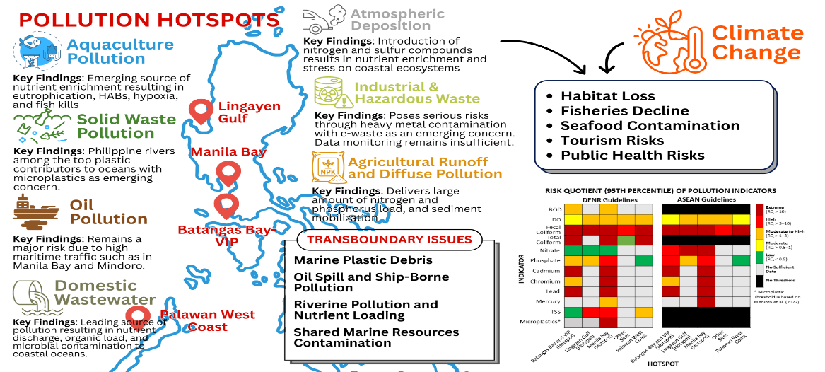

3. Pollution
Philippine coastal waters which face the South China Sea Large Marine Ecosystem (SCS-LME) are under significant pollution pressure. As a middle-income country in the ASEAN region with 36,289 km of coastline and a population exceeding 110 million, the country's strategic position at the center of the Coral Triangle makes effective pollution management crucial. Since the 2000 Transboundary Diagnostic Analysis (Talaue-McManus,2000), the Philippines has strengthened its legal framework through the Clean Water Act and Ecological Solid Waste Management Act, developed integrated coastal management approaches, and increased participation in regional initiatives (Environmental Management Bureau [EMB], 2021a; EMB, 2022). However, rapid urbanization has outpaced infrastructure development, agricultural intensification continues to increase nutrient loads, and plastic pollution has emerged as a critical threat, further compounded by the effects of climate change.

3.1 Key Findings
- Domestic wastewater is the leading source of pollution, with less than 20% of the urban population connected to treatment systems, resulting in untreated discharges of nutrients, organics, and pathogens.
- Agricultural runoff delivers large nitrogen and phosphorus loads, fueling eutrophication and harmful algal blooms; upland erosion adds sediments that degrade reefs and seagrasses.
- Solid waste and plastics are highly visible and persistent, with Philippine rivers ranked among the top global contributors of plastic leakage to the ocean.
- Industrial effluents and hazardous wastes, including heavy metals, industrial by-products, and increasing e-waste, pose localized but serious risks; however, monitoring and data remain fragmented and incomplete.
- Oil pollution from vessel discharges and tanker accidents remains a major risk in high-traffic areas such as Manila Bay and Batangas Bay.
- Aquaculture and mariculture are emerging sources of nutrient enrichment and organic loading, contributing to localized hypoxia, fish kills, and harmful algal blooms (HAB) in semi-enclosed bays.
- Atmospheric deposition could introduce reactive nitrogen and sulfur compounds from power plants, vehicles, and biomass burning, creating an additional pathway for acidification, nutrient enrichment, and stress on coastal ecosystems.
- Hotspots including Manila Bay, Lingayen Gulf, and Batangas Bay-Verde Island Passage show consistently elevated microbial contaminants, nutrients, organic, and heavy-metal levels. The west coast of Palawan is an emerging hotspot.
- Emerging contaminants, notably persistent organic micropollutants, pharmaceuticals, and microplastics, are of growing concern, but scientific monitoring in Philippine coastal and estuarine waters remains scarce.
- Impacts include degraded habitats (corals, seagrass, mangroves), fishery decline, seafood contamination, tourism risks, and public health hazards.
- Climate change is expected to exacerbate pollution impacts through intensified rainfall, increased runoff, sea-level rise, and extreme events, which in turn increase contaminant mobilization.

3.2 Current Status by Indicator Group

3.2.1 Pollution Sources and Magnitude
Understanding the sources and magnitude of pollution is critical to assessing its ecological and socio-economic impacts on Philippine waters within the SCS-LME. This section examines the dominant land- and sea-based inputs, quantifying their contributions and highlighting persistent and emerging hotspots. See Annex 3.A for the definition of pollution indicators.

3.2.1.1 Domestic Wastewater
Domestic wastewater remains the largest contributor to marine pollution. Metro Manila generated over 800 Mm³/year wastewater in 2023, with only 16% treated (Figure 3.1). Wastewater treatment facilities increased from 56 in 2014 to 65 in 2020, while normalized treatment capacity by number of facilities grew steadily to nearly 2 Mm³/facility by 2023. This indicates improvements could come primarily from expanding existing plants rather than building new facilities (Figure 3.2). In 2015, less than 15% of the national population was connected to sewer systems (National Economic and Development Authority [NEDA], 2021). Metropolitan Waterworks and Sewerage System (MWSS) concessionaires in Metro Manila served approximately 2.20 million in septage and 2.40 million in sewerage services (Annex Figure 3.B.1), representing less than 3 percent of the national population. Limited coverage is thus expected to be more pronounced in rapidly expanding peri-urban areas along Manila Bay, Lingayen Gulf, and other population centers.
Domestic wastewater contributes about a third of total BOD nationwide (Annex Figure 3.B.2.) in terms of water pollution (EMB, 2020a). The limited infrastructure results in an estimated pollution load of 530,000 ± 30,000 tons/year BOD reaching coastal waters (SCS-LME) by 2025 (Annex Table 3.B.6), a 23% increase from 2000 reported by Talaue-McManus (2000). Nutrient loading contributes 93,000 ± 5,000 tons of nitrogen and 15,000 ± 700 tons of phosphorus annually (See Annex 3.B for complete calculation on pollution load estimates). Fecal coliform levels in major waterways exceed 10⁵-10⁶ MPN/100mL, well above the 200 MPN/100mL standard. Manila Bay Office of EMB reported from 2011-2015 (19 monitoring stations) that the average FC count ranges from 5.4×10³ to 2.6×10⁴ MPN, reflecting pervasive contamination at Manila Bay. According to EMB projections of pollution load (EMB, 2020a), Region 4A consistently contributes the highest pollutant loads among the regions affecting the Philippine Waters of SCS-LME, followed by the National Capital Region (NCR) and Region 3, particularly affecting Manila Bay (Annex Figure 3.B.4).
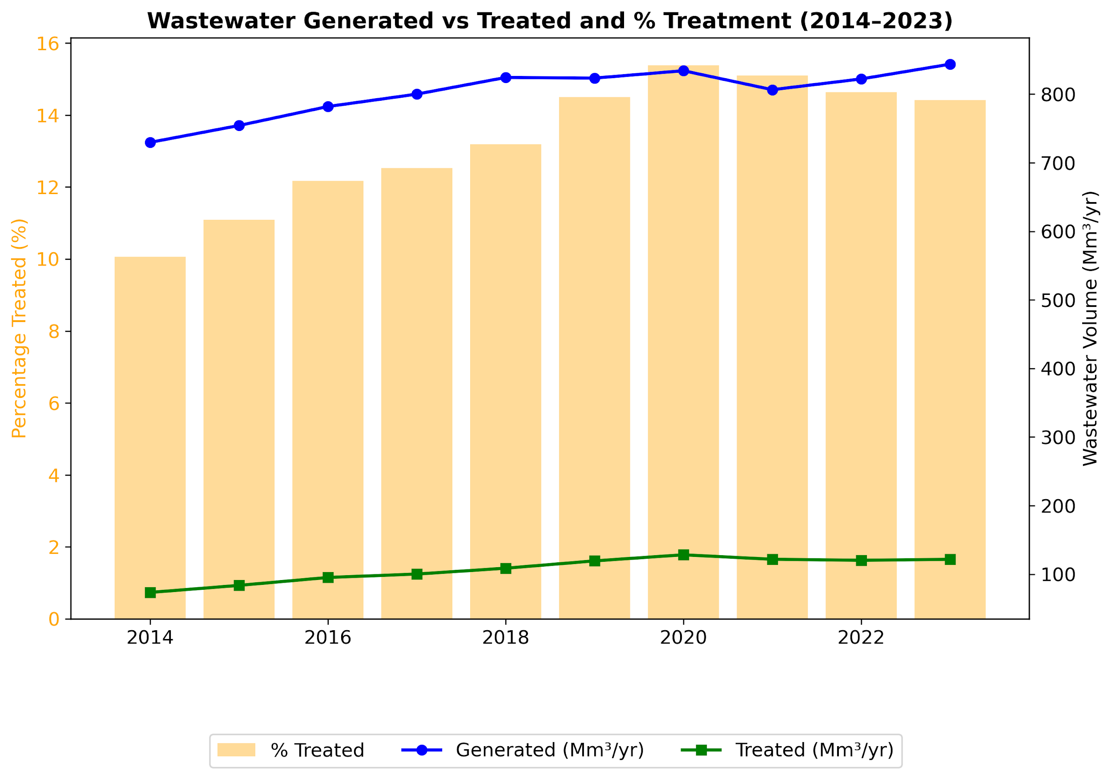
Figure 3.1. Wastewater generation and treatment trends in Metro Manila from 2014-2023. Data Source: PSA, 2024.
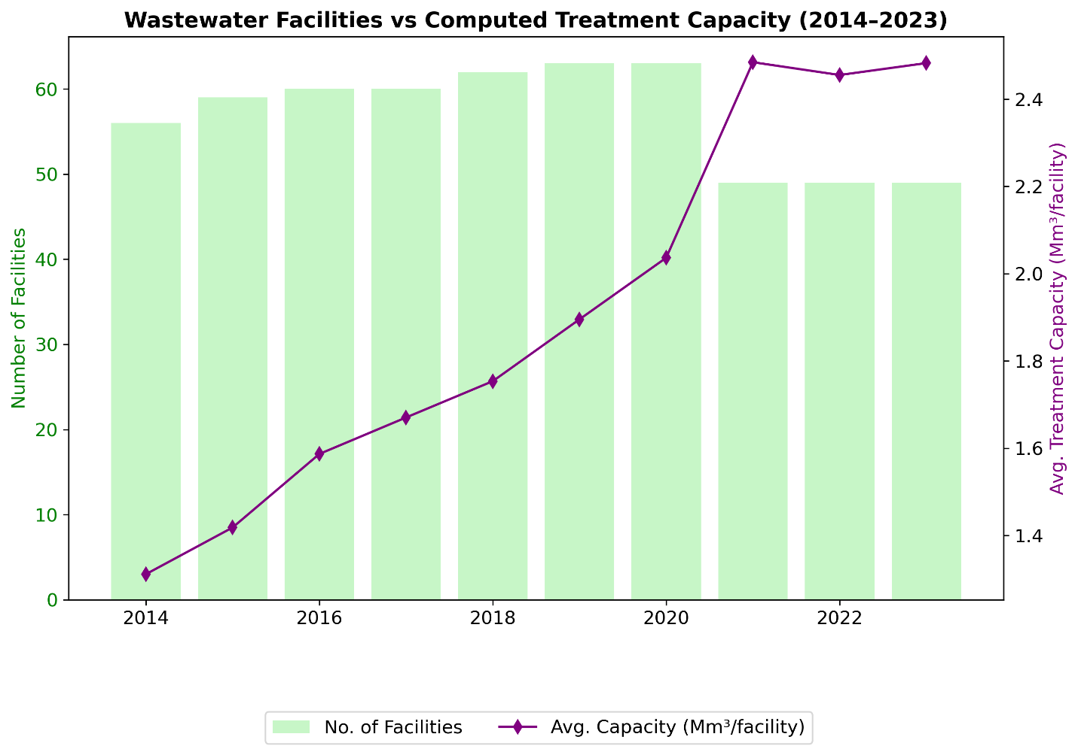
Figure 3.2. Trend of wastewater facilities and treatment capacity in Metro Manila from 2014-2023. Data source: PSA, 2024
Domestic wastewater contributes approximately 47,000 tons of nitrogen and 4,500 tons of phosphorus annually to Manila Bay, with the highest loads from densely populated Metro Manila (19,137 people/km²) and surrounding coastal provinces. This nutrient enrichment causes documented eutrophication and hypoxic conditions, with oxygen levels dropping to 2.1 mg/L during wet seasons. Nitrogen loads could increase by 27-469% by 2050, depending on population growth and sewage treatment improvements (Sotto et al., 2015).
Submarine groundwater discharge (SGD) represents another significant source of nutrient pollution in coastal waters, potentially transporting contaminated groundwater from terrestrial sources and coastal communities. In Bolinao, groundwater wells showed high ammonia concentrations (19-76 μM), indicating "areas of intense ammonification" from septic waste plumes (Senal et al., 2011). SGD also appears to be a significant source of inorganic nitrogen to Manila Bay, contributing fluxes equivalent to 42% from the Pampanga River and 96% of the Pasig River input (Taniguchi et al, 2008). These nutrient inputs stimulate dinoflagellate and cyanobacteria growth, triggering HABs formation and perpetuating the eutrophication-bloom-mortality cycle (Santos et al., 2021). The convergence of aquaculture-derived nutrients and SGD inputs could create multi-source pollution which amplifies the risk of ecological disruption in marine ecosystems.
Domestic wastewater is also a source of emerging contaminants such as PFAS (e.g., PFOS), pharmaceuticals, and endocrine disruptors, which can evade conventional treatment and pose a risk to human health and aquatic ecosystems (Guardian et al., 2020; Mariano et al., 2023). However, monitoring in Philippine coastal and estuarine waters remains scarce.

3.2.1.2 Industrial Effluents
Industrial activities generate significant pollution despite regulatory improvements. As of 2020, 820,253 industrial establishments operate nationwide, with 60% in the Manila Bay region (Tuddao, Jr., and Gonzales, 2020). Of these, 112,789 qualify as manufacturing plants, while the remainder include utilities, construction yards, repair shops, logistics depots, and other non-manufacturing facilities. Major sectors include food processing, textiles, electronics, and petroleum refining (Annex Table 3.B.9). Water Environment Partnership in Asia [WEPA] (2024) reports on the typical wastewater quality of these selected industries (Annex Table 3.B.10). Across the ten industries profiled, wastewater characteristics vary dramatically, reflecting the diversity of Philippine manufacturing processes. Industrial sources contribute 27-33% of the BOD load. Compliance rates remain low at 46% nationally and 35% in NCR (WEPA, 2021; Uyaco, 2022).
While industrial discharges contribute a smaller volume than agricultural and domestic sources (WEPA, 2024), their environmental impact is significantly greater due to their toxic composition. Industrial effluents often contain heavy metals, oils, and hazardous chemical wastes. For example, heavy metal contamination has reached severe levels in several rivers, such as the Marilao-Meycauayan-Obando River System (Pleto et al., 2020).

3.2.1.3 Agricultural Runoff and Diffuse Pollution
Agricultural intensification has led to a significant increase in fertilizer and pesticide use. Nitrogen application rose from 488,000 to 799,000 tons/year (2000-2022), while phosphorus and potassium showed over 200% increases (Annex Figure 3.C.1; see Annex 3.C for time-series graphs). Pesticide use increased from 50,000 to 85,000 tons/year (Annex Figure 3.C.2.). Rice cropping contributes approximately 23,706 tons of nitrogen to Manila Bay annually, representing a 51% loss of applied fertilizer (Magcale-Macandog et al., 2016). These inputs fuel eutrophication and harmful algal blooms in semi-enclosed bays.
Excessive fertilizer applications in Northern and Central Luzon exceed 100 kg N/ha in some provinces. Pampanga River monitoring showed phosphorus concentrations of 0.30-0.67 ppm (wet season) and 0.5-0.9 ppm (dry season) approaching Manila Bay, well above the 0.02 ppm threshold for algal growth (Magcale-Macandog et. al., 2016). A breakdown of nutrient loading into Manila Bay from the four major contributing sub-watersheds is shown in Figure 3.3. The Pasig River Basin would dominate nitrate (NO₃-N) loading, reflecting dense urban populations and untreated domestic wastewater inflows from Metro Manila. On the one hand, the Bataan Watershed would contribute the largest share of total phosphorus, likely driven by agricultural fertilizer runoff and soil erosion.
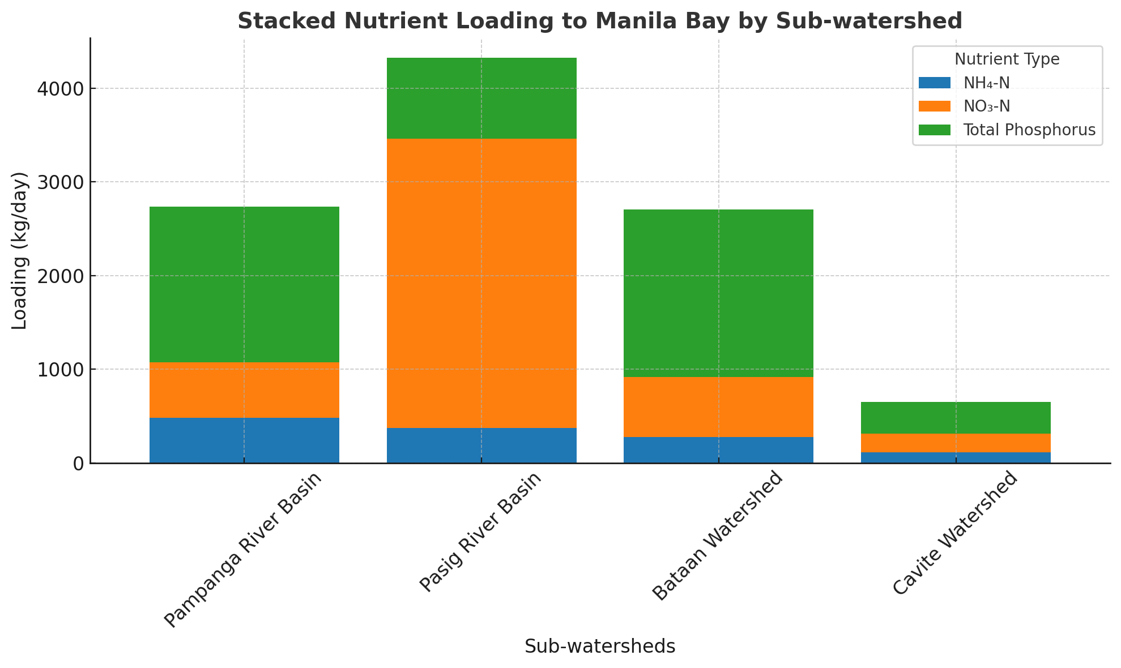
Figure 3.3. Stacked nutrient loading to Manila Bay by sub-watershed. Data source: Samar (2012) as cited in Magcale-Macandog et al. (2016)
Pesticide residues from agricultural runoff reach coastal waters, detected in rivers flowing into Lingayen Gulf and Manila Bay. While Pampanga River samples showed concentrations below the Limit of Quantitation (0.1 μL/L), paddy field drainage water contained higher residues (0.001-3.46 ppb) than inflow water (0.01-0.54 ppb). Isotopic mass balance analysis also revealed that 17-30% of the organic matter deposited in Manila Bay originates from agricultural activities (Bureau of Soils and Water Management (BSWM), 2013, as cited in Magcale-Macandog et al., 2016), providing direct evidence of agriculture's contribution to marine pollution in the Philippine Waters of the SCS-LME.
In addition to nutrient and pesticide inputs from runoff, diffuse sediment mobilization from upland erosion and land conversion has a significant impact on coastal waters. This sediment carries contaminants such as heavy metals, absorbed nutrients, and pesticides, creating multiple pollution pathways. Sediment loads from deforestation, mining activities, and poorly managed farms also increase turbidity which can smother sensitive habitats such as coral reefs and seagrass beds. Lingayen Gulf, for example, experiences heavy siltation from the Agno River system, degrading fisheries and benthic ecosystems (Deocadez et al., 2003).

3.2.1.4 Aquaculture and Mariculture Pollution
Aquaculture provides food security and economic opportunities in the Philippines, but has become a major source of nutrient enrichment and chemical pollution. In Manila Bay and Bolinao Bay, fishponds, pens, and mariculture systems discharge nitrogen, phosphorus, heavy metals, and antibiotic residues into surrounding ecosystems (Tahiluddin et al., 2025).
Between 2011 and 2018, fishponds around Manila Bay accounted for 41.19% of national aquaculture production (Baldoza et al., 2020). These produce effluents with ammonia-nitrogen (0.90-2.35 mg/L) and phosphate (1.02-2.42 mg/L) exceeding thresholds suitable for fish culture. The phosphate levels in Manila Bay also reach 0.03 mg/L, exceeding the marine water quality criterion of 0.015 mg/L (PEMSEA, 2004). Nutrient load estimations indicate that aquaculture around Manila Bay contributes approximately 12,697 metric tons of nitrogen and 2,363 metric tons of phosphorus annually, with fish pens/cages accounting for 88% of nitrogen and 86% of phosphorus loads (Montojo et al., 2020). In Bolinao Bay, nutrient discharges from milkfish pens cause localized acidification, deterioration of water quality, fish kills, and declining coral cover (San Diego-McGlone et al., 2008; Isah et al., 2022). Waste excrements and leftover fish feeds increase the amount of phosphorus, affecting the N/P ratio in Bolinao during the dry season. This phosphorus-rich environment becomes susceptible to algal blooms when nitrogen-containing freshwater arrives during the wet season (Ferrera et al., 2016).
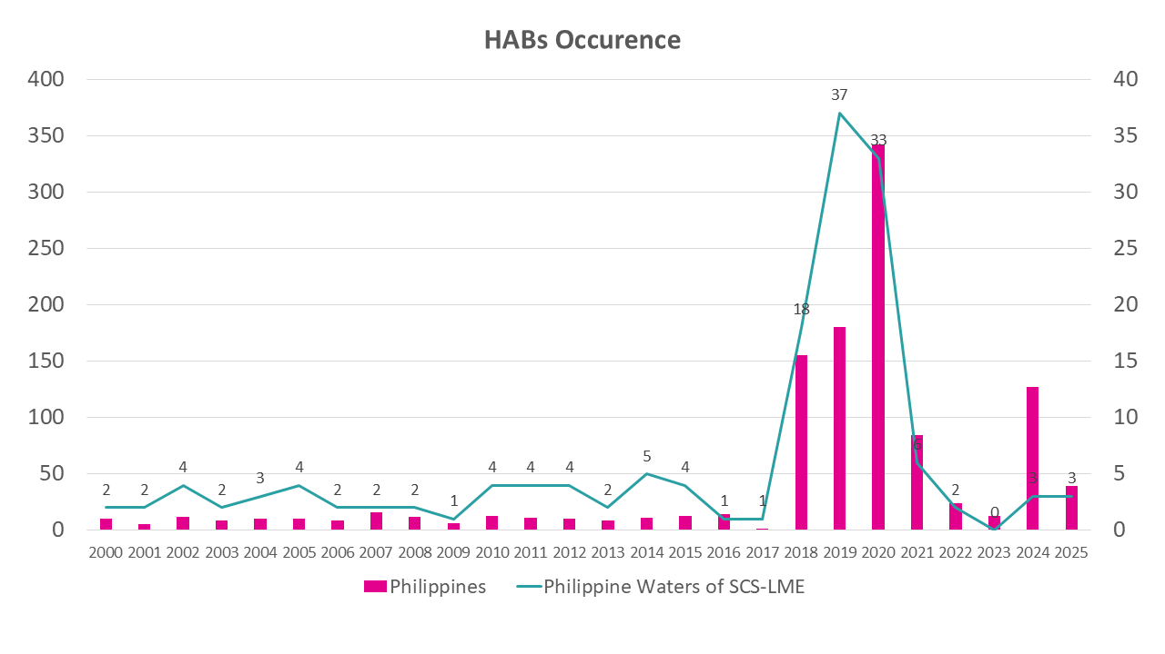
Figure 3.4. Occurrence of Harmful Algal Bloom in the Philippines and in the Philippine Waters of SCS-LME (2000-2025). Data source: Intergovernmental Oceanographic Commission, 2025.
Nutrient enrichment also drives harmful algal blooms (HABs), which threaten marine ecosystems and human health through the production of toxins. HAB events directly impact fisheries and aquaculture, including fish kills and shellfish toxicity. The Philippines' Bureau of Fisheries and Aquatic Resources (BFAR) issues shellfish advisories indicating paralytic shellfish toxin (PST) contamination (See Annex 3.D). From the national data, there is an increase in HABs occurrences in the late 2010s to 2020s, peaking at 342 recorded occurrences in 2020 (Figure 3.4). Fish kill events persist, particularly in Bolino-Anda, Pangasinan, where intensive aquaculture operations create hypoxic conditions for mass mortality (Annex Table 3.D.1). The 2002 Bolinao fish kill coincided with a Prorocentrum cordatum bloom, demonstrating the linkage between eutrophication, HABs, and fish mortality (San Diego-McGlone et al., 2024).
Beyond nutrient pollution, aquaculture is also a growing source of chemical contaminants. Heavy metals, including cadmium, lead, chromium, and mercury, accumulate in sediments and fish, threatening food safety (Tahiluddin, et al., 2025). Antibiotic use, particularly oxytetracycline, promotes the development of antibiotic-resistant bacteria, with the Philippines identified as a potential hotspot for antimicrobial resistance (AMR) in aquaculture.

3.2.1.5 Solid Waste and Marine Litter
The Philippines faces a rapidly growing solid waste challenge, driven by economic and population pressures. Municipal solid waste (MSW) reached more than 40,000 tons/day in 2016 (Talavera et al., 2024) from 37,400 tons/day in 2012, and is projected to exceed 60,000 tons/day by 2023. Regional hotspots include Metro Manila, CALABARZON, and Central Luzon, with NCR alone surpassing 9,000 tons/day (Figure 3.5). Recent data from EMB confirm 61,000 tons/day in 2024, equivalent to 22–23 million tons annually, with plastics comprising 24% of the mix. These values closely align with government projections, underscoring a persistent upward trend.
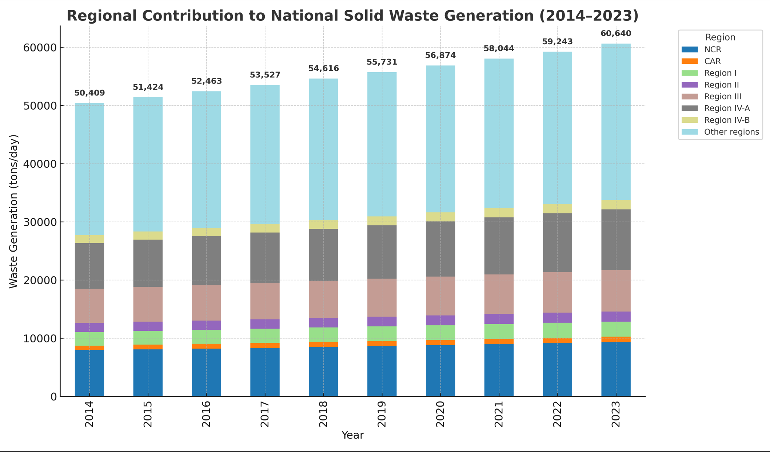
Figure 3.5. Projected Annual Solid Waste Generation and Regional Contribution from 2014-2023 (PSA, 2024)
Infrastructure, however, lags behind the demand. By 2023, the country had 11,823 material recovery facilities and 299 sanitary landfills, which fell short of the required number (Figure 3.6). Commission on Audit (COA) reports highlight chronic under-resourcing, with many barangays lacking proper facilities and resorting to open dumping or burning (Baclig, 2024). The waste composition is dominated by biodegradable material (52.31%), followed by recyclables such as paper, metals, glass, and plastics (EMB, 2020b). Plastic waste accounts for 10–11% of MSW by weight, but is disproportionately visible in waterways and seas.
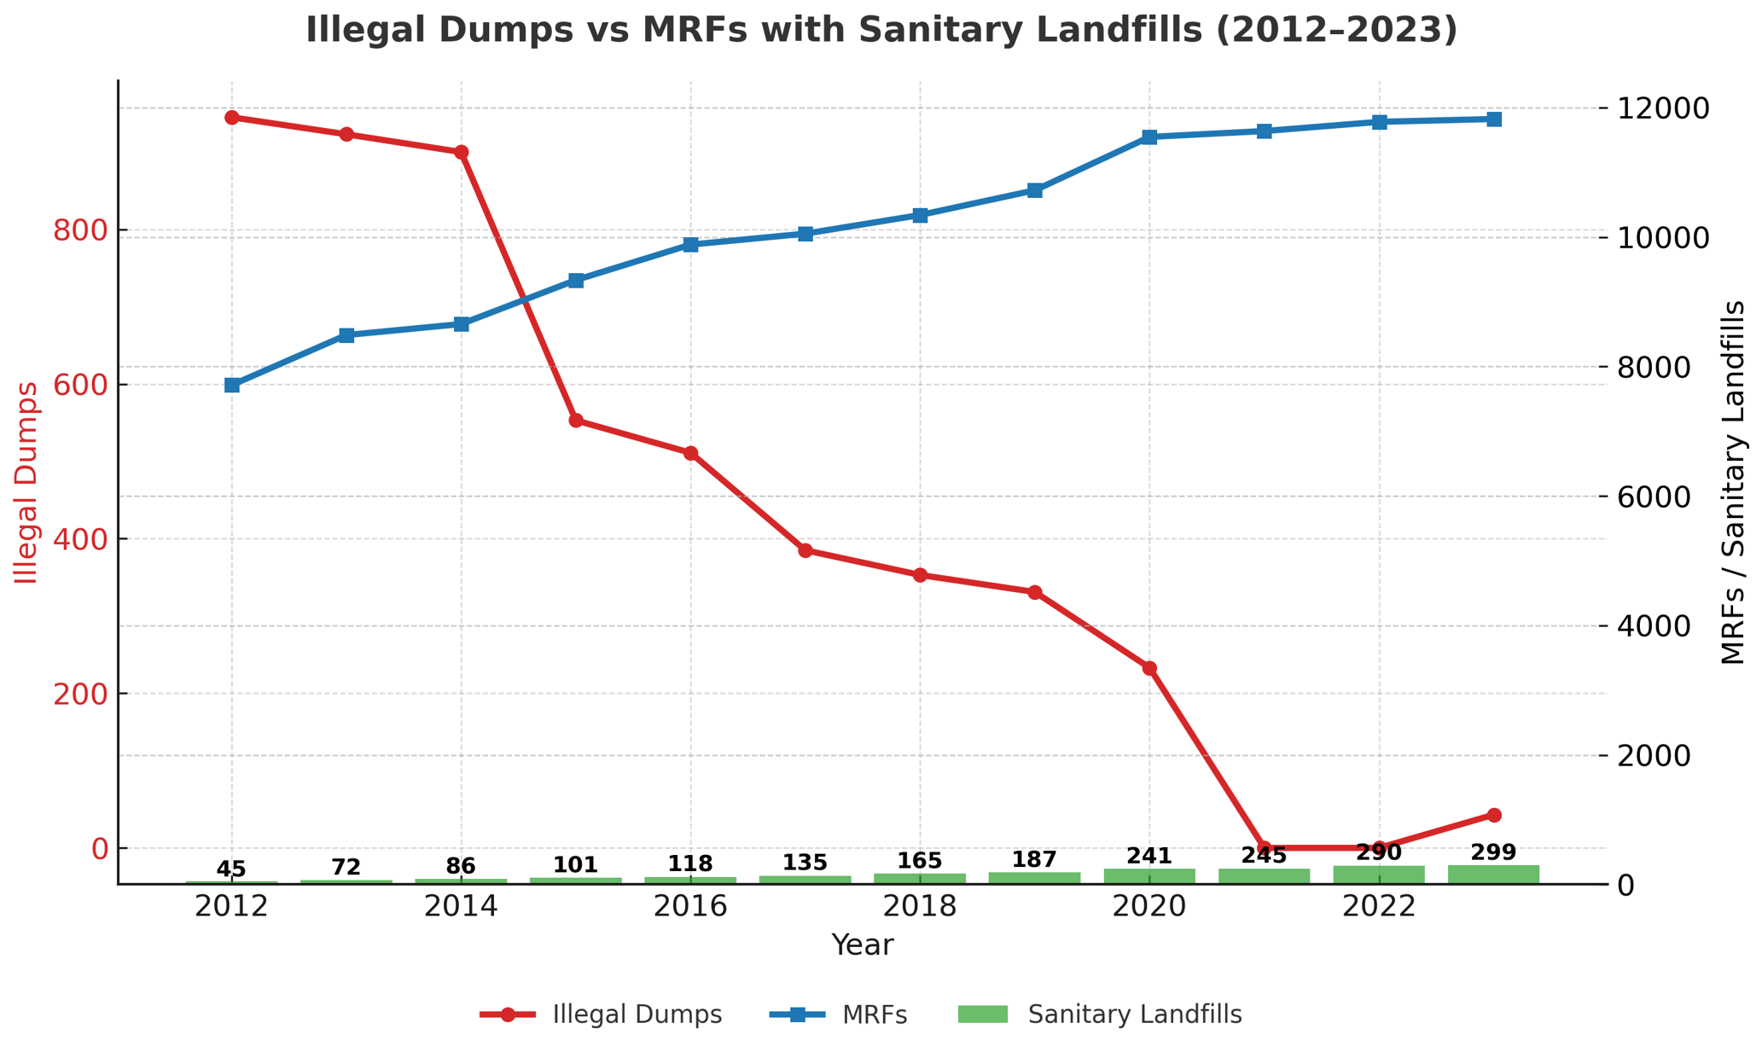
Figure 3.6. Trend on the Number of Disposal Facilities in the Philippines (2012-2023) Data source: PSA, 2024
The Philippines is thus identified as a leading contributor of marine litter from plastic waste leakage, with 0.75 million tons entering the ocean annually (World Bank Group, 2021). Modeled studies (Meijer et al., 2021) estimate over 150,000 tons/year flow through rivers, nine of which drain into the South China Sea LME, as shown in Figure 3.7 (see Annex 3.E for the complete list of rivers in the Philippines). Surveys in Manila Bay reveal more than 90% of beach debris is plastic, while mangrove habitats are increasingly clogged, impairing ecosystem services (Chaigne, 2021). Despite recent cleanup campaigns (GMA Integrated News, 2025), systemic solutions remain urgent.

Figure 3.7. Top Plastic Emitting Rivers in the Philippines Draining to the Philippine waters of SCS-LME from the modeling study of Meijer et al. (2021). Percentages shown indicate the proportion of each river's contribution to the national total.

3.2.1.6 Hazardous Waste
Hazardous waste comprises substances with no safe commercial use that are generated from industrial, chemical, or related activities, that are toxic, corrosive, flammable, reactive, infectious, or otherwise harmful. Proper handling, treatment, and disposal are critical to prevent risk to human health and environmental contamination. From 2012 to 2023, oil waste (9 million tons), inorganic chemicals (4.9 million tons), and cyanide waste (4.3 million tons) dominated hazardous waste generation (Figure 3.8). Region 4A, Region 3, and the National Capital Region (NCR) consistently account for more than 80% of national output from 2020-2023 (Figure 3.9). Reported treatment rates improved to 92% by 2019, with TSD facilities increasing from 127 to 175 by 2023 (Figure 3.10). These registered treatment, storage, and disposal (TSD) facilities are designated locations where industrial and hazardous wastes are transported, stored, treated, recycled, or disposed of. The operationalization of the online Hazardous Waste Management System in 2020 has facilitated a more reliable platform for tracking hazardous waste volumes and movements. See Annex 3.F for the complete data on hazardous waste in the Philippines.
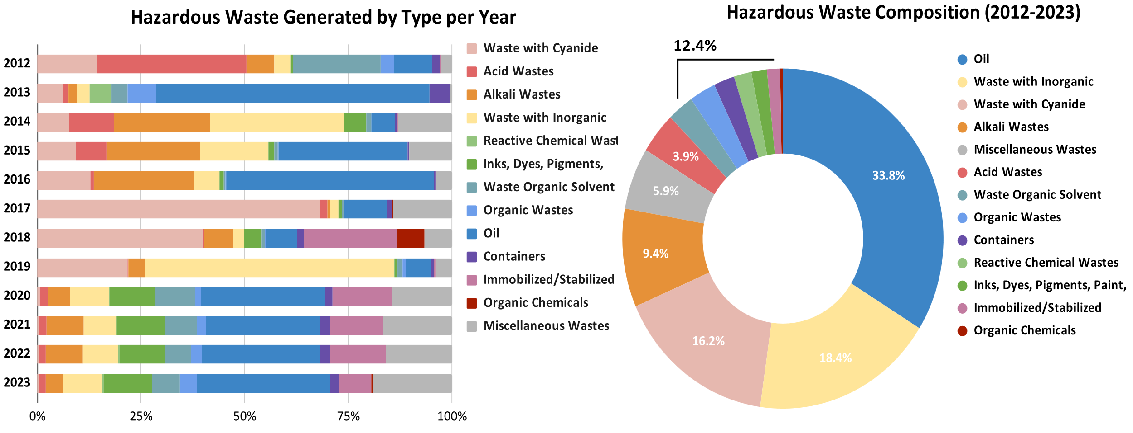
Figure 3.8. Composition of Hazardous Waste from 2012-2023. Data source: PSA, 2024
E-waste, formally categorized as "miscellaneous waste" under the Revised Procedures and Standards for the Management of Hazardous Waste (DAO, 2013-22), has rapidly grown in volume and significance in the Philippines. With rising consumer demand for electronics and short product lifecycles, e-waste generation is reported to be 4.7 kg per capita in 2022, making it one of the top generators in Southeast Asia (Baldé et al., 2025). With limited infrastructure for safe collection and treatment, informal recycling and disposal practices expose communities to hazardous substances, including lead, mercury, and brominated flame retardants.
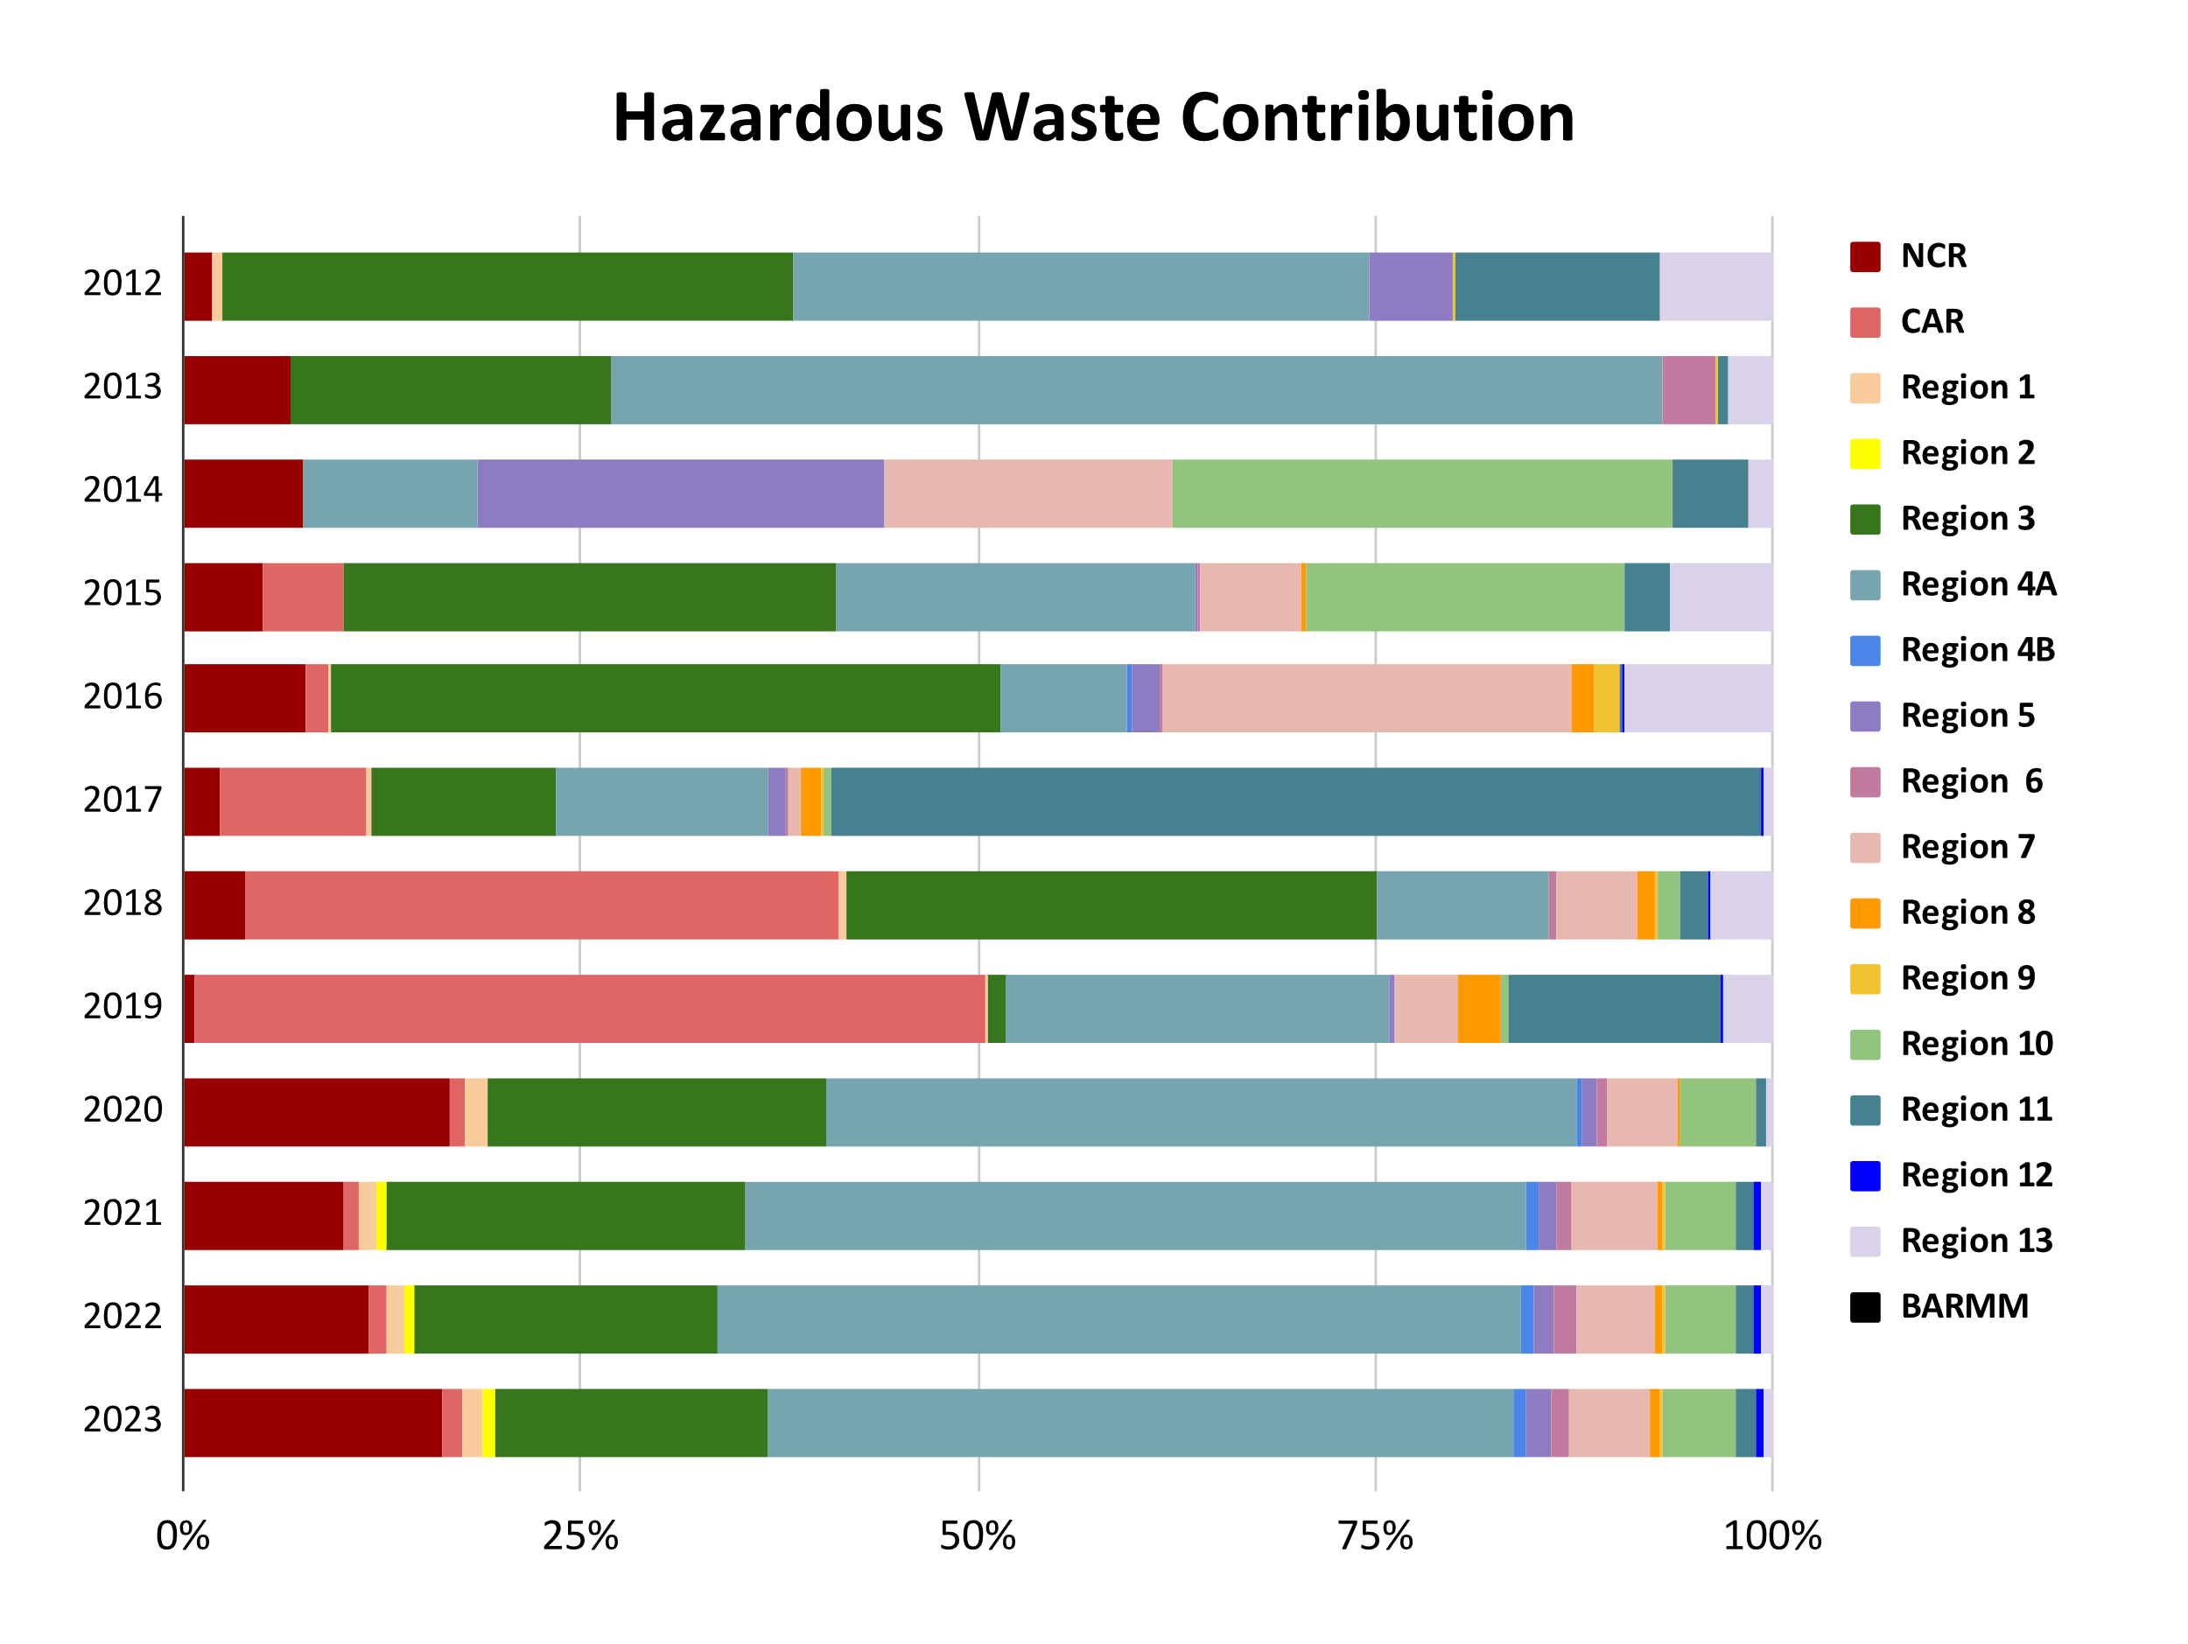
Figure 3.9. Contribution of Generated Hazardous Waste by Region from 2012-2023. Data source: PSA, 2024
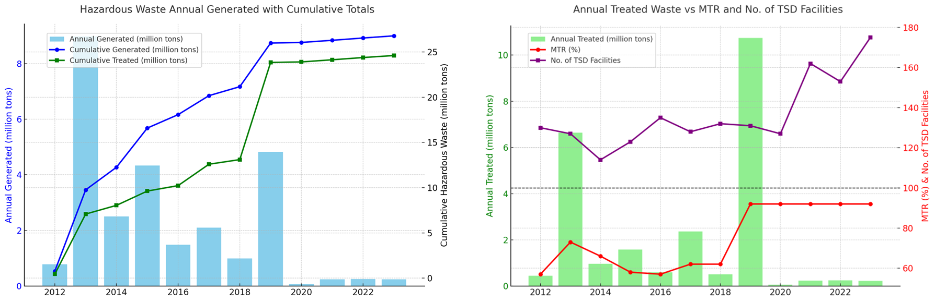
Figure 3.10. Hazardous waste generation and treatment trends in the Philippines, 2012–2023. Left panel: annual generated waste (bars) overlaid with cumulative generated and cumulative treated waste (lines). Right panel: annual treated waste (bars) overlaid with the multi-year treatment rate (MTR, %) and the number of treatments, storage, and disposal (TSD) facilities (lines) (PSA, 2024).
In addition to e-waste, other emerging hazardous waste streams should be examined as pointed out during the validation workshop (Annex 3.J). Their increasing volume in the coming decade underscores the need for early policy development, lifecycle management frameworks, and circular economy approaches for safe recovery and recycling. For example, end-of-life photovoltaic (PV) modules, batteries, and waste generated from renewable energy (RE) systems should also be examined, as these contain heavy metals, halogenated compounds, and complex composite materials that require specialized treatment and disposal pathways.

3.2.1.7 Oil Spills and Ship-Borne Pollution
The Philippines’ strategic location along major shipping routes makes it highly vulnerable to oil and sea-borne pollution. Between 2000 and 2021, 467 oil spills occurred: 14 major (>10,000 liters), 62 medium, 306 minor. NCR recorded the highest frequency (87 spills), followed by Region IV-A (64) (Alea et al, 2022). The highest volume of oil spilled was recorded in 2006 (2,118,500 liters), attributed mainly to the Guimaras oil spill incident (Figure 3.11).
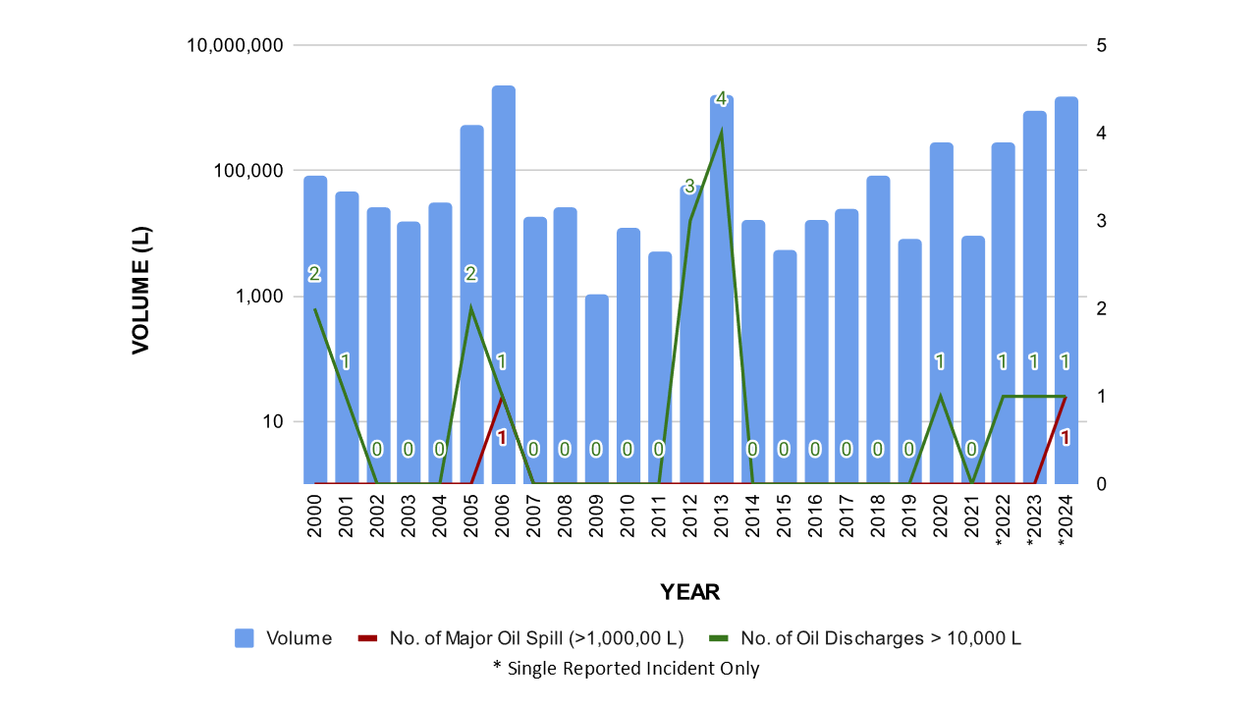
Figure 3.11. Total Volume of Recorded Oil Spill in the Philippines from 2000-2024. (Agaton et al., 2023; Alea et al., 2022; NDRRMC, 2024; Yuching, 2024)
Major incidents relevant to the SCS-LME (see Annex 3.G) include the 2000 Lingayen Gulf spill (57,000 liters), the 2013 Manila Bay pipeline leak (500,000 liters), and recent disasters: MT Princess Empress (800,000-900,000 liters, 2023) affecting Oriental Mindoro and Palawan's Verde Island (Agaton et al., 2023; Yuching, 2024), and MT Terra Nova (1,400,000-1,500,000 liters, 2024) capsizing in Manila Bay during Typhoon Gaemi, affecting Bataan, Bulacan, and Cavite fishing communities (NDRRMC, 2024). These disasters demonstrate the acute ecological and socio-economic impacts of oil pollution in bays and gulfs that drain into the South China Sea LME.
Ballast water discharge also poses another risk. Untreated ballast water introduces invasive species, microbes, and invertebrates across ecosystems (IMO, 2019). A notable case is the introduction of Mytella strigata, a mussel species native to South America, which was detected in Manila Bay between 2012 and 2014. The species has since spread to Lingayen Gulf, Aparri (Cagayan), and Batangas Port, disrupting local aquaculture (Vallejo, 2022).

3.2.1.8 Atmospheric Pollution and Deposition
Atmospheric pollution represents a significant yet often overlooked pathway of marine pollution, as airborne contaminants eventually settle into rivers, coasts, and the open ocean. Pollutants could be carried in the atmosphere, crossing watershed boundaries more easily than land-based discharges, making this pathway critical for transboundary ecosystems such as the South China Sea LME.
Point sources include coal-fired power plants and thousands of oil and gas generators, which release sulfur dioxide (SO₂), nitrogen oxides (NOₓ), and particulate matter. Mobile sources, such as cars, trucks, and buses dominate urban emissions, accounting for approximately 60% of NOₓ and 28% of SO₂. According to the 2021 National Emission Inventory, 56% of emissions originate from mobile sources, 35% from stationary sources, and 9% from diffuse “area sources” including construction, agricultural burning, and open solid waste burning (EMB, 2021b).
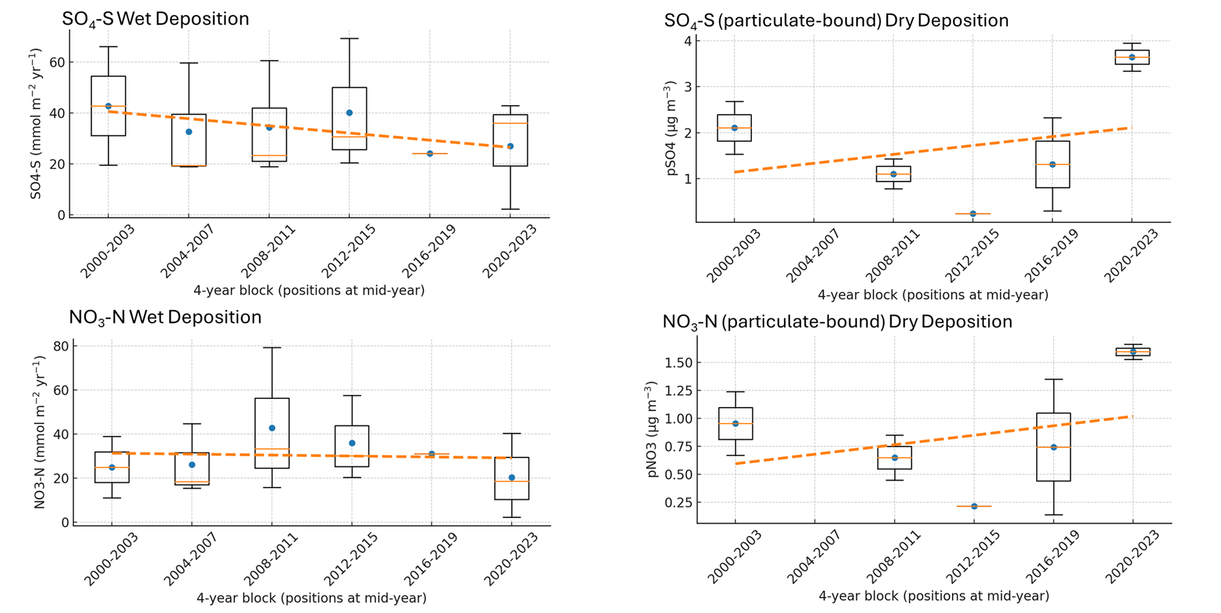
Figure 3.12. Trend analysis of wet deposition of SO₄ and NO₃ (left) and dry deposition of particulate-bound forms of SO₄ and NO₃ (right) (Network Center for EANET, 2025)
The Philippines is also part of the Acid Deposition Monitoring Network in East Asia, which provides long-term data on atmospheric deposition (Network Center for EANET, 2025). Figure 3.12 summarizes wet and dry deposition trends between 2000 and 2023, presented in four-year blocks. Wet deposition data show that sulfate-sulfur concentrations have declined slightly, reflecting the country’s gradual transition to cleaner fuels and stricter sulfur limits, especially in Metro Manila and CALABARZON. In contrast, nitrate-nitrogen levels fluctuate, with lowland sites such as Manila and Los Baños reporting increases during certain periods, likely linked to vehicle emissions, agricultural ammonia, and rainfall variability. See Annex 3.H for the reported data on wet and dry deposition, and their descriptive statistics.
Dry deposition results highlight particle-bound SO₂ and NOₓ compounds as persistent stressors, with generally increasing trends. These pollutants either fall directly onto ocean surfaces or accumulate on land and are then washed into coastal waters during rainfall. Their combined effects include acidification, nutrient enrichment, and hypoxia. Although nitrogen deposition can initially stimulate productivity, it may also elevate CO₂, reduce pH, and lower oxygen levels. These conditions stress coral reefs, mangroves, and fisheries across the South China Sea-Large Marine Ecosystem (LME).

3.2.2 Pollution Hotspots and Sensitive Areas
Several pollution hotspots along the Philippine coast of the South China Sea overlap with ecologically sensitive areas. Manila Bay is the most critical, with dense urbanization and industry producing high loads of coliform bacteria, nutrients, and solid waste. Its semi-enclosed character and limited tidal flushing trap pollutants, threatening fish nurseries and mangrove wetlands such as the Las Piñas–Parañaque Wetland Park. Health risks, fishery losses, and ecological degradation underscore the need for urgent remediation.
Lingayen Gulf is another hotspot where rivers such as the Agno and Dagupan carry sediments, nutrients, and contaminants (Deocadez et al., 2003). Sewage inputs from coastal towns, combined with upstream mining and logging, lead to increased turbidity and trace levels of mercury, cadmium, and lead. The gulf supports milkfish aquaculture, wild fisheries, and tourism (e.g., Hundred Islands National Park), making it highly vulnerable. Sewage and feed waste have triggered fish kills in aquaculture pens, while heavy metals in sediments pose a risk of bioaccumulation in seafood.
Batangas Bay and the Verde Island Passage (VIP) form a hotspot near refineries and power plants. Eastern Batangas Bay shows higher oil residues and heavy metal concentrations, whereas portions of the VIP, renowned as the “Amazon of the Oceans” for its biodiversity, are experiencing a decline in quality and trace metal pollution that could impair coral reefs and fisheries (Wagas & Andres, 2022) Likewise, even Palawan’s west coast, while less polluted, shows rising coliform counts. Recent environmental data provided by EMB regional offices were used to validate these initial findings (see Annex 3.J).
Collated data, though sparse and limited between 2000 and 2024, reinforces these hotspot patterns (Figure 3.13). Manila Bay shows elevated nutrients, coliform, and heavy metals (e.g., mercury, lead) with low DO levels, reflecting intense urban and industrial inputs (WEPA, 2025). Microplastics are also detected at elevated levels in the riverine discharge that drains to Manila Bay (Figure 3.13j). There is a growing threat of microplastic pollution at the Philippine waters of SCS-LME (Onda et al., 2024). In addition, persistent organic pollutants (POPS) such as polychlorinated biphenyls (PCBs) have been detected in plastic resin pellets (International Pellet Watch, 2025) found at Cavite City beaches and Manila Bay. These resins are industrial raw materials used to produce plastics that were unintentionally released to the environment.
On Palawan’s west coast, pressures are emerging near population and tourism centers. In Bacuit Bay (El Nido) and Coron Bay, fecal coliform levels frequently exceed standards due to inadequate sewage systems (Palawan Council for Sustainable Development [PCSD], 2023; Vicente, 2024). Nutrient enrichment poses a threat to adjacent reefs and seagrass beds. Moreover, the 200,000-ha Malampaya Sound Protected Area also receives marine litter inputs and could face risks from shipping and offshore gas operations (Coram et al., 2021; Haworth et al., 2024).
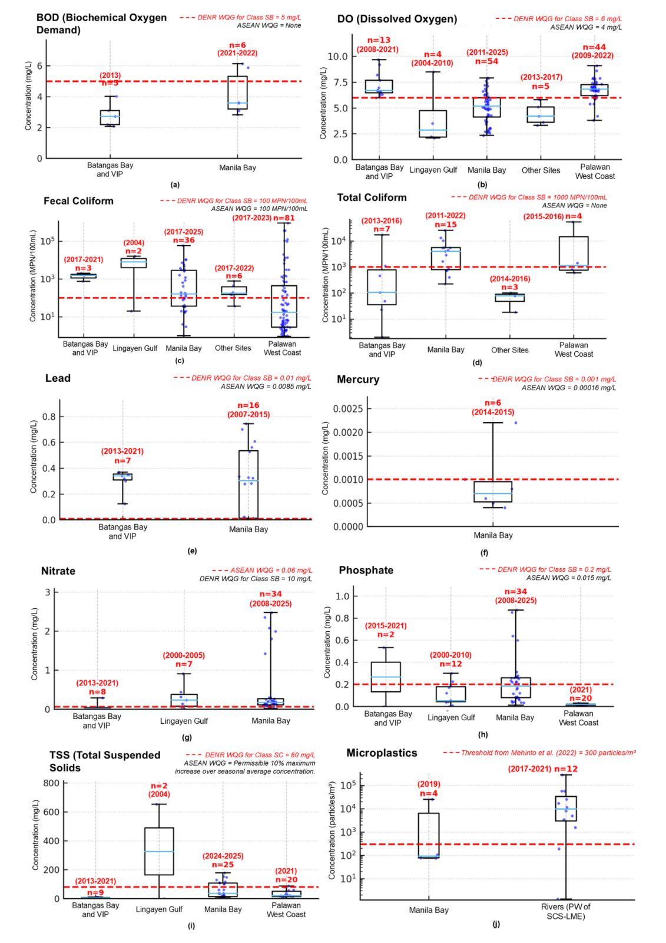
Figure 3.13. Box plot of measured concentrations of selected pollution indicators for coastal and estuarine water quality based on the compiled data (Annex 3.A) prior to the validation workshop. The box plot includes the number of datapoints (n) and temporal coverage, as well as the threshold for each water quality indicator.

3.3 Discussion and Conclusions

3.3.1 Priority Transboundary Pollution Issues
The South China Sea's interconnected oceanography creates transboundary pollution requiring multi-country collaboration:
- Marine Plastic Debris: Plastics drift across boundaries on ocean currents. Microplastics from the Mekong River reach the Philippines, which receives half of the Mekong-sourced particles stranded regionally (Nguyen et al., 2023). Philippine rivers contribute debris to Vietnam, Malaysia, and beyond, undermining marine life and tourism.
- Oil Spills and Ship-Borne Pollution: Heavy shipping traffic means spills spread across borders. Oil slicks drift to Vietnam, China, or Malaysia, depending on currents. Routine ship pollutants (bilge dumping, garbage, ballast water) have cumulative regional impacts. Joint preparedness under the ASEAN Oil Regional Spill Contingency Plan and the IMO conventions is vital.
- Riverine Pollution and Nutrient Loading: Rivers carry nutrients, sediment, and contaminants into shared waters. Philippine rivers (e.g., Pampanga, Agno) contribute to regional loadings. Nutrient plumes cause transboundary harmful algal blooms affecting multiple countries' fisheries. Mining siltation can smother distant coral reefs through sediment transport.
- Shared Marine Resources Contamination: Migratory species accumulate pollutants across regions. Microplastics, heavy metals, organometallic compounds, or persistent organic pollutants in Philippine waters could bioaccumulate in fish caught in the South China Sea LME. Conversely, pollutants released elsewhere contaminate Philippine seafood. Mercury, microplastics, POPs, and other emerging contaminants require monitoring, harmonized standards, and information exchange among regional partners.
Marine debris, oil pollution, nutrient enrichment, and toxic contaminants exemplify issues no country can address alone. These transboundary problems rank as priorities for regional cooperation and the Transboundary Diagnostic Analysis (TDA) of the South China Sea LME.

3.3.2 Impacts on Environment and Society
Pollution of coastal waters has wide-ranging environmental and societal impacts in the Philippines and across the South China Sea region. Degraded water quality undermines critical habitats. Coral reefs exposed to coastal acidification and eutrophication exhibit reduced coral cover and frequent algal overgrowth, as observed in the Lingayen Gulf (Isah et al., 2022). Seagrass beds and mangroves, vital fish nurseries, are smothered by silt and litter. In Manila Bay, remaining mangrove stands are choked with plastic waste, impairing ecological function. Biodiversity loss is evident, with declines in corals, while nutrient-driven red tides trigger mass mortality. Organic pollution load from sewage in semi-enclosed waters leads to hypoxia and periodic fish kills; Manila Bay has recorded such events alongside declining fisheries productivity. Chronic pollution also weakens ecosystem resilience to climate change, while extreme rainfall amplifies runoff of sediments and nutrients, fueling algal blooms and turbidity that further stress coral and seagrass ecosystems.
Societal impacts are equally severe. Public health is threatened as sewage contamination exposes beachgoers and coastal residents to pathogens, with extremely high coliform counts in Manila Bay and El Nido linked to gastroenteritis and other waterborne diseases. Seafood safety is at risk, as shellfish and fish accumulate bacteria and heavy metals, causing food poisoning or long-term health issues. Fisheries and aquaculture are compromised. In Dagupan (Lingayen Gulf), milkfish (bangus) ponds are affected by upstream waste discharges, which reduce the quality and prices of the fish (Stimson, 2023). Declining fish stocks and habitat degradation erode livelihoods, while smaller catches and fewer high-value species undermine incomes.
Tourism is also affected. Algal blooms, foul water, and trash-strewn beaches threaten destinations such as El Nido, where contamination has led to swimming bans. Pollution disproportionately affects poor coastal communities that rely heavily on natural resources. Informal settlers along estuaries and bays are highly vulnerable to pollution (health hazards) and its knock-on effects, such as the loss of fisheries and flooding from clogged waterways. Overall, degraded coastal waters erode ecosystem services, i.e., food, storm protection, and income, undermining the Philippines’ $17 billion blue economy potential (ADB, 2025).

3.3.3 Risk Assessment
Pollution risks in Philippine coastal and marine habitats have intensified since the early 2000s, despite growing awareness and efforts to mitigate them. Rapid urbanization, industrialization, and tourism have driven pollutant loads beyond the capacity of existing infrastructure. In Metro Manila, population growth exacerbated the contamination of Manila Bay, with fecal coliform and nutrient levels remaining very poor throughout the 2000s. By 2018, parts of the bay were virtually unfit for recreation. Lingayen Gulf also faced siltation and heavy-metal contamination from mining and deforestation. Some improvements are evident. Fecal coliform levels in Manila Bay decreased from 126,000 MPN/100mL in 2019 to 51,300 in 2022 following rehabilitation efforts (Bautista, 2023). Batangas Bay’s integrated coastal management (ICM) under PEMSEA likewise contributes to improving conditions. Yet these gains remain fragile, as fish kills, HABs, and coral die-offs have become more frequent, amplified by climate stressors.
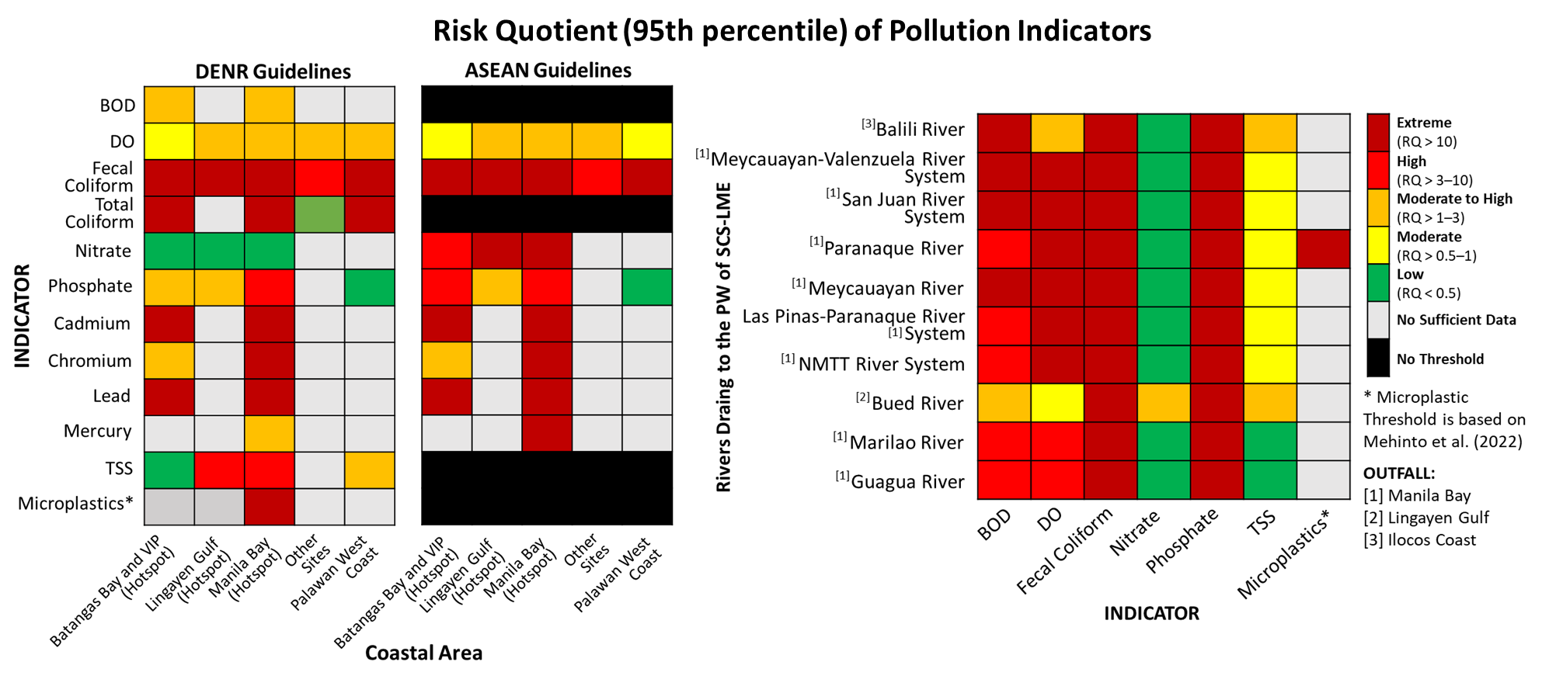
Figure 3.14. Left Panel: Heat Map for Coastal Hotspots in the Philippine Waters of SCS-LME (2000-2025). Right Panel: Heat Map for Rivers Draining to the Philippine Waters of SCS-LME (2000-2023). The DENR and ASEAN do not have established thresholds for microplastics; therefore, the threshold value was adopted from Mehinto et al. (2022). RQ was computed from the collated data of MEC prior to the validation workshop.
Figure 3.14 summarizes the risk quotient (RQ) analysis for a reasonable worst-case scenario using the DENR and ASEAN guidelines. Results show Manila Bay as the most critical hotspot, with phosphate, heavy metals, TSS, and coliforms exceeding thresholds, some in the Very High to Extreme risk bands (RQ >10 to >1000). Batangas Bay and Lingayen Gulf follow as secondary hotspots, while Palawan generally registers lower risks but still has localized exceedances. The ASEAN guidelines establish more conservative threshold values, resulting in most indicators across all sites being classified as high to extreme risk. See Annex 3.I for calculations and dataset on risk quotient analysis.
Rivers that are part of the watershed or river basin drainage to SCS-LME pose significant risks. Nitrate and TSS predominantly exhibit low to moderate risk levels. Dissolved oxygen (DO) levels indicate a moderate to high risk, with rivers in Metro Manila exhibiting extremely low DO concentrations. BOD risk levels vary considerably across different locations. In contrast, phosphate, microplastics, and particularly fecal coliform contamination register alarmingly high to extreme risk levels. These findings highlight the impact of riverine pollution and the significant role of these rivers as a major conduit for land-based pollution into coastal waters.
Figure 3.15 presents the risk matrix for priority pollution scenarios. Five priority concerns emerged.
- Nutrient-driven eutrophication, HAB, and hypoxia (critical risk quadrant): already frequent, causing fish kills and ecosystem collapse in bays.
- Marine plastics crisis (critical risk quadrant): chronic, high-likelihood, transboundary threat undermining fisheries and tourism.
- Major oil spill (high risk quadrant): low-moderate frequency but catastrophic severity, given dense South China Sea shipping.
- Sewage-driven HAB and public health outbreaks (high risk quadrant): moderate-high frequency, high human and economic impact.
- Bioaccumulation of toxic contaminants (moderate-to-high risk quadrant): moderate severity and likelihood through bioaccumulation of heavy metals, POPs, and microplastics in the food chain, presenting long-term health and trade implications.
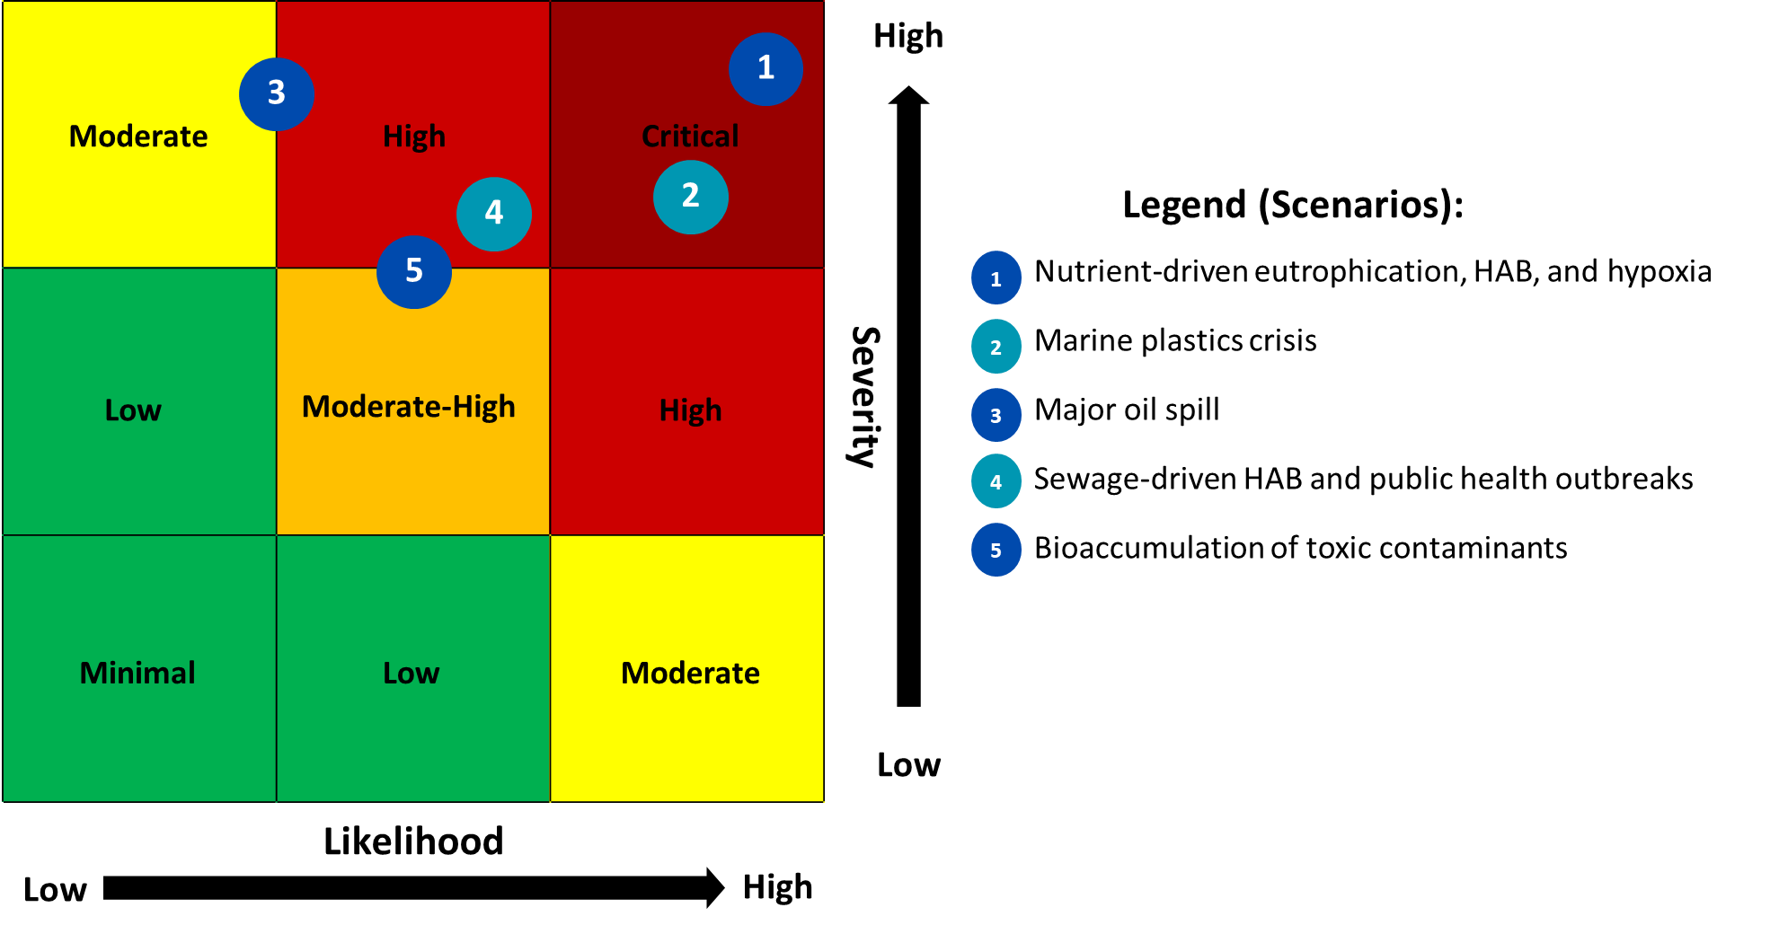
Figure 3.15. Risk Scenario Matrix
Without significant investment in wastewater and sanitation, as well as in nutrient and plastic management, high environmental and socio-economic risks are likely. Under such a “business-as-usual” scenario, persistent hypoxic zones in Manila Bay, as well as coastal habitats like coral reefs, would be under high threat from watershed-based pollution (Figure 3.16), resulting in biodiversity loss, and local fisheries decline. Climate change further compounds risks via heavier rainfall and flooding that flush pollutants into the sea.
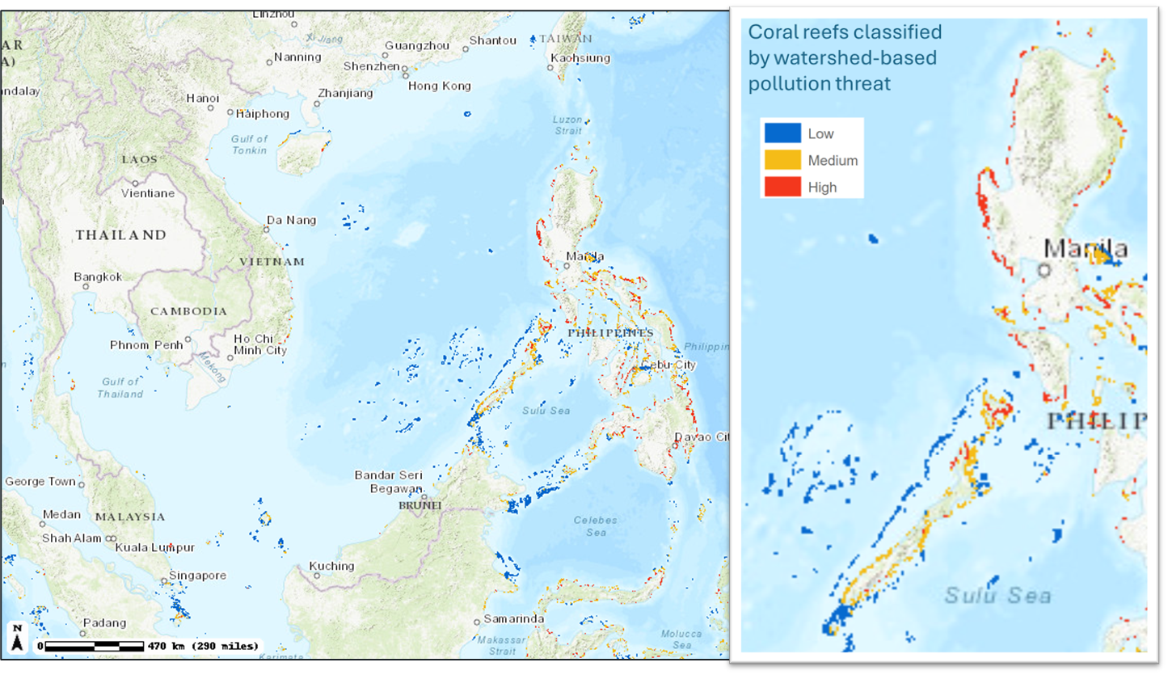
Figure 3.16. Coral reefs in the Philippine waters of the SCS-LME classified by watershed-based pollution threat (Burke, et al, 2011)

3.3.4 Current Management and Institutions
Marine pollution management in the Philippines involves multiple institutions across local, national, and regional levels. Key national frameworks include the Clean Water Act of 2004 and the Ecological Solid Waste Management Act of 2000, which are primarily implemented by the DENR-EMB, setting standards and monitoring protocols. While EMB guides the designation of Water Quality Management Areas, enforcement and infrastructure often lag. LGUs are frontline actors but face resource and capacity constraints, as seen in Manila and Dagupan, where sewage treatment remains limited. In Manila Bay, a Supreme Court Mandamus required 13 agencies to rehabilitate the bay and improve coordination, but also exposed overlapping mandates (Senate Economic Planning Office [SEPO], 2024). The Extended Producer Responsibility (EPR) Act of 2022 further strengthens plastic waste reduction by assigning producers responsibility for recovery and diversion, through compliance monitoring and integration with LGU systems remain evolving challenges.
High-profile cases highlight institutional gaps and responses driven by the institution. In Boracay (2018) and El Nido (2018–2023), closures and rehabilitation orders led to stricter enforcement of regulations on wastewater, establishment of treatment facilities, and monitoring of businesses, though low connection rates limit effectiveness (Fabro, 2018; PCSD, 2023). Civil society and universities also influence policy, e.g., studies on heavy metals in Batangas Bay prompted stricter oversight (Wagas & Andres, 2022). The Philippine Coast Guard has expanded its role in oil spill response and marine litter cleanup.
Regionally, the Philippines participates in PEMSEA’s SDS-SEA (Sustainable Development Strategy for Seas of East Asia), with Batangas Bay as a pilot for integrated coastal management, resulting in unified management plans and oil spill contingency measures (PEMSEA, 2006). The country also participates in ASEAN’s Regional Action Plan on Marine Debris (ASEAN, 2021), COBSEA’s nutrient management framework (COBSEA, 2024), and bilateral cooperation such as JOMSRE-SCS with Vietnam and the Sulu-Sulawesi Marine Ecoregion program (Supreme Court of the Philippines, 2002; Dang, 2021).
Overall, while a strong framework exists, efforts remain fragmented. Strengthening integration across levels and sectors, as well as enhancing regional collaboration, are essential for effective marine pollution governance.

3.3.5 Gaps and Priority Challenges
Despite ongoing efforts, significant gaps thus remain in addressing pollution in the Philippine coastal and marine waters. These represent priority challenges to overcome:
- Infrastructure Gap: Only a small percentage of coastal cities have sewage treatment facilities; proper MRFs and landfills are also lacking.
- Enforcement and Capacity Building Gaps: Weak monitoring, corruption, and insufficient technical capacity at the LGU level for pollution control and management.
- Fragmented Effort of Institutions: Weak and uncoordinated implementation of the inter-agencies’ and LGUs’ mandate.
- Financial Constraints: Limited sustained funding for infrastructure and monitoring.
- Weak Transboundary Coordination and Cooperation: There is no joint pollution contingency plan among SCS nations.
- Limited Public Awareness: Poor understanding of cumulative impacts and behavior change challenges.
- Scientific and Data Gaps: Incomplete data on emerging contaminants and insufficient long-term datasets. Inaccessibility of data to assess pollution sources from the industrial sector. Weak data governance on environmental data.

3.3.6 Recommended Priority Actions
A set of priority actions is recommended to tackle pollution crises in the Philippine waters (SCS-LME). The following actions should be pursued through coordinated national efforts and reinforced by regional cooperation:
- Invest in Wastewater and Waste Management Infrastructure: Accelerate construction of resource recovery facilities and treatment plants in major coastal cities, targeting 50% coverage by 2025, 100% by 2030. Implement sustainable financing schemes, public-private partnerships, circular resource-oriented sanitation (Promentilla et al., 2022), and nature-based solutions.
- Strengthen Enforcement: Expand real-time monitoring in hotspots, enforce heavier penalties, train enforcement units, and harmonize ASEAN standards.
- Expand ICM and Watershed Management: Replicate successful models across all hotspots, integrate upstream-downstream management (e.g., ridge-to-reef framework), and align sustainable agricultural and aquaculture practices.
- Strengthen Regional Contingency Plan: Develop protocols for mutual spill response, early warning systems, and operationalize ASEAN disaster response for marine pollution.
- Strengthen Marine Litter Reduction Program: Implement a ban on single-use plastics, improve collection rates, support recycling markets and circular economy innovations, and organize ASEAN Coastal Cleanup Day.
- Enhance Protection of Sensitive Ecosystems for Climate Resilience: Designate marine protected areas with high water quality, launch habitat restoration projects, and collaborate through regional initiatives.
- Enhance National and Regional Coordination: Establish and enact the appropriate national oceans policy, increase capacity-building funding, and promote joint research programs. Establish the South China Sea Watershed Partnership.
- Strengthen Community, Capacity Building, Education, Participation, and Awareness (CEPA) programs: Develop education campaigns, sustain positive behavioral changes from social and behavioral change communication (SBCC), community-based waste-to-resource recovery programs, involve fisherfolk in monitoring, and establish a civil society platform.
- Advance Science, Data Governance, and Innovation: Strengthen long-term monitoring of emerging contaminants, expand research on pollution impacts, promote open data governance, and invest in circular economy and pollution-control technologies. A need for the whole-of-society approach to harmonize standards and SOPs, interoperable data systems, consistent monitoring, and clearer cross-sectoral accountability.

3.4 Methodology and Analysis
This analysis adopted the TDA guidance document on pollution indicators, utilizing collated data from the 2000s to the 2020s (Annex 3.A). Sources included government agencies (DENR-EMB, PSA), regional bodies (World Bank, UNEP, PEMSEA), and peer-reviewed literature. Critical hotspots were identified based on the DENR EMB National Implementation Report on Land-based Pollution (2021). Analysis faced limitations from sparse spatial-temporal data coverage, methodological inconsistencies between monitoring programs, and attribution challenges in multi-stressor ecosystems. Results from data analysis should be interpreted with caution. Small sample sizes (n < 5), as seen in several sites (e.g., DO in Lingayen Gulf, mercury samples in Manila Bay), limit statistical reliability. High variability (e.g., BOD and fecal coliform in Manila Bay) reflects the influence of multiple pollution sources and variable sampling conditions. Median values alone may not fully capture the dynamics of pollution. Risk quotient analysis thus used reasonable worst-case scenarios (see Annex 3.I.) to evaluate pollution risks across sites and indicators. Where quantitative data were lacking, qualitative assessment and triangulation were employed. The methodology was also further strengthened through a multi-stakeholder validation workshop, which provided a review of datasets, clarified institutional mandates, identified emerging pollution issues, and helped verify hotspot selection and data limitations across source categories (see Annex 3.J).
Glossary
- Acidification (Coastal/Marine) - Decrease in pH of seawater due to CO2 absorption and acidic inputs.
- Agricultural Runoff / Diffuse Pollution - Non-point source pollution from farmlands carrying nutrients, sediments, and pesticides.
- Ammonia (NH₃-N) - Un-ionized/ionized ammonia in water; toxic at elevated levels.
- Antimicrobial Resistance (AMR) – occurs when microorganisms has evolved to resist the effects of antimicrobial agents (e.g. drugs)
- Aquaculture / Mariculture - Cultivation of aquatic organisms in inland/coastal waters or marine environments.
- ASEAN Regional Action Plan on Marine Debris - ASEAN framework to reduce marine plastic pollution.
- Atmospheric Deposition - Transfer of pollutants from air to surface via wet or dry processes.
- Ballast Water Discharge - Release of water used to balance ships that may contain invasive species and pathogens.
- Bioaccumulation - Uptake and retention of substances in organisms over time.
- Blue Economy - Sustainable use of ocean resources for economic growth, livelihoods, and ecosystem health.
- BOD (Biochemical Oxygen Demand) - Amount of dissolved oxygen needed by microorganisms to break down organic matter in water over a specific period (commonly 5 days).
- Box Plot - Statistical chart showing distribution (median, quartiles, outliers).
- Bureau of Fisheries and Aquatic Resources (BFAR) - Fisheries policy and management bureau under the Department of Agriculture (DA).
- Bureau of Soils and Water Management (BSWM) - DA-attached agency on soil and water research and management.
- Circular Economy - Economic model prioritizing resource efficiency, reuse, and closed loops.
- Clean Water Act (RA 9275) - Philippine law providing water quality management framework.
- Coastal Zone / Estuary - Interface where rivers meet the sea with strong gradients and high productivity.
- COBSEA (Coordinating Body on the Seas of East Asia) - UNEP regional body coordinating marine environmental protection in E/SE Asia.
- COD (Chemical Oxygen Demand) - Amount of oxygen required to chemically oxidize organic and inorganic matter in water.
- Coliform – rod-shaped, gram-negative bacteria that are indicators of fecal and/or pathogenic contamination
- Commission on Audit (COA) - Independent constitutional body auditing government use of funds.
- Contaminants – physical, chemical, biological, or radiological substances found in the environment in higher concentrations than what is natural that eventually cause harm.
- Corrosive – materials that causes damage to other materials that comes into contact with it through chemical reaction.
- Coral Reef - Marine ecosystem built by calcifying corals; biodiversity hotspot sensitive to pollution.
- Department of Environment and Natural Resources (DENR) - Philippine agency for environment and natural resource governance.
- Diffuse sediments – sediments carried into a waterbody with no single identifiable source.
- DO (Dissolved Oxygen) - Concentration of oxygen dissolved in water available for aquatic life.
- Domestic Wastewater / Sewage - Household wastewater containing organics, nutrients, and pathogens.
- Dry Deposition - Direct settling/adsorption of particles and gases onto surfaces without precipitation.
- EANET - Regional network for acid deposition monitoring in East Asia.
- Ecological Solid Waste Management Act (RA 9003) - Philippine law mandating segregation, recycling, and proper waste facilities.
- Emerging Contaminants - Chemicals newly recognized as potential risks (e.g., PPCPs, PFAS) lacking comprehensive regulation.
- Endocrine Disrupting Chemicals (EDCs) / Endocrine disruptors - Substances that interfere with hormonal systems in organisms.
- Environmental Governance - Structures and processes for decision-making on environmental issues.
- Environmental Management Bureau (EMB) - DENR bureau responsible for pollution management and monitoring.
- Eutrophication - Nutrient enrichment of water bodies leading to excessive plant/algal growth and oxygen depletion.
- E-waste (Electronic Waste) - Discarded electrical/electronic devices and components.
- Fecal Coliform (FC) - Indicator bacteria originating from human/animal feces used to assess sanitary quality of water.
- Fish Pens / Cages / Fishponds - Aquaculture structures confining fish/shellfish for grow-out.
- Harmful Algal Bloom (HAB) - Algal proliferation that can produce toxins or cause ecological/human health impacts.
- Hazardous Waste / Toxic Waste - Wastes exhibiting hazardous characteristics (toxic, corrosive, ignitable, reactive).
- Heat Map - Visual display using color gradients to depict intensity/values across locations.
- Heavy Metals - Metals and metalloids toxic at low concentrations (e.g., Cd, Pb, Hg, Cr).
- Hotspot (Pollution Hotspot) - Location with elevated pollutant levels or acute impacts requiring priority action.
- Hypoxia - Condition of low dissolved oxygen that stresses or kills aquatic organisms.
- Indicator / Pollution Indicator - Measured variable representing a pollution pressure, state, or impact.
- Industrial Effluent - Wastewater discharged from industrial facilities.
- Integrated Coastal Management (ICM) - Process for coordinated management of coastal zones integrating sectors and stakeholders.
- Invasive Species - Non-native species whose introduction causes harm to environment, economy, or health.
- Land-based Pollution - Pollution originating from land activities transported to marine/coastal waters via rivers, runoff, or air.
- Local Government Unit (LGU) - Municipal, city, or provincial government unit with local environmental mandates.
- Mangroves - Intertidal forests providing nursery habitat and coastal protection.
- Marine Litter / Marine Debris - Solid material discarded or abandoned in the marine environment.
- Marine protected area – designated marine area by law and is governed by specific guidelines to manage activities, protect, and conserve the marine ecosystem in the area.
- Material Recovery Facility (MRF) - Facility for segregation, recycling, and processing of solid waste.
- Metropolitan Waterworks and Sewerage System (MWSS) - Regulator for water supply and wastewater services in Metro Manila.
- Microplastics - Plastic particles <5 mm from fragmentation or microbeads.
- Mobile source – moving vehicles, engines, and equipment that generates air pollution through combustion of fuels
- Modeling Study / Modeled Data - Results derived from computational models rather than direct measurements.
- Nanoplastics - Plastic particles <1 µm potentially more bioavailable and reactive.
- Nature-Based Solutions (NbS) - Actions inspired by ecosystems to address societal challenges and provide co-benefits.
- Nitrate (NO₃-N) - Oxidized form of nitrogen in water; key nutrient contributing to eutrophication.
- Nitrogen Oxides (NOx) - Gases (NO, NO₂) from combustion contributing to ozone and nitrate formation.
- Nonpoint source – when an origin of pollutants is too broad or not identifiable.
- Nutrient Load / Nutrient Flux - Quantity of nutrients transported to a water body over time.
- Oil Spill / Ship-borne Pollution - Release of petroleum into the marine environment from accidents or operations.
- Palawan Council for Sustainable Development (PCSD) - Provincial body overseeing sustainable development and environment in Palawan.
- Paralytic Shellfish Toxin (PST) – neurotoxins released by microscopic algae that contaminates commercial shellfish.
- Particulate Matter (PM) - Airborne solid/liquid particles (e.g., PM10, PM2.5) affecting health and deposition.
- Particulate Matter 2.5 (PM2.5) – particles suspended in the air with diameters of 10 micrometers or smaller
- Particulate Matter 10 (PM10) - particles suspended in the air with diameters of 2.5 micrometers or smaller
- Pathogens - Disease-causing microorganisms (bacteria, viruses, protozoa) present in contaminated waters.
- PEMSEA - Partnerships in Environmental Management for the Seas of East Asia.
- Persistent Organic Micropollutants - Trace-level POP-like compounds persistent and bioactive at low concentrations.
- Persistent Organic Pollutants (POPs) - Toxic, bioaccumulative, and persistent chemicals subject to the Stockholm Convention.
- PFAS (Per- and Polyfluoroalkyl Substances) - Synthetic fluorinated chemicals resistant to degradation; linked to health risks.
- Philippine Coast Guard (PCG) - Maritime law enforcement and marine environmental protection agency.
- Philippine Waters of the SCS-LME - The portion of the SCS-LME within Philippine jurisdiction along the western seaboard.
- Phosphate (PO₄-P) - Orthophosphate concentration; a limiting nutrient that can drive algal blooms.
- Plastic Leakage / Plastic Emission - Escape of plastic waste from collection systems into the environment.
- Pollution Load - Mass of contaminants entering a water body per unit time.
- Point source – single, identifiable origin of pollution.
- Public–Private Partnership (PPP) - Cooperative arrangement between government and private sector for infrastructure/services.
- Qualitative Assessment - Non-numeric evaluation using expert judgment and triangulation.
- Quantitative Assessment - Numerical evaluation using measured or modeled data.
- Reactive – unstable materials that reacts violently with air or water, causing explosions.
- Reasonable Worst-Case Scenario - A conservative scenario using upper-bound concentrations to assess risk.
- Regional Contingency Plan - Cooperative protocol among states for emergency pollution response.
- Resource-Oriented Sanitation - Sanitation systems designed to recover water, nutrients, and energy.
- Ridge-to-Reef Framework - Integrated management approach linking uplands, rivers, and coasts.
- Risk Band / Risk Matrix - Categorization of risk by likelihood and consequence.
- Risk Quotient (RQ) - Ratio of measured concentration to guideline/threshold value to assess risk level.
- Sanitary Landfill / Open Dumping - Engineered facility for waste disposal vs. prohibited uncontrolled dumping.
- Scenario Analysis - Exploration of outcomes under different assumptions and interventions.
- Seagrass - Flowering marine plants forming coastal meadows essential for fisheries and carbon.
- Sediment Load / Siltation - Amount of eroded soil and particulate matter transported by water into aquatic systems.
- Semi-enclosed Bay / Gulf - Coastal water body with restricted exchange amplifying pollution impacts.
- Sensitive Area / Critical Habitat - Ecosystems highly vulnerable to pollution (e.g., reefs, seagrass, mangroves).
- Solid Waste / Municipal Solid Waste (MSW) - Garbage from households, commerce, institutions, and similar sources.
- South China Sea Large Marine Ecosystem (SCS-LME) - A high-biodiversity, semi-enclosed sea system shared by multiple countries, managed via LME approach.
- Spatial–Temporal Coverage - Extent of data across space and time used in analysis.
- Stationary source – nonmoving source of air pollution such as factories and power plants.
- Strategic Action Programme (SAP) - Agreed, policy-based regional program of actions addressing TDA-prioritized issues.
- Submarine Groundwater Discharge (SGD) - Flow of groundwater into the sea that can carry dissolved nutrients/contaminants.
- Sulfur Dioxide (SO₂) - Combustion-derived gas contributing to acid deposition.
- Supreme Court Mandamus (Manila Bay Case) - 2008 order directing 13 agencies to rehabilitate Manila Bay.
- Sustainable Development Strategy for the Seas of East Asia (SDS-SEA) - Regional strategy for sustainable coastal and ocean governance.
- Threshold Value / Guideline Value - Benchmark concentration used to evaluate water quality and ecological risk.
- Transboundary Diagnostic Analysis (TDA) - Analytical process identifying priority transboundary problems, their causes, and impacts.
- Transboundary Pollution - Pollution that crosses national or jurisdictional boundaries via air or water.
- Treatment, Storage, and Disposal (TSD) Facility - Authorized facility to manage hazardous wastes before final disposition.
- Trend Analysis - Statistical examination of changes in indicators over time.
- Triangulation - Cross-validation using multiple data sources/methods to increase confidence.
- TSS (Total Suspended Solids) - Particles suspended in water that can be trapped by a filter.
- Turbidity - Cloudiness or haziness of water caused by suspended particles.
- Waste-to-Resource / Waste Valorization - Conversion of wastes into valuable products or energy.
- Water Quality Management Area (WQMA) - Designated area for focused water quality management under RA 9275.
- Watershed / River Basin - Land area draining to a common outlet (river, bay, or gulf).
- Wet Deposition - Removal of pollutants via precipitation (rain, fog).
Acknowledgments
The authors acknowledge the support of the following agencies in providing data and information, especially during the validation workshop: Environmental Management Bureau, Philippine Statistics Authority, Bureau of Fisheries and Aquatic Resources, Manila Bay Coordinating Office, Philippine Coast Guard, Biodiversity Management Bureau, Laguna Lake Development Authority, as well as the respective Local Government Units.
Author Contributions
- Michael Angelo B. Promentilla - Conceptualization, Methodology, Data curation, Formal analysis, Investigation, Visualization, Writing – original draft, Writing – review & editing, Supervision, Validation.
- Nicole Alexandra C. Aguila – Data curation, Formal Analysis, Visualization, Writing – original draft, Writing – review & editing.
Funding Sources
This project was funded by the Global Environment Facility (GEF) under the GSA grant 21192-2024-01-scs.

Chapter 3 References
Agaton, C. B., Guno, C. S., Labog, R. A., & Collera, A. A. (2023). Immediate Socioeconomic Impacts of Mindoro Oil Spill on Fisherfolk of Naujan, Philippines. Resources, 12(9), 102–102. https://doi.org/10.3390/resources12090102
Alea, C., Ruiz, C. I., Yap, J. B., Molina, E. F., Saballa, A. J., Ñuneza, J. S., & Bacharo, K. B. B. (2022). An investigation of aquatic oil spills in the Philippines from 2000 to 2021. Marine Pollution Bulletin, 185, 114241. https://doi.org/10.1016/j.marpolbul.2022.114241
ASEAN. (2021). ASEAN Regional Action Plan for Combating Marine Debris in the ASEAN Member States (2021-2025) [electronic Resource]. ASEAN. https://asean.org/book/asean-regional-action-plan-for-combating-marine-debris-in-the-asean-member-states-2021-2025-2/
Asian Development Bank. (2014, March 14). Middle-income Trap Holds Back Asia’s Potential New Tiger Economies: 12 Things to Know. Asian Development Bank. https://www.adb.org/features/middle-income-trap-holds-back-asias-potential-new-tiger-economies-12-things-know
Asian Development Bank. (2025). Marine ecosystems for blue economy development program, subprogram 1: Concept note (Project No. 58379-001). https://www.adb.org/projects/58379-001/main
Baclig, C. E. (2024). Risks loom as worsening garbage mess pushes deep Philippines’ dive into waste-to-energy. Asia News Network. https://asianews.network/risks-loom-as-worsening-garbage-mess-pushes-deep-philippines-dive-into-waste-to-energy/
Baldé, C. P., Kuehr, R., Yamamoto, T., McDonald, R., D’Angelo, E., Althaf, S., Bel, G., Deubzer, O., Fernandez-Cubillo, E., Forti, V., Gray, V., Herat, S., Honda, S., Iattoni, G., Khetriwal, D.S., di Cortemiglia, V. L., Lobuntsova, Y., Nnorom, I., Pralat, N., & Wagner, M. (2024). The Global E-Waste Monitor. International Telecommunication Union (ITU) and United Nations Institute for Training and Research (UNITAR). https://ewastemonitor.info/wp-content/uploads/2024/03/GEM_2024_18-03_web_page_per_page_web.pdf
Baldoza, B. J. S., Montojo, U. M., Perelonia, K. B., Benitez, K. C. D., Cambia, F. D., & Garcia, L. C. (2020). Status of water quality in fishponds surrounding Manila Bay. The Philippine Journal of Fisheries, 27(2), 238–245. https://doi.org/10.31398/tpjf/27.2.2020A0006
Bautista, J. (2023, January 10). Water quality in Manila Bay has improved – DENR. INQUIRER.net. https://newsinfo.inquirer.net/1714543/denr-water-quality-in-manila-bay-has-improved
Burke, L., Reytar, K., Spalding, M., & Perry, A., (2011). Reefs at Risk Revisited. World Resources Institute. https://www.wri.org/research/reefs-risk-revisited
Chaigne, T. (2021, October 8). Plastic waste chokes last mangrove forests in Philippines’ Manila Bay. The Observers - France 24. https://observers.france24.com/en/asia-pacific/20211011-plastic-pollution-mangrove-forest-philippines-manila-bay
Coordinating Body on the Seas of East Asia (COBSEA) (2024). COBSEA Collaborative Action Framework on Nutrients Management. Bangkok, Thailand. United Nations Environment Programme (UNEP). https://wedocs.unep.org/handle/20.500.11822/47736
Coram, A., Abreo, N. A. S., Ellis, R. P., & Thompson, K. F. (2021). Contribution of social media to cetacean research in Southeast Asia: illuminating populations vulnerable to litter. Biodiversity and Conservation, 30(8-9), 2341–2359. https://doi.org/10.1007/s10531-021-02196-6
Dang, V. H. (2021, December 8). Resumption of JOMSRE-SCS: Practical Suggestions to Move Forward. Asia Maritime Transparency Initiative. https://amti.csis.org/resumption-of-jomsre-scs-practical-suggestions-to-move-forward/
Department of Environment and Natural Resources (DENR). (2013). DENR Administrative Order No. 2013-22: Revised Procedure and Standards for the Management of Hazardous Wastes (Revising DAO 2004-36). Supreme Court E-library. https://elibrary.judiciary.gov.ph/thebookshelf/showdocs/10/67621
Deocadez, M. R., Aliño, P. M., Bautista, A. L. S., & Gaite, P. A. (2003). Lingayen Gulf, Northwestern Philippines. In Coral Reef Information Network of the Philippines (PhilReefs). Philippine Coral Reefs through time: Workshop Proceedings. Second of the Atlas of Philippine Coral Reefs Series. Quezon City: Coral Reef Information Network (PhilReefs), University of the Philippines Marine Science Institute (pp. 13-17).
Environmental Management Bureau (EMB). (2021a). National Implementation Report on Land-based Pollution.
Environmental Management Bureau. (2021b). Emissions Inventory 2021 | Air Quality Management Section. Emb.gov.ph. https://air.emb.gov.ph/emission-inventory-2018/
Environmental Management Bureau (2022). National State of the Brown Environment Report 2016 -2021. The Philippines. https://air.emb.gov.ph/wp-content/uploads/2025/01/NSOBER-2016-2021-fin-1-1.pdf
Environmental Management Bureau. (2020a). National Water Quality Status Report (2014-2019). Department of Environment and Natural Resources-Environmental Management Bureau.
Environmental Management Bureau. (2020b). National Solid Waste Management Status Report (2008-2018). Department of Environment and Natural Resources-Environmental Management Bureau
Fabro, K. A. S. (2018, February 24). El Nido crackdown on erring establishments begins. RAPPLER. https://www.rappler.com/philippines/196770-el-nido-crackdown-establishments-environmental-violations/
Ferrera, C. M., Watanabe, A., Miyajima, T., San Diego-McGlone, M. L., Morimoto, N., Umezawa, Y., Herrera, E., Tsuchiya, T., Yoshikai, M., & Nadaoka, K. (2016). Phosphorus as a driver of nitrogen limitation and sustained eutrophic conditions in Bolinao and Anda, Philippines, a mariculture-impacted tropical coastal area. Marine Pollution Bulletin, 105(1), 237–248. https://doi.org/10.1016/j.marpolbul.2016.02.025
GMA Integrated News. (2025). Marine litter in Manila Bay has decreased – 2024 study. GMA News Online. https://www.gmanetwork.com/news/scitech/science/932956/marine-litter-in-manila-bay-has-decreased-2024-study/story/
Guardian, M. G. E., Boongaling, E. G., Bernardo-Boongaling, V. R. R., Gamonchuang, J., Boontongto, T., Burakham, R., Arnnok, P., & Aga, D. S. (2020). Prevalence of per- and polyfluoroalkyl substances (PFASs) in drinking and source water from two Asian countries. Chemosphere, 256, 127115. https://doi.org/10.1016/j.chemosphere.2020.127115
Haworth, B. T., Cadigal, G. M., Zabala Jr, E. C., Gonzales, B. J., Jalover-Par, C. L. S., Dolorosa, R. G., Gonzales-Plasus, M. M., Jontila, J. B. S., Cabrestante Jr, M. P., Bruce, E., & Baker, E. (2024). Palawan (UNESCO Biosphere Reserve), Philippines: State of the Marine Environment 2024. Palawan Council for Sustainable Development Staff, Puerto Princesa City, Philippines.
IMO (International Maritime Organization). (2019). Ballast Water Management. Www.imo.org. https://www.imo.org/en/OurWork/Environment/Pages/BallastWaterManagement.aspx
IMO. (2025). Status of IMO Treaties: Comprehensive information on the status of multilateral Conventions and instruments in respect of which the International Maritime Organization or its Secretary-General performs depositary or other functions. International Maritime Organization. https://wwwcdn.imo.org/localresources/en/About/Conventions/StatusOfConventions/Status%202025.pdf
Intergovernmental Oceanographic Commission. (2025). Harmful Algae Event Database. Iode.org; Intergovernmental Oceanographic Commission. https://haedat.iode.org/
International Pellet Watch. (2025). Pellet Watch. http://www.pelletwatch.org/gmap/#Philippines
Isah, R. R., Enochs, I. C., & San Diego-McGlone, M. L. (2022). Sea surface carbonate dynamics at reefs of Bolinao, Philippines: Seasonal variation and fish mariculture-induced forcing. Frontiers in Marine Science, 9, 858853. https://doi.org/10.3389/fmars.2022.858853
Magcale-Macandog, D. B., Paraiso, P. M. J., Salvacion, A. R., Estadola, R. V., Quinones, S. G. L., Silapan, I. M. A., & Briones, R. M. (2016). An Overview of Agricultural Pollution in the Philippines: The Crops Sector. Prepared for the World Bank. Washington, D.C.
Mariano, M. F., Angeles, L. F., Aga, D. S., Villanoy, C. L., & Jaraula, C. M. B. (2023). Emerging pharmaceutical contaminants in key aquatic environments of the Philippines. Frontiers in Earth Science, 11. https://doi.org/10.3389/feart.2023.1124313
Mehinto, A. C., Coffin, S., Koelmans, A. A., Redondo-Hasselerharm, P., & Hermabessiere, L. (2022). Risk-based management framework for microplastics in aquatic ecosystems. Microplastics and Nanoplastics, 2, 14. https://doi.org/10.1186/s43591-022-00033-3
Meijer, L. J. J., van Emmerik, T., van der Ent, R., Schmidt, C., & Lebreton, L. (2021). More than 1000 rivers account for 80% of global riverine plastic emissions into the ocean. Science Advances, 7(18). https://doi.org/10.1126/sciadv.aaz5803
Montojo, U. M., Baldoza, B. J. S., Perelonia, K. B., Cambia, F. D., & Garcia, L. C. (2020). Estimation of nutrient load from aquaculture farms in Manila Bay, Philippines. The Philippine Journal of Fisheries, 27(1), 30–39. https://doi.org/10.31398/tpjf/27.1.2019A0016
National Disaster Risk Reduction and Management Council (NDRRMC). (2024). Maritime Incident involving MT Terra Nova in Limay, Bataan (REGION III). https://ndrrmc.gov.ph/attachments/article/4260/SitRep_No._7_for_the_Maritime_Incident_involving_MT_Terra_Nova_in_Limay_Bataan_REGION_III.pdf
National Economic and Development Authority (NEDA). (2021). Philippine Water Supply and Sanitation Master Plan. National Economic and Development Authority. https://depdev.gov.ph/pwssmp/
Network Center for EANET (2025). EANET Data on the Acid Deposition in the East Asian Region. https://monitoring.eanet.asia/document/public/index (Last accessed June 3, 2025)
Nguyen, D. M., Hole, L. R., Breivik, Ø., Nguyen, T. B., & Pham, N. K. (2023). Marine Plastic Drift from the Mekong River to Southeast Asia. Journal of Marine Science and Engineering, 11(5), 925. https://doi.org/10.3390/jmse11050925
Onda, D. F. L., Gomez, N. C., Alindayo II, R. A., Casauay, R. B., & Bonita, J. D. (2024). Pathways and Distribution of Plastic Pollution. 40-48. In Arceo, H.O., Velos, M.J.P., Nuñez, M.A.C. & Aliño, P.M. (Eds.). The West Philippine Sea: State of the Coasts. University of the Philippines Marine Science Institute, Diliman, Quezon City, Philippines. 208pp.
Palawan Council for Sustainable Development (PCSD). (2023, February 7). PCSDS presents to provincial leaders the EMED water quality findings in El Nido | PCSD. Palawan Council for Sustainable Development. https://pcsd.gov.ph/pcsds-presents-to-provincial-leaders-the-emed-water-quality-findings-in-el-nido/
PEMSEA. (2004). Sustainable development and management of Manila Bay: A focus on water quality (Policy Brief). Partnerships in Environmental Management for the Seas of East Asia. https://pemsea.org/sites/default/files/2023-11/pb-2004-manila-bay.pdf
PEMSEA. (2006). Performance Evaluation Building Partnerships in Environmental Management for the Seas of East Asia (PEMSEA), Terminal Evaluation Report. PEMSEA Information Series, 177 p. Global Environment Facility/ United Nations Development Programme/International Maritime Organization Regional Programme on Building Partnerships in Environmental Management for the Seas of East Asia (PEMSEA), Quezon City, Philippines.
Philippine Statistic Authority. (2024). Compendium of Philippine Environment Statistics 2014-2023. Philippine Statistics Authority. https://library.psa.gov.ph/
Pleto, J. V. R., Migo, V. P., & Arboleda, M. D. M. (2020). Preliminary Water and Sediment Quality Assessment of the Meycauayan River Segment of the Marilao-Meycauayan-Obando River System in Bulacan, the Philippines. Journal of health & pollution, 10(26), 200609. https://doi.org/10.5696/2156-9614-10.26.200609
Presidential Communications Office. (2025). PBBM declares 112.7M Philippine population count as official. Presidential Communications Office. https://pco.gov.ph/news_releases/pbbm-declares-112-7m-philippine-population-count-as-official/
Promentilla, M.A.B., Longos Jr., A.L., Orbecido, A.H., Suplido, M.E.A.A., Rosales, E.M.E., Pausta, C.M.J., Damalerio, R.G., Lecciones, A.J.M., Devanadera, M.C.E., & Saroj, D.P. (2022). Nutrient Recycling from Septage Toward a Green Circular Bioeconomy: A Case Study in Salikneta Farm, Philippines. Chemical Engineering Transactions, 94, 1075-1080. https://doi.org/10.3303/CET2294179
San Diego-McGlone, M. L., Azanza, R. V., Villanoy, C. L., & Jacinto, G. S. (2008). Eutrophic waters, algal bloom and fish kill in fish farming areas in Bolinao, Pangasinan, Philippines. Marine Pollution Bulletin, 57(6-12), 295–301. https://doi.org/10.1016/j.marpolbul.2008.03.028
San Diego-McGlone, M. L., Yñiguez, A. T., Benico, G., Lum, W. M., Hii, K. S., Leong, S. C. Y., Leaw, C. P., Iwataki, M., & Lim, P. T. (2024). Fish Kills Related to Harmful Algal Bloom Events in Southeast Asia. Sustainability, 16(23), 10521–10521. https://doi.org/10.3390/su162310521
Santos, I. R., Chen, X., Lecher, A. L., Sawyer, A. H., Moosdorf, N., Rodellas, V., Tamborski, J., Cho, H.-M., Dimova, N., Sugimoto, R., Bonaglia, S., Li, H., Hajati, M.-C., & Li, L. (2021). Submarine groundwater discharge impacts on coastal nutrient biogeochemistry. Nature Reviews Earth & Environment, 2(5), 307–323. https://doi.org/10.1038/s43017-021-00152-0
Southeast Asian Fisheries Development Center. (2022). Fisheries Country Profile: Philippines – SEAFDEC. Seafdec.org. https://www.seafdec.org/fisheries-country-profile-philippines/
Senal, M. I. S., Jacinto, G. S., San Diego-McGlone, M. L., Siringan, F., Zamora, P., Soria, L., Cardenas, M. B., Villanoy, C., & Cabrera, O. (2011). Nutrient inputs from submarine groundwater discharge on the Santiago reef flat, Bolinao, Northwestern Philippines. Marine Pollution Bulletin, 63(5-12), 195–200. https://doi.org/10.1016/j.marpolbul.2011.05.037
Senate Economic Planning Office (SEPO). (2024). Blue Economy Policy: Harnessing Ocean Wealth for Sustainable Growth. Senate of the Philippines. https://web.senate.gov.ph/publications/SEPO/SEPO_Policy%20Brief_Blue%20Economy_final.pdf
Sotto, L. P. A., Beusen, A. H. W., Villanoy, C. L., Bouwman, L. F., & Jacinto, G. S. (2015). Nutrient load estimates for Manila Bay, Philippines using population data. Ocean Science Journal, 50(2), 467–474. https://doi.org/10.1007/s12601-015-0042-0
Stimson. (2023). CORVI: Measuring Multidimensional Climate Risks in Dagupan, Philippines. https://www.stimson.org/wp-content/uploads/2023/01/CORVI-Dagupan-Risk-Profile.pdf
Supreme Court of the Philippines. (2002). Memorandum of Understanding Between the Government ff the Republic of the Philippines and the Government of the Socialist Republic of Vietnam Relating to the Joint Oceanographic and Marine Scientific Research Expedition in the South China Sea (JOMSRE-SCS II). Supreme Court of the Philippines. https://elibrary.judiciary.gov.ph/thebookshelf/showdocs/35/10111
Tahiluddin, A. B., Bornales, J. C., Limbaro, G. R. A., Paudac, M. A. U., Amarille, R. K., Sirad, N. R., Kabirun, M. C., Ujing, R. A., Gonzaga-Torino, F. M., Sabdani, M. H., Bacla-an, R. E., Hairal, M. A. S., Magcanta-Mortos, M. L. M., & Esguerra, J. P. (2025). Environmental impacts of aquaculture in the Philippines. International Journal of Aquatic Science. https://ija.scholasticahq.com/article/133778-environmental-impacts-of-aquaculture-in-the-philippines
Talaue-McManus, L. (2000). Transboundary diagnostic analysis for the South China Sea. United Nations Environment Programme, East Asian Seas Regional Coordinating Unit.
Talavera, A. L., Dalida, L. F. M., & Diola, Ma. B. L. D. (2024). Riverine macroplastic survey along the segments of Tullahan River in Metro Manila, Philippines. Frontiers in Environmental Science, 12. https://doi.org/10.3389/fenvs.2024.1396525
Taniguchi, M., Burnett, W. C., Dulaiova, H., Siringan, F., Foronda, J., Wattayakorn, G., Rungsupa, S., Kontar, E. A., & Ishitobi, T. (2008). Groundwater Discharge as an Important Land-Sea Pathway into Manila Bay, Philippines. Journal of Coastal Research, 24(sp1), 15–24. https://doi.org/10.2112/06-0636.1
Tuddao, Jr., V. B., & Gonzales, E. A. (2020). Situation of Industrial Wastewater Regulation in the Philippines [Powerpoint Presentation]. WEPA International Workshop. https://wepa-db.net/wp-content/themes/wepa/pdf/the-15th-wepa-annual-meeting-and-international-workshop-ws-06.pdf
Uyaco, W.R. (2023). Updates on Industrial Wastewater Management in the Philippines [Powerpoint Presentation]. The 18th WEPA Annual Meeting. https://wepa-db.net/wp-content/uploads/2023/02/209_Philippines_report-2022.pdf
Vallejo, B. M. (2022). An Assessment on Biofouling Management and Its Potential Risk to the Maritime Industry in the Philippines. https://www.pemsea.org/publications/reports/assessment-biofouling-management-and-its-potential-risk-maritime-industry
Vicente, J. (2024). The ecological status and fisheries of Malampaya Sound, northwestern Palawan, Philippines. The Palawan Scientist, 16(2), 113–121. https://doi.org/10.69721/tps.j.2024.16.2.10
Wagas, E., & Andres, B. I. (2022). The trend of water quality in the heavy industrial area of Batangas Bay East, Verde Island Passage, Philippines, and its surrounding areas (Updated November 2023). Center for Energy, Ecology, and Development. Retrieved from https://ceedphilippines.com.
Water Environment Partnership in Asia. (2021). Outlook on Water Environmental Management in Asia 2021. Institute for Global Environmental Strategies. https://wepa-db.net/wp-content/uploads/2023/02/WEPA_outlook2021_e.pdf
Water Environment Partnership in Asia. (2024). Outlook on Water Environmental Management in Asia 2024. Institute for Global Environmental Strategies. https://wepa-db.net/publication/wepa-outlook-on-water-environmental-management-in-asia-2024
Water Environment Partnership in Asia. (2025). Manila Bay is identified as a pollution hotspot. Wepa-Db.net. https://wepa-db.net/archive/policies/measures/background/philippines/manilabay.htm
World Bank Group. (2021). Market Study for the Philippines: Plastics Circularity Opportunities and Barriers. East Asia and Pacific Region Marine Plastics Series. World Bank. http://hdl.handle.net/10986/35295
Yuching, M. G. (2024). LIST: Major oil spills in the Philippines. RAPPLER. https://www.rappler.com/philippines/list-major-oil-spills/

Chapter 3 Annexes

Annex 3.A. Definition of Pollution Indicators
This annex provides the pollution category and its indicators used in this report. The table below summarizes the categories, parameters, and indicators included in the database that was used for data analysis.
Table 3.A.1. Key Pollution Indicators
Pollution Category | Parameter | Indicator
Marine and coastal water quality | Nutrient Pollution  Organic Pollution  Coliform  Heavy Metals  Water Quality  Contaminants of Emerging Concerns (CEC) | Nitrate, Phosphate, Ammonia  BOD, DO  Fecal, Total Coliform  Cadmium, Chromium, Lead, Mercury  TSS  Microplastics
Aquaculture / mariculture pollution | Fish Kill Events  Shellfish Advisories | Harmful Algal Blooms (HABs)
Wastewater and industrial | Wastewater  Treatment Facility  Pollution Load | Generated, Collected and Treated  Nitrate, Phosphate, BOD, COD, TSS, Fecal Coliform
Agricultural runoff | Fertilizer Use  Pesticide Use  Nutrient Load | N, P, K Fertilizer  Nitrate, Phosphorus
Solid waste | Projected Generation  Disposal Facilities  Top Plastic-Emitting Rivers in the Philippines | Illegal Dumps, Sanitary Landfill, MRFs
Hazardous waste | Hazardous Waste  Types of Hazardous Waste  Treatment Facility | Generated, Collected and Treated  Waste with Cyanide, Acid Wastes, Alkali Wastes, Waste with Inorganic Chemicals, Reactive Chemical Wastes, Inks/Dyes/Pigments/  Paint/Latex/Adhesives/  Organic Sludge, Waste Organic Solvent, Organic Wastes, Oil, Containers, Immobilized/Stabilized Wastes, Organic Chemicals, Miscellaneous Wastes
Oil pollution | Oil Spill | Major Incidents, Volume
Atmospheric pollution | Wet Deposition  Dry Deposition | Sulfate, Nitrate  Sulfate (Particulate-bound), Nitrate (Particulate-bound)

The database in MS Excel contains several additional column parameters aside from the aforementioned ones. Key parameters include spatial characteristics (spatial resolution, region, spatial coverage, and specific site), temporal coverage (expressed in years), analytical values with corresponding units of measurement, and data sources. Additional attributes include limit of detection (LOD) values, environmental media classifications, waterbody class categories, relevance to Philippine Waters within the South China Sea Large Marine Ecosystem (SCS-LME), Predicted No Effect Concentration (PNEC) values and Risk Quotient calculations (based on DENR and ASEAN standards, see Annex 3.I.), and supplementary information. While these additional attributes are not required for all analyses, they may be essential for specific categories of pollution.
Coastal and Riverine Water Quality Indicators
This section presents statistical tables and box plot figures of water quality indicator concentration obtained from various data sources at identified pollution hotspots and rivers draining into the Philippine Waters of the SCS-LME. These statistical summaries provide insights into the concentration ranges, variability, and temporal coverage of key pollutants across sites. For detailed information on water quality thresholds, please check Annex 3.I.
Table 3.A.2. Summary Table for Number of Available Data on Water Quality by Pollution Hotspot.
Coastal Pollution  Hotspots | BOD | DO | Fecal Coliform | Total Coliform | Cadmium | Chromium | Lead | Mercury | Nitrate | Phosphate | TSS | Micro-plastics
Batangas Bay and VIP (Hotspots) | 5 | 13 | 3 | 7 | 1 | 1 | 7 | 0 | 8 | 2 | 9 | 0
Lingayen Gulf (Hotspot) | 0 | 4 | 2 | 0 | 0 | 0 | 0 | 0 | 7 | 12 | 2 | 0
Manila Bay (Hotspot) | 6 | 54 | 36 | 15 | 16 | 10 | 16 | 6 | 34 | 34 | 25 | 4
Other Sites | 0 | 5 | 6 | 3 | 0 | 0 | 0 | 0 | 0 | 0 | 0 | 0
Palawan West Coast | 0 | 44 | 81 | 4 | 0 | 0 | 0 | 0 | 0 | 20 | 20 | 0
Rivers (PW) | 470 | 519 | 99 | 0 | 0 | 0 | 0 | 0 | 95 | 100 | 93 | 12

Table 3.A.3. Summary Table for Number of Available Data on Water Quality by Selected Rivers in the Philippines.
Rivers | BOD | DO | Fecal Coliform | Nitrate | Phosphate |  | TSS |  | Micro-plastics | Drains to Philippine Waters of SCS-LME?
Abra River | 3 | 8 | 2 | 3 | 3 | 3 |  | 0 |  | Yes
Agno River | 13 | 19 | 3 | 2 | 3 | 3 |  | 0 |  | Yes
Amburayan River | 15 | 20 | 3 | 3 | 3 | 3 |  | 0 |  | Yes
Angat River | 11 | 14 | 3 | 3 | 3 | 3 |  | 0 |  | Yes
Asin Gallano River | 17 | 20 | 3 | 3 | 3 | 3 |  | 0 |  | Yes
Atlag River | 5 | 2 | 2 | 2 | 2 | 2 |  | 0 |  | Yes
Balili River | 15 | 20 | 3 | 2 | 3 | 3 |  | 0 |  | No
Bocaue River | 21 | 23 | 3 | 2 | 3 | 3 |  | 0 |  | Yes
Bued River | 18 | 23 | 2 | 1 | 2 | 3 |  | 0 |  | Yes
Cagayan River | 15 | 21 | 3 | 3 | 3 | 3 |  | 0 |  | Yes
Calao-Delinquente River System | 2 | 0 | 0 | 0 | 0 | 0 |  | 0 |  | Yes
Calapan River | 17 | 19 | 3 | 2 | 3 | 3 |  | 0 |  | Yes
Calumpang River | 6 | 3 | 3 | 3 | 3 | 3 |  | 0 |  | Yes
Canas River | 11 | 12 | 3 | 3 | 3 | 3 |  | 3 |  | Yes
Dagupan River | 7 | 10 | 0 | 0 | 0 | 0 |  | 0 |  | Yes
Diadi River System | 2 | 0 | 0 | 0 | 0 | 0 |  | 0 |  | No
Guagua River | 10 | 11 | 3 | 3 | 3 | 3 |  | 0 |  | No
Hagonoy River | 5 | 3 | 3 | 3 | 3 | 3 |  | 0 |  | Yes
Imus River | 17 | 17 | 3 | 3 | 3 | 3 |  | 0 |  | Yes
Labangan River | 6 | 3 | 3 | 3 | 3 | 3 |  | 0 |  | Yes
Las Pinas-Paranaque River System | 3 | 3 | 3 | 3 | 3 | 1 |  | 0 |  | Yes
Madlum River | 3 | 1 | 1 | 1 | 1 | 1 |  | 0 |  | Yes
Marikina River | 13 | 8 | 0 | 0 | 0 | 0 |  | 0 |  | Yes
Marilao River | 21 | 22 | 3 | 3 | 3 | 3 |  | 0 |  | Yes
Meycauayan River | 21 | 22 | 3 | 3 | 3 | 3 |  | 2 |  | Yes
Meycauayan-Valenzuela River System | 10 | 12 | 3 | 2 | 2 | 1 |  | 0 |  | Yes
Naguilian River System | 4 | 1 | 1 | 1 | 1 | 1 |  | 0 |  | Yes
NMTT River System | 6 | 20 | 3 | 3 | 3 | 1 |  | 0 |  | Yes
Obando River | 13 | 14 | 3 | 3 | 3 | 3 |  | 0 |  | Yes
Pampanga River | 17 | 21 | 3 | 3 | 3 | 3 |  | 0 |  | Yes
Pansipit River | 13 | 13 | 3 | 3 | 3 | 3 |  | 0 |  | Yes
Paranaque River | 20 | 23 | 2 | 2 | 2 | 1 |  | 2 |  | Yes
Pasig River | 11 | 14 | 0 | 0 | 0 | 0 |  | 3 |  | Yes
Pinacanauan de Tuguigarao | 5 | 8 | 1 | 1 | 1 | 1 |  | 0 |  | Yes
Pinamalayan River | 5 | 2 | 2 | 2 | 2 | 2 |  | 0 |  | Yes
Pugo River | 5 | 0 | 2 | 2 | 2 | 2 |  | 0 |  | Yes
Rio Grande River | 10 | 11 | 3 | 3 | 3 | 3 |  | 0 |  | Yes
San Juan River System | 13 | 18 | 3 | 3 | 3 | 1 |  | 0 |  | No
San Miguel River | 3 | 1 | 1 | 1 | 1 | 1 |  | 0 |  | No
Sinocalan River | 1 | 1 | 0 | 0 | 0 | 0 |  | 0 |  | Yes
Sinuculan-Dagupan River | 7 | 8 | 1 | 1 | 1 | 1 |  | 0 |  | Yes
Sta Maria River | 17 | 19 | 3 | 3 | 3 | 3 |  | 0 |  | Yes
Talisay River | 13 | 13 | 2 | 3 | 3 | 3 |  | 0 |  | Yes
Tullahan River | 0 | 0 | 0 | 0 | 0 | 0 |  | 2 |  | No
Upper Chico River | 3 | 0 | 2 | 2 | 2 | 2 |  | 0 |  | No
Ylang-Ylang River | 17 | 16 | 3 | 3 | 3 | 3 |  | 0 |  | Yes
Rivers (ALL) | 470 | 519 | 99 | 95 | 100 | 93 |  | 12

Table 3.A.4. Descriptive Statistics for Water Quality on Pollution Hotspots.
Coastal Pollution Hotspots | Indicator | unit | count | mean | std | median | p25 | p75 | p5 | p95 | min | max
Batangas Bay and VIP (Hotspots) | BOD | mg/L | 5 | 2.8 | 0.79 | 2.7 | 2.2 | 3.1 | 2.1 | 3.8 | 2.1 | 4
Batangas Bay and VIP (Hotspots) | DO | mg/L | 13 | 7.2 | 1.2 | 6.7 | 6.5 | 7.7 | 6.1 | 9.4 | 6 | 9.7
Batangas Bay and VIP (Hotspots) | Fecal Coliform | MPN/100mL | 3 | 1400 | 640 | 1500 | 1100 | 1800 | 830 | 2000 | 750 | 2000
Batangas Bay and VIP (Hotspots) | Total Coliform | MPN/100mL | 7 | 2700 | 6400 | 110 | 36 | 780 | 8.3 | 12000 | 2 | 17000
Batangas Bay and VIP (Hotspots) | Cadmium | mg/L | 1 | 0.12 |  | 0.12 | 0.12 | 0.12 | 0.12 | 0.12 | 0.12 | 0.12
Batangas Bay and VIP (Hotspots) | Chromium | mg/L | 1 | 0.065 |  | 0.065 | 0.065 | 0.065 | 0.065 | 0.065 | 0.065 | 0.065
Batangas Bay and VIP (Hotspots) | Lead | mg/L | 7 | 0.31 | 0.085 | 0.34 | 0.31 | 0.36 | 0.18 | 0.37 | 0.13 | 0.37
Batangas Bay and VIP (Hotspots) | Nitrate | mg/L | 8 | 0.049 | 0.098 | 0.015 | 0 | 0.033 | 0 | 0.2 | 0 | 0.29
Batangas Bay and VIP (Hotspots) | Phosphate | mg/L | 2 | 0.27 | 0.38 | 0.27 | 0.13 | 0.4 | 0.027 | 0.51 | 0 | 0.53
Batangas Bay and VIP (Hotspots) | TSS | mg/L | 9 | 6.4 | 3.4 | 7 | 5 | 7.8 | 1.6 | 11 | 1 | 11
Lingayen Gulf (Hotspot) | DO | mg/L | 4 | 4.1 | 3 | 2.9 | 2.2 | 4.8 | 2.1 | 7.8 | 2.1 | 8.5
Lingayen Gulf (Hotspot) | Fecal Coliform | MPN/100mL | 2 | 8000 | 11000 | 8000 | 4000 | 12000 | 820 | 15000 | 20 | 16000
Lingayen Gulf (Hotspot) | Nitrate | mg/L | 7 | 0.29 | 0.31 | 0.23 | 0.074 | 0.38 | 0.0041 | 0.77 | 0 | 0.91
Lingayen Gulf (Hotspot) | Phosphate | mg/L | 12 | 0.1 | 0.097 | 0.051 | 0.042 | 0.18 | 0.0052 | 0.26 | 0 | 0.3
Lingayen Gulf (Hotspot) | TSS | mg/L | 2 | 330 | 460 | 330 | 160 | 490 | 33 | 620 | 0.5 | 650
Manila Bay (Hotspot) | BOD | mg/L | 6 | 4.2 | 1.5 | 3.6 | 3.2 | 5.3 | 2.9 | 6.1 | 2.8 | 6.2
Manila Bay (Hotspot) | DO | mg/L | 54 | 5.1 | 1.5 | 5.2 | 4.1 | 6 | 2.7 | 7.5 | 2.4 | 7.9
Manila Bay (Hotspot) | Fecal Coliform | MPN/100mL | 36 | 3400 | 10000 | 160 | 36 | 2800 | 3.8 | 11000 | 1 | 60000
Manila Bay (Hotspot) | Total Coliform | MPN/100mL | 15 | 5400 | 6700 | 4000 | 800 | 5500 | 350 | 17000 | 220 | 26000
Manila Bay (Hotspot) | Cadmium | mg/L | 16 | 15 | 21 | 2.1 | 0.00078 | 39 | 0.00028 | 50 | 0.0002 | 57
Manila Bay (Hotspot) | Chromium | mg/L | 10 | 0.26 | 0.26 | 0.28 | 0.032 | 0.32 | 0.01 | 0.66 | 0.01 | 0.89
Manila Bay (Hotspot) | Lead | mg/L | 16 | 0.3 | 0.27 | 0.3 | 0.014 | 0.54 | 0.0083 | 0.71 | 0.0078 | 0.74
Manila Bay (Hotspot) | Mercury | mg/L | 6 | 0.00092 | 0.00066 | 0.0007 | 0.00053 | 0.00095 | 0.00043 | 0.0019 | 0.0004 | 0.0022
Manila Bay (Hotspot) | Nitrate | mg/L | 34 | 0.48 | 0.74 | 0.17 | 0.11 | 0.27 | 0.061 | 2.2 | 0.016 | 2.5
Manila Bay (Hotspot) | Phosphate | mg/L | 34 | 0.22 | 0.22 | 0.18 | 0.079 | 0.26 | 0.035 | 0.71 | 0.011 | 0.87
Manila Bay (Hotspot) | TSS | mg/L | 25 | 62 | 55 | 37 | 15 | 110 | 6.9 | 150 | 6 | 180
Manila Bay (Hotspot) | microplastics | pc/m3 | 4 | 6300 | 12000 | 91 | 77 | 6300 | 75 | 21000 | 75 | 25000
Other Sites | DO | mg/L | 5 | 4.4 | 1 | 4.2 | 3.6 | 5.1 | 3.4 | 5.7 | 3.3 | 5.8
Other Sites | Fecal Coliform | MPN/100mL | 6 | 300 | 270 | 180 | 150 | 390 | 64 | 700 | 36 | 780
Other Sites | Total Coliform | MPN/100mL | 3 | 66 | 43 | 77 | 48 | 89 | 24 | 99 | 18 | 100
Palawan West Coast | DO | mg/L | 44 | 6.8 | 0.97 | 6.8 | 6.2 | 7.3 | 5.4 | 7.9 | 3.8 | 9.1
Palawan West Coast | Fecal Coliform | MPN/100mL | 81 | 26000 | 120000 | 17 | 2.9 | 440 | 0.9 | 110000 | 0.9 | 920000
Palawan West Coast | Total Coliform | MPN/100mL | 4 | 14000 | 26000 | 1100 | 750 | 15000 | 630 | 46000 | 590 | 54000
Palawan West Coast | Phosphate | mg/L | 20 | 0.017 | 0.0059 | 0.019 | 0.01 | 0.02 | 0.01 | 0.026 | 0.01 | 0.03
Palawan West Coast | TSS | mg/L | 20 | 34 | 26 | 21 | 16 | 52 | 13 | 84 | 13 | 89
Notes: std = Standard Deviation
p25 = 25th percentile of concentrations
p75 = 75th percentile of concentrations
p5 = 5th percentile of concentrations
p95 = 95th percentile of concentrations
MPN = Most Probable Number
Table 3.A.5. Descriptive Statistics for Water Quality on Selected Rivers in the Philippines.
Rivers | Indicator | unit | count | mean | std | median | p25 | p75 | p5 | p95 | min | max
Abra River | BOD | mg/L | 3 | 1.2 | 0.19 | 1.2 | 1.1 | 1.3 | 1 | 1.3 | 0.98 | 1.4
Abra River | DO | mg/L | 8 | 9 | 1.8 | 8.8 | 7.6 | 9.5 | 7.4 | 12 | 7.4 | 13
Abra River | Nitrate | mg/L | 3 | 25 | 30 | 17 | 8.4 | 37 | 1.7 | 54 | 0.04 | 58
Abra River | Phosphate | mg/L | 3 | 0.047 | 0.015 | 0.05 | 0.04 | 0.055 | 0.032 | 0.059 | 0.03 | 0.06
Abra River | TSS | mg/L | 3 | 68 | 71 | 55 | 30 | 100 | 9.6 | 140 | 4.5 | 140
Abra River | Fecal Coliform | MPN/100mL | 2 | 18000 | 19000 | 18000 | 11000 | 25000 | 5400 | 30000 | 4100 | 31000
Agno River | BOD | mg/L | 13 | 2.6 | 2.1 | 1.3 | 1.2 | 2.3 | 1.1 | 6.7 | 1 | 6.9
Agno River | DO | mg/L | 19 | 9.7 | 2.4 | 9.2 | 7.8 | 11 | 6.7 | 13 | 5.7 | 14
Agno River | Nitrate | mg/L | 2 | 12 | 17 | 12 | 6.1 | 18 | 1.4 | 22 | 0.22 | 24
Agno River | Phosphate | mg/L | 3 | 0.067 | 0.025 | 0.07 | 0.055 | 0.08 | 0.043 | 0.088 | 0.04 | 0.09
Agno River | TSS | mg/L | 3 | 45 | 45 | 39 | 22 | 66 | 7.7 | 88 | 4.3 | 93
Agno River | Fecal Coliform | MPN/100mL | 3 | 10000 | 9100 | 12000 | 6100 | 15000 | 1700 | 18000 | 540 | 18000
Amburayan River | BOD | mg/L | 15 | 1.6 | 1.1 | 1.1 | 1 | 1.2 | 0.91 | 3.9 | 0.7 | 4.2
Amburayan River | DO | mg/L | 20 | 9.4 | 1.7 | 9.2 | 8.3 | 10 | 7.4 | 12 | 7.1 | 14
Amburayan River | Nitrate | mg/L | 3 | 6.5 | 7.2 | 4.1 | 2.5 | 9.3 | 1.1 | 14 | 0.8 | 15
Amburayan River | Phosphate | mg/L | 3 | 0.04 | 0.01 | 0.04 | 0.035 | 0.045 | 0.031 | 0.049 | 0.03 | 0.05
Amburayan River | TSS | mg/L | 3 | 14 | 4 | 13 | 12 | 16 | 11 | 18 | 11 | 19
Amburayan River | Fecal Coliform | MPN/100mL | 3 | 77000 | 58000 | 99000 | 55000 | 110000 | 21000 | 120000 | 12000 | 120000
Angat River | BOD | mg/L | 11 | 7.4 | 3.8 | 8.8 | 4.3 | 9.4 | 3.3 | 13 | 2.6 | 15
Angat River | DO | mg/L | 14 | 4.9 | 0.98 | 4.8 | 4.1 | 5.6 | 3.8 | 6.3 | 3.6 | 7.1
Angat River | Nitrate | mg/L | 3 | 0.66 | 0.39 | 0.69 | 0.48 | 0.87 | 0.3 | 1 | 0.26 | 1
Angat River | Phosphate | mg/L | 3 | 0.17 | 0.046 | 0.16 | 0.15 | 0.19 | 0.13 | 0.21 | 0.13 | 0.22
Angat River | TSS | mg/L | 3 | 23 | 12 | 16 | 16 | 26 | 15 | 35 | 15 | 37
Angat River | Fecal Coliform | MPN/100mL | 3 | 22000 | 20000 | 29000 | 15000 | 34000 | 3100 | 37000 | 200 | 38000
Asin Gallano River | BOD | mg/L | 17 | 1.4 | 0.69 | 1.1 | 1 | 1.1 | 0.98 | 2.5 | 0.9 | 3.4
Asin Gallano River | DO | mg/L | 20 | 9.6 | 2.9 | 9.1 | 8.1 | 10 | 6.9 | 14 | 6.6 | 20
Asin Gallano River | Nitrate | mg/L | 3 | 6.2 | 5.6 | 7.3 | 3.7 | 9.2 | 0.82 | 11 | 0.1 | 11
Asin Gallano River | Phosphate | mg/L | 3 | 0.11 | 0.04 | 0.12 | 0.095 | 0.14 | 0.075 | 0.15 | 0.07 | 0.15
Asin Gallano River | TSS | mg/L | 3 | 36 | 33 | 23 | 18 | 48 | 14 | 69 | 13 | 74
Asin Gallano River | Fecal Coliform | MPN/100mL | 3 | 39000 | 26000 | 46000 | 28000 | 53000 | 14000 | 59000 | 9900 | 60000
Atlag River | BOD | mg/L | 5 | 21 | 3.5 | 22 | 21 | 22 | 17 | 25 | 16 | 26
Atlag River | DO | mg/L | 2 | 2.1 | 0.33 | 2.1 | 2 | 2.2 | 1.9 | 2.3 | 1.9 | 2.3
Atlag River | Nitrate | mg/L | 2 | 0.24 | 0.028 | 0.24 | 0.23 | 0.25 | 0.22 | 0.26 | 0.22 | 0.26
Atlag River | Phosphate | mg/L | 2 | 0.61 | 0.22 | 0.61 | 0.53 | 0.68 | 0.47 | 0.74 | 0.45 | 0.76
Atlag River | TSS | mg/L | 2 | 32 | 14 | 32 | 27 | 37 | 23 | 41 | 22 | 42
Atlag River | Fecal Coliform | MPN/100mL | 2 | 380000 | 110000 | 380000 | 340000 | 420000 | 310000 | 450000 | 300000 | 460000
Balili River | BOD | mg/L | 15 | 39 | 18 | 37 | 29 | 47 | 12 | 66 | 7 | 72
Balili River | DO | mg/L | 20 | 5.7 | 1.5 | 5.6 | 4.9 | 6.3 | 4.4 | 8.3 | 3.2 | 9.9
Balili River | Nitrate | mg/L | 2 | 0.68 | 0 | 0.68 | 0.68 | 0.68 | 0.68 | 0.68 | 0.68 | 0.68
Balili River | Phosphate | mg/L | 3 | 1.2 | 0.52 | 1.2 | 0.95 | 1.5 | 0.73 | 1.7 | 0.68 | 1.7
Balili River | TSS | mg/L | 3 | 38 | 34 | 19 | 19 | 48 | 18 | 71 | 18 | 77
Balili River | Fecal Coliform | MPN/100mL | 3 | 1.5E+12 | 2E+12 | 4.2E+11 | 3.1E+11 | 2.1E+12 | 2.2E+11 | 3.5E+12 | 2E+11 | 3.8E+12
Bocaue River | BOD | mg/L | 21 | 18 | 12 | 12 | 8.8 | 32 | 6.3 | 37 | 2.5 | 39
Bocaue River | DO | mg/L | 23 | 3.5 | 2 | 2.6 | 2 | 5.4 | 1.5 | 6.7 | 1.1 | 7.9
Bocaue River | Nitrate | mg/L | 2 | 0.82 | 0.15 | 0.82 | 0.76 | 0.87 | 0.72 | 0.91 | 0.71 | 0.92
Bocaue River | Phosphate | mg/L | 3 | 2.4 | 0.99 | 2.8 | 2 | 2.9 | 1.4 | 3 | 1.2 | 3.1
Bocaue River | TSS | mg/L | 3 | 34 | 8.5 | 38 | 31 | 39 | 25 | 39 | 24 | 40
Bocaue River | Fecal Coliform | MPN/100mL | 3 | 520000 | 300000 | 650000 | 410000 | 690000 | 230000 | 730000 | 180000 | 740000
Bued River | BOD | mg/L | 18 | 4.8 | 4.8 | 2.2 | 1.3 | 8.8 | 0.85 | 13 | 0 | 16
Bued River | DO | mg/L | 23 | 8.1 | 2.1 | 8.5 | 7.7 | 9.3 | 6.4 | 10 | 0.05 | 11
Bued River | Nitrate | mg/L | 1 | 7.9 |  | 7.9 | 7.9 | 7.9 | 7.9 | 7.9 | 7.9 | 7.9
Bued River | Phosphate | mg/L | 2 | 0.53 | 0.15 | 0.53 | 0.47 | 0.58 | 0.43 | 0.62 | 0.42 | 0.63
Bued River | TSS | mg/L | 3 | 130 | 10 | 130 | 120 | 130 | 120 | 140 | 120 | 140
Bued River | Fecal Coliform | MPN/100mL | 2 | 1300000 | 17000 | 1300000 | 1300000 | 1300000 | 1300000 | 1300000 | 1300000 | 1300000
Cagayan River | BOD | mg/L | 15 | 2.3 | 1.6 | 2 | 1.8 | 2.5 | 1 | 4.2 | 1 | 7.7
Cagayan River | DO | mg/L | 21 | 7.4 | 0.78 | 7.2 | 6.9 | 7.9 | 6.4 | 8.2 | 6 | 9.4
Cagayan River | Nitrate | mg/L | 3 | 0.18 | 0.081 | 0.23 | 0.16 | 0.23 | 0.1 | 0.23 | 0.09 | 0.23
Cagayan River | Phosphate | mg/L | 3 | 0.083 | 0.0058 | 0.08 | 0.08 | 0.085 | 0.08 | 0.089 | 0.08 | 0.09
Cagayan River | TSS | mg/L | 3 | 69 | 19 | 69 | 59 | 79 | 51 | 86 | 49 | 88
Cagayan River | Fecal Coliform | MPN/100mL | 3 | 3700 | 1400 | 3700 | 3000 | 4400 | 2400 | 5000 | 2200 | 5100
Calao-Delinquente River System | BOD | mg/L | 2 | 2.7 | 0.021 | 2.7 | 2.6 | 2.7 | 2.6 | 2.7 | 2.6 | 2.7
Calapan River | BOD | mg/L | 17 | 9.1 | 4.1 | 9.3 | 5.6 | 11 | 4 | 16 | 3.8 | 17
Calapan River | DO | mg/L | 19 | 2.4 | 0.89 | 2.6 | 1.8 | 3.1 | 1.2 | 3.4 | 0.9 | 4.3
Calapan River | Nitrate | mg/L | 2 | 1.1 | 0.93 | 1.1 | 0.78 | 1.4 | 0.52 | 1.7 | 0.45 | 1.8
Calapan River | Phosphate | mg/L | 3 | 0.4 | 0.13 | 0.45 | 0.35 | 0.47 | 0.27 | 0.49 | 0.25 | 0.49
Calapan River | TSS | mg/L | 3 | 16 | 0.93 | 16 | 15 | 16 | 15 | 16 | 14 | 16
Calapan River | Fecal Coliform | MPN/100mL | 3 | 78000 | 32000 | 89000 | 65000 | 96000 | 47000 | 100000 | 42000 | 100000
Calumpang River | BOD | mg/L | 6 | 20 | 19 | 14 | 9.8 | 21 | 5.5 | 47 | 4.3 | 56
Calumpang River | DO | mg/L | 3 | 4.2 | 1.7 | 5.1 | 3.6 | 5.2 | 2.5 | 5.2 | 2.2 | 5.2
Calumpang River | Nitrate | mg/L | 3 | 1.2 | 0.67 | 0.98 | 0.86 | 1.5 | 0.76 | 1.9 | 0.73 | 2
Calumpang River | Phosphate | mg/L | 3 | 1.6 | 0.77 | 1.5 | 1.2 | 2 | 1 | 2.4 | 0.95 | 2.5
Calumpang River | TSS | mg/L | 3 | 30 | 6.7 | 34 | 28 | 34 | 24 | 34 | 22 | 34
Calumpang River | Fecal Coliform | MPN/100mL | 3 | 20000 | 13000 | 15000 | 13000 | 25000 | 10000 | 33000 | 9900 | 35000
Canas River | BOD | mg/L | 11 | 4.9 | 1.6 | 4.6 | 3.8 | 5.7 | 3 | 7.4 | 2.9 | 7.7
Canas River | DO | mg/L | 12 | 6 | 0.53 | 6 | 5.5 | 6.4 | 5.4 | 6.8 | 5.3 | 7
Canas River | Nitrate | mg/L | 3 | 1.5 | 0.51 | 1.2 | 1.2 | 1.6 | 1.1 | 2 | 1.1 | 2
Canas River | Phosphate | mg/L | 3 | 1 | 0.28 | 1.1 | 0.9 | 1.2 | 0.75 | 1.2 | 0.71 | 1.3
Canas River | TSS | mg/L | 3 | 66 | 14 | 65 | 59 | 73 | 54 | 79 | 53 | 81
Canas River | microplastics | pc/m3 | 3 | 99000 | 160000 | 7900 | 4700 | 150000 | 2200 | 260000 | 1600 | 290000
Canas River | Fecal Coliform | MPN/100mL | 3 | 180000 | 33000 | 180000 | 160000 | 190000 | 140000 | 200000 | 140000 | 200000
Dagupan River | BOD | mg/L | 7 | 6.1 | 1.9 | 6 | 5 | 7.7 | 3.8 | 8.2 | 3.3 | 8.4
Dagupan River | DO | mg/L | 10 | 4.3 | 0.55 | 4.3 | 3.7 | 4.8 | 3.6 | 4.9 | 3.6 | 4.9
Diadi River System | BOD | mg/L | 2 | 2.1 | 0.83 | 2.1 | 1.8 | 2.4 | 1.5 | 2.6 | 1.5 | 2.7
Guagua River | BOD | mg/L | 10 | 24 | 14 | 24 | 16 | 30 | 5 | 43 | 1.6 | 51
Guagua River | DO | mg/L | 11 | 3.1 | 1.3 | 3.1 | 2.4 | 3.7 | 1.4 | 5.2 | 1 | 5.7
Guagua River | Nitrate | mg/L | 3 | 0.25 | 0.12 | 0.2 | 0.19 | 0.3 | 0.17 | 0.37 | 0.17 | 0.39
Guagua River | Phosphate | mg/L | 3 | 1.3 | 0.23 | 1.2 | 1.2 | 1.4 | 1.2 | 1.6 | 1.2 | 1.6
Guagua River | TSS | mg/L | 3 | 33 | 7.2 | 37 | 31 | 37 | 26 | 38 | 25 | 38
Guagua River | Fecal Coliform | MPN/100mL | 3 | 750000 | 400000 | 950000 | 620000 | 980000 | 360000 | 1000000 | 290000 | 1000000
Hagonoy River | BOD | mg/L | 5 | 15 | 8.1 | 13 | 9.6 | 19 | 8.3 | 26 | 8 | 28
Hagonoy River | DO | mg/L | 3 | 3.2 | 0.89 | 3.4 | 2.8 | 3.7 | 2.3 | 3.9 | 2.2 | 3.9
Hagonoy River | Nitrate | mg/L | 3 | 0.45 | 0.081 | 0.44 | 0.41 | 0.49 | 0.39 | 0.53 | 0.38 | 0.54
Hagonoy River | Phosphate | mg/L | 3 | 0.28 | 0.044 | 0.3 | 0.27 | 0.31 | 0.24 | 0.31 | 0.23 | 0.31
Hagonoy River | TSS | mg/L | 3 | 45 | 4.2 | 43 | 42 | 46 | 42 | 49 | 42 | 49
Hagonoy River | Fecal Coliform | MPN/100mL | 3 | 120000 | 60000 | 110000 | 92000 | 150000 | 79000 | 180000 | 75000 | 190000
Imus River | BOD | mg/L | 17 | 11 | 3.2 | 10 | 9.5 | 12 | 7.1 | 16 | 5.7 | 19
Imus River | DO | mg/L | 17 | 5.5 | 2.2 | 5.2 | 4.7 | 5.7 | 3.9 | 7.5 | 3 | 14
Imus River | Nitrate | mg/L | 3 | 1.4 | 0.34 | 1.2 | 1.2 | 1.5 | 1.2 | 1.7 | 1.2 | 1.8
Imus River | Phosphate | mg/L | 3 | 1.5 | 0.065 | 1.5 | 1.5 | 1.6 | 1.5 | 1.6 | 1.5 | 1.6
Imus River | TSS | mg/L | 3 | 76 | 47 | 54 | 49 | 92 | 45 | 120 | 44 | 130
Imus River | Fecal Coliform | MPN/100mL | 3 | 480000 | 310000 | 470000 | 320000 | 630000 | 210000 | 760000 | 180000 | 800000
Labangan River | BOD | mg/L | 6 | 12 | 4.1 | 12 | 8.8 | 14 | 7.5 | 17 | 7.3 | 18
Labangan River | DO | mg/L | 3 | 3.4 | 0.81 | 3.3 | 3 | 3.8 | 2.7 | 4.2 | 2.7 | 4.3
Labangan River | Nitrate | mg/L | 3 | 0.38 | 0.08 | 0.38 | 0.34 | 0.42 | 0.31 | 0.45 | 0.3 | 0.46
Labangan River | Phosphate | mg/L | 3 | 0.28 | 0.11 | 0.22 | 0.22 | 0.31 | 0.21 | 0.38 | 0.21 | 0.4
Labangan River | TSS | mg/L | 3 | 36 | 16 | 31 | 27 | 42 | 24 | 51 | 24 | 54
Labangan River | Fecal Coliform | MPN/100mL | 3 | 56000 | 31000 | 66000 | 44000 | 74000 | 26000 | 80000 | 22000 | 82000
Las Pinas-Paranaque River System | BOD | mg/L | 3 | 49 | 10 | 43 | 42 | 52 | 42 | 59 | 42 | 61
Las Pinas-Paranaque River System | DO | mg/L | 3 | 0.29 | 0.33 | 0.13 | 0.11 | 0.4 | 0.085 | 0.62 | 0.08 | 0.67
Las Pinas-Paranaque River System | Nitrate | mg/L | 3 | 0.3 | 0.12 | 0.29 | 0.24 | 0.36 | 0.2 | 0.41 | 0.19 | 0.42
Las Pinas-Paranaque River System | Phosphate | mg/L | 3 | 2.1 | 0.28 | 2.3 | 2 | 2.3 | 1.8 | 2.3 | 1.8 | 2.3
Las Pinas-Paranaque River System | TSS | mg/L | 1 | 55 |  | 55 | 55 | 55 | 55 | 55 | 55 | 55
Las Pinas-Paranaque River System | Fecal Coliform | MPN/100mL | 3 | 39000000 | 15000000 | 43000000 | 32000000 | 47000000 | 24000000 | 50000000 | 21000000 | 51000000
Madlum River | BOD | mg/L | 3 | 3.6 | 0.8 | 3.2 | 3.2 | 3.9 | 3.1 | 4.4 | 3.1 | 4.6
Madlum River | DO | mg/L | 1 | 7.1 |  | 7.1 | 7.1 | 7.1 | 7.1 | 7.1 | 7.1 | 7.1
Madlum River | Nitrate | mg/L | 1 | 0.24 |  | 0.24 | 0.24 | 0.24 | 0.24 | 0.24 | 0.24 | 0.24
Madlum River | Phosphate | mg/L | 1 | 0.07 |  | 0.07 | 0.07 | 0.07 | 0.07 | 0.07 | 0.07 | 0.07
Madlum River | TSS | mg/L | 1 | 18 |  | 18 | 18 | 18 | 18 | 18 | 18 | 18
Madlum River | Fecal Coliform | MPN/100mL | 1 | 11000 |  | 11000 | 11000 | 11000 | 11000 | 11000 | 11000 | 11000
Marikina River | BOD | mg/L | 13 | 25 | 8.1 | 25 | 18 | 29 | 14 | 36 | 12 | 42
Marikina River | DO | mg/L | 8 | 3.4 | 0.96 | 3.5 | 2.9 | 3.8 | 2.2 | 4.7 | 2.2 | 5
Marilao River | BOD | mg/L | 21 | 30 | 11 | 29 | 23 | 39 | 11 | 45 | 8.2 | 52
Marilao River | DO | mg/L | 22 | 2.3 | 1.2 | 2.1 | 1.6 | 2.5 | 0.97 | 4.9 | 0.8 | 5.4
Marilao River | Nitrate | mg/L | 3 | 0.44 | 0.11 | 0.47 | 0.39 | 0.5 | 0.33 | 0.52 | 0.31 | 0.53
Marilao River | Phosphate | mg/L | 3 | 1.7 | 0.38 | 1.8 | 1.5 | 1.9 | 1.3 | 1.9 | 1.2 | 1.9
Marilao River | TSS | mg/L | 3 | 32 | 8.7 | 33 | 28 | 37 | 24 | 40 | 23 | 41
Marilao River | Fecal Coliform | MPN/100mL | 3 | 2000000 | 400000 | 1900000 | 1800000 | 2200000 | 1700000 | 2400000 | 1700000 | 2500000
Meycauayan River | BOD | mg/L | 21 | 67 | 27 | 59 | 49 | 85 | 38 | 120 | 36 | 140
Meycauayan River | DO | mg/L | 22 | 1.7 | 1.7 | 1.2 | 0.8 | 2.2 | 0.45 | 5 | 0.05 | 6.9
Meycauayan River | Nitrate | mg/L | 3 | 0.27 | 0.13 | 0.23 | 0.2 | 0.33 | 0.18 | 0.4 | 0.17 | 0.42
Meycauayan River | Phosphate | mg/L | 3 | 1.8 | 0.21 | 1.8 | 1.7 | 1.9 | 1.6 | 1.9 | 1.5 | 1.9
Meycauayan River | TSS | mg/L | 3 | 30 | 2.1 | 31 | 30 | 32 | 28 | 32 | 28 | 32
Meycauayan River | microplastics | pc/m3 | 2 | 29000 | 41000 | 29000 | 15000 | 43000 | 3100 | 55000 | 190 | 58000
Meycauayan River | Fecal Coliform | MPN/100mL | 3 | 29000000 | 40000000 | 5900000 | 5900000 | 40000000 | 5900000 | 68000000 | 5900000 | 74000000
Meycauayan-Valenzuela River System | BOD | mg/L | 10 | 64 | 14 | 67 | 59 | 76 | 42 | 77 | 40 | 78
Meycauayan-Valenzuela River System | DO | mg/L | 12 | 1.2 | 1.2 | 0.85 | 0.43 | 1.5 | 0.078 | 3.3 | 0.05 | 3.8
Meycauayan-Valenzuela River System | Nitrate | mg/L | 2 | 0.23 | 0.22 | 0.23 | 0.15 | 0.3 | 0.086 | 0.36 | 0.07 | 0.38
Meycauayan-Valenzuela River System | Phosphate | mg/L | 2 | 1.9 | 0.74 | 1.9 | 1.6 | 2.2 | 1.4 | 2.4 | 1.4 | 2.4
Meycauayan-Valenzuela River System | TSS | mg/L | 1 | 47 |  | 47 | 47 | 47 | 47 | 47 | 47 | 47
Meycauayan-Valenzuela River System | Fecal Coliform | MPN/100mL | 3 | 89000000 | 100000000 | 35000000 | 29000000 | 120000000 | 24000000 | 190000000 | 22000000 | 210000000
Naguilian River System | BOD | mg/L | 4 | 2.6 | 0.92 | 2.2 | 2.1 | 2.7 | 2 | 3.7 | 2 | 4
Naguilian River System | DO | mg/L | 1 | 9.3 |  | 9.3 | 9.3 | 9.3 | 9.3 | 9.3 | 9.3 | 9.3
Naguilian River System | Nitrate | mg/L | 1 | 0.43 |  | 0.43 | 0.43 | 0.43 | 0.43 | 0.43 | 0.43 | 0.43
Naguilian River System | Phosphate | mg/L | 1 | 0.09 |  | 0.09 | 0.09 | 0.09 | 0.09 | 0.09 | 0.09 | 0.09
Naguilian River System | TSS | mg/L | 1 | 16 |  | 16 | 16 | 16 | 16 | 16 | 16 | 16
Naguilian River System | Fecal Coliform | MPN/100mL | 1 | 3200 |  | 3200 | 3200 | 3200 | 3200 | 3200 | 3200 | 3200
NMTT River System | BOD | mg/L | 6 | 42 | 5.9 | 42 | 38 | 46 | 35 | 49 | 34 | 49
NMTT River System | DO | mg/L | 20 | 1.6 | 1.2 | 1.8 | 0.4 | 2.4 | 0.05 | 3.4 | 0.05 | 3.6
NMTT River System | Nitrate | mg/L | 3 | 0.56 | 0.4 | 0.44 | 0.34 | 0.72 | 0.25 | 0.94 | 0.23 | 1
NMTT River System | Phosphate | mg/L | 3 | 1.5 | 0.24 | 1.4 | 1.4 | 1.6 | 1.4 | 1.8 | 1.4 | 1.8
NMTT River System | TSS | mg/L | 1 | 51 |  | 51 | 51 | 51 | 51 | 51 | 51 | 51
NMTT River System | Fecal Coliform | MPN/100mL | 3 | 31000000 | 18000000 | 34000000 | 22000000 | 41000000 | 13000000 | 46000000 | 11000000 | 47000000
Obando River | BOD | mg/L | 13 | 36 | 37 | 31 | 16 | 36 | 11 | 85 | 9.8 | 150
Obando River | DO | mg/L | 14 | 3 | 1.1 | 2.9 | 2.5 | 3.7 | 1.4 | 4.7 | 1.3 | 5.2
Obando River | Nitrate | mg/L | 3 | 0.28 | 0.13 | 0.29 | 0.22 | 0.35 | 0.16 | 0.39 | 0.15 | 0.4
Obando River | Phosphate | mg/L | 3 | 2 | 2.1 | 0.73 | 0.73 | 2.6 | 0.73 | 4.1 | 0.73 | 4.5
Obando River | TSS | mg/L | 3 | 27 | 2.8 | 28 | 26 | 29 | 25 | 30 | 24 | 30
Obando River | Fecal Coliform | MPN/100mL | 3 | 220000 | 180000 | 140000 | 120000 | 290000 | 110000 | 400000 | 100000 | 430000
Pampanga River | BOD | mg/L | 17 | 11 | 12 | 9.4 | 4 | 13 | 2 | 30 | 1.8 | 52
Pampanga River | DO | mg/L | 21 | 5.1 | 1.2 | 5.4 | 4.3 | 5.9 | 3.4 | 7 | 3 | 7.2
Pampanga River | Nitrate | mg/L | 3 | 0.72 | 0.37 | 0.66 | 0.53 | 0.89 | 0.42 | 1.1 | 0.39 | 1.1
Pampanga River | Phosphate | mg/L | 3 | 0.23 | 0.04 | 0.25 | 0.22 | 0.25 | 0.19 | 0.25 | 0.18 | 0.25
Pampanga River | TSS | mg/L | 3 | 53 | 14 | 53 | 46 | 60 | 40 | 65 | 39 | 67
Pampanga River | Fecal Coliform | MPN/100mL | 3 | 24000 | 3800 | 22000 | 21000 | 25000 | 21000 | 27000 | 20000 | 28000
Pansipit River | BOD | mg/L | 13 | 2.9 | 1.5 | 2.3 | 1.7 | 4 | 1.2 | 5.1 | 1.2 | 5.7
Pansipit River | DO | mg/L | 13 | 6.5 | 1.3 | 6.7 | 6.2 | 7.4 | 4.5 | 7.9 | 4.1 | 8.5
Pansipit River | Nitrate | mg/L | 3 | 0.43 | 0.075 | 0.43 | 0.39 | 0.47 | 0.36 | 0.49 | 0.35 | 0.5
Pansipit River | Phosphate | mg/L | 3 | 0.72 | 0.075 | 0.72 | 0.69 | 0.76 | 0.66 | 0.79 | 0.65 | 0.8
Pansipit River | TSS | mg/L | 3 | 21 | 6.8 | 22 | 18 | 24 | 14 | 26 | 13 | 27
Pansipit River | Fecal Coliform | MPN/100mL | 3 | 2000 | 1900 | 1400 | 980 | 2800 | 640 | 3800 | 550 | 4100
Paranaque River | BOD | mg/L | 20 | 46 | 9.5 | 43 | 39 | 55 | 29 | 59 | 29 | 61
Paranaque River | DO | mg/L | 23 | 1.1 | 1 | 0.9 | 0.1 | 1.7 | 0.05 | 3 | 0.05 | 3.3
Paranaque River | Nitrate | mg/L | 2 | 0.54 | 0.16 | 0.54 | 0.48 | 0.59 | 0.43 | 0.64 | 0.42 | 0.65
Paranaque River | Phosphate | mg/L | 2 | 1.6 | 1.6 | 1.6 | 0.99 | 2.1 | 0.53 | 2.6 | 0.42 | 2.7
Paranaque River | TSS | mg/L | 1 | 47 |  | 47 | 47 | 47 | 47 | 47 | 47 | 47
Paranaque River | microplastics | pc/m3 | 2 | 15000 | 14000 | 15000 | 10000 | 20000 | 6000 | 24000 | 5000 | 25000
Paranaque River | Fecal Coliform | MPN/100mL | 2 | 61000000 | 16000000 | 61000000 | 55000000 | 66000000 | 51000000 | 71000000 | 49000000 | 72000000
Pasig River | BOD | mg/L | 11 | 32 | 19 | 24 | 16 | 54 | 12 | 56 | 11 | 57
Pasig River | DO | mg/L | 14 | 3.1 | 0.89 | 3 | 2.3 | 3.4 | 2.2 | 4.8 | 2.1 | 4.9
Pasig River | microplastics | pc/m3 | 3 | 6800 | 9000 | 3400 | 1700 | 10000 | 340 | 16000 | 1.3 | 17000
Pinacanauan de Tuguigarao | BOD | mg/L | 5 | 1.2 | 0.18 | 1.1 | 1.1 | 1.2 | 1.1 | 1.4 | 1.1 | 1.5
Pinacanauan de Tuguigarao | DO | mg/L | 8 | 8.9 | 2.8 | 8.1 | 7.5 | 9.7 | 6.1 | 13 | 5.6 | 15
Pinacanauan de Tuguigarao | Nitrate | mg/L | 1 | 0.12 |  | 0.12 | 0.12 | 0.12 | 0.12 | 0.12 | 0.12 | 0.12
Pinacanauan de Tuguigarao | Phosphate | mg/L | 1 | 0.04 |  | 0.04 | 0.04 | 0.04 | 0.04 | 0.04 | 0.04 | 0.04
Pinacanauan de Tuguigarao | TSS | mg/L | 1 | 8.1 |  | 8.1 | 8.1 | 8.1 | 8.1 | 8.1 | 8.1 | 8.1
Pinacanauan de Tuguigarao | Fecal Coliform | MPN/100mL | 1 | 200 |  | 200 | 200 | 200 | 200 | 200 | 200 | 200
Pinamalayan River | BOD | mg/L | 5 | 7.1 | 3.9 | 4.9 | 4.4 | 9.5 | 3.9 | 12 | 3.8 | 13
Pinamalayan River | DO | mg/L | 2 | 4.4 | 0.88 | 4.4 | 4.1 | 4.7 | 3.8 | 4.9 | 3.8 | 5
Pinamalayan River | Nitrate | mg/L | 2 | 0.51 | 0.24 | 0.51 | 0.43 | 0.6 | 0.36 | 0.66 | 0.34 | 0.68
Pinamalayan River | Phosphate | mg/L | 2 | 0.13 | 0.014 | 0.13 | 0.13 | 0.14 | 0.12 | 0.14 | 0.12 | 0.14
Pinamalayan River | TSS | mg/L | 2 | 16 | 0.31 | 16 | 16 | 17 | 16 | 17 | 16 | 17
Pinamalayan River | Fecal Coliform | MPN/100mL | 2 | 14000 | 16000 | 14000 | 8800 | 20000 | 4300 | 25000 | 3100 | 26000
Pugo River | BOD | mg/L | 5 | 0.95 | 0.04 | 0.95 | 0.93 | 0.98 | 0.91 | 1 | 0.9 | 1
Pugo River | Nitrate | mg/L | 2 | 4.8 | 4.7 | 4.8 | 3.1 | 6.4 | 1.8 | 7.8 | 1.5 | 8.1
Pugo River | Phosphate | mg/L | 2 | 0.05 |  | 0.05 | 0.05 | 0.05 | 0.05 | 0.05 | 0.05 | 0.05
Pugo River | TSS | mg/L | 2 | 7 | 4.2 | 7 | 5.5 | 8.5 | 4.3 | 9.7 | 4 | 10
Pugo River | Fecal Coliform | MPN/100mL | 2 | 13000 | 15000 | 13000 | 8000 | 19000 | 3600 | 23000 | 2500 | 24000
Rio Grande River | BOD | mg/L | 10 | 6 | 1.8 | 5.9 | 4.8 | 7 | 3.7 | 8.7 | 3.7 | 9.6
Rio Grande River | DO | mg/L | 11 | 5.9 | 0.66 | 6.1 | 5.6 | 6.5 | 4.9 | 6.6 | 4.5 | 6.6
Rio Grande River | Nitrate | mg/L | 3 | 2.3 | 0.84 | 2.2 | 1.8 | 2.7 | 1.6 | 3.1 | 1.5 | 3.2
Rio Grande River | Phosphate | mg/L | 3 | 0.99 | 0.16 | 1 | 0.93 | 1.1 | 0.84 | 1.1 | 0.82 | 1.1
Rio Grande River | TSS | mg/L | 3 | 51 | 14 | 55 | 45 | 59 | 37 | 62 | 35 | 63
Rio Grande River | Fecal Coliform | MPN/100mL | 3 | 150000 | 53000 | 130000 | 120000 | 170000 | 110000 | 200000 | 100000 | 210000
San Juan River System | BOD | mg/L | 13 | 54 | 14 | 55 | 44 | 67 | 33 | 71 | 33 | 74
San Juan River System | DO | mg/L | 18 | 1.4 | 1.1 | 1.4 | 0.2 | 2.4 | 0.05 | 3 | 0.05 | 3.1
San Juan River System | Nitrate | mg/L | 3 | 0.2 | 0.11 | 0.18 | 0.15 | 0.25 | 0.12 | 0.31 | 0.11 | 0.32
San Juan River System | Phosphate | mg/L | 3 | 2.3 | 0.11 | 2.3 | 2.3 | 2.4 | 2.2 | 2.4 | 2.2 | 2.4
San Juan River System | TSS | mg/L | 1 | 45 |  | 45 | 45 | 45 | 45 | 45 | 45 | 45
San Juan River System | Fecal Coliform | MPN/100mL | 3 | 76000000 | 50000000 | 71000000 | 50000000 | 100000000 | 33000000 | 120000000 | 29000000 | 130000000
San Miguel River | BOD | mg/L | 3 | 6.7 | 3.2 | 6.4 | 5 | 8.2 | 3.9 | 9.6 | 3.7 | 10
San Miguel River | DO | mg/L | 1 | 5.8 |  | 5.8 | 5.8 | 5.8 | 5.8 | 5.8 | 5.8 | 5.8
San Miguel River | Nitrate | mg/L | 1 | 0.45 |  | 0.45 | 0.45 | 0.45 | 0.45 | 0.45 | 0.45 | 0.45
San Miguel River | Phosphate | mg/L | 1 | 0.17 |  | 0.17 | 0.17 | 0.17 | 0.17 | 0.17 | 0.17 | 0.17
San Miguel River | TSS | mg/L | 1 | 62 |  | 62 | 62 | 62 | 62 | 62 | 62 | 62
San Miguel River | Fecal Coliform | MPN/100mL | 1 | 110000 |  | 110000 | 110000 | 110000 | 110000 | 110000 | 110000 | 110000
Sinocalan River | BOD | mg/L | 1 | 2.2 |  | 2.2 | 2.2 | 2.2 | 2.2 | 2.2 | 2.2 | 2.2
Sinocalan River | DO | mg/L | 1 | 5.8 |  | 5.8 | 5.8 | 5.8 | 5.8 | 5.8 | 5.8 | 5.8
Sinuculan-Dagupan River | BOD | mg/L | 7 | 6.1 | 3.2 | 4.3 | 4.2 | 7 | 3.8 | 11 | 3.8 | 12
Sinuculan-Dagupan River | DO | mg/L | 8 | 5.8 | 0.57 | 5.7 | 5.3 | 6.1 | 5.2 | 6.7 | 5.2 | 6.8
Sinuculan-Dagupan River | Nitrate | mg/L | 1 | 0.46 |  | 0.46 | 0.46 | 0.46 | 0.46 | 0.46 | 0.46 | 0.46
Sinuculan-Dagupan River | Phosphate | mg/L | 1 | 0.41 |  | 0.41 | 0.41 | 0.41 | 0.41 | 0.41 | 0.41 | 0.41
Sinuculan-Dagupan River | TSS | mg/L | 1 | 18 |  | 18 | 18 | 18 | 18 | 18 | 18 | 18
Sinuculan-Dagupan River | Fecal Coliform | MPN/100mL | 1 | 8700 |  | 8700 | 8700 | 8700 | 8700 | 8700 | 8700 | 8700
Sta Maria River | BOD | mg/L | 17 | 20 | 11 | 15 | 12 | 26 | 7.7 | 37 | 7.4 | 47
Sta Maria River | DO | mg/L | 19 | 3.3 | 1.4 | 2.9 | 2.5 | 4.1 | 1.8 | 5.2 | 1.3 | 6.7
Sta Maria River | Nitrate | mg/L | 3 | 0.76 | 0.38 | 0.79 | 0.58 | 0.96 | 0.41 | 1.1 | 0.37 | 1.1
Sta Maria River | Phosphate | mg/L | 3 | 2.5 | 1.6 | 2 | 1.6 | 3.2 | 1.3 | 4.1 | 1.2 | 4.4
Sta Maria River | TSS | mg/L | 3 | 26 | 3.5 | 26 | 24 | 28 | 23 | 29 | 22 | 29
Sta Maria River | Fecal Coliform | MPN/100mL | 3 | 440000 | 460000 | 240000 | 180000 | 600000 | 130000 | 890000 | 120000 | 960000
Talisay River | BOD | mg/L | 13 | 5.9 | 3 | 5.7 | 4 | 6.6 | 2.1 | 11 | 2 | 12
Talisay River | DO | mg/L | 13 | 5.2 | 1.2 | 5.3 | 4.2 | 6.3 | 3.6 | 6.7 | 3.4 | 6.7
Talisay River | Nitrate | mg/L | 3 | 0.37 | 0.096 | 0.35 | 0.32 | 0.41 | 0.29 | 0.46 | 0.28 | 0.47
Talisay River | Phosphate | mg/L | 3 | 0.12 | 0.0058 | 0.12 | 0.12 | 0.12 | 0.11 | 0.12 | 0.11 | 0.12
Talisay River | TSS | mg/L | 3 | 25 | 6.4 | 22 | 22 | 27 | 21 | 32 | 21 | 33
Talisay River | Fecal Coliform | MPN/100mL | 2 | 93000 | 18000 | 93000 | 86000 | 99000 | 81000 | 100000 | 80000 | 110000
Tullahan River | microplastics | pc/m3 | 2 | 34000 | 32000 | 34000 | 23000 | 46000 | 14000 | 55000 | 11000 | 57000
Upper Chico River | BOD | mg/L | 3 | 1.2 | 0.25 | 1.1 | 1.1 | 1.3 | 1 | 1.5 | 1 | 1.5
Upper Chico River | Nitrate | mg/L | 2 | 17 | 24 | 17 | 8.4 | 25 | 1.7 | 32 | 0.04 | 33
Upper Chico River | Phosphate | mg/L | 2 | 0.05 | 0.014 | 0.05 | 0.045 | 0.055 | 0.041 | 0.059 | 0.04 | 0.06
Upper Chico River | TSS | mg/L | 2 | 21 | 10 | 21 | 18 | 25 | 15 | 28 | 14 | 28
Upper Chico River | Fecal Coliform | MPN/100mL | 2 | 15000 | 8100 | 15000 | 12000 | 18000 | 9600 | 20000 | 9000 | 20000
Ylang-Ylang River | BOD | mg/L | 17 | 40 | 44 | 23 | 8.3 | 64 | 5.2 | 120 | 4.9 | 130
Ylang-Ylang River | DO | mg/L | 16 | 5 | 0.66 | 4.9 | 4.6 | 5.4 | 4.1 | 6.1 | 4 | 6.2
Ylang-Ylang River | Nitrate | mg/L | 3 | 1.8 | 0.43 | 1.6 | 1.5 | 1.9 | 1.5 | 2.2 | 1.5 | 2.3
Ylang-Ylang River | Phosphate | mg/L | 3 | 1.3 | 0.44 | 1 | 1 | 1.4 | 0.99 | 1.7 | 0.98 | 1.8
Ylang-Ylang River | TSS | mg/L | 3 | 99 | 85 | 50 | 50 | 120 | 50 | 180 | 50 | 200
Ylang-Ylang River | Fecal Coliform | MPN/100mL | 3 | 210000 | 55000 | 180000 | 180000 | 230000 | 180000 | 270000 | 180000 | 280000
Notes: std = Standard Deviation
p25 = 25th percentile of concentrations
p75 = 75th percentile of concentrations
p5 = 5th percentile of concentrations
p95 = 95th percentile of concentrations
MPN = Most Probable Number
Organic Pollution
BOD and DO serve as key indicators of organic pollution. BOD levels above 5 mg/L indicate elevated organic matter loadings, often from sewage or agricultural runoff. Conversely, DO levels below 6 mg/L may reflect oxygen depletion and stress on aquatic life. In this dataset, Manila Bay and Lingayen Gulf exhibit signs of organic enrichment and occasional hypoxia. The variability underscores the influence of temporal factors such as seasonality and hydrodynamic mixing.

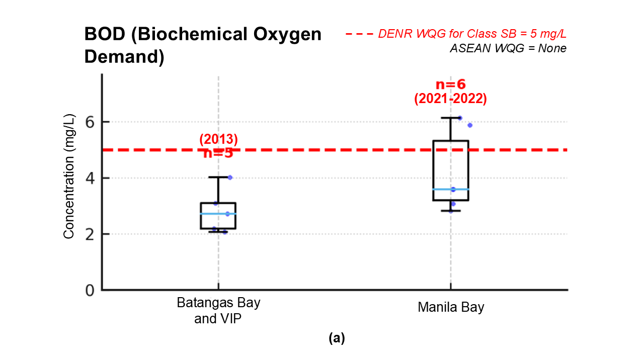
Figure 3.A.1. Box Plot for Biochemical Oxygen Demand in Coastal Pollution Hotspots
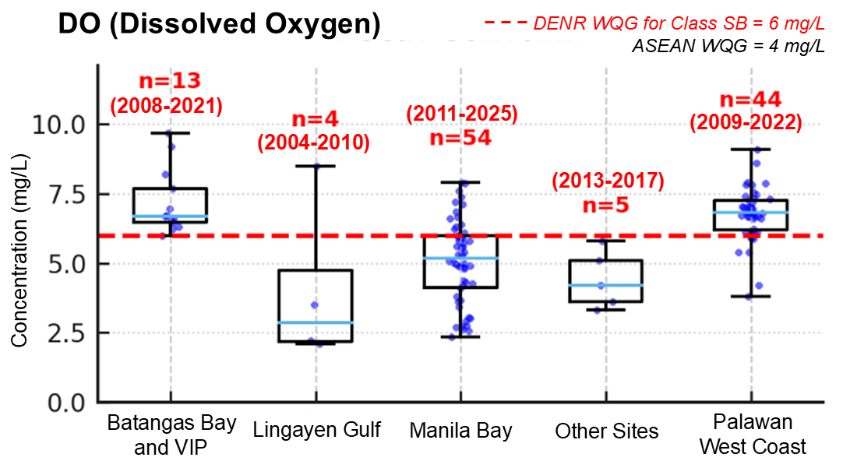
Figure 3.A.2. Box Plot for Dissolved Oxygen in Coastal Pollution Hotspots
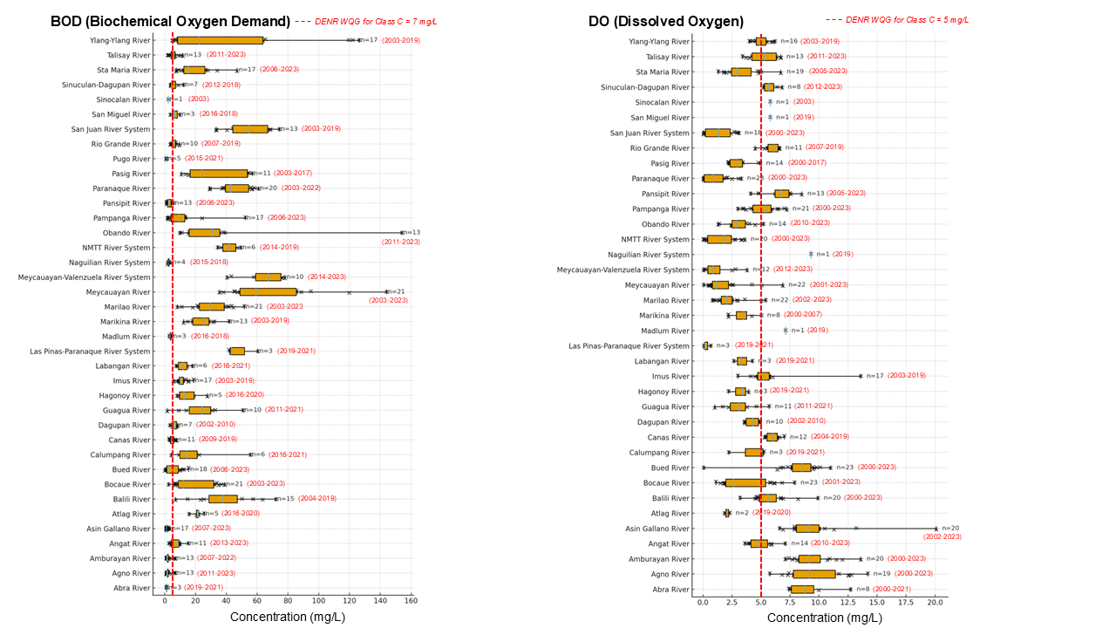
Figure 3.A.3. Box Plot for Biochemical Oxygen Demand in Rivers Draining to Philippine Waters of SCS-LME
Figure 3.A.4. Box Plot for Dissolved Oxygen in Rivers Draining to Philippine Waters of SCS-LME
Microbial Contaminants
Total and fecal coliform levels provide important indications of microbial contamination linked to untreated domestic wastewater and poor sanitation infrastructure. Exceedances above the thresholds of 1,000 MPN/100 mL (Total Coliform) and 100 MPN/100 mL (Fecal Coliform) suggest elevated public health risks. Sites such as Manila Bay consistently show high microbial counts. However, caution is advised when interpreting sites with limited samples (small n), as a few extreme values may disproportionately influence medians.

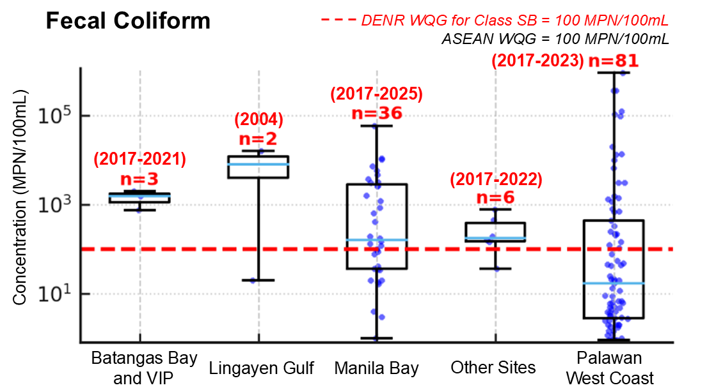
Figure 3.A.5. Box Plot for Fecal Coliform in Coastal Pollution Hotspots
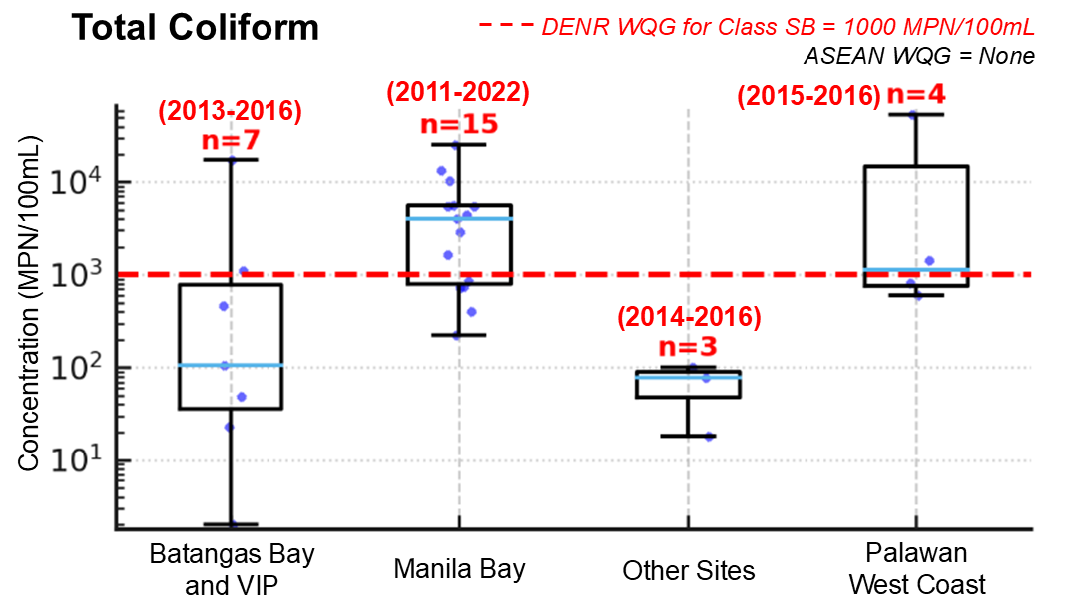
Figure 3.A.6. Box Plot for Total Coliform in Coastal Pollution Hotspots
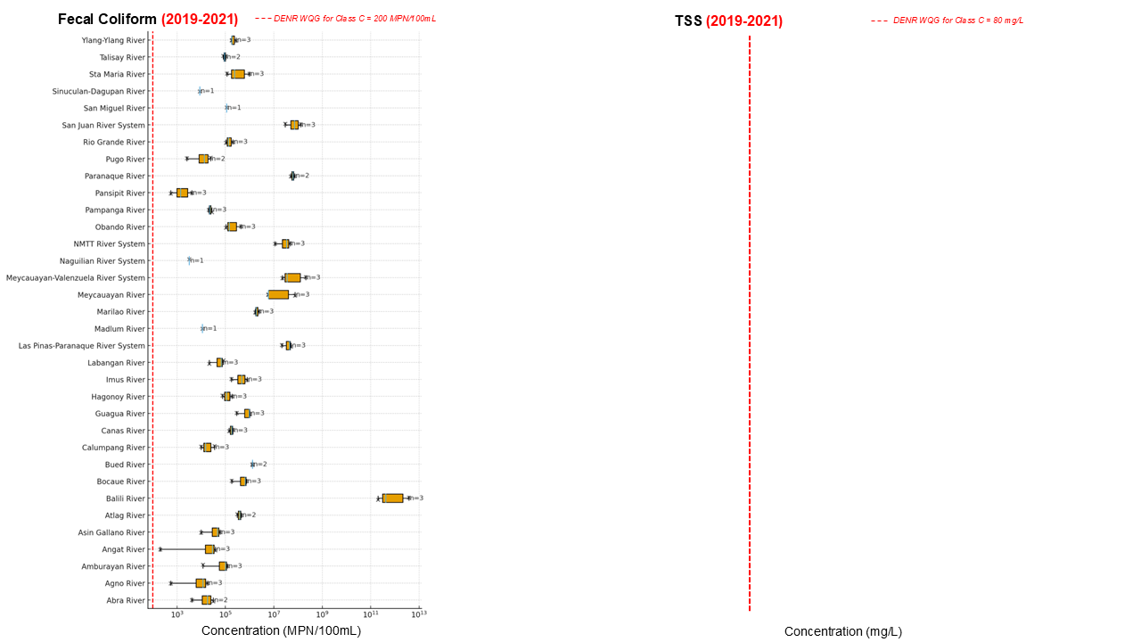
Figure 3.A.7. Box Plot for Fecal Coliform in Rivers Draining to Philippine Waters of SCS-LME
Heavy Metals
Lead and mercury represent toxic trace contaminants with serious ecological and human health implications. Lead values near or above the 0.01 mg/L threshold and mercury near or above 0.001 mg/L highlight risks of industrial and mining discharges, particularly in Manila Bay. While data for mercury are sparse, observed values warrant continued monitoring and stricter pollution control measures.
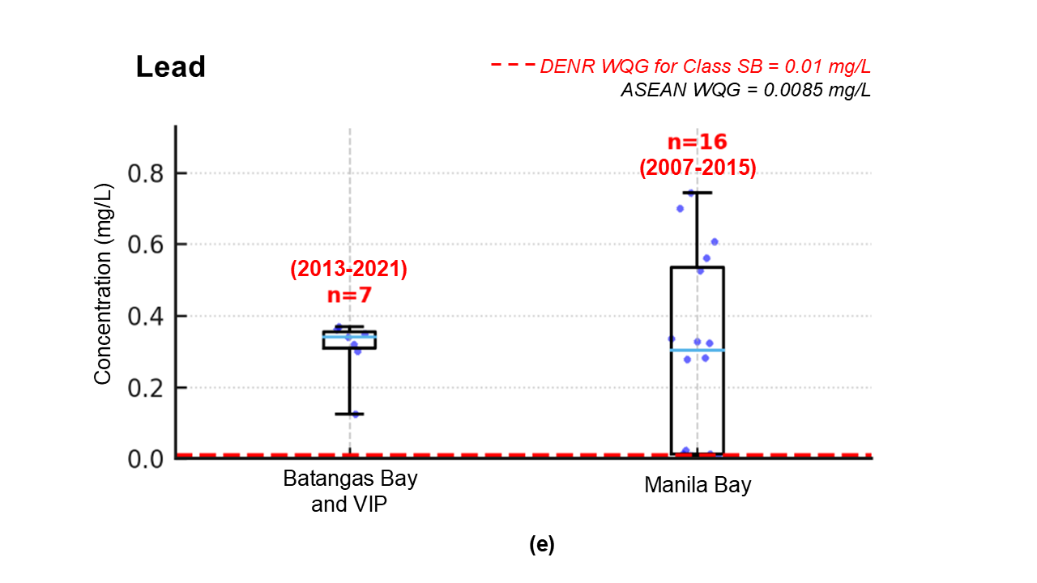
Figure 3.A.8. Box Plot for Lead in Coastal Pollution Hotspots
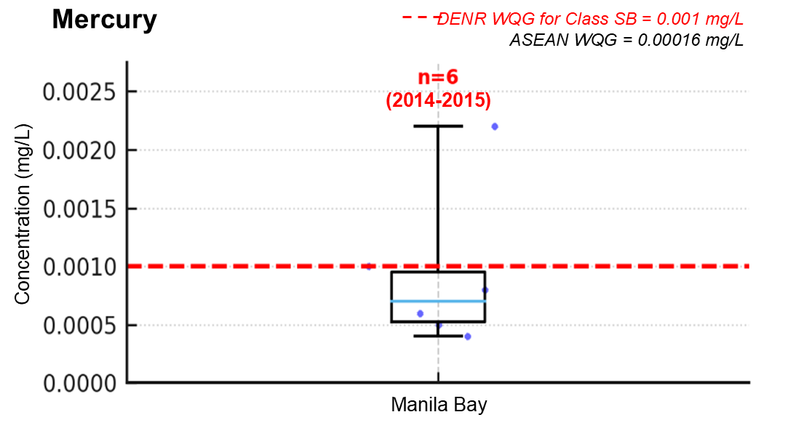
Figure 3.A.9. Box Plot for Mercury in Coastal Pollution Hotspots
Nutrients
Phosphates and nitrates are critical drivers of eutrophication. Concentrations above 0.2 mg/L (phosphates) and 0.06 mg/L (nitrates) suggest risks of algal blooms and water quality degradation. Elevated values are evident in Manila Bay and Palawan West Coast, consistent with inputs from domestic wastewater and agriculture. Care must be taken in interpreting sites with limited data, as nutrient fluxes are highly dynamic and sensitive to rainfall and seasonal agricultural cycles.

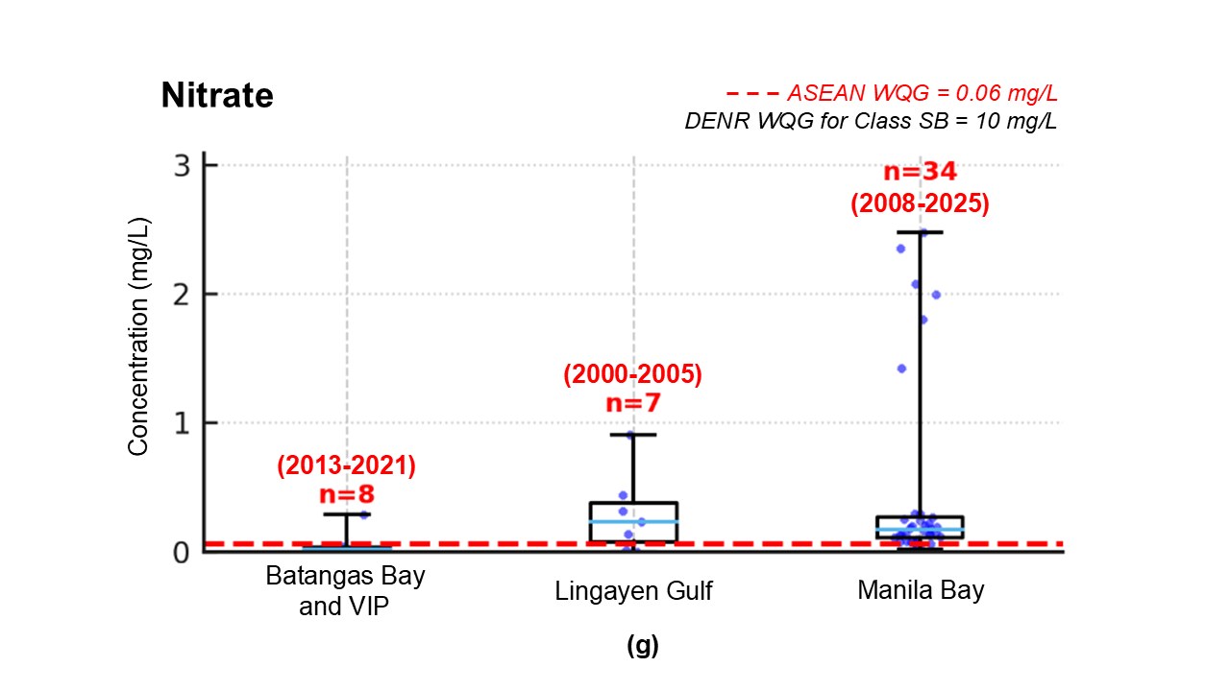
Figure 3.A.10. Box Plot for Nitrate in Coastal Pollution Hotspots

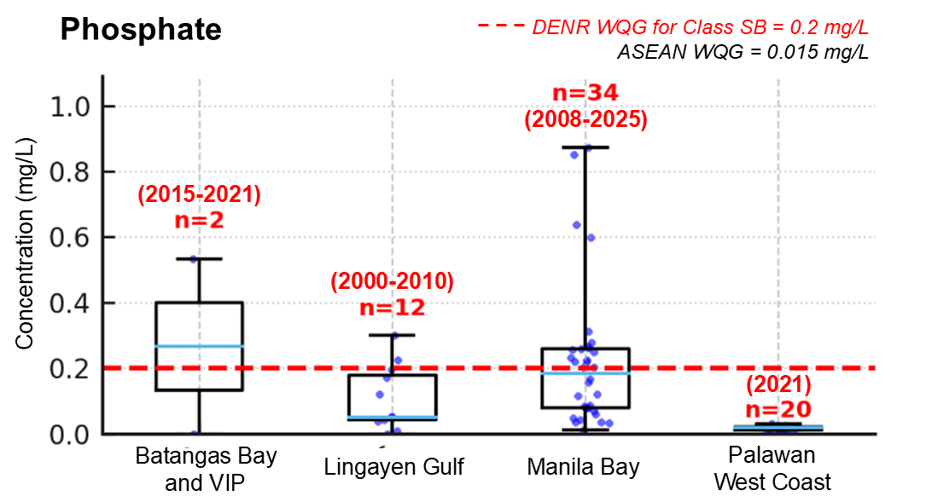
Figure 3.A.11. Box Plot for Phosphate in Coastal Pollution Hotspots
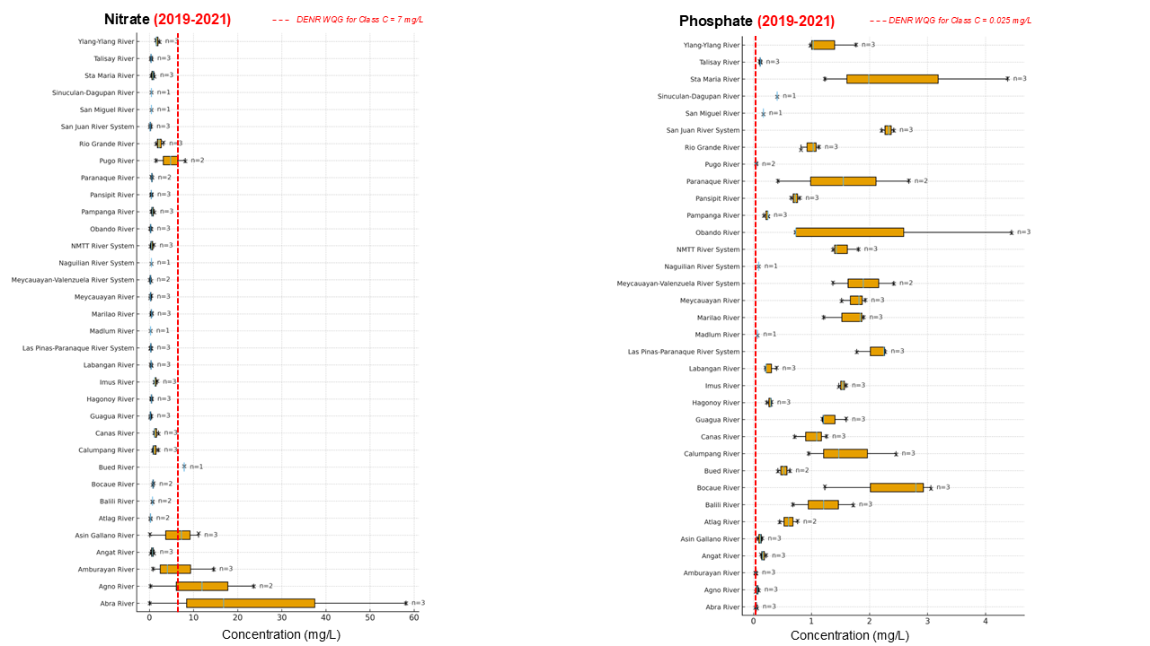
Figure 3.A.12. Box Plot for Nitrate in Rivers Draining to Philippine Waters of SCS-LME
Figure 3.A.13. Box Plot for Phosphate in Rivers Draining to Philippine Waters of SCS-LME
Particles
TSS and microplastics capture different dimensions of particulate pollution. TSS above 80 mg/L indicates high sediment and particulate loads, often driven by erosion, runoff, or reclamation activities. Microplastics are an emerging contaminant of concern, with a provisional threshold of 300 particles/m³ applied here. Sites exceeding this level highlight risks to aquatic organisms via ingestion and bioaccumulation. The field remains data-limited, and more systematic monitoring is needed.
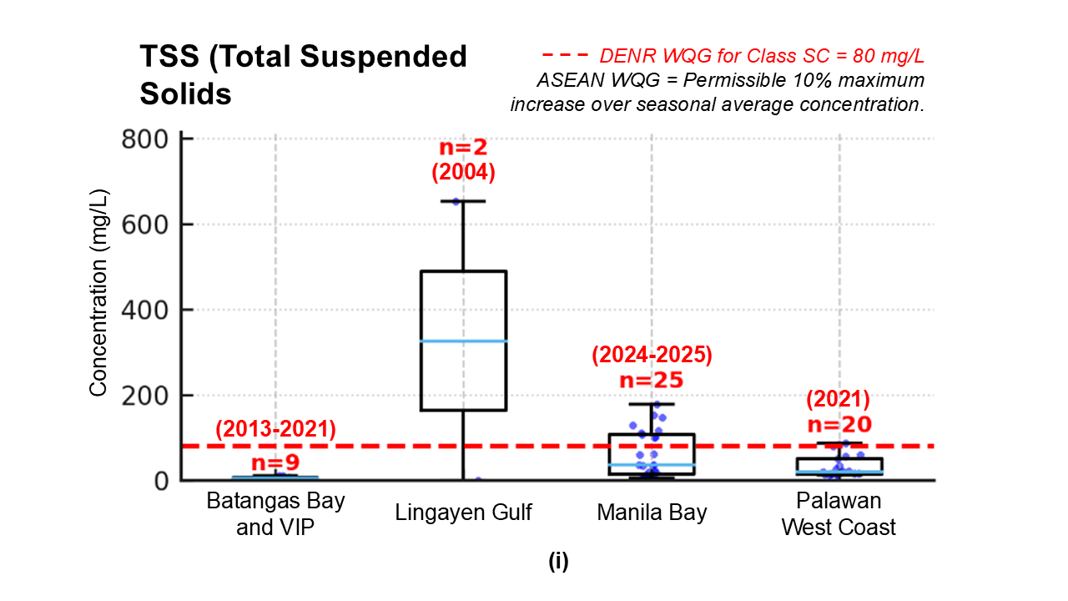
Figure 3.A.14. Box Plot for Total Suspended Solids in Coastal Pollution Hotspots

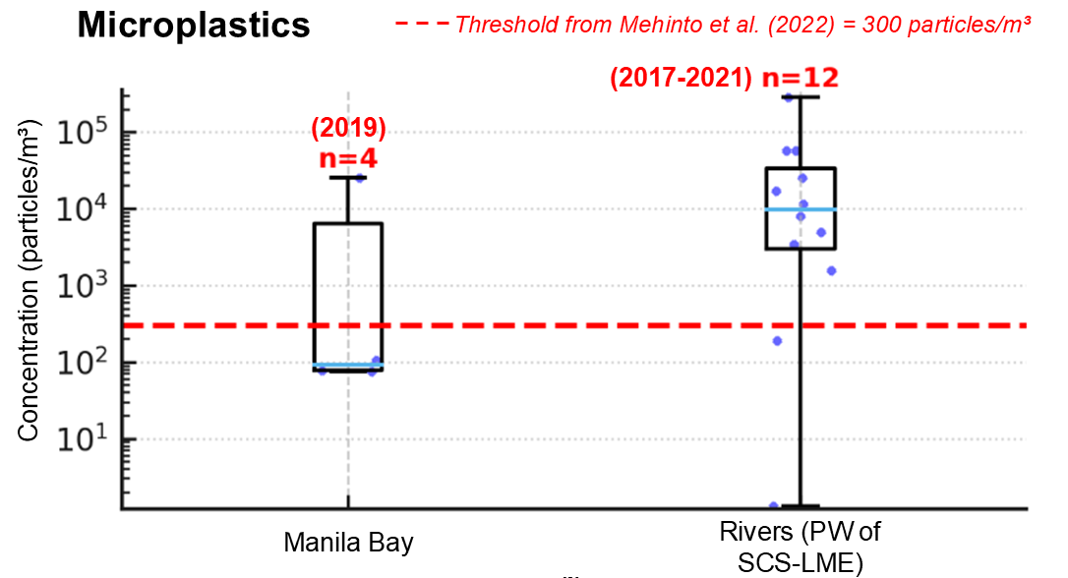
Figure 3.A.15. Box Plot for Microplastics in Coastal Pollution Hotspots
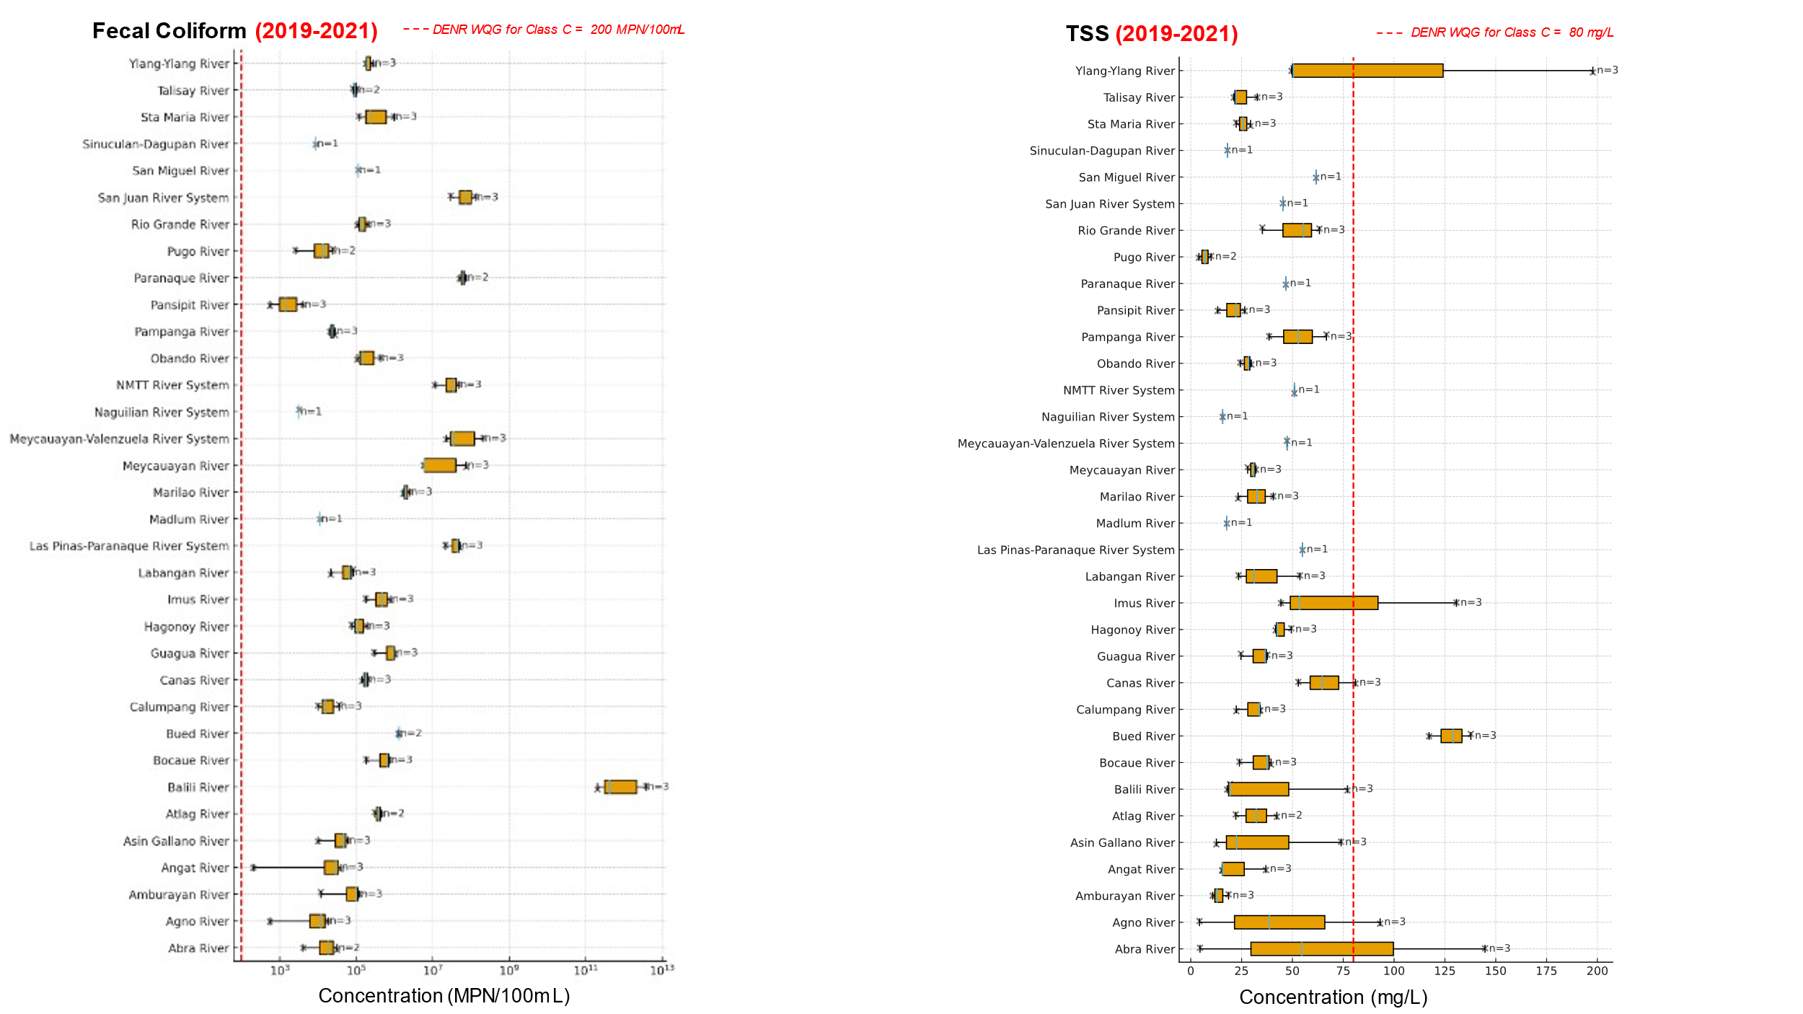
Figure 3.A.16. Box Plot for Total Suspended Solids in Rivers Draining to Philippine Waters of SCS-LME

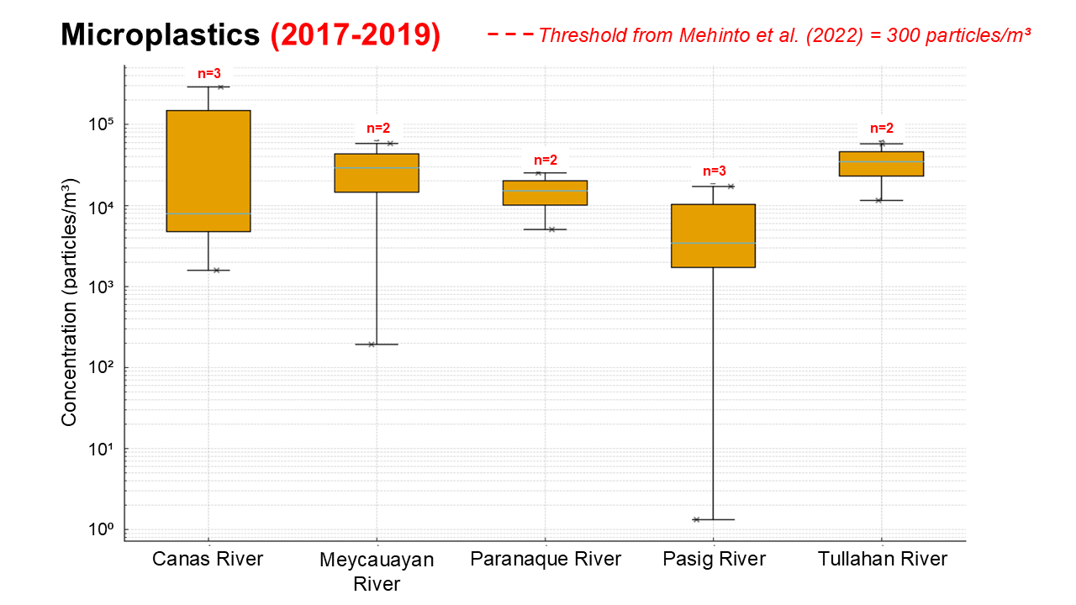
Figure 3.A.17. Box Plot for Microplastic Concentration in Rivers Draining to Philippine Waters of SCS-LME
TARGET SITES
The Philippines has designated the following target sites for implementation of the current Strategic Action Programme for the South China Sea and Gulf of Thailand (SCS SAP): Malampaya Sound Protected Landscape and Seascape (MSPLS) under the municipalities of Taytay and San Vicente in Palawan; Coron and Busuanga in Palawan; and Mabini and Tingloy in Batangas. This section examines the state of these sites in terms of the pollution indicators as well as current interventions done in the municipalities.
Wastewater
Taytay, Palawan (MSPLS)
According to the Palawan Council for Sustainable Development or PCSD (2020), there is no organized sewage disposal in the municipality. Domestic wastewater is discharged to septic tanks and open pits, with some discharged to earth canals that drain to creeks or rivers or simply allowed to seep naturally into the ground.
San Vicente, Palawan (MSPLS)
There is no centralized sewerage system established nor wastewater treatment plant installed in the municipality. However, under the Comprehensive Development Plan for San Vicente, the LGU aims to improve sewerage system in households and public market. Establishment of wastewater treatment facility in Poblacion Public Market and Barangay Port Barton were also included. The LGU also plan to have a strict implementation on discharge permit requirements and conduct information education campaign with the community on the importance oof wastewater management (Municipal Planning and Development Office, 2022).
Coron, Palawan
Similarly, there is no sewerage system in Coron (Abrenica et al., 2020). But plans on building a new septage treatment are in talks (Adonis, 2023) and a resolution was released to award the construction of a sewage treatment facility in Coron recently (TIEZA, 2025) all to manage the wastewater issues in the municipality.
Mabini and Tingloy, Batangas
The following issue to be discussed pertains to the entire province of Batangas. In terms of wastewater management, there is limited access to sewage and septage treatment. There is a lack of centralized wastewater connection system and inadequate sanitation and sewerage management. Point sources of untreated wastewater entering the waterways are largely from agricultural (45%) followed by domestic (31%) and industrial (24%). In 2016, around 12.68% of households have no sanitary toilet and resort to open defacation. The province of Batangas, as part of their action program, aims to establish an individual and centralized wastewater treatment facility/sewage treatment plant as per their Strategic Environmental Management Plan (Awitan, 2023).
Solid Waste

Taytay, Palawan (MSPLS)

Overall, poor solid waste management is an issue in the municipality of Taytay. Disposing of garbage through burning were done by 39% of the households in Taytay, 29% through dumping in open pits, 25% by burying, while only 8% are collected by garbage truck and 7% are disposed through garbage pit or composting. Only one garbage truck is in operation which collects waste daily and disposed in an open pit dumpsite in Barangay Poblacion. There is no Material Recovery Facility (MRF) or Sanitary Landfill in the municipality. The increasing solid and liquid waste together with poor waste management leads to environmental and marine pollution in the MSLPS.
Local initiatives include identifying suitable landfill sites and conducting information, education, and communication (IEC) campaigns in schools on proper waste disposal practices. A resolution prohibiting plastic and styrofoam use is currently under consideration, and regular coastal cleanup activities are being implemented. In 2018, the Palawan Council for Sustainable Development (PCSD) approved Taytay's Ten-Year Solid Waste Management Plan (2017-2027) (PCSD, 2020; MSPLS Protected Area Management Plan 2025-2035, 2024).

San Vicente, Palawan (MSPLS)

Majority of the waste generated comes from the residential sector at 90.35% based on the Waste Analysis and Characterization Study (WACS) done in 2018 (Table 3.E.4). In terms of waste composition (Table 3.E.5), biodegradable materials constitute the largest proportion at 43.31%, followed by recyclables at 23.86%. The high biodegradable percentage most likely indicates organic waste from food and vegetation. From the conducted WACS, a daily per capita rate of 0.448 kg was computed.
Table 3.A.6. Waste Disposed by Sector in San Vicente, Palawan (2018) (Municipal Planning and Development Office, 2025)
Sector | Kg/day | Kg/yr | Tons/yr | Percentage (%)
Residential | 12,715.39 | 4,641,117.75 | 4,641.12 | 90.35
Commercial | 1,036.76 | 378,418.10 | 378.42 | 7.37
Institution | 296.38 | 108,177.20 | 108.18 | 2.11
Industry | 25.57 | 9,334.27 | 9.33 | 0.18
Total | 14,074.10 | 5,127,713.06 | 5,127.71 | 100
Table 3.A.7. Waste Disposed by Composition in San Vicente, Palawan (2018) (MPDO, 2025)
Sector | Kg/day | Kg/yr | Tons/yr | Percentage (%)
Biodegradables | 6,095.72 | 2,224,938.37 | 2,224.94 | 43.31
Recyclables | 3,357.57 | 1,225,511.66 | 1,225.51 | 23.86
Residuals (with potential for diversion) | 1,886.47 | 688,559.83 | 688.56 | 13.40
Residuals | 2,219.94 | 810,277.08 | 810.28 | 15.77
Special Wastes | 514.41 | 187,760.38 | 187.76 | 3.66
Total | 14,074.10 | 5,137,047.32 | 5,137.05 | 100
In 2022, waste management practices varied considerably: 62.66% of households segregated waste, 31.55% utilized garbage truck collection services, and 23.97% engaged in composting. However, a large number of households (56.46%) still burned their waste. By 2024, waste infrastructure had improved, with 8 out of 10 barangays having an established MRFs and the LGU is actively pursuing the development of a sanitary landfill. The Solid Waste Management Code of the Municipality of San Vicente, Palawan (Ordinance No. 2006-04-108) is also in place (Municipal Planning and Development Office, 2022; 2025).
Busuanga, Palawan
As of 2020, there is no Sanitary Landfill in the municipality. Most of the garbage waste are disposed by burning or dumping in open pits (Bautista et al. 2020).
Coron, Palawan
In terms of solid waste management in Coron, most of the domestic waste are disposed through open pit in their backyards to naturally decompose, while others throw their wastes unattended in public spaces and coastal area. Only selected barangays are served by dump trucks where a municipal open dump site becomes the final disposal site. There is no established MRF in the municipality.
To mitigate the issue on solid waste, the LGU performs IEC programs on waste management, coastal cleanup activities, and regular garbage collection. A proposal on the establishment of Sanitary Landfill is also underway (Abrenica et al., 2020).
Mabini and Tingloy, Batangas
Waste generation is among the pressing issues in Batangas wherein 874,810 kg/day was generated for 2014-2015. The computed per capita generation is 0.33 kg/day. Biodegradable waste has the highest composition at 47.62%, followed by recyclables (27.37%), residuals (12.15%) while 11.09% of generated waste has potential for diversion. In 2015, the computed per capita generation for Mabini is 0.1149 kg/day while 0.1422 kg/day for the municipality of Tingloy.
The Provincial Government Environment and Natural Resources Office (PGENRO) of Batangas aims for a more effective implementation of RA 9003 (Ecological Solid Waste Management Act) by approved Solid Waste Management Plan (SWMP) for all LGUs with annual reports on the status and implementation. As of 2023, The Ten-Year SWMP of Mabini was approved in 2018 while the Ten-Year SWMP of Tingloy is subject for evaluation. Mabini also has a designated MRF and Sanitary Landfill for waste disposal. The (PGENRO action program also prioritizes eliminating uncontrolled dumping and open burning while expanding sanitary landfill capacity. The program also encourages community participation through public awareness campaigns on waste management, capacity-building seminars, and training initiatives to enhance knowledge and practices for sustainable agricultural waste management. Small and medium enterprises (SME) are also encouraged to establish recycling facilities and organic farming.
Hazardous Waste
San Vicente, Palawan (MSPLS)
In handling hazardous waste management, the LGU of San Vicente plans to construct a concrete vault as a storage for hazardous waste, provide plastic drums to store collected used oil, and establish storage area for batteries and electronic devices. Operational improvements involve coordinating with Treatment, Storage, and Disposal (TSD) companies and incorporating hazardous waste management provisions into business permit application requirements (Municipal Planning and Development Office, 2022).
Oil Pollution
Malampaya Sound
Given that MSPLS habitat consists primarily of shallow reef flats and steep drop-offs, oil spill incidents could result in severe ecological damage. Oil spills in the area may result from vessel groundings, leakages, collisions, and allisions. Response strategies should prioritize environmentally safe dispersants, solidifiers, and treatment agents while considering potential secondary impacts.
To mitigate the possible threat caused by oil spill, strict compliance to maritime regulations and continuous updated training for personnel are being implemented. Regular monitoring of weather conditions are also done to prevent maritime accidents (Response Plan of MSPLS, Taytay, Palawan 2023-2028, 2025).
Atmospheric Deposition
San Vicente, Palawan (MSPLS)
Air quality management initiatives encompass both monitoring and mitigation strategies. These include the installation of monitoring stations and establishment of airsheds to assess atmospheric conditions, alongside greenhouse gas (GHG) reduction programs such as the Zero Carbon Resort Initiative. Policy frameworks incorporate the Climate Change Program, Clean Development Mechanism, and other carbon crediting initiatives, complemented by enforcement measures such as anti-smoke belching campaigns to reduce vehicular emissions (Municipal Planning and Development Office, 2022).

Annex 3.B. Wastewater Pollution Indicators and Modeled Pollution Load
The dataset was extracted from various government reports by the PSA, NEDA, EMB, and EMB-MBO. This Annex provides the data used for the analysis and visualization, and the formulas to compute the pollution load estimates and removal in wastewater prior to discharge.
Table 3.B.1. Data on wastewater generation and treatment in Metro Manila (2014-2023) (PSA, 2024)
Year | Total wastewater generated (Mm³/yr) | Total wastewater treated (Mm³/yr) | Total number of facilities | Percentage treated | Average treatment capacity (Mm³/facility)
2014 | 729.69 | 73.42 | 56 | 10% | 1.3
2015 | 754.3 | 83.67 | 59 | 11% | 1.4
2016 | 781.97 | 95.2 | 60 | 12% | 1.6
2017 | 800.04 | 100.22 | 60 | 13% | 1.7
2018 | 824.35 | 108.72 | 62 | 13% | 1.8
2019 | 823.42 | 119.41 | 63 | 15% | 1.9
2020 | 834.21 | 128.3 | 63 | 15% | 2.0
2021 | 806.52 | 121.76 | 49 | 15% | 2.5
2022 | 822.21 | 120.32 | 49 | 15% | 2.5
2023 | 843.75 | 121.66 | 49 | 14% | 2.5
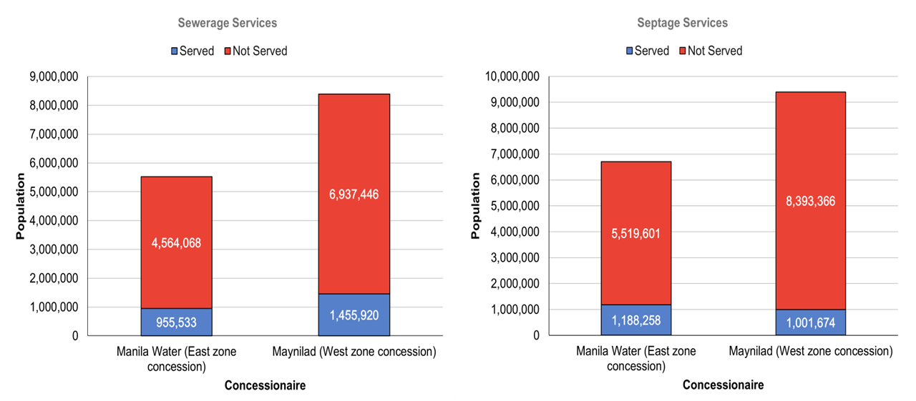
Figure 3.B.1 Sewerage and Septage Services in Metro Manila as of 2017. Stacked-bar chart showing the population in the East and West Zone of Metro Manila with and without sewerage services (left panel) and septage services (right panel) (NEDA, 2021).
Table 3.B.2. Septage and Sewerage Coverage of MWSS Concessionaires in Metro Manila, 2017, Data source: NEDA, 2021
Concessionaire | Total Population | Septage Population Served | Population Not Served with Septage | Septage Coverage (%) | Not Served (%) | Sewerage Population Served | Population Not Served with Sewerage | Sewerage Coverage (%) | Not Served (%)
Manila Water (East zone concession) | 6,707,859 | 1,188,258 | 5,519,601 | 17.7 | 82.29 | 955,533 | 4,564,068 | 14.2 | 68.04
Maynilad (West zone concession) | 9,395,040 | 1,001,674 | 8,393,366 | 10.7 | 89.34 | 1,455,920 | 6,937,446 | 15.5 | 73.84
Total | 16,102,899 | 2,189,932 | 13,912,967 | 13.6 | 86.40 | 2,411,453 | 11,501,514 | 15 | 71.43

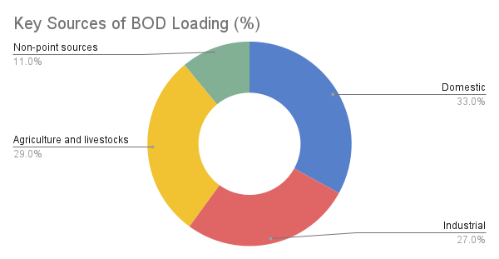
Figure 3.B.2. Four Key Sources of BOD Loading for Water Pollution. Data source: EMB DENR (2020b).
Pollution Load Estimates from Domestic Wastewater
Nomenclature
HDWL – Household Waste Load, (kg/day, for Fecal Coliform – MPN/day)
SF – Sewage Flow (use 50 gal/cap/day based in PD 856)
PUL – Pollution Unit Load assumption
HDPL – Household Pollution Load (kg/day, for Fecal Coliform – MPN/day)
TE – Treatment Efficiency
PLR – Pollution Load Removed
To estimate the domestic pollution load, the EMB Memorandum Circular 2020-25 (EMB, 2020a) was used as a reference. The calculation applied the Philippine Statistics Authority’s 2025 projected mid-year population, aggregating the populations of provinces expected to contribute wastewater from the watershed or river basins into the Philippine waters of the SCS-LME. Provinces included specifically are NCR, Benguet, Abra, Ilocos Norte, Ilocos Sur, La Union, Pangasinan, Batanes, Zambales, Nueva Ecija, Tarlac, Bataan, Pampanga, Bulacan, Cavite, Batangas, Laguna, Rizal, Occidental Mindoro, Palawan, and some municipalities/cities in Mountain Province, Nueva Vizcaya, Aurora, Quezon, and Oriental Mindoro. The following formula was used to calculate the domestic waste generated:
HDWL = Population x SF x PUL
Table 3.B.3. Household Domestic Pollution Unit Load (PUL) Assumption (Tchobanoglus et al., 2003)
Parameter/Pollutant | Pollution Unit Load or Concentration | Unit
Biochemical Oxygen Demand (BOD5) | 200 | mg/L
Chemical Oxygen Demand (COD) | 508 | mg/L
Nitrate as NO3-N | 35 | mg/L
Phosphate as Phosphorus | 5.6 | mg/L
Total Suspended Solids | 195 | mg/L
Fecal Coliform | 10,000 – 1,000,000 | MPN/100mL

Table 3.B.4. Projected 2025 Mid-Year Population in Selected Provinces (PSA, 2025)
Region | Province | Population | Year
NCR | NCR | 14,521,657 | 2025
CAR | Mountain Province (2 municipalities) | 25,306 | 2025
CAR | Benguet | 892,600 | 2025
CAR | Abra | 252,070 | 2025
Region 1 | Ilocos Norte | 628,200 | 2025
Region 1 | Ilocos Sur | 735,053 | 2025
Region 1 | La Union | 859,561 | 2025
Region 1 | Pangasinan | 3,235,249 | 2025
Region 2 | Batanes | 18,571 | 2025
Region 2 | Nueva Vizcaya (5 municipalities) | 115,108 | 2025
Region 3 | Aurora (3 municipalities) | 105,318 | 2025
Region 3 | Zambales | 949,718 | 2025
Region 3 | Nueva Ecija | 2,582,695 | 2025
Region 3 | Tarlac | 1,533,124 | 2025
Region 3 | Bataan | 896,684 | 2025
Region 3 | Pampanga | 3,115,786 | 2025
Region 3 | Bulacan | 3,923,826 | 2025
Region 4A | Cavite | 4,639,491 | 2025
Region 4A | Batangas | 3,423,043 | 2025
Region 4A | Laguna | 3,583,594 | 2025
Region 4A | Quezon (2 municipalities) | 75,777 | 2025
Region 4A | Rizal | 3,464,226 | 2025
Region 4B | Occidental Mindoro | 536,768 | 2025
Region 4B | Oriental Mindoro (4 municipalities/cities) | 257,737 | 2025
Region 4B | Palawan | 1,303,583 | 2025
TOTAL |  | 51,674,745

To estimate the pollution load removed through onsite sanitation systems, it was assumed that approximately 90% of households have access to sanitation facilities, based on the 2024 CPES report from the PSA. In 2021, the proportion of households with improved sanitation facilities in regions bordering the SCS-LME ranged from 91.9% to 99.3%; thus, a conservative estimate of 90% was applied. In this scenario, this 90% is assumed to be connected to septic tanks; thus, a 25% treatment efficiency was applied. Additionally, it was assumed that 5% of the population is connected to Wastewater Treatment Facilities (WWTFs) (Tuddao, 2019), while the remaining 5% discharge directly into waterways. All computations are subject to a 5% margin of error. The pollution load removed was then computed using the following formula:
HDPL = [HDWL x 90% x (1-TE_septic)] x [HDWL x 5% (1-TE_WWTF)] + [HDWL x 5% x (1-TE_direct)]
PLR = HDWL – HDPL
Table 3.B.5. Treatment Efficiency (TE) Assumption (EMB, 2020a)
Treatment | Efficiency
WWTF | 60% or (1-0.60)
Septic Tank | 25% or (1-0.25)
Direct Discharge or raw/untreated | 0%
Table 3.B.6. Estimated Pollution Load on Selected Provinces based on PSA’s Projected Population for 2025
Indicator | HDWL | HDPL | PLR
BOD | 710,000±36,000 | 530,000±27,000 | 180,000±9,100
COD | 1,800,000±91,000 | 1,400,000±68,000 | 460,000±23,000
Nitrate as NO3-N | 120,000±6,200 | 93,000±4,700 | 32,000±1,600
Phosphate as Phosphorus | 20,000±1,000 | 15,000±740 | 5,100±250
TSS | 700,000±35,000 | 520,000±26,000 | 180,000±8,900

Table 3.B.7. Fecal Coliform statistics in Manila Bay (19 Monitoring Stations) (EMB-MBO, 2016)
Year | Geometric Mean (MPN/100mL) | Min Count (MPN/100mL) | Max Count (MPN/100mL) | % Exceed 200 MPN
2011 | 5,429 | 1,150.00 | 33,000.00 | 100.0%
2012 | 10,149 | 85.08 | 160,000.00 | 85.7%
2013 | 13,389 | 393.28 | 540,000.00 | 100.0%
2014 | 5,396 | 266.00 | 200,000.00 | 100.0%
2015 | 25,517 | 183.33 | 5,580,000.00 | 94.1%

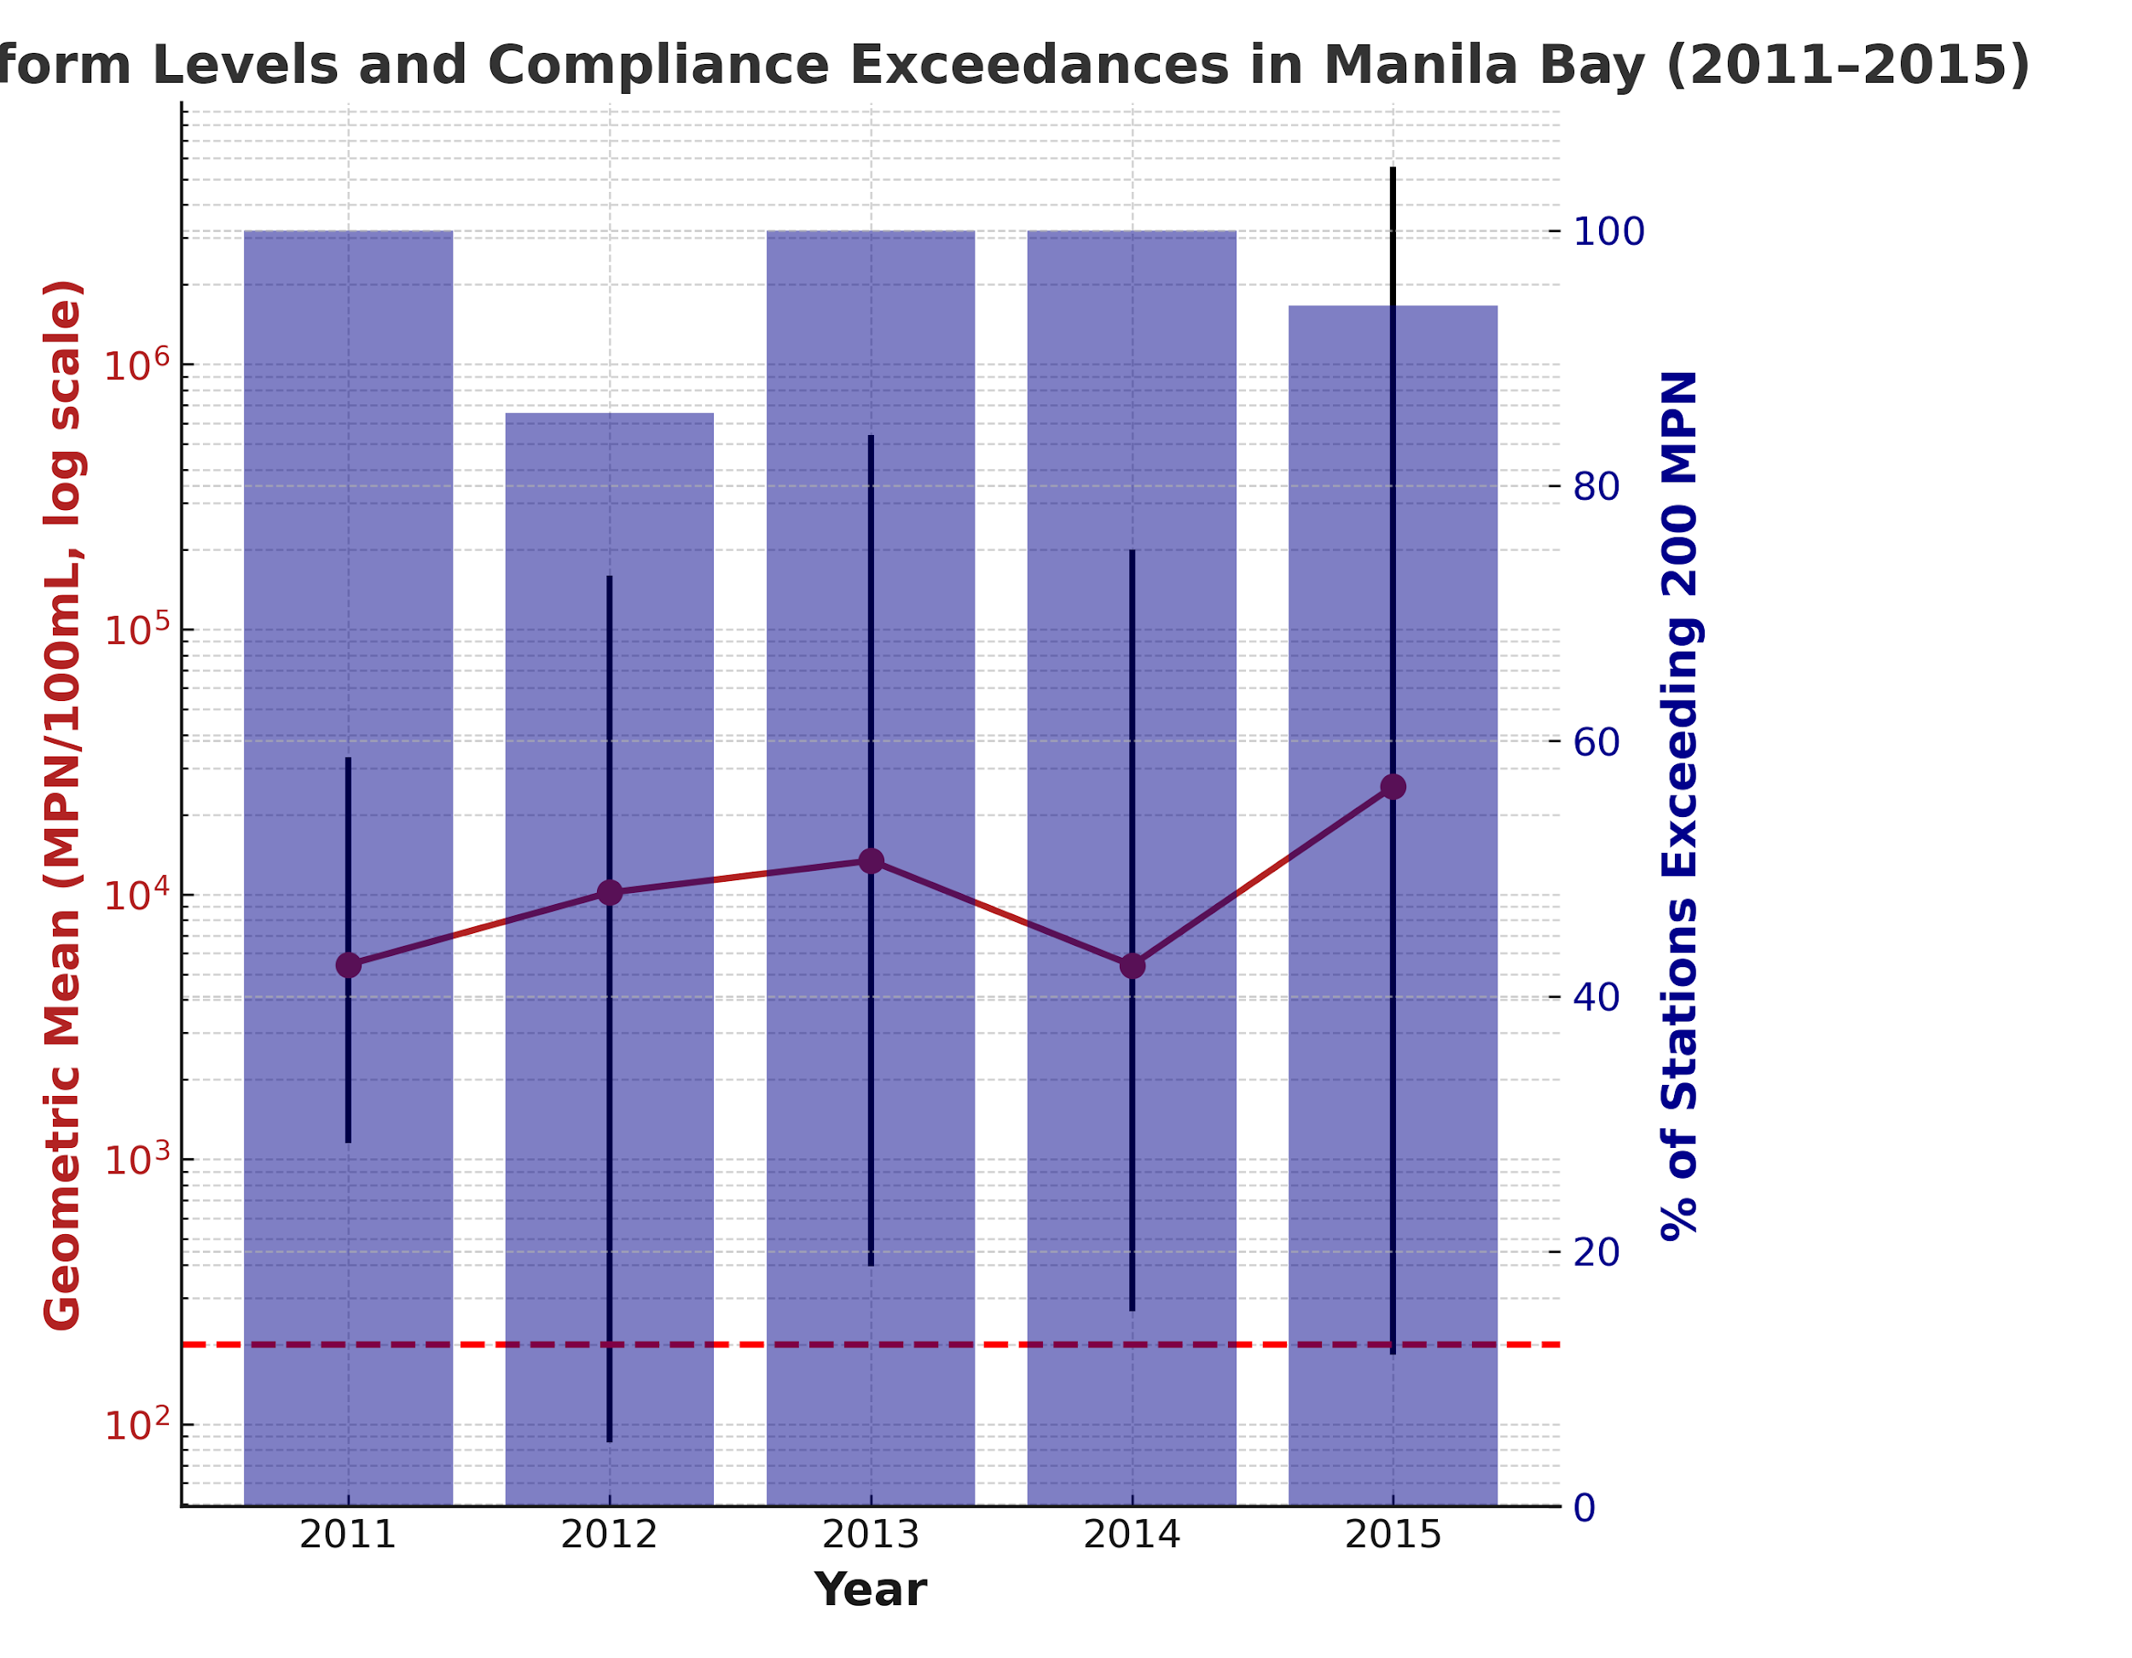
Figure 3.B.3. Fecal Coliform Levels in Manila Bay in 19 Monitoring Stations (2011-2015) (EMB-MBO, 2016).
Table 3.B.8. Pollution Load Data on Wastewater from Selected Regions in the Philippines (2019) (EMB, 2020b).
Region | BOD (tons) | COD (tons) | Nitrate (tons) | Phosphate (tons) | TSS (tons) | Fecal Coliform (MPN/100mL)
NCR | 143,231.88 | 363,808.98 | 25,065.58 | 4,010.49 | 139,651.09 | 1.99E+14
CAR | 20,954.34 | 53,224.02 | 3,667.01 | 586.72 | 20,430.48 | 2.91E+13
Region I | 57,842.79 | 146,920.68 | 10,122.49 | 1 ,619.60 | 56,396.72 | 8.03E+13
Region II | 41,040.63 | 104,243.19 | 7,182.11 | 1,149.14 | 40,014.61 | 5.70E+13
Region III | 132,959.72 | 337,717.70 | 23,267.95 | 3,722.87 | 129,635.73 | 1.85E+14
Region IV-A | 171,082.65 | 434,549.93 | 29,939.46 | 4,790.31 | 166,805.58 | 2.38E+14
MIMAROPA | 36,192.56 | 91,929.10 | 6,333.70 | 1,013.39 | 35,287.75 | 5.03E+13
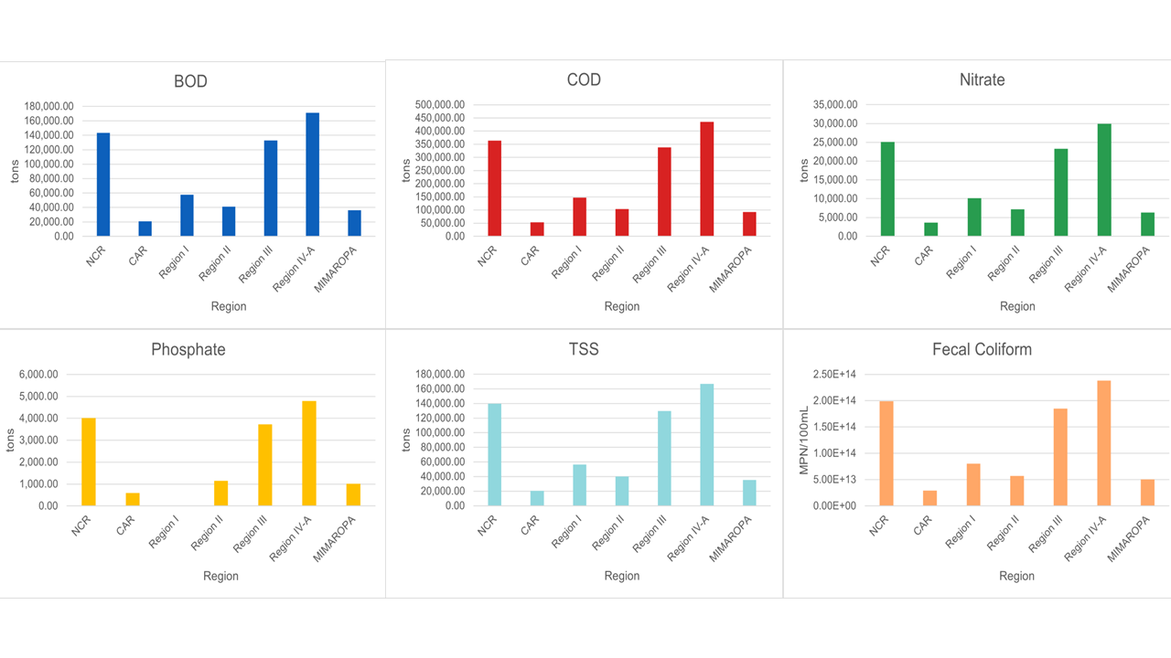
Figure 3.B.4. Projected Pollution Load on Wastewater from Selected Regions in Philippines for 2019 (EMB, 2020b).
Table 3.B.9. Sectoral profile of manufacturing plants
Sector | Typical product streams | Environmental signature/key pollutant
Pulp & paper | Kraft paper, newsprint, packaging board | High-BOD & color in wastewater; fibre sludge
Sugar mills & alcohol distilleries | Raw & refined sugar, bioethanol, rum | Molasses-rich, high-BOD effluent; bagasse waste
Food processing | Canned fruit, meat, beverages | Organic-rich effluent; oil & grease
Plastic & consumer goods | Flexible packaging, toys, housewares | Solvent VOCs; pellet micro-plastics
Base-material plants | Copper smelter, glass and steel works, cement kilns | Metal particulates; SO₂/NOₓ; slag
Electronics assembly & aerospace | Semiconductors, PCB, aircraft parts | Acid/alkali rinse water; PFAS; heavy metals
Textiles | Garments, yarn, and fabric dyeing | Dyestuff-laden wastewater; high TDS
Petroleum refining & shipbuilding | Fuels, lubricants, and ocean-going vessels | Hydrocarbon effluent, bilge & sludge oils

Table 3.B.10. Wastewater qualities of selected industry types in the Philippines (WEPA, 2024)
Industry | BOD (mg/L) | COD (mg/L) | TSS (mg/L) | Temp (°C) | pH
Sugarcane milling | 2,000–3,500 | 6,000 | 800–1,000 | – | 6.5–8.0
Manufacture of ethanol | 60,000 | 110,000 | 6,000 | 48–50 | 4–4.5
Canning of fish products | 30,000 | 45,000 | 10,700 | 25 | 6.5–7.5
Manufacture of beverages | 900 | 1,500 | 250 | 25 | 11–12
Meat processing | 1,000–1,500 | 2,000 | 250 | – | 7
Copper cathode | – | – | 43 | 30.4 | 8.15
Swine farm | 2,000–4,200 | 4,000–5,429 | 1,600–5,380 | – | –
Bottling services | 400 | 1,647.05 | 90 | 32.2 | 8.35
Manufacturing of desiccated coconut | 6,000–10,000 | 17,000–20,000 | 2,000–4,000 | – | 5.0–6.3
Pineapple processing plant | 10,200 | 20,000 | 585 | 40–50 | 4.5–6.5

Annex 3.C. Agricultural Runoff and Diffuse Pollution Indicators
The dataset on pesticide and fertilizer use in the Philippines was extracted from the Food and Agriculture Organization’s (2025) database to create time-series graphs illustrating trends in agricultural inputs over time. Data on nutrient loads in selected watersheds and river basins were sourced from Magcale-Macandog et al. (2016). A summary table of all data and figures is provided in the annex.
Table 3.C.1. Fertilizer Use per Area from 2000-2022 (FAO, 2025a; FAO, 2025b)
Spatial Coverage | Year | Unit | N Fertilizer | P Fertilizer | K Fertilizer | Pesticide
Philippines | 2000 | kg/ha | 50.2 | 12.8 | 12.6 | 1.8
Philippines | 2001 | kg/ha | 52.4 | 15.4 | 13 | 1.8
Philippines | 2002 | kg/ha | 46.2 | 13.4 | 11.7 | 1.9
Philippines | 2003 | kg/ha | 58.8 | 13.3 | 13.1 | 1.9
Philippines | 2004 | kg/ha | 63.2 | 13 | 12.1 | 1.8
Philippines | 2005 | kg/ha | 55.2 | 13.9 | 10.4 | 1.9
Philippines | 2006 | kg/ha | 47.1 | 14.8 | 11.6 | 1.9
Philippines | 2007 | kg/ha | 50.5 | 19.9 | 11.4 | 1.9
Philippines | 2008 | kg/ha | 38.2 | 7.5 | 8.7 | 1.9
Philippines | 2009 | kg/ha | 40.4 | 6.2 | 16.5 | 1.9
Philippines | 2010 | kg/ha | 56 | 8.7 | 11 | 2
Philippines | 2011 | kg/ha | 48.2 | 14 | 11.2 | 2
Philippines | 2012 | kg/ha | 43 | 7.4 | 10.1 | 2
Philippines | 2013 | kg/ha | 48.1 | 18.4 | 13 | 2
Philippines | 2014 | kg/ha | 54.2 | 12.4 | 13.5 | 2
Philippines | 2015 | kg/ha | 47.8 | 11.9 | 11 | 2.1
Philippines | 2016 | kg/ha | 56.8 | 14.3 | 14.7 | 2
Philippines | 2017 | kg/ha | 68.7 | 18.8 | 19.7 | 1.9
Philippines | 2018 | kg/ha | 58.5 | 12 | 14.6 | 1.9
Philippines | 2019 | kg/ha | 63.7 | 15.9 | 18.6 | 2.2
Philippines | 2020 | kg/ha | 67.3 | 18.5 | 19.1 | 3.1
Philippines | 2021 | kg/ha | 64 | 23.1 | 28.9 | 3.4
Philippines | 2022 | kg/ha | 71.5 | 35.9 | 35.3 | 3.4

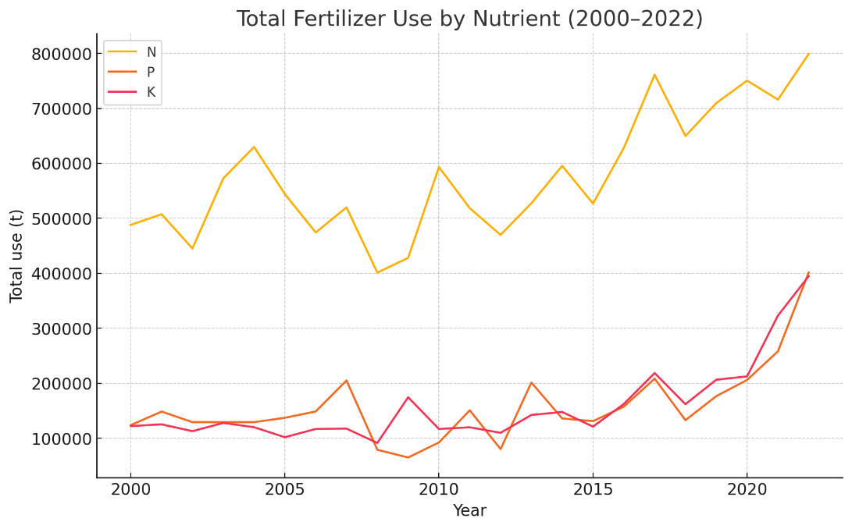
Figure 3.C.1. Trend of Annual Total Fertilizer Use (2000-2022)
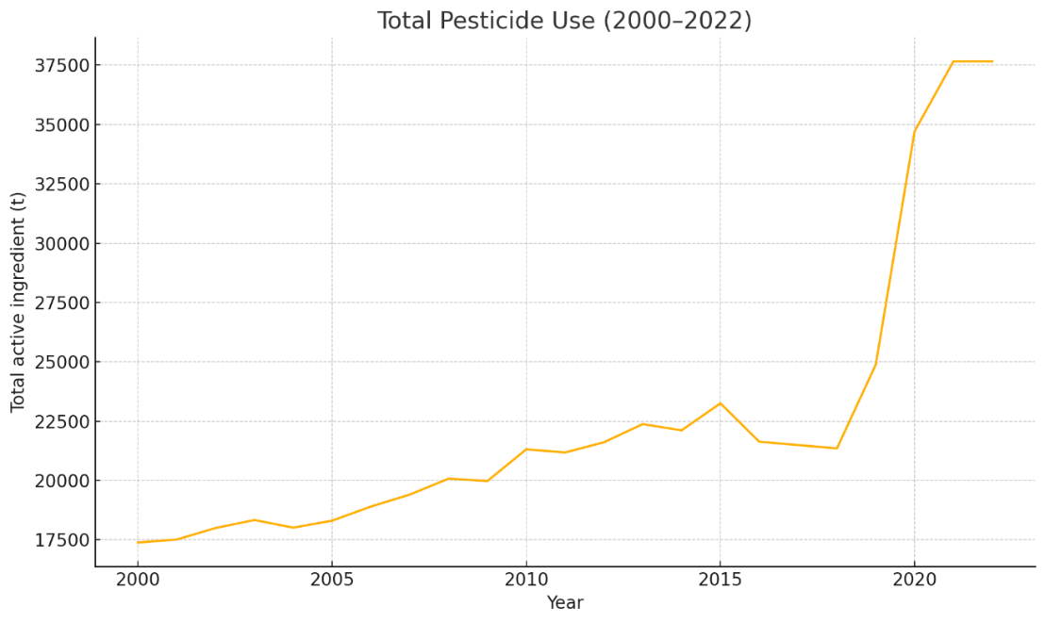
Figure 3.C.2. Trend of Annual Total Pesticide Use (2000-2022)
Table 3.C.2. Fertilizer Use by Mass Input per Year from 2000-2022 (FAO, 2025a; FAO, 2025b)
Spatial Coverage | Year | Unit | N Fertilizer | P Fertilizer | K Fertlizer | Pesticide
Philippines | 2000 | tons/yr | 488,177 | 124,113 | 122,260 | 17382.7
Philippines | 2001 | tons/yr | 507,348 | 148,655 | 125,412 | 17509.8
Philippines | 2002 | tons/yr | 445,244 | 129,401 | 113,000 | 17995.3
Philippines | 2003 | tons/yr | 572,571 | 129,401 | 128,000 | 18330.6
Philippines | 2004 | tons/yr | 629,808 | 129,401 | 120,200 | 18010.9
Philippines | 2005 | tons/yr | 544,134 | 137,311 | 102,000 | 18304
Philippines | 2006 | tons/yr | 474,332 | 148,819 | 117,000 | 18899
Philippines | 2007 | tons/yr | 519,960 | 205,168 | 117,612 | 19403.5
Philippines | 2008 | tons/yr | 401,297 | 79,239 | 91,567 | 20075.7
Philippines | 2009 | tons/yr | 428,140 | 65,149 | 174,660 | 19975.8
Philippines | 2010 | tons/yr | 593,226 | 92,446 | 116,936 | 21311.1
Philippines | 2011 | tons/yr | 518,448 | 150,962 | 120,084 | 21179.5
Philippines | 2012 | tons/yr | 470,000 | 80,400 | 110,000 | 21608
Philippines | 2013 | tons/yr | 527,459 | 201,419 | 142,463 | 22374.1
Philippines | 2014 | tons/yr | 595,539 | 136,122 | 147,889 | 22111.6
Philippines | 2015 | tons/yr | 526,906 | 131,228 | 121,243 | 23250.7
Philippines | 2016 | tons/yr | 628,136 | 157,588 | 162,480 | 21632.1
Philippines | 2017 | tons/yr | 761,288 | 208,515 | 218,624 | 21491.3
Philippines | 2018 | tons/yr | 649,676 | 132,990 | 162,050 | 21350.5
Philippines | 2019 | tons/yr | 709,569 | 176,654 | 206,534 | 24879
Philippines | 2020 | tons/yr | 750,453 | 206,193 | 212,602 | 34715.3
Philippines | 2021 | tons/yr | 715,904 | 258,040 | 323,078 | 37660.4
Philippines | 2022 | tons/yr | 799,021 | 401,638 | 394,868 | 37660.4

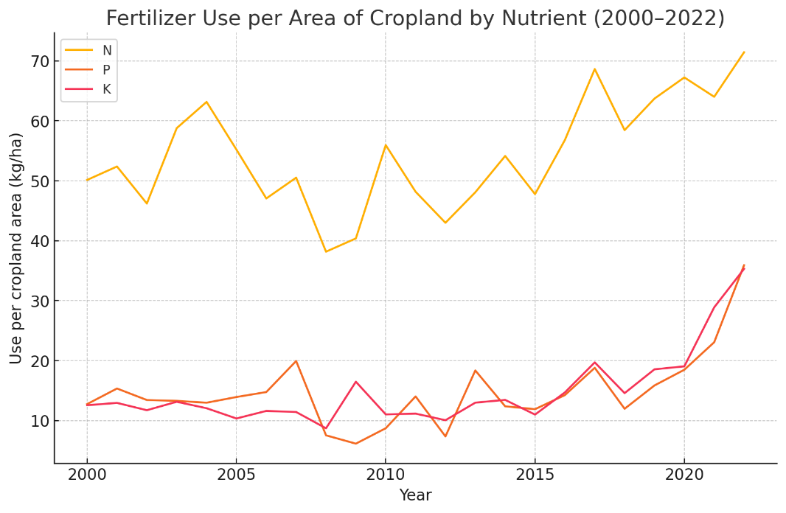
Figure 3.C.3. Trend of Annual Fertilizer Use per Area of Cropland (2000–2022)

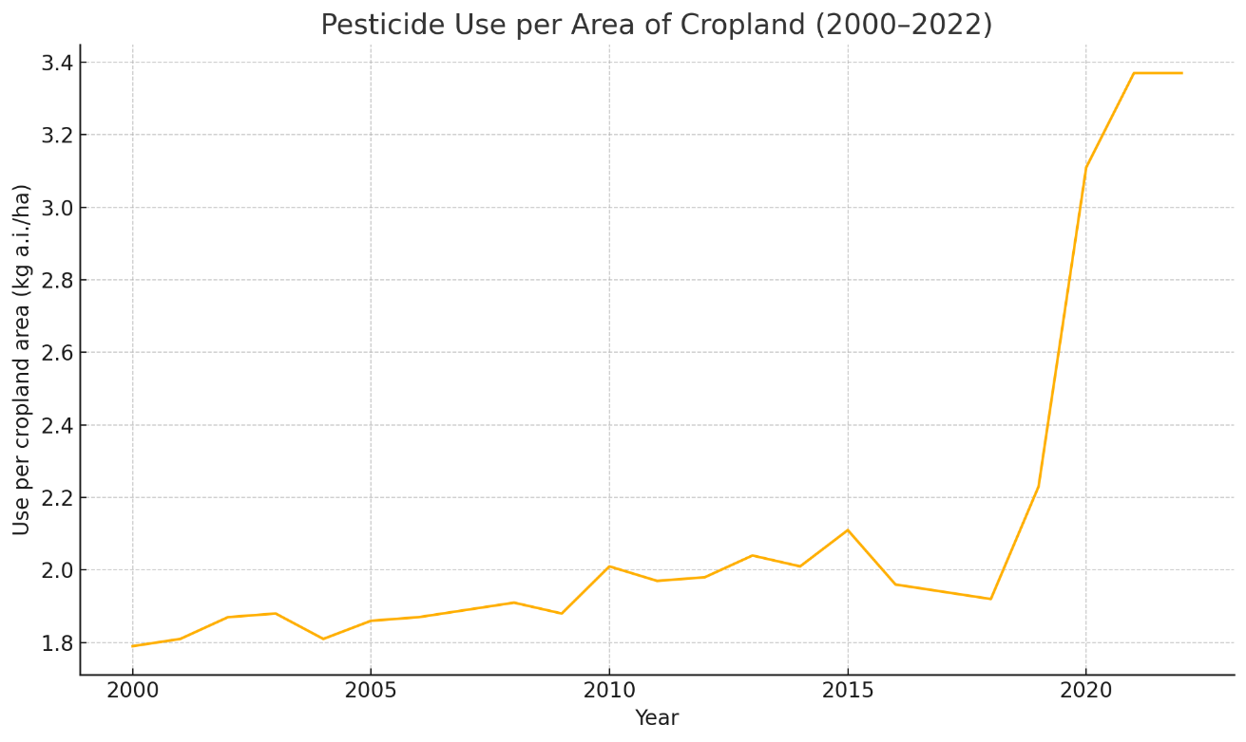
Figure 3.C.4. Trend of Pesticide Use per Area of Cropland (2000–2022)
Table 3.C.3 Nutrient Load in Selected Watersheds and River Basins, kg/day (2016) (Magcale-Macandog et al., 2016).
Watershed | Ammonium | Nitrate | Phosphorus
Pampanga River Basin | 482.89 | 590.2 | 1,663.29
Pasig River Basin | 372.82 | 3,089.74 | 861.24
Bataan Watershed | 274.58 | 646.09 | 1,788.88
Cavite Watershed | 114.95 | 199.97 | 336.1

Annex 3.D. Aquaculture Pollution Indicators
The Philippines' Bureau of Fisheries and Aquatic Resources (BFAR) is responsible for the development, improvement, law enforcement, management, and conservation of the Philippines ' fisheries and aquatic resources. BFAR plays a crucial role in the management of aquaculture in the country. Since HAB events directly impact fisheries and aquaculture, including fish kills and shellfish toxicity, BFAR monitors these events and shares this information to the Intergovernmental Oceanographic Commission. The dataset for the frequency of shellfish advisories to visualize harmful algal bloom occurrences in the Philippines was extracted from the Intergovernmental Oceanographic Commission (2025). Data on fish kills were obtained from academic journals.
Table 3.D.1. Occurrence of Harmful Algal Bloom in the Philippines (2000-2025) (Intergovernmental Oceanographic Commission, 2025)
Year | Philippines | Philippine Waters of SCS-LME | % of Occurrence in SCS-LME to National
2000 | 10 | 2 | 20.0%
2001 | 5 | 2 | 40.0%
2002 | 12 | 4 | 33.3%
2003 | 9 | 2 | 22.2%
2004 | 10 | 3 | 30.0%
2005 | 10 | 4 | 40.0%
2006 | 9 | 2 | 22.2%
2007 | 16 | 2 | 12.5%
2008 | 12 | 2 | 16.7%
2009 | 6 | 1 | 16.7%
2010 | 13 | 4 | 30.8%
2011 | 11 | 4 | 36.4%
2012 | 10 | 4 | 40.0%
2013 | 9 | 2 | 22.2%
2014 | 11 | 5 | 45.5%
2015 | 13 | 4 | 30.8%
2016 | 14 | 1 | 7.1%
2017 | 1 | 1 | 100.0%
2018 | 155 | 18 | 11.6%
2019 | 180 | 37 | 20.6%
2020 | 342 | 33 | 9.6%
2021 | 84 | 6 | 7.1%
2022 | 24 | 2 | 8.3%
2023 | 13 | 0 | 0.0%
2024 | 127 | 3 | 2.4%
2025 | 39 | 3 | 7.7%

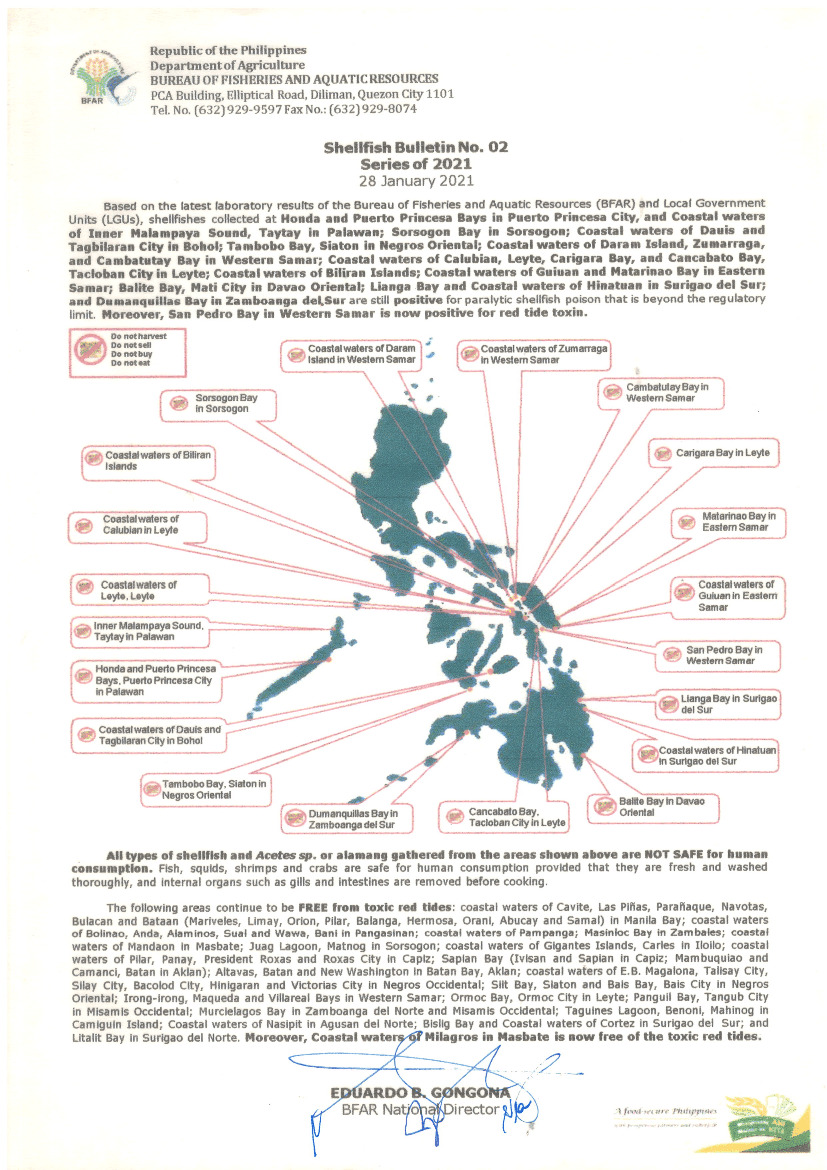
Figure 3.D.1. Shellfish Bulletin no. 2 Issued by BFAR in 2021 including Malampaya Sound in Taytay, Palawan.

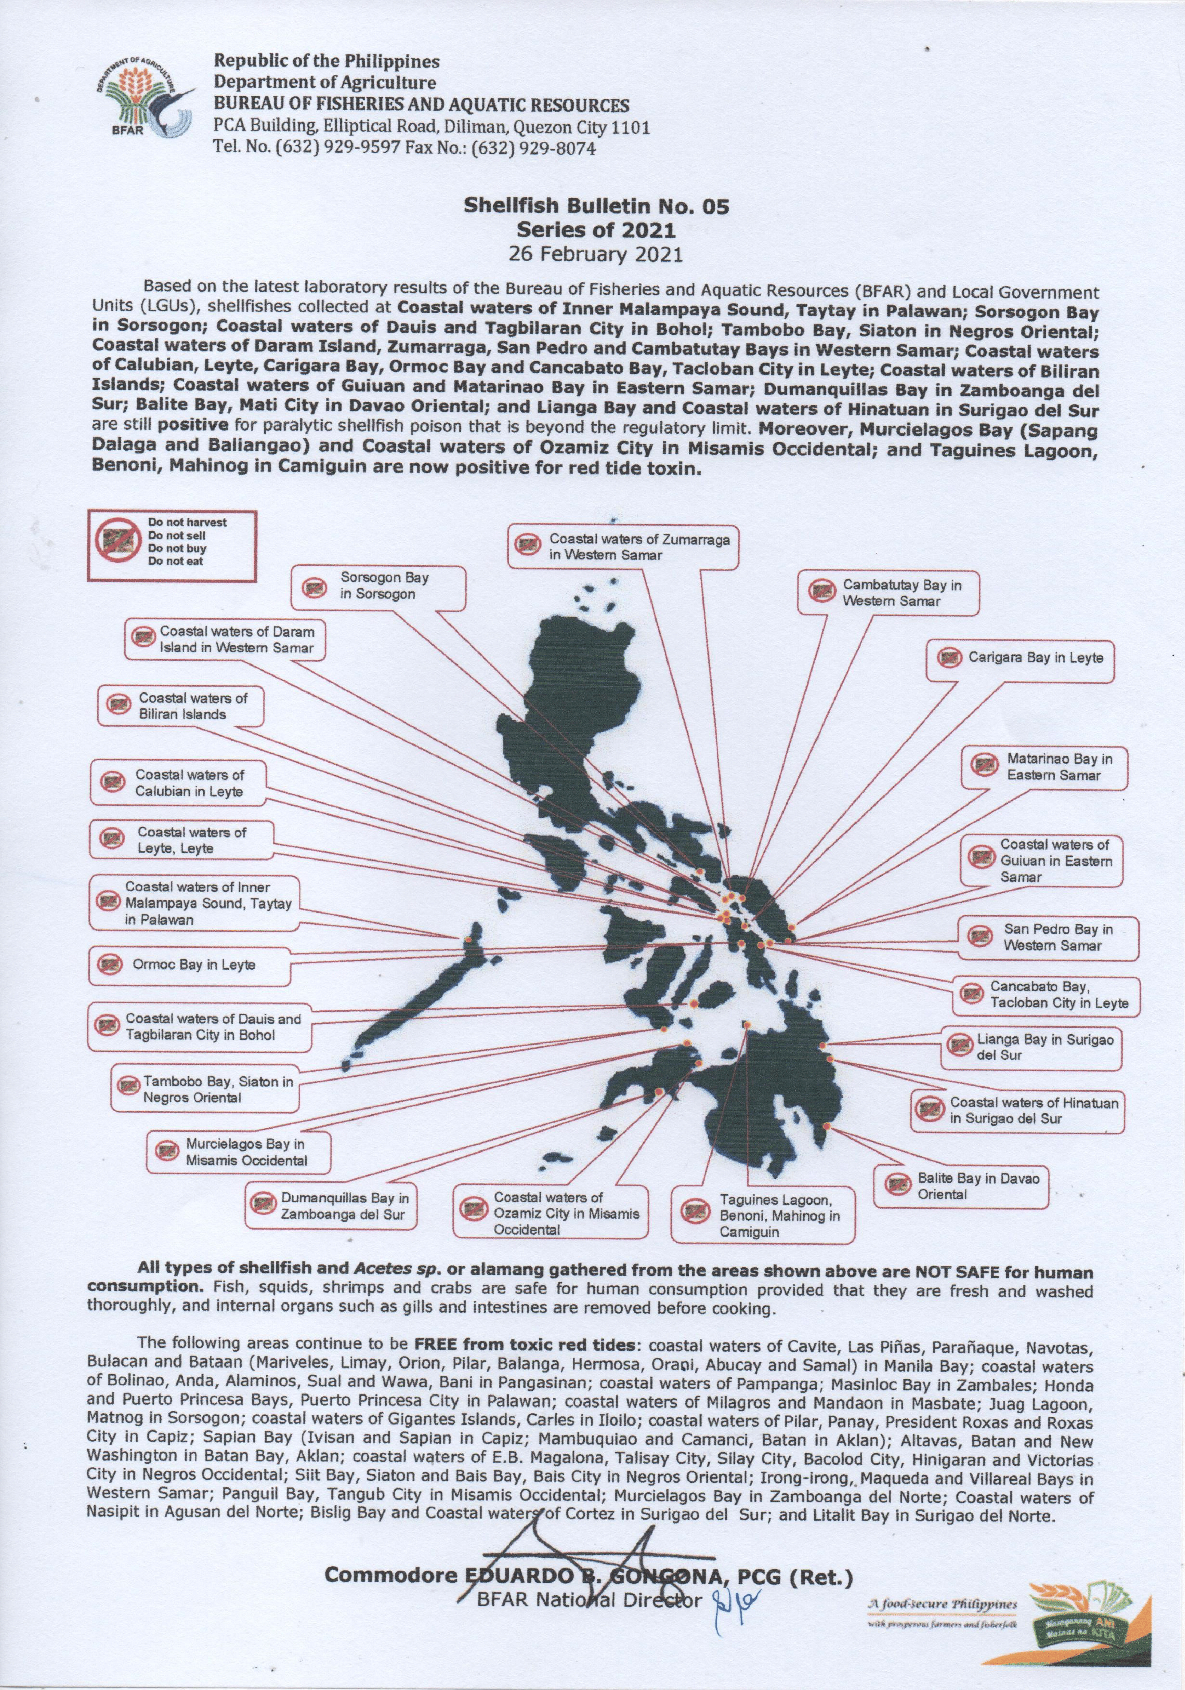
Figure 3.D.2. Shellfish Bulletin no. 5 Issued by BFAR in 2021 including Malampaya Sound in Taytay, Palawan.
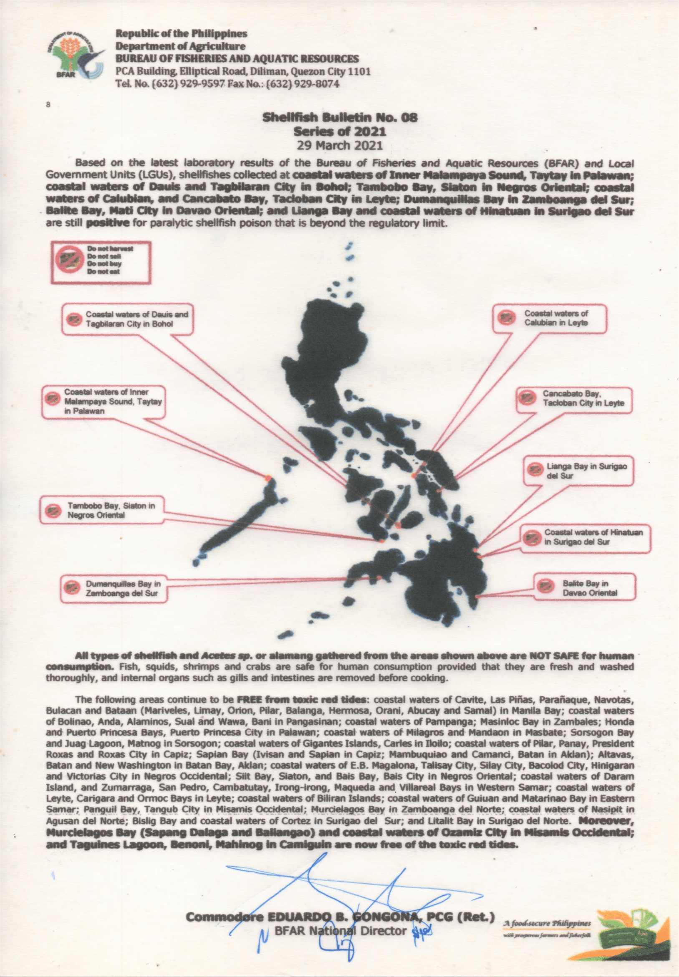
Figure 3.D.3. Shellfish Bulletin no. 8 Issued by BFAR in 2021 including Malampaya Sound in Taytay, Palawan.

Table 3.D.2. Fish Kill Events in the Philippine Waters of SCS-LME (Yniguez et al., 2021); San Diego-McGlone et al., 2024).
Year | Site | Number of Events
2002 | Bolinao-Anda, Pangasinan | 2
2002 | Balayan Bay, Batangas | 1
2002 | Eastern side of Luzon | 1
2002 | San Antonio, Zambales | 1
2003 | Bolinao-Anda, Pangasinan | 1
2003 | Dagupan City, Pangasinan | 1
2003 | Vigan City, Ilocos Sur | 2
2003 | Sto. Tomas, La Union | 1
2004 | Bolinao-Anda, Pangasinan | 1
2004 | Sto. Tomas, La Union | 1
2005 | West coast of Palawan | 1
2005 | Dagupan City, Pangasinan | 2
2005 | Binmaley, Pangasinan | 1
2005 | Bolinao-Anda, Pangasinan | 1
2005 | Bani, Pangasinan | 1
2007 | Bolinao-Anda, Pangasinan | 1
2010 | Bolinao-Anda, Pangasinan | 1
2011 | Bolinao-Anda, Pangasinan | 1
2013 | Anda, Pangasinan | 1
2015 | Bani, Pangasinan | 1
2015 | Bolinao-Anda, Pangasinan | 1
2015 | Subic, Zambales | 1
2016 | Bolinao-Anda, Pangasinan | 1
2016 | Orion, Bataan | 1
2017 | Sual, Pangasinan | 1
2017 | Vigan City, Ilocos Sur | 1
2017 | Obando, Bulacan | 1
2017 | Bulacan | 1
2018 | Anda, Pangasinan | 1
2018 | Bolinao, Pangasinan | 1
2018 | Bani, Pangasinan | 1
2018 | San Vicente, Ilocos Sur | 1
2018 | Bulacan, Manila Bay | 1
2019 | Sual, Pangasinan | 1
2019 | Las Piñas-Parañaque | 1
2020 | Dagupan City, Pangasinan | 1
2020 | San Fernando City, La Union | 1
2020 | Nasugbu, Batangas | 1
2021 | San Fabian, Pangasinan | 1
2021 | San Vicente, Ilocos Sur | 1
2021 | Sta. Catalina, Ilocos Sur | 1
2021 | Dagupan City, Pangasinan | 1
2022 | San Vicente, Ilocos Sur | 1
2022 | Obando, Bulacan | 1
2023 | Sto. Tomas, La Union | 2
2023 | Cañacao Bay, Cavite City | 1
2024 | Bolinao-Anda, Pangasinan | 1
2024 | Nasugbu, Batangas | 1
2024 | Magsaysay, Occidental Mindoro | 1
2025 | San Juan, La Union | 1
2025 | Obando, Bulacan | 1
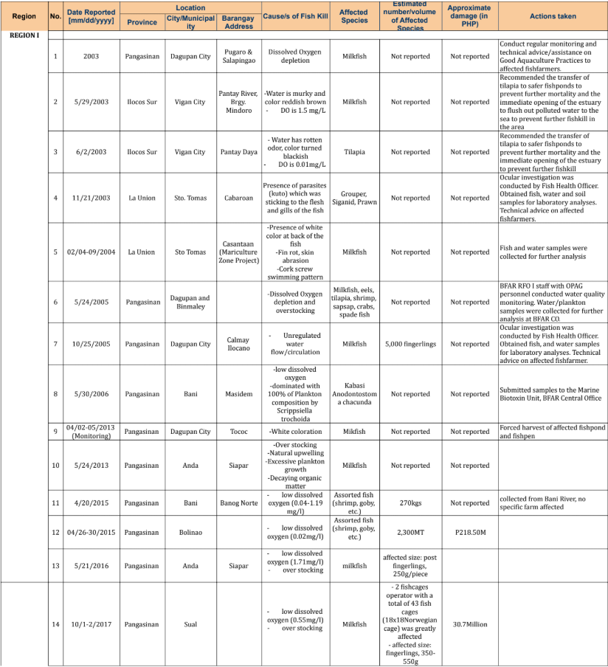
Figure 3.D.4a. Region I, 2000-2025 Fish Mortality Incidence Report (BFAR, 2025)
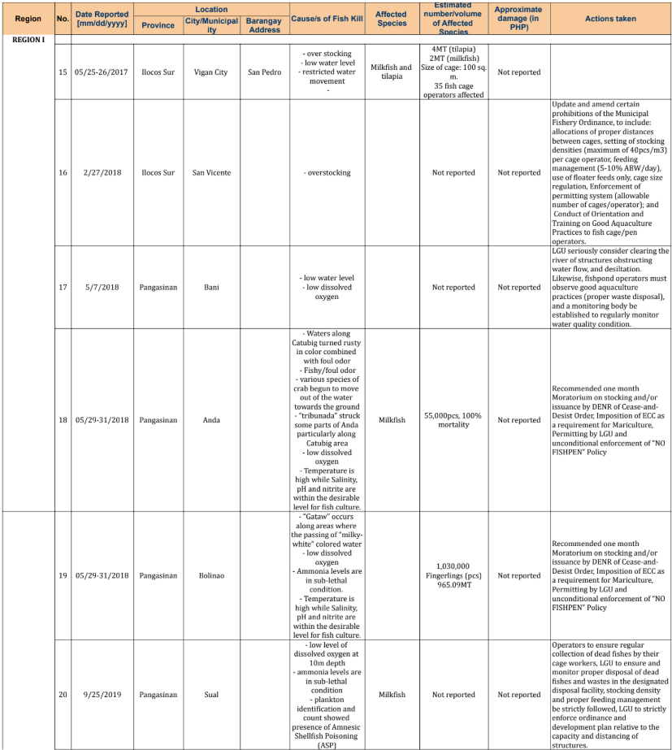
Figure 3.D.4b. Region I, 2000-2025 Fish Mortality Incidence Report (BFAR, 2025)

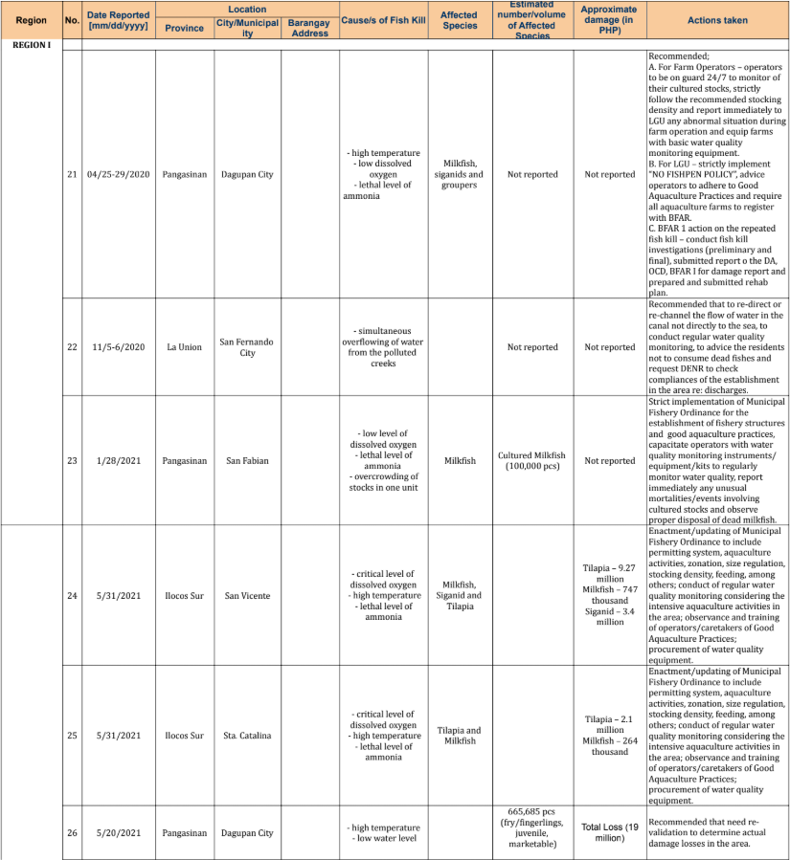
Figure 3.D.4c. Region I, 2000-2025 Fish Mortality Incidence Report (BFAR, 2025)
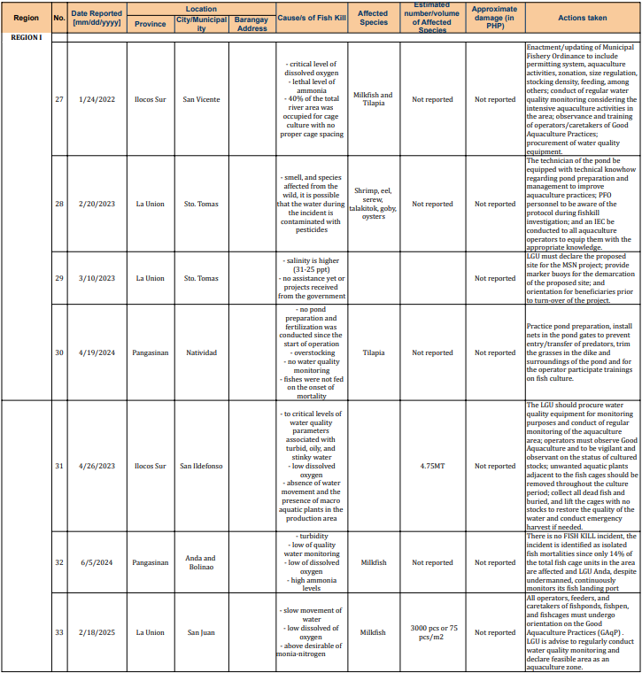
Figure 3.D.4d. Region I, 2000-2025 Fish Mortality Incidence Report (BFAR, 2025)
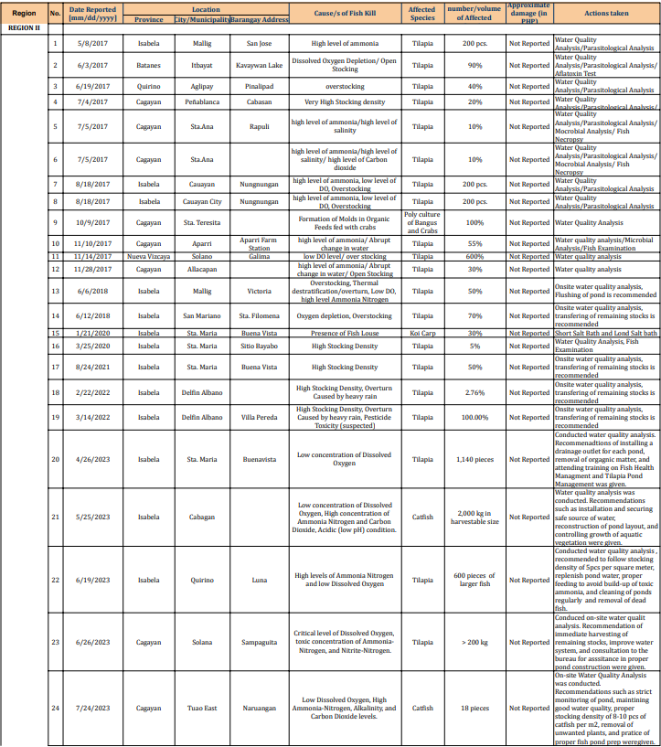
Figure 3.D.5a. Region II, 2000-2025 Fish Mortality Incidence Report (BFAR, 2025)
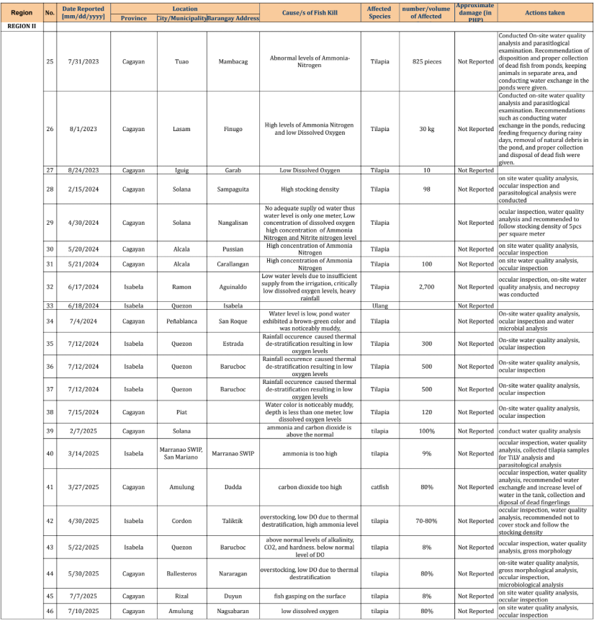
Figure 3.D.5b. Region II, 2000-2025 Fish Mortality Incidence Report (BFAR, 2025)
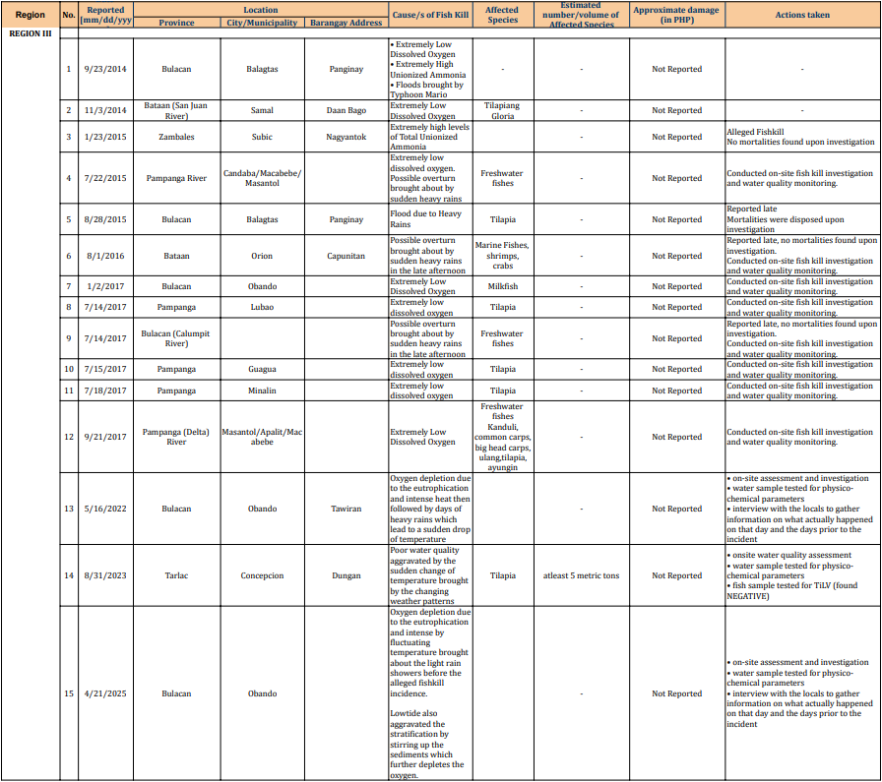Figure 3.D.6. Region III, 2000-2025 Fish Mortality Incidence Report (BFAR, 2025)
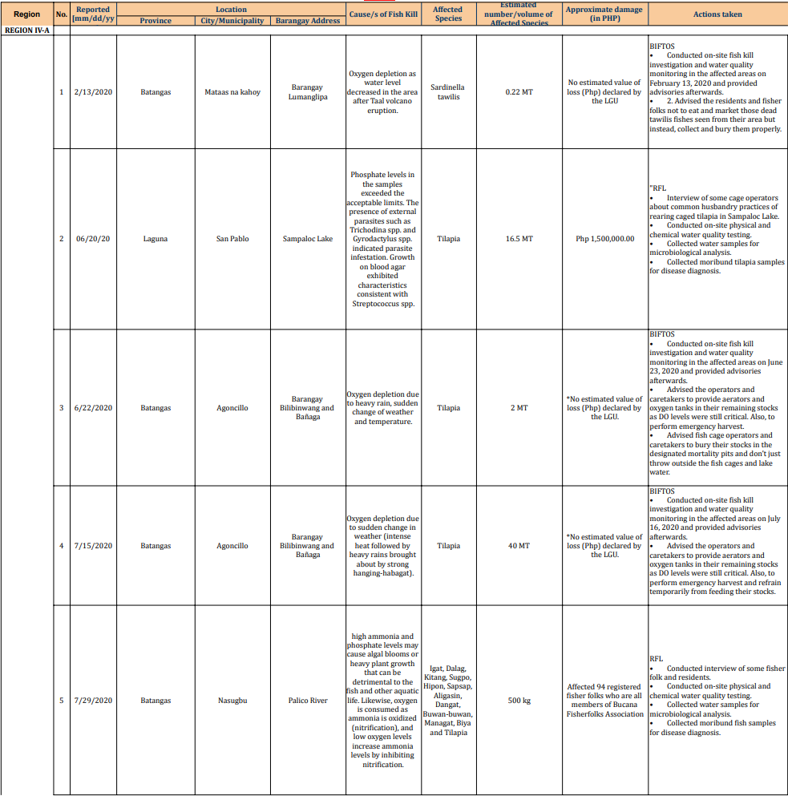 Figure 3.D.7a. Region IV-A, 2000-2025 Fish Mortality Incidence Report (BFAR, 2025)
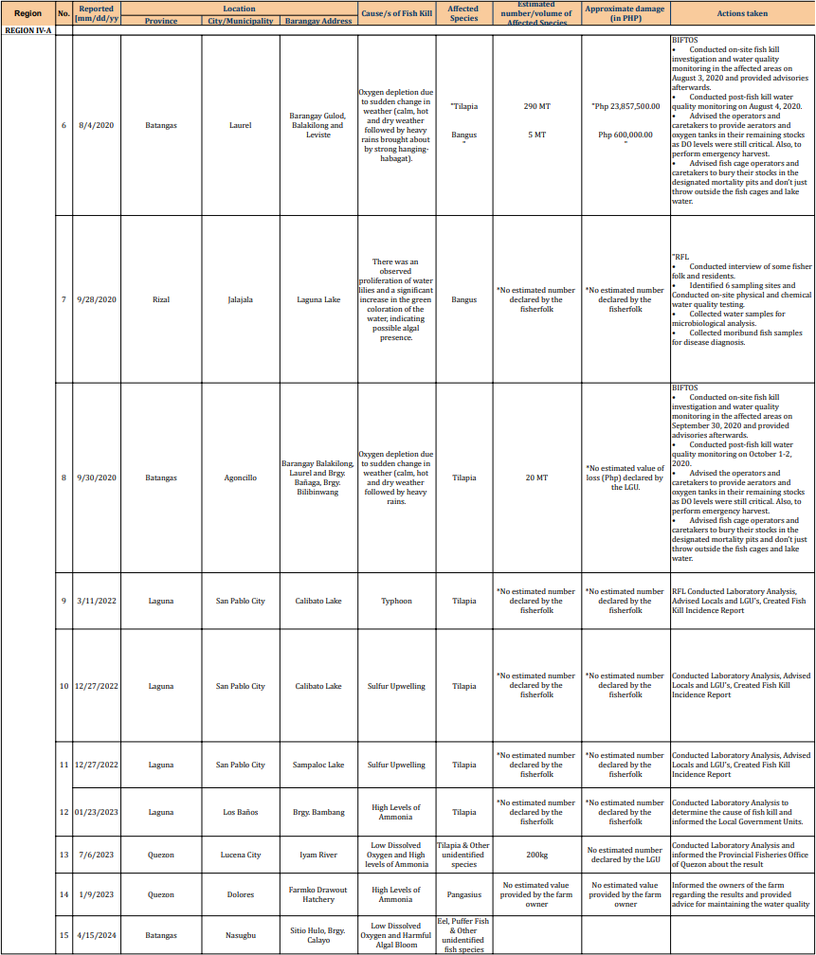Figure 3.D.7b. Region IV-A, 2000-2025 Fish Mortality Incidence Report (BFAR, 2025)
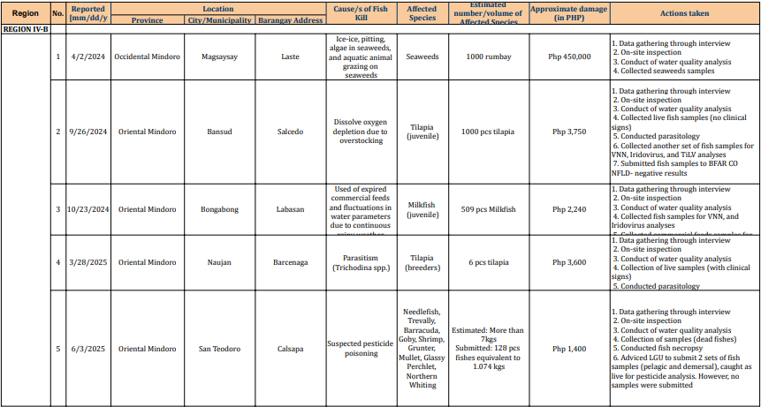Figure 3.D.8. Region IV-B, 2000-2025 Fish Mortality Incidence Report (BFAR, 2025)

Annex 3.E. Solid Waste Pollution Indicators
The solid waste dataset used in the narrative was obtained from the Compendium of Philippine Environment Statistics (CPES) published by the Philippine Statistics Authority (PSA), supplemented with data from an academic journal. The PSA projected annual waste generation was computed using the 2010 Philippine Population Census as the baseline. Meanwhile, the identification of the top plastic-emitting rivers was based on a modelled study conducted by Meijer et al. (2021). Given that this report focuses on regions and provinces contributing to the Philippine Waters of the SCS-LME, data from other regions were aggregated to be concise.
Table 3.E.1. Projected Amount of Solid Waste Generated in the Philippines per Day (2014-2023) (PSA, 2024).
Year | Unit | Philippines | NCR | CAR | Region I | Region II | Region III | Region IV-A | Region IV-B | Other Regions
2014 | Mass (tons/day) | 50,409 | 7,933 | 798 | 2,350 | 1,557 | 5,863 | 7,854 | 1,375 | 22,679
2015 | Mass (tons/day) | 51,424 | 8,073 | 812 | 2,379 | 1,579 | 5,990 | 8,105 | 1,401 | 23,085
2016 | Mass (tons/day) | 52,463 | 8,216 | 827 | 2,408 | 1,601 | 6,120 | 8,365 | 1,429 | 23,497
2017 | Mass (tons/day) | 53,527 | 8,363 | 842 | 2,438 | 1,624 | 6,252 | 8,634 | 1,457 | 23,917
2018 | Mass (tons/day) | 54,616 | 8,512 | 858 | 2,469 | 1,646 | 6,388 | 8,912 | 1,486 | 24,345
2019 | Mass (tons/day) | 55,731 | 8,665 | 873 | 2,499 | 1,669 | 6,526 | 9,200 | 1,515 | 24,784
2020 | Mass (tons/day) | 56,874 | 8,821 | 889 | 2,531 | 1,693 | 6,668 | 9,498 | 1,545 | 25,229
2021 | Mass (tons/day) | 58,044 | 8,981 | 906 | 2,562 | 1,716 | 6,813 | 9,806 | 1,576 | 25,684
2022 | Mass (tons/day) | 59,243 | 9,144 | 922 | 2,594 | 1,740 | 6,962 | 10,125 | 1,608 | 26,148
2023 | Mass (tons/day) | 60,640 | 9,290 | 962 | 2,584 | 1,762 | 7,095 | 10,455 | 1,614 | 26,878
Table 3.E.2. Number of Disposal Facilities in the Philippines from 2012-2023 (PSA, 2024).
Spatial Coverage | Year | Illegal Dump | MRFs | Sanitary Landfill
Philippines | 2012 | 945 | 7,713 | 45
Philippines | 2013 | 923 | 8,486 | 72
Philippines | 2014 | 900 | 8,656 | 86
Philippines | 2015 | 553 | 9,335 | 101
Philippines | 2016 | 511 | 9,883 | 118
Philippines | 2017 | 385 | 10,052 | 135
Philippines | 2018 | 353 | 10,340 | 165
Philippines | 2019 | 331 | 10,722 | 187
Philippines | 2020 | 233 | 11,546 | 241
Philippines | 2021 | 0 | 11,637 | 245
Philippines | 2022 | 0 | 11,779 | 290
Philippines | 2023 | 43 | 11,823 | 299

Table 3.E.3. Top Plastic Emitting Rivers in the Philippines based on the model study of Meijer et al. (2021).
Ranking (from Meijer et al. in 2021) | River | Best Calibrated Scenario (tons/yr) | Drains to the Philippine Waters of SCS-LME?
1 | Pasig | 63,000 | Yes (drains through Manila Bay)
2 | Tullahan | 13,000 | Yes (drains through Manila Bay)
5 | Meycauayan | 12,000 | Yes (drains through Manila Bay)
6 | Pampanga | 9,300 | Yes (drains through Manila Bay)
7 | Libmanan | 7,100 | No
9 | Rio Grande de Mindanao | 5,300 | No
10 | Agno | 4,600 | Yes (drains through Lingayen Gulf)
11 | Agusan | 4,600 | No
12 | Paranaque | 4,400 | Yes (drains through Manila Bay)
13 | Iloilo | 4,200 | No
24 | Imus | 3,100 | Yes (drains through Manila Bay)
29 | Zapote | 2,700 | Yes (drains through Manila Bay)
32 | Cagayan de Oro | 2,600 | No
33 | Davao RIver | 2,600 | No
38 | Malaking Tubig | 2,500 | No
40 | Tambo, Pasay (Storm drain) | 2,500 | Yes (drains through Manila Bay)
42 | Jalaur River | 2,300 | No
46 | Cagayan River | 2,300 | No
50 | Hamulauon | 2,200 | No

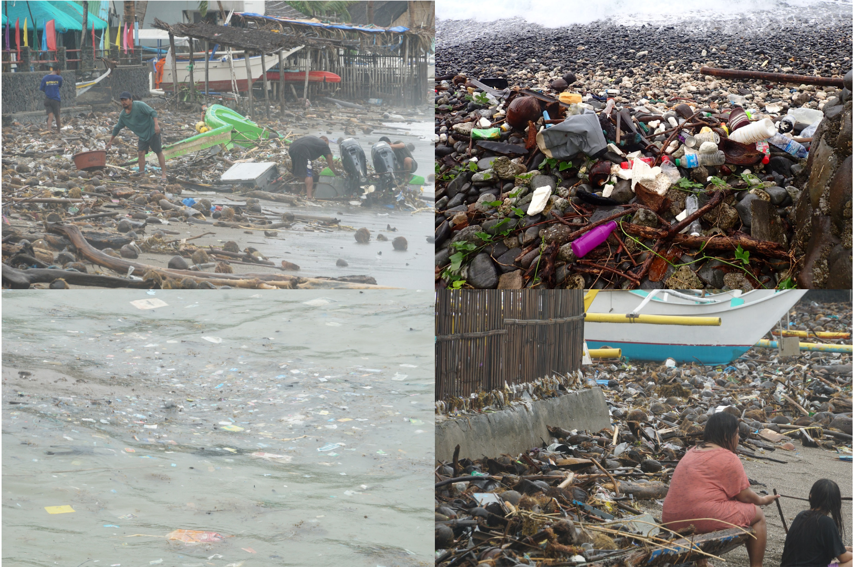
Figure 3.E.1 Plastic Debris found in the coastal waters of Balayan Bay, Mabini, Batangas.

Annex 3.F. Hazardous Waste Pollution Indicators
The dataset for hazardous waste was extracted from the Compendium of Philippine Environment Statistics (CPES), released periodically by the Philippine Statistics Authority. Table 3.F.1 presents the hazardous waste generated, classified by type, while Table 3.F.2 presents the aggregated hazardous waste generated by region per year. Table 3.F.3 shows the amount generated and treated, as well as the cumulative generated and treated waste. The Multi-Year Treatment Rate (MTR) was obtained by getting the ratio of cumulative treatment to the cumulative generated per year. The last column contains the number of TSD Facilities in the Philippines.
Table 3.F.1. Hazardous Waste Generated by Type per Year in tons (2012-2023)
Type | 2012 | 2013 | 2014 | 2015 | 2016 | 2017 | 2018 | 2019 | 2020 | 2021 | 2022 | 2023 | Total | Mean
Waste with Cyanide | 112,620.48 | 565,841.03 | 190,714.45 | 401,467.43 | 191,367.41 | 1,428,453.17 | 395,537.25 | 1,047,561.50 | 465.6 | 899.98 | 977.58 | 781.46 | 4,336,687.34 | 361,390.61
Acid Wastes | 281,166.97 | 100,891.15 | 271,959.28 | 317,403.61 | 10,096.50 | 39,024.07 | 2,759.65 | 15,314.82 | 1,282.65 | 4,481.85 | 3,952.36 | 4,220.61 | 1,052,553.52 | 87,712.79
Alkali Wastes | 53,086.00 | 195,009.36 | 579,074.32 | 983,030.13 | 361,916.41 | 14,703.85 | 70,538.76 | 193,714.02 | 3,556.62 | 21,258.78 | 22,725.57 | 9,944.48 | 2,508,558.30 | 209,046.53
Waste with Inorganic Chemicals | 29,081.96 | 269,815.90 | 806,358.72 | 710,107.45 | 88,511.56 | 43,219.74 | 24,349.58 | 2,896,162.86 | 6,309.88 | 18,781.08 | 21,555.88 | 22,443.65 | 4,936,698.26 | 411,391.52
Reactive Chemical Wastes | 337.11 | 464,668.17 | 63.15 | 330.35 | 425.82 | 503.17 | 367.06 | 5,041.30 | 97 | 245.02 | 995.34 | 802.79 | 473,876.28 | 39489.69
Inks, Dyes, Pigments, Paint, Latex, Adhesives, Organic Sludge | 5,475.11 | 10,418.35 | 134,881.37 | 67,807.14 | 14,604.04 | 16,595.62 | 41,948.78 | 36,191.36 | 7,381.62 | 27,381.62 | 27,685.19 | 27,953.24 | 418,323.44 | 34,860.29
Waste Organic Solvent | 165,136.98 | 352,381.23 | 27,970.13 | 33,822.49 | 6,941.93 | 7,398.92 | 8,373.92 | 57,277.32 | 6,448.80 | 18,445.97 | 15,572.87 | 15,888.76 | 715,659.32 | 59,638.28
Organic Wastes | 23,958.78 | 620,720.09 | 513.06 | 5,365.68 | 1,961.19 | 3,280.06 | 2,454.35 | 32,645.43 | 930.47 | 5,343.55 | 6,899.72 | 9,586.89 | 713,659.27 | 59,471.61
Oil | 72,674.83 | 5,918,533.65 | 144,694.29 | 1,351,706.03 | 744,758.48 | 220,331.10 | 75,344.75 | 302,401.17 | 20,084.39 | 65,457.17 | 71,958.19 | 76,328.12 | 9,064,272.17 | 755,356.01
Containers | 13,856.43 | 432,478.33 | 13,448.22 | 15,564.60 | 5,149.26 | 17,837.93 | 15,012.94 | 28,539.21 | 1,276.54 | 5,603.30 | 6,167.08 | 5,671.32 | 560,605.16 | 46,717.10
Immobilized/Stabilized Wastes | 3,401.79 | 1,486.10 | 4,846.70 | 2,377.17 | 2,797.70 | 6,164.20 | 222,024.56 | 18,843.93 | 9,609.25 | 30,645.36 | 33,720.60 | 18,430.64 | 354,348.00 | 29,529.00
Organic Chemicals | 36.86 | 115.04 | 2,302.40 | 928.82 | 237.85 | 2,386.55 | 67,572.90 | 345.01 | 39.35 | 312.27 | 203.95 | 619.05 | 75,100.05 | 6258.3375
Miscellaneous Wastes | 19,689.37 | 44,597.59 | 322,161.56 | 442,311.44 | 57,039.85 | 298,646.89 | 64,971.54 | 189,122.62 | 9,683.63 | 39,316.14 | 40,344.33 | 45,586.91 | 1,573,471.87 | 131,122.66

Table 3.F.2. Total Hazardous Waste Generated Per Region in tons (2012-2023)
Region | 2012 | 2013 | 2014 | 2015 | 2016 | 2017 | 2018 | 2019 | 2020 | 2021 | 2022 | 2023 | Total | % Ctrbn
NCR | 14,710.66 | 606,417.84 | 187,607.56 | 218,753.01 | 114,969.90 | 47,575.91 | 38,899.32 | 33,754.75 | 11,252.21 | 23,877.16 | 29,709.49 | 38,679.98 | 1,366,207.79 | 5.10
CAR | 0 | 0 | 0 | 217,809.10 | 21,304.08 | 194,739.83 | 369,559.49 | 2,403,828.32 | 672.22 | 2,437.74 | 2,641.66 | 3,264.74 | 3,216,257.18 | 12.01
Region 1 | 4,374.63 | 0 | 1,467.93 | 2,030.48 | 1,691.13 | 4,378.35 | 4,905.67 | 3,704.25 | 892.08 | 2,859.79 | 2,874.98 | 2,871.67 | 32,050.96 | 0.12
Region 2 | 279.2 | 73.82 | 51.61 | 0 | 10.25 | 109.97 | 156.3 | 944.61 | 58.78 | 1,265.86 | 1,670.46 | 1,819.46 | 6440.32 | 0.02
Region 3 | 279,848.18 | 1,809,183.89 | 0 | 1,344,076.60 | 626,366.99 | 246,407.70 | 331,613.98 | 49,065.38 | 14,288.58 | 54,032.95 | 48,166.12 | 40,994.90 | 4,844,045.27 | 18.09
Region 4A | 282,846.18 | 5,943,932.49 | 273,669.50 | 976,186.65 | 118,569.78 | 278,059.85 | 106,116.86 | 1,171,473.12 | 31,709.44 | 117,083.09 | 127,486.15 | 111,612.97 | 9,538,746.08 | 35.61
Region 4B | 0 | 0 | 65.17 | 0 | 3,211.57 | 712.65 | 342.52 | 480.87 | 255.5 | 1,724.59 | 2,374.41 | 2,108.76 | 11276.04 | 0.04
Region 5 | 41,127.70 | 0 | 639,622.88 | 8,637.65 | 26,656.01 | 23,197.66 | 498.43 | 10,565.65 | 613.95 | 2,921.80 | 2,816.47 | 3,605.26 | 760,263.46 | 2.84
Region 6 | 0 | 299,290.69 | 1,299.29 | 1,950.38 | 1,133.76 | 3,643.43 | 3,773.78 | 2,998.08 | 399.34 | 2,299.21 | 3,852.46 | 2,777.01 | 323417.43 | 1.21
Region 7 | 0 | 0 | 451,877.11 | 278,022.55 | 383,674.06 | 18,069.68 | 51,016.18 | 191,328.01 | 3,017.31 | 12,718.34 | 12,432.67 | 12,096.72 | 1414252.63 | 5.28
Region 8 | 0 | 0 | 508.64 | 10,674.41 | 20,777.07 | 24,044.80 | 10,892.73 | 129,992.52 | 42.88 | 938.15 | 1,087.50 | 1,448.91 | 200407.61 | 0.75
Region 9 | 978.56 | 8,073.58 | 688.46 | 527.33 | 23,217.20 | 3,384.50 | 2,069.54 | 1,391.26 | 26.57 | 242.38 | 540.07 | 402.27 | 41541.72 | 0.16
Region 10 | 0 | 1,983.11 | 786,482.29 | 871,931.94 | 0 | 9,603.50 | 14,309.28 | 18,989.13 | 3,227.68 | 10,764.48 | 11,147.49 | 11,014.22 | 1739453.12 | 6.49
Region 11 | 101,179.64 | 55,171.40 | 116,589.34 | 120,472.02 | 4,476.86 | 1,230,147.51 | 16,763.83 | 648,227.49 | 381.5 | 2,625.43 | 2,993.54 | 3,002.94 | 2,302,031.50 | 8.59
Region 12 | 0 | 0 | 280.88 | 0 | 406.71 | 1,417.46 | 1,689.30 | 2,077.42 | 84.94 | 878.77 | 1,093.09 | 1,132.38 | 9060.95 | 0.03
Region 13 | 55,177.92 | 252,829.17 | 38,777.00 | 281,150.20 | 139,342.63 | 13,052.48 | 38,648.86 | 154,339.68 | 242.82 | 1,872.33 | 1,872.11 | 1,425.73 | 978,730.93 | 3.65
BARMM | 0 | 0 | 0 | 0 | 0 | 0 | 0 | 0 | 0 | 0 | 0 | 0 | 0 | 0.00
Table 3.F.3. Hazardous Waste Generated, Treated, Cumulative, Multi-Year Treatment Rate, and TSD Facilities in the Philippines (2012-2023).
Spatial Coverage | Year | Generated (tons) | Treated (tons) | Cumulative Generated (tons) | Cumulative Treated (tons) | MTR (%) | TSD Facilities (n)
Philippines | 2012 | 780,522.67 | 444,358.91 | 780,522.67 | 444,358.91 | 56.93 | 130
Philippines | 2013 | 8,976,955.99 | 6,638,379.99 | 9,757,478.66 | 7,082,738.90 | 72.59 | 127
Philippines | 2014 | 2,498,987.65 | 962,400.78 | 12,256,466.31 | 8,045,139.68 | 65.64 | 114
Philippines | 2015 | 4,332,222.34 | 1,579,719.49 | 16,588,688.65 | 9,624,859.17 | 58.02 | 123
Philippines | 2016 | 1,485,808.00 | 603,470.61 | 18,074,496.65 | 10,228,329.78 | 56.59 | 135
Philippines | 2017 | 2,098,545.27 | 2,363,934.01 | 20,173,041.92 | 12,592,263.79 | 62.42 | 128
Philippines | 2018 | 991,256.04 | 510,659.39 | 21,164,297.96 | 13,102,923.18 | 61.91 | 132
Philippines | 2019 | 4,823,160.55 | 10,740,340.85 | 25,987,458.51 | 23,843,264.03 | 91.75 | 131
Philippines | 2020 | 67,165.80 | 58,569.14 | 26,054,624.31 | 23,901,833.17 | 91.74 | 127
Philippines | 2021 | 238,172.09 | 237,412.88 | 26,292,796.40 | 24,139,246.05 | 91.81 | 162
Philippines | 2022 | 252,758.66 | 247,010.66 | 26,545,555.06 | 24,386,256.71 | 91.87 | 153
Philippines | 2023 | 238,257.92 | 222,706.01 | 26,783,812.98 | 24,608,962.72 | 91.88 | 175

Annex 3.G. Oil Pollution Indicator
The dataset for oil pollution was compiled from multiple sources, including academic journals, news articles, and government reports. The volume from major oil spill events were aggregated per year from Table 3.G.2 to provide a comprehensive assessment of their contribution to the available total national data and their potential impact on marine ecosystems.
Table 3.G.1. Total Volume of Recorded Oil Spill in the Philippines from 2000-2021 (Agaton et al., 2023; Alea et al., 2022; NDRRMC, 2024; Yuching, 2024).
Spatial Coverage | Year | Volume | No. of Major Oil Spill (>1,000,00 L) | No. of Incidence with Oil Discharge > 10,000 L
Philippines | 2000 | 76,660 | 0 | 2
Philippines | 2001 | 45,014 | 0 | 1
Philippines | 2002 | 24,800 | 0 | 0
Philippines | 2003 | 14,990 | 0 | 0
Philippines | 2004 | 28,750 | 0 | 0
Philippines | 2005 | 516,500 | 0 | 2
Philippines | 2006 | 2,118,500 | 1 | 1
Philippines | 2007 | 17,750 | 0 | 0
Philippines | 2008 | 24,100 | 0 | 0
Philippines | 2009 | 1,000 | 0 | 0
Philippines | 2010 | 11,400 | 0 | 0
Philippines | 2011 | 4,710 | 0 | 0
Philippines | 2012 | 56,595 | 0 | 3
Philippines | 2013 | 1,496,600 | 0 | 4
Philippines | 2014 | 15,600 | 0 | 0
Philippines | 2015 | 5,000 | 0 | 0
Philippines | 2016 | 15,600 | 0 | 0
Philippines | 2017 | 22,736 | 0 | 0
Philippines | 2018 | 78,615 | 0 | 0
Philippines | 2019 | 7,676 | 0 | 0
Philippines | 2020 | 269,904 | 0 | 1
Philippines | 2021 | 8,787 | 0 | 0
Philippines | 2022* | 269,000 | 0 | 1
Philippines | 2023* | 850,000 | 0 | 1
Philippines | 2024* | 1,450,000 | 1 | 1
* Single Oil Spill Event Only as Reported
Table 3.G.2. Assessment of oil pollution contribution to the national data and their potential impact on marine ecosystems (Agaton et al., 2023; Alea et al., 2022; NDRRMC, 2024; Yuching, 2024).
Date | Locality | Region | Volume (liters) | Cause | Relevance to Philippine Waters of SCS-LME
Jan 27, 2000 | Lingayen Gulf | I | 57,000 | The bulk carrier M/V Nol Scheddar ran aground. | Important: Located in Lingayen Gulf facing Philippine Waters of SCS-LME.
Jun 29, 2000 | Ilana Bay | ARMM | 18,000 | A hose that pumps diesel from a tanker to a Caltex depot was sliced by an unidentified assailant. | Not directly relevant
Jul 17, 2001 | Davao Gulf | XI | 12,500 | Singapore-owned container vessel Pacific Eagle collided with M/V Dingalan Bay causing it to sink. | Not directly relevant
Mar 06, 2005 | Davao Gulf | XI | 128,000 | The oil tank of M/V Cala Piccola cracked. | Not directly relevant
Dec 18, 2005 | Semirara Island | VI | 364,000 | NPC Power Barge 106 ran aground that ruptured its tanks. | Not directly relevant
Aug 11, 2006 | Guimaras Strait | VI | 2,100,000 | Oil tanker M/T Solar 1 sank. This was considered the worst oil spill in Philippine history at that time. | Not directly relevant
Feb 21, 2012 | La Union | I | 10,000 | Leaked in the pipeline while M/T Panglao Island was transferring diesel fuel to a Chevron Bulk Plant. | Important: Located in La Union facing Philippine Waters of SCS-LME
Apr 03, 2012 | Polilo Island | IV-A | 10,000 | Leaked in the generator of the NPC's power source. | Not directly relevant
Feb 07, 2012 | Mactan Channel | VII | 10,000 | M/V B & E Uno sank. | Not directly relevant
Feb 17, 2013 | Bolinao | I | 10,000 | M/V Harita Bauxite encountered engine troubles causing it to sink. | Important: Located in Pangasinan facing Philippine Waters of SCS-LME
Aug 08, 2013 | Manila Bay, Cavite | IV-A | 500,000 | Leaked in the submerged pipeline of Petron Corporation. | Important: Manila Bay connects to Philippine Waters of SCS-LME
Aug 16, 2013 | Mactan Channel | VII | 160,000 | Domestic passenger ferry M/V St. Thomas Aquinas collided with M/V Sulpicio Express Siete causing it to sink. | Not directly relevant
Nov 09, 2013 | Estancia, Iloilo | VI | 800,000 | NPC Power Barge 103 dislodged from its mount caused by Super Typhoon Haiyan. | Not directly relevant
Jul 03, 2020 | Iloilo Strait | VI | 268,949 | AC Energy Power Barge 102 exploded. | Not directly relevant
Feb 28, 2023 | Off Naujan, Oriental Mindoro | MIMAROPA | 800,000-900,000 | MT Princess Empress, en route from Bataan to Iloilo, sank after encountering rough seas. The oil spread to parts of Oriental Mindoro, Batangas, Palawan, and Antique. | Important: Affected parts of Palawan which faces Philippine Waters of SCS-LME
Jul 25, 2024 | Limay, Bataan (Manila Bay) | III | 1,400,000-1,500,000 | MT Terra Nova capsized and sank due to rough seas during Typhoon Gaemi. Oil spill spread to multiple provinces along Manila Bay. | Important: Manila Bay connects to Philippine Waters of SCS-LME

Annex 3.H. Atmospheric Deposition Pollution Indicators
The dataset was extracted from the EANET database to compile the complete Philippine wet-deposition and dry concentration time-series (2000 – 2023) for sulfate-S and nitrate-N for all three EANET sites into a single tidy worksheet. Site code: PHA001 (Manila), PHA002 (Los Banos), and PHA003 (Mt. Sto Tomas)
This report summarizes 4-year block averages (2000–2003 … 2020–2023) of wet deposition (SO4-S, NO3-N) and dry concentrations (pSO4, pNO3) at PHA001–PHA003, with overlays of site series against the aggregate (mean across sites). Missing data may imply issues with monitoring equipment.
The Annex includes Tables of summarized data with descriptive statistics: number of valid years (n), completeness (n/4), mean, standard error (SE), standard deviation (SD), median, minimum, and maximum for each site × indicator × block.
Table 3.H.1. Raw Data for Wet Deposition (SO4-S, NO3-N, mmol/m²y) (Network Center for EANET, 2025).
Indicator | Year | Monitoring Stations
Indicator | Year | Manila Observatory | Los Banos | Mt. Sto Tomas
NO3-N | 2000 | 49 | 14
NO3-N | 2001 | 42 | 25
NO3-N | 2002 | 52 | 14
NO3-N | 2003 | 29 | 8
NO3-N | 2004 | 33 | 11
NO3-N | 2005 | 51 | 16
NO3-N | 2006 | 33 | 18 | 1
NO3-N | 2007 | 49 | 19 | 18
NO3-N | 2008 | 50 | 15 | 20
NO3-N | 2009 | 33 | 23 | 19
NO3-N | 2010 | 135 | 65 | 15
NO3-N | 2011 | 53 | 20 | 12
NO3-N | 2012 | 81.37 | 25.01 | 35
NO3-N | 2013 | 49 | 19 | 37
NO3-N | 2014 | 42 | 17 | 18
NO3-N | 2015 | 33 | 14 | 21
NO3-N | 2016 | 91.8 | 67.7 | 25.5
NO3-N | 2017
NO3-N | 2018
NO3-N | 2019 | 31
NO3-N | 2020 | 28
NO3-N | 2021 | 34
NO3-N | 2022 | 50 | 20 | 2
NO3-N | 2023 | 49 | 17
SO4-S | 2000 | 94 | 28
SO4-S | 2001 | 86 | 28
SO4-S | 2002 | 78 | 27
SO4-S | 2003 | 38 | 11
SO4-S | 2004 | 44 | 15
SO4-S | 2005 | 57 | 16
SO4-S | 2006 | 47 | 24 | 1
SO4-S | 2007 | 78 | 26 | 19
SO4-S | 2008 | 59 | 34 | 18
SO4-S | 2009 | 51 | 26 | 24
SO4-S | 2010 | 54 | 15 | 18
SO4-S | 2011 | 68 | 20 | 22
SO4-S | 2012 | 107.6 | 26.53 | 42
SO4-S | 2013 | 53 | 16 | 34
SO4-S | 2014 | 47 | 19 | 17
SO4-S | 2015 | 47 | 21 | 25
SO4-S | 2016 | 54.7 | 27 | 24.4
SO4-S | 2017
SO4-S | 2018
SO4-S | 2019 | 24
SO4-S | 2020 | 29
SO4-S | 2021 | 46
SO4-S | 2022 | 45 | 33 | 2
SO4-S | 2023 | 51 | 39
Table 3.H.2. Raw Data for Dry Deposition (pSO4, pNO3, mg/L) (Network Center for EANET, 2025).
Indicator | Year | Monitoring Stations
Indicator | Year | Manila Observatory | Los Banos | Mt. Sto Tomas
pNO3 | 2000 | 0.074406 | 0.031002
pNO3 | 2001 | 0.117809 | 0.086807
pNO3 | 2002 | 0.111609 | 0.049604
pNO3 | 2003 | 0.080606 | 0.031002
pNO3 | 2004 | 0.093007 | 0.037203
pNO3 | 2005 | 0.136411 | 0.062005
pNO3 | 2006 | 0.074406 | 0.049604 | 0.012401
pNO3 | 2007 | 0.086807 | 0.037203 | 0.031002
pNO3 | 2008 | 0.13021 | 0.049604 | 0.024802
pNO3 | 2009 | 0.055804 | 0.049604 | 0.024802
pNO3 | 2010 | 0.310025 | 0.192215 | 0.024802
pNO3 | 2011 | 0.086807 | 0.049604 | 0.018601
pNO3 | 2012 | 0.112849 | 0.074406 | 0.037203
pNO3 | 2013 | 0.086807 | 0.049604 | 0.049604
pNO3 | 2014 | 0.099208 | 0.049604 | 0.031002
pNO3 | 2015 | 0.080606 | 0.055804 | 0.018601
pNO3 | 2016 | 0.225698 | 0.238719 | 0.035963
pNO3 | 2017
pNO3 | 2018
pNO3 | 2019 | 0.080606
pNO3 | 2020 | 0.068205
pNO3 | 2021 | 0.080606
pNO3 | 2022 | 0.111609 | 0.055804 | 0.024802
pNO3 | 2023 | 0.086807 | 0.049604
pSO4 | 2000 | 0.220938 | 0.105666
pSO4 | 2001 | 0.355422 | 0.153696
pSO4 | 2002 | 0.249756 | 0.153696
pSO4 | 2003 | 0.163302 | 0.067242
pSO4 | 2004 | 0.19212 | 0.076848
pSO4 | 2005 | 0.230544 | 0.09606
pSO4 | 2006 | 0.172908 | 0.105666 | 0.009606
pSO4 | 2007 | 0.211332 | 0.076848 | 0.057636
pSO4 | 2008 | 0.24015 | 0.172908 | 0.028818
pSO4 | 2009 | 0.134484 | 0.086454 | 0.04803
pSO4 | 2010 | 0.19212 | 0.067242 | 0.04803
pSO4 | 2011 | 0.182514 | 0.086454 | 0.04803
pSO4 | 2012 | 0.231505 | 0.124878 | 0.067242
pSO4 | 2013 | 0.14409 | 0.067242 | 0.076848
pSO4 | 2014 | 0.172908 | 0.086454 | 0.04803
pSO4 | 2015 | 0.182514 | 0.124878 | 0.038424
pSO4 | 2016 | 0.20845 | 0.147932 | 0.052833
pSO4 | 2017
pSO4 | 2018
pSO4 | 2019 | 0.09606
pSO4 | 2020 | 0.105666
pSO4 | 2021 | 0.172908
pSO4 | 2022 | 0.153696 | 0.14409 | 0.038424
pSO4 | 2023 | 0.134484 | 0.172908
Table 3.H.3. Aggregated across sites — Wet deposition (SO4-S, NO3-N): stats per 4-yr block
Phase | Indicator | Block | n_sites | mean | se | std | median | min | max
wet | NO3-N | 2000-2003 | 2 | 24.958 | 13.872 | 19.618 | 24.958 | 11.086 | 38.83
wet | NO3-N | 2004-2007 | 3 | 26.165 | 9.284 | 16.08 | 18.467 | 15.381 | 44.647
wet | NO3-N | 2008-2011 | 3 | 42.777 | 18.959 | 32.837 | 33.286 | 15.731 | 79.315
wet | NO3-N | 2012-2015 | 3 | 35.972 | 11.124 | 19.268 | 30.207 | 20.244 | 57.464
wet | NO3-N | 2016-2019 | 1 | 31.007 |  |  | 31.007 | 31.007 | 31.007
wet | NO3-N | 2020-2023 | 3 | 20.392 | 11.035 | 19.114 | 18.492 | 2.3 | 40.385
wet | SO4-S | 2000-2003 | 2 | 42.788 | 23.223 | 32.843 | 42.788 | 19.565 | 66.011
wet | SO4-S | 2004-2007 | 3 | 32.699 | 13.516 | 23.411 | 19.403 | 18.963 | 59.73
wet | SO4-S | 2008-2011 | 3 | 34.302 | 13.197 | 22.857 | 23.299 | 19.027 | 60.58
wet | SO4-S | 2012-2015 | 3 | 40.163 | 14.878 | 25.77 | 30.76 | 20.415 | 69.314
wet | SO4-S | 2016-2019 | 1 | 24.118 |  |  | 24.118 | 24.118 | 24.118
wet | SO4-S | 2020-2023 | 3 | 27.079 | 12.515 | 21.676 | 36.003 | 2.365 | 42.868

Table 3.H.4. Aggregated across sites — Dry concentrations (pSO4, pNO3): stats per 4-yr block
Phase | Indicator | Block | n_sites | mean | se | std | median | min | max
dry | pNO3 | 2000-2003 | 2 | 0.955 | 0.285 | 0.403 | 0.955 | 0.67 | 1.24
dry | pNO3 | 2008-2011 | 2 | 0.65 | 0.2 | 0.283 | 0.65 | 0.45 | 0.85
dry | pNO3 | 2012-2015 | 1 | 0.215 |  |  | 0.215 | 0.215 | 0.215
dry | pNO3 | 2016-2019 | 2 | 0.745 | 0.605 | 0.856 | 0.745 | 0.14 | 1.35
dry | pNO3 | 2020-2023 | 2 | 1.596 | 0.069 | 0.097 | 1.596 | 1.527 | 1.665
dry | pSO4 | 2000-2003 | 2 | 2.105 | 0.575 | 0.813 | 2.105 | 1.53 | 2.68
dry | pSO4 | 2008-2011 | 2 | 1.105 | 0.325 | 0.46 | 1.105 | 0.78 | 1.43
dry | pSO4 | 2012-2015 | 1 | 0.242 |  |  | 0.242 | 0.242 | 0.242
dry | pSO4 | 2016-2019 | 2 | 1.315 | 1.015 | 1.435 | 1.315 | 0.3 | 2.33
dry | pSO4 | 2020-2023 | 2 | 3.642 | 0.307 | 0.435 | 3.642 | 3.335 | 3.95

Annex 3.I. Methodology for Computing Risk Quotients (RQs) for Pollution Indicators
1. Purpose and Scope
This document provides guidance for using the Risk Quotient (RQ) method to assess water quality. While environmental agencies primarily use standard water quality indices to assess parameters such as dissolved oxygen, nutrients, total suspended solids (TSS), and biochemical oxygen demand (BOD), the RQ method offers an approach for assessing ecological risks associated with specific pollutants. This document thus provides a step-by-step, ready-to-implement procedure to estimate the Risk Quotients (RQs) for the aquatic ecosystem associated with the pollution indicators identified as critical for the Philippines' waters in the South China Sea LME. The approach follows the standard environmental risk paradigm where RQ = (PEC or MEC) ÷ Threshold (PNEC or guideline). See Annex 3.A for raw data on concentrations used for computing the RQs.
2. Key Definitions
- PEC: Predicted Environmental Concentration at the site
- MEC: Measured Environmental Concentration at the site
- PNEC/Threshold: environmental concentration protective of aquatic life or a relevant guideline/criterion.
- RQ (Risk Quotient): (PEC or MEC) ÷ PNEC. RQ > 1 indicates potential risk that may require management decision to take action.
- Risk Band Thresholds: Typically, RQ ≤ 1 is acceptable (no risk indicated) and RQ > 1 is a potential risk (ECHA, 2008), for management prioritization in this project, the following risk bands are used:
Table 3.I.1. Risk Quotient
Risk Band | RQ Threshold | Interpretation
Green | ≤ 0.5 | Low concern
Yellow | > 0.5 – 1 | Watch / near threshold
Orange | > 1 – 3 | Moderate to high; investigate sources
Red | > 3 – 10 | High to very high; action most likely
Dark Red | > 10 | Very high; immediate action
3. Step-by-step Procedure
- Select indicator(s) from the compiled pollution indicators database (e.g., nitrate, ammonia, phosphate, dissolved oxygen, total suspended solids, fecal coliform, and plastic pollution—see Annex 3.1).
- Compile site measurements or reported data as MEC values. PEC values are estimated from the sample statistics. For a reasonable worst-case scenario, the 95th percentile of the computed risk quotients is used for the computation. Handle non-detects using half the detection limit unless the project policy specifies otherwise
- Choose the most conservative threshold source for PNEC from the following sources: (a) Philippine marine WQG for the water class (DENR, 2016; updated items per DENR, 2021); (b) ASEAN AMWQC for aquatic-life protection (ASEAN Secretariat, 2008); (c) peer‑reviewed PNEC from authoritative frameworks (ECHA, 2008; US EPA, 1985).
- Ensure unit consistency (e.g., convert ASEAN nutrient criteria in µg/L to mg/L or vice versa).
- Compute RQ = (PEC or MEC) ÷ Threshold for each record. Note that for Dissolved Oxygen as an indicator, the inverse is used to compute the RQ.
- Assign management bands (see Table 3.I.1). ECHA (2008) considers RQ ≤ 1 acceptable; project bands further prioritize actions.
- Aggregate and map results (e.g., by site category). Flag any indicators with RQ > 1 or repeated exceedances.
- Estimate the 95th percentile RQ in each indicator for different sites as the reasonable worst-case (rwc) scenario.
- Document assumptions, detection limits, and any conversions performed.
4. Worked example
Example: PEC for nitrate (as NO₃‑N) = 0.80 mg/L at a Class SB site. Threshold choices:
- PH WQG (SB): 10 mg/L → RQ = 0.80 / 10 = 0.08 (Green). (DENR, 2016)
- ASEAN AMWQC: 60 µg/L = 0.060 mg/L → RQ = 0.80 / 0.060 ≈ 13.3 (Red). (ASEAN Secretariat, 2008)
- For a conservative risk estimate, such as for a reasonable worst-case scenario, use ASEAN AMWC. The national ambient WQG indicates compliance, but the ASEAN ecological criterion signals a sensitivity concern; both could be reported transparently depending on the management context.
5. Summary of Results
The risk quotient (RQ) analysis provides a quantitative basis for evaluating pollution risks across sites and indicators. Using site-specific measured concentrations, we derived central tendencies and extreme values, and then translated these into risk quotients relative to predicted no-effect concentrations (PNECs).
For most indicators, the reasonable worst-case (RWC) condition was represented by the 95th percentile RQ (RQ_p95). These statistics allow us to distinguish typical risk levels (median RQ) from worst-case scenarios.
The traffic-light classification highlights distinct spatial and indicator-specific patterns:
- Red and Dark Red bands dominate in Manila Bay and Lingayen Gulf, especially for fecal coliforms, nutrients (nitrate, phosphate), and TSS, indicating frequent exceedances of ecological thresholds.
- Batangas Bay and VIP show elevated risks for BOD, heavy metals (lead, cadmium), and oil-related parameters, reflecting industrial activity.
- Palawan West Coast generally falls in the Green–Yellow bands, except for localized hotspots (microbial contamination in Bacuit Bay).
- Rivers (PW) exhibit extreme values in microbial and nutrient indicators, with RQ_p95 exceeding Dark Red thresholds, signifying high pollution loading from upstream catchments.
Overall, the RQ analysis confirms that nutrient enrichment, organic pollution, and microbial contamination remain the highest risk concerns in Philippine coastal waters, with emerging risks from microplastics and metals. The traffic-light pivots offer a transparent, visual tool for prioritizing management interventions and aligning them with hotspot-specific conditions.

Table 3.I.2. PNEC Values based on DENR and ASEAN Water Quality Standard (DENR Administrative Order 2016-08, DENR Administrative Order 2021-19*, DENR Administrative Order No. 34 s. 1990**, ASEAN Marine Water Quality Management Guidelines and Monitoring).
PARAMETER | Unit | PNEC VALUES FOR WATER QUALITY
PARAMETER | Unit | ASEAN Marine WQC | DENR (Marine Water) |  |  |  | DENR (Freshwater)
PARAMETER | Unit | ASEAN Marine WQC | SA | SB | SC | SD | AA | A | B | C | D
Nitrate | mg/L | 0.06 | 10 | 10 | 10 | 15 | 7 | 7 | 7 | 7 | 15
Nitrite | mg/L | 0.055 | - | - | - | - | - | - | - | - | -
Ammonia | mg/L | 0.07 | 0.04* | 0.06* | 0.06* | 0.3* | 0.06* | 0.06* | 0.06* | 0.06* | 0.3*
Phosphate | mg/L | 0.015/0.045 (coastal/estuarine) | 0.1* | 0.2* | 0.2* | 0.4* | 0.025* | 0.025* | 0.025* | 0.025* | 0.05*
BOD | mg/L | - | 3** | 5** | 7** | - | 1 | 3 | 5 | 7 | 15
DO (minimum) | mg/L | 4 | 6 | 6 | 5 | 2 | 5 | 5 | 5 | 5 | 2
Fecal Coliform | MPN/100mL | 100 | 20* | 100* | 200* | 400* | 20* | 50* | 100* | 200* | 400*
Total Coliform** | MPN/100mL | - | 70 | 1000 | 5000 | - | 50 | 1000 | 1000 | 5000 | -
TSS | mg/L | Permissible 10% maximum increase over seasonal average concentration. | 25 | 50 | 80 | 110 | 25 | 50 | 65 | 80 | 110
Oil and grease | mg/L | 0.14 | 1 | 2 | 3 | 5 | <1 | 1 | 1 | 2 | 5
Arsenic | mg/L |  | 0.01 | 0.01 | 0.02 | 0.04 | 0.01 | 0.01 | 0.01 | 0.02 | 0.04
Cadmium | mg/L | 0.01 | 0.003 | 0.003 | 0.005 | 0.01 | 0.003 | 0.003 | 0.003 | 0.005 | 0.01
Chromium (VI) | mg/L | 0.05 | 0.05 | 0.05 | 0.05 | 0.1 | 0.01 | 0.01 | 0.01 | 0.01 | 0.02
Copper | mg/L | 0.008 | 0.2* | 0.2* | 0.2* | 0.4* | 0.2* | 0.2* | 0.2* | 0.2* | 0.4*
Iron | mg/L |  | 1.5 | 1.5 | 1.5 | 7.5 | 1 | 1 | 1 | 1.5 | 7.5
Lead | mg/L | 0.0085 | 0.01 | 0.01 | 0.05 | 0.1 | 0.01 | 0.01 | 0.01 | 0.05 | 0.1
Zinc | mg/L |  | 0.04 | 0.05 | 0.8 | 1.5 | 2 | 2 | 2 | 2 | 4
Mercury | mg/L | 0.00016 | 0.001 | 0.001 | 0.002 | 0.004 | 0.001 | 0.001 | 0.001 | 0.002 | 0.004
Table 3.I.3. PNEC Values for General Effluent Standard on Fecal Coliform based on DENR Administrative Order 2021-19
NDA – No Discharge Allowed
Parameter | Unit | DENR (Marine Water) |  |  |  | DENR (Freshwater)
Parameter | Unit | SA | SB | SC | SD | AA | A | B | C | D
Fecal Coliform | MPN/100mL | NDA | 200 | 400 | 800 | NDA | 100 | 200 | 400 | 800
Table 3.I.4. PNEC Value for Microplastics in Waterbodies based from Mehinto et al. (2022)
Parameter | Unit | Threshold
Microplastics | particles/m³ | 300
Summary Tables and Heat Map for Risk Quotients (RQ)
This section provides the summary table for computations of RQ as mentioned above, and obtaining the median, minimum, maximum, 95th percentile of the RQs. The 95th percentile is considered the reasonable worst-case scenario (rwc).

Table 3.I.5. Computed RQs based on DENR Water Quality Standards for Pollution Hotspots.
Pollution Hotspots | Indicator | Unit | Count | RQ_median | RQ_min | RQ_max | RQ_p95 | RQ_rwc
Batangas Bay and VIP (Hotspots) | BOD | mg/L | 5 | 0.9 | 0.69 | 1.3 | 1.3 | 1.3
Batangas Bay and VIP (Hotspots) | DO | mg/L | 13 | 0.83 | 0.62 | 0.96 | 0.95 | 0.95
Batangas Bay and VIP (Hotspots) | Fecal Coliform | MPN/100mL | 3 | 15 | 7.5 | 20 | 20 | 20
Batangas Bay and VIP (Hotspots) | Total Coliform | MPN/100mL | 7 | 0.7 | 0.021 | 17 | 14 | 14
Batangas Bay and VIP (Hotspots) | Cadmium | mg/L | 1 | 25 | 25 | 25 | 25 | 25
Batangas Bay and VIP (Hotspots) | Chromium | mg/L | 1 | 1.3 | 1.3 | 1.3 | 1.3 | 1.3
Batangas Bay and VIP (Hotspots) | Lead | mg/L | 7 | 32 | 2.5 | 37 | 37 | 37
Batangas Bay and VIP (Hotspots) | Nitrate | mg/L | 8 | 0.0015 | 0 | 0.029 | 0.02 | 0.02
Batangas Bay and VIP (Hotspots) | Phosphate | mg/L | 2 | 1.3 | 0 | 2.7 | 2.5 | 2.5
Batangas Bay and VIP (Hotspots) | TSS | mg/L | 9 | 0.2 | 0.013 | 0.44 | 0.44 | 0.44
Lingayen Gulf (Hotspot) | DO | mg/L | 4 | 1.8 | 0.59 | 2.4 | 2.4 | 2.4
Lingayen Gulf (Hotspot) | Fecal Coliform | MPN/100mL | 2 | 40 | 0.1 | 80 | 76 | 76
Lingayen Gulf (Hotspot) | Nitrate | mg/L | 7 | 0.023 | 0 | 0.091 | 0.077 | 0.077
Lingayen Gulf (Hotspot) | Phosphate | mg/L | 12 | 0.25 | 0 | 1.5 | 1.3 | 1.3
Lingayen Gulf (Hotspot) | TSS | mg/L | 2 | 4.1 | 0.0063 | 8.1 | 7.7 | 7.7
Manila Bay (Hotspot) | BOD | mg/L | 6 | 0.72 | 0.56 | 1.2 | 1.2 | 1.2
Manila Bay (Hotspot) | DO | mg/L | 54 | 1.2 | 0.76 | 2.6 | 2.3 | 2.3
Manila Bay (Hotspot) | Fecal Coliform | MPN/100mL | 36 | 1.6 | 0.01 | 600 | 110 | 110
Manila Bay (Hotspot) | Total Coliform | MPN/100mL | 15 | 4 | 0.22 | 26 | 17 | 17
Manila Bay (Hotspot) | Cadmium | mg/L | 16 | 700 | 0.067 | 19000 | 17000 | 17000
Manila Bay (Hotspot) | Chromium | mg/L | 10 | 5.6 | 0.2 | 18 | 13 | 13
Manila Bay (Hotspot) | Lead | mg/L | 16 | 30 | 0.78 | 74 | 71 | 71
Manila Bay (Hotspot) | Mercury | mg/L | 6 | 0.7 | 0.4 | 2.2 | 1.9 | 1.9
Manila Bay (Hotspot) | Nitrate | mg/L | 34 | 0.017 | 0.0016 | 0.25 | 0.22 | 0.22
Manila Bay (Hotspot) | Phosphate | mg/L | 34 | 0.92 | 0.054 | 4.4 | 3.6 | 3.6
Manila Bay (Hotspot) | TSS | mg/L | 25 | 0.74 | 0.12 | 3.6 | 3 | 3
Manila Bay (Hotspot) | microplastics | pc/m3 | 4 | 0.3 | 0.25 | 84 | 71 | 71
Other Sites | DO | mg/L | 5 | 1.4 | 1 | 1.8 | 1.8 | 1.8
Other Sites | Fecal Coliform | MPN/100mL | 6 | 1.8 | 0.36 | 7.8 | 7 | 7
Other Sites | Total Coliform | MPN/100mL | 3 | 0.077 | 0.018 | 0.1 | 0.099 | 0.099
Palawan West Coast | DO | mg/L | 44 | 0.88 | 0.66 | 1.6 | 1.1 | 1.1
Palawan West Coast | Fecal Coliform | MPN/100mL | 81 | 0.17 | 0.0045 | 4600 | 540 | 540
Palawan West Coast | Total Coliform | MPN/100mL | 4 | 1.1 | 0.59 | 54 | 46 | 46
Palawan West Coast | Phosphate | mg/L | 20 | 0.095 | 0.05 | 0.15 | 0.13 | 0.13
Palawan West Coast | TSS | mg/L | 20 | 0.42 | 0.25 | 1.8 | 1.7 | 1.7
Note: RQ_median - median of RQ values
RQ_min – minimum from the RQ values
RQ_max – maximum from the RQ values
RQ_p95 – 95th percentile of the computed values
RQ_rwc – Reasonable Worst-Case scenario (95th percentile)
Table 3.I.6. Computed RQs based on ASEAN Water Quality Standards for Pollution Hotspots.
Pollution Hotspots | Indicator | Unit | Count | RQ_median | RQ_min | RQ_max | RQ_p95 | RQ_rwc
Batangas Bay and VIP (Hotspots) | DO | mg/L | 13 | 0.6 | 0.41 | 0.67 | 0.65 | 0.65
Batangas Bay and VIP (Hotspots) | Fecal Coliform | MPN/100mL | 3 | 15 | 7.5 | 20 | 20 | 20
Batangas Bay and VIP (Hotspots) | Cadmium | mg/L | 1 | 12 | 12 | 12 | 12 | 12
Batangas Bay and VIP (Hotspots) | Chromium | mg/L | 1 | 1.3 | 1.3 | 1.3 | 1.3 | 1.3
Batangas Bay and VIP (Hotspots) | Lead | mg/L | 7 | 40 | 15 | 44 | 43 | 43
Batangas Bay and VIP (Hotspots) | Nitrate | mg/L | 8 | 0.25 | 0 | 4.8 | 3.4 | 3.4
Batangas Bay and VIP (Hotspots) | Phosphate | mg/L | 2 | 1.8 | 0 | 3.6 | 3.4 | 3.4
Lingayen Gulf (Hotspot) | DO | mg/L | 4 | 1.5 | 0.47 | 1.9 | 1.9 | 1.9
Lingayen Gulf (Hotspot) | Fecal Coliform | MPN/100mL | 2 | 80 | 0.2 | 160 | 150 | 150
Lingayen Gulf (Hotspot) | Nitrate | mg/L | 7 | 3.9 | 0 | 15 | 13 | 13
Lingayen Gulf (Hotspot) | Phosphate | mg/L | 12 | 0.34 | 0 | 2 | 1.7 | 1.7
Manila Bay (Hotspot) | DO | mg/L | 54 | 0.77 | 0.51 | 1.7 | 1.5 | 1.5
Manila Bay (Hotspot) | Fecal Coliform | MPN/100mL | 36 | 1.6 | 0.01 | 600 | 110 | 110
Manila Bay (Hotspot) | Cadmium | mg/L | 16 | 210 | 0.02 | 5700 | 5000 | 5000
Manila Bay (Hotspot) | Chromium | mg/L | 10 | 5.6 | 0.2 | 18 | 13 | 13
Manila Bay (Hotspot) | Lead | mg/L | 16 | 36 | 0.92 | 87 | 84 | 84
Manila Bay (Hotspot) | Mercury | mg/L | 6 | 4.4 | 2.5 | 14 | 12 | 12
Manila Bay (Hotspot) | Nitrate | mg/L | 34 | 2.8 | 0.27 | 41 | 36 | 36
Manila Bay (Hotspot) | Phosphate | mg/L | 34 | 1.2 | 0.072 | 5.8 | 4.8 | 4.8
Manila Bay (Hotspot) | microplastics | pc/m3 | 4 | 0.3 | 0.25 | 84 | 71 | 71
Other Sites | DO | mg/L | 5 | 0.95 | 0.69 | 1.2 | 1.2 | 1.2
Other Sites | Fecal Coliform | MPN/100mL | 6 | 1.8 | 0.36 | 7.8 | 7 | 7
Palawan West Coast | DO | mg/L | 44 | 0.59 | 0.44 | 1.1 | 0.74 | 0.74
Palawan West Coast | Fecal Coliform | MPN/100mL | 81 | 0.07 | 0.009 | 31 | 14 | 14
Palawan West Coast | Phosphate | mg/L | 20 | 0.13 | 0.067 | 0.2 | 0.18 | 0.18
Note: RQ_median - median of RQ values
RQ_min – minimum from the RQ values
RQ_max – maximum from the RQ values
RQ_p95 – 95th percentile of the computed values
RQ_rwc – Reasonable Worst-Case scenario (95th percentile)
Table 3.I.7. Computed RQs based on DENR Water Quality Standards for Selected Rivers in the Philippines
Site Category | Indicator | Unit | count | RQ_med. | RQ_min | RQ_max | RQ_p95 | RQ_rwc | Drains to PH Waters of SCS-LME
Abra River | BOD | mg/L | 3 | 0.25 | 0.2 | 0.27 | 0.27 | 0.27 | Yes
Abra River | DO | mg/L | 8 | 0.57 | 0.39 | 0.68 | 0.67 | 0.67 | Yes
Abra River | Fecal Coliform | MPN/100mL | 2 | 180 | 41 | 310 | 300 | 300 | Yes
Abra River | Nitrate | mg/L | 3 | 2.4 | 0.0057 | 8.3 | 7.7 | 7.7 | Yes
Abra River | Phosphate | mg/L | 3 | 2 | 1.2 | 2.4 | 2.4 | 2.4 | Yes
Abra River | TSS | mg/L | 3 | 0.84 | 0.07 | 2.2 | 2.1 | 2.1 | Yes
Agno River | BOD | mg/L | 13 | 0.26 | 0.2 | 1.4 | 1.3 | 1.3 | Yes
Agno River | DO | mg/L | 19 | 0.54 | 0.35 | 0.87 | 0.75 | 0.75 | Yes
Agno River | Fecal Coliform | MPN/100mL | 3 | 120 | 5.4 | 180 | 180 | 180 | Yes
Agno River | Nitrate | mg/L | 2 | 1.7 | 0.031 | 3.4 | 3.2 | 3.2 | Yes
Agno River | Phosphate | mg/L | 3 | 2.8 | 1.6 | 3.6 | 3.5 | 3.5 | Yes
Agno River | TSS | mg/L | 3 | 0.6 | 0.066 | 1.4 | 1.3 | 1.3 | Yes
Amburayan River | BOD | mg/L | 15 | 0.22 | 0.14 | 0.83 | 0.78 | 0.78 | Yes
Amburayan River | DO | mg/L | 20 | 0.55 | 0.37 | 0.7 | 0.68 | 0.68 | Yes
Amburayan River | Fecal Coliform | MPN/100mL | 3 | 990 | 120 | 1200 | 1200 | 1200 | Yes
Amburayan River | Nitrate | mg/L | 3 | 0.59 | 0.11 | 2.1 | 1.9 | 1.9 | Yes
Amburayan River | Phosphate | mg/L | 3 | 1.6 | 1.2 | 2 | 2 | 2 | Yes
Amburayan River | TSS | mg/L | 3 | 0.2 | 0.17 | 0.29 | 0.28 | 0.28 | Yes
Angat River | BOD | mg/L | 11 | 1.3 | 0.37 | 2.2 | 1.8 | 1.8 | Yes
Angat River | DO | mg/L | 14 | 1.1 | 0.7 | 1.4 | 1.3 | 1.3 | Yes
Angat River | Fecal Coliform | MPN/100mL | 3 | 150 | 1 | 190 | 190 | 190 | Yes
Angat River | Nitrate | mg/L | 3 | 0.099 | 0.037 | 0.15 | 0.14 | 0.14 | Yes
Angat River | Phosphate | mg/L | 3 | 6.4 | 5.2 | 8.8 | 8.6 | 8.6 | Yes
Angat River | TSS | mg/L | 3 | 0.2 | 0.19 | 0.46 | 0.44 | 0.44 | Yes
Asin Gallano River | BOD | mg/L | 17 | 0.22 | 0.18 | 0.69 | 0.5 | 0.5 | Yes
Asin Gallano River | DO | mg/L | 20 | 0.55 | 0.25 | 0.76 | 0.73 | 0.73 | Yes
Asin Gallano River | Fecal Coliform | MPN/100mL | 3 | 460 | 99 | 600 | 590 | 590 | Yes
Asin Gallano River | Nitrate | mg/L | 3 | 1 | 0.014 | 1.6 | 1.5 | 1.5 | Yes
Asin Gallano River | Phosphate | mg/L | 3 | 4.8 | 2.8 | 6 | 5.9 | 5.9 | Yes
Asin Gallano River | TSS | mg/L | 3 | 0.35 | 0.19 | 1.1 | 1.1 | 1.1 | Yes
Atlag River | BOD | mg/L | 5 | 3.1 | 2.3 | 3.7 | 3.5 | 3.5 | Yes
Atlag River | DO | mg/L | 2 | 2.4 | 2.2 | 2.7 | 2.7 | 2.7 | Yes
Atlag River | Fecal Coliform | MPN/100mL | 2 | 1900 | 1500 | 2300 | 2300 | 2300 | Yes
Atlag River | Nitrate | mg/L | 2 | 0.034 | 0.031 | 0.037 | 0.037 | 0.037 | Yes
Atlag River | Phosphate | mg/L | 2 | 24 | 18 | 30 | 30 | 30 | Yes
Atlag River | TSS | mg/L | 2 | 0.4 | 0.28 | 0.53 | 0.52 | 0.52 | Yes
Balili River | BOD | mg/L | 15 | 7.5 | 1.4 | 14 | 13 | 13 | Yes
Balili River | DO | mg/L | 20 | 0.9 | 0.51 | 1.6 | 1.1 | 1.1 | Yes
Balili River | Fecal Coliform | MPN/100mL | 3 | 4200000000 | 2000000000 | 38000000000 | 35000000000 | 35000000000 | Yes
Balili River | Nitrate | mg/L | 2 | 0.097 | 0.097 | 0.097 | 0.097 | 0.097 | Yes
Balili River | Phosphate | mg/L | 3 | 48 | 27 | 69 | 67 | 67 | Yes
Balili River | TSS | mg/L | 3 | 0.3 | 0.28 | 1.2 | 1.1 | 1.1 | Yes
Bocaue River | BOD | mg/L | 21 | 1.7 | 0.36 | 5.6 | 5.2 | 5.2 | Yes
Bocaue River | DO | mg/L | 23 | 1.9 | 0.63 | 4.5 | 3.3 | 3.3 | Yes
Bocaue River | Fecal Coliform | MPN/100mL | 3 | 3200 | 900 | 3700 | 3700 | 3700 | Yes
Bocaue River | Nitrate | mg/L | 2 | 0.12 | 0.1 | 0.13 | 0.13 | 0.13 | Yes
Bocaue River | Phosphate | mg/L | 3 | 110 | 49 | 120 | 120 | 120 | Yes
Bocaue River | TSS | mg/L | 3 | 0.47 | 0.3 | 0.49 | 0.49 | 0.49 | Yes
Bued River | BOD | mg/L | 18 | 0.44 | 0 | 3.1 | 2.6 | 2.6 | Yes
Bued River | DO | mg/L | 23 | 0.59 | 0.45 | 100 | 0.78 | 0.78 | Yes
Bued River | Fecal Coliform | MPN/100mL | 2 | 13000 | 13000 | 13000 | 13000 | 13000 | Yes
Bued River | Nitrate | mg/L | 1 | 1.1 | 1.1 | 1.1 | 1.1 | 1.1 | Yes
Bued River | Phosphate | mg/L | 2 | 21 | 17 | 25 | 25 | 25 | Yes
Bued River | TSS | mg/L | 3 | 2 | 1.8 | 2.1 | 2.1 | 2.1 | Yes
Cagayan River | BOD | mg/L | 15 | 0.29 | 0.14 | 1.1 | 0.6 | 0.6 | No
Cagayan River | DO | mg/L | 21 | 0.69 | 0.53 | 0.83 | 0.78 | 0.78 | No
Cagayan River | Fecal Coliform | MPN/100mL | 3 | 19 | 11 | 25 | 25 | 25 | No
Cagayan River | Nitrate | mg/L | 3 | 0.033 | 0.013 | 0.033 | 0.033 | 0.033 | No
Cagayan River | Phosphate | mg/L | 3 | 3.2 | 3.2 | 3.6 | 3.6 | 3.6 | No
Cagayan River | TSS | mg/L | 3 | 0.86 | 0.61 | 1.1 | 1.1 | 1.1 | No
Calao-Delinquente River System | BOD | mg/L | 2 | 0.38 | 0.38 | 0.38 | 0.38 | 0.38 | No
Calapan River | BOD | mg/L | 17 | 1.3 | 0.55 | 2.4 | 2.2 | 2.2 | No
Calapan River | DO | mg/L | 19 | 1.9 | 1.2 | 5.6 | 4.3 | 4.3 | No
Calapan River | Fecal Coliform | MPN/100mL | 3 | 440 | 210 | 520 | 510 | 510 | No
Calapan River | Nitrate | mg/L | 2 | 0.16 | 0.064 | 0.25 | 0.24 | 0.24 | No
Calapan River | Phosphate | mg/L | 3 | 18 | 10 | 20 | 19 | 19 | No
Calapan River | TSS | mg/L | 3 | 0.2 | 0.18 | 0.2 | 0.2 | 0.2 | No
Calumpang River | BOD | mg/L | 6 | 2 | 0.61 | 8 | 6.8 | 6.8 | Yes
Calumpang River | DO | mg/L | 3 | 0.98 | 0.95 | 2.3 | 2.1 | 2.1 | Yes
Calumpang River | Fecal Coliform | MPN/100mL | 3 | 76 | 49 | 180 | 170 | 170 | Yes
Calumpang River | Nitrate | mg/L | 3 | 0.14 | 0.1 | 0.29 | 0.27 | 0.27 | Yes
Calumpang River | Phosphate | mg/L | 3 | 59 | 38 | 98 | 94 | 94 | Yes
Calumpang River | TSS | mg/L | 3 | 0.42 | 0.28 | 0.43 | 0.43 | 0.43 | Yes
Canas River | BOD | mg/L | 11 | 0.66 | 0.42 | 1.1 | 1.1 | 1.1 | Yes
Canas River | DO | mg/L | 12 | 0.83 | 0.71 | 0.94 | 0.93 | 0.93 | Yes
Canas River | Fecal Coliform | MPN/100mL | 3 | 910 | 700 | 1000 | 1000 | 1000 | Yes
Canas River | Nitrate | mg/L | 3 | 0.17 | 0.16 | 0.29 | 0.28 | 0.28 | Yes
Canas River | Phosphate | mg/L | 3 | 44 | 28 | 50 | 50 | 50 | Yes
Canas River | TSS | mg/L | 3 | 0.81 | 0.66 | 1 | 0.99 | 0.99 | Yes
Canas River | microplastics | pc/m3 | 3 | 26 | 5.3 | 960 | 870 | 870 | Yes
Dagupan River | BOD | mg/L | 7 | 0.86 | 0.47 | 1.2 | 1.2 | 1.2 | Yes
Dagupan River | DO | mg/L | 10 | 1.2 | 1 | 1.4 | 1.4 | 1.4 | Yes
Diadi River System | BOD | mg/L | 2 | 0.3 | 0.21 | 0.38 | 0.37 | 0.37 | No
Guagua River | BOD | mg/L | 10 | 3.5 | 0.23 | 7.3 | 6.1 | 6.1 | Yes
Guagua River | DO | mg/L | 11 | 1.6 | 0.88 | 5 | 4 | 4 | Yes
Guagua River | Fecal Coliform | MPN/100mL | 3 | 4800 | 1500 | 5100 | 5000 | 5000 | Yes
Guagua River | Nitrate | mg/L | 3 | 0.029 | 0.024 | 0.056 | 0.053 | 0.053 | Yes
Guagua River | Phosphate | mg/L | 3 | 48 | 48 | 64 | 62 | 62 | Yes
Guagua River | TSS | mg/L | 3 | 0.46 | 0.31 | 0.47 | 0.47 | 0.47 | Yes
Hagonoy River | BOD | mg/L | 5 | 1.8 | 1.1 | 4 | 3.7 | 3.7 | Yes
Hagonoy River | DO | mg/L | 3 | 1.5 | 1.3 | 2.3 | 2.2 | 2.2 | Yes
Hagonoy River | Fecal Coliform | MPN/100mL | 3 | 540 | 380 | 960 | 910 | 910 | Yes
Hagonoy River | Nitrate | mg/L | 3 | 0.063 | 0.054 | 0.077 | 0.076 | 0.076 | Yes
Hagonoy River | Phosphate | mg/L | 3 | 12 | 9.2 | 12 | 12 | 12 | Yes
Hagonoy River | TSS | mg/L | 3 | 0.53 | 0.52 | 0.62 | 0.61 | 0.61 | Yes
Imus River | BOD | mg/L | 17 | 1.5 | 0.81 | 2.7 | 2.3 | 2.3 | Yes
Imus River | DO | mg/L | 17 | 0.97 | 0.37 | 1.7 | 1.3 | 1.3 | Yes
Imus River | Fecal Coliform | MPN/100mL | 3 | 2300 | 890 | 4000 | 3800 | 3800 | Yes
Imus River | Nitrate | mg/L | 3 | 0.17 | 0.17 | 0.25 | 0.25 | 0.25 | Yes
Imus River | Phosphate | mg/L | 3 | 62 | 59 | 64 | 64 | 64 | Yes
Imus River | TSS | mg/L | 3 | 0.67 | 0.55 | 1.6 | 1.5 | 1.5 | Yes
Labangan River | BOD | mg/L | 6 | 1.7 | 1 | 2.6 | 2.5 | 2.5 | Yes
Labangan River | DO | mg/L | 3 | 1.5 | 1.2 | 1.9 | 1.9 | 1.9 | Yes
Labangan River | Fecal Coliform | MPN/100mL | 3 | 330 | 110 | 410 | 400 | 400 | Yes
Labangan River | Nitrate | mg/L | 3 | 0.054 | 0.043 | 0.066 | 0.065 | 0.065 | Yes
Labangan River | Phosphate | mg/L | 3 | 8.8 | 8.4 | 16 | 15 | 15 | Yes
Labangan River | TSS | mg/L | 3 | 0.39 | 0.29 | 0.67 | 0.64 | 0.64 | Yes
Las Pinas-Paranaque River System | BOD | mg/L | 3 | 6.2 | 6 | 8.6 | 8.4 | 8.4 | Yes
Las Pinas-Paranaque River System | DO | mg/L | 3 | 38 | 7.5 | 63 | 60 | 60 | Yes
Las Pinas-Paranaque River System | Fecal Coliform | MPN/100mL | 3 | 220000 | 110000 | 250000 | 250000 | 250000 | Yes
Las Pinas-Paranaque River System | Nitrate | mg/L | 3 | 0.041 | 0.027 | 0.06 | 0.058 | 0.058 | Yes
Las Pinas-Paranaque River System | Phosphate | mg/L | 3 | 90 | 71 | 91 | 91 | 91 | Yes
Las Pinas-Paranaque River System | TSS | mg/L | 1 | 0.69 | 0.69 | 0.69 | 0.69 | 0.69 | Yes
Madlum River | BOD | mg/L | 3 | 0.46 | 0.45 | 0.65 | 0.63 | 0.63 | Yes
Madlum River | DO | mg/L | 1 | 0.7 | 0.7 | 0.7 | 0.7 | 0.7 | Yes
Madlum River | Fecal Coliform | MPN/100mL | 1 | 56 | 56 | 56 | 56 | 56 | Yes
Madlum River | Nitrate | mg/L | 1 | 0.034 | 0.034 | 0.034 | 0.034 | 0.034 | Yes
Madlum River | Phosphate | mg/L | 1 | 2.8 | 2.8 | 2.8 | 2.8 | 2.8 | Yes
Madlum River | TSS | mg/L | 1 | 0.22 | 0.22 | 0.22 | 0.22 | 0.22 | Yes
Marikina River | BOD | mg/L | 13 | 3.6 | 1.7 | 6 | 5.2 | 5.2 | Yes
Marikina River | DO | mg/L | 8 | 1.4 | 0.99 | 2.3 | 2.3 | 2.3 | Yes
Marilao River | BOD | mg/L | 21 | 4.2 | 1.2 | 7.4 | 6.4 | 6.4 | Yes
Marilao River | DO | mg/L | 22 | 2.4 | 0.93 | 6.3 | 5.2 | 5.2 | Yes
Marilao River | Fecal Coliform | MPN/100mL | 3 | 9300 | 8500 | 12000 | 12000 | 12000 | Yes
Marilao River | Nitrate | mg/L | 3 | 0.067 | 0.044 | 0.076 | 0.075 | 0.075 | Yes
Marilao River | Phosphate | mg/L | 3 | 74 | 48 | 76 | 76 | 76 | Yes
Marilao River | TSS | mg/L | 3 | 0.41 | 0.29 | 0.51 | 0.5 | 0.5 | Yes
Meycauayan River | BOD | mg/L | 21 | 8.4 | 5.1 | 21 | 17 | 17 | Yes
Meycauayan River | DO | mg/L | 22 | 4.4 | 0.73 | 100 | 11 | 11 | Yes
Meycauayan River | Fecal Coliform | MPN/100mL | 3 | 30000 | 29000 | 370000 | 340000 | 340000 | Yes
Meycauayan River | Nitrate | mg/L | 3 | 0.033 | 0.024 | 0.06 | 0.057 | 0.057 | Yes
Meycauayan River | Phosphate | mg/L | 3 | 73 | 61 | 77 | 77 | 77 | Yes
Meycauayan River | TSS | mg/L | 3 | 0.39 | 0.35 | 0.4 | 0.4 | 0.4 | Yes
Meycauayan River | microplastics | pc/m3 | 2 | 96 | 0.64 | 190 | 180 | 180 | Yes
Meycauayan-Valenzuela River System | BOD | mg/L | 10 | 9.6 | 5.8 | 11 | 11 | 11 | Yes
Meycauayan-Valenzuela River System | DO | mg/L | 12 | 6.1 | 1.3 | 100 | 73 | 73 | Yes
Meycauayan-Valenzuela River System | Fecal Coliform | MPN/100mL | 3 | 180000 | 110000 | 1000000 | 960000 | 960000 | Yes
Meycauayan-Valenzuela River System | Nitrate | mg/L | 2 | 0.032 | 0.01 | 0.054 | 0.052 | 0.052 | Yes
Meycauayan-Valenzuela River System | Phosphate | mg/L | 2 | 76 | 55 | 97 | 95 | 95 | Yes
Meycauayan-Valenzuela River System | TSS | mg/L | 1 | 0.59 | 0.59 | 0.59 | 0.59 | 0.59 | Yes
Naguilian River System | BOD | mg/L | 4 | 0.32 | 0.28 | 0.56 | 0.53 | 0.53 | Yes
Naguilian River System | DO | mg/L | 1 | 0.54 | 0.54 | 0.54 | 0.54 | 0.54 | Yes
Naguilian River System | Fecal Coliform | MPN/100mL | 1 | 16 | 16 | 16 | 16 | 16 | Yes
Naguilian River System | Nitrate | mg/L | 1 | 0.061 | 0.061 | 0.061 | 0.061 | 0.061 | Yes
Naguilian River System | Phosphate | mg/L | 1 | 3.6 | 3.6 | 3.6 | 3.6 | 3.6 | Yes
Naguilian River System | TSS | mg/L | 1 | 0.2 | 0.2 | 0.2 | 0.2 | 0.2 | Yes
NMTT River System | BOD | mg/L | 6 | 6 | 4.9 | 7.1 | 7 | 7 | Yes
NMTT River System | DO | mg/L | 20 | 2.8 | 1.4 | 100 | 100 | 100 | Yes
NMTT River System | Fecal Coliform | MPN/100mL | 3 | 170000 | 55000 | 240000 | 230000 | 230000 | Yes
NMTT River System | Nitrate | mg/L | 3 | 0.063 | 0.033 | 0.14 | 0.13 | 0.13 | Yes
NMTT River System | Phosphate | mg/L | 3 | 57 | 55 | 72 | 71 | 71 | Yes
NMTT River System | TSS | mg/L | 1 | 0.64 | 0.64 | 0.64 | 0.64 | 0.64 | Yes
Obando River | BOD | mg/L | 13 | 4.4 | 1.4 | 22 | 12 | 12 | Yes
Obando River | DO | mg/L | 14 | 1.8 | 0.96 | 3.8 | 3.7 | 3.7 | Yes
Obando River | Fecal Coliform | MPN/100mL | 3 | 710 | 510 | 2100 | 2000 | 2000 | Yes
Obando River | Nitrate | mg/L | 3 | 0.041 | 0.021 | 0.057 | 0.056 | 0.056 | Yes
Obando River | Phosphate | mg/L | 3 | 29 | 29 | 180 | 160 | 160 | Yes
Obando River | TSS | mg/L | 3 | 0.35 | 0.3 | 0.37 | 0.37 | 0.37 | Yes
Pampanga River | BOD | mg/L | 17 | 1.3 | 0.25 | 7.5 | 4.3 | 4.3 | Yes
Pampanga River | DO | mg/L | 21 | 0.93 | 0.69 | 1.7 | 1.5 | 1.5 | Yes
Pampanga River | Fecal Coliform | MPN/100mL | 3 | 110 | 100 | 140 | 140 | 140 | Yes
Pampanga River | Nitrate | mg/L | 3 | 0.094 | 0.056 | 0.16 | 0.15 | 0.15 | Yes
Pampanga River | Phosphate | mg/L | 3 | 10 | 7.2 | 10 | 10 | 10 | Yes
Pampanga River | TSS | mg/L | 3 | 0.66 | 0.48 | 0.83 | 0.82 | 0.82 | Yes
Pansipit River | BOD | mg/L | 13 | 0.33 | 0.17 | 0.81 | 0.73 | 0.73 | Yes
Pansipit River | DO | mg/L | 13 | 0.75 | 0.59 | 1.2 | 1.1 | 1.1 | Yes
Pansipit River | Fecal Coliform | MPN/100mL | 3 | 7 | 2.8 | 21 | 19 | 19 | Yes
Pansipit River | Nitrate | mg/L | 3 | 0.061 | 0.05 | 0.071 | 0.07 | 0.07 | Yes
Pansipit River | Phosphate | mg/L | 3 | 29 | 26 | 32 | 32 | 32 | Yes
Pansipit River | TSS | mg/L | 3 | 0.28 | 0.17 | 0.33 | 0.33 | 0.33 | Yes
Paranaque River | BOD | mg/L | 20 | 6.1 | 4.2 | 8.7 | 8.4 | 8.4 | Yes
Paranaque River | DO | mg/L | 23 | 5.6 | 1.5 | 100 | 100 | 100 | Yes
Paranaque River | Fecal Coliform | MPN/100mL | 2 | 300000 | 250000 | 360000 | 350000 | 350000 | Yes
Paranaque River | Nitrate | mg/L | 2 | 0.076 | 0.06 | 0.093 | 0.091 | 0.091 | Yes
Paranaque River | Phosphate | mg/L | 2 | 62 | 17 | 110 | 100 | 100 | Yes
Paranaque River | TSS | mg/L | 1 | 0.58 | 0.58 | 0.58 | 0.58 | 0.58 | Yes
Paranaque River | microplastics | pc/m3 | 2 | 50 | 17 | 84 | 80 | 80 | Yes
Pasig River | BOD | mg/L | 11 | 3.5 | 1.5 | 8.1 | 8 | 8 | Yes
Pasig River | DO | mg/L | 14 | 1.7 | 1 | 2.3 | 2.3 | 2.3 | Yes
Pasig River | microplastics | pc/m3 | 3 | 11 | 0.0044 | 57 | 52 | 52 | Yes
Pinacanauan de Tuguigarao | BOD | mg/L | 5 | 0.16 | 0.15 | 0.21 | 0.21 | 0.21 | No
Pinacanauan de Tuguigarao | DO | mg/L | 8 | 0.62 | 0.34 | 0.89 | 0.83 | 0.83 | No
Pinacanauan de Tuguigarao | Fecal Coliform | MPN/100mL | 1 | 0.5 | 0.5 | 0.5 | 0.5 | 0.5 | No
Pinacanauan de Tuguigarao | Nitrate | mg/L | 1 | 0.017 | 0.017 | 0.017 | 0.017 | 0.017 | No
Pinacanauan de Tuguigarao | Phosphate | mg/L | 1 | 1.6 | 1.6 | 1.6 | 1.6 | 1.6 | No
Pinacanauan de Tuguigarao | TSS | mg/L | 1 | 0.074 | 0.074 | 0.074 | 0.074 | 0.074 | No
Pinamalayan River | BOD | mg/L | 5 | 0.7 | 0.54 | 1.8 | 1.7 | 1.7 | No
Pinamalayan River | DO | mg/L | 2 | 1.2 | 1 | 1.3 | 1.3 | 1.3 | No
Pinamalayan River | Fecal Coliform | MPN/100mL | 2 | 72 | 16 | 130 | 120 | 120 | No
Pinamalayan River | Nitrate | mg/L | 2 | 0.073 | 0.049 | 0.097 | 0.095 | 0.095 | No
Pinamalayan River | Phosphate | mg/L | 2 | 5.2 | 4.8 | 5.6 | 5.6 | 5.6 | No
Pinamalayan River | TSS | mg/L | 2 | 0.2 | 0.2 | 0.21 | 0.21 | 0.21 | No
Pugo River | BOD | mg/L | 5 | 0.19 | 0.18 | 0.2 | 0.2 | 0.2 | Yes
Pugo River | Fecal Coliform | MPN/100mL | 2 | 130 | 25 | 240 | 230 | 230 | Yes
Pugo River | Nitrate | mg/L | 2 | 0.68 | 0.21 | 1.2 | 1.1 | 1.1 | Yes
Pugo River | Phosphate | mg/L | 2 | 2 | 2 | 2 | 2 | 2 | Yes
Pugo River | TSS | mg/L | 2 | 0.11 | 0.062 | 0.15 | 0.15 | 0.15 | Yes
Rio Grande River | BOD | mg/L | 10 | 0.84 | 0.52 | 1.4 | 1.2 | 1.2 | Yes
Rio Grande River | DO | mg/L | 11 | 0.82 | 0.76 | 1.1 | 1 | 1 | Yes
Rio Grande River | Fecal Coliform | MPN/100mL | 3 | 670 | 520 | 1000 | 1000 | 1000 | Yes
Rio Grande River | Nitrate | mg/L | 3 | 0.31 | 0.22 | 0.45 | 0.44 | 0.44 | Yes
Rio Grande River | Phosphate | mg/L | 3 | 41 | 33 | 45 | 45 | 45 | Yes
Rio Grande River | TSS | mg/L | 3 | 0.69 | 0.44 | 0.79 | 0.78 | 0.78 | Yes
San Juan River System | BOD | mg/L | 13 | 7.8 | 4.8 | 11 | 10 | 10 | Yes
San Juan River System | DO | mg/L | 18 | 3.7 | 1.6 | 100 | 100 | 100 | Yes
San Juan River System | Fecal Coliform | MPN/100mL | 3 | 350000 | 150000 | 650000 | 620000 | 620000 | Yes
San Juan River System | Nitrate | mg/L | 3 | 0.026 | 0.016 | 0.046 | 0.044 | 0.044 | Yes
San Juan River System | Phosphate | mg/L | 3 | 93 | 88 | 97 | 96 | 96 | Yes
San Juan River System | TSS | mg/L | 1 | 0.57 | 0.57 | 0.57 | 0.57 | 0.57 | Yes
San Miguel River | BOD | mg/L | 3 | 0.92 | 0.52 | 1.4 | 1.4 | 1.4 | Yes
San Miguel River | DO | mg/L | 1 | 0.86 | 0.86 | 0.86 | 0.86 | 0.86 | Yes
San Miguel River | Fecal Coliform | MPN/100mL | 1 | 560 | 560 | 560 | 560 | 560 | Yes
San Miguel River | Nitrate | mg/L | 1 | 0.064 | 0.064 | 0.064 | 0.064 | 0.064 | Yes
San Miguel River | Phosphate | mg/L | 1 | 6.8 | 6.8 | 6.8 | 6.8 | 6.8 | Yes
San Miguel River | TSS | mg/L | 1 | 0.77 | 0.77 | 0.77 | 0.77 | 0.77 | Yes
Sinocalan River | BOD | mg/L | 1 | 0.73 | 0.73 | 0.73 | 0.73 | 0.73 | Yes
Sinocalan River | DO | mg/L | 1 | 0.86 | 0.86 | 0.86 | 0.86 | 0.86 | Yes
Sinuculan-Dagupan River | BOD | mg/L | 7 | 0.61 | 0.54 | 1.7 | 1.6 | 1.6 | Yes
Sinuculan-Dagupan River | DO | mg/L | 8 | 0.89 | 0.74 | 0.96 | 0.96 | 0.96 | Yes
Sinuculan-Dagupan River | Fecal Coliform | MPN/100mL | 1 | 44 | 44 | 44 | 44 | 44 | Yes
Sinuculan-Dagupan River | Nitrate | mg/L | 1 | 0.066 | 0.066 | 0.066 | 0.066 | 0.066 | Yes
Sinuculan-Dagupan River | Phosphate | mg/L | 1 | 16 | 16 | 16 | 16 | 16 | Yes
Sinuculan-Dagupan River | TSS | mg/L | 1 | 0.23 | 0.23 | 0.23 | 0.23 | 0.23 | Yes
Sta Maria River | BOD | mg/L | 17 | 2.2 | 1.1 | 6.7 | 5.2 | 5.2 | Yes
Sta Maria River | DO | mg/L | 19 | 1.7 | 0.75 | 3.8 | 2.9 | 2.9 | Yes
Sta Maria River | Fecal Coliform | MPN/100mL | 3 | 1200 | 580 | 4800 | 4400 | 4400 | Yes
Sta Maria River | Nitrate | mg/L | 3 | 0.11 | 0.053 | 0.16 | 0.16 | 0.16 | Yes
Sta Maria River | Phosphate | mg/L | 3 | 80 | 49 | 180 | 170 | 170 | Yes
Sta Maria River | TSS | mg/L | 3 | 0.32 | 0.28 | 0.37 | 0.36 | 0.36 | Yes
Talisay River | BOD | mg/L | 13 | 0.81 | 0.29 | 1.7 | 1.6 | 1.6 | Yes
Talisay River | DO | mg/L | 13 | 0.94 | 0.75 | 1.5 | 1.4 | 1.4 | Yes
Talisay River | Fecal Coliform | MPN/100mL | 2 | 460 | 400 | 530 | 520 | 520 | Yes
Talisay River | Nitrate | mg/L | 3 | 0.05 | 0.04 | 0.067 | 0.065 | 0.065 | Yes
Talisay River | Phosphate | mg/L | 3 | 4.8 | 4.4 | 4.8 | 4.8 | 4.8 | Yes
Talisay River | TSS | mg/L | 3 | 0.28 | 0.26 | 0.41 | 0.4 | 0.4 | Yes
Tullahan River | microplastics | pc/m3 | 2 | 110 | 38 | 190 | 180 | 180 | Yes
Upper Chico River | BOD | mg/L | 3 | 0.22 | 0.21 | 0.3 | 0.29 | 0.29 | No
Upper Chico River | Fecal Coliform | MPN/100mL | 2 | 150 | 90 | 200 | 200 | 200 | No
Upper Chico River | Nitrate | mg/L | 2 | 2.4 | 0.0057 | 4.8 | 4.5 | 4.5 | No
Upper Chico River | Phosphate | mg/L | 2 | 2 | 1.6 | 2.4 | 2.4 | 2.4 | No
Upper Chico River | TSS | mg/L | 2 | 0.33 | 0.21 | 0.44 | 0.43 | 0.43 | No
Ylang-Ylang River | BOD | mg/L | 17 | 3.2 | 0.7 | 18 | 18 | 18 | Yes
Ylang-Ylang River | DO | mg/L | 16 | 1 | 0.81 | 1.3 | 1.2 | 1.2 | Yes
Ylang-Ylang River | Fecal Coliform | MPN/100mL | 3 | 920 | 910 | 1400 | 1300 | 1300 | Yes
Ylang-Ylang River | Nitrate | mg/L | 3 | 0.22 | 0.22 | 0.33 | 0.32 | 0.32 | Yes
Ylang-Ylang River | Phosphate | mg/L | 3 | 41 | 39 | 71 | 68 | 68 | Yes
Ylang-Ylang River | TSS | mg/L | 3 | 0.63 | 0.62 | 2.5 | 2.3 | 2.3 | Yes
Note: RQ_median – median of RQ values
RQ_min – minimum from the RQ values
RQ_max – maximum from the RQ values
RQ_p95 – 95th percentile of the computed values
RQ_rwc – Reasonable Worst-Case scenario (95th percentile)
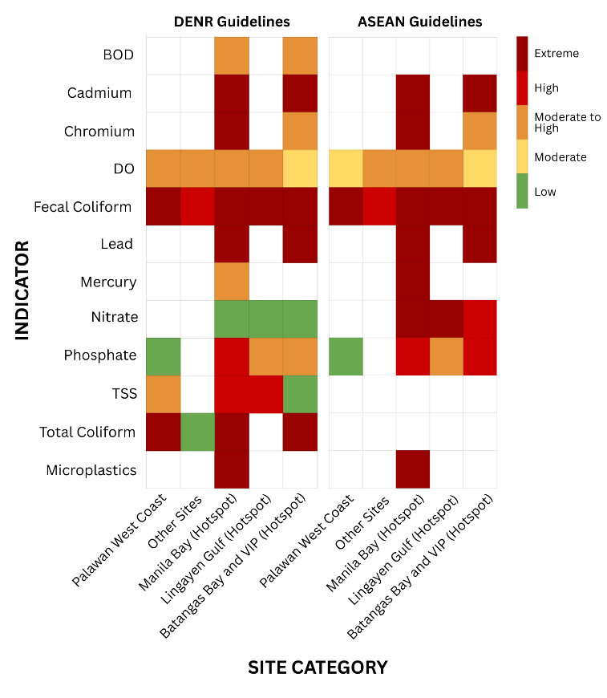
Figure 3.I.1. Heat Map for Pollution Hotspots using the 95th Ppercentile Risk Quotient
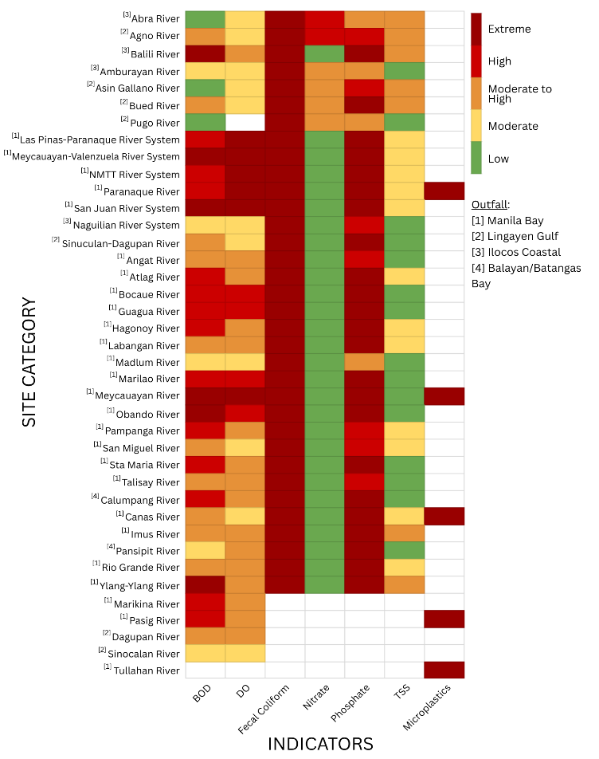
Figure 3.I.2. Heat Map for Rivers Draining to the Philippine Waters of SCS-LME using the 95th Percentile Risk Quotient.

Annex 3.J. Output from the Multi-stakeholder Validation Workshop
The validation workshop for the Pollution Component of the Philippine Transboundary Diagnostic Analysis (TDA) was convened to validate results from the collated data, refine analytical findings, and identify remaining gaps in assessing pollution pressures on the South China Sea Large Marine Ecosystem (SCS-LME). The session brought together representatives from the Environmental Management Bureau (EMB), Philippine Coast Guard (PCG), Biodiversity Management Bureau (BMB), Laguna Lake Development Authority (LLDA), Manila Bay Coordinating Office (MBCO), and civil society organizations, among others. The discussion emphasized the need to strengthen the evidence-informed governance and to harmonize institutional roles in monitoring, reporting, and regulating multiple pollution sources.
Stakeholders confirmed that domestic wastewater remains the dominant contributor to national pollution loads, reflecting low sewerage coverage and persistent untreated discharges into rivers and coastal waters. EMB and LLDA emphasized that the domestic sector continues to exceed other source categories in nutrient, organic, and pathogen loading. Nonpoint sources, particularly agricultural runoff, sedimentation from upland erosion and other land-based activities, and diffuse nutrient discharges, were also identified as significant sources but poorly quantified, with limited available datasets on nitrogen, phosphorus, and sediment load calculations. EMB noted ongoing work to develop sediment quality guidelines.
The workshop also validated the contribution of aquaculture and mariculture operations as emerging sources of pollution, especially in semi-enclosed bays. However, participants underscored weak coordination between DA BFAR and DENR EMB in monitoring aquaculture effluents, resulting in fragmented datasets and limited reporting of environmental quality attributed to aquaculture/mariculture activities. For industrial effluent and hazardous wastes, EMB highlighted ongoing efforts to improve data systems, including the development of industry-specific pollution load databases and disaggregated hazardous waste inventories from different sources. During the validation workshop, it was noted that confidence in reported hazardous waste data has been improved since 2020 with the operationalization of the online Hazardous Waste Management System (https://hwms.emb.gov.ph). Key features include online registration for these different entities, an interface to enter regulatory compliance data, and reports to track hazardous waste volumes and movements.
The Philippine Coast Guard identified incomplete oil spill datasets, particularly for minor spill events after 2022. A formal request from PCG was recommended to access the full oil spill inventory for the most recent years if needed. Though the Philippine Archipelagic Sea Lanes Act (RA 12065) has recently been enacted and stipulated the prohibition of marine pollution that includes oil discharges and ballast water, the absence of Implementing Rules and Regulations (IRR) also emerged as a critical gap, with implications for both chemical and biological pollution, including invasive alien species from ballast water from ships.
Participants validated four major pollution hotspots: Manila Bay, Lingayen Gulf, Batangas Bay–Verde Island Passage (VIP), and the west coast of Palawan. These areas exhibit exceedances in microbial contaminants, nutrients, and industrial pollutants, and are considered priority locations for management intervention, given the reasonable worse-case scenario. DENR Manila Bay Coordinating Office and DENR EMB Regional Offices (e.g., Region 4A and 4B) are willing to provide recent data to supplement the analysis in Batangas Bay and the west coast of Palawan. It was also mentioned during the workshop that several letters of request had already been sent to pertinent government agencies during the study's conduct for such data.
Batangas Bay and VIP
Nitrate concentrations have exceeded ASEAN Water Quality Guidelines (WQG) thresholds post-validation but remain compliant within the DENR WQG standards. Pre-validation data has indicated potential phosphate concerns in Batangas Bay and VIP hotspot; however, these assessments were based on only two data points. Subsequent validation revealed that phosphate levels have actually complied with DENR WQG standards in recent years (2024-2025). Wagas and Andres (2022) reported an increasing trend in heavy metal concentrations exceeding thresholds in Batangas Bay The recent monitoring data (2024-2025) indicates that chromium concentrations have complied with DENR WQG standards. However, caution must be exercised when interpreting these data, as the parameters can be subjected to factors such as seasonal variability.
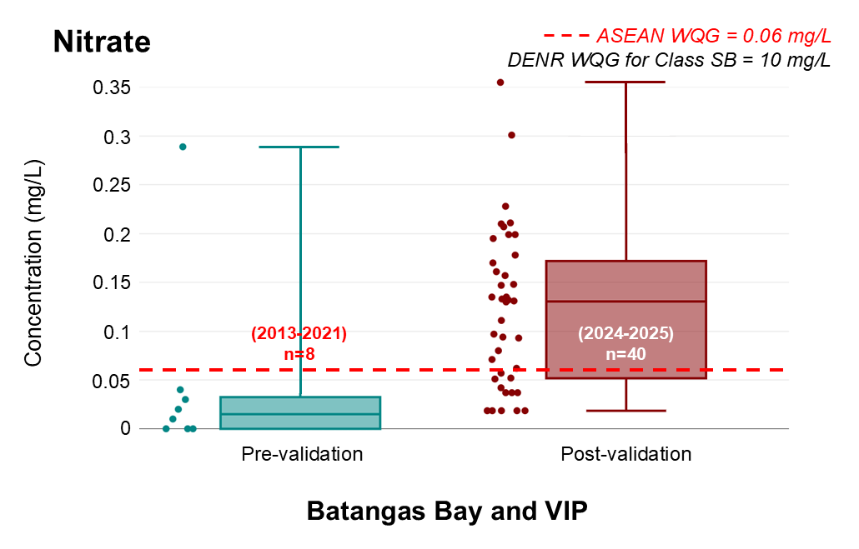
Figure 3.J.1. Box Plot for Nitrate Concentration in Batangas Bay (Pre- and Post-Validation)

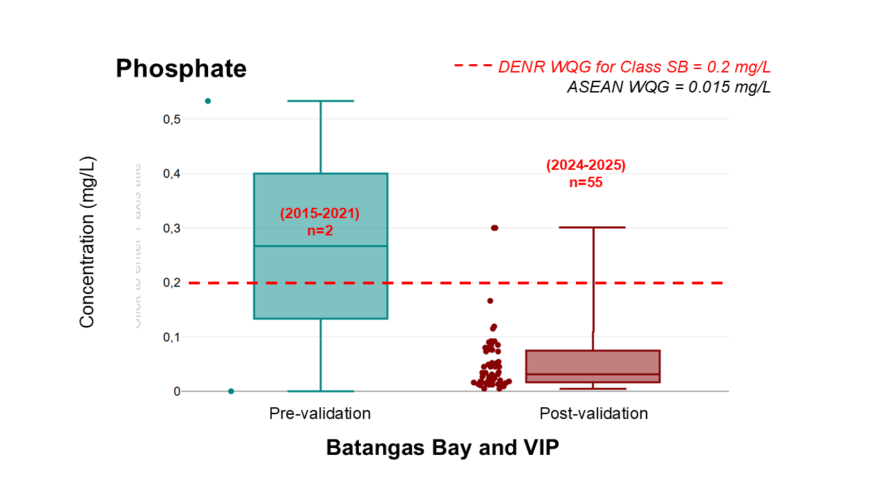
Figure 3.J.2. Box Plot for Phosphate Concentration in Batangas Bay (Pre- and Post-Validation)
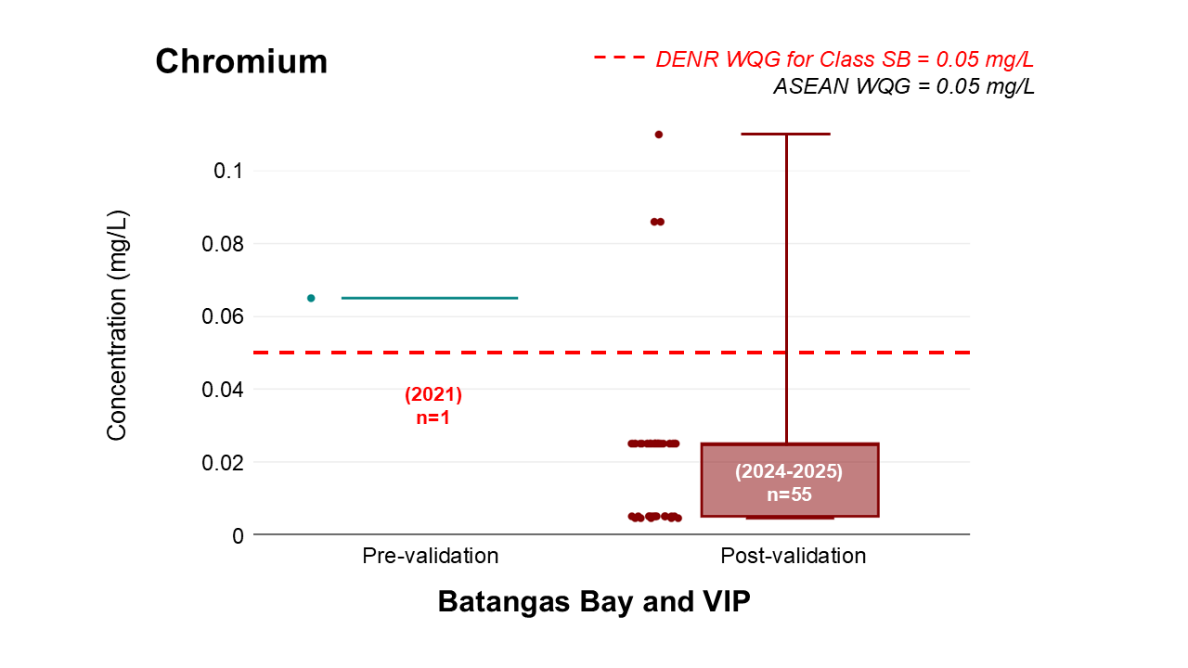
Figure 3.J.3. Box Plot for Chromium Concentration in Batangas Bay (Pre- and Post-Validation)
West Coast of Palawan
Generally, TSS levels in the west coast of Palawan falls in compliance to the DENR WQG for Class SB. Although there is a notable change in the trend for TSS concentration in Palawan (post-validation) where a significant number exceeds the DENR WQG, some in extreme exceedances. Siltation from rivers and anthropogenic activities such as quarrying may have caused the increased TSS levels. Enhanced monitoring as well as appropriate intervention is recommended, as TSS affects light penetration which in turn affects productivity in marine ecosystems. Similarly, caution must be exercised in interpreting due to the aggregation of data, as the parameter can be subjected to factors such as seasonal variability.
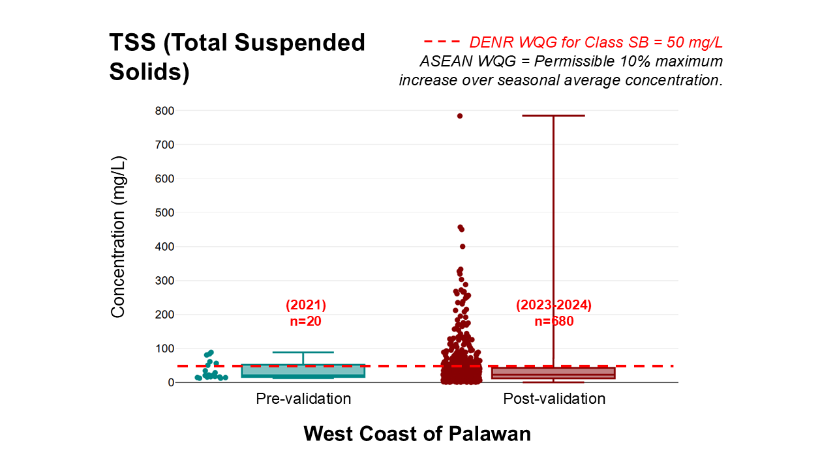
Figure 3.J.4. Box Plot for Total Suspended Solids Concentration in the west coast of Palawan (Pre- and Post-Validation)
Lingayen Gulf
Acquiring data for water quality in Lingayen Gulf remains a challenge due to limited accessibility. Following validation, the EMB Region 1 provided fecal coliform concentration data, significantly enhancing the reliability of data assessment. These post-validation data, which address previous data scarcity, reveal findings that contrast with earlier assessments. Fecal coliform levels in Lingayen Gulf generally comply with DENR Water Quality Guidelines for Class SB waters (100 MPN/100 mL), though notable exceedances occurred between 2014-2025. While results are encouraging, they underscore the need for stricter regulation and continuous monitoring to maintain compliance.
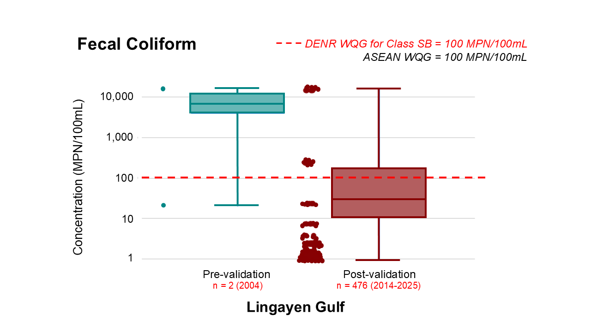
Figure 3.J.5. Box Plot for Fecal Coliform Concentration in Lingayen Gulf (Pre- and Post-Validation)
Risk Assessment
A similar risk assessment was done using the dataset provided by the concerned agencies (Figure 3.J.6). Nitrate levels for the hotspots remain a low to moderate concern, but increase in monitoring should be prioritized in the rivers draining to Manila Bay. Phosphate, BOD, DO, and TSS levels in Manila Bay (coastal and from riverine inputs) remain high to extreme risk, solidifying its position as the most critical hotspot. Despite ongoing Manila Bay rehabilitation efforts mandated by the Supreme Court, it continues to face significant environmental challenges. Enhanced water quality monitoring, stricter enforcement of environmental regulations, and increased stakeholder engagement remain essential for meaningful progress. The risk for phosphate and chromium in Batangas Bay is lowered to moderate using the dataset provided by the EMB region 4A, compared to the moderate to high risk from the previous heat map (due to limited data). However, the risk for TSS levels has increased from low to moderate, which could be attributed to the industrial activities surrounding the area. Coliform levels remain problematic for all hotspots, which could be due to the limited connections of households to sewage and septage systems in the national level. If this continues, the elevated levels of coliform would become a threat not only to the marine ecosystems but also pose risk to public health. Following the ASEAN guidelines reflect moderate to extreme risks for most indicators due to a more conservative threshold as it was developed in consideration to aquatic life protection, compared to the DENR guidelines which was developed for a waterbody’s intended use aside from ecosystem health. The additional data points have significantly increased the accuracy of the risk assessment for Batangas Bay and VIP area, Lingayen Gulf, Manila Bay, and the west coast of Palawan, with significant addition of the coasts of Ilocos.
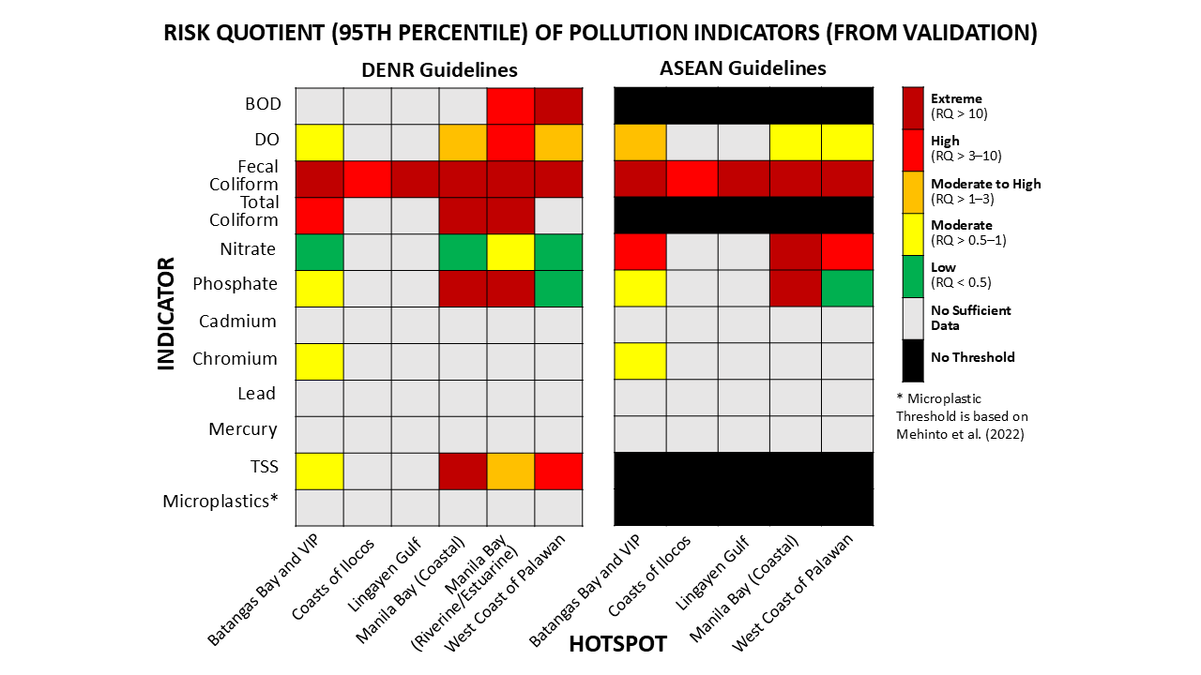
Figure 3.J.6. Heat Map for Pollution Hotspots (Post-validation) in the Philippine Waters of SCS-LME (2011-2025)
Water Quality Index (WQI) of Manila Bay
To date, the DENR EMB has no existing guidelines on measuring marine or coastal water quality index. Water quality indices provide a simplified, standardized metric for assessing complex datasets through qualitative categories such as "poor," "moderate," and "good." To evaluate coastal water quality in Manila Bay, the Canadian Council of Ministers of the Environment (CCME) Water Quality Index was applied. The CCME WQI was selected for its simplicity and flexibility in handling missing data and parameters, treating all variables with equal weight. However, this approach is susceptible to bias, particularly with incomplete parameter and temporal datasets as in the case of this assessment for Manila Bay. Despite the limitation, this assessment is necessary for communicating the water quality status of Manila Bay effectively.
Table 3.J.1. CCME WQI Category
Rating | Value | Definition
Excellent | 95-100 | water quality is protected with a virtual absence of threat or impairment; conditions very close to natural or pristine levels.
Good | 80-94 | water quality is protected with only a minor degree of threat or impairment; conditions rarely depart from natural or desirable levels.
Fair | 65-79 | water quality is usually protected but occasionally threatened or impaired; conditions sometimes depart from natural or desirable levels.
Marginal | 45-64 | water quality is frequently threatened or impaired; conditions often depart from natural or desirable levels.
Poor | 0-44 | water quality is almost always threatened or impaired; conditions usually depart from natural or desirable levels.
As provided by the Manila Bay Coordinating Office, a total of 5,386 datapoints and six parameters (DO, fecal coliform, total coliform, nitrate, phosphate, and TSS) were considered in computing for the CCME WQI. Figure 3.J.7 presents the time-series of water quality in Manila Bay assessed using the CCME WQI. A gradual upward trend is observed, potentially attributed to the rehabilitation efforts mandated by the Supreme Court mandamus. However, annual WQI values consistently fall within the "poor" category (Table 3.J.2), indicating that most parameters fail to meet DENR Water Quality Guidelines (see Table 3.J.7 for detailed calculations). The highest WQI value occurs in 2025 at 27, followed by 2017 at 24; notably, the 2025 value are subject to change as monitoring continues through year-end.
Consistent with the TDA report findings, these results reflect Manila Bay's location within the nation's most densely populated region. Given that domestic wastewater and solid waste are among the primary sources of pollution, wherein both are directly affected by population, the persistently poor water quality highlights the immediate need for more effective rehabilitation strategies to protect the marine ecosystems and sustain the livelihoods of communities dependent on Manila Bay's natural resources.
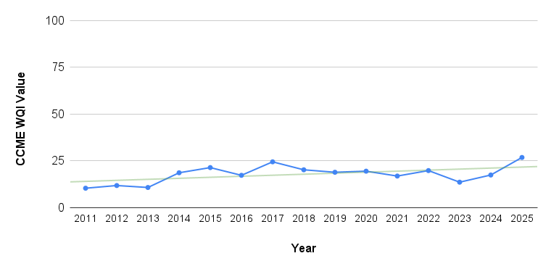
Figure 3.J.7. Time Series of CCME WQI Values in Manila Bay (2011-2025)
Table 3.J.2. CCME WQI Rating in Manila Bay from 2011-2025
Spatial Coverage | Year | CCME WQI Value | Rating
Manila Bay (Coastal) | 2011 | 10 | Poor
Manila Bay (Coastal) | 2012 | 12 | Poor
Manila Bay (Coastal) | 2013 | 11 | Poor
Manila Bay (Coastal) | 2014 | 19 | Poor
Manila Bay (Coastal) | 2015 | 21 | Poor
Manila Bay (Coastal) | 2016 | 17 | Poor
Manila Bay (Coastal) | 2017 | 24 | Poor
Manila Bay (Coastal) | 2018 | 20 | Poor
Manila Bay (Coastal) | 2019 | 19 | Poor
Manila Bay (Coastal) | 2020 | 19 | Poor
Manila Bay (Coastal) | 2021 | 17 | Poor
Manila Bay (Coastal) | 2022 | 20 | Poor
Manila Bay (Coastal) | 2023 | 14 | Poor
Manila Bay (Coastal) | 2024 | 17 | Poor
Manila Bay (Coastal) | 2025 | 27 | Poor
Several emerging pollution issues were also validated and identified, including those related to antimicrobial resistance (AMR), e-waste and other emerging hazardous waste streams, noise pollution from maritime activities, and the transport of other pollutants attached to microplastics. EMB also highlighted ongoing national initiatives to enhance marine litter monitoring, including the development of a marine debris profiling database and the implementation of the Marine Litter Management Project in Manila Bay.
To complement the national consultation workshops, a structured validation survey was conducted to systematically capture stakeholder perspectives on (a) priority causes of land-based pollution, (b) major pollution sources and pathways, and (c) perceived transboundary pollution concerns affecting the Philippine waters of the South China Sea Large Marine Ecosystem (SCS-LME) (d) gaps and challenges in pollution control and management, and (e) recommended priority actions. There is a total of twenty-five (25) respondents from multiple stakeholders, in which majority are from the government (19 respondents), followed by respondents from NGO and civil society (6), two respondents are from the community group/fisherfolk organization and one respondent from the academic/research institution.
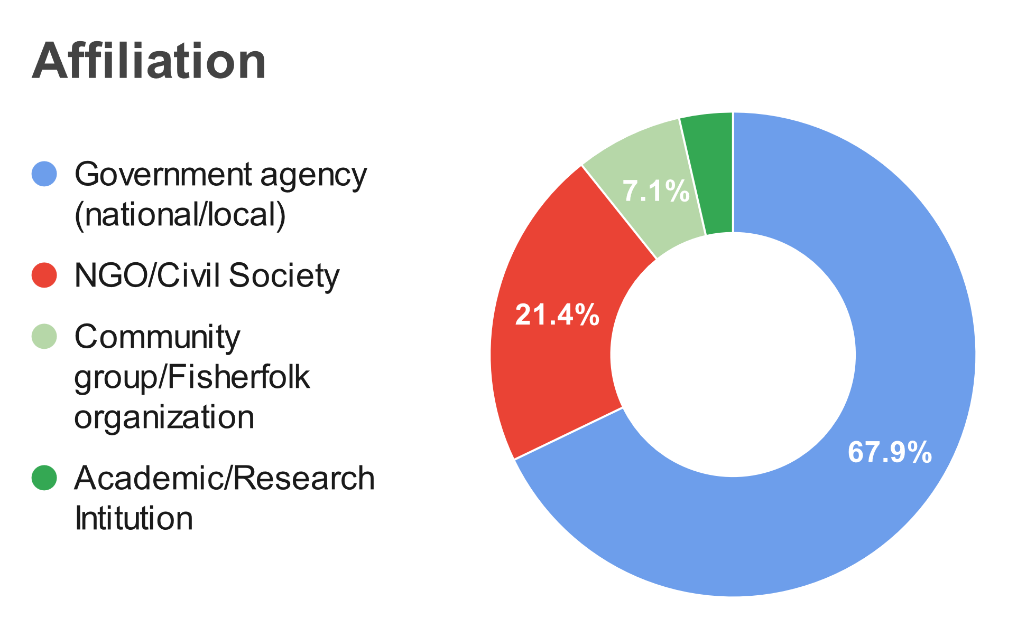
Figure 3.J.8. Composition of Stakeholders’ Affiliation
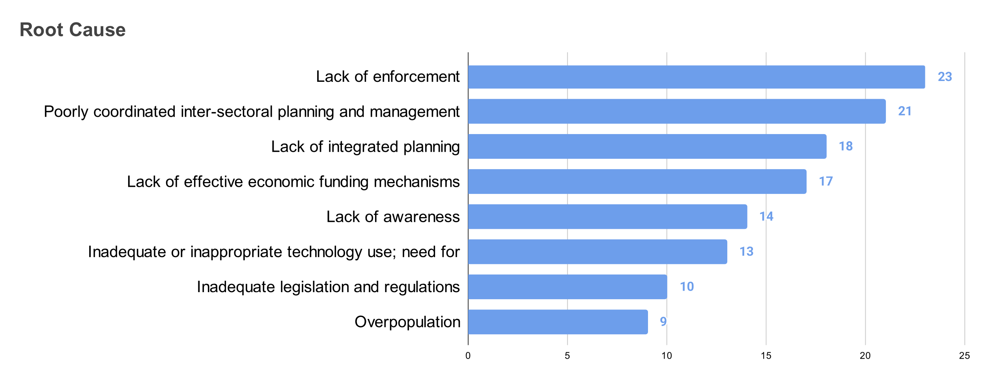
Figure 3.J.9. Ranking of Root Causes of Pollution
Twenty-three respondents have chosen lack of enforcement among their top five root cause, followed by poorly coordinated inter-sectoral planning and management (21 respondents), lack of integrated planning (18), lack of effective funding mechanisms (17), and lack of awareness (14). The five primary root causes of land-based pollution reflect systemic governance challenges. Respondents indicated that existing environmental laws is adequate; however, enforcement and implementation remain lacking. There is gap in environmental awareness existing within communities, with some LGU officials unfamiliar with environmental laws. To address these challenges, some respondents recommended implementing incentives to promote behavioral change, alongside strengthening environmental programs and activities. This suggests that effective pollution control requires not only regulatory frameworks but also comprehensive awareness campaigns, institutional and intentional capacity building, and positive reinforcement strategies to encourage compliance and sustainable practices.
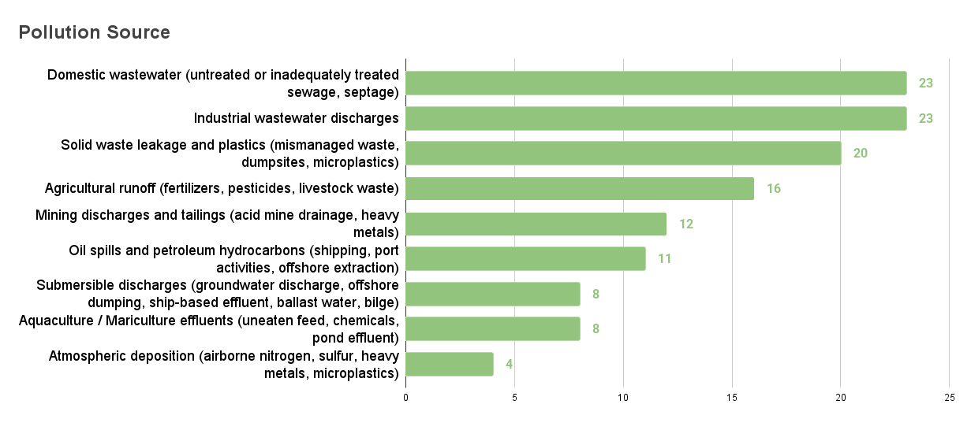
Figure 3.J.10. Ranking of Pollution Sources
Wastewater discharge (domestic and industrial) remains the top contributor of pollution especially to marine waters (23 respondents each), followed by solid waste and plastic leakage (20 respondents), and agricultural source (16 respondents). This validation survey has further strengthened and supported the findings of the TDA report. Mining discharges and tailings (12 respondents) was also considered as a major contributor to pollution. However, data is limited to accurately assess the impact of mining activities and remains a significant knowledge gap.
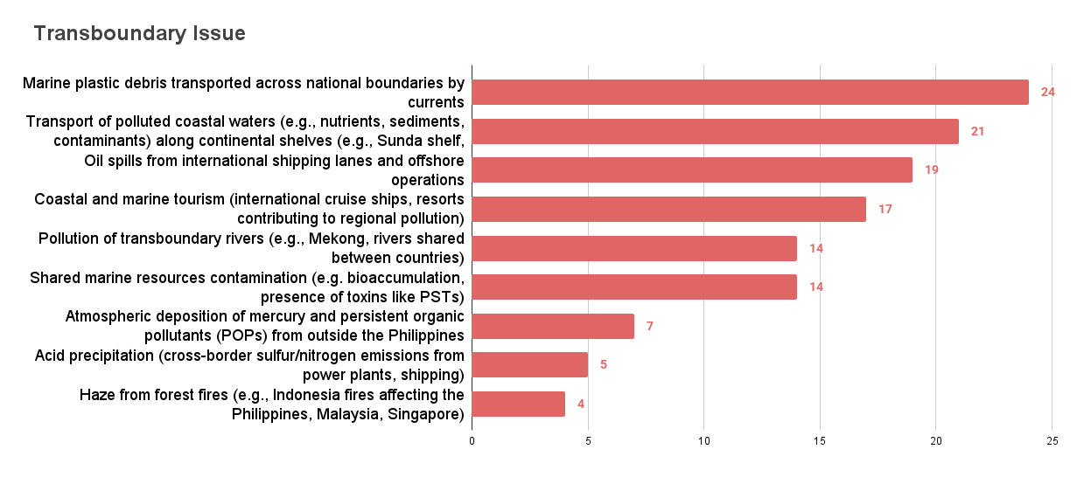
Figure 3.J.11. Primary Transboundary Issues for Pollution
The results of the validation survey support the transboundary issues presented in the TDA report. With marine plastic debris transport as the top transboundary issue (22 respondents). However, the respondents (17) also identified the increasing coastal and marine tourism-related activities as among the top five transboundary issue. This warrants consideration to develop appropriate regulations and management strategies concerning the developing coastal tourism sector among countries.
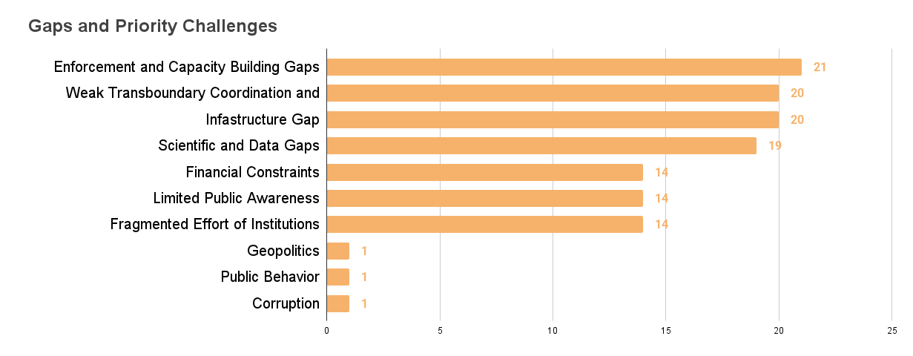
Figure 3.J.12. Gaps and Priority Challenges in Pollution Mitigation
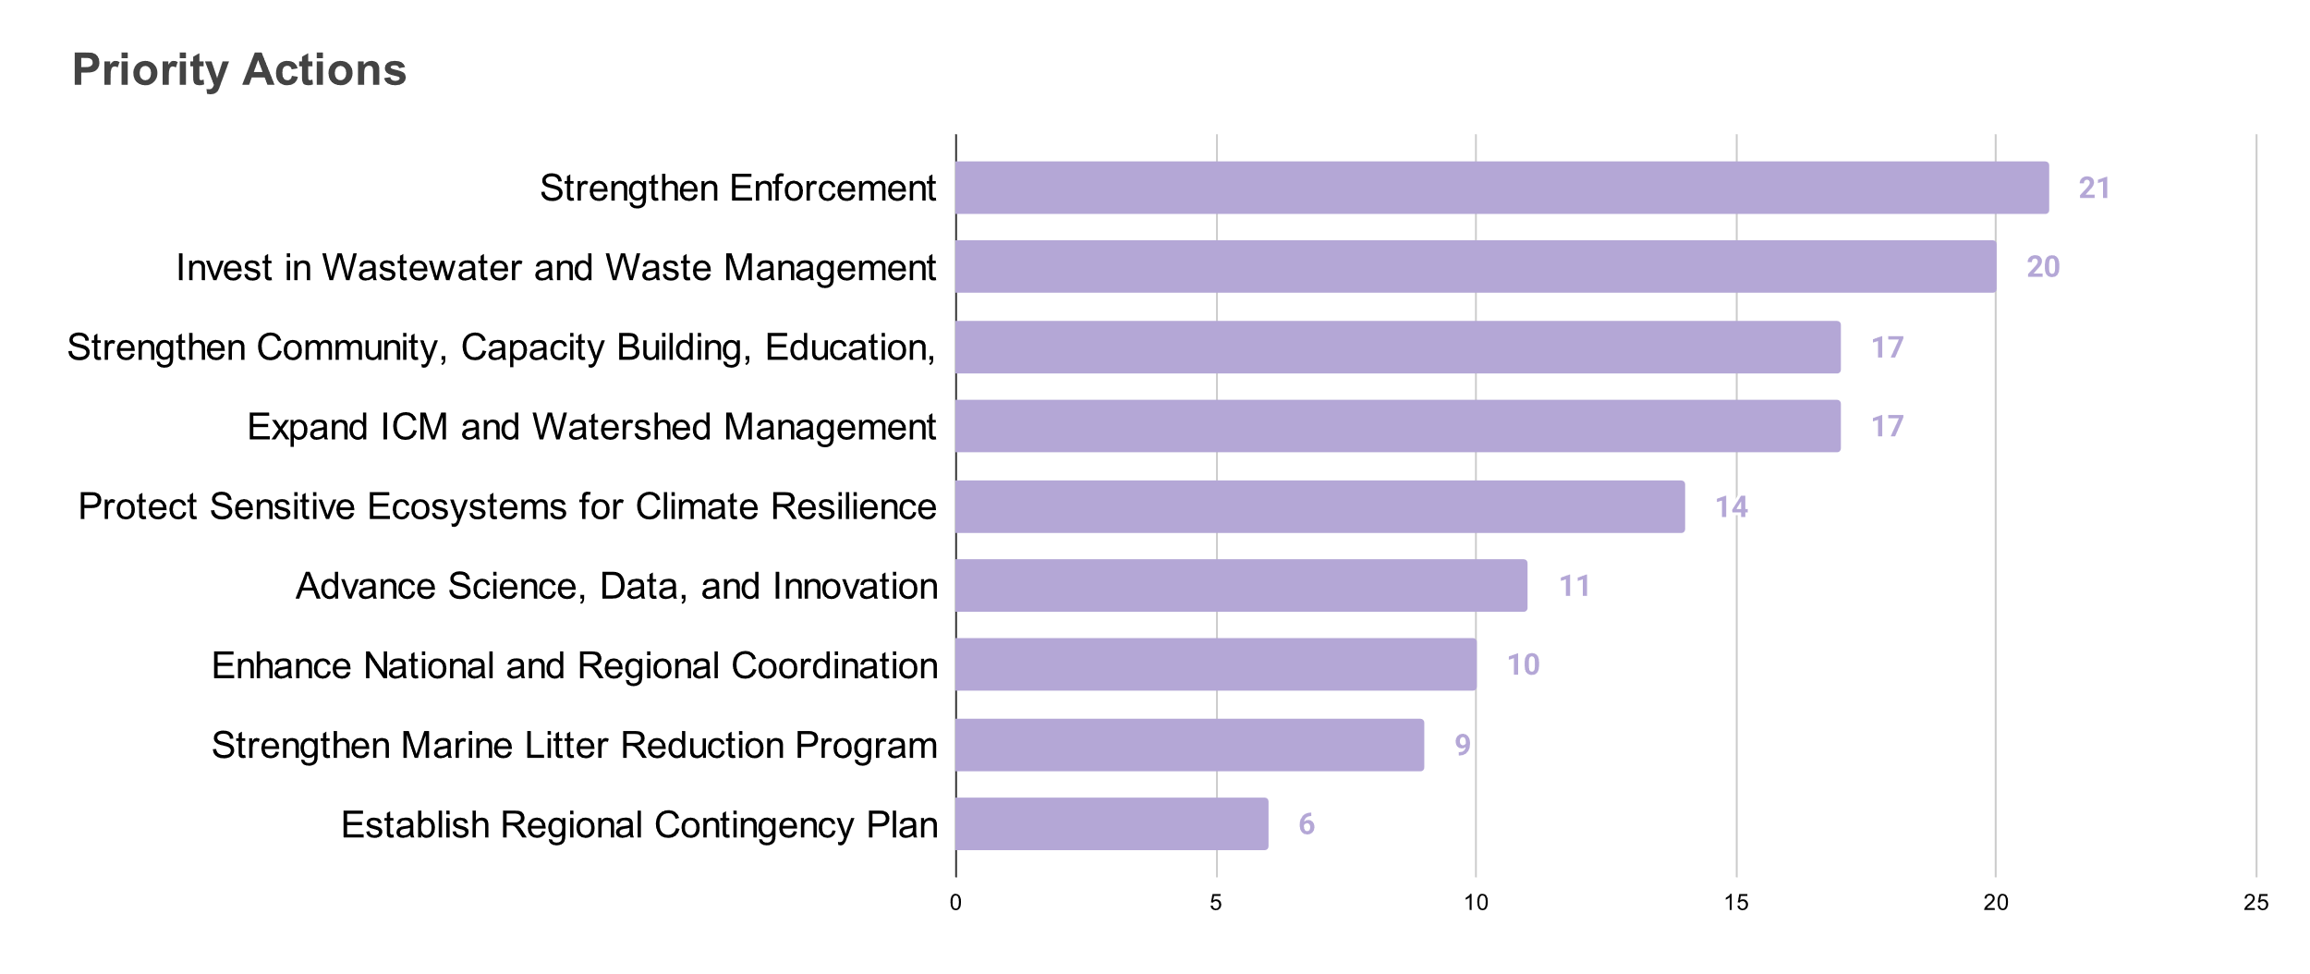
Figure 3.J.13. Priority Actions in Pollution Mitigation
Enforcement and capacity building gap is considered as the top priority challenge by 21 respondents. This is followed by weak transboundary cooperation and infrastructure gaps (20 respondents each). Scientific and data gaps (19), financial constraints (14), limited public awareness (14), and fragmented effort of institutions (14) are also considered. As mentioned, existing environmental laws are adequate and comprehensive, the apparent problem lies to enforcement and implementation. Infrastructure gaps can be connected to financial constraints. Scientific and data gaps are also highlighted that could result to the lack of public awareness. To answer these challenges, the respondents also identified the top priority actions. Strengthening enforcement (21 respondents) emerges as the top priority to address pollution. Investing to wastewater treatment infrastructure follows (20), reflecting the significance of domestic wastewater as the top contributor to land-based pollution. Strengthening CEPA activities (17 respondents) addresses the gap in public awareness. It is followed by the expansion of ICM and watershed management (17) and protection of sensitive ecosystems for climate resilience (14) which not only addresses pollution but also contributes to the ecosystem services in which the population within the SCS-LME can benefit from.
Overall, the workshop affirmed the robustness of the initial update to TDA, while emphasizing the need for strengthened interagency coordination, improved data accessibility, and updated datasets to address information gaps. The consolidated feedback will guide the refinement of the TDA and the integration of validated evidence and recommendations into the final TDA.
Table 3.J.3. Summary Table for Number of Available Data on Water Quality by Pollution Hotspot (Post-Validation)
Coastal Pollution  Hotspots | BOD | DO | Fecal Coliform | Total Coliform | Cadmium | Chromium | Lead | Mercury | Nitrate | Phosphate | TSS | Micro-plastics
Batangas Bay and VIP | 0 | 0 | 55 | 35 | 40 | 0 | 0 | 40 | 55 | 30 | 40 | 0
Coasts of Ilocos | 0 | 0 | 0 | 0 | 321 | 0 | 0 | 0 | 0 | 0 | 0 | 0
Lingayen Gulf (Hotspot) | 0 | 0 | 0 | 0 | 476 | 0 | 0 | 0 | 0 | 0 | 0 | 0
Manila Bay (Coastal) | 0 | 0 | 0 | 310 | 438 | 0 | 0 | 219 | 225 | 269 | 154 | 0
Manila Bay (Riverine/Estuarine) | 402 | 0 | 0 | 701 | 714 | 0 | 0 | 675 | 721 | 708 | 287 | 0
West Coast of Palawan | 0 | 44 | 81 | 4 | 0 | 0 | 0 | 0 | 0 | 20 | 20 | 0
Table 3.J.4 Descriptive Statistics for Water Quality on Pollution Hotspots (Post-Validation)
Coastal Pollution  Hotspots | Indicator | unit | count | mean | std | median | q25 | q75 | p5 | p95 | min | max
Batangas Bay and VIP | Nitrate | mg/L | 40 | 0.12 | 0.081 | 0.13 | 0.052 | 0.17 | 0.019 | 0.23 | 0.019 | 0.36
Batangas Bay and VIP | Phosphate | mg/L | 55 | 0.052 | 0.059 | 0.031 | 0.017 | 0.075 | 0.01 | 0.13 | 0.0045 | 0.3
Batangas Bay and VIP | DO | mg/L | 35 | 6.6 | 0.74 | 6.6 | 6.5 | 6.8 | 5.5 | 7.6 | 4 | 8
Batangas Bay and VIP | TSS | mg/L | 30 | 26 | 12 | 24 | 17 | 32 | 12 | 41 | 10 | 68
Batangas Bay and VIP | Total Coliform | MPN/100mL | 40 | 9400 | 27000 | 1000 | 350 | 4000 | 32 | 36000 | 6.1 | 160000
Batangas Bay and VIP | Fecal Coliform | MPN/100mL | 40 | 1000 | 2700 | 210 | 39 | 720 | 8.8 | 3600 | 0.9 | 16000
Batangas Bay and VIP | Chromium | mg/L | 55 | 0.022 | 0.02 | 0.025 | 0.005 | 0.025 | 0.0045 | 0.043 | 0.0045 | 0.11
Coasts of Ilocos | Fecal Coliform | MPN/100mL | 321 | 240 | 1500 | 23 | 7 | 76 | 0.9 | 540 | 0.9 | 24000
Lingayen Gulf (Hotspot) | Fecal Coliform | MPN/100mL | 476 | 560 | 2100 | 45 | 11 | 170 | 0.9 | 1700 | 0.9 | 16000
West Coast of Palawan | Nitrate | mg/L | 616 | 0.2 | 0.08 | 0.25 | 0.15 | 0.25 | 0.029 | 0.25 | 0.005 | 0.71
West Coast of Palawan | Phosphate | mg/L | 679 | 0.018 | 0.035 | 0.01 | 0.01 | 0.01 | 0.01 | 0.054 | 0 | 0.53
West Coast of Palawan | DO | mg/L | 787 | 6.2 | 1.5 | 6.4 | 5.6 | 7 | 3.3 | 8.5 | 0.51 | 11
West Coast of Palawan | TSS | mg/L | 680 | 42 | 64 | 23 | 12 | 43 | 4 | 160 | 0.5 | 780
West Coast of Palawan | Fecal Coliform | MPN/100mL | 857 | 240000 | 5500000 | 79 | 9 | 700 | 0.9 | 37000 | 0.9 | 1.6E+08
West Coast of Palawan | BOD | mg/L | 22 | 33 | 33 | 29 | 12 | 39 | 7.1 | 77 | 4.5 | 160
Manila Bay (Coastal) | Nitrate | mg/L | 219 | 190 | 1600 | 0.2 | 0.14 | 0.3 | 0.077 | 1.7 | 0.027 | 15000
Manila Bay (Coastal) | Phosphate | mg/L | 225 | 290 | 2500 | 0.14 | 0.085 | 0.27 | 0.054 | 4.1 | 0.03 | 22000
Manila Bay (Coastal) | DO | mg/L | 310 | 92 | 890 | 5.8 | 4.2 | 6.5 | 2.5 | 8.7 | 0.9 | 10000
Manila Bay (Coastal) | TSS | mg/L | 269 | 2700 | 13000 | 74 | 44 | 120 | 13 | 13000 | 5 | 140000
Manila Bay (Coastal) | Total Coliform | MPN/100mL | 154 | 7300000 | 42000000 | 5700 | 800 | 27000 | 22 | 480000 | 1.4 | 3.3E+08
Manila Bay (Coastal) | Fecal Coliform | MPN/100mL | 438 | 3.6E+10 | 7.6E+11 | 9000 | 1900 | 88000 | 91 | 22000000 | 1.7 | 1.6E+13
Manila Bay (Riverine/Estuarine) | Nitrate | mg/L | 675 | 2 | 11 | 0.35 | 0.2 | 0.83 | 0.11 | 6.1 | 0.031 | 250
Manila Bay (Riverine/Estuarine) | Phosphate | mg/L | 721 | 3.9 | 22 | 0.83 | 0.23 | 1.5 | 0.11 | 14 | 0.031 | 430
Manila Bay (Riverine/Estuarine) | DO | mg/L | 701 | 110000 | 1700000 | 3.9 | 2.8 | 5.2 | 1.7 | 7 | 0.42 | 27000000
Manila Bay (Riverine/Estuarine) | TSS | mg/L | 708 | 46 | 76 | 36 | 25 | 52 | 13 | 100 | 1.3 | 1700
Manila Bay (Riverine/Estuarine) | Total Coliform | MPN/100mL | 287 | 1.6E+09 | 1.5E+10 | 350000 | 51000 | 1500000 | 8.1 | 36000000 | 3 | 2E+11
Manila Bay (Riverine/Estuarine) | Fecal Coliform | MPN/100mL | 714 | 1.3E+09 | 1.2E+10 | 93000 | 2200 | 1100000 | 34 | 4.1E+08 | 0.49 | 1.8E+11
Manila Bay (Riverine/Estuarine) | BOD | mg/L | 402 | 2200 | 38000 | 25 | 11 | 46 | 3.1 | 78 | 1.9 | 760000
Notes: std = Standard Deviation
p25 = 25th percentile of concentrations
p75 = 75th percentile of concentrations
p5 = 5th percentile of concentrations
p95 = 95th percentile of concentrations
MPN = Most Probable Number
Table 3.J.5. Computed RQs based on DENR Water Quality Standards for Pollution Hotspots (Post-Validation).
Pollution Hotspots | Indicator | Unit | Count | RQ_median | RQ_min | RQ_max | RQ_p95 | RQ_rwc
Batangas Bay and VIP | Nitrate | mg/L | 40 | 0.013 | 0.0019 | 0.036 | 0.023 | 0.023
Batangas Bay and VIP | Phosphate | mg/L | 55 | 0.16 | 0.023 | 1.5 | 0.67 | 0.67
Batangas Bay and VIP | DO | mg/L | 35 | 0.76 | 0.63 | 1.3 | 0.9 | 0.9
Batangas Bay and VIP | TSS | mg/L | 30 | 0.29 | 0.13 | 0.85 | 0.51 | 0.51
Batangas Bay and VIP | Total Coliform | MPN/100mL | 40 | 0.2 | 0.0012 | 32 | 7.2 | 7.2
Batangas Bay and VIP | Fecal Coliform | MPN/100mL | 40 | 1 | 0.0045 | 80 | 18 | 18
Batangas Bay and VIP | Chromium | mg/L | 55 | 0.5 | 0.09 | 2.2 | 0.87 | 0.87
Coasts of Ilocos | Fecal Coliform | MPN/100mL | 321 | 0.23 | 0.009 | 240 | 5.4 | 5.4
Lingayen Gulf | Fecal Coliform | MPN/100mL | 476 | 0.45 | 0.009 | 160 | 17 | 17
West Coast of Palawan | Nitrate | mg/L | 616 | 0.025 | 0.0005 | 0.071 | 0.025 | 0.025
West Coast of Palawan | Phosphate | mg/L | 679 | 0.05 | 0 | 2.7 | 0.27 | 0.27
West Coast of Palawan | DO | mg/L | 787 | 0.94 | 0.52 | 12 | 1.7 | 1.7
West Coast of Palawan | TSS | mg/L | 680 | 0.46 | 0.01 | 16 | 3.2 | 3.2
West Coast of Palawan | Fecal Coliform | MPN/100mL | 857 | 0.79 | 0.009 | 800000 | 250 | 250
West Coast of Palawan | BOD | mg/L | 22 | 4.1 | 0.64 | 23 | 11 | 11
Manila Bay (Coastal) | Nitrate | mg/L | 219 | 0.02 | 0.0027 | 1500 | 0.17 | 0.17
Manila Bay (Coastal) | Phosphate | mg/L | 225 | 0.71 | 0.15 | 110000 | 20 | 20
Manila Bay (Coastal) | DO | mg/L | 310 | 1 | 0.00059 | 6.7 | 2.4 | 2.4
Manila Bay (Coastal) | TSS | mg/L | 269 | 1.5 | 0.1 | 2900 | 250 | 250
Manila Bay (Coastal) | Total Coliform | MPN/100mL | 154 | 5.7 | 0.0014 | 330000 | 480 | 480
Manila Bay (Coastal) | Fecal Coliform | MPN/100mL | 438 | 90 | 0.017 | 1.6E+11 | 220000 | 220000
Manila Bay (Riverine/Estuarine) | Nitrate | mg/L | 675 | 0.05 | 0.0022 | 36 | 0.75 | 0.75
Manila Bay (Riverine/Estuarine) | Phosphate | mg/L | 721 | 14 | 0.035 | 17000 | 160 | 160
Manila Bay (Riverine/Estuarine) | DO | mg/L | 701 | 1.3 | 0.00000019 | 12 | 3 | 3
Manila Bay (Riverine/Estuarine) | TSS | mg/L | 708 | 0.44 | 0.016 | 22 | 1.2 | 1.2
Manila Bay (Riverine/Estuarine) | Total Coliform | MPN/100mL | 287 | 70 | 0.0006 | 39000000 | 7200 | 7200
Manila Bay (Riverine/Estuarine) | Fecal Coliform | MPN/100mL | 714 | 460 | 0.0025 | 900000000 | 1600000 | 1600000
Manila Bay (Riverine/Estuarine) | BOD | mg/L | 402 | 1.7 | 0.13 | 110000 | 9.7 | 9.7
Note: RQ_median - median of RQ values
RQ_min – minimum from the RQ values
RQ_max – maximum from the RQ values
RQ_p95 – 95th percentile of the computed values
RQ_rwc – Reasonable Worst-Case scenario (95th percentile)
Table 3.J.6. Computed RQs based on ASEAN Water Quality Standards for Pollution Hotspots (Post-Validation).
Pollution Hotspots | Indicator | Unit | Count | RQ_median | RQ_min | RQ_max | RQ_p95 | RQ_rwc
Batangas Bay and VIP | Nitrate | mg/L | 40 | 2.2 | 0.31 | 5.9 | 3.9 | 3.9
Batangas Bay and VIP | Phosphate | mg/L | 55 | 0.21 | 0.03 | 2 | 0.89 | 0.89
Batangas Bay and VIP | DO | mg/L | 35 | 0.61 | 0.5 | 1 | 0.72 | 0.72
Batangas Bay and VIP | Fecal Coliform | MPN/100mL | 40 | 2.1 | 0.009 | 160 | 36 | 36
Batangas Bay and VIP | Chromium | mg/L | 55 | 0.5 | 0.09 | 2.2 | 0.87 | 0.87
Coasts of Ilocos | Fecal Coliform | MPN/100mL | 321 | 0.23 | 0.009 | 240 | 5.4 | 5.4
Lingayen Gulf | Fecal Coliform | MPN/100mL | 476 | 0.45 | 0.009 | 160 | 17 | 17
West Coast of Palawan | Nitrate | mg/L | 616 | 4.2 | 0.083 | 12 | 4.2 | 4.2
West Coast of Palawan | Phosphate | mg/L | 679 | 0.067 | 0 | 3.5 | 0.36 | 0.36
West Coast of Palawan | DO | mg/L | 787 | 0.63 | 0.36 | 9.8 | 1 | 1
West Coast of Palawan | Fecal Coliform | MPN/100mL | 857 | 0.78 | 0.009 | 350 | 35 | 35
Manila Bay (Coastal) | Nitrate | mg/L | 219 | 3.4 | 0.45 | 250000 | 28 | 28
Manila Bay (Coastal) | Phosphate | mg/L | 225 | 0.94 | 0.2 | 150000 | 27 | 27
Manila Bay (Coastal) | DO | mg/L | 310 | 0.69 | 0.0004 | 4.4 | 1.6 | 1.6
Manila Bay (Coastal) | Fecal Coliform | MPN/100mL | 438 | 90 | 0.017 | 1.6E+11 | 220000 | 220000
Note: RQ_median - median of RQ values
RQ_min – minimum from the RQ values
RQ_max – maximum from the RQ values
RQ_p95 – 95th percentile of the computed values
RQ_rwc – Reasonable Worst-Case scenario (95th percentile)
Table 3.J.7. Summary computation of CCME WQI in Manila Bay (2011-2025).
2011
Parameter | n | DENR WQG* | No. of Fail | No. of Pass | Overall | F1 | F2 | nse | F3 | CCMEWQI | RATING
DO | 9 | 6 | 1 | 8 | Fail | 100 | 76 | 10 | 91 | 10 | POOR
Fecal Coliform | 27 | 100 | 24 | 3 | Fail
Total Coliform | 27 | 1000 | 22 | 5 | Fail
Nitrate | 0 | 10 | 0 | 0 | Fail
Phosphate | 0 | 0.2 | 0 | 0 | Fail
TSS | 8 | 80 | 7 | 1 | Fail
2012
Parameter | n | DENR WQG* | No. of Fail | No. of Pass | Overall | F1 | F2 | nse | F3 | CCMEWQI | RATING
DO | 52 | 6 | 17 | 35 | Fail | 100 | 62 | 42 | 98 | 12 | POOR
Fecal Coliform | 52 | 100 | 46 | 6 | Fail
Total Coliform | 52 | 1000 | 33 | 19 | Fail
Nitrate | 0 | 10 | 0 | 0 | Fail
Phosphate | 0 | 0.2 | 0 | 0 | Fail
TSS | 26 | 80 | 16 | 10 | Fail
2013
Parameter | n | DENR WQG* | No. of Fail | No. of Pass | Overall | F1 | F2 | nse | F3 | CCMEWQI | RATING
DO | 66 | 6 | 29 | 37 | Fail | 100 | 63 | 190 | 99 | 11 | POOR
Fecal Coliform | 65 | 100 | 61 | 4 | Fail
Total Coliform | 50 | 1000 | 32 | 18 | Fail
Nitrate | 0 | 10 | 0 | 0 | Fail
Phosphate | 20 | 0.2 | 20 | 0 | Fail
TSS | 51 | 80 | 17 | 34 | Fail
2014
Parameter | n | DENR WQG* | No. of Fail | No. of Pass | Overall | F1 | F2 | nse | F3 | CCMEWQI | RATING
DO | 62 | 6 | 29 | 33 | Fail | 83 | 55 | 160 | 99 | 19 | POOR
Fecal Coliform | 60 | 100 | 52 | 8 | Fail
Total Coliform | 52 | 1000 | 30 | 22 | Fail
Nitrate | 15 | 10 | 0 | 15 | Pass
Phosphate | 20 | 0.2 | 20 | 0 | Fail
TSS | 36 | 80 | 4 | 32 | Fail
2015
Parameter | n | DENR WQG* | No. of Fail | No. of Pass | Overall | F1 | F2 | nse | F3 | CCMEWQI | RATING
DO | 63 | 6 | 38 | 25 | Fail | 67 | 64 | 16,000 | 100 | 21 | POOR
Fecal Coliform | 63 | 100 | 61 | 2 | Fail
Total Coliform | 43 | 1000 | 28 | 15 | Fail
Nitrate | 20 | 10 | 0 | 20 | Pass
Phosphate | 20 | 0.2 | 20 | 0 | Fail
TSS | 21 | 80 | 0 | 21 | Pass
2016
Parameter | n | DENR WQG* | No. of Fail | No. of Pass | Overall | F1 | F2 | nse | F3 | CCMEWQI | RATING
DO | 65 | 6 | 38 | 27 | Fail | 83 | 60 | 120,000 | 100 | 17 | POOR
Fecal Coliform | 72 | 100 | 64 | 8 | Fail
Total Coliform | 48 | 1000 | 35 | 13 | Fail
Nitrate | 28 | 10 | 0 | 28 | Pass
Phosphate | 28 | 0.2 | 20 | 8 | Fail
TSS | 28 | 80 | 4 | 24 | Fail
2017
Parameter | n | DENR WQG* | No. of Fail | No. of Pass | Overall | F1 | F2 | nse | F3 | CCMEWQI | RATING
DO | 66 | 6 | 36 | 30 | Fail | 67 | 52 | 1,000,000 | 100 | 24 | POOR
Fecal Coliform | 68 | 100 | 60 | 8 | Fail
Total Coliform | 1 | 1000 | 0 | 1 | Pass
Nitrate | 36 | 10 | 0 | 36 | Pass
Phosphate | 36 | 0.2 | 5 | 31 | Fail
TSS | 68 | 80 | 41 | 27 | Fail
2018
Parameter | n | DENR WQG* | No. of Fail | No. of Pass | Overall | F1 | F2 | nse | F3 | CCMEWQI | RATING
DO | 65 | 6 | 25 | 40 | Fail | 83 | 46 | 1,900,000 | 100 | 20 | POOR
Fecal Coliform | 67 | 100 | 58 | 9 | Fail
Total Coliform | 0 | 1000 | 0 | 0 | Fail
Nitrate | 36 | 10 | 0 | 36 | Pass
Phosphate | 60 | 0.2 | 22 | 38 | Fail
TSS | 68 | 80 | 32 | 36 | Fail
2019
Parameter | n | DENR WQG* | No. of Fail | No. of Pass | Overall | F1 | F2 | nse | F3 | CCMEWQI | RATING
DO | 108 | 6 | 60 | 48 | Fail | 83 | 53 | 790,000,000 | 100 | 19 | POOR
Fecal Coliform | 124 | 100 | 110 | 14 | Fail
Total Coliform | 60 | 1000 | 48 | 12 | Fail
Nitrate | 96 | 10 | 0 | 96 | Pass
Phosphate | 108 | 0.2 | 30 | 78 | Fail
TSS | 105 | 80 | 69 | 36 | Fail
2020
Parameter | n | DENR WQG* | No. of Fail | No. of Pass | Overall | F1 | F2 | nse | F3 | CCMEWQI | RATING
DO | 70 | 6 | 41 | 29 | Fail | 83 | 50 | 1,800 | 100 | 19 | POOR
Fecal Coliform | 121 | 100 | 89 | 32 | Fail
Total Coliform | 24 | 1000 | 6 | 18 | Fail
Nitrate | 67 | 10 | 0 | 67 | Pass
Phosphate | 67 | 0.2 | 21 | 46 | Fail
TSS | 74 | 80 | 55 | 19 | Fail
2021
Parameter | n | DENR WQG* | No. of Fail | No. of Pass | Overall | F1 | F2 | nse | F3 | CCMEWQI | RATING
DO | 106 | 6 | 74 | 32 | Fail | 83 | 62 | 980 | 100 | 17 | POOR
Fecal Coliform | 151 | 100 | 146 | 5 | Fail
Total Coliform | 58 | 1000 | 46 | 12 | Fail
Nitrate | 106 | 10 | 0 | 106 | Pass
Phosphate | 106 | 0.2 | 38 | 68 | Fail
TSS | 106 | 80 | 86 | 20 | Fail
2022
Parameter | n | DENR WQG* | No. of Fail | No. of Pass | Overall | F1 | F2 | nse | F3 | CCMEWQI | RATING
DO | 105 | 6 | 60 | 45 | Fail | 83 | 50 | 120 | 99 | 20 | POOR
Fecal Coliform | 131 | 100 | 122 | 9 | Fail
Total Coliform | 12 | 1000 | 12 | 0 | Fail
Nitrate | 108 | 10 | 0 | 108 | Pass
Phosphate | 108 | 0.2 | 22 | 86 | Fail
TSS | 91 | 80 | 62 | 29 | Fail
2023
Parameter | n | DENR WQG* | No. of Fail | No. of Pass | Overall | F1 | F2 | nse | F3 | CCMEWQI | RATING
DO | 115 | 6 | 66 | 49 | Fail | 100 | 49 | 2,100 | 100 | 14 | POOR
Fecal Coliform | 159 | 100 | 136 | 23 | Fail
Total Coliform | 60 | 1000 | 19 | 41 | Fail
Nitrate | 115 | 10 | 7 | 108 | Fail
Phosphate | 115 | 0.2 | 24 | 91 | Fail
TSS | 115 | 80 | 80 | 35 | Fail
2024
Parameter | n | DENR WQG* | No. of Fail | No. of Pass | Overall | F1 | F2 | nse | F3 | CCMEWQI | RATING
DO | 59 | 6 | 38 | 21 | Fail | 83 | 60 | 240 | 100 | 17 | POOR
Fecal Coliform | 113 | 100 | 102 | 11 | Fail
Total Coliform | 12 | 1000 | 12 | 0 | Fail
Nitrate | 59 | 10 | 0 | 59 | Pass
Phosphate | 59 | 0.2 | 38 | 21 | Fail
TSS | 59 | 80 | 26 | 33 | Fail
2025
Parameter | n | DENR WQG* | No. of Fail | No. of Pass | Overall | F1 | F2 | nse | F3 | CCMEWQI | RATING
DO | 53 | 6 | 42 | 11 | Fail | 83 | 40 | 6.3 | 86 | 27 | POOR
Fecal Coliform | 65 | 100 | 37 | 28 | Fail
Total Coliform | 30 | 1000 | 4 | 26 | Fail
Nitrate | 58 | 10 | 0 | 58 | Pass
Phosphate | 54 | 0.2 | 10 | 44 | Fail
TSS | 54 | 80 | 35 | 19 | Fail
Notes: *Class SB
DO, Nitrate and TSS follows the DENR Administrative Order 2016-08
Phosphate and Fecal Coliform DENR Administrative Order 2021-19
Total Coliform follows the DENR Administrative Order No. 34 s. 1990
n = number of data points
F1 = represents the percent of failed parameters that do not meet the guidelines at least once
F2 represents the percentage of individual tests that do not meet guidelines
nse = collective amount by which individual tests are out of compliance
F3 = represents the amount by which failed test values do not meet their guidelines

