Status, Trends, and Management of Coastal Ecosystems of the Philippine Waters in the South China Sea-Large Marine Ecosystem (SCS-LME)
Filiberto A. Pollisco Jr.^{1,*}, Floredel D. Dangan-Galon^{2,*}, Lucas R. Felix Jr.^{3,*}
¹Society for the Conservation of Philippine Wetlands, Inc. (SCPW), Unit 208 Grand Emerald Tower, F. Ortigas, Jr. cor. Garnet St., Ortigas Center, Pasig, 1605 Metro Manila
²Palawan State University (PSU), Tiniguiban, Puerto Princesa City
³OceanBio Laboratory, Division of Biological Sciences, CAS, University of the Philippines Visayas
*corresponding author: docnoypollisco@gmail.com
Abstract
This report presents the current status of mangrove, wetland, coral reef, and seagrass ecosystems in the Philippine waters of the South China Sea Large Marine Ecosystem (SCS-LME). Data used were derived from published articles and other related available references. The gathered biodiversity, natural and human-induced threats, and socioeconomic valuation studies were analyzed to generate the risk indices from the identified threats to the ecosystems. The estimated average mangrove cover in this region is 35,553 ha, representing 14% of the entire Philippine mangrove forests. Of these provinces, the western seaboard of Palawan has the highest relative percent mangrove cover (76.5%) and the greatest species diversity (30 species). Mangrove cover had increased, particularly in 2020, resulting in an overall increase of 5,667 ha from 2000 to 2023. The average live coral cover in the region ranges from 24 to 26%, placing it in the fair condition category. Palawan has the largest reef area, comprising around 80% (325,770 ha), where the Kalayaan Island Group (KIG) alone accounts for roughly 320,000 ha of the Palawan reefs. Higher coral covers were located between Palawan and Occidental Mindoro while higher fish biomass, abundance, and diversity were also concentrated between Occidental Mindoro and the Calamianes Group of Islands in Palawan, including the KIG. The current estimated seagrass cover in the SCS-LME is at 12,685 km², or 1,268,500 ha. This reflects a 10,560 km² (1,056,000 ha) decrease in seagrass cover in the region from 2008 to 2020, or an overall decline of 54%. The coastal wetlands, Malampaya Sound Protected Landscape and Seascape in Palawan, the Las Piñas Parañaque Wetland Park, and Tanza Marine Tree Parks are among the significant biodiversity areas in the region. Data analysis had indicated the direct link of natural and human-induced threats to the deteriorating patterns of mangrove, coral, and seagrass ecosystems. Socioeconomic analysis identifies Palawan, Batangas, and Pangasinan as priority conservation areas where high biodiversity value coincides with intense human reliance and high ecological risks. Economic valuation underscores urgency: a 1% decline in coral reefs, mangroves, or seagrasses could result in millions of US dollars in annual losses, threatening fisheries, coastal protection, and tourism. Key challenges include incomplete and fragmented datasets, over-reliance on remote sensing without adequate ground-truthing, fluctuating mangrove cover, inequitable conservation outcomes across provinces, and limited institutional coordination. The findings stress the need for standardized monitoring, expanded and connected MPAs, stronger legal and institutional frameworks, climate-adaptive ecosystem management, and enhanced community stewardship and transboundary cooperation.
Keywords: Assessment, monitoring, risks, threats, valuation

Graphical Abstract
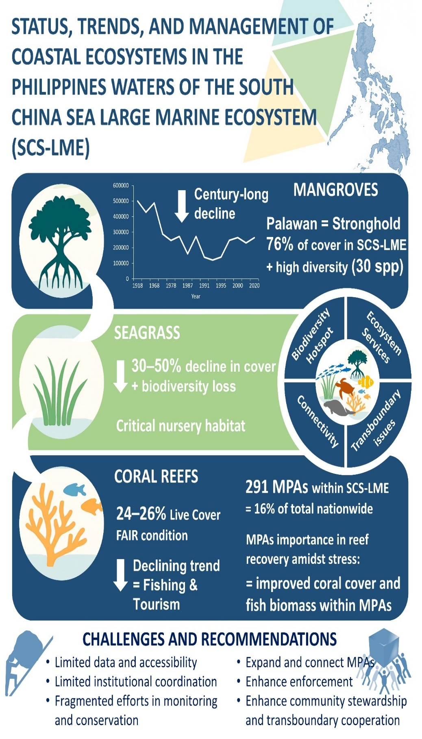

4. Ecosystems
The Strategic Action Programme for the South China Sea (SCS-SAP) was jointly developed by seven participating countries bordering the South China Sea (SCS): Cambodia, China, Indonesia, Malaysia, the Philippines, Thailand, and Viet Nam. The SCS-SAP provides a cooperative regional framework to address the degradation and loss of coastal and marine ecosystems through the development of a Transboundary Diagnostic Analysis (TDA), which identifies priority environmental issues, their underlying societal and economic root causes, and the transboundary impacts affecting the SCS region. The initial TDA highlighted that rapid economic growth, coastal urbanization, and population expansion in the SCS coastal zone—particularly during the period 1975–1995—were primary drivers of ecosystem degradation and resource depletion (UNEP, 2008).
Among the ecosystems identified as requiring strategic and priority actions under the SCS-SAP are mangroves, wetlands, coral reefs, and seagrass meadows. The regional assessment documented rapid and significant declines in the extent and condition of mangroves, coral reefs, and seagrass habitats across the SCS, driven by a combination of anthropogenic pressures—such as overfishing, destructive fishing practices, coastal development, pollution, and sedimentation—and natural stressors, including climate variability and extreme events. Corresponding management responses and regional targets were proposed to guide SCS-SAP implementation and support ecosystem recovery and sustainable use (UNEP, 2008).
This report contributes updated national-level information to the regional TDA-SAP process by synthesizing available data on coastal and marine ecosystems in the Philippine waters of the South China Sea Large Marine Ecosystem (SCS-LME) from 2000 onwards. It presents the current status and recent trends of mangroves, coral reefs, and seagrass ecosystems in the Philippines, with a particular focus on spatial patterns, observed changes in ecosystem condition, and key anthropogenic pressures influencing ecosystem health. By providing updated and site-specific evidence, this assessment aims to strengthen the Philippine input to the regional TDA, support improved ranking of ecosystem threats, and inform priority actions under the SCS-SAP framework.

4.1 Key Findings
- Ecosystem Decline with Localized Gains: Across mangroves, coral reefs, seagrasses, and wetlands in the SCS-LME, long-term trends show overall decline in extent and health, yet localized improvements (e.g., Palawan MPAs, seagrass recovery in some provinces) demonstrate that management interventions can be effective when consistently applied.
- Palawan as the Stronghold: Palawan emerges as the most ecologically significant province, hosting the largest and most stable mangrove forests, extensive coral reefs, and the highest seagrass cover, while also supporting the richest biodiversity, including many endangered and endemic species.
- Vulnerability to Climate and Anthropogenic Pressures: Coral reefs, particularly in the Kalayaan Island Group, remain in poor condition (average coral cover ~16%) and are highly exposed to climate pressures (typhoons, warming seas). Coastal development, destructive fishing, and weak enforcement amplify these risks.
- Critical Biodiversity Hotspots Under Stress: Key Biodiversity Areas (KBAs) such as Apo Reef, Malampaya Sound in Palawan, the Las Piñas-Parañague Wetland Park and Tanza Marine Tree Park in National Capital Region (NCR) harbor high ecosystem diversity and connectivity, but are increasingly threatened by habitat loss, poaching, and unregulated tourism, underscoring the need for integrated protection.
- Economic Losses from Ecosystem Degradation: Even small declines in reef, mangrove, seagrass, and wetland extent translate to millions of dollars in lost ecosystem services annually, with coral reefs carrying the greatest potential economic losses due to their role in fisheries, tourism, and coastal protection.
- Species of Global Concern at Risk: The SCS-LME remains a refuge for critically endangered and vulnerable species (e.g., hawksbill turtles, dugongs, napoleon wrasse, giant clams), yet many populations face steep declines from overfishing, habitat degradation, and marine debris, pointing to urgent conservation needs.
- Spatially Uneven Data and Management Gaps: While Palawan and selected MPAs benefit from robust monitoring, other provinces lack consistent, site-level data on habitat condition, biodiversity, and climate vulnerability, limiting the reliability of national-scale assessments and impeding evidence-based decision-making.
- Socioeconomic Dependence vs. Risk: Provinces like Pangasinan and Batangas rank high in both socioeconomic reliance and ecological risk, highlighting how local communities are directly vulnerable to ecosystem degradation. By contrast, low-priority provinces such as Batanes and Ilocos Norte currently show lower biodiversity and human pressure, though monitoring remains necessary to detect emerging threats.
- Need for Regional and Transboundary Action: Ecological connectivity (e.g., larval dispersal between Kalayaan and Palawan) highlights that ecosystems and species span boundaries. Strengthened transboundary cooperation under frameworks like SCS-SAP is critical to sustain ecological resilience and biodiversity in the wider region.

4.2 Current Status by Ecosystem and by Indicator Group

4.2.1 Mangroves and Wetlands

4.2.1.1 Mangroves

4.2.1.1.1 Mangroves Species Diversity
The most recent list of mangroves in the Philippines is provided by Buot Jr. et al. (2022) (see ANNEX A). This includes 39 species with conservation status per IUCN Red List of Threaten Species (Table 4.1). The listed near-threaten species, the Ceriops decandra (Griff.) W. Theob. is now named Ceriops zippeliana (Sheue et al., 2010). Aside from the endangered Camptostemon philippinense (S.Vidal) Becc., two other species, the Pemphis acidula J.R. Forst. & G. Forst. and Kandelia candel (L.) Druce are categorized as threaten species in the Philippines per Department of Environment and Natural Resources Administrative Order or DAO 2017-11 also known as the Philippine Red List. These species are highly exploited and have very limited range of distribution. The Kandelia candel (L) Druce for instance can be found only in Baler Aurora in the central easternmost coast of Luzon Island (Malabrigo et al., 2021).
The earlier report of Primavera (2000) on mangrove species from various sources (1920-1986) indicated at least eight species missing in the 2004-2007 listing or became locally extinct or extirpated (Table 4.2). This includes the IUCN-critically endangered species, the Bruguiera hainesii C.G.Rogers. Both information from IUCN and Philippines Red Lists of threaten species are important to policy-makers, environmental managers, and the communities.
Table 4.1. The IUCN and the Philippines Red Listed mangrove species (Buot Jr. et al., 2022).
Family | Species | DAO 2017-11 | IUCN
Lythraceae | Sonneratia ovata Backer |  | NT
Lythraceae | Pemphis acidula J.R. Forst. & G. Forst. | EN
Malvaceae | Camptostemon philippinense (S.Vidal) Becc. | EN | EN
Malvaceae | Brownlowia tersa (L.) Kosterm. |  | NT
Primulaceae | Aegiceras floridum Roem. & Schult. |  | NT
Rhizophoraceae | Bruguiera hainesii C.G.Rogers |  | CR
Rhizophoraceae | Ceriops decandra (Griff.) W.Theob. |  | NT
 | Kandelia candel (L.) Druce | CR
Legend: CR= Critically Endangered; EN= Endangered; NT= Near-Threaten
Table 4.2. The summary list of locally extinct mangrove species in the Philippines (Primavera, 2000).
Family | Locally Extinct Species (Extirpated)
Bombacaceae  Sonneratiaceae  Meliaceae  Plumbaginaceae  Rhizophoraceae | Camptostemon schultzii  Sonneratia gulngai  Sonerratia lanceolata  Xylocarpus mekongensis  Aegialitis annulata  Bruguiera exaristata  Bruguiera hainesii  Rhizophora lamarckii
Among provinces in the Philippines waters of SCS-LME, the western seaboard of Palawan hosts the most diverse mangrove forests, with 30 species, dominated by Rhizophora and Sonneratia species. This is followed by Pangasinan (25 spp.), Zambales (21 spp.), and Batangas (20 spp.) (Salmo III et al., 2014; Ting et al., 2014; (Figure 4.1). However, information on mangrove species diversity over time in these provinces remains limited. Existing data, derived from sporadic studies fail to capture temporal trends in species diversity. Systematic and site-specific monitoring are imperative to generate such information.

Figure 4.1. The number of mangrove species in provinces bordering the Philippine waters within the SCS-LME.

4.2.1.1.2 Threats to Mangrove Forests
The human-induced and natural threats to mangroves and wetlands across provinces in the Philippine waters with the SCS-LME are presented in Table 4.3. The information was derived from the latest available published articles. Mangrove forests and coastal wetlands across the assessed provinces are experiencing compounding pressures from climate-related hazards and anthropogenic activities, resulting in varying but often high levels of ecosystem vulnerability. Typhoons, storm surges, flooding, and sea-level rise are pervasive natural stressors across all provinces, establishing a baseline of climate risk. However, human-induced pressures, particularly land conversion, aquaculture expansion, coastal reclamation, and pollution, are the dominant drivers of degradation, especially in Manila Bay provinces (NCR, Cavite, Bulacan, and Bataan) where cumulative impacts are most severe. Cagayan and Pangasinan also exhibit high combined threat levels due to the interaction of intense natural hazards with extensive aquaculture development and watershed-derived pollution. In contrast, the Ilocos provinces and La Union are primarily influenced by climate-driven risks with moderate development pressures, while Occidental Mindoro and the west coast of Palawan retain relatively intact mangrove systems but face emerging risks from development and increasing climate variability. The occurrence of these threats across provinces in the Philippine waters with the SCS-LME is provided in Annex 4.A.
Table 4.3. List of human-induced and natural threats to mangroves and wetlands across provinces in the Philippines waters within the SCS-LME (Hermes, 2024; CCC 2024; Baloloy et al., 2023; WB, 2017; Garcia et al., 2013).
Province | Natural threats | Human-induced threats
Ilocos Norte | Storms/typhoons, storm surge, coastal hazards affecting mangroves | Land-use conversion (coastal development, aquaculture/ponds), settlement pressure, pollution/plastic and waste threats
Ilocos Sur | Coastal erosion, storm / climate-driven hazards to mangroves | Coastal development / land conversion; aquaculture/fishpond conversion; human settlement expansion
La Union | Coastal hazard exposure (sea-level rise, storms, inundation risk, erosion) | Conversion/clearing for agriculture or settlement; degradation from land-use change and resource extraction
Cagayan | Typhoons, coastal hazard risk, changes in sediment/river-mouth dynamics threatening mangrove regeneration | Conversion for aquaculture/ponds, human settlement and land-use change, over-harvesting for wood/charcoal
Pangasinan | Coastal flooding, storm surge, erosion, sea-level / climate-driven stress on coasts | Large-scale conversion to fishponds/aquaculture; loss of mangrove area; pollution/runoff and degradation from land-use change
Cavite | Coastal hazard risk (storms, surge, sea-level rise), exposure due to bay/shoreline geography | Land reclamation, coastal development, conversion to urban/industrial uses, habitat destruction & pollution from coastal infrastructure
Batangas | Coastal erosion/shoreline changes, storm / sea-level rise risk on exposed bays and coasts | Coastal development (tourism, ports, infrastructure), conversion for settlements or aquaculture, pollution risks from industrial and urban runoff / coastal activities
NCR (Metro Manila/Manila Bay) | Coastal squeeze: hardened shorelines + sea-level rise/ storm surge increase inundation & flood risk; reduced natural buffering capacity | Massive land reclamation, urban/industrial coastal development, pollution, waste discharge, habitat loss from coastal infrastructure
Bulacan | Flooding, storm surge risk in low-lying coastal/wetland zones; salinity and erosion risk in tidal flats | Reclamation / coastal land conversion (Manila Bay zone), urban expansion, altered hydrology, pollution from upstream runoff
Bataan | Coastal hazard exposure — storms, coastal inundation and erosion risks on bay/coast wetlands | Historical conversion to aquaculture/fishponds or land-use change; industrial/urban coastal development and pollution pressures from Manila Bay ecosystem change
Occidental Mindoro | Coastal erosion, shoreline changes and climate-driven hazards (storm, sea-level changes) that affect mangrove stability | Conversion to aquaculture/ponds, clearing for settlements, deforestation for wood/charcoal, land-use change and general anthropogenic degradation
West coast of Palawan | Storm / typhoon damage, sea-level rise and coastal hazard exposure; natural shoreline dynamics risking mangrove stability | Clearing for aquaculture/ponds or fish-farms, coastal development (settlements, resource extraction such as wood/charcoal), pollution, land conversion and other human pressures despite protected-area status in parts

The national estimate of total mangrove forest cover in 1980, 1990, and 2000, as well as the corresponding percent rate of loss per year, were provided in the SCS-SAP Project (UNEP, 2008). From 2000 to 2020, the Philippines mangrove forest cover is illustrated in Figure. 4.1. There was a decreased of approximately 63,429 ha in mangrove cover from 2000-2010 while an increase of 34,221 ha from 2010-2020 or a net decreased of 29,208 ha from 2000-2020 (Baloloy et al., 2023).
There are 12 provinces bordering the Philippine waters within the South China Sea- Large Marine Ecosystem (SCS-LME). These include the Ilocos Norte, Ilocos Sur, La Union, Pangasinan, Batanes, Cagayan, Bataan, Bulacan, Cavite, Batangas, Occidental Mindoro, and western seaboard of Palawan. The estimated average mangrove cover in this region is 35,553 ha, representing 14% of the entire Philippine mangrove forests. Of these provinces, the western seaboard of Palawan has the highest relative percent mangrove cover (76.5%) followed by Cagayan (13.5%). The remaining 10% is shared by other provinces except the Batanes in Region 2, which is devoid of mangroves (Long et al., 2014; Zablan et al., 2022).

Figure 4.2. The Philippines mangrove forest cover from 1918 to 2020 with emphasis on the recent data, years 2000-2020.
The trends of mangrove cover from 1990 to 2023 among provinces in the region are presented in Figure 4.3. At least nine provinces, the Bataan, Bulacan, Cavite, La Union, NCR, Batangas, Pangasinan, Occidental Mindoro, and the western seaboard of Palawan have increasing mangrove cover. The Cagayan, Pampanga, and Zambales have minimal change over time while Ilocos Sur and Ilocos Norte have decreasing trends. The change of mangrove covers in the region between 2000-2023 is shown in Figure. 4.3. Mangrove cover had increased, particularly in 2020, resulting to an overall increase of 5, 667 ha from 2000-2023 (Long et al., 2014; Salmo III et al., 2015; Ting et al., 2015; PSA CPES 2010-2019; 2012-2022;2014-2023; Hawort et al., 2024).
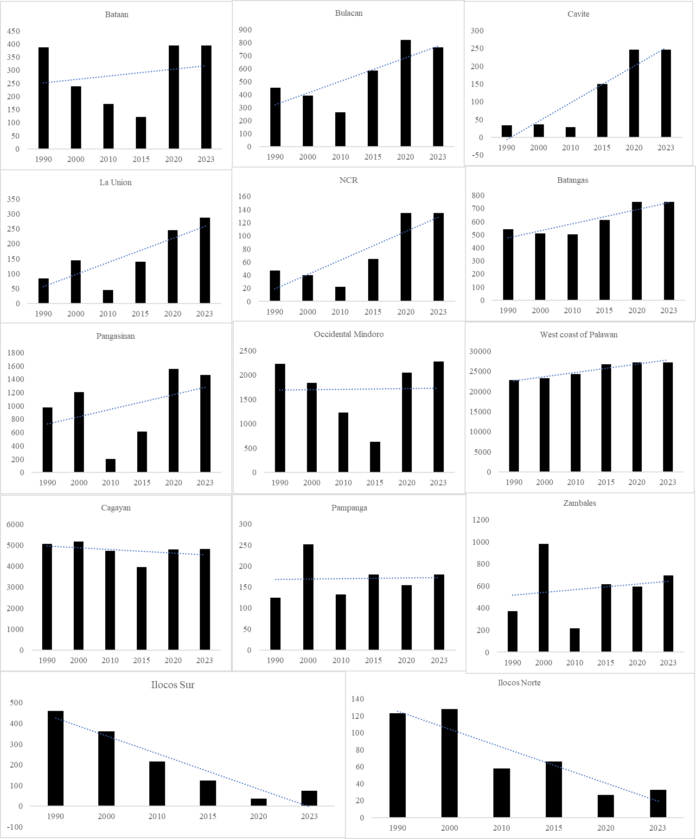
Figure 4.3. The trend of mangrove forest cover in provinces bordering the Philippine waters of the SCS-LME from 1990-2023.

Figure 4.4. Mangrove cover change in the Philippine waters of SCS-LME from 2000-2023.

4.2.2 Coral Reefs and Seagrasses

4.2.2.1 Coral Reefs

4.2.2.1.1 Coral Reef Area
The Philippine waters in the SCS-LME has an estimated coral reef area ranging from 3,712.1 km² (371,210 ha) to 4,051.6 km² (405,161 ha), representing approximately 30% of the Philippines’ total reef area (Aliño et al., 2019). The total reef area of each province bordering the SCS-LME is shown in Figure 4.5. The average live coral cover across the Philippine waters in the SCS-LME range from 24–26%, placing it in the fair condition category (Licuanan et al., 2019; Arceo et al., 2024). Palawan has the largest reef area comprising around 80% (325,770 ha) where the Kalayaan Island Group (KIG) alone accounts for roughly 320,000 ha of the reefs of Palawan, but with a much lower average coral cover of 16% (Arceo et al., 2024). As shown in Figure 4.6, of the 13 sites across the provinces in the SCS-LME, 40% were in poor condition (LHC cover: 0-22%) and 40% were in fair condition (LHC cover: 22-33%). Only 2 sites (13.3%) were in good condition (LHC cover: 33-44%) and only 1 province with excellent condition (LHC: > 44%). Generally higher coral covers were located between Palawan and Occidental Mindoro with highest observed in Sablayan, Mindoro. For fish parameters, higher fish biomass, abundance, and diversity were also concentrated between Occidental Mindoro and Calamianes Group of Islands in Palawan. Interestingly, despite low coral cover, fish biomass was also high in KIG (Figure 4.6).

Figure 4.5. Estimates of Coral Reef Area in the provinces bordering the South China Sea-Large Marine Ecosystems (Source: PSA CPES 2014-2023; Arceo et al., 2024).
a
b
c
d
Figure 4.6. Reef parameters: a) Live hard coral cover (%), b) fish biomass (mt/km²), c) fish abundance (indl/500m²), and d) fish diversity (no. of species/500m²) in different reef sites in the WPS. Data gathered from Arceo et al., 2024.

4.2.2.1.2 Coral Cover
The establishment of Marine Protected Areas (MPAs) has long been recognized as an essential conservation strategy and has gained significant increase since the 1990s (Campos & Aliño, 2008). Tere are approximately 1,800 MPAs across the Philippines (Cabral et al., 2014), with about 291 of these are located within the Philippine waters of the South China Sea Large Marine Ecosystem (SCS-LME) (Arceo et al., 2024). At the local scale, particularly within well-managed MPAs, some sites have demonstrated encouraging trends in reef health (Figure 4.7). Long-term surveys show positive changes in live coral cover in three MPAs in Calamianes, Palawan: Bugor (Culion) improved from 41.4% in 2006 to 52% in 2022; Concepcion (Busuanga) increased from 60.4% to 65.2% over the same period; and Siete Pecados (Coron) recorded a slight increase from 52% in 2013 to 53.1% in 2022 (Campos et al., 2022). These gains suggest that effective management and protection can promote localized reef recovery. This result is consistent with that obtained in the municipality of Taytay, though with considerable variation between sites (0–7.3% per year), corals showed an average annual recovery rate of 2.8 percent over the nine years (Abesamis et al., 2023).
By contrast, reef sites outside MPAs or exposed to heavy fishing and tourism pressures have shown marked declines. In Diwaran Island (Coron) and Denicolan (Busuanga), coral covers dropped from above 50% in 2006 (PCSD, 2006) to less than 30% by 2016 (DENR, 2017). Similar trends were observed in heavily visited sites such as Dynamite Point (Culion) and Calambuyan (Busuanga). Although survey methods may differ (e.g., transect placement, use of LIT vs. photo transects, depth), these results point to consistent signs of localized reef degradation.

Figure 4.7. Reef parameters observed from biennial surveys in three Marine Protected Areas (MPAs) in the Calamianes: Busuanga and Culion (2006-2022), and Coron (2013-2022). Data collected by Campos et al., 2022
On the larger scale, the relatively low coral cover in SCS-LME, particularly in the KIG, suggests limited ecological recovery and continued exposure to stressors such as climate change, overfishing, and destructive practices. Historical records show that Pag-asa Island experienced an average of one typhoon per year in the 1980s, rising to two per year in the 2000s (Villanoy & Yñiguez, 2024), adding climate-related pressures. Weak enforcement particularly in remote and offshore reefs remains a major barrier to conservation. Overall, a comparison between 2003–2007 and 2015–2017 (Fig. 4.8) shows a decline of live hard coral cover (LHC) and fish biomass across multiple reef sites in the waters off SCS-LME (SAP-SCS, 2008; CRINP, 2008; Licuanan et al., 2019; Arceo et al., 2024). This declining trend of coral cover is consistent with that observed in several reef sites around Palawan from 2012-2023 (Haworth et al., 2023).
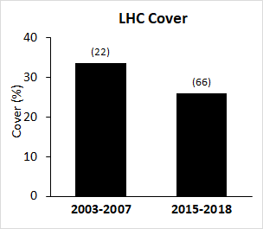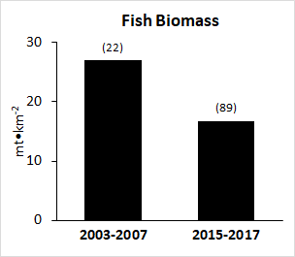
Figure 4.8. Live hard coral cover (left) and fish biomass (right) recorded between 2003-2007 and 2015-2018 across selected sites in the WPS. Data gathered from SAP-SCS, 2008; CRINP, 2008; Licuanan et al., 2019; Arceo et al., 2024

4.2.2.2 Seagrasses

4.2.2.2.1 Seagrasses Cover
From the 2008 TDA-SAP report, the seagrass meadow confined in the Philippine water within the SCS-LME was estimated at 23,245 km² (UNEP, 2008). In 2020, the country's seagrass cover of 14,923 km² was reported in the World Conservation Monitoring Center of the Global Distribution of Seagrasses-United Nations for the Environment and Programme (Fortes, 2021). Based on an approximate 85% representation of the SCS-LME seagrass cover compared to the entire cover in the Philippines (Fortes, 2018), the current estimated seagrass cover in the SCS-LME is at 12,685 km² or 1,268,500 ha. This reflects a 10,560 km² (1,056,000 ha) decrease in seagrass cover in the region from 2008-2020 or an overall decline of 54%.
Across provinces within the SCS-LME, the Pangasinan, particularly the Cape Bolinao holds the highest recorded seagrass cover followed by the western seaboard of Palawan and Occidental Mindoro. The seagrass cover value for these provinces was confined only to Ulugan Bay, Honda Bay, Bacuit Bay, Malampaya Sound, Busuanga, and Coron (for Palawan) and Puerto Galera (for Occidental Mindoro) (Figure 4.9). Time-series data reflecting the change in seagrass cover over time in these provinces is lacking. The only available data is from PCSD report, indicating the declining health condition of seagrasses in Palawan from 2004-2020 (Howart et al., 2024). Accordingly, the percentage of seagrass meadows in “excellent-good” conditions had decreased while those in “fair-poor” status had increased (Figure 4.10).

Figure 4.9 Seagrass cover in provinces bordering the Philippine waters of the SCS-LME.

Figure 4.10. Status of seagrass meadows in Palawan from 2004-2020.

4.2.2.2.2 Seagrass Species Diversity
The country is home to 19 seagrass species (Fortes et al., 2018). From 2000 to date, only a few articles on seagrass biodiversity studies were published. The available data on species richness in provinces bordering the SCS-LME is presented in Fig. 4.11. At present only 13 seagrass species have been documented in the Philippines (see ANNEX C). The six other species, the Halophila beccarii, Halophila decipiens, Halophila gaudichaudii, Halophila ovata, Halophila spinulosa, and Ruppia maritima were unreported, and the species Thalassodendron ciliatum is becoming rare or having a very limited distribution. It was also reported that H. beccarii had faced local extinction decades ago (Fortes, 2021).

Figure 4.11. Seagrass species richness in some provinces bordering the Philippine waters in the SCS-LME.

4.2.2.2.3 Seagrass Threats
The decline in seagrass cover and diversity was attributed to increased nutrient loading and sedimentation that resulted from unsustainable coastal development, forest loss, aquaculture, and rising temperatures of shallow coastal waters (Fortes, 2021; Sudo et al., 2021). The country’s seagrass beds are prone to such disturbance, considering that only 9% of the total seagrass beds are withing the Marine Protected Area or MPA and only 25.8% are covered within the Ecologically or Biologically Significant Marine Areas or EBSAs (Sudo et al., 2021). The detailed list of natural and human-induced threats with corresponding degree of severity of impact to seagrass meadows is presented in Table 4.4. According to Fortes (2021), these threats were the same since 1990’s and only the severity of impact had changed over time. The occurrence of these threats across provinces in the Philippine waters with the SCS-LME is provided in Annex 4.D.
Table 4.4. The list of human-induced and natural threats to seagrass meadows in the Philippines (Fortes, 2021)
Human-Induced Threats | Degree of Impact | Natural Threats | Degree of Impact
Habitat destruction | *** | Red tides | *
Sewage pollution | *** | Natural hazards (typhoons, storm surges) | *
Industrial pollution | *** | Sea-level rise | *
Fisheries overexploitation | *** | Sea surface temperature rise | *
Siltation / sedimentation | *** | Natural sediment dynamics | *
Oil pollution | **
Agricultural pollution | **
Hazardous waste | *
Coastal erosion | *
Legend: *** Severe, ** Moderate, * Slight / Low

4.2.3 Biodiversity Hotspots and Sensitive Areas

4.2.3.1 Mangrove and Wetlands
The western seaboard of Palawan, covering the coastal municipalities of Balabac, Rizal, Quezon, Aborlan, Puerto Princesa City, San Vicente, Taytay, El Nido, Linapacan, Culion, Busuanga, and Coron, serves as a mangrove biodiversity hotspot of the Philippine waters within the SCS-LME because of its extensive forest cover, high species richness, and biogeographic significance. The coast contains approximately 41% of the total mangroves in the region. These forests exhibit high structural complexity and ecological integrity with positive cover changes of 3,078. 65 ha between 2000-2010 and 2,233.36 ha in 2010-2020. The municipalities of Balabac and Taytay and the City of Puerto Princesa contributed a huge percentage to the overall mangrove cover in the island (Figure 4.12) (Zablan et al., 2022). Mangroves in Taytay, Palawan are concentrated in Taytay Bay and Malampaya Sound while in Puerto Princesa City, at Ulugan Bay. Using multi-date landsat satellite images combined with Markov chain model, the present and projected mangrove cover in these sites were determined and based from the predicted outcome, mangroves in Taytay Bay, Malampaya Sound, and Ulugan Bay are expected to increase in years 2030 and 2050, provided that threats are regulated and restoration initiatives will continue (Cayetano et al., 2023). The Calamianes Group of Islands, comprising of Culion, Busuanga, and Coron, in the northern-most part of Palawan is also a site-specific mangrove biodiversity hotspot within the province.

Figure 4.12. Mangrove cover in municipalities bordering the western seaboard of Palawan
Situated also in the west coast of Palawan are the four Protected Areas (PA) with extensive mangrove cover, the Calauit Island Game Preserve and Wildlife Sanctuary in Busuanga (PD No. 1578 s. 1976; El Nido Manage Reserve Protected Area in El Nido (Proclamation No. 32 s. 1998; Malampaya Sound Protected Landscape and Seascape (MSPLS) in Taytay (proclamation No. 342 s. 2000); and Puerto Princesa Subterranean River and Natural Park in Puerto Princesa City (Proclamation No. 212 s. 1999). The biodiversity profile of MSPLS is presented in Annex 4.C. of the report.
The mangrove forest in the NCR or Metro Manila is the most sensitive vegetation in region. The Las Piñas-Parañaque Wetland Park (LPPWP) and Tanza Marine Tree Park (TMTP) are significant mangrove areas within Manila Bay, with estimated cover of 20.73 ha and 30 ha, respectively. The LPPWP was proclaimed (Proclamation No. 1412, s. 2007) as critical habitat and ecotourism area on 22 April 2007. Years later, it was upgraded into a national protected area through the Expanded National Integrated Protected Areas System (ENIPAS) Act of 2018 and subsequently declared as a RAMSAR site. The LPPWP harbors 23 mangrove species and a number of bird species (ERDB, 2021). The TMTP was designated as a "marine tree park" through a Barangay Council Ordinance No. 4, s. 2011. It is home to 13 mangrove species, endangered and migratory birds (DENR-NCR, 2021) (see Annex 4.F).
Human-induced threats to mangrove forests in LPPWP and TMTP are the on-going reclamation projects; poor water quality attributed to wastes and pollutants from the inadequate management of wastes from domestic, commercial, and industrial activities and wastewater discharges from households, industries, and commercial and institutional establishments; and garbage deposition and pollution. Particularly, garbage from the communities in Canacao Bay, Bacoor Bay, Paranaque City and Las Piñas are directly dump into the rivers and gradually to the beaches of LPPWP (ERDB, 2021).

4.2.3.2 Corals and Seagrass
Connectivity studies have demonstrated that the Kalayaan Island Group, functions as both a larval source and sink, with currents dispersing coral and fish larvae toward Palawan and northern Sulu Sea ecosystems (Juinio-Meñez et al., 2015; Dorman et al., 2016). This underscores the transboundary ecological role of the SCS-LME in sustaining regional biodiversity. Seasonal monsoon currents further reinforce this connectivity, facilitating recruitment across interconnected reef systems (Dorman et al., 2016). In addition, the Verde Island Passage is also a critical biodiversity hotspot, known for harboring exceptionally high densities of fish eggs and serving as an important spawning and larval dispersal area (Campos et al., 2008).
The ecological sensitivity of the different provinces in SCS-LME is also influenced by climate exposure. According to the Philippine Climate-Ocean Typology (Aliño et al., 2019), areas within the SCS-LME are subject to significant sea surface temperature fluctuations, sea level rise, and monsoonal disturbances. Fig. 4.13a shows that western Luzon including Ilocos Sur, Pangasinan and Zambales, are exposed to several climate threats such as extreme heat, extreme rainfall, sea level rise, and monsoonal disturbance (Aliño et al., 2019). Storm frequency and fisher density are also relatively high in these areas including the KIG (Fig. 4.13b-c). These climate pressures compound the impacts of destructive fishing, coastal development, and pollution, increasing the vulnerability of reef ecosystems. El Niño events, for example, have been shown to disrupt larval connectivity across the Eastern Pacific barrier, potentially limiting recruitment success and reducing genetic flow between coral populations (Wood et al., 2016). Additionally, outbreaks of Crown-of-Thorns Starfish (Acanthaster cf. solaris), driven by elevated nutrient loads and high larval survival, pose a recurring threat to coral cover and reef structure. Genetic analyses confirm that populations of this coral predator are moderately connected across the SCS, including the Spratlys and Palawan (Chen et al., 2021), underscoring the need for transboundary outbreak management.
Palawan is the most notable hotspot of seagrass biodiversity in the region. Seagrasses serve as a vital ecological link between mangroves and coral reefs and offer vital habitat for fisheries and megafauna like the dugongs. The Occidental Mindoro and Batangas function as regional seagrass biodiversity hotspots. Occidental Mindoro supports large, relatively intact seagrass meadows along the Mindoro Strait, characterized by high species richness and important dugong feeding grounds, and retains comparatively higher ecological integrity. In contrast, Batangas, particularly within the Verde Island Passage, hosts diverse seagrass assemblages tightly connected to one of the world’s richest coral reef systems, but these ecosystems are increasingly constrained by intense coastal development, shipping, and tourism pressure. At a more localized scale, Cape Bolinao in Pangasinan stands out as a seagrass hotspot along the western Luzon coast. Although spatially limited, its seagrass beds exhibit relatively high species diversity and productivity and play an important role in supporting adjacent reef fisheries.
Figure 4.13. Exposure to different threats: a) climate typology (Alino et al., 2019); storm frequency (Cinco et al., 2016); and fisher density across the South China Sea in Philippine waters (LME). Color darkens with increase in values.
a
b
c

4.2.4 Endemic, Endangered, Threatened Species
Mangroves and wetlands in the Philippines are essential habitats for many Red List Threaten Species under the International Union for the Conservation of Nature (IUCN). This includes the hawksbill turtle and the Philippine crocodile. Marine mammal, the Irrawaddy dolphin is also associated with mangrove ecosystem. The occurrence of this species was reported from the inner Malampaya Sound in Taytay (Smith et al., 2004) and Quezon, Palawan (Dolar and Matillano, Unpub.) Irrawaddy dolphins in the Philippines live in habitats that often overlap with human activities and are therefore susceptible to boat collision and entanglement to fishing nets (Gonzales and Matillano, 2008; Lirazan et al., 2022).
Many migratory bird species, the Chinese egret (Vulnerable), Nordmann's greenshank (Endangered), and black-faced spoonbill (Endangered) also depend on mangroves and wetlands. The famous Philippine cockatoo also prefers riverine, coastal, and mangrove forests. This bird is present in El Nido Manage Reserve Protected Area and Puerto Princesa Subterranean River and Natural Park. Its estimated total number of wild populations is estimated at 1,120 individuals. This number is expected to decrease as habitat destruction, poaching, and pet trade remain unregulated (Que et al., 2021).
The coral reefs and seagrass meadows also support a remarkable diversity of threaten marine species. The coral species such as Anacropora spinosa (Endangered) and several Acropora spp. (Licuanan et al., 2024) are vulnerable to warming seas and human impacts. In Palawan, the globally endangered coral species (Pectinia maxima, Anacropora spinosa, and Lobophyllia serratus) were recorded. The iconic reef-associated species such as the napoleon wrasse and the humphead parrotfish are considered endangered and vulnerable, respectively, due to overfishing and the live reef food fish trade (Chan et al., 2012; Russell, 2004). The whale shark (Rhincodon typus), a Vulnerable species and the world’s largest fish, has been documented in WPS waters, particularly around Palawan (Guzman et al., 2022). Adding to the list of vulnerable reef inhabitants are several species of giant clams, which are suffering from overharvesting for shells and meat (Dolorosa et al., 2024). These clams are not only ecologically important as reef builders and filter feeders but are also culturally and economically valuable. Their slow growth and reproductive rates make them highly susceptible to exploitation.
The mangrove-associated hawkbill turtle also use the seagrass meadow as nesting and feeding grounds together with the leatherback and loggerhead turtles and the “Least concern” green turtle (previously categorized as endangered) (Mortimer & Donnelly, 2008; Wallace et al., 2013; Casale and Tucker, 2017; Seminoff, 2023). These species face threats from poaching, beach development, and marine debris (PCSD, 2025; Poonian et al. 2016). The Dugong (Marsh & Sobtzick, 2019) also relies heavily on seagrass meadows for food. At present, this marine mammal is threatened by habitat loss, bycatch, and boat strikes (Del Rosario, C. 2022; Guinhawa, 2019). Similarly, endangered and vulnerable seahorses are also present in seagrass meadows and are facing risks from overharvesting and bycatch.
This rich assemblage of endangered and vulnerable species highlights the exceptional biodiversity value of the Philippines waters in the South China Sea LME, but it also underscores its fragility. Conservation of these species requires protecting the habitats they depend on coral reefs, seagrass beds, mangroves, nesting beaches—as well as tackling systemic threats such as overfishing, pollution, climate change, and poorly managed tourism. Collectively, these species highlight the SCS-LME as both a biodiversity stronghold and a region of conservation concern. The summary list of these associated organisms with respective IUCN Redlist status is presented in (Table 4.5).
Table 4.5. Summary list of threaten species associated with the mangroves and wetlands and seagrass and coral reefs ecosystems in the Philippine waters within the South China Sea- large Marine Ecosystems.
Associated Species |  | Mangroves & Wetlands | Coral Reefs | Seagrass  meadows | IUCN Redlist Status
English Name | Scientific Name
Philippine Cockatoo | Cacatua haematuropygia | + |  |  | CR
Philippine Crocodile | Crocodylus mindorensis | + |  |  | CR
Bottlenose Dolphin | Tursiops truncatus |  |  | + | EN
Irrawaddy Dolphin | Orcaella brevirostris | + |  | + | CR
Dugong | Dugong dugon |  | + | + | CR
Hawksbill Turtle | Eretmochelys imbricata |  | + | + | CR
Olive Ridley Turtle | Lepidochelys olivacea |  |  | + | VU
Leatherback Sea Turtle | Dermochelys coriacea |  | + |  | VU
Loggerhead Turtle | Caretta caretta |  | + |  | VU
Napoleon Wrasse | Cheilinus undulatus |  | + |  | EN
Humphead Parrotfish | Bolbometopon muricatum |  | + |  | VU
Barbour's seahorse | Hippocampus barbouri |  | + |  | EN
Tiger tail seahorse | Hippocampus comes |  | + |  | EN
Hedgehog seahorse | Hippocampus spinosissimus |  | + | + | EN
Whale Shark | Rhincodon typus |  | + |  | VU
True giant clam | Tridacna gigas |  | + |  | VU
Horse's Hoof Clam | Hippopus hippopus |  | + |  | VU
Legend: Endangered Species (EN) Critically Endangered (CR) Vulnerable (VU)

4.3 Discussion and Conclusions

4.3.1 Priority Transboundary Biodiversity Issues
Biodiversity loss, particularly of threaten megafauna (marine mammals) in the region is alarming. The Irrawaddy dolphin population in Malampaya Sound, Palawan had decreased sharply between 1995 and 2013 (Vira-Mendoza, 2017), although there are no recent abundance assessments available. Among the factors of this decline were attributed to population growth, habitat degradation, and uncontrolled use of fishing gears (Gonzales-Matillano et al., 2017). Meanwhile, dugong stranding incidents showed a declining pattern from 2013 to 2022 (Ramilo et al., 2022). While this may reflect changes in population size, distribution, or reporting effort, the major cause of stranding incident was due to net entanglement. These shifts, alongside persistent threats such as overfishing, habitat loss, pollution, and climate change impacts, underline the urgent need for strengthened conservation and management interventions (see Table 4.5). Climate-related hazards and adaptive capacity of provinces bordering SCS-LME. Bleaching events, typhoon impacts, flooding and qualitative assessments of susceptibility and resilience. Levels are categorized as High (H), Moderate (M), or Low (L).

4.3.2 Risk Assessment and Valuation of Economic Losses

4.3.2.1 Risk Assessment
The assessment of biodiversity significance, socioeconomic importance, and risk levels across selected coastal provinces in SCS-LME highlights varying conservation and management priorities. As shown in Fig. 4.14, Palawan consistently emerged as the most ecologically important province, scoring the highest in biodiversity significance while also ranking high in socioeconomic importance. However, Palawan is also subject to considerable environmental risks, underscoring its status as a critical conservation hotspot. Batangas similarly reflects this pattern, with high biodiversity and socioeconomic values compounded by elevated risks. Pangasinan, although scoring moderately in biodiversity, stands out for its high socioeconomic importance and the highest recorded risk score. This indicates that the heavy reliance of local communities on coastal resources, combined with anthropogenic pressures, makes the province especially vulnerable and in urgent need of integrated management interventions.
Provinces categorized as low priority include Batanes, Cavite, and Ilocos Norte. These areas generally exhibit low biodiversity significance, lower socioeconomic reliance, and relatively low to moderate risks. Batanes, in particular, shows the lowest values in all three categories, reflecting its relatively isolated status and lower anthropogenic pressure. Cavite, while moderately at risk, ranks low in both biodiversity and socioeconomic importance, reducing its urgency for immediate conservation intervention. Ilocos Norte shows relatively balanced but low-to-moderate scores across all indicators, similarly placing it in the low-priority category.
Overall, the findings suggest that Palawan, Batangas, and Pangasinan require immediate and focused management attention due to the convergence of high ecological and socioeconomic values with elevated risks. Medium-priority areas need preventive and adaptive strategies to curb rising pressures, while low-priority provinces should be continuously monitored to safeguard against future threats. This analysis underscores the importance of a tiered management approach, ensuring that resources and interventions are allocated effectively, balancing ecological protection with socioeconomic sustainability.

Figure 4.14. Mean scores of biodiversity significance (black bars), socioeconomic importance (gray bars), and risk assessment (red line) across selected coastal provinces in the SCS-LME. Scores are based on a standardized scale (0–3), with higher values indicating greater ecological or socioeconomic importance, and elevated risk levels.

4.3.2.2. Valuation of Economic Losses
The valuation of major coastal and marine ecosystems across the SCS-LME demonstrates the significant economic implications of habitat loss (Table 4.7). Coral reefs, covering 371,210 hectares, emerge as the most valuable ecosystem with an estimated total economic value (TEV) ranging from US$507 to US$22,963 per-hectare. A mere one percent loss in the total reef area in SCS-LME, equivalent to 3,712 hectares, could translate into an annual economic loss of US$1.88 million to 82.24 million. This reflects their critical role in fisheries production, shoreline protection, and tourism. Mangrove forests, occupying 72,584 hectares, also provide considerable value with an estimated TEV of US$851 to 3,101 per hectare. Losing just one percent of their area (726 hectares) would result in an annual loss between US$618,000 and 2.25 million, underscoring their importance in sustaining fisheries, providing timber and fuelwood, and mitigating coastal hazards. Seagrass beds, though limited in extent at 23,255 hectares, are highly productive ecosystems valued at US$934 to 1,590 per hectare. The loss of one percent (233 hectares) would incur US$217,000 to 370,000 annually in lost benefits, highlighting their role as nursery habitats and carbon sinks. Wetlands, with the second largest area at 80,866 hectares, show lower per-hectare values of US$299 to 690, yet a one percent loss (809 hectares) still amounts to US$243,000 to 558,000 annually. While wetlands may appear economically undervalued compared to reefs or mangroves, their ecological functions such as water purification, flood regulation, and support for migratory species are vital and often underestimated in monetary terms. Overall, the results indicate that coral reefs carry the greatest potential economic loss, but mangroves, seagrasses, and wetlands each provide essential services that sustain coastal communities. Protecting these ecosystems is not only an ecological necessity but also an economically sound strategy, as even small-scale degradation leads to millions of dollars in annual losses.
Table 4.6. Estimated economic value of major coastal and marine ecosystems in terms of total area, per-hectare value, and projected annual economic loss from a 1% decline in area. Values are expressed in US dollars per hectare per year, highlighting the potential costs of ecosystem degradation.
 | Total Area (Ha) | Total Economic Value (US$/Ha) | 1% of Total Area (Ha) | Value of 1% Loss (US$/Ha/Yr)
Coral Reefs | 371,210 | 507 - 22,963 | 3,712.1 | 1,882,035 - 82,240,952
Seagrasses | 23,255 | 934 - 1,590 | 232.6 | 217,202 - 369,638
Mangrove Forests | 72,584 | 851 - 3,101 | 725.8 | 617,762 - 2,250,975
Wetlands | 80,866 | 299 - 690 | 808.7 | 242,789 - 557,975

4.3.3 Current Management and Institutions
Management of coastal and marine ecosystems of the Philippine Seas in the SCS-LMEs is a collective effort. It is shared among national agencies (DENR-BMB, BFAR), local governments, NGOs, and academic partners. Local government units (LGUs) play a central role in day-to-day stewardship, while broader support comes from institutions and national agencies such as the DENR-Biodiversity Management Bureau (DENR-BMB). Over the years, these partnerships have helped establish and strengthen Marine Protected Areas (MPAs), many of which are showing clear signs of success, healthier coral reefs and increased fish populations within their boundaries. However, offshore reefs in the KIG face weak enforcement and governance gaps.
These efforts are further boosted by the work of non-governmental organizations (NGOs) and academic institutions, which provide technical support, conduct ecological monitoring, and help build local capacity through training and research. However, challenges remain. The division of responsibilities among different agencies can sometimes lead to gaps in coordination and enforcement, particularly in areas outside of MPAs. As a result, some important ecosystems may fall through the cracks. Strengthening institutional coordination, enforcement, and science-based planning is essential to scale up conservation gains.

4.3.4 Gaps and Priority Challenges
- Incomplete temporal data for some provinces: While Palawan has consistent data from 2015 to 2023, other provinces bordering the South China Sea-LME lack time-series data on mangrove forest cover. Figure 6 highlights the absence of reliable data for these regions, limiting comparative analysis and targeted conservation efforts.
- Limited ground validation: The report on mangrove and seagrass cover relies heavily on remote sensing (e.g., Landsat-derived Mangrove Vegetation Index). While useful, these methods may miss finer ecological details without ground-truthing.
- Fluctuating mangrove cover: Although there are periods of regrowth (e.g., 1990, 2003), the overall trend from 1918 to 2020 is a net decline. This instability poses a challenge for long-term conservation planning.
- Data accessibility and integration: The report pulls from various sources (UNEP, PSA, NAMRIA, etc.), but integration and standardization of these datasets remain a challenge for national monitoring.
- Conservation inequity across provinces: Palawan shows strong conservation outcomes, but other provinces lack both data and documented efforts, suggesting uneven implementation of mangrove protection strategies.
- Species loss and biodiversity threats: The reduction in recorded species may indicate biodiversity loss, which could compromise ecosystem resilience and services.
Although site-specific data on mangrove forest cover are available, the biophysical characteristics of the sites (as area mapping, tree inventory, associated organisms, and carbon stock) remain understudied or lacking. These data are vital in the ecosystem valuation. In cases, when data are available, the monitoring practices varied widely, making it difficult to compare data across sites or track long-term changes accurately. There’s also limited information on the status of key species like dugongs and sea turtles, which makes it harder to protect them effectively. Planning that links activities on land and sea is still lacking, despite their close ecological connection.

4.3.5 Recommended Priority Actions Including Regional Cooperation
- Strengthening legal and institutional frameworks for ecosystem-based management: strengthen the laws and institutions that guide how we manage our coasts and oceans, ensuring that planning happens not just at individual sites, but across entire seascapes.
- Expanding and connecting MPAs across ecological corridors: MPAs should be expanded and better connected, especially between important ecological zones like the Calamianes, KIG, and the Spratlys, where species and larvae naturally move and interact.
- Standardizing monitoring protocols for corals, seagrass, mangroves and key wildlife across the Philippine Seas in the SCS-LME and SCS region: while standard monitoring protocols are already in use in the Philippines, it is crucial to promote its consistent application across the country and within the broader South China Sea region, and to establish similar standardized approaches for other key marine wildlife such as dugongs and sea turtles—to ensure reliable, comparable data to guide science-based decisions;
- Engaging local communities in enforcement and stewardship: continue investing in community-based enforcement and capacity-building initiatives to empower local stakeholders. Strengthen their role in monitoring fishing pressure, promoting compliance, and supporting evidence-based management decisions at the local level.
- Integrating climate adaptation into reef and seagrass management: as climate change intensifies, we must also weave climate adaptation into how we care for reefs, seagrass, and mangrove areas, making sure they remain resilient in the face of rising seas and warming waters; and
- Enhancing transboundary cooperation under the SCS-SAP to address shared threats and sustain ecological connectivity: because marine ecosystems don’t follow national boundaries, stronger cooperation between countries is essential, working together under frameworks like the South China Sea-Strategic Action Programme (SCS-SAP) to protect our shared ecological heritage.

4.4 Methodology and Analyses
This report brings together a rich mix of data, from field surveys to scientific models—to provide a clearer picture of the state of mangroves, wetlands, coral reefs, and seagrasses within the Philippine waters of the SCS-LME. Data sources include both past and recent field surveys, long-term monitoring results from 2006 to 2022 within local Marine Protected Areas (MPAs) (Campos et al., 2022), and scientific modeling tools. Mangrove and seagrass conditions were evaluated through a combination of remote sensing techniques and the transect-plot method, allowing for both spatial mapping and ground validation of habitat extent and condition. Mangrove cover loss was computed to track changes over time, while risks and threats to coastal ecosystems were systematically summarized and tabulated to highlight key pressures. The analysis followed the established framework of the Transboundary Diagnostic Analysis (TDA) guidelines, ensuring a structured assessment of ecological conditions, drivers of change, and implications for management and conservation.
For coral reefs, standardized underwater survey techniques were employed. The line-intercept transect (LIT) method was used to quantify changes in coral cover and benthic composition, while fish visual census methods were applied to assess fish biomass, abundance, and diversity. Spatial distribution patterns of reef fish and benthic parameters across Philippine waters in the SCS LME were compiled from recent reports (Arceo et al., 2024). Temporal comparisons of reef condition between 2003–2007 and 2015–2018 were generated using datasets from SAP-SCS (2008), CRINP (2008), Licuanan et al. (2019), and Arceo et al. (2024). Reef health status was assessed against updated national benchmarks established by Licuanan et al. (2017), providing a consistent basis for evaluating ecosystem trajectories and management needs.
To understand how reefs are connected across wider regions, the study also looked at larval dispersal patterns to show how coral and other larvae move with ocean currents. This includes findings from oceanographic models (like those by Dorman et al., 2016) and genetic research, which show that reefs in Palawan, the Spratlys, and other parts of the South China Sea are ecologically linked. Different risks were analyzed using the Philippine Climate-Ocean Typology established by Aliño et al. (2019), storm frequency (Cinco et al., 2016) and fisher density (fishers/km²) was computed using the number of registered fishers and total land area by locality in the report by Arceo et al., 2024. Altogether, this multi-layered approach helps us better understand not just reef conditions, but also their ecological importance and what kind of protection or management they need most.

Chapter 4 References
Ancog, Rico C., R.M. Gamido, J. DeRamos, B. Samaniego, G.G. Villancio, J.R. Tabarno, D. Montesclaros Jr, J.F. Beloy, P.A. Felix, R. Sales Jr., M.B. Hernandez, and E. Austria. (20__ n.d.). Assessment of Biodiversity Associated with the Wetland Ecosystems of the Las Piñas-Parañaque Wetland Park (LPPWP) and the Tanza Marine Tree Park (TMTP): Coastal Biodiversity Report for LPPWP and TMTP. UPLB SESAM DENR NCR Adamson University.
Ancog, Rico C., Peter Alexander G. Felix, Stella Grace P. Aclan, Juzzeill C. Peren, Ronaldo Y. Sales, and Gil Gabriel S. Villancio. (20__ n.d.). Valuation of Wetland Ecosystems: Las Piñas–Parañaque Wetland Park. UPLB SESAM DENR NCR Adamson University.
Arceo, H.O., Velos, M.J.P., Nuñez, M.A.C. and Aliño, P.M. (Eds.). (2024). The West Philippine Sea: State of the Coasts. University of the Philippines Marine Science Institute, Diliman, Quezon City, Philippines. 208pp.
Baig, S. P., Rizvi, A., Josella, M., & Palanca-Tan, R. (2016). Cost and benefits of ecosystem-based adaptation: the case of the Philippines. IUCN, Gland, Switzerland, viii, 32.
Baloloy AB, Martinez KP, Blanco AC, Neri MEP, Ticman KDV, Burgos DF, Principe JA, Reyes RB, Salmo III SG, and Nadaoka K. 2023. Climate Change Strategies: Handling the Challenges of Adapting to a Changing Climate, Climate Change Management, Chapter 12, https://doi.org/10.1007/978-3-031-28728-2_12.
Borja, V.M., E.F. Furio, and A.K. Rodriguez. 2000. Horizontal and Vertical Distribution of Pyrodinium Bahamense Cysts In Sediments of Malampaya Sound, Palawan, Philippines. In Proc. International Conference on Algal Blooms. 9th Conf. Tasmania, Australia. P.115
Buitre, M.J.C., Zhang, H. and Lin, H. (2019). The mangrove forests change and impacts from tropical cyclones in the Philippines using time series satellite imagery. Remote Sensing, 11:(688).
Buot Jr., I.E, Marne, M.G. and Obena, R.D. (2022). Conservation status of native mangrove species in the Philippines. Journal of Wetlands Biodiversity,12: 51-65.
Cayetano CB, Creencia LA, Sullivan E, Clewely D, Miller PI. Multi-spatiotemporal analysis of changes in mangrove forests in Palawan, Philippines: predicting future trends using a support vector machine algorithm and the Markov chain model. UCL Open: Environment. 2023;(5):04. Available from: https://doi. org/10.14324/111.444/ucloe.000057.
Dela Peña, H.P., J.S.Sespeñe, and M.D.Pido. 2015. Revisiting Malampaya Sound In Palawan As The Philippines' Fish Bowl: Interventions For Sustainable Management. BIMP-EAGA Journal for Sustainable Tourism Development Volume 4. No. 1. 2015 ISSN 2232-10603
DENR 2019. DAO 2019-09 Updated National List of Threatened Philippine Fauna and Their Categories
Fortes, M.D., J.L. Sim Ooi, Y.M. Tan, A. Prathep, J.S. Bujang and S.M. Yaakub. 2018. Seagrass in Southeast Asia: A review of status and knowledge gaps, and a road map for conservation. Botanica Marina 2018; 61(3): 269–288.
Garcia, K.B., Malabrigo, Jr. P.L., and Gevaña, D.T. (2014). Philippines’ mangrove ecosystem: Status, threats and conservation. In I. Faridah-Hanum and A. Latiff (Eds.), Mangrove ecosystems of Asia: Status, challenges and management strategies. Springer New York Heidelberg Dordrecht, London. DOI 10.1007/978-1-4614-8582-7.
Giesen, W., S. Wuffraat, S., M., Scholten, L. 2007. Mangrove guidebook for Southeast Asia. FAO regional Office for Asia and the Pacific, Bangkok, Thailand.
Gonzales, B.J., M.V.D. Matillano, G. Aludia, J.A. Miguel and R.B. Climaco. 2017. Cpue Of Fishing Gears In Malampaya Sound, Western Taytay, Palawan, Philippines. WWF Technical Report. WWF-Palawan, Phils and Western Philippines University, Palawan, Phls.
Haworth, B. T., Cadigal, G. M., Zabala Jr, E. C., Gonzales, B. J., Jalover-Par, C. L. S., Dolorosa, R. G., Gonzales-Plasus, M. M., Jontila, J. B. S., Cabrestante Jr, M. P., Bruce, E., & Baker, E. (2024). Palawan (UNESCO Biosphere Reserve), Philippines: State of the Marine Environment 2024. Palawan Council for Sustainable Development Staff, Puerto Princesa City, Philippines.
IUCN-MMPATF (2022). Malampaya Sound IMMA Factsheet. IUCN Joint SSC/WCPA Marine Mammal Protected Areas Task Force, 2022. https://www.marinemammalhabitat.org/portfolio-item/malampaya-sound/ accessed 02 April 2025
IUCN. 2025. IUCN Red List of Threatened Species. https://iucnredlist.org/search?query accessed 18 April 2025
Long, J., Napton, D., Giri, C. and Graesser, J. (2014). A mapping and monitoring assessment of the Philippines’ mangrove forests from 1990 to 2010. Journal of Coastal Research 30 (2): 260-271
Malabrigo Jr., P.L,Eduarte, G.T., Malabrigo, L.D., Coracero, E.E. (2021). Kandelia candel (L.) Druce, a true native species in the Philippines. Philippine Journal of Science 150 (5): 1121-1129.
Malabrigo, Jr. P.L., Umali, A.G.A., Replan, E.L. (2016). Damage assessment and recovery monitoring of the mangrove forests in Calauit Island affected by Typhoon Yolanda (Haiyan). Journal of Environmental Science and Management, Special Issue 2-2016: 39-46 ISSN 0119-1144.
Malampaya Foundation. 2015. Malampaya Sound PAMB approves new 8,000 ha management zone within the protected area. https://malampayafoundation.org/news/malampaya-sound-pamb-approves-new-8-000-hectare-management-zone-within-the-protected-area accessed 19 March 2025
Miguel D. Fortes, M.D. (2021). Seagrass factor in climate change mitigation in the Philippines. Philippine Journal of Science 151 (1): 195-206.
MSPLS General Management Plan 2019 – 2024
MSPLS Response Plan Taytay Palawan 2023 – 2028
PAMP MSPLS 2025 – 2034. DENR Region IV-B Palawan
PCSDS (2020). State of the Environment, Palawan (UNESCO Biosphere Reserve), Philippines 2020 Updates. Palawan Council for Sustainable Development Staff, Puerto Princesa City, Philippines.
PCSDS. 2005a. Plant Diversity Assessment in San Vicente, Palawan. PCSDS JICA Daruma, Inc.
PCSDS. 2005b. Plant Diversity Assessment in Taytay, Palawan. PCSDS JICA Daruma, Inc.
PCSDS. 2006a. Baseline Report on Coastal Resources for Taytay, Municipality, Palawan Council for Sustainable Development, Puerto Princesa City, Palawan
PCSDS. 2006b. Baseline Report on Coastal Resources for San Vicente, Municipality, Palawan Council for Sustainable Development, Puerto Princesa City, Palawan
Pilien, Jonathan and Peter Walpole. 2003. Moving from open access extraction to new participatory levels of accountable management Malampaya Sound, Palawan, the Philippines. Environmental Science for Social Change (ESSC) and FAO Case Study. pp.252 – 268.
Presidential Proclamation No. 342. 2000. Declaring the Malampaya Sound, situated in the municipalities of Taytay and San Vicente, Province of Palawan, as a protected area pursuant to Republic Act 7586 (NIPAS Act of 1992) and shall be known as Malampaya Sound Protected Landscape And Seascape.
Primavera, J.H (2000) Development and conservation of the Philippine mangroves: Institutional issues. Ecol 35:91–106.
PSA CPES 2010-2019; 2012-2022;2014-2023
Salmo, S.G. III, Favis, A.M.T., Ting, M.N.S. (2015). State of the mangrove summit: Northwestern Luzon proceedings. Ateneo de Manila University, 113 pp.
Sheue, C.R, Liu, H.Y, Tsai, C.C, and Yang, Y.P. (2010). Comparison of Ceriops pseudodecanda sp. nov. (Rhizophoraceae), a new mangrove species in Australasia, with related species. Botanical Studies, 51: 237-248.
Sudo K., T. Quiros, A. Prathep, C.V. Luong, H-J Lin, J.S. Bujang, J.L.S. Ooi, M.D. Fortes, M.H. Zakaria, S.M. Yaakub, Y.M. Tan, X. Huang and M. Nakaoka. 2021. Distribution, Temporal Change, and Conservation Status of Tropical Seagrass Beds in Southeast Asia: 2000–2020. Front. Mar. Sci. 8:637722.
Tara Sayuki Whitty. 2015. Governance potential for cetacean bycatch mitigation in small-scale fisheries: A comparative assessment of four sites in Southeast Asia. Applied Geography Vol 59; 131-141 Elsevier https://doi.org/10.1016/j.apgeog.2015.01.003
Ting, M.N.S., Favis, A.M.T., Lim, A.B., Salmo, S.G. III (2015). State of the mangroves in Southern Luzon: A synthesis of experiences, lessons, and management recommendations. Ateneo de Manila University, 113 pp.
Uchiyama, C.; Ichikawa, K.; Saito, O. Exploring Landscape Values and Willingness to Pay for Perceived Ecosystem Services: The Case of Malampaya Sound, a Socio-Ecological Production Landscape and Seascape. Sustainability 2024, 16, 3210. https://doi.org/10.3390/su16083210
UNEP, 2008. Strategic Action Programme for the South China Sea. UNEP/GEF/SCS Technical Publication No. 16.
Vicente JA. 2024. The ecological status and fisheries of Malampaya Sound, northwestern Palawan, Philippines. The Palawan Scientist, 16(2): 113-121. https://doi.org/10.69721/TPS.J.2024.16.2.10
Zablan, C. D. C., Nerves, A. A., Blanco, A. C., Baloloy, A. B., Martinez, K.P., Neri, M.E.P. (2022). Spatio-temporal analysis of decadal mangrove cover and fragmentation in Region IV-B MIMAROPA, Philippines. The International Archives of the Photogrammetry, Remote Sensing and Spatial Information Sciences, Volume XLVIII-4/W6-2022.

Chapter 4 Annexes

Annex 4.A. List of Mangrove Species in the Philippines
Table 4.A.1. List of Mangrove Species found in the Philippines
Family | Species | Primavera et al (2000) | FAO (2005) | Giesen et al. (2007)
Acanthaceae | Acanthus ebracteatus | + | + | +
 | Acanthus illicifolius | + | + | +
Avicenniaceae | Avicennia alba | + | + | +
 | Avicennia eucalyptifolia | - | - | +
 | Avicennia lanata | - | - | +
 | Avicennia marina | + | + | +
 | Avicennia officinale | + | + | +
 | Avicennia rumphiana | + | + | -
Bombacaceae | Camptostemon philippinensis | + | - | -
 | Camptostemon schultzii | + | + | +
 | Lumnitzera littorea | + | + | +
 | Lumnitzera racemosa | + | - | +
Euphorbiaceae | Lumnitzera rosea | + | + | +
Lythraceae | Exoecaria agallocha | + | + | +
Sonneratiacea | Pemphis acidula | + | + | +
 | Sonneratia alba | + | + | +
 | Sonneratia caseolaris | + | - | -
 | Sonneratia gulngai | + | - | -
 | Sonerratia lanceolata | + | + | +
Meliaceae | Sonneratia ovata | + | + | +
 | Xylocarpus granatum | - | + | -
 | Xylocarpus mekongensis | + | + | +
 | Xylocarpus moluccensis | - | + | +
Myrsinaceae | Xylocarpus rumphii | + | + | +
 | Aegiceras corniculatum | + | + | +
Myrtaceae | Aegiceras floridum | + | + | +
Palmae | Osbornia octodonta | + | + | +
Plumbaginaceae | Nypa fruitican | + | - | -
Pteridaceae | Aegialitis annulata | + | + | +
 | Acrostichum aureum | + | + | +
Rhizophoraceae | Acrostichum speciosum | + | + | +
 | Bruguiera cylindrica | + | - | -
 | Bruguiera exaristata | + | + | +
 | Bruguiera gymnorhiza | + | - | -
 | Bruguiera hainesii | + | + | +
 | Bruguiera parviflora | + | + | +
 | Bruguiera sexangular | + | + | +
 | Ceriops decandra | + | + | +
 | Ceriops tagal | + | + | +
 | Kandelia candel | + | + | +
 | Rhizophora apiculata | + | - | -
 | Rhizophora lamarckii | + | + | +
 | Rhizophora mucronate | + | + | +
Rubiaceae | Rhizophora stylosa | + | + | +
Sterculiaceae | Scyphiphora hydrophylacea | + | + | +
Tiliaceae | Heritiera littoralis | - | + | +
 | Brownlowia argentata | - | - | +
 | Brownlowia tersa | - | - | +
17 | 48 | 41 | 36 | 39

Annex 4.B. List of Seagrass Species in some Provinces in the Philippine Waters of SCS-LME.
Table 4.B.1. List of Seagrass Species found in some Provinces in the Philippine Waters of SCS-LME
Seagrass Species | Pal | Bat | Pang | Zam | Cag | Occ. Min
Family Potamogetonaceae
Cymodocea rotundata Ehrenberg and Hemprich, ex Ascherson | / | / | / | / | / | /
Cymodocea serrulata (R. Brown) Ascherson and Magnus | / |  |  | / |  | /
Halodule pinifolia (Miki) den Hartog | / | / | / |  |  | /
Halodule uninervis (Forskal) Ascherson | / | / | / | / | / | /
Syringodium isoetifolium (Ascherson) Dandy | / | / | / | / | / | /
Thalassodendron ciliatum (Forskal) den Hartog | /
Family Hydrocharitaceae
Enhalus acoroides (L. f.) Royle | / | / | / | / | / | /
Halophila beccarii Ascherson
Halophila minor (Zollinger) den Hartog | / | /
Halophila decipiens
Halophila gaudichaudii
Halophila ovalis (R. Brown) Hooker f | / | / | / | / | / | /
Halophila ovata
Halophila spinulosa (R. Brown) Ascherson
Thalassia hemprichii (Ehrenberg) Ascherson | / | / | / | / | / | /
Family Ruppiaceae
Ruppia maritima
Species Richness | 10 | 8 | 7 | 7 | 6 | 8

Annex 4.C. Expanded Explanatory Text MSPLS
Coastal Wetlands

Introduction
The South China Sea is a semi-enclosed large body of water that supports unique habitats and ecosystems that are amongst the most biologically diverse shallow-water marine ecosystems globally. The richness and productivity of the South China Sea and associated environments are seriously threatened by high population growth, pollution, overharvest, and habitat modification, resulting in high habitat loss rates and impairment of living resources' regenerative capacities. The socio-economic impacts of environmental deterioration are significant for the economies of this region.
The countries of the region (Cambodia, China, Indonesia, Thailand, Philippines and Vietnam) sought the assistance of UNEP and the Global Environment Facility (GEF) in preparing a Transboundary Diagnostic Analysis (TDA) of the issues and problems and their societal root causes as the basis for the development of a Strategic Action Programme (SAP) which was inter-governmentally adopted in 2008. During the first phase of the project, the Philippines through the DENR Biodiversity Management Bureau (BMB), has signed a Memorandum of Understanding with UNEP to act as Specialized Executing Agencies (SEA) for national level activities of the project. At this point, that is 2024, the Society for the Conservation of Philippine Wetlands (SCPW), who shares mandate and interest in coastal ecosystem conservation with the SCS SAP project, was recognized as the implementation partner for selected activities, for lack of any communication from the DENR to continue with the SCS SAP Project. Recognizing that the SCPW does not have the institutional assets that DENR possesses, the SCPW and SCS SAP Project agreed to scale down the outputs, number of sites, and activities which was previously agreed upon with DENR during the planning and inception phase. This new arrangement, which minimizes logistical, personnel, and operational requirements, was envisioned to ensure that the SCPW can deliver its commitments under the Agreement with the resources available for implementation. SCPW will thus be directly involved in delivering the project outputs for the wetland site in Malampaya Sound Protected Landscape and Seascape (MSPLS).
The SCPW will thus support the implementation of Component 1 of SCS SAP Project particularly focusing on promoting integrated management of coastal wetland including habitat restoration, reducing habitat degradation and strengthening habitat protection; more specifically, sub-component 1.4 Integrated management of 813,647 ha of coastal wetland at 19 sites (in this case, only MSPLS), including habitat restoration and protection strengthened at priority locations. Implementation of Components 2 & 3 will also be supervised by SCPW.
The Malampaya Sound Protected Landscape and Seascape (MSPLS)
- Background & Location
The MSPLS covers a total area of 200,115 ha inclusive of the open sea 10 km distance from the shoreline to the north and west into the West Philippine Sea. The marine portion covers 111,339 ha while the terrestrial portion is 88,776 ha. Malampaya Sound Protected Landscape and Seascape (MSPLS) was established under the NIPAS Act (RA 7586) framework by the National Integrated Protected Areas Programme (NIPAP). Presidential Proclamation No. 324, signed by President Joseph Estrada last July 12, 2000, establishes the Malampaya Protected Land and Seascape.
The MSPLS shares common borders with Lake Danao in Taytay to the east, the El Nido-Taytay Managed Resource Protected Area (ENTMRPA) to the north, and the Municipality of San Vicente with four of its barangays (New Canipo, Sto. Niño, Alimanguan, San Isidro) to the south. The portion of open sea to the northwest was included in the PA to maintain the stability of marine resources in the area and to prevent the intrusion of commercial fishers as well as minimize illegal activities (PAMP, 2025-2034).
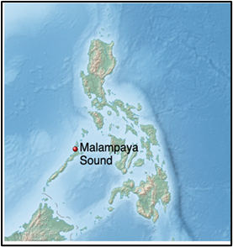
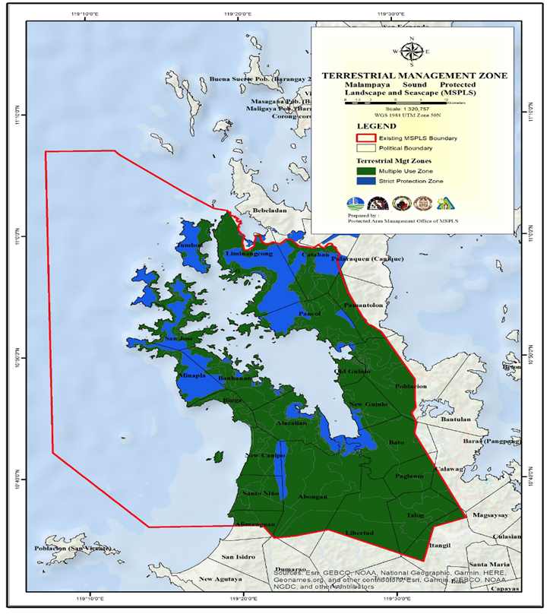
Figure 4.C.1 Location map of the MSPLS and its terrestrial management zones (PAMP, 2025-2034)
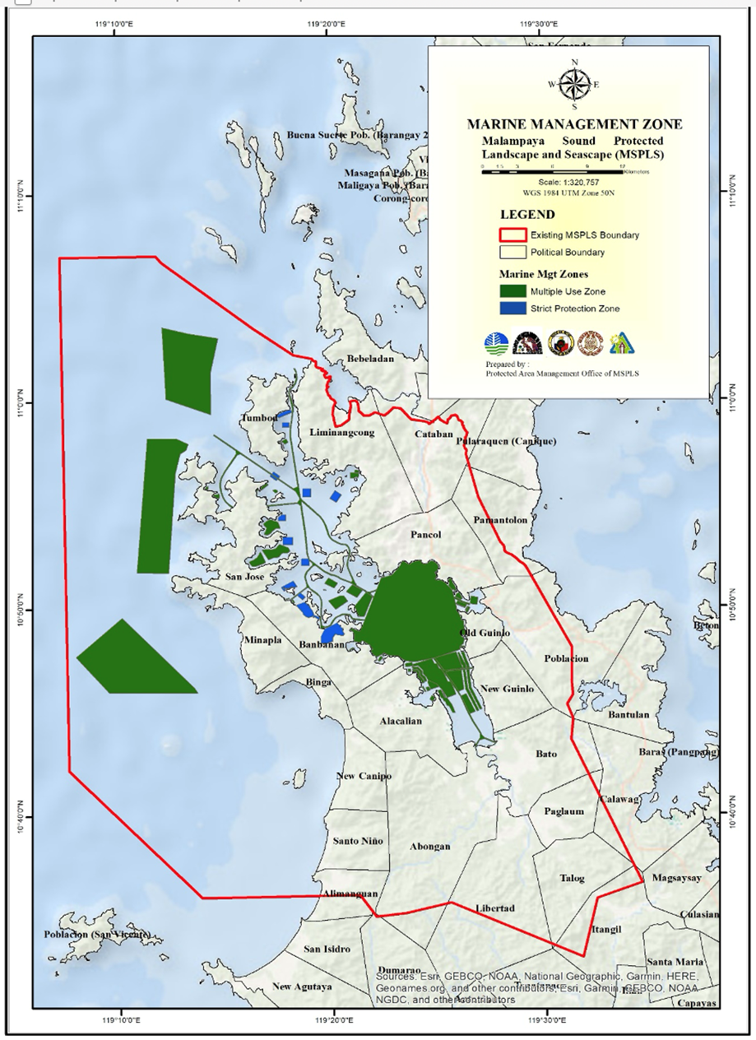
Figure 4.C.2 Marine management zones (PAMP, 2024-2034)
Marine & Coastal Wetlands.
In the coastal wetlands, the mudflats / tidal flats are characterized as areas along the coasts that are unvegetated and exposed substrate with sandy and muddy sediments that undergo regular tidal inundation (Ancog et.al undated). Despite these habitats being lost due to anthropogenic activities such as conversion to fishponds for aquaculture and land reclamation, they are poorly studied, hence data for them can rarely be found in the country (Ancog et.al, n.d.).
Threatened marine mammalian and reptilian species were found inhabiting the MSPLS. Two species of dolphins have been observed in the Malampaya Sound – the Bottle-nosed Dolphin (EN: Tursiops truncatus), or Lumod Lumod in the local language, seen in the Outer Sound, while the Irrawaddy Dolphin (CR: Orcaella brevirostris) has been observed in the Inner Sound. Dugongs (CR: Dugong dugon) have been sighted in seagrass beds of the MSPLS. The Hawks Bill (CR: Eretmochelys imbricata) and Green (EN: Chelonia mydas) Sea Turtles and the Olive Ridley (VU: Lepidochelys olivacea) were found to nest in the western coasts of the MSPLS. They visit their nesting sites regularly to lay eggs from December to March (MSPLS GMP 2019). Details are in Chapter 4.2.4.
The live coral reefs in the Sound cover only 17%, which is considered poor. The coral reefs in the west coast are in better condition. There are 27 genera of coral under 13 families that are found in the area (MSPLS GMP 2019). The rare Giant Clam (Tridacna spp.) was also found to thrive in the Sound (Vicente 2024). There were 262 species of fish identified (Vicente, 2024) as of 2024.
Landscape.
There are 11 mammalian threatened species (CR, EN, VN), 5 amphibian and 10 avifauna species found therein. Details are also found in chapter 4.2.4.
Landscape and Topography of the MSPLS
Malampaya Sound has moderately rolling hills with slopes ranging from 8 percent to 30 percent. The southwestern coast has soft white sands, coves, bedrocks and is relatively flat and rising gradually to undulating hills. Altitude ranges from 100 to 500 meters, which form the watershed divide of the Sound. Above 200 meters, the area is naturally stony granite (MSPLS GMP, 2019; IUCN-MMPATF, 2022).
The elevation rises abruptly from sea level to 1,013 meters at Mt. Capoas, the highest peak of the landscape along the northwestern coast of the Sound. The topography in the northern section of Mt. Capoas drops in elevation ranging from 350 to 100 meters above sea level. Mt. Capoas provides a unique habitat as the only mossy forest outcrop (MSPLS GMP, 2019).
The coast rises to the watershed ridge about 318 meters at Olongo Peak. Steep rocks characterize its western coastline and the northern part has a gentler gradient. The watershed ridge along the Inner Sound is not as high and only on moderate slopes. The forest is intact although the cover is patchy while the forest cover is excellent on slopes along the southwestern part. White fine sand interspersed with rocky sandstone describe the coast. Granite and limestone formations are present (MSPLS GMP, 2019).
At the head of the Sound, the gently rolling hills broaden out to an extensive broad plain. These areas are used for agriculture. In the southern section, minor plains are narrow and randomly occur between patches of land with slopes ranging from nearly level to gently sloping with an elevation ranging from three to 100 meters (MSPLS GMP, 2019).
The hills in the barangays of New Guinlo, Bato and Paglaum are characterized as level to gently sloping, sloping to undulating, and undulating to rolling. Hills around the Sound are predominantly metamorphic. The areas with elevation less than 150 meters are utilized for upland and orchard farming (MSPLS GMP, 2019).
The Sound’s landscape is significantly covered with forest with dipterocarps as the dominant trees. It serves as a wildlife corridor connection between El Nido and central Palawan forests. The landscape contains some of the most important biological resources with national significance (MSPLS GMP, 2019).
Residual forest patches occur on hills with elevations greater than 150 meters that form the watershed ridge along barangays Talog, Libertad, Paglaum, Abongan and Alacalian in Taytay. Forest cover is fairly good on these slopes since most of the agricultural activities are in the broad plains that extend into the mangrove delta of the Buwaya Sound. An estimated 20% of the protected area is covered by old growth forest and 25.7% by residual forest (MSPLS GMP, 2019).
Generally, there are five major types of soil found in Taytay and San Vicente: the Busuanga Loam, Coron Clay Loam, the Sibuyan Silty Clay and Silty Clay Loam (MSPLS GMP, 2019).
Seascape and Topography of the MSPLS
The 34 km long Sound is divided into two sections, a salt water Outer Sound and a brackish Inner Sound. The Outer Sound varies in depth from about 22 meters to 46 meters and the Inner Sound varies from 4 m to 16.5 meters. The Inner Sound is 9 km wide and covers a surface area of 24,500 hectares. (MSPLS GMP, 2019).
The Malampaya Sound has two entrances – the Worcester Strait, which is the main entrance, has strong tidal streams and a fairway that is quite deep; and the Endeavor Strait that has a depth of 8.7 m (29 ft) in the fairway. There are about 50 islands and rock formations in MSPLS, 13 of which separate the Outer and the Inner Sound. Most of these islands range from 50 to 100 meters above sea level, mostly farmed or logged, some planted with cashew. Tuluran Island is the largest with significant forest cover and habitat to some endangered wildlife. Wedge Island and Lison Rock are observed by communities to be bird sanctuaries. Imuruan Island is known for its white fine sand (MSPLS GMP, 2019; PAMP, 2025-2034).
Sediment of the Sound is of soft, fine mud from the closed end (southeast) to the open end (northwest). The former exhibits dark green coloration while the latter has light green coloration (MSPLS GMP, 2019).
Along the western coast, several seagrass beds are present. Dugongs, dolphins, whales and sea turtles have been observed at Miñon and Imuran Bays. The soft sands along the west coast are breeding habitats of sea turtles (MSPLS GMP, 2019).
The live coral reefs in the Sound cover only 17%, which is considered poor. The coral reefs in the west coast are in better condition. There are 27 genera of coral under 13 families that are found in the area (MSPLS GMP, 2019).
More than 156 species of fish are found in the Sound of which 60 species are considered to be first class species with high commercial value (MSPLS GMP 2019). There are already 262 species of fish identified (Vicente, 2024). Below (Table 4.A.1) shows the marine and other aquatic products that are harvested as alternative livelihood.
Table 4.C.1. Other Sources of Income from Marine and Aquatic Products (PAMO, MSPLS, 2024)
Resource | Type of Product | Frequency of Harvest | Market
1. Jellyfish | Processed jellyfish products | Seasonal; May-July | Manila, Japan, China and Korea
2.Seaweeds | Jan – May inner MSPLS
3. Lato | No commercial value
4. Bangus Fry | Catching of Sabalo fry is prohibited in MSPLS
5. Blue Crabs | Crab meat | Year round | Manila and within Palawan
6.Mangrove Crab |  | Year round
7. Sea Cucumber |  | Seasonal from Jan.-June | Local community, Taytay
8. Lobster |  | June – December outer MSPLS | Manila
9. Shrimp |  | Feb- June inner MSPLS | Manila and within Palawan
10. Squid |  | Nov.–June outer MSPLS; Feb-May – inner MSPLS | Manila and within Palawan
11. Green Mussel | Dried and Fresh | July – Dec inner MSPLS Year-round | Manila and within Palawan
12.Other Shellfish | Kabitsin, Kibaw, Balilit, Saka-saka | Year round | Local Community, within Taytay
Mangroves and Coastal Wetlands
In the coastal wetlands, the mudflats / tidal flats are characterized as areas along the coasts that are unvegetated and exposed substrate with sandy and muddy sediments that undergo regular tidal inundation (Ancog et.al undated). Despite these habitats as being lost due to anthropogenic activities such as conversion to fishponds for aquaculture and land reclamation, they are poorly studied, hence data for them can rarely be found in the country (Ancog et.al, n.d.).
There are several old growth mangrove forests containing about 16 species (PAMP, 2025-2034) that are found in the estuaries of four major river systems - Abongan, Alacalian, Bato and Pinagupitan, which flows into the head of the Inner Sound. There are about 30 river systems inside the MSPLS (MSPLS GMP 2019). Mangroves in the Inner Sound are made up of species such as Bakuauan- babae (Rhizophora mucronata), Bakauan-lalake (R. apiculata), Bani (Milletia pinnata), Busain (Bruguiera gymnorhiza), Buta-buta (Excoecaria agallocha), Dungon-late (Heritiera littoralis), Kulasi (Lumnitsera racemosa), Langarai (Bruguiera parviflora), Malatangal, Pagatpat (Sonneratia alba), Pedada (S. caseolaris), Pototan (B. sexangula), Sagasa, Tabigi (Xylocarpus granatum), and Tangal (Ceriops tagal). The Mangrove forests are estimated to cover 3.9% of the protected area (MSPLS GMP, 2019).
Vicente (2024) citing from a study by PCSDS (2006a), identified only 9 species of mangroves in the Sound, namely Rhizophora apiculata Blume, Rhizophora mucronata Poir, Xylocarpus granatum J. Koenig, Bruguiera cylindrica Blume, Ceriops tagal C.B. Robinson, Bruguiera gymnorrhiza Lam, Excoecaria agallocha L, Scyphiphora hydrophyllacea C.F.Gaertn, and Lumnitzera littorea Voigt.
Table 4.C.2. Stand Estimates and species of mangroves in Malampaya Sound (PCSD, 2006
Barangay | No. of Trees/ha | Stand Volume  (m³ Ha⁻¹) | SV Class | Species present
Old Guinlo | 1037 | 361.44 | High | Ct, Bc
New Guinlo | 696 | 127.15 | Moderate | Ct, Ra Rm
Alacalian | 702 | 367.8 | High | Ct, Ra, Rm, Xg, Bg, Bc, Ll, Sh
Abongan | 429 | 388.18 | High | Bs, Ra, Ct, Xg, Bg, Ea
Banbanan | 329 | 274.41 | High | Bg, Ra
San Jose | 116 | 120.59 | Logged over to High | Bg, Ra, Rm
Liminangcong | 322 | 278.38 | Moderate to High | Ct, Ra, Rm
Pancol | 566 | 184.56 | Moderate to High | Ct, Ra, Rm
Mean | 524.63 | 262.81 | High
Legend: Ra = Rhizophora apiculata, Rm = Rhizophora mucronata, Xg = Xylocarpus granatum, Bc = Bruguiera cylindrica, Ct = Ceriops tagal, Bg = Bruguiera gymnorrhiza, Ea = Excoecaria agallocha, Sh = Scyphiphora hydrophyllacea, and Ll = Lumnitzera littorea
Several barangays exhibited a moderate to high mangrove cover. These include Old and New Guinlo, Alacalian, Abongan, Banbanan, Liminangcong, and Pancol. Malampaya mangroves have an average density of 525 trees per hectare. All barangays, except San Jose, experienced extensive illegal logging. Dela Peña et al. (2015b cited by Vicente, 2024) found that 46% of the mangrove areas are in healthy condition. Only Bgy Banbanan has good mangrove forest cover (Vicente, 2024).
The total area covered by the mangroves within the MSPLS is 3,338 has. Liminangcong has the highest mangrove forest cover at 473.75 ha among the four barangays. However, along with the other two barangays, its perceived condition is fair. Only Banbanan has good mangrove forest cover (Dela Peña et al., 2015). Dela Peña et al. (2015) further reported that the overall perceived condition of its 802-hectare (ha) mangrove forest is fair due to on-going wood harvesting for charcoal making and house repair (dela Peña et al., 2015).
Fisherfolk recognizes the association between declining fish populations and shrinking mangrove areas. Communities in Malampaya Sound are also socially and economically dependent on forest resources and non-timber forest products for building materials and traditional fishing gear. Some of these are bamboo, wood, rattan, pandan, unprocessed rattan poles, nipa and timber, and the exploitation of many of these materials does not respect government regulations, because no levies are paid (Pilien & Walpole, 2003).
Coral Reefs & Seagrasses
Seagrass.
Malampaya Sound harbors 8 species of seagrasses and various species of corals and macroinvertebrates including the rare giant clam Tridacna spp (Vicente, 2024). Generally, its 211 ha of seagrass bed is disturbed (dela Peña et al., 2015).
In Malampaya Sound seagrass beds cover an area of about 21 km² (PNSS, 2004 cited by Vicente 2024) mainly in Barangays Banban, Bucal, Liminangcong, San Jose, and Tumbod (PCSDS 2006; dela Peña et al. 2015b cited by Vicente 2024). Eight of the 13 seagrass species in the Philippines are found in the Sound. These species are: Enhalus acoroides Royle, 1839; Cymodocea rotundata Asch. And Schweinf.; Cymodocea serrulata Ascherson and Magnus, 1870; Halodule pinifolia Hartog; Halodule uninervis Ascherson; Halophila ovalis Hooker, 1858; Syringodium isoetifolium Dandy; and Thalassia hemprichii Ascherson, 1871. In 2004, the outside of the Sound had a percentage cover of these species ranging from very poor to poor (8 –30%). However, the monospecific stands of E. acoroides thickly cover the inner Sound (PCSDS 2006a; dela Peña et al. 2015b cited by Vicente, 2024).
The growth of seagrass is sparse in Malampaya Sound and less diverse, particularly in the Inner Malampaya Sound, as reported by PCSDS (2006a). The seagrass in Barangay Banbanan, located in the Inner Sound, was described as pristine by FGD participants and key informants. The seagrass bed of Sitio Bucal in Barangay Liminangcong was said to be diverse and well-developed as it covers a wide area of the sandy substratum (PCSDS, 2006a). However, the seagrass beds of Barangay Liminangcong as a whole is currently characterized as disturbed by its fishers. The villages of San Jose and Tumbod have seagrass beds, having less than a hectare, that are disturbed and in altered conditions, respectively (dela Peña et al., 2015).
Coral Reef.
There are extensive coral features along the western coast all the way north to the west coast of Tuluran Island. Wedge and Imuruan Islands have broad coral cover in excellent condition (MSPLS GMP, 2019). In the Outer Sound, the fringing reefs are found in Barangays Liminangcong, Tumbod, San Jose, and Bambanan. There has been no published report on how many species of corals are present in the area; however, it was reported in 2004 that coral cover ranges from 30 to 75% (CHE-UPLB, 2015). A similar report was published by the PCSDS (2006a; 2006b) accounting for the coral reefs from fair to good condition. Around 1,632 ha of coral reefs are in poor condition (dela Peña et al. 2015). However, the latest published surveys reported that the condition in the Sound worsened from fair to poor (Matillano et al. 2014; dela Peña et al. 2015a cited by Vicente 2024), except in areas on the Outer Sound like Liminangcong where corals remained in excellent condition (Matillano et al. 2014 cited by Vicente 2024). Among the four selected MSPLS barangays, only Banbanan’s coral reef area, which also happens to be the smallest in size at 24 ha, has fair coral cover. Located at Noble Hump Island, the reefs are said to be protected by the island’s owner (Dela Peña, 2015).
Associated reef fish are also abundant in the Sound. There are 262 species of fish recorded (Balisco et al., 2014; Dolorosa and Matillano, 2014 cited by Vicente, 2024), of which 101 were target species, 97 were indicator species, and 64 were major species. Pomacentrids and chaetodontids mostly dominate the fish population. The Sound harbors more fish species than the reefs found in the adjacent Taytay, Turtle, Binunsalian, and Bacuit Bays. It is estimated that the reefs have a high productivity that can yield fish biomass of 59.94 t.km² (Vicente, 2024).
Macroinvertebrates also inhabit the area with 10 species recorded including the rare Tridacna spp. Bruguière, 1797, and Conus spp. Linnaeus, 1758 (Dolorosa and Matillano, 2014 cited by Vicente, 2024). The presence of the destructive Crown of Thorns Starfish Acanthaster plancii Linnaeus 1758, were also noted (Vicente, 2024).
Deterioration has been observed among the reefs around the Sound over time. The use of beach seine (baring) and turbid waters in Inner Malampaya Sound have generally contributed to its deterioration in Banbanan. Liminangcong and Tumbod’s poor coral reef cover is due to rampant use of Danish seine (hulbot-hulbot), sodium cyanide, and dynamite in fishing. In San Jose, “baring” is said to be used in addition to hulbot-hulbot along Worcester Strait and dynamite fishing in Bolalo Bay. These fishing methods tend to destroy coral reefs in these areas. Generally, the reportedly present poor coral reef conditions in four selected MSPLS barangays are worse than their previous fair to good conditions as reported by PCSDS (2006a) and dela Peña et al. 2015. In 2015, the remaining corals were in either poor or fair condition (PCSDS 2006a; Matillano et al., 2014; dela Peña et al., 2015b cited by Vicente, 2024).
Biodiversity hotspots and sensitive areas
Located in Figure 4.A.3 below are the biodiversity hotspots in terms of ecosystems such as coral, seagrass, mangroves, and sensitive areas where nesting sites of sea turtles and sightings of threatened marine mammals such as the Irrawaddy Dolphin and the Bottle-nose Dolphins have been identified. Biodiversity hotspots and sensitive areas are found mostly inside the Inner and Outer Malampaya Sound, while the western coastline is found to be nesting sites of the sea turtles. The Risso’s Dolphin had been observed at the western coast in a cove in Bgy Minapla.
Coral reefs are mostly found in the Outer Sound in island fringes and coves where they are mostly protected from strong currents in the monsoon months. Mangroves are found in the Inner Sound mostly lining the coastal mudflats, where rivers empty into the Sound. Seagrass beds are found in sheltered coves in Barangays Banbanan, Pangcong and Liminangcong.
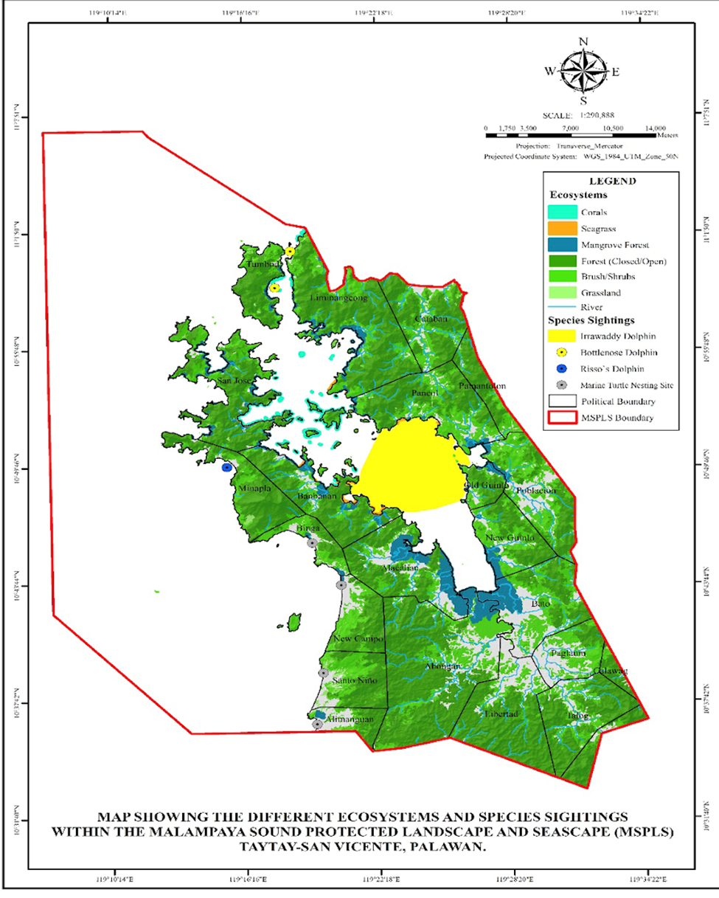
Figure 4.C.3. Sensitive areas and biodiversity hotspots in the MSPLS (PAMP, 2025-2034).
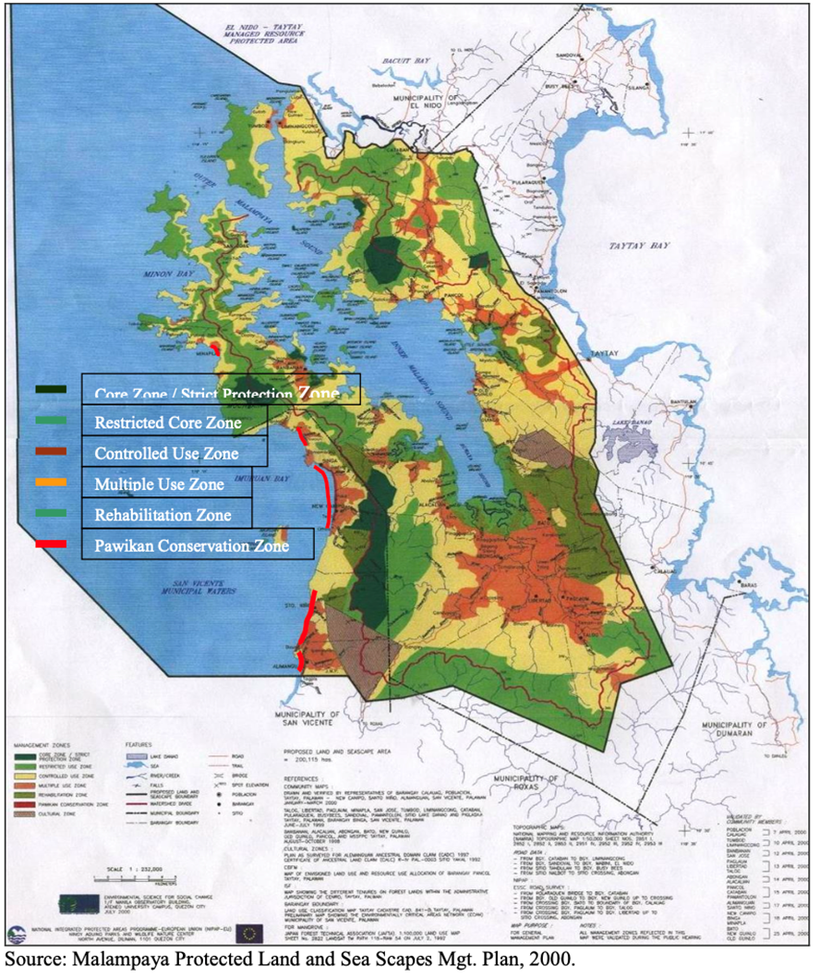
Figure 4.C.4. Management zones identified in the MSPLS in yr2000 which can be translated into biodiversity hotspots and sensitive areas (MSPLS Mgt. Plan, 2000).
Figure 4.A.4 above shows the management zones identified for MSPLS in yr2000. As shown, which the present time MSPLS management zones have adopted, are the sensitive areas mostly found in the western coastline where nesting sites of sea turtles are located. Restricted core zones are also located at the head of the Inner Sound where large areas of mangroves are found. Corals and Seagrass beds are still found in the areas where the current PAMP 2024-2034 have located them.

Endemic, Endangered, Threatened Species
PCSDS (2006a) and Irreplaceability.org (2025) listed as threatened 11 terrestrial mammalian species, 5 amphibians, 10 avifauna. Marine mammals and reptiles have 7 dolphin species, 4 whale species, one dugong and 3 sea turtle species. The threatened category ranges from critically endangered (CR) to Data Deficient (DD – but still threatened). The dolphins were mostly recorded at the east side of the Municipality of Taytay which is outside of the MSPLS. However, the survey also was conducted at the Outer Sound of the MSPLS at the entrance of the Malampaya Sound (Bgy Tumbod, Taytay) where sightings of these animals were also reported.
Prominent among the marine mammals is the Irrawaddy Dolphin observed to be in the Inner Sound while the Bottlenose Dolphin was observed in the Outer Sound (MSPLS GMP, 2019). However, no recent literature (2020 – 2024) has reported sightings of the other mentioned dolphin species inside the MSPLS. These include also the Cetacean (whale) species. No recent reported sightings, however does not mean that the marine mammals are extinct in the area. Given their wide range of distribution and saltatory nature, the animals may come around at any time.
The Sperm Whale and the Killer Whale were also recorded. Unfortunately, the whales (Sperm Whale – either Dwarf or Pygmy; Killer Whale – Pygmy) were not specifically identified. However, their conservation status remains as least concern (LC) under the IUCN Red List (2025).
Terrestrial threatened species in the MSPLS are mostly endemics and there are 11 mammalian species, 5 amphibians, and 10 avifauna identified (Irreplaceability.org accessed in May, 2025). Endemic to the Palawan Province, but still found inside the MSPLS are the Palawan Bearded Pig, the Northern Palawan Tree Squirrel, The Palawan Stink Badger and the Palawan Flying Fox, to name a few. The complete list is found in 4.C.7.
The sea turtles (Green Turtle, Hawksbill Turtle and the Olive Ridley Turtle) were recorded in the western side of the MSPLS facing the West Philippine Sea where they have their nesting sites (MSPLS GMP 2019; PCSDS 2006b). They are sometimes sighted inside the Outer Sound above coral reefs and seagrass beds. PCSDS (2006a) recommended these areas as core zones for conservation in 2006 and the PAMO / PAMB have designated the western side as the Sea Turtle Conservation Zone (MSPLS GMP 2019). One sea turtle, the Loggerhead Turtle, has been sighted in 2006 but this species is rarely seen since then (PCSDS, 2006a, 2006b).
Mangrove species have been protected in Palawan since PD 705 and its protection have been strengthened by R.A. 7611, the Strategic Environmental Plan for Palawan Act, in June 1992 (Section 7). As such, many true mangrove species have been categorized by the IUCN Red List (2025) as threatened but of least concern (see list in Annex 4). Two species of note are Tabau (Lumnitzera littoralis), which is Critically Endangered (IUCN Red List, 2025), and the Gapas Gapas (Camptostemon philippinensis), which is of Endangered status (IUCN Red List, 2025). The former can be found in mangrove ecosystems in both Taytay and San Vicente areas of the MSPLS, while the latter can only be found in the Taytay mangrove areas of the MSPLS.
Priority Transboundary Biodiversity Issues

Threats/Risks and Issues
Bio-physical and social threats, issues and concerns are related to the management of the MSPLS. Transboundary biodiversity issues focus more on biological and to some degree, physical concerns. However, physical concerns are manifestations of anthropogenic causes that plague the MSPLS.
Priority transboundary issues are the conservation status of marine mammals and reptiles that are found in the MSPLS. They migrate all over the SCS and the GoT, especially the marine turtles, which are threatened species identified by the RedList 2025 of IUCN, and they are inadequately protected by the countries bordering the GoT and the SCS. These turtles are the Hawksbill Turtle, Green Turtle, the Olive Ridley Turtle, and as rare sightings but nevertheless present, the Loggerhead Turtle. The Hawksbill is critically endangered, whereas the Green Turtle is endangered. The other turtles are classified as vulnerable.
For marine mammals (cetaceans), the Irrawaddy Dolphin has a small population residing in the Inner Sound of the MSPLS and they are classified as endangered (PAMP 2025-20340; IUCN Red List 2025). However, the species can also be found in the Irrawaddy Estuary in Myanmar and some small populations in Southeast Asia. Hence, the Irrawaddy Dolphins are considered as of global importance. Due to their small populations around the GoT and the SCS, particularly in the MSPLS, they are threatened with extinction due to habitat destruction and as by-catch / accidental catch by fisherfolks (Tara Sayuki Whitty, 2015).
Other cetaceans found in the MSPLS but nevertheless threatened, although of least concern, are the Risso Dolphin, the Bottlenose Dolphin, the Pantropical Spotted Dolphin, Fraser’s Dolphin and the Risso Dolphin. They are found in offshore zones at the entrance to the Malampaya Sound and in the western offshore zones of the MSPLS. Sighting in the same offshore zones are the whale species such as the Pygmy Killer Whales, the Dwarf Sperm Whale, the Short-finned Pilot Whale and the Melon-Headed Whale. As migratory species, they appear seasonally within the MSPLS.
Trend Analysis
Cited by Ancog, et.al (undated), Garcia et.al (2014), Nickerson (1999) and Long and Giri (2011) estimated that the Philippine mangroves have about 450,000 – 500,000 ha in the early 1920s and by 2000, only 256,185 ha remain. The last 75 years saw the escalation of mangrove deforestation. Approximately 337,000 ha or at least 75% of mangrove habitats have been lost due to conversion into brackish-water fishponds, timber harvesting for building materials, and coastal development which happened mostly in 1950s-1990. However, Ancog et.al (undated) cited Garcia et.al in 2014 found that despite the decrease in the total area of the mangroves through the decades, there has been an increase in the late 1990s and early 2000s. Mangroves in Palawan and particularly in the MSPSL have similar trends.
The different risks and threats within the PA are reflected on a map in Figure 4.C.5 below (PAMP, 2025-2034).
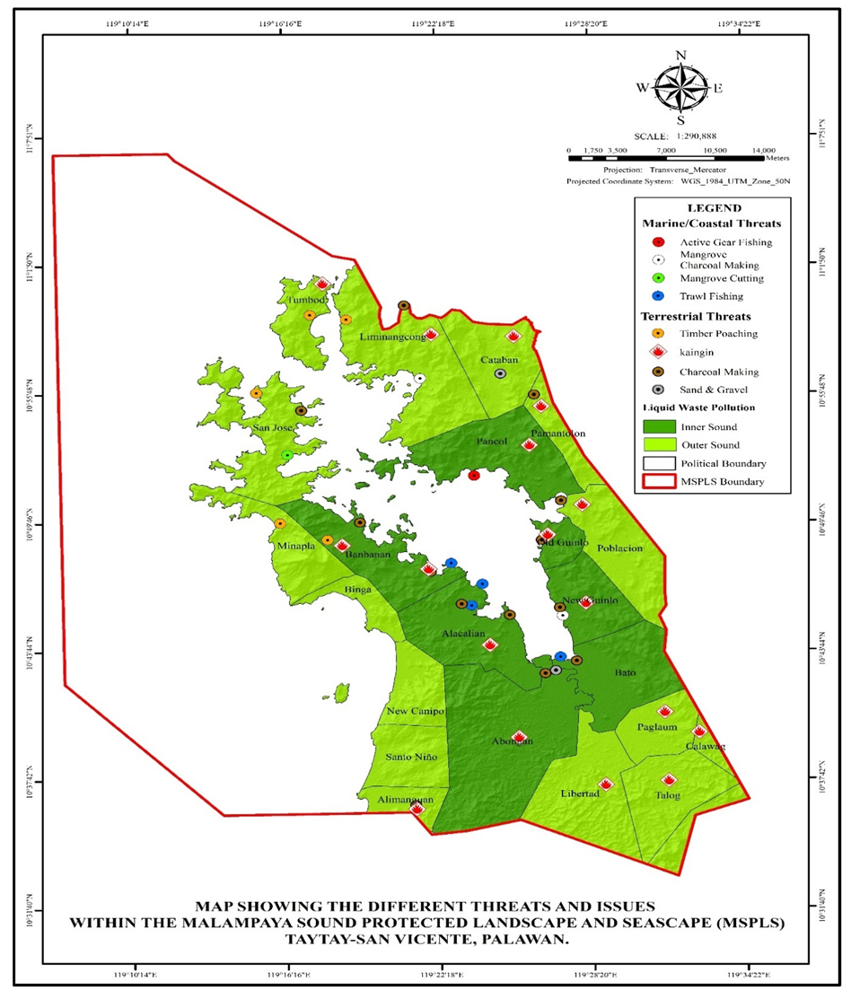
Figure 4.C.5. Sources and locations of different threats and issues within the MSPLS (PAMP, 2025-2034).
Fishery Resource.
From 1960s to the present, the Malampaya Sound has been a thriving traditional fishing ground so much so that it has been named as the “fishbowl” of the Philippines. As such, fishing pressure and other anthropogenic factors such as tourism and pollution loading have brought about much stress on the ecology of the MSPLS causing damage to corals, seagrass beds, mangroves and other marine life (McNeely et al. 1990; Deocadez and Aliño 2005 cited by Vicente 2024). This can permanently impact ecological timelines when combined with changing climate conditions due to rising atmospheric carbon dioxide (Bindoff et al. 2005; Doney et al. 2012; Doney et al. 2016 cited by Vicente 2024). More than 156 species of fish are found in the Sound of which 60 species are considered to be first class species with high commercial value (MSPLS GMP 2019). By 2024, there were already 262 species of fish identified (Vicente 2024). However, literature did not state whether this was due to habitat improvement or due to more intensive survey.
Biodiversity.
The degrading ecological conditions of Malampaya Sound, mainly due to anthropogenic activities, led to a decline in biodiversity and habitat quality. As a result, it negatively impacts the productivity and sustainability of its fishery resources by reducing fish stocks and altering species composition. In effect, it decreases economic opportunities for local fishing communities. The implementation of applicable conservation measures and restoration activities is vital to achieving ecological resilience and sustainable fisheries (Vicente, 2024).
Table 4.C.3 lists the issues and challenges faced by Malampaya Sound, as identified by various authors through the years (1995 – 2025).
Table 4.C.3. Trending Issues and challenges faced by Malampaya Sound, 1995 – 2025.
Threats and Issues | 1995 | 1996 | 2003 | 2006 | 2009 | 2015 | 2015a | 2017 | 2025
Terrestrial Development (Occupation of easement area*)
Population Increase (Occupation of easement area*)
Overexploitation
Resource Conflict (use & access) [Occupation of easement area*]
Habitat Destruction (timber poaching*)
Pollution
Cyanide & Dynamite Fishing (unsustainable fishing*)
Illegal Fishing (unsustainable fishing*)
Organic Matter & Nutrient Loading
Poor Waste Disposal & Management (waste discharge/marine debris*)
High Export of Fish Supply
Climate Change (natural hazards: storm surge/strong typhoons*)
Harmful algal blooms (HABs)/Red tide*
Coral bleaching / Crown of thorns infestation*
Oil slick / oil sheen*
Legend: ªPido 1995; ^{b}Sandalo 1996; ^{C}Pilien & Walpole 2003; ^{d}David et al. 2009; ^{e}Avillanosa et al. 2006; ^{f}CHE-UPLB 2015; ^{g}Dela Pena et al. 2015a; ^{h}Gonzales et al. 2017, ^{i}PAMP 2025-2034
(Vicente 2024; *PAMP 2025-2034)
Many of these problems are interrelated and that one problem leads to another. For example, the high demand for fish in the export market and the growing population led to the use of illegal and harmful fishing techniques, which caused habitat destruction and overfishing.
Pollution.
Threats to endangered species are plastic pollution, which has been recently identified in 2015 (CHE UPLB 2015 as cited by Vicente 2024) and up to the present.^{[2]} Plastics from land sources find their way to rivers and eventually into the sea. Worse, they are being transported by ocean currents into the SCS, where the plastics affect the marine turtles and the cetaceans, sometimes leading to their deaths when ingested.
Land-based activities such as poor waste disposal and agri-chemicals run-off find its way to the Sound. Added to this is the sedimentation which was measured by Sombrito et al. in 2004 having ranges from 0.2 to 4 cm per year. David et al. (2009), cited by Vicente 2024, also found that the silt in the Sound is mainly siliciclastics, indicating a terrestrial-dominated source. They further emphasized that the slight increase in organic content in younger sediments reflects the rise in various anthropogenic inputs into the coastal region. The high total coliform concentration in the Sound could be attributed to household waste/ sewage and/ or effluent run-off, making it unsuitable for recreational purposes (Vicente, 2024).
Algal Blooms/Red Tide.
Algal blooms already frequently occur indicating eutrophication process is taking place (Sellner et al., 2003 cited by Vicente, 2024). Such events can result in massive fish kills and even mortality in humans due to the depletion of oxygen in the water and the toxins they release (McGowan, 2016 cited by Vicente 2024). According to Borja et al. (2000) and Sombrito et al. (2004), the cysts of Pyrodinium are responsible for causing harmful algal blooms.
Mangroves/Wetlands.
The mangroves in Malampaya Sound are among the finest in the country and are considered one of the Sound’s most important resources. They are being cut for charcoal production, fuelwood, fish pen construction and housing materials. Some areas have been cleared and converted to fishponds or put to agricultural use. In 1985, satellite images showed that mangroves covered 2,500 ha. By 1998, there were fewer than 1,500 ha left. PSA, in 2020 cited by Vicente 2024, reported that the mangrove population has improved from 2,500 ha in 1985 to 3,342 ha in 2017. As of 2025, the total mangrove area is 3,338 has (PAMP, 2025-2034).
Hazards.
Anthropogenic activities reduce the ability of the Sound to recover from natural pressures like typhoons and diseases. This is evident in the current coverage of seagrass and coral, as discussed in the previous chapter. The declining fish catch and biodiversity in the area are causes for concern among the marginal fisherfolk. The rampant use of illegal and destructive fishing methods by non-resident fishers were perceived by respondents as the main cause of habitat destruction (dela Peña et al., 2015). Immediate action is needed to address this issue and safeguard the livelihoods of the people who depend on fishing for their income and sustenance. Fishermen continue to experience a 60-80% reduction in catch (dela Peña et al. 2015b cited by Vicente, 2024).
Coral Reef and Seagrass.
The corals in the Sound have been observed to deteriorate over time. Banbanan, Liminangcong, and Tumbod coral reef are in poor condition due to the use of beach seine (baring) and turbid waters in the Inner Sound and to rampant use of Danish seine (hulbot-hulbot), sodium cyanide, and dynamite in fishing. However, the coral reefs in the Outer Sound in Bgys Banbanan and Liminangcong remain in good condition. At present, the coral reefs are in poor condition in the four selected MSPLS barangays in 2015 than previously reported as fair to good condition in 2006 (PCSDS, 2006a; Matillano et al., 2014; dela Peña et al., 2015b cited by Vicente, 2024).
In summary, as shown in Table 4.A.5, all identified threats and issues have converged by 2025 whereas there were only sporadic identification of threats and issues through the years since 1995. This indicates a trend that anthropogenic pressures have increased in the MSPLS and that management measures are not enough in mitigating them. This is exacerbated by climate change and natural hazards. The MSPLS management staff complement has not kept pace to the increase in threats. As such, innovative management approaches and strategies need to be done to face this challenge. The MSPLS was called the “fishbowl of the country” since the late 1990s up to present because it provides a substantial contribution to the country’s economy through the fishery sector (Vicente, 2024). Since then, degradation threatens its resources, much of it due to human causes. Conservation measures have been put in place including its declaration as a protected landscape and seascape in 2000. However, degradation continues to this day. Only the mangrove ecosystem has made improvements but only in selected areas. Seagrass and coral ecosystems are still in poor to fair conditions (Vicente, 2024).
Other threats, issues and concerns and recommendations are listed in Annex 4 as identified by the PAMP, 2025-2034.
Risk Assessment and Valuation of economic losses
The major sources of livelihood are fishing and farming. In Taytay, fishing is 39% and farming is 34%. In San Vicente, fishing is 48% and farming is 33%. While majority of local fishers use hook and line, fishing pressure in Malampaya Sound is critically high with a density of 23 fishers/km², thus, fishers are experiencing a 60-80% decrease in catch during the period 2012 – 2015 (dela Peña et al., 2015).
Other economic activities of the locals are trading, services and employment in the public and private sectors, manufacturing and construction, aquaculture, NTFP collection, agroforestry, mat weaving, rope making, furniture making, food processing, baskets, and boat making, bamboo/rattan plantation, bank/finance, resort operations and retail / sari-sari stores (MPDO Taytay, Socio-Economic Profile 2022; PAMP, 2025-2034). The total mangrove area of about 802 ha in the study site, of which only about 46% is in healthy condition, has fisheries value and direct economic revenue estimated at PhP 7.378 million (US$ 184,460) and PhP 14.756 Million (US$ 368,920), respectively (Dela Peña et al. 2015). As discussed above, resource use/extraction is a major concern, and the risk is high for resource degradation to happen. This, in turn, will place all the livelihood activities at risk since without the resource base, the livelihoods will not be successful.
Tourism in Taytay and San Vicente is being strengthened as an industry. At present, the activities in the area are mostly nature-based. Taytay’s rich biodiversity are both found underwater and in its terrestrial environs. Malampaya Sound is also famous for its Irrawaddy dolphins (Orcaella brevirostris), a critically endangered species found only in few remote places in Southeast Asia. Features in the four (4) barangays of San Vicente that are included in MSPLS that have high potential for tourism activities are its beaches, landscape view on hilltops, dive sites and the transpiring surfing area at the Long Beach in Barangay Alimanguan (PAMP, 2025-2034). As to the risks in the tourism industry, the carrying capacity of the places where tourism is high, may be exceeded thus putting much pressure on the resources of the Sound. It may also disturb the nesting areas of the marine turtles and the feeding habits of the Dugongs.
Potential Impact/Risks of Natural Threats and Occurrences of Hazards
The following threats and hazards that have an impact on the biodiversity and natural resource of the PA were identified as follows (PAMP, 2025-2034):
- Unsustainable Fishing;
- Occupation of Easement Area;
- Harmful Algal Blooms (HABS)/ Red Tide;
- Coral Bleaching/ Crown of Thorns Infestation;
- Waste Discharge/ Marine Debris;
- Timber Poaching;
- Oil Sleek/Oil Sheen; and
- Natural hazards: storm surge/strong typhoon
Most of the hazards identified are human induced except for natural occurrences such as strong typhoons, storm surge, coral bleaching and infestation of crown of thorns. The protected area being surrounded by the sea is prone to strong waves and typhoon. The houses, infrastructure and livelihood such as fish cages, baklad, green mussel culture, boats and gears are at risk to be affected/damaged by these natural events. Mobility of people, goods and services are affected due to road damage caused by these hazards (PAMP, 2025-2034). Typhoon Odette (internationally named “Rai”) in December 2021, left 89,782 houses damaged (PAMP, 2025-2034).
Rice farms in the low-lying areas of the PA are at risk of damage due to flooding in Barangay Abongan. This could put the food security of the municipality at high risk. On the other hand, drought also causes damages (PAMP, 2025-2034).
Climate change has caused corals to bleach and die. At risk due to this damage is the food security of the municipalities surrounding the MSPLS since coral reefs provide support to the local fishing livelihood of the communities and protect the shoreline against sea level rise, storm surges and strong waves. It also has been observed that the Crown of Thorns Starfish (CoT) have infested many coral reefs in the MSPLS. These may cause also the death of the corals (MSPLS’ Response Plan, 2023-2028).
Algal bloom, or red tide, events have been recorded in the past in the MSPLS and has direct impact on the shellfish harvest. This occurrence has put the green mussel culture of the coastal communities at risk and also a major health risk to humans that consume affected shellfish. The probability of repeat events is high (MSPLS’ Response Plan, 2023-2028).
In a FGD and validation workshop event as cited by Dela Peña in 2015, the participants identified weak enforcement of the ban on mangrove cutting as the main reason for its degradation in spite of the entire province of Palawan being declared as a national mangrove reserve. Mangroves in barangays Liminangcong, San Jose and Tumbod have fair mangrove condition. The workshop also considered charcoal production as the top threat to mangrove forests especially in six villages of Taytay (PCSDS, 2006b). The Philippine National Police plant 100 seedlings of mangroves in Tumbod every month since October 2012 making it an indication of reforestation efforts, cited in the same workshop (dela Peña, 2015 cited in MSPLS PAMP, 2025-2034).
Interviews were conducted in 2015 (MSPLS PAMP 2025-2034). Of the 64 validated responses from 113 households, the biggest perceived threat to mangroves in the study site is wood harvesting for charcoal making (68.8%) since 93.8% of 113 households interviewed use wood and charcoal as fuel for cooking. Natural causes and pollution are the least perceived threats to mangrove habitat. Destructive fishing method such as the use of dynamite, sodium cyanide, and Danish seine (hulbot-hulbot) have generally caused the poor condition of coral reefs in the four selected MSPLS barangays in Taytay. These illegal and destructive fishing methods have been in existence for a long time and still continue to this day. This is confirmed by 86% of household respondents who indicated that the primary threat to their coral reefs is illegal and destructive fishing methods. No single huge threat is evident for seagrass beds (dela Pena et al., 2015). Table 4.E.4 below summarizes the resource management issues in MSPLS.
Table 4.C.4. Summary of fishery-related resource management issues in Malampaya Sound, Taytay, Palawan, Philippines (dela Peña et al., 2015 cited in MSPLS PAMP, 2025-2034).
Category of Issues | Mangrove | Seagrass | Corals
Resource Use | - Cutting of mangroves for charcoal/repair of house  - Presence of plastic garbage | Presence of plastic garbage | - Except in Banbanan, the use of dynamite, sodium cyanide, and Danish seine (hulbot-hulbot) are present in 3 MSPLS barangays  - In Liminangcong, scarelines of Danish seine (hulbot-hulbot) are reportedly left in coral reefs
Resource access |  |  | - Non-resident fishers (Batangas, Manila and Cebu) using Danish seines have caused huge damage to coral reefs in Liminangcong, Tumbod, and San Jose  - These Danish seines are reportedly operators having local partners

Current Management and Institutions
- Policy & Institutional Framework
Malampaya Sound Protected Landscape and Seascape (MSPLS) was established as protected area under the National Integrated Protected Areas System (NIPAS) Act (RA 7586) on July 12, 2000 by virtue of Presidential Proclamation No. 324 signed by President Joseph Estrada on July 12, 2000. It covers a total area of 200,115 comprised of 88,776 hectares of land and 111,339 hectares of water (Figure 4.C.1). The protected area covers 22 barangays of which 18 are under the administrative jurisdiction of Taytay and 4 are under San Vicente (MSPLS General Management Plan, 2019 and PAMP, 2025-2034).
The multi-sectoral PAMB is responsible for deciding policies, the development, implementation and reviewing the GMP programs for the area. The PAMB ensures that communications with outside organizations are maintained so that their policies are acknowledged and implemented by other agencies. Projects and programs that affect the environment are evaluated and approved by the PAMB (MSPLS GMP, 2019). The PAMB also seeks to generate fees for the area through charging for the use of resources such as irrigation canals, rice mills, dryers, timber, rattan, marine resources and products that are marketed outside of the protected area boundary. It will continue to seek grants and other means to ensure the programs can be sustained financially (MSPLS GMP, 2019). Skills development for PAMB members and PAO staff needs to be provided to enhance and strengthen capabilities in PA management (MSPLS GMP, 2019).
- Protection Status
As provided in the ENIPAS Act of 2018, the Protected Area Management Board (PAMB) will be responsible for the overall implementation of the management plan. At present, there are 37 PAMB members duly appointed by the DENR Secretary (MSPLS PAMP, 2025-2034).
The Protected Area has the following stakeholder’s group who plays a crucial role in the protection, management and sustainable utilization of the natural resource of Malampaya Sound Protected Landscape and Seascape (MSPLS PAMP, 2025-2034).
Table 4.C.5. Stakeholders in the MSPLS (PAMP, 2025-2034)
Stakeholders’ Group of MSPLS | Representatives
Community Level | Senior Citizens, Indigenous People, Youth, Women, Fisherfolks, Farmers
Barangay Officials | Leaders of the local community, Eighteen (18) Barangays in Taytay and Four (4) Barangays in San Vicente
Municipal, Provincial, and National Government | Municipal Agriculturist Office (MAO), Municipal Environment and Natural Resources Office (MENRO), Municipal Planning and Development Office (MPDO), Municipal Tourism Office (MTO), Bureau of Fisheries and Aquatic Resources (BFAR), Palawan Council for Sustainable Development Staff (PCSDS)
Community-based organizations and NGOs with environmental related projects and programs | Malampaya Foundation Inc. (MFI), World Wildlife Fund (WWF), Peoples’ Organizations
Private Sector | Business managers, the work force and their representatives involved in particular economic activities such as water supply, communication, fisheries and tourism
Academe | Department of Education, Western Philippines University (WPU), researchers
Enforcement Agencies | Philippine Coast Guard (PCG), Philippine National Police (PNP), PNP-Maritime, Philippine Navy (WESCOM), Bantay-Dagat and Bantay Gubat
Resource Managers | Protected Area managers, planners and management staff (PAMO), DENR, NGOs, PCSDS

- Institution (MSPLS PAMP, 2025-2034)
The Protected Area Management Office (PAMO) headed by the Protected Area Superintendent presently works in the area. As of June 2024, total PAMO staffing is 13 with 11 contractual staff and two detailed by DENR (MSPLS PAMP, 2025-2034).
Table 4.C.6. Current Park Management Office (PAMO) Manpower (PAMO-MSPLS, 2024)
Position | Contractual | DENR detailed | Total
Protected Area Superintendent |  | 1
Administrative Assistant | 2
Office Support Staff | 1
Coastal and Marine Ecosystem Management Program Extension Officer | 1
Data Encoder | 1
Forest Ranger |  | 1
Park Rangers | 5
Janitor | 1
TOTAL | 11 | 2 | 13
Four (4) units support the PASu; marine protection, forest protection, IEC and planning. An administrative and finance unit of the PENRO provides auxiliary services (PAMP 2025-2034). The current deployment consists of six (6) staff. Six rangers are currently deployed in the proposed land area totaling 88,776 hectares. If the current deployment rate is used, present ration is one marine ranger for every 22,514 hectares of marine waters and one forest ranger for every 17,647 hectares of land forests (MSPLS PAMP, 2025-2034).
The Park Management Office located at Barangay Old Guinlo has the following logistical equipment for its day-to-day operation: one (1) speed boat with t5hp engine, two (2) units of desktop computers, three (3) printers, three (3) laptops. The office is installed with five (5) CCTV cameras. Mobile phone devices are used in carrying out official communication and as well as multimedia tool in checking emails, photo documentation and social media updates (MSPLS PAMP, 2025-2034).
Management Constraints (MSPLS PAMP, 2025-2034)
- Inadequate fund allocation to financially support the day-to-day activities and field operation of the PA.
- Understaffed and lack of technical manpower needed in the assessment and monitoring of the resources within MSPLS.
- Insufficient logistics in carrying out activities for marine and land patrolling operations.
- Lack of sustainable financing for the implementation of MSPLS plans and programs.
- Weak support from the enforcement agencies when requesting for assistance in various apprehension scenarios conducted by the PAMO.

Gaps and Priority Challenges
As discussed in the report, Ancog et.al (undated) reported in their study of the Wetland Park in Manila Bay that the mudflats and tidal flats are poorly studied and as such information about them are found wanting. As in the case of the MSPLS, the same finding holds true.
Vicente, in 2024, conducted a study on the MSPLS by researching online scientific journals pertaining to MSPLS. His probe revealed that there have been very few studies conducted on Malampaya Sound. Only an average of 2 articles every year were published in scientific journals. These are mainly related to biodiversity, coastal resource management, geology, and aquaculture. In short, there is a scarcity of information on the MSPLS (Vicente, 2024).
With respect to the tourism sector, sites for cultural interactions with local communities are yet to be identified by the Municipal Tourism Office. Eco-tourism activities in the Malampaya Sound Protected Land and Seascape (MSPLS) are yet to be firmed up to ensure that visitor and tourist management’s end goal is for the conservation and protection of the natural resource of the PA (MSPLS PAMP, 2025-2034).

Priority Challenges
Securing the locals’ support requires a great deal of effort and determination for the PA management because people want higher productivity in their core economic activities. With the realization of dwindling resources, its limit and capacity, stakeholders became more involved in resource management and intends to have a stake in the outcome of conservation work within the PA (MSPLS PAMP 2025-2034). The local communities aspire to improve their standard of living.
The Malampaya Sound boasts a rich and diverse ecosystem. However, it is threatened by destruction due to human-made disturbances such as poor waste disposal, high sedimentation rate, high coliform concentration, terrestrial development, habitat destruction, pollution, illegal fishing, and overexploitation. While protective measures have been in place since the 1970s, more work is needed to achieve sustainable use of the area. The seagrass and coral cover in the area is still in poor to fair condition, indicating the need for urgent action to protect them (Vicente, 2024).
The preservation of Malampaya Sound is only achievable through the collaboration and cooperation of the academic community, government agencies, non-government organizations, and the local community. The protection of this ecosystem requires a joint effort from all stakeholders to ensure a sustainable future for the Sound and the surrounding environment. Community involvement and empowerment, income diversification of the locals, strict enforcement of existing laws, monitoring of environmental parameters, and implementation of sustainable fishing practices is required to ensure long-term sustainability of marine resources (Vicente, 2024).
In summary, the priority challenges are:
- Seeking funding to conduct biodiversity studies and assessments in mudflats and tidal flats
- The need to bolster community involvement in resource management planning, decision making, policy formulation, and implementation.
- The LGUs need to prioritize interventions to address the growing population (i.e high in-migration rate) that puts greater pressure in the utilization of natural resources in both municipalities.
- The need for more effective enforcement and implementation of existing laws within the Protected Area.
- Address limited knowledge and capabilities in resource management
- The need to bolster technical and financial support from LGUs.
- A more effective resource management and less organizational politics locally and within the region.
- Improve people’s limited access to basic needs such as food, shelter, healthcare education and employment.

Coastal Wetlands
Table 4.C.7 MSPLS List of Threatened Species
Mammals
Scientific Name | Common Name | Family | Order | IUCN Red List | Population Trend | Distribution  (Km²) | %overlap | Rank / Number
Sundasciurus juvenicus | Northern Palawan Tree Squirrel | Sciuridae | Rodentia | LC | stable | 7,784 | 11.1 | 3/4
Sus ahoenobarbus | Palawan Bearded Pig | Suidae | Cetartiodactyla | VU | decreasing | 10,538 | 8.4 | 3/4
Hylopetes nigripes | Palawan Flying Squirrel | Sciuridae | Rodentia | NT | decreasing | 11,505 | 7.5 | 3/4
Crocidura palawanensis | Palawan Shrew | Soricidae | Eulipotyphla | LC | unknown | 11,807 | 7.3 | 3/4
Hystrix pumila | Philippine Porcupine | Hystricidae | Rodentia | VU | decreasing | 12,398 | 7.0 | 3/4
Mydaus marchei | Palawan Stink Badger | Mephitidae | Carnivora | LC | unknown | 12,447 | 6.9 | 3/4
Acerodon leucotis | Palawan Flyng Fox | Pteropodidae | Chiroptera | VU | decreasing | 12,751 | 6.8 | 3/17
Manis culionensis | Philippine Pangolin | Manidae | Pholidota | NT | decreasing | 12,895 | 6.7 | 3/4
Maxomys panglima | Palawan Maxomys | Muridae | Rodentia | LC | stable | 13,144 | 6.6 | 3/4
Tupaia palawanensis | Palawan Tree Shrew | Tupaiidae | Scandentia | LC | stable | 13,168 | 6.6 | 3/4
Chiropodiemys calamianensis | Palawan Pencil-Tailed Tree Mouse | Muridae | Rodentia | DD | unknown | 14,052 | 6.3 | 3/4
Legend: EN – Endangered; VU – Vulnerable; LC – Least Concern; DD – Data Deficient; NT – Near Threatened
Source: https://irreplaceability.cefe.cnrs.fr/sites/14753 accessed 19 March 2025
Amphibians
Scientific Name | Common Name | Family | Order | IUCN Red List | Population Trend | Distribution  (Km²) | % overlap | Rank / Number
Megophrys ligayae | Palawan Horned Frog | Megophryidae | Anura | EN | Decreasing | 1930 | 12.5 | 3/5
Barbourula busuangensis | Philippine Flat-Headed Frog | Bombinatoridae | Anura | VU | Decreasing | 2668 | 7.8 | 3/4
Ingerophrynus philippinicus | Philippine Toad | Bufonidae | Anura | LC | Stable | 13,477 | 6.4 | 3/4
Sanguirana sanguinea | NA | Ranidae | Anura | LC | Stable | 15,214 | 5.7 | 4/5
Legend: EN – Endangered; VU – Vulnerable; LC – Least Concern
Source: https://irreplaceability.cefe.cnrs.fr/sites/14753 accessed 19 March 2025
Birds
Scientific Name | Common Name | Family | Order | IUCN Red List | Population Trend | Distribution  (Km²) | % overlap | Rank / Number
Ptilocichla falcata | Falcated Wren-Babbler | Timaliidae | Passeriformes | VU | Decreasing | 6,001 | 14.4 | 3/4
Otus fuliginosus | Palawan Scops Owl | Strigidae | Strigiformes | NT | Decreasing | 8,607 | 10.0 | 3/3
Cyornis lemprieri | Palawan Blue Flycatcher | Muscicapidae | Passeriformes | NT | Decreasing | 10,986 | 7.9 | 3/4
Polyplectron napoleonis | Palawan Peacock Pheasant | Phasianidae | Galliformes | VU | Decreasing | 11,489 | 7.5 | 3/4
Ficedula platenae | Palawan Flycatcher | Muscicapidae | Passeriformes | VU | Decreasing | 11,491 | 7.5 | 3/4
Ixos palawanensis | Sulphur-Bellied Bulbul | Pycnonotidae | Passeriformes | LC | Decreasing | 11,493 | 7.5 | 3/4
Malacocincla cinereiceps | Ashy-Headed Babbler | Timaliidae | Passeriformes | LC | Decreasing | 12,143 | 7.1 | 3/4
Aethopyga shelleyi | Lovely Sunbird | Nectariniidae | Passeriformes | LC | Stable | 13,485 | 6.4 | 3/4
Copsychus niger | White-Vented Shama | Muscicapidae | Passeriformes | LC | Decreasing | 13,693 | 6.3 | 3/4
Parus amabilis | Palawan Tit | Paridae | Passeriformes | NT | Decreasing | 14,312 | 6.2 | 3/4
Legend: EN – Endangered; VU – Vulnerable; LC – Least Concern; NT – Near Threatened
Source: https://irreplaceability.cefe.cnrs.fr/sites/14753 accessed 19 March 2025
Marine Mammals and Reptiles in MSPLS
Scientific Name | Common Name | Family | Order | IUCN Red List | Population Trend | Observation / Presence | REMARKS
Orcaella brevirostris | Irrawaddy Dolphin | Delphinidae | Artiodactyla | EN | decreasing | Inner Sound | Mostly found in the Inner Souind
Tursiops truncatus | Bottle-Nosed Dolphin | Delphinidae | Artiodactyla | LC | unknown | Outer Sound | Commonly sighted in Taytay East
Stenella longirostris | Spinner Dolphin | Delphinidae | Artiodactyla | LC | unknown | Outer Sound | Commonly sighted in Taytay East
Stenella attenuata | Pantropical Spotted Dolphin | Delphinidae | Artiodactyla | LC | unknown | Outer Sound | Commonly sighted in Taytay East
Lagenodelphis hosei | Fraser’s Dolphin | Delphinidae | Artiodactyla | LC | Unknown | Outer Sound | Commonly sighted in Taytay East
Grampus griseus | Risso’s Dolphin | Delphinidae | Artiodactyla | LC | Unknown | Outer Sound | Commonly sighted in Taytay East
Steno bredanensis | Rough-toothed Dolphin | Delphinidae | Artiodactyla | LC | Decreasing | Outer Sound; Offshore West | Commonly sighted in Taytay East
Peponocephala electra | Melon-headed Whale | Delphinidae | Cetacea | LC | Unknown | Outer Sound; Offshore West | Commonly sighted in Taytay East
Globicephala macrorhynchus | Short-finned Pilot Whale | Delphinidae | Cetacea | LC | Unknown | Outer Sound; Offshore West | Commonly sighted in Taytay East
Kogia sima  Kogia breviceps | Sperm Whale (Dwarf)  (Pygmy) | Delphinidae | Cetacea | LC | Unknown | Outer Sound: Offshore West | Commonly sighted in Taytay East. Did not specify
Feresa attenuata | Killer Whale (Pygmy) | Delphinidae | Cetacea | LC | Unknown | Outer Sound; Offshore West | Commonly sighted in Taytay East. Did not specify
Dugong dugon | Dugong | Dugongidae | Sirenia | VU | Decreasing | Outer Sound | Among seagrass beds
Chelonia mydas | Green Turtle | Cheloniidae | Testudines | EN | decreasing | West side MSPLS  Outer Sound | Nesting area in western MSPLS
Eretmochelys imbricata | Hawks Bill Turtle | Cheloniidae | Testudines | CR | Decreasing | Western MSPLS  Outer Sound | Nesting area in western MSPLS
Carreta carreta | Loggerhead Turtle | Cheloniidae | Testudines | VU | decreasing | Outer Sound | Rarely seen
Lepidochelys olivacea | Olive Ridley Turtle | Chelodinae | Testudines | VU | Decreasing | Outer Sound | 2nd commonly seen next to the Hawksbill Turtle
Legend: CR – Critically Endangered; EN – Endangered; VU – Vulnerable; LC – Least Concern
Source: PCSDS 2006 ECAN Report and IUCN REDLIST 2025
Table 4.C.8 List of Mangrove Species in MSPLS
Family Name | Scientific Name | Common Name | Taytay* | San Vicente** | Conservation Status***
True Mangrove
Primulaceae | Aegiceras floridum | Tinduk-tindukan |  | × | NT
Primulaceae | Aegiceras corniculatum | Saging-saging | × |  | LC
Rhiziphoraceae | Bruguiera gymnorrhiza | Busain | × | × | Common
Rhiziphoraceae | Bruguiera sexangula | Pototan | × | × | LC
Rhiziphoraceae | Bruguiera cylindrica | Pototan Lalaki | × | × | LC
Rhiziphoraceae | Bruguiera parviflora | Langarai | × | × | LC
Rhiziphoraceae | Ceriops tagal | Tangal | × | × | LC
Rhiziphoraceae | Ceriops decandra | Malatangal | × | × | NT
Combretaceae | Lumnitzera littorea | Tabau | × | × | CR
Combretaceae | Lumnitzera racemosa | Kulasi | × | × | NT
Arecaceae | Nypa fruticans | Nipa | × | × | LC
Rhiziphoraceae | Rhizophora apiculata | Bakauan Lalaki | × | × | LC
Rhiziphoraceae | Rhizophora mucronata | Bakauan Babae | × | × | LC
Rhiziphoraceae | Rhizophora stylosa | Bakauan Bato | × | × | LC
Lythraceae | Sonneratia alba | Pagatpat | × | × | LC
Lythraceae | Sonneratia caseolaris | Pedada | × | × | LC
Euphorbiaceae | Excoecaria agallocha | Buta Buta | × | × | LC
Meliaceae | Xylocarpus granatum | Tabigi | × | × | LC
Meliaceae | Xylocarpus moluccensis | Piag-au | × | × | LC
Malvaceae | Camptostemon philippinensis | Gapas-Gapas | × |  | EN
Mangrove Associate
Acanthaceae | Acanthus ebracteatus | Tigbau | × | × | LC
Leguminosae | Acacia farnesiana | Aroma | × | × | Common
Pteridaceae | Acrostichum aureum | Lagolo | × | × | LC
Lecythidaceae | Barringtonia asiatica | Botong | × | × | LC
Lecythidaceae | Barringtonia racemosa | Putat | × | × | LC
Leguminosae | Caesalpinia crista | Sapinit | × | × | Common
Leguminosae | Cynometra ramiflora | Balitbitan | × | × | LC
Leguminosae | Derris trifoliata | Mangasin/ Derris | × | × | Common
Malvaceae | Hibiscus tiliaceus | Malubago/ Malibago | × | × | LC
Leguminosae | Instia bijuga | Ipil | × | × | Common
Rubiaceae | Morinda citrifolia | Bangkoro/ Apatot | × | × | LC
Myrtaceae | Osbornia octodonta | Tualis | × | × | LC
Pandanaceae | Pandanus tectorius | Prickly Pandan | × | × | LC
Leguminosae | Pongamia pinnata / Milletia pinnata | Bani | × | × | LC
Rubiaceae | Scyphiphora hydrophyllacea | Nilad | × | × | LC
Combretaceae | Terminalia catappa | Talisay | × | × | LC
Malvaceae | Thespesia populneoides | Malabanalo | × | × | Common
Malvaceae | Thespesia populnea | Banalo | × | × | LC
Apocynaceae | Cerbera manghas | Baraibai | × | × | LC
Bignoniaceae | Dolichandrone spathacea | Tui | × | × | LC
Legend: CR – Critically Endangered; EN – Endangered; LC – Least Concern; NT – Near Threatened.
Sources: *PCSDS 2006a, **PCSDS 2006b; ***IUCN RedList 2025

Breakdown:
- Total number of species surveyed (2006): 40
  - Total number of True Mangrove species (2006): 20
  - Total number of Mangrove associates (2006): 20
- Total number of Families (2006): 19
  - Total number of True Mangrove families: 8
  - Total number of families of Mangrove associates: 11
Table 4.C.9 MSPLS Threats, Issues, Concerns for Coastal Wetlands 2000 – 2025
2000 – 2006* | 2007-2015** | 2016 – 2025*** | Recommendations‡
Mangroves / Coastal wetlands
Conversion to fishpond; subject to cutting; Cutting and charcoal making are rampant | Habitat destruction due to wood harvesting for charcoal making & house repair | Timber poaching for house construction, building or repairing boats, furniture making, infrastructure, firewood & charcoal making  - Severe to heavy siltation due to soil erosion caused by mangrove degradation  - Mangrove cutting used for charcoal making and for construction of houses | Programs for implementation include protection and sustainable management with enterprise development and support funds from government & private institutions  - Apprehension, Filing of case, regular patrol and monitoring, establishment of Forest Product Monitoring Stations (FPMS), paralegal training, procurement of enforcement patrol and equipment  - Community organizing (CO) should be an integral part of the development and rehabilitation of mangrove areas, together with the other coastal resources  - The local institutions should be developed and the capabilities of mangrove-dependent households should be strengthened and enhanced for them to become effective stewards and de facto managers of the resources.  - The CBMFM/CBRMP concept of restoring the coastal resources may be adopted to generate local participation and to ensure the sustainability of whatever interventions implemented  - Programs for implementation include protection and sustainable management with enterprise development and support funds from government & private institutions  - Immediate rehabilitation and protection; Enrichment planting and assisted natural regeneration can be adapted to rehabilitate said areas using species distribution and zonation as among the bases for the choice of species.  - Areas with clearings and developed but unproductive fishponds, abandoned and not covered with FLAs are proposed for aqua - silviculture applications.
Seagrass
- Re fish corrals and fish cages, no impacts are expected from the presence of these fishing structures on the seagrass ecosystems surveyed;  - Continuous use of illegal fishing methods  - Absence of sea cucumbers were observed in seagrass beds  - Kaingin, cutting of mangroves threaten associated seagrass beds;  - Siltation  - Indiscriminate throwing of garbage threatens seagrass beds;  - Pollution & extensive use of agrichemicals  - Declining water quality associated with eutrophication (nutrient loading), pollution from several forms of coastal development and destructive forms of fishing  - Sparse growth of seagrass in MSPLS | Habitat destruction due to Illegal and destructive fishing methods | Damage to seagrass habitats | Programs for implementation include protection and enterprise development with support funds from government & private institutions
Corals
- Destructive fishing practices like use of dynamite and sodium cyanide  - No sign of stress or discoloration associated with blast & cyanide fishing at time of survey  - No coral bleaching event were observed at time of survey  - Absence of Crown of Thorns in the coral reefs | Habitat destruction due to Illegal and destructive fishing methods | - Unsustainable fishing practices  - Damage to coral reef  - Coral bleaching  - Crown of thorns (CoT) starfish infestation  - Waste discharge and marine debris from terrestrial sources (includes solid wastes, agro-chemicals, siltation/ sedimentation) | - Programs for implementation include protection and enterprise development with support funds from government & private institutions  - Address climate change issues  - Bring back predators of CoT by controlling use of illegal fishing gears and unsustainable fishing practices;  - Physical removal of CoT [existing program] and coastal clean-up  - Research on probable effects & impacts; monitoring & assessment; Hydrological studies;
Fishery
Grouper populations relatively in good condition | - Decline in fishery resources due to Illegal and destructive fishing methods  - Fishing pressure | - Fish stocks threatened by increased demand for fish and seafood products;  - Need for more efficient fishing methods;  - inadequate management & enforcement;  - lack of livelihood options  - Use of destructive fishing methods  - Increasing human demand for fish  - Limited support from government  - Unsustainable resource extraction practices, such as the use of fish mesh nets active gears (e.g. trawl fishing)  - Electro-fishing, fish poisoning and blast fishing  - Intrusion of commercial fishers into the municipal waters  - Diminishing stocks/ populations of commercially important fish and invertebrates | - Programs for implementation include sustainable harvesting of fishery resources, enterprise development with support funds from government & private institutions  - Training on alternative livelihood (seaweeds farming, abalone culture) [existing/ongoing]  - Seaborne patrol & monitoring,  - Impose regulation for sustainable fishing [ongoing]  - Marine zoning [ongoing]  - Management regimes such as: zoning, close season, protected areas, gear registration, use of pingers, etc are management options to regulate the fisheries in Malampaya Sound.
Marine Mammals / Reptiles
- Sea turtles were observed swimming over coral reefs were observed at time of survey  - Declining population due to hunting for food (especially Dugong), by-catch / accidental capture, slow reproductive rate, dynamite & cyanide fishing  - Most available data are qualitative, extensive gaps in status, distribution, and behavioral characteristics;  - Quantitative data are deficient due to absence of research & monitoring  - Irrawaddy dolphin population is in immediate danger of extinction due to low numbers, limited range, and high mortality  - Conservation awareness is high among respondents | - Declining population of Irrawaddy Dolphins due to Illegal and destructive fishing methods  - Competition between Irrawaddy Dolphins’ and fishers’ food resource  - Contamination with pollutants and diseases, together with limited genetic diversity have all been identified as viable threats to Irrawaddy populations  - bycatch in local fisheries is the major threat to this population | - Declining food resource due to destructive fishing gears used  - Displacement of habitat for Irrawaddy Dolphin  - Mortalities of Irrawaddy dolphins  - bycatch in local fisheries is the major threat to this population | - In terms of Irrawaddy conservation and protection, the primary gear for regulation should be shrimp gillnet, followed by crab pots, crab gill net, bottom and surface gillnets for fish  - The death encountered by dolphin with fishing gears in the recent years (last 5 years) should be surveyed. An assessment of Irrawaddy Dolphin population (number) should be undertaken and compared to previous data  - The bottom line for Irrawaddy conservation is to keep the population number of the dolphin viable  - Management regimes such as: zoning, close season, protected areas, gear registration, use of pingers, etc are management options to conserve and protect the Irrawaddy Dolphin population and the environment of Malampaya Sound.
Others (covers terrestrial)
Recurring algal bloom affects mussel farms in Inner Sound due to climate change |  | - Land use & land classification are in conflict  - Occupation of easement & waterways; Settlement within easement/salvage zone  - High in-migration rate.  - Displacement of coastal habitat, waste accumulation, flood and/or storm surge prone communities, salvage zone are occupied  - Recurring Red Tide / algal bloom which have harmful effects on health (e.g., Paralytic Shellfish Poisoning & Diarrhetic Shellfish Poisoning)  - Natural hazards: storm surge, flooding, typhoons resulting to scarcity / depletion of freshwater for domestic use due to natural hazards  - Siltation and sedimentation from eroded roads  - Sand and gravel extraction in rivers  - Unregulated harvesting of marine resources  - The increasing solid and liquid waste from waste generators such as household, industries, and motorboats. Poor solid waste management practices in the localities resulting to environmental and marine pollution in MSPLS  - Unmonitored used of agro-industrial chemicals from agricultural fields that flows directly into the Sound affecting water quality and fish production  - Presence of build-up and agricultural areas before declaration of the PA  - Conversion of agricultural land into other non-agricultural uses  - Salt water intrusion in agricultural lands  - Limited knowledge and capabilities in resource management  - Inadequate technical and financial support from LGUs  - Inadequate fund allocation to financially support the day-to-day activities and field operation of the PA.  - Lack of sustainable financing for the implementation of MSPLS plans and programs.  - Resource management cannot be fully realized because of too much organizational politics locally and within the region  - Understaffed and lack of technical manpower needed in the assessment and monitoring of the resources within MSPLS.  - Insufficient logistics in carrying out activities for marine and land patrolling operations.  - Weak support from the enforcement agencies when requesting for assistance in various apprehension scenarios conducted by the PAMO | - Inventory of structures, census, Issuance of Notice of Violation, Boat and Fisherfolk Registration, Free Public Land Survey Program [existing / ongoing]  - The LGUs need to prioritize interventions to address the growing population that puts greater pressure in the utilization of natural resources in both municipalities  - Continuous monitoring activities  - Continuous monitoring activities  - IEC (Fisherfolks, Community People)  - Campaigns on Organic Farming  - Strict Implementation of existing National and Local Laws, Resolutions and Ordinances addressing Climate Change and Environmental Protection  - CEPA on Environmental Protection  - Mangrove and Tree planting (Reforestation)  - Strict Implementation of existing national and local Laws, Resolutions and Ordinances addressing Climate Change and Environmental Protection  - Thorough hazard characterization of MSPLS, to further substantiate the 2023 MSPLS Response Plan is essential to guide and aid resource managers in effectively managing critical natural and human resources of the area  - Scientific studies on the impacts of climate change in the marine and coastal areas of MSPLS, in its forestry and agriculture; in the various species and natural areas of the PA; as well as health impacts through infectious diseases and air quality-respiratory should be undertaken in order to come-up with a climate change adaptation plan/measure for MSPLS.  - Bolster community involvement in resource management planning, decision making, policy formulation, and implementation
Sources: *PCSDS 2006a&b; **Dela Pena et al. 2015, Malampaya Foundation 2015; ***Vicente 2024, PAMP2025-2034, MSPLS GMP 2019-2024, MSPLS Response Plan 2023-2028, Uchiyama et al. 2024, Gonzales et al. 2017, IUCN MMPATF 2022; ‡ all sources.
Table 4.C.10. Monitoring: Coordinates of Baseline Sampling for Taytay MSPLS in terms of coral cover (PCSDS, 2006)
Location | N latitude | E Longitude | Hard Coral Cover, % (2004 baseline)
Bgy Tumbod | 10.58219 | 119.17500 | 31-50
Bgy Tumbod | 10.58217 | 119.17498 | 31-50
Bgy Tumbod | 10.58237 | 119.17501 | 31-50
Bgy Tumbod | 10.58276 | 119.17498 | 31-50
Mabatingan Island | 10.52446 | 119.19592 | 31-50
Mabatingan Island | 10.52429 | 119.19549 | 31-50
Mabatingan Island | 10.52427 | 119.19542 | 31-50
Mabatingan Island | 10.52408 | 119.19506 | 31-50
Inner Bahura | 10.49324 | 119.23479 | 31-50
Boat Rock | 10.55239 | 119.20094 | 31-50
Boat Rock | 10.55296 | 119.20102 | 31-50
Talisay Bay | 10.56149 | 119.16423 | 51-75
Talisay Bay | 10.56137 | 119.16379 | 51-75
Talisay Bay | 10.56133 | 119.16373 | 51-75
Talisay Bay | 10.56128 | 119.16324 | 51-75
Malapeña Island | 10.55424 | 119.18438 | 51-75
Malapeña Island | 10.55392 | 119.18443 | 51-75
Malapeña Island | 10.55391 | 119.18445 | 51-75
Malapeña Island | 10.55351 | 119.18493 | 51-75
Binaloan Bay | 10.54423 | 119.20293 | 51-75
Binaloan Bay | 10.54413 | 119.20247 | 51-75
Binaloan Bay | 10.54413 | 119.20289 | 51-75
Binaloan Bay | 10.54412 | 119.20355 | 51-75
Islang Mayaman | 10.52175 | 119.18449 | 51-75
Islang Mayaman | 10.52210 | 119.18407 | 51-75
Islang Mayaman | 10.52212 | 119.18497 | 51-75
Islang Mayaman | 10.52226 | 119.18407 | 51-75
Sapatos Island | 10.50419 | 119.18297 | 51-75
Sapatos Island | 10.50429 | 119.18271 | 51-75
Sapatos Island | 10.52420 | 119.18270 | 51-75
Sapatos Island | 10.50397 | 119.18271 | 51-75
Table 4.C.11. Monitoring: Coordinates of Baseline Sampling for Taytay MSPLS in terms of reef fishes.
Location | N latitude | E Longitude | Remarks  (2004 baseline)
Sapatos Island | 10 50 42.9 | 119 18 27.1 | Low coral, high C.teres, 5m is sand
Mabatingan Island | 10 52 40.8 | 119 19 50.6 | High richness
Inner Bahura | 10 49 32.4 | 119 23 47.9 | Rocky rubble; low fish
Malapaeña | 10 55 35.1 | 119 18 44.6 | High coral, high richness, low vis
Asugunan Pt. Talisay Bay | 10 56 13.7 | 119 16 37.9 | High coral; near Sound mouth; high vis; richness; turtle
Tumbod, Penabaltan Bay | 10 58 21.9 | 119 17 50.0 | High coral; near Sound mouth; high vis; richness; turtle
Boat Rock | 10 55 29.6 | 119 20 10.2 | Low vis; Laticauda
Mulawi, Binaloan | 10 54 49.3 | 119 20 24.5 | High DCA, high richness; near NPAP Guardhouse
Table 4.C.12. Monitoring: Coordinates of Baseline Sampling for Taytay MSPLS in terms of seagrass.
Location | N latitude | E Longitude | Approx Bed Width, in meters | Remarks  (2004 baseline)
Bambanan (inner Sound) Malaya Bay | 10 47 42.6 | 119 22 31.7 | 50 | Mangroves as coastal vegetation
Liminangcong (outer Sound) Bucal | 10 54 12.8 | 119 20 20.9 | 250 | Shrubs, small trees as coastal vegetation

Table 4.C.13. Monitoring: Coordinates of Baseline Sampling for Taytay MSPLS in terms of Mangroves
Location | N latitude | E Longitude | Area,  in sqm | Dominant Spp  (2004 baseline)
So. Mayatan, Old Guinlo, bgy Guinlo | 10 49 33.8 | 119 27 26.1 | 7000 | Ct
So. Yakal, New Guinlo, Bgy Guinlo | 10 49 33.8 | 119 27 26.1 | 3500 | Ra & Rm
So. Ipil, Bgy Bato | 10 44 30.7 | 119 27 25.1 | 4000 | Rm
Bgy Bato |  |  | 3750 | Ra & Rm
Panikian, Abongan River | 10 43 22.3 | 119 26 55.0 | 5500 | Ra
So. Pinaggupitan, Abongan | 10 42 48.9 | 119 26 28.5 | 4000 | Bs, Xg
So. Inrea, Abongan River | 10 12 54.4 | 119 22 25.1 | 3000 | Xg
So. Tibay, Bgy Alacalian | 10 43 33.5 | 119 25.7 | 3500 | Ra & Rm
Bgy Alacalian | 10 45 15 | 119 25 29.0 | 2500 | Ra
Malampaya Maratpat Island, Alacalian, |  |  | 2500 | Ra
So. Kawakayan |  |  | 300 | Rm & Ra
So. Maratdat, Bgy Alacalian | 10 45.93 0 | 119 23.67 0 | 5750 | Rm & Ra
So. Lapay, Bgy Banbanan | 10 50 56.9 | 119 16 52.3 | 2500 | Ra
So. Sinyaran, Bgy Banbanan | 10 48 42.2 | 119 19 50.5 | 3500 | Ra & Bg
So. Turao, San Jose |  |  | 1750 | Rm & Ra
So. Turao, San Jose | 10 52 12.5 | 119 15 47.4 | 2200 | Ra & Rm
So. Pirate, San Jose | 10 54 07.2 | 119 16 34.1 | 900 | Ra
Tumbol Island | 10 00 00.6 | 119 17 56.0 | 2550 | Ra, Bg, Rm
Liminangcong Center | 10 58 62.9 | 119 18 44.8 | 1000 | Ra & Ct
So. Binaluan, Liminangcong | 10 56 70.0 | 119 20 12.6 | 1500 | Rm
So. Buluran, Bgy Binaluan | 10 56 41.9 | 119 21 19.3 | 5000 | Ra & Rm
So. Binaloan, Pancol | 10 54 56.4 | 119 20 72.6 | 1000 | Rm & Ra
So. Tulduan, Liminangcong | 10 09 40.6 | 119 20 74.3 | 3500 | Ra
Kataban River, Malampaya |  |  | 6000 | Rm & Ra
Pancol, Dibalat River |  |  | 1500 | Rm & Ra
So. Dibalat, Pancol | 10 56 13.5 | 119 21 06.9 | 1680 | Ra
So. Dimaabot, Pancol | 10 50 49.3 | 119 26 31.9 | 6000 | Ct
Legend: Ct- Ceriops tagal; Ra – Rhizophora apiculata; Rm – Rhizophora mucronate; Bg – Bruguiera gymnorrhiza; Xg – Xylocarpus granatum; Bs – Bruguiera sexangulare

Monitoring: Coordinates of Baseline Sampling for San Vicente MSPLS in terms of corals (PCSDS, 2006).
- Sampling sites for corals in San Vicente are Imuruan Island off New Canipo and Binga

Table 4.C.14. Monitoring: Coordinates of Baseline Sampling for San Vicente MSPLS in terms of Seagrass.
Location | N latitude | E Longitude | Approx Bed Width, in meters | Remarks  (2004 baseline)
Bgy Binga | 10.746730 | 119.330010 | 180 ± 20 | Sand & rock substratum
New Canipo  Imuruan Island | 10.716350 | 119.340050 | 260 ± 110 | Fine sand
New Canipo  Imuruan Island | 10.691 280 | 119.336250 | 100 ± 50 | Sand
New Canipo  Imuruan Island | 10.700430 | 119.310740 | 25 ± 5 | Sand

Table 4.C.15. Monitoring: Coordinates of Baseline Sampling for San Vicente MSPLS in Mangroves
Location | N latitude | E Longitude | Area,  in sqm | Remarks  (2004 baseline)
So. Lumambong, Binga | 10 46 15.2 | 119 19 03.7 | 500 | Sparse
So. Boding, Binga | 10 44 05.2 | 119 20 36.3 | 600 | Sparse
Bgy Alimanguan | 10 36 56.4 | 119 19 24.6 | 3000 | Sparse
Bgy Alimanguan | 10 36 55.1 | 119 19 26.6 | 4500 | Newly developed
RAMSAR Convention defines wetlands as “areas of marsh, fen, peatland, or water, whether natural or artificial, permanent or temporary, with water that is static or flowing, fresh, brackish, or salt, including areas of marine water shallower than six meters at low tide. This definition also encompasses riparian and coastal zones adjacent to wetlands, as well as islands or marine areas within the wetland, regardless of depth at low tide”.

Information obtained during the Inception Workshop of the TDA/SAP Project in Manila, 26-27 March 2025

Annex 4.D. Las Piñas–Parañaque Wetland Park (LPPWP) Write-up
Key Findings
- Despite the presence of anthropogenic disturbance and high degradation of the marine and coastal ecosystems of LPPWP and TMTP, both can still support a number of fish species.
- The key factor of success in mangrove rehabilitation / restoration was community involvement, making the community recognize the need to manage its natural resources such as the mangrove because of their dire local needs for fuel wood, and construction materials for building boats and houses (Garcia et.al, 2014).
Current Status by Ecosystem and by Indicator Group
Mangroves and Wetlands.
- The LPPWP represents a portion of the Manila de Bay and different ecosystem dynamics from open waters as it is in between two (2) tributaries, the Parañaque and Las Piñas River. Furthermore, the presence of mangroves creates mudflats that provide new habitats and resources for macrofauna to exploit.
- Mangrove area of 20.73 has (LPPWP); 23 mangrove species (ERDB report 2021); the Avicennia marina or Bungalon is the most abundant mangrove species with 68 trees occurring on the site. It is due to the presence of numerous mother trees, favorable environmental conditions, and continuous supply of fresh water from different rivers which facilitates its growth and survival.
- 30 has for TMTP; Several aquatic birds, both migratory and local, find food and shelter among the mangroves and the mudflats that develop during low tide. The earliest floral assessment done in TMTP was in 1996 as part of the Resource Ecological Assessment. They recorded a total of six (6) mangrove species which includes Aegiceras corniculatum, Avicennia lanata, Avicennia marina, Avicennia officianallis, Nypa fruticans, Rhizophora mucaronata, and Sonneratia alba (Aquino, 2022). A subsequent study was then done in 2005 wherein 16 mangrove species from nine (9) families were recorded (Gamido et al., 2015). The latest report on floral diversity of TMTP was done by DENR-NCR wherein the agency conducted a biodiversity assessment and monitoring in 2011. This was part of their study exploring the blue carbon stock potential of urban mangrove forests. The report recorded a total of 14 species from six (6) families of mangroves of which, the Avicennia marina was the most abundant species in the assemblage representing 94% of the total assemblage of mature mangroves (DENR-NCR, 2021). In terms of faunal diversity, the TMTP is an important habitat for migratory birds traversing the East Asian-Australasian Flyway and wetland birds. In 2012, the DENR-NCR recorded a total 12,242 Coastal Biodiversity Assessment Report for LPPWP & TMTP | 7 wetland and migratory birds of which, the agency recorded observations of the endangered Chinese Egret (Egretta eulophotes). Other endangered wetland bird species recorded in TMTP include the Black-face Spoonbill (Platalea minor), Far-eastern Curlew (Numenius madagasceriensis), and Great Knot (Calidris tenuirostris). The 2011 DENR-NCR assessment also recorded species of Aphids, Coleopterans, Thomisidae, and Bivalves.
- A total of 67 species and 39 families were recorded in both sites composed of 56 species and 33 families of fish, six (6) species and two (2) families of crustaceans, and five (5) species and four (4) families of polycheates.
- The Black Chin Tilapia (Sarotherodon melanotheron) and the Blue Swimmer Crab (Portunus pelagicus) are the most abundant species among the fish and crustacean capture assemblage.
- Results of this assessment may reinforce the establishment and identification of the extent of the LPPWP buffer zone pursuant to Section 8 of Republic Act 11038, in terms of ecological and economic criteria. The buffer zone will address the need to protect coastal species including below-water biodiversity associated with mangroves and mudflats of LPPWP that may be at risk of exposure to pollution and other forms of disturbances.
- It also aims to come up with and recommend permanent monitoring plots for below-water coastal diversity in mangroves and mudflats of LPPWP and TMTP. This may complement the Biodiversity Assessment and Monitoring System (BAMS), which is an important decision-making tool in effective management of protected areas, by recommending additional methods to capture below-water Coastal Biodiversity Assessment Report for LPPWP & TMTP | 2diversity associated with mangroves, mudflats, and other wetland ecosystem types.
- technical report by Jensen (2018), about 90 species of waterbirds, or approximately 60% of the known population of waterbirds in the Philippines are found in Manila Bay. This includes species under threatened ecological status, with some even facing risk of extinction, that feed on fishes and invertebrates found on shallower waters of the Bay as well as in the intertidal mudflats.
- Deforestation of Philippine mangroves has been escalating during the last seventy-five (75) years. Approximately, 337000 hectares (75%) of mangrove habitats have been lost to brackish-water fishponds, timber harvesting for building materials, and coastal development which happened mostly in 1950-1990. To lessen the decline of mangrove habitats, several efforts have been implemented which are mostly afforestation, the earliest of which is in Bais Bay in the 1930s and Banacon, Bohol in the 1950s, intended primarily for wood supply and coastal protection against typhoons. The genus Rhizopora was almost exclusively used for afforestation efforts due to it can be handled more conveniently and may not require nursery culture before planting in flood-prone areas (Samson & Rollon, 2008).
- The long-term survival rate of the mangroves in rehabilitation programs is only at 10-20%. Two main reasons were cited on why it has a low survival rate: First is the favored species used for afforestation of mangroves, Rhizophora is planted in places unsuitable for its growth like the sandy substrates of exposed coastlines instead of the natural colonizers like Avicennia and Sonneratia. The second reason was mangroves were planted in places it has never existed before such as seagrass beds and tidal flats, for them to grow successfully, they should have been planted where fishponds were, where it was originally growing before it was repurposed for fishponds.

Discussion and Conclusions
Manila Bay is a large natural harbor in the Philippines, and it is surrounded by various ecosystems, including wetland habitats. Wetlands are important ecological features that provide various ecosystem services such as water filtration, flood control, habitat for diverse species, and carbon storage. In the context of Manila Bay, wetland ecosystems such as LPPWP play crucial roles to its ecology. For instance, mangrove forests in wetland habitats play a vital role in stabilizing shorelines, providing habitat for various marine and terrestrial species. Tidal flats, on the other hand, provide feeding and resting grounds for migratory birds and support a variety of small aquatic organisms. However, anthropogenic activities posed significant threats to both the ecological integrity of Manila de Bay and the wetland habitat of LPPWP.
Early estimations of the country’s mangrove area have seen mangrove forests having approximately 450,000-500,000 ha in the early 1920s (Garcia et al., 2014; Nickerson, 1999) and a total area of 256,185 ha in 2000(Long and Giri, 2011). Across the publication landscape, the reported values of mangrove forest areas have decreased; Looking at the figure presented by Garcia et al. (2014), there is a decrease in the total area followed by an increase in the late 1990s and early 2000s. In terms of value, Lagbas and Habito (2016), stated the overall value of mangroves in terms of fisheries, wood, and other values at approximately US$ 84M per 140,000 hectares which translates to Php 28,942.9/ha. In another study, the value of mangroves in terms of their protective services was estimated at Php 193,000/ ha (Pelayo et al, 2018).
Due to the impending threat of climate change, regulating services provided by the mangroves has been more crucial now than ever, especially the buffering capacity against storms and flooding. Mangroves have the capacity to hold back and reduce wave forces with their extensive and dense above-ground roots. They provide a home to a wide variety of reptiles, amphibians, mammals, fish, crabs, shrimps, mollusks, and many other invertebrates. They also serve as nesting grounds for a variety of bird species. Due to the archipelagic nature of the country, more than half of the country’s towns and villages depend on mangroves for food and other services they provide. As the country has been frequented by strong winds and storm surges brought about by typhoons, mangroves have been used as one of the strategies to protect the coastline.
Due to the impending threat of climate change, regulating services provided by the mangroves has been more crucial now than ever, especially the buffering capacity against storms and flooding. Mangroves have the capacity to hold back and reduce wave forces with their extensive and dense above-ground roots (Garcia et.al., 2014).
Early estimations of the country’s mangrove area have seen mangrove forests having approximately 450,000-500,000 ha in the early 1920s (Garcia et al., 2014; Nickerson, 1999) and a total area of 256,185 ha in 2000(Long and Giri, 2011). Across the publication landscape, the reported values of mangrove forest areas have decreased; Looking at the figure presented by Garcia et al. (2014), there is a decrease in the total area followed by an increase in the late 1990s and early 2000s. In terms of value, Lagbas and Habito (2016), stated the overall value of mangroves in terms of fisheries, wood, and other values at approximately US$ 84M per 140,000 hectares which translates to Php 28,942.9/ha. In another study, the value of mangroves in terms of their protective services was estimated at Php 193,000/ ha (Pelayo et al, 2018).

Priority Transboundary Biodiversity Issues
- Garbage from the communities in Canacao Bay, Bacoor Bay, Paranaque City and Las Piñas is due to the communities using the bays along the river as dumping ground, it gets pushed and deposited to the beaches of LPPWP through the sea water current. For this reason, a strict implementation of the Supreme Court decision regarding the management of Manila Bay particularly those provisions on pollution and garbage management. As defined by the Supreme Court, the Manila Bay Coordinating Office (MBCO) was recommended to strictly manage the Manila de Bay.
- The poor water quality of LPPWP can be attributed to being a catch basin to all wastes and pollutants from the inadequate management of wastes from domestic, commercial, and industrial activities and wastewater discharges from households, industries, and commercial and institutional establishments (ERDB, 2021). This is based on the secondary data gathered by the Environmental Management Services (EMS) of the National Capital Region (NCR) of the Department of Environment and Natural Resources (DENR) from 2010 to 2014 taken from the four sampling sites, namely: Paranaque River, Las Piñas River, and the north and south lagoons. According to the monitoring done, only the sea waters located on the north and northeastern and southeast and southwest part are considered highly vulnerable to pollutants coming from the 3 rivers while the low elevation areas including the beaches at the western side of the 2 islands are moderately vulnerable to pollutants.
Risk Assessment and Valuatiuon of Economic Losses
- Economic value of fisheries based on two (2) scenarios, 350-meter and three (3) kilometer fishing ground radius, was at PhP 521,821.00 and PhP 3,055,707.00 respectively in LPPWP and PhP800, 233.00 and PhP4,686,047.00 respectively in TMTP.
- the economic value of the ecosystem services of the mangrove forest of LPPWP. In terms of direct benefits from ecosystem goods, mainly the wetland fish and marine resource production, the estimated total value of marine products derived from the LPPWP ranges from PhP 245,129.62 to 26,730,962.61 (USD 4,426.84 – 479,079.56). In terms of the wetlands’ direct use value as a recreational site using Travel Cost Method, the recreational value of LPPWP was estimated to be at PhP 949,381 (USD 16,930.27) per year.
- non-use value of the wetland through a contingent valuation method. Presenting a contingent scenario to each respondent, the annual willingness to pay of each household to support programs aimed for the preservation and protection of the wetland was estimated at PhP 1,003.32 (usd 18.05). Given this and the assumption that all households in the surveyed barangays will support and contribute from the proposed scenario, the annual value of the indirect benefits of the mangrove/wetland ecosystem of LPPWP was estimated at PhP 34,067,469.70 (USD 612,840.01) per year.
Current Management and Institutions
Gaps and Priority Challenges
- Currently, the BAMS for coastal and marine ecosystems only provides methods for the assessment and monitoring of mangrove habitats and does not include fauna as well as below-water species. It is essential to determine the underwater diversity in these ecosystems as it would provide further insights on the potential strategies for the conservation of mangrove stands and the coastal environment to further improve the services that these habitats provide.
- Information gaps with regards to the value of ecosystem services in LPPWP and TMTP hinders the formulation and implementation of policies and strategies that would protect the coastal ecosystems in these areas.
Recommended Priority Actions Including Regional Cooperation
- Baseline information and empirical data can be established that would address information gaps on the economic value of the ecosystems in LPPWP and TMTP as well as guidelines that would help decision-makers and other key stakeholders.

Annex 4.E. Summarized LPPWP per Indicator
Mangrove Area: 20.73 ha
Legal Status:
- Proclamation No. 1412 dated April 22, 2007 as critical habitat and ecotourism area
- eNIPAS Act 2019, as a national protected area
- RAMSAR Site

Bio-Physical Characteristics:
- Composed of 2 islands: Freedom Island and Long Island
- 23 species of mangroves in 14 taxonomic families
- 46 spp of birds in 25 failies
- Macrobenthic assemblage – Phylum Annelida, Arthropoda, and Mollusca (most represented grp: in 9 families, 23 spp of bivalves, 10 families; 23 spp of gastropods
- Wetland & migratory birds – 12,242
- 3 species of crustaceans (Portunidae family: mudcrabs and swim crabs); Gecarcinidae (Land crabs)
  - Scylla serrata (Alimango: most abundant species – Density of 61.4 individuals per hectare [74%])
  - Portunus pelagicus (Alimasag: 2nd most abundant species – Density of 21.8 (26%)
- Polycheates: Terebralia sulcata (Sulcate Swamp Cerith) from the family Potamididae and Perna viridis (Asian Green Mussel) fam: Mytilidae
Table 4.E.1. Species composition and density of recorded macrofaunal and microbenthic species in the LPPWP.
Family | Scientific Name | English Name | Local Name | Density (indvl/ha)
Fish
Ambassidae | Ambassis  gymnocephalus | Bald Glassy | Langaray |  | 0.2
Carangidae | Caranx sp. | Trevally/Jack | Talakitok |  | 0.2
Carangidae | Selaroides leptolepis | Yellow-stripe Scad | Salay Ginto |  | 0.6
Carangidae | Scomberoides sp. | Queenfish | Lapis |  | 1.0
Cichlidae | Sarotherodon  melanotheron | Blackchin Tilapia | Tilapia Arroyo |  | 375.6
Dorosomatidae | Sardinela sp. | Sardinella | Tamban |  | 0.2
Dorosomatidae | Nematalosa nasus | Bloch's Gizzard Shad | Kabasi |  | 6.0
Elopidae | Elops saurus | Ladyfish | Berber |  | 2.6
Gerridae | Gerres filamentosus | Whipfin Silver-Biddy | Malakapas |  | 0.2
Gobiidae | Amblygobius sp. | Goby | Biya |  | 0.4
Hemiramphidae | Hemiramphus sp. | Halfbeak | Sigwil |  | 0.4
Leiognathidae | Leignathus sp. | Ponyfish | Sapsap |  | 1.8
Megalopidae | Megalops cyprinoides | Indo Pacific Tarpon | Buwan-Buwan |  | 0.8
Mugilidae | Crenimugil seheli | Blue Spot Mullet | Kapak |  | 70.0
Mugilidae | Mugil cephalus | Flathead Grey Mullet | Banak |  | 55.4
Mugilidae | Ellochelon vaigiensis | Squaretail Mullet | Timbuker |  | 0.6
Osphronemidae | Trichopodus trichopterus | Three-spot Gourami | Gourami |  | 0.8
Serranidae | Epinephelus sp. | Grouper | Lapu-Lapu |  | 0.2
Terapontidae | Pelates quadrilineatus | Four-lined Terapon | Malabansi |  | 1.0
Tetraodontidae | Arothron sp. | Puffer | Butete |  | 0.2
Crustacean
Portunidae | Scylla serrata | Mudcrab / mangrove crab | Alimango | 61.4
Portunidae | Potunus pelagicus | Blue crab / blue swimmer crab | Alimasag | 21.8
Gecarcinidae | Cardisoma carnifex | Brown Land Crab | Kagang | 0.2
Polychaetas
Potamididae | Terebralia sulcata | Sulcate Swamp Cerith | Suso
Mytilidae | Perna viridis | Asian Green Mussel | Tahong
(Ancog et al., n.d.)
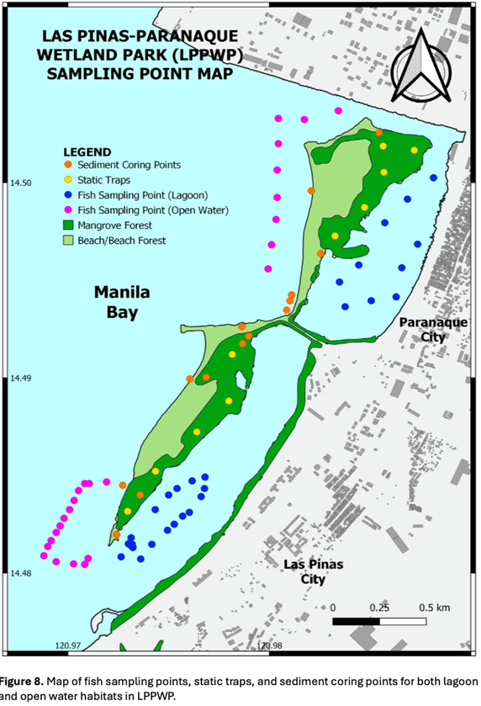
Figure 4.E.1. Map of fish sampling points, static traps, and sediment coring points for both lagoon and open water habitats in LPPWP
Threats:
- Four (4) reclamation projects are proposed / ongoing are next to the LPPWP
- Poor water quality – attributed to wastes and pollutants from the inadequate management of wastes from domestic, commercial, and industrial activities and wastewater discharges from households, industries, and commercial and institutional establishments
- Garbage deposition and pollution - only the sea waters located on the north and northeastern and southeast and southwest part are considered highly vulnerable to pollutants coming from the 3 rivers while the low elevation areas including the beaches at the western side of the 2 islands are moderately vulnerable to pollutants.
  - Garbage from the communities in Canacao Bay, Bacoor Bay, Paranaque City and Las Piñas is due to the communities using the bays along the river as dumping ground, it gets pushed and deposited to the beaches of LPPWP through the sea water current
- Four capture methods used by communities – Gill Net (Tibog), Seine Net (Hatak / dala), Gill Net (Lambat), Nylon Net / Bamboo or Steel (Bubo)
- Geologic instability – erosion due to storm surge, tsunami, typhoons, sea-level rise, flooding brought about by climate change

Annex 4.F. Summarized Tanza Marine Tree Park (TMTP) per Indicator
Mangrove Area: 30 has
Legal Status:
- In 2011, the Barangay Council of Tanza issued Ordinance No. 4, the first of its type in Metro Manila, designating the region as a "marine tree park" due to the presence of mangroves and migratory birds together.

Bio-Physical Characteristics:
- 14 mangrove species in 6 families- Aegiceras corniculatum, Avicennia lanata, Avicennia marina, Avicennia officianallis, Nypa fruticans, Rhizophora mucaronata, and Sonneratia alba
- A.marina is the most abundant representing 94% of the total mature mangroves
- Important area for migratory birds
  - 12,242 migratory bird individuals
  - Endangered species – Chinese Egret (Egretta eulophotes), Black-face Spoonbill (Platalea minor), Far-eastern Curlew (Numenius madagasceriensis), and Great Knot (Calidris tenuirostris)
- Insect species – aphids, coleopterans, Thomisidae
- Bivalves
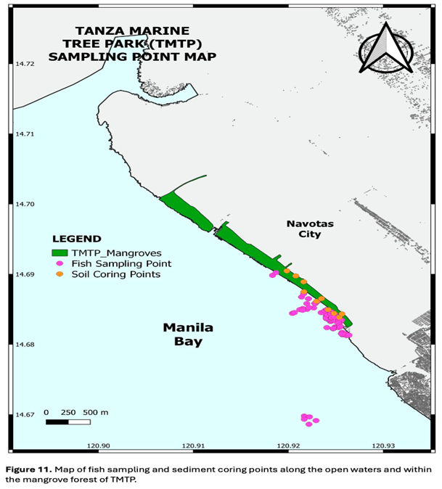
Figure 4.F.1 Map of fish sampling and sediment coring points along the open waters and within the mangrove forest of TMTP.
- Total of 57 species in 34 families recorded
  - 52 fish species: 5 crustaceans
  - Gobiidae (Goby) and Dorosomatidae (Sardinella, Shads, Lizardfish) were the most represented families among the captured fish assemblage with five (5) species each.
  - This was followed by the Ambassidae (Glassfish) with four (4) species, and Carangidae (Trevally, Jack & Queenfish), Leiognathidae (Ponyfish), and Platycephalidae (Flathead) have three (3) species representing each family.
  - Sarotherodon melanotheron was the most abundant species among the captured fish assemblage with D = 517.4 individuals per hectare (~39%). This was followed by Crenimugil seheli with D = 124.8 individuals per hectare (9%), Ambassis gymnocephalus locally known as Langaray with D = 96.9 individuals per hectare (7%), Anodontostoma sp. locally known as Talandi with D = 75.6 individuals per hectare (~6%), and Chanos chanos locally known as Bangus with D = 54.2 individuals per hectare (4%)
  - The Portunidae family (Mud Crabs & Swimmer Crabs) was the only family of crustaceans caught in TMTP and represented by five (5) species. Among these, Portunus pelagicus was the most abundant species among the captured crustacean species with D = 634 individuals per hectare (~92%). This was followed Scylla serrata with D = 34.5 individuals per hectare (5%) and an unidentified Mangrove Crab species, Scylla sp., locally known as Alimangong Bato with D = 19.7 individuals per hectare (~3%).
  - Recorded polycheates during the macrobenthic sampling, four (4) species from four (4) families were captured. This includes Telescopium telescopium (Telescope Snail) from the family Ptamididae, Umbonium vestiarium (Common Bottom Top) from the Trochidae, Perna viridis (Asian Green Mussel) from the family Mytilidae, and an unidentified clam (Ruditapes sp.) from the family Veneridae.
  - Valued at USD $102,314 ecosystem services
Table 4.F.1 List of species in TMTP.
Family | Scientific Name | English Name | Local Name | Density (indvl/ha)
Fish
Ambassidae | Ambassis  gymnocephalus | Bald Glassy | Langaray | 96.9
Ambassidae | Ambassis sp 1 | Glassfish | Langaray | 3.3
Ambassidae | Ambassis sp 2 | Glassfish | Langaray | 4.9
Ambassidae | Ambassis marianus | Estuary Glassfish | Langaray | 13.1
Anguillidae | Anguilla marmorata | Giant Mottled Eel | Palos | 1.6
Carangidae | Carangoides armatus | Long Fin Trevally | Talakitok | 3.3
Carangidae | Caranx sp | Jack / Trevally | Talakitok | 1.6
Carangidae | Scomberoides sp. | Queenfish | Lapis | 3.3
Chanidae | Chanos chanos | Milk fish | Bangus | 54.2
Cichlidae | Sarotherodon  melanotheron | Blackchin Tilapia | Tilapia Arroyo | 517.4
Cynoglossidae | Paraplagusia sp. | Tonguefish | Dapa | 19.7
Cyprinidae | Tor tambroides | Thai Mahseer | Upos | 23.0
Dorosomatidae | Saurida tumbil | Greater Lizardfish | Kalaso | 27.9
Dorosomatidae | Anodontostoma sp. | Gizzard Shad | Talandi | 75.6
Dorosomatidae | Sardinella fimbriata | Fringescale Sardinella | Tunsoy | 36.1
Dorosomatidae | Sardinella sp. | Sardinella | Tamban | 3.3
Dorosomatidae | Nematalosa nasus | Bloch's Gizzard Shad | Kabasi | 34.5
Echeneidae | Remora remora | Shark Sucker | Kumi | 1.6
Elopidae | Elops hawaiensis | Hawaiian Ladyfish | Bidbid | 8.2
Gerridae | Gerres filamentosus | Whipfin Silver-Biddy | Malakapas | 4.9
Gerridae | Gerres | Mojarra | Malakapas | 6.6
Gobiidae | Amblygobius sp. 1 | Goby | Biya | 8.2
Gobiidae | Ambyglobius sp 2 | Goby | Biya | 3.3
Gobiidae | Ambyglobius sp 3 | Goby | Biya | 4.9
Gobiidae | Glossogobius aureus | Golden Tank Goby | Biya Tabang | 29.6
Gobiidae | Oxyurichthys microlepis | Maned Goby | Talimusak | 3.3
Haemulidae | Pomadasys kaakan | Javelin Grunt | Aguot/Bakoko | 14.8
Hemiramphidae | Hyporhampus sp. | Halfbeak | Boging | 3.3
Latidae | Lates sp | Lates Perches | Ayungin | 1.6
Leiognathidae | Leignathus sp. | Ponyfish | Sapsap | 9.9
Leiognathidae | Leiognathus equula | Common Ponyfish | Sapsap | 8.2
Leiognathidae | Eubleekeria splendens | Splendid Ponyfish | Taksay | 1.6
Megalopidae | Megalops cyprinoides | Indo Pacific Tarpon | Buwan-Buwan | 9.9
Mugilidae | Crenimugil seheli | Blue Spot Mullet | Kapak | 124.8
Mugilidae | Mugil cephalus | Flathead Grey Mullet | Banak / Talilung | 11.5
Nemipteridae | Nemipterus japonicus | Japanese Threadfin Bream | Bisugo | 1.6
Platycephalidae | Platycephalus sp. 1 | Flathead | Biyang Dapa/ Biyang Sunog | 41.1
Platycephalidae | Platycephalus indicus | Bartall Flathead | Sunog | 13.1
Platycephalidae | Platycephalus sp. 2 | Flathead | Sunog | 1.6
Pleuronectiformes | Pleuronectiformes sp. | Flounder | Dapa | 13.1
Polynemidae | Eleutheronema tetradactylum | Fourfinger Threadfin | Bikaw | 11.5
Scatophagidae | Scatophagus argus | Spotted Scat | Kitang | 4.9
Sciaenidae | Johnius belangerii | Belanger's Croaker | Alakaak | 3.3
Scombridae | Rastrelliger brachysoma | Short-bodied Mackerel / Short  Mackerel | Hasa/Hasa-Hasa | 4.9
Serranidae | Epinephelus sp. | Grouper | Lapu-Lapu | 1.6
Siganidae | Siganus spp. | Spinefoot / Rabbitfish | Danggit | 1.6
Sillaginidae | Sillago sihama | Silver sillago | Asohos | 3.3
Sphyraenidae | Sphyraena sp. | Barracuda | Barracuda | 1.6
Terapontidae | Terapon jarbua | Crescent Grunter/ Crescent Perch | Baga-ong | 6.6
Terapontidae | Pelates quadrilineatus | Four-lined Terapon | Babansi | 1.6
Tetraodontidae | Arothron sp. | Puffer | Butete | 27.9
Triacanthidae | Trixiphichthys weberi | Blacktip Tripodfish | Helicopter | 21.4
Crustacean
Portunidae | Scylla serrata | Mudcrab / mangrove crab | Alimango | 34.5
Portunidae | Potunus pelagicus | Blue crab / blue swimmer crab | Alimasag | 634.0
Portunidae | Scylla sp. | Mudcrab / mangrove crab | Alimango Bato | 19.7
Portunidae | Podophthalmus vigil | Stalk Eyed Swimmer Crab | Bultron | 1.6
Portunidae | Charybdis feriata | Crucifix crab | San Franscico | 1.6
Polychaetas
Potamididae | Telescopium telescopium | Telescope Snail | Bagongon
Mytilidae | Perna viridis | Asian Green Mussel | Tahong
Trochidae | Umbonium vestiarium | Common Button Top | Common Button Top
Veneridae | Ruditapes sp | Clam | Halaan
Threats/Risks:
- Susceptible to over-exploitation
  - Four capture methods used by communities – Gill Net (Tibog), Seine Net (Hatak/dala), Gill Net (Lambat), Nylon Net / Bamboo or Steel (Bubo)
  - Garbage deposition and pollution from nearby Manila dumpsite
  - Charcoal – making of mangrove trees
  - Fauna hunted for food by informal settlers

