“Been there, done that, and yet things have gotten worse somewhat”
An Update on the Philippine Coastal and Marine Policy and Governance Set-up
Elpidio Ven Peria*
Society for the Conservation of Philippine Wetlands, Inc. (SCPW), Unit 208 Grand Emerald Tower, F. Ortigas Jr cor. Garnet St., Ortigas Center, Pasig. 1605 Metro Manila
*corresponding author: pingperia16@gmail.com
Abstract
The Philippines from the year 2000 to 2023 has shown an unsteady economic growth pattern even if it still fared comparatively well vis-à-vis the global trend. Notwithstanding this, a well-developed set of policies, institutions, regulatory agencies, and administrative arrangements were implemented through the NTDA 1.0 recommendations on pollution and water-related issues, aquatic and marine resources conservation and sustainable utilization and the integration of land care and coastal management, with the exception of the establishment and strengthening of legal and institutional support for integrated watershed management systems, enhanced management of the surface and groundwater resources and the prioritization of water conservation and the regeneration of degraded water reservoirs. Through the years, the Philippines has steadily taken on commitments under various international agreements on fisheries, biodiversity, marine pollution, climate change and the UN process on the Sustainable Development Goals (SDGs) while also engaging actively with various transboundary governance arrangements in Southeast Asia. In spite of these established institutional frameworks and arrangements, its effectiveness has been limited as borne out by the findings of the other thematic areas on ecosystems, land-based pollution and fisheries and this is occurring in the midst of heightened exposure to the impacts of climate and natural hazards. The assessment reveals medium risks in policy completeness, with very low risks in integration and engagement while key governance challenges include weak enforcement, competing commitments for coastal and marine conservation reliance on external funding for sustainability, and socio-economic pressures driving destructive practices. This makes imperative the urgent need for strengthened and consistent implementation, enhanced inter-agency coordination, community empowerment, and sustainable financing that could be integrated into a coherent strategic action programme anchored on regional cooperation taking into account current international biodiversity and climate targets and the SDGs.
Keywords: Administrative arrangements, transboundary governance, enhanced inter-agency coordination, strengthened and consistent implementation

Graphical Abstract
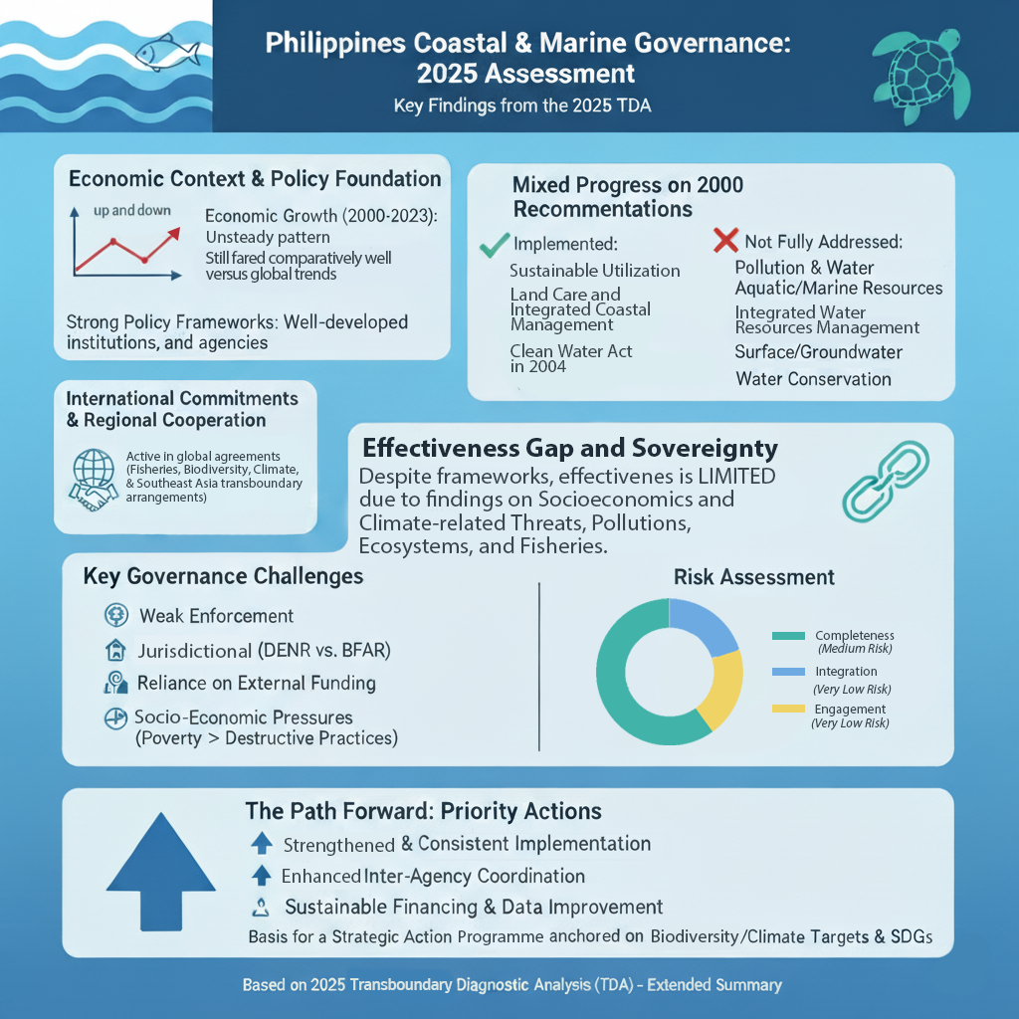

6. Governance
There was some degree of optimism back in the year 2000 when the first transboundary diagnostic analysis (NTDA 1.0) for the Philippines was prepared and there was an anticipated paradigm shift in views towards improved environmental management in general and in integrated coastal zone management (ICZM) arena. This was eventually carried out by a flurry of movement policy-wise on matters relating to coastal and marine resources management including land-based pollution which proceeded to the establishment of comprehensive measures on clean water, clean air, protected areas, fisheries and later integrated coastal management.
The true test of effective governance lies in whether all the institutional mechanisms and practices that were developed delivered on their supposed objectives and policy declarations. From the various thematic areas in previous chapters, it appears the supposed outcomes on healthy ecosystems and fishery resources have not really occurred, and they face the prospect of being further degraded, even diminished further with the intensifying threat of climate and natural hazards. What is important then is to have a further examination of what might be needed, even at the level of regional cooperation and the application of useful international frameworks, so that the supposed meaningful vision of a healthy and vital coastal and marine ecosystem will still be realized, if all the institutional players in the entire governance infrastructure do their part and just continue to work on the things that need to be done, without further short-cuts or exemptions or let-up, then the continued degradation of coastal and marine ecosystems including land-based pollution that have been well-documented in other thematic areas might as well pause and instead proceed into steady and continued recovery.

6.1 Key Findings
This report on Governance tracks the key recommendations on legislation and policies from the 2000 Transboundary Diagnostic Analysis (UNEP, 2000) and updates them for this 2025 assessment:
- On pollution in water-related issues, NTDA 1.0 for the Philippines recommended to establish legal and institutional mechanisms for environmental monitoring and compliance systems with public and private sector participation, implementation of programmatic environmental impact assessments for pollution abatement and use of market and non-market based interventions These are now addressed by the Clean Water Act in 2004 although in 2025 the NTDA 2.0 recommends for the strengthened implementation of said law in terms of enforcement and funding.
- On the improvement of water quality, NTDA 1.0 for the Philippines recommended for the strengthening of legal and institutional support for integrated watershed management systems, for enhanced management of the surface and groundwater resources and the prioritization of water conservation and the regeneration of degraded water reservoirs and improving the water resources development boards at the local, regional and national levels. These recommendations were largely not acted upon but are now presented in a comprehensive proposal for a Department of Water Resources for consideration and implementation.
- On the over-exploitation of the living aquatic resources and promoting its sustainable utilization, proposals included the institutionalization of inter-agency action programmes on aquatic and marine resources conservation and management while stimulating public and private sector cooperation through national and regional fisheries management councils and harmonizing social and economic incentives. These are now established through the Fisheries Code, and the Wildlife Act to protect dugong and marine turtles under the DENR’s Biodiversity Management Bureau which was reinforced by legislation established for protected areas through the National Integrated Protected Areas Act passed in 1992 but expanded in 2018 through the Expanded National Integrated Protected Areas Act.
- On the matter of land care and integrated coastal management, the DENR was recommended to be the lead agency to integrate land care, i.e., agriculture and watershed management and integrated coastal management and to enact appropriate land use and coastal zonation plans for all municipalities. This is now carried out through Executive Order 533.
Further, the various thematic areas of the 2025 TDA showed some key governance findings:
The SOCIO-ECONOMICS thematic area (Agaton and Ancheta, 2025) underscored the need for well-trained people who will explore smart solutions supported by well-capacitated stakeholders including the necessity of having clear guidelines that will strengthen legislative-executive support for sustainable efforts as to how different sectors should contribute to reaching the required indicators for sustainable development and in all of these to increase network-building and partnerships such that all relevant communities could be involved.
The LAND-BASED POLLUTION thematic area (Promentilla and Aguila, 2025) noted that significant gaps remain in the implementation, enforcement and monitoring of infrastructure development while also noting institutional fragmentation of implementation by identified agencies in the Clean Water Act of their mandated roles, limited funding for infrastructure, and inconsistent enforcement of discharge standards continue to hamper effective domestic wastewater management. In addressing wastewater from industrial effluents, the lead agency that will address this, the DENR still lacks a central database that aggregates effluent volumes, and pollutant loads from all regulated facilities to estimate the pollutant load reliably.
The ECOSYSTEMS (Coastal Wetlands) (Galon, 2025) thematic area identified the need for a comprehensive approach to protect the remaining mangrove and wetland resources of the country, including stronger community involvement and empowerment. The strict enforcement of the existing laws is still one of the critical activities needed to save the remaining environmental resources of the Malampaya Sound and the coastal western seaboard of the Philippines. In addition, regular monitoring of environmental resources and water quality is needed.
The ECOSYSTEMS (Coral Reefs and Seagrasses) (Felix, 2025) thematic area identified the need to strengthen legal and institutional frameworks for ecosystem-based management including the laws and institutions that guide how the coasts and oceans are managed. Connectivity across ecological corridors is also recommended, as well as standardizing monitoring protocols for corals and key wildlife across the Philippine Seas in the SCS-LME and SCS region. The local communities also need to be engaged in enforcement and stewardship with their role in monitoring fishing pressure, promoting compliance, and supporting evidence-based management decisions at the local level considered necessary for effective implementation.

6.2 Current Status

6.2.1 Economic and Policy Drivers

6.2.1.1 Political and Economic Drivers
According to the World Bank 360 database (World Bank, n.d.), the annual GDP growth of the Philippines from the year 2000 to the latest year 2023 with available data, shows an unsteady up-and-down pattern but over-all it fares comparatively well vis-à-vis the global trend as seen in Figure 6.1.
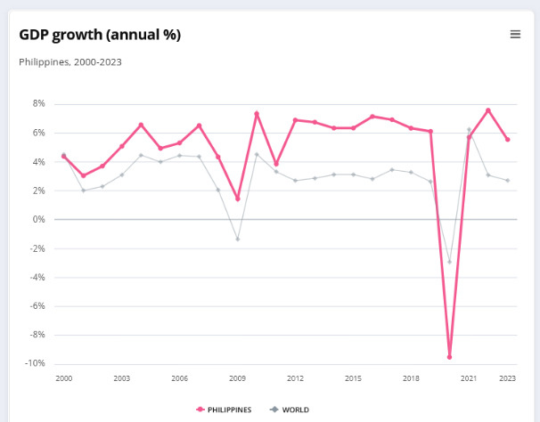
Figure 6.1 Philippine GDP growth, 2000-2023 (World Bank 360 database)
Notwithstanding that up-and-down trend above, within the same 20-year period, the Philippine GDP per capita has shown a steady upward trend, from the year 2000 to 2020 as seen in Figure 6.2 below:
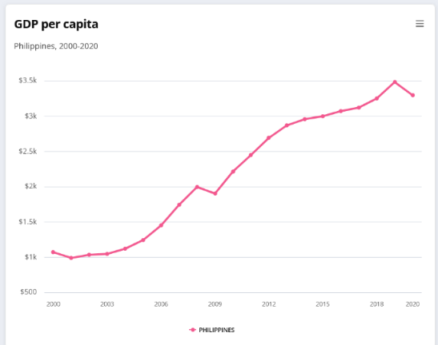
Figure 6.2 Philippine GDP per capita (World Bank 360 database)
This upward trajectory can also be seen in government revenue, as seen in Figure 6.3.
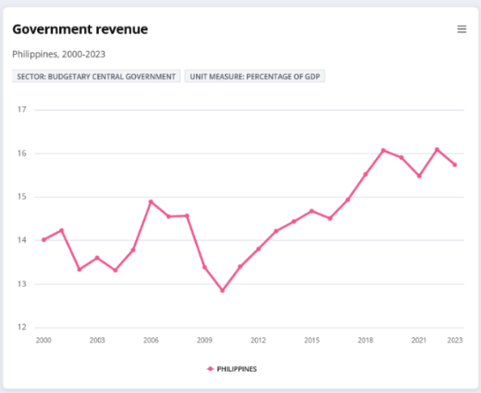
Figure 6.3. Philippine government revenue, 2000-2023 (World Bank 360 database)

6.2.1.2 National Budgetary Allocations for Coastal and Marine Resources Management
The budgetary allocations for coastal and marine management-related activities within a 10-year period (2016-2025), of key agencies tasked for these concerns, the Bureau of Fisheries and Aquatic Resources (BFAR) as well as the coastal and marine management program of the Department of Environment and Natural Resources (DENR), show stable funding, as can be seen in the Annex 6.A, Table 6.A.1 and in Figure 6.4 below. Whether these resources are adequate is something that cannot be fully determined at this time considering the many factors that need to be considered, i.e., incomplete assessment of actual need the stated priorities of the agencies and the actual challenges and difficulties in implementation that will affect the actual amount that will be needed to implement identified plans, programs and activities.
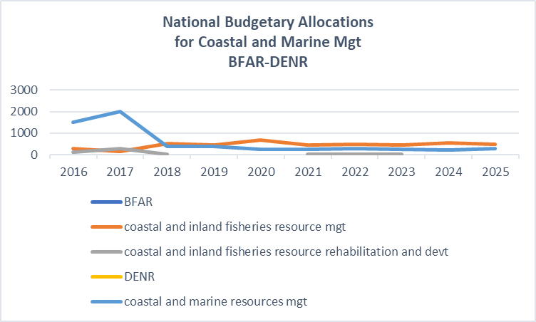
Figure 6.4. Coastal and Marine Resources Management Budgetary Allocations (General Appropriations Act 2016-2025)

6.2.2 Institutional Setting

6.2.2.1 Institutions, Regulatory Agencies, and Administrative Arrangements
The Department of Environment and Natural Resources is mandated under Executive Order 533 issued by the Philippine President in 2006 (Official Gazette, n.d.), to lead all concerned national agencies in the implementation of the integrated coastal management (ICM) programme and promote best practices that fall within their respective mandates. The support agencies shall identify, prepare, and provide policy guidance, and technical and resource assistance to DENR and local government units (LGUs) in the implementation of the National and Local ICM Programmes and enforcement of relevant coastal and marine policies and regulations.
On the other hand, the LGUs or sub-national governments, shall act as the frontline agencies in the formulation, planning and implementation of ICM programmes that shall be in line with the National ICM Programme (Ibid.).
The Fisheries Code passed by the Philippine Congress in 1998 has provided for Fisheries and Aquatic Resources Management Councils (FARMCs) to be established at the national level and in all municipalities/cities abutting municipal waters. The FARMCs shall be formed by fisherfolk organizations/cooperatives and NGOs in the locality and be assisted by the LGUs and other government entities (DA-BFAR, n.d.). The FARMCs are also organized up to the barangay level.
The LGUs, as provided by the Local Government Code (DILG, n.d.), possess a wide degree of latitude in enacting ordinances on coastal resources management using the general welfare clause, which authorizes the local government units to enact ordinances for the good of the municipality and its inhabitants (Supreme Court of the Philippines, 2004).
The BFAR has recently issued an administrative order setting up Fisheries Management Areas (FMAs) (DA-BFAR, 2021) to manage the straddling and shared fish stocks within the FMAs, taking into account the ecosystem approach to fisheries management (EAFM) (Ibid.). A management body shall be created for each FMA which shall be the operating entity that will manage the affairs of an FMA(Ibid.).
This management body in the FMAs is envisioned to function similarly like the protected area management boards or PAMBs, a multi-sectoral body created in each protected area which may either be in the terrestrial or marine environment, vested with powers of budget allocations, approval of proposals for funding and matters relating to planning, peripheral protection and general administration of the protected area in accordance with the general management strategy, among others.(DENR, 2002).
The country’s efforts on implementing the SDGs and particularly in SDG 6.5.1 on Integrated Water Resources Management is in Annex 6.H: Supplementary Material A.

6.2.2.2 Informal Arrangements and Structures
These informal arrangements and structures are understood to be the ways which enable communities to manage their coastal and marine resources using their indigenous and customary ways of doing things which may or may not be documented and are often associated with how their local ecological knowledge or indigenous knowledge systems.
In the island of Coron, one of the project sites in Palawan, the indigenous cultural community, the Tagbanuas, who are engaged in traditional fishing practices within their ancestral waters in the context of sacred marine areas or panya’an which is similar to fish sanctuaries. They are also dependent on fishing, hunting and foraging (Capistrano, 2010). The Calamian Tagbanua homeland was once host to rich, diverse, unique and ecologically intact marine and terrestrial ecosystems but the onslaught of dynamite and cyanide fishing have now reduced their coral systems to rubble (De Vera and Zingapan, 2007). Then in the early 1970s, the municipal government of Coron seized all the clan caves in Coron Island and auctioned them off (subasta) to raise revenue for the municipal treasury, and the Tagbanuas of Coron Island were reduced from being owners and sellers to gatherers paid for their labor. The Tagbanuas slipped into further misery, when the municipal government auctioned off tax declarations which had lapsed with their payments to tourist resort developers, real estate agents, and the like (Ibid.).
The Tagbanuas organized and filed an application for a Certificate of Ancestral Domain Claim or CADC with the DENR which was approved in 1998 by then DENR Secretary Victor O. Ramos, consisting of 22,400 hectares of land and waters. In 2002, the National Commission on Indigenous Peoples (NCIP) converted the Tagbanwa’s CADC into a Certificate of Ancestral Domain Title (CADT), and after the review and revalidation increased it to 2,236 hectares (De Vera and Zingapan, 2007). This Coron CADT was a precedent for further recognition of two other CADT claims in Northern Palawan (Ibid).

6.2.3 Legal and Policy Setting

6.2.3.1 International Legal/Policy Frameworks & Forums
Table 6.1 below shows the various international legal/policy arenas and forums to which the Philippines is a Party or has joined on the date indicated.
Table 6.1 Philippine’s Engagement with International Legal/Policy Arenas
Policy Arena/Forum | Date of PH Ratification/Accession
United Nations Convention on the Law of the Sea (UNCLOS) | Signature – 10 December 1982;  entry into force -16 Nov 1994
UNCLOS Implementing Legislations  - Philippine Baselines Act (Republic Act 9522)  - Philippine Maritime Zones Act (Republic Act 12064)  - Philippine Archipelagic Sea Lanes Act (Republic Act 12065) | Approved: March 10, 2009  Approved: November 7, 2024  Approved: November 7, 2024
Fisheries-related instruments  Agreement relating to the implementation of Part XI of the UNCLOS Convention of 10 December 1982  UN Fish Stocks Agreement  FAO Compliance Agreement  2009 FAO Agreement on Port State Measures  WTO Agreement on Fisheries Subsidies | Acceded: 23 July 1997  Acceded: 24 September 2014  Acceded: 30 May 2018  Acceded: 26 April 2018  Acceptance: 24 February 2024
Biodiversity-related instruments  Convention on Biological Diversity (CBD)  Convention on Migratory Species (CMS)  Convention on International Trade in Endangered Species of Wild Fauna and Flora (CITES)  International Treaty on Plant Genetic Resources for Food and Agriculture (ITPGRFA)  Ramsar Convention on Wetlands,  World Heritage Convention  International Plant Protection Convention  International Whaling Commission | Ratified: 8 October 1993  Ratified: 1 February 1994  Ratified: 18 August 1981  Acceded: 27 December 2006  Acceded: 8 November 1994  Ratified: 19 September 1985  Ratified: 3 December 1983  Member from 1981-1988
Maritime Pollution-related instruments  International Maritime Organization (IMO) Convention  International Convention for the Prevention of Pollution from Ships (MARPOL) and Annexes I-VI | Year joined: 1964
Climate Change-related instruments  United Nations Framework Convention on Climate Change (UNFCCC)  Kyoto Protocol  Paris Agreement | Ratified: 2 August 1994  Ratified: 20 November 2003  Ratified: 23 March 2017
Sustainable Development Goals  2030 Agenda for Sustainable Development  (UN General Assembly Resolution A/RES/70/1) | Adopted: 25 September 2015  PH joined all UN Member States in unanimously adopting the 2030 Agenda for Sustainable Development

6.2.3.2. Regional Legal/Policy Frameworks and Forums
At the ASEAN level, there is an ASEAN Working Group on the Coastal and Marine Environment, (AWGCME), that works on coastal and marine environment in coordination with the ASEAN Centre for Biodiversity (ACB) and the ASEAN Working Group on Nature Conservation and Biodiversity (AWGNCB), as well as other working groups and sectoral bodies. The AWGCME will oversee the planning, technical and implementation issues under this Strategic Priority Area, while the ASEAN Environment Ministers and the ASEAN Senior Officials on Environment will provide policy and strategic guidance for its work (ASEAN Secretariat, n.d.).
Another major ASEAN initiative of relevance to this review is the ASEAN Leaders’ Declaration on the Blue Economy (ASEAN Secretariat, 2021), issued in the middle of the pandemic, in 2021. This was further elaborated in 2023 during the Chairmanship of Indonesia, where the ASEAN Blue Economy Framework (ASEAN Secretariat, 2023) was formulated, and there, the ASEAN Blue Economy Vision was articulated.
Transboundary Arrangements
The Philippines is also active in PEMSEA, COBSEA and the Coral Triangle Initiative, in addition to this current Project, the SCS-SAP, to pursue its constant efforts to ensure the effective conservation of this coastal and marine resources.

6.2.3.3 National and Subnational Legislation and Policies
At the outset, a key document in relation to coastal ecosystems management is the 1987 Philippine Constitution, which declares that “the State shall protect the nation’s marine wealth in its archipelagic waters, territorial sea, and exclusive economic zone, and reserve its use and enjoyment exclusively to Filipino citizens” (Official Gazette, n.d.). This is further qualified by a mandate to Congress to pass a law which may “allow small-scale utilization of natural resources by Filipino citizens, as well as cooperative fish farming, with priority to subsistence fishermen and fishworkers in rivers, lakes, bays, and lagoons” (Ibid.).
The following Table 6.2 lays out the key national laws and measures addressing coastal and marine resources management, including those that address fisheries and biodiversity conservation:
Table 6.2 Legislative and Policy Measures on Coastal and Marine Conservation and Management
Legislation/Policy Measure | Subject
Fisheries Code (Republic Act 8550) 1998 | -Fisheries conservation and management
Fisheries Code amendment (Republic Act 10654) 2015 | -Address and deter IUU fishing
Executive Order No. 533 (2006) | -Established ICM as a national policy framework
National Integrated Protected Areas NIPAS Act (Republic Act 7586) 1992  And its amendment, RA 11038 in 2018 | -Established the process for setting up protected areas, including marine protected areas
As to the establishment of marine protected areas, they are included in the National Integrated Protected Areas Act (Supreme Court E-library, n.d.), amended by the Expanded National Integrated Protected Areas Act, approved in 2018 (Senate, n.d.). The Wildlife Act (Official Gazette, n.d.) approved in 2001, mandated that jurisdiction over all terrestrial plant and animal species, all turtles and tortoises and wetland species, including but not limited to crocodiles, waterbirds and all amphibians and dugong is vested with the (DENR), while the Department of Agriculture (DA) shall have jurisdiction over all declared aquatic critical habitats, all aquatic resources including but not limited to all fishes, aquatic plants, invertebrates and all marine mammals, except dugong, and in the Province of Palawan, jurisdiction over all these species vested to the Palawan Council for Sustainable Development pursuant to Republic Act No. 7611 or the Strategic Environmental Plan (SEP) for Palawan Act (PCSD, n.d.).
In the most recent iteration of the Philippine Biodiversity Strategy and Action Plan (PBSAP) 2024-2040, there is a plan to expand the country’s marine protected areas from a baseline of 3.2 million has to 35.24 million has by 2040, as shown in Figure 6.5, from the most recent consultation activity by the Biodiversity Management Bureau in Iloilo City in September 16-17, 2025 (DENR-BMB, 2025):
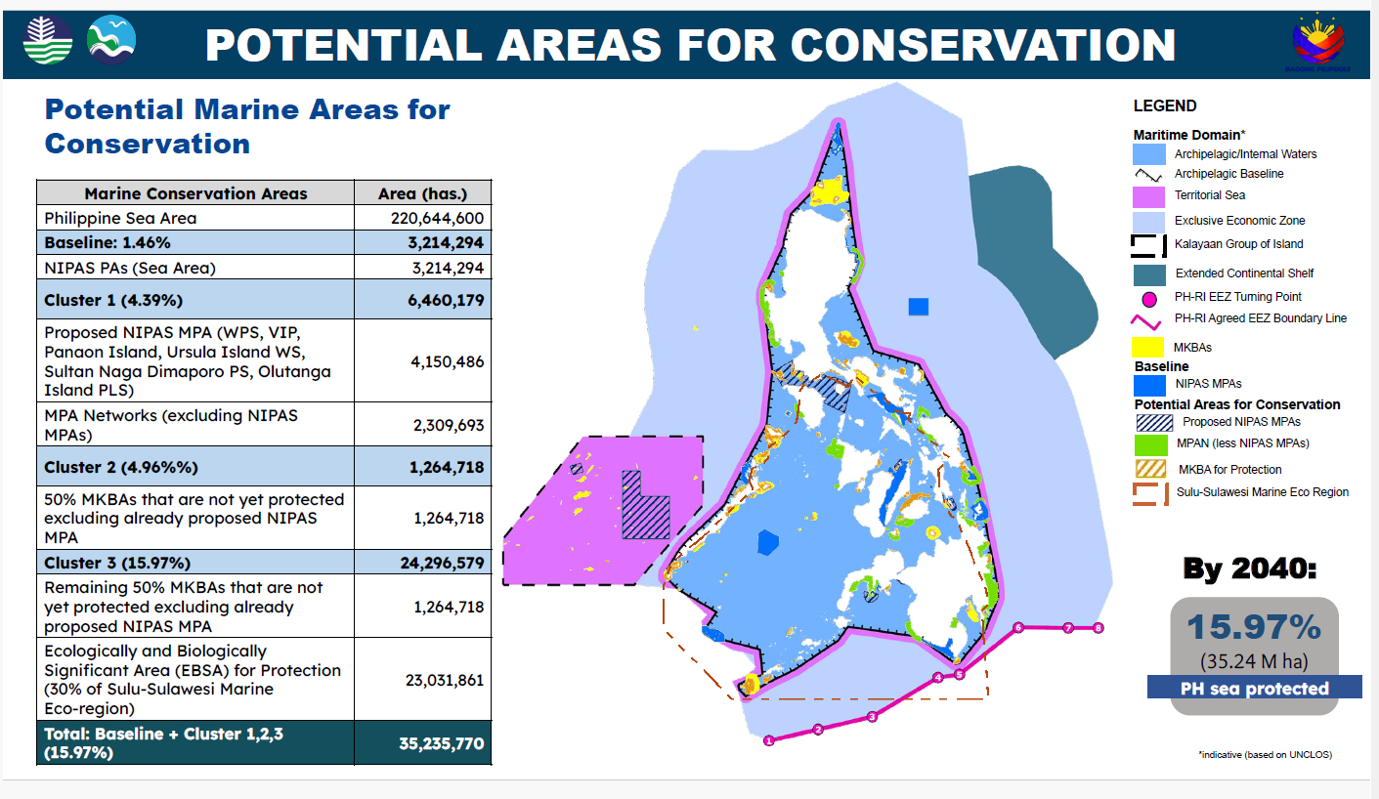
Figure 6.5. Potential Marine Areas for Conservation (DENR-BMB, 2025)
This PBSAP has also identified actions to be undertaken by key government agencies to implement the Kunming-Montreal Global Biodiversity Framework (CBD Secretariat, n.d.) which has an extensive set of targets to effectively manage these protected areas, including on marine spatial planning.
While the BFAR issued the Fisheries Administrative Order No. 263, series of 2019 (DA-BFAR, 2023), which established FMAs to realize the ecosystem-based approach to fisheries management and integrated coastal area management. The Philippine Coast Guard, by virtue of its mandate under Republic Act 9993, the Philippine Coast Guard Law of 2009, is tasked in the enforcement of laws for the protection of marine environment and resources from offshore sources or pollution within the maritime jurisdiction of the Philippines (Senate, n.d.).
In regards to land-based sources of pollution, there is the Executive Order No. 192, which empowers the Environmental Management Bureau (EMB) of the DENR to: (a) Recommend possible legislations, policies and programs for environmental management and pollution control; (b) Formulate environmental quality standards such as the quality standards for water, air, land, noise and radiations; (c) Recommend rules and regulations for environmental impact assessments and provide technical assistance for their implementation and monitoring; (d) Formulate rules and regulation for the proper disposition of solid wastes, toxic and hazardous substances (Official Gazette, n.d.)
The EMB takes charge of overseeing the implementation of the Clean Water Act, which addresses water quality management in all water bodies, primarily applying to the abatement and control of pollution from land based sources (Senate E-Library, n.d.) . There is also the recently passed Extended Producer Responsibility Act of 2022 that requires producers to be environmentally responsible throughout the life cycle of a product, especially its post-consumer or end-of-life stage (Senate of the Philippines, n.d.).
The land-based pollution thematic area report (Promentilla & Aguila, 2025) noted some persistent challenges in the following areas:
- Wastewater treatment due to rapid urbanization along coastlines and unabated infrastructure development;
- Pesticide and nutrient overloading in the country’s river systems persist due to continuing agricultural intensification;
- Plastic pollution, along with solid waste, continue to pollute the country’s waterways

All these are exacerbated by climate change, which is altering precipitation patterns, raising sea levels, and increasing the frequency of extreme weather events—all factors that influence pollutant transport and impact.
The Senate Economic Planning Office in 2023 proposed a suite of legislative measures to comprehensively address these problems, a key measure of which called for the creation of a Department of Water Resources (SEPO, 2023). A step towards this institutionalization is the establishment of the Water Resources Management Office (Official Gazette, n.d.) to be headed by an Undersecretary to be appointed by the President, upon the recommendation of the DENR Secretary.
Recently, in regard to the implementation of the ASEAN’s Blue Economy Framework recently (Aksyon Klima, 2025), the DENR laid out its key priorities for the next two years 2025-2026, and among the measures that are being eyed that relates to the blue economy include a draft policy on blue carbon to complement the Blue Economy Bill and other initiatives under the National Blue Carbon Action Partnership (NBCAP) and the creation of a blue economy database that would track the involvement of stakeholders and ongoing initiatives related to the promotion of a blue economy. The DENR also launched the NBCAP between the Zoological Society of London, UK DFID and DENR-BMB was launched in UNFCCC COP 28 in 2023 (DENR, 2023).

There are pending legislative measures on the Blue Economy and these measures will have to be passed to fully articulate the Philippine Oceans Policy, of which there was one referred to by the Philippine delegation in the recent UN Oceans Conference in Busan, South Korea (Department of Foreign Affairs, 2025).

6.2.4 Civil Society, Stakeholders and Participation

6.2.4.1 Key NGOs and Special Interest Groups
The key non-government organizations (NGOs) working on coastal and marine issues in the Philippines includes the NGOs for Fisheries Reform (NFR), composed of 12 non-government organizations which has been in existence since 1994. There is also the PAMALAKAYA-Pilipinas, a militant alliance of small fisherfolk established in 1987, with 9 regional chapters, 43 provincial chapters and over 80,000 individual members nationwide (PAMALAKAYA, n.d.). These NGOs are effective within their areas of advocacy, though in essence, not all of their concerns are immediately integrated in government policies, programs and activities as they will have to be further reviewed before they are taken on-board.
There are also area-based NGOs such as the Marine Conservation Philippines (MCP) based in Zamboanguita, Negros Oriental that uses science to understand how local and global pressures affect marine ecosystems, and they empower, engage, and build local and national capacity to reduce and adapt to these pressures, aiming for a sustainable future for the Philippine people and environment (MCP, n.d.) or the Coral Reef & Rainforest Conservation Project which implements several marine conservation projects in Siquijor Island (CRCP, n.d.). These NGOs follow the path taken by Coastal Conservation and Education Foundation, Inc., which, since 1998, helped conserve coastal and marine resources for the benefit of all coastal residents in various coastal communities in the Visayas (White, 2024).

6.2.4.2. Trade Associations and Business Groups
When Batangas Bay was identified as a national ICM demonstration site in 1994, it provided a more focused direction to the Batangas Coastal Resources Management Foundation (BCRMF), earlier established in 1991. The Foundation, organized through the efforts of the provincial governor and five of the largest companies in the province: Pilipinas Shell, Caltex Philippines, Chemphil Albright Philippines, AG&P Inc., and General Milling Corporation, provided supporting funds, staff, and other logistical support for the implementation of the ICM program, covering such activities as public awareness, coastal cleanups, coral reef rehabilitation, and monitoring of environmental changes in Batangas Bay (PEMSEA, 2023).

6.2.5 Governance Performance and Effectiveness
Good governance is about adhering to principles of participation, transparency, accountability, equity, and coordination. At the national level, an assessment of existing governance arrangements and processes was undertaken to identify whether they are consistent with accepted institutional norms and practices (i.e., architecture, process, engagement):
- Governance architecture – there are institutional arrangements in place, established formally by law, particularly the Water Quality Management Area (WQMA) Governing Board for clean water, as well as the Airshed Governing Board for air pollution. For coastal and marine resources management, there’s the FARMC framework which starts at the national level and at various levels which is now updated into FMA which should act like a protected area management board (PAMB) that is the main mechanism established for biodiversity conservation and management at the local level.
These structures can also be replicated at the local government level whenever there’s political acceptance for it, thus a similar local-level WQMA Governing Board, or a PAMB may also be recreated. This is possible because of the inherent power accorded to the local government unit to establish similar governance structures.
The problem arises when these established local government structures that are similar to the national-level institutional arrangements make decisions that do not take into account the national-level bodies’ decisions or guiding parameters for effective conservation and management efforts either due to lack of capacity, funding or political will. This is not limited to an issue of communication but of effectively considering each other’s initiatives that will need to be considered when local decisions are to be made. Truly, Mahon and Fanning’s point on what “coordination” means, which involves communication and some mutual adjustment of activities among multiple existing decision-making centers as well as “integration”, which means a deliberate process to combine or link diverse, often fragmented, sectoral plans and policies into a single, cohesive, holistic framework for comprehensive management, is illustrated starkly in the case of the Philippines where the proliferation of local parallel governance structures are not coordinated or integrated with the nationally-established governance structures.
This propensity of institutional structures to be also replicated down to the local government level but not having the capacity and the means to address the concerns of coastal and marine resources management and land-based pollution at their level also leads to a fragmentation of implementation efforts that are apparent in how certain issues like land-based pollution, are addressed, but actually failing to achieve the desired outcomes
- Coverage of the full set of issues – the legislation setting up these governance entities have identified the responsibilities for the full range of issues, including at the local level. While it is feasible that the locally-organized governance structures may also deal with the full set of these concerns, the issue arises whether they have the requisite capacity to fully implement the identified measures to address coastal and marine resources management and pollution concerns. In addition, the full set of resources, technical and administrative, to fully administer these policy measures needs to be in place.
- Coverage of the full policy cycle (data and information, formulation and provision of advice; decision-making; implementation; and review and evaluation of policy and implementation) - the full policy cycle is largely covered by all governance structures reviewed but what is missing is the continued effort to review and evaluating these policies’ effectiveness including their implementation, These governance structures and mechanisms do not have an effective mechanism for fully reviewing and evaluating its past policies and their implementation, thus there is a need to fully regularize the impact evaluation of the policies that are identified and reviewed here.

Some details of this assessment can be found in Annex 6.F.2
Effective governance is about achieving results, often measured by indicators like government effectiveness and regulatory quality (World Bank Governance Indicators). Effective governance is a component or result of good governance, as adherence to good governance principles often leads to more effective and sustainable outcomes.

An assessment was undertaken to determine whether governance practices have achieved what they were established to do (ecosystem pressure, ecosystem state, social justice, human well-being), and resulted in changes in peoples’ behavior and changes in ecosystem states. An elaboration of this can be found in an Supplementary Material 6.B while the corresponding Gap Analysis is in Annex 6.H: Supplementary Material C.

6.3 Discussion and Conclusions

6.3.1 Risk Assessment: Current Governance Capacity to Engage Stakeholders, Reduce Ecosystem Stresses, Improve or Protect Ecosystems, Achieve Socially Just Outcomes, and Improve Human Well-Being
At the national level, the Philippine’s national-level performance can be observed through broad global governance indicators:
- Environmental Performance Index (2024): The Philippines was ranked 168th out of 180 countries, with a low overall score, indicating significant environmental challenges, particularly in waste management. This suggests systemic issues that could filter down to provincial-level implementation.
- Government Effectiveness Percentile Rank: Captures the quality of public services, the capacity of the civil service, and the quality of policy formulation and implementation. The Philippines generally remains in the medium tier for government effectiveness, which suggests some strengths in its governance, but also indicates an opportunity to improve compared to other countries globally the quality of civil service and policy implementation. This would likely impact the capacity at provincial levels
- Regulatory Quality Percentile Rank: Assesses the ability of a government to formulate and implement sound policies and regulations that permit and promote private sector development. Whilst ranking in the medium tier globally, the Philippines has a generally steady ranking in its regulatory quality percentile rank over time, indicating some challenges in its national regulatory environment. Effective national regulatory quality is crucial for developing and enforcing rules that can be implemented at the provincial level, including for fisheries management and pollution
- Control of Corruption Rank: is ranked in the lower tiers, and has shown to have decreased Philippines in the last two decades
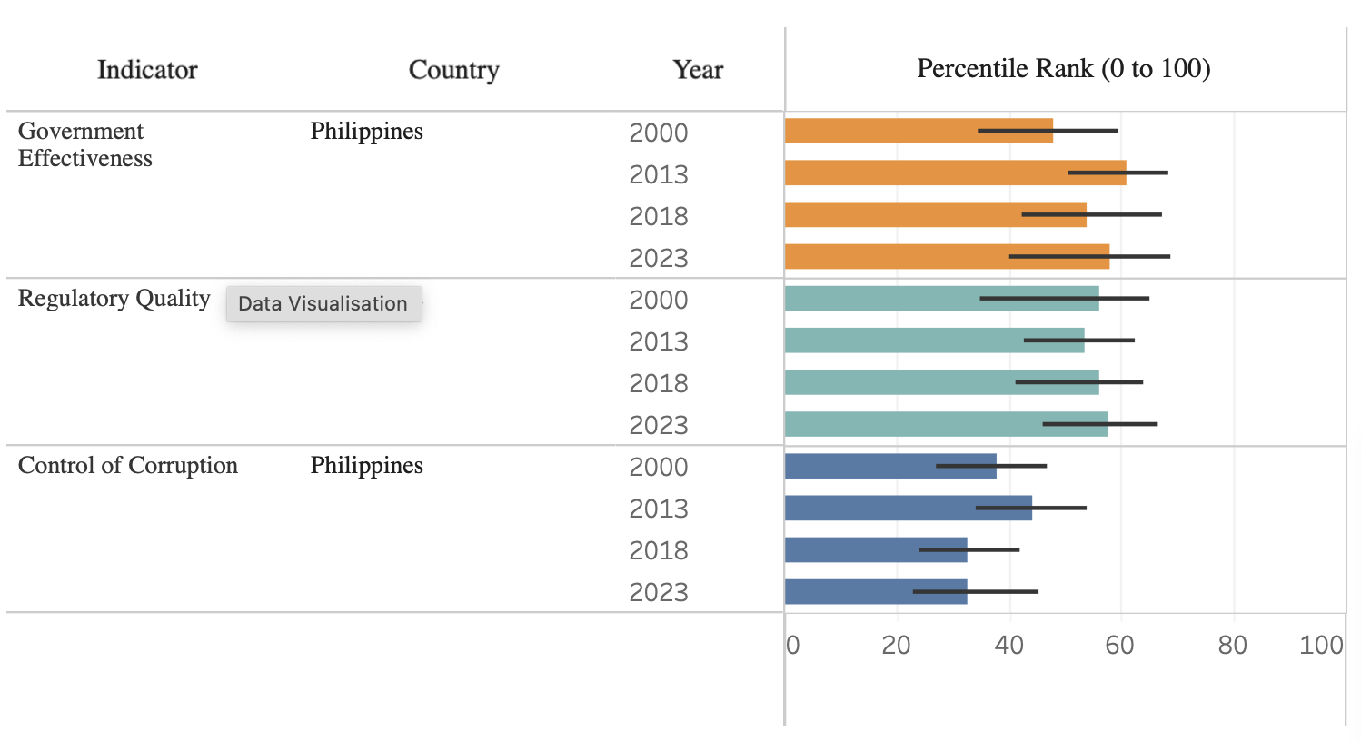
Figure 6.6. Indicators for Governance (World Governance indicators http://www.govindicators.org/)
While specific data on provincial capacity for the Philippines is not available, the assessment using the national-level governance indicators suggests that the Philippines faces challenges in its governance capacity at the provincial level within the South China Sea.
At the provincial level, the governance review undertook a consultative risk assessment of governance capacity using the Governance Architecture Risk Ranking Guide from the TWAP Assessment of LME’s (Fanning et al. 2017) to assess completeness, integration and engagement, particularly at the project site level.
The assessment drew from information collected through a questionnaire provided at the NTDA Inception Workshop in March 2025 (see Annex 6.A) to key stakeholders from the project sites, with the results of this assessment as follows: medium risk of completeness, and very low risk for integration and engagement. In comparison, the TWAP Assessment of Governance Architecture for the transboundary governance of the South China Sea of: medium risk of completeness, high risk for integration, and low risk for engagement.
The detailed results of this assessment based on the responses to the questionnaire is in Appendix 6.A.1:
Table 6.3. Governance Architecture Risk Ranking Guide (Fanning et al., 2017)
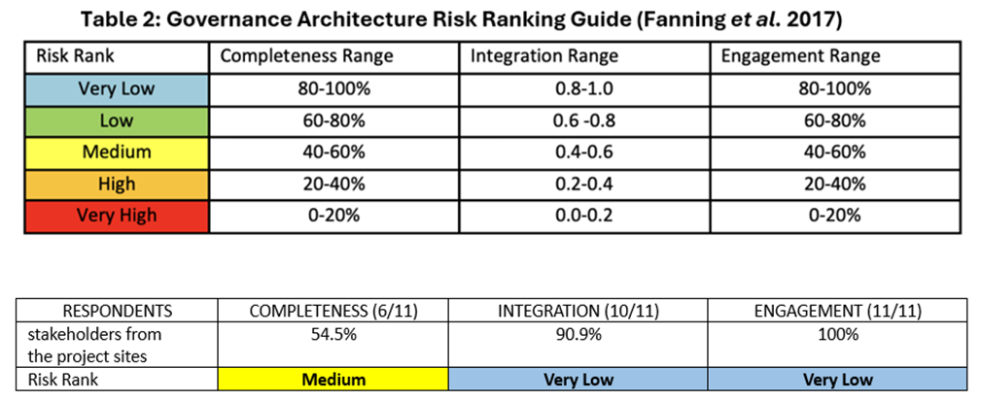

6.3.2 Current Governance Capacity to Respond to Climate and Major Environmental Changes, as well as Population Growth and Demand
There currently exists the Climate Change Commission, established by the Climate Change Act (Climate Change Commission, n.d.), which provides some capacity governance-wise, in addressing climate change and other environmental issues. The challenge lies in getting these initiatives mainstreamed in government-wide efforts considering that the Philippine President, the supposed Chair of the Climate Change Commission, has largely delegated the running of the Commission to his designated Cabinet Secretary.
The recent State of the Climate in the South-West Pacific 2024 Report showed some good news citing a case study pointing to strengthened early warning systems and Anticipatory Action in the Philippines that enabled communities to prepare and respond to the back-to-back typhoons in 2024. This helped to protect lives and livelihoods and ensure dignified, timely support for vulnerable communities (WMO, 2025).

6.3.3 Strategies to Enhance Government Responses to Climate Change and Achieve Sustainability of the Coastal and Marine Environments
The Philippine Development Plan 2023-2028 (NEDA, 2023), which is currently being updated to accord by the current administration, lays out the government’s broad-based strategy to enhance government responses to climate change and the sustainability of the coastal and marine environments. Climate change is addressed in Chapter 15 of the said Plan which seeks to accelerate climate action and strengthen the country’s disaster resilience. The promotion of the country’s coastal and marine environment is couched in terms of securing the country’s food security in Chapter 5 of the same Plan which seeks to modernize the country’s agriculture sector while emphasizing and allocating the needed resources to harness the full potential of the blue economy.

6.3.4 Recommended Priority Actions Including Regional Cooperation
Given the existence of institutional frameworks and mechanisms that address the issues identified back in the NTDA 1.0, a major effort needs to be made to make sure that the current policy and governance infrastructure and mechanisms work and deliver effective and good outcomes, starting from making sure they are funded more than sufficiently and the institutional entities that are tasked with implementation possess the appropriate capacity with the appropriate political will to carry them out given existing and forthcoming challenges.

Equally as important is a steady and consistent effort at implementing these existing policy frameworks to ensure they achieve their identified policy targets and outcomes. The government agencies and stakeholders have faced challenges to the extent that the Supreme Court, which is not generally tasked with implementing laws and policies has played a supervisor role over the government agencies to make sure they carry out their mandate, roles and responsibilities under existing laws. This is what has happened in the case of Manila Bay, which, in essence is an atypical effort at implementing specific government policies on a particular spatial area and should not in any way be touted as a best practice at government agencies coordinating their efforts over a particular subject matter.

While priority actions and recommendations for regional action are also detailed in each of the thematic chapters this review and the academic literature has identified the following challenges on which to build these priority actions and areas for regional cooperation:
- Decentralized Governance and Local Implementation: The Philippines has adopted a decentralized approach where Local Government Units are crucial in implementing marine environmental policies, particularly for Marine Protected Areas. This involves establishing legal frameworks that integrate national and local contexts (Espenilla, 2020) and fostering co-management initiatives with fishing communities (Sunderlin & Gorospe, 1997).

- Challenges in Data, Funding, and Enforcement: A consistent finding is the significant challenge of poor data collection and reporting at all levels, from municipal to national, which directly impacts the effectiveness of policy and enforcement at the provincial level (Grantham et al., 2022). Many MPAs, often managed by local governments, face budgetary constraints and lack sustainable financing (Maypa et al., 2012). There are also persistent issues with insufficient monitoring and documentation, which hinder proper management (Viability of UNCLOS amid Emerging Global Maritime Challenges, 2024).

- Institutional Capacity Gaps: While decentralization aims to enhance local autonomy, its effectiveness can be impeded by "institutional capacity gaps, political interference, and limited financial autonomy at the local government level" (Moreno & Sulasula, 2024). Overall, a critical challenge is the "persistent lack of institutional coordination and insufficient human resource capacity, particularly at provincial levels," which undermines effective policy implementation [current document].

- Localized Assessments and Progress: Despite these systemic challenges, there are instances of successful localized governance. For example, some studies assess the effectiveness of local government initiatives in specific areas, such as MPA implementation in Sarangani Province (Jama & Flores, 2024) and the Visayan Region, where higher-rated MPAs correlate with better coral reef health (Maypa et al., 2012). The importance of harmonizing policies across different governance levels and engaging local communities has been highlighted as crucial for environmental improvement in case studies like Batangas Bay (Ishii, n.d.).

The National Validation Workshop held last 12-14 November 2025 also generated governance-related recommendations as can be seen in Annex 6.G.

6.4 Methodology and Analysis
This chapter did a textual analysis of legal and policy documents and compared them with available accomplishment reports of key agencies online. National and sub-national data was collected online for analysis within the Palawan and Batangas provinces (Annex 6.B).
Glossary
- Certificate of Ancestral Domain Claim (CADC), also Certificate of Ancestral Land Claim (CALC) - refers to the land tenure instrument issued by the DENR recognizing the claim of indigenous cultural communities on land, resources and rights thereon within a defined territory.
- Certificate of Ancestral Domain Title (CADT) refers to a title formally recognizing the rights of possession and ownership of ICCs/IPs over their ancestral domains identified and delineated in accordance with R.A. No. 8371.
- Coordination involves communication and some mutual adjustment of activities among multiple existing decision-making centers. It often happens within sectors (e.g., within fisheries ministries) or at sub-regional levels. It is a necessary but often insufficient step for addressing complex, transboundary, ecosystem-based challenges
- Fisheries and Aquatic Resources Management Councils (FARMCs) – is an institutional mechanism established by the Fisheries Code formed by fisherfolk organizations/cooperatives and NGOs in the locality and assisted by the LGUs and other government entities. Before organizing FARMCs, the LGUs, NGOs, fisherfolk, and other concerned POs shall undergo consultation and orientation on the formation of FARMCs.
- Fishery Management Areas or FMAs are areas (bay, gulf, lake or others) identified by the Department of Agriculture’s Bureau of Fisheries and Aquatic Resources (DA-BFAR) as major fishing grounds based on stocks boundary/range/distribution, structure of fisheries and administrative subdivisions which integrate science-based, participatory and transparent governance framework and mechanism to sustainably manage fisheries in such areas to stop overfishing, fight illegal, unregulated and unreported fishing and promote food security and poverty alleviation in the Philippines.
- Integrated Coastal Management or ICM is a dynamic process of planning and management involving stakeholders, and requiring the analysis of the environmental and socioeconomic implications of development, the ecosystem processes, and the interrelationships among land-based and marine-related activities across jurisdictions
- Integrated Coastal Zone Management or ICZM is a resource management system which employs an integrative, holistic approach and an interactive planning process in addressing the complex management issues in the coastal area. It could serve as the blueprint for attaining the goals and objectives of sustainable development by maintaining the functional integrity of the coastal ystems, reducing resource-use conflicts, maintaining the health of the environment and facilitating the progress of multisectoral development.
- Integration is a deliberate process to combine or link diverse, often fragmented, sectoral plans and policies into a single, cohesive, holistic framework for comprehensive management (such as Integrated Ocean Management or Ecosystem-Based Management). It requires creating specific institutional mechanisms to ensure consistency across policy goals, shared vision, and effective decision-making.
- Local government units are institutional units whose fiscal, legislative and executive authority extends over the smallest geographical areas distinguished for administrative and political purposes.
Acknowledgments
The assistance and diligent work provided by the technical support team provided by the SCPW, particularly Yuijiro, Chiara, Zoisane, Daniel, Johanna, led by the always-amiable Amy, the formidable Romy and the indefatigable Sim are deeply appreciated
Author Contributions
The regional governance advisor, Megan Patricia Knight, is very much a co-author of this work, as she has patiently gone through the various drafts of this Chapter, from its initial iteration back in April 2025. This will not come out in this manner without her wise advice and sagacious suggestions.
Funding sources
The activities that enabled the validation of information organized under this Chapter and the technical staff that were critical in providing assistance to the consultants were funded from support generated by the SCPW from its regular funding partners.

Chapter 6 References
Agaton, C. and Ancheta, M.J.J. (2025). Socioeconomics and Climate-Related Threats in the Philippine Seas in the South China Sea Large Marine Ecosystem. 2025 Transboundary Diagnostic Analysis (TDA) for the Philippines, South China Sea-Strategic Action Programme.
Aksyon Klima Pilipinas (2025). Notes on the DENR CSO Consultation meeting, 13 May 2025
Aquino, A.P.& Correa, A.B.D. (2014). Executive Order No. 533: Integrated Coastal Management Policy. FFTC Agricultural Policy Platform (FFTC-AP). https://ap.fftc.org.tw/article/716
Arceo, H.O., Velos, M.J.P., Nuñez, M.A.C. and Aliño, P.M. (Eds.). (2024). The West Philippine Sea: State of the Coasts. University of the Philippines Marine Science Institute, Diliman, Quezon City, Philippines. 208pp. https://pcsd.gov.ph/wp-content/uploads/2024/07/WPS-SOC-2024-Full-Report-ebook-144dpi-2.pdf
ASEAN Secretariat (2025). ASEAN Environmental Initiatives and Climate Actions: Teatime with ASEAN: ASEAN-UN Briefing to Strengthen Regional Cooperation. Episode 2. February 13, 2025. https://www.unescap.org/sites/default/d8files/event-documents/003_PPT%20on%20ASEAN%20Environmental%20Initiatives%20and%20Climate%20Actions%20%28ASEAN-UN%20Teatime%29.pdf
ASEAN Secretariat (2023). ASEAN Blue Economy Framework. https://asean.org/wp-content/uploads/2023/09/ASEAN-Blue-Economy-Framework.pdf#:~:text=Implement%20integrated%20marine%20ecosystem%20management%20policies.%20To,the%20environment%20from%20harm%20and%20ecosystem%20degradation.
ASEAN Secretariat (2021). ASEAN Leaders’ Declaration on the Blue Economy. https://asean.org/wp-content/uploads/2021/10/4.-ASEAN-Leaders-Declaration-on-the-Blue-Economy-Final.pdf
ASEAN Secretariat (n.d.) About ASEAN Coastal and Marine Environment. https://environment.asean.org/coastal-and-marine-environment/about
Bacal, J., & Garcia, R. (2024). Proposed Coastal Resource Management Program for An Island Municipality. https://research.lpubatangas.edu.ph/wp- content/uploads/2024/08/12.-APJMSD-2024-15.pdf
Batongbacal, J. (2024). Policies on Coastal and Marine Resources. Chapter 1.12 in Arceo, H.O., Velos, M.J.P., Nuñez, M.A.C. and Aliño, P.M. (Eds.). (2024). The West Philippine Sea: State of the Coasts. University of the Philippines Marine Science Institute, Diliman, Quezon City, Philippines. 208pp. https://pcsd.gov.ph/wp-content/uploads/2024/07/WPS-SOC-2024-Full-Report-ebook-144dpi-2.pdf
BIOFIN (n.d.). BIOFIN. About Us. https://www.biofin.org/about-us
BIOFIN [2] (n.d.). BIOFIN. Philippines. https://www.biofin.org/philippines
Brown, D., Staples, D. and Funge-Smith, S. (2005), Mainstreaming fisheries co-management
in the Asia-Pacific. Paper prepared for the APFIC Regional Workshop on Mainstreaming Fisheries Co-management in Asia-Pacific Siem Reap, Cambodia 9-12 August 2005. https://openknowledge.fao.org/server/api/core/bitstreams/55805164-ef9f-47b7-bd95-92713d6fc1d6/content
Bulao, RJG (n.d.), The Problems of Coastal Environment and Natural Resources: The Case of the Philippines, https://www.google.com/url?sa=t&source=web&rct=j&opi=89978449&url=https://kochi.repo.nii.ac.jp/%3Faction%3Drepository_uri%26item_id%3D8627%26file_id%3D17%26file_no%3D1&ved=2ahUKEwi7ntjqm96MAxVezTgGHUO9OccQFnoECCEQAQ&usg=AOvVaw2XzHD5FugAJw6hPv76eGkb
Capistrano, R.C., (2010). Indigenous Peoples, Their Livelihoods and Fishery Rights in Canada and the Philippines: Paradoxes, Perspectives and Lessons Learned. he United Nations-Nippon Foundation Fellowship Programme 2009 – 2010. DIVISION FOR OCEAN AFFAIRS AND THE LAW OF THE SEA OFFICE OF LEGAL AFFAIRS, THE UNITED NATIONS NEW YORK, 2010. https://www.un.org/depts/los/nippon/unnff_programme_home/fellows_pages/fellows_papers/capistrano_0910_philippines.pdf
Chavez, L. (2021). With growing pressures, can the Philippines sustain its marine reserves? Mongabay, 30 June 2021. https://news.mongabay.com/2021/06/with-growing-pressures-can-the-philippines-sustain-its-marine-reserves/#:~:text=Governments%20and%20communities%20have%20recognized%20the%20importance,of%20coastal%20and%20marine%20areas%20by%202020.
CBD Secretariat (n.d.) Kunming-Montreal Global Biodiversity Framework. CBD COP Decision 15/4. https://www.cbd.int/doc/decisions/cop-15/cop-15-dec-04-en.pdf
Climate Change Commission (n.d.) Climate Change Act. Republic Act 9729. https://climate.gov.ph/public/ckfinder/userfiles/files/Knowledge/RA%209729.pdf
COBSEA (n.d.) Who We Are. https://www.unep.org/cobsea/who-we-are#:~:text=At%20the%20request%20of%20participating%20countries%2C%20the,environment%20and%20coastal%20areas%20of%20the%20region.
Coral Reef and Rainforest Conservation Project (n.d.). Research Design and Methodology. https://coralreefandrainforestconservationproject.org/coralreef/monitoring/data/
DA-BFAR (2024). Philippine IUU Fishing Assessment and Report 2023. Department of Agriculture-
Bureau of Fisheries and Aquatic Resources (DA-BFAR). Quezon City, Philippines. https://www.bfar.da.gov.ph/wp-content/uploads/2024/11/Philippine-IUU-Fishing-Assessment-Report-2023- 300dpi.pdf
DA-BFAR (2023). DA-BFAR’s FishCoRe Project Gets World Bank Approval, To Start Implementation in August, Press Release. 13 June 2023. https://www.bfar.da.gov.ph/2023/06/13/da-bfars-fishcore-project-gets-world-bank-approval-to-start-implementation-in-august/
DA-BFAR (2021). Fisheries Administrative Order No. 263, series of 2019. Establishment of Fisheries Management Areas (FMA) for the Conservation and Management of Fisheries in Philippine Waters. https://www.bfar.da.gov.ph/wp-content/uploads/2021/04/FAO-No.-263-s.-2019.pdf
DA-BFAR (2021). Republic Act 10654. https://www.bfar.da.gov.ph/wp-content/uploads/2021/04/ra10654.pdf
DA-BFAR (n.d.). The Fisheries Code of 1998. https://www.bfar.da.gov.ph/wp-content/uploads/2021/02/Philippine-Fisheries-Code-of-1998.pdf
De Vera, D. and Zingapan, K. (2017). The Ancestral Lands and Waters of the Indigenous Tagbanwa Communities of Northern Palawan. Prepared for the project “Mainstreaming Voluntary Guidelines on Governance of Tenure (VGGT): Philippines”, supported by the Food and Agriculture Organization (FAO) of the United Nations. October 2017. https://chr-observatories.uwazi.io/api/files/1589915210176lt7irghr12b.pdf
Department of Budget and Management. (2016). General Appropriations Act 2016. Republic Act 10717. https://www.dbm.gov.ph/wp-content/uploads/GAA/GAA2016/VOLUME%20II-A/DA/C.pdf
Department of Budget and Management. (2016). General Appropriations Act 2016. Republic Act 10717. https://www.dbm.gov.ph/wp-content/uploads/GAA/GAA2016/VOLUME%20II-A/DENR/DENR.pdf
Department of Budget and Management. (2017). General Appropriations Act 2017. Republic Act 10924. https://www.dbm.gov.ph/wp-content/uploads/GAA/GAA2017/VolumeI/DA/C.pdf
Department of Budget and Management. (2017). General Appropriations Act 2017. Republic Act 10924.
https://www.dbm.gov.ph/wp-content/uploads/GAA/GAA2017/VolumeI/DENR/DENR.pdf
Department of Budget and Management. (2018). General Appropriations Act 2018. Republic Act 10964. https://www.dbm.gov.ph/wp-content/uploads/GAA/GAA2018/VolumeI/DA/C.pdf
Department of Budget and Management. (2018). General Appropriations Act 2018. Republic Act 10964. https://www.dbm.gov.ph/wp-content/uploads/GAA/GAA2018/VolumeI/DENR/DENR.pdf; this is the year where the allocation for coastal and marine ecosystems management was disaggregated from conservation and protection of wildlife where in years prior, they were lumped together
Department of Budget and Management. (2019). General Appropriations Act 2019. Republic Act 11260.
https://www.dbm.gov.ph/wp-content/uploads/GAA/GAA2019/VolumeI/DA/C.pdf
Department of Budget and Management. (2019). General Appropriations Act 2019. Republic Act 11260.
https://www.dbm.gov.ph/wp-content/uploads/GAA/GAA2019/VolumeI/DENR/DENR.pdf
Department of Budget and Management. (2020). General Appropriations Act 2020. Republic Act 11465.
https://www.dbm.gov.ph/wp-content/uploads/GAA/GAA2020/VolumeI/DA/C.pdf
Department of Budget and Management. (2020). General Appropriations Act 2020. Republic Act 11465.
https://www.dbm.gov.ph/wp-content/uploads/GAA/GAA2020/VolumeI/DENR/DENR.pdf
Department of Budget and Management. (2021). General Appropriations Act 2021. Republic Act 11518.
https://www.dbm.gov.ph/wp-content/uploads/GAA/GAA2021/VolumeI/DA/C.pdf
Department of Budget and Management. (2021). General Appropriations Act 2021. Republic Act 11518.
https://www.dbm.gov.ph/wp-content/uploads/GAA/GAA2021/VolumeI/DENR/DENR.pdf
Department of Budget and Management. (2022). General Appropriations Act 2022. Republic Act 11639.
https://www.dbm.gov.ph/wp-content/uploads/GAA/GAA2022/VolumeI/DA/C.pdf
Department of Budget and Management. (2022). General Appropriations Act 2022. Republic Act 11639.
https://www.dbm.gov.ph/wp-content/uploads/GAA/GAA2022/VolumeI/DENR/DENR.pdf
Department of Budget and Management. (2023). General Appropriations Act 2023. Republic Act 11936.
https://www.dbm.gov.ph/wp-content/uploads/GAA/GAA2023/VolumeI/DA/C.pdf
Department of Budget and Management. (2023). General Appropriations Act 2023. Republic Act 11936.
https://www.dbm.gov.ph/wp-content/uploads/GAA/GAA2023/VolumeI/DENR/DENR.pdf
Department of Budget and Management. (2024). General Appropriations Act 2024. Republic Act 11975. https://www.dbm.gov.ph/wp-content/uploads/GAA/GAA2024/VolumeI/DA/C.pdf
Department of Budget and Management. (2024). General Appropriations Act 2024. Republic Act 11975.
https://www.dbm.gov.ph/wp-content/uploads/GAA/GAA2024/VolumeI/DENR/DENR.pdf
Department of Budget and Management. (2025). General Appropriations Act 2025. Republic Act 12116.
https://www.dbm.gov.ph/wp-content/uploads/GAA/GAA2025/VolumeIA/DA/C.pdf
Department of Budget and Management. (2025). General Appropriations Act 2025. Republic Act 12116.
https://www.dbm.gov.ph/wp-content/uploads/GAA/GAA2025/VolumeIA/DENR/DENR.pdf
Department of Environment and Natural Resources (2023). Philippines pushes blue economy agenda as it joins the Blue Carbon Action Partnership. Press Release. December 7, 2023. https://denr.gov.ph/news-events/philippines-pushes-blue-economy-agenda-as-it-joins-the-blue-carbon-action-partnership/
Department of Environment and Natural Resources - Biodiversity Management Bureau (DENR-BMB). (2025). PHILIPPINE BIODIVERSITY STRATEGY AND ACTION PLAN PBSAP 2024-2040 -PREPARATION OF THE 7TH NATIONAL REPORT TO THE CONVENTION ON BIOLOGICAL DIVERSITY AND REVIEW OF ENIPAS ACT, powerpoint presentation made for the Southern Luzon Cluster (Regions IV-A, IV-B & 5) 19-22 August 2025 | Hotel Centro Puerto Princesa, Palawan
Department of Environment and Natural Resources - Biodiversity Management Bureau (DENR-BMB). (2024). State of Coastal and Marine Ecosystems Report. DENR, Philippines.
Department of Environment and Natural Resources – Biodiversity Management Bureau (DENR-BMB). (2023). 2022 BMB Annual Report. https://bmb.gov.ph/wp-content/uploads/2023/10/CY-2022-BMB-Annual-Report-1.pdf
Department of Environment and Natural Resources. (2002). Department Administrative Order No. 2002-02. Establishment and Management of Community-based Program in Protected Areas. January 3, 2002. https://philchm.ph/wp-content/uploads/dao_2002-02.pdf
Department of Foreign Affairs (2025). Philippines Joins Call for Ocean Action at 10th Our Oceans Conference. Press Release. 9 May 2025. https://dfa.gov.ph/dfa-news/news-from-our-foreign-service-postsupdate/36539-philippines-joins-call-for-ocean-action-at-10th-our-oceans-conference#:~:text=SEOUL%2009%20May%202025%20%E2%80%94%20The%20Philippine,conservation%20of%20endangered%20marine%20species%2C%20among%20others.
Department of Interior and Local Government (n.d.), The Local Government Code of the Philippines. https://dilg.gov.ph/PDF_File/reports_resources/dilg-reports-resources-2016120_fce005a61a.pdf
Espenilla (2020) Area-Based Marine Protection in the Philippines Asia-Pacific Journal of Ocean Law and Policy
Grantham, Pandan, Roxas, Hitchcock (2022) Overcoming Catch Data Collection Challenges and Traceability Implementation Barriers in a Sustainable, Small-Scale Fishery Sustainability 2024 Viability of UNCLOS amid Emerging Global Maritime Challenges
House of Representatives (n.d.) House Bill No. 69. An Act Establishing a Framework for Blue Economy, Promoting Stewardship and Sustainable Development of Coastal and Marine Ecosystems and Resources. https://docs.congress.hrep.online/legisdocs/basic_19/HB00069.pdf
House of Representatives (n.d.) House Bill No. 1158. An Act Establishing a Framework for Blue Economy, Promoting Stewardship and Sustainable Development of Coastal and Marine Ecosystems and Resources, Reorganizing and Renaming the National Coast Watch System as the National Maritime Monitoring System, and Providing Funds Therefor https://docs.congress.hrep.online/legisdocs/basic_20/HB01158.pdf
Galveia, M.C. and Macusi, E.D. (2025). Management effectiveness of marine protected areas (MPAs) in the Southeastern Mindanao, Philippines. Marine Policy 174 (1). January 2025. DOI:10.1016/j.marpol.2025.106596, https://www.researchgate.net/publication/388110069_Management_effectiveness_of_marine_protected_areas_MPAs_in_the_Southeastern_Mindanao_Philippines
Inosante, A.R.A. (2025). ADB pushes for Blue Economy Act. News Release. 14 April 2025. https://www.bworldonline.com/agribusiness/2025/04/14/665591/adb-pushes-for-blue-economy-act
Ishii n.d. From Coast to Coast: Celebrating 20 Years of Transboundary Management of Our Shared Oceans Local Government Unit Initiative on Implementing Marine Protected Areas in Barangay Kamanga and Colon, Maasim Sarangani Province Jama, Flores Journal of interdisciplinary perspectives 2024
Lowry, K., White, A., Courtney, C., (2005). National and local agency roles in integrated coastal management in the Philippines. Ocean & Coastal Management. Volume 48, Issues 3–6, 2005, Pages 314-335, https://www.sciencedirect.com/science/article/abs/pii/S0964569105000621
Marine Conservation Philippines (n.d.). About Marine Conservation Philippines. https://marineconservationphilippines.org/about-marine-conservation-philippines/
Maypa, White, Caňares, Martinez, Eisma-Osorio, Aliño, Apistar (2012) Marine Protected Area Management Effectiveness: Progress and Lessons in the Philippines Coastal Management
Milne, N. and Christie, P. (2005). Financing integrated coastal management: experiences in Mabini and Tingloy, Batangas, Philippines. Ocean and Coastal Management. Vol 48, Isss 3–6, Pgs 205‐484. https://www.forest-trends.org/wpcontent/uploads/imported/Milne%2BChristie_2005_Financing%20Coastal%20Mgmt%20Philippines.pdf
Moreno, Sulasula (2024) Decentralized governance and local government management in the Zamboanga Peninsula Region, Philippines: An analytical review
National Economic Development Authority (2023). CALABARZON Regional Development Plan 2023-2028. https://pdp.neda.gov.ph/wp-content/uploads/2023/07/CALABARZON-RDP-2023-2028.pdf
National Economic Development Authority (2023). Philippine Development Plan 2023-2028. Chapter 15 Accelerate Climate Action and Strengthen Disaster Resilience,@ page 365. https://pdp.neda.gov.ph/wp-content/uploads/2023/01/PDP-2023-2028.pdf
NGOs for Fisheries Reform (NFR) (n.d.). NFR Member-Organizations. https://site.nfr.ph/our-members/
Office of the Sangguniang Panlalawigan of Palawan (2025). Provincial Ordinance No. 3646. Series of 2025. Declaration of a Fifty (50) Year Extendible Moratorium on the Issuance of Endorsements for All Large and Small Scale Mining Applications, Including Applications for Exploration Permits, Mineral Agreements and Financial or Technical Agreements, in the Province of Palawan.https://www.elacphilippines.org/wp-content/uploads/2025/04/Provincial-Ordinance-No.3646-series-of-2025-Mining-Moratorium.pdf
Official Gazette (n.d.) Sec. 2, Article XII, National Economy and Patrimony, 1987 Constitution, https://www.officialgazette.gov.ph/constitutions/1987-constitution/
Official Gazette (n.d.) Wildlife Resources Conservation and Protection Act. Republic Act 9147. https://www.officialgazette.gov.ph/2001/07/30/republic-act-no-9417/
Official Gazette (n.d.) Executive Order 22, series of 2023. Creating the Water Resources Management Office in the Department of Environment and Natural Resources. https://www.officialgazette.gov.ph/2023/04/27/executive-order-no-22-s-2023/
Official Gazette (n.d.) Executive Order 533, series of 2006. Adopting Integrated Coastal Management as a National Strategy To Ensure the Sustainable Development of the Country’s Coastal and Marine Environment and Resources and Establishing Supporting Mechanisms For Its Implementation. https://www.officialgazette.gov.ph/2006/06/06/executive-order-no-533-s-2006/
Official Gazette (n.d.) Executive Order 192, series of 1987. Providing for the Reorganization of the Department of Environment, Energy and Natural Resources, renaming it as the Department of Environment and Natural Resources, and for other Purposes. https://www.officialgazette.gov.ph/downloads/1987/06jun/19870610-EO-0192-CCA.pdf
Palawan Council for Sustainable Development (n.d.) Municipality of Busuanga ECAN Resource Management Plan 2017-2022 https://pcsd.gov.ph/wp-content/uploads/2020/12/07.-Busuanga-ECAN-Resource-Management-Plan.pdf
Palawan Council for Sustainable Development (n.d.) Strategic Environmental Plan (SEP) for Palawan Act. Republic Act 7611. https://pcsd.gov.ph/republic-act-7611/

Palawan Provincial Government. (2025). Invitation to Bid to Submit Comparative Proposals for the Coron Lagoons Waterfront Development Project. https://palawan.gov.ph/2025/03/31/invitation-to-submit-comparative-proposals-for-the-coron-lagoons-waterfront-development-project/
PAMALAKAYA (n.d.). PAMALAKAYA-PILIPINAS. National Federation of Small Fisherfolk Organizations in the Philippines. Brochure. https://peche-dev.org/IMG/pdf/pamalakaya_brochure.pdf
PEMSEA (2023). ICM Solutions for Sustainable Seas Leveraging Public-Private Sector Partnerships in ICM through Corporate Social Responsibility (CSR). https://pemsea.org/sites/default/files/2023-11/Leveraging%20Public-Private%20Sector%20Partnerships%20in%20ICM%20through%20Corporate%20Social%20Responsibility%20%28CSR%29.pdf
PEMSEA (2023). History of Philippine Engagement in PEMSEA. https://www.pemsea.org/sites/default/files/2023-11/History%20of%20the%20Philippines%E2%80%99%20Engagement%20in%20PEMSEA.pdf
PEMSEA (n.d.). Our Story. https://www.pemsea.org/index.php/our-story
Philippine Statistics Authority (2025). The Philippine Sustainable Development Goals 2024 Pace of Progress Results. https://psa.gov.ph/system/files/phdsd/2024%20SDG%20POP%20Infographics.pdf
Philippine Statistics Authority (2025). Philippine Statistics Authority (2025). 2024 Consolidated SDG Watch. https://psa.gov.ph/system/files/phdsd/2024%20Consolidated%20Watch_24Mar2025_0.pdf
Philippine Statistics Authority (2023). Provincial Product Accounts. 2023 Economic Performance. Province of Palawan. https://rssomimaropa.psa.gov.ph/system/files/infographics/2024IG-023-2023%20Economic%20Performance%20of%20the%20Province%20of%20Palawan.pdf
Philippine Statistics Authority (2020). Population Density of Batangas. https://rsso04a.psa.gov.ph/content/highlights-population-density-batangas-2020-census-population-and-housing-2020-cph#:~:text=As%20of%2001%20May%202020%2C%20the%20population,posted%20at%20934%20persons%20per%20square%20kilometer
Philippine Statistics Authority (2020). Population of Mabini. https://rsso04a.psa.gov.ph/content/highlights-municipality-mabini-population-2020-census-population-and-housing-cph#:~:text=The%20population%20of%20the%20Municipality%20of%20Mabini,than%20the%20population%20of%2044%2C391%20in%202010.
Philippine Statistics Authority (2020). Population of Palawan, Puerto Princesa and Municipalities. https://rssomimaropa.psa.gov.ph/content/highlights-population-density-palawan-and-city-puerto-princesa-2020-census-population-and https://psa.gov.ph/classification/psgc/citimuni/1705300000
Promentilla. M.A. and Aguila (2025). Philippines Land-based Pollution Report for TDA SCS-LME. 2025 Transboundary Diagnostic Analysis (TDA) for the Philippines, South China Sea-Strategic Action Programme.
Provincial Government of Batangas (2022). Provincial Development and Physical Framework Plan 2022-2030, https://drive.google.com/file/d/1sL7hUebaRbjkWSPpHjP7vji65zkIjLeT/view
Public-Private Partnership Center (2025). Summary of PPP Projects in the Pipeline. Repurposing of the existing PNOC Port at Mabini Batangas to be an Offshore Wind Integration Port (OSWIP) for the OSW Development in Batangas or Mindoro Area. Project No. 28., https://ppp.gov.ph/wp-content/uploads/2025/02/03-List-of-PPP-projects-in-the-pipeline-20250224.pdf
Quieta, J.P.S. (2025). Addressing Key Challenges in Coastal and Marine Resource Management: Establishing a Blue
Economy Framework. CPBRD Policy Brief 2025-01. Congressional Policy and Budget Research Department,
House of Representatives. https://cpbrd.congress.gov.ph/wp-content/uploads/2025/02/PB2025-01-Coastal- and- Marine-Resource-Management.pdf
Quieta, J.P.S. (2016). A Framework for an ICM Legislation. CPBRD Policy Brief 2016-03. Congressional Policy and
Budget Research Department, House of Representatives. https://cpbrd.congress.gov.ph/wp-content/uploads/2023/09/PB2016-03_ICM.pdf

Rettet den Regenwald,e.V. (2025). In solidarity with the Palawan indigenous peoples and local communities, in the Philippines, facing massive environmental degradation, in spite of the newly signed 50 years mining moratorium. Petition-letter for co-signing before August 15, 2025. https://www.regenwald.org/csl/76692b78-f383-4df4-814f-be085bec09eb/en
Reyes Jr, E. M. (2018): Island-mainland nexus: the case of the coastal livelihood of Tingloy Island and the southwestern portion of Batangas, Philippines. European Journal of Environmental Sciences, Vol. 8, No. 1, pp. 61–68 https://doi.org/10.14712/23361964.2018.9. https://karolinum.cz/data/clanek/5868/EJES_8_1_0061.pdf
Senate Economic Planning Office (2023). Senate Economic Planning Office (2023). The State of Water At a Glance. August 2023 AAG 23-03, https://web.senate.gov.ph/publications/SEPO/State%20of%20Water%20AAG_August%202023.pdf
Senate of the Philippines (n.d.) Committee Report No. 138. In substitution of S. Nos. 1993 and 2377, taking into consideration S. R. No. 81 AN ACT ESTABLISHING A FRAMEWORK FOR BLUE ECONOMY, PROMOTING STEWARDSHIP AND SUSTAINABLE DEVELOPMENT OF COASTAL AND MARINE ECOSYSTEMS AND RESOURCES. https://web.senate.gov.ph/lisdata/4277438930!.pdf
Senate of the Philippines (n.d.) Senate Bill No. 168. AN ACT ESTABLISHING A FRAMEWORK FOR BLUE ECONOMY, PROMOTING STEWARDSHIP AND SUSTAINABLE DEVELOPMENT OF COASTAL AND MARINE ECOSYSTEMS AND RESOURCES. https://web.senate.gov.ph/lisdata/4664542650!.pdf
Senate of the Philippines (n.d.) Philippine Coast Guard Law of 2009. Republic Act 9993. https://legacy.senate.gov.ph/republic_acts/ra%209993.pdf
Senate of the Philippines (n.d.) Extended Producer Responsibility Act of 2022. Republic Act 11898. https://legacy.senate.gov.ph/republic_acts/ra%2011898.pdf
Senate of the Philippines (n.d.). Expanded National Integrated Protected Areas System Act of 2018 (E-NIPAS Act). Republic Act 11038. https://legacy.senate.gov.ph/republic_acts/ra%2011038.pdf
Siry, H. Y. (2007). Making Decentralized Coastal Zone Management Work for The Southeast Asian Region: Comparative Perspectives. Division For Ocean Affairs and the Law of the Sea Office of Legal Affairs, The United Nations New York, 2007. https://www.un.org/depts/los/nippon/unnff_programme_home/fellows_pages/fellows_papers/siry_0607_indonesia.pdf
Sunderlin, Gorospe 1997 Fishers' Organizations and Modes of Co-Management: The Case of San Miguel Bay, Philippines Human Organization
Supreme Court of the Philippines (2004). Rural Bank of Makati, Inc., et.al. vs. Municipality of Makati, et.al., G.R. No. 150763, July 02, 2004. 2nd Division. https://elibrary.judiciary.gov.ph/thebookshelf/showdocs/1/45590#:~:text=The%20appellate%20court%20also%20brushed%20aside%20petitioners%27,the%20regulation%20of%20useful%20occupations%20and%20enterprises.
Supreme Court E-Library (n.d.) Clean Water Act. Republic Act 9275. https://elibrary.judiciary.gov.ph/thebookshelf/showdocs/2/11437
Supreme Court E-Library (n.d.) National Integrated Protected Areas (NIPAS) Act. Republic Act 7586. https://elibrary.judiciary.gov.ph/thebookshelf/showdocs/2/3508
UN Department of Economic and Social Affairs (n.d.) The Coral Triangle Initiative on Coral Reefs, Fisheries and Food Security (CTI-CFF). Description. https://sdgs.un.org/partnerships/coral-triangle-initiative-coral-reefs-fisheries-and-food-security-cti-cff#:~:text=In%202009%2C%20the%20six%20Coral%20Triangle%20governments,through%20a%20people%20centered%20approach%20to%20conservation
UN-Water, SDG 6.5.1 IWRM Implementation Database (Geneva: United Nations, 2023). Data from the 2021-2022 reporting cycle remains the most recent comprehensive dataset.
White, A.T. (2024), President’s Note, 2024 Annual Report, CCEF, https://www.coast.ph/wp-content/uploads/2025/03/CCEF_Annual_Report_2024_web_250404.pdf
White, A.T., Deguit, E., Jatulan, W., Eisma-Osorio L., (2006). Integrated Coastal Management in Philippine Local Governance: Evolution and Benefits. Coastal Management 34(3):287-302 September 2006. DOI:10.1080/08920750600686687, https://www.researchgate.net/publication/254966478_Integrated_Coastal_Management_in_Philippine_Local_Governance_Evolution_and_Benefits
World Meteorological Organization (2025). Ocean heat and sea-level rise threaten communities in the South-West Pacific. Press Release, 5 June 2025. https://wmo.int/news/media-centre/ocean-heat-and-sea-level-rise-threaten-communities-south-west-pacific#:~:text=The%20report%20contains%20some%20good,of%20WMO's%20top%20strategic%20priorities United Nations Environment Programme UNEP (2000). National Report of the Philippines on the Formulation of a Transboundary Diagnostic Analysis and Preliminary Framework of a Strategic Action Programme for the South China Sea. United Nations Environment Programme East Asian Seas Regional Coordinating Unit. Bangkok, Thailand
World Bank (n.d.) World Bank Group. Data 360. https://data360.worldbank.org/en/search?search=p

Chapter 6 Annexes

Annex 6.A Results from Interview Questions
Results from Interview Questions Provided to Inception Workshop Participants
- Are you aware of current policies and measures that deal with coastal and marine resources management in your area of work/operation/activity and if you are aware, can you enumerate what are they?
- Are these policies and measures complete which means they address all the issues and concerns that need to be addressed and if your answer is no, please explain.
- What are the gaps in the implementation of these policies and how do you think they need to be addressed?
Table 6.A.1. Assessment results (Current Policies and Measures and Completeness/Adequacy)
 | Respondent Type | Current Policies and Measures | Completeness/Adequacy (6/11)
1 | NGO1 | Not aware | No.
2 | NGO2 | ICM code, solid waste management ordinance, anti-plastic ordinance, sewage management ordinance | At one point, it is complete. However, some issues arise that will merit a review of the policy.
3 | NGO3 | Mabini has an existing IRR and ICM | ADEQUATE
4 | NGO4 | ICM Code | Yes
5 | LGU Coron | MPA ordinances, CLUP, Zoning Ordinance, ECAN Zones Map | Lack of MENRO as a focal person or responsible for environmental management in the LGU
6 | PNP Maritime Unit | No dumping of garbage in waterways | While policies and measures exist for managing coastal habitats and land-based pollution, they are not necessarily complete or adequate due to challenges in enforcement funding, and the transboundary nature of pollution.
7 | PNP | National laws (E-NIPAS) and local ordinance | No, there is a need to revise policies and measures
8 | Academe | ICM Code | No
9 | DENR PENRO Palawan | NIPAS (PAMP): local fishery code | Complete but needs harmonization and funding
10 | DENR CENRO | eNIPAS Act, PAMP, Municipal Fishery Code, RA9003 Fishery Code of the Philippine (amended) | It is completed; however, the implementation of the policies should be intensive.
11 | LGU Busuanga | “Establishment of the MPAs (5) Establishment of ECAN Coastal and Marine ECAN Map” | Policy Review and formulation of more comprehensive policies are still needed
12 | PGENRO Palawan | Answers to follow | Answers to follow
Table 6.A.2. (Integration, Engagement, and Interventions to Address Gaps)
 | Respondent type | Integration (10/11) | Engagement (11/11) | Interventions to Address Gap
1 | NGO1 | Not Aware | Maybe | Communication, Education and Public Awareness (CEPA)
2 | NGO2 | Yes, an inter-agency council supports this aim | Yes, consultations prior to the creation of the policy, involvement in monitoring and evaluation, feedback mechanisms | Self-policing mechanisms, group accreditation requirements, code of conduct
3 | NGO3 | Yes, through stakeholder consultations | LGU, Resort Owners, Fishing Folks, NGOs | LGU’s implementation and support
4 | NGO4 | The ICM Code of Mabini is only being implemented in Mabini. As of my knowledge there are no current agencies using this | LGU, fisherfolk, dive professionals, boatmen, Resorts Owner Association of Mabini, PNP-MG, Coast Guard, Coast Guard Auxillary, MPIF, MEP-I | Lack of LGU support, and the capabilities of the bantay-kalikasan to enforce the code. But the biggest problem is corruption of the trust fund of the ICM office.
5 | LGU Coron | There is resolution for the creation of the MENRO office. But there is still none appointed for the role. | Yes. The local community brings in to sectoral planning need for MENRO. | Appointment of MENRO in the LGU
6 | PNP Maritime Unit | Yes, policies and measures should be designed to be integrated and mutually supportive across relevant agencies, ensuring they address the same issues cohesively and avoid duplication or conflict. This means policies and measures should be designed to be compatible and not contradictory, and should be communicated effectively to all relevant parties. | Private sectors and local units | To address policy and measure gaps, interventions should focus on strengthening evidence-based approaches, promoting interdisciplinary collaboration, and ensuring equitable access and implementation
7 | PNP | Yes | LGUs SUC, local communities, national agencies and foreign stakeholder | Law enforcement gaps, inter-agency gaps and coordination gaps, there is a need to establish a robust law enforcement and coordination policies to effectively enforce relevant laws and ordinances
8 | Academe | Yes | Yes, MPA management board. Dive professionals, resort owners, fisherfolk, freedivers, boat operators | Enforcement of rules inside MPAs. Implementation of existing policies and workplans.
9 | DENR PENRO Palawan | Yes, but needs harmonization | Yes – MFI and WWF; conduct various CEPA and other behavioral change strategies in the local communities within PA
10 | DENR CENRO | Yes | Community-Based Forest Management PO of Brgy. Pansol and Brgy. Bato (Involved in the PAMP updating) | Needs intervention on the implementation of policies and measures specially in the enforcement side of the implementing agency (ex. Organization of enforcement team of MSPLS together with the related agencies within the MPA)
11 | LGU Busuanga | It should be. Some policies and prioritization still overlap with various agencies such as PCSD, DENR, BFAR, MAO, and MENRO | Women’s Youth MFARMC IP Business Sector Tourism Sector NGO specialized on Environmental Management | - All existing policies should be reviewed  - Align the policies to complement with international, national, and other relevant policies
12 | PGENRO Palawan | Answers to follow | Answers to follow | Answers to follow
Table 6.A.3 Governance Architecture Risk Ranking Guide (Fanning et al. 2017)
Risk Rank | Completeness Range | Integration Range | Engagement Range
Very Low | 80-100% | 0.8-1.0 | 80-100%
Low | 60-80% | 0.6-0.8 | 60-80%
Medium | 40-60% | 0.4-0.6 | 40-60%
High | 20-40% | 0.2-0.4 | 20-40%
Very High | 0-20% | 0.0-0.2 | 0-20%

Respondents | Completeness (6/11) | Integration (10/11) | Engagement (11/11)
Stakeholders from the project sites | 54.5% | 90.9% | 100%
Risk Rank | Medium | Very Low | Very Low

Annex 6.B SCS-SAP Project Sites
Table 6.B.1. List of SCS-SAP Project Sites
Province | Population | City/Municipality | Capital
Batangas | 2,908, 484 (PSA, 2020) |  | Batangas City
Batangas | 50, 858 (PSA, 2020) | Mabini | Batangas City
Batangas | 19, 215 (PSA, 2020) | Tingloy | Batangas City
Palawan | 939. 594 (PSA, 2020) |  | Puerto Princesa City
Palawan | 25, 617 (PSA,2020) | Busuanga | Puerto Princesa City
Palawan | 65. 855 (PSA, 2020) | Coron | Puerto Princesa City
Palawan | 83,357 (PSA, 2020)  33, 507 (PSA, 2020) | Malampaya Sound  -Taytay  -San Vicente | Puerto Princesa City

Provincial Investment Profile
- Batangas Province
Level of Economic Development
Batangas province contributes 21% to the gross domestic product of the CALABARZON region, the second biggest economic region of the country next to the National Capital Region with a gross regional domestic product (GRDP) of Php 571 billion pesos (NEDA, 2023).
Economic Structure
According to the Provincial Development and Physical Framework Plan 2022-2030 (Provincial Government of Batangas, 2022), the strategic location and positive economic climate in the Province of Batangas spurred the organization of economic activities in the province into the following three basic sectors:
- Agriculture/Fishing and Forestry;
- Industry Sector, which encompasses activities in mining and quarrying, manufacturing, construction and electricity, gas and water; and
- Services Sector.
The SCS-SAP project sites, particularly the municipality of Tingloy, identifies the island municipality’s role (Mabini, Bauan and San Pascual) as a rural settlement providing raw materials which is evident through the established market for fisheries products. This has implications on the exhaustion and the over exploitation of other fishery resources including the overworking of the fishermen (Reyes, Jr., 2018).
The municipality of Mabini, while known as a tourism hub, will soon become the site of an Offshore Wind Integration Port (OSWIP), which will play a key role in the development of offshore wind farms in the Batangas/Mindoro region (Public Private Partnership Center, 2025). The impacts of this project is still to be determined pending the usual environmental impact assessment for this project.
- Palawan Province
Level of Economic Development and Recent Updates in Economic Activities
Palawan Province, as of 2023, has a gross regional domestic product of Php 129.10 billion, with agriculture, fisheries and forestry contributing 25.2% to its 2023 economic performance (PSA, 2023). On March 5 2025, the local legislative council at the provincial level, the Sangguniang Panlalawigan, Provincial Ordinance No. 3646, set a fifty-year extendable moratorium on the issuance of endorsements for all large- and small-scale mining applications, including applications for exploration permits, mineral agreements, and financial and technical assistance agreements in the province of Palawan (Office of the Sangguniang Panlalawigan of Palawan, 2025). This moratorium may result in reduced waterway pollution that will have a positive effect on the coastal and marine ecosystems in Palawan. However, a petition signed by various local and international NGOs dated 30 May 2025 (Rettet den Regenwald, e.V, 2025) showed that this ordinance has a loophole as the moratorium will not apply to the extensions or renewal of existing mining permits or agreements that do not involve new areas. Moreover, it will allow existing mining operations to continue, encroaching on indigenous peoples’ territories, in various municipalities of Southern Palawan.
In the interest of promoting sustainable tourism in the province, the Provincial Government has recently proceeded with the commercial development of the 8.8 hectares of land located described as the Coron Lagoons Waterfront Development Project (Palawan Provincial Government, 2025).
The various investments mentioned here in the project sites, the Offshore Wind Integration Port (OSWIP) in Mabini, Batangas, and the Coron Lagoons Waterfront Development Project in Coron, Palawan, could have an outsized impact on the conservation efforts, including pollution prevention efforts that will be undertaken by the local government units in the sites.
Initiatives at the Project Sites
Since 1998 Kalikasan ng Pilipinas (KKP) has been carrying out conservation activities at Tingloy. It began with the establishment of the Mabini-Tingloy Coastal Area Development Council, a community-based, multi-sectoral, intermunicipal council (MATINGCADC) which it envisages as the one which ultimately manages the rich marine resources in the region. To ensure this further, the project reinforced the coastal law enforcer "BantayDagat" organized by the local council. "BantayDagat" patrols the municipal waters of Mabini and Tingloy every night until wide daylight to increase the level of safety and the area 's protection from illegal fishermen. Recently, the municipality designated 22.01 hectares (54.4 acres) of thriving coral reef habitat as a marine protected area (MPA), only the second MPA to be established in the municipality which helped bolster an emerging ecotourism industry (Bacal and Garcia, 2024).
In the province of Palawan, as provided by Republic Act 7611, there is institutionalized the establishment of Environmentally Critical Areas Network (ECAN) that guides the plans, programs, and projects implemented by the local governments. Thus, in the municipality of Busuanga, they have an Environmentally Critical Area Network (ECAN) Resource Management Plan 2017-2022 pursuant to this mandate (PCSD, n.d.).

Annex 6.C. Institutions and their Duties and Functions related to Governance
Table 6.C.1 List of institutions and their duties and functions related to Governance
Institution | Mandate | Linkages to Marine Governance | Legal Foundation
Department of Environment and Natural Resources (DENR) | The primary government agency responsible for: | Matters relating to conservation, management, development and proper use of coastal and marine resources  Licensing and regulation of all activities related to the above | Sec. 4, Executive Order No. 192, series of 1987
Department of Environment and Natural Resources (DENR) | The conservation, management, development and proper use of the country's environment and natural resources,
Department of Environment and Natural Resources (DENR) | The licensing and regulation of all natural resources as may be provided for by law
Department of Environment and Natural Resources (DENR) | The primary government agency responsible for the implementation and enforcement of the Clean Water Act |  | Sec. 19, Clean Water Act, RA 9275
Environmental Management Bureau (EMB) | Matters relating to environmental management & pollution control | These mandates relate to the management and maintenance of the good quality of the marine ecosystem | Sec. 16 (a) and (b), Executive Order No. 192, series of 1987
Environmental Management Bureau (EMB) | (c) Formulate environmental quality standards such as the quality standards for water, air, land, noise and radiations; |  | Sec. 16 (c), E0 192
Environmental Management Bureau (EMB) | (e) formulate rules and regulation for the proper disposition of solid wastes, toxic and  hazardous substances; |  | Sec. 16 (e), E0 192
Environmental Management Bureau (EMB) | Converted to a line bureau to lead the implementation of the Clean Water Act |  | Sec. 34, Clean Air Act (RA 8749)
Biodiversity Management Bureau | (a)establishment and management of marine parks, | Setting up of marine parks and similar protected areas | Sec. 18 (a), EO 192
Biodiversity Management Bureau | (b) formulate policies for the preservation of biological diversity, genetic resources, and endangered Philippine flora and fauna; | Setting up of marine parks and similar protected areas | Sec. 18 (b), EO 192
Bureau of Fisheries and Aquatic Resources (BFAR) | Formulate and implement a Comprehensive Fishery Research and Development Program, … aimed at increasing resource productivity, improving resource use efficiency, and ensuring the long-term sustainability of the country's fishery and aquatic resources; | These mandates relate to the utilization and belatedly, the conservation and management, of fisheries resources | Sec. 65 (e), Fisheries Code, RA 8550
Bureau of Fisheries and Aquatic Resources (BFAR) | Provide extensive development support services in all aspects of fisheries production, processing and marketing; |  | Sec. 65 (g), Fisheries Code, RA 8550
Bureau of Fisheries and Aquatic Resources (BFAR) | Formulate and implement rules and regulations for the conservation and management of straddling fish stocks, highly migratory fish stocks and threatened living marine resources |  | Sec. 65 (r), Fisheries Code, as amended by RA 10654

Annex 6.D. Legal and Institutional Mapping, and Stakeholders Related to Coastal and Marine Management
Table 6.D.1. Qualitative observation on Stakeholders’ Coastal and Marine Management
Institution | Fisheries & Livelihoods | Ecosystem-based Assessment/Marine Park Planning | Habitat | Pollution/  Nutrients | Endangered Species | Climate Change | Qualitative Observations
Department of Environment and Natural Resources (DENR) |  | x |  |  |  | x
- Environmental Management Bureau (EMB) |  |  |  | x |  |  | There are clearly delineated areas of influence and competence of the various DENR bureaus
- Biodiversity Management Bureau (BMB) |  | x | x |  | x |  | There are clearly delineated areas of influence and competence of the various DENR bureaus
- Bureau of Fisheries and Aquatic Resources (BFAR) | x | x |  |  | x |  | Because of RA 10654, BFAR’s mandate went beyond pursuit of fisheries and livelihood
Climate Change Commission |  |  |  |  |  | x | all aspects of coastal and marine management may also be addressed in the pursuit of climate change adaptation policies and measures
NGOs  - NGOs for Fisheries Reform  - PAMALAKAYA-Pilipinas | x | x | x | x | x | x | These NGOs are advocacy organizations, they whenever they will secure funding for certain tasks, they will enter those areas of influence and advocacy

Annex 6.E. Regulation Group Based on Issues
Table 6.E.1. Qualitative Observations on International Conventions, Regional Frameworks and Transboundary Agreements
No | International Conventions, Regional Agreements, Transboundary Agreements, Laws and Regulation, Plans and Action Plans | Biological Resources/Ecosystems | Pollution | Fisheries | Climate Change | Qualitative Observations
 | International Conventions
 | UNCLOS |  |  |  |  | Sec. 56 now implemented through RA 12064
 | UNCLOS Agreement on Part XI |  |  | x
 | UNCLOS Fish Stocks Agreement |  |  | x
 | FAO Compliance Agreement
 | FAO Agreement on Port State Measures
 | Convention on Biological Diversity | x | x | x | x | Through the KMGBF, CBD lets states address a broader set of issues
 | World Trade Organization |  |  | x
 | UNFCCC |  |  |  | x
 | Paris Agreement |  |  |  | x
 | Regional Frameworks/Declarations
 | ASEAN Leaders’ Declaration on the Blue Economy | x | x | x | x
 | Transboundary Agreements
 | COBSEA |  |  | x | x
 | PEMSEA |  |  | x | x
 | CTI-CFF |  |  | x | x
A | Laws and Regulations
 | Executive Order No. 533 on ICM | x | x | x | x | The EO addresses the inter-linkages among associated watersheds, estuaries and wetlands, and coastal seas, by all relevant national and local agencies.
 | Clean Water Act |  | x
 | FAO 263, series of 2019 | x |  | x |  | Institutionalizes the ecosystem approach to fisheries management (EAFM) that balance ecological well-being with human and societal well-being
B | Plans and Action Plans
 | PBSAP | x | x | x | x | The targets of KMGBF addresses all these concerns

Annex 6.F. Coastal and Marine Management Budgetary Allocations
Table 6.F.1. Coastal and Marine Budgetary Allocations for BFAR and DENR (GAA, 2016-2025)
 | 2016 | 2017 | 2018 | 2019 | 2020 | 2021 | 2022 | 2023 | 2024 | 2025
BFAR
Coastal and inland fisheries resource management plans | ₱290.1 M | ₱151.05 M | ₱534.5 M | ₱453.2 M | ₱680.7 M | ₱483.8 M | ₱487.1 M | ₱459.2 M | ₱553.2M | ₱477.8 M
Coastal and inland fisheries resource rehabilitation and development | ₱112.7 M | ₱304.05M | ₱26 M (Oplan Sagip Ludong Project) |  |  | ₱30 M (Operationalization of FMAs Program) | ₱10M  (FMAs  Program) | ₱11.132M  (FishCORE  Project)
DENR
Coastal and marine resources management | ₱1.521 B | ₱2.000B | ₱400.3 M | ₱ 388.5 M | ₱243.8M | ₱248.3 M | ₱271.8 M | ₱246.1 M | ₱216.6 | ₱292.5M
Table 6.F.2. Good Governance Assessment
Category | Sub-category indicators | Evidence | Assessment
Governance Architecture | Existence and structure of institutions | What institutional arrangements are in place for governance? | WQMA Governing Board for clean water
Governance Architecture | Agreements concluded | What institutional arrangements are in place for governance? | Airshed Governing Board for air pollution
Governance Architecture | Mechanisms for linking stages of the policy cycle | Are they formal or informal? | Established by provisions of the law
Governance Architecture | Mechanisms for integration | Are they formal or informal? | - Sec. 5 RA 9275 for WQMA Governing Board
Governance Architecture |  | Are they formal or informal? | - Sec. 9, RA 8749 for the Airshed Governing Board
Governance Architecture |  | Do they cover the full set of key issues, and do they make clear where responsibilities for implementation lie.? | The laws identified sets out action plans that address all key issues, including where responsibilities are, particularly the local government units, the private sector and other government agencies
Governance Architecture |  | Is a policy cycle in place? five key stages: data and information, formulation and provision of advice; decision-making; implementation; and review and evaluation of policy and implementation | Yes, and while it appears evaluation of the policy has not been covered, there’s a Joint Congressional Oversight Committee for the Clean Water Act (sec. 33) and for the Clean Air Act (sec. 53) to monitor the implementation of the law and review its IRR. It appears though that the reports of these Committees are not available online.
Governance Architecture |  | Are there vertical and lateral linkages between levels; from local to global? E.g. NMC | The DENR provides data to NEDA (now DEPDev) for the latter’s regular Voluntary National Reports for the achievement of the SDGs. Local bodies however are not directly connected to the bodies hearing these reports.

Table 6.F.3. Assessment of Findings of Land-based Pollution Trends from Land-based Pollution Thematic Area
Land-based Pollution Item | General Findings |  |  | Assessment
Domestic Wastewater
Sewerage and treatment |  | - Less than 15% of the Philippine population is connected to sewer systems and wastewater treatment facilities as of 2015 | - While there is no data per WQMA, the over-all trend shows the Clean Water Act’s various schemes are largely ineffective in addressing these domestic wastewater items given the data provided
BOD loading |  | - 33% of total BOD load from domestic sources  - BOD load draining to SCS – up 38% from 2000 TDA
Nutrient loading |  | - 140,000 ± 20,000 tons of nitrogen and 24,000 ± 20,000 tons of phosphorus annually to water bodies, with a significant portion eventually reaching coastal waters of the West Philippine Sea
Microbial contamination |  | - Fecal coliform (FC) levels in major urban waterways such as the Pasig River frequently exceed 105 to 106 MPN/100mL, well above the 200 MPN/100mL standard for recreational waters.  - While infrastructure developments have increased capacity to treat septage, the treatment capacity is <1 % of the wastewater volume processed daily in Metro Manila, as scaling would remain critical.
Wastewater from Industrial Effluents
 | According to the DENR-EMB (2020) National Water Quality Status Report, while industrial discharges contribute a smaller volume than agricultural and domestic sources, their environmental impact is significantly greater due to their toxic composition. Industrial effluents often contain heavy metals, oils, and hazardous chemical wastes. |  |  | While there is monitoring of this item as per the National Water Quality Status Report referred to, the assessment of its bigger environmental effect is something that needs to be done, at the national level.
Agricultural run-off
Fertilizer use | From 2000 to 2022,  nitrogen (N) use - 64 % increase  phosphorus (P) use - 224 % increase  potassium (K) use - 223 % increase |  |  | As per Clean Water Act mandate, the Department of Agriculture does not appear to have addressed this in a significant manner.
Pesticide use | Between 2000 and 2022, total pesticide use in the Philippines rose steadily from approximately 50,000 tons/year of active ingredient (a.i.) to over 85,000 tons/year, while application rates per hectare climbed from 5.8 kg a.i./ha to 15.2 kg a.i./ha (FAO, 2025).
Solid Waste and Marine Litter
Waste generation | The total municipal solid waste (MSW) in 2016 was around 40,000 tons/day nationwide (Talavera et al., 2024) compared to 37,400 tons/d in 2012. This corresponds to about 0.40 kg per capita per day. |  |  | The DENR appears to be struggling to address these concerns, through the years.
Waste composition | Biodegradable/organic waste (e.g., food and yard waste) dominates the waste stream (~50–55%) (EMB, 2019). Plastic waste is roughly 10–11% of MSW by weight, and mismanagement has become a national crisis
Plastic waste leakage | PH a as a top source of ocean plastics (e.g., ~0.75 million tons of mismanaged plastic enter the ocean each year (WB, 2021).
Hazardous Waste
 | Data from 2012-2023 showed that the peak amount of hazardous waste generated was in 2013, amounting to 8,976,955.99 tons. It has declined to a mere 238,257.92 tons in 2023. |  |  | This is one bright spot in an otherwise bleak picture of performance in all other areas.
Oil Pollution
 | Between 2000 and 2021, 467 oil spills were recorded in Philippine waters. Of these, 14 were classified as major spills (>10,000 liters), 62 as medium spills (1,000-10,000 liters), 306 as minor spills (<1,000 liters), while 85 were reported with undetermined volumes (Alea et al., 2022). |  |  | These events are usually considered “acts of God” but the clean-up and compensation for the damage caused is another item that must be further assessed.
Atmospheric Pollution
 | The majority (56%) of these air pollutants is attributed to mobile sources such as cars, motorcycles, trucks, and buses, while thirty-five percent (35%) was contributed by stationary sources such as power plants and factories. The rest (9%) were from area sources such as construction activities, open burning of solid wastes, and kaingin in the upland, among others. |  |  | Not clear from the data if the trend is increasing or decreasing

Annex 6.G. Recommendations on Governance from the National Validation Workshop, 12-14 Nov 2025
Breakout session questions:

- How do we build the capacity of LGUs towards an effective and sustained pollution control and management and ICM implementation?

- How do we ensure continuity in the efforts of national agencies and LGUs?

- What are the ways to ensure effective coordination across various agencies and various efforts in many areas in relation to pollution control and management ICM?

Key Recommendations generated from the breakout session questions:

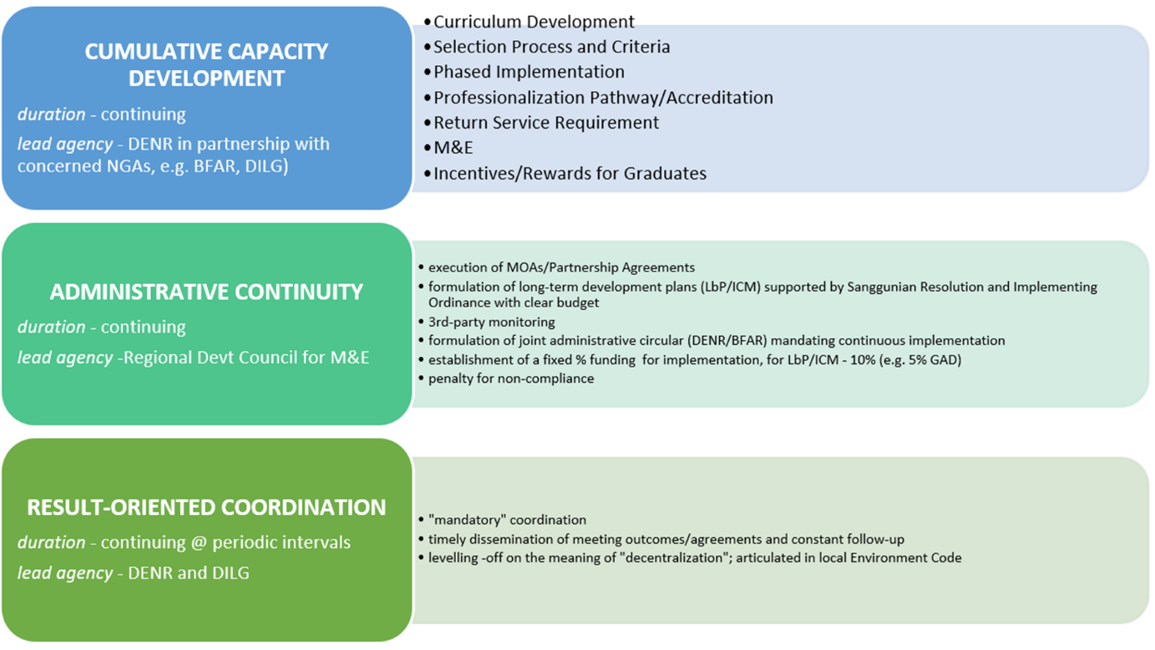

From the discussions that preceded the break-out session, it was emphasized by the participants that the capacity development efforts to enhance governance over-all should be one that may be described as CUMULATIVE where the trainings are of a continuous character preferably with the same set of participants for the duration of the capacity building effort. Then, to avoid the pitfalls commonly experienced when political leaders at the local level may have differing ideas from their predecessors who may have initiated good governance efforts, it was suggested to zero in on ADMINISTRATIVE CONTINUITY such that whatever may be the outcomes of political exercises that result in changes in political leaders, at least all the efforts initiated from previous local leaders should at least be guaranteed a higher degree of stability and build-up of implementation to ensure that whatever gains may have been secured are not set aside just because it has not been initiated by the current political leader. Finally, given that coordination between and among various local authorities including also vis-à-vis local and national authorities, the participants underlined the importance of not doing coordination for coordination’s sake but to instead have that goal-focused approach or RESULT-ORIENTED effort to it all in the interest of maximizing whatever activities that may be initiated in the area of coastal and marine management and land-based pollution.
In addition to the above recommendations shown in the graphic, there were further recommendations on fisheries and science, technology and innovation but the important area of intervention that cuts across these key recommendations above involve the matter of incentives for good behavior which range from mobilizing resources so that the good practices for coastal and resource management are sustained and these resources range from those that are available at the international level like the funds provided by the Green Climate Fund and the Fund for Responding to Loss and Damage under the UN Framework Convention on Climate Change or payments for ecosystem services which are established at the local level by resource users and affected communities. Then there is also the usual application of sanctions provided by law to erring local government units especially those that involve the misuse of public easements on coastal and foreshore sites and locations including referral to the Environmental Ombudsman.
There was also a bonus question relating to what other areas may be added for consideration in the purported adoption of a national legislative measure on the BLUE ECONOMY (as typified by House Bill No. 1158 by Rep. Benitez under the 20th Congress) and the group suggested two items: one, how to connect communities outside of protected areas; and two, how to incentivize and organize the communities such that they may be able to actively participate and be involved in all the other components of the Blue Economy.

Annex 6.H. Supplementary Materials
Progress in Sustainable Development Goals

Supplementary Material A
Progress on Sustainable Development Goals

The Philippines is on track towards meeting SDG Goal 14.5 conservation of coastal areas as well as Target 14.5.1 on establishment of marine protected areas (Philippine Statistics Authority, 2025). Although in 2020, the country reported protecting 9.7% of its seascapes, narrowly missing its commitment under the Convention on Biological Diversity’s Aichi Biodiversity Targets to protect 10% of coastal and marine areas by 2020 (Chavez, 2021)

SDG 6.5.1: Integrated Water Resources Management (IWRM)

The Philippines' progress on IWRM, which connects water management from source to sea, is crucial for coastal health. The most recent official assessment submitted to the UN-Water platform (2021 data) scored the Philippines at 51 out of 100 for IWRM implementation. (UN Water, 2023) This indicates that while the country has a foundational framework, including the National Water Resources Board (NWRB), the integration between national policies and local government implementation is not yet fully effective. The lack of a unified governing body for water remains a significant legislative hurdle to advancing integrated management.

In spite of these seemingly established frameworks and structures and apparent progress in attaining the SDG Goals, this institutional infrastructure for coastal and resource management is still constrained by a continuing lack of integrated and collaborative efforts (White, et.al., 2006), weakness in enforcement due to several factors such as resource scarcity (Milne and Christie, 2005), capacity gaps and legal hurdles such as the documented lack of training and expertise among many local enforcers, police, public prosecutors, and judges regarding the technicalities of environmental law (Galveia and Macusi, 2025), and socio-economic realities where many impoverished, small-scale fishers, engage in illegal or destructive fishing methods as a matter of survival, especially in the face of declining legal catch confirmed by a recent BFAR report on illegal, unreported and unregulated (IUU)IUU fishing where the majority of local government units reported that illegal fishing remained to be a critical challenge as there are many repeat offenders who might not have faced significant accountability or received only minor sanctions. (DA-BFAR, 2024). Underpinning all other constraints is the fundamental and chronic failure to adequately finance coastal and marine management which is a marked need and while considerable financial support has been provided by the international development community, this funding does not directly address the question of financial sustainability (Quieta, 2016),

Supplementary Material B
Assessment of Governance Effectiveness
Reduction in Ecosystem Stressors
Changes in peoples’ behavior
The land-based pollution thematic chapter did not directly measure whether any changes related to the actual behavior of people, the over-all trends in domestic wastewater, wastewater from industrial effluents, agricultural run-off, solid waste and marine litter, hazardous waste, oil pollution, including atmospheric pollution indicate a worse situation compared to the last TDA in 2000. The details of this assessment can be seen in Annex 6.A, Table 6.A.3.
Despite these findings, the updated Philippine submission on its fulfillment of the SDG Goals, points to the accomplishment of improved water quality for the indicators for dissolved oxygen and biochemical oxygen demand (Philippine Statistics Authority, 2025):
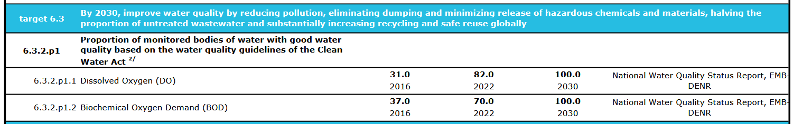Figure 6.H.1. SDG Score card in the Philippines (PSA, 2025)
Changes in Ecosystem States
The key findings of the ecosystems thematic area indicate that the overall condition of the reef ecosystems in the covered areas is considered fair, with localized recovery occurring within well-managed marine protected areas (MPAs), where coral cover has shown sustained increases between 2006 and 2022. In contrast, reefs outside MPAs remain highly degraded, particularly in areas experiencing intense fishing and tourism activities, where coral cover has declined dramatically—from above 50% in 2006 to below 30% by 2016 in some sites. One notable finding from the reef ecosystems thematic area is that climate change is an additional and escalating driver of reef degradation in these areas. Increasing sea surface temperatures, more frequent typhoons, and recurring bleaching events exacerbate existing pressures.
As to mangrove, the overall trend continues to fluctuate, where it is noted that for the last 20 years, from 2020, a negative change (-35,040 ha) was documented in 2010 with only a minimal positive change (+34,221 ha) recorded in 2020.
As to seagrasses, the entire Philippines seagrass ecosystem, where 85% of which is confined in the South China Sea, showed a 30 to 50% decline in cover over the past years, particularly from the northwestern part of the island.
As to fisheries thematic area (Garces, 2025), the key findings indicate: (i) overfishing and depletion of fish stock in coastal waters; (ii) IUU fishing; (iii) environmental degradation (pollution and coastal habitat destruction); and (iv) climate related impacts on fisheries.
These are happening amidst increasing exposure of the country to climate and natural hazards (Agaton and Ancheta, 2025).
Supplementary Material C
Gap Analysis
Gaps in Institutional Frameworks and/or in their Implementation
A major gap relates to the jurisdictional barrier between fisheries and the environment and between the DA-BFAR and DENR. The DA-BFAR’s principal competencies and resources are focused on fisheries and fisheries-related activities but do not extend to other maritime activities that impact on fishery resources, such as shipping, coastal infrastructure development, etc. The DENR meanwhile has a much broader mandate and residual powers for environmental management and resource management, but has no specifically empowered and enabled marine office, although it carries out a Coastal and Marine Ecosystems Management Program as one of other programs implemented by the DENR-BMB (Arceo, et.al, 2024).
Both the DENR and DA-BFAR have mandates to establish area management measures, but while the DA-BFAR has the power to establish fishery reserves and sanctuaries in national waters, such measures are within the purview only of the cities and municipalities within municipal waters extending 15 km from the shore. More comprehensive protected landscape and seascape areas are established through a separate multisectoral and inter-agency process managed by the DENR (Batongbacal, 2024).
The challenge in this overlap in mandate between the DENR and BFAR relates to how the two agencies may fully cooperate and mutually integrate each other’s agency priorities within their respective plans, programs and activities. The opportunity for collaboration between these two agencies lies in both agencies actively pursuing conservation efforts of the coastal and marine ecosystem through a ridge-to-reef approach while simultaneously addressing the ecosystem challenges of meeting productivity and food security concerns. The PBSAP provides the policy platform for these two agencies to weave together and coordinate their respective specific policies and measures to achieve the common targets of the KMGBF while taking steps to build the capacity of LGUs as well as local communities with the help of civil society organizations and the private sector to achieve identified achievable targets.
The fish and fisheries thematic area (Garces, 2025) recently pointed to the threat of a local court ruling affirmed by the Supreme Court in 2024 (Mercidar Fishing Corporation v. BFAR, G.R. No. 290929) which nullified the current legislative basis for limiting fishing in municipal waters to municipal fishermen, the effect of which is to let big commercial fishing operators compete with small marginalized fishermen. The problem with this is that allowing commercial vessels to operate within municipal waters jeopardizes the livelihoods of thousands of subsistence fishers and accelerates the depletion of already fragile fish stocks. The potential impacts on small-scale fishers and municipal waters may include: (i) shrinking fishing grounds of municipal fisherfolk; (ii) further depletion of fish stocks in coastal areas; (iii) exploitation or destruction of marine protected areas (MPAs) and fish sanctuaries; and (v) intensify competition over the fisheries resources between municipal fishers and commercial fishers.
Following discussions and consultation at the Philippines NTDA Inception Workshop more specific institutional gaps in relation to the project sites were identified mostly in the area of law enforcement and coordination among the various law enforcement units at the local government level. This may be addressed by appointing a local environment and natural resources officer or strengthening the law enforcement auxiliary group (the Bantay Kalikasan).
Assessment from the Policy Cycle Perspective
Existing ICM policies are in various stages of implementation and overall the governance architecture for were assessed as medium risk for completion (refer to Table 6.2).

