Graphical Abstract
Ecosystem condition and resilience in the Gulf of Thailand: An indicator-based synthesis
for integrated coastal management

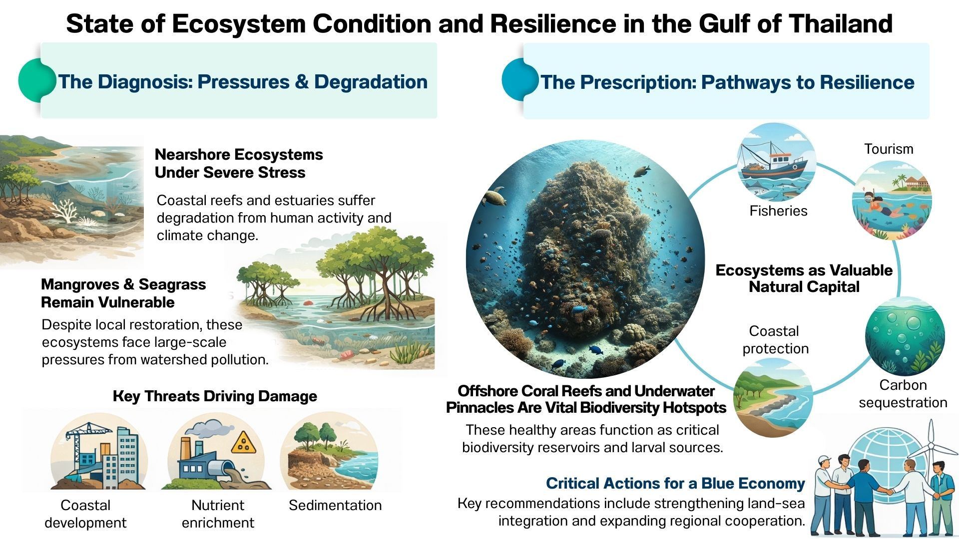
Ecosystem condition and resilience in the Gulf of Thailand: An indicator-based synthesis for integrated coastal management

Thamasak Yeemin^{a,*}, Makamas Sutthacheepª, Wichin Suebpalaª, Sittiporn Pengsakunª, Wanlaya Klinthongª, Charernmee Chamchoyª, Laongdow Jungrak^{b}, Wiphawan Aunkhongthong^{b}

ª Marine Biodiversity Research Group, Faculty of Science, Ramkhamhaeng University, Huamark, Bangkapi, Bangkok, Thailand
^{b} Association of Marine Biodiversity Conservation and Education, Department of Biology, Ramkhamhaeng University, Huamark, Bangkapi, Bangkok, Thailand

Abstract
Coastal and marine ecosystems underpin ecological integrity, economic activity, and climate regulation, but are increasingly compromised by cumulative anthropogenic pressures and climate change. This review synthesizes ecosystem indicator assessments from Thailand’s National Transboundary Diagnostic Analysis to evaluate ecosystem condition, resilience, and management responses across the Gulf of Thailand. Focusing on mangroves, coral reefs, seagrass meadows, wetlands, and biodiversity hotspots, the review integrates biophysical indicators, pressure–response dynamics, ecosystem service valuation, and institutional frameworks to derive policy-relevant insights for integrated coastal management. The synthesis reveals a pronounced spatial gradient in ecosystem condition. Offshore coral reefs and underwater pinnacles retain high ecological integrity and function as biodiversity reservoirs and larval source areas, while nearshore reefs and estuarine systems exhibit moderate to severe degradation driven by sedimentation, nutrient enrichment, coastal development, and climate stress. Mangrove and seagrass ecosystems show localized recovery associated with restoration efforts and community co-management, but remain highly vulnerable to watershed-scale pressures and fragmented institutional arrangements. Estimated ecosystem service values underscore the role of coastal ecosystems as natural capital underpinning fisheries, tourism, coastal protection, and carbon sequestration. The review highlights the value of indicator-based assessments for bridging science, policy, and finance. Strengthening land–sea integration, institutionalizing blue carbon accounting, expanding other effective area-based conservation measures, and enhancing regional cooperation emerge as critical pathways for sustaining ecosystem resilience and advancing a climate-resilient blue economy in the Gulf of Thailand and comparable tropical coastal systems.

Keywords:
Integrated coastal management; ecosystem resilience; blue carbon; indicator-based assessment; Gulf of Thailand; nature-based solutions

1. Introduction
Coastal and marine ecosystems are increasingly recognized as strategic natural assets that support biodiversity conservation, climate adaptation, disaster risk reduction, and sustainable economic development. Mangroves, coral reefs, seagrass meadows, and coastal wetlands collectively provide ecosystem services valued in the trillions of dollars globally, including fisheries production, shoreline stabilization, nutrient cycling, and carbon sequestration (Moberg & Folke, 1999; Barbier et al., 2011). Despite their importance, these ecosystems are under accelerating pressure from coastal development, land-based pollution, resource overexploitation, and climate-driven disturbances (Department of Marine and Coastal Resources, 2024a–h).
In tropical and semi-enclosed seas, such as the Gulf of Thailand (Fig. 1), cumulative impacts are particularly pronounced due to high population density, intensive coastal use, and limited hydrodynamic flushing (Department of Marine and Coastal Resources, 2024b,d,f,g). Conventional sector-based management approaches have proven insufficient to address cross-scale drivers that link watersheds, coasts, and offshore ecosystems. As a result, integrated coastal management (ICM) and ecosystem-based management (EBM) have emerged as dominant paradigms for addressing coastal sustainability challenges.
Indicator-based ecosystem assessments play a critical role in operationalizing ICM and EBM by translating complex ecological information into decision-relevant metrics. When coupled with socio-economic valuation and institutional analysis, such assessments provide a powerful bridge between science and policy. Thailand’s National Transboundary Diagnostic Analysis (TDA) offers one of the most comprehensive applications of this approach in South China Sea and Gulf of Thailand, synthesizing ecosystem condition, pressures, responses, and economic values across multiple coastal systems (Department of Marine and Coastal Resources, 2024a–h).
This review article synthesizes the ecosystem indicator assessment component of the National TDA to (1) evaluate ecosystem condition and resilience across the Gulf of Thailand, (2) identify cross-cutting pressures and management responses, and (3) extract transferable lessons for integrated coastal management and blue economy policy in tropical coastal regions.

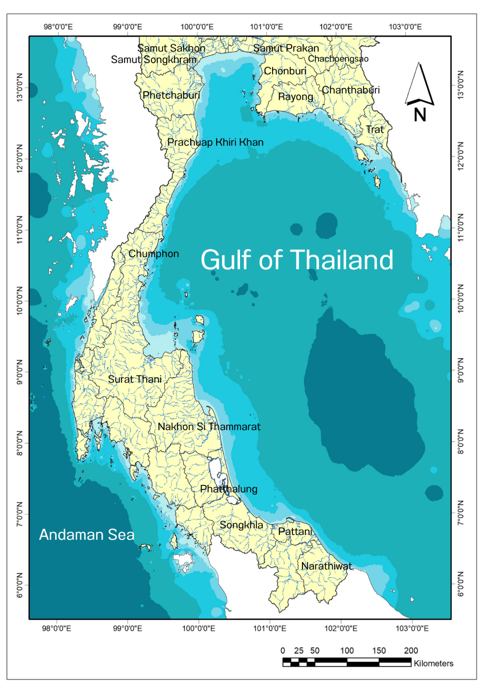
Fig. 1. Map of the Gulf of Thailand

2. Ecosystem status across indicator groups
This section synthesizes the current status of major coastal and marine ecosystems in the Gulf of Thailand using an indicator-based framework integrating ecosystem condition, pressures, ecosystem services, and management responses. Rather than treating ecosystems as isolated units, the assessment emphasizes connectivity, cumulative impacts, and resilience, reflecting the functional interdependence of mangroves, wetlands, coral reefs, seagrass meadows, and biodiversity hotspots across land–sea gradients (Department of Marine and Coastal Resources, 2024a–h).
The Gulf of Thailand is a semi-enclosed tropical sea characterized by high biological productivity, complex circulation patterns, and strong coupling between terrestrial and marine processes. Rapid coastal development, intensive aquaculture, tourism expansion, and climate-related stressors have created pronounced spatial heterogeneity in ecosystem condition. Indicator synthesis reveals a consistent pattern: offshore systems generally retain higher ecological integrity, while nearshore and estuarine systems experience chronic stress, driven primarily by land-based pressures and governance constraints (Department of Marine and Coastal Resources, 2024a–h).
To capture these dynamics, ecosystem status is reviewed across four interconnected components:
(i) mangroves and coastal wetlands,
(ii) coral reefs and underwater pinnacles,
(iii) seagrass meadows, and
(iv) biodiversity hotspots and threatened species.

2.1 Mangroves and coastal wetlands

2.1.1 Spatial extent and landscape configuration
Mangroves and coastal wetlands form the structural and functional backbone of the Gulf of Thailand’s coastal zone. Across the five focal systems, Welu River Estuary, Bandon Bay, Pak Phanang Bay, Samut Prakan Province, and Don Hoi Lot, wetlands collectively cover approximately 2,613.7 km², of which 480.7 km² (18.4%) are mangrove forests (Suk-Ueng et al., 2013; Natthasuk, 2014; Department of Marine and Coastal Resources, 2024a,b,c,d,e,g). These ecosystems occur as extensive estuarine complexes, river-mouth systems, mudflats, and remnant coastal fringes embedded within landscapes increasingly shaped by human use.
Spatial distribution reflects historical land-use trajectories and hydrological modification. Bandon Bay supports the largest contiguous mangrove system (255.7 km²), functioning as a major sediment trap and productivity hotspot linked to multiple river basins (Paw, 1988; Department of Marine and Coastal Resources, 2024c). Pak Phanang Bay (90.0 km²) retains large, relatively intact mangrove stands associated with deltaic processes and lower urban pressure (Panapitukkul et al., 1998; Department of Marine and Coastal Resources, 2024b). In contrast, Samut Prakan represents a highly transformed wetland landscape, where mangroves persist as narrow, fragmented strips adjacent to industrial and urban infrastructure (Saipattana, 2014; Yukkolthon et al., 2020; Department of Marine and Coastal Resources, 2024d). Don Hoi Lot, though smaller in extent, retains high ecological integrity due to long-standing protection and traditional management (Marine and Coastal Resources Conservation Center 2, 2015; Tan-on, 2007; Department of Marine and Coastal Resources, 2024e). (Table 1)

2.1.2 Structural condition and species diversity
Mangrove species diversity in the Gulf of Thailand remains high by global standards, with 17–30 species recorded across focal sites (Natthasuk, 2014; Suk-Ueng et al., 2013; Saipattana, 2014; Yukkolthon et al., 2020; Department of Marine and Coastal Resources, 2024a–h). Dominant taxa include Rhizophora apiculata, R. mucronata, and Avicennia alba, which provide complex root architectures critical for sediment stabilization, shoreline protection (Panapitukkul et al., 1998; Tan-on, 2007; Marine and Coastal Resources Conservation Center 2, 2015; Department of Marine and Coastal Resources, 2024b,e), and nursery habitat. Structural indicators, canopy cover, basal area, and tree height, are highest in Pak Phanang Bay and Don Hoi Lot, reflecting limited hydrological disturbance and sustained protection.
The occurrence of globally threatened mangrove taxa, Bruguiera hainesii and Sonneratia griffithii (Critically Endangered), and Heritiera fomes (Endangered), highlights the international conservation importance of these ecosystems (Department of Marine and Coastal Resources, 2024a–h). These species persist primarily in fragmented or localized populations, indicating high vulnerability to further habitat alteration. Their presence elevates Thailand’s mangrove ecosystems to international conservation importance, reinforcing the need for targeted genetic and habitat protection measures.
Soil and biomass indicators further highlight mangroves as major blue carbon reservoirs, with estimated carbon stocks ranging from 0.25 to 2 million tonnes of carbon per site, depending on extent, sediment depth, and forest maturity. These values position mangrove ecosystems as critical assets within Thailand’s climate mitigation and adaptation strategies (Department of Marine and Coastal Resources, 2024a–h) (Table 1)

2.1.3 Pressure indicators and drivers of change
Despite documented recovery in several areas, mangroves and wetlands remain subject to multiple interacting pressures. Aquaculture expansion, particularly shrimp and fish farming, has historically driven large-scale conversion in Welu River Estuary and Bandon Bay, altering hydrology and fragmenting habitat (Paw, 1988; Department of Marine and Coastal Resources, 2024a,c). Urbanization and industrial development dominate pressure profiles in Samut Prakan, where land reclamation, pollution, and infrastructure development constrain natural regeneration (Saipattana, 2014; Yukkolthon et al., 2020; Department of Marine and Coastal Resources, 2024d).
Additional pressures include:
- Nutrient and chemical runoff from agriculture and industry (Department of Marine and Coastal Resources, 2024a–h).
- Reduced sediment supply linked to upstream dams and river regulation (Department of Marine and Coastal Resources, 2024b,c,g).
- Coastal erosion and altered shoreline dynamics (Department of Marine and Coastal Resources, 2024a–h).
- Illegal harvesting and encroachment in unprotected areas (Department of Marine and Coastal Resources, 2024a–h).
- Tourism-related disturbance in sensitive mudflat systems (Tan-on, 2007; Marine and Coastal Resources Conservation Center 2, 2015; Department of Marine and Coastal Resources, 2024e,g).
These pressures operate across spatial scales and interact synergistically, often overwhelming site-level restoration efforts. Indicator trends show that mangrove recovery is most successful where hydrological connectivity and sediment supply are maintained, highlighting the importance of watershed-scale management (Department of Marine and Coastal Resources, 2024a–h). (Table 1)

2.1.4 Management responses and resilience outcomes
Thailand has made substantial progress in mangrove rehabilitation through national programs led by the Department of Marine and Coastal Resources (DMCR), restoring more than 80 km² of degraded mangroves since the mid-2010s (Department of Marine and Coastal Resources, 2024a–h). Community-based co-management initiatives in Welu River Estuary, Bandon Bay, and Don Hoi Lot have strengthened local stewardship, improved monitoring coverage, and enhanced compliance (Department of Marine and Coastal Resources, 2024a,c,e,g; Tan-on, 2007; Marine and Coastal Resources Conservation Center 2, 2015).
These interventions have reversed historic declines, estimated at up to 60% mangrove loss since the 1970s, and restored key ecosystem services, including shoreline stabilization, fisheries nursery habitat, and carbon sequestration. However, indicator synthesis indicates that long-term resilience remains constrained by unresolved watershed-scale drivers and fragmented institutional mandates, suggesting that restoration must be embedded within broader land–sea governance frameworks (Department of Marine and Coastal Resources, 2024a–h). (Table 1)

Table 1.
Mangroves and wetland in the Gulf of Thailand
Geographic information showing total area, areas of mangrove, forest, area of tidal flats (beach forest, peat swamp forest), and area of seagrass beds
Name of area | Total area (km²) | Areas of mangrove  forest (km²) | Area of tidal flats (km²)  (Beach Forest)
MG1: Welu River Estuary | 104.00 | 72.06 | -
MG2: Bandon Bay | 494.59 | 255.70 | -
MG3: Pak Panang Bay | 135.97 | 90.00 | 1.11
MG: Samut Prakan Province | 1,004.12 | 33.74 | -
WL1: Don Hoi Lot | 875.00 | 29.19 | 24.09
Total | 2,613.68 | 480.69 | 25.20
Biological data showing present status and natural/managed
Name of area | Present status (km²) | Natural/Managed
MG1: Welu River Estuary | 72.06 | ≥ 52.7 % / ≤ 47.3 %
MG2: Bandon Bay | 255.70 | ≈ 63–77.5 % / ≈ 37–22.5 %
MG3: Pak Panang Bay | 90.00 | ≥ 65.0 % / ≤ 35.0 %
MG: Samut Prakan Province | 33.74 | -
WL1: Don Hoi Lot | 29.19 | 100/0

Biological data showing mangrove diversity, density and dominant species
Name of area | Mangrove diversity | Dominant species
MG1: Welu River Estuary | 26 Species | - Rhizophora apiculata  - Excoecaria agallocha  - Lumnitzera racemosa
MG2: Bandon Bay | 24 Species | - Rhizophora apiculata  - Rhizophora mucronata  - Avicennia alba
MG3: Pak Panang Bay | - | - Avicennia alba  - Sonneratia caseolaris  - Rhizophora apiculata
MG: Samut Prakan Province | Khlong Dan subdistrict  30 species  Bangpu Nature Education Centre  17 species | Khlong Dan subdistrict  - Bruguiera cylindrica  - Bruguiera gymnorrhiza  - Ceriops tagal  - Rhizophora apiculate  - Rhizophora mucronata  Bangpu Nature Education Centre  - Rhizophora apiculata  - Rhizophora mucronata  - Bruguiera sp.
WL1: Don Hoi Lot | - | - Rhizophora apiculate  - Rhizophora mucronata

2.2 Coral reefs and underwater pinnacles

2.2.1 Offshore–nearshore gradients in reef condition
Coral reef ecosystems in the Gulf of Thailand exhibit pronounced spatial contrasts aligned with distance from shore and exposure to land-based stressors. Offshore reefs, such as Koh Losin and Koh Tao, retain good to excellent ecological condition, with live coral cover of 61–70%, high species richness, and complex three-dimensional structures (Department of Marine and Coastal Resources, 2024b,c,g). These reefs support diverse assemblages dominated by Acropora, Porites, Montipora, and Pocillopora, providing habitat for reef fish and invertebrates of high ecological and economic value.
In contrast, nearshore reefs at Koh Si Chang, Koh Mak, and Koh Kood show moderate degradation, with live coral cover ranging from 29–39% (Department of Marine and Coastal Resources, 2024a,f,g). Indicator data reveal elevated proportions of dead coral, rubble, and algal cover, reflecting chronic sedimentation, eutrophication, coastal construction, and recreational pressure (Department of Marine and Coastal Resources, 2024a,f,g). While nearshore reefs retain some recovery potential, repeated disturbances reduce resilience and favor stress-tolerant taxa. (Table 2)

2.2.2 Coral assemblage structure and resilience signals
Across both offshore and nearshore systems, coral assemblage composition provides insight into resilience trajectories. The dominance of massive and sub-massive corals (Porites, Dipsastraea, Platygyra) in degraded areas indicates structural resistance to physical stress and thermal anomalies (Department of Marine and Coastal Resources, 2024a,f,g). However, the reduced abundance of branching and tabulate Acropora suggests diminished habitat complexity and fisheries productivity.
Repeated bleaching events associated with marine heatwaves have disproportionately affected nearshore reefs, where thermal stress is compounded by poor water quality (Department of Marine and Coastal Resources, 2024a,f,g,h). Offshore reefs, benefiting from deeper waters and stronger circulation, exhibit faster recovery and lower post-bleaching mortality (Department of Marine and Coastal Resources, 2024b,c,g). These patterns highlight the importance of depth gradients and hydrodynamic refugia in sustaining coral resilience under climate change. (Table 2)

2.2.3 Underwater pinnacles as connectivity nodes
Underwater pinnacles in Chumphon Province represent ecologically significant mesophotic reef habitats, with live coral cover of 55–68% and high structural relief (Yeemin et al., 2019; Yeemin et al., 2021; Department of Marine and Coastal Resources, 2024g). Dominant taxa (Porites lutea, Platygyra sinensis, Dipsastraea pallida) form dense coral gardens at depths of 15–25 m. These systems function as connectivity nodes, facilitating larval exchange between shallow and deeper reefs and enhancing regional resilience (Yeemin et al., 2021; Department of Marine and Coastal Resources, 2024g).
Indicator synthesis suggests that underwater pinnacles play a disproportionate role in maintaining genetic diversity and recruitment potential across the Gulf. Their strategic importance supports inclusion within Other Effective Area-Based Conservation Measures (OECMs) and broader marine spatial planning frameworks (Yeemin et al., 2019; Yeemin et al., 2021). (Fig. 2; Table 2)

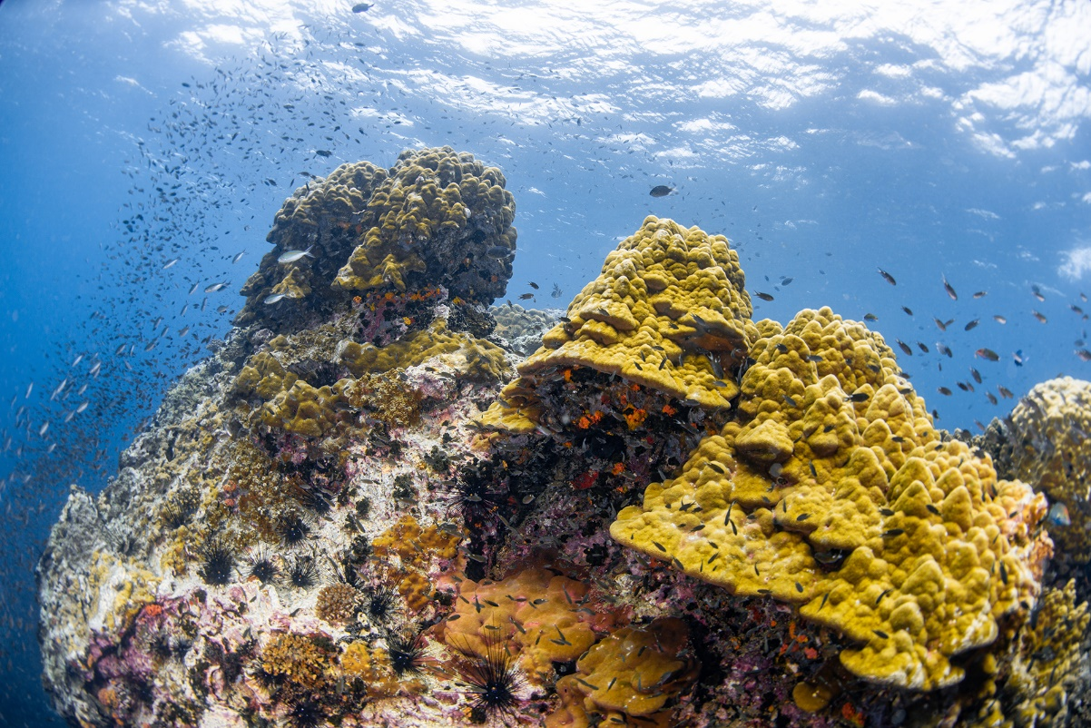

(a)

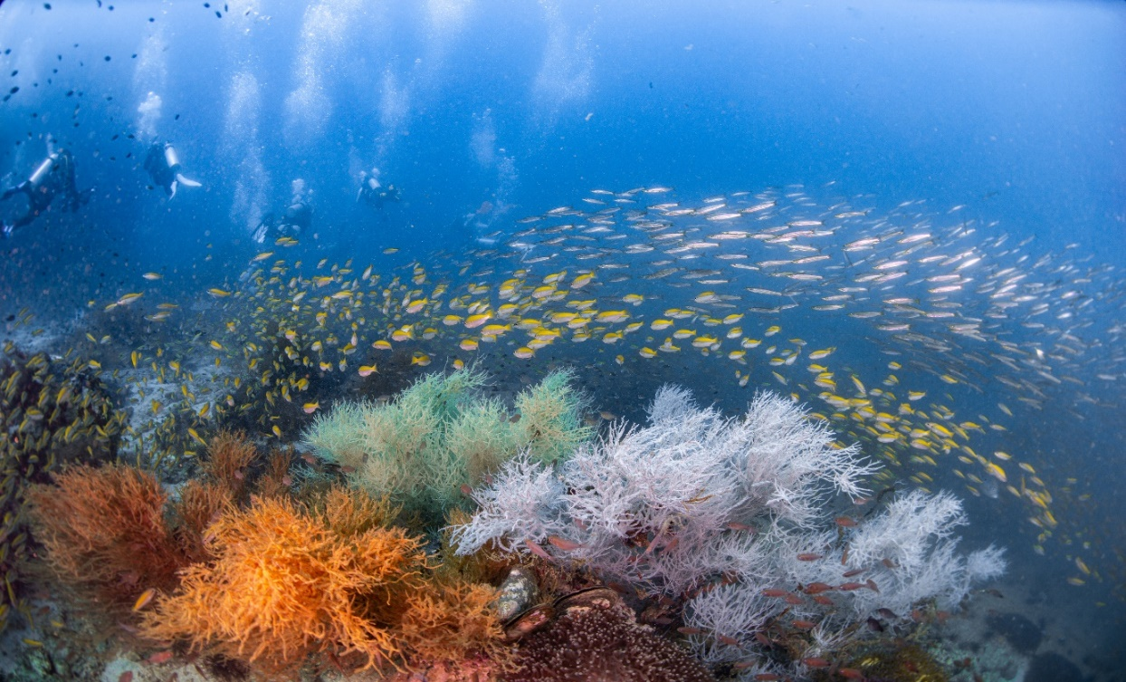

(b)

Fig. 2. Photographs of underwater pinnacles at Hin Lak Ngam, Chumphon Province, the Western Gulf of Thailand; (a) Scleractinian coral community, (b) Gorgonian corals and fish schools at a popular diving site

Table 2.
Coral and seagrass areas in the Gulf of Thailand
Geographic information showing total area, areas of coral reef and reef type
Name of area | Areas of coral reef (km²) |  | Reef type
Name of area | Areas of coral reef (km²) | Areas of seagrass (km²) | Reef type
CR:1 Koh Si Chang | 0.35 | - | Fringing Reef
CR:2 Koh Lan | 1.18 | - | Fringing Reef / Patch Reef
CR:3 Koh Kood | 13.18 | - | Fringing Reef
CR:4 Koh Mak | 5.04 | - | Fringing Reef
CR:5 Koh Tao | 0.66 | - | Fringing Reef / Patch Reef
CR:6 Koh Kra | 0.13 | - | Small fringing reefs, patch reefs
CR:7 Koh Losin | 0.35 | - | Fringing Reef/ Small patch reefs
CR:8 Underwater pinnacle Chumphon Province |  | - | -
SG1: Ban Don Bay | - | 12.74
SG2: Chumphon | - | 11.64
Environmental state information showing present status, composition of coral reefs (live coral, dead coral, sand, rock and other)
Name of area | Present status | Composition (%)
Name of area | Present status | Composition of coral reefs (%) |  |  |  |  | Composition of seagrass (%)
Name of area | Present status | Live coral | Dead coral | Sand | Rock | Other | Composition of seagrass (%)
CR:1 Koh Si Chang | Degraded condition | 29.24 | 12.48 | 9.58 | 39.34 | 9.32 | -
CR:2 Koh Lan | Degraded condition | 39.50 | 34.68 | 9.40 | 13.90 | 2.55 | -
CR:3 Koh Kood | Moderately healthy | 33.45 | 44.91 | 20.49 | 0.31 | 0.83 | -
CR:4 Koh Mak | Moderately healthy | 29.69 | 43.33 | 7.04 | 19.58 | 0.36 | -
CR:5 Koh Tao | Healthy condition | 61.27 | 35.64 | 0.40 | 1.71 | 0.98 | -
CR:6 Koh Kra | Remarkably healthy | 59.52 | 32.50 | 1.80 | 6.15 | 0.00 | -
CR:7 Koh Losin | Healthy condition | 69.50 | 29.00 | 1.30 | 0.00 | 0.30 | -
CR:8 Underwater pinnacle Chumphon Province | Healthy condition | 31.11 | 27.21 | 16.76 | 23.77 | 1.15 | -
SG1: Ban Don Bay | Moderately healthy | - | - | - | - | - | 12.74
SG2: Chumphon |  | - | - | - | - | - | 11.64

2.3 Seagrass meadows

2.3.1 Distribution and species composition
Seagrass meadows cover approximately 25 km² in the Gulf of Thailand, with major concentrations in Bandon Bay (12.74 km²) and Chumphon Province (11.64 km²) (Department of Marine and Coastal Resources, 2024c,g). Dominant species include Enhalus acoroides, Thalassia hemprichii, Halodule uninervis, and Halophila ovalis. These meadows provide critical nursery habitat for juvenile fish and crustaceans, feeding grounds for dugongs and green turtles, and important sediment stabilization functions (Department of Marine and Coastal Resources, 2024c,g).

2.3.2 Condition, productivity, and blue carbon role
Indicator assessments show that seagrass condition remains generally stable in deeper and less disturbed areas, with high shoot density and biomass (Department of Marine and Coastal Resources, 2024c,g). Seagrass sediments store significant amounts of organic carbon, contributing to blue carbon stocks of 35–60 t C ha⁻¹ (Department of Marine and Coastal Resources, 2024c,g). Productivity indicators underscore their role in supporting coastal fisheries and food security.

2.3.3 Pressures and connectivity constraints
Despite their importance, seagrass meadows remain highly vulnerable to turbidity, nutrient enrichment, boat anchoring, and coastal reclamation (Department of Marine and Coastal Resources, 2024c,d,f,g). Habitat fragmentation reduces connectivity with adjacent coral reefs and mangroves, weakening trophic linkages and ecosystem resilience. Bandon Bay stands out as a national model for integrated seagrass monitoring and community-based restoration (Department of Marine and Coastal Resources, 2024c), yet similar approaches remain limited elsewhere.

2.4 Biodiversity hotspots and threatened species
The Gulf of Thailand supports a network of biodiversity hotspots encompassing coral reefs, seagrass meadows, mangroves, and estuarine wetlands. Offshore reef complexes, Ramsar-listed wetlands (Don Hoi Lot), and large mangrove–seagrass systems (Bandon Bay, Chumphon) sustain high species richness and ecological productivity (Tan-on, 2007; Marine and Coastal Resources Conservation Center 2, 2015; Paw, 1988; Department of Marine and Coastal Resources, 2024c,e,g) (Tables 3 and 4).
Threatened and endemic specie, including dugongs (Dugong dugon), Irrawaddy dolphins (Orcaella brevirostris), migratory shorebirds, and regionally endemic corals, depend on habitat integrity and connectivity (Department of Marine and Coastal Resources, 2024a–h). Indicator trends indicate that population persistence is closely linked to the condition of nearshore habitats, emphasizing the need for ecosystem-based and landscape-scale conservation.
Table 3.
Mangroves and wetland areas in the Gulf of Thailand: Biological data showing seagrass diversity and composition, migrating species, SCS endemic species, endangered of threatened species (IUCN), and source & sink of larvae
Name of area | Migrating species | SCS Endemic species | Endangered of threatened species (IUCN) | Source & sink  of larvae
MG1: Welu River Estuary | - Charadrius mongolus  - Lanius cristatus | - | Plant species:  Critically Endangered  - Bruguiera hainesii  - Sonneratia griffithii  Endangered  - Heritiera fomes  Birds:  Endangered  - Calidris tenuirostris  Vulnerable  - Halcyon pileate  - Rhyticeros subruficollis  - Egretta eulophotes | -
MG2: Bandon Bay | - Xenus cinereus  Mammals:  Irrawaddy dolphin – seasonal coastal movements
MG3: Pak Panang Bay | Mammals:  Dugong in adjacent seagrass areas – seasonal foraging
MG: Samut Prakan Province | - Numenius Arquata  Mammals:  Irrawaddy dolphin (Orcaella brevirostris) – partial seasonal movement | -
WL1: Don Hoi Lot | Used by East Asian–Australasian Flyway birds, e.g., Little Tern (Sternula albifrons), Whiskered Tern (Chlidonias hybrida), Grey Heron (Ardea cinerea), plus seasonal shorebirds using the mudflats as feeding/roosting habitat. | Razor clam Solen regularis (regional endemic/flagship of the site). | Recorded/threat-noted species include Baer’s Pochard (Aythya baeri, CR), Striped Catfish (Pangasianodon hypophthalmus, EN), and King Cobra (Ophiophagus hannah, VU) in the wider site context. | Functions as a nursery and larval exchange area for coastal/estuarine fauna in the Upper Gulf; decapod larvae and bivalve recruits are commonly recorded in the Mae Klong estuary–mudflat system, indicating source–sink connectivity.
Table 4.
Coral and seagrass areas in the Gulf of Thailand: Biological data showing SCS endemic species and endangered of threatened species (IUCN)
Name of area | SCS Endemic species | Endangered of threatened species (IUCN)
CR:1 Koh Si Chang  CR:2 Koh Lan  CR:3 Koh Kood,  CR:4 Koh Mak  CR:5 Koh Tao  CR:6 Koh Kra  CR:7 Koh Losin  CR:8 Underwater pinnacle Chumphon Province | - Pectinia Lactuca  - Turbinaria patula  - Acropora microclados  - Merulina ampliata  - Echinopora lamellose  - Pectinia Paeonia  - Pectinia maxima  - Goniopora stokesi | Endangered (EN)  Pectinia Lactuca  Vulnerable (VU  Acropora humilis, Acropora muricata, Acropora millepora, Acropora hyacinthus, Acropora nasuta, Acropora gemmifera,  Acropora tenuis, Acropora robusta Acropora loripes Montipora foliosa Montipora digitata, Montipora aequituberculata, Montipora monasteriata, Pocillopora acuta, Turbinaria patula, Turbinaria mesenterina, Hydnophora rigida, Echinopora lamellose,Merulina ampliata  Near Threatened (NT)  Favia favus, Favites abdita, Platygyra daedalea, Goniastrea retiformis, Galaxea fascicularis, Pavona cactus, Fungia fungites,  Herpolitha limax, Ctenactis echinata, Porites lutea, Porites cylindrica, Goniopora stokesi, Heliopora coerulea (Blue coral)
SG1: Ban Don Bay
SG2: Chumphon

2.5 Integrated synthesis of ecosystem status
Taken together, indicator-based assessments reveal a heterogeneous but connected seascape, where offshore ecosystems retain high resilience and nearshore systems remain constrained by cumulative pressures. While restoration and co-management have yielded measurable gains, long-term sustainability depends on addressing land-based drivers, strengthening institutional coordination, and protecting ecological connectivity across the Gulf of Thailand (Department of Marine and Coastal Resources, 2024a–h).

3. Discussion

3.1 Interpreting ecosystem patterns: resilience, thresholds, and connectivity
The indicator-based assessment across the Gulf of Thailand reveals a consistent and policy-relevant pattern: ecosystem condition and resilience are strongly structured along offshore–nearshore and land–sea gradients. Offshore coral reefs and underwater pinnacles retain high ecological integrity, structural complexity, and recovery potential, whereas nearshore coral reefs, seagrass meadows, and estuarine wetlands are increasingly constrained by cumulative land-based pressures and climate stressors (Yeemin et al., 2019; Yeemin et al., 2021; Department of Marine and Coastal Resources, 2024a–h). This spatial divergence is not unique to Thailand, but reflects a broader phenomenon observed in semi-enclosed tropical seas globally, where watershed-driven impacts overwhelm local marine management interventions.
From a resilience perspective, offshore reefs function as ecological refugia and larval source areas, supporting recolonization and recovery across degraded coastal zones. Their persistence underscores the importance of protecting depth gradients, water circulation pathways, and connectivity nodes such as underwater pinnacles (Yeemin et al., 2021; Department of Marine and Coastal Resources, 2024g; Sutthacheep et al., 2024; Yeemin et al., 2024). In contrast, nearshore systems are approaching ecological thresholds, where recurrent disturbances, sedimentation, eutrophication, thermal stress, and physical damage, progressively erode recovery capacity and favor stress-tolerant species assemblages (Department of Marine and Coastal Resources, 2024a,f,g,h). Indicator trends suggest that without addressing upstream drivers, localized restoration efforts alone are unlikely to reverse long-term degradation trajectories.
Mangrove, wetland systems exhibit a more nuanced pattern. While extensive restoration and natural regeneration have stabilized or increased mangrove cover in several focal sites, hydrological alteration, sediment imbalance, and coastal encroachment continue to erode functional connectivity (Panapitukkul et al., 1998; Paw, 1988; Department of Marine and Coastal Resources, 2024a–e). These findings reinforce the principle that resilience is not solely a function of habitat extent, but of process integrity, particularly freshwater flow, sediment supply, and land–sea linkages.

3.2 Cumulative pressures and climate change as interacting stressors
A central insight of this review is that ecosystem degradation in the Gulf of Thailand is driven less by single stressors than by interacting and cumulative pressures. Aquaculture expansion, urban and industrial development, tourism, and fisheries exploitation interact with climate-driven stressors such as sea-level rise, marine heatwaves, and altered monsoon regimes (Saipattana, 2014; Yukkolthon et al., 2020; Department of Marine and Coastal Resources, 2024a–h). These interactions amplify ecological risk, particularly in estuarine and deltaic environments where exposure is highest.
Climate change acts as a risk multiplier, accelerating erosion, intensifying coral bleaching, and increasing the frequency of extreme events. Offshore ecosystems currently demonstrate higher resistance and faster recovery following bleaching, while nearshore systems show delayed or incomplete recovery (Department of Marine and Coastal Resources, 2024a,f,g,h). This divergence highlights the growing importance of climate refugia, depth gradients, and spatial heterogeneity in sustaining biodiversity under warming scenarios.
The assessment further indicates that climate adaptation strategies cannot be decoupled from land-use and watershed management. For example, reducing sediment and nutrient loads can significantly enhance coral and seagrass tolerance to thermal stress. Thus, effective climate adaptation in coastal systems requires an integrated land–sea and ridge-to-reef approach, rather than isolated marine interventions (Department of Marine and Coastal Resources, 2024a–h).

3.3 Ecosystem services, economic risk, and the blue economy
Economic valuation results underscore the magnitude of ecosystem services generated by mangroves, coral reefs, and seagrass meadows in the Gulf of Thailand. Annual values of US$17–32 million per site reflect contributions to fisheries, coastal protection, tourism, and carbon sequestration (Sripanomrat and Vincent, 2019; Sripanomrat and Srilawa-Atchan, 2021). However, these values remain largely external to decision-making processes, with limited integration into coastal planning, investment appraisal, or climate finance mechanisms.
The review highlights a critical policy paradox: ecosystems with the highest economic value often experience the greatest degradation due to competing short-term development incentives. Where mangrove loss or reef degradation occurs, economic risk increases through declining fisheries productivity, heightened coastal vulnerability, and loss of blue carbon assets. These risks are magnified in densely populated coastal provinces (Sripanomrat and Vincent, 2019; Department of Marine and Coastal Resources, 2024a–h), where ecosystem degradation translates directly into livelihood insecurity and increased disaster exposure.
Institutionalizing natural capital accounting and blue carbon valuation offers a pathway to realign economic incentives with ecosystem resilience. The indicator framework used in this assessment provides a technical foundation for embedding ecosystem services into national accounts, climate commitments, and sustainable finance instruments (Sripanomrat and Vincent, 2019; Department of Marine and Coastal Resources, 2024a–h). Without such integration, the blue economy risks reinforcing extractive growth patterns rather than supporting long-term resilience.

3.4 Governance performance and the limits of sectoral management
Thailand has made notable progress in coastal and marine governance through Integrated Coastal Management (ICM), national restoration programs, and community-based co-management. The Department of Marine and Coastal Resources (DMCR) plays a central coordinating role, supported by partnerships with other agencies, academic institutions, and local communities (Department of Marine and Coastal Resources, 2024a–h). Nevertheless, the assessment identifies persistent governance constraints that limit effectiveness.
Key challenges include fragmented institutional mandates, uneven enforcement capacity, and weak integration between terrestrial and marine planning frameworks. Overlapping responsibilities among national and provincial agencies complicate decision-making, while data fragmentation limits the use of indicators for adaptive management (Department of Marine and Coastal Resources, 2024a–h). These issues are most pronounced in nearshore and mixed-use areas, where development pressures are highest.
Community-based management emerges as a critical governance strength. Local stewardship initiatives in Welu River Estuary, Bandon Bay, and Don Hoi Lot demonstrate that co-management enhances compliance, monitoring coverage, and social legitimacy (Tan-on, 2007; Marine and Coastal Resources Conservation Center 2, 2015; Department of Marine and Coastal Resources, 2024a,c,e,g). However, scaling these successes requires stronger legal recognition, long-term financing, and integration into formal planning systems. Without institutional support, community initiatives remain vulnerable to external economic pressures.

3.5 Transboundary dimensions and regional cooperation
The Gulf of Thailand is ecologically and economically interconnected with the wider South China Sea, making transboundary cooperation essential. Migratory species, larval dispersal pathways, marine pollution, and climate impacts transcend national borders. The assessment identifies shared challenges among Gulf-rim countries, including habitat fragmentation, declining migratory species populations, and cumulative climate stress (Department of Marine and Coastal Resources, 2024a–h).
Thailand’s engagement in regional frameworks, such as the Strategic Action Programme (SAP) for the South China Sea, ASEAN biodiversity initiatives, and COBSEA, provides a platform for coordinated action. However, the review argues that regional governance remains underdeveloped relative to ecological connectivity. Harmonizing indicators, monitoring protocols, and ecosystem service valuation across countries would strengthen collective responses to shared risks.
Indicator-based assessments can serve as a common language for regional cooperation, enabling joint priority setting, comparative evaluation, and shared learning. Thailand’s experience integrating blue carbon, community co-management, and ecosystem-based management offers transferable lessons for neighboring countries facing similar challenges.

3.6 Priority pathways for action
Synthesizing the findings across ecosystems and governance scales, several priority pathways emerge:
- Strengthen land–sea integration by aligning watershed management, coastal zoning, and marine spatial planning (Department of Marine and Coastal Resources, 2024a–h).
- Institutionalize ecosystem and blue carbon accounting within national climate, finance, and development frameworks (Sripanomrat and Vincent, 2019; Department of Marine and Coastal Resources, 2024a–h).
- Protect and connect resilience hotspots, including offshore reefs, seagrass meadows, and mangrove corridors (Yeemin et al., 2019; Yeemin et al., 2021; Department of Marine and Coastal Resources, 2024a–h).
- Scale community co-management through legal recognition, capacity building, and sustainable financing (Tan-on, 2007; Marine and Coastal Resources Conservation Center 2, 2015; Department of Marine and Coastal Resources, 2024a–h).
- Enhance regional cooperation through harmonized indicators and joint monitoring under ASEAN and South China Sea frameworks (Department of Marine and Coastal Resources, 2024a–h).
These pathways emphasize that resilience is not achieved through conservation alone, but through governance systems capable of managing complexity, uncertainty, and cross-scale interactions.

4. Conclusion
This review demonstrates that the coastal and marine ecosystems of the Gulf of Thailand, comprising mangroves, coral reefs, and seagrass meadows, represent a complex mosaic of resilience and vulnerability, shaped by cumulative anthropogenic pressures, climate change, and governance capacity (Department of Marine and Coastal Resources, 2024a–h). Across the five focal systems (Welu River Estuary, Bandon Bay, Pak Phanang Bay, Samut Prakan Province, and Don Hoi Lot), ecosystem condition reflects both notable conservation gains and persistent structural challenges, underscoring the need for integrated, ecosystem-based management at multiple spatial scales (Paw, 1988; Tan-on, 2007; Department of Marine and Coastal Resources, 2024a–h).
Mangrove and wetland ecosystems remain foundational to coastal resilience and the national blue economy. Mangroves occupy approximately 480.7 km² (18.4%) of total wetland area, with the most extensive stands in Bandon Bay and Pak Phanang Bay, and smaller but ecologically critical tracts in Samut Prakan and Don Hoi Lot (Paw, 1988; Panapitukkul et al., 1998; Department of Marine and Coastal Resources, 2024b,c,d,e). High species diversity (17–30 species), dominated by Rhizophora apiculata, R. mucronata, and Avicennia alba, together with the presence of globally threatened taxa (Bruguiera hainesii, Sonneratia griffithii, Heritiera fomes), highlights Thailand’s international conservation significance (Ueng et al., 2013; Natthasuk, 2014; Suk- Saipattana, 2014; Yukkolthon et al., 2020; Department of Marine and Coastal Resources, 2024a–h). Restoration and replanting programs led by the Department of Marine and Coastal Resources (DMCR) and community networks have successfully reversed historical losses in several areas, restoring shoreline protection, nursery functions, and substantial blue carbon stocks (0.25–2 million tonnes C per site) (Department of Marine and Coastal Resources, 2024a–h). Nevertheless, mangrove resilience remains constrained by watershed-scale drivers, hydrological modification, and coastal encroachment.
Coral reef ecosystems exhibit pronounced offshore–nearshore contrasts. Offshore reefs at Koh Losin and Koh Tao retain good to excellent condition (live coral cover >60%), characterized by high biodiversity, complex reef structures, and strong recovery potential, functioning as regional refugia and larval source areas. In contrast, nearshore reefs at Koh Si Chang, Koh Mak, and Koh Kood show moderate degradation (29–39% live coral cover), driven by sedimentation, nutrient enrichment, tourism pressure, and recurrent bleaching events. While the dominance of massive coral forms (Porites, Dipsastraea, Platygyra) indicates structural resistance, chronic land-based pressures continue to suppress full recovery (Department of Marine and Coastal Resources, 2024a,f,g,h). Offshore underwater pinnacles in Chumphon Province further enhance ecological connectivity by linking shallow and deeper reef habitats, supporting their strategic importance for inclusion within Other Effective Area-Based Conservation Measures (OECMs) (Yeemin et al., 2019; Yeemin et al., 2021; Department of Marine and Coastal Resources, 2024g).
Seagrass meadows, covering approximately 25 km² and concentrated in Bandon Bay and Chumphon, play a critical role as nursery habitats, dugong feeding grounds, sediment stabilizers, and blue carbon sinks. Dominant species (Enhalus acoroides, Thalassia hemprichii, Halodule uninervis, Halophila ovalis) support high ecosystem productivity and carbon sequestration. However, these systems remain highly vulnerable to turbidity, nutrient runoff, anchoring damage, and coastal reclamation, leading to fragmentation and weakened connectivity with adjacent coral and mangrove ecosystems. The Bandon Bay seagrass–mangrove complex nevertheless stands out as a national model for blue carbon monitoring and community-based restoration.
Across all ecosystem types, cumulative pressures, including aquaculture expansion, urbanization, eutrophication, chemical pollution, coastal erosion, sea-level rise, and climate-driven thermal anomalies, interact synergistically to reduce ecological connectivity and resilience. These pressures are most severe where land–sea interactions remain poorly managed, reinforcing the necessity of integrated watershed-to-coast governance and effective pollution control (Department of Marine and Coastal Resources, 2024a–h).
Economic valuation underscores the strategic importance of these ecosystems. Combined annual ecosystem service values are estimated at US$17–32 million per site, reflecting contributions to fisheries, tourism, shoreline protection, and carbon storage. Mangroves and seagrasses provide measurable blue carbon assets, while coral reefs underpin marine tourism, biodiversity conservation, and fisheries productivity. Yet, despite their high economic value, ecosystem services and carbon stocks remain insufficiently internalized in development planning, climate finance, and investment decision-making (Sripanomrat and Vincent, 2019; Sripanomrat and Srilawa-Atchan, 2021).
This review highlights the value of indicator-based assessment as a powerful mechanism for bridging science, policy, and finance. By explicitly linking ecosystem condition with ecosystem services, economic risk, and management performance, indicators enable more informed, adaptive, and transparent decision-making. However, realizing this potential requires sustained institutional commitment to data integration, inter-agency coordination, and long-term investment.
Thailand has established a strong foundation for Integrated Coastal Management (ICM) and Nature-based Solutions (NbS) through mangrove rehabilitation, coral and seagrass restoration, and community co-management. Nonetheless, management fragmentation and enforcement gaps persist. To secure long-term ecosystem resilience and socio-economic benefits, priority actions include: (i) strengthening coordination among DMCR, DNP, DOF, and provincial agencies; (ii) scaling up blue carbon initiatives and verified carbon-credit schemes; (iii) integrating land–sea connectivity into watershed planning and coastal zoning; (iv) expanding OECM networks and community-based restoration; and (v) mobilizing sustainable financing through payment for ecosystem services, eco-certification, and community-based ecotourism.
Ultimately, sustaining the Gulf of Thailand’s ecosystems requires a transition from fragmented, sector-based management toward integrated, ecosystem-based, and regionally coordinated governance. By embedding natural capital into national development planning, empowering coastal communities, and strengthening regional cooperation under frameworks such as the Ramsar Convention, the BBNJ Agreement, and the UN Sustainable Development Goals (SDGs 13, 14, and 15), Thailand can position the Gulf of Thailand as a leading model for climate-resilient, nature-positive, and inclusive blue economy development in the South China Sea region.

Acknowledgements
The authors gratefully acknowledge the Department of Marine and Coastal Resources, the Department of National Parks, Wildlife and Plant Conservation, the Pollution Control Department, and the Ministry of Natural Resources and Environment of Thailand for providing essential data and information. The authors also wish to express their sincere appreciation to the Marine Biodiversity Research Group, Faculty of Science, Ramkhamhaeng University, for their valuable support throughout this study.

References
Barbier, E.B., Hacker, S.D., Kennedy, C., Koch, E.W., Stier, A.C., Silliman, B.R., 2011.The value of estuarine and coastal ecosystem services. Ecol. Monogr. 81 (2), 169–193.
Barbier, E.B., Georgiou, I.Y., Enchelmeyer, B., Reed, D.J., 2013. The value of wetlands in protecting southeast Louisiana from hurricane storm surges. PLoS ONE 8 (3), e58715.
Department of Marine and Coastal Resources, 2024a. Report on the situation of marine and coastal resources and coastal erosion in Chanthaburi Province. Department of Marine and Coastal Resources, Ministry of Natural Resources and Environment, Thailand.
Department of Marine and Coastal Resources, 2024b. Report on the situation of marine and coastal resources and coastal erosion in Nakhon Si Thammarat Province. Department of Marine and Coastal Resources, Ministry of Natural Resources and Environment, Thailand.
Department of Marine and Coastal Resources, 2024c. Report on the situation of marine and coastal resources and coastal erosion in Surat Thani Province. Department of Marine and Coastal Resources, Ministry of Natural Resources and Environment, Thailand.
Department of Marine and Coastal Resources, 2024d. Report on the situation of marine and coastal resources and coastal erosion in Samut Prakan Province. Department of Marine and Coastal Resources, Ministry of Natural Resources and Environment, Thailand
Department of Marine and Coastal Resources, 2024e. Report on the situation of marine and coastal resources and coastal erosion in Samut Songkhram Province. Department of Marine and Coastal Resources, Ministry of Natural Resources and Environment, Thailand.
Department of Marine and Coastal Resources, 2024f. Report on the situation of marine and coastal resources and coastal erosion in Chon Buri Province. Department of Marine and Coastal Resources, Ministry of Natural Resources and Environment, Thailand.
Department of Marine and Coastal Resources, 2024g. Report on the situation of marine and coastal resources and coastal erosion in Chumphon Province. Department of Marine and Coastal Resources, Ministry of Natural Resources and Environment, Thailand.
Department of Marine and Coastal Resources, 2024h. Report on the situation of marine and coastal resources and coastal erosion in Pattani Province. Department of Marine and Coastal Resources, Ministry of Natural Resources and Environment, Thailand.
Moberg, F., Folke, C., 1999. Ecological goods and services of coral reef ecosystems. Ecol. Econ. 29 (2), 215–233.

Marine and Coastal Resources Conservation Center 2, 2015. Manual of marine and coastal resources of Don Hoi Lot. Department of Marine and Coastal Resources, Ministry of Natural Resources and Environment, Thailand.
Natthasuk, U., 2014. Survey of mangrove flora and application of satellite remote sensing data for mangrove mapping at the mouth of the Welu River, Khlung District, Chanthaburi Province. Burapha Sci. J. 19 (1), 24–36.
Panapitukkul, N., Duarte, C.M., Thampanya, U., Kheowvongsri, P., Srichai, N., Geertz-Hansen, O., Boromthanarath, S., 1998. Mangrove colonization: mangrove progression over the growing Pak Phanang (SE Thailand) mud flat. Estuar. Coast. Shelf Sci. 47 (1), 51–61.
Paw, J.N. (Ed.), 1988. The coastal environmental profile of Ban Don Bay and Phangnga Bay, Thailand. WorldFish, Vol. 424.
Saipattana, P., 2014. Survey of mangrove plant species diversity at the Royal Thai Army Nature Study Center, Bang Pu, Samut Prakan Province. Veridian E-J. Sci. Technol. 1 (1), 13–18.
Sripanomrat, O., Srilawa-Atchan, I., 2021. Assessment of economic loss from coral reef ecosystem damage through environmental justice processes: Final research report. Submitted to Thailand Science Research and Innovation (TSRI), Bangkok, Thailand.
Sripanomrat, O., Vincent, J.R., 2019. Economic valuation of mangrove ecosystem services: Final research report. Submitted to Thailand Research Fund (TRF), Thammasat University, Bangkok, Thailand.
Suk-Ueng, N., Buranapratheprat, A., Gunbua, V., Leadprathom, N., 2013. Mangrove composition and structure at the Welu estuary, Khlung district, Chanthaburi province, Thailand. IOSR J. Environ. Sci. Toxicol. Food Technol. 7 (5), 17–24.
Sutthacheep, M., Jungrak, L., Chamchoy, C., Aunkhongthong, W., Sasithorn, N., Suebpala, W., Yeemin, T., 2024.Low impacts of coral bleaching in 2024 on the underwater pinnacles from Krabi Province, the Andaman Sea. Ramkhamhaeng Int. J. Sci. Technol. 7 (2), 1–14.
Tan-on, S., 2007. Management of Don Hoi Lot wetland, Samut Songkhram Province, under the Ramsar Convention. Thammasat University, No. 111741.
Yeemin, T., Sutthacheep, M., Aunkhongthong, W., Chamchoy, C., Jungrak, L., Chaithanavisut, N., Sukkeaw, M., 2024. Community structure of underwater pinnacles in Mu Ko Si Chang, the Upper Gulf of Thailand. Ramkhamhaeng Int. J. Sci. Technol. 7 (2), 15–35.
Yeemin, T., Sutthacheep, M., Klinthong, W., 2021. Development of ecotourism on underwater pinnacles in the Eastern Gulf of Thailand. Submitted to Program Management Unit for Competitiveness (PMUC), Bangkok, Thailand.
Yeemin, T., Sutthacheep, M., Yoodcharoen, M., Pannathevee, W., 2019. Promotion and development of ecotourism sites for snorkeling and SCUBA diving in Chumphon Province. Submitted to Program Management Unit for Competitiveness (PMUC), Bangkok, Thailand.
Yukkolthon, S., Wipaparn, C., Walwipha, S., Supitcha, W.-P., Rampradamee, B., 2020. Survey of mangrove plant species in Khlong Dan Subdistrict, Bang Bo District, Samut Prakan Province. Hua Chiew Chalermprakiet Sci. Technol. J. 6 (2), 32–45.

