1. Introduction

Thailand is located between two oceans: the Gulf of Thailand, which is part of the Pacific Ocean, and the Strait of Malacca and the Andaman Sea, which are parts of the Indian Ocean. Fishery in Thailand is divided into two sectors: capture fishery and culture fishery. In terms of production, capture fisheries contribute approximately 60% of the fisheries production, while the remaining 40% comes from culture fisheries. The capture fisheries occur both in inland and marine areas. Catch from marine capture fisheries contribute 93% of the total capture fisheries production, while catch from inland capture fisheries contribute only 7%. Marine fisheries in Thailand are divided into two sectors – artisanal and commercial fisheries. Artisanal fisheries are characterized by vessels that are less than 10 gross tons, while commercial fisheries include those from 10 gross tons and above.
Marine fisheries play an important role in Thailand’s economy. In 2024, the total catch from marine fisheries was 1.43 million tonnes (0.96 million tonnes in the Gulf of Thailand and 0.47 million tons in the Andaman Sea), valued at 2,267 million USD (1,607 million USD in the Gulf of Thailand and 660 million USD in the Andaman Sea). The per capita consumption of aquatic animals in Thailand in 2024 was 34.76 kg/person/year. In addition, Thailand exported 1.76 million tonnes of fisheries products to several countries around the world, worth 7,387 million USD, with some of the raw materials imported for processing and export. The main importing countries of fisheries products from Thailand include the USA, Japan and China. The marine fishing industry also generates employment and income for related activities such as fishing ports, shipyards, ice factories, seafood processing plants, and fishing gear factories. Thailand's marine fisheries also generate a large number of jobs. There are approximately 190,000 workers on artisanal and commercial fishing vessels, 215,000 workers at 1,608 fishing ports, and 338 fish processing plants.
The Gulf of Thailand is a highly productive area, nourished by several rivers that carry various nutrients into the gulf. These nutrients are used by phytoplankton for photosynthesis, making phytoplankton the primary producers and the starting point of the food chain. The Gulf of Thailand also features diverse ecosystems, such as mangrove forests, coral reefs, and seagrass beds, which serve as critical habitats for spawning and nursing areas for aquatic species. As a result, the Gulf of Thailand has a wide variety of fisheries resources and serves as an important fishing ground in Thai waters. Notably, marine fisheries production from the Gulf of Thailand accounts for 70% of the total catch.
Fisheries management system in Thailand is based on the Royal Ordinance on Fisheries B.E. 2558 (2015). The management system has been shifted from an open access fishery to a limited access fishery. A key principle of the current fisheries law is that fisheries resource management must be based on a reference point. Currently, Maximum Sustainable Yield (MSY) is used as the reference point. MSY is calculated annually, and the Total Allowable Catch (TAC) is determined based on the MSY. Several management measures have been issued under the Royal Ordinance. This chapter presents some background information on marine fisheries in the Gulf of Thailand, including fisheries production, fishing vessel, and fishing gear, fisheries indicators, fish stock assessment, and fisheries management measures.

2. Key finding

Fisheries development in Thai waters had resulted in overfishing and a decrease in the abundance of aquatic resources, which could be seen in the decrease in the catch per unit effort (CPUE) of research vessels, which is used as an indicator of resource abundance. In 1971, the total catch in the Gulf of Thailand was 481,270 metric tonnes and increased to a maximum of 1,590,104 metric tonnes in 1989. It then remained relatively stable, ranging from 903,935 to 1,040,058 metric tonnes between 2008 and 2023. Meanwhile, the CPUE in 1961, when the trawl fishery was first introduced to Thailand, was about 300 kg/hr. The CPUE then rapidly decreased during the first decade of trawl fishery development to 87.07 kg/hr in 1971 and continued decreasing to around 20 kg/hr during the 2010s.
Following the enactment of the Royal Ordinance on Fisheries B.E. 2558 (2015), overfishing has ended and resources have recovered to levels where biomass can produce MSY. The number of fishing vessels were frozen to reduce fishing capacity, resulting in a continuous decrease in the number of commercial fishing vessels in the Gulf of Thailand from 9,122 vessels in 2016 to 7,053 vessels in 2024. As the fisheries law supports artisanal fishing, the number of registered vessels has increased from 27,200 vessels in 2016 to 45,600 vessels in 2025. In addition, several management measures under the new fisheries law have been imposed such as fishing day limitation for commercial fishing vessels using high efficiency gears, seasonal area closures, and fishing gear control (e.g. mesh size limitation, destructive fishing gear banned, and fishing gear efficiency control). By implementing these measures, fishing effort has been controlled not exceeding the optimum level (F_{MSY}) and biomass of all species groups, namely demersal species, pelagic fish, and anchovy is higher than B_{MSY}. Marine Trophic Index also reached its maximum during the last 20 years, indicating that the ecosystem is recovering.
However, marine fisheries in the Gulf of Thailand still face problems with small-sized fish caught from trawlers, which has slowed the recovery of demersal species. Furthermore, fisheries management in the Gulf of Thailand requires cooperation among countries in the Gulf of Thailand and the South China Sea region to research transboundary species and to cooperate in joint fisheries resource management.

3. Fisheries and aquaculture production

Thailand has systematically collected marine fisheries statistics since 1971. In that year, the total catch in the Gulf of Thailand was 481,270 metric tonnes. After that, the catch increased rapidly, reaching a maximum of 1,590,104 metric tonnes in 1989. It then showed a deceasing trend to the lowest of 906,781 metric tonnes in 2007. Between 2008 and 2023, the catch remained relatively stable, ranging from 903,935 to 1,040,058 metric tonnes. The recent catch in 2023 was 1,022,529 metric tonnes (Figure 1 and Annex Table 1).
In terms of catch composition, the total catch was dominated by demersal and pelagic fishes. The development of trawl fisheries contributed to higher demersal fish catches, increasing from 353,684 metric tonnes in 1971 to a maximum of 893,374 metric tonnes in 1987. After that, the demersal catch continuously decreased due to overfishing for a couple of decades. Over the last 20 years, the demersal catch ranged from 367,707 to 508,872 metric tonnes, with an average of 424,462 metric tonnes. On the other hand, during the early 1970s, pelagic fish catches were still very low compared to demersal fish catches. However, in the mid-1970s, purse seine fisheries were developed using light luring and fish aggregating devices, which increased the catch of pelagic fish to near demersal fish catches. During the last 20 years, the pelagic catches have been quite stable, ranging from 334,330 to 426,643 metric tonnes, with an average of 367,567 metric tonnes (Figure 1 and Appendix Table 1).

Figure 1 Annual catch and catch composition from marine fisheries in the Gulf of Thailand between 1971 and 2023

Inland capture fisheries production in the coastal provinces along the Gulf of Thailand was 11,164.2 metric tonnes in 2009 and increased to 14,810.2 metric tonnes in 2012. After that, the production continuously decreased to 8,362.69 metric tonnes in 2023. The inland fisheries catch mainly consisted of freshwater fishes, approximately 95% of the total catch, and a few percentages of freshwater crustaceans (Appendix Table 2).
For aquaculture, the main cultured species are brackish water and marine species, such as marine shrimps (e.g. giant tiger prawn, whiteleg shrimp, and banana prawn), brackish water fishes (e.g. barramundi, groupers, and milkfish), shellfishes (e.g. blood cockle, green mussel, and oyster), and crabs. In addition, there is some freshwater aquaculture in the coastal provinces. The major cultured species include Nile tilapia, catfish, common silver barb and giant freshwater prawn. The annual production between 2016 and 2023 ranged from 440,829.50 to 513,074.18 metric tonnes, with an average of 481,088.66 metric tonnes. The production in 2023 was slightly higher than the average, at 496,446.64 metric tonnes. In recent years, Chachoengsao Province has produced the highest aquaculture production among the coastal provinces along the Gulf of Thailand, followed by Surat Thani Province (Appendix Table 3).

4. Number of fishing vessels and fishing gears

Fishing vessels in Thailand are categorized into two groups, namely artisanal and commercial fishing vessels. Artisanal fishing vessels are characterized by the vessel size of less than 10 gross tonnage (GT), while commercial fishing vessels are those of 10 GT and above. Commercial vessels are required to have a fishing license. Fishing gears in Thailand are also categorized into two groups, namely high efficiency gear (HEG) and low efficiency gear (LEG). High efficiency gears refer to less selective gear, such as trawls, purse seines, and anchovy falling net, while low efficiency fishing gears refer to more selective gears, such as traps, gillnets, clam dredges.
The number of vessels having a commercial fishing license in the coastal provinces along the Gulf of Thailand was 9,122 vessels in 2016. Since then, the number of fishing vessels has gradually decreased to 7,053 vessels in 2024 (Table 1). Several measures have been implemented to control the number of fishing vessels. The issuance of fishing license is based on biological reference point, as described in the Royal Ordinance on Fisheries B.E. 2558 (2015). As Thailand has been facing an overcapacity problem, i.e., an excessive number of fishing vessels, no new fishing vessel is allowed to be registered as a commercial fishing vessel. Fishing vessels may deteriorate over time, or fishers may withdraw from the fishing business on their own.

Table 1 Number of fishing vessels having commercial fishing license in the coastal provinces along the Gulf of Thailand between 2016 – 2024

Year | Number of fishing vessels having commercial fishing license
2016 | 9,122
2017 | 8,906
2018 | 8,692
2019 | 8,598
2020 | 8,449
2021 | 8,190
2022 | 7,703
2023 | 7,603
2024 | 7,053

In addition, the government has been implementing a vessel buyback program. Since 2016, more than 1,000 vessels have been bought back, and the vessels must be either destroyed or have their permit changed to other propose before receiving compensation from the government, to ensure that fishing vessels are permanently removed from the fisheries system. The government has also been implementing a fishing license combination program. A fishing day scheme has been introduced to address the overfishing problem and control the level of fishing effort by limiting the number of fishing days per year for each type of fishing gear. For instance, the number of fishing days for trawlers in the Gulf of Thailand was 220 days/year in 2016-2017, increased to 240 days/year in 2018-2023, and reached 245 days/year in 2024-2025 (Table 2). To allow the fishers to have more fishing days, vessel owners can transfer fishing days from one vessel to other vessels, on the condition that the original vessel is removed from the fisheries system. These are some of the management measures implemented to effectively reduce the number of fishing vessels.
In 2016-2017, commercial fishing vessels were allowed to apply for only one type of HEG or one type of LEG. The unit of fishing gear was only 9,096 and 8,878, respectively. The most commonly used fishing gear was trawl, i.e., otter board trawl, beam trawl, and pair trawl. with 3,087 and 3,043 licensed vessels, followed by falling net, i.e., anchovy falling net and squid falling net, with 1,767 and 1,747 licensed vessels, respectively (Appendix Table 4).
However, in 2018, vessel owners were allowed to apply for one type of HEG and one type of LEG for the same vessel. Handline could also be applied in addition to either HEG or LEG. In case where they applied for only LEG, they could apply for up to three types of LEG, plus handline. Thus, the unit of fishing gear increased to 16,509 in 2018. Handline became the most commonly used fishing gear, with 7,332 units, because almost all vessels applied for handline to be equipped on board and used time to time by crews. However, when considering the main fishing gear, trawls were still the most commonly used, with a slightly lower number of 2,975 units. After that, the number of fishing gear units showed a decreasing trend following the reduction in the number of fishing vessels, reaching 14,196 units in 2024 (Appendix Table 4). Although, a fishing vessel may apply for multiple fishing gears, only one type of fishing gear must be operated at a time.

Table 2 Number of fishing days allocated to each type of fishing gear operated in the Gulf of Thailand between 2016 and 2025

Group of fishing gear | Type of fishing gear | Number of fishing days (day/year)
Group of fishing gear | Type of fishing gear | 2016 -2017 | 2018 -2023 | 2024 -2025
High efficiency fishing gear | Otter board trawl,  beam trawl, pair trawl | 220 | 240 | 245
High efficiency fishing gear | Purse seine | 220 | 240 | 255
High efficiency fishing gear | Anchovy falling net, anchovy lift net,  anchovy purse seine | 235 | 255 | 270
High efficiency fishing gear | Light luring vessel | Not defined
Low efficiency fishing gear | Squid falling net, traps,  krill push net, gillnets,  clam dredges, pomfret lift net, longline, handline,  red frog crab lift net | Not defined

In 2024, Pattani province had the highest number of fishing gear units, totaling 1,822 because it had the largest number of purse seiners, with 146 licensed vessels. These purse seiners are often operated with light luring vessels, which are also required to obtain a fishing license. These fishing vessels commonly have handlines equipped on board. Chumphon Province ranked second, with 1,637 fishing gear units, for the same reason as Pattani - it has a large number of purse seiners. It was followed by Nakhon Si Thammarat province, where the situation differs, as the province has the highest number of trawlers in the Gulf of Thailand, totaling 572 vessels (Appendix Table 5).

5. Fisheries and ecosystem indicators

5.1 Catch per unit effort

The Department of Fisheries (DOF) has been conducting annual fisheries resource surveys since 1961 using research vessels equipped with otter board trawl with cod-end mesh size of 2.5 cm. In 1961, when trawl was first introduced to Thailand, the catch per unit effort (CPUE) in the Gulf of Thailand was 297.80 kg/hr. Thereafter, the CPUE gradually decreased to 127.90, 63.31, and 25.82 kg/hr in 1970, 1980, and 1990, respectively. It further declined to its lowest of 14.69 kg/hr in 2013.
In 2016, the DOF began using otter board trawl with cod-end mesh size of 4.0 cm for the surveys, in accordance with the cod-end mesh size requirement prescribed under the Royal Ordinance on Fisheries B.E. 2558 (2015). The survey in 2016 recorded a CPUE of 12.61 kg/hr. Then, the CPUE showed an increasing trend to 21.52 kg/hr in 2023. However, in 2024, the CPUE decreased again to 16.62 kg/hr (Figure 2 and Appendix Table 6).

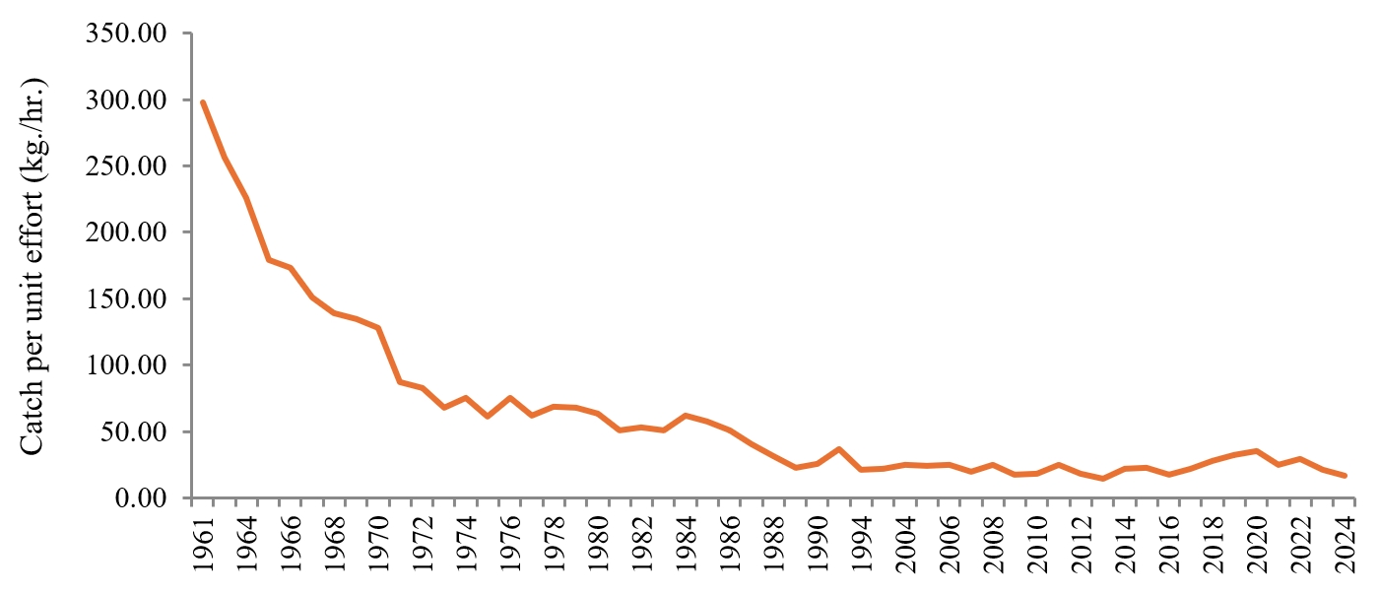

Figure 2 Catch per unit effort of DOF research vessels using otter board trawl in the Gulf of Thailand between 1961 and 2024
Remark: The cod-end mesh size used between 1961 and 2015 was 2.5 cm, while the cod-end mesh size of 4.0 cm has been used since 2016.

5.2 Fishing effort

For stock assessment purpose, fisheries resources in Thai waters are divided into three species groups, namely demersal species, pelagic fish, and anchovy. The demersal species include demersal fishes, squids and cuttlefishes, shrimps, crabs, clams, and krill, while the pelagic fish are all midwater and pelagic fishes, including mackerels, scads, sardines, barracudas, and neritic tunas. The anchovy group includes all species of Encrasicholina spp. and Stolepholus spp. The Maximum Sustainable Yield (MSY) assessment for the three groups of species is conducted every year using the Fox surplus production model (Appendix A) (Fox, 1970).
The fishing effort of demersal species, pelagic fish, and anchovy in 2015, just before the implementation of limited access fishery prescribed under the Royal Ordinance on Fisheries B.E. 2558 (2015), was above the fishing effort at MSY level (E_{MSY}) at 148.76%, 136.95%, and 100.88% of the E_{MSY}, respectively, indicating overfishing for all groups of species. The year 2016 was the first year that the fishing license issuance was based on the biological reference point. In 2016, the fishing effort significantly declined. For demersal group, the fishing effort in 2016 and 2017 was 79.93% and 97.77% of the E_{MSY}, respectively. After that, until 2024, the fishing effort ranged from 62.30 to 82.57% of the E_{MSY}. For the pelagic fish group, the fishing effort in 2016 was still high at 115.19% of the E_{MSY}, but it was subsequently controlled to remain well below the E_{MSY} level, ranging from 41.42 – 68.86% of E_{MSY} between 2021 - 2024. For anchovy group, the fishing effort continuously declined and has remained around 20% of the E_{MSY} during the past five years (Table 3).

Table 3 Fishing effort at MSY (E_{MSY}) and standard fishing effort of demersal species, pelagic fish, and anchovy group in the Gulf of Thailand between 2015 and 2024

Year | Demersal species |  |  | Pelagic fish |  |  | Anchovy
Year | Fishing effort at MSY (hour) | Standard fishing effort  (hour) | % fishing effort | Fishing effort at MSY (day) | Standard fishing effort  (day) | % fishing effort | Fishing effort at MSY (day) | Standard fishing effort  (day) | % fishing effort
2015 | 24,331,498 | 36,196,522 | 148.76 | 130,493 | 178,709 | 136.95 | 114,588 | 115,600 | 100.88
2016 | 26,326,863 | 21,042,318 | 79.93 | 152,512 | 175,677 | 115.19 | 155,923 | 75,992 | 48.74
2017 | 22,796,139 | 22,287,587 | 97.77 | 135,882 | 111,999 | 82.42 | 171,378 | 55,518 | 32.40
2018 | 23,268,351 | 19,213,636 | 82.57 | 136,386 | 114,204 | 83.74 | 172,880 | 60,722 | 35.12
2019 | 22,606,170 | 17,342,281 | 76.71 | 133,991 | 113,705 | 84.86 | 172,480 | 52,476 | 30.42
2020 | 23,104,173 | 15,507,765 | 67.12 | 142,723 | 100,837 | 70.65 | 158,813 | 32,522 | 20.48
2021 | 23,438,995 | 19,305,368 | 82.36 | 145,134 | 78,934 | 54.39 | 126,358 | 23,381 | 18.50
2022 | 23,954,077 | 14,923,835 | 62.30 | 207,303 | 85,873 | 41.42 | 133,934 | 24,998 | 18.66
2023 | 24,180,496 | 16,293,292 | 67.38 | 210,272 | 122,184 | 58.11 | 127,569 | 30,134 | 23.62
2024 | 24,905,641 | 16,057,399 | 64.47 | 180,849 | 124,535 | 68.86 | 127,917 | 28,857 | 22.56

5.3 Stock biomass

As fisheries resources in Thai waters are divided into three species groups - demersal species, pelagic fish, and anchovy - biomass was calculated for each group using JABBA (Just Another Bayesian Biomass Assessment) (Winker et al., 2018). The input data includes time-series catch and catch per unit effort. The model also requires several parameters, namely, K (carrying capacity), r (intrinsic rate of population increase), and B (initial biomass).
The assessment results from JABBA present two dimensions of fisheries resource status –biomass (B) and fishing mortality (F). The biomass of all species groups in the Gulf of Thailand in 2023 was higher than the biomass that can produce the Maximum Sustainable Yield (B_{MSY}). The B/B_{MSY} of demersal species, pelagic fish, and anchovy was 1.007, 1.294, and 2.191, respectively (Table 4 and Figure 3). The biomass assessment results indicated a recovery of fisheries resources in the Gulf of Thailand. In 2023, fisheries resources across all species groups were abundant and exceeded the level required to achieve MSY. However, demersal species have a low natural recovery rate and may take longer to recover than other groups. In addition, fishing mortality of all groups in 2023 was well below the fishing mortality that can produce MSY (F_{MSY}), particularly anchovy group which the F/F_{MSY} was about 0.2 indicating that fishing effort can be increased (Figure 3).
In addition to the species group assessment, the DOF has also conducted single species assessments. In 2023, 17 economically important species were selected to represent species groups, including 12 demersal species, four pelagic species, and one anchovy species. A length-based model was used to estimate the biomass. The results showed that the biomass of 11 species in 2023 was higher than B_{MSY}, one species was at B_{MSY}, and five species were lower than B_{MSY}. The latter group consisted of three species of demersal fauna and two species of pelagic fish (Appendix Table 7).

Table 4 Biomass assessment of three species groups in the Gulf of Thailand in 2023

Species group | Biomass in 2023 (tonne) | Biomass at MSY  (tonne) | B/B_{MSY}
Demersal species | 2,655,915 | 2,637,453 | 1.007
Pelagic fish | 1,095,572 | 846,656 | 1.294
Anchovy | 1,308,942 | 597,418 | 2.191

The results of single species assessment were consistent with species group assessment, showing that biomass of most species was higher than B_{MSY} (Table 4 and Appendix Table 7). Eight of the twelve demersal species had biomass levels higher than B_{MSY}. Shorthead anchovy, Encrasicholina heteroloba, which is the most dominant species in anchovy group, was selected for the biomass assessment. The biomass of the shorthead anchovy was the highest among the 17 selected species, reflecting the results of the species group assessment. However, the assessment of four pelagic fish species showed that the biomass of two species was lower than B_{MSY}, while two species were higher than B_{MSY}. Close monitoring of pelagic species is required, and additional pelagic species could be included in future assessments.

5.4 Catch from bottom-impacting gear types

Bottom-impacting fishing gear consists of pair trawl, otter board trawl, beam trawl, and clam dredges. The proportion of catch from the bottom-impacting fishing gears in the Gulf of Thailand between 2016 and 2021 ranged from 45.33% – 49.64% of the total catch. During 2022 – 2024, the catch from these gears showed a decreasing trend, accounting for 38.84% – 39.99% of the total catch. Pair trawl catch remained stable since 2016, while otter board trawl catch showed a decreasing trend from 162,728 tonnes in 2016 to 115,856 tonnes in 2024. Beam trawl and clam dredge catch contributed only few percentages of the total catch in the Gulf of Thailand and catch from both gears showed decreasing trends (Figure 4 and Appendix Table 8).

A)

B)

C)

Figure 3 Stock assessment results in the Gulf of Thailand in 2024 using JABBA
A) Demersal species B) Pelagic fish C) Anchovy

Figure 4 Catch by types of fishing gear (tonne) in the Gulf of Thailand between 2016 and 2024

5.5 Stock Status Plots

The assessment of fisheries resources using the Stock Status Plot method categorizes the status of resources into five levels: rebuilding, developing, exploited, over-exploited, and collapsed (Kleisner and Pauly, 2011). In terms of catch volume, the percentage of catch in the Gulf of Thailand from over-exploited stocks increased over time beginning in the late 1960s and reached a maximum of 58.4% of the total catch in 2008. After that, the catch from over-exploited stocks decreased continuously. The recent results in 2019 showed that majority of the catches, approximately 60% of the total catch in the Gulf of Thailand, came from healthy stocks either exploited, developing or rebuilding stocks. About 38% of the total catch came from over-exploited stocks, while 1% of the total catch came from collapsed stocks (Figure 5a) (Sea Around Us, 2025a).
In terms of number of stocks, the proportion of developing stocks decreased over time from about 70% in the early 1960s to 7% of the total number of stocks in 2019, whereas the number of over-exploited and collapsed stocks increased from 6.3% in 1970 to a maximum of 66.1% of the total number of stocks in 2011. After that, in 2019, the number of both stocks decreased to about 40%, and 60% of the total number of stocks was in either exploited, developing or rebuilding stocks (Figure 5b).

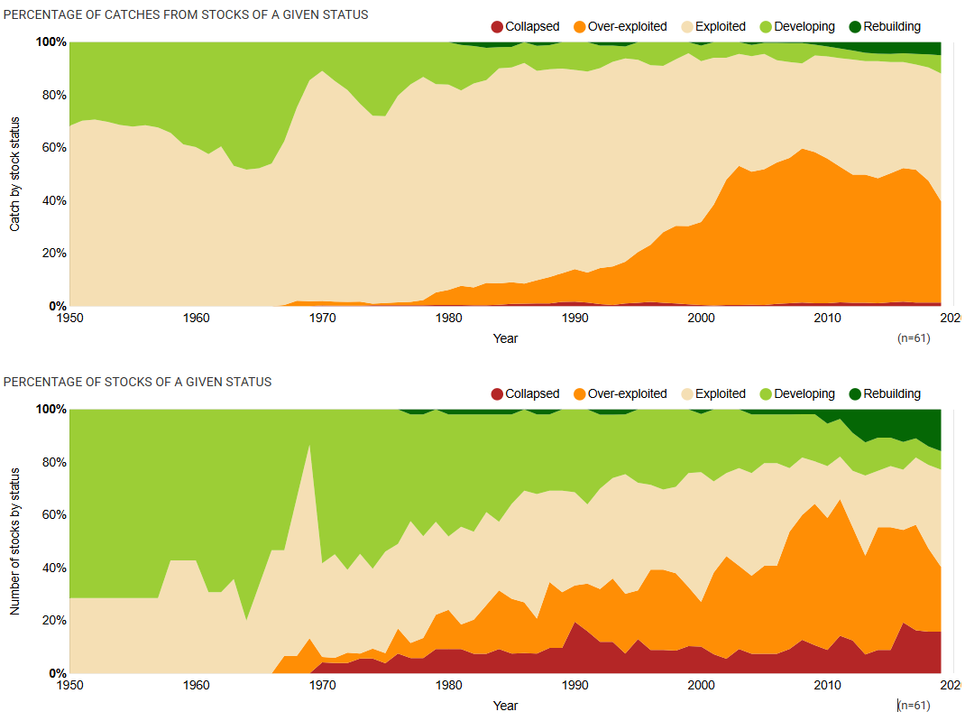
2020
2020
a)

b)
Figure 5 Results of Stock Status Plot in the Gulf of Thailand (Sea Around Us, 2025a)
a) percentage of catches from stocks of a given status
b) percentage of stocks of a given status

5.6 Primary Production Required for catches (PPR)

Key periods of change in the Primary Production Required (PPR) for catches in the Gulf of Thailand can be identified across several decades. During the 1950s and 1960s, PPR values were low and relatively stable, suggesting limited fishing pressure and a healthier equilibrium with the region’s primary production. In contrast, the 1970s through the 1990s showed a steady and rapid increase in PPR, reaching the maximum PPR fraction of 2.67582 and reflecting the intensification of fishing activities. This increase was likely driven by the development of fisheries, an expansion in fleet capacity, and higher catch volumes. Between the 2000s and 2010s, PPR remained high and fluctuated, indicating ongoing and potentially unsustainable fishing pressure (Figure 6) (Sea Around Us, 2025b).
Ecologically, a PPR value exceeding 1% is typically viewed as a warning sign of possible ecosystem overfishing, as it suggests that fisheries are consuming a significant share of the ocean’s primary production. In the Gulf of Thailand, PPR has far exceeded this threshold, which implies that the fishery may be ecologically unsustainable. This situation could result in a decline in fish stocks, trigger trophic cascades, and reduce the overall resilience of the marine ecosystem.

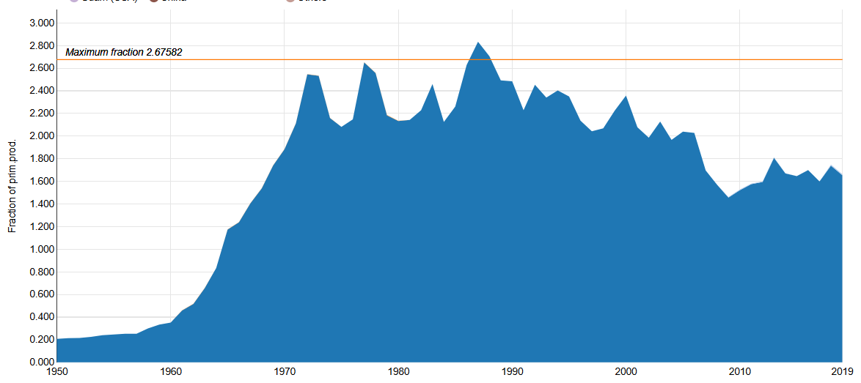

Figure 6 Primary Production Required for catches in the Thai waters of the Gulf of Thailand between 1950 and 2019 (Sea Around Us, 2025b)

5.7 Marine Trophic Index (MTI)

To calculate the Marine Trophic Index (MTI), fisheries resources in the Gulf of Thailand were classified into 39 groups with similar trophic levels based on their dietary habits and ecological roles. The trophic level for each species or group was calculated using diet composition data. The trophic levels were found to be as low as 2.1994 for shellfish, 2.3454 – 2.3458 for shrimp and prawn, and 2.5574 for trash fish. Coastal tunas, large piscivores (e.g. grouper), and sharks are among the top predators in the marine ecosystems, with trophic level exceeding 4.0000 (Appendix Table 9).
MTI was calculated for the period between 1990 and 2023. During the 1990s, the MTI was relatively high, exceeding 3.7600, and reached the maximum of 3.8462 in 1997. After that, MTI declined and dropped to its lowest value of 3.6959 in 2009. However, as a result of the implementation of the Royal Ordinance on Fisheries B.E. 2558 (2015), the MTI increased steadily and reached its highest level in 2023 at 3.7651, the highest value since 2000 (Figure 7).

Figure 7 Marine Trophic Index (MTI) in the Gulf of Thailand between 1990 and 2023

6. Transboundary problems and issues

Fish stock assessment should be conducted covering the entire population of each species that share common biological characteristics, such as sharing common growth and mortality parameters. In addition, fisheries management requires comprehensive protection throughout the life cycle, requiring knowledge of spawning, nursery, and feeding grounds, etc. Management measures to conserve critical life stages, such as seasonal area closure in Thailand, still only consider migration routes and life history studies only in Thai waters. Several species in the Gulf of Thailand and the South China Sea are known to migrate across boundaries based on empirical knowledge; however, there is still a lack of clear research on the migration routes of aquatic animals in these regions. Therefore, studying the migration routes of aquatic animals in the Gulf of Thailand and the South China Sea is important for fisheries management, especially for highly migratory species such as neritic tunas.
Furthermore, after studying the stock status of transboundary species, these shared stocks require cooperative management. Management of transboundary species by any single country may not achieve sustainability targets or may only address part of the life cycle. Regional fisheries resource management may be implemented through the development of regional fisheries management plans.

7. Management and conservation efforts

The current management of Thai fisheries is governed by the Royal Ordinance on Fisheries B.E. 2558 (2015), which has been amended twice: the first is the Royal Ordinance on Fisheries (No. 2) B.E. 2560 (2017) and the second is the Act Amending the Royal Ordinance on Fisheries B.E 2558 (2015) B.E. 2568 (2025). The provisions of this Royal Ordinance aim to reorganize fisheries in Thailand to prevent IUU fishing in order to preserve aquatic animal resources as a sustainable source of food for humanity and preserve the environment in an appropriate state along the criteria and standards recognized internationally. The key principles and management measures under this law for the management of marine fisheries are shown in Appendix B.

8. Regional cooperation

8.1 ASEAN Network for Combating IUU Fishing (AN-IUU)

The ASEAN Network for Combating IUU Fishing (AN-IUU) was initiated by Thailand during its chairmanship of the ASEAN Summit in 2019, aiming to ensure the sustainability of aquatic resources across the region. The project gained momentum both nationally and regionally, with Thailand actively advocating for its establishment. Approval was granted at the Special Senior Officials Meeting of the 40th ASEAN Ministers on Agriculture and Forestry (SSOM-40th AMAF) in Vietnam on August 5, 2019, and it was subsequently endorsed at the 41st ASEAN Ministers' Meeting on Agriculture and Forestry in Brunei Darussalam on October 15, 2019. Thailand serves as the host for the Network Centre and manages the AN-IUU Interactive Platform, an online system for fisheries information exchange among member states.
The main objectives of AN-IUU are to facilitate the sharing of information related to illegal, unreported, and unregulated (IUU) fishing, to establish clear rules and procedures for information exchange, and to strengthen regional cooperation in combating IUU fishing. The ASEAN Secretariat and the Department of Fisheries, with support from the Enhanced Regional EU-ASEAN Dialogue Instrument (E-READI) and the Directorate-General for Maritime Affairs and Fisheries (DG-MARE), developed guidelines for sharing and accessing IUU fishing-related information. These guidelines were agreed upon at the 30th ASEAN Sectoral Working Group on Fisheries meeting in June 2022. To promote effective use of the AN-IUU Interactive Platform, training sessions have been organized for network coordinators from ASEAN Member States, allowing them to practice data exchange and system operations. Thailand has also expressed willingness to provide further training to member states to maximize the platform's effectiveness in joint surveillance and combating IUU fishing activities.

8.2 Regional Plan of Action to Promote Responsible Fishing Practices Including Combating IUU Fishing in the Region (RPOA-IUU)

The Regional Plan of Action to Promote Responsible Fishing Practices, Including Combating Illegal, Unreported, and Unregulated (IUU) Fishing in the Region (RPOA-IUU), was jointly initiated by the governments of Indonesia and Australia. The action plan was officially endorsed in Bali on May 4, 2007. Thailand, together with ten other participating countries—Australia, Brunei Darussalam, Cambodia, Indonesia, Malaysia, Papua New Guinea, the Philippines, Singapore, Timor-Leste, and Vietnam—engages in the RPOA-IUU on a voluntary basis. The primary objective of this initiative is to foster responsible fishing practices and to eliminate IUU fishing, with a particular emphasis on the South China Sea, the Sulu-Sulawesi Seas, and the Arafura-Timor Sea.
The RPOA-IUU is guided by a comprehensive work plan adapted from the International Plan of Action to Prevent, Deter and Eliminate Illegal, Unreported and Unregulated Fishing (IPOA-IUU) framework. This work plan encompasses twelve core elements, including the implementation of legal instruments, promotion of international cooperation, and delineation of responsibilities among coastal, flag, port, and market states. Key activities under the RPOA-IUU include human resource development, capacity building, enhancement of monitoring, control, and surveillance (MCS) systems, and regulation of fish transshipment. Meetings under this framework routinely involve advisory contributions from regional fisheries organizations such as SEAFDEC, FAO, and INFOFISH. While participation remains voluntary, member states have consistently demonstrated a strong commitment to collaboration. A Coordination Committee has been established to oversee the implementation and progress of the action plan. These collective efforts have resulted in more robust and effective regional measures to combat IUU fishing and have promoted increased accountability in fisheries management.

8.3 Scientific Working Group on Neritic Tunas Stock Assessment in the Southeast Asian Waters (SWG-Neritic tunas)

The Scientific Working Group on Neritic Tunas Stock Assessment in Southeast Asian Waters (SWG-Neritic tunas) was established following the Expert Group Meeting on the Regional Plan of Action for Sustainable Utilization of Neritic Tuna Resources held in June 2014. SEAFDEC Member Countries nominated experts to join this group, and a formal Terms of Reference (ToR) was finalized in November 2014 and adopted in April 2015, with subsequent revisions in 2018 to expand its scope to additional species such as anchovy, sardines, and Indo-Pacific mackerel. The main objective of the working group is to foster regional cooperation among ASEAN Member States for effective stock assessment and management of neritic tunas and other important pelagic fishes, ensuring sustainable utilization of these resources in Southeast Asian waters.
The activities of the SWG-Neritic tunas include providing technical and scientific advice on the status of neritic tuna fisheries, recommending fisheries management policies, collecting and sharing catch and biological data for regional stock assessments, identifying human capacity needs within member countries, and coordinating with international and regional organizations for sustainable fisheries management. The group supports data collection, genetic studies, and related research to inform policy and management decisions, contributing to improved fisheries management and conservation throughout the region. The Eighth Meeting of SWG-Neritic tunas was the most recent meeting, which was held on 22 August 2024 via an online platform.

9. Recommendations and Priority Actions for Fisheries Management
Based on the current assessment of fisheries resource status, stock biomass, and governance gaps, the following priority actions are recommended to ensure the transition from stock stabilization to long-term sustainability and ecosystem resilience.

9.1 Enhancing the Efficiency of Fisheries Resource Assessments
To address current data gaps and improve the precision of Maximum Sustainable Yield (MSY) estimates, the following technical enhancements are required:
- Integrate Primary Production Data: Future stock assessments must incorporate primary production data for the Gulf of Thailand to refine MSY estimates. It is recommended to retrieve and digitize historical analog data from the Department of Fisheries (DOF) archives to construct a long-term productivity baseline that complements current catch data.
- Single species assessment: Currently, multispecies MSY, i.e., demersal species, pelagic fish, and anchovy, are used as reference points for fisheries management. Species that reflect the fishery based on inherent vulnerability, current risk, ecological importance and management importance should be identified and assessed in addition to species group assessment, as part of monitoring program. Several indicators, e.g. biomass, length-based spawning potential ratio (LB-SPR), and yield-per-recruit (YPR), can be applied to single species assessment.
- Reference Point for trash fish from trawls: Half of the trawl catch consists of trash fish (reduction component), which includes juvenile economic species and true trash fish. These species are inevitably caught by trawl, so it is necessary to establish an appropriate reference point for the quantity of trash fish caught that does not disrupt the ecological balance or hinder the recovery of fisheries resource.

9.2 Policy Reforms and Governance Alignment
Management measures must evolve to address the complexities of multi-gear fisheries and the socio-economic reality of fishing communities.
- Differentiated Management for Small-Scale Fisheries (SSF): The Fisheries Action Plan must be realigned to reflect the local realities of the artisanal sector.
Action: Develop a management plan for artisanal fisheries by applying the FAO Voluntary Guidelines for Securing Sustainable Small-Scale Fisheries to fit Thailand’s economic, social, and resource conditions.
- Managing Fishing Effort and Efficiency: While the "Fishing Days" scheme has successfully addressed overfishing and stabilized CPUE of research vessels (stabilizing at ~16–21 kg/hr), the risk of "effort creep" (increased efficiency per day) remains.
Action: Monitoring must expand beyond "days at sea" to track efficiency of fishing operations (e.g. net and fishing method modifications) that increase catch even when fishing time remains constant.

9.3 Adoption of Ecosystem Approach to Fisheries Management (EAFM)
- Area-based Conservation in Vulnerable Zones: EAFM principles must be operationalized in ecologically sensitive areas. Specific zones identified as critical nursing or spawning grounds (e.g., seagrass beds, coral reefs) require strict gear restrictions (e.g., banning bottom-impacting gears) to protect benthic habitats.
- Ecosystem-based fisheries management: Management measures under the current national fisheries management plan are based on multispecies MSY. To achieve ecosystem balance and increase ecosystem resilience to various pressures, such as fishing activities and climate change, it is important for the ecosystem to maintain a moderate level of resilience to adapt to these pressures. Ecosystem indicators and reference points should be incorporated in the next fisheries management plan.
- Gear Selectivity: accelerate the transition towards selective fishing gears. The dominance of "trash fish" (low trophic level species, trophic level ~2.55) in catches indicates continued ecosystem alteration. Incentives should be introduced to install bycatch reduction devices on trawls and to replace non-selective trawls with more selective gears (e.g., traps, specific mesh-size gillnets) to reduce bycatch of juveniles.

9.4 Enhancing Regional Cooperation (Transboundary Management)
One of the key principles for fish stock assessment is that it should cover the whole populations of the same species with similar biological characteristics. Given the semi-enclosed nature of the Gulf of Thailand, national efforts alone are insufficient for managing migratory stocks.
- Joint Management of Transboundary Species: Immediate steps should be taken to establish joint management plans for economically critical transboundary species, specifically neritic tunas (Thunnus spp., Euthynnus spp., Auxis spp.), and Spanish mackerel and king mackerel (Scomberomorus spp.).
- Regional Mechanisms: Thailand should leverage the Promoting the Blue Economy and Strengthening Fisheries Governance of the Gulf of Thailand through the Ecosystem Approach to Fisheries (GoTFish) Project as a platform to harmonize stock assessment methodologies and data sharing protocols with neighboring countries (Cambodia, Vietnam, and Malaysia).
Action Plan:
  - Conduct joint stock assessments for shared stocks to determine a regional Total Allowable Catch (TAC).
  - Harmonize adaptive closed seasons based on migratory and biological studies to protect critical life stages
  - Develop a regional fisheries management plan, particularly for transboundary species

10. Reference

Fox Jr, W. W. (1970). An exponential surplus-yield model for optimizing exploited fish populations. Transactions of the American Fisheries Society, 99, 80-88.
Kleisner, K. and D. Pauly. 2011. Stock-Status Plots of Fisheries for Regional Seas. In: Christensen, V., S. Lai, M. L. D. Palomares, D. Zeller and D. Pauly (eds.). The State of Biodiversity and Fisheries in Regional Seas. Fisheries Centre Research Reports 19 (3), University of British Columbia, Vancouver. pp. 37-40.
Sea Around Us. 2025a. Stock status in the waters of Thailand (Gulf of Thailand). Available at https://www.seaaroundus.org/data/#/eez/957/stock-status
Sea Around Us. 2025b. Primary Production Required for catches in the waters of Thailand (Gulf of Thailand) https://www.seaaroundus.org/data/#/eez/957?chart=multinational-footprint
Winker, H., Carvalho, F., & Kapur, M. (2018). JABBA: Just Another Bayesian Biomass Assessment. Fisheries Research, 204, 275–288.

