2. Socioeconomics and Climate-related threats

2.1 Key findings
This National TDA report assesses Thailand's current vulnerabilities by analyzing socioeconomic risks, climate hazards, and the policy landscape. The synthesis yields the following key findings:

1. Distinct socioeconomic risk profiles: The Composite Risk Index classifies coastal provinces into three priority groups. The 'Pure intensity risk' group covers economic hubs like Bangkok that need targeted spatial management. The 'Pure magnitude risk' group includes large provinces like Surat Thani requiring broad resource planning. Finally, the 'Hybrid risk' group ranks high in both metrics and demands the most integrated policy response.
2. Climate hazards as risk multipliers: Physical threats act as a multiplier that intensifies existing socioeconomic vulnerabilities. National data confirms that hydrometeorological hazards, such as cyclones and erosion, significantly amplify the risks facing coastal provinces.
3. Established policy architecture: Thailand has established a comprehensive multi-level framework to address these challenges. This hierarchy spans from the Level 1 National Strategy (2018-2037) to the Level 2 13th National Economic and Social Development Plan, specifically Milestone 11. It is then operationalized through Level 3 agency-specific frameworks, such as the Action Plans of the Department of Climate Change and Environment.
4. Critical implementation gaps: Despite good planning, four deficiencies hinder progress. Strategic gaps arise from a lack of coordination between economic and climate policies. Technical gaps arise from scientific uncertainty about specific climate impacts. Operational gaps involve resource constraints where agencies like the DCCE face expanded mandates without sufficient budget or staff. Systemic gaps persist due to a budgeting preference for reactive relief over proactive mitigation.
5. Priority actions to transition from reactive to proactive governance: A shift to proactive governance requires three key steps. First, the budget structure must change to prioritize prevention, supported by data from applied risk assessment models. Second, the government needs to implement differentiated, area-based adaptation. This means tailoring responses to specific needs, such as infrastructure resilience for 'Intensity-risk' groups, ecosystem restoration for 'Magnitude-risk' groups, and comprehensive planning for 'Hybrid-risk' areas. Third, regional cooperation must be strengthened to manage shared threats. Essential measures include upgrading early warning systems, managing marine pollution and oil spills collaboratively, and formulating joint strategies for climate finance.

2.2 Current status by indicator group

2.2.1 Demographic patterns

Thailand has 23 coastal provinces, including Bangkok, stretching along both the Gulf of Thailand and the Andaman Sea, covering a diverse range of ecological, economic, and geographic characteristics (Figure 2.1). Of these, six provinces are situated along the Andaman coast, namely Ranong, Phang-nga, Phuket, Krabi, Trang, and Satun, while seventeen provinces lie along the Gulf of Thailand, including Trat, Chanthaburi, Rayong, Chon Buri, Samut Prakan, Samut Sakhon, Samut Songkhram, Bangkok, Chachoengsao, Phetchaburi, Prachuap Khiri Khan, Chumphon, Surat Thani, Nakhon Si Thammarat, Songkhla, Pattani, and Narathiwat. The province with the longest coastline is Chumphon, extending approximately 248.33 kilometers, whereas Bangkok has the shortest coastline, measuring only 7.11 kilometers.

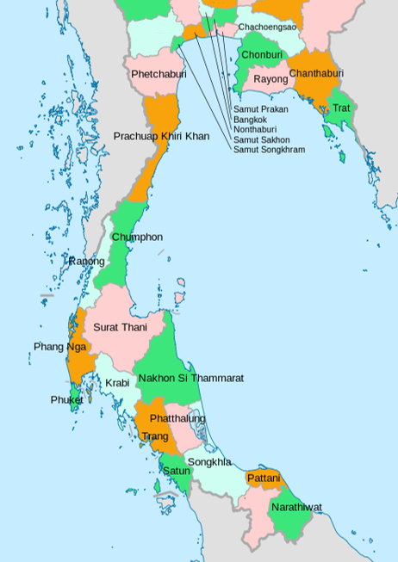
Figure 2.1 The coastal provinces of Thailand

Combined covering 101,647 km² as of 2020, the coastal provinces along the Gulf of Thailand account for 19.8% of the national land area. Provincial sizes vary significantly, ranging from extensive territories like Surat Thani (12,891.5 km², 2.5% of the national total) and Nakhon Si Thammarat (9,942.5 km², 1.9%) to smaller entities such as Samut Songkhram, which occupies only 416.7 km² or 0.08% of the country's total area (Figure 2.2).
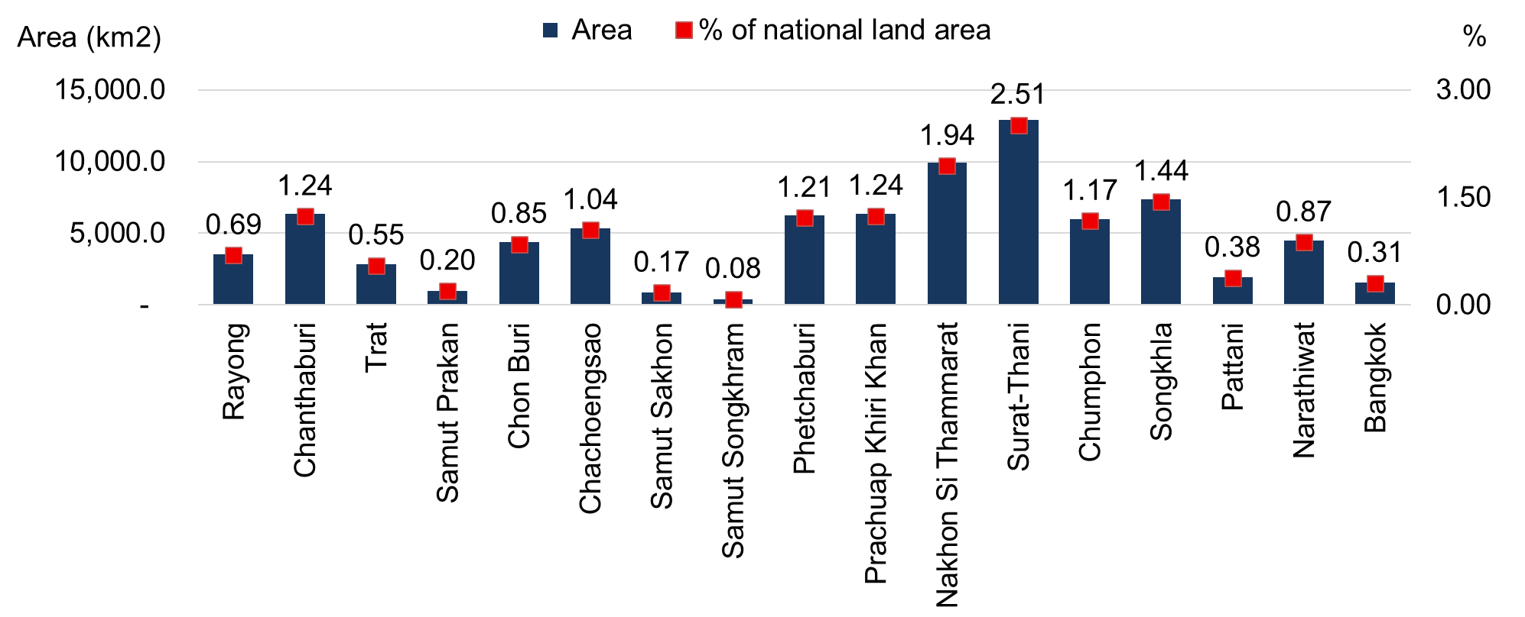
Figure 2.2 Land area and national share of coastal provinces along the Gulf of Thailand (2020)
Source: Department of Provincial Administration. 2025. Official statistics registration systems. https://stat.bora.dopa.go.th/stat/statnew/statMenu/newStat/home.php (accessed 19 April 2025)

Between 2000 and 2020, Thailand’s total population increased from 61.9 million to 66.2 million, reflecting a gradual national growth, with the 17 coastal provinces along the Gulf of Thailand accounting for approximately 18.6 million people in 2020. This population consists of nearly equal proportions of males and females, although the share of females increased to 51.7% (Figure 2.3) alongside a steady rise in the number of households due to smaller household sizes and urban migration. Provinces with the largest coastal populations include Nakhon Si Thammarat, Chon Buri, Songkhla, Samut Prakan, and notably Bangkok, which stands out as the most populous province with over 5.5 million residents and a predominance of females. In contrast, smaller provinces such as Samut Songkhram and Trat maintained populations below 300,000 (Figure 2.4).
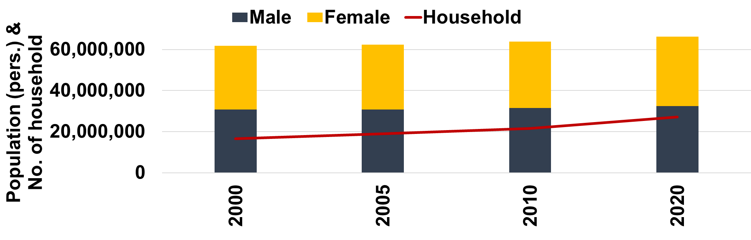
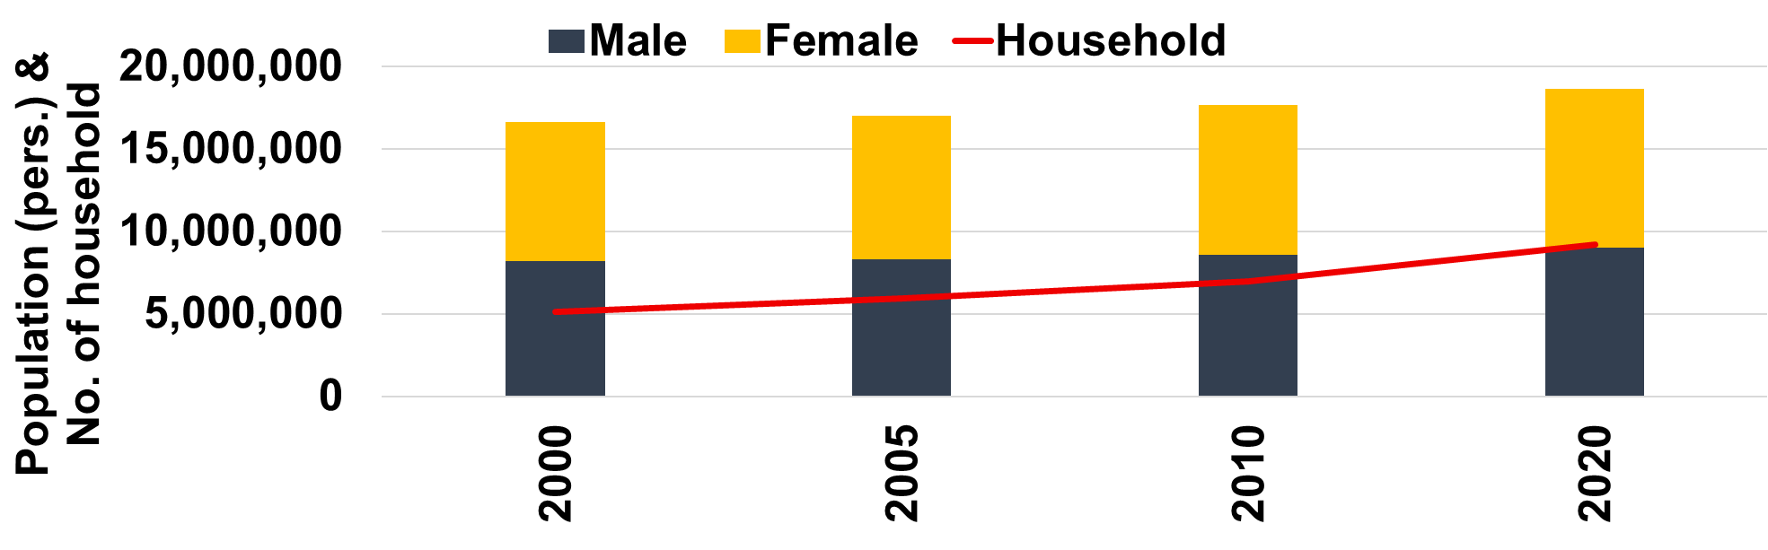
Figure 2.3 Population and Household Trends in Thailand (above) and Coastal Provinces along the Gulf of Thailand (below): 2000, 2005, 2010, 2020
Source: Department of Provincial Administration. 2025. Official statistics registration systems. https://stat.bora.dopa.go.th/stat/statnew/statMenu/newStat/home.php (accessed 19 April 2025)

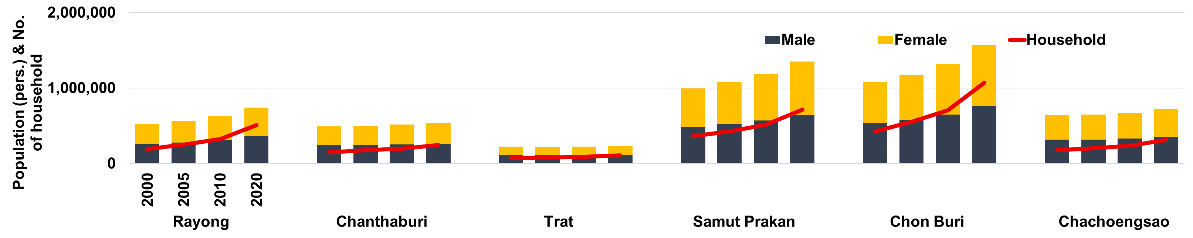
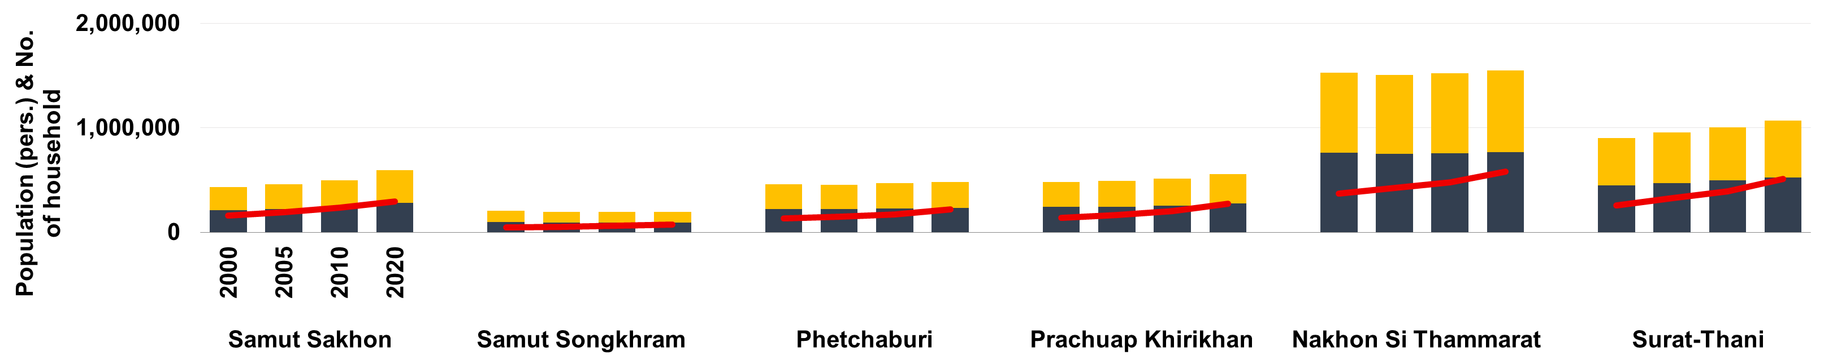
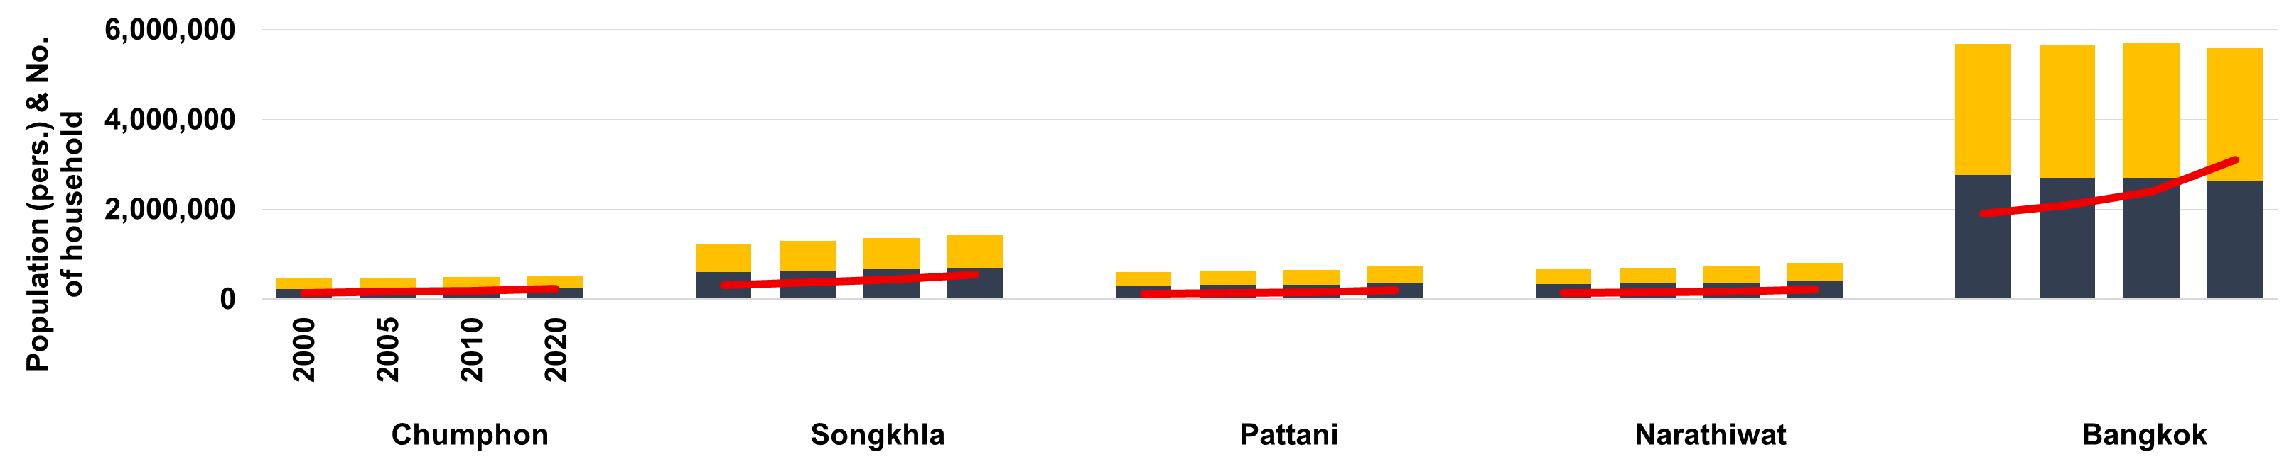
Figure 2.4 Population and household trends in Thailand’s coastal provinces along the Gulf of Thailand (2000, 2005, 2010, 2020)
Source: Department of Provincial Administration. 2025. Official statistics registration systems. https://stat.bora.dopa.go.th/stat/statnew/statMenu/newStat/home.php (accessed 19 April 2025)
Between 2000 and 2020, the population of Thailand’s coastal provinces along the Gulf of Thailand grew at an average annual rate of 0.6–0.9% when excluding Bangkok, compared to 0.4–0.7% when Bangkok is included (Table 2.1), which is considered a moderate level of growth by global demographic standards.

Table 2.1 Population growth rate (%) and household growth rate (%) of coastal provinces along the Gulf of Thailand (2000-2020)

Year | Population growth rate (%) |  | Household growth rate (%)
Year | Without Bangkok | With Bangkok | Without Bangkok | With Bangkok
2000-2005 | 0.6 | 0.4 | 3.4 | 2.7
2005-2010 | 0.9 | 0.7 | 3.2 | 2.9
2010-2020 | 0.8 | 0.5 | 3.1 | 2.9

When considering the rate of change between 2000 and 2020, the annual household growth in coastal provinces excluding Bangkok declined from 3.4% to 3.1%, yet remains high. In contrast, the trend for coastal provinces including Bangkok diverges, with household growth stabilizing around 2.7–2.9% despite modest population growth of 0.4–0.7%. As noted by UN-Habitat (2016), households are growing faster than population due to declining household size, a pattern evident in Bangkok’s shift toward smaller, fragmented urban living arrangements. This increase in households translates into higher demand for housing, energy, and coastal land resources (Liu et al., 2003; FAO, 2018), intensifying pressure on ecosystems in the land-constrained upper Gulf of Thailand.

Population and household growth trends vary significantly across the region. Economic hubs such as Chonburi (1.28–2.05%) and Rayong (1.13–2.01%) demonstrated relatively high population growth rates, while household growth was even more pronounced at 4.7% to over 5% annually (Figure 2.5), driven by tourism and industrial expansion. Conversely, provinces such as Samut Songkhram and Nakhon Si Thammarat recorded minimal or negative growth, likely reflecting outmigration and limited economic opportunities. Bangkok also experienced periods of slight population decline ranging from –0.06% to –0.32%, influenced by changing socio-economic conditions that have led to shifts in childbearing behavior, with people opting to have fewer or no children due to financial and time constraints (Figure 2.5).
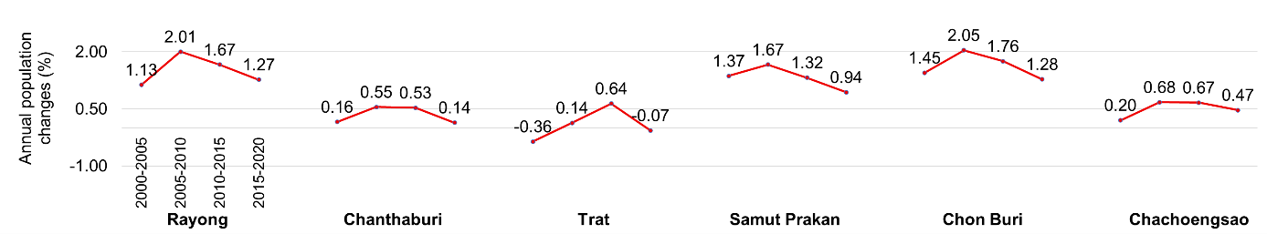
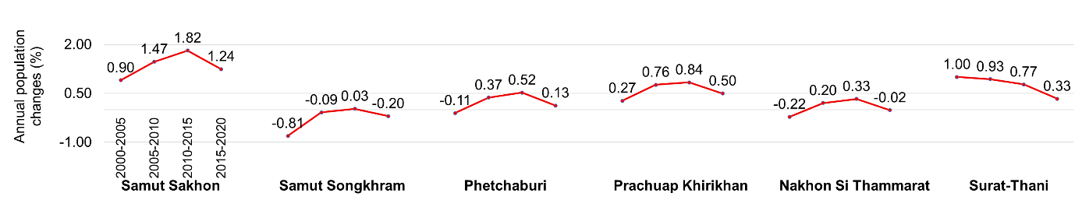
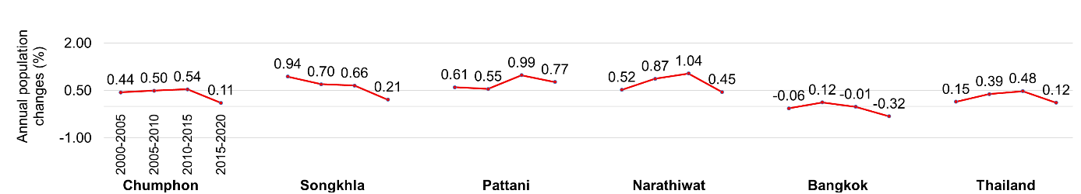
Figure 2.5 Annual population changes by coastal provinces along the Gulf of Thailand (2000-2020)
Source: Author’s calculation based on data from Department of Provincial Administration. 2025. Official statistics registration systems. https://stat.bora.dopa.go.th/stat/statnew/statMenu/newStat/home.php (accessed 19 April 2025)

Figure 2.6 presents the proportion of each coastal province’s population relative to the national total for 2000, 2005, 2010, and 2020. While the overall coastal share has remained relatively stable, ranging from 26.8% to 28.1%, Bangkok alone accounted for the largest share, representing 9.2%, 9.1%, 8.9%, and 8.4% across these respective years. Although this share has gradually declined, Bangkok remains the central economic and administrative hub. Other provinces such as Samut Prakan and Chonburi also hold substantial shares due to their proximity to major urban centers and importance in industrial development, with Chonburi’s increasing share aligning with the Eastern Economic Corridor (EEC) initiative. In contrast, provinces such as Trat and Samut Songkhram have consistently accounted for less than 1% of the national population each.

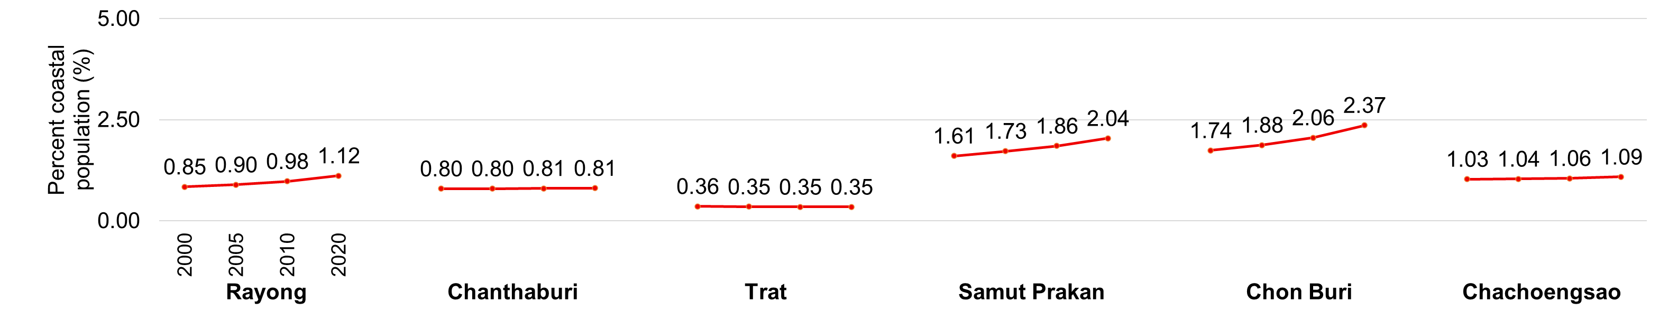
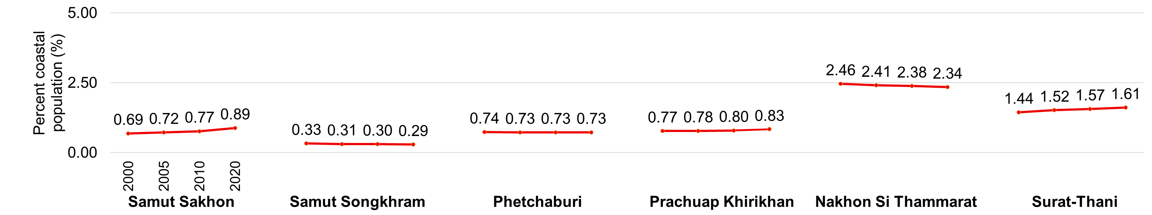
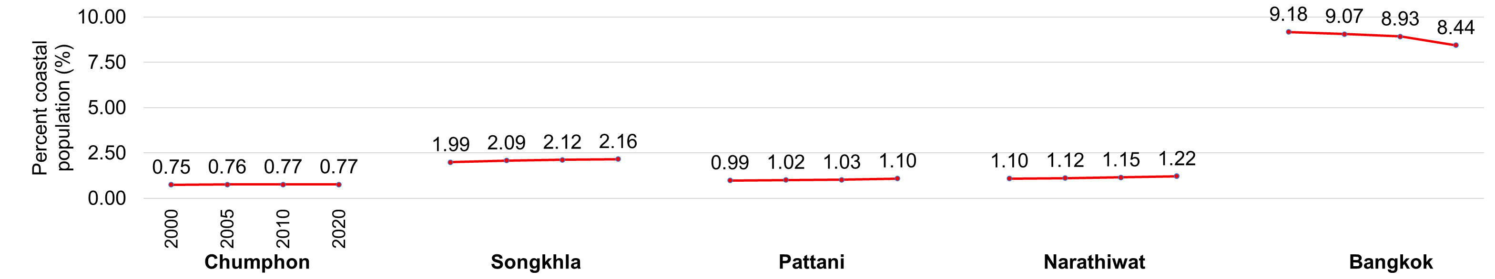
Figure 2.6 Provincial share of coastal population along the Gulf of Thailand (2000, 2005, 2010, 2020)
Source: Author’s calculation based on data from Department of Provincial Administration. 2025. Official statistics registration systems. https://stat.bora.dopa.go.th/stat/statnew/statMenu/newStat/home.php (accessed 19 April 2025)

Figure 2.7 illustrates the relationship between land area and population concentration from 2000 to 2020. While Thailand’s national average density increased gradually from 121 to 129 persons/km², coastal provinces exhibit densities far exceeding this benchmark. Bangkok consistently recorded the highest extreme concentration, ranging between 3,562 and 3,634 persons/km². Similarly, Samut Prakan (992–1,346 persons/km²), Samut Sakhon (492–672 persons/km²), and Samut Songkhram (461–492 persons/km²) display densities significantly higher than the national level due to large populations confined within limited land areas.
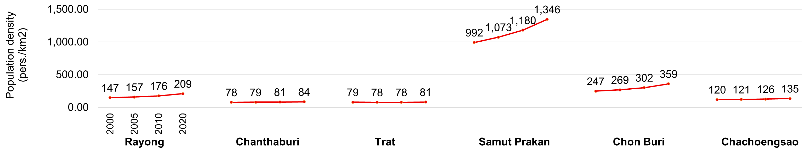
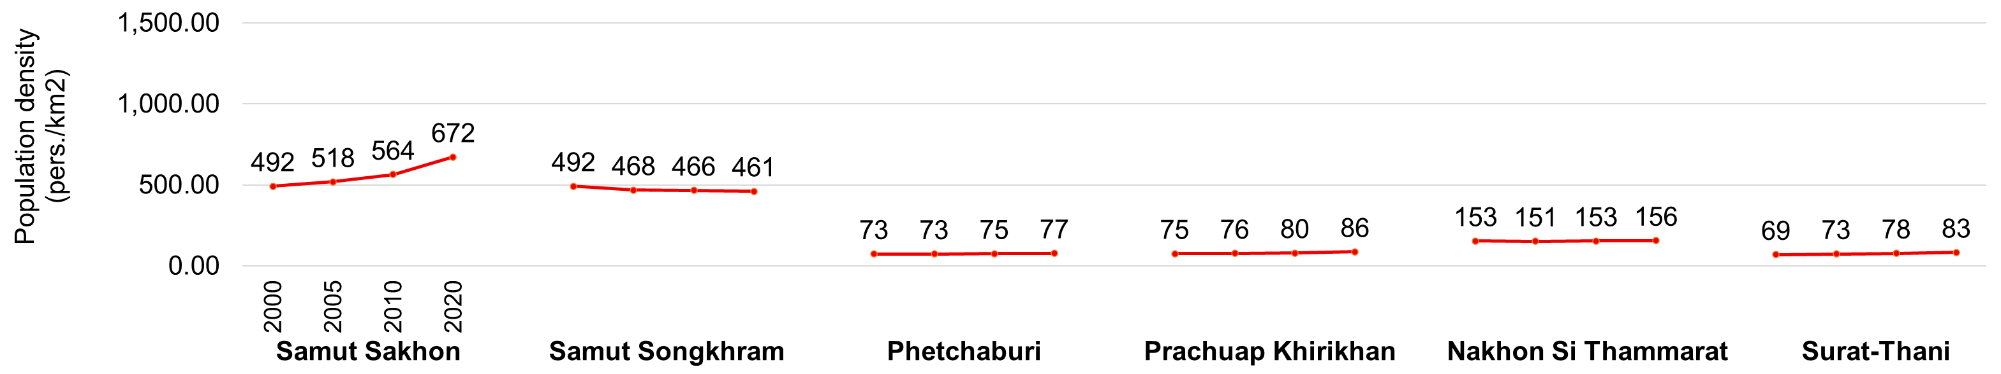
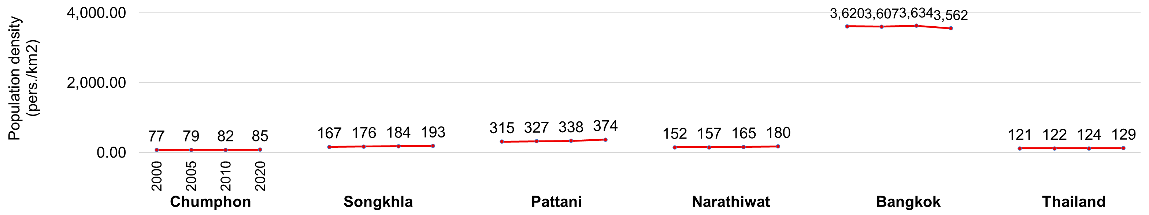
Figure 2.7 Population density of Thailand and coastal provinces along the Gulf of Thailand (2000, 2005, 2010, 2020)
Source: Author’s calculation based on data from Department of Provincial Administration. 2025. Official statistics registration systems. https://stat.bora.dopa.go.th/stat/statnew/statMenu/newStat/home.php (accessed 19 April 2025)

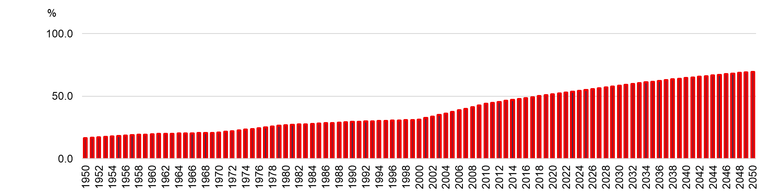
Figure 2.8 Percentage of population at mid-year residing in urban areas of Thailand (1950-2050)
Source: United Nations, Department of Economic and Social Affairs, Population Division (2018). World Urbanization Prospects: The 2018 Revision, Online Edition.

As illustrated in Figure 2.8, the percentage of Thailand’s population residing in urban areas rose from 16.5% in 1950 to 51.4% by 2020, with projections reaching approximately 69.5% by 2050. This trend reflects economic growth, rural-to-urban migration, and infrastructure expansion.

The 2020 urban population ratio and density data reveal distinct spatial patterns among coastal provinces (Table 2.2). While the national average indicates moderate urbanization (34.5% share, 129 persons/km²), coastal areas exhibit stronger contrasts. The upper Gulf forms Thailand’s primary urban corridor, extending from Bangkok to the Eastern Economic Corridor (EEC), where industrial development dominates. Key provinces here include Bangkok (100%, 3,562 persons/km²), Samut Prakan (48.6%, 1,346), Samut Sakhon (45.6%, 672), and Chon Buri (68.9%, 359). In contrast, lower Gulf provinces such as Chumphon, Narathiwat, and Nakhon Si Thammarat reflect predominantly rural settlement patterns with low urban ratios (< 25%) and densities (< 200 persons/km²).

Table 2.2 Urban population ratio and population density of Thailand and coastal provinces along the Gulf of Thailand (2020)
Provinces | Urban population ratio (%) | Density (pers./km²)
Nation | 34.5 | 129
Rayong | 48.6 | 209
Chanthaburi | 42.3 | 84
Trat | 24.4 | 81
Samut Prakan | 48.6 | 1,346
Chon Buri | 68.9 | 359
Chachoengsao | 21.8 | 135
Samut Sakhon | 45.6 | 672
Samut Songkhram | 19.8 | 461
Phetchaburi | 33.9 | 77
Prachuap Khiri Khan | 31.2 | 86
Nakhon Si Thammarat | 18.8 | 156
Surat-Thani | 41.3 | 83
Chumphon | 19.1 | 85
Songkhla | 50.8 | 193
Pattani | 17.9 | 374
Narathiwat | 20.8 | 180
Bangkok | 100.0 | 3,562

Figure 2.9 illustrates the progressive loss of Thailand’s natural and semi-natural vegetated land between 2005 and 2022. The indicator reports the loss as a percentage of the natural and semi-natural land area in the base year 2000, increasing from 1.26% in 2005 to 2.13% in 2022. This pattern suggests a continued conversion of vegetated land to other land uses over the period.
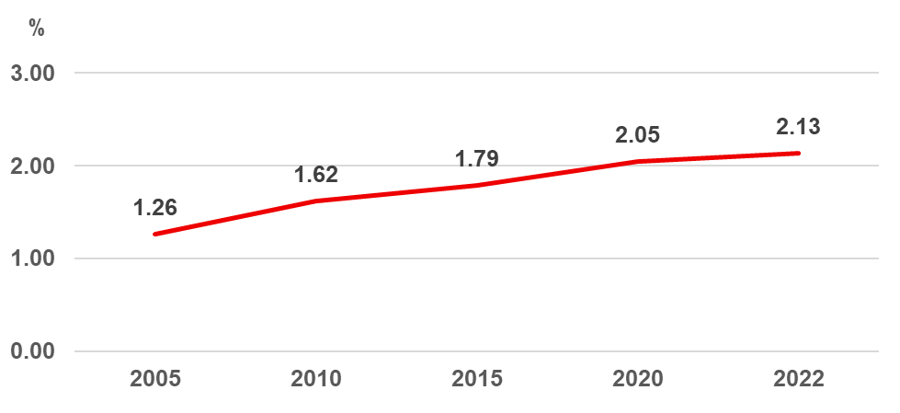
Figure 2.9 Loss of natural and semi-natural vegetated land in Thailand
(2005, 2010, 2015, 2020, 2022)
Source: OECD Data Explorer. 2025. Land cover and land change. https://data-explorer.oecd.org/ (accessed 25 May 2025)

2.2.2 Human wellbeing

Poverty in coastal areas is a key indicator of vulnerability, particularly where communities depend on open-access ecosystems such as coastal fisheries, mangroves, and intertidal zones. While population size alone does not adequately reflect pressure, the number of poor residents provides a direct measure of subsistence dependence. National statistics from 2000 to 2020 reveal a significant reduction in those living below the poverty line, falling from approximately 25.7 million (41.7%) to 4.7 million (7.2%), representing an average annual reduction of 4.1% (Figure 2.10). This positive trend reflects broader socioeconomic developments, including agricultural expansion and targeted government assistance via social protection schemes and improved access to public services. Together, these factors have contributed to a marked reduction in poverty and a consequent shift in natural resource dependence patterns in coastal regions.
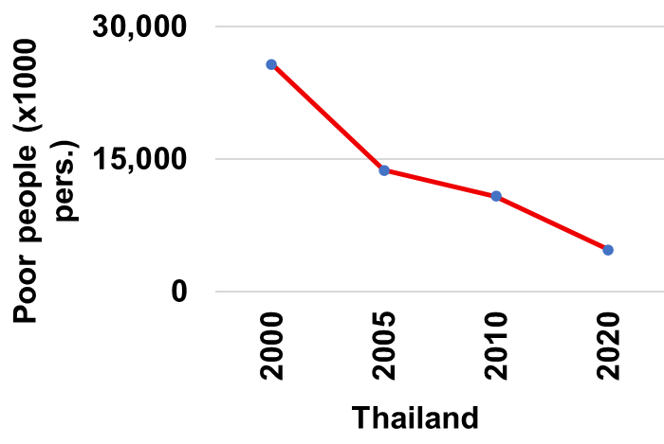 | 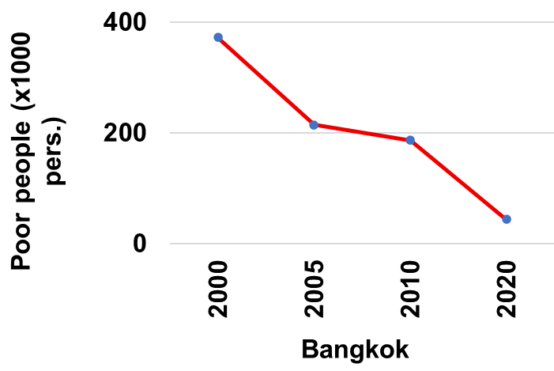
Figure 2.10 Poor people of Thailand and Bangkok province (2000, 2006, 2010, 2020)
Source: Office of the National Economic and Social Development Council. 2025. Household Socio-Economic Survey by the National Statistical Office; compiled by the Division of Social Data and Indicators Development, NESDC. https://www.nesdc.go.th/main.php?filename=social (accessed 22 April 2025)

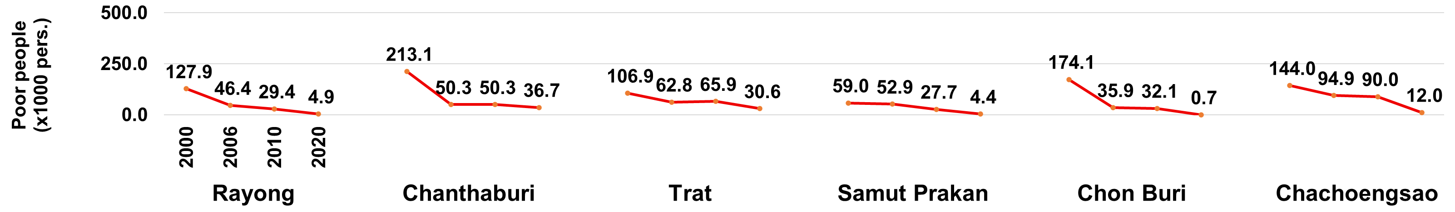
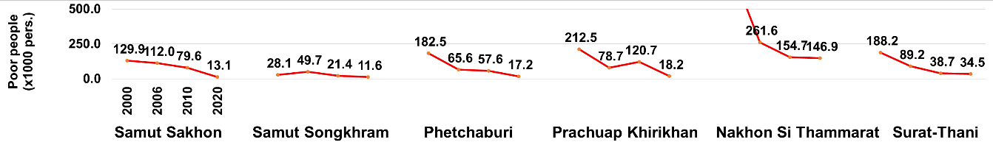
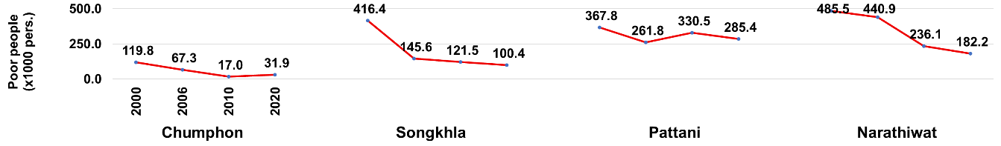
Figure 2.11 Poor people in coastal provinces along the Gulf of Thailand (2000, 2006, 2010, 2020)
Source: Office of the National Economic and Social Development Council. 2025. Household Socio-Economic Survey by the National Statistical Office; compiled by the Division of Social Data and Indicators Development, NESDC. https://www.nesdc.go.th/main.php?filename=social (accessed 22 April 2025)

Data from the 17 coastal provinces shows significant but unequal progress in reducing poverty (Figure 2.11). Industrial hubs like Rayong, Chonburi, and Samut Prakan achieved dramatic declines driven by the Eastern Economic Corridor (EEC), with Rayong’s poor population dropping over 96% to just 4,900. Bangkok also saw significant improvement, falling to 44,100. Conversely, southern provinces face persistent poverty where Pattani saw only slight improvement to 285,400 and Narathiwat recorded over 182,000, reflecting complex local issues. These regional differences are critical as high poverty often correlates with reliance on fragile ecosystems.

Regarding SDG 1, Thailand is broadly on track to end extreme poverty by 2030 provided social protection continues. However, progress varies significantly. While industrial coastal provinces may meet targets early, persistent poverty in Pattani and Narathiwat requires area-specific, conflict-sensitive, and livelihood-diversification measures. Without such interventions, Thailand risks meeting SDG 1 nationally while retaining significant coastal pockets of poverty.

Contemporary Human Development Index (HDI)
Thailand’s HDI has shown steady progress over the past three decades, rising from 0.584 in 1990 to 0.742 by 2010 due to improvements in life expectancy, education attainment, and gross national income per capita (Figure 2.12). The index reached 0.800 in 2021 before experiencing a slight dip to 0.792 in 2022 and subsequently recovering to 0.798 in 2023.
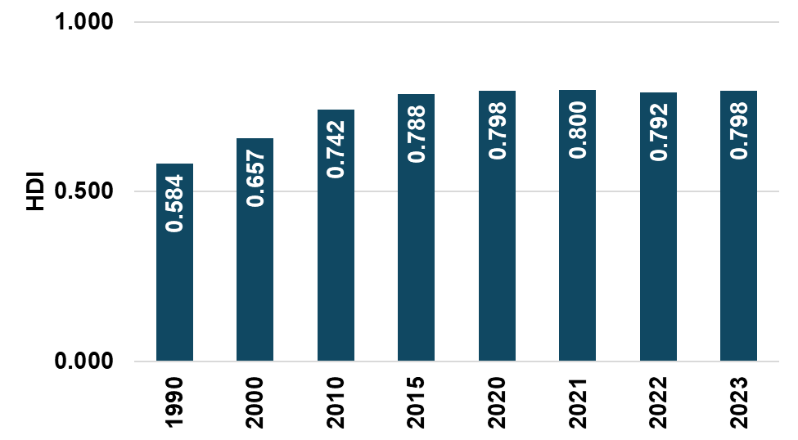
Figure 2.12 HDI of Thailand (1990-2023)
Source: UNDP. 2025. Human Development Reports. https://hdr.undp.org/data-center/documentation-and-downloads (accessed 22 April 2025)

Inequality-adjusted human development index (IHDI)
From 2012 to 2023, Thailand’s IHDI increased from 0.622 to 0.677, signaling reduced overall inequality across key development sectors likely stemming from better healthcare, education, and targeted social policies (Figure 2.13). While the index temporarily dropped to 0.670 between 2020 and 2022 due to COVID-19 disruptions, it rebounded to 0.677 in 2023, indicating the country is recovering from these recent vulnerabilities.

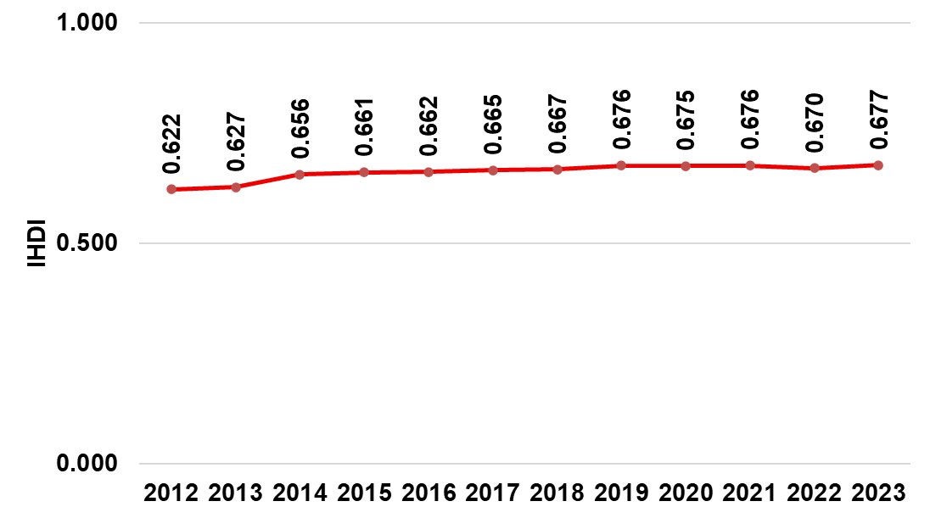
Figure 2.13 IHDI of Thailand (2012-2023)
Source: UNDP. 2025. Human Development Reports. https://hdr.undp.org/data-center/documentation-and-downloads (accessed 22 April 2025)

2.2.3 Economic activities

Provincial GDP data highlights varying degrees of economic diversification as shown in Figure 2.14. The service sector dominates tourism destinations like Phetchaburi and Songkhla while agriculture plays a major role in Trat. Conversely, industrial activity is clustered in Chon Buri, Rayong, Chachoengsao, and Samut Sakhon due to proximity to ports and special economic zones.

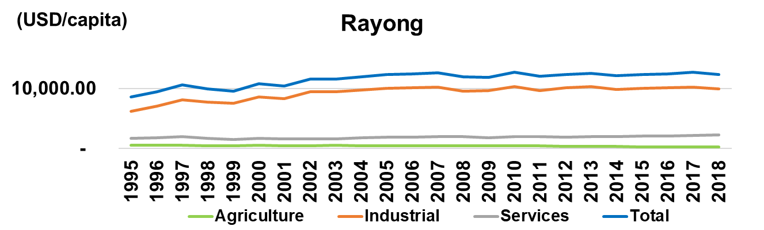 | 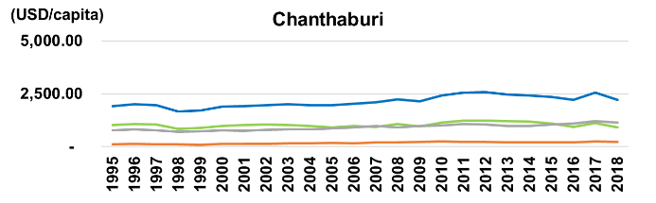
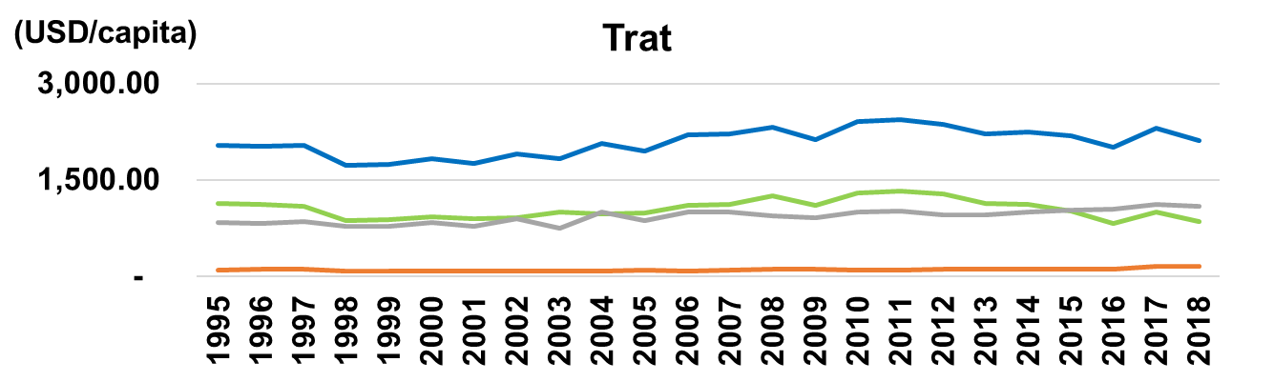 | 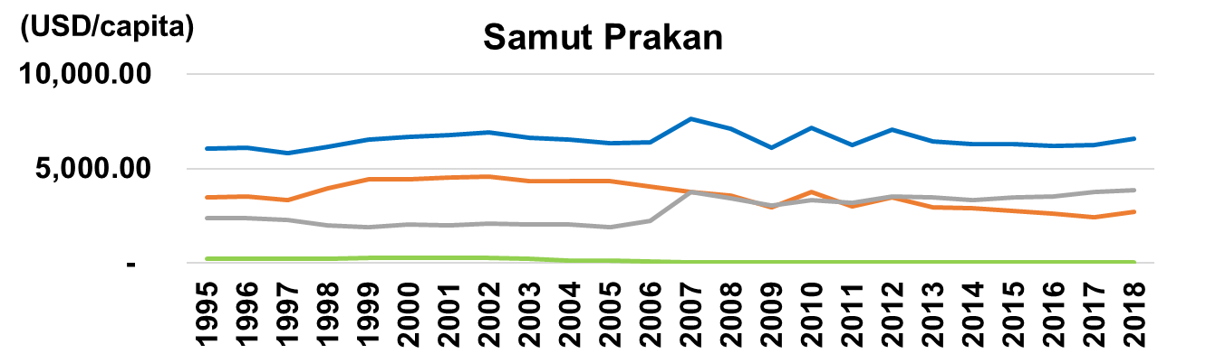
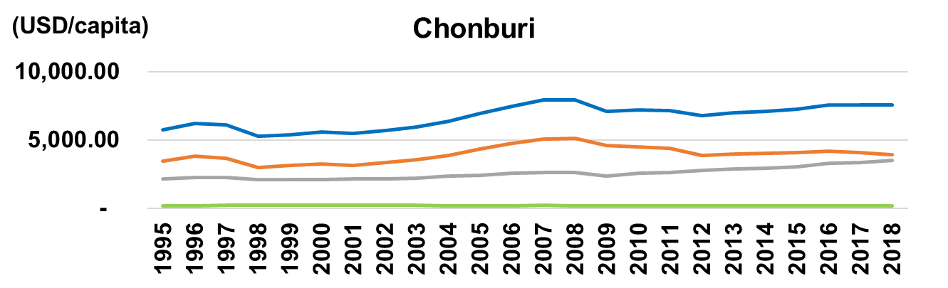 | 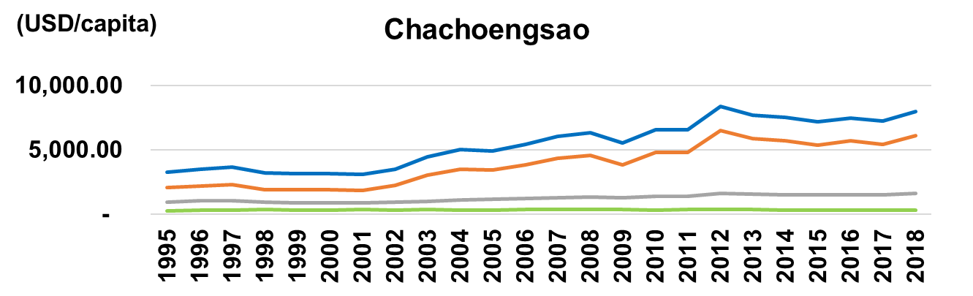
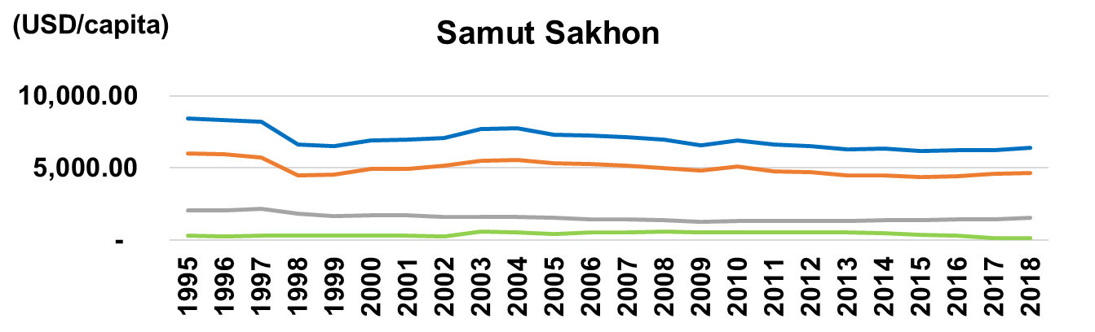 | 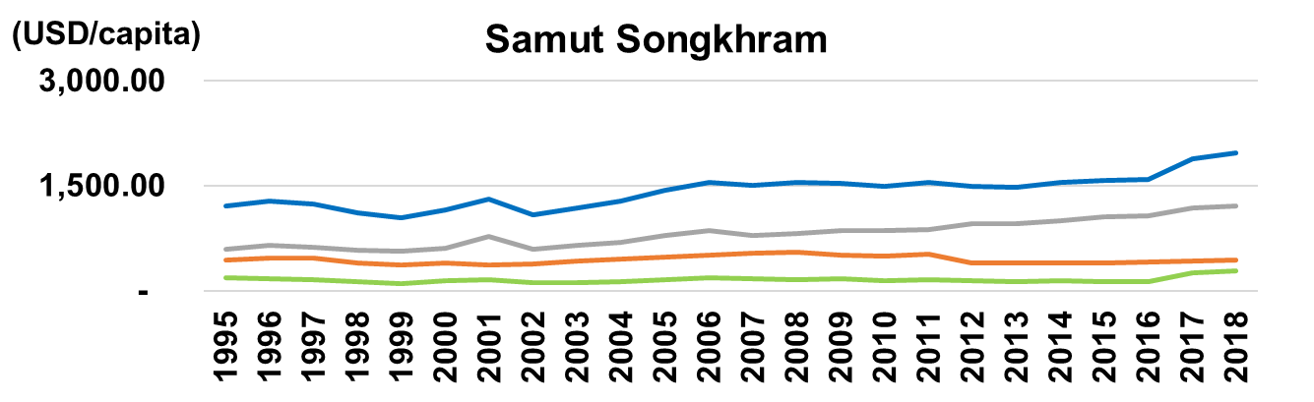

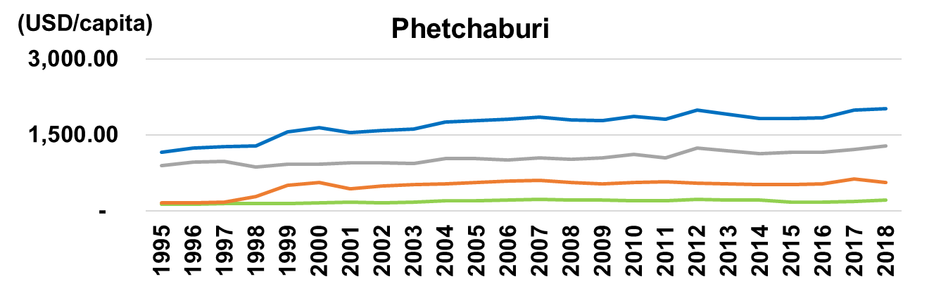 | 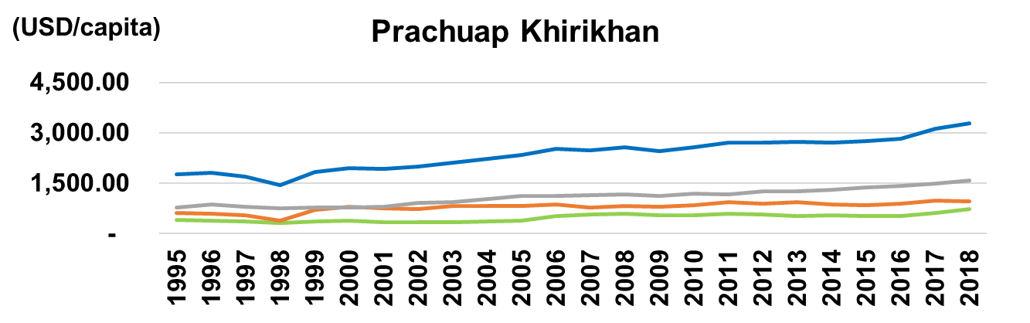
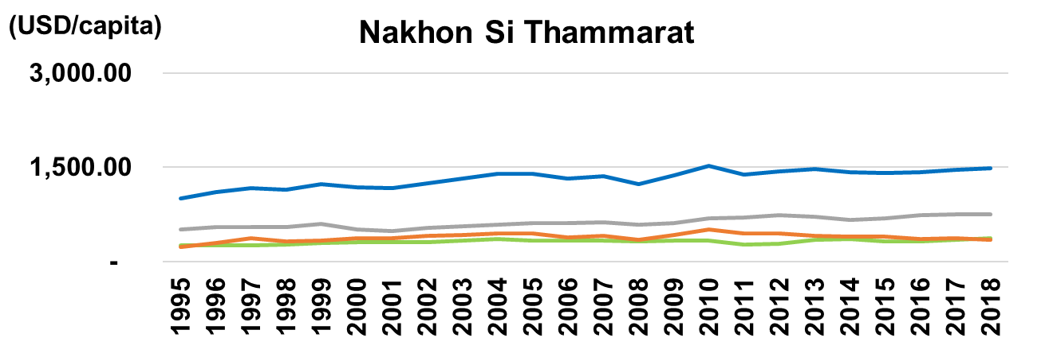 | 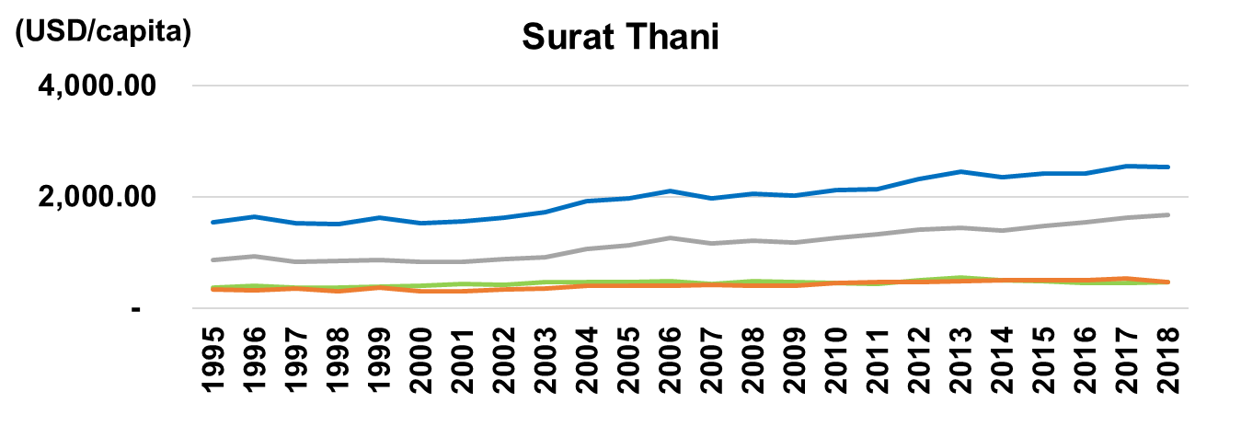
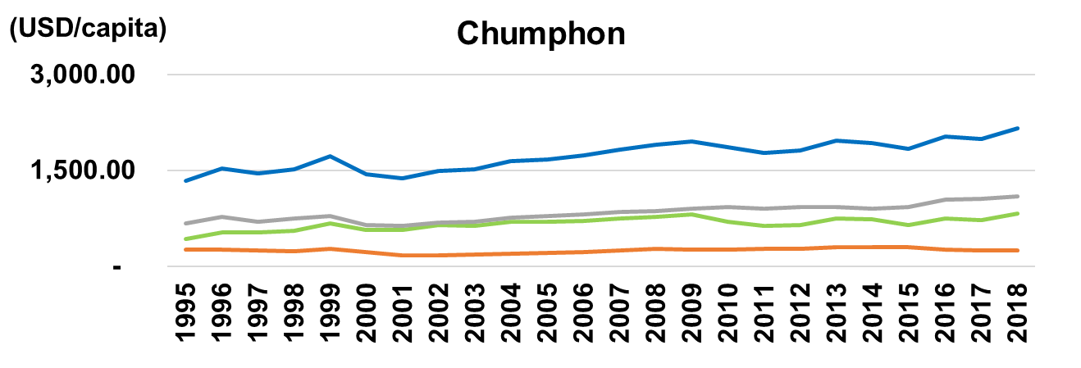 | 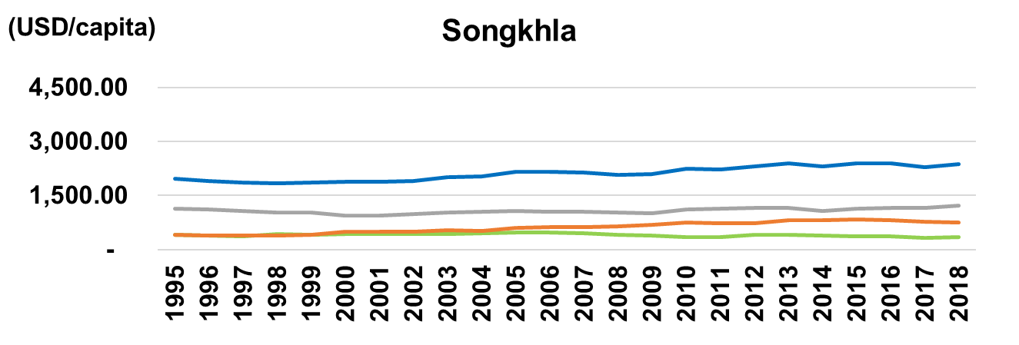
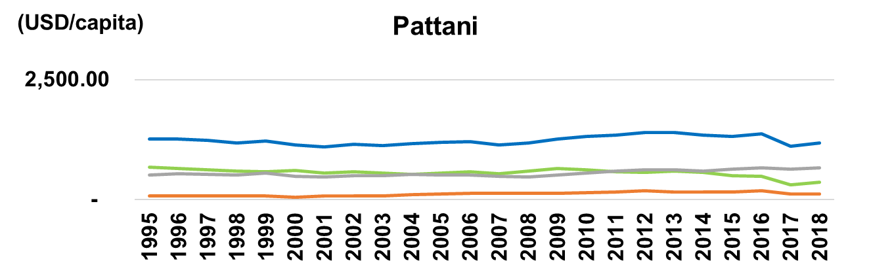 | 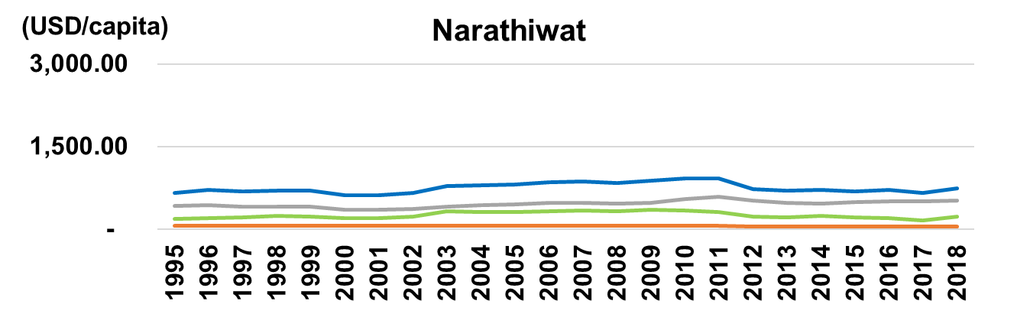
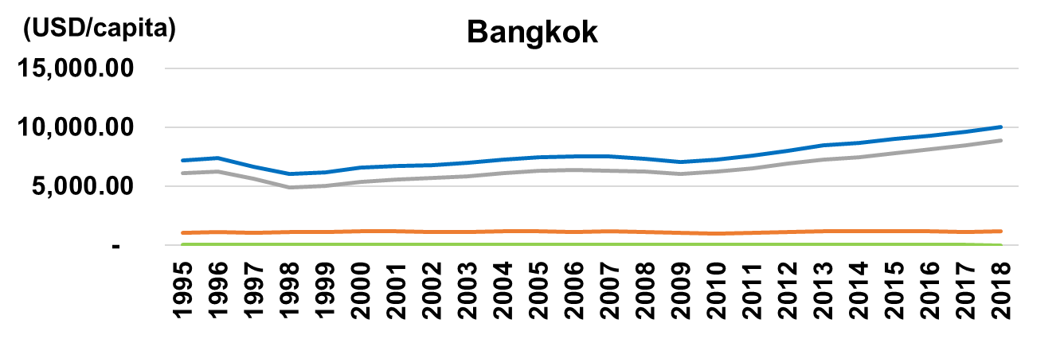 | 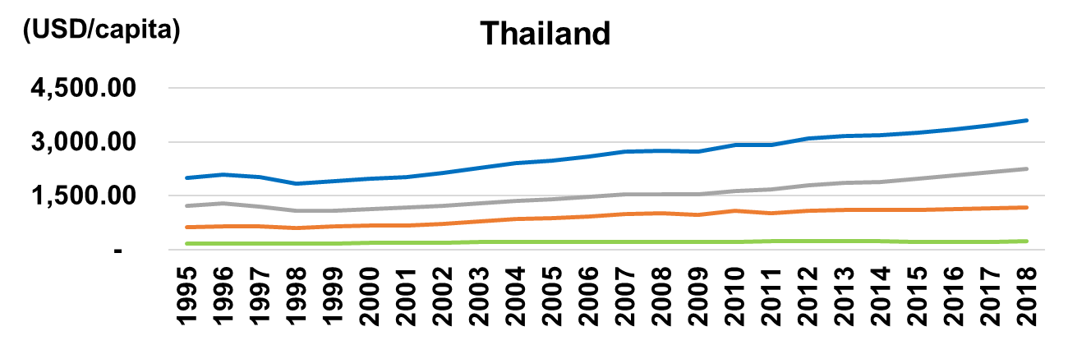
Figure 2.14 GDP per capita by sector (agriculture, industrial, services) of coastal provinces along the Gulf of Thailand (1995-2018)
Source: Office of the National Economic and Social Development Council. 2025. GDP. https://www.nesdc.go.th/nesdb_en/more_news.php?cid=156&filename=index (Accessed 21 Apr 2025)

A broader comparison highlights clear differences between the national economy and Bangkok. The capital is heavily reliant on the service sector, consistent with its role as the primary commercial hub. Nationally, the economic structure is more balanced, featuring strong contributions from both services and industry, the latter supported by export-oriented investments. In both contexts, agriculture is no longer the dominant sector, though it remains a supporting pillar of the economy.

Sustainable fisheries contribution to GDP
Between 2011 and 2021, the contribution of sustainable fisheries to Thailand’s GDP dropped from 0.45% to 0.28% (Figure 2.15). This downward trend coincided with a period of broader structural shifts in the economy and the strict enforcement of measures against Illegal, Unreported, and Unregulated (IUU) fishing. In this changing environment, the sector faces the critical task of balancing ecological compliance with the economic stability of fishing communities.
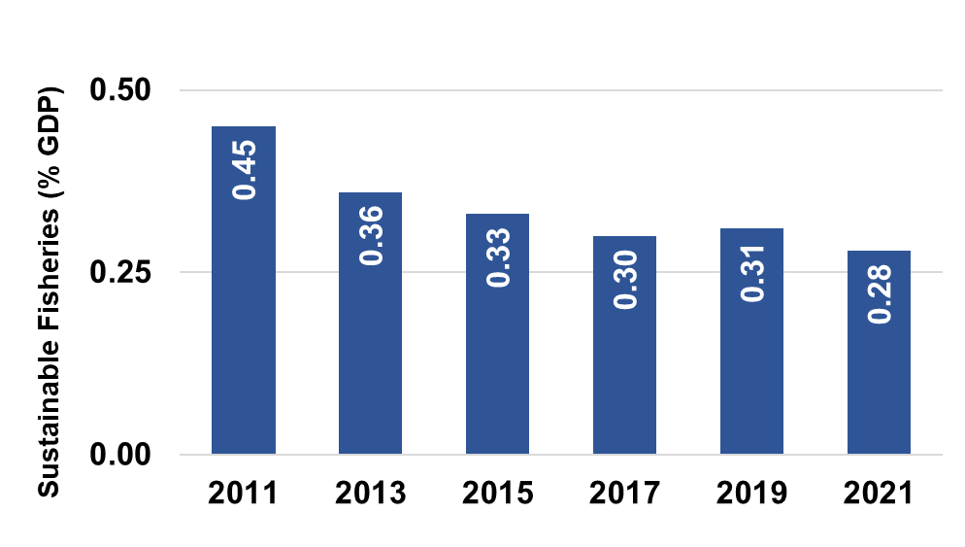
Figure 2.15 Sustainable fisheries as a percentage of GDP in Thailand (2011-2021)
Source: FAO. 2025. Sustainable fisheries as a proportion of GDP. https://de-public-statsuite.fao.org/ (Accessed 25 June 2025)

Tourism percent of GDP
Thailand’s tourism sector saw robust growth between 2010 and 2019, with its GDP contribution climbing from 3.56% to a peak of over 7.4% (Figure 2.16). This expansion established tourism as a critical economic driver, particularly for coastal destinations like Phuket and Chon Buri, while also increasing the demand for infrastructure and resources. The trend, however, was drastically reversed by the COVID-19 pandemic, which caused the sector’s share to drop to 0.84% by 2021 due to global travel disruptions.

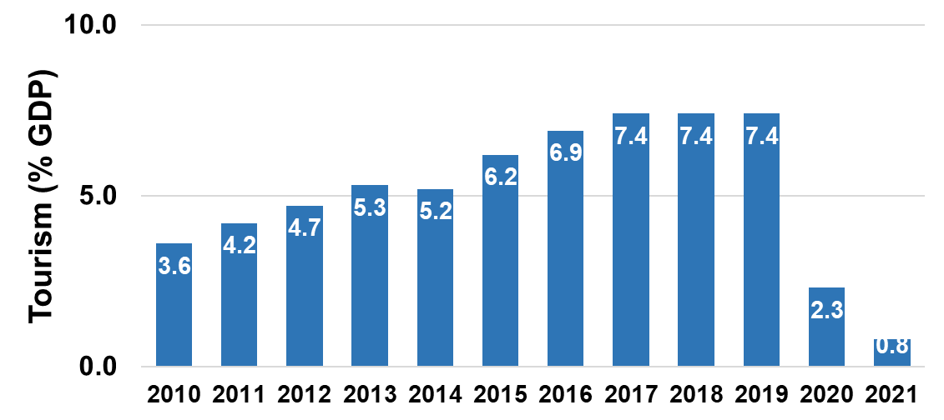
Figure 2.16 Tourism as a percentage of GDP in Thailand (2011-2021)
Source: Our World in Data. 2024. Tourism’s contribution to GDP. https://www.unwto.org/tourism-statistics/economic-contribution-SDG (Accessed 25 June 2025)

2.2.4 Climate-related threats
Tropical cyclones remain a major threat to Thailand’s coastal economies and natural resources. Data from the Thai Meteorological Department (2000–2024) indicates an annual average of 1.6 cyclones, peaking at three in specific years (Figure 2.17). Although long-term frequency shows no clear increase, significant annual variation highlights climate uncertainty, demanding strong disaster response mechanisms to protect high-risk areas from storm surges.
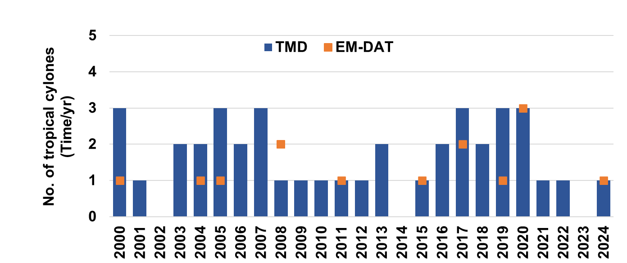
Figure 2.17 Number of tropical cyclones per year of Thailand (2000-2024) from Thai Meteorological Department (TMD) and EM-DAT
Source: EM-DAT, CRED / UCLouvain. 2025. www.emdat.be (Accessed 25 Jun 2025); TMD. 2025. Tropical Cyclones in Thailand (1951-2024).

Although storm frequency has not steadily increased, human impact varies significantly. Data between 2000 and 2024 highlights this unpredictability, with death tolls surging to 45 in 2024 and exceeding 10 in 2005 and 2020, in sharp contrast to years like 2008 and 2017 with zero recorded deaths (Figure 2.18). These contrasts expose the fragility of low-lying coastal areas, reinforcing the urgent need for effective early warning systems and community-based risk reduction to minimize fatalities.
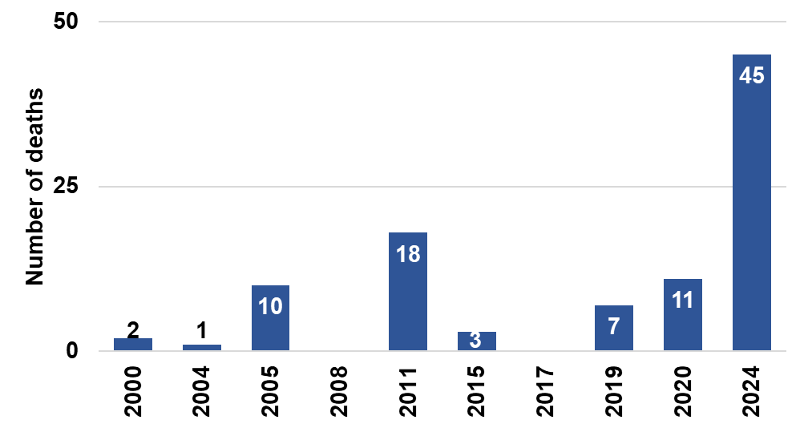
Figure 2.18 Number of deaths from tropical cyclones per year of Thailand (2000-2024)
Source: EM-DAT, CRED / UCLouvain. 2025. www.emdat.be (Accessed 25 Jun 2025)

Data on cyclone-related damages in Thailand (2005–2024) reveal significant annual variation. Losses ranged from USD 20 million in 2005 (USD 32.1 million adjusted) and a minor USD 561,000 in 2015 (USD 742,000 adjusted) to a peak of USD 904 million in 2024 (Figure 2.19).

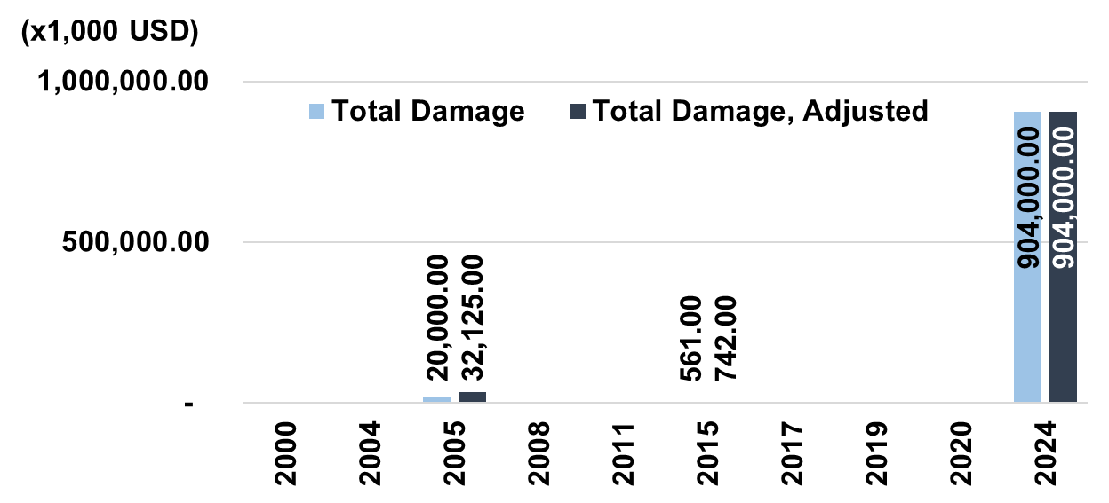
Figure 2.19 Total damage and total damage (adjusted)
due to tropical cyclones of Thailand (2000-2024)
Source: EM-DAT, CRED / UCLouvain. 2025. www.emdat.be (Accessed 25 Jun 2025)

2.3 Discussion and conclusions

2.3.1 Risk assessment from socioeconomic trends
For sustainable management, a Composite Risk Index (CRI) was established to quantify risk across 17 Gulf of Thailand provinces based on the DPSIR framework (EEA, 1999; Kristensen, 2004). Calculated as CRI = 0.5×PI + 0.5×VI, the index equally weights Pressure (PI) and Vulnerability (VI). The PI aggregates three socioeconomic drivers: population dynamics (2000–2020), current population density (2020), and economic pressure derived from gross provincial product (2000-2020). The VI averages social sensitivity proxies: changes in poverty headcount and gender ratio imbalance (2000–2020). All indicators are normalized to a [0,1] scale. Notably, critical physical exposure variables such as elevation metrics and tropical cyclone statistics were excluded due to a lack of provincial resolution, ensuring the index remains spatially consistent and comparable across all provinces.
The 'Risk intensity' format (CRI_Unweighted) measures severity independent of physical size, identifying Bangkok (0.646), Samut Songkhram (0.538), and Samut Prakan (0.419) as highest-risk (Table 2.3). Drivers vary from concentrated economic and industrial activity in Bangkok and Samut Prakan to high population density within Samut Songkhram’s confined territory. Conversely, Rayong registered the lowest intensity at 0.261.

Table 2.3 Risk intensity assessment (CRI_Unweighted) and provincial ranking
Province | Pressure index (PI) score | Vulnerability index (VI) score | Risk intensity score (CRI_Unweighted) | Intensity rank
Bangkok | 0.586 | 0.706 | 0.646 | 1
Samut Songkhram | 0.337 | 0.740 | 0.538 | 2
Samut Prakan | 0.332 | 0.506 | 0.419 | 3
Samut Sakhon | 0.316 | 0.438 | 0.377 | 4
Chumphon | 0.382 | 0.362 | 0.372 | 5
Pattani | 0.209 | 0.531 | 0.370 | 6
Songkhla | 0.264 | 0.470 | 0.367 | 7
Chachoengsao | 0.458 | 0.253 | 0.355 | 8
Surat-Thani | 0.369 | 0.326 | 0.348 | 9
Phetchaburi | 0.219 | 0.452 | 0.336 | 10
Chon Buri | 0.497 | 0.160 | 0.329 | 11
Chanthaburi | 0.249 | 0.378 | 0.314 | 12
Narathiwat | 0.226 | 0.401 | 0.314 | 13
Prachuap Khiri Khan | 0.387 | 0.148 | 0.268 | 14
Trat | 0.183 | 0.346 | 0.265 | 15
Nakhon Si Thammarat | 0.231 | 0.293 | 0.262 | 16
Rayong | 0.425 | 0.098 | 0.261 | 17

Incorporating area weighting, the 'Overall risk magnitude' (CRI_Final) measures total risk volume rather than concentration, causing a distinct shift in priorities. Surat Thani (0.055), Songkhla (0.033), and Nakhon Si Thammarat (0.032) rise to the top (Table 2.4) as extensive geography increases the aggregate exposure of critical habitats and communities. Conversely, rankings for smaller provinces like Samut Songkhram and Samut Sakhon decline, confirming that while local pressures are intense, overall resource exposure is limited by size.

Table 2.4 Overall risk magnitude assessment (CRI_Final) and provincial ranking after area weighting
Province | Risk intensity score (CRI_Unweighted) | Intensity rank | Area weight | Risk magnitude score (CRI_Final) | Final rank
Surat-Thani | 0.348 | 9 | 0.158 | 0.055 | 1
Songkhla | 0.367 | 7 | 0.091 | 0.033 | 2
Nakhon Si Thammarat | 0.262 | 16 | 0.122 | 0.032 | 3
Chumphon | 0.372 | 5 | 0.074 | 0.027 | 4
Phetchaburi | 0.336 | 10 | 0.076 | 0.026 | 5
Chanthaburi | 0.314 | 12 | 0.078 | 0.024 | 6
Chachoengsao | 0.355 | 8 | 0.066 | 0.023 | 7
Prachuap Khiri Khan | 0.268 | 14 | 0.078 | 0.021 | 8
Chon Buri | 0.329 | 11 | 0.054 | 0.018 | 9
Narathiwat | 0.314 | 13 | 0.055 | 0.017 | 10
Bangkok | 0.646 | 1 | 0.019 | 0.012 | 11
Rayong | 0.261 | 17 | 0.044 | 0.011 | 12
Trat | 0.265 | 15 | 0.035 | 0.009 | 13
Pattani | 0.370 | 6 | 0.024 | 0.009 | 14
Samut Prakan | 0.419 | 3 | 0.012 | 0.005 | 15
Samut Sakhon | 0.377 | 4 | 0.011 | 0.004 | 16
Samut Songkhram | 0.538 | 2 | 0.005 | 0.003 | 17
Total |  |  | 1.000

Finally, the 'Hybrid-risk group,' exemplified by Chumphon (Intensity rank 5, Magnitude rank 4), faces the dual burden of intense pressure and large scale. This 'double-risk' status creates a complex management scenario requiring a complete response that combines urgent action for specific areas with long-term planning for vast resources.

This risk assessment identifies three priority groups essential for policy planning. The 'Pure intensity risk' group (e.g., Bangkok, Samut Songkhram) requires urgent spatial management to control concentrated pressures in small areas. The 'Pure magnitude risk' group (e.g., Surat Thani, Songkhla) demands large-scale resource management and budgetary allocation due to extensive resource portfolios despite lower intensity. Finally, the 'Hybrid-risk group' (e.g., Chumphon) ranks high in both dimensions requiring complex integrated responses that combine urgent management with large-scale planning. This analysis serves as a critical tool for prioritizing interventions and designing effective responses.

2.3.2 Risk assessment from climate- and environment-related threats
The socioeconomic risks identified in section 2.3.1 are compounded by physical, climate- and environment-related threats. Although province-level physical vulnerability data is unavailable, the broader hazard context is critical as the Gulf of Thailand persistently faces hydrometeorological hazards including coastal erosion, storm surges, and tropical cyclones.

National-level data (Figures 2.17–2.19) confirms this persistent threat, showing numerous cyclone events annually between 2000 and 2024. These events have caused significant economic damages and loss of life, with recorded losses of approximately $32 million in 2005, $742,000 in 2015, and a severe $904 million in 2024. While this data covers the national level, the 17 coastal provinces are primary targets. Consequently, this general exposure acts as a risk multiplier, threatening to amplify the socioeconomic weaknesses, such as poverty and dense settlements, identified in the CRI assessment.

2.3.3 Mitigating socioeconomic vulnerability from climate-mediated environmental change- current actions and gaps
Thailand implements a structured policy system to build coastal resilience against climate change risks across three levels. Level 1 sets the long-term vision through the National Strategy. Level 2 guides mid-term planning via the Master Plan under the National Strategy (2023 to 2037) and the 13th National Economic and Social Development Plan (NESDP) for 2023 to 2027. Level 3 executes these strategies through specific agency plans, including the Department of Climate Change and Environment’s 5 Year Action Plan.

The 20 Year National Strategy (2018 to 2037) addresses unpredictable climate change threats to lives, infrastructure, food security, and ecosystems. It targets a stable nation with sustainable natural resources by fostering environmentally friendly growth. This vision builds a climate friendly society that reduces greenhouse gas emissions and adapts to minimize disaster loss. These goals serve as the foundation for the National Economic and Social Development Plan and other master plans.

Level 2 translates the National Strategy into the Master Plan under the National Strategy (2023 to 2037), specifically Issue 18 on sustainable growth. This issue features a sub-plan for creating a climate friendly society aimed at lowering greenhouse gas emissions. The plan outlines four development guidelines: reducing emissions, adapting to minimize loss from natural disasters, promoting climate friendly infrastructure investments, and enhancing adaptation and emission reduction capacity.

The 13th National Economic and Social Development Plan (NESDP) for 2023 to 2027 puts this vision into practice toward Security, Prosperity, and Sustainability based on the Sufficiency Economy Philosophy. It aims to transform the country into a progressive, value driven, and sustainable society. The plan prioritizes building resilience against global risks like climate change to reduce socioeconomic vulnerability. It establishes 13 specific Development milestones to direct national action.

Milestone 11 builds capacity to reduce disaster and climate change impacts through three primary objectives. First involves minimizing damage by lowering fatalities, economic loss, and affected areas. Second lowers exposure using provincial risk maps and effective early warning systems. Third strengthens societal resilience, targeting 80% community self-management by 2027 and expanded insurance access. These efforts utilize five strategies: preventing risks in critical zones, building community skills, utilizing technology, restoring ecosystems, and promoting international cooperation.

At practical Level 3 broad national strategies turn into action through agency specific plans like the Department of Climate Change and Environment (DCCE) 5 Year Action Plan (2023 to 2027). This plan guides the department under the Ministry of Natural Resources and Environment toward climate resilience and a low carbon lifestyle. To achieve this the DCCE focuses on five areas aligning policy with global commitments, creating tools for adaptation and mitigation, building public networks, improving data for governance, and strengthening the organization.

In essence, Thailand's implementation, as reflected in the previously mentioned plans, is presented in Table 2.5.

Table 2.5 Significance of the implementation driven by the DCCE
Issue | Key implementation aspects
Impacts of climate change at both the global and national levels (Thailand) | 1. Assessing impacts and developing risk datasets from climate change, covering 6 adaptation sectors, such as: agriculture and food security, water management and disasters, tourism, public health, natural resource management, and the human settlement and security sector, including area-based risks.  2. Formulation of policies and plans for climate change adaptation.  3. Driving and promoting public readiness to adapt to climate change.  4. Developing adaptation plans at the policy and area levels to cover the adaptation sectors, including the implementation of efficient and effective adaptation measures.  5. Driving and implementing actions at the policy level in collaboration with central and local agencies to drive area-based adaptation and scale up implementation.  6. Monitoring and evaluation of implementation and ensuring continuous improvement.
GHG Mitigation, Carbon Neutrality, and Net-Zero | 1. Assess the potential for greenhouse gas (GHG) mitigation and develop policies and plans, including setting national GHG-reduction targets that cover the five key sectors: energy; industrial processes and product use (IPPU); waste; agriculture; and land use and forestry.  2. Prepare and submit implementation reports on the plans and targets that Thailand has pledged, in accordance with the submission timelines under the United Nations Framework Convention on Climate Change (UNFCCC) and the Paris Agreement, such as National Communications (NCs) and Biennial Transparency Reports (BTRs).  3. Drive and implement climate policy in coordination with central and local government agencies.  4. Promote and enable the public to be ready to develop and adopt low-GHG lifestyles.  5. Advance GHG mitigation actions across sectors and at subnational levels, and scale up successful initiatives.  6. Continuously monitor and evaluate progress and improve implementation.

Even with these solid policies in place, putting them into practice remains difficult. A review of the DCCE’s analysis highlights serious obstacles that stand in the way of reducing risks for the population. These challenges generally fall into two main groups:
1. Strategic and technical gaps
These challenges arise from the complex nature of the climate problem itself and the tools available to address it:
- Scientific uncertainty remains a primary gap in conducting precise risk assessments. While general climate impacts are understood significant uncertainty persists regarding specific timing severity and exact location. This lack of precision limits targeted cost effective adaptation policies and complicates clear public communication.
- Problem complexity and integration make management difficult as climate change affects multiple sectors. A fragmented approach persists where economic development policies are not fully integrated with climate adaptation goals often leading to conflicting objectives. National frameworks like NESDP Milestone 11 set general goals but deploy a one size fits all approach. This fails to address distinct needs of priority groups specifically Intensity risk provinces like Bangkok, Magnitude risk group like Surat Thani or Hybrid risk group like Chumphon.

2. Operational and institutional gaps
These challenges concern the ability of key institutions, particularly the DCCE, to carry out the national strategy effectively:
- Expanded mandate vs resource constraints arise as the DCCE faces a heavier workload from severe climate impacts like frequent disasters and ecosystem loss. Although new specialized divisions for GHG reduction and adaptation were established this wider scope creates a resource shortage. Consequently, the agency requires significant new funding modern monitoring technology and continuous personnel training to meet demands.
- Cooperation and communication gaps hinder effective coordination and implementation involving the need to strengthen cooperation across ministries and local governments to drive area-based adaptation. A challenge remains in translating complex scientific data into clear public communication. Overcoming this is essential to build broad support among stakeholders and encourage real behavioral change.

2.3.4 Recommended priority actions, including regional cooperation
Thailand has a structured policy framework yet significant gaps remain between planning and implementation. The system struggles with institutional constraints and lacks specific strategies for Intensity Magnitude and Hybrid risk groups. To address high climate exposure the country must shift from reactive measures to a proactive risk governance model. Accordingly, the following priority actions are recommended.

1. Priority 1: Mainstream proactive risk governance and financing
The most critical gap is the reliance on reactive management. This is sustained by budget systems that allocate more funds to post-disaster relief than pre-disaster mitigation.
- Action Shift budget priorities. Adjust budget structure to focus on proactive risk reduction. Integrate climate adaptation and disaster prevention into key planning stages including the national budget process 13th NESDP implementation and provincial plans.
- Action Expand use of risk assessment models. Apply the study risk assessment model widely. The CRI methodology exemplifies applied risk assessment models required by the 13th NESDP. Quantifying specific risks provides data to justify proactive budget allocation. Future assessments must incorporate ocean literacy as a vulnerability indicator. Measuring public understanding is critical as lower awareness reduces preparedness and conservation support increasing overall vulnerability.

2. Priority 2: Implement differentiated, area-based adaptation
The CRI analysis shows that risk varies significantly across different areas. Therefore, policy responses must be tailored to the specific risk profile of each province.
- For pure intensity risk groups e.g. Bangkok, Samut Songkhram actions focus on enforcing resilience standards. Require climate proofing for all new infrastructure and urban development to manage high concentration of socioeconomic pressure.
- For pure magnitude risk Groups e.g. Surat Thani, Songkhla prioritize large scale Ecosystem based Adaptation EbA. Invest in soft infrastructure like mangrove restoration and watershed protection to safeguard resource bases.
- For hybrid risk Group e.g. Chumphon, high intensity and magnitude requires comprehensive response. Combine targeted spatial planning with large scale resource management.
3. Priority 3: Strengthen transboundary and regional cooperation
Analysis confirms severe threats like tsunamis typhoons and droughts are transboundary and unmanageable alone. The 17 coastal provinces serve as the frontline making regional cooperation critical for domestic resilience.
- Action Enhance regional early warning systems. Improve data sharing and technical cooperation covering meteorological hazards through partnerships with ASEAN and typhoon committees. Address seismic and tsunami risks drawing on lessons from the 2004 disaster.
- Action Establish regional frameworks for shared resources. Manage shared marine ecosystems and fisheries sustaining local economies. Address transboundary environmental issues like marine pollution and oil spills impacting vulnerable coastal communities.
- Action Develop joint regional strategies. Collaborate to access international climate finance and technology converting shared goals into effective regional action.
2.4 Methodology and analysis
The Composite Risk Index (CRI) ranks risk across 17 Gulf of Thailand provinces based on the DPSIR framework. The model operates on the principle that Risk aggregates Pressure and Vulnerability mapping the interactions between socioeconomic trends and environmental conditions.

The Pressure Index (PI) comprises three pillars population dynamics density and economic pressure. The Vulnerability Index (VI) assesses social sensitivity through poverty and gender imbalance indicators. All metrics analyze data changes between 2000 and 2020.

Indicators measuring temporal change utilize Compound Annual Growth Rate CAGR. Density change was excluded to prevent statistical redundancy with population metrics. All data undergoes min-max normalization to a standard [0, 1] interval allowing aggregation of different units. Directionality is adjusted so higher values consistently indicate negative outcomes

The methodology applies equal weighting for calculation. The PI score averages its three pillars while the VI score averages its two indicators. The final CRI score results from the simple average of the calculated PI and VI scores.

The assessment utilizes two dimensions. The Intensity Score measures risk concentration regardless of physical size highlighting localized urban pressure. The Magnitude Score applies area weighting to reflect the total scale of resources and management workload. This dual analysis identifies three specific categories Intensity risk Magnitude risk and Hybrid risk.

Glossary
Composite Risk Index (CRI) | An index constructed by integrating metrics of risk magnitude and risk intensity to diagnose and rank the risk levels of coastal areas, which subsequently informs the prioritization of management measures.
DCCE | Department of Climate Change and Environment; the primary government agency in Thailand responsible for climate policy and environmental management.
Eastern Economic Corridor (EEC) | A special economic zone in eastern Thailand (Chonburi, Rayong, and Chachoengsao provinces) designed to be the nation's leading economic hub for trade, investment, and innovation.
EbA | Ecosystem-based Adaptation; the use of biodiversity and ecosystem services as part of an overall adaptation strategy to help people adapt to the adverse effects of climate change.
EM-DAT | Emergency Events Database; a global database on natural and technological disasters maintained by the Centre for Research on the Epidemiology of Disasters (CRED).
GDP | Gross Domestic Product; the total monetary or market value of all the finished goods and services produced within a country's borders in a specific time period.
GHG | Greenhouse Gas; gases in the earth's atmosphere that trap heat, such as carbon dioxide (CO₂​) and methane (CH₄​), contributing to the greenhouse effect.
GPP | Gross Provincial Product; the total economic value of all final goods and services produced within a specific province during a given period.
HDI | Human Development Index; a statistical composite index of life expectancy, education, and per capita income indicators, used to measure key dimensions of human development.
Hybrid Risk | A risk classification for areas that rank high in both risk magnitude and risk intensity, requiring the most integrated and comprehensive policy responses.
IHDI | Inequality-adjusted Human Development Index; an index that combines a country's average achievements in health, education, and income with how those achievements are distributed among the population.
Intensity Risk | A risk classification characterized by high economic density or concentrated asset value within a specific area (e.g., economic hubs), often requiring targeted spatial management.
Magnitude Risk | A risk classification characterized by the broad geographic scale or large population size exposed to potential hazards, often requiring broad resource planning.
NESDP | National Economic and Social Development Plan; Thailand’s five-year national master plan for economic and social development.
Pressure Index (PI) | An index that measures the intensity of human activities and their potential negative impacts on natural resources and ecosystems, calculated in this study using population count, household count, population density, and Gross Provincial Product (GPP).
SDGs | Sustainable Development Goals; a collection of 17 interlinked global goals set by the United Nations to achieve a better and more sustainable future for all by 2030.
TMD | Thai Meteorological Department; the governmental agency responsible for weather forecasting and issuing warnings for hydrometeorological hazards in Thailand.
UNFCCC | United Nations Framework Convention on Climate Change; an international environmental treaty establishing a framework for intergovernmental efforts to address climate change.
Vulnerability Index (VI) | An index that measures the socioeconomic susceptibility of a population, calculated in this study using the poverty headcount ratio and sex ratio imbalance.

Acknowledgement
The author gratefully acknowledges the Department of Marine and Coastal Resources (DMCR) for serving as the National Coordinator for Thailand. Sincere appreciation is extended to the regional team for their technical guidance, and to all experts and stakeholders for their contributions to the completion of this National Transboundary Diagnostic Analysis.

Author contributions
Monissa Srisomwong: Data curation, formal analysis, methodology, visualization, writing-original draft, writing-review and editing,

References
Department of Climate Change and Environment (DCCE), 2023. 5-Year Action Plan (2023-2027). Ministry of Natural Resources and Environment, Thailand. https://www.dcce.go.th/ (accessed 5 November 2025).

Department of Provincial Administration, 2025. Official statistics registration systems. https://stat.bora.dopa.go.th/stat/statnew/statMenu/newStat/home.php (accessed 19 April 2025).

EEA, 1999. Environmental indicators: Typology and terminology. EEA Technical report No 25. https://www.eea.europa.eu/publications/TEC25 (accessed 27 November 2025).

EM-DAT, CRED / UCLouvain, 2025. www.emdat.be (accessed 25 Jun 2025)

FAO, 2018. The State of World Fisheries and Aquaculture 2018 - Meeting the sustainable development goals. Rome. https://www.fao.org/3/i9540en/i9540en.pdf (accessed [Accessed Date]).

FAO, 2025. Sustainable fisheries as a proportion of GDP. https://de-public-statsuite.fao.org/ (accessed 25 June 2025).

Kristensen, P., 2004. The DPSIR Framework. Paper presented at the 27-29 September 2004 workshop on a comprehensive/detailed assessment of the vulnerability of water resources to environmental change in Africa using indicator based methods, UNEP. https://dce-fs-live-dce.it.au.dk/filarkiv/89/AR_89.pdf (accessed 27 November 2025).

Liu, J., Daily, G.C., Ehrlich, P.R., Luck, G.W., 2003. Effects of household dynamics on resource consumption and biodiversity. Nature, 421(6922), pp.530-533. https://www.nature.com/articles/nature01359 (accessed 19 April 2025).

National Economic and Social Development Council (NESDC), 2019. Study report on assumptions for population projections of Thailand, 2010–2040 (Revised edition). Bangkok: Office of the National Economic and Social Development Council. (in Thai).

OECD Data Explorer, 2025. Land cover and land change. https://data-explorer.oecd.org/ (accessed 25 May 2025).

Office of the National Economic and Social Development Council, 2025. GDP. https://www.nesdc.go.th/nesdb_en/more_news.php?cid=156&filename=index (accessed 21 Apr 2025).

Office of the National Economic and Social Development Council, 2025. Household Socio-Economic Survey by the National Statistical Office; compiled by the Division of Social Data and Indicators Development, NESDC.
https://www.nesdc.go.th/main.php?filename=social (accessed 22 April 2025).

Office of the National Economic and Social Development Council (NESDC), 2018. National Strategy (2018 - 2037). https://faolex.fao.org/docs/pdf/tha200834.pdf (accessed 5 November 2025).

Office of the National Economic and Social Development Council (NESDC), 2022. The Thirteenth National Economic and Social Development Plan (2023-2027). https://www.nesdc.go.th/download/document/Socio-Economic/13th_Plan_Eng.pdf (accessed 5 November 2025).

Our World in Data, 2024. Tourism’s contribution to GDP. https://www.unwto.org/tourism-statistics/economic-contribution-SDG (accessed 25 June 2025).

TMD, 2025. Tropical Cyclones in Thailand (1951-2024). Climate Center, Meteorological Development Division, Thai Meteorological Department.

UNDP, 2025. Human Development Reports.
https://hdr.undp.org/data-center/documentation-and-downloads (accessed 22 April 2025).

UN-Habitat (United Nations Human Settlements Programme), 2016. World Cities Report 2016, Urbanization and Development: Emerging Futures. Nairobi. https://unhabitat.org/world-cities-report-2016 (accessed 19 April 2025).

United Nations, Department of Economic and Social Affairs, Population Division, 2018. World Urbanization Prospects: The 2018 Revision, Online Edition.

